Successful Management of Notoedres cati in Cats: A Comparative Study of Selamectin Spot-On and Ethnoveterinary Medicine

Abstract:
A total of 4500 clinical cases of domestic cats presented to the Veterinary Clinical Complex (VCC), Rajendranagar, between 2022 and 2024 were screened for Notoedres cati infestation. Out of these, 250 cats (5.0%) were diagnosed positive based on characteristic clinical signs and microscopic identification of mites in skin scrapings. The infection occurred in both males (54%) and females (46%), predominantly in cats aged 6 months to 2 years. Among affected cats, 60% were between 6 months–1 year and 40% between 1–2 years. Clinically, infested cats showed alopecia, crusting, hyperkeratosis, excoriations, and intense pruritus, with lesions primarily on the ear margins, face, neck, and forelimbs. Few owners exhibited pruritic papular eruptions on their hands and wrists, suggestive of zoonotic transmission.
The study evaluated the therapeutic efficacy of Selamectin spot-on (6 mg/kg body weight) and an Aloe vera-virgin coconut oil formulation in 250 naturally infested cats divided equally into two treatment groups. Selamectin-treated cats (Group I) achieved complete recovery by day 21 post-treatment, while those treated with the ethnoveterinary formulation (Group II) showed significant improvement by day 28. Both treatments were effective; however, Selamectin resulted in faster recovery, whereas the Aloe vera–virgin coconut oil formulation was more economical and environmentally safe.
The study emphasizes the ongoing prevalence of Notoedres cati in domestic cats in the Hyderabad region and highlights the importance of early detection, routine screening, and appropriate therapeutic interventions to prevent recurrence and zoonotic transmission.
Keywords: Notoedres cati, Selamectin, Aloe vera–virgin coconut oil, cats, zoonosis.
- Introduction
Dermatological disorders are among the most frequently encountered clinical conditions in domestic cats. Among various parasitic diseases, mange is one of the most prevalent. Mite infestations lead to skin thickening, wrinkling, and folding, eventually resulting in the formation of dense, firmly adherent crusts varying in color from yellow to gray (Sivajothi et al., 2015). Scabies in cats is a highly contagious zoonotic disease that can be transmitted between animals and humans. It is caused by tiny mites, Notoedres cati and Sarcoptes scabiei (Goldust et al., 2013). Notoedric mange is a relatively rare infectious skin disease of disease affecting domestic and stray cats caused by obligate burrowing mites belonging to the genus Notoedres (family: Sarcoptidae) (Deak & Dumitrache, 2021). These mites burrow into the skin, leading to crusted dermatitis, particularly in sparsely haired regions such as the head, neck, axillae, groin, and tail (Hardy et al., 2012). Typical scabies lesions appear at the burrowing sites as papular or vesicular eruptions, often accompanied by a generalized allergic dermatitis and severe pruritus (Mounsey et al. (2013). Hence, prompt treatment of scabies in cats is essential to prevent skin thickening, folding, and crust formation.
Morphologically, Notoedres mites resemble other members of the family Sarcoptidae, such as Sarcoptes species, but are smaller and possess characteristic “thumbprint” appearance with distinct dorsal striations, shorter limb stalks, dorsal legs and spines, and a dorsal anus rather than the terminal anus typical of Sarcoptes (Ozukum et al., 2019). Common lesions in cats include alopecia, lichenification, crusts, scales, and occasionally scabs, typically affecting the head, legs, and genital areas (Dangi et al., 2023) and are often worsened by secondary bacterial infections resulting from excoriations caused by self-trauma (Györke et al., 2022).
Although Notoedres mites primarily affects cats, the disease has also been reported in more than 15 other animal species, and humans can also acquire the infection through close contact with affected cats, resulting in intense pruritus and papular lesions on the arms and legs (Sinha et al., 2023). In humans, hypersensitivity reactions to Notoedres cati bites result in papulovesicular eruptions accompanied by intense pruritus (Chakrabarti, 1986; Deplazes et al., 2016). However, as the mite is unable to complete its life cycle in human hosts, the condition is generally self-limiting and transient (Chakrabarti, 1986; Deplazes et al., 2016).
Despite the rapid advancements in modern medicine, the role of natural and traditional remedies should not be overlooked (Khairullah et al., 2020; Khairullah et al., 2021; Ansori, et al., 2021). Despite growing interest in plant-based therapies, there remains limited knowledge regarding the variety of plants that could serve as natural medicines for specific treatments and be developed into standardized formulations (Pratasik et al., 2019; Solikhah et al., 2020; Khairullah et al., 2021).
Among natural remedies, Aloe barbadensis, commonly known as Aloe vera, possesses high potential as a pharmaceutical raw material (Bashir et al., 2011) with several studies reporting its effectiveness in treating scabies in animals (Ansori et al., 2021; Sindhu et al., 2012; Oyelami et al., 2009) have reported the effectiveness of Aloe vera in treating scabies in animals. Its combination with Virgin Coconut Oil, a natural oil derived from the fresh and mature kernel of the coconut (Cocos nucifera L.) through mechanical or natural processes, with or without the application of heat, and without any chemical modification or transformation of the oil, is of particular interest due to VCO’s rich content of vitamins and antioxidants, as well as its lauric acid component, which possesses strong antimicrobial and antiviral properties. Its medium-chain fatty acids (MCFAs) also enhance digestibility (Mansor et al., 2012; Solikhah & Solikhah, 2019). The unsaturated fatty acids present in VCO help neutralize free radicals and support immune function, making it beneficial in preventing and managing various health conditions. Additionally, VCO is a natural, pesticide-free oil with a composition that promotes skin absorption, leaving the skin soft and smooth (Abujazia et al., 2012). Topical cream formulations are particularly suitable for localized therapy (Majid & Citraningtyas, 2019).
Conventional pharmacological treatments for Notoedres cati are highly effective, with selamectin being well tolerated, practical, and providing broad-spectrum ecto-parasitic protection (Beale and Fujioka, 2001). Reddy et al. (2020) reported comparative data supporting selamectin as a first-line treatment for feline scabies, while also highlighting the potential of other macrocyclic lactones in situations where selamectin may not be available or feasible. Although macrocyclic lactones such as ivermectin and selamectin are highly effective, they can be costly and, in some cases, associated with adverse effects. In contrast, traditional ethnoveterinary remedies using plant-based oils and herbal extracts have gained attention for their safety, accessibility, and affordability, particularly in rural and resource-limited settings. Therefore, the present study was undertaken to compare the clinical efficacy of Selamectin spot-on therapy and an ethnoveterinary herbal formulation in the management of Notoedres cati infection in domestic cats

2. Materials and Methods
2.1 Study Animals
The present study was conducted on domestic cats presented to the Veterinary Clinical Complex and the Department of Veterinary Clinical Medicine, Rajendranagar, during the period from 2021 to 2023. A total of 250 cats aged between 6 months and 2 years, naturally infested with Notoedres cati, were selected based on typical lesions such as alopecia, crust formation, thickened skin and intense pruritus. Diagnosis was confirmed through microscopic examination of skin scrapings, which revealed the presence of Notoedres cati mites.
2.2 Experimental Design
Infested cats were randomly divided into two equal groups (n=125 per group). Group I animals were treated with Selamectin spot-on (6 mg/kg body weight) topically applied at the infested areas on days 0, and 14 while Group II was treated with an ethnoveterinary formulation comprising cream base (100 g), Aloe vera gel (15%) and virgin coconut oil (20 mL) as per Solikhah et al. (2021), which was applied once daily over the affected areas for 7 consecutive weeks. All cats were housed under hygienic conditions and fed a balanced diet throughout the 8-week study period.
2.3 Clinical Evaluation
Lesions were scored based on alopecia, crust formation, erythema, and pruritus using a 0–3 scale (0 = absent, 3 = severe) on days 0, 7, 14, 21,28,35,42 and 56 post treatment.
2.4 Parasitological Examination
Deep skin scrapings were examined microscopically at 7-day intervals for mite detection and assessment of parasitological cure.
2.5 Statistical Analysis
Mean lesion scores were analyzed using one-way ANOVA, and differences were considered significant at P < 0.05.

3. Results
On physical examination, affected cats exhibited characteristic signs of notoedric mange, including alopecia, thick crusty scabs and intense pruritus, most prominently on the head, ears, eyes, nose, neck, forelimbs, and tip of the tail (Fig. 1), along with moderate increase in temperature and emaciation, while no other serious abnormalities were observed Among the examined population, 250 cats (4.7%) were confirmed positive through clinical evaluation and microscopic detection of Notoedres cati (Fig. 2), with infections occurring in both males (54%) and females (46%), predominantly in younger cats aged 6 months to 2 years. Among affected cats, 60% were between 6 months–1 year and 40% between 1–2 years. Haematological examination revealed marked eosinophilia, being approximately three times higher than that of normal cats, which is in agreement with the observations of Dovhiy and Melniychuk (2024).
Zoonotic transmission was observed in one of the owners who developed erythematous papules and crusted lesions on the exposed areas of the forearm and neck (Fig. 3), accompanied by moderate pruritus. The lesions appeared approximately one week after handling the infested cat. The owner’s condition improved following medical attention and resolution of the animal’s infestation, confirming the zoonotic potential of Notoedres cati.
Selamectin-treated cats (Group I) showed rapid improvement, with reduced pruritus by day 7, 80% hair regrowth by day 14, and complete clinical and parasitological recovery by day 28. The Aloe vera + VCO group (Group II) showed gradual improvement from day 14, with mean clinical score decreasing from 8.2 ± 0.4 to 2.3 ± 0.3 by day 28 and complete recovery in 85% of cats by day 56. Mite clearance was 100% in Group I by day 28 and 90% in Group II by day 56 (p < 0.05). Both treatments significantly reduced clinical scores (p < 0.05), with faster recovery in the selamectin group. No systemic adverse reactions occurred, except mild transient erythema in two Aloe vera + VCO treated cats, resolved within 24 h. Supportive therapy was provided orally with Vitabest Derm containing omega fatty acids (2 ml twice daily for 30 days) for both the groups. The treatment response and comparative efficacy of Selamectin and the ethnoveterinary formulation are presented in Table 1. Subsequent to treatment, skin scrapings examined after 8 weeks were negative for mites, and marked clinical improvement with regrowth of hair was observed (Fig. 4). However, the herbal formulation also gave satisfactory results and can be considered a cost-effective option, especially in areas with limited access to veterinary care. Hair regrowth was better with selamectin, while smoother skin and lesser post-lesional dryness were seen with Aloe vera + VCO.
Table 1. Comparative efficacy of Selamectin and ethnoveterinary formulation against Notoedres cati infestation in cats.
Parameter | Group I (Selamectin) | Group II (Aloe vera + VCO)
No. of cats | 125 | 125
Clinical recovery (%) by day 21 | 98 | 65
Clinical recovery (%) by day 56 | 100 | 85
Parasitological cure (%) | 100 | 90
Mean reduction in clinical score | 97.6% | 86.6%
Adverse effects | None | Mild transient erythema (2 cats)

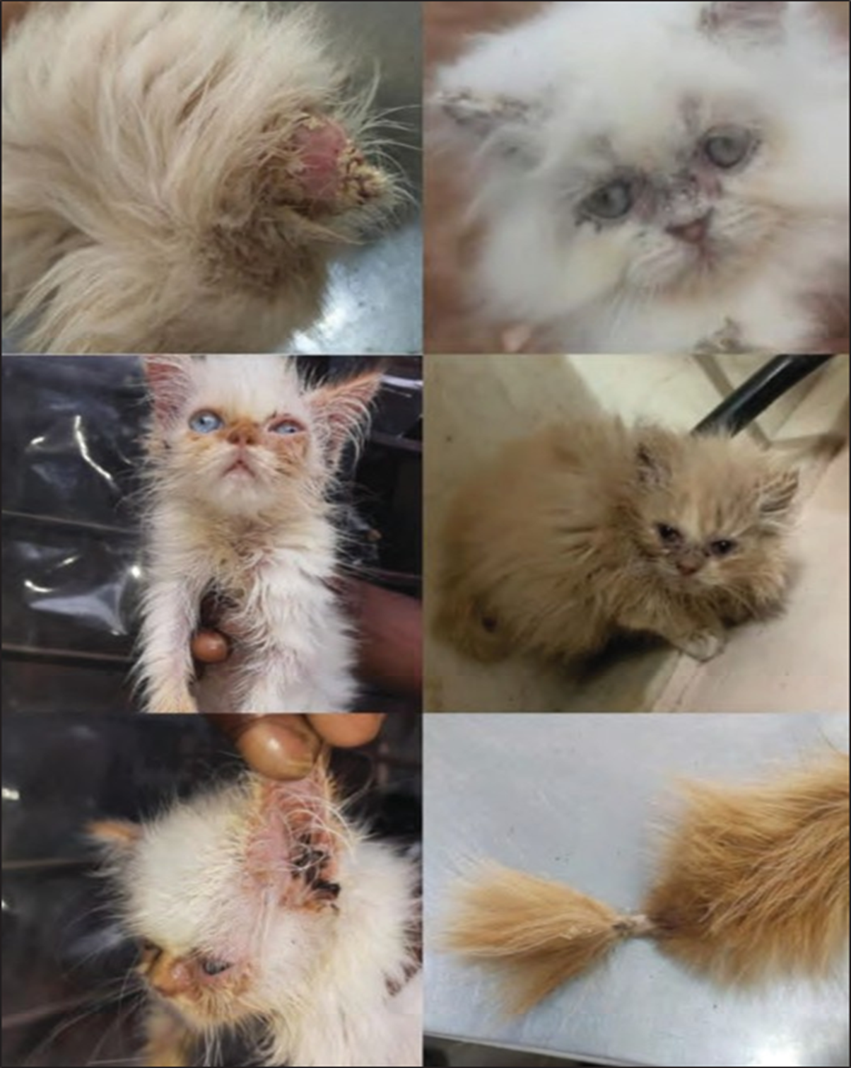
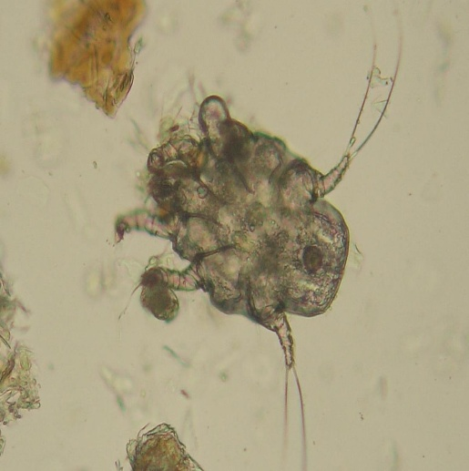
Fig. 1. Characteristic lesions of Notoedres cati infestation in cats showing thick crusty scabs at tip of the ears, eye, nose, neck forelimbs and tip of the tail.
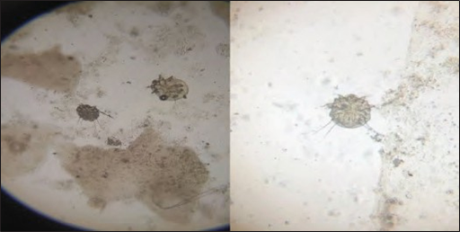
Fig. 2. Microscopic examination of skin scrapping showing mite with circular body, very short legs, pedicels unsegmented and dorsal anus confirming Notoedres cati.
This Photo by Unknown Author is licensed under CC BY-SA
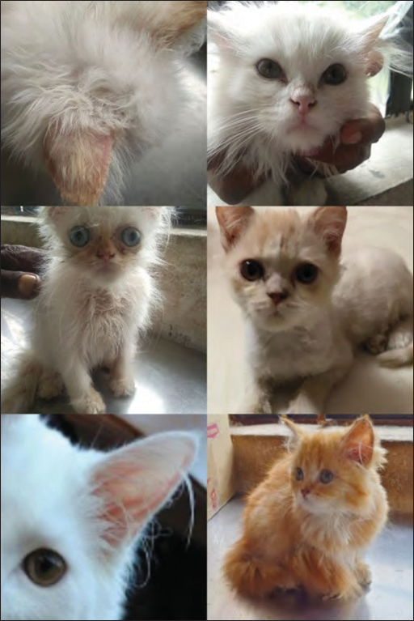
Fig. 3. Marked clinical improvement and hair regrowth in cats following treatment with Selamectin and Ethnoveterinary formulation.
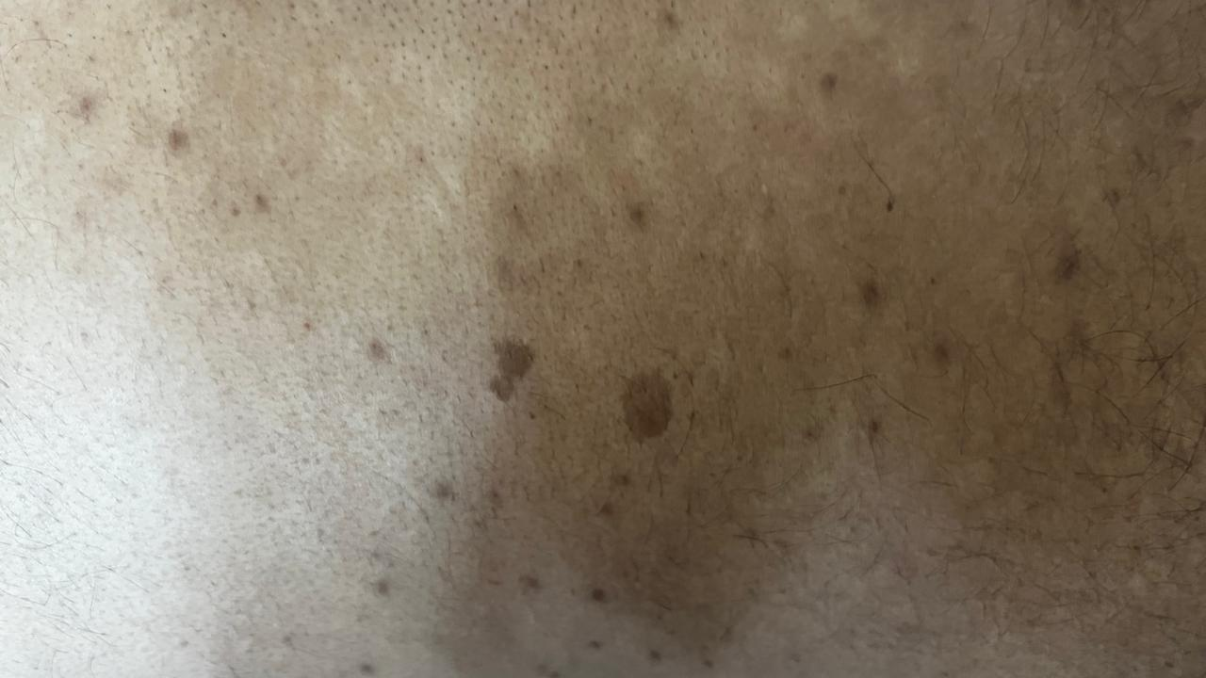
Fig. 4. Zoonotic manifestation of Notoedres cati in a cat owner showing erythematous papular lesions on the forearm region.

4. Discussion
The present findings confirm the high efficacy of Selamectin in treating Notoedres cati infestation, aligning with previous studies (Chakrabarti et al., 1986; Reddy et al., 2020) reporting 100% mite clearance within three weeks. A study conducted by Solikhah et al. (2021) investigated the efficacy of Aloe vera gel cream combined with VCO in accelerating the healing process of scabies in cats. An Aloe vera gel cream formulated with a virgin coconut oil (VCO) base demonstrated faster effectiveness compared to other formulations. VCO contributes to the healing of scabies due to its rich content of saturated fatty acids, which aid in tissue repair and regeneration (Viste et al., 2013). Previous research reported that Aloe vera gel not only alleviates sunburn symptoms but also helps reduce itching associated with scabies. Furthermore, a study published in Phytotherapy Research provided evidence supporting the efficacy of Aloe vera in the treatment of scabies (Oyelami et al., 2009). The results of the study revealed that Aloe vera gel and Virgin Coconut Oil (VCO) is equally effective as benzyl benzoate, a commonly prescribed treatment for scabies (Solikhah, Solikhah and Susilo, 2021). The therapeutic significance of Aloevera-VCO combination lies in the individual properties of Aloe vera and VCO. Aloe vera is known for its anti-inflammatory, antimicrobial, and wound-healing properties, which can aid in soothing irritated skin and promoting tissue repair. VCO possesses antibacterial, antifungal, and moisturizing effects, contributing to skin hydration and protection against secondary infections. Together, these natural substances may offer a complementary approach to managing N. cati infestations, especially in cases where conventional treatments are unavailable or less effective.
Marked eosinophilia observed in the affected cats, nearly three times higher than that of healthy animals, corroborates the findings of Dovhiy and Melniychuk (2024), indicating an allergic and hypersensitivity reaction to Notoedres cati infestation. In previously reported cases, cat owners developed intense itching and small red papules on different areas of the body (Chakrabarti, 1986; Sivajothi et al., 2015). These findings highlight the importance of advising owners to handle affected cats with caution and to thoroughly clean all items that have been in contact with infested animals, even though the condition in humans is generally self-limiting (Foil, 2003; Sivajothi et al., 2015).
While the ethnoveterinary formulation demonstrates promising results, further research and controlled clinical trials are required to establish standardized treatment protocols and to evaluate its long-term efficacy and safety. Veterinarians should exercise caution and consider individual patient factors when recommending alternative therapies. Although Selamectin provides a faster recovery, the herbal formulation represents a sustainable and cost-effective option, especially for community cats and in regions with limited access to veterinary care

5. Conclusion
Feline notoedric mange, caused by Notoedres cati, is a highly contagious and pruritic dermatological condition in cats, with potential zoonotic transmission to humans and other animals. The mite burrows into the epidermis, resulting in alopecia, crust formation, and intense pruritus, predominantly affecting the head and ears. Diagnosis is confirmed through skin scraping examination and identification of characteristic lesions in affected areas. Therapeutic intervention with Selamectin spot-on has demonstrated rapid clinical recovery, while an ethnoveterinary formulation comprising herbal components achieved comparable outcomes over an extended period without observable adverse effects. Integrating early diagnosis with both modern and ethnoveterinary treatment strategies presents a sustainable and accessible approach to feline mange management. Moreover, controlling N. cati infestations carries significant zoonotic importance, as effective treatment not only enhances feline health and welfare but also mitigates the risk of transmission to humans, underscoring the necessity for clinical vigilance and heightened public awareness

References:
- Abujazia, M.A., Muhammad, N., Shuid, A.N. and Soelaiman, I.N., 2012. The effects of virgin coconut oil on bone oxidative status in ovariectomised rat. Evidence‐Based Complementary and Alternative Medicine, 2012(1), p.525079.
- Bashir, A., Saeed, B., Mujahid, T.Y. and Jehan, N., 2011. Comparative study of antimicrobial activities of Aloe vera extracts and antibiotics against isolates from skin infections. African Journal of Biotechnology, 10(19), pp.3835-3840.
- Beale, K.M. and Fujioka, C., 2001. Effectiveness of selamectin in the treatment of Notoedres cati infestation in cats. Vet Dermatol, 12(237), p.20012001.
- Chakrabarti, A., 1986. Human notoedric scabies from contact with cats infested with Notoedres cati. International journal of dermatology, 25(10), pp.646-648.
- Dangi, R., Mehta, H.K., Choudhary, N.S., Agrawal, V., Singh, T. and Bhagherwal, R., 2023. Therapeutic management of notoedric mange in cat. Indian Journal of Veterinary Sciences and Biotechnology, 19(3), pp.102-104.
- Deak G, Dumitrache MO. Therapeutic efficacy of topical treatment with selamectin and sarolaner against notoedric mange in a domestic cat: Case report; 2021
- Dovhiy, Y.Y. and Melniychuk, I.V., 2024. Pathogenesis of notohedrosis in cats. Scientific Messenger of LNU of Veterinary Medicine and Biotechnologies. Series: Veterinary Sciences, 26(113), pp.145-149.
- Foil, C.S., 2003. An approach to feline alopecia. BSAVA Manual of small animal dermatology, 2nd edn. BSAVA, Gloucestor.
- Goldust M, Rezaee E, Raghifar R. 2013. Comparative trial of permethrin 5% versus lindane 1% for the treatment of scabies. J Dermatol Treat 24(6):522–524.
- Györke, A., Dumitrache, M.O., Ursache, A.L., D'Amico, G. and Mircean, V., 2022. Case Report: Notoedric Mange and Aelurostrongylidosis in Two Domestic Cats From Rural Environment in Romania. Frontiers in Veterinary Science, 9, p.849525.
- Hardy, J.I., Fox, M.T., Loeffler, A. and Sinclair, G., 2012. Feline sarcoptic mange in the UK: a case report. The Veterinary Record, 171(14), p.351.
- Khairullah, A.R., Solikhah, T.I., Ansori, A.N.M., Fadholly, A., Ramandinianto, S.C., Ansharieta, R., Widodo, A., Riwu, K.H.P., Putri, N., Proboningrat, A. and Kusala, M.K.J., 2020. A review of an important medicinal plant: Alpinia galanga (L.) willd. Systematic Reviews in Pharmacy, 11(10), pp.387-395.
- Khairullah, A.R., Solikhah, T.I., Ansori, A.N.M., Hanisia, R.H., Puspitarani, G.A., Fadholly, A. and Ramandinianto, S.C., 2021. Medicinal importance of Kaempferia galanga L. (Zingiberaceae): A comprehensive review. Journal of Herbmed Pharmacology, 10(3), pp.281-288.
- Khairullah, A.R., Solikhah, T.I., Ansori, A.N.M., Hidayatullah, A.R., Hartadi, E.B., Ramandinianto, S.C. and Fadholly, A., 2021. Review on the pharmacological and health aspects of apium graveolens or celery: An update. Systematic Reviews in Pharmacy, 12(1), pp.606-612.
- Majid, N.S., Yamlean, P.V. and Citraningtyas, G., 2019. Formulasi dan uji efektivitas krim antibakteri ekstrak daun nangka (Artocarpus heterophyllus Lam.) terhadap bakteri Staphylococcus aureus. Pharmacon, 8(1), pp.225-233.
- Mansor, T.S.T., Che Man, Y.B., Shuhaimi, M., Abdul Afiq, M.J. and Ku Nurul, F.K.M., 2012. Physicochemical properties of Virgin Coconut Oil extracted from different processing methods. International Food Research Journal, 19(3).
- Mounsey, K.E., McCarthy, J.S. and Walton, S.F., 2013. Scratching the itch: new tools to advance understanding of scabies. Trends in parasitology, 29(1), pp.35-42.
- OA, O., A, O., OA, O. and LA, A., 2009. Preliminary study of effectiveness of Aloe vera in scabies treatment. Phytotherapy Research: An International Journal Devoted to Pharmacological and Toxicological Evaluation of Natural Product Derivatives, 23(10), pp.1482-1484.
- Ozukum, S., Reihii, J. and Monsang, S.W., 2019. Clinical management of Notoedric mange (Feline scabies) in domestic cats: A case report. The Pharma Innovation Journal, 8(3), pp.306-308.
- Reddy, P.K., Rao, T.S. & Kumar, P., 2020. Comparative efficacy of macrocyclic lactones against feline scabies. Journal of Veterinary Parasitology, 34(1), pp.45–49.
- Sinha, S., Maiti, S.K., Ratre, H.K., Raj, L. & Bante, N., 2023. Notoedric mange in cats: Its treatment and zoonotic importance. The Pharma Innovation Journal, 12(7S), pp.2061–2062.
- Sivajothi, S., Sudhakara Reddy, B., Rayulu, V.C. and Sreedevi, C., 2015. Notoedres cati in cats and its management. Journal of Parasitic Diseases, 39(2), pp.303-305.
- Solikhah, T.I. and Solikhah, G.P., 2019. The effect of virgin coconut oil waste in the ration against broiler chicken growth (Gallus sp.). Ecology, Environment and Conservation, 25(September Suppl. Issue), pp.S55-S60.
- Solikhah, T., Solikhah, G.P. and Susilo, R.J.K., 2021. Aloe vera and virgin coconut oil (VCO) accelerate healing process in domestic cat (Felis domesticus) suffering from scabies.
- Soulsby, E.J.L., 1982. Helminths, arthropods and protozoa of domesticated animals (No. 7th edition, pp. xiii+-809pp).
- Viste, G.B., Silvestre, R.C., Tabije, N.B. and Silvestre, J.Q., 2013. Efficacy of Virgin Coconut (Cocos nucifera) oilsoap against mange in dogs. Int Sci Res J, 5(2), pp.227-241.
- Zia-ud-Din Sindhu, Z.U.D.S., Shafiq Ullah, S.U., Abbas, R.Z., Zafar Iqbal, Z.I. and Mansoor Hameed, M.H., 2012. Inventory of ethno-veterinary practices used for the control of parasitic infections in District Jhang, Pakistan.

