WILDLIFE VEHICLE COLLISION (WVC) ASSESSMENT OF FAUNAL CARCASSES ALONG NATIONAL HIGHWAYS 353D AND 353C: A STUDY FROM NAGBHID TO GADCHIROLI
ABSTRACT
The rapid expansion of road networks has significantly enhanced economic growth and regional connectivity but has also resulted in severe ecological consequences, particularly wildlife-vehicle collisions (WVCs). The present study was conducted to estimate roadkill incidents along state highways between Nagbhid and Gadchiroli. Using public road surveys and opportunistic sampling methods, a fortnightly survey recorded 52 roadkill cases belonging to 14 species of amphibians, reptiles, birds, and mammals between April 2024 and December 2024. Amphibians were the most affected taxa (32.26%), followed by birds (25%), mammals (23.07%) and reptiles (21.15%). Amphibians and reptiles are particularly vulnerable due to their slow movement and inability to evade approaching vehicles. Additionally, driver negligence and unawareness contribute to the high mortality rates among these species. The study found that roadkill incidents were significantly higher along highway stretches near rivers and other water bodies than in dry landscapes. Implementing mitigation strategies such as speed breakers, wildlife corridors, and awareness programs in ecologically sensitive zones could help reduce WVCs and protect biodiversity. The findings highlight the urgent need for conservation measures to minimize the impact of road networks on wildlife populations.
Key words: Roadkill, Wildlife-Vehicle Collisions, Biodiversity, Conservation, Habitat Fragmentation, Mitigation Strategies

Introduction
The rapid expansion of road networks has been a hallmark of modern infrastructure development, facilitating economic growth, regional connectivity, and urbanization. However, the ecological repercussions of this expansion are profound and often overlooked. Among the most visible and immediate environmental impacts is the occurrence of faunal carcasses on highways, a direct consequence of wildlife-vehicle collisions (WVCs). Anthropogenic activities significantly impact animal populations and pose a serious threat to their diversity. Deforestation and urbanization are major contributors to the rising extinction rates observed duringthe Holocene epoch, which extends into the present era known as the Anthropocene. (Steffen et al. 2007; Ceballos et al. 2015, 2017). Numerous studies have been conducted globally to assess the effects of these threats on wildlife. The growing need for road expansion, along with rising traffic and rapid urbanization characterized by vast networks of national and state highways, poses significant threats to natural wildlife populations (Ferreira et al., 2023). This has caused defragmentation of many terrestrial habitats. Roads have become one of the severe threats to animal and plant diversity (Forman & Alexander, 1998). Small to medium–sized animals and nocturnal animals are the prime victims of vehicles (Behera et al., 2021). Significant attention has been given in regions like North America, Australia, Europe, and Africa to evaluate the impact of roads on wildlife, but Asian countries have largely overlooked this issue. In India, numerous highways pass through reserve forests and protected areas. Recently, the effects of highway construction on forest regions have been acknowledged (Vijayakumar et al. 2001). India has the second largest road network in the World about 63.45 lakh km. This comprises National Highways, Expressways, State Highways, Major District Roads, Other District Roads and Village Roads (Indian Road Industry 2023-24).
The construction of a road has both direct and indirect effects on the ecosystems it traverses. A direct consequence of road construction is the risk of vehicles running over wildlife (Samson et al., 2014). Collisions between vehicles on these roads and wildlife attempting to cross them are a leading cause of wildlife mortality globally (Hill et al. 2019). The frequency of animal-vehicle collisions is influenced by various factors, including the type of animal, environmental conditions, traffic patterns, and characteristics of the road (Benítez-Lopez et al. 2010). Killing animals by collision with vehicles which is mainly dangerous to small mammals, reptiles, amphibians and birds due to the changes in ecological behaviour (Behera et al.,2021).
In India, few studies have been conducted to examine the issue of wildlife fatalities on roads (Baskaran and Boominathan, 2010; Fellows et al., 2015; Rakesh et al., 2020). Gadchiroli and Chandrapur district is rich in faunal biodiversity, but there is no information on the effect of road traffic on the fauna of this area. Hence attempt has been made to study the mortality of each vertebrate (amphibians, reptiles, birds and mammals) and identify the species that were most affected in the National highway that passes through Chandrapur and Gadchiroli District.
The present study was carried out April 2024 to December 2024, to evaluate the impact of vehicular traffic on vertebrate fauna in terms of animals killed by automobiles in this area.
MATERIAL AND METHODS
Study Area
The study was conducted on NH-353D passing through Nagbhid to Armori and NH-353C, passing Armori to Gadchiroli, spanning approximately 150 km. The highways connect Chandrapur and Gadchiroli District. Nagbhid tehsil is situated in Chandrapur district, and is between 20° 34' 59.99" N and 79° 39' 59.99" E. Meanwhile, Armori tehsil is situated in Gadchiroli district, and is between 20° 16' 48.00" N and 79° 34' 48.00" E. This region includes deciduous forests, agricultural landscapes, and water bodies, supporting diverse wildlife including mammals, reptiles, and avifauna.
The highways were surveyed between April 2024 and December 2024. The survey was conducted two to three days per week, primarily in the mornings, by two observers. The survey began at 07:00 during winter and at 06:00 during summer, depending upon visibility. The observations were carried out using a motorcycle traveling at a steady speed of 30–40 km/h and the total distance covered is approximately 10800 km in 9 months. The observation is specially made for the taxa amphibians, reptiles, Aves, and mammals. The overall mortality rates were determined for each species individually.
This survey method was followed by various researchers and found satisfactory in evaluating the road kills (Grimmat et al. 2009; Rasmussen and Anderton 2012; Betleja et al. 2020). During this survey, no animals were preserved. Taxonomic keys and reference books were used to identify the road kills.
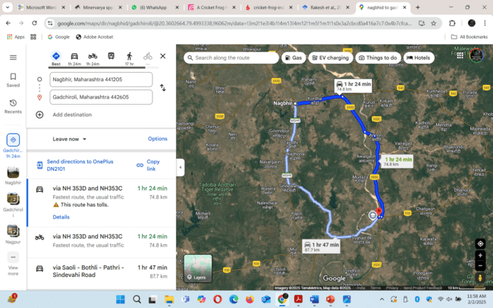
Figure 1: Road map of study area
Result
A total of 52 faunal roadkills were recorded , comprising 16 amphibians (two species), 13 birds (three species), 12 mammals (five species), and 11 reptiles (four species).Table 1 lists the species and numbers of roadkill animals found. The most common species was Hoplobatrachus tigerinus (Bullfrog)(n=11), and the least vulnerable werethe Garden lizard, jungle cat and spotted deer, each with one individual recorded. Peak roadkill incidences were observed during monsoon (June-September), coinciding with increased animal activity. Key hotspots were identified near forest stretches and water crossings, particularly between Nagbhid-Armori and Armori-Gadchiroli. Higher roadkill frequencies were associated with sections lacking speed restrictions or wildlife crossings.
Table 1: List of faunal Road kills on NH-353D and NH-353C
Sr. No. | Animal Group | Total Number of Species | No. of Roadkills | Percentage | Mortality Rate
1. | Amphibians | 2 | 16 | 32.76
2. | Reptiles | 4 | 11 | 21.15
3. | Aves | 3 | 13 | 25
4. | Mammals | 5 | 12 | 23.07
 | Total | 14 | 52

Table 2: Number of road kills for each species recorded on NH-353D and NH-353C
Sr. No. | Common Name | Scientific Name | Total Road Kill
I. | Amphibian
1. | Indian Cricket frog | Fejervarya limnocharis | 5
2. | Bull Frog | Hoplobatrachus tigerinus | 6
3. | Juvenile Bull Frog |  | 5
II. | Reptiles
1. | Banded kukri snake | Oligodon arnensis | 5
2. | Trinket snake | Coelognathus helena | 2
3. | Water snake | Nerodia sipedon | 3
4. | Garden lizard | Calotes versicolor | 1
III. | Aves
1. | Nightjar bird | Caprimulgus asiaticus | 6
2. | Greater Coucal | Centropus sinensis | 4
3. | Jungle babbler | Turdoides striata | 3
IV. | Mammals
1. | Indian Jackal | Canis aureus indicus | 3
2. | Cat | Felis catus | 2
3. | Jungle Cat | Felis chaus | 1
3. | Street Dog | Canis lupus familiaris | 3
4. | Greater bandicoot rat | Bandicota indica | 2
5. | Spotted deer | Axis Axis | 1

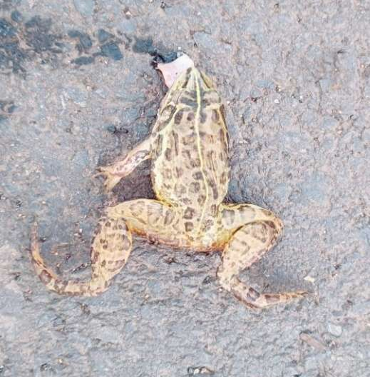
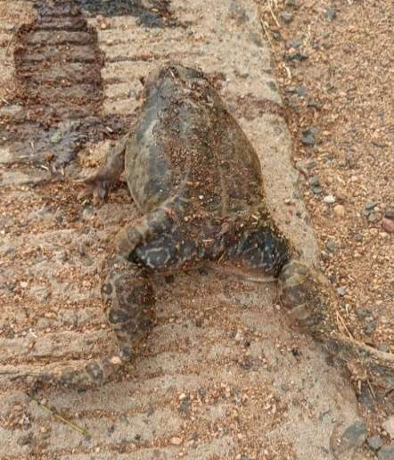
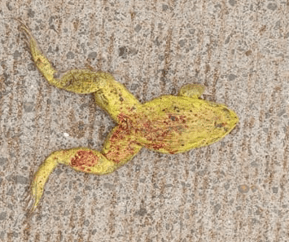
Photo Plate A
C
B
A

Figure 2: Few depictions of Amphibian species, A- Indian Cricket Frog, B & C- Indian Bullfrog
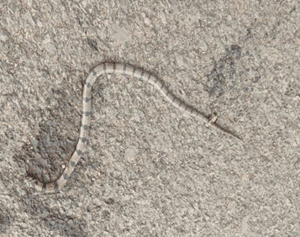
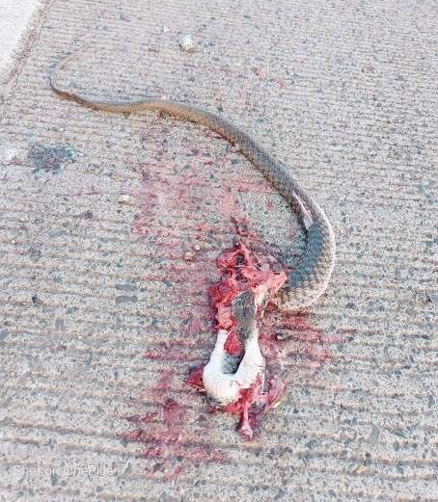
Photo Plate B
A
B
C
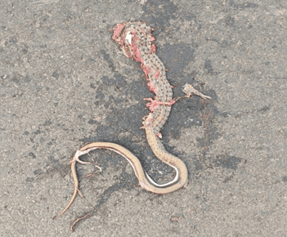

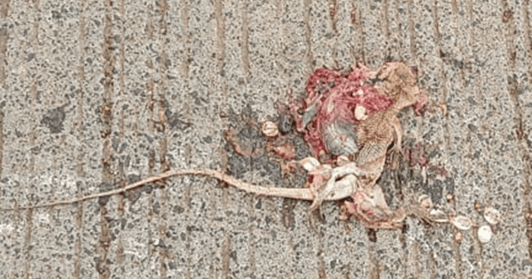

D

Figure 3: Few depictions of Reptile species, A- Trinket Snake, B- Banded Kukri Snake, C- Water Snake, D- Garden Lizard
Photo Plate C
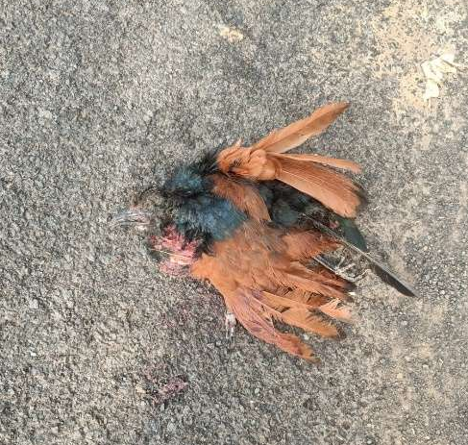
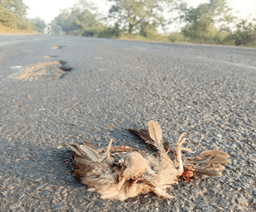
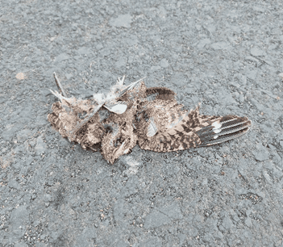
B
C
A

Figure 4: Few depictions of bird’s species, A- Indian Nightjar, B- Jungle Babbler, C- Greater Coucal
Photo Plate D
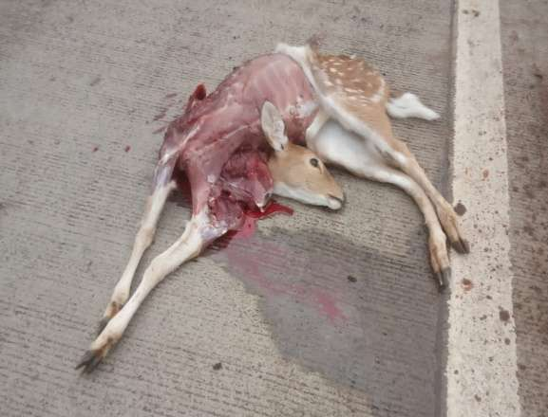
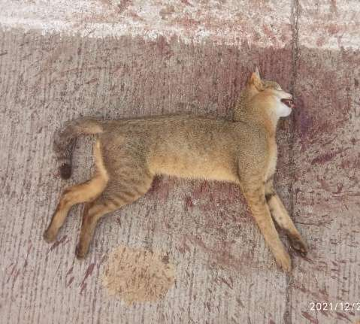
C
B
A
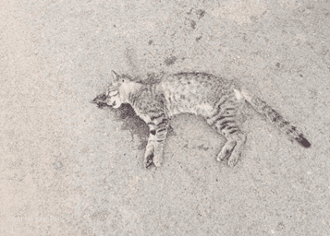
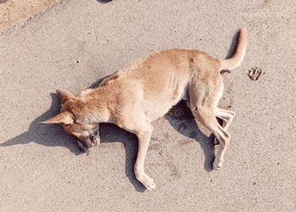
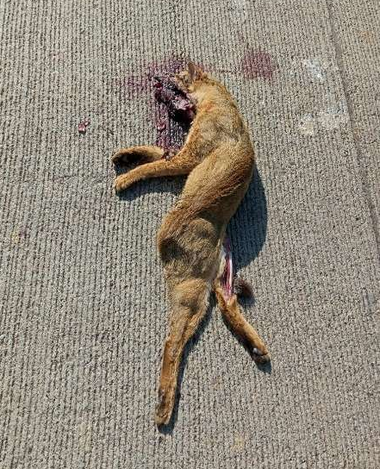

D
E

Figure 5: Few depictions of faunal species collision with vehicular traffic on National highway NH–353C and 353-D: A -Indian Jackal, B- Spotted deer, C-Jungle Cat, D- Cat, E- Street Dog
Discussion
In the present study, it appears that amphibians are the most vulnerable to roadkill, accounting for over 32.76% of individuals and 14.29% of species. Among the amphibians, Indian Bullfrog (Hoplobatrachus tigerinus) was the most frequently observed roadkill species (n=11). This finding aligns with previous studies conducted in Udhagamandalam and Mettupalayam (Deepan et al., 2021) as well as in the Mudumalai Tiger Reserve (Vijayakumar et al., 2001), where amphibians were also reported as the primary victims of roadkill incidents.
Several ecological and behavioural factors contribute to the high susceptibility of Bullfrog to road mortality. These frogs are commonly found near artificial light sources such as street lamps, vehicle headlights and paddy crops, where they actively forage for insects (Daniels, 2005). This behaviour significantly increases their exposure to vehicular traffic, making them vulnerable to collisions. Furthermore, their highly adaptable (eurytopic) nature and their tendency to thrive in human-modified environments (Daniel et al., 2002; Daniels et al., 2005) further elevate their risk of becoming roadkill victims.
The present findings showed that birds were the second most affected taxa in roadkill incidents, with three species recorded; Nightjar (Caprimulgus asiaticus)(n=6). Greater Coucal (Centropus sinensis)(n=4), and Jungle Babbler (Turdoides striata)(n=3). These species are warm-blooded, ground-dwelling, and low-flying birds, making them particularly vulnerable to vehicle collisions. Their behavioral traits, such as low-altitude flight, nocturnal activity, and frequent foraging near roads, significantly increase their risk of roadkill.
This outcome aligns with prior studies such as Santos et al. (2016), who reported that Nightjars are more likely to be struck by passing vehicles. Furthermore, Kociolek et al. (2015) noted that birds, particularly Nightjars, active during dawn and dusk andface a higher mortality rate due to reduced visibility and increased vehicle speeds at night.
Similarly, this research supports the findings of Erritzoe et al. (2003) and Bishop and Brogan (2013), who reported that Greater Coucals and Jungle Babblers frequently forage near roads, where food resources such as insects and small vertebrates are abundant. Their habitual movement across roads in search of food puts them at greater risk of collisions. Loss et al. (2014) further emphasized that birds with slow and low-altitude flight patterns are more vulnerable to vehicle strikes than species that fly at higher altitudes, making Coucals and Babblers particularly susceptible.
Additionally, habitat fragmentation and road expansion in areas near forest edges, agricultural lands, and scrublands have been identified as major contributing factors to bird mortality (Laurance et al., 2009). These habitats, which are commonly occupied by Nightjars, Coucals, and Babblers, are increasingly intersected by roads, leading to more frequent interactions between wildlife and vehicles. This may be related to the abundance of landing sites and shelter provided by the shrubs and trees along the highway, as suggested by Vestjens et al., (1972and Brown et al., (1986). In nature, they feed on insects and graminivorous in habit (Ali et al., 1987).
Following birds, mammals were the most affected taxa in roadkill incidents. Among these, nocturnal species such as the Greater Bandicoot Rat (Bandicota indica), Indian Jackal (Canis aureus indicus), domestic Cat (Felis catus), Jungle cat (Felis chaus), and spotted deer (Axis Axis) were those recorded in this study. This observation is in line with previous studies that have reported a high incidence of nocturnal mammalian roadkill due to factors such as artificial lighting, vehicle headlights, and movement patterns. Furthermore, these findings more concurrent with Ascensão et al. (2019) who observed that the highest roadkill rates occurred at night, particularly for small- to medium-sized mammals, supporting the hypothesis that nocturnal activity increases road mortality. Comparatively, Seiler (2005)found that nocturnal mammals are overrepresented in roadkill records due to their tendency to freeze when exposed to bright lights, reducing their chances of escape.Grilo et al. (2012) and Ramesh et al. (2012) reported that carnivores, including jackals and foxes, are commonly killed on roads at night due to their scavenging behavior and increased movement in low-light conditions, with Indian Jackals being one of the most frequent roadkill victims in South Indian forests. Hatti, et.al (2019) reported that most of mammalian species including jungle cat killed on the road are nocturnal in habit. It was also found that spotted deer (Axis Axis) is also the victims of roadkill.
Similarly, Ramesh et al. (2012) found that dogs were frequent roadkill victims near human settlements on South Indian highways, while Teixeira et al. (2013) reported high roadkill rates for domestic dogs, especially in urban-rural transition zones. Grilo et al. (2016) observed significant mortality among dogs in areas with poor fencing and high-speed traffic.
Additionally, the present study found that Reptiles were the least affected faunal group on this highway, with only four recorded species. Andrews et al. (2008) suggested that roadkill estimates for reptiles and amphibians are often underestimated due to rapid carcass scavenging, with predators such as birds and mammals reducing recorded mortality counts (Santos et al., 2011). The most frequently recorded species was Oligodon arnensis (Banded Kukri Snake).Besides, the results demonstrated that reptile and amphibian sightings increased after inconsistent rainfall, particularly in highway sections near water bodies such as rivers. Road mortality for these species was noticeably higher during the rainy season compared to the dry season, likely due to their increased activity in warmer temperatures and greater food availability.
Several studies support the observation that reptiles and amphibians exhibit seasonal road mortality patterns. Studies by Gibbs & Shriver (2005) and Langen et al. (2007) indicate that amphibians and reptiles are more frequently killed during the wet season, coinciding with increased movement related to breeding, dispersal, and migration towards water bodies. Similarly, Sillero (2008) found that amphibians, being highly dependent on moisture, tend to move more during rainy periods, increasing their likelihood of road encounters.
Furthermore, the present findings align with research by Ashley & Robinson (1996) and Shepard et al. (2008), which observed that reptiles frequently use road surfaces for basking, especially when natural basking sites are scarce. Additionally, heavy rainfall can flood reptile burrows, disrupting their thermal balance and compelling them to seek alternative basking sites, such as the warm asphalt of roads, which further increases their risk of vehicle collisions.
\ (Rosen & Lowe, 1994). Similarly, Smith & Dodd (2003) highlighted that roads near wetlands and rivers often experience higher amphibian road mortality, particularly during breeding migrations, while Glista et al. (2008) reported that highways crossing aquatic habitats pose a significant threat to herpetofauna due to their seasonal movements.
To mitigate these ecological impacts, various conservation strategies, including wildlife corridors, underpasses, and improved fencing, have been proposed to reduce reptile and amphibian road mortality (Dodd et al., 2004). Furthermore, Beebee (2013) emphasized the importance of landscape connectivity in preserving amphibian populations, particularly in areas where roads fragment their habitats.

CONCLUSIONS
The study reveals that a total of 52 individuals belonging to 14 species were killed on the road during a nine-month study period, with amphibian diversity being the most affected and observed during monsoon (June-September), compared to other species. The impact of roads on amphibians, as well as both domestic and wild animals, can be linked to anthropogenic activities and vehicular collisions. This study provides a vital baseline for continued monitoring efforts that will contribute to plan effective mitigation measures. Implementing speed breakers in wildlife habitats could help reduce roadkill incidents across various animal species.
REFERENCES
Alfred-Ştefan, C. L., István, S. K., & Severus-Daniel, C. O. V. A. C. I. U. (2016). Non road human influence upon road mortality on three secondary roads in the Vâlsan river protected area, Romania. Oltenia, Studii si Comunicari Seria Stiintele Naturii, 32(2).
Andrews, K. M., Gibbons, J. W., & Jochimsen, D. M. (2008). Ecological effects of roads on
amphibians and reptiles: A literature review. Herpetological Conservation and Biology,3(1), 1-22.
Ascensão, F., et al. (2019). "Roadkill risk and population vulnerability in terrestrial vertebrates: linking landscape features with animal traits." Biological Conservation, 236, 69-76.
Ashley, E. P., & Robinson, J. T. (1996). Road mortality of amphibians, reptiles and other wildlife on the Long Point Causeway, Lake Erie, Ontario. Canadian Field-Naturalist, 110(3), 403-412.
Bager, A., & Rosa, C. (2011). "Influence of different road types on the roadkill of vertebrate wildlife in Southern Brazil." Perspectives in Ecology and Conservation, 9(1), 127-134.
Baskaran, N., & Boominathan, D. (2010). Road kill of animals by highway traffic in the tropical forests of Mudumalai Tiger Reserve, southern India. Journal of Threatened Taxa, 2(3), 753-759.
Beebee, T. J. C. (2013). Effects of road mortality and mitigation measures on amphibian populations. Conservation Biology, 27(6), 1135-1142.
Behera, S., Nayak, S., Dash, P. K., & Swain, S. K. (2021). Wildlife roadkill in Odisha, India: the threat to biodiversity needs to be addressed. Arxius de Miscel· lània Zoològica, 19, 151-159.
Benítez-López, A., Alkemade, R., & Verweij, P. A. (2010). The impacts of roads and other infrastructure on mammal and bird populations: a meta-analysis. Biological conservation, 143(6), 1307-1316.
Bishop, C. A., & Brogan, J. M. (2013). Estimates of avian mortality due to vehicle collisions on U.S. roads. Journal of Wildlife Management, 77(5), 940-948. https://doi.org/10.1002/jwmg.546.
Brunen, B., et al. (2020). "Do wildlife warning reflectors reduce roadkill? A study of small mammals in Europe." Ecological Solutions and Evidence, 1(2), e12016.
D'Amico, M., et al. (2015). "Roadkill risk and population vulnerability in European vertebrates." Global Ecology and Biogeography, 24(9), 1091-1102.
Daniels, R. J. R. (2005). Amphibians of peninsular India. Universities Press.
Daniels, R. J. R., Ishwar, N. M., & Subramanian, K. A. (2002). The role of roadkills in the assessment of herpetofauna: A case study in the Western Ghats, India. Current Science, 83(5), 633-638.
Deepan, V. K., Gokulakrishnan, G., & Ramanujam, M. E. (2021). Roadkill analysis of vertebrate fauna in Udhagamandalam-Mettupalayam National Highway, Tamil Nadu, India. Journal of Threatened Taxa, 13(1), 17561-17571. https://doi.org/10.11609/jott.6517.13.1.17561-17571
Dodd, C. K., Barichivich, W. J., & Smith, L. L. (2004). Effectiveness of a barrier wall and culverts in reducing wildlife mortality on a heavily traveled highway in Florida. Biological Conservation, 118(5), 619-631.
Erritzoe, J., Mazgajski, T. D., & Rejt, Ł. (2003). Bird casualties on European roads—A review. Acta Ornithologica, 38(2), 77-93. https://doi.org/10.3161/068.038.0204
Forman, R. T., & Alexander, L. E. (1998). Roads and their major ecological effects. Annual review of ecology and systematics, 29(1), 207-231.
Gibbs, J. P., & Shriver, W. G. (2005). Can road mortality limit populations of pool-breeding amphibians? Wetlands Ecology and Management, 13(3), 281-289.
Glista, D. J., DeVault, T. L., & DeWoody, J. A. (2008). Vertebrate road mortality predominantly impacts amphibians. Herpetological Conservation and Biology, 3(1), 77-87.
Grilo, C., Borda‐de‐Água, L., Beja, P., Goolsby, E., Soanes, K., le Roux, A., ... & González‐Suárez, M. (2021). Conservation threats from roadkill in the global road network. Global Ecology and Biogeography, 30(11), 2200-2210.
Grilo, C., et al. (2012). "Do well-connected landscapes promote road-related mortality?" European Journal of Wildlife Research, 57(4), 707-716.
Grilo, C., et al. (2016). "Roadkill risk and population vulnerability in terrestrial vertebrates: linking landscape features with animal traits." Biological Conservation, 236, 69-76.
Indian Road Industry 2023-24.
Kociolek, A. V., Clevenger, A. P., St. Clair, C. C., & Proppe, D. S. (2015). Effects of road networks on bird populations. Conservation Biology, 29(2), 615-623. https://doi.org/10.1111/cobi.12480
Langen, T. A., Machniak, A., Crowe, E. K., Mangan, C., Marker, D. F., Liddle, N., & Roden, B. (2007). Factors influencing amphibian road mortality in a rural landscape. Environmental Management, 40(6), 1005-1018.
Laurance, W. F., Goosem, M., & Laurance, S. G. (2009). Impacts of roads and linearclearings on tropical forests. Trends in Ecology & Evolution, 24(12), 659-669. https://doi.org/10.1016/j.tree.2009.06.009
Loss, S. R., Will, T., & Marra, P. P. (2014). Estimation of bird-vehicle collision mortality on U.S. roads. Journal of Wildlife Management, 78(5), 763-771. https://doi.org/10.1002/jwmg.721
Masroor, M. D., Sengar, M., Masroor, Z., Pal, S., Kumar, R., Bala, K., ... & Patel, K. S. (2023). Assessing road-kill mortality in the highway passing through urban, agricultural, forest and river landscapes in Bihar. Journal of Experimental Zoology India, 26(2).
Pessanha, L. A., Ferreira, M. S., Bueno, C., Leandro, F. D. S., & Gomes, D. F. (2023). Danger under wheels: mammal roadkills in the threaten lowland Atlantic Forest in southeast Brazil. Iheringia. Série Zoologia, 113, e2023007.
Praveen, J., Jayapal, R., & Rasmussen, P. C. (2019). Birds of South Asia: Additions over ‘The Ripley Guide’. Indian BIrds, 15(4), 112-116.
Ramesh, T., et al. (2012). "Roadkill of animals by highway traffic in the tropical forests of South India." Journal of Threatened Taxa, 4(8), 2833-2840.
Rosen, P. C., & Lowe, C. H. (1994). Highway mortality of snakes in the Sonoran Desert of southern Arizona. Biological Conservation, 68(2), 143-148.
Samson, A. (2023). AN INVENTORY OF ROADKILLS OF NOCTURNAL MAMMALS IN COONOOR GHAT HIGHWAY NH 67, THE NILGIRIS, WESTERN GHATS, INDIA. Труды Мордовского государственного природного заповедника им. ПГ Смидовича, (32), 68-76.
Santos, S. M., Carvalho, F., & Mira, A. (2011). Factors affecting road mortality of vertebrates in Mediterranean-type ecosystems. Biodiversity and Conservation, 20(8), 1773-1789.
Santos, S. M., Carvalho, F., & Mira, A. (2016). How long do the dead survive on roads? Carcass persistence probability and implications for road-kill monitoring surveys. PLoS ONE, 11(3), e0160915. https://doi.org/10.1371/journal.pone.0160915
Schwartz, A. L., Shilling, F. M., & Perkins, S. E. (2020). The value of monitoring wildlife roadkill. European journal of wildlife research, 66(1), 18.
Seiler, A., & Helldin, J. O. (2006). "Mortality of mammals in relation to roads: impact assessment and mitigation." Wildlife Biology, 12(3), 279-291.
Selvan, K. M., Sridharan, N., & John, S. (2012). Roadkill animals on national highways of Karnataka, India. Journal of Ecology and the Natural Environment, 4(14), 363-365.
Shepard, D. B., Dreslik, M. J., Jellen, B. C., & Phillips, C. A. (2008). Reptile road mortality around an oasis in the Illinois Corn Desert. Copeia, 2008(2), 349-356.
Sillero, N. (2008). Amphibian mortality levels on Spanish country roads: Descriptive and spatial analysis. Amphibia-Reptilia, 29(3), 337-347.
Smith, L. L., & Dodd, C. K. (2003). Wildlife mortality on U.S. Highway 441 across Paynes Prairie, Alachua County, Florida. Florida Scientist, 66(2), 128-140.
Teixeira, F. Z., et al. (2013). "Revisiting the tragedy of the commons: The importance of road mortality in the conservation of Iberian carnivores." Biodiversity and Conservation, 22(2), 2981-2994.
Van der Ree, R., et al. (2015). "Effectiveness of road mitigation strategies: A global review of past and future research." Transportation Research Part D: Transport and Environment, 44, 77-91.
Van Langevelde, F., Schalken, W., & van der Ree, R. (1995). Effect of roads on the movements of small mammals. Landscape Ecology, 10(3), 173-177. https://doi.org/10.1007/BF00129254
Vijayakumar, S. P., Devy, M. S., & Kumar, A. (2001). Amphibian roadkills at Mudumalai Wildlife Sanctuary, southern India. Hamadryad, 26(2), 265-272.
Vijayakumar, S. P., Vasudevan, K., & Ishwar, N. M. (2001). Herpetofaunal mortality on roads in the Anamalai Hills, southern Western Ghats. Hamadryad-Madras-, 26, 253-260.

