CLINICO-PATHOLOGICAL AND MOLECULAR DIAGNOSIS OF CCPP IN GOATS - A Case study

Abstract
Contagious caprine pleuropneumonia (CCPP) in goats is caused by Mycoplasma capricolum subsp. capripneumoniae (Mccp). Eleven cases among three goat flocks in Thotaravulapadu village, NTR district, Andhra Pradesh were suspected for CCPP exhibiting characteristic clinical signs like severe respiratory distress with sero-mucoid nasal discharges, cough, pyrexia and general malaise. Necropsy findings in three diseased goats revealed hydrothorax, pleural thickening, consolidation of lungs with marbling and fibrinous hydropericardium. Histopathology revealed fibrin deposition, infiltration of polymorphonuclear cells and mononuclear cells in alveoli and interlobular septa of lungs along with pleuritis and fibrinous pericarditis. Amplification of Mccp gene by specific primers using RNA extracted from lung tissues yielded 316 bp product. Diagnosis of CCPP in the present study was confirmed based on the gross, histopathology and PCR.
Key words: Adhesion, Goat, Marbling, Mycoplasma
INTRODUCTION
Sheep and goat rearing forms the backbone of the rural economy in India, playing a vital role in improving the socio-economic status of rural and peri-urban communities. The Government of India actively promotes sheep and goat farming as a means to enhance livelihood security and achieve food security. Contagious caprine pleuropneumonia (CCPP) is a serious disease of goat with high morbidity and mortality rates. It is caused by Mycoplasma capricolum subsp. capripneumoniae (Mccp) which was previously known as Mycoplasma F38 strain (Bascunana et al.,1994, Bolske et al., 1996 and Abraham et al., 2015). The principal lesion at necropsy is fibrinous pleuropneumonia with massive lung consolidation, accompanied by accumulation of strawcoloured pleural fluid. Affected goats are characterized by fever, coughing and severe respiratory signs with pneumonic changes causing a fatal condition (Abraham et al., 2015 and Yatoo et al., 2019). Hence, diagnosis is essential and should be rapid for this devasting disease in endemic areas, to lower the morbidity and mortality rates (Yatoo et al., 2018 and Parray et al., 2019).
HISTORY AND OBSERVATIONS
In the present study eleven goats of different age group among three goat flocks in Thotaravulapadu village, NTR district, Andhra Pradesh presented with history of clinical signs like respiratory distress, with sero-mucoid nasal discharges, coughing, dyspnoea, pyrexia and general malaise (Fig.1). Among them, three kids of age four months died and were brought for postmortem examination. At necropsy, external examination showed muco-purulent discharges from nostrils and skin eruptions on the rim of nostrils. Internal examination revealed 100ml (approx.) of tan yellow coloured serous fluid in thoracic cavity and fibrinous pleural adhesions bilaterally (Fig.2). Grossly, lungs exhibited lobes of consolidation and widened interlobular septa with jelly like material giving marbling appearance (Fig.3). Pericardial sac contained 40ml (approx.) of serous fluid along with deposition of fibrin on pericardium (Fig.4).
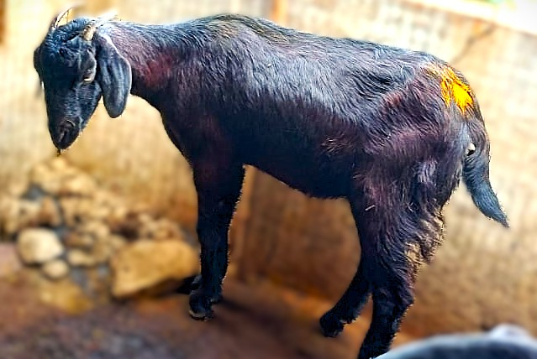 | 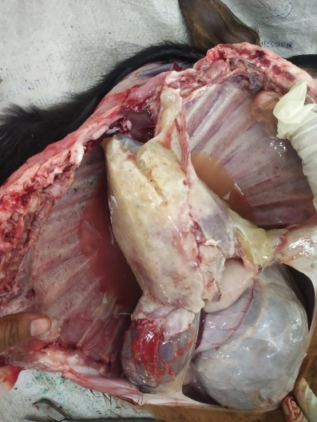
Fig 1: CCPP effected goat with sero-mucoid nasal discharges | Fig 2: Thoracic cavity: presence of yellow coloured serous fluid and bilateral fibrinous pleuritis
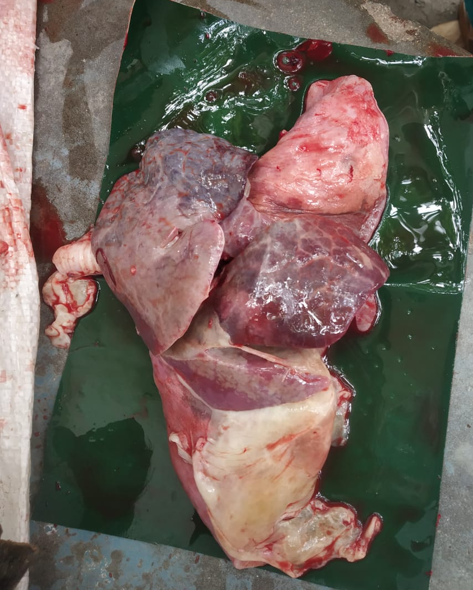 | 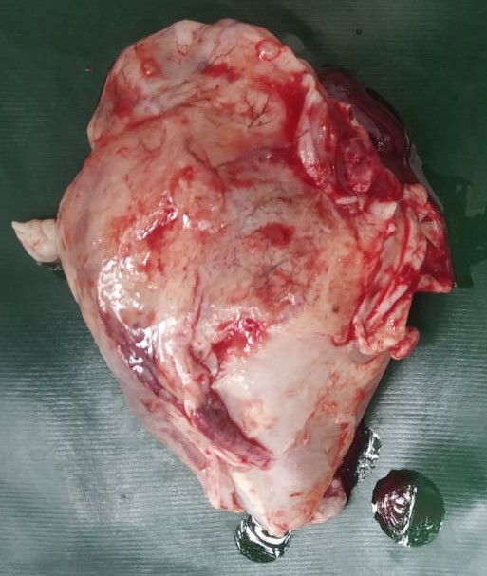
Fig 3: Marbling appearance of lungs | Fig 4: Fibrinous pericarditis
MATERIAL AND METHODS
Representative tissue samples like lung, heart, liver and trachea were collected in 10% formalin and processed as per standard procedures for histopathology. In brief, the NBF fixed tissues were sectioned into small pieces (2-3mm) and embedded in paraffin. The paraffin blocks were then cut into 5–6 μm thick sections and stained with hematoxylin and eosin (Luna, 1972).
Lung samples were collected and stored in -20ºc for molecular diagnosis. Polymerase chain reaction was carried out to amplify arcD gene of Mccp using specific primers as described by Abraham et al. (2015). Forward primer- 5’ ATCATTTTTAATCCCTTCAAG 3’ and Reverse primer- 5’ TACTATGAGTAATTATAATATATGCAA 3’.
RESULTS
Histopathological lesions
Almost all the lung sections revealed presence of fibrin and mixed leucocytic infiltrates in the alveoli and bronchioles. Several sections exhibited multiple focal areas of severe necrosis of lung parenchyma and these were surrounded by numerous polymorphonuclear cells and mononuclear cells. Further these necrotic areas were encircled by one to two layers of fibroblasts in few sections (Sequestration) (Fig 5 and 6). Few sections showed infiltration of inflammatory cells predominately macrophages within the peribronchiolar and alveolar subepithelial areas (Fig 7). All the sections demonstrated dilated interlobular septa containing edema, fibrin and inflammatory cells and the lesions extended to pleural surface resulting in fibrinous pleuritis. Sections from heart showed fibrin deposition along with numerous PMNs in pericardium (Fig.8). Degenerative changes in hepatocytes were also noticed in liver along with severe congestion.

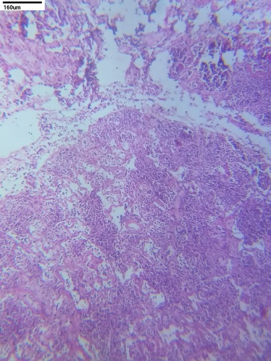 | 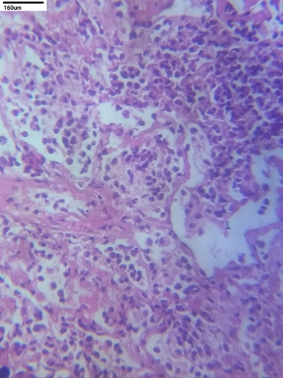
Fig5: Multifocal areas of necrosis and sequestration in lung parenchyma H&E,100x. | Fig 6: Numerous PMNs and mononuclear cells in alveoli, H&E, 400x.
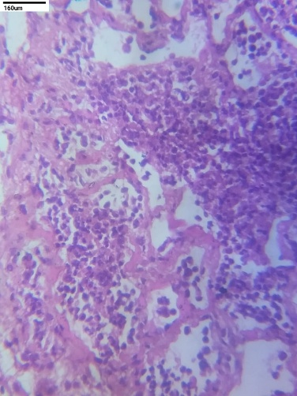 | 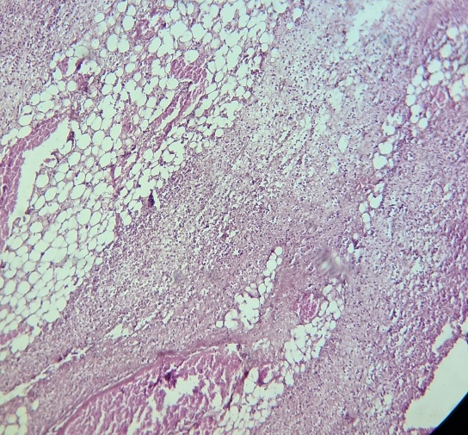
Fig7: Infiltration of inflammatory cells within the peribronchiolar and alveolar subepithelial regions, H&E,100x. | Fig 8: Fibrin deposition along with numerous inflammatory cells in pericardium, H&E, 400x.

Polymerase chain reaction
For confirmatory diagnosis, DNA was extracted from lung and PCR targeting arcD gene of Mccp was carried out. Positive amplification produced bands of the expected 316 bp size on agarose gel electrophoresis (Fig. 9).
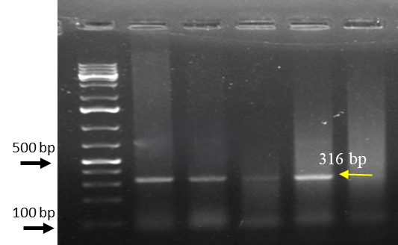
Fig 9: Agarose gel electrophoresis showing amplified arcD gene fragment of Mccp
DISCUSSION AND CONCLUSION
The current study on an outbreak of Contagious Caprine Pleuropneumonia (CCPP) affecting eleven goats of varying age groups across three flocks in Thotaravulapadu village, NTR district, Andhra Pradesh, offers comprehensive insights. The affected animals exhibited typical clinical signs, including respiratory distress, sero-mucoid nasal discharge, coughing, dyspnea, pyrexia, and general malaise are considered as hallmark indicators of CCPP, a disease known for its high morbidity and mortality rates in goats (Kusiluka et al. 2000, Tharwat et al., 2017, Iqbal et al., 2019, Dhaygude et al., 2023 and Esmaeili and Joghataei, 2024). These symptoms are directly linked to the pathogenesis initiated by the inhalation of Mycoplasma capricolum subsp. capripneumoniae (Mccp), the causative agent of CCPP. Upon inhalation, Mccp colonizes the respiratory tract, adhering to the ciliated epithelium of the lungs (Iqbal et al.,2019).
Postmortem examinations of three deceased kids revealed characteristic lesions of CCPP, including muco-purulent nasal discharges, skin eruptions around the nostrils, accumulation of approximately 100 ml of tan-yellow serous fluid in the thoracic cavity, bilateral pleural adhesions with fibrin deposition, consolidated lungs with widened interlobular septa containing jelly-like material, and about 40 ml of serous fluid in the pericardial sac with fibrin deposition on the pericardium, which were also reported similarly by Zachary and McGavin (2013) and Dhaygude et al. (2023). The marked gross lesions like hydrothorax, pleural thickening, pleural adhesion, consolidation of lobes of the lung and characteristic marbling observed in the present case are in accordance with the previous observations (Nicholas et al., 2008; OIE, 2008, Sasikala et al., 2020). Colonization of bacteria in ciliated epithelium triggers an inflammatory response characterized by the release of cytokines such as tumour necrosis factor and interleukins, leading to vasculitis and fibrinocellular exudation. (Elhassan and Salama 2018, Iqbal et al., 2019, Parray et al., 2019 and Sasikala et al., 2020).
In corroboration with the earlier reports, histopathology of lung sections revealed severe congestion, multifocal necrotic areas along with infiltration of numerous PMNs and mononuclear cells encircled by one to two layers of fibroblasts (Abraham et al., 2015 and Nicholas and Churchward, 2012). Further, the dilated interlobular septa containing edema, fibrin and inflammatory cells and the extended lesions to pleural surface resulting in fibrinous pleuritis were in agreement with (Parray et al., 2019 and Sasikala et al., 2020). Unilateral lung involvement and marbling are a characteristic feature of CBPP and rarely seen in CCPP but it was more prominent in the present case (Radostatis et al., 2000, Sasikala et al., 2020).
An outbreak of CCPP in a goat farm of Kerala was reported by Abraham et al. (2015) based on PCR amplification of the arcD gene and as similar report by Abdollahi et al. (2023), in the current study, the molecular diagnosis of the presence of the pathogen in lung samples was done through Polymerase Chain Reaction (PCR) targeting the arcD gene of Mccp confirmed, with the amplification of a 316 bp fragment. This gene exhibits significant sequence divergence compared to homologous regions in closely related species within the Mycoplasma mycoides cluster. Due to this high variability, the arcD gene serves as a specific and reliable target for PCR-based diagnostics, enabling accurate identification of Mccp and differentiation from other mycoplasmas that may cause similar clinical signs in goats (Woubit et al., 2004).
This molecular confirmation, in conjunction with the clinical signs, gross and histopathological lesions, underscores the diagnosis of CCPP in the affected goat flocks. The present study describes the typical patho morphological changes of mycoplasmal pneumonia in a goat caused by Mycoplasma capricolum subsp. capripneumoniae which was confirmed by PCR.
References
Abdollahi, M., Lotfollahzadeh, S., Shirazi, M. H. N., Shokrpoor, S., Moosakhani, F., & Nasr, M. P. (2023). First identification of Mycoplasma capricolum subspecies capripneumoniae in goats in Iran. Veterinary Research Forum, 14(2), 109-112. https://doi.org/10.30466/vrf.2022.555079.3496
Abraham, S. S., Asha, T. T., Julie, B., Prathiush, P. R., Nandakumar, S., & Prasad, P. M. (2015). Pathological and molecular characterization of contagious caprine pleuropneumonia (CCPP) outbreak in Kerala. Indian Journal of Veterinary Pathology, 39, 121-124. https://doi.org/10.5958/0973-970X.2015.00028.0
Bascuñana, C. R., Mattsson, J. G., Bölske, G., & Johansson, K. E. (1994). Characterization of the 16S rRNA genes from Mycoplasma sp. strain F38 and development of an identification system based on PCR. Journal of Bacteriology, 176(9), 2577-2586. https://doi.org/10.1128/jb.176.9.2577-2586.1994
Bölske, G., Mattsson, J. G., Bascuñana, C. R., Bergström, K., Wesonga, H., & Johansson, K. E. (1996). Diagnosis of contagious caprine pleuropneumonia by detection and identification of Mycoplasma capricolum subsp. capripneumoniae by PCR and restriction enzyme analysis. Journal of Clinical Microbiology, 34(4), 785-791. https://doi.org/10.1128/jcm.34.4.785-791.1996
Dhaygude, V., Kamdi, B., Barate, A., Sukare, J., Sabharwal, D., Tumlam, U., & Mote, C. (2023). Pathological and molecular diagnosis of contagious caprine pleuropneumonia (CCPP) in naturally infected goats (Capra hircus) from Maharashtra, India. Emerging Animal Species, 7, 100024. https://doi.org/10.1016/j.eas.2023.100024
Esmaeili, H., & Joghataei, S. M. (2024). Detection of Contagious Caprine Pleuropneumonia in Three Provinces of Iran: 2017-2018. Archives of Razi Institute, 79(6), 1263-1270. https://doi.org/10.32592/ARI.2024.79.6.1263
Elhassan, M. A., & Salama, A. O. (2018). Clinical and laboratory diagnosis of contagious caprine pleuropneumonia in Qassim region, Saudi Arabia: a comparative study. Tropical Biomedicine, 35(1), 67–75. https://msptm.org/files/journals/1/articles/100/public/100-299-1-PB.pdf
Yatoo, M. I., Parray, O. R., Bashir, S. T., Muheet, Bhat, R. A., Gopalakrishnan, A., Karthik, K., Dhama, K., & Singh, S. V. (2019). Contagious caprine pleuropneumonia – a comprehensive review. Veterinary Quarterly, 39(1), 1-25. https://doi.org/10.1080/01652176.2019.1580826
Kusiluka, L. J., Semuguruka, W. D., Kazwala, R. R., Ojeniy, B., & Friis, N. F. (2000). Demonstration of Mycoplasma capricolum subsp. Capripneumoniae and Mycoplasma mycoides subsp. mycoides, small colony type in outbreaks of caprine pleuropneumonia in eastern Tanzania. Acta Veterinaria Scandinavica, 41(3), 311-319. https://doi.org/10.1186/BF03549639
Luna, L. G. (Ed.). (1968). Manual of histologic staining methods of the Armed Forces Institute of Pathology (3rd ed.). McGraw-Hill Book Co.
Nicholas, R., & Churchward, C. (2012). Contagious caprine pleuropneumonia: new aspects of an old disease. Transboundary and Emerging Diseases, 59(3), 189-196. https://doi.org/10.1111/j.1865-1682.2011.01262.x
Nicholas, R., Ayling, R., & McAuliffe, L. (2008). Contagious caprine pleuropneumonia. In R. Nicholas, R. Ayling, & L. McAuliffe (Eds.), *Mycoplasma Diseases of Ruminants* (pp. 116–129). Commonwealth Agricultural Bureaux International. https://doi.org/10.1079/9780851990125.0000
World Organisation for Animal Health. (2008). *World Animal Health in 2006*. World Organisation for Animal Health. https://www.woah.org/fr/portail-documentaire/ (Navigate to 'RAPPORTS' > 'Santé Animale Mondiale - rapports statistiques' to find archived reports)
Parray, O. R., Yatoo, M. I., Muheet, Bhat, R. A., Malik, H. U., Bashir, S. T., & Magray, S. N. (2019). Seroepidemiology and risk factor analysis of contagious caprine pleuropneumonia in Himalayan Pashmina goats. Small Ruminant Research, 171, 23–36. https://doi.org/10.1016/j.smallrumres.2018.12.004
Radostits, O. M., Gay, C. C., Blood, D. C., & Hinchcliff, K. W. (2000). Disease caused by Mycoplasma. In O. M. Radostits, C. C. Gay, D. C. Blood, & K. W. Hinchcliff (Eds.), Veterinary Medicine: A textbook of the diseases of cattle, sheep, pigs, goats and horses (9th ed., pp. 748–785). W.B. Saunders Company Ltd.
Sasikala, M., Selvaraj, J., Prasath, N. B., Ponnusamy, P., & Arulkumar, T. (2020). Pathology of mycoplasmal pneumonia in a goat. Ruminant Science, 9(2), 259-262.
Tharwat, M., & Al-Sobayil, F. (2017). Ultrasonographic findings in goats with contagious caprine pleuropneumonia caused by Mycoplasma capricolum subsp. capripneumoniae. BMC Veterinary Research, 13(1), 263. https://doi.org/10.1186/s12917-017-1167-4
Woubit, S., Lorenzon, S., Peyraud, A., Manso-Silván, L., & Thiaucourt, F. (2004). A specific PCR for the identification of Mycoplasma capricolum subsp. capripneumoniae, the causative agent of contagious caprine pleuropneumonia (CCPP). Veterinary Microbiology, 104(1-2), 125-132. https://doi.org/10.1016/j.vetmic.2004.08.006
Yatoo, M. I., Parray, O. R., Bashir, S. T., Bhat, R. A., Gopalakrishnan, A., Karthik, K., Dhama, K., & Singh, S. V. (2019). Contagious caprine pleuropneumonia–a comprehensive review. The Veterinary Quarterly, 39(1), 1-25. https://doi.org/10.1080/01652176.2019.1580826
Yatoo, M. I., Parray, O. R., Mir, M. S., Qureshi, S., Amin, Z., Kashoo, M. N., Fazili, M. U. R., Tufani, N. A., Singh, M., Kanwar, S. C., & Dhama, K. (2018). Mycoplasmosis in small ruminants in India: A review. *Journal of Experimental Biology and Agricultural Sciences*, *6*(2), 264–281. https://doi.org/10.18006/2018.6(2).264.281
Zachary, J. F., & McGavin, M. D. (2011). *Pathologic Basis of Veterinary Disease-E-Book* (5th ed.). Elsevier Health Sciences. https://www.elsevier.com/books/pathologic-basis-of-veterinary-disease-e-book/zachary/978-0-323-07533-6

