Foot Health and the Emergence of Antimicrobial-Resistant Citrobacter youngae and Aerococcus viridans in Captive Asiatic Elephants of Central India

Abstract
Foot affections are a major welfare and health concern in captive Asiatic elephants (Elephas maximus indicus), often leading to chronic pathological lesions. This study aimed to systematically investigate the prevalence of foot affections and characterize the bacterial agents and their antimicrobial resistance patterns in captive elephants across five prominent Tiger Reserves in Madhya Pradesh, Central India. A total of 59 captive Asiatic elephants were screened for various foot lesions, including wounds, nail cracks, and abscesses. Samples (swabs from pus and fluids) were collected and cultured for aerobic and facultative anaerobic bacteria. Isolates were identified using the BD Phoenix M50 automated system, and their antimicrobial susceptibility was determined via disc diffusion and automated systems (CLSI, 2018). Pathological lesions, categorized as mild, moderate, or severe, were frequently observed. Among the isolates, 24 were identified as Citrobacter youngae a Gram-negative rod and 6 as Aerococcus viridans a Gram-positive coccus. C. youngae isolates showed significant resistance to several key antibiotics, including Penicillin-G, Amoxicillin-clavulanate, Levofloxacin, Ceftriaxone and Clindamycin, but remained sensitive to Piperacillin-tazobactam, Ciprofloxacin and Gentamicin. The Multidrug Resistance (MAR) index for C. youngae was 0.290. A. viridans isolates showed high resistance to Amoxicillin-clavulanate and Ampicillin (MAR index 0.179) but were broadly sensitive to numerous third and fourth-generation cephalosporins, fluoroquinolones and aminoglycosides.
Keywords- Ampicillin, Captive, Citrobacter youngae, Aerococcus viridans

INTRODUCTION
The Asiatic elephant is the largest living land animal in Asia (Shoshani and Eisenberg,1982). The only living species of the genus Elephas and is distributed throughout the Indian subcontinent and southeast Asia. The subspecies found in the habitat of central Indian landscape is Elephas maximus indicus. Since 1986, the Asian elephants have been listed as endangered International Union for Conservation of Nature (IUCN) red list and Schedule-I species under the Indian Wildlife (Protection) Act 1972, prohibits commercial trade and ownership of elephants are limited to those in possession of elephant before law came into force. The act was amendment in 2022 with provision in section 43 (2) which carved out additional exceptions for transfer and transport of captive elephants for “regions and other purposes” in addition to special purposes mention under section 12 of the act. It is primarily threatened by loss of habitat, habitat degradation, fragmentation and poaching (Choudhury et al., 2021).
The captive elephants are indispensable part of wildlife management particularly for in situ conservation of tigers and additionally, extensive deployment for anti-poaching patrols, communication, transportation and eco-tourism. Modern day trend of using captive trained elephant as koonkies for driving away the crop raiding wild herbs from human habitations is a promising way of countering human-elephant conflict (Sarma et al., 2012).
Elephants are heavy animals with body weight ranging from 2000-3500kg and they have massive legs to bear heavy body weight. The bones of elephants lack a marrow cavity and marrow cavity is replaced with a network of dense cancellous bone which provides hematopoiesis but remoulds the bone much stronger (Csuti et al., 2001). The foot has an integumentary covering consisting of skin, toenails and a cornified but flexible sole (slipper). The bones of the front foot include the phalanges, metacarpal and eight carpal bones arranged in two rows. The hind foot is smaller than the front foot and has an oval shape. The tarsus consists of seven bones arranged in three rows. Elephant toe nail has a cuticle similar to the human fingernail and they are not weight bearing unlike those of hoofed animals. Elephant toe nail grows approximately 0.5-1cm per month. Pathological lesions of nails, soles are generally and more frequently reported in the captive elephants. The prevalence of pathological lesions have been in elephant feet that ranged between 67.4% to 80.3% in (Mikota et al., 1994).
Fowler and Mikota (2006) reported that weight bearing increased the circumference of the elephant foot just above the nails from (5.0-11.4cm) by 7.0-9.7%. As weight is applied, the digital cushion compresses and pushes peripherally, causing the increase in circumference and at the same time compressing the veins in the foot. Lack of ability to flex the foot is an indication of either pain or ankylosis with in the foot. Foot affections are one of the major issue faced by the elephant in captivity. Through all National Parks/Tiger Reserves use captive elephants for various of activity. Till date, no systemic and scientific investigation on foot affections has been done in captive Asiatic elephants of Madhya Pradesh.

MATERIALS AND METHODS
Location and place of work
The proposed work was carried out at the School of Wildlife Forensic and Health, N.D.V.S.U., Jabalpur (M.P.) and protected areas viz. Kanha Tiger Reserve, Bandhavgarh Tiger Reserve, Panna Tiger Reserve, Pench Tiger Reserve and Satpura Tiger Reserve.

Selection of animals

Captive Asiatic elephant (N=59) of either sex for foot affections were screened in the present study.

Duration of work
The study was conducted for a period of one year (April 2024-March 2025).
Methodology
Screening of captive elephants
All 59 elephants were physically screened for foot lesions. The presence of wounds, nail crack, abscess, podo-dermatitis, foot rot, split nails and nail over growth were examined recorded with digital camera. History of the elephants were taken from the care takers, treatment registers and direct interaction with Wildlife Health Officers of the parks. The management practices of the elephants were noted specially practice of placing chaining in the feet. The schedule of replacing the chains with new ones were also noted. The treatment schedule of wounds, foot care practices were recorded from the park registers.
Collection of samples
Samples (swabs from pus, fluids and wounds) were collected from foot lesions of captive Asiatic elephants having foot affections. Foot affections in captive elephants were categories as presences of wound, abnormal cuticle growth and nail cracks (major and minor).

Isolation and identification of bacteria
Sterile swab samples were used for collecting bacterial swabs from wounds, pus and fluids in the wounds (Table 01). Isolation and identification of aerobic and facultative anaerobic bacteria was done as per the protocol described by Markey et al. (2013). Collected swab/pus samples was inoculated in brain heart infusion (BHI) broth and incubated at 37°C for 24-48 hrs. for enrichment. Enriched samples were streaked on Nutrient agar, Sheep Blood agar and MacConkey Lactose agar (MLA) and Nutrient agar (NA) and incubated aerobically at 37°C for 24-48 hrs.
Gram staining was performed from colonies grown in sheep blood agar. Observed gram positive cocci were further streaked on Mannitol Salt agar and Edward’s media containing 5% blood and incubated aerobically at 37°C for 24- 48 hrs.
Pink and pale colonies from MacConkey agar were further streaked on selective and differential media EMB (Eosin Methylene Blue) agar, XLD (Xylose Lysine Deoxycholate agar) and CLED (Cystine–lactose–electrolyte-deficient agar) agar and incubated aerobically at 37°C for 24-48 hrs. On the basis of colonial characteristics and gram staining, purified bacteria were identified by BD Phoenix M50 automated bacterial identification system.
Antibiogram assay
Each isolated bacteria were tested for antimicrobial susceptibility by disc diffusion method/broth dilution method (CLSI, 2018) or by BD Phoenix M50 automated bacterial identification system and antibiogram results were recorded.
Result and discussion
The present investigation focused on the isolation, biochemical identification and antimicrobial profiling of Citrobacter youngae and Aerococcus viridans from foot ailments of captive Asian elephants (Elephas maximus). Based on colony characteristics and gram staining, all isolates of Citrobacter youngae. On Gram staining, the isolates exhibited pink-coloured, small rod-shaped bacteria, confirming their Gram-negative nature (Fig. 2c). When cultured on Eosin Methylene Blue (EMB) agar, the colonies appeared dark pink to purple due to lactose fermentation colonies of bacteria. The colonies were of medium to large size with smooth margins (Fig. 2b). Growth on Nutrient agar presented smooth, moist and slightly mucoid colonies, indicating typical morphology associated with Citrobacter spp. (Fig. 2a). A total of 24 Citrobacter youngae isolates were obtained, of which 07 were isolated from the left forelimb, 06 from the right forelimb and 07 from hindlimbs (left and right combined). The highest frequency of Citrobacter youngae was recorded from Bandhavgarh Tiger Reserve (11 isolates) followed by Panna Tiger Reserve (05), Pench Tiger Reserve (03) and Kanha Tiger Reserve (03) (Table 01). Out of these isolates, four originated from nail cracks, whereas 12 isolates were associated with open foot wounds, indicating a greater prevalence in infected tissues than structural hoof defects. This finding aligns with the report of Veeraselvam et al. (2024), who documented the presence of Citrobacter spp. (3; 1.9%) in captive elephants from Tamil Nadu, suggesting that members of this genus may be opportunistic contaminants or emerging pathogens in elephants. Antibiotic sensitivity patterns revealed that all C. youngae isolates exhibited high resistance to Penicillin-G, Amoxiclav, Levofloxacin, and Cefepime, followed by moderate resistance to Ceftriaxone, Clindamycin, and Ceftizoxime (Table 02; Plate 01). However, the isolates were found to be highly sensitive to Piperacillin-Tazobactam, Ciprofloxacin, Gentamicin, Co-trimoxazole and Cefotaxime. Some isolates showed an intermediate response to Cefoxitin, Tetracycline and Cefepime. These multi-drug resistance patterns reflect progressive antimicrobial resistance among Gram-negative bacteria in wildlife. To date no published literature has reported antimicrobial susceptibility and resistance patterns of Citrobacter youngae isolated from wounds or foot lesions of captive Asian elephants, making the current findings novel and relevant for treatment protocols. Naturally, Citrobacter species inhabit soil, water, sewage sludge, food and the intestinal tract of animals and humans (Forsythe et al., 2015). In humans, infections caused by Citrobacter spp. are associated with high fatality rates, particularly in neonates, with mortality reaching up to 48% (Pepperell et al., 2002). The MAR (Multiple Antibiotic Resistance) index of C. youngae in this study was calculated as 0.290, indicating exposure to high-risk sources of contamination where antibiotics are frequently misused, thus highlighting an urgent need for judicious antibiotic use in wildlife veterinary practices. Considering the pathogenic potential and resistance profile, documentation of this organism from elephant foot wounds serves as a valuable reference for developing targeted therapeutic strategies.
Aerococcus viridans isolates were identified and characterized on Gram staining, A. viridans appeared as Gram-positive cocci, arranged in tetrads, small clusters, or pairs (Fig. 4b). When cultured on nutrient agar, the colonies appeared circular, small, smooth, slightly convex, translucent to opaque, and moist (Plate 2). The isolates demonstrated hemolysis on blood agar, producing small, odor-bearing colonies with smooth to slightly rough margins, indicative of hemolysin production and possible pathogenicity. Growth on Mannitol Salt Agar (MSA) resulted in small, translucent colonies without changing the medium to yellow, indicating the absence of mannitol fermentation (Fig. 4a). Six isolates of Aerococcus viridans were recovered from three elephants, with distributions as follows: left forelimb (02), right forelimb (03), and left hindlimb (01) (Table 4). All isolates originated exclusively from wounds, suggesting that A. viridans may act as an opportunistic pathogen associated with infected tissues rather than nail cracks or early hoof lesions. The highest prevalence was observed in captive elephants from Pench Tiger Reserve (06 isolates). Antibiotic profiling revealed that all isolates were highly resistant to Amoxicillin-clavulanate and Ampicillin (Table 05). In contrast, high sensitivity was observed toward cephalosporins, fluoroquinolones, aminoglycosides and several β-lactam drugs including Cefoxitin, Ciprofloxacin, Ceftriaxone, Gentamicin, Levofloxacin, Meropenem, Piperacillin, Aztreonam, Piperacillin-Tazobactam, Ceftizoxime, Cefepime, Chloramphenicol, Trimethoprim-sulfamethoxazole, Tetracycline and Amikacin (Table 06). The MAR index of A. viridans was low (0.179), indicating a lower frequency of antimicrobial exposure or resistance compared to C. youngae.

Table 01: Zone of Inhibition of different antibiotics for Citrobacter youngae (manually disc diffusion method)
S. No | Antibiotics | Symbol | Concentration | Sensitive (mm or more) | Intermediate (mm) | Resistant | Disc diffusion method (mm) | Interpretation
 | Cefoxitin | (CX) | 30mcg | 18 | 15-17 | 14 or less | 16 | IM
 | Piperacillin Tazobactam | (PIT) | 100\10mcg | 25 | 21-24 | 20 | 25 | s
 | Ciprofloxacin | (CIP) | 5mcg | 21 | 18-20 | 17 | 22 | S
 | Ceftriaxone | (CTR) | 30mcg | 23 | 20-22 | 19 | <10 | R
 | Gentamicin | (GEN) | 10mcg | 18 | 15-17 | 14 | 18 | S
 | Levofloxacin | (LE) | 5mcg | 21 | 17-20 | 16 | 13 | R
 | Co-trimoxazole | (COT) | 25mcg | 16 | 11-15 | 10 | 25 | S
 | Clindamycin | (CD) | 2mcg | 21 | 15-20 | 14 | <10 | R
 | Tetracycline | (TE) | 30mcg | 15 | 12-14 | 11 | 13 | IM
 | Cefepime | (CPM) | 30mcg | 25 | 19-24 | 18 | 24 | IM
 | Ceftizoxime | (CZX) | 30mcg | 25 | 22-24 | 21 | 21 | R
 | Amoxicillin clavulanate | (AMC) | 30mcg | 18 | 14-17 | 13 | 13 | R
 | Cefotaxime | (CTX) | 30mcg | 23 | 15-22 | 22 | 24 | S
 | Penicillin -G | (P) | 10unit | 29 | - | 28 | <10 | R
(S=Sensitive, R=Resistance and IM=Intermediate)

Table 02: BD Phoenix ID system antimicrobial resistance against Citrobacter youngae
Citrobacter youngae
S.No. | Antibiotics | MIC | Interpretation
1. | Amikacin | <=8 | S
2. | Gentamicin | <=2 | S
3. | Imipenem | <=1 | S
4. | Meropenem | <=1 | S
5. | Cefazolin | >16 | R
6. | Cefoxitin | >16 | R
7. | Ceftazidime | <=1 | S
8. | Cefotaxime | <=4 | -
9. | Cefepime | <=2 | S
10. | Cefoperazone- Sulbactam | <0.5/8 | -
11. | Aztreonam | <=2 | S
12. | Ampicillin | >16 | S
13. | Piperacillin | <=4 | S
14. | Amoxicillin Clavulanate | >16/8 | R
15. | Piperacillin- Tazobactam | <4/4 | S
16. | Colistin | R56 | -
17. | Trimethoprim-Sulfamethazole | <=0.5/9.5 | S
18 | Chloramphenicol | >16 | S
19 | Ciprofloxacin | <=0.5 | -
20 | Levofloxacin | <=1 | -
21 | Tetracycline | (R=1233) | R
(S=Sensitive, R=Resistance and IM=Intermediate)
Table 03: Multidrug resistance pattern in Citrobacter youngae isolates
No. of Citrobacter youngae resistance | Ceftriaxone | Levofloxacin | Cefepime | Clindamycin | Ceftizoxime | Amoxyclav Clavunic acid | Penicillin -G
Ceftriaxone | 22R | 17R | R | R | R | 4R | R
Levofloxacin | 5R | 24R | 4R | 22R | 4R | 18R | 22R
Cefepime | 2R | R | 24R | R | R | R | 20R
Clindamycin | 14R | 17R | 8R | 8R | 5R | R | 7R
Cefepime | 4R | R | R | R | 7R | R | 19R
Ceftizoxime | R | 14R | 8R | 22R | 2R | 14R | 11R
Amoxicillin clavulanate | R | R | R | R | 15R | 24R | 10R
Penicillin -G | R | 15R | 7R | 20R | 7R | 20R | 24R
(S=Sensitive, R=Resistance and IM=Intermediate)

Table 04: Zone size interpretative chart for antibiotic sensitivity assay for Aerococcus viridans (manually disc diffusion method)
S. No | Antibiotics | Symbol | Concentration of Disc | Sensitive  (mm or more) | Intermediate (mm) | Resistant  (mm or less) | Disc diffusion method (mm) | Interpretation
1 | Cefoxitin | (CX) | 30 mcg | 18 | 15-17 | 14 | 31 | S
2 | Piperacillin Tazobactam | (PIT) | 100 mcg | 25 | 21-24 | 20 | 19 | R
3 | Ciprofloxacin | (CIP) | 5mcg | 21 | 18-20 | 17 | 28 | S
4 | Ceftriaxone | (CTR) | 30 mcg | 23 | 20-22 | 19 | 30 | S
5 | Gentamicin | (GEN) | 10 mcg | 18 | 15-17 | 14 | 21 | S
6 | Levofloxacin | (LE) | 5 mcg | 21 | 17-20 | 16 | 24 | S
7 | Co-trimoxazole | (COT) | 25 mcg | 16 | 11-15 | 10 | 20 | S
8 | Clindamycin | (CD) | 2 mcg | 21 | 15-20 | 14 | 26 | S
9 | Tetracycline | (TE) | 30 mcg | 15 | 12-14 | 11 | 32 | S
10 | Cefepime | (CPM) | 30 mcg | 25 | 19-24 | 18 | 36 | S
11 | Ceftizoxime | (CZX) | 30 mcg | 25 | 22-24 | 21 | 26 | S
12 | Amoxyclav Clavunic acid | (AMC) | 30 mcg | 18 | 14-17 | 13 | 38 | S
13 | Cefotaxime | (CTX) | 30 mcg | 23 | 15-22 | 22 | 38 | S
14 | Penicillin -G | (P) | 10unit | 29 | - | 28 | 28 | R
15 | Ceftazidime | (CAZ) | 10 mcg | 21 | 18-20 | 17 | 13 | R
16 | Imipenem | (IPM) | 10 mcg | 23 | 20-22 | 19 | R | R
17 | Amikacin | (AK) | 30 mcg | 18 | 15-17 | 14 | 22 | S
18 | Meropenem | (MRP) | 10 mcg | 22 | 19-21 | 18 | 32 | S
19 | Ampicillin | (AMP) | 10 mcg | 16 | 12-15 | 11 | 38 | S
(S=Sensitive, R=Resistance and IM=Intermediate)

Table 05: Antimicrobial resistance against Aerococcus viridans
Aerococcus viridans
Antibiotics | BD Phoenix ID system
Antibiotics | MIC | Interpretation
Ampicillin Amikacin | 8 | S
Gentamicin | <=2 | S
Imipenem | <=1 | S
Meropenem | <=1 | S
Cefazolin | >16 | R
Cefoxitin | >16 | R
Ceftazidime | <=1 | S
Cefotaxime | <=4 | -
Cefepime | <=2 | S
Cefoperazone-  sulbactam | <=0.5/8 | -
Aztreonam | <=2 | S
Ampicillin | >16 | R
Piperacillin | <=4 | S
Amoxicillin-clavulanate | >16/8 | R
Piperacillin-Tazobactam | <=4/4 | S
Colistin | <=0.5 | -
Trimethoprim-sulfamethoxazole | <=0.5/9.5 | S
Chloramphenicol | <=4 | S
Ciprofloxacin | <=0.5 | -
Levofloxacin | <=1 | -
Tetracycline | <=2 | S
(S=Sensitive, R=Resistance and IM=Intermediate)
Table 06: Multidrug resistance pattern in Aerococcus viridans isolates
No. of A. viridans resistances | Ceftazidime | Imipenem | Cefazolin | Cefoxitin | Ampicillin | Amoxicillin-clavulanate
Ceftazidime | 3R | 2R | 3R | 2R | 2R | 6R
Imipenem | R | 4R | R | 2R | 2R | 5R
Cefazolin | 2R | 3R | 5R | 4R | 3R | 2R
Cefoxitin | 2R | R | R | 5R | 4R | 3R
Ampicillin | 3R | 2R | R | 2R | 6R | 2R
Amoxicillin-clavulanate | 5R | R | R | 3R | 3R | 6R
(S=Sensitive, R=Resistance and IM=Intermediate)
Conclusion
Foot affections represent a persistent and critical welfare issue among captive Asiatic elephants in Central Indian tiger reserves. The present study not only documented a high prevalence of varying grades of foot lesions but also successfully identified two significant opportunistic bacterial pathogens associated with infected wounds: Citrobacter youngae and Aerococcus viridans. The detection of C. youngae with a comparatively high multidrug resistance index highlights its emerging role as a potential threat to elephant health, particularly due to its resistance to frequently used antibiotics. In contrast, A. viridans exhibited less resistance, suggesting easier therapeutic management; however, its presence in active foot wounds further emphasizes the need for vigilant monitoring. The antimicrobial findings offer valuable evidence-based therapeutic options for clinicians treating elephant foot infections, demonstrating that targeted drug selection is vital to prevent treatment failures and promote optimal recovery. The study underscores the urgent need to strengthen biosecurity, regulate antibiotic use, and prioritize early detection and timely veterinary intervention in captive facilities. Overall, the results provide crucial guidance for developing standardized treatment protocols and reinforce the importance of proactive health management to safeguard the welfare and longevity of captive Asiatic elephants in conservation centres.

References
Schiffmann, C. (2021). Posture abnormalities as indicators of musculoskeletal disorders in 12 zoo elephants – A visual guide. Gajah, 53, 20–29. https://www.asesg.org/gajah-archive.php .
Clinical and Laboratory Standards Institute. (2018). Performance standards for antimicrobial disk and dilution susceptibility tests for bacteria isolated from animals (5th ed., CLSI standard VET01, Vol. 38, No. 13). Clinical and Laboratory Standards Institute. https://clsi.org/standards/products/veterinary-medicine/documents/vet01/
Csuti, B., Sargent, E. L., & Bechert, U. S. (2001). The elephant's foot: Prevention and care of foot conditions in captive Asian and African elephants. Iowa State University Press. https://www.abebooks.com/book-happy-booksellers/Elephant-Foot-Prevention-Care-Conditions-Captive/30900000000/bd .
Forsythe, S. J., Abbott, S. L., & Pitout, J. (2015). Klebsiella, Enterobacter, Citrobacter, Cronobacter, Serratia, Plesiomonas, and Other Enterobacteriaceae. In Manual of Clinical Microbiology (pp. 714–737). https://doi.org/10.1128/9781555817381.ch38 .
Fowler, M. E., & Mikota, S. K. (2006). Biology, Medicine, and Surgery of Elephants. Blackwell Publishing. https://www.wiley.com/en-us/Biology,+Medicine,+and+Surgery+of+Elephants-p-9780813806761 .
Mikota, S. K., Sargent, E. L., & Ranglack, G. S. (1994). Medical management of the elephant. Indira Publishing House. https://books.google.com/books/about/Medical_Management_of_the_Elephant.html?id=2_0tAAAACAAJ .
Pepperell, C., Kus, J. V., Gardam, M. A., Humar, A., & Burrows, L. L. (2002). Low-virulence Citrobacter species encode resistance to multiple antimicrobials. Antimicrobial Agents and Chemotherapy, 46(11), 3555–3560. https://doi.org/10.1128/AAC.46.11.3555-3560.2002 .
Sarma, K. K., Thomas, S., Gogoi, D., Sarma, M., & Sarma, D. K. (2012). Foot diseases in captive elephant. Intas Polivet, 13(2), 221-227. http://www.indianjournals.com/ijor.aspx?target=ijor:ipoandvolume=13andissue=2andarticle=014andtype=pdf .
Shoshani, J., & Eisenberg, J. F. (1982). Elephas maximus. Mammalian Species, 182(18), 1–8. https://doi.org/10.2307/3504045 .

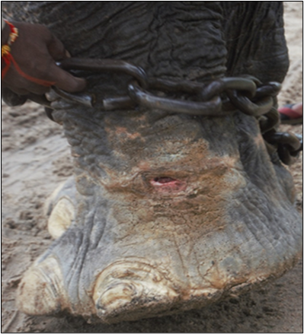

Fig. 1: Collection of bacteriological swab sample from wound in sterilized swab from foot of captive Asian elephant

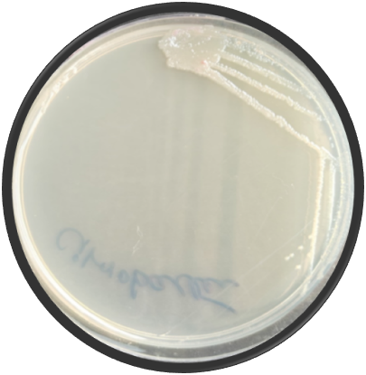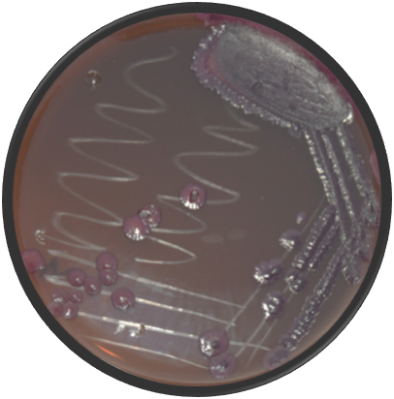
2b
2a

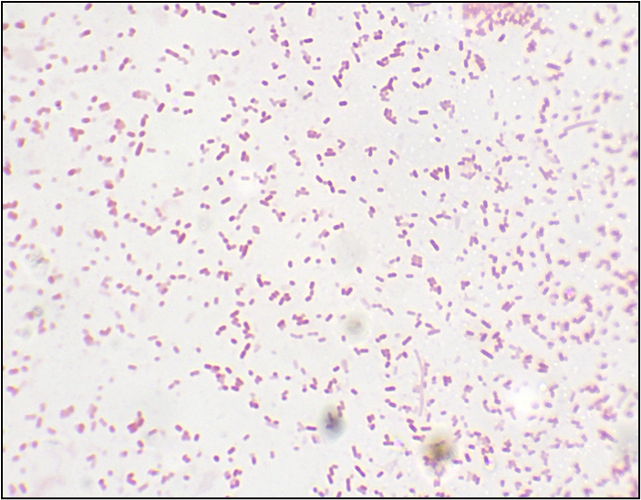

2c

Fig. 2: Growth of Citrobacter youngae in various media on Nutrient agar (2a) and Eosin Methylene Blue agar (Dark purple-coloured colonies) (2b) Gram negative rods suspected for Citrobacter Spp. (1000X) (2c)

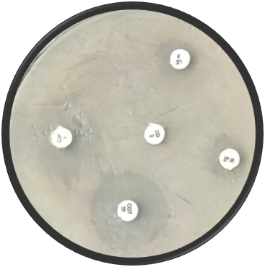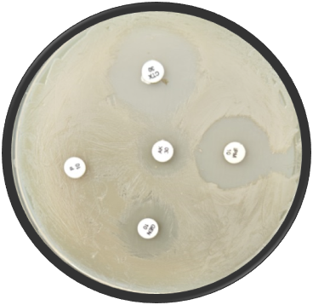

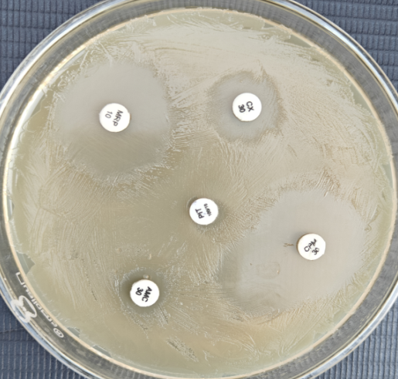
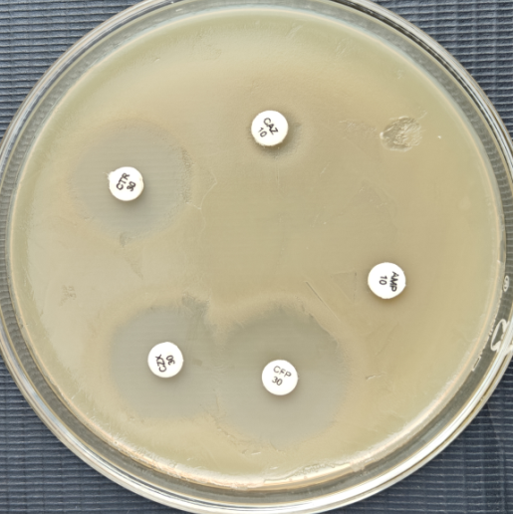

Fig. 3: Multidrug susceptibility profile of Citrobacter youngae

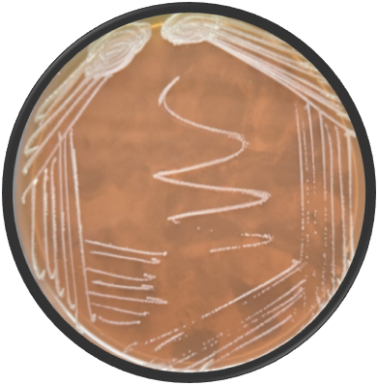
4a

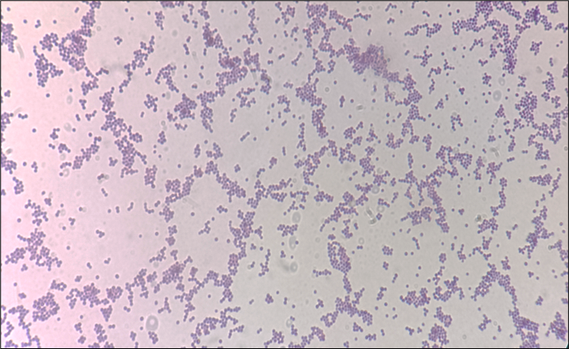
4b

Fig. 4: Growth of Aerococcus viridans in Mannitol Salt agar (4a) Gram postive cocci suspected for Aerococcus viridans (1000X) (4b)

