Rearing Performance evaluation of Bivoltine Mulberry Silkworm (Bombyx mori L.) breed in two distinct agro-climatic zones of Manipur during the Spring Season.

ABSTRACT
The present study investigates the rearing performance of the mulberry silkworm, Bombyx mori L. (bivoltine C004 breed), in two distinct agro-climatic zones (Sanjenbam Hill and Wangkhei) of Manipur during the spring season (March-April) 2025. A comparative study was conducted between two different zones in Manipur to evaluate the influence of regional environmental factors on the growth, development, and cocoon yield of silkworms under standardised rearing conditions. Key parameters such as fecundity, hatchability, larval duration, larval weight, cocoon weight, pupal weight, shell weight, shell ratio, effective rate of rearing, eclosion, silk productivity, filament length, denier, renditta and cocoon yield were recorded. The rearing house of Wangkhei, with a temperature range of 15-29.5⁰C and 38%- 91.50% relative humidity range, exhibited shorter larval duration (26±0.577 days), while the rearing house of Sanjenbam hill, with a temperature range of 10.49- 26⁰C and a 22.46%- 99.21% humidity range, showed longer larval duration (30±0.578 days). Fecundity, hatchability, weight of ten mature larvae, cocoon weight, pupal weight, shell weight, shell ratio, eclosion, silk productivity, filament length and cocoon yield (by weight) were recorded higher in the Wangkhei zone, whereas survival rate, effective rate of rearing, denier, renditta and cocoon yield (by number) were recorded higher in Sanjenbam hill. The findings highlight the role of different environmental conditions in sericultural productivity and emphasise the need for location-specific strategies to optimise silkworm rearing outcomes.
Keywords: Bombyx mori L.; bivoltine; breed; spring; silkworm.

- Introduction
Natural fibres are best known for their exclusive comfort, high tensile strength and biodegradable properties. The need of it are still on demand due to their cost effectiveness in industrial process including dying properties, light weight, production of new product and good mechanical properties compared with synthetic fibres (Ilyas & Sapuan et al., 2020; Ramesh and Deepa, 2018). They are produced from plant or animal sources. Among the natural fibres, those obtained from silkworms are best known as the queen of all fibres for their softness, elegance, durability, water absorbency, resistance to heat, superior dyeing efficiency, and luminance. Fabrics made using fine silk thread can be a symbol of royal patronage. According to Meyer (2000), silk is used in the making of luxury and decorative items, garments, and essential parts of various musical instruments. However, there must be no compromise on the quality of the product, so that the forward movement of sericulture-based natural products towards sustainable fashion and the promotion of cultural heritage can be enhanced worldwide.
The art of rearing silkworms for the production of protein fibre called silk involves four stages, and it takes 50 -60 days for one complete cycle (Banno et al., 2010) and cultivation of silk using Bombyx mori dates back to around 3000 - 2700 BCE in China (Barber, 1992). More than 400 species of the silkworm have been documented so far, a few species, such as Mulberry, Tasar, Eri, Muga, Anaphe, Fagara, Mussel silks, etc., are known for the commercial silk production and among them, Bombyx mori or Mulberry silk plays a pivotal role in the production of around 90% of the world's silk. Although the total silk volume in the market is less than 1%, its value and importance are increasing day by day. So China, the major silk-producing country, earned more than US$3 billion (Babu, 2019). Although India has become the second-largest producer of silk, most of it is consumed within the country. Thus, India must give special attention to the production of high-quality silk to gain a significant economic advantage in the international market.
India produced 38,913 metric tons (MT) of silk, employing approximately 9.76 million people in rural and semi-urban areas during the 2023-24 fiscal year. The sericulture activities in India are spread across 52,360 villages. Major silk-producing states in the country are Andhra Pradesh, Assam, Bihar, Gujarat, Jammu and Kashmir, Karnataka, Chhattisgarh, Maharashtra, Tamil Nadu, Uttar Pradesh and West Bengal. Karnataka contributed around

32.3% of the total silk in the country during FY 2024 (CSB: Central Silk Board of India). Diversity in topography, relief, and varied climatic factors in India leads to the production of different types of silk from various silkworms.
Silkworms are highly sensitive to fluctuations in environmental factors, and specifically, B. mori L. is one of the delicate species. Temperature and humidity are controlling their adaptability, developmental stages as well as productivity (Rahmathulla, 2011). Photoperiod, soil properties, and leaf quality affect the production of cocoon, the quality of the product and the life cycle of the silkworm. Seasonality, thus, also affects its cocoon-related characters. They have been evaluated in various environmental and agro-climatic conditions to identify season- and region-specific breeds for utilisation (Malik et al., 2002).
Silkworms can be adapted and domesticated in man-made houses. Among them, Bombyx mori live in an optimum temperature of 23-28⁰C °C, having 60-80% humidity and feeding on mulberry leaves, while species like Antheraea mylitta, Antheraea assamensis, Samia cynthia ricini are distributed and thrive well in dense forest to agricultural fields, feeding on specific host plants across India ( Kumar et al., 2012, Sasmal et al., 2015). Considering the agro-climatic conditions of Manipur, it is suitable for rearing all four types of silkworms, namely Mulberry, Tasar, Eri, and Muga. Domestication of Bombyx mori in a bivoltine cycle has been practised for the last three decades. Rearing of silkworm is becoming an important source of income in the north-eastern states of India, including Manipur. According to Quadri et al., (2010), silkworm rearing helps improve the economic conditions of landless farmers by providing supplementary employment and supplementing the income of rural farmers, especially the economically weaker sections of society. However, it remains a challenge to produce international silk grade, as farmers need to acquire knowledge about new technologies and adopt such techniques in the field. It is observed that most farmers are reluctant to adopt recommended new technologies due to various socio-economic and biotic factors. This not only results in reduced productivity but also means that 95 per cent of the total cocoons produced by farmers do not meet the standard quality. The farmers who do not adopt such technologies would generally lose higher income in sericulture and as such fetch low dividends (Lakshmanan, 1998). Overcoming these challenges can help increase cocoon production as well as silk quality, thereby reducing imports and increasing exports. Hence, the present investigation was undertaken to evaluate the rearing performance and various economic traits of silkworm Bombyx mori during the spring season in two different agro-climatic zones of Imphal East district, Manipur- a north-eastern state of India.

Substantial evidence indicates that multiple factors significantly affect agricultural productivity. The objective of this study is to demonstrate the impact of variability in abiotic factors and niche complementarity on the rearing and silk productivity of bivoltine silkworms in the state of Manipur.
- Materials and methods:
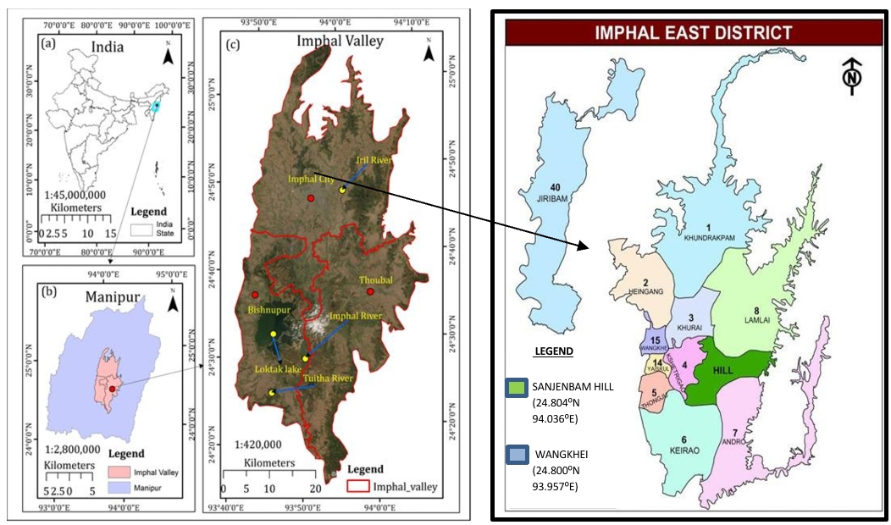
The present study evaluated the rearing performance of the bivoltine silkworm Bombyx mori Chinese C004 breed. Rearing is conducted in two different agro-climatic zones of Imphal East district (Sanjenbam Hill and Wangkhei), Manipur, during the Spring season (March-April 2025). The room and rearing equipment were first disinfected using a mixture of 2% formalin and 0.02% detergent, a solution known to be an effective disinfectant. The disease-free layings (DFLs) were obtained from the Directorate of Sericulture, Sangaipat, Imphal East, Manipur. After hatching, the larvae were brushed with a feather on the plastic tray and fed the S-1365 mulberry variety three times a day (7:00 a.m., 2:00 p.m., and 9:00 p.m.). Proper hygiene was maintained throughout the work period.
Figure 1. Location of the study area.

  - Experimental site
The experiment was conducted in the silkworm rearing house at Sanjenbam hill (24.804⁰N 94.036⁰E) with an altitude of 997m a.s.l. and Wangkhei (24.800⁰N 93.957⁰E), a valley region with an altitude of 783m a.s.l.
  - Equipment
Plastic rearing trays, rearing stand, chopping board, chopping knife, feather, cleaning nets, mountages, hygrometer, thermometer, antwells and electronic balance.
  - Data collection and observation
Chinese mulberry silkworm bivoltine breed (C004) was reared in two zones of Imphal East district, Manipur (Sanjenbam Hill and Wangkhei), during the spring season (March-April) of 2025. The silkworm rearing was conducted according to Dandin et al., (2003) with four replicates of 1 disease-free laying (DFL) following the standard method under natural conditions. Temperature and relative humidity were recorded for each of the rearing places. The length, weight and duration of larval stages were also recorded. Key parameters such as fecundity, hatchability, larval duration, larval length, larval weight, cocoon weight, pupal weight, shell weight, shell ratio, effective rate of rearing, eclosion, silk productivity, filament length, denier, renditta and cocoon yield of the two zones were recorded.
Data of the following parameters were recorded-
    - Fecundity (no.)
- The fecundity was calculated by taking the number of eggs laid by a single adult moth from each replication. The number of eggs was counted individually and recorded.
    - Hatching (%)
- The hatching % was calculated by deducting unhatched, unfertilized and dead eggs from the total number of eggs laid by a single adult female moth. It was calculated as
Hatching (%) = No. of hatched eggs/total number of eggs laid × 100
    - V Instar Larval Duration (days)
- It was calculated as the total number of days taken by larvae from the first day of V instar to the mounting of the ripe larvae.

    - Total Larval Duration (days)
- It was calculated as the total number of days from the date of brushing to the mounting of ripe worms.
    - Weight of Ten Mature Larvae (g)
- Ten mature larvae were selected randomly from each replicate of each treatment and weighed separately.
    - Larval survival rate (%)
- Larval Survival Rate (%)=Initial number of larvae/ Number of larvae that survive ×100
    - Cocoon Weight (g)
- Ten cocoons from each replicate of each treatment were selected randomly and weighed to determine the average cocoon weight.
    - Shell Weight (g)
- The cocoons used to determine the average single cocoon weight were cut open and weighed to obtain the shell weight.
    - Pupal Weight (g)
- The pupae obtained from the cut-open cocoons were weighed to determine the average papal weight.
    - Shell Ratio (%)
- It was calculated as,
Shell ratio (%) = single shell weight/single cocoon weight × 100
    - Silk productivity (cg/day)
- It was calculated as
Silk productivity (cg/day) = shell weight/ 5th instar larval duration × 100
    - The effective rate of Rearing is important for silk worm rearing, as it is a valuable parameter for determining the amount of silk to be spun.
ERR (%) = No. of cocoon yield/ No. of cocoon brushed × 100.
    - Eclosion/ Moth emergence (%) = Number of moths emerged/ Number of cocoons kept for moth Emergence × 100.
    - Filament length- selected cocoons were reeled to determine the filament length.

    - Denier (filament size) = filament weight/ filament length × 9000.
    - Renditta - Renditta is one of the essential traits that denote the production of a certain number of kilograms of cocoons required to produce one kilogram of raw silk.
RENDITTA = weight of cocoon/ weight of raw silk reeled.

    - Cocoon Yield /10,000 Larvae
- Cocoon yield (by number) = no. of cocoons harvested from each replicate/ no. of worms retained after third moult × 10000.
Cocoon yield (by weight) = weight of cocoons harvested from each replicate/ no. of worms retained after third moult × 10000.

  - Statistical analysis- Student's t-test (P≤0.05) was estimated using Statistica.

- Result:
Table 1: Characteristic features of the C004 bivoltine silkworm Bombyx mori under study.
Genotype | Voltinism | Parental source | Larval pattern | Cocoon colour | Cocoon shape | Cocoon grains | Origin | Source
C004 | Bivoltine | Chinese breed | Plain | White | Oval | Fine to medium | China | Directorate of Sericulture, Sangaipat

Table 2. Mean meteorological data of two zones of Manipur during the Spring season (March-April), 2025.
ZONES | PHOTOPERIOD |  | TEMPERATURE (⁰C) |  | HUMIDITY (%)
ZONES | Light | Dark | Min. | Max. | Min. | Max.
WANGKHEI | 11:53 | 12:07 | 15 | 29.50 | 38 | 91.50
SANJENBAM | 12:04 | 11:56 | 10.49 | 26 | 22.46 | 99.21
REGION | PARAMETERS | 1ST INSTAR LARVA | 2ND INSTAR LARVA | 3RD INSTAR LARVA | 4TH INSTAR LARVA | 5TH INSTAR LARVA
WANGKHEI | LENGTH (cm) | 0.62±0.024 | 1.05±0.047 | 2.57±0.057 | 4.13±0.055 | 7±0.061
WANGKHEI | WEIGHT OF 10 LARVAE (g) | 0.05±0.016 | 0.29±0.019 | 1.74±0.073 | 7.16±0.370 | 41.44±0.197
WANGKHEI | DURATION(DAYS) | 3 | 3 | 3 | 4 | 8
SANJENBAM | LENGTH | 0.59±0.027 | 1.04±0.047 | 2.54±0.052 | 4.11±0.043 | 6.9±0.071
SANJENBAM | WEIGHT OF 10 LARVAE (g) | 0.04±0.019 | 0.25±0.04 | 1.68±0.06 | 6.99±0.163 | 39.70±0.146
SANJENBAM | DURATION(DAYS) | 4 | 3 | 4 | 4 | 10

Table 3: Table showing larval length, weight and duration of two zones.
The values are mean±SE (Standard Error).

ZONES | Fecundity | Total larval duration  (days) | Weight of ten mature larvae  (g) | Pupal weight (g) | Shell weight (g) | Cocoon weight (g) | Cocoon shell ratio (%) | Silk productivity  (cg/day) | Silk Filament length  (m) | Denier | Renditta  (kg) | Cocoon yield/ 10,000 larvae  (by number) | Cocoon yield/ 10,000 larvae  [by weight  (kg)]
WANGKHEI | 497.25  ±  27.158 | 26  ±  0.577 | 41.44  ±  0.197 | 1.18  ±  0.048 | 0.40  ±  0.020 | 1.59  ±  0.0443 | 25.12  ±  1.495 | 4.95  ±  0.254 | 1060  ±  10.697 | 3.17  ±  0.026 | 4.26  ±  0.120 |  | 15.18  ±  0.300
  9605.14
  ±
  190.202
SANJENBAM HILL | 495.25  ±  9.068 | 30±  ±  0.578 | 39.70  ±  0.146 | 1.09  ±  0.051 | 0.34  ±  0.033 | 1.50  ±  0.0442 | 22.71  ±  1.864 | 3.41  ±  0.327 | 850.50  ±  14.011 | 3.33  ±  0.019 | 4.78  ±  0.173 | 9614.13  ±  143.428 | 14.33  ±  0.212
t value | 0.069 | -4.899* | 7.097* | 1.339 | 1.429 | 1.405 | 1.011 | 3.720* | 11.885* | -2.180 | -2.459* | -0.038 | 2.312
Table 4. Mean performance of bivoltine Bombyx mori (C004 breed) in two zones of Manipur during the Spring season 2025.
The values are mean±SE.*significant difference at P≤0.05% significant level.

Figure 2: Graph showing hatching%, larval survival rate, ERR, moth emergence of two zones. Error bars represent Standard Error (±SE).

Results showed variation in the commercial characteristics of mulberry silkworm rearing in two different zones during the spring season.
3.1 Morphological Characters
The morphological characteristics of the C004 breed of mulberry silkworm were observed during the rearing period. The egg is small, oval, and white, turning yellowish in 2-4 days and then blue-black at the time of hatching, which takes approximately 12-14 days. The larva (caterpillar) passes through five instars with four moults, characterised by a segmented, cylindrical body with a creamy white colour. The larval stage lasts for about 26-30 days. The pupa appears brown and enclosed inside a silk cocoon. Pupal stage last for 8- 10 days. The cocoon colour was white, oval-shaped, with fine to medium grains. The adult moth is creamy white in colour with short antennae in females and more feathery antennae in males.
3.2 Larval Parameters
3.2.1 Larval length (cm)
Larval length reared in Wangkhei zone is 0.62±0.024 cm in the 1st instar, 1.05±0.047 cm in the 2nd instar, 2.57±0.057 cm in the 3rd instar, followed by 4.13±0.055 cm in the 4th instar and 7±0.061 cm in the last 5th instar. In contrast, larval length reared at Sanjenbam hill is 0.59±0.027 cm during the 1st instar, 1.04±0.047 cm in the 2nd instar, 2.54±0.052 cm in the 3rd instar, followed by 4.11±0.043 cm in the 4th instar and 6.9±0.071 cm in the last 5th instar (Table 3).
3.2.2 Larval weight (g)
C004 breed of mulberry silkworm reared at Wangkhei zone exhibited a marked difference in mature larval weight. Larval weight is a crucial characteristic feature that is responsible to influence both the larvae's well-being and the standard of the produced cocoon spun (Nguku et al.). The weight of 10 mature larvae was significantly higher (41.44±0.197 g) in the Wangkhei zone as compared to Sanjenbam hill (39.70±0.146 g) (Table 3).
3.2.3 Larval duration (days)
Insects must rely on nature for their survival and development, and their biological and developmental processes are limited by the current ecological actions and rather by their genetic construct (Buhroo). There was a significant difference (P≤0.05) in larval duration, with rearing in the Wangkhei zone having a larval duration of 26±0.577 days, while rearing in Sanjenbam hill had a larval duration of 30±0.578 days (Table 3).
3.2.4 Larval survival rate (%)
The larval survival rate was found to be higher in Sanjenbam hill with a 99.37±0.255 % survival rate, whereas larvae reared at Wangkhei zone had a lower survival rate (98.99±0.798%) (Figure 2). No significant differences were observed in the survival of larvae between the two zones.

3.2.5 Effective rate of rearing (%)
Effective Rate of Rearing (ERR) was found to be higher in Sanjenbam hill (96.14±1.434 %) as compared to Wangkhei zone (96.05±1.905 %) (Figure 2).
3.3 Cocoon parameters
3.3.1 Cocoon weight (g)
Cocoon weight is a significant commercial attribute that is used to estimate the amount of raw silk that can be looped. (Rahmathulla; Singh and Kour). (Sharma et al.) also concluded that environmental conditions negatively affect economic features like the weight of the shell and the weight of the cocoon, in addition to the physiology of insects. Cocoon weight was found to be higher, i.e., 1.59±0.044 g, when reared in the Wangkhei zone as compared to cocoon weight reared in the Sanjenbam hill (1.50±0.044 g) (Table 4). The cocoon weight does not exhibit significant variation between the two zones.
3.3.2 Shell weight (g)
Major productive traits in sericulture are cocoon weight and shell weight. (Masarat et al. 2014) have also revealed that increased shell ratio and cocoon shell weight in any breed suggest that the breed is more adaptable to specific seasonal conditions. Rearing in the Wangkhei zone has a greater shell weight of 0.40±0.020 g, while rearing in the Sanjenbam hill has a lower shell weight of 0.34±0.033 g (Table 4). The analysis of data showed that there is no significant variation in shell weight between the two zones.
3.3.3 Pupal weight (g)
There are no significant differences in pupal weight, but higher pupal weights were observed in the Wangkhei zone (1.18±0.048 g), whereas pupal weights were recorded as lower in Sanjenbam Hill (1.09±0.051 g) (Table 4).
3.3.4 Cocoon- shell ratio (%)
The ratio between shell weight and cocoon weight is known as the cocoon-shell ratio, and it gives a fair indication of the quantity of raw silk that can be reeled from a cocoon. The cocoon-shell ratio was recorded as higher in the Wangkhei zone (25.12±1.495 %) compared to the rearing in Sanjenbam hill (22.71±1.864 %) (Table 4).
3.3.5 Silk productivity (cg/day)
Silk productivity was significantly higher when reared in the Wangkhei zone (4.95±0.254 cg/day) compared to rearing in the Sanjenbam hill (3.41±0.327 cg/day) (Table 4).
3.3.6 Denier
A higher denier was recorded in Sanjenbam hill (3.33±0.019), while Wangkhei zone had a lower denier (3.17±0.026) (Table 4).

3.3.7 Renditta
Rearing in Sanjenbam hill has a significantly higher renditta (4.78±0.173) as compared to rearing in Wangkhei zone (4.26±0.120) (Table 4).
3.3.8 Filament length (m)
Significant variation was observed in filament length, with longer filaments when reared in the Wangkhei zone (1060±10.697 m) compared to rearing in the Sanjenbam hill (850.50±14.011 m) (Table 4).
3.3.9 Cocoon yield
Cocoon yield (by number) was recorded higher in Sanjenbam (9614.13±143.4), whereas cocoon yield (by weight) was observed higher in Wangkhei (15.18±0.300 kg) (Table 4).
3.4 Grainage parameters
3.4.1 Moth emergence (%)
Moth emergence was significantly higher in Wangkhei (90±1.78 %) as compared to Sanjenbam hill (80.2±1.93 %) (Figure 2).
3.4.2 Fecundity
Fecundity was lower in moths that emerged from cocoons formed by worms reared in Sanjenbam hill (495.25±9.068) and was higher in those that resulted from pupae formed by worms reared at Waangkhei zone (497.25±27.158) (Table 4).
3.4.3 Hatchability (%)
Maximum hatchability was obtained when worms were reared at Wangkhei zone (97.26±0.674 %), whereas a lower hatching % was observed when reared in Sanjenbam hill (96.12±1.068 %) (Figure 2).

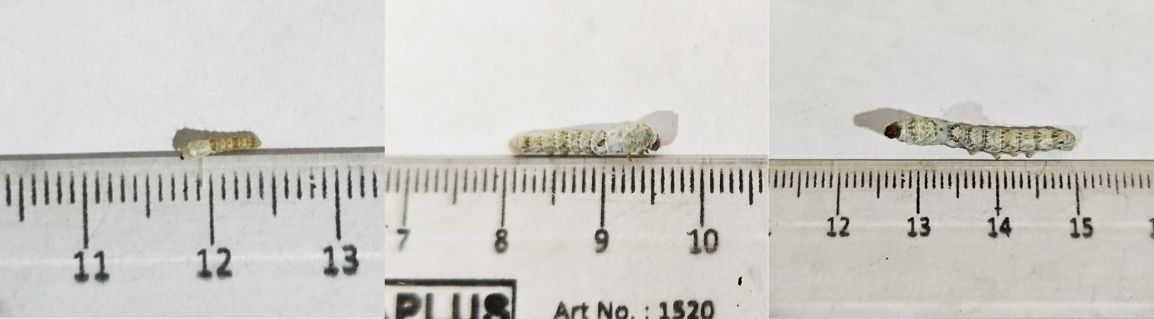
A
C
B

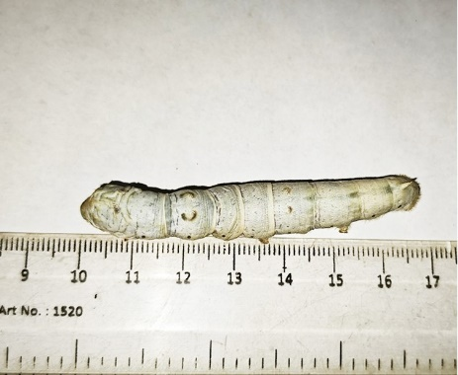
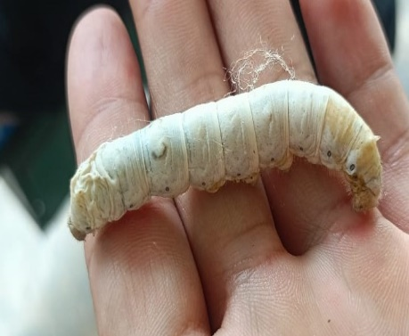
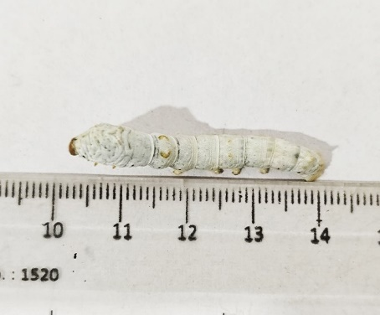
F
E
D

Figure 3: Different larval stages of bivoltine silkworm Bombyx mori (C004 breed). (A) 1st Instar, (B) 2nd Instar, (C) 3rd Instar, (D) 4th Instar, (E) 5th Instar, (F) Late 5th Instar
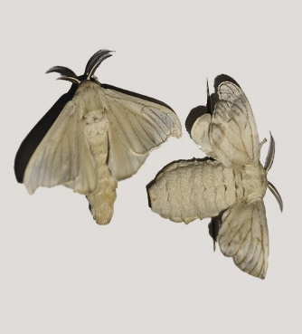
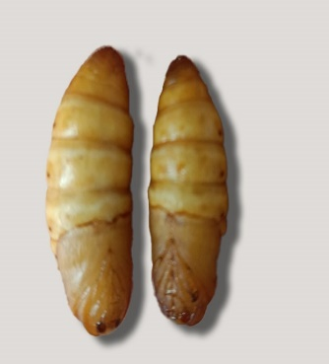
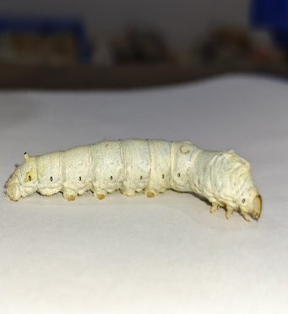
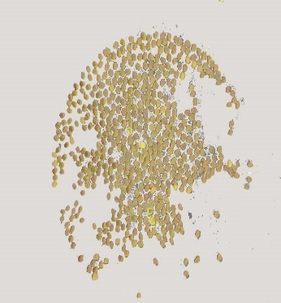
MOTH
PUPAE
LARVA
EGG
Figure 4: Life cycle of silkworm Bombyx mori.
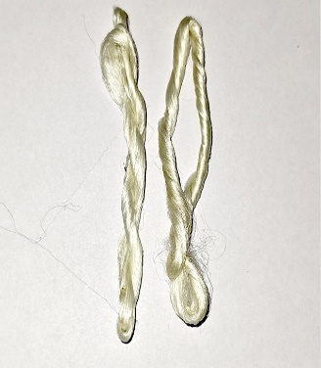
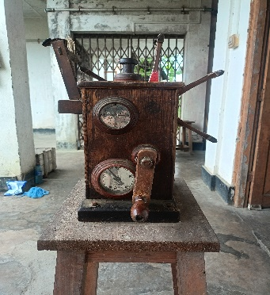
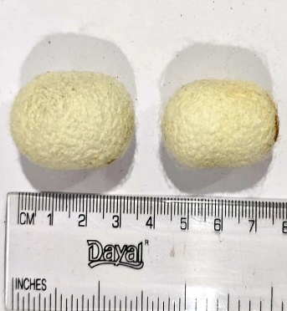
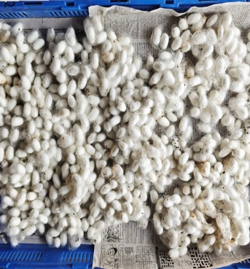

Figure 5: Cocoons reeled into thin filaments.

- Discussion
Since the bivoltine strain of China has been producing quality silk than the multivoltine, and the same has been well adapted to the studied sites, it is highly encouraged that farmers adopt the rearing of the bivoltine strain. There is variability in terms of duration and weight of the larval growth in two rearing sites, though they were located within the same climatic region. This suggests that the larval growth of cold-blooded silkworms is highly influenced by multiple factors, including photoperiod, temperature, and humidity. The role of temperature in larval growth has played a significant role, as reported by Rahmathulla (2011), and is consistent with the present finding. It requires maintaining an ambient temperature within the farming area. The study suggests that B. mori has well adapted and attains better growth in an area where there is high temperature and less humidity with an average photoperiod of 11- 12 hrs. The maintenance of the microclimatic zone in the niche development should be paid off in the rearing of the selected species. Besides, the quality of the shootlets that feed the silkworms significantly affects the larval growth and development, concomitant with the findings of Rayar et al., 2010, Mathur et al., 2002, Yokoyama 1974 etc. As reported, the freshness and high moisture content in the shootlet feed might enhance the digestion and make more nutrients available to the growing worm (Mathur et al., 2002, Dandin et al., 2000, Badiger and Patil, 1999). Miyashita et al., (1986) reported that the mulberry leaf and climatic factors are highly influenced in the successful qualitative and quantitative cocoon production than other traits accounted for best yield. Therefore, the existing instar larval growth variability among the two rearing sites might also be related to the moisture content of the shootlets, as the shootlets are grown in different microclimatic niches along with varying intensities of radiant energy. More water is required during the first and second instar periods of the silkworm. With the advancement of larval instar, the silkworms require mature mulberry leaves to obtain more protein and carbohydrates. It should be taken care to ensure the provided feed is right for the growing larva, feeding them tender ones at the initial stage and more mature ones at the late stages of the larva. However, in the present investigation, larval duration, weight of 10 mature larvae, moth emergence, silk productivity, filament length and renditta of the silkworms at two rearing sites show significant variability whereas other parameters such as fecundity, hatching %, effective rate of rearing, cocoon weight, shell weight, cocoon shell ratio, etc are found to be non-significant.
Though many factors surround the productivity of silkworms, the strains selected for silk production in the region are able to produce higher yields. The state has the pride andprivilege of rearing silkworms and pays off higher yields by manual, unskilled workers.

Being located in the extreme north eastern corner, most of the people living here are underprivileged due to poverty and lack of financial support. Such cultivars can grow their economy by producing silk on a large scale, but for this, they need financial support. These findings suggest that the Bombyx mori can cultivate in the region without using intensive high technology. Further studies can also focus on molecular analysis of the natural protein in the silk and its benefits when wearing silk on our skin.
- Conclusion:
This shows that the differences in environmental factors in two different zones of Manipur plays a significant role in larval growth, development and productivity. Overall, Wangkhei zone with more stable and optimal climatic condition showed superior rearing performance, highlighting the importance of location specific management practices.
- DISCLAIMER (ARTIFICIAL INTELLIGENCE)
Author(s) hereby declare that NO generative AI technologies such as Large Language Models (ChatGPT, COPILOT, etc) and text-to-image generators have been used during writing or editing of this manuscript.

- References
- Babu, K. M. (2019). Silk reeling and silk fabric manufacture. In *Silk (Second Edition)* (pp. 31-50). https://doi.org/10.1016/B978-0-08-102540-6.00002-4 .
- BADIGER, K. S. AND PATIL, G. M., 1999, Performance of chawki silkworms, Bombyx mori L. on leaf and shoot feeding of improved mulberry varieties. Proc. Nat. Sem. Trop. Seri., Banagalore, 2: 148-149.
- Banno, Y., Shimada, T., Kajiura, Z., & Sezutsu, H. (2010). The Silkworm—An Attractive BioResource Supplied by Japan. Experimental Animals, 59(2), 139-146. https://doi.org/10.1538/expanim.59.139
- Barber, E.J.W. (1992) Prehistoric Textiles: The Development of Cloth in the Neolithic and Bronze Ages with Special Reference to the Aegean. Princeton University Press, Princeton, 31.
- Biram, S. N. M., Tribhuwan, S., & Beera, S. (2009). Occurrence of Unfertilized Eggs in the Mulberry Silkworm, Bombyx mori (L.) (Lepidoptera: Bombycidae). International Journal of Industrial Entomology, 18, 1-7. https://koreascience.or.kr/article/JAKO200911020000101.page
- Buhroo, Z. I., Malik, M. A., Ganai, N. A., Kamili, A. S., & Mir, S. A. (2017). Rearing Performance of Some Popular Bivoltine Silkworm (Bombyx Mori L.) Breeds during Spring Season. Advances in Research. https://doi.org/10.9734/AIR/2017/32853
- Dandin SB, Jayant J, Giridhar K. Handbook of Sericulture Technologies. Central Silk Board, Bangalore, India, 2003.
- Fang, S. M., Zhou, Q. Z., Yu, Q. Y., & Zhang, Z. (2020). Genetic and genomic analysis for cocoon yield traits in silkworm. Scientific Reports. https://doi.org/10.1038/s41598-020-62507-9 .
- Hussain, M., Naeem, M., Khan, S. A., Bhatti, M. F., & Munawar, M. (2011). Studies on the influence of temperature and humidity on biological traits of silkworm (Bombyx mori L.; Bombycidae). African Journal of Biotechnology, 10(57), 12368–12375. https://doi.org/10.5897/AJB11.1805
- Ilyas, R. A., Asyraf, M. R. M., Sapuan, S. M., Afiq, T. M. N., Suhrisman, A., Atikah, M. S. N., & Ibrahim, R. (2021). Development of Roselle Fibre-Reinforced Polymer Biocomposite Mug Pad Using the Hybrid Design for Sustainability and Pugh Method. In *Roselle* (pp. 197-213). https://doi.org/10.1016/b978-0-323-85213-5.00002-0
- Kumar, P., Bhutia, R., & Ahsan, M. M. (1995). Estimates of genetic variability for commercial quantitative traits and selection indices in bivoltine races of mulberry silkworm (Bombyx mori L.). Indian Journal of Genetics and Plant Breeding, 55(02), 109–116. https://www.isgpb.org/
- Kumar, S., et al. (2012). “Tasar Silkworm: Biology, Ecology, and Silk Production.” Journal of Sericulture Research, 45(2), 123-135.
- Lakshmanan S. Adoption of technological innovations and productivity behavior of sericulture in Tamil Nadu. An econometric analysis. Ph.D. thesis, University of Mysore, Mysore, India; c1998.
- Malik GN, Kamili AS, Wani SA, Dar HU, Ahmad R, Sofi, AM. Evaluation of some bivoltine silkworm (Bombyx mori L.) genotypes. SKUAST Journal of Research. 2002;4:83-87.

- Malik, F.A., Reddy, Y.S., 2007. Role of mulberry nutrition on manifestation of post cocoon characters of selected races of the silkworm Bombyx mori L. Sericologia 47, 63–76.
- MATHUR, V. B., RAVI, H. K. AND RAHMATHULLA, V. K., 2002, Effect of shootlet feeding during young age of silkworm, Bombyx mori L. and its impact on cocoon production. Bull. Indian Acad. Seri., 6: 86-89.
- Miller, W. E. (2005). Extrinsic effects on fecundity-maternal weight relations in capital-breeding Lepidoptera. Journal of the Lepidopterists' Society, 59, 143–160. https://doi.org/10.5281/zenodo.16543349
- Mirhosseini, S. Z., Nematollahian, S., Ghanipoor, M., & Seidavi, A. R. (2010). Comparison of phenotypic and genetic performance of local silkworm groups and two commercial lines. Biological Research, 43(4), 411–416. https://doi.org/10.4067/S0716-97602010000400005 .
- Miyashita Y. (1986). A Report on Mulberry Cultivation and Training Methods Suitable to Bivoltine Rearing in Karnataka. Central Silk Board, Bangalore, India, pp. 1-7.
- Nguku, E. K., Muli, E. M., & Raina, S. K. (2007). Larvae, cocoon and post-cocoon characteristics of Bombyx mori L. (Lepidoptera: Bombycidae) fed on mulberry leaves fortified with Kenyan royal elly. Journal of Applied Sciences and Environmental Management, 11(4), 85–89. http://www.bioline.org.br/ja
- Qadri, S. F. A., Malik, M. A. Sabhat, A. and Malik, F. A. (2010).Adoption of improved Sericultural practices by Sericulturists in border area of Kashmir. International Journal of Agriculture Statistics and Sciences, 6 (1): 197-201.
- Rahmathulla, V. K. (2012). Management of climatic factors for successful silkworm (Bombyx mori L.) crop and higher silk production: A review. Psyche: A Journal of Entomology. https://doi.org/10.1155/2012/121234
- Rahmathulla, V. K. (2012). Management of Climatic Factors for Successful Silkworm (Bombyx mori L.) Crop and Higher Silk Production: A Review. Psyche: A Journal of Entomology https://doi.org/10.1155/2012/121234 .
- Ramesh, M., & Deepa, C. (2022). Applications of green composites for sustainable development. In Green Sustainable Process for Chemical and Environmental Engineering and Science. https://doi.org/10.1016/B978-0-323-99643-3.00005-X
- Rayar, S. G. (2010). Suitability of mulberry varieties for shootlet feeding to young age silkworm, Bombyx mori L. and its impact on cocoon production. *Mysore Journal of Agricultural Sciences*, *44*(2), 300-303. https://www.cabidigitallibrary.org/doi/10.1079/PA20100044
- Sasmal, A., et al. (2015). “Muga Silkworm: Ecology and Silk Production in Northeast India.” Journal of Sericulture and Apiculture, 56(3), 210-220.
- Abdelmegeed, S. M. (2015). Effect of mating duration and the number of females/male moth of Bombyx mori L. on eggs fertility. Annals of Agricultural Sciences, 60(2), 341-343. https://doi.org/10.1016/j.aoas.2015.10.008
- Seidavi, A.R., S.Z. Mirhosseini, M. Ghanipoor and A.R. Bizhannia, 2008. Comparison study on performance and grasserie disease resistance of some genetic combinations of silkworm in Iran. Modern Genet. J., 3: 21-28.

- Singh, A., Sharma, R. K., & Sharma, B. (2010). Low temperature induced alterations in certain biochemical constituents of 5th instar larvae of Philosamia ricini (Lepidoptera: Satunidae). Open Access Insect Physiology. https://doi.org/10.2147/OAIP.S11745
- India Brand Equity Foundation. (2024). Silk Industry and Export in India. https://www.ibef.org/exports/indian-silk-industry .
- Singh, T., Bhat, M., & Khan, M. (2011). Critical analysis of correlation and heritability phenomenon in the silkworm, Bombyx mori (Lepidoptera: Bombycidae). Advances in Bioscience and Biotechnology. https://doi.org/10.4236/abb.2011.25051 .
- Yokoyama. Text Book of Tropical Sericulture. Japan Overseas Cooperation Volunteer, Tokyo, Japan, 1974, 444-537.

