Original Research Article
Integrative Assessment of Avian Diversity in Wetland Ecosystems: Application of Multiple Alpha and Beta Diversity Indices over a Longitudinal Study

ABSTRACT
The present study conducted for 36 months from January 2022 to December 2024, and created a first comprehensive avian survey of Koothiyarkundu water tank, documenting 110 bird species spanning 14 orders and 46 families. The assessment identified six Near threatened and one Vulnerable species according to IUCN. Residential analysis revealed 81 resident birds, alongside 23 winter visitors, one local migrant, and five non-breeding residents, including notable long-distance migrants such as bar-tailed and black-tailed godwits. Feeding guild analysis revealed 40 insectivores, 33 carnivores, 18 omnivores, 10 granivores, 6 frugivores, and 3 nectarivores, illustrating diverse ecological niches supported by the wetland. Bird species richness and abundance increased over time, with observed species rising from 85 to 110 and individual counts exceeding 1,200. Diversity indices showed upward trends, Margalef’s index peaked at 15.02, Fisher alpha at 31.30. Shannon-Wiener diversity improved from 3.3 to 3.9, with evenness improving 0.4 to 0.6, while dominance indices (Dominance D and Berger-Parker) declined, indicating reduced species dominance and enhanced community balance. Beta diversity analysis using Whittaker (0.35) and Wilson-Shmida (27.2) indices highlighted spatial turnover and compositional heterogeneity within the assemblage. Urban encroachment posed significant threats, particularly to migratory species’ habitats, emphasizing the urgent need for protective buffer zones. Effective conservation demands integrated wetland zoning that combines core protected areas with multifunctional buffer and sustainable use zones to safeguard critical bird habitats and maintain ecological integrity. This comprehensive dataset establishes a crucial baseline for monitoring and managing avian diversity in this wetland ecosystem.
Keywords: Urban ecology, Biodiversity, Madurai, Species richness patterns, Habitat heterogeneity, Wetland management.

1.INTRODUCTION
Biodiversity is, in essence, a comparative science (Magurran, 2004). Birds respond quickly and measurably to habitat alteration, pollution, hydrological change and climate shifts. Therefore, changes in their richness, abundance and community composition are widely used as indicators of ecosystem health. (Cooper, 2023; Bharathi et al, 2025). Birds, irrespective of their taxonomic classification, rely on wetlands for drinking, bathing, roosting, and protection. The relationship between wetlands and birds is bidirectional because wetland characteristics (size, depth, hydroperiod, vegetation, and food resources) filter which bird assemblages can persist, while bird activities such as seed dispersal and others; influences wetland plant communities and nutrient dynamics. Consequently, patterns of avian species richness and community structure in wetlands both reflect underlying wetland condition and contribute to the long-term maintenance of wetland biodiversity and function (Ganjeh et al, 2017; Kiran et al, 2022; Pant et al,2024). The diversity of a landscape is determined by both α and β diversity. The alpha (α) diversity measures the richness and evenness of individuals within a habitat, while beta (β) diversity measures the diversity of the species across different habitats (Dauda et al., 2016). Additionally, turnover through time provides insight into the temporal dynamics of assemblages (Magurran, 2004). At this study site, avian diversity was systematically surveyed and a comprehensive species checklist was developed for the water tank habitat. To quantify the observed diversity beyond simple species counts, multiple diversity indices were applied, providing a robust and quantitative assessment of community structure. This statistical approach enables not only understanding of the current diversity but also offers tools to detect potential declines in abundance or species richness over time. When combined with observations of anthropogenic threats, these analyses provide a comprehensive picture of how avian diversity is changing in the Koothiyarkundu water tank. Such integrated assessment is essential for guiding effective conservation and management strategies. Fig 1: Geographical representation of the study sites within Madurai
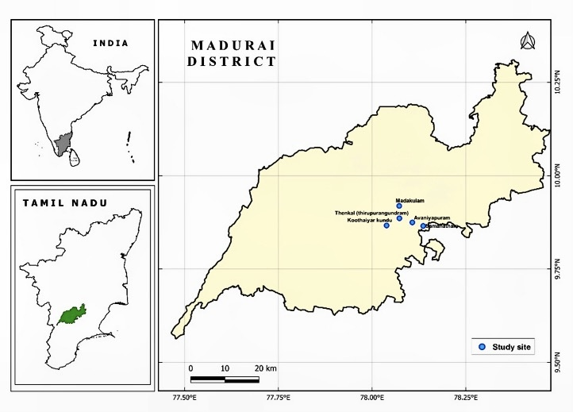
2.METHODOLOGY
2.1 Study Site
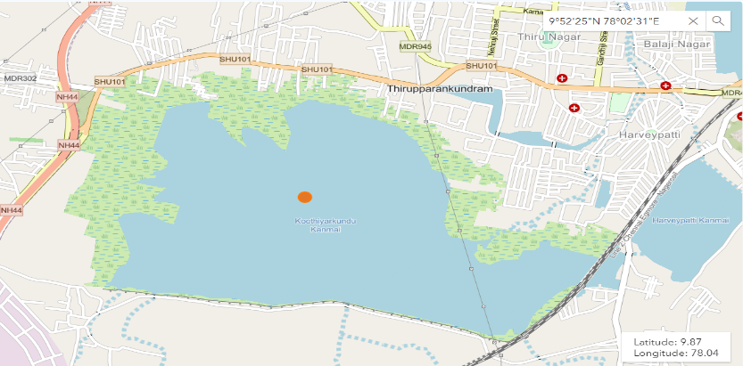
Madurai, referred to as the ‘Athens of the East’, is the second largest corporation city by area and third largest city by population in Tamil Nadu. There are 1338 traditional ‘kanmais’ (man-made tanks) in Madurai which are mostly semi-arid (District administration, Madurai 2024). Among them, five wetlands have been chosen for the study which are situated in the south of Madurai (Fig .1). The present study focuses on the study site named, Koothiyarkundu [(9.8646° N, 78.0288° E)], historically known as Chaturvedi Mangalam (Rajagopal, 2023), which is about 176.22 hectares (Fig. 2), is a village in the Thirupparankundram block of Madurai district, Tamil Nadu. The region is known for its water bodies, including tanks and lakes, which play a crucial role in local water management and irrigation (madurai.nic.in). The study site was chosen based on several factors, such as, availability of water, accessibility, anthropogenic activities, and existence of a significant bird population, all of which were assessed prior to the commencement of the study as prerequisites.
Fig 2: Satellite image of the study site, showing the location of the Koothiyarkundu water tank area

2.2 Avian Survey
Bird surveys were conducted systematically over 36 months from January 2022 to December 2024, with visits three times each month at the water tank. Observations were carried out between 7 a.m. and 10 a.m., when birds are most active. The primary focus was on wetland birds, followed by terrestrial birds. The point count method, as described by Gregory et al, (2004) served as the standard protocol and used audio recordings of bird calls following Whitman et al.'s (1997) guidelines. The study area consists of 10 to 15 fixed scanning points spaced 150 to 250 meters apart, and birds were observed using field binocular (Olympus 10X50) and a camera (Sony Cybershot DSC-HX400v). Bird identification was done using field guides by Salim Ali’s Book of Indian Birds (2003), alongside digital tools such as Merlin Bird ID application and ebird (Cornell Lab of Ornithology).
2.3 Biodiversity Analysis
To quantitatively characterize the avian community structure, multiple diversity indices were calculated, encompassing measures of species richness, diversity, evenness, dominance, and temporal turnover.
Alpha diversity metrics included, Margalef Index, Fisher Alpha Index, which were used to assess species richness, Shannon-Wiener Index, Pielou's Evenness Index (J'), Dominance D and Berger-Parker Index were calculated to quantify species diversity, incorporating both richness and evenness components. Beta diversity metrics were employed to assess species turnover across the three study years. Whittaker Beta Diversity (βW) quantified overall compositional differentiation and Wilson-Shmida Index (βT) measured temporal species turnover standardized by mean annual species richness, providing insight in community dynamics across years (Magurran, 2004).
All diversity indices were computed using PAST software (version 4.03), which implements standard formulas as described in Magurran (2004). This analytical approach enabled robust quantitative evaluation of avian community structure and temporal changes in biodiversity at the study site.

Fig. 3: Distribution of Bird Families and Species by Taxonomic Order at Koothiyarkundu Tank (2022–2024)

Fig. 4: IUCN Conservation Status of Bird Species Recorded at Koothiyarkundu Tank (2022–2024)

3.Results & Discussion
3.1 Avian Diversity
The present study has been conducted for 36 months from January 2022 to December 2024 and a cumulative assessment revealed a total of 110 bird species (Table I) in Koothiyarkundu water tank. For the documented species, a checklist has been created which is the first documentary inventory for the site. Taxonomic distribution of the observed species belonged to 14 orders and 46 families. Among the 14 orders, the order Passeriformes had been the most prevalent with 37 species across 20 families (Fig. 3), followed by the order Pelecaniformes and Charadriiformes, which consists mostly of water-dependent species also known to be obligate aquatic feeders (biodb.com). Multi-faceted factors like habitat stability & characteristics such as water depth, spatial heterogeneity, vegetative structure, prey availability are crucial elements for waterbird assemblages, which likely contributed the prevalence of the waterbirds in the study site. (Mott et al, 2023; Marnn et al, 2025).
Fig. 5: Residential Status of Bird Species at Koothiyarkundu Tank (2022–2024)

The IUCN status analysis revealed six species from Near Threatened (NT) category such as, one species from Vulnerable category. The remaining 104 species belonged to Least Concern (LC) category (Fig. 4) (IUCN, 2024). The presence of threatened and vulnerable species signals the habitats’ ecological importance as these species require restricted habitat. It also signifies the tanks’ ecological resilience and functionality (Bouregbi et al, 2025).
The residential status analysis revealed 81 species as residents, 23 as winter visitors, 1 as local migrant and 5 as non-breeding residents (Fig. 5). This composition exhibits the tanks role as a vital habitat for both breeding residents and migratory birds, notably long-distance migrants like Bar-tailed Godwits and Black-tailed Godwits. The presence of such species in huge congregations, suggests that this site is a critical stopover with sufficient resources.
According to the analysis of the structure of feeding guild, insectivores emerged as the dominant group with 40 species, followed by carnivores with 33 species, omnivores with 18 species, granivores with 10 species, frugivores and nectarivores with 6 & 3 species respectively (Fig. 6). Such varied feeding guilds reflect the tanks heterogeneity of microhabitats, ranging from open water zones to vegetated margins and adjacent agricultural areas.

Fig. 6: Feeding Guild Distribution of Avian Species at Koothiyarkundu Tank (2022–2024)

Table I: Checklist of Birds Observed in Koothiyarkundu Tank
S. No: | Order Name/ Family Name/ Common Name | Scientific Name | IUCN Status | Residential Status |  | Guild | Relative abundance
Accipitriformes: Accipitridae
 | Black kite | Milvus migrans | LC |  | R | C | C
 | Booted Eagle | Hieraaetus pennatus | LC |  | WV | C | UC
 | Greater Spotted Eagle | Clanga clanga | VU |  | WV | C | UC
 | Pallid Harrier | Circus macrourus | NT |  | WV | C | Ra
 | Shikra | Accipiter badius | LC |  | R | C | C
Anseriformes: Anatidae
 | Fulvous Whistling Duck | Dendrocygna bicolor | LC |  | LM | O | C
 | Eurasian Wigeon | Mareca penelope | LC |  | WV | O | UC
 | Garganey | Spatula querquedula | LC |  | WV | O | UC
 | Green Winged Teal | Anas crecca | LC |  | WV | O | UC
 | Indian Spot-billed Duck | Anas poecilorhyncha | LC |  | R | O | C
 | Knob-billed Duck | Sarkidiornis melanotos | LC |  | R/NB | O | UC
 | Lesser Whistling Duck | Dendrocygna javanica | LC |  | R/NB | O | C
 | Northern Pintail | Anas acuta | LC |  | WV | O | Ra
 | Northern Shoveler | Spatula clypeata | LC |  | WV | O | UC
Bucerotiformes: Upupidae
 | Eurasian Hoopoe | Upupa epops | LC |  | R | I | UC
Podicipedidae
 | Little Grebe | Tachybaptus ruficollis | LC |  | R | C | C
Caprimulgiformes: Apodidae
 | Asian Palm Swift | Cypsiurus balasiensis | LC |  | R | I | C
 | Alpine Swift | Tachymarptis melba | LC |  | R | I | UC
Charadriiformes: Charadriidae
 | Little Ringed Plover | Charadrius dubius | LC |  | WV | I | UC
 | Red-wattled Lapwing | Vanellus indicus | LC |  | R | O | C
Laridae
 | Gull-billed Tern | Gelochelidon nilotica | LC |  | WV | C | Ra
 | Whiskered Tern | Chlidonias hybrida | LC |  | WV | C | UC
Recurvirostridae
 | Black Winged Stilt | Himantopus himantopus | LC |  | R | I | C
Scolopacidae
 | Bar Tailed Godwit | Limosa lapponica | NT |  | WV | I | UC
 | Black Tailed Godwit | Limosa limosa | NT |  | WV | I | UC
 | Common Sandpiper | Actitis hypoleucos | LC |  | WV | I | UC
 | Common Snipe | Gallinago gallinago | LC |  | WV | I | UC
 | Green Sandpiper | Tringa ochropus | LC |  | WV | I | UC
 | Marsh Sandpiper | Tringa stagnatilis | LC |  | WV | I | UC
 | Pin Tailed Snipe | Gallinago stenura | LC |  | WV | I | UC
 | Wood Sandpiper | Tringa glareola | LC |  | WV | I | UC
Columbiformes: Columbidae
 | Eurasian Collared Dove | Streptopelia decaocto | LC |  | R | G | C
 | Laughing Dove | Spilopelia senegalensis | LC |  | R | G | C
 | Rock Pigeon | Columba livia | LC |  | R | G | C
 | Spotted Dove | Spilopelia chinensis | LC |  | R | G | C
Coraciiformes: Alcedinidae
 | Common Kingfisher | Alcedo atthis | LC |  | R | C | C
 | Pied Kingfisher | Ceryle rudis | LC |  | R | C | C
 | White Throated Kingfisher | Halcyon smyrnensis | LC |  | R | C | C
Coraciidae
 | Indian Roller | Coracias benghalensis | LC |  | R | I | C
Meropidae
 | Asian Green Bee-eater | Merops orientalis | LC |  | R | I | UC
 | Blue Tailed Bee-eater | Merops philippinus | LC |  | R | I | C
Cuculiformes: Cuculidae
 | Asian Koel | Eudynamys scolopaceus | LC |  | R | O | C
 | Blue Faced Malkoha | Phaenicophaeus viridirostris | LC |  | R | O | C
 | Common Hawk Cuckoo | Hierococcyx varius | LC |  | R | O | Ra
 | Greater Coucal | Centropus sinensis | LC |  | R | C | C
 | Pied Cuckoo | Clamator jacobinus | LC |  | R | I | C
Galliformes: Phasianidae
 | Gray Francolin | Ortygornis pondicerianus | LC |  | R | G | C
 | Indian Peafowl | Pavo cristatus | LC |  | R | O | C
Gruiformes: Rallidae
 | Eurasian Coot | Fulica atra | LC |  | R | C | C
 | Eurasian Moorhen | Gallinula chloropus | LC |  | R | C | C
 | White Breasted Waterhen | Amaurornis phoenicurus | LC |  | R | C | C
Passeriformes: Acrocephalidae
 | Blyth’s Reed Warbler | Acrocephalus dumetorum | LC |  | R/NB | I | UC
 | Booted Warbler | Iduna caligata | LC |  | R | I | C
Alaudidae
 | Jerdon’s Bushlark | Mirafra affinis | LC |  | R | I | C
 | Oriental Skylark | Alauda gulgula | LC |  | R | I | C
Artamidae
 | Ashy Woodswallow | Artamus fuscus | LC |  | R | I | C
Cisticolidae
 | Ashy Prinia | Prinia socialis | LC |  | R | I | C
 | Common Tailorbird | Orthotomus sutorius | LC |  | R | I | C
 | Jungle Prinia | Prinia sylvatica | LC |  | R | I | C
 | Plain Prinia | Prinia inornata | LC |  | R | I | C
 | Zitting Cisticola | Cisticola juncidis | LC |  | R | I | C
Corvidae
 | House Crow | Corvus splendens | LC |  | R | O | C
 | Large Billed Crow | Corvus macrorhynchos | LC |  | R | O | C
 | Rufous Treepie | Dendrocitta vagabunda | LC |  | R | O | C
Dicruridae
 | Black Drongo | Dicrurus macrocercus | LC |  | R | I | C
Estrildidae
 | Indian Silverbill | Euodice malabarica | LC |  | R | G | C
 | Scaly-breasted Munia | Lonchura punctulata | LC |  | R | G | C
 | Tricolored Munia | Lonchura malacca | LC |  | R | G | C
Hirundinidae
 | Barn Swallow | Hirundo rustica | LC |  | WV | I | C
Laniidae
 | Brown Shrike | Lanius cristatus | LC |  | WV | I | C
Leiothrichidae
 | Yellow-billed Babbler | Argya affinis | LC |  | R | I | C
Monarchidae
 | Indian Paradise Flycatcher | Terpsiphone paradisi | LC |  | R/NB | I | UC
Motacillidae
 | Paddyfield Pipit | Anthus rufulus | LC |  | R | I | C
 | Western Yellow Wagtail | Motacilla flava | LC |  | WV | I | UC
 | White-browed Wagtail | Motacilla maderaspatensis | LC |  | R | I | C
 | White Wagtail | Motacilla alba | LC |  | WV | I | Ra
Muscicapidae
 | Indian Robin | Copsychus fulicatus | LC |  | R | I | C
 | Oriental Magpie Robin | Copsychus saularis | LC |  | R | I | C
 | Pied Bushcat | Saxicola caprata | LC |  | R | I | C
Nectariniidae
 | Loten’s Sunbird | Cinnyris lotenius | LC |  | R | N | UC
 | Purple Rumped Sunbird | Leptocoma zeylonica | LC |  | R | N | C
 | Purple Sunbird | Cinnyris asiaticus | LC |  | R | N | C
Oriolidae
 | Indian Golden Oriole | Oriolus kundoo | LC |  | R | O | UC
Passeridae
 | House Sparrow | Passer domesticus | LC |  | R | G | C
Ploceidae
 | Baya Weaver | Ploceus philippinus | LC |  | R | G | C
Pycnonotidae
 | Red Vented Bulbul | Pycnonotus cafer | LC |  | R | F | C
Sturnidae
 | Brahminy Starling | Sturnia pagodarum | LC |  | R | F | UC
 | Common Myna | Acridotheres tristis | LC |  | R | F | C
Vangidae
 | Common Woodshrike | Tephrodornis pondicerianus | LC |  | R | I | Ra
Pelecaniformes: Anhingidae
 | Oriental Darter | Anhinga melanogaster | NT |  | R | C | UC
Ardeidae
 | Cattle Egret | Bubulcus ibis | LC |  | R | C | C
 | Great Egret | Ardea alba | LC |  | R | C | C
 | Gray Heron | Ardea cinerea | LC |  | R | C | C
 | Indian Pond Heron | Ardeola grayii | LC |  | R | C | C
 | Intermediate Egret | Ardea intermedia | LC |  | R | C | C
 | Little Egret | Egretta garzetta | LC |  | R | C | C
 | Purple Heron | Ardea purpurea | LC |  | R | C | C
 | Yellow Bittern | Ixobrychus sinensis | LC |  | R/NB | C | UC
Ciconiidae
 | Asian Openbill Stork | Anastomus oscitans | LC |  | R | C | C
 | Painted Stork | Mycteria leucocephala | NT |  | R | C | C
Pelecanidae
 | Spot Billed Pelican | Pelecanus philippensis | NT |  | R | C | C
Phalacrocoracidae
 | Great Cormorant | Phalacrocorax carbo | LC |  | R | C | C
 | Indian Cormorant | Phalacrocorax fuscicollis | LC |  | R | C | C
 | Little Cormorant | Microcarbo niger | LC |  | R | C | C
Threskiornithidae
 | Black-headed Ibis | Threskiornis melanocephalus | NT |  | R | C | C
 | Eurasian Spoonbill | Platalea leucorodia | LC |  | R | C | C
 | Glossy Ibis | Plegadis falcinellus | LC |  | R | C | C
Piciformes: Megalaimidae
 | Coppersmith Barbet | Psilopogon haemacephalus | LC |  | R | F | C
Picidae
 | Black Rumped Flameback | Dinopium benghalense | LC |  | R | F | C
Psittaciformes: Psittacidae
 | Rose-ringed Parakeet | Psittacula krameri | LC |  | R | F | C
LC- Least Concerned, NT- Near Threatened, VU- Vulnerable, R- Resident, WV- Winter Visitor, R/NB- Non-Breeding Residents, LM- Local Migrant, I- Insectivore, C- Carnivore, O-Omnivore, G-Granivore, F-Frugivore, N-Nectivore, C-Common, UC- Uncommon, Ra- Rare
3.2 Diversity Indices
In addition to the assessment of avian diversity in the study site, the present study also examined the seasonal variations and interannual trends in species richness, abundance and subjected it to diversity indices to understand the ecological dynamics. The mean values of species richness exhibited an upward trend ranging between 85 species to 110 species from 2022 to 2024. Similarly, the number of individuals peaked at 1200+ individuals. However, there was a slight dip in individual numbers in 2024, which most likely due to environmental factors like lesser rainfall, lower water levels. Overall, highest species and abundance was observed during pre-monsoonal months (Fig. 7 & 8).
Fig. 8: Temporal Variation in the number of individual birds observed at Koothiyarkundu tank (2022 -2024)

Fig. 7: Temporal variation in the number of bird species observed in Koothiyarkundu tank (2022 -2024)

Table II: Alpha Diversity Indices
DIVERSITY INDEX | WINTER | PRE-MONSOON | MONSOON | POST-MONSOON
Margalef
2022 | 8.93 | 11.59 | 11.96 | 12.41
2023 | 12.57 | 12.65 | 11.3475 | 11.89
2024 | 14.45 | 15.02 | 11.97 | 13.41
Fisher_alpha
2022 | 19.63 | 22.70 | 27.66 | 29.11
2023 | 24.26 | 23.58 | 23.91 | 24.58
2024 | 31.30 | 30.97 | 26.01 | 30.95
Shannon
2022 | 3.36 | 3.50 | 3.77 | 3.80
2023 | 3.75 | 3.80 | 3.75 | 3.72
2024 | 3.86 | 3.94 | 3.74 | 3.81
Evenness
2022 | 0.59 | 0.44 | 0.62 | 0.61
2023 | 0.50 | 0.51 | 0.62 | 0.56
2024 | 0.51 | 0.51 | 0.58 | 0.56
Dominance_D
2022 | 0.03 | 0.04 | 0.02 | 0.02
2023 | 0.03 | 0.02 | 0.02 | 0.02
2024 | 0.02 | 0.02 | 0.02 | 0.02
Berger-Parker
2022 | 0.09 | 0.12 | 0.06 | 0.06
2023 | 0.08 | 0.06 | 0.06 | 0.06
2024 | 0.07 | 0.06 | 0.06 | 0.07
Table III: Beta Diversity Indices
INDEX | VALUES OBTAINED
Whittaker | 0.35
Wilson-Shmida | 27.22
Both Margalef’s and Fisher Alpha indices showed an increased values from 2022-2024, indicating the observed growth in species richness. Peak values observed at 15.02 & 31.30 for Margalef & Fisher Alpha respectively in 2024. Shannon-Weiner index values ranged between 3.3 and 3.9 from 2022 to 2024 and Evenness ranged between 0.44 in 2022 to 0.6 in 2024. This suggests moderate to highly diverse and equitable bird species in the study site. Dominance (D) values decreased from 0.04 in 2022 to 0.02 in 2024, which aligns with the above increased values of Shannon and evenness from 2022 to 2024, indicating less monopolization by few dominant species over the years (Magurran, 2004). Berger-Parker dominance index was also evaluated to obtain a fuller picture and it exhibited a downward trend from 0.12 (2022) to 0.06 (2024) which supports the observed increase in species diversity and reduced dominance. Seasonal variations revealed post-monsoon, winter & pre-monsoon recorded high diversity. Lowest diversity index values were observed in monsoonal months (Table II). Beta diversity analysis involved two indices such as Whittaker’s index& Wilson-Shmida index, which examines species turnover and compositional heterogeneity between years. The Whittaker index value (βW=0.35) indicated relatively low overall differentiation in species composition across the three years, suggesting the presence of a stable core avifaunal assemblage persisting through time. However, the Wilson-Shmida index (βT=27.2) (Table III), which standardizes species gains and losses by mean species richness, revealed considerable species turnover between years (2022,2023,2024). This demonstrates that, while the core community remains largely constant, there is substantial replacement among a subset of species between years. Together, these indices reveal a dynamic community structure characterized by temporal stability in dominant species alongside notable fluctuations in transient species.
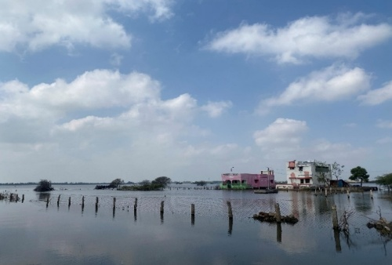
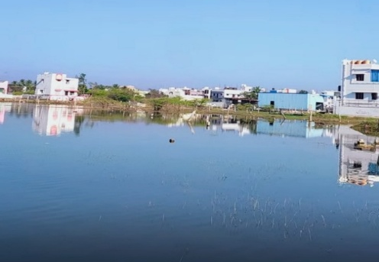
3.3 Anthropogenic Pressures and the threat of urban encroachment
Fig. 9: Plots & Residential Buildings constructed within the water tank

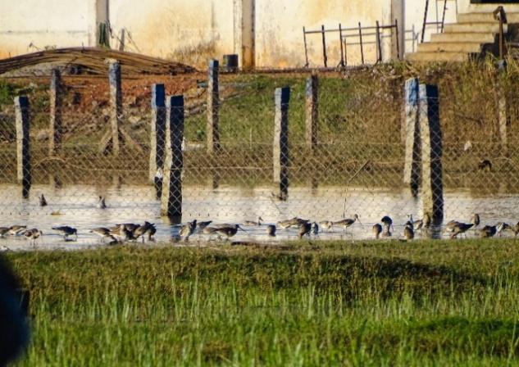
Urban encroachment poses a severe threat to the ecosystem health of this water tank. In particular, expansion of residential buildings into the tank ecosystem. The construction of plots and buildings within the tank area has drastically altered the landscape, diminishing available habitat for both local and migratory species. Notably, during the post-monsoon and winter months, the site becomes an island, with water surrounding the newly constructed buildings (Fig. 9). This particular section of the tank has historically served as a crucial stopover site, especially for long-distance migrants like the Bar-tailed Godwit (Limosa lapponica) and Black-tailed Godwit (Limosa limosa) (Fig. 10). Prior analyses confirm peak migratory bird activity during February, March, and April, highlighting this wetland’s critical role as a refuelling and resting site for birds undertaking long journeys. Literature review suggests that urban expansion, infrastructure development leads to habitat fragmentation & destruction which is the major threats faced by wetland-dependent birds (Sun et al, 2022; Singh et al, 2025). Though population is stable in the study site, other studies have documented population declines, community composition changes and reduced biodiversity at sites experiencing rapid urbanization (Xu et al, 2022; Rahlin et al, 2022; Yusuf, 2024). Effective wetland conservation requires integrated zoning that combines protected core areas, surrounding buffer zones and functional zoning that prioritizes critical habitats for birds while allowing sustainable use in outer areas (Ramsar Convention Secratariat, 2010; Zhang et al, 2022).
Fig. 10: Long-distance Migratory birds, Bar-tailed & Black-tailed Godwit, observed in the same part of the water tank

4. Conclusion
The present study underscores the ecological significance of Koothiyarkundu water tank, documenting a total of 110 bird species, including six Near Threatened and One Vulnerable species. The tank serves as a critical stopover for migratory birds with 23 winter visitors in huge congregations. Diversity indices revealed consistently high dynamic community structure with stable population throughout the study period. Despite the current stability in bird populations, the increasing threat of urban encroachment poses a serious risk to the ecological integrity of this habitat. The expansion of infrastructure and associated disturbances can lead to habitat fragmentation and degradation which are known drivers of population declines globally. Given the tanks ecological importance, immediate implementation of conservation zoning is crucial to safeguard its biodiversity and ecological functions.

References
- Magurran, A. E. (2004). Measuring biological diversity. Blackwell Publishing. https://www.wiley.com/en-us/Measuring+Biological+Diversity-p-9780632056330

- Cooper E. 2023. Birds and Biodiversity: The Vital Role of Birds in Ecosystem Function. Research & Reviews: Journal of Zoological Science. https://doi.org/10.4172/2321-6190.11.2.007
- Bharathi, A & Thasnim, MS & Veronica, C & Madhumitha, S & Rajadurai, G. (2025). Feathered allies as bioindicators and agents for sustainable agriculture. International Journal of Agriculture and Food Science. 7. 396-400. https://doi.org/10.33545/2664844X.2025.v7.i7e.537
- Jahanbakhsh Ganjeh, M., Khorasani, N., Morshedi, J., Danehkar, A., & Naderi, M. (2017). Factors influencing abundance and species richness of overwintered waterbirds in Parishan international wetland in Iran. Applied Ecology & Environmental Research, 15(4). https://doi.org/10.15666/aeer/1504_15651579
- Yodha, K., Singh, D., Kour, A., Priya., Delu, V., & Kumar, R., Punia, N., & Sunita. (2022). Different strategies adopted by birds to sustain ecosystem: A review. The Pharma Innovation. SP-11. 412-422. https://www.thepharmajournal.com/archives/2022/vol11issue9S/PartF/9-10-6-848.pdf
- Pant, S. R., Bhattarai, B. P., Baral, H. S., & Thapa, T. B. (2024). Diversity, species richness, and community composition of wetland birds in the lowlands of western Nepal. Ecology and Evolution, 14(12), e70538. https://doi.org/10.1002/ece3.70538
- Dauda, T. O., Hafiz, M. B., & Anuara, M. S. S. (2016). Birds’ species diversity measurement of Uchali Wetland (Ramsar site) Pakistan. Journal of Asia-Pacific Biodiversity, 30, 1e9. https://doi.org/10.1016/j.japb.2016.06.011
- Government of Tamil Nadu. (n.d). Madurai https://madurai.nic.in/district-profile/
- Rajagopal. (2023). Vijayanagar inscriptions around Madurai temples-a historical review. Proceedings of One Day State Level Conference on Vijayanagar Rule in Tamilnadu.132-151. https://www.researchgate.net/publication/379201974_VIJAYANAGAR_INSCRIPTIONS_AROUND_MADURAI_TEMPLES-A_HISTORICAL_REVIEW/fulltext/660424653e07d7301c238b97/VIJAYANAGAR-INSCRIPTIONS-AROUND-MADURAI-TEMPLES-A-HISTORICAL-REVIEW.pdf
- District, Government of Tamil Nadu, Athen of the East. Retrieved from https://madurai.nic.in/
- Gregory, R. D., Gibbons, D. W., & Donald, P. F. (2004). Bird census and survey techniques. Bird ecology and conservation, 17-56. https://doi.org/10.1093/acprof:oso/9780198520863.003.0002
- Whitman, A. A., Hagan III, J. M., & Brokaw, N. V. (1997). A comparison of two bird survey techniques used in a subtropical forest. The Condor, 99(4), 955-965. https://doi.org/10.2307/1370146
- Ali, S. (2003) Book of Indian Birds. Bombay Natural History Society.
- Mott, R., Prowse, T. A., Jackson, M. V., Rogers, D. J., O'Connor, J. A., Brookes, J. D., & Cassey, P. (2023). Measuring habitat quality for waterbirds: A review. Ecology and Evolution, 13(4), e9905. https://doi.org/10.1002/ece3.9905
- Marnn, P., Ali, H., Jiang, H., Liu, Y., Li, Z., Ahmed, S., ... & He, C. (2025). Modeling the Impact of Ecological Restoration on Waterbird Diversity and Habitat Quality in Myanmar’s Moe Yun Gyi Wetland. Biology, 14(5), 519. https://doi.org/10.3390/biology14050519
- Bouregbi, I., Bensakhri, Z., Zebsa, R., Zouaimia, A., Bensouilah, S., Bouteraa, O., ... & Houhamdi, M. (2025). Threatened Birds in a Changing Mediterranean Wetland: Long-Term Trends and Climate-Driven Threats. Life, 15(6), 892. https://doi.org/10.3390/life15060892
- Sun, B., Lu, Y., Yang, Y., Yu, M., Yuan, J., Yu, R., ... & Li, J. (2022). Urbanization affects spatial variation and species similarity of bird diversity distribution. Science Advances, 8(49), eade3061. https://doi.org/10.1126/sciadv.ade3061
- Singh, D. P., Padhi, G. R., Kumari, R., Ram, R. K., Kumar, P. and Mogalekar, H. S. 2025. Ramsar Sites in India: Conservation Challenges and Management Strategies. Vigyan Varta 6 (6): 75-80. https://www.vigyanvarta.in/
- Xu, Q., Zhou, L., Xia, S., & Zhou, J. (2022). Impact of urbanisation intensity on bird diversity in river wetlands around Chaohu Lake, China. Animals, 12(4), 473. https://doi.org/10.3390/ani12040473
- Rahlin, A. A., Saunders, S. P., & Beilke, S. (2022). Spatial drivers of wetland bird occupancy within an urbanized matrix in the upper midwestern United States. Ecosphere, 13(9), e4232. https://doi.org/10.1002/ecs2.4232
- Yusuf, A. (2024). Impact of urban expansion on migratory birds in the Lagos wetlands: breeding habits and population dynamics. Studies in Social Science & Humanities, 3(5), 1-5. https://doi.org/10.56397/SSSH.2024.05.01
- Zhang, J., Xiong, K., Liu, Z., & He, L. (2022). Research progress on world natural heritage conservation: its buffer zones and the implications. Heritage Science, 10(1), 102. https://doi.org/10.1186/s40494-022-00744-z
- Ramsar Convention Secretariat. (2010). Managing wetlands: Frameworks for managing Wetlands of International Importance and other wetland sites (Ramsar handbooks for the wise use of wetlands, 4th ed., Vol. 18). https://www.ramsar.org/resources/handbook-18-managing-wetlands

