BUBBLE TEST- A PROGNOSTIC INDICATOR TO IDENTIFY THE LUNG MATURITY IN NEONATAL PUPS

Abstract:
The present investigation was carried out in P.V.Narasimha raoTelangana Veterinary University, Veterinary Clinical complex, C.V.Sc, Rajendranagar. A total of 12 dogs belonging to five different breeds were selected for the study and was divided into two groups (Group I and II) of six each. The first samples of amniotic fluid from 6 pregnant dogs were collected through amniocentesis on day 63 or the last day of pregnancy. Amniotic fluid samples were analysed for the presence of lung surfactant, using bubble test. Bubble test prognostic indicator in newborns diagnosing death due to Respiratory Disstress Syndrome.
Keywords: Amniotic fluid, Bubble test, RDS, Neonatal pups, pregnant bitches, Amniocentesis
Introduction
Emergency caesarean is the only alternative for majority of pregnant dogs suffer with dystocia (Bergstrom et al, 2006), though there is a higher risk for dam & neonate as well (Moon et al., 2000). Elective caesarean section (C-section) is an alternate approach but, with the risk of delivery of premature foetuses. Though not fully understood about the mechanism during final days of pregnancy, some essential changes occur that help the future neonate adapt to the extra-uterine environment and enable its survival without difficulty (Concannon et al, 1989). Rise in foetal adrenocorticosteroids and the decrease of progesterone concentration during the final period of pregnancy are associated with the maturation of vital organs, including lung (Bonte et al., 2017). Production of lung surfactant is the critical phase in the progression of lung maturity and the impairment of which causes most significant pathological condition called respiratory distress syndrome (Vannucchi et al., 2012).Surfactant is produced by Type II pneumocytes during the saccular stage of lung development; in-utero foetal breathing movements and ciliated epithelium of the respiratory passages promotes diffusion of alveolar surfactant into amniotic fluid (Castagnetti et al., 2007). This leads to the concept of sampling amniotic fluid for assessing foetal lung maturity. However, studies for assessing foetal lung surfactant in dogs are lacking. Hence, the study was conducted to assess the presence of lung surfactant by bubble test, in the amniotic fluids collected during two different stages of pregnancy among dogs.
Materials and methods
The present investigation was carried out in P.V.Narasimha rao Telangana Veterinary University, Veterinary Clinical complex, C.V.Sc, Rajendranagar. A total of 12 dogs belonging to five different breeds were selected for the study and was divided into two groups (Group I and II) of six each. The first samples of amniotic fluid from 6 pregnant dogs were collected through amniocentesis on day 63 or the last day of pregnancy. Abdomen of the pregnant bitch was shaved, and samples were collected after a surgical scrub and under ultrasonographic guidance using sterile techniques (Fig.1). The puncture was performed preferably on the midline of the abdomen, avoiding the mammary tissue. Continuous ultrasound guidance was performed by positioning the probe transversely and manually driving the needle progression into the middle of the field of view. The needle (22 G) was placed in the cranial portion of the amnios, close to the head of the foetus and approximately 1 ml of sample was collected. The second set of amniotic fluid samples was collected from 6 dogs during the C-section, after the extraction of the neonates and before opening the foetal bags (Fig.2). The sampling was done from every foetal bag, by needle puncture of amniotic sac between the foetal legs, before opening the foetal bags. The amniotic fluid samples were collected with 1-4 samples per bitch with a median of 2 amples per bitch and transferred into a sterile glass tube. Amniotic fluid samples were analysed for the presence of lung surfactant, using bubble test (Bonte et al. 2017). About, 1 mL of amniotic fluid sample was pipetted into a clean glass test tube and to which 1 mL of 95 per cent of ethanol was added. Test tube was shaken vigorously for 30 sec and allowed to stand for 15 to 30 sec at room temperature and examined for the presence of bubbles at the meniscus. Grading of results was done by counting the number of layers of stable bubble (Bonte et al. 2017).
Bubble test grading system used in the study Observation Grades Inference No bubbles 0 Negative A single layer of bubbles 1+ Two layers of bubbles 2+ Positive (Sufficient surfactant for extra-uterine life) Three layers of bubbles 3+ Whole surface of the tube covered with bubbles 4+.

Results and Discussion:
Table:1 Indicating Group- 1(Eutocia):
S.no | Breed | Total no. of. Pups
1 | Labrador | 3
2 | GSD | 4
3 | Chow chow | 1
4 | Beagle | 3
5 | Shitzu | 2
6 | CB | 1
Total |  | 14
Out of 14 samples from group 1 dogs, 5 amniotic fluid samples showed a positive bubble test (Fig 3) as there two- three layers of bubbles. while the remaining 9 samples were shown negative for bubble test (Fig.4) as there were a single layer (among 3) and no bubbles (among 6)
Table :2 indicating Group-II ( C-section)
s.no | Breed | Total no.of.pups
1 | Rottweiler | 5
2 | Dashund | 2
3 | Beagle | 4
4 | Pug | 3
5 | Mini pom | 3
6 | Cross breed | 1
Total |  | 18
Similarly group 2 of the 18 samples that was collected during C-section revealed a positive bubble test (Fig 5) with presence of multiple layers of bubbles and whereas 5 samples did not showed any bubbles, thus confirming negative bubble test (Fig.6).
Table 3: Total no. of. pups. showing different layers of bubble test in group -I
s.no | Breed | No. of. pups | 0 layer | 1 layer | 2 layer | 3 layer | 4 layer
1 | Labrador | 3 | 1 | 1 |  |  | 1
2 | GSD | 4 | 1 | 1 |  | 2
3. | Chow chow | 1 | 1
3 | Beagle | 3 | 1 |  |  |  | 1
4 | Shitzu | 2 |  | 1 |  | 1
5 | Cross breed | 1 | 1

Similarly group 2 of the 18 samples that was collected during C-section revealed a positive bubble test (Fig 5) with presence of multiple layers of bubbles and whereas 5 samples did not showed any bubbles, thus confirming negative bubble test (Fig.6) .
Table 4 Total no. of. pups. showing different layers of bubble test in group -II
s.no | Breed | No. of. pups | 0 layer | 1 layer | 2 layers | 3 layers | 4 layers
1 | Rottweiler | 5 | 1 |  | 1 | 1 | 2
2 | Dashund | 2 | 1 |  | 1
2 | Beagle | 4 |  |  |  | 2 | 2
3 | Pug | 3 | 1 |  |  | 2
4 | Mini pom | 3 | 1 | 1 |  | 1
5 | Cross breed | 1 |  |  |  |  | 1

We first studied the effect of the contamination on these samples during Ultrasound guided Amniocentesis.
We focused on the bitches that undergone both the amniocenteses and the C-section to evaluate the evolution of bubble scores between the two procedures, excluding the contaminated samples. Bubble scores obtained by amniocentesis were lower than the scores obtained during C-section.
Among 14 dead pups the postmortem examination done and samples were analysed for histopathological examination. Revealed Atelectasis condition. Showing that surfactant deficiency especially in respiratory distress syndrome (RDS). Remaining 2 healthy pups dead after 2hrs and remaining 16 pups are healthy.
Bubble test prognostic indicator in newborns diagnosing death due to RDS.
C-sections are common in small animal veterinary practice. Elective C-sections can have an excellent prognosis for maternal and foetal viability when timed correctly and may be less stressful to the bitch, puppies and attending veterinarian than waiting for a potential dystocia.
The bubble test and other foam-stability tests also known as Clements’ test or shake test have been developed in human medicine to evaluate the risk of respiratory distress syndrome in the newborn. During high-risk pregnancies the evaluation of the risk of pulmonary immaturity is done by using bubble test and also the decision regarding an early semi-elective but medically indicated, birth is made to prevent maternal complications (Bates et al., 2010). Should any doubt concerning the date of normal whelping exist, the use of bubble tests in dogs could be a reliable and fast way to confirm the pulmonary maturity of the puppies before performing a C-section. In humans, this test is a good screening test with high sensitivity (Varner et al., 2013). In dogs, Kutzler and Volkmann established that this test can be used to evaluate the presence of foetal surfactant in the amniotic fluid obtained during ovariohysterectomy on term pregnant bitches (Kutzler & Volkmann, 2008), but the reliability of this test for amniotic fluid obtained via amniocentesis has not previously been confirmed. In this study, we observed no complications following amniocentesis, and the observed mortality rate was similar to that of a previous study using the same protocol for elective C-sections (Levy, Fontaine, Segalini, & Fontbonne, 2009). This demonstrates that amniocentesis can be used to collect amniotic fluid samples during late pregnancy and that this process has no effect on the mortality rate 14 days after C-sections. It should be noted that amniocentesis could be difficult to achieve. Indeed, puncturing the amniotic fluid requires that the bitch stay calm in a dorsally recumbent position, which is not always possible late in pregnancy. During the last day of pregnancy, the quantity of amniotic fluid can also be too small to perform an amniocentesis under safe conditions.The changes in bubble test results when final lung maturation takes place. Finally, our results confirm the need to observe samples before performing bubble tests, as we obtained a majority of the negative results when the presence of blood or meconium was suspected, whereas other samples (clear fluid, not contaminated) were positive in the same bitch. The high rate of sample contamination during the surgery (33.2%) should encourage us to be particularly careful during sample collection and to collect several samples to avoid false-negative results due to contaminated fluids.
In our study the bubble test negative pups are dead immediately after few hours. Those pups further carried out the Postmortem examination and revealed all lobes of the lungs showed extensive or entire collapse, were redpurple and sank readily in water. No abnormalities were detected in the heart or other organs. On histopathological examination revealed of all lobes of the lungs showed extensive or entire collapse and no abnormalities were detected in the heart or other organs and also revealed complete alveolar collapse and distended respiratory bronchioles (B. W. manktelow and A. Baskerville 1972) (fig.7 and 8).

CONCLUSION :
We suggest that amniocentesis can be carried out without excessive risk to the dam and her fetuses at term and that the collected fluids allow the use of a bubble test to reliably confirm final lung maturation in the fetuses. No complications were observed following amniocentesis, and the mortality rate remained unchanged compared to that of previous studies. We confirmed that the contamination of amniotic fluid could be a major cause of false-negative results, making it necessary to exclude all contaminated samples. Bubble test is a prognostic marker in identification of lung surfactant in new born pups.
References
Bates, E., Rouse, D. J., Mann, M. L., Chapman, V., Carlo, W. A., & Tita, A. T. (2010). Neonatal outcomes after demonstrated fetal lung maturity prior to 39 weeks of gestation. Obstetrics and Gynecology, 116(6), 1288–1295.
Beccaglia, M., Alonge, S., Trovo, C., & Luvoni, G. C. (2016). Determination of gestational time and prediction of parturition in dogs and cats: An update. Reproduction in Domestic Animals, 51(Suppl. 1), 12–17. Beccaglia, M., & Luvoni, G. C. (2012). Prediction of parturition in dogs and cats: Accuracy at different gestational ages. Reproduction in Domestic Animals, 47(Suppl 6), 194–196.
Bergstrom, A., Nodtvedt, A. N. E., Lagerstedt, A. S. and Egenvall, A. 2006. Incidence and breed predilection for dystocia and risk factors for caesarean section in a Swedish population of insured dogs. Vet. Surg. 35: 786-791.
Bonte, T., Del Carro, A., Paquette, J., CharlotValdieu, A., Buff, S. and Rosset, E. 2017. Foetal pulmonary maturity in dogs: Estimated from bubble tests in amniotic fluid obtained via amniocentesis. Reprod. Dom. Anim. 52: 1025-1029.
B. W. manktelow and A. Baskerville 1972 respiratory distress syndrome in newborn puppies 3. small Anim. Pract. (1972) 13, 329-332.
Castagnetti, C., Mariella, J., Serrazanetti, G. P., Grandis, A., Merlo, B., Fabbri, M. and Mari, G. 2007. Evaluation of lung maturity by amniotic fluid analysis in equine neonate. Theriogenology. 67: 1455-1462.
Concannon, P. W., McCann, J. P., & Temple, M. (1989). Biology and endocrinology of ovulation, pregnancy and parturition in the dog. Journal of Reproduction and Fertility, Supplement, 39, 3–25.
Gil, E. M., Garcia, D. A., & Froes, T. R. (2015). In utero development of the fetal intestine: Sonographic evaluation and correlation with gestational age and fetal maturity in dogs. Theriogenology, 84, 875–879.
Jayakumar, C., Bibin, B., Smitty, J., Raheema, A. and Kurien, M.O. 2018. Foam test for assessment of fetal lung surfactant in amniotic fluid of dogs. Proceedings of the XV ISACP Symposium, Sri Venkateswara Veterinary University, Andhra Pradesh, India, pp. 245.
Kutzler, M. A. and Volkmann, D. H. 2008. Fetal lung development and surfactant production in the dog. Proceedings of the 6th ISCFR Symposium, University of Veterinary Sciences, Vienna, pp. 13-15.
Moon, P.F., Erb, H.N., Ludders, J.W., Gleed, R.D. and Pascoe, P.J. 2000. Perioperative risk factors for puppies delivered by cesarean section in the United States and Canada. J. Am. Anim. Hosp. Assoc. 36: 359-368.
Senger, P. L. (2012). Pathways to pregnancy & parturition, 3rd ed.. Redmond, OR: Current Conceptions.
Sipriani, T. M., Grandi, F., Da Silva, L. C. G., Maiorka, P. C. and Vannucchi, C. I. 2009. Pulmonary maturation in canine foetuses from early pregnancy to parturition. Reprod. Dom. Anim. 44:137- 140.
Vannucchi, C.I., Silva, L.C. G., Lucio, C.F., Regazzi, F.M., Veiga, G.A.L. and Angrimani, D.S. 2012. Prenatal and Neonatal Adaptations with a Focus on the Respiratory System. Reprod. Dom. Anim. 47: 177-181
Fig-1: Collection of amniotic fluid from a pregnant bitch after abdominal shaving and surgical scrub, using ultrasonographic guidance and sterile technique
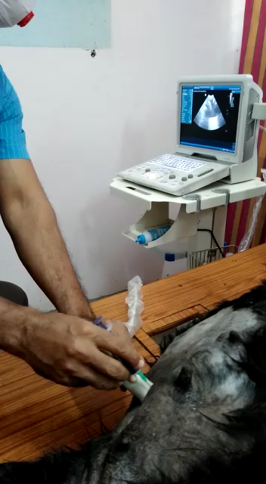
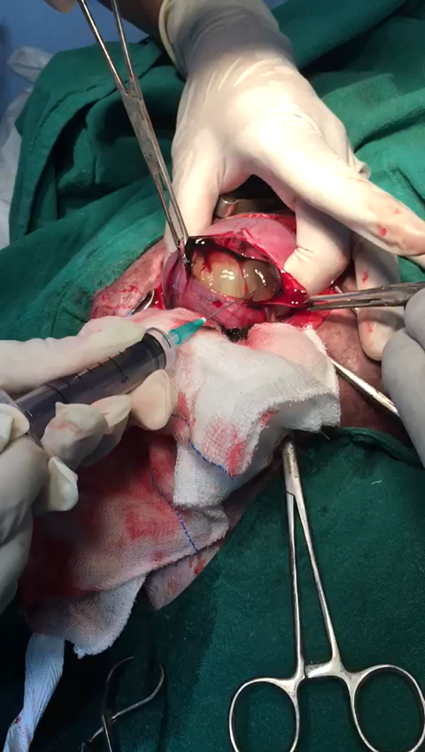
Fig-2: Collection of amniotic fluid during C-section from six dogs, after neonatal extraction and prior to opening the fetal membranes

Fig-3: Positive bubble test in amniotic fluid samples from Group 1 dogs
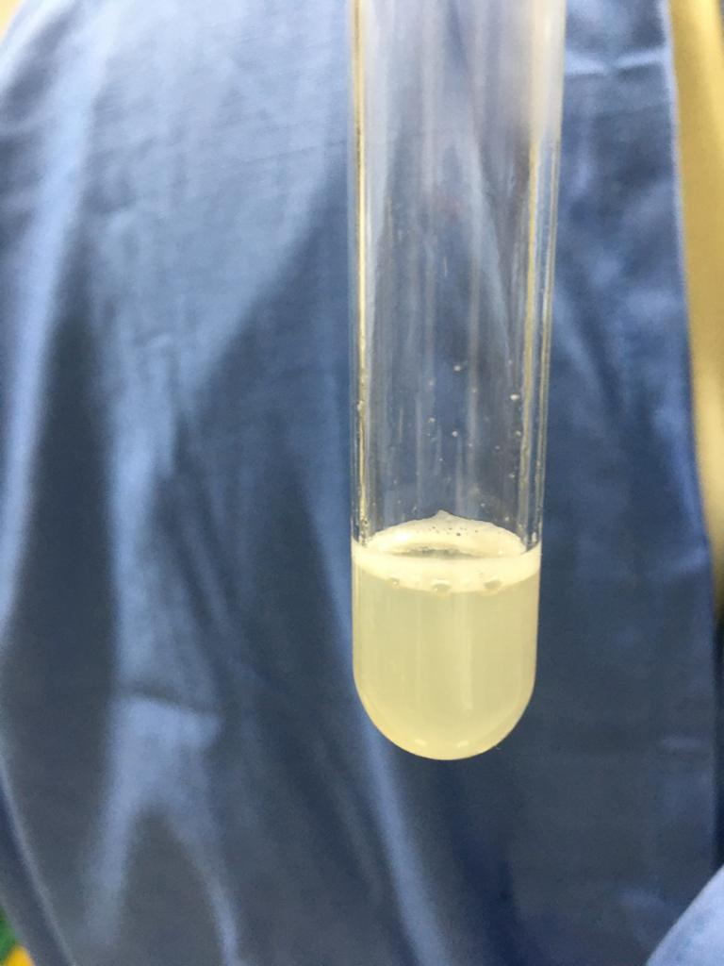

Fig 4: Negative bubble test in amniotic fluid samples from Group 1 dogs

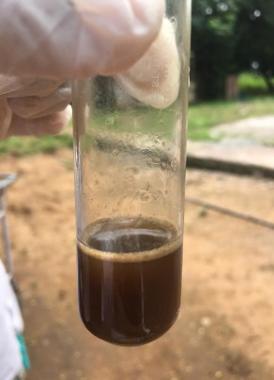

Fig-5: Positive bubble test in amniotic fluid samples collected from Group 2 dogs
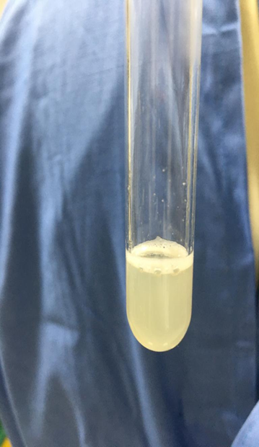

Fig-6: Negative bubble test in amniotic fluid samples from Group 2 dogs
