Poecilobdella kananbalaae A New Species of Leech from Karnataka, India

ABSTRACT:
There are more than 721 species of leeches (Annelida: Hirudinea) in the world. India has 88 different species. Only 8 species have been identified of Poecilobdella genus (Poecilobdella granulosa Savigny, 1820, Poecilobdella manilensis Lesson, 1924, Poecilobdella javanica Wahlberg, 1856, Poecilobdella viridis Moore, 1927 and Poecilobdella aligarhensis Mandal et al., 2021. Poecilobdella sukhendui Mandal et al., 2024. Poecilobdella Manashiae Mandal et al., 2025. Poecilobdella lakshmikantai Mandal et al., 2025. This research will establish a new leech species, Poecilobdella kananbalaae, which was collected from Ulsoor lake in Bangalore, Karnataka, India.
KEY WORDS: Annelida, new leech, Poecilobdella kananbalaae, Karnataka, India.
INTRODUCTION:
Leeches are popularly regarded as slimy, black, blood-feeding hermaphroditic worms inhabiting unclean ponds and marshes, Leeches (subclass Hirudinea) in fact occupy diverse aquatic (freshwater, estuarine, and marine) and moist terrestrial ecosystems worldwide, with their distribution excluding only terrestrial Antarctica (Phillips et al. 2020). Globally, nearly 700 leech species have been documented, with India harboring a significant 12% of this diversity (Mandal 2021). Pioneering studies on Indian leeches include Baugh’s (1960, 1960a) foundational work on Indian Rhynchobdellida and Harding & Moore’s (1927) comprehensive review of 51 species, which collectively identified 54 species (36 freshwaters, 9 terrestrials, and 10 marine) distributed across 25 genera and 5 families. Chandra (1991) later described 30 novel leech species from India. The genus Poecilobdella comprises seven aquatic leech species endemic to India. Mandal’s research expanded this record with 26 additional species, including 8 terrestrials and 18 aquatic taxa, notably the aquatic Paraclepsis gardensi (Glossiphoniidae; Mandal 2004) and the recently described Poecilobdella sukhendui (Hirudinidae; Mandal 2024). The taxonomic framework for Indian leeches was further refined by Chandra (1983) and Ghosh (1998), building upon global systematic contributions by Soós (1965) The authors have recently been given the opportunity to report a new species discovered in Ulsoor lake, Bangalore, India.

MATERIALS AND METHODS:
Leeches were sorted and surface-sterilized. The cleaned specimens were transferred to a shallow tray containing a minimal volume of water and gradually anaesthetized using 70% ethanol, administered dropwise at intermittent intervals until mortality was achieved. After dissection and observation of narcotised leeches, they were immediately fixed and preserved in 4% Formalin for long-term storage. Identified specimens were subsequently catalogued and deposited in the General Non-Chordata (GNC) repository of the Zoological Survey of India (ZSI), Kolkata, for archival and future taxonomic reference.

MATERIAL EXAMINED:
Ulsoor lake, Bangalore, Karnataka, India. (Latitude 12̊ 58̍ 53.3̎ N, Longitude 77̊ 37̍ 9.17̎ and Altitude 896 metres). Holotype- 01ex. (ZSI-GNC-An 88373/2); 18. VII. 2023. Coll. Dr. Anoop Sachi.

RESULTS AND DISCUSSION:
During a personal research survey conducted in Karnataka, Dr. Anoop Sachi collected several specimens of leeches. Subsequent careful observation and analysis of the collected material strongly suggested the potential discovery of a species previously undocumented by the scientific community. The author then completed a thorough taxonomic identification, successfully confirming and establishing this new leech species originating from Karnataka, India. As a direct result of this discovery, the cumulative number of recognized leech species in India is now 89, and the total count of species belonging to the genus Poecilobdella has increased to nine.
DIAGNOSTIC CHARACTERS (Plate-1 & 2): Poecilobdella kananbalaae sp. nov.
These leeches collected from Kerala. The colour of these species were brown dorsally and ventrally yellowish without any spots. Dorso-medial breaking black stripe. Three pairs black dorsal stripe. Most lateral one pair breaking black stripe. Ventro lateral one pair black stripe. Since the leeches expired prior to narcotisation, the leeches where mildly degraded. The positioning of the eyes was at 3, 5, 6, 8 and 11 annuli. Eyes are half immersed in the annuli. Anterior suckers 6cm in diameter and posterior sucker 1.1cm. Length – 9.9cm. Breadth – 1.4cm. The gonophores were present between 33rd and 34th annuli and between the 38th and 39th annuli. The total number of annuli is 110, no sucker rays are round in shape just like cutted trunk of trees. 27 pairs white receptors as sensillae are seen: Anteriorly 5 segments are devoid of sensillae. Up to 11 segments each segment concists of 2 annuli in each segment due the position of sensillae. From 12 segment to 25th each segment consists of 4 annuli in each segment. Last two segment having only one annuli in each segment. Anterior sucker consists of seven annuli, posterior sucker having 5 annuli. Total 27 segments are visible on the body. Male pore has 5 rays almost round in shape position towards- 34 segment. Female pore has no rays, horizontal line shaped. Total white receptors are 8 pairs. Four pair lateral, dorso-median 2 pairs, dorsal 2 pairs, lateral receptors bears nephridial pores in the middle of the same. Crop caecum lare in size.
DISTRIBUTION: India: Karnataka.
Table-I. Showing comparison Poecilobdella kananbalae sp. nov. With the other eight species of the genus Poecilodella in India.
Characters | Poecilobdella manillensis | Poecilobdella granulosa | Poecilobdella viridis | Poecilobdella javanica | Poecilobdella aligarhensis | Poecilobdella sukhendui | Poecilobdella manashui | Poecilobdella lakshmikantai | Poecilobdella kananbalae
Stripe | Tree pairs dorso-lateral yellow stripes. One bright black median broken constricted line palpable than other stripes. | Two pairs longitudinal yellow stripes. One black median broken constricted line. Four pairs line bordering yellow stripes. Ventral sub marginal black stripes. | Marginal orange stripes. Presence of metameric spots. | Dark stripes. Metameric spots. | Seven broken stripes. Dorso-medial is paler than other six dorso-lateral stripes. | No stripe on the body. | Five breaking black stripes on dorsal side. Ventral side brownish in colour bearing black coloured dot shaped spots. | Seven stripes black in colour, 2 ventro lateral | Three pairs black on dorsal.  One pair ventro lateral
Colour | Brown dorsally, Green ventrally | Olive green dorsally reddish orange ventrally | Dorsal olive green. Ventral greyish green | Olive green to grass green. Margins yellow or orange. | Brown dorsally, cream coloured ventrally. | Brown dorsally, fade up ventrally | Grayish | Reddish brown | Brown dorsally,yellowish ventrally
Body length | 12.3cm | 9.5cm. | 11.2cm. | 10.7cm. | 41mm. | 14.5 cm. | Total length 82mm. | 35mm. | 9.9cm
Breadth | 2.8cm. | 2.3cm. | 2.4cm. | 2.1cm. | 9mm. | 3.5 cm. | Breadth 11mm. | 8mm. | 1.4cm
Breadth of anterior sucker | 1.8mm. | 1.9mm. | 1.7mm. | 1.3mm. | 2mm in diameter, | Anterior sucker 2.1mm. Almost ten times little than posterior sucker. | 8mm. | 1mm. | 6mm
Breadth of posterior sucker | Caudal sucker larger than anterior | Caudal sucker little larger than anterior | Caudal sucker smaller than anterior | Caudal suckers larger than anterior and almost broad like maximum breadth of the body | Posterior sucker 5.2mm almost third time larger than the anterior sucker. Not equal to breadth. | Posterior sucker is almost round 2.3cm broad. Sucker rays are 110. | Posterior sucker breadth 9mm | 3mm. | 11mm.
Clitellum | Prominent | Prominent | Not prominent | Prominent | Moderate | 37-45  9 annuli | 32-38  7 annuli | 31-38 8annuli | 33-39  7 annuli
Gonophores | Separated by 5 annuli | Separated by 5 annuli | Separated by 5 annuli | Separated by 7 annuli | Separated by 5 annuli. Male pore between 33-34 rings. Female pore between 38-39 rings. | Male gonopore large in between 29 and 30 segment. Female genital pore minute between 34-35 segments nearer to 34 segments | Gonopores separated by 5 annuli | Gonopores separated by 6 annuli | 5 annuli
Vaginal Stalk | Almost equal  in length of caecum | Equal in length of caecum | Twice the length of caecum | Absent | Larger than the anterior crop caecum | Shorter than caecum. | Short | Very short | Large, almost equal ual in size of sac
Breading season | - | - | June-July | - | April-July | May-July | July-August | June -July
Eyes | - | - | - | Five pairs eyes on 2,3,4,6 and 9th annuli. | Nine pairs of eyes on rings 3, 4, 6, 8 and 11th rings. Last four annuli having two pairs of eyes on each annulus laterally. First eyes bearing annuli is having only one pair of eyes. | Five pairs eyes on 2,3,5,6 and 8th annuli. | Five pairs  on 2,3, 4, 6 and 9th annuli | Five pairs  on 3,4, 5, 7 and 10th annuli | Five pairs  on 3,5, 6, 8 and 11th annuli
Ring | 112 | 101 | 107 | 105 | 108(including 5 rings of posterior sucker). | Total 111 rings | Total 112 rings | 110 | 110
Reference | (Lesson, 1842) | ( Sevigny, 1820) | Moore, 1927 | ( Wahlberg, 1856) | Mandal et.al., 2021 | Mandal et.al., 2024 | Mandal et.al., 2025 | Mandal et.al., 2025 | Recent Authors

HISTORICAL REVIEW:
The number of leech increasing the known diversity from 300 (Ghosh, 1998) to over 700 species (Phillips et al., 2020). While most abundant in northern temperate freshwater systems and absent from terrestrial Antarctica, marine species occur worldwide (Phillips et al., 2020). Foundational works by Linnaeus (1767), Savigny (1820) established early taxonomy, followed by regional studies including Tennent's (1859) Ceylonese records, Whitman's (1886) Japanese fauna, and Harding & Moore's (1924, 1927) comprehensive surveys of Indian species (both aquatic and terrestrial), later expanded to Burma and Sri Lanka (Harding & Oka, 1924). Moore's (1927) Fauna of British India: Hirudinea and Bhatia's (1940) remain seminal for South Asian leech taxonomy, building on earlier contributions by Annandale (1913) and Kaburaki (1921).

Pioneering taxonomic work by Soota and Ghosh (1977), Chandra (1983) and Sanjeeva Raj and Glandstone (1981) in india. Chandra's comprehensive 1981 handbook detailing 60 species across 25 genera and subsequent checklists (1983, 1984) is also important taxonomic work.
Building upon earlier work, Mandal documented the presence of 28 leeches in India. He first published one species from West Bengal in 2004 and 1 aquatic leech of the genus Poecilobdella in 2024, 2 aquatic leech of the same genus in 2025.

Conclusion :
The eyes are situated at 3, 5, 6, 8 and 11 annuli. The gonophores were present between 33rd and 34th annuli and between the 38th and 39th annuli. The total number of annuli is 110, no sucker rays are round in shape just like cutted trunk of trees. 27 pairs white receptors as sensillae are seen: Anteriorly 5 segments are devoid of sensillae. Up to 11 segments each segment concists of 2 annuli in each segment due the position of sensillae. From 12 segment to 25th each segment consists of 4 annuli in each segment. Last two segment having only one annuli in each segment. Anterior sucker consists of seven annuli, posterior sucker having 5 annuli. Total 27 segments are visible on the body. Male pore has 5 rays almost round in shape position towards- 34 segment. Female pore has no rays, horizontal line shaped. Total white receptors are 8 pairs. Four pair lateral, dorso-median 2 pairs, dorsal 2 pairs, lateral receptors bears nephridial pores in the middle of the same. Nine pairs of crop caeca. Last right crop caecum little large than the left one.
DISTRIBUTION: Karnataka, India.

REFERENCES:
ANNANDALE, N. 1913. The leeches of the lake of Tiberias. J. Proc. Asiat. Soc. Bengal (n.s.) 9(6): 211–214.
BHATIA, M. L. 1940. On Haemopis indlcus sp. nov. A new Arhynchobdellid carnivorous leech from Kashmir. Proc. nat. Acad. Sci. India 10(4): 133–144.

BAUGH, S.C.1960 (Indian bengala). Hemiclepsis bhatiai Baugh, 1960 Kalipahar, Dist. Monghyr, Bihar. Studies on Indian Rhynchobdellid leeches 11. Zool. Anz., Leipzig 165 (11&12), pp. 468-477.

CHANDRA, M. 1981. A check-list of leeches of India. Rec. Zool. Surv. India, 80: 265–290.

CHANDRA, M. 1984. The leech fauna of Jammu region of Jammu and Kashmir State, India. Rec. Zool. Surv. India, 81(1-2): 289–298.
CHANDRA, M. 1991. The leeches of India- A Handbook. Director Zoological Survey of India (ed.), Publ. Zool. Surv. India, Calcutta, ii +130 p.
GHOSH, G.C. 1998. Leech fauna of West Bengal. State Fauna Series 3. Zool. Surv. India Part 10: 227249.
MANDAL, C.K. 2004. Paraclepsis gardensis (Hirudinea: Glossiphonidae) a new species of Leech from West Bengal, India. Rec. zool. Surv. India: 103 (Part1-2): 111-114.
MANDAL, C. K, MRIDHA, S., YASIR, M., KALAM, A., JAMEEL, M., ANWAR, M., GHOSH, S. 2021. Poecilobdella aligarhensis A new leech (Clitellata: Hirudinida) from Aligarh, India.J. Appl Zool. Res. 32 (2).145-149.
MANDAL, C. K., GHOSH, S., BHATTACHARJEE, R. & BANERJEE, D. 2024. An aquatic new leech Poecilobdella sukhendui. J. Appl. Zool. Res 35(2): 184-189.
MANDAL, C. K., BOSE, MADHURIMA, SHARMA, P., MRIDHA, SUPRITI, SIKDAR, R., HASSAN, N., GHOSH, S.2025. Poecilobdella lakshmikantai a new leech from Arunachal Pradesh, India. J. Appl.Zool.. Res. 36(1): 75-85.
MANDAL, C. K., BOSE, MADHURIMA, SHARMA, P., MRIDHA, SUPRITI, SIKDAR, R., HASSAN, N., GHOSH, S.2025. Poecilobdella manashi a new leech from Tripura, India. J. Appl. Zool. Res. 36(1): 85-93.
MOORE, J.P. AND HARDING, W.A.1927. Fauna of British India, Hirudinea. Tailor and Francis, London. Pp. 185-89.
BLANCHARD, R. 1917. Monographie des Hemadipsines (Sangsues terrestres). Bull. de la Soc. Pathologie Exotique 10: 640–675.
GHOSH, G.C. 1998. State Fauna Series 3: Fauna of West Bengal (Part 10): 227–249.
KABURAKI, T. 1921. Glossiphonia reticulata Kaburaki, 1921. On some leeches from the Chilka lake. Mem. Indian Mus. 5: 661–675.
LINNAEUS, C. 1767. Systema naturae sive regna tria naturae, secundum classes, ordines, genera, species, cum characteribus, differentiis, synonymis, locis. Laurentii Salvii, Holmiae. 12th ed. 1(2): 533–1327.
MOORE, J.P. 1924. Notes on some Asiatic leeches (Hirudinea) principally from China, Kashmir and British India. Proc. Acad. Nat. Sci. 76: 343–388.
MOORE, J.P. 1927. Fauna of British India, Hirudinea. London: Taylor & Francis, pp. 185–189.
SANJEBVA RAJ, P. J. AND GLADSTONE, M. 1981. On a new species of the land-leech of the genus Haemadipsa Tennent, 1859 from the peninsular India. Rec. Zool. Surv. India 79: 1–18.
SAVIGNY, J.C. (1820) 1822. Système des Annélides, princialment de celles des cotes de l’Ègypte et de la Syrie, offrant les caractères tant distinctift que naturels des orders, familles et genres, avec la description des espèces. Paris: Description de l’Ègypte 1(3): 1–128.
Sawyer, R.T. 1986. Leech Biology and Behaviour. Oxford, UK: Oxford University Press, 3 volumes, pp. 421–793.
SOÓS, A. 1965. Identification key to the leech (Hirudinoidea) genera of the World, with a Catalogue of the species. 111-1V. Acta. Zool. Acad. Hungary 11(3-4): 415-464.
SOOTA, T. D. AND GHOSH, G.C. 1977. On some Indian Leeches. Newsl. Zool. Surv. India: 3(6): 359- 360.
TENNENT, SIR J.E. 1859. Ceylon; an account of the island physical, historical and topographical, with notices of its natural history, antiquities, and productions. London: Longman, Green, Longman and Roberts, 2 volumes.
WHITMAN, C.O. 1886. The leeches of Japan. Quart. J. Micro. Sci. 26: 317–416

Plate-1. Ventral and Dorsal view of Poecilobdella kananbalaae indicating sucker, eyes and pores
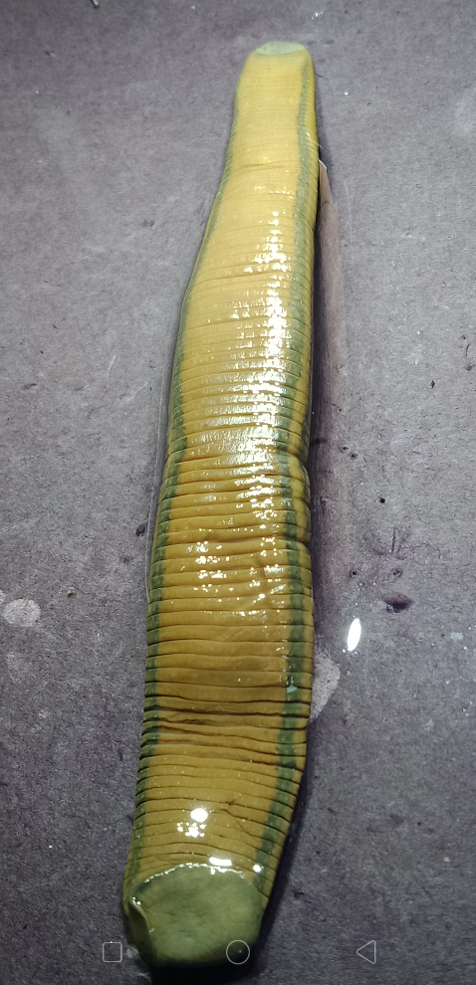
Ventral view of Poecilobdella kananbalaae
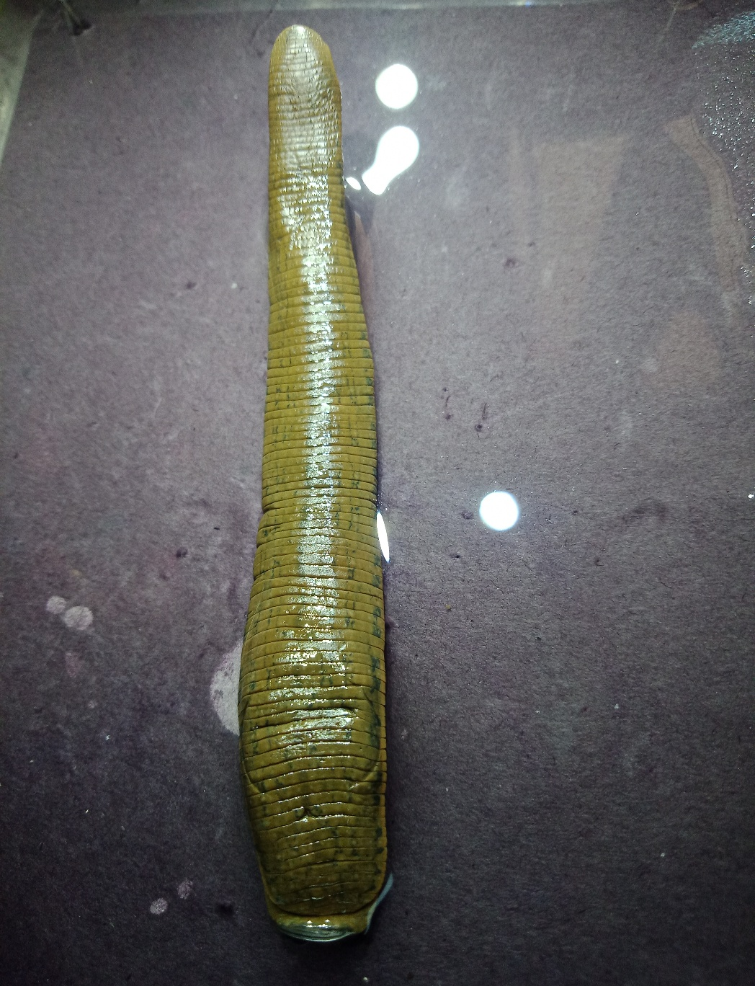
Dorsal view of Poecilobdella kananbalaae
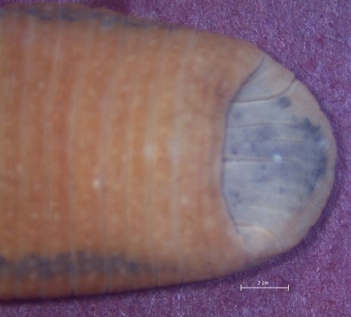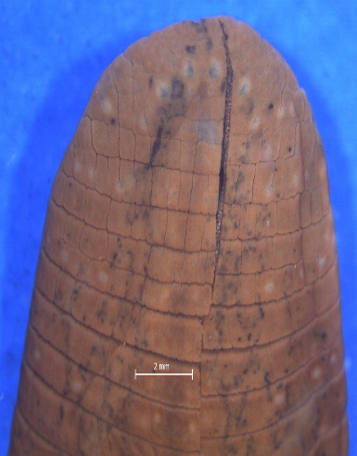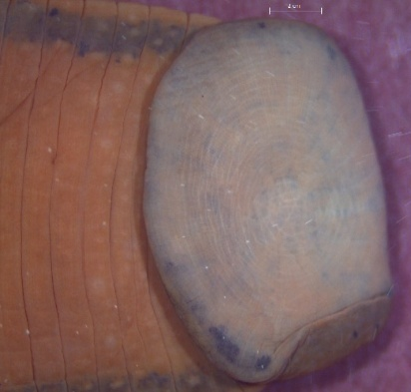
Anterior sucker Five pairs of eyes Posterior sucker

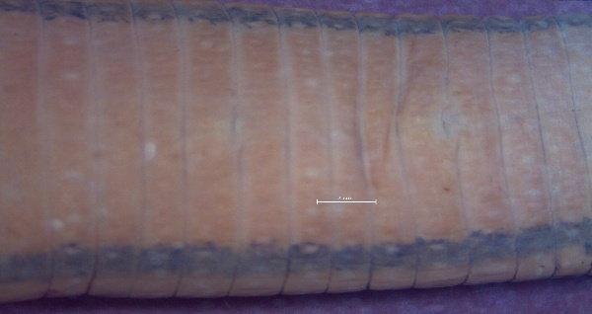
b
a
- Male and b) Female pores of Poecilobdella kananbalaae

Plate-2. Characteristics of Poecilobdella kananbalaae
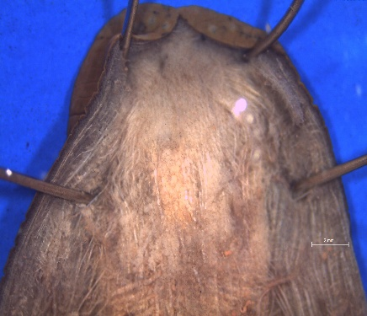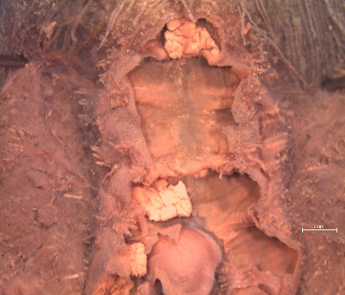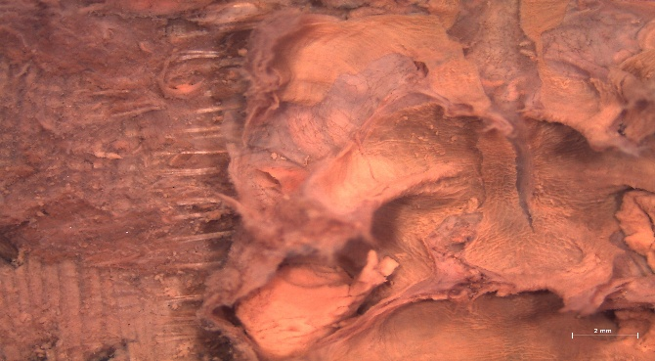
Pharynx and salivary gland Prostate gland Crop caeca
F
E
D
C
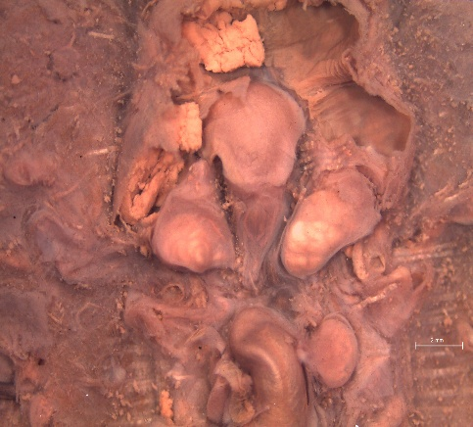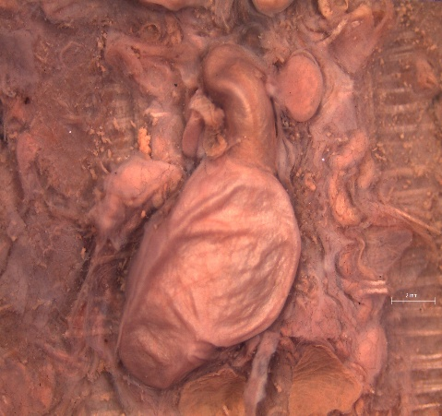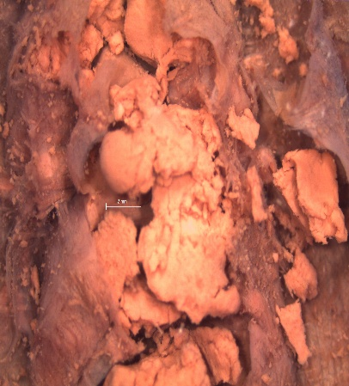
B
A
A-Prostate and B-epididymis C- ovary, D-vaginal duct and E-vaginal caecum, F- Crop caeca

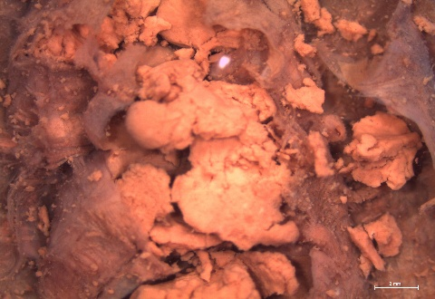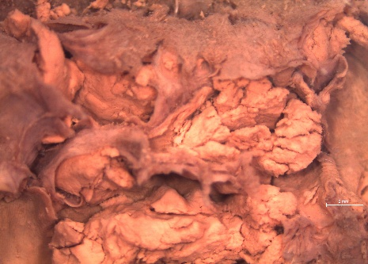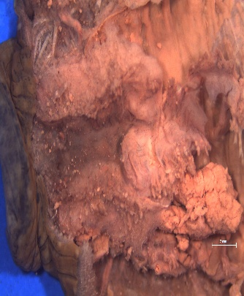
G
Crop caeca Crop caeca G-Crop caecum

