Original Research Article
PHYTOCAPPED GREEN SILVER NANOPARTICLES USING MURRAYA KOENIGII AND ITS ANTIOXIDANT AND ANTIBACTERIAL ACTIVITY

Abstract
The trend towards synthesis of green, low cost, environmentally friendly and low toxic nano drug is increasing. The present study reported synthesis of phytocapped silver nanoparticles mediated by green synthesis method using Muraya koenigii leaf extract. The synthesized AgNPs wear confirmed by the electronic spectroscopy by UV Visible spectroscopy at 420nm along with crystalline nature by XRD analysis.TEM confirmed average size of 25-50 nm and TEM with globular shape architecture and showing defined elemental composition with representative mixture of plant and silver content by FTIR. Further AgNPs confirm better antibacterial activity against S. aureus, followed by E. coli. AgNPs recorded IC₅₀ value for antioxidant recorded as 2.33 µg/ml . The present study confirmed the synthesis of multidimensional silver nanoparticle which can be utilized in medicinal field.
Keywords: Silver nanoparticles; Murraya koenigii; antibacterial; antioxidant
INTRODUCTION
The practical interest in green synthesis methodologies for nanoparticles originates from the critical demand for environmentally conscious and sustainable alternatives to traditional physicochemical routes. This fundamental paradigm shift prioritizes the strategic leverage of natural resources, such as botanical extracts, to facilitate nanomaterial synthesis, thereby significantly mitigating the generation of hazardous by-products and reducing energy expenditure (Baker et al., 2020 . Ashtaputrey et al., 2017), . This approach leverages the inherent biochemical reducing and capping agents present in botanical sources, leading to more biocompatible and stable nanoparticles (Binorkar 2025). Specifically, the green synthesis of silver nanoparticles using plant extracts like Murraya koenigii has gained significant attention due to the plant's rich phytochemical profile, which effectively reduces silver ions into stable AgNPs (Chahande 2020) . M. koenigii, commonly known as the curry tree, is particularly notable for its therapeutic properties, which are attributed to a diverse array of bioactive compounds including alkaloids, phenolics, and flavonoids (Abdelwahab 2022). These phytochemicals not only act as reducing agents for silver ions but also serve as stabilizing agents, preventing agglomeration of the newly formed nanoparticles (Ashtaputrey 2022) . The robust medicinal profile of M. koenigii, including its antioxidant, antimicrobial, and anticancer properties, further enhances the therapeutic potential of the synthesized silver nanoparticles (Abdelwahab 2023). This integration of green synthesis with the phytochemistry of M. koenigii offers a promising avenue for developing novel nanomedicines with enhanced efficacy and reduced toxicity (Ashtaputrey., 2017, Arshad 2023). Indeed, the synergistic combination of AgNPs with M. koenigii extracts has been explored for its thrombolytic activity, underscoring its multifaceted therapeutic utility (Pram ., 2022). This method not only aligns with sustainable practices but also opens new possibilities for targeted drug delivery and biomedical applications (Rahuman, 2022). Green synthesis, particularly using plant extracts, has emerged as a superior method compared to traditional chemical and physical techniques due to its simplicity, cost-effectiveness, and environmentally friendly attributes (Sarwer.,2022). This approach utilizes various plant-based metabolites, such as phenolics, terpenoids, and flavonoids, to reduce metal ions, acting as natural reducing and capping agents for nanoparticle formation (Fares et al., 2021., Habeeb et al., 2022). These naturally occurring biomolecules facilitate the formation of stable nanoparticles by preventing agglomeration and imparting unique surface characteristics (Islam, Md.S., 2021). Utilizing a green synthesis approach, silver nanoparticles were successfully synthesized from Martynia annua and confirmed for AgNPs with polygonal morphology, an average size of 64 nm, and a polydispersity index of 0.385. Here AgNPs enhanced glucose uptake by yeast cells, indicating their promising therapeutic role in managing diabetes mellitus (Abbigeri,et al., 2025) . Simarouba glauca leaf extract used for silver nanoparticles synthesis having UV-Vis spectra at 413 nm with 12.45 nm size and able to control A549 cells as a cancer cell and improved the paralysis once assessed in Caenorhabditis elegans (Bhavi et al., 2024). Nanotechnology presents novel avenues for skin cancer treatment, leveraging its benefits in precise drug delivery, advanced imaging techniques, and diagnostic applications. Thus, nanomaterials prove highly advantageous in dermatology by augmenting the penetration and sustained retention of therapeutic agents, thereby mitigating adverse effects (Jadhavet al., 2024). Biologically-based nanomaterials have garnered significant interest for cancer therapy owing to their notable characteristics and effects, such as biocompatibility, biosafety, biodegradability, and their synergistic and autologous therapeutic potential (Elemike, E.E et al., 2025) By addressing current challenges through concerted interdisciplinary efforts, biosynthesized nanoparticles hold the potential to transform fields such as nanomedicine, agriculture, and environmental sustainability, thereby ushering in a new era of sustainable technological advancements [18]. Hence based on the previous data published, present study synthesized AgNPs from M. koenigii extracts and screened for the antibacterial, antioxidant, antibiofilm and anticancer activity as per in vitro protocols to confirm its roles in future therapies.
MATERIALS AND METHODS
2.1. Preparation of silver nitrate solution
In the present study silver nitrate was used as a silver salt (HiMedia) and prepared as 1M in aqueous solution.
2.2. Plant collection and preparation of aqueous solution
Fresh leaves of Murraya koenigii were air dried, powdered and passed through muslin to get fine content. 20 grams of plant powder then transferred to 200 ml distilled water and allowed to boil for 15 minutes, further cooled and filtered to be used as reducing agent source.
2.3. Synthesis of green silver nanoparticles
The silver nanoparticles preparation carried out by adding 8:2 ratio of 1M silver nitrate and plant extract and it was allowed to react at 70°C for 30 minutes on magnetic stirrer and kept for 24 hours of incubation.Upon incubation change in color indicated formation of AgNPs via M. koenigii reduction which was then centrifuged at 20000 rpm for 30 minutes. The pellet then concentrated by discarding supernatant and calcinated at 500°C for one hour and nanoparticle powder then stored in sealed tube till further use as shown in Fig. 1.
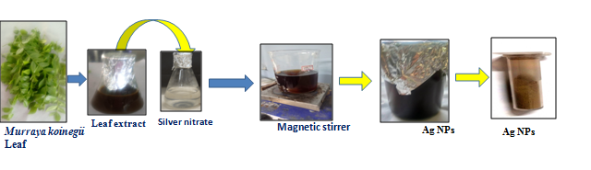
Figure. 1 Schematic representation of AgNPs.

2.5. Characterization of silver nanoparticles
UV-Visible spectroscopy the absorption maxima recorded for AgNPs using wavelength scan at 0-800 nm. Fourier Transform Infrared Spectroscopy- AgNPs in powder form recorded for spectrum-based vibrations once data collected at 500 cm⁻¹ to 4000 cm⁻¹ and data then related to function groups once compared to reference standard data.X-ray Diffraction Analysis (XRD)- XRD carried out by involving X-ray diffractometer model Bruker Eco D8, and confirmed for its crystalline nature. In line TEM also carried out to decipher more in-depth analysis of shape and size nanoparticles. (Dawadi, S. Katuwal et al.,2021., Panja, S et al., 2020).

2.6. Screening of potential for AgNPs
2.6.1. Antibacterial activity
Here MTCC standard cultures as Escherichia coli and Staphylococcus aureus were grown in nutrient broth and allowed to set at 1 O.D. as per McFarland turbidity standard. The testing solution of AgNPs prepared as 1mg/ml and its effectiveness to control pathogens tested by well diffusion assay. In a protocol by involving Muller Hinton agar plates, its surface was inoculated by 10 µl of nutrient broth culture and then punctured by three wells in equidistant manner. The wells then inoculated with 25 µg, 50 µg, and 100 µg dose of AgNPs along with 5 µg of ciprofloxacin as positive control. Plates kept standing for 30 minutes and incubated at 37°C for 24 hours. The data analyzed as triplicate with formed zone of inhibition in millimeters recorded with standard deviation (Arif, W. Rana et al., 2017).
2.6.2. Antioxidant activity by DPPH assay
In a protocol, 2.5 mM concentration of DPPH prepared in methanol solvent and testing dosage of AgNPs along with standard ascorbic acid set as 20, 40, 60, 80, 100 and 120µg/ml. The content then added to the 2.5 ml of DPPH solution and mixed by vortexing. The content then incubated at room temperature for 30 minutes. Upon incubation, the changes in absorbance were recorded at 517 nm by involving UV-Visible spectroscopy.
Here % DPPH inhibition calculated by using formula as:
% DPPH inhibition = (O.D. of control-O.D. of test/O.D. of control) x 100
Further based on the data, IC₅₀ value of antioxidant activity for AgNPs recorded by linear regression [22].
3. RESULTS & DISCUSSION
3.1. Characterization of AgNPs by UV-visible spectroscopy
The formation of M. koenigii-reduced AgNPs was confirmed by a distinct color change in the reaction solution, transitioning from green to dark brown upon incubation, which is indicative of nanostructure synthesis (Fig. 1). The UV-Visible spectrum further confirmed the synthesis of AgNPs by displaying a characteristic surface plasmon resonance band at 420 nm (Fig. 2). This observation aligns with previous studies where the development of AgNPs results in a distinctive color shift and a surface plasmon resonance band, confirming their formation [22,23].
3.2. FTIR analysis of AgNPs
FTIR analysis of M. koenigii based AgNPs we recorded typical nine peaks as 3455, 2883, 1632, 1556, 1523, 1492, 1385, 1090 and 542 cm⁻¹, indicated that these characteristics peaks belong to various functional groups present mainly in plant extract, thereby responsible for the reduction of Ag⁺ ions and its stabilization thereof. Here peak at 3455 cm⁻¹ linked with O-H stretching vibration; peak at 2883 cm⁻¹ linked to C-H stretching; peak at 1632 cm⁻¹ linked to C=C stretching; peak at 1556 cm⁻¹ and 1523 cm⁻¹ linked to C=O stretching or of C=C stretching. Here peak at 1492 cm⁻¹ belongs to C-H bending vibrations. The peaks at 1385, 1090 and 542 cm⁻¹ belongs to C-N stretching, C-O stretching, respectively (Fig. 3). These distinct absorption bands collectively indicate the presence of biomolecules such as flavonoids, phenolic compounds, and proteins, which act as effective capping and reducing agents in the biogenic synthesis of AgNPs [24, 25]. The presence of electron-rich functional groups within the plant extract, such as those identified by FTIR, are crucial for facilitating the reduction of silver ions and subsequent nanoparticle formation [26].
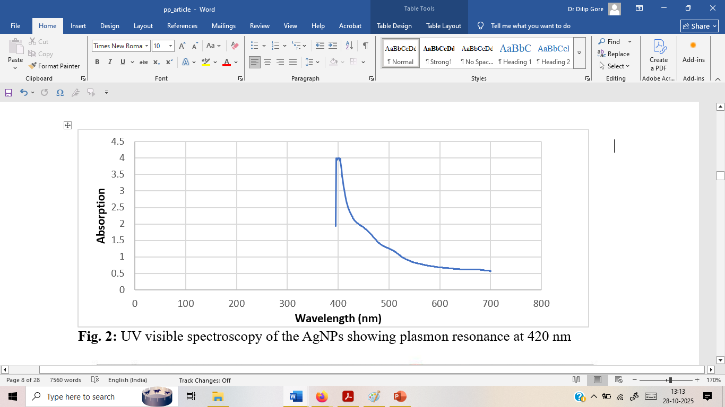
Fig. 2: UV visible spectroscopy of the AgNPs showing plasmon resonance at 420 nm
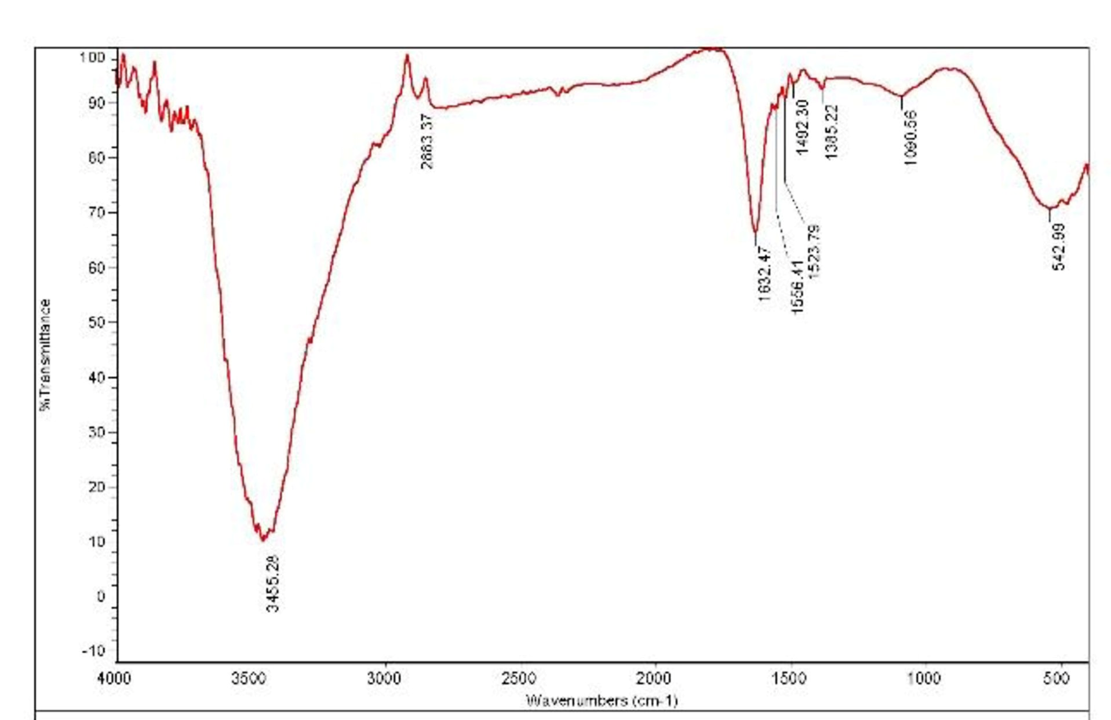
Fig. 3: FTIR spectra of the AgNPs for the wavelength 500-4000 cm⁻¹

3.3. X-Ray diffraction analysis of AgNPs
As shown in Fig. 4 and as per Debye-Scherrer formula, it has been showcased that these AgNPs bears higher surface area to volume ratio of the nanocrystals with average size of 20-50 nm and affirmed to bear crystalline structure with face-centered cubic lattice. This crystalline nature is further corroborated by the presence of Bragg reflections in the X-ray diffraction pattern, which align with established data for face-centered cubic silver . The intensity and broadening of these peaks further indicate the crystalline nature and small crystallite size of the synthesized nanoparticles (Mahakham et al., 2017).
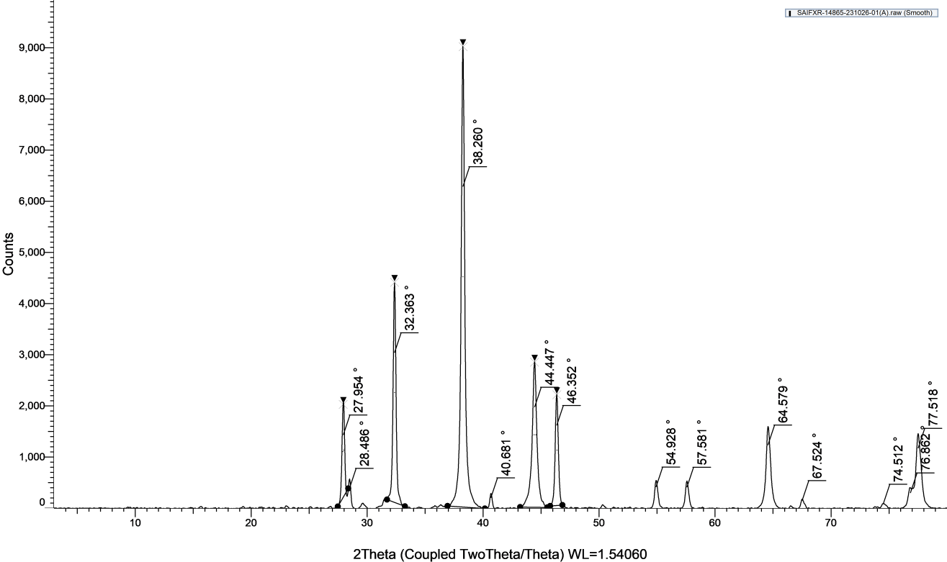
Fig. 4: XRD pattern of the AgNPs showcasing the details of size and 2 theta values
3.4 TEM analysis of AgNPs
TEM data, we registered the defined globular shaped AgNPs with average size of 25-50 nm. (Fig. 6) TEM analysis also revealed the presence of clear lattice fringes, indicating the highly crystalline nature of the nanoparticles and confirming their structural integrity [28,29]. The high-resolution TEM further elucidated these crystalline characteristics, showing a lattice spacing of approximately 0.234 nm, which corresponds to the plane of face-centered cubic silver [30].
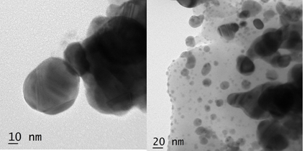
Fig. 5: M. koenigii based AgNPs represented with globular shaped nanoparticles as per TEM analysis

3.5. Antibacterial activity of AgNPs
Synthesized AgNPs were studied on S. aureus (MTCC 1678) and E. coli (MTCC 737) reported good antimicrobial activity as showns (Fig.5, 6) ((Pelgrift RY et al., 2013). AgNPs stronger activity against S. aureus than E. coli, consistent with the understanding that Gram-positive bacteria, having a single peptidoglycan layer, are more susceptible to nanoparticles than Gram-negative bacteria with an additional outer membrane (Jayeoye, T.J. Eze et al., 2021. Slavin YN et al., 2017). AgNPs reported concentration dependent zone of inhibition of bacteria as the concentration increases 25ug/ml to100ug/ml zone of inhibition also increased (Pelgrift RY et al., 2013). Nevertheless, silver nanoparticles have demonstrated broad-spectrum antibacterial activity, making them a promising alternative for combating drug-resistant bacteria (Abo-Elmaaty et al., 2022).
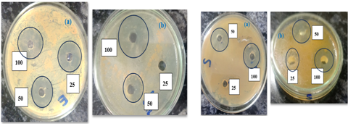
Fig. 6: E. coli inhibition by AgNPs Fig. 7: S. aureus inhibition by AgNPs
3.6. Antioxidant activity of AgNPs
Antioxidant activity here screened with 20-120 µg/ml dose of AgNPs along with standard ascorbic acid by DPPH assay Fig. 7. AgNpPs recorded an excellent antioxidant activity of M. koenigii reduced AgNPs since its IC₅₀ value recorded as 2.33 µg/ml which is just like ascorbic acid whose IC₅₀ value was 2.07 µg/ml, thus result indicated that AgNPs potential as an equivalent antioxidant like that of ascorbic acid .Moreover, the scavenging activity of green-synthesized AgNPs against free radicals, as demonstrated by DPPH assays, often increases with nanoparticle concentration, reaching maximal efficacy at higher dosages. For example, AgNPs biosynthesized from Nepeta cataria extracts have demonstrated significant antioxidant effects through DPPH assays, highlighting their capacity to neutralize free radicals.

Fig.8 DPPH Assay of AgNPs
CONCLUSION
The study reported succesfulll phytochemical reduced synthesis of AgNPs Havinfg average size 25-50nm. AgNPs confirmed antimicrobial activity against both gram-positive and gram-negative pathogens also reported excellent antioxidant activity.These results support the integration of nanotechnology in antimicrobial research, particularly for developing alternatives in response to antibiotic resistance.The increased susceptibility of S. aureus to both nanoparticles suggests structural factors play a critical role in determining nanoparticle efficacy. These results support the integration of nanotechnology in antimicrobial research, particularly for developing alternatives in response to antibiotic resistance.
Disclaimer (Artificial intelligence)
Author(s) hereby declare that NO generative AI technologies such as Large Language Models (ChatGPT, COPILOT, etc.) and text-to-image generators have been used during the writing or editing of this manuscript.

REFERENCES

Abbigeri, M.B. Thokchom, B. Singh, S.R. Bhavi, S.M. Harini, B.P. Yarajarla, R.B. (2025) Antioxidant and anti-diabetic potential of the green synthesized silver nanoparticles using Martynia annua L. root extract, Nano TransMed. 100070. https://doi.org/10.1016/j.ntm.2025.100070
Abdelwahab, S.İ. Taha, M.M.E. Global research trends of the studies on Murraya koenigii (L.) spreng: a Scopus-based comprehensive bibliometric investigation , (2023). Bulletin of the National Research Centre/Bulletin of the National Research Center. 47(1) https://doi.org/10.1186/s42269-023-01113-x.
Abo-Elmaaty, S.A. Shati, A.A. Alfaifi, M.Y. Elbehairi, S.E.I. Sheraba, N.S. Hassan, M.G. Badawy, M.S.E.M. Ghareeb, A. Hamed, A.A. Gabr, E.Z. (2022) Biofilm Inhibitory Activity of Actinomycete-Synthesized AgNPs with Low Cytotoxic Effect: Experimental and In Silico Study, Microorganisms. 11(1) 102. https://doi.org/10.3390/microorganisms11010102
Arif, W. Rana, N.F. Saleem, I. Tanweer, T. Khan, M.B. Alshareef, S.A. Sheikh, H. Alaryani, F.S. Al-Kattan, M.O. Alatawi, H.A. Menaa, F. Nadeem, A.Y. (2022) Antibacterial Activity of Dental Composite with Ciprofloxacin Loaded Silver Nanoparticles, Molecules. 27(21) 7182. https://doi.org/10.3390/molecules27217182 .
Arshad, F. Naikoo, G.A. Hassan, I.U. Chava, S.R. El‐Tanani, M. Aljabali, A.A.A. Tambuwala, M.M. (2023) Bioinspired and Green Synthesis of Silver Nanoparticles for Medical Applications: A Green Perspective [Review of Bioinspired and Green Synthesis of Silver Nanoparticles for Medical Applications: A Green Perspective], Applied Biochemistry and Biotechnology. 196(6) 3636. https://doi.org/10.1007/s12010-023-04719-z.
Ashtaputrey, S.D. Ashtaputrey, P.D. Rathod, G. (2017) Eco-friendly Green Synthesis and Characterization of Silver Nanoparticles Derived from Murraya koenigii Leaves Extract, Asian Journal of Chemistry. 29(9) 1966. https://doi.org/10.14233/ajchem.2017.20680 .
Baker, S. Olga, P. Рукосуева, Т.В. Nadezhda, P. Tatyana, G. Tatyana, R.E.E.S. Olga, K. Elizaveta, G. Karina, G. Ekaterina, U. Anastasia, S. Margarita, P. (2020) Phyto-nano-hybrids of Ag-CuO particles for antibacterial activity against drug-resistant pathogens, Journal of Genetic Engineering and Biotechnology. 18(1) 53. https://doi.org/10.1186/s43141-020-00068-0
Bhavi, S.M. Padti, A.C. Thokchom, B. Singh, S.R. Bhat, S.S. Bajire, S.K. Shastry, R.P. Srinath, B.S. Gummani, S.S. Harini, B.P. Yarajarla, R.B. (2024) Biogenic silver nanoparticles from Simarouba glauca DC leaf extract: Synthesis, characterization, and anticancer efficacy in lung cancer cells with protective effects in Caenorhabditis elegans, Nano TransMed. 100052. https://doi.org/10.1016/j.ntm.2024.100052
Binorkar, C.P.S.J.C. Pendakur, S.V. Pal, B. Rodrigues, R. Chitti, W.J. Firdaus, R.J. Chella, M. (2025) Synthesis of Green Metal Nanoparticle using Medicinal plants extracts for Antimicrobial Activity, Journal of Neonatal Surgery. 14 133. https://doi.org/10.52783/jns.v14.2510.
Chahande, R. Mehere, B.A. Pantawane, P.K. Chouke, P.B. Murai, S. (2020) Bio-inspired synthesis of silver nanoparticles assisted Murraya koneigii leaf extract and its antimicrobial activity, Materials Today Proceedings. 29 923. https://doi.org/10.1016/j.matpr.2020.05.383 .
Dawadi, S. Katuwal, S. Gupta, A. Lamichhane, U. Thapa, R. Jaisi, S. Lamichhane, G. Bhattarai, D.P. Parajuli, N. (2021) Current Research on Silver Nanoparticles: Synthesis, Characterization, and Applications, Journal of Nanomaterials. 20, 1-45 https://doi.org/10.1155/2021/6687290
Edo, G.I. Mafe, A.N. Ali, A.B. Akpoghelie, P.O. Yousif, E. Isoje, E.F. Alamiery, A.A. (2025) Eco-friendly Nanoparticle Phytosynthesis via Plant Extracts: Mechanistic Insights, Recent Advances, and Multifaceted Uses, Nano TransMed. 100080.
Elemike, E.E. Onunkwo, I.C. Ughumiakpor, O. Alawuru, F. Mukoro, A. Ishom, P. Obarakpor, F. Hossain, I. Aziza, A.E. (2025) Bio-nanomaterials: promising anticancer properties and treatment strategies, Nano TransMed. 4 100076. https://doi.org/10.1016/j.ntm.2025.100076
Fares, A. Mahdy, A. Ahmed, G. (2024).Unraveling the mysteries of silver nanoparticles: synthesis, characterization, antimicrobial effects and uptake translocation in plant—a review, Planta. 26(1) https://doi.org/10.1007/s00425-024-04439-6
Garibo, D. Borbón-Núñez, H.A. León, J.N.D. de, García‐Mendoza, E. Estrada, I. Toledano‐Magaña, Y. Tiznado, H. Ovalle, M. Soto-Ramos, A.G. Blanco-Salazar, A. Rodriguez, J. Romo, O.A. Chávez-Almazán, L.A. Susarrey‐Arce, A. Green synthesis of silver nanoparticles using Lysiloma acapulcensis exhibit high-antimicrobial activity, Scientific Reports. 10(1) (2020). https://doi.org/10.1038/s41598-020-69606-7
Habeeb, H. Thoppil, J.E. Medicinal herbs as a panacea for biogenic silver nanoparticles, (2022) Bulletin of the National Research Centre/Bulletin of the National Research Center. 46(1). https://doi.org/10.1186/s42269-021-00692-x
Islam, Md.S. (2021) Green Synthesis of Phytochemical Nanoparticles and their Antimicrobial Activity, A Review Study [Review of Green Synthesis of Phytochemical Nanoparticles and their Antimicrobial Activity, A Review Study], Biomedical Journal of Scientific & Technical Research. 34(4). Biomedical Research Network. https://doi.org/10.26717/bjstr.2021.34.005580
Jadhav, L.A. Mandlik, S.K. (2024) Nanocarriers in Skin Cancer Treatment: Emerging Drug Delivery Approaches and Innovations, Nano TransMed. 100068.
Jalil, P.J. (2021) Silver Nanoparticles: Green Synthesis, Characterization, Blood Compatibility and Protoscolicidal Efficacy against Echinococcus granulosus, Pakistan Veterinary Journal. 41(3) 393. https://doi.org/10.29261/pakvetj/2021.039.
Jayeoye, T.J. Eze, F.N. Olatunde, O.O. Singh, S. Zuo, J. Olatunji, O.J. (2021) Multifarious Biological Applications and Toxic Hg2+ Sensing Potentiality of Biogenic Silver Nanoparticles Based on Securidaca inappendiculata Hassk Stem Extract, International Journal of Nanomedicine. 7557. https://doi.org/10.2147/ijn.s325996
Jebril, S. Fdhila, A. Dridi, C. (2021). Nanoengineering of eco-friendly silver nanoparticles using five different plant extracts and development of cost-effective phenol nanosensor, Scientific Reports. 11(1) https://doi.org/10.1038/s41598-021-01609-4
Konappa, N. Patil, R.H. Kariyappa, A.S. Krishnamurthy, S. Ramachandrappa, N.S. Krishnappa, R. Chowdappa, S. (2024).Green Synthesis of silver nanoparticles using Amomum nilgiricum leaf extracts: Preparation, physicochemical characterization and ameliorative effect against human cancer cell lines, Research Square (Research Square). https://doi.org/10.21203/rs.3.rs-5197419/v1.
Liaqat, N. Jahan, N. Khalil-ur-Rahman, A.T. & Qureshi, H. (2022) Green synthesized silver nanoparticles: Optimization, characterization, antimicrobial activity, and cytotoxicity study by hemolysis assay, Frontiers in Chemistry. 10. https://doi.org/10.3389/fchem.2022.952006
Maduraimuthu, V. Ranishree, J.K. Gopalakrishnan, R.M. Ayyadurai, B. Raja, R. Heese, K. (2023) Antioxidant Activities of Photoinduced Phycogenic Silver Nanoparticles and Their Potential Applications, Antioxidants. 12(6) 1298. https://doi.org/10.3390/antiox12061298 .
Mahakham, W. Sarmah, A.K. Maensiri, S. Theerakulpisut, P. (2017) Nanopriming technology for enhancing germination and starch metabolism of aged rice seeds using phytosynthesized silver nanoparticles, Scientific Reports. 7(1). https://doi.org/10.1038/s41598-017-08669-5
Panja, S. Choudhuri, I. Khanra, K. Pati, B. Bhattacharyya, N. (2020)Biological and Photocatalytic Activity of Silver Nanoparticle Synthesized from Ehretia laevis Roxb. Leaves Extract, Nano Biomedicine and Engineering. 12(1). https://doi.org/10.5101/nbe.v12i1.p104-113.
Patel, S.G. Patel, N.K. (2022). Biogenic Synthesis of Silver Nanoparticles and Investigation of Antibacterial Activity from Leaves of Duranta erecta, Egyptian Journal of Agricultural Research. 0 https://doi.org/10.21608/ejar.2022.151716.1252
Pelgrift RY, Friedman AJ. (2013) Nanotechnology as a therapeutic tool to combat microbial resistance. Adv Drug Deliv Rev.;65(13–14):1803–15.
Pram, P. Mishra, N. Mohanasrinivasan, V. Samuel, M.K. Mohanan, M. Kothari, N. Chandrasekaran, S.D. (2024)Green Synthesis of Silver Nanoparticles using Coriandrum sativum and Murraya koenigii Leaf Extract and its Thrombolytic Activity, Cardiovascular & Hematological Agents in Medicinal Chemistry. 22(2) 230. https://doi.org/10.2174/0118715257279159240118050207.
Rahuman, H.B.H. Dhandapani, R. Narayanan, S. Velmurugan, P. Paramasivam, R. Ramalakshmi, S. Thangavelu, S. Saravanan, M. (2022) Medicinal plants mediated the green synthesis of silver nanoparticles and their biomedical applications [Review of Medicinal plants mediated the green synthesis of silver nanoparticles and their biomedical applications], IET Nanobiotechnology. 16(4) 115. Institution of Engineering and Technology. https://doi.org/10.1049/nbt2.12078 .
Raj, S. Singh, H.G. Trivedi, R. Soni, V. (2020) Biogenic synthesis of AgNPs employing Terminalia arjuna leaf extract and its efficacy towards catalytic degradation of organic dyes, Scientific Reports. 10 (1). https://doi.org/10.1038/s41598-020-66851-8.
Sarwer, Q. Amjad, M. Mehmood, A. Binish, Z. Mustafa, G. Farooq, A. Qaseem, M.F. Abasi, F. Lastra, J.M.P. de la. (2022) Green Synthesis and Characterization of Silver Nanoparticles Using Myrsine africana Leaf Extract for Their Antibacterial, Antioxidant and Phytotoxic Activities, Molecules. 27(21) 7612. https://doi.org/10.3390/molecules27217612.
Shrivastava, S. Kulshreshtha, A. Gangwar, R.K. Srivast, S. Kumar, S. Banerjee, M. Chaudhary, D.K. Kumari, D. (2024) A novel approach for phyto-synthesis of silver nanoparticles using floral extract of Punica Granatum for potent anti-cancerous and antibacterial capabilities, Research Square (Research Square).. https://doi.org/10.21203/rs.3.rs-5054888/v1 .
Slavin YN, Asnis J, Häfeli UO, Bach H. (2017) Metal nanoparticles: understanding the mechanisms behind antibacterial activity. J Nanobiotechnol.;15(1):65.
Ullah, A.K.M.A. Kabir, M.F. Akter, M. Tamanna, A.N. Hossain, A. Tareq, A.R.M. Khan, M.N.I. Kibria, A.K.M.F. Kurasaki, M. Rahman, M.M. (2018) Green synthesis of bio-molecule encapsulated magnetic silver nanoparticles and their antibacterial activity, RSC Advances. 8(65) 37176.https://doi.org/10.1039/c8ra06908e

