Evaluation of Aloe vera’s Impact on Semen Parameters in Albino Rat Using Computer-Assisted Semen Analysis (CASA) Technique

Abstract
Aloe vera is a significant and well-recognized medicinal plant, extensively utilized by people globally as a popular remedy for overall health. Despite its widespread use, it has been established that Aloe vera exhibits anti-fertility properties. Consequently, this research was conducted to explore the potential of Aloe vera to cause male reproductive dysfunction. Our findings indicate that Aloe vera leads to a reduction in both body weight and testis weight. Additionally, results from CASA (Computer Assisted Semen Analysis) reveal a dose-dependent decrease in sperm concentration and motility. Furthermore, it increased the percentage of sperm abnormalities. Therefore, Aloe vera has been shown to exert an anti-fertility effect on the male reproductive system of albino rats.
Keywords- Testis, Aloe vera, fertility, Sperm count, Sperm motility

Introduction
About 80% of people in developing nations, who cannot afford pharmaceutical medications, rely on traditional medicines, primarily plant-based ones, to meet their basic medical needs, according to the WHO in 2003. Worldwide, a comprehensive search has been conducted for antifertility effects in males using Ayurvedic literature and traditional medicine.
Since the beginning of civilization, medicinal plants have been used to treat illnesses. Our ancient texts on Ayurvedic, Siddha, Unani, and Chinese medicine contain information regarding the advantages of herbal medications.
One of the most well-known herbs for cosmetic purposes is Aloe vera, which has also been researched for its potential to treat other serious conditions like cancer, myocardial ischemia, ulcers, diabetes, haemorrhagic shock, hepatotoxicity, inflammation, allergic rhinitis, and oxidative stress. Aloe also has a number of other benefits, including anti-leishmanial anti-fungal, immunomodulatory, wound healing, cathartic, neuroprotective, radioprotective, hypotensive, and antiviral properties.
Aloe vera is the collective name for the aloe family of succulent plants. The sticky gel found in the aloe plant's thick leaves is full with substances that may have therapeutic uses. But the entire spectrum of health benefits from Aloe consumption is still unknown, and Aloe may have adverse effects. Although Aloe has not yet been connected to hormonal abnormalities, it may have an impact on certain hormones that the body produces. Some studies have shown that Aloe vera has an anti-fertility effect on the body. But data regarding this is little. Hence this study is being undertaken to study the abnormalities caused by Aloe vera in male albino rats.
Materials and methods
Aloe vera was administered orally to the animals. Fresh Aloe vera pulp was extracted from Aloe vera leaves and mixed with jowar flour to form pallets. The low dose of Aloe vera was 50 mg/kg BW, the medium dose was 100 mg/kg BW, and the high dose was 200 mg/kg BW. The trial lasted for 45 days.
Animal collection and maintenance-
The albino rats were bought from Datta Meghe College of Pharmacy in Wardha. The rats were allowed to freely eat a standard laboratory diet and water prior to the experiment. They were kept in a controlled environment with a 12-hour light and 12-hour dark cycle, adequate ventilation, and relative humidity. After the acclimation period, healthy rats were used for the study, and the animal was used in accordance with the recommended procedure by meeting all ethical standards.

General Protocol
After anaesthesia, rats were sacrificed by cervical dislocation and weighed. The testis was dissected and removed. Before measuring sperm movement, the tissue was diced with scalpels for about a minute, and the dish was incubated for 15 minutes at 37°C. After removing the tunica albuginea from both the left and right testes, the testes were weighed. As explained below, the testes were subsequently homogenized individually. The semen was extracted by crushing the epididymis and was diluted up to 10 times and sent to computer assisted semen analysis study (CASA) for further analysis.

RESULTS
Body and Testis Weights
Fig.1 and 2 shows the weights of the rats' bodies, over the course of 45 days, the control animal's body and reproductive organ weights increased noticeably. In the control animal, the weight of the testes grew roughly linearly. But in case of the medium dose and high dose Aloe vera treated animals, the weight of the testis and body decreased in a dose dependent manner. In the control animal, the initial body weight was 276.66±2.30 and the final body weight increased to 284±2.87 but in case of the high dose Aloe vera treated animal, the initial body weight was 303.83±3.87 and final body weight was 281.16±4.93*** Thus, there was a decrease in body weight. Similar was the case with testis weight. In the control animal, the testis weight was 1.93±0.042 and in the high dosed animal, the testis weight was 1.61±0.0057***. Thus, there is a decline in the weight of the testis.
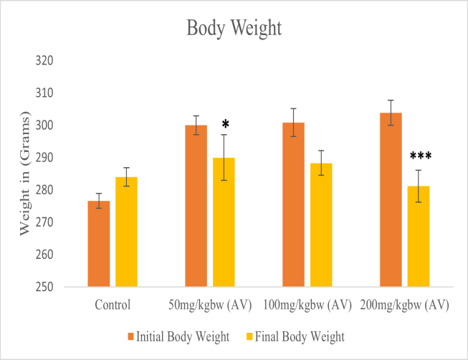
Fig.1: Body weight of control and Aloe vera treated rats for 45 days duration.
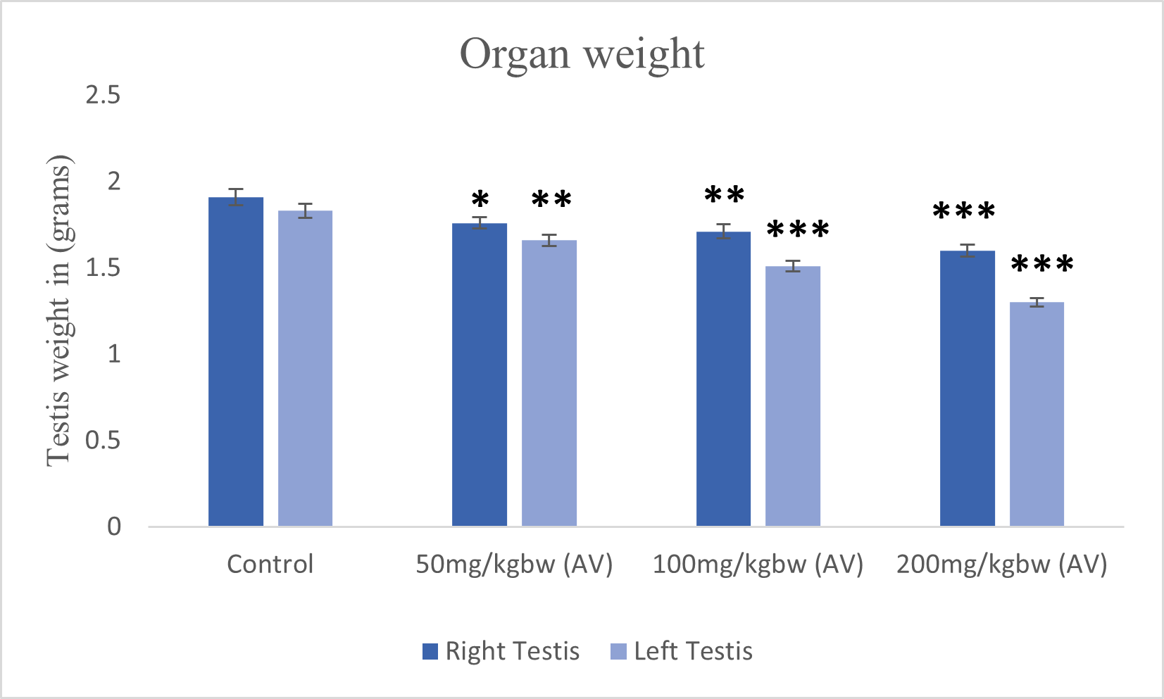
Fig.2: Testis weight of control and Aloe vera treated rats for 45 days duration.
Sperm count
The sperm concentration of the Aloe vera treated animal was studied. It was seen that. The sperm concentration in the control rat treated with normal saline was found to be 45.49±0.41 in the 50 mg/kg bw Aloe vera treated group, it was found to be 40.12±0.38***
and in the 100 mg/kg bw Aloe vera treated, it was found to be 32.13±0.33***
and in the 200 mg/kg bw Aloe vera treated it was found to be 28.36±0.25*** Thus, there was a dose dependent decline in the sperm concentration of the Aloe vera treated rats. Thus, it can be concluded that Aloe vera decreases the sperm count in rats.
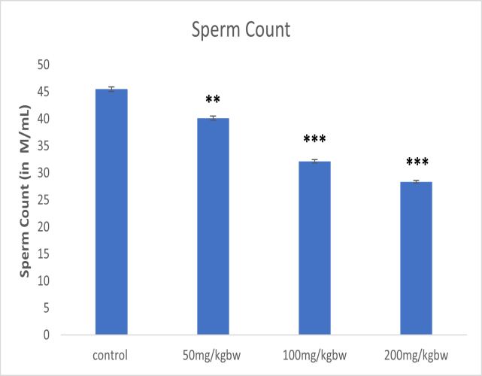
Fig.3: Sperm count of control and Aloe vera treated rats for 45 days duration

Sperm motility
The sperm motility of the Aloe vera treated animal was studied. It was seen that, the sperm motility in the control group rat treated with normal saline was found to be 29.46±0.25 in the 50 mg/kg bw Aloe vera treated group, it was found to be 21.33±0.50** and in the 100 mg/kg bw Aloe vera treated, it was found to be 18.6±0.29*** and in the 200 mg/kg bw Aloe vera treated group it was found to be 17.4±0.36*** Thus, there was a dose dependent decline in the sperm motility of the aloe vera treated rats. Thus, it can be concluded that Aloe vera decreases the sperm count in rats.
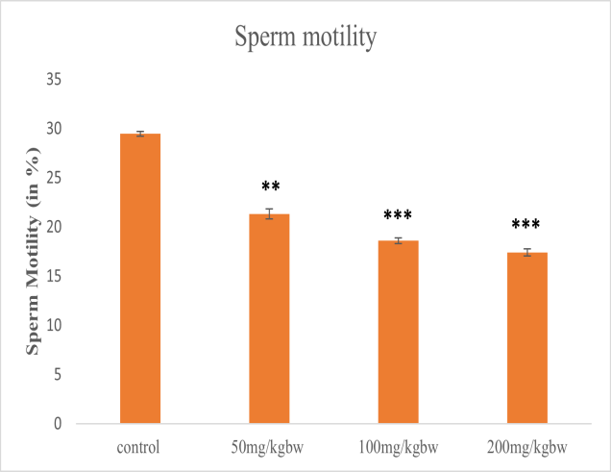

Fig.4: Sperm Motility of control and Aloe vera treated rats for 45 days duration

Sperm morphological abnormalities
The sperm morphological abnormalities of the Aloe vera treated animal was studied. It was seen that, the sperm morphological abnormalities in the control group rat treated with normal saline was found to be 29.46±0.25 in the 50 mg/kg bw Aloe vera treated group, it was found to be 21.33±0.50** and in the 100 mg/kg bw Aloe vera treated group, it was found to be 18.6±0.29*** and in the 200 mg/kg bw Aloe vera treated group it was found to be 17.4±0.36*** Thus, there was a dose dependent increase in the sperm morphological abnormalities of the Aloe vera treated rats. Thus, it can be concluded that Aloe vera increases the sperm morphological abnormalities in rats.
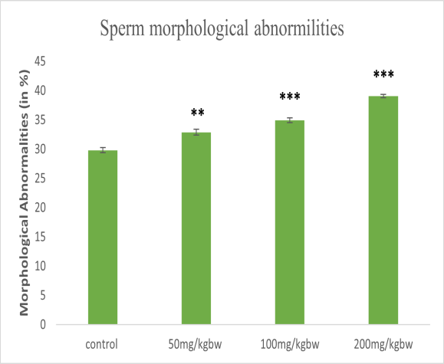
Fig.5: Sperm Morphological abnormalities of control and Aloe vera treated rats for 45 days duration.

Enzymatic Activity
Enzyme Superoxide Dismutase
Rats treated with Aloe vera for 45 days showed a decrease in the quantity of the antioxidant enzyme superoxide dismutase. Rats in the control group that were given normal saline had an enzyme level of 7.53±0.063 for superoxide dismutase. It was 6.22±0.092*** in the group treated with 50 mg/kg bw Aloe vera, 6.15±0.022*** in the group treated with 100 mg/kg bw Aloe vera, and 5.37±0.127*** in the group treated with 200 mg/kg bw Aloe vera. These results demonstrate that when the dosage of Aloe vera rose, the antioxidant enzyme superoxide dismutase dropped.
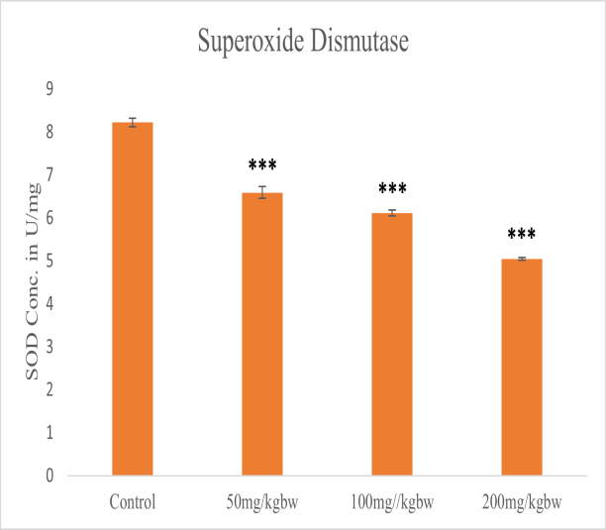
Fig.6: SOD concentration of control and Aloe vera treated rats for 45 days duration
Enzyme Catalase
Rats treated with Aloe vera for 45 days showed a decrease in the quantity of the antioxidant enzyme catalase. According to the study, the catalase enzyme was 67.33± 0.07 in the control group of rats given normal saline. The corresponding values for 50 mg/kg bw, 100 mg/kg bw, and 200 mg/kg bw are 66.96± 0.26, 50.78± 0.34***, and 38.67± 0.17***.
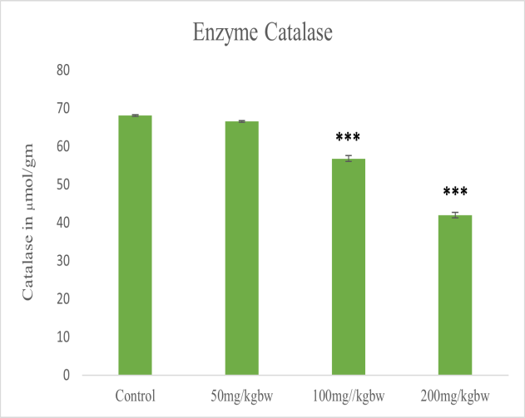
Fig.7: Catalase concentration of control and Aloe vera treated rats for 45 days duration
Enzyme Lipid peroxidase (LPO)
Rats treated with Aloe vera for 45 days showed a decrease in the concentration of the antioxidant enzyme lipid peroxidase. The enzyme LPO was observed to be 2.8± 0.06 in the control group of rats treated with normal saline, 6.22±0.092*** in the 50 mg/kg bw Aloe vera treated group, 6.15±0.022*** in the 100 mg/kg bw Aloe vera treated group, and 5.37±0.127*** in the 200 mg/kg bw Aloe vera treated group.
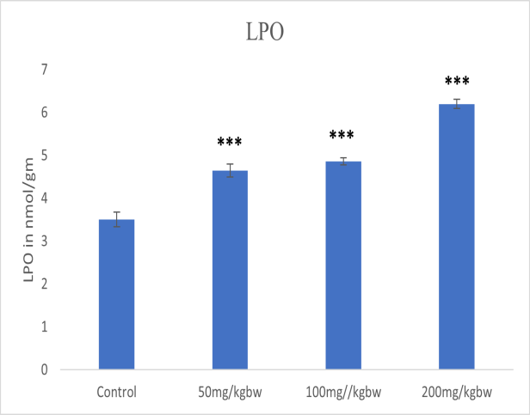
Fig.8: LOP concentration of control and Aloe vera treated rats for 45 days duration

Discussion
The weight of the Aloe vera-treated animal in our investigation is dropping in a dose-dependent fashion. Low food intake and the metabolic alterations brought on by Aloe vera are most likely to justify for this. Similar outcomes were observed in research by Sakib, 2019; Misawa et al., 2012; and Beya et al., 2012, where in consumption of Aloe vera at different dosages led to a decrease in body weight, most likely as a result of increased oxidative stress and energy expenditure.
The weight of the testicles of animals treated with Aloe vera decreased in a dose-dependent manner. These findings are comparable to those of Oyewopo et al., (2011).
In our study, the sperm count is decreasing with the increasing concentration of Aloe vera. These results are consistent with (Oyewopo et al., 2011). Our findings in this study are in accord with the observation of Lang (1993), who observed impairment of fertility as one of the major precautions in the use of the plant Aloe vera. This study supports this claim by showing that Aloe vera negatively affects the testicles.

However, this result contradicts that of Maurice (1993), who found that a dose of 60 mg/kg bw Aloe vera powder boosted rabbits' reproductive rate and litter size. Since seminiferous tubules make up around 80% of the testes' volume, a decrease in their quantity may result in less sperm cell synthesis from the testis, which could explain the testicular weight loss (Abdel-Razik et al., 2021; Oyewepo et al., 2011).
In contrast to the findings of Nwanjo (2006), who indicated that Aloe vera is rich in antioxidants that inhibit lipid peroxidation and mops up free radicals, the investigations also showed a drop in testicular weight, sperm count, and sperm motility. The reduction in sperm cell production from the testis may be the cause of the testicular weight decline. This might have happened because the seminiferous tubules, which make up around 80% of the testicular volume, were reduced.
Conclusion-
Aloe vera has been shown to have anti-fertility properties. Therefore, the purpose of this study was to examine Aloe vera's potential to cause male reproductive dysfunction. According to our research, Aloe vera reduces both body and testicular weight, also it affects the antioxidant enzyme activity. In addition, research on CASA (Computed Assisted Semen Analysis) indicates that it reduces sperm concentration and motility in a dose-dependent manner. Additionally, it raised the proportion of sperm defects. Aloe vera has therefore been shown to have an antifertility effect on albino rats' male reproductive system.

Ethical Approval:
Animal Ethic committee approval has been collected and preserved by the author(s)
Disclaimer (Artificial intelligence)
Option 1:
Author(s) hereby declare that NO generative AI technologies such as Large Language Models (ChatGPT, COPILOT, etc.) and text-to-image generators have been used during the writing or editing of this manuscript.
Option 2:
Author(s) hereby declare that generative AI technologies such as Large Language Models, etc. have been used during the writing or editing of manuscripts. This explanation will include the name, version, model, and source of the generative AI technology and as well as all input prompts provided to the generative AI technology
Details of the AI usage are given below:
1.
2.
3.

References
Asgharzade, S., Rafieian-kopaei, M., Amin, M., Somaye R., and Loghman, S. 2015. Aloe vera toxic effects: expression of inducible nitric oxide synthase (NiOS) in testis of Wistar rat. Iran J Basic Med Sci. 18(10): 967-973.
Dhurvey, V., Jiwantare, U., Karim, F. 2020. Ameliorating potentiality of sesame seed on Aloe vera induced male albino rat. Mukt Shabd Journal. Volume IX issue X. 541-548.
Estakhr, J., Javdan, N. 2011. Spermatogenesis activity of Aloe vera in adult male rats. Pharmacology online. 2: 886-889.
Ghazanfar, S.A. 1994. Handbook of Arabian medicinal plants: Boca Rato: CRC Press.
Habeeb, F., Shakir, E., Bradbury, F., Cameron, P., Taravati, M.R., Drummond, A.J. 2007. Screening methods used to determine the anti-microbial properties of Aloe vera inner gel. Methods. 42:315-20.
Wendmu, H., Ekanem, P. E., Alem, B., Gebreslassie, A., Abrha, N., Asfaw, Y.T., Nyaga, A. C. K. 2020. Evaluation of Aloe megalacantha Baker Leaf Latex on Testicular Histopathology and Hormonal Profile of Sprague Dawley Rats. Biomedical & Pharmacology Journal Vol. 13(4)1975-1985.
Helal, E. G. E., Sayed, R. A. A., Hoda, E.l. and Abu-Taleb. M. 2015. Studies on the use of Aloe vera extract as a contraceptive in female rats. The Egyptian Journal of Hospital Medicine. Vol. 60: 274-281.
Ibtisam, J.S. and Zena, M. H. 2014. Effect of Aloe vera extracts on histological features of male mice testis. Iraqi J. Embryos and Infertility Researches. 4(1):28-32.
Jeyasakthy, S., Rosdan, S., Irfan, M., and Azian, H. 2017. Antifungal effect of Malaysian Aloe vera leaf extract on selected fungal species of pathogenic otomycosis species in in vitro culture medium. Oman Medical Journal. Vol. 32.1:41–46.
Jiwantare, U., Dhurvey, V. and Katke, S. 2017. Studies on histological changes in testes and analysis of serum hormonal level Aloe vera treated male albino rat, Rattus norvegicus. International Journal of Researches in Biosciences, Agriculture and Technology. Special issue 2:281-284.
Jiwantare, U. and Dhurvey, V. 2022. Effect of Aloe vera and chloroquine on testes, sperm morphology and serum levels of reproductive hormones in albino rat. AGPE The Royal Gondwana Research Journal of History, Science, Economic, Political and Social science. Vol. 03 22-31.
Jorsarai, S. G. A., Shibahara, H., Ayustawati., Hirano, Y., Shiraishi, Y., Khalatbari, A., Pasha, Y. Y. and Suzuki, M.,2008 The in-vitro effects of nicotine, cotinine and leptin on sperm parameters analyzed by CASA system. Iranian Journal of Reproductive Medicine Vol.6(3) 157-165
Karim, F. and Dhurvey, V. 2017. Histopathological studies on the effect of Aloe vera extract on seminal vesicle of wistar rats, Rattus norvegicus. International Journal of Researches in Biosciences, Agriculture and Technology. 2: 353-356.
Karimi, J. H., Najmadini, N. and Hooshmand, F. 2012. Effect of alcoholic extract of Aloe vera plant on serum testosterone and gonadotropin levels in rats. J Jahrom Univ Med Sci. 10(2): 2.
Kushwaha, M. P. 2013. Effects of Aloe vera (Liliaceae) on gonad development in Nile tilapia, Oreochromis niloticus (L.) during intensive aquaculture. International Journal of Fisheries and Aquatic Studies. 1(2):56-60.
Mahmoud, R., Gabr sh. A., Yousif, A. I. A., El-Sherbieny, M. A., EI-Hayes, A. M., and Abdel-Khalek, A. E., 2023 Visual Examination and Computer Assessed Sperm Analysis (Casa) of Goat Semen Diluted by Tris-Extender Supplemented with Aqueous Extract of Moringa Oleifera Leaves. Journal of Sustainable Agricultural and Environmental Sciences (JSAES) 2 (4), 81-90.
Mehrdad, M. and Alireza, K. 2014. The effects of Aloe vera extract on reproductive parameters in mice. International Conference on Biological, Environment and Food Engineering (BEFE). X Bali (Indonesia).
Misawa, E., Tanaka, M., Nomaguchi, M., Yamada, M., Toida, T., Takase, M., Iwatsuki, K. and Kawada, T. 2008. Administration of phytosterols isolated from Aloe vera gel reduce visceral fat mass and improve hyperglycemia in Zucker dabetic fatty (ZDF) rats. J Obe Res Clin Prac. 2:239–245.
Mahrous, E. and Ahmed, H. 2021. Impact of Aloe Vera gel aqueous extract-supplemented yogurt on reproductive performance of male rats. International Journal of Veterinary Sciences.4(1): 40-53.
Nalimu, F., Oloro, J., Emanuel, L. Peter, E.L., and Ogwang, P.E. 2022. Acute and sub-acute oral toxicity of aqueous whole leaf and green rind extracts of Aloe vera in Wistar rats. BMC Complementary Medicine and Therapies. 22-16.
Oyewopo, A.O., Oremosu, A.A., Akang, E.N., Noronha, C.C. and Okanlawon, A.O. 2011. Effects of Aloe vera (Aloe Barbadensis) aqueous leaf extract on testicular weight, sperm count and motility of adult male Sprague-Dawley Rats. Journal of American Science. 7(4):31-34.
Oyeyemi M. O., Samuel G.O., Ajayi T.A., Adeniji D. A. (2011). Semen characteristics and sperm morphological studies of the West African Dwarf Buck treated with Aloe vera gel extract. Iranian Journal of Reproductive Medicin.e Vol. 9, 2:83-88.
Poorfarid, M., Karimi Jashni, H. and Houshmand, F. 2013. The effects of Aloe vera sap on progesterone, estrogen and gonadotropin in female rats. J Jahrom Univ Med Sci. 10(4):6-10.
Reuter, J., Jocher, A., Stump, J., Grossjohann, B., Franke G. and Schempp, C.M. 2008. Skin Pharmacol. Physiol. 21:106.
Reynolds, T., Dweck, A.C. (1999).Aloe vera leaf gel: A review update. J Ethnopharmacol. 68:3-37.
Richard, L.W. 2005. Aloe vera gel: Update for dentistry. Pharmacology Today. 6-9.
Saravanan, R. and Bavani, V. 2017. Ovulatory effect of Aloe Barbadensis Mill in mature New Zealand rabbit does. International Journal of Pharmacological Research. 7(12):240-247.
Shah, H., Qureshi, S., Tariq, M. and Ageel, A. M. 1989. Toxicity studies on six plants used in traditional Arab system of medicine.1989. Phytotherapy research, 3(1):25-29.
Shah, S. K., Jhade, D. and Chouksey. R. 2017. Pharmacological evaluation and antifertility activity of Aloe barbadensis linn on female wistar rats. International journal of phytomedicine. vol.9:253-260.
Shariati, M., Mokhtari, M. and Rastegar, S. 2009. Effect of Aloe vera extract on testosterone and gonadotropin hormone changes in rats. J Sabzevar Univ M Sci. 16(1):12-17.
Surjushe, A., Vasani, R. and Saple, D.G. 2008. Aloe vera: A short review. Indian J Dermato. 53,4:163-166.
Sydiskis, R.J., Owen, D.G., Lohr, J., Rosler, K.H. and Blomster, R.N. 1991. Inactivation of enveloped viruses by anthraquinones extracted from plant. Antimicrob Agent Chemother. 35:2463-2466.
Zohreh, N., Shahla, R. and Reza, M. 2014. The effect of Aloe vera extract on the sperm quality in male diabetic rats. Bulletin Environ. Pharma Life Sci. 3(3):223-228.

