Comprehensive Biochemical and Histopathological Assessment of Hepatic and Renal Protective Effects of Cobalt Nanoparticles by using alcoholic extract of Artemisia herba alba in laboratory male rats Induced Diabetic

Absrtact
In this experimental investigation, 30 male rats with alloxan-induced diabetes were used to assess the biochemical, histopathological, and physiological effects of three treatments: Artemisia herba alba-coated cobalt nanoparticles (CoNPs-AHA), Artemisia herba alba nanoparticles (AHA-NPs), and alcoholic extract of Artemisia herba alba (AHA extract). Significant weight loss resulted with the injection of alloxan (150 mg/kg), which also caused notable changes in blood biochemical markers and the weights of the liver, kidney, and pancreas. Along with normalised creatinine (20.66 ±6.77), urea (5.59 ±1.57), AST, ALT, and ALP levels (70.50 ±6.65, 28.50 ±5.39, 100.66 ±10.15) in ( P≤ 0.05), and the restoration of liver and kidney histological architecture, CoNPs-AHA (104.5µg\ml) treatment led to a considerable improvement in body weight and pancreatic weight as compared to the diabetic group. The administration of AHA-NPs (146µg\ml) improved lipid profiles (HDL 32.66 ±4.17, TG 29.00 ±1.64, TCh 24.28 ±1.00) at ( P≤ 0.05), and liver enzyme levels while also considerably increasing body and pancreatic weights. Furthermore, when compared to diabetic controls, therapy with AHA extract resulted in positive changes in organ weights, lipid profiles, and serum urea and creatinine levels. Histological evaluation demonstrated that the CoNPs-AHA group had almost full restoration of normal morphology, confirming the regenerative effects of these therapies on the liver and kidneys. These results suggest that CoNPs-AHA, AHA-NPs, and AHA extract may be useful therapeutic agents for reducing the biochemical and histological effects of diabetes mellitus in experimental rat models. This research focuses on an innovative approach for diabetes mellitus treatment, offering a new therapeutic possibility. Our study provides a promising evidence that could enhance the diabetes management. Furthermore, these finding open a new horizon for the researcher in the future who seeking for diabetes treatment with advance solution.
Keywords: Artemisia herba alba, Co₃O₄-NPs, Diabetes mellitus, Histopathology
Introduction
Manipulating matter at the nanoscale, typically between 1 and 100 nanometers, is the primary goal of the rapidly developing field of nanotechnology (1). Nanoparticles reduce systemic exposure and toxicity in non-target tissues by facilitating medication transport to specific organs or tissues. Nanoparticles can avoid the reticuloendothelial system by altering their surface in ways like PEGylation, which prolongs circulation durations and encourages aggregation at the intended site (2). By shielding the encapsulated nanoparticles from early metabolic breakdown by intestinal or liver wall enzymes, they guarantee that the active medication reaches its target location. By using other absorption channels to circumvent initial hepatic metabolism, they also eliminate the first-pass effect (3). By avoiding hepatic metabolism, nanoparticles can reach the systemic circulation by lymphatic absorption. They can also be specifically delivered through mucosal surfaces such as the mouth, nose, or rectal cavity to reduce exposure to liver enzymes after the first absorption (4). Artemisia herba-alba, or white wormwood, is a perennial plant that grows in Mediterranean dry steppes (5). The plant has been shown in studies to dramatically minimize the total cholesterol levels. When using its extracts as a supplement, for instance, participants' cholesterol levels have dramatically decreased, particularly for those with diabetes and those on high-fat diets (6). The plant has also been connected to a reduction in lipid levels. The research indicates that the extract from Artemisia herba-alba effectively lowers the levels of triglyceride, which is beneficial for metabolic syndrome management and cardiovascular health (7). Artemisia herba-alba extract, dramatically decreased liver enzyme levels in rats that have been exposed to hepatotoxic substances, indicating that its antioxidant qualities may show some protection against liver injury (8). This suggests that Artemisia herba alba may help to control chronic liver health issues, such as fatty liver disease linked to metabolic syndrome, in addition to avoiding acute liver injury (9) Artemisia herba-alba has strong hepatoprotective properties such as lowering the levels of liver enzyme, increasing antioxidant activity, enhancing biochemical indicators linked to liver function, and perhaps lowering chronic disorders like metabolic syndrome (10). The antioxidant qualities of A. herba alba shield renal tissues from oxidative stress, minimising kidney damage, particularly that brought on by diabetes and high blood sugar levels (11). In diabetic mice, administering Artemisia herba alba lowers urea and creatinine levels, potentially improving glomerular filtration rates and kidney function (12). Treating with Artemisia herba alba enhances the kidney histology and may guard against structural alterations brought on by oxidative stress or harmful chemicals by lowering the damage markers, such as inflammation and thickening of the blood vessel wall (13).

2. materials and methods
2.1 Collection and preparation of Artemisia herba alba
Artemisia herba alba was gathered from Basrah, Iraq's local marketplace. In independent experiments, 100 grammes of air-dried ground plant material were extracted using 500 millilitres of an aqueous methanol solvent (methanol: water, 80% v/v) for eight hours under Soxhlet conditions on a water bath. The plant extract was separated and its solvent content concentrated using a rotary evaporator set to 45 °C. After being weighed to determine the yield, the dried crude concentrated extracts of Artemisia herba alba were kept in a refrigerator at 4 °C until they were used (14).

2.2 Hydrothermal Method of CoNPs Biosynthesis

To create cobalt oxide (Co₃O₄) nanoparticles, 10 millilitres of a 200 mg/ml concentration of Artemisia herba alba extract was added to 6 grammes of cobalt nitrate solution. A KOH solution was then added, and the mixture was stirred for 15 minutes. After adding the hydrazine monohydrate and oleic acid solutions, the mixture's volume reached two-thirds of the autoclave's total volume. It was then stirred for two hours to completely dissolve the solid reagents before being transferred into a Teflon-coated autoclave and placed in an electric oven, where it was kept at 160 ˚C for twenty-four hours. The autoclave has been left to naturally cool to room temperature after twenty-four hours. Ultimately, the final preparation solution was centrifuged, the liquid phase was decanted, and the resulting black precipitate was dried in an oven at 70 ˚C to separate the obtained Cobalt NPs from the liquid phase (15).
2.3 Experimental Animals:
30 mature male rats in a good, healthy condition, weighing between 300 and 400 grams. Before the research, the animals were given a week to acclimate to the lab environment under strict, clean, hygienic, and standard managing conditions at temperature (21-25°C), in a controlled room on a 12-hour light and 12h dark [16]. The animals were divided into five groups, each containing six male rats, and were given the following care:

Group 1: a control group, giving normal saline 0.5ml (I.P)
Group 2: Each rat was injected with alloxan (150 mg/kg). (17)
Group 3: Each rat was daily treated with cobalt nanoparticles coated with Artemisia herba alba (104.5µg\ml)
Group 4: Each rat was daily treated with Artemisia herba alba nanoparticles (146µg\ml)
Group 5: Each rat was daily treated with Artemisia herba alba extract (500 mg/kg) (17).
The animals were experimentally induced with diabetes mellitus, and two days after injection, the levels of blood glucose were measured to confirm the development of diabetes. After confirming the treatment regimen started and continues for thirty days.

Collection of Blood Sample
At the end of the trail, blood samples have been collected from the hearts of the rats for biochemical analysis. Four ml of the blood was placed in an anticoagulant-free tube and centrifuged at 4000 rpm for 15 minutes [18].

3. Results
3.1 The body and organs' weight
In table (1) compared to the control group, the administration of alloxan (150 mg/kg) produced a significant decrease in the weight of the body after the experiment ( P≤ 0.05). treated with cobalt nanoparticles leads to a slightly significant reduction in the body weight ( P≤ 0.05) compared to the control group, but a significant increase when compared to the alloxan group. also treated with Artemisia herba alba nanoparticles, causing a significant increase ( P≤ 0.05) in the body weight compared to the control group. The last group of treatment with Artemisia herba alba shows a significant increase (P ≤ 0.05) in body weight compared to the healthy group.
Table (1) shows the body weights before and after treatments
Parameters  Groups | Body weight (g)  Before | Body weight (g)  After
Control (0.9% N.S) | e  335.33  ±19.70 | c  337.83  ±21.16
Alloxan (150mg/kg) | b  359.00  ±25.00 | e  294.66  ±19.10
Cobalt nanoparticles coated with AHA (104.5µg\ml) | c  339.66  ±13.27 | d  335.50  ±11.62
Artemisia herba albananoparticles (146µg\ml) | d  337.33  ±23.67 | b  338.00  ±24.86
Artemisia herba alba (500mg/kg) | a  361.00  ±25.95 | a  352.50  ±28.13
LSD | 2.00 | 0.16

Different litters refer to significant differences among groups ( P≤ 0.05)
Table (2) shows that the weight of the liver and kidney is significantly, and a significant decrease in pancreas weight (P≤ 0.05) compared to the healthy group. While rats treated with cobalt nanoparticles exhibit a significant increase in pancreas weight and a significant decrease in kidney and liver weight (P ≤ 0.05) compared to the alloxan group, the values are comparable to those of the control group. Treated with Artemisia herba alba nanoparticles, the liver and kidney weights decrease significantly, while the pancreas weight increases significantly (P ≤ 0.05) compared to the untreated group(alloxan). also, treatment with Artemisia herba alba shows a significant increase in the weight of the pancreas, and a significant decrease in the weight of the kidney and liver at (P≤ 0.05) compared to the alloxan group.
Table (2): The weight of body organs (liver, Kidney, and pancreas).
Parameters  Groups | Liver (g) | Kidneys (g) | Pancreas (g)
Control (0.9% N.S) | e  7.91  ±0.69 | b  1.98  ±0.19 | c  1.24  ±0.16
Alloxan (150mg/kg) | a  11.13  ±1.34 | a  2.05  ±0.71 | e  0.92  ±0.31
Cobalt nanoparticles coated with AHA(104.5µg\ml) | d  8.45  ±0.57 | d  1.69  ±0.16 | d  1.21  ±0.17
Artemisia herba alba nanoparticles  (146µg\ml) | c  9.16  ±0.66 | e  1.62  ±0.15 | a  1.33  ±0.23
Artemisia herba alba extract  (500mg/kg) | b  9.35  ±0.41 | c  1.85  ±0.07 | b  1.32  ±0.22
LSD | 0.19 | 0.06 | 0.01

Different litters refer to significant differences among groups (P≤ 0.05)
3.2 Biochemical results
3.2.1 The effect of cobalt nanoparticles, Artemisia herba alba nanoparticles, and Artemisia herba alba on liver enzymes in male rats with induced diabetes
This table shows a significant increase in AST, ALT, and ALP in the alloxan group according to (p≤0.05) when it compared with the control group. While the treated with cobalt nanoparticles coated with A. herba alba show a significant decrease in the liver enzymes AST, ALT, and ALP at (p≤0.05) compared to the untreated group. The result shows a significant decrease in the liver enzymes AT, ALT, and ALP at (p≤0.05) when treated with A. herba alba nanoparticles and the extract of Artemisia herba alba.
Table (3): The liver enzymes (AST, ALT, and ALP) values.
Parameters  Groups | AST (U/L) | ALT (U/L) | ALP (U/L)
Control (0.9% N.S) | b  99.16  ±17.29 | b  35.83  ±6.11 | b  113.00  ±31.36
Alloxan (150mg/kg) | a  172.66  ±24.53 | a  72.16  ±12.78 | a  272.16  ±42.30
CoNPs coated with AHA(104.5µg\ml) | e  70.50  ±6.65 | e  28.50  ±5.39 | e  100.66  ±10.15
A. herba alba nanoparticles(146µg\ml) | d  76.00  ±8.07 | d  29.00  ±1.54 | c  112.83  ±18.28
A. herba alba extract (500mg/kg) | c  82.66  ±5.68 | c  33.50  ±5.99 | d  109.66  ±22.58
LSD | 5.50 | 0.50 | 0.16
Different litters refer to significant differences among groups (P≤ 0.05)
3.2.2 The effect of cobalt nanoparticles, Artemisia herba alba nanoparticles, and Artemisia herba alba on kidney function (creatinine and urea) in male rats induced diabetes
Table (4) shows a significant increase in creatinine and urea when administered alloxan at (p≤0.05), treated by cobalt nanoparticles coated with A. herba alba cause a significant decrease in creatinine value (P≤ 0.05), but it is closely to the control group, but the urea value is significantly increase ( P≤ 0.05) also it is similar when compared to the healthy group. When the rats were treated with Artemisia herba alba nanoparticles, it causes to a significant increase in the levels of creatinine and urea at (p≤0.05), but this elevation is less than alloxan and close to the value of the control group. Also, in this table, the treatment with alcoholic extract of Artemisia herba alba caused a significant increase in creatinine and urea (p≤0.05). The rise in the value of Artemisia herba alba is less than alloxan and close to the control group.
Table (4): creatinine and urea value in male rats induced diabetes
Parameters  Groups | Creatinine (umol/L) | Urea (mmol/L)
Control (0.9% N.S) | d  21.66  ±9.83 | e  5.50  ±2.12
Alloxan (150mg/kg) | a  52.83  ±12.15 | a  15.70  ±3.41
CoNPs coated with AHA(104.5µg\ml) | e  20.66  ±6.77 | d  5.59  ±1.57
A. herba alba nanoparticles(146µg\ml) | c  24.33  ±5.39 | c  6.91  ±1.00
A. herba alba extract (500mg\kg) | b  25.83  ±5.38 | b  7.87  ±0.82
LSD | 1.00 | 0.09
Different litters refer to significant differences among groups (P≤ 0.05)

3.2.3 The effect of cobalt nanoparticles, Artemisia herba alba nanoparticles, and Artemisia herba alba on total cholesterol, triglycerides, high-density lipoprotein, low-density lipoprotein, and very low-density lipoproteins on male rats induced diabetes.
The results in table (4.8) show the levels of total cholesterol, triglycerides, low-density lipoproteins, and very low-density lipoproteins were significantly increase at (p≤0.05), but a significant decrease in high-density lipoproteins at (p≤0.05), when administered alloxan causes hyperglycemia, hypercholesterolemia, and hypertriglyceridemia, compared with healthy rats. Treated with cobalt nanoparticles coated with A. herba alba causes a significant increase in total cholesterol, triglycerides, and high-density lipoprotein at (p≤0.05), but a significant decrease in LDL and VLDL at (p≤0.05), these values are close to the healthy group. In the same table, when treated with Artemisia herba alba nanoparticles, the total cholesterol, triglycerides, and high-density lipoprotein, low-density lipoprotein have been increase significantly at (p≤0.05), but a significant decrease in very low-density lipoprotein at (p≤0.05). The table also shows a significant increase in total cholesterol, triglycerides, and high-density lipoprotein, low-density lipoprotein at (p≤0.05), but a significant decrease in very low-density lipoprotein at (p≤0.05) when treated with alcoholic extract of Artemisia herba alba compared with the healthy group.
Table (5): lipid profile of male rats (TCh, TGS, HDL, LDL, and VLDL)
Parameters  Groups | TCh (mg/dl) | TGS (mg/dl) | HDL (mg/dl) | LDL (mg/dl) | VLDL (mg/dl)
Control (0.9% N.S) | e  22.56  ±1.60 | d  27.54  ±1.71 | c  29.61  ±3.44 | d  26.97  ±2.36 | b  8.69  ±0.91
Alloxan (150mg/kg) | a  35.08  ±2.38 | a  46.99  ±8.56 | e  17.98  ±1.18 | a  40.18  ±4.45 | A  13.53  ±3.31
CoNPs coated with AHA(104.5µg\ml) | d  23.00  ±2.61 | e  27.51  ±1.77 | a  32.73  ±1.71 | e  26.16  ±2.43 | e  6.65  ±0.78
A.herba alba nanoparticles (146µg\ml) | c  24.28  ±1.00 | c  29.00  ±1.64 | b  32.66  ±4.17 | c  27.84  ±1.16 | D  7.32  ±0.92
A.herba alba extract (500mg/kg) | b  28.58  ±1.18 | b  30.40  ±1.07 | d  29.53  ±0.87 | b  29.42  ±0.84 | C  7.40  ±0.95
LSD | 0.43 | 0.02 | 0.06 | 0.80 | 0.07
Different litters refer to significant differences among groups (P≤ 0.05)

3.2.4 The effect of cobalt nanoparticles, Artemisia herba alba nanoparticles, and Artemisia herba alba on glucose, HbA1c and insulin levels on male rats induced diabetes.
In table (6) the glucose and HbA1c have been significantly increased at (p≤0.05) after administrated of alloxan, but insulin has been significantly decreased at (p≤0.05) compared with the control group. Treated with cobalt nanoparticles causes a significant decrease in glucose and HbA1c levels but a significant increase in insulin levels at (p≤0.05) compared with the control group. Artemisia herba alba nanoparticles cause a significant decrease in glucose and HbA1c, and a significant increase in the levels of insulin (p≤0.05) compared with the untreated group. Additionally, the table shows a significant decrease in glucose and HbA1c, and a significant increase in insulin level (p ≤ 0.05) compared with the alloxan group.
Table (6): Glucose, HbA1c, and insulin values in male rats.
Parameters  Groups | Glucose (mg/dl) | HbA1c (%) | Insulin (ng/ml)
Control (0.9% N.S) | c  136.16  ±15.36 | b  4.17  ±0.10 | b  1.61  ±0.52
Alloxan (150mg/kg) | a  483.66  ±15.50 | a  5.72  ±0.68 | e  0.40  ±0.19
CoNPs coated with AHA(104.5µg\ml) | e  118.50  ±8.43 | e  3.40  ±0.18 | a  2.32  ±0.59
Artemisia herba alba NPs(146µg\ml) | d  132.00  ±12.99 | d  3.65  ±0.40 | c  1.42  ±0.31
Artemisia herba alba (500mg/kg) | b  212.33  ±37.90 | c  3.83  ±0.55 | d  0.84  ±0.34
LSD | 4.16 | 0.17 | 0.19

3.3 histological changes
3.3.1 histological changes of the liver
The histopathological section of the control group's liver reveals a normal architecture of liver parenchyma, the hepatocytes arranged normally in cords radiating from the central vein and normal sinusoids (Figure 1). Whereas, the liver of the alloxan group shows the disrupted architecture of liver parenchyma, consisting of a dilated central vein, degenerative hepatocytes, and dilated sinusoids (Figure 2). The liver of CoNPs coated with A. herba alba shows a regenerated architecture of liver parenchyma, consisting of a normal hepatocytes, normal central vein, and normal sinusoids (Figure 3).
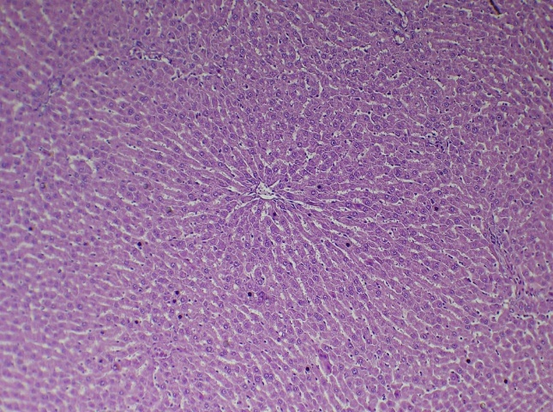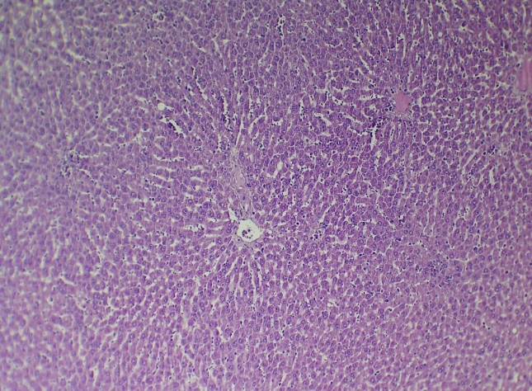
Figure (1 ): Histological micrograph of the liver of the G1 control group shows the normal architecture of liver parenchyma, consisting of a normal centrall vein (black arrow), normal hepatocytes (blue arrow), and normal sinusoids (yellow arrow). H&E stain 100X.
Figure (2): Histological micrograph of the liver of the G2 (alloxan group) shows the disrupted architecture of liver parenchyma, consisting of a dilated central vein (black arrow), degenerative hepatocytes (blue arrow), and dilated sinusoids (yellow arrow). H&E stain 100X.
.
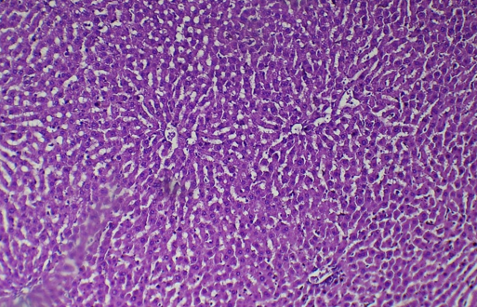
Figure (3): Histological micrograph of the liver of the G3 (CoNPs coated with AHA) treatment group shows regenerated architecture of liver parenchyma, consisting of a normal central vein (black arrow), normal hepatocytes (blue arrow), and normal sinusoids (yellow arrow). H&E stain 100X.

3.3.2 Histological changes of the kidney
In the control group, the kidney exhibits normal architecture of the kidney parenchyma, comprising normal glomeruli and renal tubules (Figure 4). While the kidney of the alloxan group shows the disrupted architecture of kidney parenchyma, consisting of atrophied glomeruli, degenerated and dilated renal tubules (Figure 5). CoNPs coated with A. herba alba kidney show a regenerated architecture of kidney parenchyma, consisting of normal glomeruli and normal renal tubules (Figure 6)
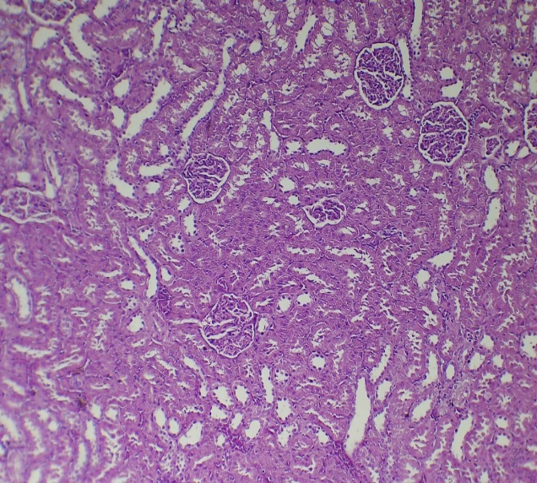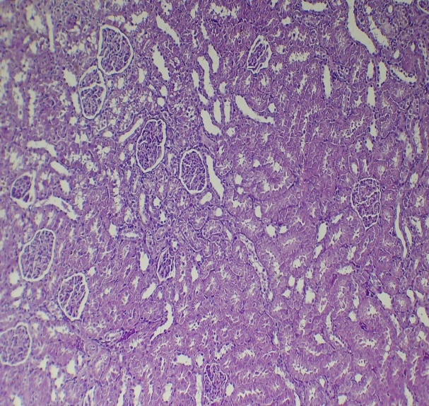
Figure (5): Histological micrograph of the kidney of the G2 alloxan group shows the disrupted architecture of kidney parenchyma, consisting of atrophied glomeruli (black arrow), degenerated and dilated renal tubules (yellow arrow). H&E stain 100X.

Figure (4): Histological micrograph of the kidney of the G1 control group shows the normal architecture of kidney parenchyma, consisting of normal glomeruli (black arrow), normal renal tubules (yellow arrow). H&E stain 100X.
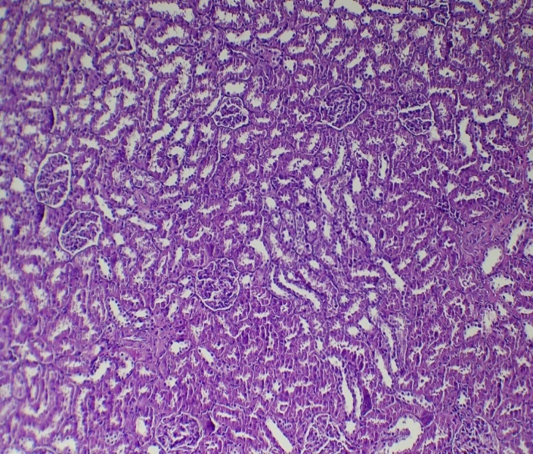
Figure (6): Histological micrograph of the kidney of the G3 (CoNPs coated with AHA) treatment group shows regenerated architecture of kidney parenchyma, consisting of normal glomeruli black arrow), normal renal tubules (yellow arrow). H&E stain 100X.

4. discussion
Diabetes has been related to decreased body weight (19). In particular, alloxan-induced diabetes caused a decrease in body weight in untreated diabetic rats throughout the study period, compared to both the treated and control diabetic groups. Treated with cobalt nanoparticles coated with AHA, the body weight shows an improvement compared with the untreated group. Also there is an improvement in the body weight when the diabetic rats are treated with Artemisia herba alba nanoparticles. The results of the current study revealed that alloxan-induced diabetes caused a significant increase in liver weight in the diabetic rat group compared to the healthy control group (20) . This refers to the absence of the hormone insulin and increased glucose levels in the blood (21). Overabundant glucose is stored in the liver cells in the form of glycogen, which causes to increase in liver weight (22). However, a decrease in liver weight was observed when treated with the aqueous extract of A. herba alba. This refers to the components of the herb that contain flavonoids, which improve the body's metabolic and health status and reduce the risk of disease. Alloxan-induced diabetes leads to a significant increase in kidney weight in the diabetic rat group when compared to the healthy group. This is coordinated with (23). Due to hyperglycemia or other metabolic activities associated with diabetes, which leads to kidney enlargement (24). However, when treated by using the of Artemisia herba alba aqueous extract, the weight of the kidney was decreased. This outcome is comparable to that of a study (25) that demonstrated that a significant increase in kidney weight was observed in male rats with induced diabetes when treated with the aqueous extract of Artemisia herba alba at doses of 200, 100, and 50 mg/kg. This is due to the flavonoid content of Artemisia herba alba, which increases the antioxidant enzymes effectiveness in the kidney by decreasing oxidative stress. According to (26), diabetic animals have higher levels of the enzymes ALT and AST. This alludes to the production of free radicals, which contribute to liver damage by causing necrosis, the breakdown of liver cells, and the discharge of waste products into the blood. Male rats with alloxan-induced diabetes had higher blood serum levels of the enzyme alkaline phosphatase (ALP). This aligns with the research conducted by (27). Alkaline phosphatase (ALP) levels in the diabetic group are higher because of damage from alloxan administration (28), which raises blood glucose levels and produces free radicals (29). The disintegration of some tissues, including the liver, due to substance metabolism or reduced biliary secretory flow may be the cause of this rise in the enzyme level (30). Furthermore, because pancreatic damage affects the bile duct, it causes an increase in the enzyme (31). According to the study, diabetic male rats' blood levels of ALT, ALP, and AST significantly decreased after receiving 500 mg/kg of Artemisia herba alba aqueous extract thrice daily for a month (32; 25). This is because the aerial portions of Artemisia herba alba contain active substances that are important for safeguarding the liver tissue (33). The current investigation demonstrated that male albino rats with diabetes induced by alloxan had elevated blood urea and creatinine levels. This aligns with the findings of research conducted by (34). Elevated in blood urea and creatinine levels leads to diabetic nephropathy, which is characterised by slow, gradual negative changes in kidney function, this is one of the chronic complications that cause this increase in some body organs as a result of long-term diabetes (35; 36; 37). Treating diabetic animals with Artemisia herba alba aqueous extract at a dose of 500 mg/kg once daily for a month resulted in a significant decrease in urea and creatinine levels. This result is consistent with a study by (25), which showed that male albino rats with induced diabetes that has been treated with an aqueous extract of Artemisia herba alba at doses of 50, 100, and 200 mg/kg showed a significant decrease in the levels of urea and creatinine compared to the untreated group. This was attributed to the active components of the plant, terpenoids and flavonoids, which decreased lipid peroxidation and increased antioxidants in the rats. This also reduced accumulated fat and blood glucose, leading to improved kidney tissue (38). The findings of the study demonstrated that male albino rats' blood serum cholesterol levels increased when diabetes was induced. This is in line with (39), which found that the blood serum cholesterol levels will be raised when giving rats alloxan relative to the healthy group. Due to increased activity of the enzyme cholesterol acyl transferase, which promotes insulin insufficiency in diabetes, high cholesterol in diabetes is ascribed to increased intestinal absorption (40). Additionally, the study demonstrated that diabetic mice's cholesterol levels significantly decreased after receiving an aqueous extract of Artemisia herba alba at a dosage of 500 mg/kg once daily for a month. The outcome was in line with research showing that Artemisia herba alba decreased cholesterol levels in diabetic rats relative to healthy rats (41; 25). The decrease in cholesterol released into the blood may refer to increased insulin levels and lower blood sugar, which leads to a decrease in lipid levels. This is because the lipase enzyme in fat cells is inhibited by insulin (42). The study's findings demonstrated that male albino rats' blood serum triglyceride levels rose when diabetes was induced. This is in line with the findings of (43), who found that diabetic patients had higher triglyceride levels (44). They demonstrated that male albino rats with diabetes induced by alloxan had lower levels of HDL in their blood serum. This is in line with the findings of (41), which shown that alloxan caused a drop in HDL-C in the blood serum of male albino rats. Hyperglycemia and insulin insufficiency may be the cause of this, since they may promote HDL-C metabolism. The findings also demonstrated that diabetes brought on by alloxan raised the levels of low-density lipoproteins (LDL). This aligns with research conducted by (45). Because lipoprotein lipase is less active, it is unable to convert most LDL to VLDL and break down triglycerides, which raises the amount of LDL in the blood serum. This is the reason for the rise in LDL concentration. Since it increases the risk of heart disease, this is undesirable (46). Furthermore, male albino rats with diabetes induced by alloxan had higher blood serum levels of extremely low-density lipoprotein. This is in line with the findings of a study that examined the impact of VLDL concentration on the severity of diabetes in rats that had been given alloxan. Compared to healthy mice, they discovered that infected animals had higher VLDL concentrations (47). According to (48), this might be because diabetes inhibits the lipoprotein lipase enzyme, which lowers the rate of VLDL metabolism and raises its blood level. Additionally, the study demonstrated that giving diabetic rats Artemisia herba alba aqueous extract once daily for a month at a dosage of 500 mg/kg significantly raised HDL levels in the blood serum while significantly lowering triglyceride, VLDL, and LDL levels. This outcome was in line with research done on rats by (41). They found that giving rats an aqueous extract of A. herba alba at a dosage of 390 mg/kg for two weeks significantly reduced triglycerides, cholesterol, and LDL while increasing levels of high-density lipoproteins, hence preventing hyperlipidaemia. The high proportion of flavonoids and antioxidant capability is the cause of this (49). Additionally, when compared to AHA treatment, the use of A. herba alba nanoparticles results in a significant decrease in total cholesterol, triglycerides, LDL, and VLDL and a significant increase in HDL. The result show that injection of alloxan leads to increase the levels of blood glucose and HbA1c, and decrease of insulin level. This result was consistent with (50). This study showed that treating diabetic animals with Artemisia herba alba aqueous extract at a dose of 500 mg/kg once daily for one month caused a significant decrease in the levels of glucose. This result was consistent with (51). Artemisia herba alba contains glycosides and saponins, which reduce the glucose levels (52). It also contains flavonoids, which lower cholesterol and triglycerides, increase the secretion of insulin, and stimulate the beta cells of the pancreas to secrete more insulin by increasing the enzyme hepatic glucokinase (53). The result of the histological study in normal rats shows that the liver consists of several lobes, each lobe containing a central vein surrounded by cuboidal cells called hepatocytes that are arranged in cords, and between these cords are blood-filled spaces called sinusoids (54). In diabetic rats, the liver exhibits infiltration of inflammatory cells, congestion in the portal area of the hepatic lobules, and vacuolation of hepatocytes, accompanied by dilation and irregularity of the sinusoids, compared to the control group. The study shows that induced diabetes in male rats leads to changes in the liver tissue compared with the healthy rats (23). Our study revealed for the first time that renal parenchyma regeneration was significantly enhanced by treatment with cobalt nanoparticles coated with Artemisia herba alba (CoNPs-AHA). In contrast to the control group, the study's results showed that male albino rats' kidneys altered when they were administered diabetes. This is consistent with research on rats (23), which shows that degenerative changes in the kidneys of diabetic rats are connected to the direct effects of alloxan. Necrosis is brought on by alloxan (55). Furthermore, diabetic nephropathy is significantly influenced by oxidative stress (56), and necrosis was seen in the kidneys of diabetic rats as one of the alterations brought on by diabetes (57). Our research revealed for the first time that renal parenchymal architecture significantly recovered after being treated with cobalt nanoparticles coated with Artemisia herba alba (CoNPs-AHA). Indicative of improved renal tissue healing and structural remodelling, histopathological investigation showed the return of normal kidney morphology, with intact glomeruli and well-organised renal tubules.

Conclusion

The current study demonstrates that in rats with diabetes induced by alloxan, Artemisia herba alba in various formulations—cobalt nanoparticle-coated (CoNPs-AHA), Artemisia herba alba nanoparticle (AHA-NPs), and alcoholic extract—exerted significant therapeutic benefits. With the restoration of liver and kidney architecture and the normalisation of important biochemical indicators such as creatinine, urea, and liver transaminases, CoNPs-AHA demonstrated the most noticeable improvements among the therapies. A. herba alba extract and Artemisia herba alba-NPs both improved organ function and lipid metabolism, thereby enhancing the physiological state. According to these results, A. herba alba has strong antioxidant, hepatoprotective, and renoprotective properties, especially when mixed with cobalt nanoparticles. It also shows promise in the treatment of diabetes mellitus and the biochemical and histological problems that are linked to it.

Ethical Approval
The study was approved by the Research Ethics Committee of the College of Veterinary Medicine, University of Basrah, according to Protocol No. 94/37/2025, dated September 1, 2024.

Disclaimer (Artificial intelligence)
Option 1:
Author(s) hereby declare that NO generative AI technologies such as Large Language Models (ChatGPT, COPILOT, etc.) and text-to-image generators have been used during the writing or editing of this manuscript.
Option 2:
Author(s) hereby declare that generative AI technologies such as Large Language Models, etc. have been used during the writing or editing of manuscripts. This explanation will include the name, version, model, and source of the generative AI technology and as well as all input prompts provided to the generative AI technology
Details of the AI usage are given below:
1.
2.
3.

Reference
- Ahire, S. A., Bachhav, A. A., Pawar, T. B., Jagdale, B. S., Patil, A. V., & Koli, P. B. (2022). The Augmentation of nanotechnology era: A concise review on fundamental concepts of nanotechnology and applications in material science and technology. Results in Chemistry, 4, 100633.
- Metkar, S. P., Fernandes, G., Navti, P. D., Nikam, A. N., Kudarha, R., Dhas, N., ... & Mutalik, S. (2023). Nanoparticle drug delivery systems in hepatocellular carcinoma: a focus on targeting strategies and therapeutic applications. OpenNano, 12, 100159.‏
- Zheng, Y., Luo, S., Xu, M., He, Q., Xie, J., Wu, J., & Huang, Y. (2024). Transepithelial transport of nanoparticles in oral drug delivery: From the perspective of surface and holistic property modulation. Acta Pharmaceutica Sinica B.‏
- Zhang Y, Xiong GM, Ali Y, et al. Layer-by-layer coated nanoliposomes for oral delivery of insulin. Nanoscale. 2021;13:776–89
- Mohammed, M. J., Anand, U., Altemimi, A. B., Tripathi, V., Guo, Y., & Pratap-Singh, A. (2021). Phenolic composition, antioxidant capacity and antibacterial activity of white wormwood (Artemisia herba-alba). Plants, 10(1), 164
- Jin, Z., & Wang, X. (2024). Traditional Chinese Medicine and Plant-Derived Natural Products in Regulating Triglyceride Metabolism: Mechanisms and Therapeutic Potential. Pharmacological Research, 107387.
- Chaachouay, N., & Zidane, L. (2024). Plant-derived natural products: a source for drug discovery and development. Drugs and Drug Candidates, 3(1), 184-207.
- Sunday, G., Stephen, E. C., Chinedu, I., Tsuvini, J., & Attah, A. D. (2024). Antidiabetic and Hepatoprotective Effects of Aqueous and Ethanolic Leaf Extracts of Mitracarpus Hirtus on Alloxan-Induced Diabetic Rats. Asian Journal of Science, Technology, Engineering, and Art, 2(2), 222-242.
- Sokal-Dembowska, A., Jarmakiewicz-Czaja, S., Ferenc, K., & Filip, R. (2024). Can Nutraceuticals Support the Treatment of MASLD/MASH, and thus Affect the Process of Liver Fibrosis?. International Journal of Molecular Sciences, 25(10), 5238.
- Fathy Hassan, A., Mohamed Gebril, S., Ismael, M., & Hefny Gad, M. (2022). Protective effect of Artemisia herba-alba extract on the liver of diabetic albino male rats. Sohag Journal of Sciences, 7(3), 155-160
- Darenskaya, M., Kolesnikov, S., Semenova, N., & Kolesnikova, L. (2023). Diabetic nephropathy: significance of determining oxidative stress and opportunities for antioxidant therapies. International Journal of Molecular Sciences, 24(15), 12378.
- Segev, G., Cortellini, S., Foster, J. D., Francey, T., Langston, C., Londoño, L., ... & Jepson, R. E. (2024). International Renal Interest Society best practice consensus guidelines for the diagnosis and management of acute kidney injury in cats and dogs. The Veterinary Journal, 106068.
- Jin, Q., Liu, T., Qiao, Y., Liu, D., Yang, L., Mao, H., ... & Zhan, Y. (2023). Oxidative stress and inflammation in diabetic nephropathy: role of polyphenols. Frontiers in immunology, 14, 1185317.
- Sultana B.; Anwar F. and Ashraf M. (2009). Effect of Extraction Solvent/ Technique on the Antioxidant Activity of Selected Medicinal Plant Extracts Molecules 14: 2167-2180
- Ansari, S.; Bhor, R.; Pai, K.; Sen, D.; Mazumder, S.; Ghosh, K.; Kolekar, Y.; Ramana, C. Cobalt nanoparticles for biomedical applications: Facile synthesis, physiochemical characterization, cytotoxicity behavior and biocompatibility. Appl. Surf. Sci. 2017,414, 171–187.
- Adam, R. S., Shahab, Z. A., & Al-Masoudi, W. A. (2020). Synthesis, biochemical and histopathological study of oxime derivative on cadmium chloride induced male rats. Biochemical and Cellular Archives, 20(1), 2331–2335
- Al-Ghanimi, D. A. H. (2014). The effect of hot aqueous extract of Artemisia herba-alba plant on some functional and histological parameters in some organs of male rats induced with diabetes [Master’s thesis, University of Karbala].
- Hafth, H. A., Alkatrani, Z. A. S., & Alahmed, H. A. A. (2025). Effects of drenching aqueous extracts of licorice root (Glycyrrhiza glabra) and Matricaria chamomile on hematological parameters of adult female rabbits (Lepus cunicolus). Laboratory Diagnostics Eastern Europe, 14(1), 39–46
- Pupim, L. B., Heimburger, O., Qureshi, A. R., Ikizler, T. A., and Stenvinkel, P. (2005). Accelerated lean body mass loss in incident chronic dialysis patients with diabetes mellitus. Kidney international, 68(5), 2368-2374.‏
- Lucchesi, A. N., Cassettari, L. L., & Spadella, C. T. (2015). Alloxan‐induced diabetes causes morphological and ultrastructural changes in rat liver that resemble the natural history of chronic fatty liver disease in humans. Journal of diabetes research, 2015(1), 494578.
- Murray, R.D. Granner, P. Mayesand W.V Rod (2000)Harpers Biochemistry 25th ed.
Appleton and LangeStamford. Connecticut PP. 611 – 617
- Goel,R.K.; Mahajan ,M.P.and Kulkarni,S.K.(2004) Evaluation of antihyperglycemic
activity of some novel monocyclic beta laclams .
- AL-Joubori , M . A . H . (2012) . Histological and Cytological Effects of Some Plants
Extracts on Hyperglycemic Male Rats . Ph.D. thesis . College of
Science University of Babylon
- Ellis, E. N.; Steffes, M. W.; Goetz, F. C.; Sutherland, D. E. R. and Mauer, S. M. (1985).
Relationship of renal size to nephropathy in type 1 (insulin dependent)
diabetes. Diabetologia.,28:12-15.
- Sunmonu,T.Oand Anthony J. Afolayan (2013)Evaluation of Antidiabetic Activity and
Associated Toxicity of Artemisia afra Aqueous Extract in Wistar Rats
Hindawi Publishing Corporation Evidence-Based Complementary and
Alternative Medicine Article ID 929074, 8 pages
- Ahmad, M.; Zaman, E.; Sharif, T.and Zabta, M.(2008) Antidiabetic Hypolipidemic effects of Aqueous methanolic extract of Acaia Nilotica Pods in alloxan induced Diabetic rabbits. Sc. and .J.Lab-Anim. Sci.35(1): 29-34.
- Mersal, A. T., & El-Gendy, A. (2023). Evaluation of Biochemical Changes in Induced Diabetic Male Rats by Different Methods. International Journal of Theoretical and Applied Research, 2(2), 247-255.
- Qia, X.; Chenb, W.; Zhangb, L. and Xie, B. (2008). Mogrosides extract from Siraitia grosvenori scavenges free radicals in vitro and lowers oxidative stress, serum glucose, and lipid levels in alloxan-induced diabetic mice. Nutr. es.28: 278–284
- Szkudelski T.,( 2001): activation of Creatine Kinase Physiol. Res.;50:536-548.Talib, V.H. (1996). A handbook of medical laboratory technology. CBS Publishers and Distributors, India, PP. 7-8
- Gopal, D. V., & Rosen, H. R. (2000). Abnormal findings on liver function tests: Interpreting results to narrow the diagnosis and establish a prognosis. Postgraduate medicine, 107(2), 100-114.
- Hanna, A.N.; Waisman, W.J.; Lott, J.A. & Koesters, S.C. (1997). Increased alkalin phophatase isoform in autoimmune disease. Clin. Chem., 43: 1357-1364
- Ghazanfar,K.; Ganai,B.A; Akbar,S.; Ahmad,K.S.; Younis.M. and Tantry,MA.( 2014) Antidiabetic Activity of Artemisia amygdalina Decne in Streptozotocin Induced Diabetic Rats.
- Iriadam M, Musa D, Gumushan H, Baba F. 2006. Effects of two Turkish medicinal plants Artemisia herba-alba and Teucrium polium on blood glucose levels and other biochemical parameters in rabbits. J Cell Mol Biol 5: 19-24.
- Ighodaro, O. M., Adeosun, A. M., & Akinloye, O. A. (2017). Alloxan-induced diabetes, a common model for evaluating the glycemic-control potential of therapeutic compounds and plants extracts in experimental studies. Medicina, 53(6), 365-374.
- Bartosikova L.,Necas J.,Suchy V.,Kubinova R.,Vesel D.,Benes L.,BartosikT.,Illek J.,SalplachtaJ.,Klusakova J.,Bartosova L.,StrnadovaV.,Frana P.and Franova J.(2003).Monitoring of antioxidatve effect of Morin in Alloxan-induced diabetes mellitus in the laboratory rat. Acta Vet. BRNO., 72:191-200.
- Le Roith D.,Taylor S. and Olefsky J. (2000) . Diabetes mellitus, a Fundamental text. 2nd edition Lippincott Williams and Wilkins
- Ishimura Y.,Nishizawa S.,Okuno S., Matsumoto N., Emoto M. ,Inaba M., Kawagishi T., Kim C. and Morii H.(1998).Diabetes Mellitus increase the severity of anemia in non- dialyzed patients with renal failure. J. Nephrology., 11(2):88-91.
- Abd-Allaa H. I. ;. Alyb H. F.; Shalabya, N .M.;. Albalawyd, M. A. and Aboutablc, E. A .(2014) Hunting for renal protective phytoconstituents in Artemisia judaica L. and Chrysanthemum coronarium L. (Asteraceae) Egyptian Pharmaceutical Journal 2014, 13:46–57
- Ojiako, O. A., Chikezie, P. C., & Ogbuji, A. C. (2016). Blood glucose level and lipid profile of alloxan-induced hyperglycemic rats treated with single and combinatorial herbal formulations. Journal of traditional and complementary medicine, 6(2), 184-192.
- Hori, M.; Satoh, M.; Furukawa, K.; Sakamoto, Y.; Hakamata, H.; Komohara, Y.; Takeya,
M.; Sasaki, Y.; Miyazaki, A. and Horiuchi,S. (2004) Acyl-coenzyme A:
cholesterol acyltransferase-2 (ACAT-2)is responsible for elevated intestinal
CATactivity in diabetic rats.Arterioscler Thromb Vasc Biol. 24(9):1689-95
- Mansi,k; Amneh ,m. and Nasr, h . (2007) the hypolipidemic affects of
Artemisia sieberi(A.herba alba)in allloxan induced diabetic ratsE nternational Journal of pharmacology.3(6):487-491
- Roche, E.; Santana, A.; Vicente-Salar ,N.and Reig, JA.( 2005) From stem cells to insulinproducing cells: towards a bioartificial endocrine pancreas. Panminerva Med.
47:39-51
- Bury,J.E.;Stroup,J.S.;Stephens,J.R.andBaker,D.L.(2007) Achieving American diabetes
association goals in HIV- seropositive Patients with diabetes mellitus
Proc.Bayl. Univ. ed.Cent. 20:118-123.
- Verzehi ,G.; Navino, C.; Bolzani, R.; Galli, G. and Panzella, G. (1998) Acetate-free
biofiltration versus hemodialysis in the treatment Of patients with diabetic
nephropathy: cross-over multicentric study. Nephrol. Dial. Transplant.
13(4):955-61
- Rekha, N.; Balaji, R. and Deecaraman, M . (2010). Antihyperglycemic and antihyper
lipidemic effects of extracts of the pulp of Syzygium cumini and bark of
Cinnamon zeylanicum instreptozotocin-induced diabetic rats, Journal of
Applied Biosciences. 28: 1718-1730. relative weights of kidney, liver and
pancreas in albino rats: A omparative
- Daisy, P.; Santosh, K.; Rajathi, M. (2009). Antihyperglycemic and antihyperlipidemic
effects of Clitoria ternatea Linn. in alloxan-induced diabetic rats. Afr. J.
Microbiol. Res., 3 (5) , 287-291.
- Ene, A.C.; Nwankwo, E.A. ; Samdi , L. M. (2007) . Alloxan-Induced Diabetes in Rats
and the Effects of Black Caraway (Carum carvi L.) Oil on Their Body
Weight . Res. J. Medicine and Med. Sci., 2(2), 48-52
- Kovar, J.; Fejefarova, V. Pelikanova, T. and Poledne, R. (2004).Hyperglycemia down
regulates total lipoprotein lipase activity in humans. Physiol. Res.; 53: 61-68
- Kim YJ, Kim CM, Choi JH, Choi IH. (2012). Effect of dietary mugwort (Artemisia
vulgaris L.) and pine needle powder (Pinus densiflora) on growth performance,
serum cholesterol levels, and meat quality in broilers. Afr J Biotech 11: 11866-
11873.
- Saikat,D.; Sekahar, B.; Ranabir, S. and Subhash,M. (2008) Antidiabetic effect of
matured fruits of Diospyros peregrine in alloxan induced diabetic rats.
International journal of green pharmacy .2(2):95-99
- Mansi,K And Lahham,J(2008) Effects Of Artemisia Sieberi BesserHerba-Alba) On Heart Rate And Some Hematological Values In Normal And AlloxanInducedDiabetic Rats Journal Of Basic And Applied Sciences Vol. 4,No. 2, 57-62
- Abdel-Hassan , I.A. , Abdel-Barry , J. A . and Mohammed , S.T. (2002) The hypoglycemia and anti hyperglycemic effect of Citrullus colocynthis fruit aqueous extract in normal and alloxan diabetic rabbits" . Journal of Ethnopharmacology.71 325–330
- Bhushan MS, Rao CHV, Ojha SK, Vijayakumar M, Verma A. An analytical review of plants for anti diabetic activity withtheir phytoconstituent & mechanism of action. IJPSR 2010; 1(1): 29-46.
- El-Maddawy, Z. K., & El-Sayed, Y. S. (2018). Comparative analysis of the protective effects of curcumin and N-acetyl cysteine against paracetamol-induced hepatic, renal, and testicular toxicity in Wistar rats. Environmental science and pollution research, 25(4), 3468-3479
- Ravi, K.; Sivagnanam, K. and Subramanian, S. (2004). Antidiabetic activity of Eugenia
jambolana seed kernels on streptozocine induced diabetic rats. J. Med. Food,
7 (2): 187-191.
- Abo-Salem,O.; EL-Edel, R.H.; Harisa,G. E. ; AL-Halawany,N. and Ghonaim, M. M.
(2009). Experimental diabetic nephropathy can be prevented by propolis:
effect on metabolic disturbances and renal oxidative parameters Pak. J.
Pharm. Sci., 22(2):205-210.
- Teoh, S. L.; Abd- Latiff, A. and Das, S. (2010). Histological changes in the kidneys
ofexperimental diabetic rats fed with Momordica charantia (bittergourd)
extract. Journal of Morphology and Embryology.,51(1):91–95

