Comparative Analysis of Variations in Water Quality Parameters in Shrimp Cultivated in Low Saline and Saline Aquaculture Systems

.
ABSTRACT
Shrimp aquaculture is highly influenced by fluctuations in water salinity, which directly affect pond physicochemical parameters, nutrient balance, and overall shrimp productivity. This study aimed to comparatively evaluate the effects of salinity on key water quality parameters in low-salinity and saline shrimp aquaculture systems. Water samples were systematically collected from representative ponds in both environments across multiple culture cycles. Standard analytical protocols were used to assess parameters including temperature, pH, dissolved oxygen (DO), ammonia (NH₃-N), nitrite, nitrate, alkalinity, hardness, and total dissolved solids (TDS). Statistical analyses were performed using one-way ANOVA and Principal Component Analysis (PCA) to determine the most influential variables governing water quality variations. Results revealed significant (p < 0.05) differences in ammonia, TDS, and alkalinity between low-salinity and saline ponds, indicating salinity-driven alterations in water chemistry. PCA identified ammonia, pH, and TDS as the major contributors explaining over 70 % of the total variance among the systems. These findings demonstrate that maintaining optimal salinity and nutrient balance is essential for sustainable shrimp production. The study provides valuable baseline data for developing adaptive pond-management strategies, improving shrimp health, and ensuring environmental sustainability in brackish and low-salinity aquaculture operations.

Keywords: Shrimp aquaculture, Water Quality and Pollution Reduction, Saline, Sustainable Food Production.

1. INTRODUCTION
In shrimp cultivation, water quality management is essential for the healthy growth of the organisms and is a prerequisite for the quality and quantity of the final product (Venkateswarluet al., 2019). In contrast, poor water quality increases shrimp stress, leading to decreased reproduction, higher mortality rates, and disease outbreaks (Casillas-Hernández et al., 2007). The primary goal of water management is to regulate environmental parameters that could negatively impact the ecosystem, thereby preventing potential crises in shrimp ponds. Knowledge-based systems are essential for addressing water quality crises and managing disease and health in aquaculture systems. These systems provide various ecological solutions for shrimp habitats (Duan et al., 2003; Li et al., 2009; El-Saadonyet al., 2022).
Recently, declining water quality has emerged as one of the primary causes of production limitations, constraints, and process disruptions (Nair et al., 2023), resulting in significant financial losses for farmers. Furthermore, regulatory requirements limiting the disposal of waste products from culture farms have become more stringent, making the development of a system for objectively monitoring water quality a crucial task for risk assessment. Effective culture management is vital for understanding contamination and limiting its impact, given the complex variations in water quality monitoring programs and reliable water quality estimation (Arya et al., 2023; Ferreira et al., 2011; Sánchez et al., 2007).
India has one of the most extensive coastlines in the world, measuring around 8,118 km in length. Shrimp farming, which encompasses approximately 1.24 million hectares of brackish water and 5.4 million hectares of freshwater across nine coastal states, plays a significant role in India's fish production industry (Handbook on Fisheries Statistics, 2020; Anand et al., 2023). In 2009, the introduction of specific pathogen-free (SPF) Pacific white shrimp aimed to revitalize the declining shrimp farming sector, which had struggled due to the harmful white spot disease affecting black tiger shrimp crops. The cultivation area for P. vannamei expanded significantly, growing from 283 hectares in 2009–2010 to 50,241 hectares in 2014–2015. During the same period, production of P. vannamei also surged, increasing from 1,731 metric tonnes to 353,413 metric tonnes in 2014–2015 (Nagaraju et al., 2023). In the 2020–2021 period, the culture of Pacific white shrimp expanded to 108,526 hectares, with production reaching 815,745 metric tonnes. Andhra Pradesh emerged as the leading producer, contributing 634,672 metric tonnes from 71,921 hectares of cultivation area (MPEDA, 2021).
Cultivating shrimp in inland waters presents a compelling opportunity, offering several advantages over coastal shrimp farming. Inland farming activities utilize untapped saline water resources, located far from the nearest sea (Didar-Ul Islam and Bhuiyan, 2016). Consequently, the risk of devastating viral disease outbreaks is significantly reduced. While this system incorporates inherent biosecurity measures, implementing scientifically advanced techniques is crucial for the widespread expansion of shrimp farming in these inland areas (Kathyayani et al., 2019). Additionally, the absence of mangrove crabs in these inland regions alleviates a significant concern that affects shore-based farms. Coastal shrimp farming has faced substantial criticism for its adverse impact on fragile coastal habitats. By relocating agricultural operations to more resilient inland regions, this issue can be effectively addressed (Debroy et al., 2020).
Salinities of inland saline groundwater resources in the southwestern region of Punjab, India, range from three to fifteen parts per thousand. In the districts of Bathinda, Muktsar, and Fazilka, as well as certain parts of Mansa, there are areas with low-salinity groundwater. However, agricultural productivity in this region is lower compared to the rest of Punjab due to various factors, including poor soil fertility, inadequate irrigation infrastructure, the absence of major river systems, and the presence of saline groundwater (Rao and Shrivastava, 2022). In 2017, the ICAR-Central Institute of Brackish Water Aquaculture (ICAR-CIBA) in Chennai successfully demonstrated the cultivation of Pacific white shrimp (P. vannamei) using modified inland low-saline water and a partnership farming approach. Their findings indicated that inland shrimp farming, utilizing adjusted low-saline water, offers an alternative technological option for farming. The crop cycle typically lasts between ninety and one hundred twenty days and has the potential to significantly boost farmers' income by producing high-value shrimp, generating employment opportunities, and contributing to societal development (Amal et al., 2023).
The management of water quality in ponds is crucial for the profitable cultivation of shrimp and the overall viability of aquaculture farms, particularly in intensive culture systems. Effective management involves regular monitoring of water quality (Adnan et al., 2014; Orozco-Lugo et al., 2022). This is due to the strong correlation between the growth and survival rates of shrimp and the physicochemical and biochemical properties of the water (Carbajal & Sánchez, 2008; Slathia et al., 2023). Monitoring initiatives and accurate estimation of water quality play a vital role in culture management due to the intricate changes in water quality that are often challenging to interpret. These initiatives enable a comprehensive understanding of the extent of contamination, facilitating the implementation of measures to mitigate its impact (Ferreira, Bonetti, and Seiffert, 2011).
The present study evaluates the impact of salinity on key water quality parameters in shrimp farming. It employs multivariate statistical techniques, such as principal component analysis (PCA), to analyze complex data matrices, facilitating the investigation of water quality and the identification of critical components (Lusiana et al., 2022). The study compares the stability and fluctuations of these parameters between low-salinity and saline aquaculture ponds. It aims to identify crucial factors such as salinity, pH, ammonia, dissolved oxygen, and temperature that influence pond conditions and shrimp health. Additionally, it highlights the role of salinity in stabilizing water quality parameters, particularly pH and ammonia levels. Overall, the study provides nd enhancing productivity in shrimp aquaculture.

2. material and methods

2.1 Study Area

The study area included the shrimp ponds at the low saline and saline area at Andhra Pradesh (Fig. 1). This pond culture is situated near to river bed (Ramapuram, Thummalapalli, Nandivada) salinity approximately 5 ppt and coastal region (Pallithummalapalem, Kona, KPT Palem) salinity approximately 24 ppt. The study was conducted from February to June 2022.
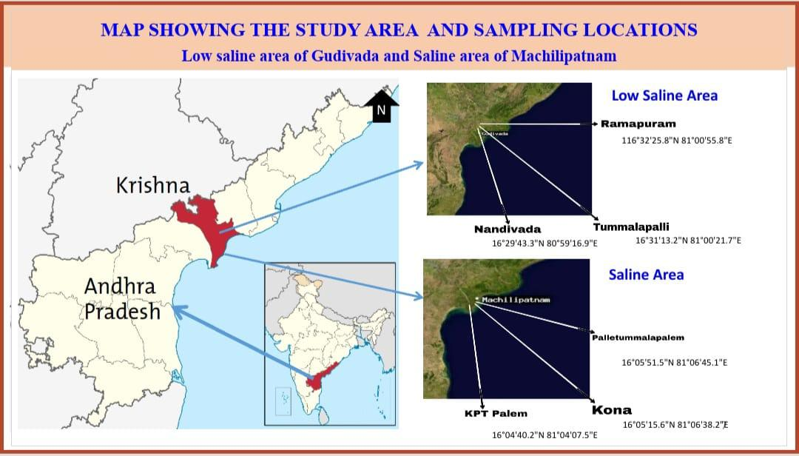
Fig. 1 Map showing the study area of the present study.
2.2 Collection and Analysis of Water Samples

Water samples were collected at regular intervals from the culture ponds using 500 mL clean sterile polyethylene bottles (Fig. 2). The sampling was conducted at a depth of 1-2 feet in the ponds over a period of 14 days. Subsequently, the collected samples were transported to the laboratory for analysis of various water quality parameters, including temperature LCD portable Digital Multi-Stem thermometer, pH (pH tester 2, Oakton), salinity (Atago, Japan), dissolved oxygen, total dissolved solids (TDS), alkalinity, carbonate, bicarbonate, total hardness, calcium, magnesium, total ammonia nitrogen, nitrite, nitrate, phosphate, and silicate (APHA, 1998, 2001).
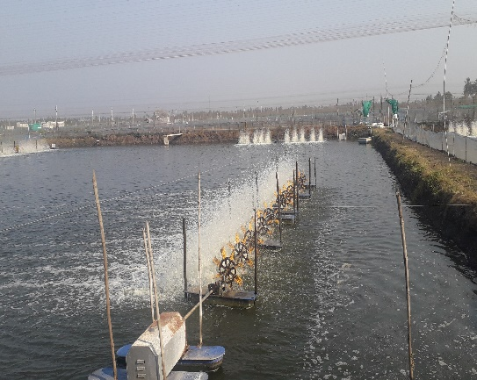  Low saline pond | 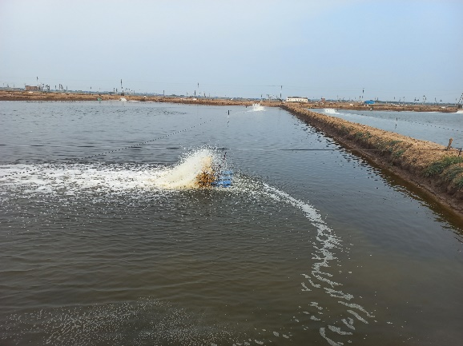  Saline pond
Fig. 2 Sample collection site of low saline and saline area.
  - Principal component analysis

Principal component analysis (PCA) was employed in this study to reduce the dimensionality of the data and identify a smaller set of independent factors, known as principal components. The components with Eigen values greater than or equal to 1.0 were retained for further analysis. Additionally, a varimax rotation was applied to the retained components using OriginPro 8.5 software.

  - Statistical Analysis

The experimental biological data were analyzed to determine significant differences among groups using one-way ANOVA in IBM SPSS Statistics software (Version 21). Statistical significance was established at a threshold of p < 0.05, following the criteria described by Zar (1998).

3. results and discussion

Maintaining water quality is essential for successful shrimp production in an aquaculture system. In turn, a variety of environmental conditions and management practices affect water quality. Several factors should be taken into account when evaluating pond water quality, including pond design, sediment type, water supply, water exchange rate, stocking density, feed quality, species used, pond preparation details, and pond age (Abd El-Hack et al., 2022). Recent studies affirm that real-time sensor-based monitoring and modelling of water quality greatly improve shrimp production outcomes (Ahmed et al., 2024). In the present study, the water quality characteristics were investigated in six shrimp pond cultures from low saline and saline regions of Andhra Pradesh.
The water quality parameters were recorded from all the six stations at 14 days intervals and the averaged results were plotted using a graph (Fig. 3, 4, & 5). Variations in water quality parameters outside of a certain range will undoubtedly have an effect on production. The cultured shrimp grows best in a temperature range from 24-32 ºC (Fast & Lester, 2013; Araneda et al., 2020). During the study, temperature was recorded between 31.2 - 31.5 °C in all six ponds (Fig. 3a). Temperature is one of the most influential factors in physiological responses in shrimps, including respiration, metabolism, growth, and reproduction (Zweig, Morton, and Stewart 1999; Ren et al., 2021). A recent evaluation found that temperature deviations of more than 2 °C above the optimal range led to a measurable 10 % reduction in growth rate in vannamei culture (Do et al., 2025). The pH of shrimp culture pond water samples varied from 8.0 to 8.2. The pH levels of aquaculture pond water have been observed to adhere to the permissible range of pH prescribed by MPEDA (1992). Many variables influence the pH of pond water, including pH, water supply, acidity of bottom soil, shrimp culture inputs, and numerous biological activities (Wang et al., 2004; Chen et al., 2023).
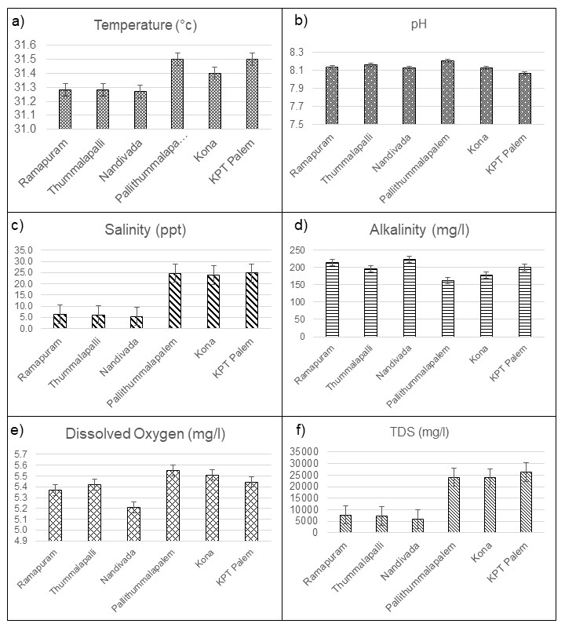
Fig. 3 Water quality parameters of six different aquaculture pond of low saline and saline sites.
In the present investigation, the range of salinity was 5.4 to 24.8 ppt. There was not a significant amount of difference between the ponds in terms of the salinity of the water. Shrimp may be cultured successfully in brackish water with salinities ranging from 10 to 35 ppt. However, acclimatizing shrimp to low saline settings and then growing them back in those conditions leads to better and faster growth. Shrimp can tolerate several environmental conditions, including low salinity (Esparza-Leal et al., 2009). Whiteleg shrimp ponds with salinity as low as 1 ppt had no noticeable effect on feed conversion (Jaffer et al., 2020). Other research demonstrates that 2 ppt salinity affects growth indicators and survival rates (Jaffer et al., 2020; Gao et al., 2016). Alkalinity refers to the capacity of water to function as a buffer. It may potentially impact both primary production and the water's pH. The analysis revealed that the alkalinity levels varied from 162 to 222 mg/l, above the recommended standards for water quality as proposed by MPEDA (1995). According to the findings of Varadaraju et al., (2010), the water and soil qualities of the ponds were within the limit for shrimp farming. They also found that the correlation between soil and water quality parameters and shrimp growth showed that pH, dissolved oxygen, and temperature had a significant effect on shrimp production. Previous reports by Brahmbhatt et al., (2012) on the physical and chemical properties of shrimp ponds in Gujarat have proven what was already known. Comparatively, these findings align with previous studies from Southeast Asia, where salinity variation was shown to alter nutrient cycling and bacterial community structure in shrimp ponds (Peng et al., 2025). The present results contribute new region-specific evidence for Indian aquaculture systems, highlighting how small shifts in salinity can cascade through biogeochemical processes and ultimately impact shrimp productivity.
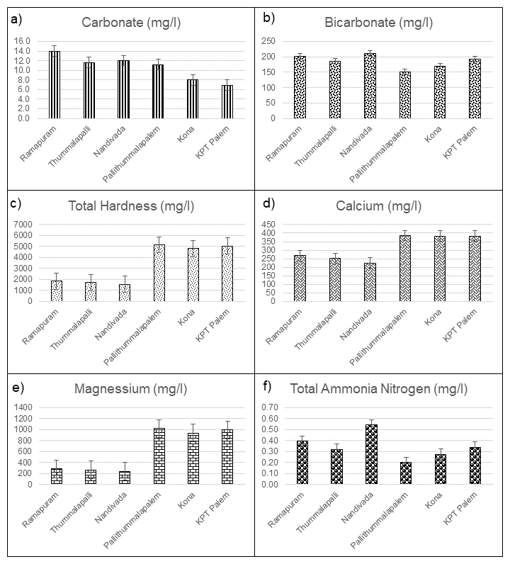
Fig. 4 Water quality parameters of six different aquaculture pond of lowsaline and saline sites.
Dissolved oxygen is a major abiotic element impacting littoral biodiversity. The concentration of dissolved oxygen varied between 5.2 and 5.5 mg/l. The production of phytoplankton in response to a strong and prolonged light period may have contributed to a rise in the concentration of dissolved oxygen. Shrimp culture requires DO levels above 4.5 mg/L (Simbeye and Yang 2014), depending on salinity, shrimp weight, and stocking density. This optimal value is crucial for aerobic respiration and oxidation-reduction in water and sediment ponds (Boyd 2019). In addition to this, the rate of decomposition and the amount of water exchange, agitation, temperature, salinity, and the development of algae, all have a significant impact (Rahi et al., 2021). The minimum concentration of TDS was observed in the low saline area at 5975 mg/l whereas, maximum was observed in the saline area at 26331 mg/l. Similar results were observed in coastal shrimp farming than inland farming in Thailand (Boyd 2019). The increase in TDS could be due to agricultural practices around the farm with use of fertilizers and pesticides (Shanuret al., 2015). It may impact the development and survival rates of aquatic organisms and potentially result in the spread of undesirable species, such as certain types of algae and aquatic weeds. The total hardness in the study area was varied from 1564 to 5156 mg/l. Minimum was recorded at Nandivada village of low saline area whereas maximum was recorded Pallithummalapalem village of saline area. The calcium and magnesium concentrations varied from 225-386 mg/l and 243-1019 mg/l respectively. The minimum concentration of both the elements were recorded in low saline and maximum was recorded in saline area. The total hardness of water, measured in milligrams per litre, is determined by the concentration of dissolved minerals, chiefly calcium and magnesium. According to Kumar et al., (2017) and Stevens (2007), the development of fish bones and scales requires both calcium (Ca) and magnesium (Mg). Both of these minerals are essential. Furthermore, if Ca and Mg were to have formed purely via carbonate and silicate weathering, then the alkalinity should be enough to bring these elements into equilibrium. This implies that these ions are the result of the weathering of carbonates and sulphate minerals (Boyd 2019; Datta, Bhattacharya, and Tyagi 1996), and it is possible that they are the consequence of the dissolution of calcite, dolomite, and gypsum, which are the principal processes in a system (Rajmohan and Elango 2001). Interestingly, the carbonate and bicarbonate were varied in the range of 6.9-14 mg/l and 150-211 mg/l, respectively. Water contains both strong and weak bases, such as carbonates, bicarbonates, and hydroxide, depending on its quantitative capacity (Karikari, 2013).
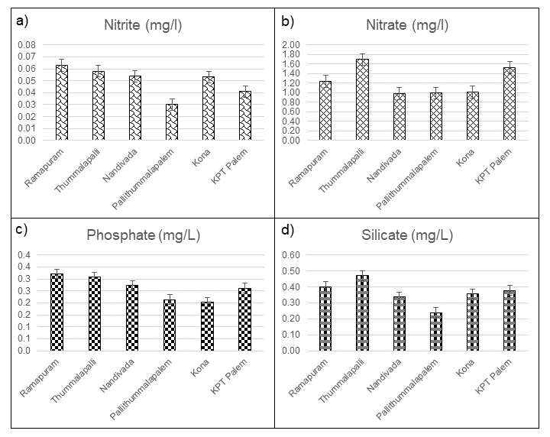
Fig. 5 Water quality parameters of six different aquaculture pond of lowsaline and saline sites.
Ammonia serves as the primary byproduct of protein breakdown in crustaceans, constituting a significant portion of nitrogen excretion, ranging from 40% to 90% (Ip and Chew 2010). The current investigation revealed that the concentrations of total ammonia nitrogen ranged from 0.2 to 0.54 mg/l. A significant number of farmers demonstrate conscientiousness in managing their culture ponds, using weekly applications of pond care products to effectively mitigate ammonia levels and maintain optimal water quality. The observation of ammonia concentrations in water may be attributed to the elevated excretion of ammonia by aquatic species, which leads to a decrease in its levels. This reduction in ammonia levels has been shown to have an impact on blood pH, as well as unfavourable effects on enzyme-catalyzed processes and membrane stability (Bower and Bidwell 1978a; Yan et al., 2019). Nitrite is formed as a result of the increased activity of bacteria that oxidize ammonia, which is stimulated by the increased availability of ammonia. In this study, the levels of nitrite varied from 0.03-0.06 mg/l. These values need to be decreased since, if left unchanged, they will have an impact on the cultural species. The nitrate level (NO₃) in the waterways is due to the oxidation of nitrites (NO₂) that have accumulated as a byproduct of shrimp waste and the breakdown of bacteria that algae have taken in as a source of sustenance. The results showed that the nitrate levels ranged 0.98 to 1.69 mg/l. The minimum and maximum concentration was observed at the low saline pond of Nandivada and Thummalapalli village. According to (Bower and Bidwell 1978b; Bert 2007; Gomez Isaza, Cramp, and Franklin 2020), the recommended maximum concentration of nitrate in water used for aquaculture should be less than 100 mg/l. Phosphate is a nutrient that is non-toxic to aquatic organisms in general. However, an overabundance of phosphates in aquaculture promotes plant growth, subsequently leading to eutrophication (Najla, 2015). In this study, the minimum phosphate concentration (0.2 mg/l) was observed at Kona village in a saline area and maximum phosphate concentration (0.32 mg/l) was observed at Ramapuram village in the low saline area, which was a permissible limit. In fact, phosphorus can get into surface water through agro-food and household discharges or through the release of phosphate fertilisers and some herbicides from farmed land (Amon and Konan 2017). On the other hand, low levels of phosphates found in ponds are due to thephytoplankton eating this nutrient or due to the high ability of different particles to hold phosphorus, which could cause phosphorus to build up in sediments (Amon and Konan 2017; El-Otify 2015). In aquaculture, silicate levels can have both positive and negative effects, depending on the species being cultured. In this study, the minimum silicate level (0.23 mg/l) was observed at Pallithummalapalem village of saline area and maximum silicate level (0.47 mg/l) was observed at Thummalapalli village of lowsaline area.
The Principal Component Analysis (PCA) method has been widely applied to study various environmental conditions and water quality (Tahri et al., 2005) to identify underlying patterns and relationships among different water quality parameters. In this study, the PCA analysis of the water quality variables in lowsaline and saline areas established two principal components (Fig. 6). Eigen values of the first component (PC1) and second component (PC2) represented 78.92 % of the total variability in water quality of shrimp ponds at lowsaline and saline farms. PC1 explains that 45.7 % of the total variance was largely influenced by Temperature, Nitrate, Nitrite, Total Ammonium Nitrogen, Silicate, Phosphate, Salinity, TDS, Total Hardness, Magnesium, and Calcium, while PC2 was dominated by pH, Dissolved Oxygen, Alkalinity, Carbonate and Bicarbonate with 33.2 % variance. The contribution of each water quality element to the overall variance in the dataset is presented, and it is clear that salinity, pH, and ammonia have the major contributions to the overall variation in the dataset. Because of this, it is possible to consider them to be the determinants of changes in the dynamics of the water quality in the prawn pond (Musa et al., 2023). In addition, the first two principal components of this study are representative of these different factors. According to (Kumlu, Eroldogan, and Aktas 2000), the salinity of the environment is one of the most influential factors on the presence, development, and dispersion of a wide variety of aquatic organisms, including prawns. These organisms rely on salinity as a primary factor. This is because the prawn goes through different stages of its normal life cycle in both the seas and rivers (Walker et al., 2009). In the tropics, where the climate consists of dry and rainy seasons, salinity changes are magnified (Walker et al., 2009; Chand et al., 2015). The PCA biplot distinctly separated low-salinity and saline pond samples into two clusters, confirming salinity as the major environmental driver of water chemistry. Variables such as ammonia and pH loaded inversely along PC1, indicating that higher pH is associated with lower ammonia levels and better nitrification efficiency in saline systems. From a management perspective, the study underscores the importance of maintaining optimal salinity (15–25 ppt) along with adequate alkalinity (>100 mg/L as CaCO₃) and low ammonia (<0.1 mg/L NH₃-N). These thresholds ensure stable pond ecology and enhance feed utilization efficiency (Do et al., 2025). Moreover, integrating routine physicochemical monitoring with microbial profiling and sensor-based systems could further optimize real-time water management. Future work should examine the functional role of nitrifying and sulfate-reducing bacteria under variable salinity conditions to establish predictive models for nutrient control.
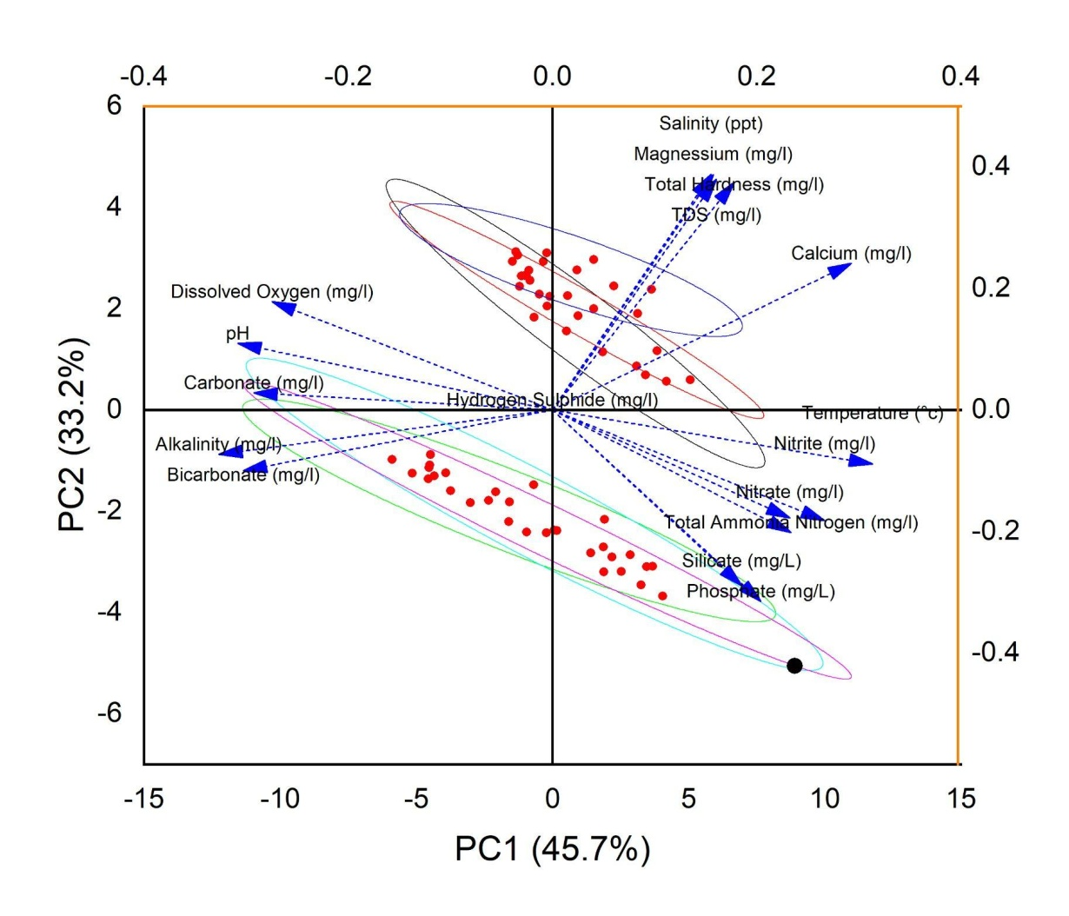
Fig. 6 Principal Component analysis (PCA) loadings of components 1 and 2 for the water quality parameters in lowsaline and saline sites.

4. Conclusion

The present study clearly demonstrates that salinity exerts a significant regulatory influence on key water quality parameters in shrimp aquaculture systems. Comparative analysis revealed that ammonia, pH, total dissolved solids (TDS), and alkalinity are the most responsive variables distinguishing saline and low-salinity ponds. Elevated ammonia and lower alkalinity in low-salinity systems indicate weaker nitrification efficiency and reduced buffering capacity, whereas saline ponds maintained more stable physicochemical conditions conducive to shrimp growth. Principal Component Analysis (PCA) further confirmed that these parameters collectively explained over 70% of total environmental variation, identifying ammonia and pH as the most critical indicators of water stability. These findings highlight the importance of maintaining balanced salinity and nutrient dynamics to sustain optimal pond health and shrimp productivity. The study provides baseline information for developing salinity-specific water quality management protocols and adaptive monitoring systems. Future work should integrate microbial and molecular biomarkers to elucidate underlying nitrogen cycling mechanisms and support predictive aquaculture water management models.

Disclaimer (Artificial intelligence)

The authors acknowledge the use of ChatGPT (GPT-5, OpenAI) for language editing and improving the clarity, g rammar, and structure of the manuscript. The tool was not used to generate or interpret data; all scientific content, analysis, and conclusions were developed and verified by the authors.

References

Abd El-Hack, M. E., El-Saadony, M. T., Nader, M. M., Salem, H. M., El-Tahan, A. M., Soliman, S. M., & Khafaga, A. F. (2022). Effect of environmental factors on growth performance of Nile tilapia (Oreochromis niloticus). International Journal of Biometeorology, 66(11), 2183–2194.
Ahmed, F., Bijoy, M. H. I., Hemal, H. R., & Noori, S. R. H. (2024). Smart aquaculture analytics: Enhancing shrimp farming in Bangladesh through real-time IoT monitoring and predictive machine learning analysis. Heliyon, 10(17).
Amal, C. T., Bharti, V. S., Choudhary, M., Kara, T., Kumar, S., & Rao, A. A. (2023). Biochar for improving growth performance of shrimp and environmental quality in an inland saline culture system. ACS Omega, 8(41), 37991–38004.
Amon, L. N., & Konan, L. K. (2017). Characterization and typology of Aghien Lagoon waters (South-East of Côte d’Ivoire): Potential resources for drinking water production. IOSR Journal of Applied Chemistry, 10(1), 1–7.
Anand, P. S., Balasubramanian, C. P., Aravind, R., Biju, I. F., Rajan, R. V., Vinay, T. N., & Vijayan, K. K. (2023). Reproductive performance of captive-reared Indian white shrimp, Penaeus indicus, broodstocks over two generations. Frontiers in Marine Science, 10, 101806.
Araneda, M., Gasca-Leyva, E., Vela, M. A., & Domínguez-May, R. (2020). Effects of temperature and stocking density on intensive culture of Pacific white shrimp in freshwater. Journal of Thermal Biology, 94, 102756.
Arya, M. S., Biju, A., & Benchamin, D. (2023). Assessment of spatial and temporal variations in water quality using multivariate statistical analysis in Munroe Island, Kerala, India. Acta Ecologica Sinica, 43(5), 751–763.
Bert, T. M. (2007). Environmentally responsible aquaculture—A work in progress. In Ecological and Genetic Implications of Aquaculture Activities (pp. 1–31). Dordrecht: Springer Netherlands.
Bower, C. E., & Bidwell, J. P. (1978a). Ionization of ammonia in seawater: Effects of temperature, pH, and salinity. Journal of the Fisheries Research Board of Canada, 35(7), 1012–1016.
Bower, C. E., & Bidwell, J. P. (1978b). Ionization of ammonia in seawater: Effects of temperature, pH, and salinity. Journal of the Fisheries Research Board of Canada, 35(7), 1012–1016.
Boyd, C. E. (2019). Water Quality: An Introduction (3rd ed.). Cham, Switzerland: Springer Nature.
Chand, B. K., Trivedi, R. K., Dubey, S. K., Rout, S. K., Beg, M. M., & Das, U. K. (2015). Effect of salinity on survival and growth of giant freshwater prawn Macrobrachium rosenbergii (de Man). Aquaculture Reports, 2, 26–33.
Chen, Y., Mitra, A., Rahimnejad, S., Chi, S., Kumar, V., Tan, B., & Xie, S. (2023). Retrospect of fish meal substitution in Pacific white shrimp (Litopenaeus vannamei) feed: Alternatives, limitations and future prospects. Reviews in Aquaculture.
Datta, P. S., Bhattacharya, S. K., & Tyagi, S. K. (1996). 18O studies on recharge of phreatic aquifers and groundwater flow-paths of mixing in the Delhi area. Journal of Hydrology, 176(1–4), 25–36.
Debroy, S., Paul, T., & Biswal, A. (2020). Shrimp culture in inland saline waters of India: A step towards sustainable aquafarming. Food and Scientific Reports, 1(4), 84–88.
Didar-Ul Islam, S. M., & Bhuiyan, M. A. H. (2016). Impact scenarios of shrimp farming in coastal region of Bangladesh: An approach of an ecological model for sustainable management. Aquaculture International, 24, 1163–1190.
Do, D. D., Le, A. H., Le, D. A. N., & Bui, H. M. (2025). Evaluation of water quality and key factors influencing water quality in intensive shrimp farming systems using principal component analysis-fuzzy approach. Desalination and Water Treatment, 321, 101002.
El-Otify, A. M. (2015). Evaluation of the physicochemical and chlorophyll-a conditions of a subtropical aquaculture in Lake Nasser area, Egypt. Beni-Suef University Journal of Basic and Applied Sciences, 4(4), 327–337.
El-Saadony, M. T., Swelum, A. A., Ghanima, M. M. A., Shukry, M., Omar, A. A., Taha, A. E., & Abd El-Hack, M. E. (2022). Shrimp production, the most important diseases that threaten it, and the role of probiotics in confronting these diseases: A review. Research in Veterinary Science, 144, 126–140.
Esparza-Leal, H. M., Ponce-Palafox, J. T., Aragón-Noriega, E. A., Arredondo-Figueroa, J. L., García-Ulloa Gómez, M., & Valenzuela-Quiñonez, W. (2009). Growth and performance of the whiteleg shrimp Penaeus vannamei (Boone) cultured in low-salinity water with different stocking densities and acclimation times. Aquaculture Research, 41(6), 878–883.
Ferreira, N. C., Bonetti, C., & Seiffert, W. Q. (2011). Hydrological and water quality indices as management tools in marine shrimp culture. Aquaculture, 318(3–4), 425–433.
Gao, W., Tian, L., Huang, T., Yao, M., Hu, W., & Xu, Q. (2016). Effect of salinity on the growth performance, osmolarity, and metabolism-related gene expression in white shrimp Litopenaeus vannamei. Aquaculture Reports, 4, 125–129.
Gomez Isaza, D. F., Cramp, R. L., & Franklin, C. E. (2020). Simultaneous exposure to nitrate and low pH reduces the blood oxygen-carrying capacity and functional performance of a freshwater fish. Conservation Physiology, 8(1), coz092.
Handbook on Fisheries Statistics 2020. (2021). Department of Fisheries, Ministry of Fisheries, Animal Husbandry & Dairying, Government of India, New Delhi.
Ip, Y. K., & Chew, S. F. (2010). Ammonia production, excretion, toxicity, and defense in fish: A review. Frontiers in Physiology, 1, 134.
Jaffer, Y. D., Saraswathy, R., Ishfaq, M., Antony, J., Bundela, D. S., & Sharma, P. C. (2020). Effect of low salinity on the growth and survival of juvenile Pacific white shrimp, Penaeus vannamei: A revival. Aquaculture, 515, 734561.
Kathyayani, S. A., Muralidhar, M., Kumar, T. S., & Alavandi, S. V. (2019). Stress quantification in Penaeus vannamei exposed to varying levels of turbidity. Journal of Coastal Research, 86(SI), 177–183.
Kumlu, M., Eroldogan, O. T., & Aktas, M. (2000). Effects of temperature and salinity on larval growth, survival and development of Penaeus semisulcatus. Aquaculture, 188(1–2), 167–173.
Lusiana, E., Mahmudi, M., Hutahaean, S., Darmawan, A., Buwono, N., Arsad, S., & Musa, M. (2022). A multivariate technique to develop hybrid water quality index of the Bengawan Solo River, Indonesia. Inżynieria Ekologiczna, 23(2), 123–131.
MPEDA. (2021). Annual Report 2020–2021. Marine Products Export Development Authority, Cochin.
Musa, M., Mahmudi, M., Arsad, S., Lusiana, E., Sunadji, S., Wardana, W., Ompusunggu, M., & Damayanti, D. (2023). Interrelationship and determining factors of water quality dynamics in whiteleg shrimp ponds in tropical eco-green aquaculture system. Inżynieria Ekologiczna, 24(1), 19–27.
Nagaraju, T. V., Sunil, B. M., Chaudhary, B., Prasad, C. D., & Gobinath, R. (2023). Prediction of ammonia contaminants in aquaculture ponds using soft computing coupled with wavelet analysis. Environmental Pollution, 331, 121924.
Nair, N. V., & Nayak, P. K. (2023). Uncovering water quality and evaluating vulnerabilities of small-scale fisheries in Chilika Lagoon, India. Frontiers in Marine Science.
Peng, C., Xue, H., Zhang, J., Zhang, J., Dai, J., Zhang, Y., & Hu, S. (2025). Salinity modulates gut microbiota and host transcriptome dynamics in juvenile euryhaline fish yellowfin seabream (Acanthopagrus latus). Aquaculture Reports, 44, 103075.
Rahi, M. L., Azad, K. N., Tabassum, M., Irin, H. H., Hossain, K. S., Aziz, D., Moshtaghi, A., & Hurwood, D. A. (2021). Effects of salinity on physiological, biochemical, and gene expression parameters of black tiger shrimp (Penaeus monodon): Potential for farming in low-salinity environments. Biology, 10(12).
Rao, D. V., & Shrivastava, K. B. P. (2022). Litopenaeus vannamei (whiteleg shrimp) farming in Indian inland saline ecosystem. International Journal of Fauna and Biological Studies, 9(3), 68–72.
Ren, X., Wang, Q., Shao, H., Xu, Y., Liu, P., & Li, J. (2021). Effects of low temperature on shrimp and crab physiology, behavior, and growth: A review. Frontiers in Marine Science, 8, 746177.
Simbeye, D. S., & Yang, S. F. (2014). Water quality monitoring and control for aquaculture based on wireless sensor networks. Journal of Networks, 9(4), 840–849.
Slathia, N., Langer, S., & Jasrotia, R. (2023). Assessment of water quality and its effect on prawn abundance in three tributaries of Shiwalik rivers: Chenab and Ravi of Jammu, India—a case study. Applied Water Science, 13, 77.
Tahri, M., Benyaïch, F., Bounakhla, M., Bilal, E., Gruffat, J. J., Moutte, J., & Garcia, D. (2005). Multivariate analysis of heavy metal contents in soils, sediments and water in the region of Meknes (Central Morocco). Environmental Monitoring and Assessment, 102(1–3), 405–417.
Venkateswarlu, V., Seshaiah, P. V., Arun, P., & Behra, P. C. (2019). A study on water quality parameters in shrimp L. vannamei semi-intensive grow-out culture farms in coastal districts of Andhra Pradesh, India. International Journal of Fisheries and Aquatic Studies, 7(4), 394–399.
Walker, S. J., Neill, W. H., Lawrence, A. L., & Gatlin III, D. M. (2009). Effect of salinity and body weight on ecophysiological performance of the Pacific white shrimp (Litopenaeus vannamei). Journal of Experimental Marine Biology and Ecology, 380(1–2), 119–124.
Yan, Z.-G., Fan, J.-T., Zheng, X., Wang, S.-P., Guo, X.-S., Zhang, T.-X., Yang, S.-W., & Zhang, Y.-Z. (2019). Neglect of temperature and pH impact leads to underestimation of seasonal ecological risk of ammonia in Chinese surface freshwaters. Journal of Chemistry and Chemical Engineering, 2019(September).
Zweig, R. D., Morton, J. D., & Stewart, M. M. (1999). Source Water Quality for Aquaculture: A Guide for Assessment. World Bank.
Zar, J. H. (1998). Two-sample hypotheses. In Biostatistical Analysis (pp. 123–161).

