Seasonal Population Dynamics of the Cowpea Aphid, Aphis craccivora (Koch) on Bean, and its Correlation with Abiotic Factors under Kashmir Conditions
ABSTRACT:
Aphis craccivora Koch, commonly known as the cowpea aphid, is a cosmopolitan and highly polyphagous pest of leguminous crops. It infests more than 50 host plant species across over 19 families easpecially from fabaceae. A two-year field investigation (2023–2024) was conducted in the Kashmir Valley to study the population dynamics of the cowpea aphid, Aphis craccivora Koch, infesting common bean (Phaseolus vulgaris L.) at three locations viz: Shalimar, Shuhama and Habak. The aphid population exhibited a characteristic sigmoidal growth pattern during both years. Initial colonization occurred in the 19th Standard Meteorological Week (SMW), followed by a gradual increase from the 20th SMW and a rapid rise by the 23rd SMW. Peak infestation was observed between the 25th and 30th SMWs, after which the population declined sharply by the 36th SMW. Mean aphid populations per three leaves were 44.79 and 46.11 at Shalimar, 47.71 and 43.30 at Shuhama, and 49.78 and 45.53 at Habak during 2023 and 2024 respectively. Highly significant positive correlation between maximum temperature and all aphid stages (nymphs, apterous, and alates), indicating that warmer conditions favored aphid multiplication and development. Minimum temperature also showed a positive but weaker correlation with aphid density. In contrast, both maximum and minimum relative humidity exhibited significant negative correlations, suggesting that humid conditions suppressed aphid buildup. These consistent trends across all sites indicate that temperature plays a promotive role, while relative humidity acts as a limiting factor in the population development of A. craccivora under Kashmir conditions.The study highlights the period between the 23rd and 25th SMWs as critical for implementing integrated pest management (IPM) strategies against A. craccivora in common bean.
Keywords: Aphis craccivora, common bean, population dynamics, temperature, relative humidity, correlation.

- INTRODUCTION
“Common bean (Phaseolus vulgaris L.) is multipurpose leguminous crop and since it is high in nutrient content” (Mwanauta et al., 2015). “It is second important in terms of production and area of productivity due to early maturity intercrop with other crop like maize, improver soil fertility, animal fead and become to commercial potential” (Demelash, 2018). “More, it has substantial role in to provide balance diet, and provides amino acid like folic acid” (Filella and Peñuelas, 1994). Similar study reported as it contributed around 57% dietary protein and 23% of carbohydrate. Furthermore, Montoya et al. (2006) reported as “usual a use of leguminous crops advertised due to minimizes the risk of disease such as cancer, diabetes, or coronary heart diseases”. “Many compounds have been identified in P. vulgaris, such as phenolic acids (chlorogenic acid, syringic acid, caffeic acid), flavonoids (kaempferol, pelargonidin, cyanidin, delphinidin), sugars, fatty acids, and tocopherols, among others” (Rodríguez et al.,2022) . “In addition to their nutritional value, beans improve soil fertility through atmospheric nitrogen fixation and play a vital role in sustainable cropping systems” (Broughton et al., 2003). “It is the second most important legume crop in terms of area planted and volume of production after faba bean, Vicia faba, production in 2020-21 was around 0.55 million tons from 0.31 million hectares However, the average yield of common bean in Ethiopia (1.8 tons per hectare) is far below the genetic potential of the crop, which is estimated to be >3 t ha-1” (Demelash, 2018) and also the common bean is grown worldwide over 29.39 million ha−1 with a production of 26.83 million tons (t) (FAOSTAT, 2016). Myanmar, India, Brazil, the USA, Tanzania, China, and Mexico are the top dry bean producers (Siddiq et al., 2022). “Phaseolus vulgaris L. is grown on 9.47 million ha−1 in India, with a production of 3.90 million t and a productivity of 0.41 t ha−1” (FAOSTAT, 2016). “India’s leading agricultural producing regions are Jammu and Kashmir, Himachal Pradesh, Uttar Pradesh, Maharashtra, the Nilgiri and Palani Hills of Tamil Nadu, parts of the Western Ghats of Kerala, the Chickmagalur Hills of Karnataka, and the Darjeeling Hills of West Bengal. Pulses are often cultivated in the regions of Jammu and Kashmir, either as a mono or as an intercrop with maize under a low-input system, producing low yields. The districts of Baramulla, Bandipora, and Kupwara in the Kashmir Valley have the potential for bean cultivation” (Sheikh et al., 2017). “The interactions between pest activity with biotic and abiotic factors help in deriving predicative models that in turn forecast the pest incidence. The population buildup of any insect is intimately related to the weather parameters” (Boopathi et al., 2017). “Climate as an exogenous factor plays a crucial role in determining abundance and distribution of insect and pest population” (Chiu et al., 2019). “The crop is attacked by a number of insect pests, viz., bean aphid, Aphis craccivora Koch, leaf hopper, Empoasca fabae Harris, Empoasca krameri Ross and Moore, Empoasca kerri Pruthi, pod borer, whitefly, Bemisia tabaci Gennadius, stem fly, Ophiomyia phaseoli Tryon, hairy caterpillars, Ascotis imparta Walker, Bihar hairy caterpillar, Spilosoma obliqua Walker etc. Among these insect pests, bean aphid (A. craccivora) causes considerable crop damage. Bean aphid, Aphis craccivora Koch (Homoptera: Aphididae) was first described by Koch in 1854 and is commonly known as cowpea aphid, black bean aphid, legume aphid and oriental pea aphid. Aphids are the major insect pest both in tropical and temperate regions. It is cosmopolitan species. Throughout the world it is causing direct and indirect (as vectors) damage to cultivated crops. The aphid, A. craccivora is highly polyphagous as it is recorded feeding on plants belonging to eight plant families. It is a serious pest of leguminous crop and sucks the sap from tender shoots, inflorescence and pods resulting in the drying up of tender shoot and premature fall of flower buds, flowers and tender pods. Crops attacked by this aphid include cowpea, field bean, groundnut, chickpea, mung bean, urd bean, pigeon pea, brassicas, cucurbits, beetroot, cotton, etc.” (Anonymous, 2014). “In case of severe infestation, these pests attack all parts of the plants including pods which results in stunted growth and decreased yield. The honey dew secretion of the aphids provides a suitable media for the development of sooty mould and fungi which ultimately hampers the process of photosynthesis” (Anonymous, 2013). “Cowpea Cowpea aphid reduces reduces the amount of nutrients and water available to the crop and causes transmission of plant viruses. Aphid feeding induces symptoms that include chlorosis and stunting that delays onset of flowering and even plant death when infestations are high especially at seedling stage” (Blackman and Eastop, 2000 and Keating et al., 2015). Bean aphid is polymorphic (with apterous and alate form), viviparous and in the tropics parthenogenetic reproduction occurs throughout the year. The cowpea aphid, Aphis craccivora Koch, is a highly destructive and difficult to manage pest due to its polyphagous nature, short life cycle, and rapid reproductive potential. To better understand its population dynamics and the influence of environmental conditions on its abundance, a research investigation was undertaken. The study aimed to determine seasonal population fluctuations of the aphid in relation to key abiotic parameters such as temperature and relative humidity under field conditions.
- MATERIAL AND METHODS
The present investigation on the population dynamics of Aphis craccivora Koch infesting bean crops was carried out for two consecutive cropping seasons 2022–23 and 2023–24 at three locations in the Kashmir Valley: the experimental field of the Division of Entomology, SKUAST-K, Shalimar; the Seed Multiplication Farm, Shuhama; and the Division of Vegetable Science field, SKUAST-K, Habak. Bean cultivars ‘Sel-3’ and ‘Contender’ were sown on two different dates, i.e., 8th March and 15th March, maintaining a spacing of 30 cm between rows and 10 cm between plants . All standard agronomic practices were followed to ensure proper crop growth. The primary objective of the study was to assess the extent of aphid infestation under field conditions and its relationship with prevailing abiotic factors. Observations on the aphid population were recorded at weekly intervals. On each sampling date, ten plants were randomly selected from each experimental site. From every plant, three leaves representing the top, middle, and bottom portions were examined. All individuals of A. craccivora were counted and categorized as nymphs, apterous (wingless) adults, and alate (winged) adults. The population density for each stage was expressed as the mean number of aphids per three leaves. Pest incidence was assessed by inspecting ten randomly selected plants per plot. The percentage of plant infestation was calculated using the formula:
Plant infestation (%) = Number of infested plants × 100
Total number of plants
Experimental details: Design of experiment: Randomized Complete Block Design RCBD)

Statistical Analysis: To determine the influence of abiotic factors on aphid population build-up weekly average meteorological data on maximum and minimum temperatures and relative humidity were obtained from the Division of Agrometeorology, Faculty of Horticulture, SKUAST-K, Kashmir. The correlation between aphid population data and weather parameters for both cropping seasons was computed. Statistical analysis was performed using OPSTAT online software in order to investigate the effects of meteorological conditions on pest occurrence.

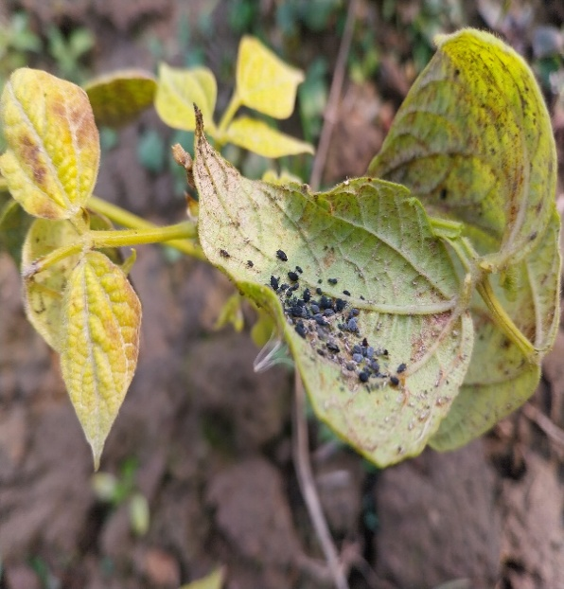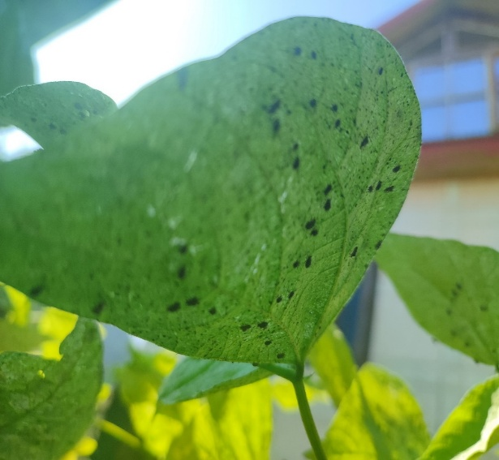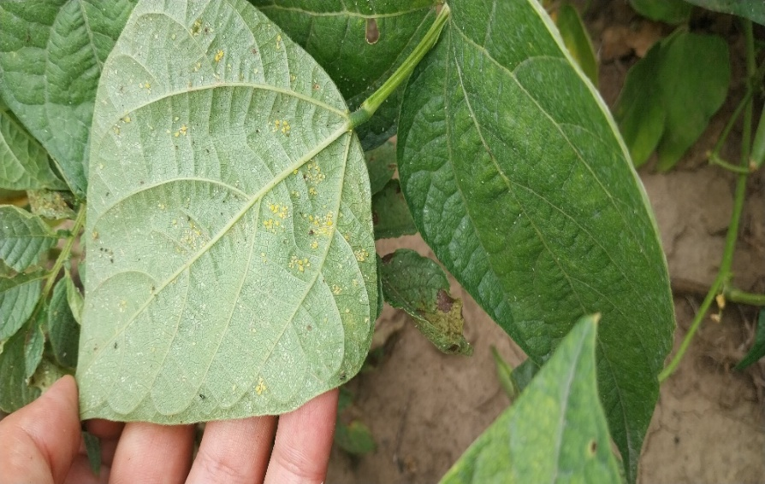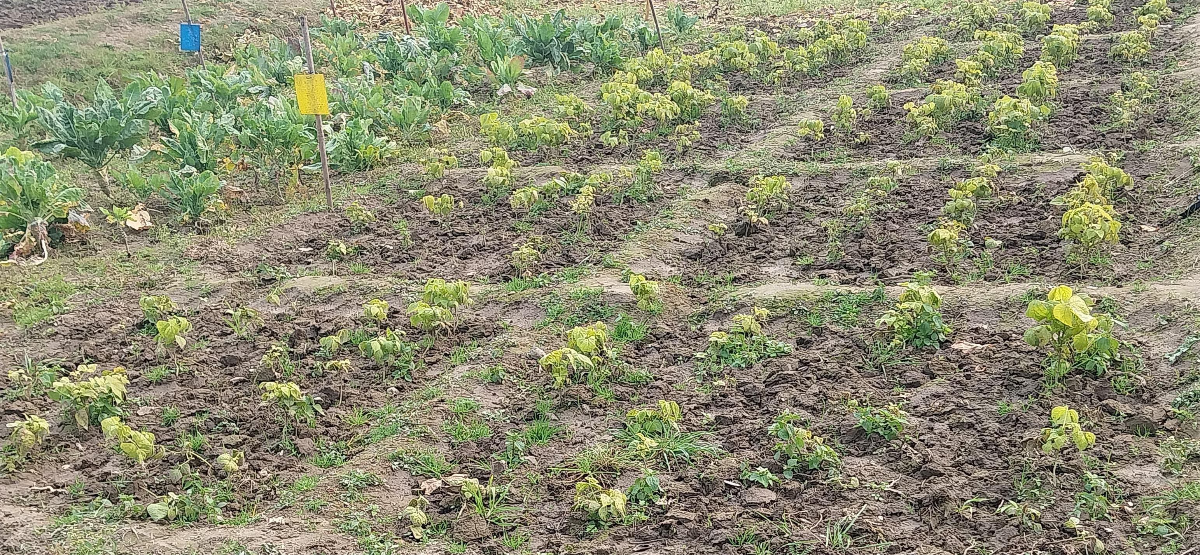

Plate 1. Field Infestation of Aphis craccivora on Bean Crop .

- RESULTS AND DISCUSSION

The population density of Aphis craccivora displayed a highly uniform sigmoidal growth pattern across all three locations during both study years (Figure 1-6). This pattern consisted of four distinct phases: initial establishment, exponential growth, a distinct peak, and a subsequent rapid decline. The incidence of bean aphid, Aphis craccivora on bean crop during Rabi 2023-2024 commenced from 2nd week of May, i.e. 19th SMW with an average population level below 3.0 individuals per three leaves leaf and gradually increased and peak densities were recorded between the 25th and 30th SMWs (late June to early July), reaching 44.79 and 46.11 aphids per three leaves at Shalimar, 47.71 and 43.30 at Shuhama, and 49.78 and 45.53 at Habak during 2023 and 2024, respectively the above results are in agreement with Parekh and Patel (2024) who studied Aphis craccivora and observed population dynamics that exhibited gradual increase starting post early season, with peak aphid populations reaching approximately 41.8 aphids per twig around the 45th SMW (early November) and also with Ranjana bali et al.( 2025) who stated that there was a significant increase in the number of aphids from 3.67 per leaf during the 13th standard week to 54.33 per leaf during the 17th week, which marked the peak aphid density. This was accompanied by particular weather, The aphid population then began to decline, reaching a low of 2.33 aphids per leaf by the 24th standard week. The cultural, physical and biological factors might be responsible for the fluctuation in aphid populations during the period. The pre-ponderence of the bean aphid might be due to weather parameters prevailed during the period as well as succulent foliage available during that time. Dixon (1985) have reported that the aphids responded to cues that signal seasonal trends in weather and food quality, by developing such morphs that are well adapted to survive the seasonal changes in habitat quality. The decrease in bean aphid population might be due to the maturity of the crop as aphids infest young shoots and leaves of the crop. The present findings on the incidence of aphid population on pea crop was strengthened by Kumar and Nath (2003) who reported that aphids infested legumes during the vegetative and reproductive stage of the crop. The findings are more or less similar with the findings of Chatar et al. (2010) who reported that the insect population declined slowly towards the maturity of the crop. Initial colonization coincided with the bean crops vegetative stage, which offers tender foliage and a suitable microclimate. The exponential rise from late May to June aligned with moderate temperatures (22–26°C) and relative humidity (65–75 per cent), conditions known to be optimal for aphid reproduction in accordance with Blackman and Eastop (2000). These results were similar with the findings of Rekha and Mallapur (2007) who reported that the aphid, A. craccivora peak incidence was noticed in large number froms september to first week of october with a population range of 30.5 to 50.0 and 8.4 to 11.2 aphids per three leaves, respectively. The present findings were also in agreement with the results reported by the earlier workers such as Kumar et al. (2023 ) who observed that the highest incidence of aphids i.e. 42.32 per 3 branches of 10 cm was observed in the 4th week of February (8th SMW) during rabi, 2021-22 on French bean. These results were similar with the findings of Yaqoob et al.(2019) where incidence of aphids commenced from 29th standard week and was lowest (3.30 aphids/3 leaves). The aphid count gradually increased and reached its peak in 32nd SW (47.28 aphids/3leaves) thereafter it declined and was again minimum during 40th SW (5.19 aphids/3 leaves).
Throughout the season, nymphs were the dominant , followed by apterous adults and a smaller fraction of alates. A marked increase in the proportion of alates during 24-25 SMWs occurred alongside population crowding and declining host quality, indicating the initiation of dispersal behavior to locate new host plants a common adaptive strategy in aphids (Dixon, 1998; Van Emden and Harrington, 2007).

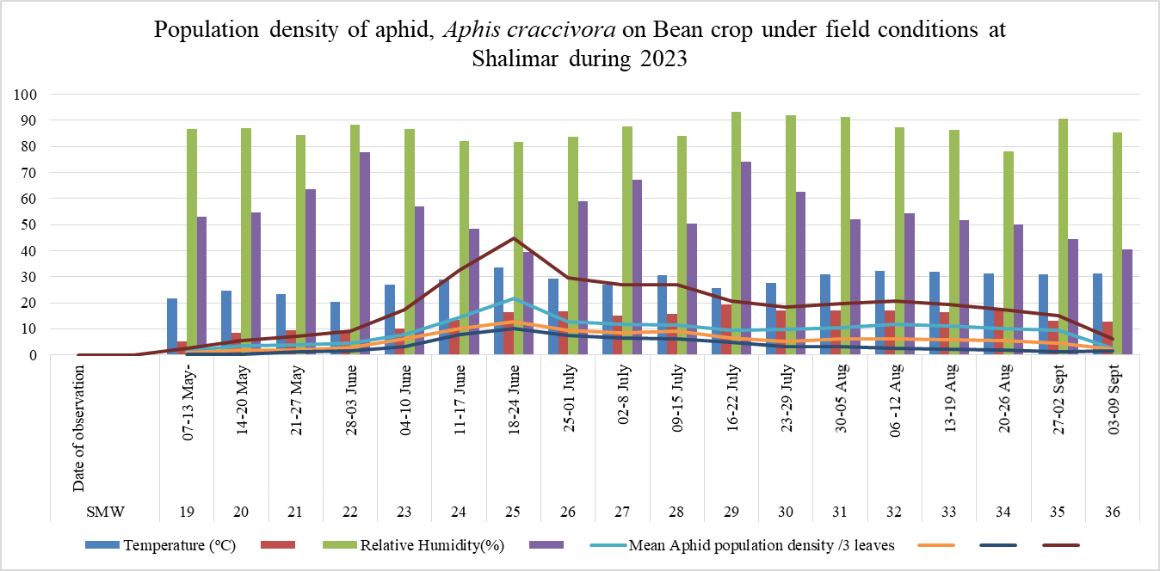
Fig.1.Population density of aphid, Aphis craccivora on Bean crop under field conditions at Shalimar during year, 2023.

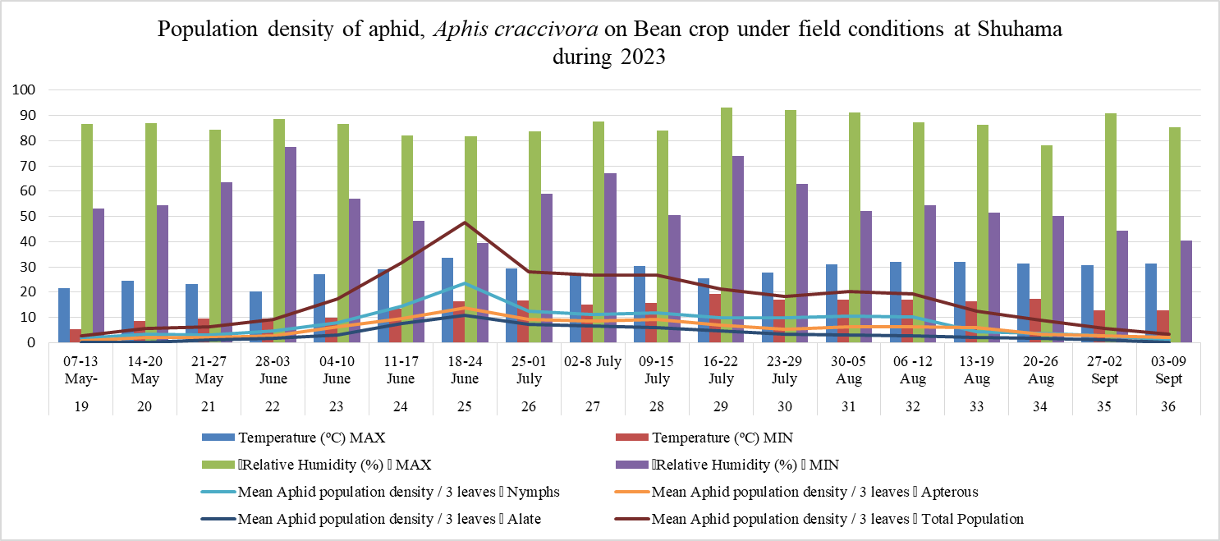
Fig.2. Population density of aphid, Aphis craccivora on Bean crop under field conditions at Shuhama during year, 2023.

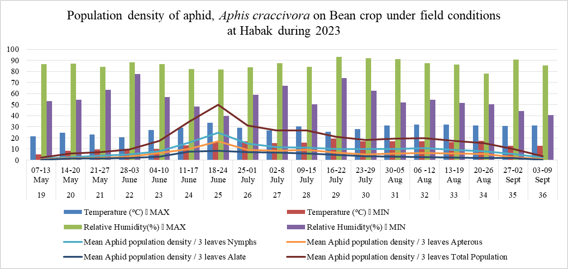
Fig.3. Population density of aphid, Aphis craccivora on Bean crop under field conditions at Habak during year, 2023.
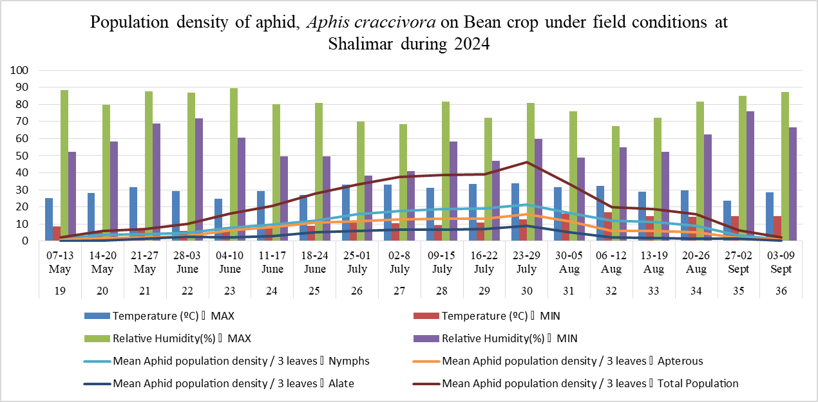
Fig.4. Population density of aphid, Aphis craccivora on Bean crop under field conditions at Shalimar during year, 2024.

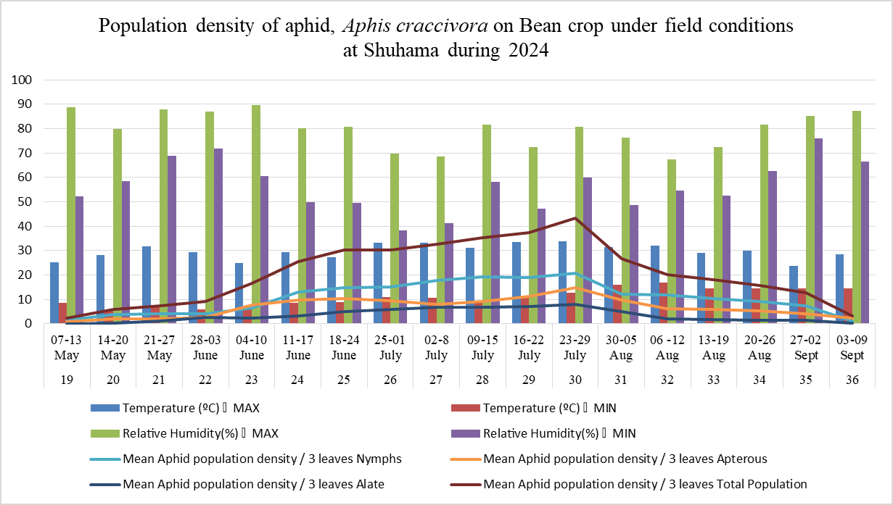
Fig.5. Population density of aphid, Aphis craccivora on Bean crop under field conditions at Shuhama during year, 2024.

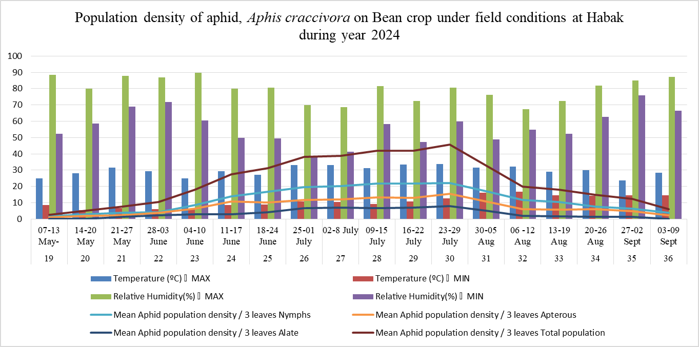
Fig.6. Population density of aphid, Aphis craccivora on Bean crop under field conditions at Habak during year, 2024.

3.1. Correlation Between Aphid Population and Weather Parameters (2023–2024)
Correlation analysis across all three experimental locations viz: Shalimar, Shuhama, and Habak during 2023–2024 revealed consistent and statistically significant relationships between aphid population density and key abiotic factors ( Fig. 7). Across sites, maximum temperature showed a strong and highly significant positive correlation with all aphid stages, indicating that warmer conditions strongly promoted aphid multiplication and development. The correlation coefficients for nymphs, apterous, and alate forms ranged between r = 0.521 – 0.634 (p < 0.01) across the three locations. This suggests that rising daytime temperatures enhanced aphid activity, fecundity, and overall colony growth, particularly during the early to mid-season when populations were expanding rapidly. Minimum temperature also exhibited a positive correlation, though generally weaker than that of maximum temperature. Significant associations were observed mainly for the nymphal and apterous stages (r = 0.228* – 0.329**, p < 0.05), implying that milder night temperatures may support aphid survival and continuous reproduction during the critical early infestation phase.
In contrast, both maximum and minimum relative humidity displayed a consistent and significant negative correlation with aphid population density across all sites (r = –0.523** to –0.324, p < 0.01). This inverse relationship indicates that higher humidity levels suppressed aphid population buildup, most likely due to the proliferation of entomopathogenic fungi and reduced feeding efficiency under moist conditions. The effect was particularly pronounced for nymphs and apterous forms, which are more vulnerable to microbial infections and cuticular wetness. Among the three locations, Shuhama recorded the highest correlation coefficients between aphid density and maximum temperature (r ≈ 0.634**), suggesting slightly more favorable thermal conditions for aphid development, while Habak showed marginally lower magnitudes, possibly due to microclimatic or edaphic differences. The above results are in agreement with Kataria and Kumar (2016) who stated that “the aphid population was showing positive correlation with high temperature aand negative correlation with , relative humidity”. The present findings are also in close agreement with the observations of Chundawat and Ameta (2011) and Siddarth et al. (2017), who reported “a significant positive correlation between maximum temperature and aphid population , indicating that rising temperatures favor aphid multiplication and activity. Notably, strong positive correlations between maximum temperature and aphid population suggest a potential role of temperature in influencing aphid dynamics over the longer term. Relative humidity, particularly the average of 3 days before aphid inspection, demonstrates a significant positive strong correlation, underscoring the importance of humidity as a factor influencing aphid populations”. The significance of correlations, especially with maximum temperature and relative humidity, resonates with the broader literature on aphid responses to climate. Sun et al. (2022) and Wains et al. (2010) highlighted the positive correlation between temperature and aphid population growth, while Kishor et al.(2023) underscored the “importance of relative humidity in shaping aphid abundance”. “The findings of this study align with prior research, particularly in confirming the significant influence of mean temperature on A. craccivora abundance” (Mahmoud et al., 2017) while as according to Patel and Jena (2024) the minimum temperature had highly significant positive correlation with the population of A. craccivora, . The results are also in conformity with Prakash and Tomar (2010) who also found similar correlation pattern of aphid population with weather parameters. These findings are also supported by Khating et al. (2016) who also observed positive correlation of aphid count with maximum, minimum temperature. Nevertheless, the overall trends remained remarkably uniform across all field sites, underscoring the strong and predictable influence of temperature and humidity on the seasonal dynamics of Aphis craccivora in the Kashmir Valley.

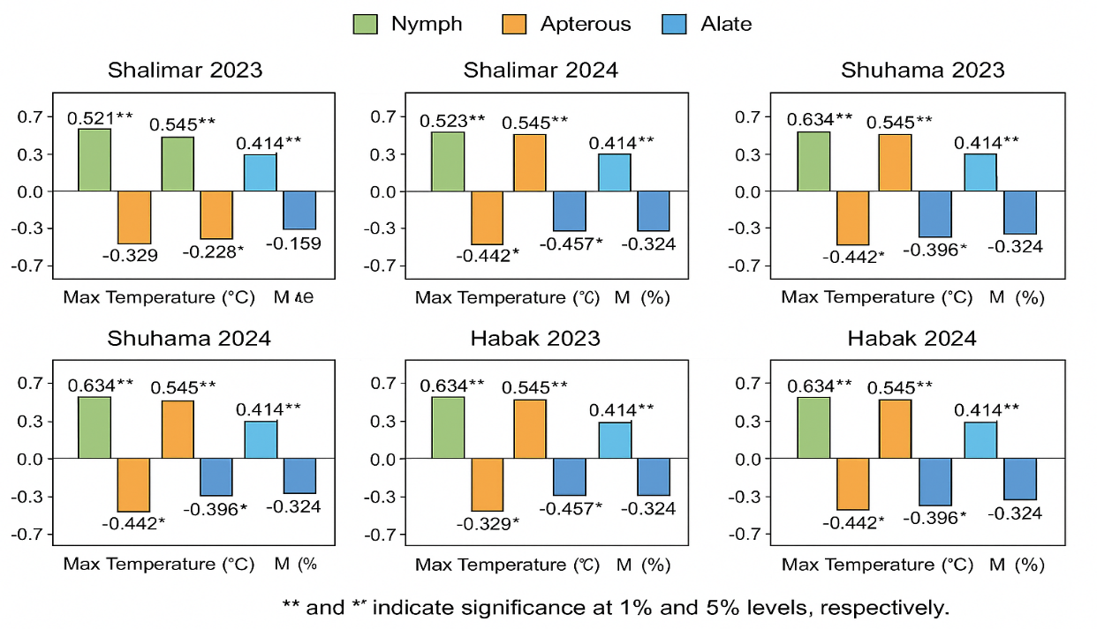
Fig. 7. Correlation between abiotic factors and population of different stages of Aphis craccivora (nymphs, apterous, and alates) across three locations (Shalimar, Shuhama, and Habak) during 2023 and 2024.

4. Conclusion
The population dynamics of Aphis craccivora in the Kashmir Valley are primarily governed by the interplay of temperature and relative humidity, which strongly influence its seasonal incidence and fluctuation. Favorable moderate temperatures during the early to mid-growing season promote rapid population buildup, with densities peaking around the crop’s pod formation stage. Statistical correlations indicate that aphid incidence increases significantly with rising temperatures up to an optimal threshold (approximately 22–26 °C) and moderate relative humidity (65–75%), conditions that enhance reproduction and survival. Beyond these ranges, particularly under higher humidity or elevated temperatures, aphid populations decline sharply due to reduced reproductive efficiency and increased mortality. Thus, the characteristic seasonal trend from gradual establishment to a pronounced peak followed by rapid decline closely mirrors the prevailing temperature and humidity patterns across the valley.

DISCLAIMER (ARTIFICIAL INTELLIGENCE)

Author(s) hereby declare that NO generative AI technologies such as Large Language Models (ChatGPT, COPILOT, etc) and text-to-image generators have been used during writing or editing of this manuscript.

REFERENCES

Anonymous. (2013). Datasheet – Aphis craccivora. CABI. Retrieved from http://www.cabi.org/isc/datasheet/6192
Anonymous. (2014). Institution of Agricultural Technologists Diary (p. 60). Queens Road, Bengaluru.

Bali, R., Singh, A. K., Khan, B. A., Hussain, T., & Farid, M. (2025). Population dynamics and management of aphids (Aphis craccivora) in cluster bean (Cyamopsis tetragonoloba L. Taub). Plant Archives, 25(1), Article 212. https://doi.org/10.51470/PLANTARCHIVES.2025.v25.no.1.212

Blackman, R. L., & Eastop, V. F. (2000). Aphids on the World’s Crops: An Identification and Information Guide (2nd ed.). John Wiley & Sons, Chichester, UK.

Boopath, T., Singh, S. B., Manju, T., Dutta, S. K., Singh, A. R., Chowdhury, S., ... & Lungmuana, S. (2017). Temporal modeling for forecasting of the incidence of litchi stink bug using ARIMAX analysis. Indian J. Hortic, 74(4), 604-607.
Broughton, W. J., Hernández, G., Blair, M., Beebe, S., Gepts, P., & Vanderleyden, J. (2003). Beans (Phaseolus spp.) model food legumes. Plant and Soil, 252, 55–128.

Chatar, V. P., Raghvani, K. L., Joshi, M. D., Ghadge, S. M., Deshmukh, S. G. and Dalave, S. K. 2010. Population dynamics of pod borer, Helicoverpa armigera (Hubner) infesting chickpea. International Journal of Plant Protection 3(1): 65-67.

Chiu, L.Y., D.J.A. Rustia, C.Y. Lu and T.T. Lin: Modelling and forecasting of greenhouse whitefly incidence using time-series and ARIMAX analysis. IFAC-Papers Online, 52, 196-201 (2019).
Chundawat, A. S. and Ameta, O.P., 2011, Incidence of sucking insect pests of okra in relation to weather parameters. Ind. J. Appl. Entomol., 25 (1): 36–38.
Demelash BB., (2018) Common Bean Improvement Status (Phaseolus vulgaris L.) in Ethiopia. Adv Crop Sci Tech 6: 347. doi: 10.4172/2329-8863.1000347.

Dixon, A. F. G. 1985. Aphid ecology. Blackie-Methuen, London. 157pp.
Dixon, A. F. G. (1998). Aphid Ecology: An Optimization Approach (2nd ed.). Chapman and Hall, London.
Filella, I. and Penuelas, J. (1994). The Red Edge Position and Shape as Indicators of Plant Chlorophyll Content, Biomass and Hydric Status. International Journal of Remote Sensing, 15, 1459-1470. http://dx.doi.org/10.1080/01431169408954177
FAOSTAT. Crops and Livestock Products. 2016. Available online: https://www.fao.org/faostat/en/#data/QCL (accessed on 1 January 2023).

Kataria, R. and Kumar, D., 2016, Population dynamics of Tetranychus spp. (Koch) and its natural enemies on bean crop in relation to weather parameters in Vadodara, Gujarat, India. Legume Res., 40(3): 571-579.

Keating, J.D.H.; Wang, J.F.; Dinssa, F.F.; Ebert, A.W.; Hughes, J.D.A.; Stoilova, T.; Nenguwo, N.; Dhillon, N.P.S.; Easdown, W.J. Indigenous vegetables worldwide: Their importance and future development. Acta Hortic. 2015, 1102, 1–20

Khating SS, Kabre GB, Dhainje AA. Seasonal incidence of sucking pests of okra along with natural enemies in Khandesh region of Maharashtra. Asian Journal of Biosciences. 2016; 11(2):269-272.

Kishor, R.; Malik, Y.P.; Sirajuddin; Mishra, P.K.; Kushwaha, D.; Verma, S.K. Correlation between the Seasonal Incidence of Aphids and Coccinellids on the Indian Mustard in Different Varieties and Sowing Dates. Int. J. Environ. Clim. Change 2023, 13, 1452–1466. [Google Scholar]

Kumar, A. and Nath, P. 2003. Pest complex and their population dynamics on early variety of pigeonpea UPAS-120 at Varanasi. Indian Journal of Entomology 64(4): 293-296.
Kumar B, Chandrakar G, Awasthi AK, Chandrakar S, Mahajan S, Kerketta A, . Studies on major insect pests of French bean (Phaseolus vulgaris L.) and bio efficacy evaluation of newer insecticides. The Pharma Innovation Journal. 2023;12(8):1004-1006.
Mahmoud, M.A.; El-Khawass, K.A.; Hammad, S.A.; Ali, M.I. Effect of Temperature, Relative Humidity and Natural Enemies on Some Insect Pests Infesting Faba Bean Plants at El-Monofia Governorate. J. Plant Prot. Pathol. 2017, 8, 447–451. [Google Scholar]
Montoya, C. A., Lallès, J.-P., Beebe, S., Montagne, L., Souffrant, W. B. and Leterme, P. (2006). Influence of the Phaseolus Vulgaris Phaseolin Level of Incorporation, Type and Thermal Treatment on Gut Characteristics in Rats. British journal of Nutrition, 95, 116 123. http://dx.doi.org/10.1079/BJN20051613

Mwanauta, R. W., Mtei, K. M. and Ndakidemi, P. A., (2015). Potential of Controlling Common Bean Insect Pests (Bean Stem Maggot (Ophiomyia phaseoli), Ootheca (Ootheca bennigseni) and Aphids (Aphis fabae)) Using Agronomic, Biological and Botanical Practices in Field. Agricultural Sciences, 6 (05), p. 489.
Parekh, S.A., & Patel, S.D. (2024). Population dynamics of aphid, Aphis craccivora Koch and their natural enemies in Indian bean. International Journal of Advanced BiochemistryResearch,8(12S),12511254. https://doi.org/10.33545/26174693.2024.v8.i12Sp.3311
Patel, P., & Jena, M. (2024). Population dynamics of sucking pests, natural enemies, and the incidence of yellow mosaic disease on Vigna radiata (L.) Wilczek in relation to weather factors. ENTOMON, 49(4), 553–556. https://doi.org/10.33307/entomon.v49i4.1346.
Prakash S, Tomar S. Impact of weather parameters on aphid population in cotton. Indian Journal of Agricultural research. 2010; 44(2):125-130.
Rodríguez, L., Mendez, D., Montecino, H., Carrasco, B., Arevalo, B., Palomo, I., & Fuentes, E. (2022). Role of Phaseolus vulgaris L. in the Prevention of Cardiovascular Diseases—Cardioprotective Potential of Bioactive Compounds. Plants, 11(2), 186. https://doi.org/10.3390/plants11020186
Rekha, S. and Mallapur, C. P., 2007, Abundance and reasonability of sucking pests of dolichos bean. Kar. J. Agric. Sci., 20(2): 397-398.
Sheikh, F.A.; Khan, M.N.; Sofi, P.A.; Dar, Z.A.; Sofi, N.R.; Bhat, J.A.; Bhat, M.A. Farmers’ Preference Ranking in Bush Type of Common Bean (Phaseolus vulgaris L.) in Kashmir—Participatory Varietal Selection. Int. J. Pure Appl. Biosci. 2017, 5, 712–719. [Google Scholar].

Siddartha, D., Kotikal, Y. K., Venkateshalu and Sanjiv, D. (2017), Seasonal incidence of sucking pests on okra. Global journal of bio science and bio technology, 6(2): 245-250.
Siddiq, M.; Uebersax, M.A.; Siddiq, F. (2022), Global production, trade, processing, and nutritional profile of dry beans and other pulses. In Dry Beans and Pulses: Production, Processing, and Nutrition; John Wiley & Sons: Hoboken, NJ, USA, pp. 1–28. [Google Scholar]
Sun, J.; Tan, X.; Li, Q.; Francis, F.; Chen, J. (2022 ), Effects of Different Temperatures on the Development and Reproduction of Sitobion miscanthi from Six Different Regions in China. Front. Ecol. Evol. , 10, 794495. [Google Scholar]
Van Emden, H. F., & Harrington, R. (2007). Aphids as Crop Pests. CABI Publishing, Wallingford, UK.
Wains, M.; Ali, M.; Hussain, M.; Anwar, J.; Zulkiffal, M.; Sabir, W. (2010). Aphid Dynamics in Relation to Meteorological Factors and Various Management Practices in Bread Wheat. J. Plant Prot. Res., 50, 385–392. [Google Scholar]
Yaqoob, Munazah & Kashmir, Jammu & Qurat, India & Ayoub, India & Kashmir, Jammu & Ain, Qurat & Ayoub, Liyaqat. (2019). Seasonal incidence of aphid, Aphis gossypii infesting okra and its relation with weather parameters. Journal of Entomology and Zoology Studies. 7. 672-674.

