Original Research Article
Insecticidal efficacy of Catharanthus roseus leaf extract against Sitophilus oryzae in stored rice grain

Abstract
The present study evaluated the insecticidal efficacy of Catharanthusroseus leaf powder extract against Sitophilus oryzae and its effect on reducing rice grain weight loss. Mortality and grain damage were assessed at different extract concentrations (1, 1.5, 2 and 2.5 %) over various exposure periods. The mortality rate increased progressively with higher concentrations and longer exposure durations. On the first day, mortality ranged from 4.16 to 22.91 % mortality at 1 and 2.5% cconcentrations with a significant rise by the 14th day (33.33% at 2.5%) and reaching the maximum (43.75%) on the 21st day at 2.5% concentration. Similarly, a notable reduction in grain weight loss was observed in all treatments after 21 days of infestation. The highest weight loss was recorded in the control (25.54 ± 1.198%), while the lowest occurred at 2.5% concentration (11.583 ± 0.27%). Treatments with 1, 1.5 and 2% extracts showed intermediate reductions (15.836 ± 0.15%, 13.52 ± 0.26%, and 12.666 ± 0.27%, respectively). Overall, the findings indicate that C. roseus powder extract exhibits potent insecticidal activity and effectively minimizes grain loss, suggesting a promising candidate for eco-friendly pest management strategies especially in stored grain protection.
Keywords:Catharanthus roseus, leaf powder, rice weevil, Sitophilus oryzae, insecticidal efficacy, stored grain pest
Introduction
Rice (Oryzasativa L.), commonly known as paddy rice, is one of the most important staple crops worldwide, serving as a primary dietary component for a large proportion of the global population. It is cultivated in both upland and lowland ecosystems, excluding American wild rice (Zizania palustris L.) (Smith and Dilday, 2002). Particularly in developing countries, rice constitutes a vital component of the daily diet, contributing approximately 20% of the total protein intake and about 27% of the overall energy requirement (Majd-Maraniet al., 2023). Its nutritional value is further enriched by the presence of proteins, starch, and essential vitamins such as B1, B3, B6, and E. Additionally, it contains important minerals including phosphorus, potassium, iron, and magnesium, while remaining low in fat and cholesterol (Ertürket al., 2017). Rice is a rich source of carbohydrates, contributing up to 80% of its composition, and serves as an important source of energy. It is also light on the stomach and easily digestible, making it a staple food for a large section of the population (Ogbanet al., 2022). The quality of rice depends on various factors such as milling, appearance, cooking characteristics, and nutritional value. However, consumers are generally more concerned with its visual appeal and cooking performance (He et al., 1999). To maintain the quality and edibility of rice, it must be properly dried and stored under suitable conditions, like other grains. Additionally, careful protection from pest infestation is essential (Ertürk et al., 2017).Rice is yielded in over 95 countries globally, with India produces about 26% of it (19). Rice is an edible starchy grain derived from a grass plant belonging to the Poaceae family. The ideal storage temperature for preserving grains like rice is 40°F or below, which helps maintain their quality and prevents contamination. Rice is also regarded as one of the major sources of livelihood and income for rural populations (Ogban et al., 2022). Stored product insects are responsible for significant post-harvest losses, estimated at around 9% in developed countries and over 20% in developing countries. In India, these losses amount to approximately 12–16 million metric tons of food grains annually (Mehta and Kumar, 2020).
Among stored grain pests, the rice weevil, Sitophilus oryzae (L.) (Coleoptera: Curculionidae), is recognized as the most predominant and destructive pest (Radhakrishnanet al., 2025). It causes substantial quantitative and qualitative losses in stored rice and represents a serious economic threat to food security in India (Cao et al., 2024; Choudhury and Chakraborty, 2014; Mehta and Kumar, 2020). Under normal storage conditions, Sitophilus oryzae can cause grain losses ranging from 10% to 65%, and if the grains are stored for prolonged periods without proper monitoring, the losses may increase to as high as 80% (Gupta and Gupta, 2024). Infestations of S. oryzae elevate the temperature and moisture content of stored grains, thereby creating favourable conditions for the development of secondary insect pests and pathogenic microorganisms. This chain reaction exacerbates the extent of damage and, in the absence of timely and effective management strategies, may ultimately result in complete spoilage of stored grains (Hardman, 1977; Longstaff, 1981; Okram& Hath, 2019).
Plant-derived products hold considerable potential in addressing the challenges posed by storage insect pests. Botanical pesticides are increasingly being recognized as promising alternatives to synthetic chemicals and as integral components of integrated pest management (IPM) programs due to their proven insecticidal efficacy, biodegradability, and photo stability. A wide range of botanicals have demonstrated effectiveness against various pests, particularly insects, (Chayengiaet al., 2010) and among them, Catharanthusroseus has been well documented for its bioactive properties. Analysis of C. Roseus leaf extract through biochemical tests and UV TLC Profiling showed the presence of bioactive compounds (Gupta and Gupta, 2025). Thus, the following study was carried out to test the insecticidal efficacy of C.Roseusleaf extract against S. oryzae in stored rice.
Materials and methods
The present study was conducted under laboratory conditions in the Department of Zoology, R.B.S. College, Dr. Bhimrao Rao Ambedkar University, Agra.
Preparation of Powder Extract: Fresh leaves of Catharanthus roseus were collected and rinsed with running water 2-3 times and then with distilled water, shade-dried for 7–10 days and powdered using an electric grinder. The powder was sieved and stored in airtight containers.
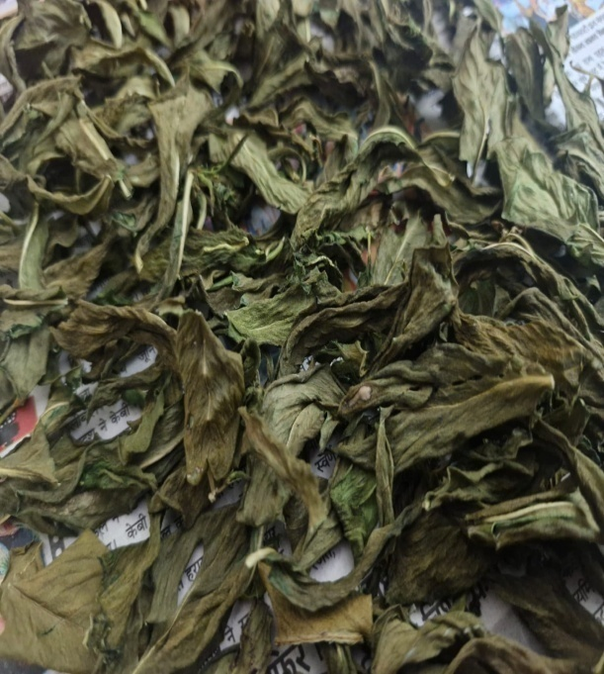
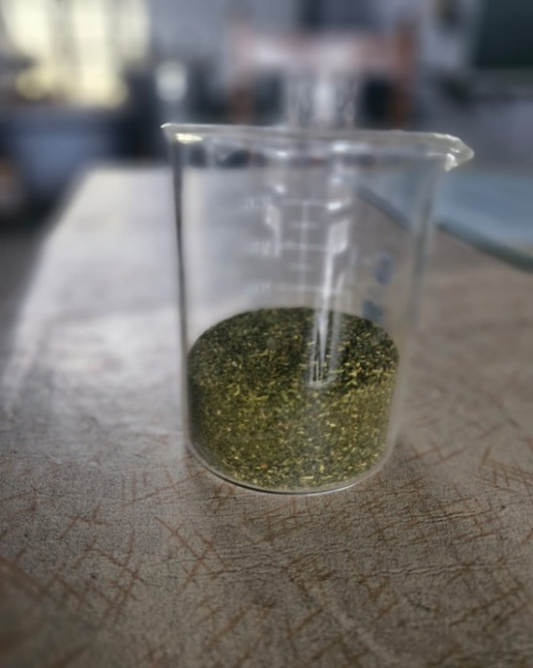
a. b.
Figure 1-: a. Catharanthus roseus dry leaf, b. Powder of dry leaf of C. roseus
Rearing of test Insect: For maintaining the laboratory culture, adult Sitophilus oryzae were collected from infested rice grains and transferred into plastic jars half-filled with rice. The mouths of the jars were covered with muslin cloth to allow aeration while preventing insect escape.
Bioassay
Effects of Catharanthus roseus leaf powder on the mortality of Sitophilus oryzae and weight loss in rice grain were studied.
30 gm rice grain was mixed with four concentrations of plant powder 1, 1.5, 2 and 2.5% (w/w = weight of powder/weight of rice) in the jar and mixed thoroughly by manual agitation to ensure a homogeneous distribution. Control treatments were carried out without powder extract. After treatments, 8 pairs of adult S. oryzae were introduced into both treated and untreated rice grains, kept in glass jars covered with muslin cloth, and maintained at controlled temperature and relative humidity. The treatments were replicated three times and the experimental design for mortality test and weight loss was completely randomized design. The number of dead adults was recorded at 1, 3, 7, 14 and 21 days post-exposure.
$$\text{Rice weevil Mortality=}\frac{\text{Number of dead insects}}{\text{Total number of insects}}\text{× 100}$$
Data on the percentage of adult weevil will be corrected using Abbott’s (1925) formula.
$$\text{Percentage of corrected mortality=}\frac{\text{(Observed mortality - Control mor}\text{t}\text{ality)}}{\text{(}\text{100 - Control mortality}\text{)}}\text{× 100}$$
At the end of the 21 days, weight loss was calculated as the difference between the final and initial weights of treated or untreated rice grain, corrected for changes in moisture content, and expressed as a percentage of the initial weight of rice grains. The following equation was used: (Devi et al., 2014).
$$\text{\% Weight loss =}\frac{\text{(Initial weight - Final weight)}}{\text{Initial weight}}\text{× 100 }$$
Statistical analysis
The data obtained were subjected to statistical analysis and the result was committed as mean ± standard deviation (SD). The data were subjected to statistical analysis applying one way ANOVA at value p<0.05 followed by Tukey’s Post Hoc test with p≤0.05 was used.

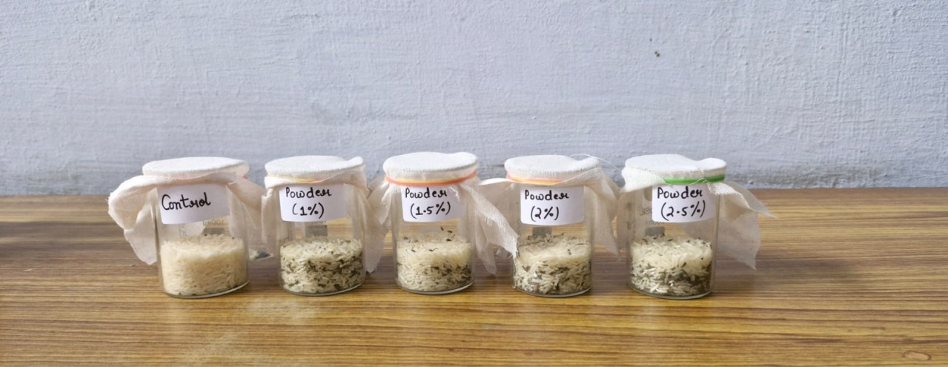
Figure 2-:Showing bioassay experiments with different concentration of powder extract of C. roseus leaf
Results
Effect of powder extract on the mortality of S. oryzae
The mortality response of Sitophilus oryzae to the powder extract of Catharanthus roseus is summarized in Table 1. A steady upward shift in mortality was recognized with increasing extract concentrations and longer exposure periods. After 24 hours of treatment, mortality ranged from 4.166% at 1% concentration to 22.916% at 2.5% concentration. A moderate progress was recognized on the 3rd and 7th days, with values ranging between 14.583–25% and 16.666–27.083%, respectively. By the 14th day, mortality exhibited a pronounced rise, peaking at 33.333% for the 2.5% concentration. The highest mortality was reported on the 21st day, reaching 43.75% at 2.5%, followed by 41.666% at 2%, while the minimum (25%) occurred at 1% concentration.
Weight loss of rice grains mixed with powder extract by S. oryzae
Table 2 presents the impact of Catharanthus roseus powder extract on the weight loss of rice grains infested by Sitophilus oryzae after 21 day exposure period. All treated samples displayed a pronounced decline in weight loss compared to the untreated control. The highest grain loss occurred in the control group (25.54 ± 1.198%), where as the lowest loss was reported in grains treated with the highest extract concentration of 2.5% (11.583 ± 0.27%). Among the treated groups, the 1% extract resulted in a weight loss of 15.836 ± 0.15%, followed by 13.52 ± 0.26% at 1.5% and 12.666 ± 0.27% at 2% concentration. These findings evidently exhibit that increasing the concentration of C. roseus extract significantly reduced grain weight loss, showing its effectiveness in protecting stored rice from S. oryzae infestation.
Table – 1: Effect of powder extract of Catharanthus roseus on the mortality of Sitophilus oryzae on rice
S. no. | Day | Mean % mortality of powder extract (w/w %) |  |  |  | F value | P value
S. no. | Day | 1% | 1.5% | 2% | 2.5% | F value | P value
1 | 1 | 4.166±3.608ª | 12.5±6.25 ^{ab} | 10.416±3.608ª | 22.916±3.608^{b} | 9.333 | 0.005
2 | 3 | 14.583±3.608 ª | 16.666±3.608 ª | 20.833±3.608ª | 25±6.25 ª | 3.277 | 0.079
3 | 7 | 16.666±3.608 ª | 20.833±3.608 ª | 22.916±3.608ª | 27.083±7.216ª | 2.476 | 0.135
4 | 14 | 20.833±3.608 ª | 22.916±3.608 ª | 29.166±3.60^{ab} | 33.333±3.608^{b} | 7.583 | 0.01
5 | 21 | 25±6.25 ª | 27.083±3.608 ª | 41.666±3.608^{b} | 43.75±6.25^{b} | 10.833 | 0.003

Note: The values of % mortality after correction of control mortality represent the mean ± SD of triplet experiments. Statistical analysis through one way ANOVA at value p<0.05 followed by Tukey’s Post Hoc test with p≤0.05 was used. The means withdifferent alphabets are significantly different with each other as indicated by Tukey’s Post Hoc test (row by row analysis) at alpha = 0.05.

Figure – 3: Effect of powder extract of Catharanthus roseus on the mortality of Sitophilus oryzae on rice

Table – 2: Effect of powder extract of Catharanthus roseus on the weight loss in rice caused by Sitophilus oryzae after 21 days
S. no. | Mean % wt loss in control | Mean % wt loss in rice with powder extract (w/w %) |  |  |  | F value
S. no. | Mean % wt loss in control | 1% | 1.5% | 2% | 2.5% | F value
1 | 25.54±1.198ª | 15.836±0.15^{b} | 13.52±0.26^{c} | 12.666±0.27^{cd} | 11.583±0.27^{d} | 285.467

Note: The values of % weight loss in rice represent the mean ± SD of triplet experiments. Statistical analysis through one way ANOVA at value p<0.05 followed by Tukey’s Post Hoc test with p≤0.05 was used. The means withdifferent alphabets are significantly different with each other as indicated by Tukey’s Post Hoc test (row by row analysis) at alpha = 0.05.

Figure – 4: Effect of powder extract of Catharanthus roseus on the weight loss in rice caused by Sitophilus oryzae after 21 days
Discussion
The findings of the present research displayed that the powder extract of Catharanthus roseus demonstrates potent insecticidal properties against Sitophilus oryzae. Mortality rates gradually increased with both higher extract concentrations and longer exposure periods, suggesting prolonged toxicity arising from the plant’s bioactive constituents. The elevated mortality recognized at the 2.5% concentration signifies that secondary metabolites such as alkaloids, terpenoids, tannins, and phenolic compounds may disrupt crucial physiological and metabolic processes in the insect, ultimately causing death. Comparable results have been documented for other plant-derived extracts demonstrating potent insecticidal and repellent properties against stored-product pests (Mostafa et al., 2023; Fabrick et al., 2020).
Furthermore, a notable reduction in grain weight loss was reported in all treated groups, supporting the protective role of C. roseus extract in reducing storage damage. This reduction is likely attributed to the deterrent and antifeedant effects of its phytoconstituents, which may hinder feeding, oviposition, and population build-up of S. oryzae within stored grains.
Comparable outcomes have been documented for several botanicals. Pongamia pinnata leaf powder caused 13.33 percent mortality of rice weevil (Kuldipakeet al., 2016). While Ageratum conyzoides achieved 96.7% mortality, 12.61% grain damage and only 1.75% weight loss (Mehta and Kumar, 2020). Similarly, Adhathoda vasica, Lantana camara, Vitex negundoand Catharanthus roseus extracts resultedIn 53.83% mortality with reduced seed damage (Soujanya et al., 2016). Najafabadi et al. (2014), observed high mortality with Mentha, Datura and Neem extracts and Rani et al.,(2019), reported 100% mortality using sweet flag rhizome extract. Moreover, Govindan and Nelson (2009), noted that V. negundo cost 99.1% mortality with a concurrent reduction in grain damage and weight loss.
The upward trend in mortality followed by an equivalent reduction in grain weight loss indicates a combined toxic and deterrent action of the phytochemicals present in the plant extract. These dual effects highlight the potential of Catharanthus roseus as a viable, eco-friendly alternative for managing storage pests. Its natural biologically active compounds offer an environmentally friendly approach to stored grain protection, reducing dependence on chemical pesticides that are often associated with residue accumulation, pest resistance, and adverse environmental impacts.
Conclusion
Overall, the results indicate that Catharanthus roseus powder extract exhibits both insecticidal and protective efficacy against Sitophilus oryzae. Mortality of the pest increased gradually with longer exposure time and progressive extract concentrations, while grain weight loss was notably reduced across all treatments compared to the control. The 2.5% extract concentration was found to be the most effective, causing the highest mortality and the least weight loss after 21 days. These results emphasize the potential of C. roseus as a natural, safe, and sustainable alternative to synthetic insecticides for the protection of stored rice grains against weevil infestation. Additional research on optimized extract formulations, the underlying mode of action, and field-level applications will be important to confirm its practical utility in integrated pest management (IPM) programs.

Disclaimer (Artificial intelligence)
Option 1:
Author(s) hereby declare that NO generative AI technologies such as Large Language Models (ChatGPT, COPILOT, etc.) and text-to-image generators have been used during the writing or editing of this manuscript.

References

- Abbott, W.S. (1925). A method of computing the effectiveness of an insecticide. Journal of Economic Entomology, 18: 266-267.
- Cao, Y., Hu, Q., Huang, L., Athanassiou, C.G., Maggi, F., D’Isita, I., Liu, Y., Pistillo, O.M., Miao, M., Germinara, G.S. and Li, C. (2024). Attraction of Sitophilus oryzae (L.) (Coleoptera: curculionidae) to the semiochemical volatiles of stored rice materials. Journal of Pest Science, 97: 73-85.
- Chayengia, B., Patgiri, P., Rahman, Z., and Sarma, S. (2010). Efficacy of different plant products against Sitophilus oryzae (Linn.)(Coleoptera: Curculionidae) infestation on stored rice. Journal of Biopesticides, 3(3): 604-609.
- Choudhury, S.D., and Chakraborty, K. (2014). Study on both the life cycle and morphometrics of Sitophilus oryzae on rice cultivar Sampamashuri in laboratory conditions. J. of Appl. Sci. And Research, 2(6): 22- 28.
- Devi, M. B., Devi, N. V., and Singh, S. N. (2014). Effects of six botanical plant powder extracts on the control of rice weevil, Sitophilus oryzae L. in stored rice grains. International Journal of Agriculture Innovations and Research, 2(5): 683-686.
- Ertürk, S., Ferizli, A.G., and Emekçi, M. (2017). Evaluation of diatomaceous earth formulations for the control of rice weevil, Sitophilus oryzae L., 1763 (Coleoptera: Curculionidae) in stored rice. Turkish Journal of Entomology, 41(3): 347-354.
- Fabrick, J. A., Yool, A. J., & Spurgeon, D. W. (2020). Insecticidal activity of marigold Tagetespatula plant and foliar extracts against the hemipteran pests, LygusHesperus and Bemisiatabaci. PLOS ONE, 15(5), e0233511.
- Govindan, K., and Nelson, S. J. (2009). Insecticidal activity of twenty plant powders on mortality, adult emergence of Sitophilus oryzae L. and grain weight loss in paddy. Journal of Biopesticides, 2(2): 169-172.
- Gupta, J., & Gupta, S. (2025). Phytochemical Screening and TLC Profiling of Leaf Extracts of Catharanthus roseus Show Presence of BiopesticidalSecondary Metabolites. Current Journal of Applied Science and Technology, 44(9): 172-179.
- Gupta, J., and Gupta, S. (2024). Review study on Sitophilus oryzae (L.) a pest of stored food grains. Innovation The Research Concept, 9(2): 01-08.
- Hardman, J. M. (1977). Environmental changes associated with the growth of populations of Sitophilus oryzae (L.) confined in small cells of wheat. Journal of Stored Products Research, 13: 45-52.
- He, P., Li, S. G., Qian, Q., Ma, Y. Q., Li, J. Z., Wang, W. M., and Zhu, L. H. (1999). Genetic analysis of rice grain quality. Theoretical and Applied Genetics, 98(3): 502-508.
https://doi.org/10.1371/journal.pone.02335
- Kuldipake, S. A., Mhaske, B. M., and Patil, N. M. (2016). Study of mortality and repellency of rice weevil Sitophilus oryzae L. on wheat seeds during storage. International journal of plant protection, 9(2): 479-482.
- Longstaff, B. C. (1981). Biology of the grain pest species of the genus Sitophilus (coleoptera: curculionidae): a critical review. Protect. Ecol., 2: 83-130.
- Majd-Marani, S., Naseri, B., Hassanpour, M., Razmjou, J., and Jalaeian, M. (2023). Life history and population growth parameters of the rice weevil, Sitophilus oryzae L. (Coleoptera: Curculionidae) fed on 10 rice cultivars and lines. Research Square: 01-14.
- Mehta, V., and Kumar, S. (2020). Influence of different plant powders as grain protectants on Sitophilus oryzae (L.) (coleoptera:Curculionidae) in stored wheat. Journal of Food Protection, 83(12): 2167-2172.
- Mostafa, M.E.H., Abdelmonem, A., El-Ablack, F. Z., Abdel-Mogib, M., and Ayyad, S.E.N. (2023). Insecticidal and phytochemical investigation of Catharanthus roseus L. extracts to Spodopteralittoralis (Boisd.). Scientific Journal for Damietta Faculty of Science, 13(1): 39-47.
- Najafabadi, S. M., Beiramizadeh, E., and Zarei, R. (2014). Repellency and toxicity of three plants leaves extraction against Oryzaephilussurinamensis L. and Triboliumastaneum Herbst. J. Bio. & Env. Sci., 4(6): 26-32.
- Navigating uncertainties: india’s rice industry outlook (2023) https://www.infomerics.com
- Ogban, E.I., Oparacke, A.M., Joshua, E.D., and Udeme, A.U. (2022). Efficacy of three plant oils against Sitophilus oryzae L. (Coleoptera: Curculionidae) on stored polished and local rice. Journal of Entomology and Zoology Studies, 10(6): 22-27.
- Okram, S., and Hath, T.K. (2019). Biology of Sitophilus oryzae (L.) (Coleoptera: curculionidae) on stored rice grains during different seasons in Teraiagro- ecology of West Bengal. Int. J. Curr. Microbiol. App. Sci, 8(4): 1955-1963.
- Radhakrishnan, V., Arulprakash, R., Ravi, M., Allwin, L., Vijay, S., Vijayaprabhakar, A., andHarisudan, C. (2025). Botanical management of Sitophilus oryzae (L.) in sorghum seeds. International Journal of Agriculture and Food Science,7(1): 35-37
- Rani, S. S., Justin, C. G. L., and Roseleen, S. S. J. (2019). Evaluation of plant extracts against rice weevil, Sitophilus oryzae (Coleoptera: Curculionidae) in stored sorghum seeds. The Pharma Innovation Journal, 8(8): 154-159.
- Smith, C.W., and Dilday, R.H. (Eds.). (2002). Rice: origin, history, technology, and production (Eds.). John Wiley & Sons, 3.
- Soujanya, P. L., Sekhar, J. C., and Kumar, P. (2016). Efficacy of plant extracts against rice weevil Sitophilus oryzae (L.) in stored maize. Indian Journal of Entomology, 78(4): 342-345.

