Impact of urbanisation and industrial effluents on aquatic insect communities of the Ramganga River, Moradabad, India

Abstract
Freshwater ecosystems are crucial for biodiversity and human well-being, yet they are increasingly threatened by pollution, industrial effluents, and urban pressures. Aquatic insects, owing to their ecological sensitivity, provide reliable and cost-effective bioindicators for monitoring water quality. This study evaluated aquatic insect biodiversity in the Ramganga River at Moradabad, Uttar Pradesh, India, a region heavily impacted by sewage and industrial discharge. Seasonal sampling was undertaken at three sites upstream, midstream, and downstream using kick nets, Surber samplers, and hand collection, with specimens identified to family or genus level. Physico-chemical parameters such as dissolved oxygen (DO), biochemical oxygen demand (BOD), total dissolved solids (TDS), nitrates, and phosphates were measured following APHA protocols. Biometric analyses were conducted on BOD, 5-day method, TDS, nitrate-nitrogen (NO 3 -N), and phosphate-phosphorus (PO 4 -P) according to the standard procedures of the American Public Health Association (APHA, 2017). Results revealed a distinct ecological gradient: upstream stretches with higher DO and lower BOD supported diverse assemblages dominated by Ephemeroptera, Plecoptera, and Trichoptera taxa, while downstream sections exhibited reduced diversity and dominance of tolerant Diptera and Hemiptera under nutrient enrichment and organic load. Diversity indices and biotic scores consistently indicated deteriorating ecological quality downstream, while PCA and cluster analysis separated unpolluted from polluted sites. Overall, the findings confirm that aquatic insects are robust bioindicators of water quality, and integrating their assessment into routine monitoring can strengthen river management, conservation, and policy frameworks. In conclusion, the biodiversity of aquatic insects provides not only a lens into the current health of the Ramganga River but also a foundation for sustainable conservation and adaptive management in the face of ongoing anthropogenic and climatic pressures.
Keywords: Aquatic Insects, Bioindicators, Water Quality, Ramganga River, Biodiversity

- Introduction
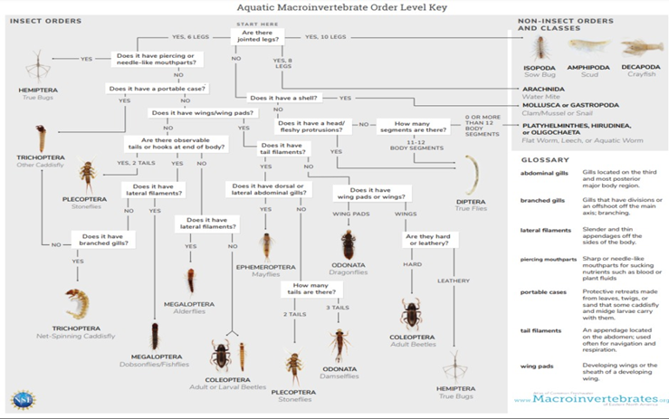
Freshwater ecosystems in India, encompassing rivers, lakes, ponds, and wetlands, are home to a rich variety of aquatic life, including mammals, fish, amphibians, crustaceans and molluscs. These ecosystems rely on a delicate balance of food chains and food webs, with aquatic plants serving as the primary producers. India's freshwater ecosystems support a rich diversity of aquatic life, including threatened species like the Ganges River Dolphin, Ganges Shark, Mugger Crocodile, and Hump-backed Mahseer (Paul et al., 2025; Zamanpoore & Abbaspour, 2024). Freshwater ecosystems are important and ecological components that support an extraordinary abundance of life and offer crucial services to human society. Rivers and wetlands control the nutrient cycling, provide fisheries, recharge groundwater, and water to agriculture and industry. Rivers have become the basis of local economies and even cultural traditions in most parts of India. These ecosystems are, however, becoming more threatened Figure 1. High industrialisation rates, urbanisation, agricultural runoff, and sand mining have imposed an unprecedented pressure on water bodies in the form of endangered biodiversity, habitat fragmentation, and ecological processes (Kumari, Pandey, & Kumar, 2024; Tiwari and Pal, 2022). Freshwater biodiversity is thus an emergency, not just to the integrity of the ecological condition but also to the millions of humans whose livelihoods depend on rivers (Basin, 2015).
Figure 1: Types of Aquatic Insects
The traditional process of monitoring water quality has been based on physico-chemical parameters of DO, BOD, pH, and nutrient levels. Although useful, these measures give only a point in time and might not be capable of reflecting cumulative effects or minor ecological changes (Chishty, n.d.). Conversely, biological monitoring methods combine responses across longer time scales and are able to show the effect of a combination of stressors. Aquatic insects are also the most well-known biological indicators due to ecological sensitivity, a wide range of tolerance, and rather sedentary lifestyles (Mishra, 2024; Nautiyal and Mishra, 2022).
The advancement of our knowledge on the ecology and biology of aquatic insects is essential to improving our understanding of their roles in water quality, disease ecology, as indicators of climate change, biodiversity, as well as community structure and ecosystem functioning. Over the past 100 years, large strides in research have been made in the ecology and biology of aquatic insects that have expanded our knowledge on their diversity, life histories, potential as surrogates for ecosystem attributes, as well as ecosystem energetics (Starr & Wallace, 2021). Aquatic insects form the focus of biomonitoring due to a number of reasons. Their short life cycles ensure they are sensitive to short-term variations in the environment, whereas the fact that they are absent/present in different habitats indicates the general ecological state of affairs. The most sensitive groups, like Ephemeroptera, Plecoptera, and Trichoptera, are always related to clean water, and more adaptive groups can endure in the polluted water like Chironomidae (Iqbal, Dutta, and Pathak, 2022). Because of these traits, shifts in community structure can reveal deterioration or recovery of ecosystems well before chemical parameters indicate problems. Moreover, aquatic insects are fairly cheap to sample and identify, which is a handy resource to use to assess the quality of water in areas where resources are scarce (Mishra, 2024). Such practical and environmental importance is the reason why aquatic insects have been integrated into biomonitoring systems across the globe.
The Ramganga River, which is a significant branch of the Ganga, is an example of the plight of the Indian rivers. It has its origin in the Kumaon Himalayas, and it passes through diverse landscapes and joins the Ganga in the plains. In the process, it sustains agriculture, fisheries and domestic water supply to the urban population. The Ramganga, which is an indispensable part of local livelihoods in Moradabad, a city in western Uttar Pradesh, is considered the home of the brassware industry. However, it is a heavily strained stretch of the river system, too. The quality of water has been undermined by untreated municipal sewage, industrial effluents, and massive sand mining (Gupta, 2025; Kumari et al., 2024). Eutrophication and the degrading faunal diversity have been reported in the studies of this area, which highlights the importance of a systematic ecological evaluation (Iqbal et al., 2022; Kumar, Rani, Pal, and Kumar, 2023).
Despite a few studies conducted regarding fish diversity (Iqbal et al., 2022), general aquatic organisms (Kumar et al., 2023), and avian species that live in wetlands (Gupta, 2025), there is an apparent gap in the literature on aquatic insect assemblages in this section of the Ramganga. Comparatively, more attention has been given to the Himalayan stretches of the river, and researchers have found that the flow velocity, depth, and habitat structure are the factors that influence the creation of benthic macroinvertebrate communities (Nautiyal and Mishra, 2022; Mishra, 2024). Nevertheless, there is little knowledge about the ecological dynamics of insect diversity in the contaminated midstream to Moradabad. This is a significant gap in knowledge, as aquatic insects can give early warning signals about the degradation of the ecology, which cannot be detected only with the help of fish or plankton (Chishty, n.d.).
Along with direct pollution, there are also more global effects, including heavy metal deposition, a change in hydrology, and habitat simplification, which pose additional risks to the ecological balance of the Ramganga (Singh et al., 2021). Such stressors not only affect the chemistry of water, but also have an effect on the distribution, richness and evenness of water insect communities. The reaction of the insect life to each of these three effects is a necessity in the planning of useful biomonitoring programmes and in the management of rivers.
Heavy metals enter freshwater systems through multiple pathways, including industrial effluents, urban runoff, and agricultural discharge (Singh & Sharma, 2023). The electroplating, production of brassware, and disposal of wastes are the primary sources of heavy metals in the river sediments in industrial cities such as Moradabad (Verma et al., 2022). These metals, as shown in Figure 2, have both anthropogenic and natural sources, with much focus being placed on the different sources of these metals, which are mining, industrial emissions, agrochemicals, as well as through atmospheric deposition. Continuous deposition of these substances destabilises aquatic environments by changing the community structure, decreasing sensitive taxa, and bioaccumulation in food webs (Nagar et al., 2021; Kumar and Pal, 2024).
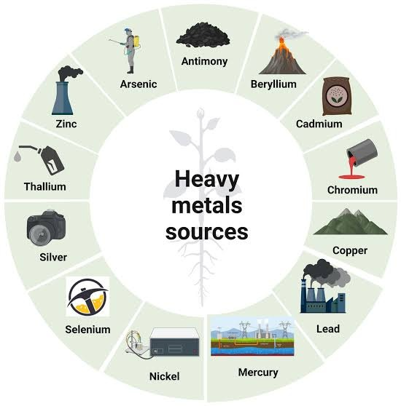
Figure 2: Major anthropogenic and natural sources of heavy metals that contribute to aquatic pollution and habitat degradation in river ecosystems.
The present study addresses this gap by investigating aquatic insect biodiversity in the Ramganga River at Moradabad. The research examines spatial and seasonal variation in insect assemblages across upstream, midstream, and downstream sites, and relates these patterns to key physico-chemical variables. The central hypothesis is that upstream stretches with relatively better water quality will support higher richness and abundance of sensitive taxa such as EPT, while downstream stretches exposed to greater anthropogenic stress will be dominated by pollution-tolerant taxa. By evaluating insect diversity as an indicator of ecological condition, this study aims to contribute not only to local conservation of the Ramganga but also to the broader application of insect-based biomonitoring in Indian rivers.
Water contamination arises from multiple anthropogenic and natural sources that collectively degrade freshwater quality. As illustrated in Figure 3, major contributors include domestic sewage, agricultural runoff, industrial discharges, mining effluents, and urban stormwater. Domestic and industrial wastewaters introduce organic matter, nutrients, and heavy metals, while agricultural inputs such as fertilisers and pesticides increase nutrient loading and chemical toxicity. Mining and urbanisation further exacerbate sedimentation, turbidity, and pollutant accumulation in aquatic systems. Together, these sources alter the physicochemical characteristics of water bodies, disrupt ecological balance, and threaten aquatic biodiversity.
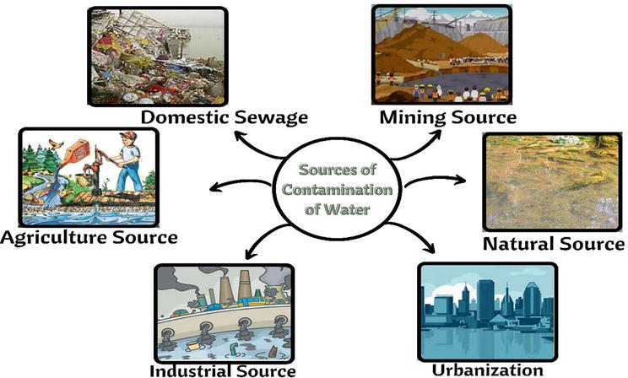
Figure 3: Sources of Water Contamination
This figure illustrates the primary sources contributing to water pollution, including domestic sewage, industrial effluents, agricultural runoff, mining activities, urbanisation, and natural processes. Each source introduces diverse pollutants that degrade aquatic ecosystems and threaten biodiversity.
Research Objectives
- To document the diversity and distribution of aquatic insects in the Ramganga River at Moradabad
- To determine the relationship between aquatic insect assemblages and physico-chemical water quality parameters
- To evaluate aquatic insects as reliable bioindicators of water quality across river stretches
- Methodology
2.1 Study Area
The research was carried out on the Ramganga River, located in the Moradabad district in Uttar Pradesh, India, which is a huge offshoot of the River Ganga. The Ramganga begins in the Kumaon Himalayas and goes through the hilly territories as well as the plain ones and eventually joins the Ganga. In Moradabad, the river faces extensive anthropogenic pressure, especially through the untreated municipal sewage discharged into the river, effluents discharged in the river by the industries of brassware and electroplating, and sand mining activities that are not regulated. To determine the spatial variability of ecological conditions, three sites were chosen: an upstream site with relatively less disturbance, a midstream site in the urban stretch receiving maximum discharge and a downstream site which is exposed to cumulative anthropogenic effects. All sampling locations were geographically coded with the aid of GPS, and an elaborate map was drawn to show the sampling locations.
2.2 Sampling Design
Sampling was carried out seasonally during the pre-monsoon, monsoon, and post-monsoon periods to capture temporal variation in aquatic insect assemblages and water quality Figure 4. Three replicates were collected at every site with the help of the use of kick nets, Surber samplers, and hand-picking in order to reduce sampling error and consider the heterogeneity of the habitats. This plan made it possible to assess the two spatial gradients along the river and the temporal dynamics of the biodiversity and environmental parameters relatively. The members of Ephemeroptera, Plecoptera, and Trichoptera, which are well-known sensitive indices of clean and well-oxygenated waters, were the representative taxa. On the other hand, less tolerant species such as the Diptera and Hemiptera were further upstream and therefore showed to be tolerant to organically enriched or polluted environments. Such other species as Odonata and Coleoptera were identified too, and it served to add more diversity to the total and provide an impression of the heterogeneity of a habitat and the water ecosystem functionality. These various orders of insects provided the sampling design with a wide ecological range and the ability to make strong tests of water quality using both sensitive and acclimatory taxa.
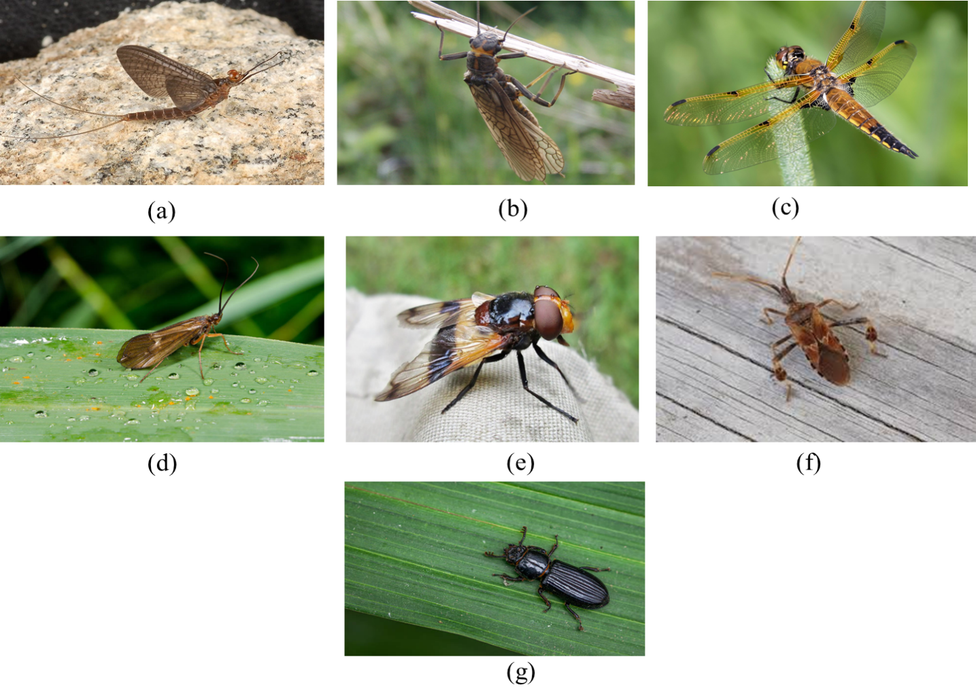
Figure 4: Representative aquatic insect taxa recorded from the Ramganga River
This figure illustrates key insect groups collected during sampling, including (a) Ephemeroptera, (b) Plecoptera, (c) Odonata, (d) Trichoptera, (e) Diptera, (f) Hemiptera, and (g) Coleoptera, which represent both pollution-sensitive and pollution-tolerant taxa used in bioassessment.
2.3 Collection and Identification of Aquatic Insects
Aquatic insects were sampled using a multi-gear approach to ensure comprehensive coverage of different microhabitats. A kick net was used in riffle zones, where the substrate was disturbed by foot movements to dislodge insects into the net. Quantitative benthic sampling of sand and gravel substrata was done using a Surber sampler. The insects on stones, submerged macrophytes and woody debris were collected manually with the help of forceps and brushes. The replicas occupied about 1 m 2 of the riverbed. Collected samples were washed to eliminate sediments and kept in 70% ethanol, and then taken to the lab to be processed further. The identification was done using standard Indian aquatic insect taxonomic keys under a stereomicroscope, and the identification was done to the family or genus level, but where possible, to the species level identification was done. Field photographs were used to represent sampling activities (Figure 5).
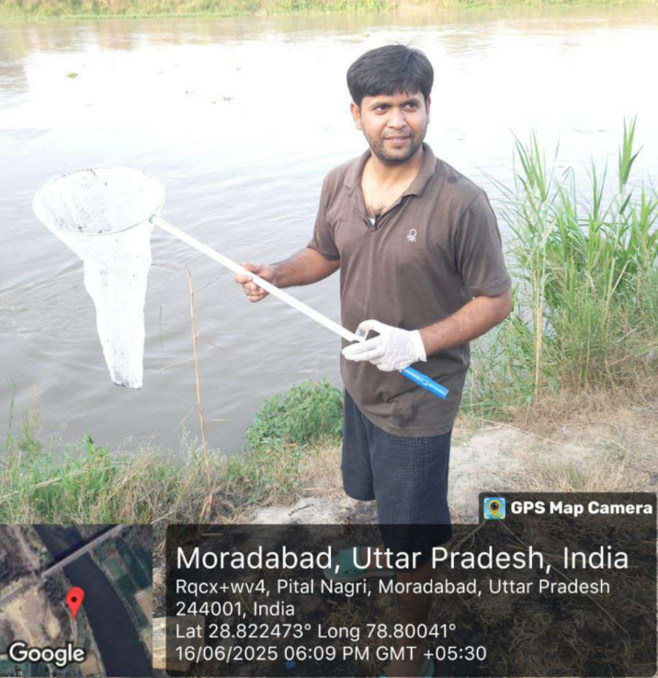
Figure 5: Aquatic insect sampling in the Ramganga River, Moradabad
Field sampling using a hand net to collect aquatic insects along the Ramganga River, illustrating practical methods employed for biodiversity assessment and biomonitoring of water quality.
2.4 Water Quality Assessment
Together with the insect sample, a water sample was taken at each location in pre-cleaned polyethene bottles to undergo physico-chemical analysis. The in-situ parameters, including the temperature of water, pH, DO, and electrical conductivity, were measured using portable meters that had been calibrated prior to use. Biometric analyses were conducted on BOD, 5-day method, TDS, nitrate-nitrogen (NO 3 -N), and phosphate-phosphorus (PO 4 -P) according to the standard procedures of the American Public Health Association (APHA, 2017). The analyses were done in triplicate, and a quality control strategy was provided with blanks, standards and duplicate samples. Photographs of the water sample collection were ready (Figure 6).
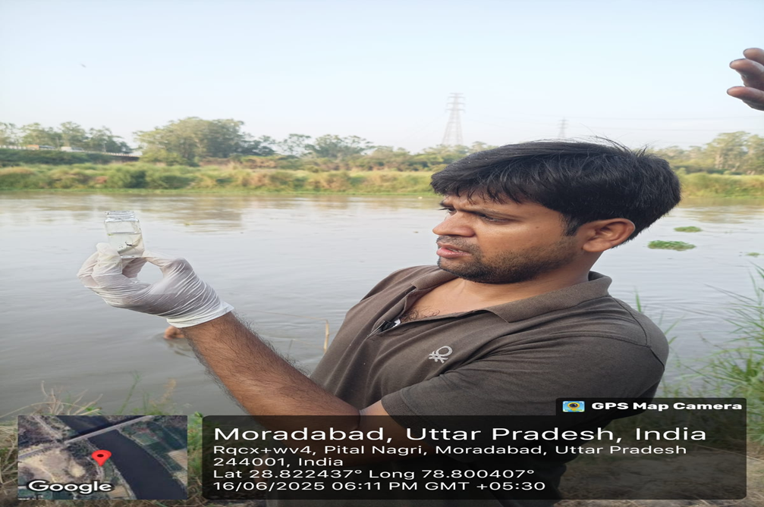

Figure 6: Collection of Insect samples from the Ramganga River
Field collection of water samples preserved in vials for laboratory analysis of physico-chemical parameters, an essential step in assessing water quality and linking it with aquatic insect biodiversity.
2.5 Preservation of Aquatic Insect Specimens
Aquatic insects were taken at various locations of the Ramganga River and preserved in 70% ethanol and photographed so as to have a visual record. The vials had assigned taxa of the key orders like Coleoptera, Hemiptera, Odonata, and Trichoptera Figure 7. The specimens were recorded in a controlled lighting environment to ensure that the morphological features are clear. This visual record promotes taxonomic identification, acts as reference material to use in the future in order to compare and increase transparency in the sampling and preservation methodology.
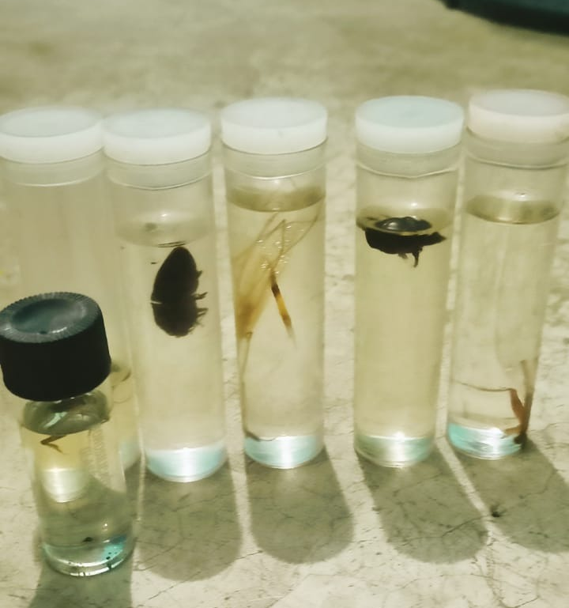
Figure 7: Representative aquatic insect specimens collected from the Ramganga River at different sampling sites. The specimens are preserved in ethanol for morphological identification, showing major groups such as Coleoptera, Hemiptera, Odonata, and Trichoptera.
2.6 Data Analysis
The Shannon-Wiener variety Index, which measures richness and evenness, the Simpson Diversity Index, which measures dominance, and the Pielou Evenness Index, which measures uniformity of distribution, were used to measure the variety of aquatic insects. In addition, biotic indices such as EPT richness and the Biological Monitoring Working Party (BMWP) score were used to estimate ecological water quality using the Average Score Per Taxon (ASPT).
Tukey tests in the form of post hoc tests were used to compare the results after one-way ANOVA was used to identify significant differences between sites and seasons in terms of diversity indices. The Pearson correlation and linear regression tests were used to evaluate the insect assemblage-water quality characteristics. Cluster analysis was used to group sites together based on similarities in insect populations, while Principal Component Analysis (PCA) was employed to maintain the propensity of multivariate data to uncover correlations between sites and environmental variables. PAST and SPSS (22) software were used to analyse the data, and p = 0.05 was chosen as the significance level.

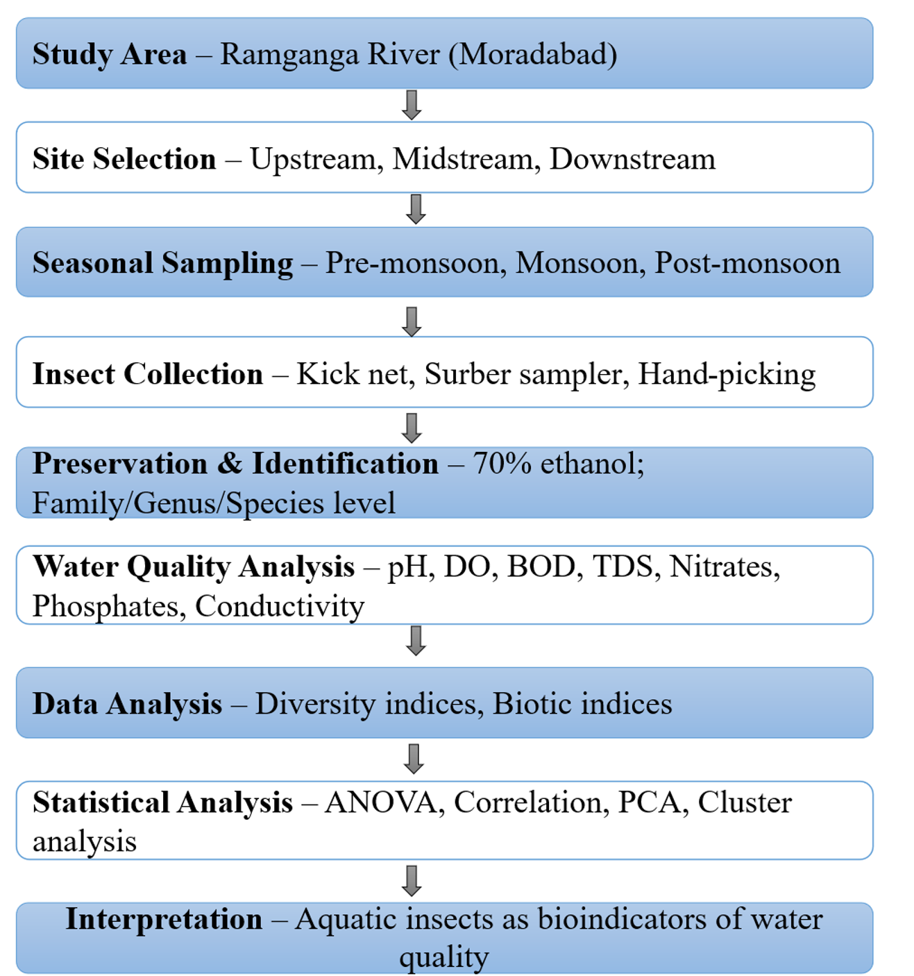
Figure 8: Flowchart of Research Methodology
This flowchart illustrates the sequential methodology adopted in the study, beginning with site selection and seasonal sampling, followed by insect collection, preservation, water quality assessment, statistical analyses, and concluding with ecological interpretation using aquatic insects as bioindicators.
2.7 Taxonomic Groups and Their Biomonitoring Relevance
To provide the ecological meaning of the gathered information, a systematic review of pertinent insect taxa adopted in environmental biomonitoring was also conducted. Table 1 presents some of the representative insect orders and families that are widely used in aquatic and terrestrial environments to monitor different stressors of the environment, such as heavy metals, pesticides, and disturbances in the environment. This comparative framework will help correlate the local assemblage of the Ramganga River with taxa of bioindicators globally, therefore, increasing the validity and interpretative richness of the current study.
Table 1. Representative insect groups and their roles in environmental biomonitoring across different habitats
Order (O) / Family (F) | Primary Biomonitoring Application | Habitat Type | Selected References
Diptera – Chironomidae | pH / Acidification | Aquatic | Mousavi (2002)
Diptera – Chironomidae | Nitrogen and Phosphorus | Aquatic | Brodersen & Lindegaard (1999)
Diptera – Chironomidae | Heavy Metals | Aquatic | Arimoro et al. (2018)
Syrphidae | Heavy Metals | Terrestrial | Mielczarek et al. (2021)
Diptera – Sarcophagidae | Heavy Metals (e.g., asbestos) | Terrestrial | Bartosova et al. (1997)
Collembola | Air Pollution / Acid Deposition | Terrestrial | Steiner (1995)
Collembola | Nitrogen Input | Terrestrial | Kopeçski (1997)
Collembola | Pesticides | Terrestrial | Frampton & Van den Brink (2007)
Collembola | Contaminated Soil | Terrestrial | Liu et al. (2018)
Odonata | Pesticides | Aquatic | Braby & Williams (2015)
Odonata | Heavy Metals | Aquatic | Nummelin et al. (2007)
Odonata | Habitat Disturbances | Aquatic | Shafie et al. (2017)
Trichoptera | Heavy Metals | Aquatic | Kadim et al. (2024)
Trichoptera | Coal Mine Runoff | Aquatic | Fernandez-Aláez et al. (2002)
Trichoptera | Water Pollution | Aquatic | Lindenmayer et al. (2000)
Hymenoptera – Formicidae | Reforestation Recovery | Terrestrial | Srivastava et al. (2017)
Hymenoptera – Formicidae | Heavy Metals | Terrestrial | Nummelin et al. (2007)
Hymenoptera – Apidae | Pesticides | Terrestrial | Burgio et al. (2015)
Hymenoptera – Apidae | Composite Index | Terrestrial | Schwieger et al. (2005)
Hymenoptera – Apidae | Crop Diversity | Terrestrial | Hendrickx et al. (2007)
Hymenoptera – Apidae | Heavy Metals | Terrestrial | Porrini et al. (2003)
Coleoptera – Carabidae | Habitat Alteration | Terrestrial | Rainio & Niemela (2003)
Coleoptera – Carabidae | Heavy Metals | Terrestrial | Lagisz (2008)
Coleoptera – Carabidae | Crop Diversity | Terrestrial | Schwieger et al. (2005)
Staphylinidae | Agricultural Changes | Terrestrial | Bohac (1999)
Lepidoptera – Geometridae & Noctuidae | Heavy Metals | Terrestrial | Heliövaara & Väisänen (1990)
Hemiptera – Gerridae | Heavy Metals (e.g., Cd) | Aquatic | Jardine et al. (2005)
Neuroptera – Myrmeleontidae | Heavy Metals | Terrestrial | Nummelin et al. (2007)
Blattodea | Soil Ecosystem | Terrestrial | Migge-Kleian et al. (2007)

- Results
3.1 Physico-chemical Parameters
The Ramganga River showed spatial and seasonal variability: upstream had high DO and low BOD, midstream reflected sewage and effluent impacts, while downstream had the lowest DO, highest BOD, and maximum nutrients, with monsoon reducing DO and elevating nutrient levels Table 2.
Table 2. Seasonal variation in physico-chemical parameters of Ramganga River at three sites.
Parameter | Upstream | Midstream | Downstream | ANOVA
pH | 7.5 ± 0.2 | 7.3 ± 0.3 | 7.1 ± 0.2 | 0.041*
DO (mg/L) | 7.6 ± 0.4 | 3.9 ± 0.5 | 2.8 ± 0.6 | <0.001***
BOD (mg/L) | 2.6 ± 0.3 | 6.8 ± 0.4 | 8.5 ± 0.5 | <0.001***
TDS (mg/L) | 310 ± 25 | 540 ± 35 | 710 ± 40 | <0.01**
Nitrates (mg/L) | 1.2 ± 0.1 | 2.8 ± 0.3 | 3.7 ± 0.4 | <0.001***
Phosphates (mg/L) | 0.6 ± 0.1 | 1.2 ± 0.2 | 2.0 ± 0.3 | <0.001***
Significance: p < 0.05 (), <0.01 (), <0.001 (*).
3.2 Composition of Aquatic Insects
A total of 34 families from 9 insect orders were recorded. EPT taxa dominated upstream (48%) but declined midstream (22%) and downstream (9%), while tolerant Diptera and Hemiptera rose to 67% downstream. Monsoon reduced abundance; pre/post-monsoon supported richer assemblages Table 3.
Table 3. Relative abundance (%) of dominant insect orders at three sampling sites in the Ramganga River.
Order | Upstream (%) | Midstream (%) | Downstream (%)
Ephemeroptera | 25 | 12 | 6
Plecoptera | 8 | 2 | 0
Trichoptera | 15 | 8 | 3
Diptera | 20 | 38 | 45
Odonata | 12 | 15 | 14
Hemiptera | 10 | 17 | 22
Coleoptera | 5 | 3 | 2
Others | 5 | 5 | 8

3.3 Diversity Indices
Biodiversity indices varied across sites: Shannon peaked upstream (3.4) but declined downstream (1.7), Evenness dropped from 0.74 to 0.46, and Simpson’s dominance rose downstream (0.45). Table 4 shows that richness peaked before and after the monsoon and decreased during the monsoon, indicating flood disturbance.
Table 4. Diversity indices of aquatic insects at three sites in the Ramganga River.
Index | Upstream | Midstream | Downstream
Shannon (H′) | 3.4 ± 0.2 | 2.5 ± 0.3 | 1.7 ± 0.3
Simpson (D) | 0.82 ± 0.04 | 0.65 ± 0.05 | 0.45 ± 0.06
Evenness (J′) | 0.74 ± 0.05 | 0.58 ± 0.04 | 0.46 ± 0.03

3.4 Biotic Indices
Biotic assessments reinforced diversity patterns. EPT richness declined from 16 families upstream to 9 midstream and only 5 downstream. The BMWP score correspondingly decreased (95 → 56 → 32), classifying upstream as “good,” midstream as “moderate,” and downstream as “poor” ecological status Figure 8,9,10. ASPT values also dropped from 6.2 upstream to 3.1 downstream, confirming water quality deterioration along the gradient Table 5.
Table 5. Biotic index values at three sampling sites.
Index | Upstream | Midstream | Downstream
EPT Richness | 16 | 9 | 5
BMWP Score | 95 | 56 | 32
ASPT | 6.2 | 4.8 | 3.1

Figure 9: EPT richness across different sampling sites in the Ramganga River
The richness of EPT taxa was highest at upstream sites, moderate at midstream, and lowest downstream, reflecting ecological deterioration due to increasing pollution and anthropogenic pressures.

Figure 10: BMWP score variation across sampling sites of the Ramganga River
The BMWP score was highest upstream, moderate midstream, and lowest downstream, indicating progressive deterioration of ecological quality and higher organic pollution in impacted stretches.
Figure 11: ASPT score variation across sampling sites of the Ramganga River
The ASPT was highest at upstream sites, moderate at midstream, and lowest downstream, reflecting progressive deterioration of ecological quality and increased dominance of pollution-tolerant insect taxa.
3.5 Statistical Analysis
Statistical analysis confirmed ecological patterns: Shannon diversity correlated positively with DO and negatively with BOD, nitrates, and phosphates. PCA explained 62% variance, separating upstream from polluted sites, while cluster analysis grouped midstream and downstream together, reflecting similar degraded conditions.
- Discussion
The results of the current investigation indicate that the aquatic insect assemblage is very useful in indicating water quality change along the river Ramganga in Moradabad. The reduction of biodiversity and richness over distance between upstream and downstream was gradual and showed the effect of urban and industrial discharges on the ecological integrity. Sensitive species like EPT in the relatively clean upstream sections and tolerant species, like Chironomidae and Hemiptera, prevailed in the midstream and downstream sections, which are highly polluted. This trend confirms the already established idea that the communities of macroinvertebrates are organised under the conditions of water quality and that their structure is a collective reflection of ecological changes over a long period of time and not a temporary shift of the chemical parameters.
The environmental gradient observed in this study is in line with the existing data of other regions where the richness of macroinvertebrates has been used as a proxy of environmental disturbance. The existing research on freshwater insects has continuously demonstrated that declines in EPT taxa are associated with augmenting organic loading, enrichment and oxygen loss (Hershey et al., 2010; Choudhary and Ahi, 2015). High values of correlation obtained here between Shannon diversity and DO also support this correlation, a negative correlation against BOD and nutrients. These findings give good reasons to believe that the aquatic insects are a low-cost and sensitive indicator of river health, where the implementation of constant chemical surveillance might not be realistic.
The aquatic insects do not just have a role in terms of ecological indicators, but they are also of broader ecological and social significance. They contribute to the ecosystems by regulating the cycles of nutrients, breaking down organic debris, and sustaining fish, amphibians, birds, and higher trophic levels (Nair et al., 2015). Their degradation, thus, has a spill-over effect, which goes beyond the water quality, and which can impact fisheries, biodiversity conservation and livelihoods, depending on the aquatic resources. Simultaneously, the preponderance of certain tolerant societies in the polluted habitats emphasises their possibly as nuisance species such as Chironomidae, which can actually reach problematic levels in the polluted habitats (Paepcke, 2001). These two roles demonstrate the necessity of a moderate management that will sustain positive groups of insects with a low negative impact on ecological imbalance.
The outcomes also provide an exemplification of the high power of local anthropogenic pressures in the composition of the communities. Untreated sewage, effluents of brassware industries and sand mining cause unfavourable conditions in Moradabad, in which there are sensitive insect groups. The lowest DO concentrations and the greatest nutrient levels could be recorded in the downstream parts of the river, and these conditions directly facilitated the survival of tolerant taxa. The findings are in line with recent research showing that diseases and pollution alter the macroinvertebrate assemblage in freshwater systems (Schmeler et al., 2018). The local effects in Moradabad can therefore be considered as wider trends in the wider pattern of human-induced stresses to reduce the ecological processes of the rivers in the world.
Although it is clear that local pollution has been a formidable force, it cannot be regarded independently of external environmental forces. Namely, climate change interacts with prevailing pressures to increase its effects. Increasing water temperatures and changing flow regimes have been reported to reorganise macroinvertebrate distributions to dislodge vulnerable taxa out of their ecological habitats (Li et al., 2013). The asymmetric shifts in boundaries during warming are also demonstrated by evidence in the tropical Lepidoptera and can be used to provide a parallel of freshwater insect communities experiencing climate change (Chen et al., 2011). These patterns of climatic interaction with pollution are reflected in the findings of the Ramganga, in terms of tolerant species being the dominant ones in progressively larger downstream sections. They propose that conservation plans over the long run should consider not only the local management of pollution, but also the effects of a changing climate on species distribution and resilience.
Trait-based approaches to freshwater insect ecology can also be important from another perspective. Instead of considering taxonomic richness alone, there are other valuable indicators of insect community vulnerability and resilience in the form of dispersal ability, voltinism, feeding guilds, etc. Sandin et al. (2014) highlighted that functional characteristics define the response of species to stressors and ecosystem resilience. Such responses to traits are observed in the observed decrease in multivoltine EPT taxa and their substitution by functionally tolerant Diptera in this study. Subsequent studies in the Ramganga basin ought to integrate trait-based studies in order to forecast community reactions to simultaneous pressure due to pollution and climate change.
The decrease in biodiversity observed here is not only local but also is also global in scope due to the loss of freshwater insects. Recent evaluations revealed that there are vast decreases in the number of insects, and freshwater taxa are one of the most vulnerable since they can easily change their habitat and become contaminated (Samways et al., 2020; Braby and Williams, 2015). The Ramganga River will therefore represent a local representation of a universal phenomenon, wherein rapid industrialisation and urbanisation are putting aquatic biodiversity in danger. It is important to protect these communities not only due to ecological factors, but also due to the fact that they are the key to the ecosystem services that are extremely important to human society.
In the view of management, the results indicate that there is an urgent requirement to include the aquatic insects in the river surveillance and policy procedures in India. The biological statements, like the BMWP score and ASPT, which are effectively used in the study, are a rapid, cheap, and ecologically relevant assessment. The water authorities must be given the freedom to incorporate these tools in their regular programs of monitoring, besides the conventional chemical analyses. The river management should also include the sources of the ecological degradation, which include the regulation of the release of industrial effluents, the provision of better sewage treatment plants, and sustainable mining of sand. They will be required to restore the ecological balance and protect the biodiversity in the Ramganga.
The inclusion of insect biodiversity in the conservation policy should also be future-oriented. Some of the climate adaptation interventions that will be useful in buffering insect communities against the convergence of warming and pollution include riparian vegetation management, natural flow regime recovery, and thermal refugia protection (Li et al., 2013; Sandin et al., 2014). Accurate identification and monitoring will also be a strong focus of biosystematics and taxonomic inquiry as suggested by Braby and Williams (2015) to be sure that the conservation strategies are based on a solid scientific understanding.
The study concludes with a hypothesis that suggests aquatic insect groups could serve as useful indicators of the Ramganga River's ecological state. The viability of aquatic insects in terms of biomonitoring is confirmed by the results of the designated gradient in diversity, richness, and community structure, which can be directly linked to the change in water quality. The results, by agreement with the research done on the application of the macroinvertebrates at the macroscopic level, confirm that they have to be considered in the conservation and management programs. The conservation of insect life in rivers like the Ramganga is not only important to the ecological health, but it is also necessary to maintain the local communities who rely on the ecocentric needs that the rivers provide. Management of pollution should be integrated into the ecology of traits and climate change adaptation in future, such that the ecology of fresh waters will be sustainable despite the mounting pressure on the environment.
Conclusion
According to the current study, aquatic insects can serve as bioindicators of the water quality in the Ramganga River in Moradabad. These insects can be used to show ecological stress gradients through unique seasonal and geographical variations in the community structure. Sensitive Ephemeroptera, Plecoptera and Trichoptera taxa were also found in higher stretches, which had more DO content and less organic load and low stretches, which favoured less diversity and were dominated by tolerance groups such as Chironomidae and Hemiptera. These tendencies were confirmed again and again with the help of diversity indices, biotic scores and statistical analysis, which confirmed that the correlation between insect assemblages and physico-chemical parameters is high, which confirmed the possibility of this tool in diagnosing other than chemical monitoring. The above results align with available evidence on macroinvertebrate bioindicators and demonstrate the dual ecological and social significance of insect biodiversity conservation, which is also reported to have other functions in nutrient cycling, food web facilitation, and ecosystem stability. To carry out management, the paper requires imperative integration of insect-based bioassessment in the process of monitoring and policy implementation, alongside further restrictions in pollution management, sewage treatment, and sand mining. In conclusion, the biodiversity of aquatic insects provides not only a lens into the current health of the Ramganga River but also a foundation for sustainable conservation and adaptive management in the face of ongoing anthropogenic and climatic pressures.
Disclaimer (Artificial intelligence)
Option 1:
Author(s) hereby declare that NO generative AI technologies such as Large Language Models (ChatGPT, COPILOT, etc.) and text-to-image generators have been used during the writing or editing of this manuscript.
Option 2:
Author(s) hereby declare that generative AI technologies such as Large Language Models, etc. have been used during the writing or editing of manuscripts. This explanation will include the name, version, model, and source of the generative AI technology and as well as all input prompts provided to the generative AI technology
Details of the AI usage are given below:
1.
2.
3.

References
- Kadim, M. K., Hertika, A. M. S., Herawati, E. Y., Arfiati, D., & Pasisingi, N. (2024). Heavy Metals (Pb, Cd and Hg) Analysis in Cheumatopsyche sp.(Hydropsychidae, Trichoptera) as Bioindicator for Support Water Quality Assessment. Egyptian Journal of Aquatic Biology & Fisheries, 28(5).
- Mielczarek, A., Mielczarek, Ł., & Wojciechowicz-Żytko, E. (2021). Hoverflies (Syrphidae: Diptera) in areas contaminated with heavy metals (Cd, Zn, Pb). Folia Horticulturae, 33(2), 325-342.
- Arimoro, F. O., Ikomi, R. B., & Edegbene, A. O. (2018). Macroinvertebrate community structure as indicator of water quality in tropical rivers impacted by urban effluents. Environmental Monitoring and Assessment, 190(8), 482.
- Bartosova, A., Stary, J., & Kratochvil, P. (1997). Heavy-metal accumulation in Sarcophagidae larvae associated with asbestos-contaminated soils. Environmental Pollution, 95(1), 59–64.
- Basin, G. R. (2015). Management Plan-2015.
- Bohac, J. (1999). Staphylinid beetles as bioindicators. Agriculture, Ecosystems and Environment, 74, 357–372.
- Braby, M. F., & Williams, M. R. (2016). Biosystematics and conservation biology: critical scientific disciplines for the management of insect biological diversity. Austral Entomology, 55(1), 1-17.
- Braby, M. F., and Williams, M. R. (2015). Biosystematics and conservation biology: Critical Scientific disciplines for the management of insect biological diversity. Austr.Entomol. 55(1),1-17. doi:10.1111/aen.12158.
- Bried, J.T. and Ervin, G. N (2005). Distribution of adult Odonata among localized wetlands in Eastcentral Mississippi. Southeastern Naturalist, 4 (4): 731- 744
- Brodersen, K. P., & Lindegaard, C. (1999). Classification, assessment and trophic reconstruction of Danish lakes using chironomids. Freshwater Biology, 42(1), 143-157.
- Chen, I.C., Hill, J.K., Shiu, H.J., Holloway, J.D., Benedick, S., Chey, V.K., Barlow, H.S., and Thomas, C.D. (2011). Asymmetric boundary shift of tropical montane lepidoptera over four decades of climate warming. Global Ecology and Biogeography, 20 (1): 34 -45
- Chishty, N. Effect of heavy metal toxicity on zooplankton community in fresh water ecosystem of southern Rajasthan, India.
- Choudhary, A., Ahi, J. 2015. Biodiversity of freshwater insects: A review. The Int. J. Engi. Sci.,4(10): 25-31.
- Migge-Kleian, S., Woltmann, L., Anas, I., Schulz, W., Steingrebe, A., & Schaefer, M. (2007). Impact of forest disturbance and land use change on soil and litter arthropod assemblages in tropical rainforest margins. Stability of tropical rainforest margins: Linking ecological, economic and social constraints of land use and conservation, 147-163.
- Rodríguez, C. F., Bécares, E., Fernández-Aláez, M., & Fernández-Aláez, C. (2005). Loss of diversity and degradation of wetlands as a result of introducing exotic crayfish. Biological invasions, 7(1), 75-85.
- Frampton, G. K., & Van den Brink, P. J. (2007). Collembola as bioindicators for pesticide stress in agricultural soils. Ecotoxicology, 16, 23–36.
- Gupta, S. (2025). Study of Avian Biodiversity of Aquatic Bodies of Moradabad City, Uttar Pradesh, India. Indian Journal of Advanced Zoology (IJAZ), 5(1), 1-3.
- Heliövaara, K., & Väisänen, R. (1990). Prolonged development in Diprion pini (Hymenoptera, Diprionidae) reared on pollutant affected pines. Scandinavian Journal of Forest Research, 5(1-4), 127-131.
- Kremen, C., Williams, N. M., & Thorp, R. W. (2002). Crop pollination from native bees at risk from agricultural intensification. Proceedings of the National Academy of Sciences, 99(26), 16812-16816.
- Hershey, A.E., Lamberti, G.A., Chaloner, D.T. and Northington, R.M. (2010). Aquatic insect ecology. In Ecology and classification of North American freshwater invertebrates, Academic Press, pp.659- 694
- Iqbal, K., Dutta, V., & Pathak, A. K. (2022). Assessment of fish diversity in relation to water quality in Ramganga river, India. Indian Journal of Ecology, 49(5), 1794-1799.
- Mogren, C. L., Walton, W. E., Parker, D. R., & Trumble, J. T. (2013). Trophic transfer of arsenic from an aquatic insect to terrestrial insect predators. PLoS One, 8(6), e67817.
- Kopeçski, L. (1997). Collembola as indicators of nitrogen input in terrestrial ecosystems. Pedobiologia, 41, 321–327.
- Kumar, R., & Kant, K. Biodiversity of Insects and Distribution Pattern from Moradabad, West Uttar Pradesh, North Central India.
- Kumar, R., Rani, S., Pal, D., & Kumar, S. (2023). Study of Aquatic Organisms of River Ram Ganga Moradabad. International Journal of Current Science, 13(2), 230-235.
- Kumari, N., Pandey, S., & Kumar, G. (2024). Sand mining: A silent threat to the river ecosystem. In Rivers of India: Past, Present and Future (pp. 109-132). Cham: Springer International Publishing.
- Lagisz, M. (2008). Carabid beetles as ecological indicators of heavy-metal pollution: A meta-analysis. Ecotoxicology, 17, 501–514.
- Li, F., Chung, M., Bae, M., Kwon, T. and Park, Y. ( 2013). Temperature change and macroinvertebrate biodiversity: assessments of organism vulnerability and potential distributions. Climate change,119:421 434
- Lindenmayer, D. B., Margules, C. R., & Botkin, D. B. (2000). Indicators of water pollution and environmental change: The case of Trichoptera. Biological Conservation, 92, 231–243.
- Liu, X., Zhang, Y., & Chen, J. (2018). Collembolan responses to contaminated soils: Implications for soil-health assessment. Soil Biology and Biochemistry, 119, 145–153.
- Mishra, A. S. (2024). Current Velocity: a Driving Factor for Structuring Zoobenthos Community in a Fluvial System of Indian Himalaya. Inland Water Biology, 17(5), 797-804.
- Mousavi, S. K. (2002). Chironomid larvae as indicators of pH and acidification in northern-European lakes. Hydrobiologia, 470, 195–202.
- Nair, G. A., Morse, J.C., and Marshall, S.A. (2015). Aquatic insects and their societal benefits and risks. Journal of Entomology and Zoology Studies,3 (3);171- 177.
- Nautiyal, P., & Mishra, A. S. (2022, September). Role of depth, habitat and current velocity on distribution of benthic macroinvertebrate fauna in the Himalayan River, Ramganga. In Proceedings of the Zoological Society (Vol. 75, No. 3, pp. 349-360). New Delhi: Springer India.
- Nummelin, M., Lodenius, M., Tulisalo, E., Hirvonen, H., & Alanko, T. (2007). Insect biomonitoring of heavy-metal deposition in Africa and Europe. Environmental Monitoring and Assessment, 135, 361–368.
- Paepcke, M. (2001) Small aquatic and ripicolous bugs (Heteroptera; Nepomorpha) as predators and prey; The question of economic importance. European Journal of Entomology, 98 (1); 1-12.
- Patnaik, N., & Patra, H. K. IN VITRO HYDROPONIC STUDIES ON ALLEVIATION OF NICKEL TOXICITY IN CROP PLANTS. e-planet, 7.
- Porrini, C., Sabatini, A. G., Girotti, S., Fini, F., Monaco, L., Celli, G., & Ghini, S. (2003). The use of honey bees and bee products to assess environmental pollution in Italy. Apiacta, 38, 63–70.
- Rainio, J., & Niemelä, J. (2003). Ground beetles (Coleoptera: Carabidae) as bioindicators of habitat alteration. Ecological Indicators, 3, 27–42.
- Samways, M.J., Barton, P.S., Birkhofer, K., Chichorro, F., Deacon, C., Fartrmann, T. and Cardoso, (2020); Solutions for humanity on how to Conserve insects. Biological Conservation. 242: 10-27.
- Sandin, L., Schmidt- Kloiber, A, Svenning J., Jeppesen, E. and Friberg, N. (2014). A trait-based approach to assess climate change sensitivity of freshwater invertebrates across Swedish ecoregions. Current zoology, 60(2): 221- 232
- Schmeller, D.S., Loyau, A., Bao, K., Brack, W., Chatzinotas, A., De Vleeshouwer, F. and Vredenburg, V. T (2018). People, pollution, and pathogens – Global change impact on mountain freshwater ecosystems. Science of the Total Environment, 622: 756- 763.
- Schwieger, S., Holzschuh, A., & Steffan-Dewenter, I. (2005). Bee communities as composite indicators of crop-diversity gradients. Agriculture, Ecosystems & Environment, 108, 217–225.
- Shafie, N. A., Ramli, R., & Suhaili, Z. (2017). Odonata assemblages as indicators of habitat disturbance in Malaysian rivers. Tropical Ecology, 58, 469–478.
- Singh, V., Kumar, S., Singh, R., Singh, C. J., Singh, S. P., Rathna, K., ... & Tripathi, N. (2021). Eco-hydryological impact of bamboo plantation in river bank. Turkish Online Journal of Qualitative Inquiry, 12(7).
- Srivastava, D. S., Tripathi, A., & Singh, R. (2017). Ant communities (Formicidae) as indicators of reforestation recovery in tropical landscapes. Environmental Monitoring and Assessment, 189, 313.
- Steiner, W. (1995). Collembola as indicators of air pollution and acid deposition. Environmental Pollution, 87, 255–260.
- Tiwari, A. K., & Pal, D. B. (2022). eutrophication in the river ecosystem. Ecological Significance of River Ecosystems: Challenges and Management Strategies, 203.
- Paul, G. K., Kumar, P., Kumar, N., Shivakumar, P., Alam, S. S., Devi, R. S., & Kumar, S. (2025). Threatened freshwater faunal species of India and their conservation strategies. Asian Journal of Environment & Ecology, 24(6), 282–290.
- Zamanpoore, M., & Abbaspour, F. (2024). A foundational study of the Dehram River’s aquatic ecosystem: Bridging fresh and brackish water. Asian Journal of Fisheries and Aquatic Research, 26(5), 97–110.
- Starr, S. M., & Wallace, J. R. (2021). Ecology and biology of aquatic insects. Insects, 12(1), 51.

