FABRICATION OF CADMIUM SULPHIDE NANOPARTICLES AND THEIR CYTOTOXICITY IMPACTS
Abstract
A typical semiconductor used in electronics is cadmium sulphide (CdS). In this study, CdS nanoparticles were sustainably synthesised using an extract from Plectranthusamboinicus. The cubic structure of the nanoparticles was confirmed through X-ray diffraction.While their nanoscale dimensions were evidenced by field emission scanning electron microscopy (FESEM). Additionally, organic compounds present on the surfaces were identified using Fourier-transform infrared spectroscopy (FTIR). According to UV-visible studies ranged from 200 to 800 nm, absorption peak at 476 nm confirms the formation of CdS nanoparticles. The 2.61 eV bandgap suggests longer wavelength transitions. Comparing to doxorubicin, anticancer tests showed a promising cytotoxicity against MCF-7 cells, with an IC₅₀ of 122.015 µg/mL, suggesting the possibility of its use in anticancer therapy.
Keywords :Plectranthus amboinicus, MCF-7 cell line, CdS naoparticles, Surface plasmon resonance, Cytotoxicity, MTT assay.
- Introduction
A substance that has electrical conductivity in between that of an insulator and a conductor is called a semiconductor. Semiconductors capture the interest of many scientists due to their advantageous optical, electrical, and catalytic properties. Cadmium sulfide (CdS), a type II semiconductor, stands out for its size and shape dependent optoelectronic traits [1, 2]. Its applications span photocatalysts, photoresistors, photoelectric devices, solar cells, sensors, and telecommunications [3, 4]. The demand for these applications necessitates innovative and safe synthesis methods for nanoparticles (NPs) [5]. Nanoparticles must possess specific structure, morphology, stability, and size tailored to their intended use. Since their physical properties are influenced by morphology and size, controlled synthesis is vital. [6] Various physical and chemical techniques, such as vapor deposition, hydrothermal, micelle encapsulation, and pyrolysis, are employed for the synthesis of nanoparticles. While these methods yield high-purity NPs, they often require costly equipment and toxic chemicals, necessitating thorough post-processing [7].
Green chemistry proposes a different approach to produce nanostructured materials from naturally derived compounds or extracts [8]. This biosynthesis approach utilizes the natural ability of plants, bacteria, fungi, and algae, which are able to synthesize nanostructures in the right size and shape at moderate temperature and pressure utilizing a variety of abundant and nontoxic precursors. Thus, the biosynthesis approach eliminates the use of hazardous chemicals and reaction conditions. Green synthesized NPs exhibit superior properties such as unique morphology, narrow size distribution, bioactivity, and durability. Biogenic NPs are integral components of many biological processes and demonstrate different activities such as photocatalytic activity [9-11].
Apart from applications, NPs have posed potential toxicity to human health and environment [12]. The toxicity of CdS and other metal chalcogenides arises from further transformation reactions that produce toxic cadmium ions [13]. Hence, safety is crucial in the design and utilization of NPs. Biogenic NPs explore a dual function as NPs and biocompatible stabilizing agents and thus eliminate biosafety concerns. As multicellular organisms, plants undergo phytotoxicity through upregulation of specific stabilization or detoxification mechanisms that limit the growth and metabolism of metal ions [14]. Biofunctionalization of nanostructured materials is an emerging area that offers attractive synthetic strategies that utilize the naturally occurring biological components of organisms such as plant extracts, ligands, biomolecules, and metabolites to direct the desired structure, composition, stability, and morphology of inorganic NPs. Distinctly from conventional methods utilizing solely stabilizing agents or ligands, biogenic NPs are endowed with natural biosafety, biocompatibility, and bioactivity [15-17].
2. Methods and materials
2.1. Collection of plant materials
The study utilized plectranthus amboinicus leaves from Kulaiyankarisal village in Tuticorin Taluk, Tamil Nadu and India.
2.2 .Preparation of plant extract
In the preparation of the extracts, fresh leaves of the plant were initially subjected to washing with distilled water followed by sterile water to eliminate the presence of both organic and inorganic contaminants. A precisely measured 10 g of Plectranthus amboinicus leaves were subsequently minced into fine fragments and placed into 500 mL beakers containing 200 mL of sterile water. The resulting mixtures were subjected to boiling for duration of 30 minutes at approximately 100 °C. The resultant extracts were allowed to cool at ambient temperature. Following the cooling phase, the resulting leaf extracts were filtered employing Whatman No. 41 filter paper. This extract functioned as the capping and stabilizing agent during the synthesis of cadmium sulfide nanoparticles (CdS NPs). This methodology ensured that the extract was devoid of contaminants and therefore appropriate for utilization in the synthesis process [18].
2.3. Biogenic synthesis of CdS nanoparticles
About 50 mL aqueous solution comprising 0.1 M cadmium nitrate was prepared, to which 5 mL of Plectranthus amboinicus plant extract was added. Subsequently, 50 mL of 0.1 M sodium sulfide aqueous solution was incrementally introduced to the resulting mixture, drop by drop. This mixture exhibited an immediate chromatic transition from light brown to orange. The solution was subjected to vigorous agitation at a temperature range of 60-80 °C for duration of 16 hours in a dark environment. The final orange color of the solution indicated the formation of cadmium sulfide (CdS) nanoparticles [19].
Cd(NO₃)₂ + Na₂S + Plant extract → CdS NPs + 2NaNO₃
2.4. Cytotoxic activity
2.4.1. Reagents
FBS (Fetal Bovine Serum), RPMI-1640 media, 3-(4,5-dimethylthiazol-2-yl)-2,5-diphenyltetrazolium bromide (MTT Salt), Streptomycin, Penicillin, Dimethyl Sulphoxide (DMSO), Glutamine, Distilled Water.
2.4.2. Development of Cell Culture
The American type culture collection provided the breast cancer from which human breast adenocarcinoma (MFC-7) cells were produced (ATCC, MCF7 - HTB-22). RPMI-1640 media supplemented with 10% FBS, glutamine (2 mM), penicillin (100 units/mL), and streptomycin (100 µg/mL) was used to maintain MCF-7 cells. The cells were grown in a humidified 5% CO₂ incubator at 37°C
2.4.3. Cytotoxicity Assay:
In order to evaluate the cytotoxic activity of the green route derived CdS NPs 3-(4,5-dimethylthiazol-2-yl)-2,5-diphenyltetrazolium bromide was used. Using dimethyl sulphoxide (DMSO) serial dilution, the concentrations of the nanoparticle test sample were diluted from the stock solution within the range of 500 to 62.5 µg/mL. The standard drug utilized was Doxorubicin, an anti-cancer drug (0.1 µg/mL).
In accordance with the manufacturer's instructions, the MTT test was used to determine the cytotoxicity of the plant extracts. In summary, three rows of 96-well plates were seeded independently with 5000 MCF-7 cells per well, and 100 µL of culture media (RMPI 1640) was added. The next day, the cells were exposed to four different doses of DMSO-dissolved CdS NPs (500, 250, 125, and 62.5 μg/mL) for a whole day. Additionally, doxorubicin was employed as a positive control medication against MCF-7 cells at 0.1 µg/mL (corresponding to an IC₅₀ value). Four hours later, MTT reagent was added to the medium. Following the addition of the solubilization solution (DMSO) to each well, the plates were left at room temperature for 30 minutes. The absorbance was then measured with a Microtiter plate reader at 590 nm. Three duplicates of the assay run were recorded [20].The cell growth inhibition was measured using below formula;
$$\% of growth inhibition= \frac{(Control O.D Value - Test Sample O.D Value)}{Control O.D Value} x 100$$
2.3.4. Statistical Analysis and IC₅₀ Calculation
The mean standard deviation of the triplicate values was provided. Using an online tool called IC₅₀, Linear regression analysis was performed after the evaluation at various concentrations to obtain the half-maximal (IC₅₀) inhibitory concentration values for each experiment.
2.4. CHARACTERISATION
CdS nanoparticles were characterized using a UV-Vis spectrophotometer (JASCO V-630, Japan) operating between 200 and 800 nm. FTIR analysis was conducted on powder samples with a Shimadzu 8400S (Japan) at a resolution of 4 cm⁻¹ and 50 scans to improve the signal-to-noise ratio.UV-Vis spectrophotometer equipped with a diffuse reflectance accessory, covering 200-900 nm. FESEM and EDAX employed a CarlZeiss Sigma Brucker imaging up to 500000 x (Germany). XRD investigations used a PAN alyticalX’pert-pro powder X’celerator diffractometer with Cu-kα radiation with CuKα radiation at 1.5406 Ã and a graphite monochromator for selecting the desired wavelength and filtering out K_{β} radiation.
3. Result and Discussion

3.1. Diffuse Reflectance Spectroscopy
UV-Visible diffuse reflectance spectra of pure CdS nanoparticles were shown comprehensively in Fig. 1 across the broad range of 200 to 800 nm. The spectrum reveals distinct reflectance edges at the critical wavelength of 476 nm, accompanied by corresponding energy values calculated to be 2.61 eV. The band gap energy of the pure CdS nanoparticles was determined from the diffuse reflectance spectra utilizing the equation.
E_{g}= hv =$\frac{hc}{λ}$= $\frac{1240}{λ}$ev [1]
Where h = Plank constant, C= velocity of light, λ = CutoffWavelength
The determined band gap values have been systematically tabulated in Table 1 for clarity. It is noteworthy that the higher bandgap of pure CdS nanoparticles stands in contrast to the lower value observed for bulk CdS, which is approximately 2.42 eV. This difference can be attributed to the quantum confinement effect [21], which arises due to the significantly smaller size of the nanoparticles. Additionally, because the constituent atoms of CdS nanoparticles are heavier, as supported by the literature, it is observed that the bandgap of semiconductors falling under group II–VI tends to decrease. The remarkable quantum size effect is a crucial factor here, as it results in a larger bandgap for nanoparticles possessing diameters that range between 2 to 4 nm compared with that of the bulk semiconductor material [22].
Table.1.Determination of band gap of CdS NPs from DRS spectra
Sample | Wavelength [nm] | Band gap [eV]
Bulk CdS | 512 | 2.42
Pure CdS Nanoparticles | 476 | 2.61
Fig.1.DRS spectra of CdS NPs
3.2.XAY DIFFRACTION PATTERN
X-ray diffraction analysis is as an adjustable, simple, and non-destructive method. X-ray diffraction analysis was performed on the prepared CdS NPs to study the crystal structure and phase distribution, measurement of crystalline percentage, and analysis of sample purity. As an example, the crystal structure of the green synthesized CdS NPs using Plectranthus amboinicus extract was found by the characteristic peaks obtained in the XRD pattern.
The XRD pattern of these NPs demonstrated four prominent peaks in the spectrum of 2θ values ranging from 0 to 80. Moreover, the XRD pattern of green route (Fig.2) derived pure CdS NPs had peaks corresponding to Miller indices (111), (220), (311) and (331) which confirms the FCC structure of CdS NPs.Strong diffraction peaks were seen at 27.20°, 43.84°, 52.73°, and 70.77° which can be indexed to the (111), (220), (311) and (331) planes of face centered crystalline CdS respectively. These results matched with the peaks of pure CdS crystals published by Joint Committee for Powder Diffraction Standards (JCPDS (ICDD) file number 10- 454 for CdS). The average crystallite size of the nanoparticles was found to be 4.5 nm which was calculated by full width half maximum (FWHM) of the strongest peak in the plane (111) using the Scherrer’s equation:
$D=\frac{Kλ}{βCosθ}$ [2]
Where λ is the wavelength of X - ray radiation, β is the full width at half maximum (FWHM) in radians, θ is the Bragg angle of diffraction and K is the shape factor.
The particles size correlates with the results obtained by FESEM analysis. The lattice plane of the CdS nanoparticles showed spacing (d) of 3.3 nm corresponding to the strongest peak in the plane (111) of the face centered crystalline CdS nanoparticles. The particle size also depends on the reaction time, as the reaction time increases the particle size also increases. But however, the agglomerations of the neighbouring crystals help restrict the particle size to nanoscale range. As a result, the XRD peak intensity decreases and the width of the peak increases with decreasing crystallite size. The effect of changing cadmium nitrate ratio did not have an impact on the crystal structure of the nanoparticles.
Fig.2.XRD pattern of CdS NPs
3.2.1. STRUCTURAL PARAMETERS FROM XRD ANALYSIS
[A] INTERPLANAR DISTANCE (D)
The interplanar distance is calculated by using
nλ = 2d sinθ [3]
where n represents the order of the corresponding reflection, and this value is always an integer. The symbol λdenotes the wavelength of the radiation being used in the experiment. Meanwhile, d refers to the periodic spacing between the planes, which is also known as the interplanar distance. Finally, θ symbolizes the Bragg’s angle, which is crucial in determining the conditions under which constructive interference occurs in the diffraction pattern produced.
[B] LATTICE CONSTANT (a)
Lattice constant ‘a’ is a key physical dimension that represents the size of the unit cells within a crystal lattice. In the case of cubic structures, this constant is calculated using a specific relation that allows for the determination of the length of the edges of the cube that forms the basis of the crystal lattice structure.
$a=\frac{d}{\sqrt{h^{2}+k^{2}+l^{2}}}$ [4]
[C] DISLOCATION DENSITY (𝞭)
Dislocation density is defined as the dislocation line length per unit volume and serves as a crucial measure of the number of defects present in the crystal structure. This important property provides valuable insights into the material's mechanical behaviour and performance. The dislocation density (denoted as 𝞭) is quantified using a straightforward approach established by Williamson and Smallman, which allows for consistent and reliable assessments of dislocation characteristics within crystalline materials. Understanding dislocation density is essential for materials science, particularly in evaluating and predicting the strength and ductility of metals and alloys, as these parameters are closely linked to the arrangement and movement of dislocations within the crystal lattice [25,26].
$δ= \frac{1}{D^{2}}$ [5]
[D] AVERAGE STRAIN (ε):It can be determined from the following relation or formula which is used to analyze material deformation under stress. In CdS NPs, a positive average strain generally indicates a stretching or tensile strain, meaning the crystal lattice is under tension and its atoms are displaced outwards from their ideal positions. This type of internal deformation is often caused by crystal imperfections, such as dislocations, grain boundaries, or coherency stresses between adjacent crystalline domains, leading to peak broadening in (XRD) patterns. The structural properties of the as-prepared CdS nanoparticles are clearly and comprehensively illustrated in table 2.
$ε=\frac{βcosθ}{4}$ [6]
Table.2.Structural parameters of CdS NPs
hkl | Interplanar Distance (d) | Lattice Constant (a) | Size (D)  nm | Dislocation Density (δ) | Strain (ε)
111 | 3.2738Å | 1.8901 Å | 3.27 | 9.38x10¹⁶ | 0.0111

3.3.Fourier Transform Infrared Spectroscopy
FTIR spectroscopy is a powerful analytical technique that can be utilized to predict and analyze the nature and surface characteristics of nanostructured materials with high precision. The investigation into the surface structure of pure CdS nanostructures was conducted using an FTIR spectrophotometer across a wavenumber range extending from 400 to 4000 cm⁻¹, employing the KBr method at room temperature. This methodology is critical for analyzing powder samples of pure CdS nanoparticles, as demonstrated in Fig.3.
In the resulting spectra, various significant vibrational bands were identified that correspond to the unique nano network structure of CdS. Notably, there is one broad band that spans the region from 3300 to 3600 cm⁻¹, [29] which can be attributed to the stretching vibrations of the O-H group present in alcohols or phenols. This suggests the interaction of the CdS nanoparticles with organic compounds. Furthermore, a strong band observed at 1723 cm⁻¹ is associated with the OH stretching vibration of water molecules [30] that have been adsorbed onto the surface of the CdS particles.
Additionally, a weak band located at 1383 cm⁻¹ represents a significant contribution from the C═N bonds, which arise from the plant extracts utilized during the synthesis process of these nanoparticles. This highlights the role of natural materials in the production of CdS nanostructures. Another very strong band found in the range of 1110-1120 cm⁻¹is indicative of the C=O symmetric stretching vibrations of carbon dioxide molecules from the surrounding atmosphere [31]. These vibrations tend to be even more pronounced in the case of nanosized particles which possess a notably high surface area.
The presence of peaks at 1200 and 1000 cm⁻¹ further indicates the existence of N-H bending groups. This observation demonstrates the impact that the capping agents have on the stabilization and surface characteristics of the CdS particles. Moreover, a broad band located around 829 cm⁻¹ and between 600-650 cm⁻¹signifies the formation of the Cd-S lattice stretching mode within the CdS nanoparticles. Typically, the stretching frequencies for Cd–S have been found in the lower wavenumber region, particularly below 700 cm⁻¹. In the higher energy region, an observable peak at 3420 cm⁻¹ is specifically assigned to the O-H stretching vibrations of the water that has been absorbed on the surface of the CdS. The presence of water has further been confirmed by its bending vibrations, detected around 1625 cm⁻¹[32].
Across all analyzed samples, the peaks that fall within the range of 3300–3335 cm⁻¹are related to the O-H and N-H stretching vibrations, which can be attributed to the presence of protein molecules on the surface of the CdS nanoparticles. This comprehensive analysis emphasizes the multifaceted interactions between CdS nanostructures and surrounding molecules, significantly influencing their surface characteristics and potential applications [33].
Fig.3.FTIR spectrum of plectranthusamboinicusplant powder and CdS NPs
3.4. FILED EMISSION TRANSMISSION ELECTRON MICROSCOPY
The size and morphology of CdS nanoparticles were examined by FESEM analysis (Figure 4). The images were analysed for four different magnification The synthesized CdSnanoparticles were mostly a mix of elongated, rod like forms and irregular blocky structure. There were many number aggregates seen inthe nanoparticles suggesting that the proteins play an important role as capping agents for nanoparticles thus preventing internal agglomeration and providing stability and specific structure to the nanoparticles [34].
3.5. ENERGY DISPERSIVE X-RAY ANALYSIS
The elements present in the sample were analysed by EDAX. The results showed that the strong signals of Cd and S indicating the nanoparticles were made of Cadmium nitrate and sodium sulphide precursors. The spectrum plotted between energy (KeV) and X-ray counts for ratios 1:1 CdS NPs. Fig.5.showed optical absorption band peak from 3 - 4 KeV which is the typical absorption peak for metallic CdS nanocrystals obtained due to surface plasmon resonance [35]. No additional peaks were detected.
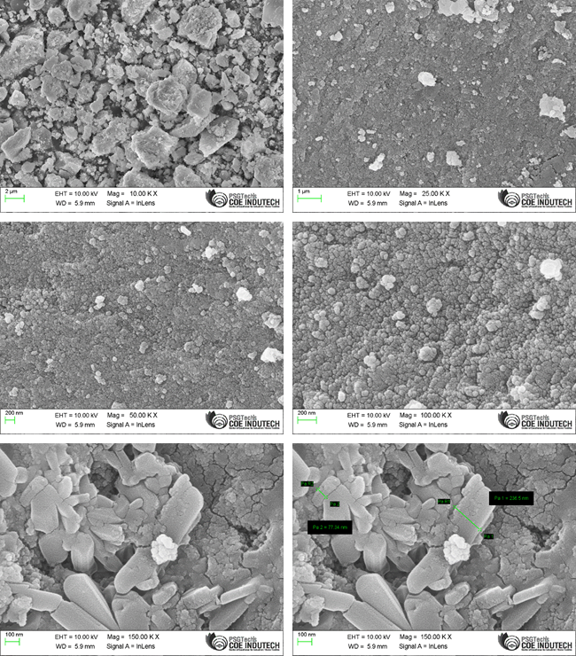
Fig.4.FESEM image of CdS NPs
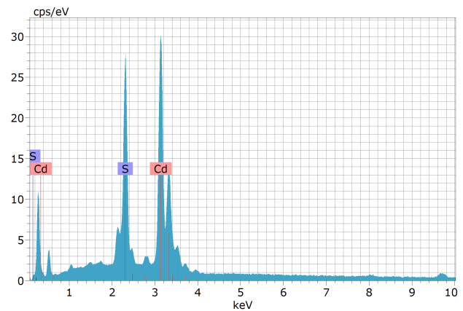
Element | Series | Unn.C  [Wt.%] | Unn.C  [Wt.%] | Atom.C [at%] | Sigma  [wt%]
Cadmium | L series | 39.46 | 78.82 | 51.50 | 3.72
oxygen | K series | 10.60 | 21.18 | 48.50 | 1.24

Fig.5. EDAX spectrum of CdS NPs
3.6. PHOTOLUMINESCENCE SPECTROSCOPY
Photoluminescence (PL) spectroscopy utilizes a focused laser beam to capture light emitted from a substance as it reverts from an excited state to a ground state. The analysis of the resulting luminescence spectrum is crucial for detecting and identifying impurities and defects within the material. A significant characteristic of semiconductor nanoparticles is their distinctive optical properties, which can greatly influence various applications.
In this study, a xenon arc lamp was used as the excitation source (𝛌_{max}= 350nm), and a Spectrofluorometer was employed to investigate the PL characteristics of CdS nanoparticles (NPs). The analysis of the PL spectra indicated that the majority of the emission peaks were predominantly situated within the visible spectrum. A total of six emission peaks were identified at wavelengths of 404, 467, 488, 565, 619, 759, and 823 nm, as shown in Fig.6. Notably, self-trapped excitons (STE) are involved in the radiative recombination process, accounting for the emission peaks observed at 401 nm. In this state, the electron-hole pair is confined and cannot move through the crystal lattice. The narrow band at 467 nm appears to shift along the wavelength axis in response to changes in the excitation wavelength, likely due to Raman scattering effects.
In addition, considering the hydrophilic properties of CdS, the peak observed at 488 nm is likely due to band-edge emission, which entails the recombination of electron-hole pairs and indicates a shift towards the blue region of the spectrum. The observed change is probably influenced by surface confinement effects, though excitonic recombination mechanisms may also play a role. Furthermore, the broad and pronounced peak at 619 nm is likely attributed to defects associated with deep trap states on the surface. Various structural imperfections, such as interstitial vacancies and sulfur-related defects, can be directly linked to this particular emission observed in the luminescence spectrum [36].

Fig.6.PhotoLuminesnce spectrum of CdS NPs
The emission peak at 495 nm can be attributed to band edge emission with the radiative recombination of the electron and holes in the valence and the conduction band of CdS noticed at 567 nm is attributed to the surface trap effect, which contains the recombination of electrons captured in the vacancy of sulphur with a hole in the valence band of CdS and nanoparticles. The red emission-related peak is observed at 759 and 823 nm, associated with the surface defects of cadmium and sulphur [37].
3.7.ANTICANCER ACTIVITY - CYTOTOXICITY EFFECT
The MCF-7 cancer cell line was used to assess CdS NPs cytotoxicity through the MTT test [38]. Cell growth suppression percentages were determined at varying concentrations of CdS NPs. The graph indicates that the cytotoxicity ofCdS NPs, illustrated in Fig 7-9, rose with increasing concentration. The CdS NPs displayed an IC₅₀ of122.015 μg/mL, suggesting concentration-dependent cytotoxicity.
Table.3: O.D. Values of CdS NPs Treated MCF-7 Breast Cancer Cells
[CdS NPs] (µg/mL) | Optical Density (OD) values [𝛌_{max} = 590 nm]
[CdS NPs] (µg/mL) | Trial 1 | Trial 2 | Trial 3 | Average OD | Standard Deviation | Cytotoxicity (%)
500 | 0.164 | 0.169 | 0.165 | 0.166 | 0.002645751 | 23.46
250 | 0.239 | 0.237 | 0.234 | 0.237 | 0.002516611 | 33.44
125 | 0.365 | 0.364 | 0.369 | 0.366 | 0.002645751 | 51.72
62.25 | 0.657 | 0.659 | 0.659 | 0.658 | 0.001154701 | 93.03
Control | 0.696 | 0.691 | 0.699 | 0.695 | 0.004041452 | 98.26

Table.4. O.D. Values of Doxorubicin treated MCF-7 Breast Cancer Cells
[Doxorubicin](µg/mL) | O.D Values [𝛌_{max} = 590 nm]
[Doxorubicin](µg/mL) | Trial 1 | Trial 2 | Trial 3 | Average OD | Standard Deviation | Cytotoxicity (%)
500 | 0.194 | 0.189 | 0.199 | 0.194 | 0.005 | 26.97
250 | 0.337 | 0.335 | 0.339 | 0.337 | 0.002 | 46.85
125 | 0.403 | 0.409 | 0.407 | 0.406 | 0.00305505 | 56.49
62.25 | 0.523 | 0.519 | 0.52 | 0.521 | 0.00208166 | 72.38
Control | 0.707 | 0.702 | 0.705 | 0.707 | 0.00251661 | 97.96

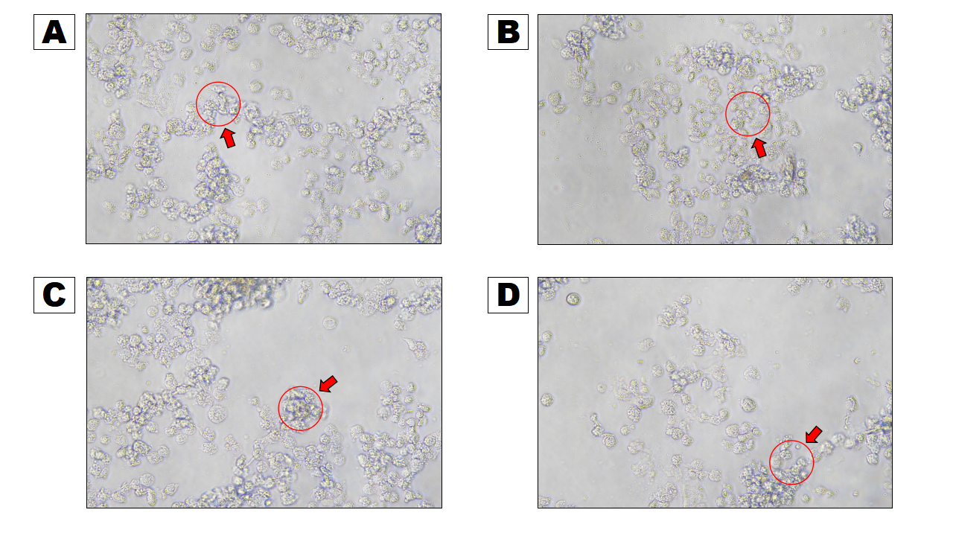
Fig.7. MCF-7 cell morphology photos were captured using a digital camera under an inverted contrast phase microscope, following treatment with the different concentrations of CdS NPs. (A) 62.5 μg/mL treated cells, (B) 125 μg/mL treated cells, (C) 250 μg/mL treated cells, (D) 500 μg/mL treated cells.

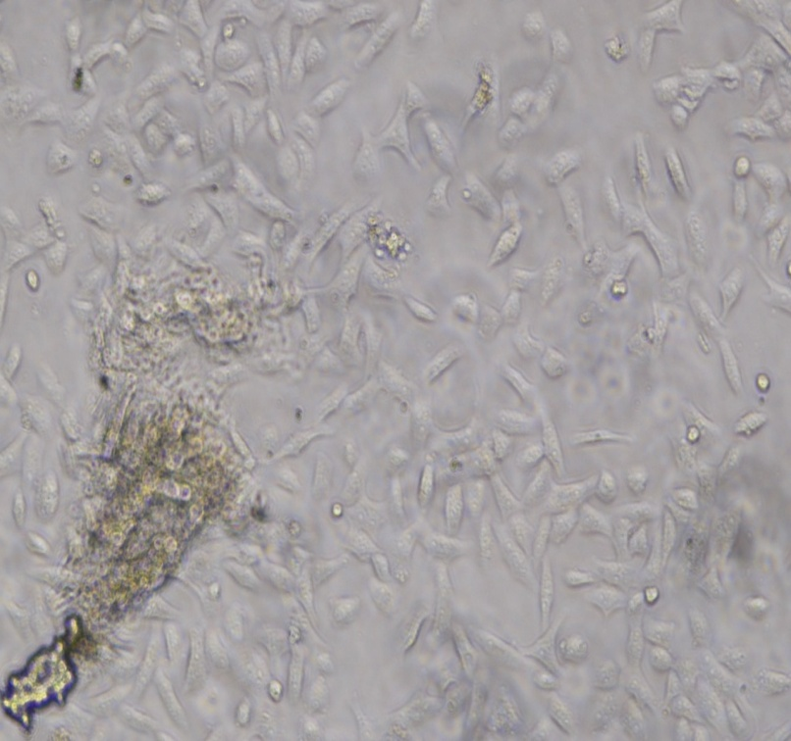

Fig.8.MCF-7 cell line morphology of control cells

Fig.9. Percentage of Cytotoxicity Effect of CdS NPs and Doxorubicin in MCF-7 cell line.
To investigate the morphological changes and alterations in MCF-7 cells induced by CdS nanoparticles (NPs), a comprehensive morphological analysis of the cells treated with CdS NPs was performed, as illustrated in Fig.7. The cells exposed to CdS NPs exhibited several significant morphological changes, including ballooning, chromatin condensation, cellular shrinkage, membrane blebbing, and the presence of apoptotic bodies [39]. Additionally, the assessment of autophagic cell death included observations of cytoplasmic vacuolations and the presence of double membrane vesicles transporting organelles within the cells [40]. The morphological changes in the MCF-7 cells post-exposure to CdS NPs were meticulously examined under a microscope. The most prominent and significant effects were noted in cells after treatment with CdS NPs. Compared to untreated and doxorubicin-treated cells, microscopic examinations indicated that the CdS NPs had a distinct and unique impact on the MCF-7 cells [41]. Observations showed a marked increase in the number of dead cells correlating with rising concentrations of the extract treatment. At a concentration of 500 μg/mL, classified as a high concentration, the cells exhibited noticeable enlargement. Membrane blebbing, characterized by small membrane protrusions, was identified in approximately 40%–50% of the cells, along with substantial ballooning. Cells treated with CdS NPs also showed indications of apoptotic bodies (Fig.7.C and D). Moreover, significant cytoplasmic vacuolation was observed, suggesting a cell death mechanism resembling autophagy. Autophagosome-like structures were clearly detectable in cells exposed to CdS NPs (Fig.7.D).The cells displayed rounder, shrunken forms, with evident detachment from the well surface at the highest dosage of 500 µg/mL, indicative of cell death. This cell death phenomenon is a major factor contributing to the observed reduction in the number of viable cells post-treatment with nanoparticle therapy. Our extensive studies provide initial and vital evidence that CdS nanoparticles have substantial cytotoxic effects on MCF-7 human breast cancer cells [42, 43]. Further research is necessary to thoroughly assess their potential as effective chemotherapeutic agents, explore their anticancer properties, and understand the underlying mechanisms of action. This detailed evaluation would improve our knowledge and may lead to the formulation of more effective cancer treatment strategies in the future.
4. CONCLUSION
The establishment of sustainable protocols for the synthesis of high-quality nanoparticles at standard temperature and pressure, while utilizing minimal energy and avoiding toxic agents, poses significant challenges. Our methods demonstrate efficiency and environmental friendliness, facilitating the production of various nanoparticle types. This research illustrates that green synthesis techniques can yield small-sized semiconductor nanoparticles, employing biomolecules for surface passivation to mitigate cytotoxic effects; specifically, proteins and polysaccharides contribute to this reduction. Pure cadmium sulfide (CdS) nanoparticles were synthesized via a green methodology, with their structural characteristics and size verified through powder X-ray diffraction (XRD). The calculated micro strain was 0.0111 and the dislocation density was 0.0941. XRD patterns confirmed cubic crystallization, and Debye Scherrer’s formula indicated particle sizes between 2 to 5 nm. Diffuse reflectance spectroscopy (DRS) showed a peak absorbance at 471 nm, alongside a blue-shifted band gap of 2.61 eV. Photoluminescence (PL) spectra revealed emission peaks at 488 nm and 759 nm, attributed to electron-hole recombination in CdS. Fourier-transform infrared (FTIR) analysis detected peaks around 700 cm⁻¹, associated with Cd-S vibrations. Field emission scanning electron microscopy (FESEM) depicted aelongated rod-like structure with some aggregation. Energy dispersive X-ray spectroscopy (EDAX) confirmed the elemental composition of the nanoparticles. The observed anticancer activity indicated that CdS nanoparticles reduce cell viability, demonstrating promising cytotoxic effects on MCF-7 cells and encouraging further exploration of their potential chemotherapeutic applications.
Disclaimer (Artificial intelligence)
Author(s) hereby declare that NO generative AI technologies such as Large Language Models (ChatGPT, COPILOT, etc.) and text-to-image generators have been used during the writing or editing of this manuscript.

5. Reference
- F. Pelayo García De Arquer, Victor I. Klimov Yasuhiko Arakawa, Manfred Bayer and Edward H. Sargent, Science, 373.6555 (2021) https://doi.org/10.1126/science.aaz8541
- Xuanyu Yang, Yu Deng, Haitao Yang, Yaozu Liao, Xiaowei Cheng, Yidong Zou, Limin Wu, and Yonghui Den, Adv. Sci. 2023, 10, 2204810, https://doi.org/10.1002%2Fadvs.202204810
- Singh, Anoop, Aamir Ahmed, and Sandeep Arya. "Semiconductor Photoresistors." CRC Press, 2022. 75-90 ,https://doi.org/10.1201/9781003188582
- Golovynskyi, S. "Nanomaterials for optoelectronics: an overview." Ukr. J. Phys. Opt, 25(1) pp. 01045 – 01053,2024. https://doi.org/10.3116/16091833/24/5/S1/2023
- Joudeh, N. and Linke, D. Journal of nanobiotechnology, 20 (262) 2022. https://doi.org/10.1186/s12951-022-01477-8
- Abbasi, R., Shineh, G., Mobaraki, M. Journal of Nanoparticle Research 25.3 (2023): 43.https://doi.org/10.1007/s11051-023-05690-w
- Shekarian, E., Ijadi, B., Zare, A., and Majava, J. Sustainability, 2022, 14, 7892. https://doi.org/10.3390/su14137892
- Karunakaran, G., Sudha, K. G., Ali, S., and Cho, E. B. Molecules 2023, 28(11), 4527, https://doi.org/10.3390/molecules28114527
- Mughal, B., Zaidi, S. Z. J., Zhang, X., and Hassan, S. U. Appl. Sci. 2021, 11(6), 2598; https://doi.org/10.3390/app11062598
- Das, S., Bhardwaj, A., and Pandey, L. M. ,Current Nanomaterials, 6, ( 2), 2021, pp. 119-139(21),https://doi.org/10.2174/2468187310999201222112144
- Shah, Syed Tawab, Ira PuspitaSari , Dede HeriYuliYanto, Green Chemistry Letters and Reviews 18.1 (2025): 2448171. https://doi.org/10.1080/17518253.2024.2448171
- Yadav, S., Yashas, S. R., and Shivaraju, H. P. Environ Chem Lett 19, 3683–3700 (2021). https://doi.org/10.1007/s10311-021-01269-w
- Rahman, A. and Khan, M. M. "Chalcogenides as photocatalysts." New Journal of Chemistry, 2021. academia.edu
- Choudhury, Simran, Indrani Bhattacharya, Shreni Agrawal, Biogenic Nanoparticles. 2025. 55-75. https://doi.org/10.1016/B978-0-443-33819-9.00007-X
- Deepshikha Gupta BasilSajanVarghese, MeeraSuresh· Chitransh Panwar, Tejendra Kumar Gupta Journal of nanoparticle Research 24.10 (2022):196.https://doi.org/10.1007/s11051-022-05577-2
- Tiza, TM., Kpur, G., Ogunleye, E., and Sharma S. Materials Today,2023. https://doi.org/10.1016/j.matpr.2023.03.212
- Chakraborty S, Bera D, Roy L Bioinspired and green synthesis of nanostructures: a sustainable approach (2023): 353-404. https://doi.org/10.1002/9781394174928.ch15
- Villagrán, Zuamí, Luis Miguel Anaya-Esparza, Carlos Arnulfo Velázquez-Carrile, Resources 2024, 13(6), 70; https://doi.org/10.3390/resources13060070
- Kuznetsova, Yulia V, Kuznetsova , Ivan D. Popov , Evgeny Yu. Gerasimov , Andrey A. Rempel. Journal of Molecular Liquids, 371 (2023): 121084. https://doi.org/10.1016/j.molliq.2022.121084.
- Ilaghi, Mozhde,,Iraj Sharifi FaribaSharififar, Parasite Epidemiology and Control 12 (2021): e00201. https://doi.org/10.1016/j.parepi.2021.e00201
- Atmani, E. H., Bziz, I., Fazouan, N., and Aazi, M." Applied Physics A, 127(11) 2021. https://doi.org/10.1007/s00339-021-05009-3
- Zajac, W., Rozycka, A., and Trenczek-Zajac, A. Inorganic Chemistry, 2023, 62, 10955−10964 https://doi.org/10.1021/acs.inorgchem.3c00935
- Asif Ali , Yi Wai Chiang and Rafael M. Santos, Minerals, 2022, 12, 205. https://doi.org/10.3390/min12020205,
- Numan Zada Khan Mohmand, Habib Ullah , Yasir Shah , Saeed Ahmad , Amir Hassan , Liaqat Ali, Hanif Ur Rahman, Lett. Appl. NanoBioSci. 13,(2), 2024, 74. https://doi.org/10.33263/LIANBS132.074
- Sangho Jeon , Xuanjiang Liu , Colby Azersky , Jie Ren , Shengbiao Zhang , Wen Chen , Robert W. Hyers , Kelly Costa , Matthias Kolbe , Douglas.M. Matson, Materialia, 18(1),2021,101161. https://doi.org/10.1016/j.mtla.2021.101161
- Sanghita Basak, Debojyoti Nath, Ratan Das, Journal of molecular structure, 5 , 2023, 136273https://doi.org/10.1016/j.molstruc.023.136273
- Mittemeijer, Eric J, Springer International Publishing, 2 nd edition 2022. 231-282.
- Perez, N. "Crystal Defects." Materials Science: Theory and Engineering, 2024. https://doi.org/10.1007/978-3-031-57152-7
- Hu, J., Hussain, S. A., Liu, H., Hu, C., and Jiao, F. Chemical Engineering Science,2026,320 Part A, 122470. https://doi.org/10.1016/j.ces.2025.122470
- Langa, C. D., Mabuba, N., and Hintsho-Mbita, N. C. Catalysts 2025, 15(8), 27. https://doi.org/10.3390/catal15080727
- Yuxiao Chen , Wei Zhong , Feng Chen , Ping Wang , Jiajie Fan , Huogen Yu, Journal of material science and technology,121(10)2022, p19-27. https://doi.org/10.1016/j.jmst.2021.12.051
- Ahluwalia, V. K.Ane book publication pvt Ltd,2023. https://doi.org/10.1007/978-3-031-38355-7.
- Yusuf, M. O. Appl. Sci. 2023, 13(5), 3353. https://doi.org/10.3390/app13053353
- Gebre, S. H. Journal of Cluster Science, 1(1), 2023. https://doi.org/10.1007/s10876-022-02276-9
- Ghasempour, A., Dehghan, H., Ataee, M., Chen, B., and Zhao…, Z. Molecules 2023, 28(9), 3857. https://doi.org/10.3390/molecules28093857
- YunqiYang ,Chaowen Wang , Chengsi Wang, Minerals 13.5 (2023): 663. https://doi.org/10.3390/min13050663
- Li, W., Wu, S., Ren, J., and Xiong, P. Adv. Funct. Mater. 2025, 2506198,1-13..https://doi.org/10.1002/adfm.202506198
- Amol Pawar and Aniket Pawanoji. Journal of Inorganic and Organometallic Polymers and Materials (2025): 1(1), 1-16. https://doi.org/10.1007/s10904-025-03606-w
- Srinivasan, A., Gayathri, G., Muthupandi, M. Journal of Cluster Science 34.2 (2023): 773-788.https://doi.org/10.1007/s10876-022-02253-2
- R P Lefojane , B T Sone , N Matinise , K Saleh , P Direko , P Mfengwana , S Mashele , M Maaza , M P Sekhoacha , Scientific Reports 11.1 (2021): 30. https://doi.org/10.1038/s41598-020-78720-5
- Kasirajan Kasinathan , Karunakaran Marimuthu , Balaji Murugesan , Nithya Pandiyan , Boomi Pandi , Sundrarajan Mahalingam , Balamurugan Selvaraj, Journal of Molecular Liquids 323 (2021): 114631. https://doi.org/10.1016/j.molliq.2020.114631
- Mehdi Dadmehr , Behnaz Korouzhdehi , Abolfazl Tavassoli , Mitra Malekkiani, Nanotechnology 33.39 (2022): 395101. https://doi.org/10.1088/1361-6528/ac79bc
- Harish, R., Nisha, K. D., Prabakaran, S., Sridevi, B., Harish, S., Navaneethan, M., & Ganesh, M. R. (2020). Cytotoxicity assessment of chitosan coated CdS nanoparticles for bio-imaging applications. Applied Surface Science, 499, 143817.

