Morphological Diversity and Taxonomic Assessment of Trichoptera in Spring-fed Streams of the Garhwal Himalaya, Uttarakhand,India

.
ABSTRACT

In the present study, samples of Trichoptera (Caddisflies) were collected from two spring-fed tributaries, Khanda Gad and Dhundprayag Gad, in the Garhwal region of the Himalayas, Uttarakhand, India. For the taxonomic assessment and morphological study, a detailed examination of morphological and meristic features of each collected individual was conducted using a microscope and a hand lens. Structural observations of the specimens were photographed, identified, and validated using a standard key. A pencil drawing of different parts of the head capsule, thoracic sclerites, Labrum, submetum, claws, and anal prolegs was produced, and differences were noted. Based on the differences and examination, a total of 15 species belonging to six families (Hydropsychidae, Philopotamidae, Psychomyiidae, Rhyacophilidae, Stenopsychidae, and Polycentropodidae) were collected and analysed, and it was found that the most dominant family was Hydropsychidae (198 individuals), followed by Philopotamidae (151) and Psychomyiidae (114). Less abundant families included Rhyacophilidae (29), Polycentropodidae (50), and Stenopsychidae (59). The study provides baseline data on freshwater Trichoptera, which serve as indicators of water quality and ecosystem health. It also contributes to the taxonomic knowledge of Himalayan aquatic insects and serves as a valuable reference for future biodiversity and conservation studies, emphasising the ecological importance of Trichoptera.

Keywords: Trichoptera, Khanda and Dhunprayag Gad, Morphological Identification, Taxonomic assessment

1. INTRODUCTION

Trichoptera (caddisflies) are one of the most diverse and well-studied groups. Initially described as Phryganea by Linnaeus in 1758, the order now includes over 17,000 species globally (Morse, 2023). Their larvae exhibit remarkable morphological diversity, often building protective cases using silk and natural materials (Wiggins, 1996). In India, a total of 1,407 species across 27 families and 102 genera have been reported (Pandher, 2024).
In 1813, Kirby suggested that if Phryganea were to be recognised as a separate order, it could be named Trichoptera due to the presence of hairy wings in all known species.
The order Trichoptera is commonly known as caddisflies, a group of aquatic insects characterised by their hairy wings and case-building larvae found in freshwater habitats. The larvae build protective cases from sand, pebbles, or plant materials, while others spin silk webs to capture food or anchor themselves in flowing water, and these larvae are mostly detritivores or plant feeders. Most of the caddisflies do not make cases but instead spin silken webs, which are used to capture food drifting in the stream. The larval diversity in any aquatic system is an indicator of freshwater quality, and a smaller number indicates the levels of pollution.
Larvae, often undergoing five instars in univoltine life cycles, represent the longest and most ecologically significant stage of the life cycle. The larval head is fully developed and sclerotised, possesses well-developed eyes, and typically has short, single-segmented antennae. Their mouthparts are clearly defined, including a small labrum, strong mandibles, short maxillae, and a distinct labium. Each thoracic segment is separate and equipped with a pair of segmented legs. These are either more or less the same length, or the forelegs are the shortest and the hind legs the longest. Tarsi are one-segmented, and tarsal claws are single. In all families, the prothorax bears a pair of heavily sclerotized pronotal plates, very narrowly separated along the midline. The abdomen consists of 10 segments. A pair of anal prolegs on the last abdominal segment, with each proleg bearing a strong anal claw. Abdominal gills may or may not be present. Abdominal segment 9 usually bears dorsal sclerites, especially in the case-making families. Adults are terrestrial, short-lived, and morphologically varied to suit brief reproductive phases (Unzicker et al., 1982; Morse et al., 2019).
Several studies on benthic communities have been carried out in different rivers and streams in Uttarakhand by several workers (Sunder & Subla, 1986; Dobriyal et al., 1992; Suren, 1994; Kumar et al., 1998; Singh et al., 2010; Negi & Mamgain, 2013; Balodi & Koshal, 2015; Rana et al., 2017; Koshal et al., 2017). Despite increased attention to freshwater biodiversity in India, knowledge gaps persist in the Garhwal Himalaya, particularly the Trichoptera (caddisfly) diversity.
Our research focuses solely on the Trichoptera order, its diversity and morphological variation, as well as the differences between capture species in two tributaries of the River Alaknanda.

2. materialS and methods

The study was conducted in two important tributaries of the River Alaknanda, named Khanda and Dhundprayag Gad. Field sampling was carried out monthly from November 2024 to April 2025 for the collection of aquatic insects. The location of the study or site selection was based on the availability of aquatic insects, as preliminary observations conducted prior to planning this study.
Insects were collected monthly from both sites using random sampling methods, including the kick method and occasional hand-picking. The collected insects were placed in a wide-mouth, translucent plastic bottle (half-filled with water) and brought to the laboratory of the Department of Himalayan Aquatic Biodiversity for further analysis and study. The collected insects were preserved in the laboratory using 5% formalin solution. The Trichoptera were sorted, counted, and identified using standard keys and literature from Pescador & Rasmussen (1995), Dudgeon (2003), Bouchard (2004), and Gulati (2007), with the aid of a dissecting microscope and a magnifying hand lens. The study examined various morphological features, including the head capsule, thoracic sclerites, Labrum, submetum, and anal prolegs and claws. Drawings were made and used for the identification and taxonomic description of each individual.

3. RESULTS AND DISCUSSION
Taxonomic assessment
After a detailed investigation and careful examination of morphometric and meristic characteristics of collected individuals of Trichoptera, a total of 15 species were described from Khanda Gad (Pauri Garhwal) and Dhundprayag Gad (Tehri Garhwal), and the variations in morphological characters and taxonomic assessments, were presented as follows (Figures 1 to 15) and their diagnostic characteristics, key
micro-morphological observations, and availability are systematically presented in Table 1.

- Chimarra aterrima (Hagen, 1861)
2025, Chimarra aterrima (Hagen, 1861), Coll and identification by Pallavi and Koshal (Locality: Khanda Gad (Pauri Garhwal) and Dhundprayag Gad (Tehri Garhwal), Uttarakhand, India).
Material Observed: Several individuals were observed monthly from both locations, Khanda Gad (Pauri Garhwal) and Dhundprayag Gad (Tehri Garhwal), Uttarakhand, India.
Common Name: Little Black Sedge
Scientific Classification:
Kingdom: Animalia
Phylum: Arthropoda
Class: Insecta
Order: Trichoptera
Family: Philopotamidae
Genus: Chimarra
Species: C. aterrima
A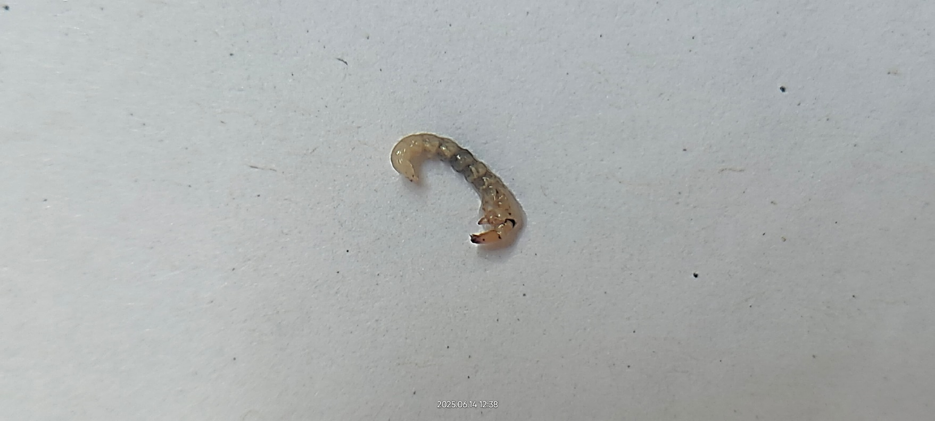 | B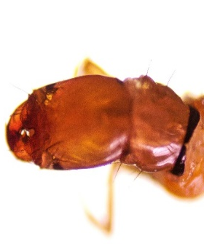
C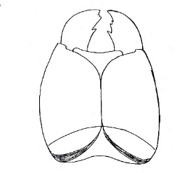 | D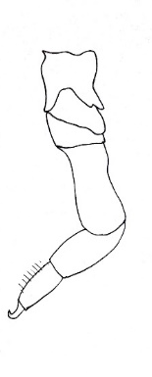
Figure 1 Chimarra aterrima larva (A) Lateral view, (B) Dorsal view of head, (C) Ventral view of head, (D) Right foreleg
Ecology/Habitat: - Chimarra aterrima is typically found in small streams, usually occurring beneath submerged rocks and logs.
Diagnostic Characters: The larvae are usually yellow or light orange in color; Apex of frons markedly asymmetrical with a large or pointed left lobe and smaller right one (Figure 1B); Marginal lobes of frons slightly closer together; Labrum T-shaped and anterior margin having brush of dense setae: Head capsule with blackspot at each posterolateral margin (figure 1A); dorsal ecdysial sulture 1/3 as long as frontoclypeus (figure 1C); Frontoclypeus elongated omega/deep U shaped, constricted as its posterior 1/3; Dorsum of 9th abdominal segment entirely membranous; tarsus with brush of dense setae (figure 1D);
- Chimarra ferio (Stephens, 1829)
2025, Chimarra ferio (Stephens, 1829), Collection and identification by Pallavi and Koshal (Locality: Khanda Gad (Pauri Garhwal) and Dhundprayag Gad (Tehri Garhwal), Uttarakhand, India).
Material Observed: Several specimens were collected and examined monthly from two sites—Khanda Gad (Pauri Garhwal) and Dhundprayag Gad (Tehri Garhwal), Uttarakhand, India.
Common Name: Little Black Sedge
Scientific Classification:
Kingdom: Animalia
Phylum: Arthropoda
Class: Insecta
Order: Trichoptera
Family: Philopotamidae
Genus: Chimarra
Species: ferio
A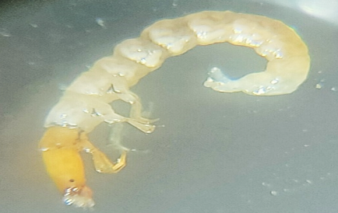 | B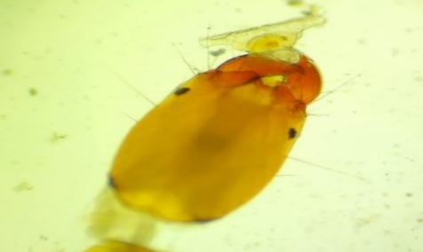
C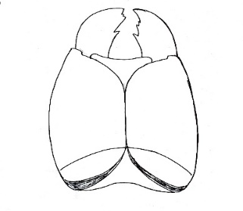 | D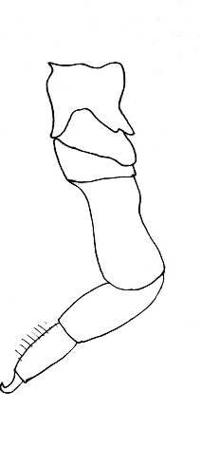
Figure 2 Chimarra ferio larva (A) Lateral view, (B) Dorsal view of head, (C) Ventral view of head, (D) Right foreleg
Ecology/Habitat: Chimarra ferio species are commonly found in small streams, typically inhabiting microhabitats beneath submerged rocks and logs.
Diagnostic Characters:- The larval head are usually yellow or light orange in color (figure 2A); Apex of frons slightly asymmetrical; Frontoclypeal notch small and with narrow opening (figure 2B); Labrum T-shaped and anterior margin having brush of dense setae: Head capsule with black spot at each posterolateral margin; dorsal ecdysial sulture 1/3 as long as frontoclypeus (figure 2C); Frontoclypeus elongated omega/deep U shaped, constricted as its posterior 1/3; Mesonotum and metanotum entirely membranous; Dorsum of 9th abdominal segment entirely membranous; tarsus with brush of dense setae (figure 2D)
- Dolophilodes shawnee (Ross, 1938)
2025, Dolophilodes shawnee (Ross, 1938), Collection and identification by Pallavi and Koshal (Locality: Khanda Gad (Pauri Garhwal) and Dhundprayag Gad (Tehri Garhwal), Uttarakhand, India).
Material Observed: Several specimens were collected and examined monthly from two sites—Khanda Gad (Pauri Garhwal) and Dhundprayag Gad (Tehri Garhwal), Uttarakhand, India.
Common Name: Medium Evening Sedge
Scientific Classification:
Kingdom: Animalia
Phylum: Arthropoda
Class: Insecta
Order: Trichoptera
Family: Philopotamidae
Genus: Dolophilodes
Species: Shawnee

A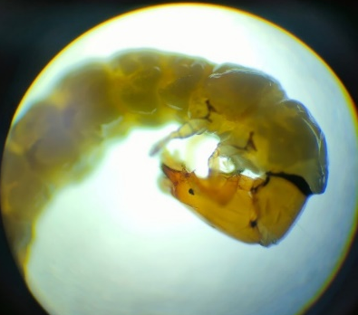 | B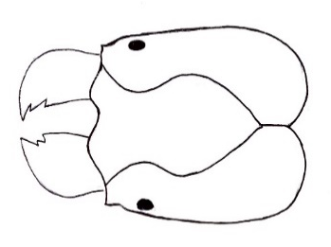 | 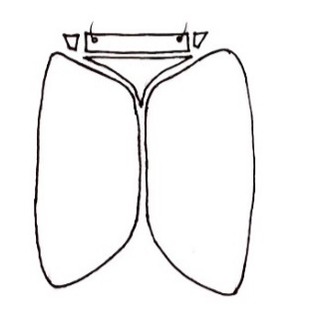  C
D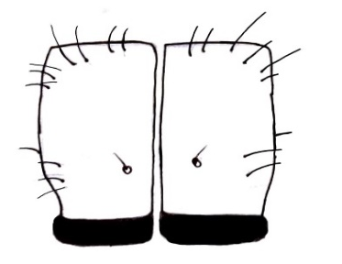 | 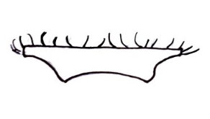  E | F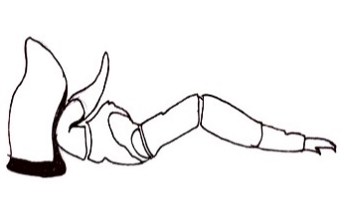
Figure 3 Dolophilodes shawnee larva (A) Lateral view, (B) Dorsal view of head, (C) Ventral view of head, (D) Dorsal view of pronotum, (E) Labrum, (F) Right foreleg and trochantin
Ecology/Habitat: Dolophilodes shawnee is typically found in clear, unpolluted waters, where it constructs protective cases using materials such as twigs and leaves.
Diagnostic Characters: Head capsule chestnut brown (figure 3A); Lateral margin slightly curved (figure 3B); Anterior margin of frontoclypeus is slightly asymmetrical with posterior portion widened separated by a constriction from anterior portion (figure 3B); The ventral head seta is near the mid length position of ventral ecdysial line; Maximum length of frontoclypeus sclerite sub equal to the width of head; Labrum T-shaped and anterior margin having brush of dense setae(figure 3E) Mesonotum and metanotum entirely membranous; Foreleg trochantin robust and freely extended as a fingerlike-projections (figure 3F); Femur longer than tibia, tibia longer than tarsus.

4. Psychomyia flavida (Hagen, 1861)
2025, Psychomyia flavida (Hagen, 1861), Collection and identification by Pallavi and Koshal (Locality: Khanda Gad (Pauri Garhwal) and Dhundprayag Gad (Tehri Garhwal), Uttarakhand, India).
Material Observed:- Several specimens were collected and examined monthly from two sites—Khanda Gad (Pauri Garhwal) and Dhundprayag Gad (Tehri Garhwal), Uttarakhand, India.
Common Name: Dinky Net-tube Caddisfly
Scientific Classification:
Kingdom: Animalia
Phylum: Arthropoda
Class: Insecta
Order: Trichoptera
Family: Psychomyiidae
Genus: Psychomyia
Species: P. flavida
A | B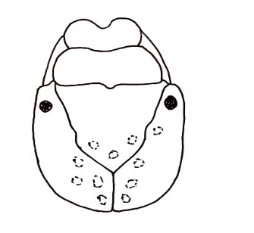
C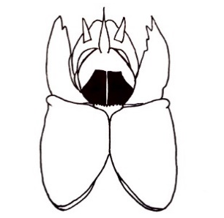 | D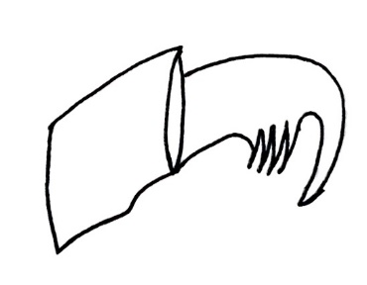
Figure 4 Psychomyia flavida larva (A) Lateral view, (B) Dorsal view of head, (C) Ventral view of head, (D) Anal claw.
Ecology/Habitat: Psychomyia flavida typically inhabits cool, flowing waters and is commonly found living in silk tubes attached to submerged rocks and logs.
Diagnostic Characters: The head is almost square with lateral margins that are almost parallel (figure 4B); Head and pronotum is yellowish brown, cuticle is thick and finely granular; body green color; Frons with anterior margin sinuate(figure 4B); Apex of mandibles with a long terminal whip (figure 4C); Legs short, claw short and angled; Mesonotum and metanotum entirely membranous; Anal hook with a row of 4 long teeth along inner ventral margin (figure 4D); 10th segment short with scarcely any ventral margin; Mentum forming a pair of distinct sclerotized plates;
5. Psychomyia pusilla (Fabricius, 1781)
2025, Psychomyia pusilla (Fabricius, 1781), Collection and identification by Pallavi and Koshal (Locality: Khanda Gad (Pauri Garhwal) and Dhundprayag Gad (Tehri Garhwal), Uttarakhand, India).
Material Observed: Several specimens were collected and examined monthly from two sites—Khanda Gad (Pauri Garhwal) and Dhundprayag Gad (Tehri Garhwal), Uttarakhand, India.
Common Name: Small Yellow-Sedge Caddisfly
Scientific Classification:
Kingdom: Animalia
Phylum: Arthropoda
Class: Insecta
Order: Trichoptera
Family: Psychomyiidae
Genus: Psychomyia
Species: pusilla
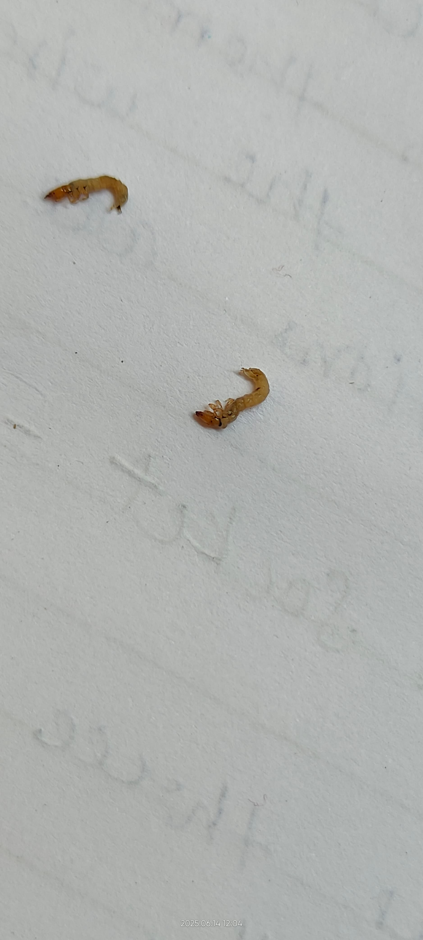  A | B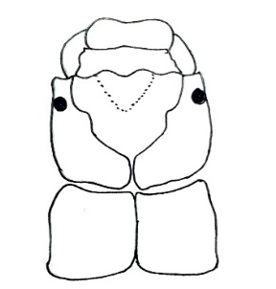 | 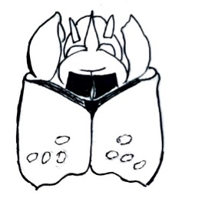C
D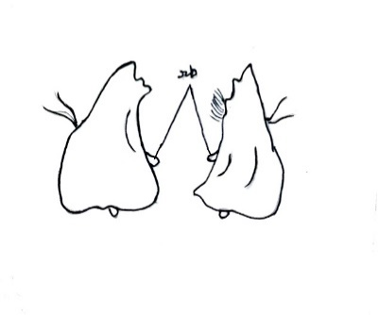 | E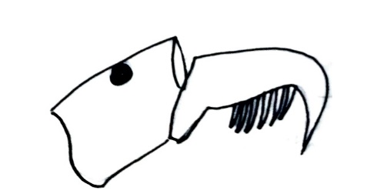
Figure 5 Psychomyia pusilla larva (A) Lateral view, (B) Dorsal view of head, (C) Ventral view of head, (D) Left and right mandible, (E) Anal claw
Ecology/Habitat: Psychomyia pusilla generally inhabits cool, flowing waters and is typically found residing in silk tubes attached to submerged rocks and logs.
Diagnostic Characters: The head is almost square with lateral margin that are almost parallel (figure 5B); Head is yellow, cuticle is thick and finely granular; Irregular marks in the median part of frontoclypeal apotome(figure 5B); Anterior margin of the frontoclypeal apotome bears a pair of blackish processes; In lateral profile, the top of head is flat; sub mental sclerites appears as a dark indented strips (figure 5C); In ventral view, the anterior margin of head capsule forms an obtuse angle; the ventral ecdysial line is short; mandibles are about twice as long as broad and subaruate; Left mandibles bears a tuft of hair like spinules (figure 5D); Each anal claw has the same number (six) of teeth(figure 5E).
- Polycentropus flavomaculatus (Pictet, 1834)
2025, Polycentropus flavomaculatus (Pictet, 1834), Collection and identification by Pallavi and Koshal (Locality: Khanda Gad (Pauri Garhwal) and Dhundprayag Gad (Tehri Garhwal), Uttarakhand, India).
Material Observed: Several specimens were collected and examined monthly from two sites—Khanda Gad (Pauri Garhwal) and Dhundprayag Gad (Tehri Garhwal), Uttarakhand, India.
Common Name: Tube-Making Caddisfly
Scientific Classification:
Kingdom: Animalia
Phylum: Arthropoda
Class: Insecta
Order: Trichoptera
Family: Polycentropodidae
Genus: Polycentropus
Species: flavomaculatus
A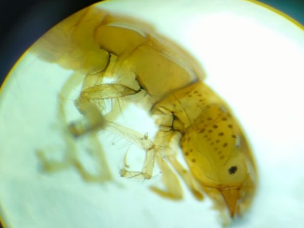 | B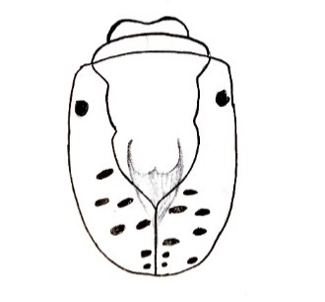
C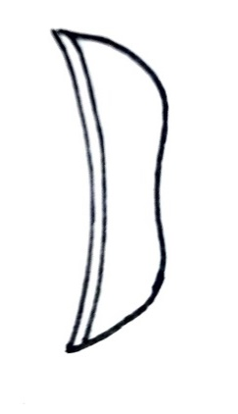 | D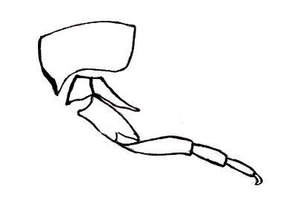
Figure 6 Polycentropus flavomaculatus larva (A) Lateral view, (B) Dorsal view of head, (C) Dorsal view of labrum, (D) Right foreleg and trochantin
Ecology/Habitat: Polycentropus flavomaculatus species are typically found in shallow to moderately deep waters, often near shorelines.
Diagnostic Characters: Head capsule is generally elongate and hypognathous; Head and pronotum muscle insertion spots light brown (figure 6A); Frontoclypeus narrow and triangular and frontoclypeal ecdysial line with a slight median constriction (figure 6B); Tarsi nearly cylindrical and all narrower than corresponding tibiae (figure 6D); Anal claw without conspicuous teeth; Tarsi on foreleg two third length of tibiae; Labrum rounded and sclerotized(figure 6C).Head muscle scars darker than the surrounding area; Foretrochantin fused with episternum with acute apex(figure 6D), not expanded into a broadened lobe.

- Rhycophila fasciata (Hagen, 1859)
2025, Rhycophila fasciata (Hagen, 1859), Collection and identification by Pallavi and Koshal, (Locality: Khanda Gad (Pauri Garhwal) and Dhundprayag Gad (Tehri Garhwal), Uttarakhand, India).
Material Observed: Several specimens were collected and examined monthly from two sites—Khanda Gad (Pauri Garhwal) and Dhundprayag Gad (Tehri Garhwal), Uttarakhand, India.
Common Name: Green Sedge Caddisfly
Scientific Classification:
Kingdom: Animalia
Phylum: Arthropoda
Class: Insecta
Order: Trichoptera
Family: Rhyacophilidae
Genus: Rhyacophila
Species: R. fasciata

A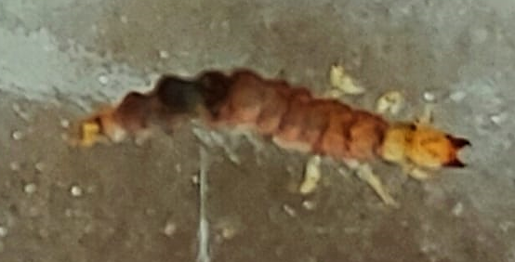 |  | B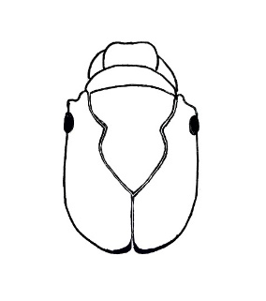
C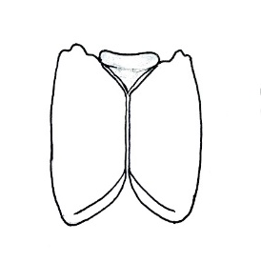 | D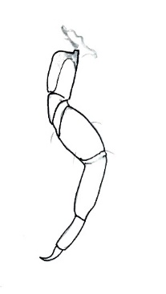 | E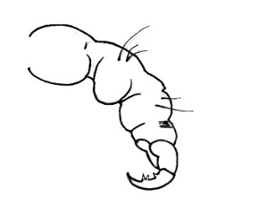
Figure 7 Rhyacophila fasciata larva (A) Dorsal view, (B) Dorsal view of head, (C) Ventral view of head, (D) Right foreleg, (E) Anal proleg and claw
Ecology/Habitat: Rhyacophila fasciata are commonly found in clear, fast-flowing streams, where they live beneath rocks and among clumps of moss and algae.
Diagnostic Characters: Head capsule prognathous, elongated with smooth surface and maximum width at head center; Dorsal and ventral head sections chestnut brown, with pale muscle attachment; Spots on frontoclypeus and brown one on parietalia with paler area around eyes along lateral sections of parietalia; Frontoclypeus bell shaped, with deep central constriction posterior of eye level(figure 7B); Sclerotized labrum semi-circular, yellowish brown with pale anterior broader; Submentum darker brown, triangular, distinctly wider than long(figure 7C; Fore femur distinctly wider than mid and hind femur (figure 7D); abdomen dorsally dark purplish, laterally and ventrally creamish white; Anal claw long, blade-like, regularly curved with 3 ventral teeth(figure 7E).
- Hydropsyche briareus (Malicky & Chantaramongkol, 2000)
2025, Hydropsyche briareus (Malicky & Chantaramongkol, 2000), Collection and identification by Pallavi and Koshal (Locality: Khanda Gad (Pauri Garhwal) and Dhundprayag Gad (Tehri Garhwal), Uttarakhand, India).
Material Observed: Several specimens were collected and examined monthly from two sites—Khanda Gad (Pauri Garhwal) and Dhundprayag Gad (Tehri Garhwal), Uttarakhand, India.
Common Name: Common Net-Spinning Caddisfly
Scientific Classification:
Kingdom: Animalia
Phylum: Arthropoda
Class: Insecta
Order: Trichoptera
Family: Hydropsychidae
Genus: Hydropsyche
Species: H.briareus
A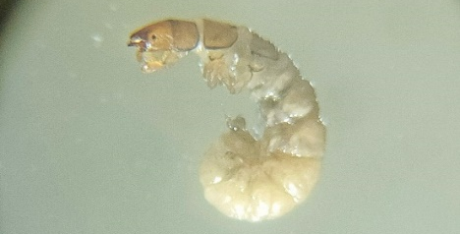 |  | B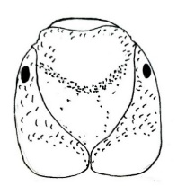 | C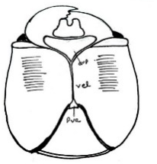
D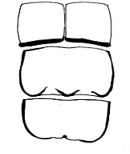 | E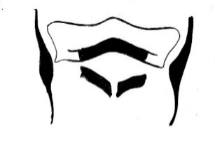 | F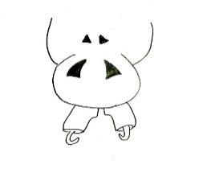 | G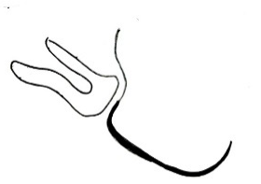
Figure 8 Hydropsyche briareus larva (A) Lateral view, (B) Dorsal view of head, (C) Ventral view of head, (D) Dorsal view of pronotum, mesonotum and metanotum, (E) Prosternal plate, (F) Anal proleg and claw, (G) Trochantin

Ecology/Habitat: Hydropsyche briareus larva found in flowing water. It builds nets to catch drifting organic matter for food.
Diagnostic Characters: Head is rectangular in dorsal view(figure 8A); Dorsum of head uniformly brown and yellowish brown; Anterior margin of frontoclypeal apotome is nearly straight(figure 8A); In ventral view, anterior ventral apotome triangular in shape, with anterior border slightly concave (figure 8C) and anterolateral angles rounded; Ventral ecdysial line nearly twice as long as anterior ventral apotome; Anterior margin of pronotum straight on both sides of mid dorsal ecdysial line and color is darker than the middle; The posterior angle of frontoclypeal apotome is ogival, at an angle of about 100 degree; prosternites with both medial and lateral sections darkly pigmented (figure 8E). Each fore trochantin is short and bifurcated(figure 8G); Anal prolegs are each slightly sclerotised; the pronotum, mesonotum, and metanotum are sclerotised (figure 8D). 8th and 9^{th,} segments possess a subtriangular sternum, each bearing a pair of ventral plates (figure 8F)
- Hydropsyche angustipennis (Curtis, 1834)
2025, Hydropsyche angustipennis (Curtis, 1834), Collection and identification by Pallavi and Koshal (Locality: Khanda Gad (Pauri Garhwal) and Dhundprayag Gad (Tehri Garhwal), Uttarakhand, India).
Material Observed: Several specimens were collected and examined monthly from two sites—Khanda Gad (Pauri Garhwal) and Dhundprayag Gad (Tehri Garhwal), Uttarakhand, India.
Common Name: Net-Spinning Caddisfly
Scientific Classification:
Kingdom: Animalia
Phylum: Arthropoda
Class: Insecta
Order: Trichoptera
Family: Hydropsychidae
Genus: Hydropsyche
Species: H. angustipennis
A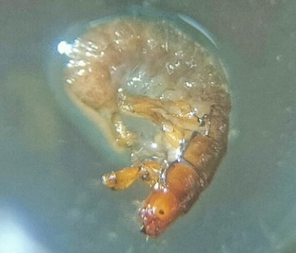 | B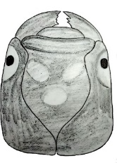 | C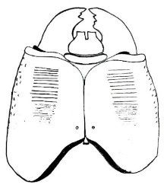
D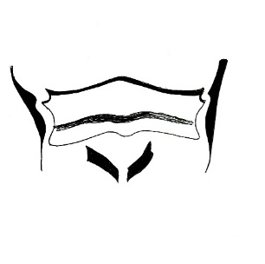 | E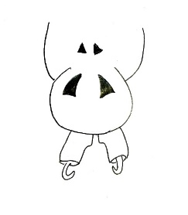 | F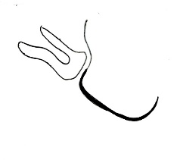
Figure 9 Hydropsyche angustipennis larva (A) Lateral view, (B) Dorsal view of head, (C) Ventral view of head, (D) Prosternal plate, (E) Anal proleg and claw, (F) Trochantin
Ecology/Habitat: Hydropsyche angustipennis is typically found in stream outflows, favoring habitats with moderate to high current velocities and substrates composed of coarse gravel.
Diagnostic Characters: Dorsal head surface with conspicuous yellow marking (figure 9A); Front margin of pronotum without numerous long bristles; Gills present on 7th abdominal segments; Frontoclypeal pattern with aboral and lateral marks separate; prosternites with both medial and lateral sections darkly pigmented(figure 9D); the lateral section is little lighter than the medial part; The ecdysial line on the ventral part of head is shorter than half the width of the head; The frontoclypeal apotome has only three lateral light area (figure 9B); The front of the frontoclypeus apotome is not convex(figure 9B); The lateral part of submetum is long and thin; The prothoracic venter, situated behind the prosternal plate, contains a pair of distinct sclerites within the intersegmental fold (Figure 9D). The eighth and ninth segments feature subtriangular sterna with paired ventral plates (Figure 9E), and the trochantin exhibits a fork-like structure (Figure 9F).
- Hydropsyche rhadamanthys (Malicky, 2001)
2025, Hydropsyche rhadamanthys (Malicky, 2001), Collection and identification by Pallavi and Koshal (Locality: Khanda Gad (Pauri Garhwal) and Dhundprayag Gad (Tehri Garhwal), Uttarakhand, India).
Material Observed: Several specimens were collected and examined monthly from two sites—Khanda Gad (Pauri Garhwal) and Dhundprayag Gad (Tehri Garhwal), Uttarakhand, India.
Common Name: Net-Spinning Caddisfly
Scientific Classification:
Kingdom: Animalia
Phylum: Arthropoda
Class: Insecta
Order: Trichoptera
Family: Hydropsychidae
Genus: Hydropsyche
Species: H. rhadamanthys
A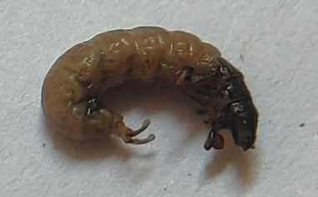 | B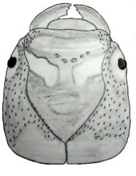 | C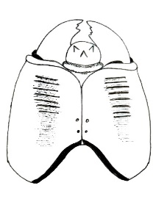
D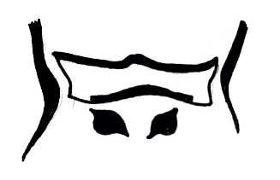 | E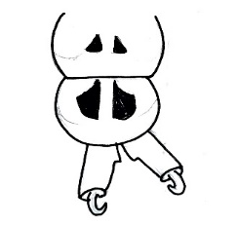 | F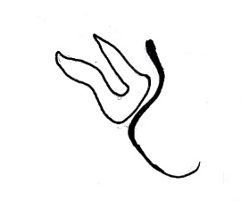
Figure 10 Hydropsyche rhadamanthys larva (A) Lateral view, (B) Dorsal view of head, (C) Ventral view of head, (D) Prosternal plate, (E) Anal proleg and claw, (F) Trochantin
Ecology/Habitat: Hydropsyche rhadamanthys are typically found in flowing waters, preferring habitats with moderate to high current velocity and substrates composed of coarse gravel
Diagnostic Characters: Head in dorsal view rectangular; Frontoclypeal apotome narraow; Anterior margin and anterior sides straight to slightly concave (figure 10B); Posterior region ogival with sides rounded; Posterior tip pointed; Notal plates brown to light brown; Median region of posterior prosternites strongly pigmented(figure 10D); In ventral view, two distinctive longitudinal wide dark bands usually covering most of cephalic capsule except from area behind submentum (figure 10C); Abdominal gills present on segment 7th; Ventral plates on abdominal segment 7th subtriangular, brown-ochre (figure 10 E); Ventral sides of each anal prolegs bearing series of tapering long dark hair like setae; Ventral membranous area covered with hair like setae; trochatin forked shaped(figure 10F).
- Diplectrona aiensis (Kobayashi, 1987)
2025 Diplectrona aiensis (Kobayashi, 1987), Collection and identification by Pallavi and Koshal , (Locality: Khanda Gad (Pauri Garhwal) and Dhundprayag Gad (Tehri Garhwal), Uttarakhand, India).
Material Observed: Several specimens were collected and examined monthly from two sites—Khanda Gad (Pauri Garhwal) and Dhundprayag Gad (Tehri Garhwal), Uttarakhand, India.
Common Name: Net-building Caddisfly
Scientific Classification:
Kingdom: Animalia
Phylum: Arthropoda
Class: Insecta
Order: Trichoptera
Family: Hydropsychidae
Genus: Diplectrona
Species :D. aiensis
A.

A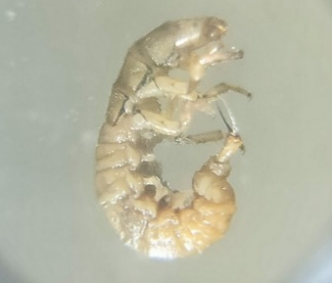 | B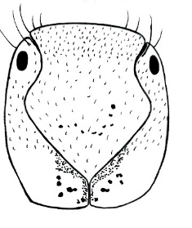 | C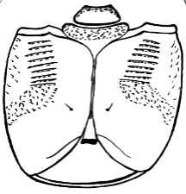
D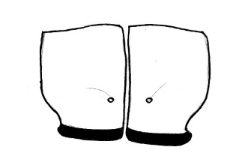 | E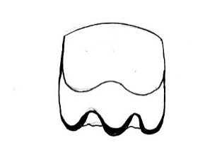 | F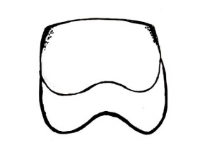
G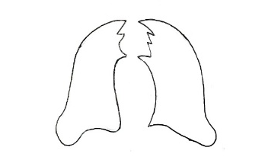 | H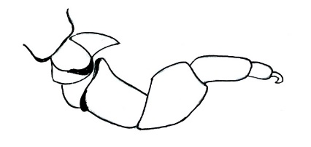
Figure 11 Diplectrona aiensis larva (A) Lateral view, (B) Dorsal view of head, (C) Ventral view of head, (D) Pronotum, (E) Mesonotum, (F) Metanotum, (G) Right and left mandible, (H) Trochantin
Ecology/Habitat: Diplectrona aiensis are found in clean freshwater environments, where they construct silk nets to capture drifting food particles.
Diagnostic Characters: Foreleg trochantin has a spine that is not forked (figure 11H); Sclerotized plates on each of three thoracic segments(figure 11D-11F)); Gula triangular and short, genae therefore fussed most of their length(figure 11C); Frons expanded lateral, lateral extension sharp(figure 11B); Frontoclypeus constructed at eye level(figure 11B); Posterior ventral apotome present, at least half of the length of median ecdysial line(figure 11C); Frontoclyeal area light to yellowish brown with central longitudinal markings in darker brown; Submentum triangular with short lateral lobes (figure 11C); Tergites of 2nd and 3rd thoracic segment with distinct transverse sulture; Anterior prosternites deeply indented laterally;
- Arctopsyche grandis (Banks, 1900)
2025, Arctopsyche grandis (Banks, 1900), Collection and identification by Pallavi and Koshal (Locality: Khanda Gad (Pauri Garhwal) and Dhundprayag Gad (Tehri Garhwal), Uttarakhand, India).
Material Observed: Several specimens were collected and examined monthly from two sites—Khanda Gad (Pauri Garhwal) and Dhundprayag Gad (Tehri Garhwal), Uttarakhand, India.
Common Name: Great Gray Spotted Sedge Caddisfly
Scientific Classification:
Kingdom: Animalia
Phylum: Arthropoda
Class: Insecta
Order: Trichoptera
Family: Hydropsychidae
Genus: Arctopsyche
Species: A.grandis
A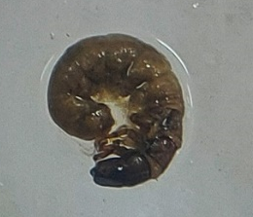 | B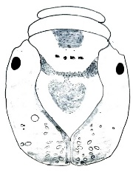 | C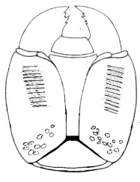
D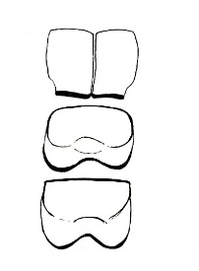 | E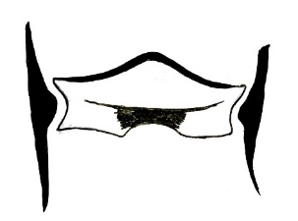 | F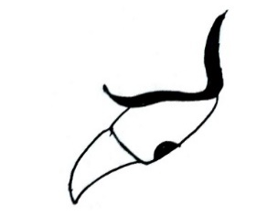
Figure 12 Arctopsyche grandis larva (A) Lateral view, (B) Dorsal view of head, (C) Ventral view of head, (D) Dorsal view of pronotum, mesonotum, metanotum, (E) Prosternal plate, (F) Trochantin
Ecology/Habitat: Arctopsyche grandis larva typically inhabits swift, cold water streams with large boulders and fast currents
Diagnostic Characters: Head of larvae is dark brown with pale median dorsal on the anterior of the frontoclypeus(figure 12B); Head is long and anterior margin of frontoclypeaus is convex(figure 12B); Ventral view of head showing the ventral apotome completely separating the genae (figure 12C); Ventral apotome is very wide and usually rectangular; Dorsum of most abdominal segments with single long setae; Abdominal segment ventral margin with filamentous gills; Gula narrowed posteriorly; Foreleg trochantin has a spine that is not forked (figure 12F);
- Cheumatopsyche pettiti (Banks, 1908)
2025, Cheumatopsyche pettiti (Banks, 1908), Collection and identification by Pallavi and Koshal (Locality: Khanda Gad (Pauri Garhwal) and Dhundprayag Gad (Tehri Garhwal), Uttarakhand, India).
Material Observed: Several specimens were collected and examined monthly from two sites—Khanda Gad (Pauri Garhwal) and Dhundprayag Gad (Tehri Garhwal), Uttarakhand, India.
Common Name: Net-Spinning Caddisfly
Scientific Classification:
Kingdom: Animalia
Phylum: Arthropoda
Class: Insecta
Order: Trichoptera
Family: Hydropsychidae
Genus: Cheumatopsyche
Species: C. pettiti
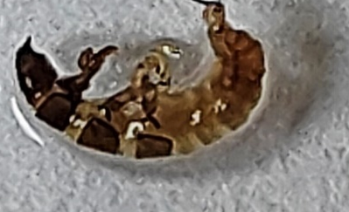  A | 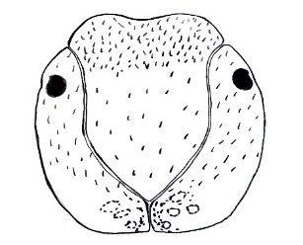  B | 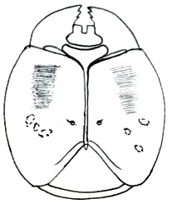  C
D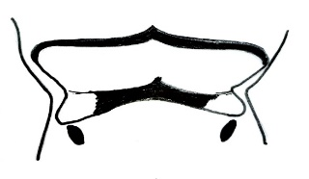 | E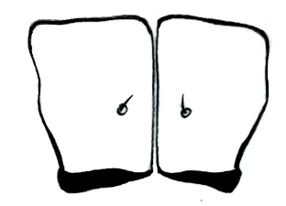 | F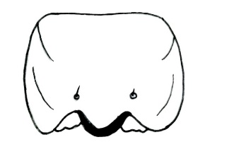
G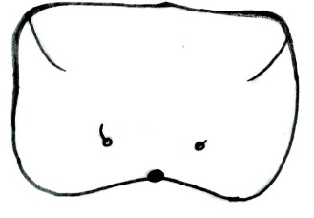 | H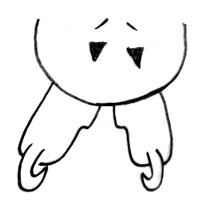 | 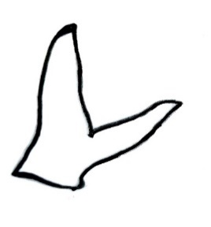  I
Figure 13 Cheumatopsyche pettiti larva (A) Lateral view, (B) Dorsal view of head, (C) Ventral view of head, (D) Prosternal plate, (E) Pronotum, (F) Mesonotum, (G) Metanotum, (H) Anal proleg and claw, (I) Trochantin
Ecology/Habitat: Cheumatopsyche pettiti are commonly found in running water, where they construct protective cases using materials such as small stones and organic debris.
Diagnostic Characters: Sides of head converge to form vertical line on ventral surface; Trochantin on foreleg forked shaped(figure 13I); Submentum notched at apex(figure 13C); prosternum with a pair of small sclerites posterior to prosternal plate(figure 13D); Both sclerites posterior on abdominal segment 9th notched at posterior margins(figure 13H); Prothorax venter posterior to prosternal plate, usually with minute pair of sclerites in intersegmental fold(figure 13D); frontoclypeus anterior margin usually with a small median notch(figure 13B); Dorsal abdominal segments with plain setae; Head bearing dense short tapered hair like setae; pronotum, mesonotum and metanotum sclerotized (figure 13E-13G)
- Stenopsyche angustata (Martynov, 1930)
2025, Stenopsyche angustata (Martynov, 1930), Collection and identification by Pallavi and Koshal (Locality: Khanda Gad (Pauri Garhwal) and Dhundprayag Gad (Tehri Garhwal), Uttarakhand, India).
Material Observed: Several specimens were collected and examined monthly from two sites—Khanda Gad (Pauri Garhwal) and Dhundprayag Gad (Tehri Garhwal), Uttarakhand, India.
Scientific Classification:
Kingdom: Animalia
Phylum: Arthropoda
Class: Insecta
Order: Trichoptera
Family: Stenopsychidae
Genus: Stenopsyche
Species: S. angustata
A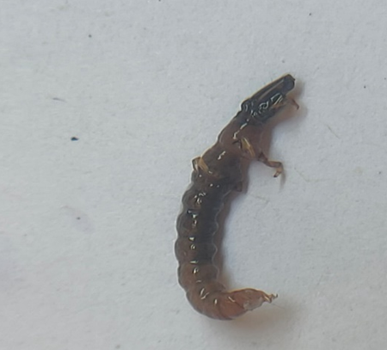 | B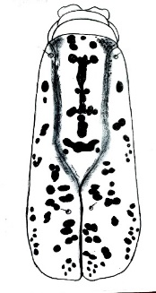 | C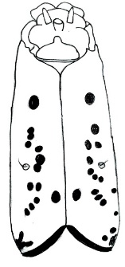
D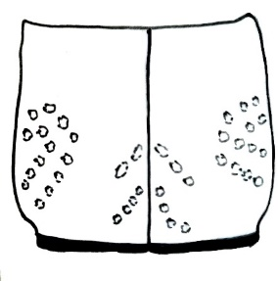 | E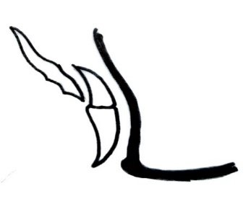
Figure 14 Stenopsyche angustata (A) Lateral view, (B) Dorsal view of head, (C) Ventral view of head, (D) Dorsal view of pronotum, (E) Trochantin
Ecology/Habitat: Stenopsyche angustata are typically found in cool, fast-flowing waters, where they utilise silk nets to capture food particles from the current.
Diagnostic Characters: Head and pronotum strongly sclerotised (Figure 14A); Head elongated; The head is yellowish-brown with dark spots distributed across the entire capsule (Figure 14B). The eyes are black, each surrounded by a yellow area. The labrum appears dark brown, while the clypeus is yellow with a smooth, rounded anterior margin. The frontoclypeal apotome is yellowish-brown, marked with scattered black dots and streaks (Figure 14B). The mentum is semicircular, with an anterior margin that is produced into a small process (Figure 14C), and each posterolateral angle has a bristle. The Anterior margin is apotome triangular, as broad as the mentum (Figure 14C). The pronotum is strongly sclerotised and sub-rectangular in dorsal view, showing a sinuate ventrolateral margin in lateral view (Figure 14D). Its ground colour is yellowish-brown, with dark spots concentrated on the posterior and lateral regions, and a pair of prominent black spots positioned just above the base of each foreleg; Foretrochantin acute (figure 14E); Femur with three dark rings and black longitudinal strips on the outer side.
- Stenopsyche marmorata. (McLachlan, 1866)
2025, Stenopsyche sp. (McLachlan, 1866), Collection and identification by Pallavi and Koshal (Locality: Khanda Gad (Pauri Garhwal) and Dhundprayag Gad (Tehri Garhwal), Uttarakhand, India).
Material Observed: Several specimens were collected and examined monthly from two sites—Khanda Gad (Pauri Garhwal) and Dhundprayag Gad (Tehri Garhwal), Uttarakhand, India.
Scientific Classification:
Kingdom: Animalia
Phylum: Arthropoda
Class: Insecta
Order: Trichoptera
Family: Stenopsychidae
Genus: Stenopsyche
Species: S. marmorata
A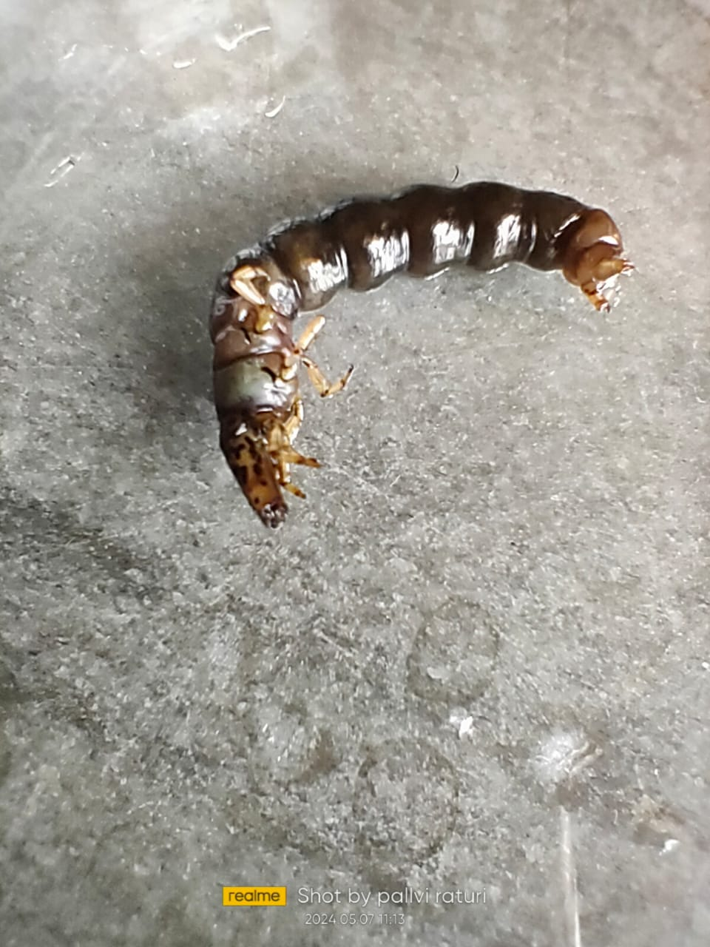 |  | B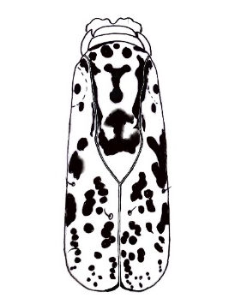
C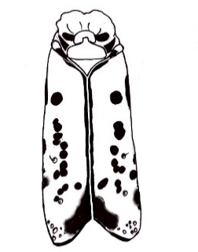 | D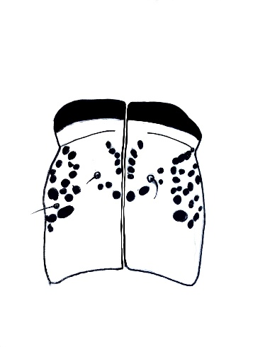 | E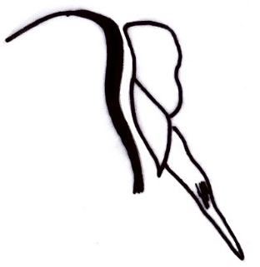
Figure 15 Stenopsyche marmorata larva (A) Lateral view, (B) Dorsal view of head, (C) Ventral view of head, (D) Dorsal view of pronotum, (E) Trochantin

Ecology/Habitat: Stenopsyche marmorata are typically found in cool, fast-flowing waters, where they use silk nets to capture food particles from the current.

Diagnostic Characters:- Head and pronotum strongly sclerotized(figure 15A); Head subrectangular and long; Ground color brown, with distinct punctate pattern; Frontoclypeal apotome with dark strips and spots forming ghost face(figure 15B); Other portion with head capsule with scattered dark strips of coalesced black dots, and dark strips along ventral ecdysial line in ventral view; eyes small, eye area large pale; Labrum dark brown mesally and light brown lateral; Frontoclypeus yellow with longitudinal pale lines separating rectangular darker area; Mentum semi-circular, anterior margin with mesal tongue like lobe(figure 15C); Anterior ventral apotome black, triangular(figure 15C); Pronotum strongly sclerotized, sub rectangular in dorsal view, ventrolateral view sinuous(figure 15D); Foretrochantins in ventrolateral view rhomboid, long(figure 15E); Episterna small;

During this study, a total of 15 species have been reported, and their diagnostic characteristics, micro-morphological observations and availability are systematically presented in Table 1. These distinguishing meristic and morphological observations of each species have been carefully drawn and documented, subsequently used in the preparation of an identification key, which serves as the baseline information for further taxonomic analysis and ecological studies of Trichoptera (Caddisflies) diversity.

Table 1. List of Trichoptera species recorded from the Khanda Gad (Pauri Garhwal) and Dhundprayag Gad (Tehri Garhwal), Uttarakhand.
S.No. | Scientific Name | Family | Identification | Relative Abundance
1 | Chimarra aterrima | Philopotamidae | Marginal lobes of the frons are slightly closer together. Frontoclypeal notch deep, U-shaped. | Abundant
2 | Chimarra ferio | Philopotamidae | The frontoclypeal notch is small and has a narrow opening. | Abundant
3 | Dolophilodes shawnee | Philopotamidae | Frontoclypeal slightly asymmetrical, Lateral margin slightly curved. Having an extended finger-like foreleg trochanter. | Rare
4 | Psychomyia flavida | Psychomyiidae | Anal Hooks with a row of 4 long teeth along the inner ventral margin. | Abundant
5 | Psychomyia pusilla | Psychomyiidae | Each anal claw has six teeth or dentations | Abundant
6 | Polycentropus flavomaculatus | Polycentropodidae | Head and pronotum show light-brown muscle insertion marks, while the frontoclypeus shows an ecdysial line with a slight constriction at the centre. | Common
7 | Rhycophila fasciata | Rhyacophilidae | Frontoclypeus bell-shaped with deep central constriction. Anal claw long, regularly curved and fitted with two ventral teeth. | Common
8 | Hydropsyche briareus | Hydropsychidae | In the ventral view, the anterior ventral apotome is nearly triangular, with the anterior border slightly concave and the anterolateral angles rounded | Rare
9 | Hydropsyche angustipennis | Hydropsychidae | The frontoclypeal apotome has only two lateral light areas; The front of the frontoclypeus apotome is not convex; The ecdysial line on the ventral part of the head is shorter than half the width of the head. | Rare
10 | Hydropsyche rhadamanthys | Hydropsychidae | Frontoclypeal apotome narrow; Anterior margin and anterior sides straight to slightly concave | Common
11 | Diplectrona aiensis | Hydropsychidae | Posterior ventral apotome at least one-half as long as the median ecdysial line. Frontoclypeus constricted at eye level. | Abundant
12 | Arctopsyche grandis | Hydropsychidae | Ventral view of detached head showing the ventral apotome completely separating the genae | Common
13 | Cheumatopsyche pettiti | Hydropsychidae | The ventral side of the prothorax, located behind the prosternal plate, typically bears a small pair of sclerites within the intersegmental fold. | Common
14 | Stenopsyche angustata | Stenopsychidae | Dark spots are scattered over the whole capsular area. Frontoclypeus apotome is yellowish-brown with scattered black dots and stripes. Anterior ventral apotome triangular, as broad as mentum. | Abundant
15 | Stenopsyche marmorata | Stenopsychidae | Head is ground colour brown with distinct punctate patterns. Frontoclypeus apotome with dark strips forming a Ghost face. Mentum semi-circular, anterior margin with mesal tongue-like lobe. | Common

4. CONCLUSION
This is a detailed morphological study of order Trichoptera (Caddisflies) to assess the taxonomy of individuals collected from two spring-fed tributaries—Khanda Gad (Pauri Garhwal) and Dhundprayag Gad (Tehri Garhwal)—in Uttarakhand, India. A total of 15 species belonging to six families were identified through detailed morphological and meristic studies. The comprehensive identification and documentation of these specimens provide valuable baseline data for future ecological and water quality monitoring studies.
In conclusion, this research provided valuable baseline data on Himalayan freshwater Trichoptera diversity, thereby broadening our knowledge of aquatic insect taxonomy. Conclusively, this study enhances the existing taxonomic understanding of aquatic insects and serves as a scientific reference for future ecological monitoring and conservation initiatives in mountain freshwater systems. Our findings serve as a crucial reference for future biomonitoring programs, conservation planning, and environmental assessments in the Himalayan region.
5. Acknowledgement
The authors are grateful to the Department of Himalayan Aquatic Biodiversity, H.N.B. Garhwal University (A Central University), Srinagar (Garhwal)-246174, Uttarakhand, India, for the facilities provided for this study.

Conflicts of Interest
The authors have declared no conflict of interest

Declaration of Funding
'This research did not receive any specific funding

Data Availability Statement:
No data have been shared in this study. Data will be made available upon reasonable request.

Disclaimer (Artificial intelligence)
The author (s) hereby declare that NO generative AI technologies such as Large Language Models (ChatGPT, COPILOT, etc.) and text-to-image generators have been used during the writing or editing of this manuscript.

References
Abowei J. F. N. & Ukoroije B.R. (2012). The Identification types, taxonomic orders, biodiversity and importance of aquatic orders. British Journal of Pharmacology and Toxicology.
Allan J.D. & Castillo M. (2007). Stream Ecology: Structure and function of running waters.
Anamika, K. V, Shashi Meena S, Lata R.K. (2021). Diversity and distribution of aquatic entomofauna in India. International Journal of Entomology Research
Andersen, N. M. & Cheng, L. (2004). The marine insect Halobates (Heteroptera: Gerridae): biology, adaptations, distribution and phylogeny. Oceanography and Marine Biology: An Annual Review
Bae M.J., Kwon Y.S., Hwang S.J. (2011). Relationships between three major stream assemblages and their environmental factors in multiple spatial scales. Annales de Limnologie International Journal of Limnology.
Balian E.V., Segers H, Leveque C, Martens K. (2008). The Freshwater Animal Diversity Assessment: An overview of the results
freshwater animal diversity assessment.
Balodi VP & Koshal Kumar (2015). Macrozoobenthic study in relation to physicochemical parameters of Khoh River in Uttarakhand. Int. J. Sci. Res. 4 (6): 171-173 ISSN- 2277–8179.
Barman B (2014). The importance of aquatic insects as biomonitors of freshwater ecosystems. International Journal of environment and natural sciences
Battle J.M., John K.J., Bernard W.S. (2007). Mesh size affects macroinvertebrate descriptions in large rivers: examples from the Savannah and Mississippi Rivers." Hydrobiologia.
Belayeva N.V., Rasnitsyn A.P., Quicke D.L.J. (2002). History of insects, 1st edition. Kluwer Academic Publishers
Bouchard, W. R. (2004). Guide to Aquatic Invertebrates of the Upper Midwest.
Calor, A.R., Holzenthal, R.W. & Amorim, D.S. (2006) Phylogenetic analysis of Notalina (Neonotalina) Holzenthal (Tri-choptera: Leptoceridae), with the description of two new species from southeastern Brazil. Zootaxa
Carter J.L., Resh V.H. (2001). After site selection and before data analysis: sampling, sorting, and laboratory procedures used in stream benthic macroinvertebrate monitoring programs by USA state agencies.
Choudhary A, Ahi J. (2015). Biodiversity of Freshwater Insects: A Review. The International Journal of Engineering and Science.
Collins, N.M. (2012). The conservation of insects and their habitats. Academic Press.Fonnesu,
Cranston P.S., Gullan P.J. (2009). Phylogeny of Insects. Encyclopedia of Insects (second Edition)
Crespo J.G. (2010). A review of Chemo sensation and related behaviour in Aquatic Insects. Journal of Insect Science
Daly H.V. (1984). General classification and key to the orders of aquatic and semiaquatic insects. In: Merritt RW, Cummins KW, Editors. An Introduction to the Aquatic Insects of North America, Kendall/Hunt Publishing Company.
Deharveng L., Haese C.A.D. & Bedos A., (2008) Global diversity of springtails (Collembola; Hexapoda) in fresh-water.
Dijkstra B, Monaghan M.T, Pauls S.U. (2014). Freshwater biodiversity and aquatic insect diversification.
Dijkstra K.B., Monaghan M.T., Pauls S.U. (2013). Freshwater Biodiversity and Aquatic Insect Diversification. Annual Review of Entomology
Dobriyal AK and Bhaguna AK, Kotnala CB, Kumar N and Singh HR (1992) Preliminary observation on seasonal trends in macrozoobenthic diversity in the river Nayar of Garhwal Himalaya. In. Sehgal, K.L. (Ed.). Recent Research in Coldwater Fisheries. pp. 119-127
Dudgeon, D. (2003). Freshwater Macroinvertebrates in Hong Kong
Elango K, Vijayalakshmi G, Arunkumar P, Sobhana E & Sujithra P. (2021). Aquatic Insects’ Biodiversity: Importance and Their Conservation. Biological Diversity: Current Status and Conservation Policies Vol 1
Fischer, F.C.J. (1960–1973) Trichopterorum Catalogus, vol. 1–15 index. Nederlandsche Entomologische Vereeniging, Amsterdam
Flint, O.S. (1999). The Chilean genus Charadropsyche, with the description of its immature stages (Trichoptera: Tasimiidae) (Studies of neotropical caddisflies, LVII.
Foottit, R.G, & Alder, P.H. (2009). Insect Biodiversity Science and Society
Fred W.B., Brink V.D., Velde G.V. & Wijnhoven S. (2012). Seasonal changes in caddisfly larval assemblages in river-floodplain habitats along a connectivity gradient.
Ghosh SS, Saikia K, Deka P (2021). Aquatic insect ecology, threats and challenges for its conservation: A review, International Journal of Entomology Research.
Ghosh, L.K. and Singh, R. (2000). Biodiversity of Indian insects with special reference to aphids (Homoptera: Aphididae). Zoological Survey of India.
Goswami G., Singh D., (2017). Dynamics of Aquatic Insects in the Mandakini River of Uttarakhand, India. Ecology, Environment and Conservation.
Gulati P (2012). Handbook of Aquatic Insects
Havel, J.E. & Shurin, J.B. (2004). Mechanisms, effects, and scales of dispersal in freshwater zooplankton: a synthesis. Limnology and Oceanography.
Hershey A.E. (2010). "Aquatic insect ecology." Ecology classification of North American freshwater invertebrates. Academic Press.
Hickin N.E. (1967). Caddis Larvae: Larvae of British Trichoptera
Hjalmarsson A.E., Graf W., Jahniq S.C., Vitecek S., Pauls S.U. (2018). Molecular Association and Morphological characterisation of himalopsyche larval types (Trichoptera, Rhyacophilidae).
Holzenthal R.W., Blahnik R.J., Prather A.L., and Kjer K. (2007). Order Trichoptera Kirby, 1813 (Insecta). Caddisflies zootaxa 1668.
John C. Morse (2009). The Trichoptera World Checklist, Zoosymposia
Khyriem K., Yadav M.K., Papang H., Saxsena S., & Kher D. (2024). Insect diversity of Freshwater Ecosystem in Meghalaya, Northeast of India. Uttar Pradesh Journal of Zoology.
Kirby W. (1813). Strepsiptera, a new order of insects proposed; and the characters of the order, with those of its genera, laid down. Transactions of the Linnean Society, London.
Koshal Kumar, Jitendra Singh Rana, Anita Rawat Rana, & Kotnala, CB (2017). Checklist of Benthic Macroinvertebrate Communities of Stream Rawasan In Garhwal Region (Central Himalaya), Uttarakhand (India). J Mountain Res 12: 91–95.
Kumar N, Kumar, B & Dobriyal AK (1998). Geomorphic influence on the distribution of benthic diversity in two hill streams of the Garhwal Himalaya. Proceedings of Indo-Us Workshop. Punjab University, Chandigarh. pp. 53-66
Lamberti GA, Moore JW (1984). Aquatic Insects as Primary Consumers. Praeger, New York:
Lancaster J., Downes B.J. (2013). Aquatic Entomology. Oxford University Press,
Lancaster, J., Downes, B.J., Lester, R., Rice, S.P. (2018). University of Melbourne: Melbourne, VIC, Australia
Leveque C., Balian E.V., & Martens K. (2005). An assessment of animal species diversity in continental waters. Aquatic Biodiversity II
Macadam CR, Stockan JA. 2015. More than Just Fish Food: Ecosystem Services provided by Freshwater Insects. Ecological Entomology 40(S1)
Majumder J., Das R.K., Majumder P., Ghosh D., & Agarwak B.K. (2013). Aquatic Insects Fauna and Diversity in Urban Freshwater Lakes of Tripura, Northeast India)
Moor F.C., Ivanov V. D. (2008). Global Diversity of Caddisfly (Trichoptera: Insecta ) in freshwater.
Morse J.C., Frandsen P.B., Graf W. & Thomas J.A. (2019). Diversity and Ecosystem Services of Trichoptera
Morse, J.C. (2023). Trichoptera World Checklist.
Negi, R. & Mamgain, S (2013). Seasonal variation of benthic macroinvertebrates from the Tons River of Garhwal Himalaya, Uttarakhand. Pak. J. Biol. Sci. 16(22): 1210–1516.
Pandher M.S. (2024). Arthropoda: Insecta: Trichoptera. Fauna of India
Peckarsky, B.L., Fraissinet, P.R., Penton, M.A., and. Conklin, D. (1990). Freshwater Macroinvertebrates of Northeastern North America. Cornell University Press, Ithaca, NY.
Pescador M.L., Rasmussen A.K. (1995). Identification manual for the caddisfly (Trichoptera) larvae of Florida.
Pritchard, G., Harder, L.D. & Mutch, R.A. (1996). Development of aquatic insect eggs in relation to temperature and strategies for dealing with different thermal environments. Biological Journal of the Linnean Society, 58(2)
Priyank G., G.L. & Prasad G. (2013). Diversity of Aquatic Insects (EPT) in Kallar stream and its tributaries.
Rana J.S., Semalty B., Singh P., Swami N., Dewan S, Singh J., Gusain M.P. (2019). Checklist of Benthic Macroinvertebrates Taxa along Different Riparian Land Use Types in Alaknanda River Catchment of Central Himalaya, Uttarakhand (India).
Rana JS, Semalty B, Singh P, Swami N, Dewan S, Singh J, Gusain MP, & Gusain OP (2017). Checklist of benthic macroinvertebrate taxa along different riparian land use types in Alaknanda River Catchment of the Central Himalaya, Uttarakhand (India). Proc. Zool. Soc. pp. 1–24.
Resh, V.H. & Rosenberg, D.M. (1984). The Ecology of Aquatic Insects. Praeger, New York
Sabetta A., Basset L. (2005). Factors affecting macroinvertebrate distribution in a Mediterranean intermittent stream. Journal of Freshwater Ecology.
Singh J, Gusain MP & Gusain OP (2010). Benthic insect-substratum relationship along an altitudinal gradient in a Himalayan stream, India. Int. J. Ecol. Env. Sci. 36 (4): 215-231
Subramanian K.A., Sivaramakrishnan (2007). Aquatic Insect of India – A Field Guide Ashoka Trust for Ecology and Environment (ATREE), Bangalore, India.
Sunder S & BA Subla (1986). Macrobentic fauna of the Himalayan River. Indian J. Ecol. 13(1): 127–132.
Suren AM (1994). Macroinvertebrate communities of streams in western Nepal: effect of altitude and land use. Freshwat. Biol. 32: 323–336.
Thambiratnam S., Pabdiarajan P., Rajasekaran I., Barathy S. (2019). Study on Diversity and Molecular Systematics of Stenopsyche kodaikanelensis (Insecta: Trichoptera) and Phylogenetic lineage with Trichoptera and Lepidoptera in Kurangani Streams, Speciality Journal of Biological Sciences.
Tolonen K.E. (2016). Hierarchical decomposition of trait patterns of macroinvertebrate communities in subarctic streams." Freshwater Science
Turkmen G, Kazanci N. (2010). Applications of various biodiversity indices to benthic macroinvertebrate assemblages in streams of a national park in Turkey. Review of Hydrobiology
Unzicker, J. W., Resh, V.H., & Morse, J.C. (1982). Trichoptera. Midwest Aquatic Enterprises.
Vilenica M., Vuataz L., & Yanai Z. (2022). Introduction to the Special Issue. ‘Aquatic insects’: Biodiversity, Ecology and Conservation Challenges)
Wallace J.B., Webster J.R. (1996). The role of macroinvertebrates in stream ecosystem function. PubMed
Williams D.D., Feltmate B.W. (1992). Aquatic insects, 1st edition. Redwood Press Ltd.
Xinyu G, Peng L., Morse J.C, Wang J., Zang H., Sun L.Y., Wang B., (2024) Phylogenomics resolves a 100-year-old debate regarding the Evolutionary History of Caddisflies (Insecta: Trichoptera)

Author contributions
Pallavi and Divya wrote the manuscript, collected the data, and performed the analysis. KK designed the study, edited, and finalised the manuscript

