An Invasive Catfish Pterygoplichthys pardalis: A Review on Global Distribution and Ecological Impacts
ABSTRACT
Suckermouth catfishes possessing invasive nature caused threat to non-native ecosystems globally. They can disturb nutrition availability by impacting food chain and native faunal interactions. Catfishes belonging to Loricariidae have great ornamental trade value. Sailfin catfish (genus Pterygoplichthys) traded for aquarium purpose is currently distributed all over the world. Pterygoplichthys species were deliberately introduced by aquarium owners into areas outside of their native range and as a result, they have established stable populations in a different freshwater environment globally. This species has caused impacts on physical structure of water body by making burrows for laying eggs. It also feeds on eggs and spawns of other species causing threats of extinction on native species. Its occurrence had negative effect on socio-economic and environmental implications. This work focusses on comprehensive records and distribution of this genus worldwide. Its impact on ecosystems and native fish fauna also emphasized in this review work. Also, suggestions highlighting the need for molecular level species identification and strategical practices to control invasion in the future.
Keywords: Suckermouth armored catfishes, ecosystem threats, invasive species, Pterygoplichthys pardalis, India
INTRODUCTION
“As some exotic fishes have invaded aquatic system globally, they have become a major threat to endemic biodiversity. It is Aquaculture and aquariums that introduce ornamental and economically important fish species into new environment. Humans do deliberate introductions of such exotic species for ornamental purpose” (Chavez et al., 2006). “Aquarium pet trade commonly focussing on ornamental fishes trading internationally is a multibillion-dollar industry” (Rhyne et al., 2012; Tlusty et al., 2013). More than 1800 marine and 5000 freshwater fish species are traded as aquarium pets globally, with 10% of the fish coming from captive breeding and the rest of these species coming from wild capture. (Raghavan et al., 2013; Rhyne et al., 2012; Olivier, 2001).
“Unwanted fishes from aquarium were released from aquariums or commercial rearing ponds into the natural habitats without knowing consequences about invasion of exotic fishes” (Copp et al., 2005; Bijukumar et al., 2015; Hirsch et al., 2021). Such non-scientific practices caused negative impression on native fish diversity and overall ecosystem health (Capps and Flecker 2013; Bijukumar et al., 2015; Capps et al., 2015; Hussan et al., 2016; Parvez et al., 2023). India has over 300 alien fish species introduced intentionally or unintentionally. Almost 291 of these 300 species are ornamental (Singh and Lakra, 2011).
Loricariidae is the largest catfish family having about 957 species comprising to 120 genera (Froese and Pauly, 2018; Nelson, 2006). These fishes are characterized by bony plate like body coverings on dorsal surface and ventrally placed sucker-mouth (Hussan et al., 2016). According to literature, Pterygoplichthys species have been widely distributed and established in water resources of United States, Mexico, Philippines, Singapore, Thailand, Bangladesh, India, Indonesia, Taiwan and Japan (Ajithkumar et al., 1998; Liang et al., 2005; Chavez et al., 2006, Page and Robins, 2006; Hossain et al., 2008, Samat et al., 2008, Krishnakumar et al., 2009, Sinha et al., 2010, Chaichana et al., 2011).
“Pterygoplichthys pardalis is a native to Amazon basin in South America. It is a freshwater tropical fish of order Siluriformes and family Loricariidae. It has dorsal body surface covered with bony overlapping plates and a sucker mouth therefore commonly known as sucker mouth armoured catfish, Sailfin Catfish, Crocodile Catfish, Janitor fish and Devil fish. The members of genus Pterygoplichthys typically have nine or more dorsal fin rays” (Nelson, 2006; Weber, 1992; Ferraris, 2007; Fuller, et al., 1999). Four Pterygoplichthys species, Pterygoplichthys pardalis (Castelnau, 1855), Pterygoplichthys multiradiatus (Hancock, 1828), Pterygoplichthys disjunctivus (Weber, 1991), and Pterygoplichthys anisitsi (Eigenmann & Kennedy, 1903), are phylogenetically close and have very similar external morphology and biological characters (Weber, 1991, 1992; Armbruster, 2004).
Pterygoplichthys spp. became successful global invader attributed to its high fecundity (Gibbs et al., 2008; Hoover et al., 2004), rapid growth rate (Gibbs et al., 2013; Liang et al., 2005), longer life (Gibbs et al., 2013), “tolerance to wide environmental condition and spines covering body”. (Harter et al., 2014; Liang et al., 2005; Gibbs and Grof, 2014; Brion et al., 2013; Capps et al., 2011). P. pardalis can survive in polluted water and has ability to tolerate low water quality. As a fish food, they have no value, but as aquarium fish, they are in high demand (Hussan et al., 2016). It is very difficult to eradicate once they have established.
“The genus is characterised by a complex taxonomic history comprising large number of specific and generic synonymies” (Armbruster, 2004). “Such taxonomic ambiguity might obstruct in searching through literature for past records of invasion. It could result in poor throughout management decisions and strategies. The fragmented traits of invasion records for Pterygoplichthys species further complicate control efforts to control its population in wild. There is no database exists that records the genus distribution in details so far. The Global Biodiversity Information Facility (GBIF) and the Global Invasive Species Database (GISD) provide online distribution database that are incomplete since they provide fragmented information and do not contain non established invasion records, which can be useful for predict and preventing future invasions” (Kulhanek et al., 2011; GISD 2017). “The absence of a broad and quantitative framework for possible threats provided by these fishes to colonized habitats further complicate possible future control efforts. Giving priority to its eradication activities can benefit from the application of adaptable, quantitative and generic framework for impact assessment” (Nentwig et al., 2010; van der Veer and Nentwig 2016).
Our study aims to address these gaps in knowledge and provide tool that will help future management work. Our study has 2 objectives:
1) Review all relevant literature on the genus spread and compile a data of its distribution.
2) To provide details about its impact on biodiversity. In result, we propose recommendations for future research on this highly invasive genus.
RECENT DATA AND UPDATE ON DISTRIBUTION IN INDIA
Genus Pterygoplichthys has 17 valid species reported (Fricke et al., 2020) that have been invaded 4 in continents and 21 countries (Orfinger and Goodding, 2018) (Table 1). P. pardalis and P. multiradiatus are popular in aquarium owners in South India (Knight, 2010); however, as they grow bigger, traders and hobbyists face challenges in keeping them in tanks. They prefer releasing them into natural drainage. In India some species of Pterygoplichthys have been reported by researchers. It includes P. anisitsi from Bihar (Sinha et al., 2010), P. multiradiatus from Kerala and Tamil Nadu (Ajithkumar et al., 1998; Daniels, 2006; Krishnakumar et al., 2009; Knight, 2010). P. disjunctivus and P. paradalis in freshwaters of Andhra Pradesh, West Bengal, Bihar, Uttar Pradesh Tamil Nadu and Maharashtra (Singh, 2014; Kumbhar et al., 2018; Seshagiri et al., 2021; Daniel et al., 2022). Hassan et al., 2019 have reported P. paradalis in wetlands of East Kolkata region. It has invasive nature (Smrithy Raj et al., 2020; Rajasekaran et al., 2025; Seshagiri et al., 2021). Study of DNA barcoding of Pterygoplichthys Spp. was done in East Kolkata, West Bengal (Sahoo et al., 2022) Pterygoplichthys spp. feeds mainly on algae and detritus so have very high demand in ornamental aquarium fish trade and exported globally beyond their natural ranges (Fuller et al., 1999; Krishnakumar et al., 2009). In Maharashtra P. pardalis has been recorded in the Bhima River and Nirmal Lake Palghar (Kumbhar et al., 2018; Avhad et al., 2025). P. disjunctivus has been recorded from Gosekhurd Dam, Vainganga River, Maharashtra (Wanjaria et al., 2024) (Table 2)
Table 1. Invasion records of Pterygoplichthys species in the world
Continent | Country | Reference
Asia | Bangladesh | Hossain et al., 2008
Asia | China | Wei et al., 2017
Asia | India | Krishnakumar et al., 2009; Panikkar et al., 2015; Bijukumar et al., 2015; Mogalekar, 2017; Kumbhar et al., 2018
Asia | Indonesia | Kottelat, 1993, Page and Robins, 2006
Asia | Israel | Golani and Snovsky, 2013
Asia | Japan | Golani and Snovsky, 2013
Asia | Malaysia | Page and Robins, 2006; Samat, 2008
Asia | Philippines | Nakabo, 2002; Chavez, 2006
Asia | Turkey | Ozdilek, 2007
Asia | Taiwan | Liang, 2005; Wu, 2011
Asia | Singapore | Page and Robins, 2006
Asia | Indo- Burma biodiversity hotspot | Marr et al., 2024
Asia | Sri Lanka | Sumanasinghe and Amarasinghe, 2013
Asia | Vietnam | Levin, 2008; Zworykin and Budaev, 2013
Europe | Italy  Poland | Piazzini, 2010  Keszka, 2008
North America | Mexico  USA  Puerto Rico | Wakida-Kusonoki, 2007; Capps, 2011; Rodríguez-Santiago et al., 2016  Capps, 2008; Gibbs, 2008; Pound, 2011  Bunkley-Williams, 1994
South America  (Native range) | Brazil & Peru | Weber, 2003; Page and Robins, 2006

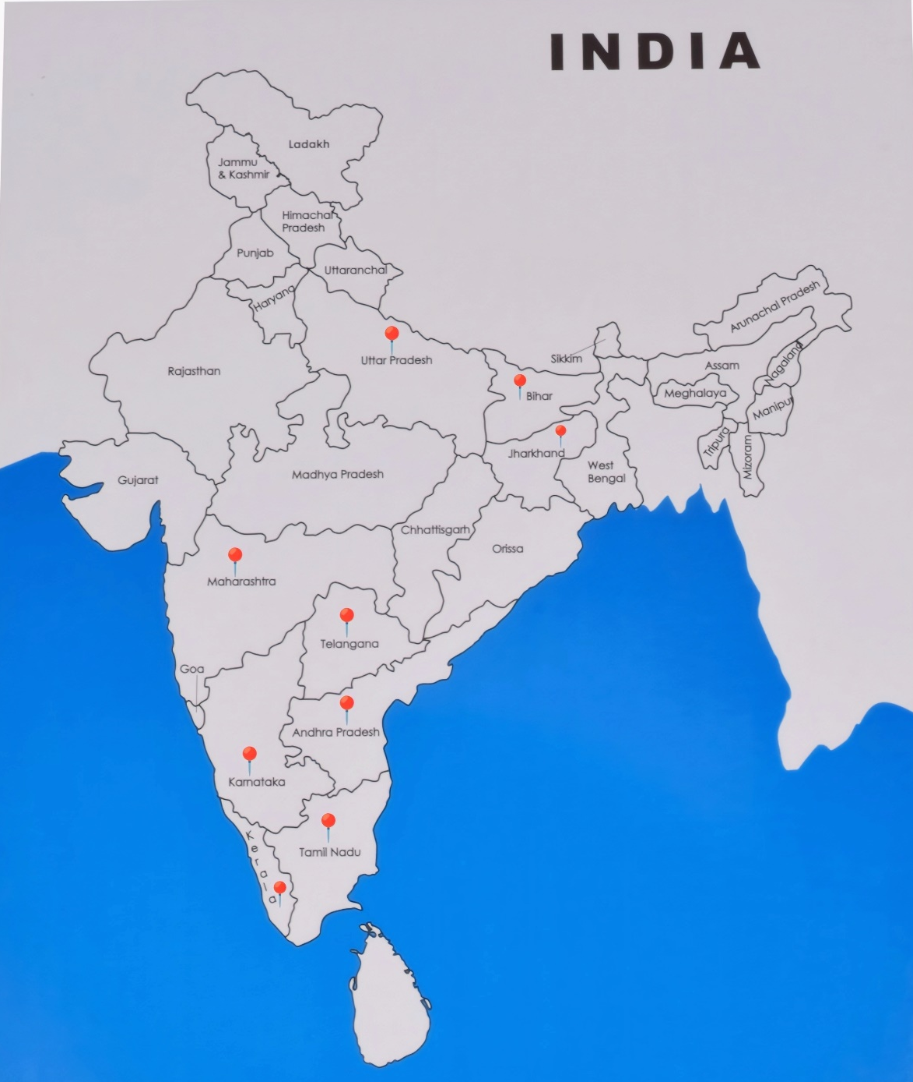
Fig. 1 Showing extended distribution of Pterygoplichthys species in the India

Table 2. Pterygoplichthys species reported from different inland water bodies of India
Species | Distribution | Reference
P. pardalis | Manimuthar dam on river Tambaraparani in southern Tamil Nadu  Cauvery river system of peninsular India  Freshwater tanks of Jangaon, Telangana  Drainages of Thiruvananthapuram city, Kerala  Vellayani lake, Kerala  Thalainayeru and Nagapattinam district ponds, Tamil Nadu  Kerala  Bhima river, Maharashtra  Nirmal Lake Palghar, Maharashtra | Mogalekar, 2017  Murlidharan, 2015  Rao and Sunchu, 2017  Bijukumar, 2015  Reenamole and Ambili, 2016  Shanmugam et al., 2022  Raj et al., 2020  Kumbhar et al., 2018  Avhad et al., 2025
P. disjunctivus | Cauvery river system of peninsular, Karnataka, India  Gomti river, Uttar Pradesh  Drainages of Thiruvananthapuram city, Kerala  Vellayani lake, Kerala  Parakkai Lake, Kanyakumari, Tamil Nadu  Gosekhurd Dam, Vainganga River, Maharashtra  Ganga River, West Bengal | Panikkar et al., 2015  NBFGR, 2009  Bijukumar, 2015  Reenamole and Ambili, 2016  Daniel et al., 2022  Wanjaria et al., 2024  Das et al., 2020
P. multiradiatus | Vembanad lake, Kerala  Akkulam lake, Kerala  Wetland of Chennai | Krishnakumar, 2009  Baiju, 2009  Knight, 2010
P. anisisti | Ganga River, Patna and Gomti near Lucknow, North India  Ganga river Patna, Bihar | Singh and Lakra, 2011  Rav et al., 2010
Pterygoplichthys spp. | Godavari River, Andhra Pradesh  East Kolkata Wetland, West Bengal  Cauvery and Vaigai, Tamil Nadu  Karamana and Neyyar River, drainage canals (Amayi zhanchan Thodu), Vellayani freshwater lake and Veli brackish-water lake, Kerala | Seshagiri et al., 2021  Sahoo et al., 2022  Rajasekaran et al., 2025  Biju Kumar et al., 2018

Impact and threats to biodiversity:
Pterygoplichthys spp. are considered as severe ecologic and freshwater-fisheries threat in Eurasia (Singh and Lakra, 2011; Hossain et al., 2008; Liang et al., 2005; Chavez et al., 2006; Golani and Snovsky, 2013; Levin et al., 2008; Page and Robins, 2006; Keszka, et al., 2008) and North America (CEC, 2009; Hoover et al., 2004; Wakida-Kusunoki, 2007). Pterygoplichthys spp. have widely occupied habitats in Indo- Burma biodiversity hotspots and threatened many native species. It is recognized as high risk taxon for fishes in this region (Marr et al., 2024). P. pardalis have several anti-predatory adaptations (Fuller et al., 1999) such as external bony plates, deep and stout body structure that can protect them from native predators even in mainstream habitats (Liang et al., 2005; Ozdilek, 2007; Wakida-Kusunoki et al., 2007), so their abundance is not easily controlled naturally where they invaded rivers (CEC, 2009; Nico et al., 2012). They are also known to have ability to regenerate appendages like pectoral fins (Sinha et al., 2010). “Vulnerability to piscivorous birds, defensive purpose erection of dorsal and pectoral spines poses a mortal (asphyxiation) danger to their predators”(CEC, 2009; Hoover et al., 2004; Bunkley-Williams et al., 1994). Once they get introduced in natural waters, they can interfere food chain and change the amount of food availability as well as the physical cover available in habitat for aquatic insects. “These insects are food for native fishes by grazing on benthic algae and detritus matter” (Mendoza et al., 2009).
P. pardalis possesses an invasive nature and may predate or compete with native species for food, shelter and breeding grounds (Hill and Lodge, 1999). It ultimately leads to decline in local fauna or native species (Chapin et al., 2000). It competes with native bottom dwelling fishes for eating algae. It consumes bottom hatched eggs and spawn of other fishes causing eradication of other fish species (Chaichana and Jongphadungkiet, 2012). It has burrowing habit for egg laying that causes bank erosion thereby causing increase in water turbidity (Gibbs et al., 2010). It has spiny hard exoskeleton that gets entangled into nets causing tearing of nets and economic loss to fishermen community (Chavez et al., 2006; Nico, 2010). Pterygoplichthys spp. dose not have any market value, so when they found by local fisherman, they discard the species on the bank of river (Soundararajan et al., 2015) (figure 2).
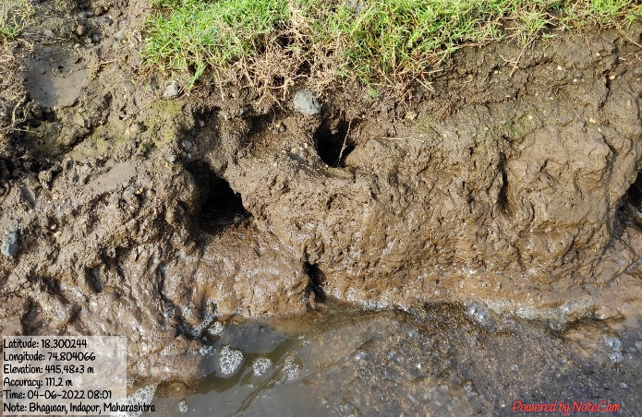  Figure 2. Burrows made by P. pardalis in Bhima River, Maharashtra, India. | 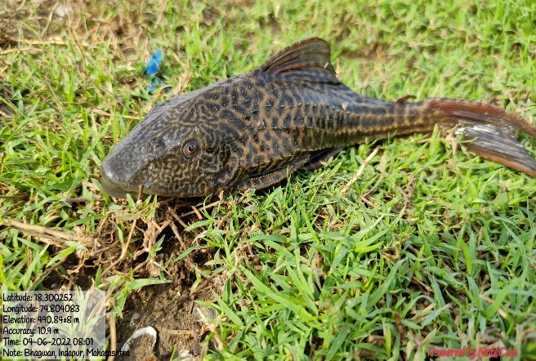  Figure 3. Discarded P. pardalis on the banks of Bhima River, Maharashtra, India.

Conclusion:
Our paper provides the comprehensive list of records and distribution of Pterygoplichthys genus worldwide. Our research emphasizes the invasive impact on ecosystems. We conclude by providing the following guidelines for collecting future data. Researchers should (1) collect voucher specimen and sample of tissue for genetic studies and identification. (2) publish clear collection and the identification remarks in methodology to better compare across research and indicate study limitations (3) submit collection material, such as high-resolution photos and voucher acceptance codes to online database like The Global Biodiversity Information Facility (GBIF) and the Global Invasive Species Database (GISD) (4) establish eradication or control strategies to prevent future invasions.

Disclaimer (Artificial intelligence)
Author(s) hereby declare that NO generative AI technologies such as Large Language Models (ChatGPT, COPILOT, etc.) and text-to-image generators have been used during the writing or editing of this manuscript.
Reference:
- Ajithkumar C., Biju R., Thomas R. 1998. Plecostomus multiradiatus - an armoured catfish from freshwater ponds near Kunnamkulam, Kerala and its possible impact on indigenous fishes. LAK News, Limnological Association of Kerala, pp. 1-2.
- Armbruster J. 2004. Phylogenetic relationships of the suckermouth armoured catfishes (Loricariidae) with emphasis on the Hypostominae and the Ancistrinae. Zool. J. Linn. Soc. 141, 1–80.
- Baiju P. 2009. Population status of exotic catfish Pterygoplichthys multiradiatus (Hancock) in the feeder canals of Akkulam lake, Thiruvanantha- puram, Kerala. Dissertation, University of Kerala, India.
- Bandla Seshagiri., Saroj Kumar Swain., Bindu R. Pillai., Chintada Satyavati., Y Sravanti., P.V. Rangacharyulu., Ramesh Rathod and V. Ratnaprakash, 2021. Suckermouth armoured catfish (Pterygoplichthys spp.) menace in freshwater aquaculture and natural aquatic systems in Andhra Pradesh, India. International Journal of Fisheries and Aquatic Studies. 9(1): 375-38.
- Bijukumar A., Smrithy, R., Sureshkumar U. and George S. 2015. Invasion of south American suckermouth armoured catfish Pterygoplichthys spp. (Loricariidae) in Kerela, India- a case study. Journal of Threatened Taxa 7(3): 6987-6995.
- Biju Kumar. A., Pamela J. Schofield., Smrithy Raj and Sima Satheesh 2018. Salinity tolerance of non-native suckermouth armoured catfish (Loricariidae: Pterygoplichthys sp.) from Kerala, India. Management of Biological Invasions. 9, 1: 49–57
- Brion MA., Guillermo JG Jr., Uy C. 2013. Salinity tolerance of introduced South American Sailfin Catfishes (Loricariidae: Pterygoplichthys Gill 1858). Philipp J Sci 142(1):13–19.
- Bunkley-Williams L., Williams E., Lilystrom C., Corujo-Flores I., Zerbi A., Aliaume C. 1994. The South American sailfin catfish, Liposarcus multiradiatus (Hancock), a new exotic established in Puerto Rican fresh waters. Caribb. J. Sci. 30, 90–94.
- Capps K. 2008. The impacts of sailfish catfish (Siluriformes: Loricariidae) on invaded freshwater ecosystems. Abstracts of Annual Meeting of American Ichthyologist and Herpetologist Society, July 23-28, 2008, Montreal, Canada.
- Capps K., Nico L., Mendoza-Carranza M., Arevalo-Frias W., Ropicki A., Hellpern S., Rodiles-Hernandez R. 2011. Salinity tolerance of non-native suckermouth armoured catfish Pterygoplichthys (Loricariidae) in south-eastern Mexico: Implications for invasion and dispersal. Aquat. Conserv. 21, 528–540.
- Capps KA, Flecker AS. 2013. Invasive aquarium fish transform ecosystem nutrient dynamics. Proc R Soc B 280:20131520. https://doi.org/10.1098/rspb.2013.1520
- Capps KA, Ulseth A, Flecker AS. 2015. Quantifying the top down and bottom-up effects of a non-native grazer in freshwaters. Biol. Invasions 17:1253–1266. https://doi.org/ 10.1007/s10530-014-0793-z.
- CEC (Commission for Environmental Cooperation) 2009. Trinational Risk Assessment Guidelines for Aquatic Alien Invasive Species: Test Cases for the Snakeheads (Channidae) and Armored Catfishes (Loricariidae) in North American Inland Waters; CEC Publications: Montreal, QC, Canada.
- Chaichana R., Pouangcharean S., Yoonphand R. 2011. Habitat, abundance, and diet of invasive suckermouth armored catfish (Loricariidae: Pterygoplichthys) in the Nong Yai Canal, East Thailand. Tropical Zoology 24(1):49–62.
- Chaichana R., and Jongphadungkiet S. 2012. Assessment of the invasive catfish Pterygoplichthys pardalis (Castelnau, 1855) in Thailand: ecological impacts and biological control alternatives. Tropical Zoology 25(4):173–182.
- Chapin F., Zavaleta E., Eviner V., Naylor R., Vitousek P., Reynolds H. 2000. Consequences of changing biodiversity. Nature 405: 234-242.
- Chavez J., de la Paz R., Manohar S., Pagulayan R., Vi J. 2006. New Philippine record of South American sailfin catfishes (Pisces: Loricariidae). Zootaxa 1109, 57–68.
- Daniel.N., J Praveenraj and J Stephen Sampath Kumar, 2022. Report on the invasion of South American armored suckermouth catfish (Pterygoplichthys disjunctivus) from Southern India. International Journal of Biology Sciences 4(2): 199-202.
- Das B., Ray A., Manna R., Roshith C., Baitha R., Karna S., Gupta S., Bhor M. 2020. Occurrence of exotic vermiculated sailfin catfish Pterygoplichthys disjunctivus from the lower stretch of River Ganga, West Bengal, India, Current Science, 119, NO. 12.
- Ferraris C. 2007. Checklist of catfishes, recent and fossil (Osteichthyes: Siluriformes), and catalogue of Siluriform primary types. Zootaxa, 1418, 1–300.
- Froese R., and Pauly D. 2018. Pterygoplichthys pardalis (Castelnau, 1855). FishBase. Available: http://www.fishbase.org/summary/Pterygoplichthys-pardalis.html. (February 2018).
- Fuller P., Nico L., Williams J., 1999. Nonindigenous fishes introduced into inland waters of the United States. Am. Fish. Soc. Spec. 27, 1–622.
- Gibbs M., Shields J., Lock D., Talmadge K. and Farrell, T. 2008. Reproduction in an invasive exotic catfish Pterygoplichthys disjunctivus in Volusia Blue Spring, Florida, U.S.A. Journal of Fish Biology 73: 1562-1572.
- Gibbs M., Shields J., Lock D., almadge K., Farrell T. 2010. Reproduction in an invasive exotic catfish Pterygoplichthys disjunctivus in Volusia Blue Spring, Florida, U.S.A. Journal of Fish Biology 73: 1562–1572.
- Gibbs MA., Kurth BN., Bridges CD. 2013. Age and growth of the loricariid catfish Pterygoplichthys disjunctivus in Volusia Blue Spring. Fla Aquat. Invasions 8(2):207–218. https://doi.org/10.3391/ai.2013.8.2.08
- Gibbs MA, Grof BW. 2014. Patterns of aerial respiration by Pterygoplichthys disjunctivus (Loricariidae) in Volusia Blue Spring, Florida. Fla Sci 77(2):53.
- Global Invasive Species Database (GISD). 2017. http://www. issg.org/database/species/. Accessed October 2017.
- Golani D. and Snovsky G. 2013. Occurrence of suckermouth armored catfish (Siluriformes, Loricariidae, Pterygoplichthys) in inland waters of Israel. BioInvasions Rec. 2, 253–256.
- Harter TS., Shartau RB., Baker DW., Jackson DC., Val AL, Brauner CJ. 2014. Preferential intracellular pH regulation represents a general pattern of pH homeostasis during acid-base disturbances in the armoured catfish, Pterygoplichthys pardalis. J Comp Physiol B 184(6):709718. https://doi.org/10.1007/s00360-014-0838-8.
- Hill A., and Lodge D. 1999. Replacement of resident crayfishes by an exotic crayfish: the roles of competition and predation. Ecological Applications, 9(2), 678-690.
- Hill JE., Sowards J. 2015. Successful eradication of the non-native loricariid catfish Pterygoplichthys disjunctivus from the Rainbow River, Florida. Manag Biol. Invas. 6(3):311- 317.
- Hirsch PE., N’Guyen A., Burkhardt-Holm P. 2021. Hobbyists acting simultaneously as anglers and aquarists: novel pathways for non-native fish and impacts on native fish. Aquat. Conserv. 31(6):1285–1296. https://doi.org/10.1002/ aqc.3557.
- Hossain M., Rahman M., Ahmed Z., Ohtomi J., Islam A. 2008. First record of the South American sailfin catfish Pterygoplichthys multiradiatus in Bangladesh. J. Appl. Ichthyol. 24, 718–720.
- Hoover J., Killgore K., Cofrancesco A. 2004. Suckermouth catfishes: threats to aquatic ecosystems of the United States ANSRP Bulletin 4, 1–9.
- Hussan A., Choudhury T., Das Arabinda., Gita, S. 2016, Suckermouth Sailfin Catfishes: A future threat to aquatic ecosystems of India, Aquaculture Times, 2(6) – 020.
- Keszka S., Panicz R., Tanski A. 2008. First record of the leopard pleco, Pterygoplichthys gibbiceps (Actinopterygii, Loricariidae) in the Brda River in the centre of Bydgoszcz (northern Poland). Acta Ichthyol. Piscat. 38, 135–138.
- Knight J. 2010. Invasive ornamental fish: a potential threat to aquatic biodiversity in peninsular India. J. Threat. Taxa 2(2):700-704.
- Kottelat M., Whitten A., Kartikasari S. and Wirjoatmodjo S. 1993. Freshwater Fishes of Western Indonesia and Sulawesi, Periplus Editions, Hong Kong. 259.
- Krishnakumar K., Raghaban R., Prasad G., Bijukumar A., Sekharan M., Pereira B., Ali A. 2009. When pets become pests-Exotic aquarium fishes and biological invasions in Kerala, India. Curr. Sci. India 97, 474–476.
- Kulhanek SA., Ricciardi A., Leung B. 2011. Is invasion history a useful tool for predicting the impacts of the world’s worst aquatic invasive species? Ecol. Appl 21(1):189-202.
- Kumbhar D., Shaikh S., Mhaske D. 2018. Fish faunal diversity of Bhima River at pedgaon, Shrigonda (Ahmednagar District), International Journal of Creative Research Thoughts, 6(2): 2320-2882.
- Lakshman Sahoo., Pragyan Paramita Swain., Ajmal Hussan., Anil Mohapatra and Jitendra Kumar Sundara, 2022. DNA barcoding delineates the identity of invasive South American sucker mouth armoured catfishes of genus Pterygoplichthys of East Kolkata Wetland, West Bengal, India as single species. Indian J. Fish., 69(4): 115-118.
- Levin B., Phuong P., Pavlov D. 2008. Discovery of the Amazon sailfin catfish Pterygoplichthys pardalis (Castelnau, 1855) (Teleostei: Loricariidae) in Vietnam. J. Appl. Ichthyol. 24, 715–717.
- Liang S., Wu H., Shieh B. 2005. Size structure, reproductive phenology, and sex ratio of an exotic armored catfish (Liposarcus multiradiatus) in the Kaoping River of southern Taiwan. Zool. Stud. 44, 252–259.
- Marr S.M., Patoka J. and Zworykin D. D. 2024, Estimating the potential distribution range of the invasive south American sucker mouth Armoured catfishes Pterygoplichthys spp. in the Indo- Burma biodiversity hotspot using MaxEnt. Aquatic conservation: Marine and Freshwater Ecosystems. 34 (5), e4173.
- Mendoza R., Cudmore R., Orr S., Balderas W., Courtenay P., Osorio N., Mandrak P., Torres M., Damian C., Gallardo A., Sanguines G., Greene D., Lee A., Orbe-Mendoza C., Martinez R., Arana O. 2009. Trinational risk assessment guidelines for aquatic alien invasive species. Commission for Environmental Cooperation, Montreal, Canada.
- Mogalekar H., Jawahar P., Srinivasan A., Karal Max K., Sujathkumar N., Canciyal J. Sudhan C. 2017. Discovery of the Amazon sailfin catfish Pterygoplichthys pardalis (Castelnau, 1855) (Teleostei: Loricariidae) from Manimuthar dam, Tamiraparani river system. Journal of Entomology and Zoology Studies, 5(4): 1229-1231.
- Mohan Raj Rajasekaran., Indhar Saidanyan Ravichandran., Parthiban Balasingam and Chandrasekaran Sivagnanam 2025. The Ecological and Socio-economic Impacts of the Aquarium Sailfin Catfish Invasion: Fate of Fisherfolk at Major Inland Water Bodies, Tamil Nadu, South India. Ecology, Economy and Society–the INSEE Journal 8(2): 33-66.
- Montoya-Burgos J., Weber C., Le Bail P. 2002. Phylogenetic relationships within Hypostomus (Siluriformes: Loricariidae) and related genera based on mitochondrial D-loop. Rev. Suisse Zool. 109, 369–382.
- Muralidharan M., Manikandan Gobi M. 2015. Extended distribution of the invasive sucker catfish Pterygoplichthys pardalis (Pisces: Loricariidae) to Cauvery River system of Peninsular India. International Journal of Aquatic Biology 3(1):14–18.
- Nakabo T. 2002. Fishes of Japan with Pictorial Keys to The Species (English edition). Tokai University Press, Tokyo. 1474 р.
- NBFGR. 2009. First record of the southern sailfin catfish, Pterygoplichthys disjunctivus from India. In 7:4.
- Nelson J. 2006. Fishes of the World, 4th ed.; John Wiley & Sons: Hoboken, NJ, USA.
- Nico L. 2010. Nocturnal and diurnal activity of armoured suckermouth catfish (Loricariidae: Pterygoplichthys) associated with wintering Florida manatees. Neotrop. Ichthyol, 8(4).
- Nentwig W., Kühnel E., Bacher S. 2010. A Generic Impact Scoring System Applied to Alien Mammals in Europe. Conserv Biol. 24(1):302-311. doi:10.1111/j.1523- 1739.2009.01289.x.
- Nentwig W., Bacher S., Pyšek P., Vilà M., Kumschick S. 2016. The generic impact scoring system (GISS): a standardized tool to quantify the impacts of alien species. Environ Monit Assess 188(5):1-13.
- Nico L., Butt P., Johnston G., Jelks H., Kail M., Walsh S. 2012. Discovery of South American suckermouth armored catfishes (Loricariidae, Pterygoplichthys spp.) in the Santa Fe River drainage, Suwannee River basin, USA. BioInvasions Rec. 1, 179–200.
- Olivier K. 2001. The ornamental fish market. FAO/Globefish Research Programme, The Food and Agriculture Organization of United Nations, Rome.
- Orfinger A. and Goodding D. 2018. The global invasion of the suckermouth armored catfish genus Pterygoplichthys (Siluriformes: Loricariidae) annotated list of species, distributional summary, and assessment of impacts. Zoological Studies 57(7) DOI:10.6620/ZS.2018.57-07.
- Ozdilek S. 2007. Possible threat for Middle East inland water: An exotic and invasive species, Pterygoplichthys disjunctivus (Weber, 1991) in Asi River, Turkey (Pisces: Loricariidae). E.U. Su Urunleri Dergisi 24, 303–306.
- Page L., Robins R. 2006. Identification of sailfin catfishes (Teleostei: Loricariidae) in southeastern Asia. Raffles B. Zool. 54, 455–457.
- Panikkar P., Jagadeesh T., Rao D., Sarkar, U. and Naska M. 2015. First record of non-native loricariid catfish, Pterygoplichthys disjunctivus (Weber, 1991) (Siluriformes, Loricariidae) in Cauvery River of peninsular India. The Bioscan 10: 1659-1663.
- Parvez MT., Lucas MC., Hossain MI. 2023. Invasive vermiculated sailfin catfish (Pterygoplichthys disjunctivus) has an impact on highly valued native fish species. Biol. Invasions. https://doi.org/10.1007/s10530-023-03012-8
- Piazzini S., Lori E., Favilli L., Cianfanelli S., Vanni S. and Manganelli G. 2010. Invasion note: a tropical fish community in thermal waters of southern Tuscany. Biological Invasions 12: 2959-2965.
- Pound K., Nowlin W., Huffman D. and Bonner T. 2011. Trophic ecology of a nonnative population of suckermouth catfish (Hypostomus plecostomus) in a central Texas spring-fed stream. Environmental Biology of Fishes 90: 277-285. http://dx.doi.org/10.1007/s10641- 010-9741-7.
- Rav. K. Sinha., Raj. K. Sinha., U. K. Sarkar and W.S. Lakra, 2010. First record of the southern sailfin catfish, Pterygoplichthys anisisti Eigenmann and Kennedy, 1903(Teleostei: Loricariidae), In India. Journal of Applied Ichthyology, 26. 606-608
- Rao R. and Sunchu, V. 2017. A report on Pterygoplichthys pardalis amazon sailfin suckermouth catfishes in freshwater tanks at Telangana State, India. International Journal of Fisheries and Aquatic Studies 5(2): 249-254.
- Raghavan R., Dahanukar N., Tlusty MF. 2013. Uncovering an obscure trade: threatened freshwater fishes and the aquarium pet markets. Biol. Conserv. 164:158–169. https://doi.org/10.1016/j.biocon.2013.04.019.
- Reenamole G. and Ambili T. 2016. Occurrence of suckermouth armoured sailfin catfishes in Vellayani fresh water lake, Kerala, southwest coast of India. International Journal of Scientific Research 5(3): 1142-1145.
- Rinkesh Nemichand Wanjaria., Tasaduq Hussain Shaha., Prashant Telvekarb., Farooz Ahmad Bhata., Karankumar Kishorkumar Ramtekec., Aadil Hussain Maglooa., Dhanalakshmi Mathialagan 2024. A new record of the invasive vermiculated sailfin catfish Pterygoplichthys disjunctivus in the Wainganga River, Eastern Maharashtra, India. Journal of Asia-Pacific Biodiversity 17. 484e489.
- Rhyne AL., Tlusty MF., Schofield PJ. 2012 Revealing the appetite of the marine aquarium fish trade: the volume and biodiversity of fish imported into the United States. 7(5):e35808. https://doi.org/10.1371/journal.pone. 0035808.
- Rodríguez-Santiago MA., García-Prieto L., Mendoza-Garfias B., González-Solís D., Grano-Maldonado MI. 2016. Parasites of two coexisting invasive sailfin catfishes (Siluriformes: Loricariidae) in a tropical region of Mexico. Neotrop Ichthyol 14(3):e160021.
- Samat A., Shukor M., Mazlan A., Arshad A. and Fatimah M. 2008. Length-weight relationship and condition factor of Pterygoplichthys pardalis (Pisces: Loricariidae) in Malaysia peninsula. Research Journal of Fisheries and Hydrobiology 3: 48-53.
- Singh A. and Lakra W. 2011. Risk and benefit assessment of alien fish species of the aquaculture and aquarium trade into India. Reviews in Aquaculture 3, 3–18. doi: 10.1111/j.1753-5131.2010.01039.
- Shanmugam Sudarshan., Vetri Vijayarahavan., Shanmugam Santhoshkumar., Arunachalam Subburaj., Venkatesan Alamelu and Natarajan Krishnaveni, 2022. Length-Weight Relationship and Condition Factor of Invasive Amazon Sailfin Catfish, Pterygoplichthys Pardalis (Castelnau, 1855) In River-Fed Ponds, Nagapattinam, Tamil Nadu. J. Exp. Zool. India Vol. 25, No. 1, pp. 1045-1050.
- Singh A. 2014. Emerging alien species in Indian aquaculture: prospects and threats. J. Aquat. Biol. Fish. 2:32-41.
- Sinha R., Sinha R., Sarkar U., Lakra W. 2010. First record of the southern sailfin catfish, Pterygoplichthys anisisti Eigenmann & Kennedy, 1903 (Teleostei: Loricariidae), in India. J. Appl. Ichthyol. 26, 606–608.
- Smrithy Raj., Appukuttannair Biju Kumar., Rajeev Raghavan., Neelesh Dahanukar, 2020. Amazonian invaders in an Asian biodiversity hotspot: Understanding demographics for the management of the armoured sailfin catfish, Pterygoplichthys pardalis in Kerala, India. journal of Fish Biology, 1–5.
- Soundararajan N., Mohan Raj., Kamaladhasan N., Saidanyan R., Chandrasekaran S. 2015. Online trade of aesthetic exotic organisms: sword of Damocles? Curr. Sci., 109(8), 1404–1410.
- Sumanasinghe H. and Amarasinghe U. 2013. Population dynamics of accidentally introduced Amazon sailfin catfish, Pterygoplichthys pardalis (Siluriformes, Loricariidae) in Pologolla reservoir, Sri Lanka. Sri Lanka Journal of Aquatic Sciences 18:37-45.
- Sunil B. Avhad., Chris Rodrigues., Jagruti Chaugule and Prem Singh 2025. First Documented Occurrence of the Non-native Invasive Armored Catfish Pterygoplichthys pardalis (Castelnau, 1855) in Nirmal Lake, Vasai, Palghar District, Maharashtra, India. Asian Journal of Research in Zoology. vol. 8, no. 3, pp. 122-130
- Tlusty MF., Rhyne AL., Kaufman L. 2013. Opportunities for public aquariums to increase the sustainability of the aquatic animal trade. Zoo Biol. 32(1):1–12. https://doi.org/ 10.1002/zoo.21019.
- Van der Veer G. and Nentwig W. 2015. Environmental and economic impact assessment of alien and invasive fish species in Europe using the generic impact scoring system. Ecol. Freshwater Fish 24(4):646-656.
- Wakida-Kusunoki A., Ruiz-Carus R., Amador-del-Angel E. 2007. Amazon sailfin catfish, Pterygoplichthys pardalis (Castelnau, 1855) (Loricariidae), another exotic species established in southeastern Mexico. Southwest. Nat. 52, 141–144.
- Weber C. 1991. Nouveaux taxa dans Pterygoplichthys sensu lato (Pisces, Siluriformes, Loricariidae). Rev. Suisse Zool. 98, 637–643.
- Weber C. 1992. Revision du genre Pterygoplichthys sensu latu (Pisces, Siluriformes, Loricariidae). Rev. Fr. Aquariol. 19, 1–36.
- Weber C. 2003. Loricariidae Hypostominae (Armored catfishes). In: Checklist of the Freshwater Fishes of South and Central America, Porto Alegre: EDIPUCRS, Brasil. pp 351-372.
- Wei H., Copp GH., Vilizzi L., Liu F., Gu D., Luo D., Hu Y. 2017. The distribution, establishment and life-history traits of non-native sailfin catfishes Pterygoplichthys spp. in the Guangdong Province of China. Aquat Invasions 12(2):241-249.
- Wu L., Liu C. and Lin S. 2011. Identification of exotic sailfin catfish species (Pterygoplichthys, Loricariidae) in Taiwan based on morphology and mtDNA sequences. Zoological Studies 50: 235-246.
- Zworykin D. and Budaev, S. 2013. Non- indigenous armoured catfish in Vietnam: invasion and systematic. Ichthyological Research 60(4): 327-333. dx.doi.org/10.1007/s10228-013 0356-9.

