Role of Habitat Change in Insect Diversity: A Comparative Study of Different Habitats in Dhapa, Kolkata, West Bengal, India

Abstract
Situated on the eastern outskirts of Kolkata, India, Dhapa offers a remarkable natural environment where agricultural operations, waste disposal, and naturally regenerating vegetation coexist. Although commonly perceived as a landfill, Dhapa sustains a mosaic of human-modified and semi-natural habitats that support considerable insect diversity. The study was conducted across three distinct sections of the Dhapa dumpsite—agricultural fields, mixed vegetation zones, and disturbed areas—to quantify insect diversity and assess habitat variation. The study of diversity of insects is very important to determine the number of insect species present in a particular area for conservation purposes, and pest management strategies are also fundamentally based on insect diversity. A total of 1,301 insect individuals from 10 orders and 55 families were documented between September 2024 and February 2025. The dominant order was Hemiptera (31.24%), followed by Diptera (20.31%) and Hymenoptera (20.01%). According to diversity indices, disturbed sites had the lowest values of species richness and Shannon diversity, while mixed vegetation had the highest values (d = 3.556; H' = 2.302). ANOVA verified that the three habitats' diversity differed statistically significantly (p < 0.05). Cluster analysis also revealed that while disturbed areas stood apart, reflecting the effects of anthropogenic disturbance, agricultural fields and mixed vegetation formed a close cluster due to their ecological smilarity. These results demonstrate the importance of vegetation complexity in forming insect communities and the necessity of combined waste management and conservation approaches.

Keywords: insect diversity, different vegetation types, species richness, biodiversity indices, and Dhapa, West Bengal, India

Introduction
Urbanization has reshaped natural ecosystems globally, often leading to habitat loss, pollution, and fragmentation (McKinney, 2008). However, several urban areas, particularly those associated with waste management and peri-urban wetlands, continue to support diverse
faunal communities. Dhapa, located in the eastern fringe of Kolkata, West Bengal, is one such ecosystem where anthropogenic and natural processes intersect. Although predominantly known as a landfill site, Dhapa contains agricultural fields, wetlands, and disturbed habitats
that collectively foster an intricate mosaic of biodiversity.
In recent years, urban ecologists have begun to explore such overlooked spaces to understand how insect biodiversity adapts and thrives under extreme environmental modifications. Insects, as vital components of terrestrial ecosystems, serve numerous ecological functions—from pollination and nutrient cycling to acting as prey in food webs (Gullan and Cranston, 2014). Urban ecologists have increasingly recognized the importance of studying insect
populations in altered habitats to understand patterns of adaptation and resilience.
The wetlands surrounding Dhapa include a complex network of sewage-fed fisheries, agricultural plots, and water bodies, which maintain ecological services essential for urban sustainability. The presence of these aquatic systems significantly influences local insect populations, especially aquatic beetles, odonates, and dipterans (Rong, 2023).
The dynamic peri-urban landscape of Dhapa is characterized by the close coexistence of contrasting ecological elements. Initially identified mainly as a landfill area, it has progressively evolved into a complex environmental interface influenced by both natural regrowth and human activity. Seasonal water bodies created by monsoonal runoff, densely populated urban areas, and heavily polluted; waste-filled tracts are the landscape's defining features. A mosaic-like habitat matrix that sustains unexpected levels of biological activity has been produced by the coexistence of degradation and renewal, especially among insects, which serve as sensitive ecological indicators (Mitra et al., 2016; Ghosh and Mukherjee, 2018). Instead of serving as an ecological waste, Dhapa is a prime example of how marginal habitats can transform into biologically meaningful areas where disturbance-induced habitats support new species assemblages. It provides various microhabitats, enabling survival of both generalist and specialist insect species. These ecological niches are especially crucial for insects such as butterflies, dragonflies, ground beetles, and true bugs that are sensitive indicators of environmental change (Chowdhury and Soren, 2011).
Although Dhapa and the East Kolkata Wetlands (EKW) are geographically contiguous and ecologically interconnected, they are not officially classified as the same entity. Dhapa lies at the urban fringe of Kolkata and functions as a transitional interface between the city’s landfill zone and the peripheral wetlands, whereas the EKW is a designated Ramsar site recognized for its sewage-fed aquaculture and ecological services (Ghosh, 2005; Kundu et al., 2018). While Dhapa shares hydrological linkages and ecological processes with the EKW—particularly in terms of nutrient flow, wetland vegetation, and associated insect fauna—it is not formally a part of the protected wetland system. Instead, Dhapa serves as a buffer landscape that both influences and is influenced by the ecological dynamics of the EKW. This positioning has led scholars to identify Dhapa as an ecotonal zone where anthropogenic disturbance coexists with biodiversity resilience, making it ecologically significant despite its degraded status (Mitra et al., 2016).
Research on Lepidoptera and Coleoptera from Kolkata and its outskirts has identified significant variation in species richness and abundance, strongly linked to the availability of host plants, water quality, and seasonal variation (Ghosh and Saha, 2016). Moreover, the wetlands in and around Dhapa provide ideal breeding and feeding grounds for aquatic insects such as Hemiptera and larval stages of Diptera, contributing to the trophic dynamics of these systems (Saha et al., 2007). The area also provides diversity of insect fauna associated with different winter crops cultivated at Dhapa (Mondal et al., 2025)
Dhapa embodies a striking urban paradox: an area heavily burdened by pollution that nonetheless supports pockets of life. Air quality measurements in the region consistently indicate hazardous conditions, with the Air Quality Index (AQI) often ranging from 250 to 350, levels considered “very unhealthy” by both national and World Health Organization standards (CPCB, 2023). Particulate matter concentrations are similarly alarming, with PM₁₀ averaging 180–220 µg/m³—well above the national permissible limit of 100 µg/m³—and PM₂.₅ frequently exceeding 100 µg/m³, nearly four times the WHO guideline of 25 µg/m³. Soil and leachate from the landfill are contaminated with elevated levels of heavy metals, including lead (1.4–1.9 mg/kg), cadmium (0.06–0.11 mg/kg), and chromium (2.3–2.8 mg/kg), surpassing safe ecological thresholds. Methane emissions from decomposing waste further amplify environmental stress, with measured rates of 35–45 g/m²/day, marking Dhapa as one of the most significant urban methane sources in India. Remarkably, despite these extreme pressures, Dhapa still sustains wetland vegetation and diverse insect communities, illustrating how even severely disturbed urban landscapes can retain ecological significance and support biological resilience.
As urban development encroaches upon natural habitats, insect populations often suffer from habitat loss, reduced genetic diversity, and pollution stress. However, studies in Indian cities like Bangalore have found that urban gardens and wetlands can maintain substantial insect populations if floral resources and microhabitats are preserved (Hulamani, 2018).
In Dhapa, organic waste, untreated leachate, and heavy metals pose major threats to insect survival. Yet, some insect taxa have shown resilience by adapting to these modified habitats, suggesting a form of ecological filtering that favours pollution-tolerant species (Jana et al., 2006). Understanding these adaptive traits can inform future strategies for urban biodiversity management.
Insects such as bees and butterflies serve as effective bioindicators of environmental health, offering insights into subtle shifts in climate, pollution, and land-use changes in regions like Dhapa. Recent studies underscore the utility of insects in assessing environmental contamination, as they are particularly sensitive to pollutants in soil, water, and air (Chowdhury et al., 2023). For instance, a 2024 review highlights the role of insects in detecting pollution and monitoring environmental changes, emphasizing their significance in ecosystem assessment (Parikh et al., 2021).
Promoting community science and fostering academic collaboration in Dhapa can enhance our understanding of these bioindicators. Such initiatives not only contribute to scientific knowledge but also inform evidence-based policy decisions on urban planning and landfill management. Engaging local communities in monitoring insect populations can lead to more sustainable environmental practices and better-informed urban development strategies.
This study aims to evaluate and compare insect diversity across three representative habitat types in Dhapa agricultural fields, mixed vegetation zones, and heavily disturbed areas through quantitative diversity indices and rigorous statistical analyses. Dhapa is often described as an ecologically paradoxical landscape because, despite being heavily impacted by urbanization, waste disposal, and pollution, it continues to support pockets of rich biodiversity. The coexistence of severely degraded landfill tracts alongside wetlands, seasonal pools, and cultivated fields creates a mosaic of habitats that simultaneously reflects environmental stress and biological resilience. By linking habitat complexity to species richness and abundance, this research seeks to elucidate how such a marginal urban ecosystem sustains diverse insect communities, offering insights into the mechanisms that allow life to persist in highly disturbed environments (Samways, 2015).

Materials And Methods

Study Area

Dhapa is close to the East Kolkata Wetlands (22.561333°N, 88.44225°E), a Ramsar site of international significance, and the Eastern Metropolitan Bypass (Fig.1).
The area has a tropical climate, and the June–September monsoon season has a big impact on the growth of the vegetation. Relative humidity levels in Dhapa fluctuate throughout the year, ranging from approximately 58% in February to 83% in July, with an annual average of 70.8% and average temperatures range from 12°C in the winter to 40°C in the summer.
Field surveys were conducted between September 2024 and February 2025 at three sites in Dhapa, Kolkata. The sites are: Agricultural land site (enriched with organic waste compost), Mixed vegetation site (combining natural and cultivated flora), Disturbed areas (characterized by high pollution and low vegetation cover)
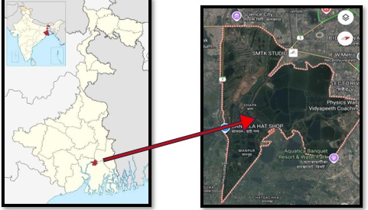

Figure 1: Study Area

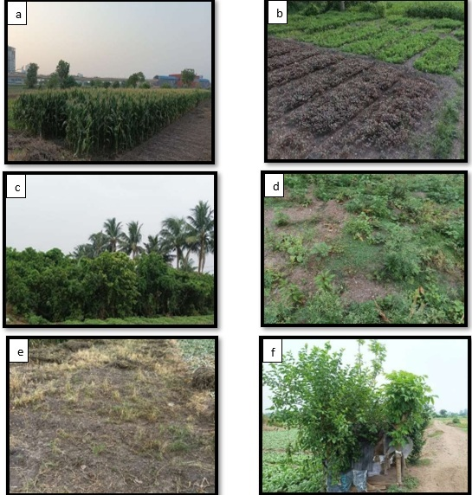

Figure 2: Few pictures of different sites in Dhapa observed for insect diversity
a. Agricultural land site 1; b. Agricultural land site 2; c. Mixed vegetation site 1; d. Mixed vegetation site 2; e. Disturbed area site 1; f. Disturbed area site 2.

Methodology
Insects were collected by transect method using sweep nets, beating sheets, and hand-picking to ensure representation of arboreal, terrestrial, and soil-dwelling taxa. The specimens were euthanized in ethyl acetate killing jars and subsequently preserved in 70% ethanol. Standard field guides and taxonomic keys were used for identification (Kehimkar, 2008; Subramanian, 2009). Using PAST 4.13 software, diversity indices such as Shannon-Wiener (H'), Simpson's (D), Evenness (E), Margalef (d), and Equitability (J) were calculated. One-way ANOVA tested for statistical differences across habitats, and Bray-Curtis cluster analysis examined community similarities.

Data Analysis
The following Biodiversity indices were computed using PAST 4.13 software and Microsoft Excel 2007;

    - Relative Abundance (%) = Total Number of Individual insect species x 100
Total Number of insect Species Population

    - The Simpson index of diversity (D):
(D)= 1- [Σn_{i}(n_{i}-1) / N(N-1)]
Where, Σ = sum of (Total)
n_{i} = the number of individuals of each different species
N = the total number of individuals of all the species

    - The Shannon-Weiner index of diversity (H):
(H)=- [Σ(n_{i}/N) × ln(n_{i}/N)]
Where, Σ = sum of (Total)
n_{i} = the number of individuals of each different species
N = the total number of individuals of all the species

    - The Evenness of diversity (E):
(E)= H/ ln(S)
Where, H = Shannon's diversity index
ln(S) = Natural logarithm of species richness

    - The Margalef diversity index (d):
(d) = (S – 1)/ log N
Where, S=The number of species
N= The total number of individuals in the sample

    - The Equitability index of diversity (J):
(J)= [Σ(n_{i}/N) × ln(n_{i}/N)]/ln N
Where, Σ = sum of (Total)
n_{i} = the number of individuals of each different species
N = the total number of individuals of all the species

    - Two-way Cluster analysis based on Bray Curtis has been used to understand the similarity, distribution and community patterns of different insects’ species in their respective habitat or collection sites of East Calcutta Wetlands.

    - One-Way ANOVA was used by using Microsoft Excel 2021 to observe the difference in insect species composition across the three different habitats of Dhapa, West Bengal, India. The dendrogram indicated that the Mixed Vegetation and Agricultural Field sites share a higher degree of similarity, forming a closely related cluster, whereas the Disturbed Area forms a separate branch, reflecting greater ecological divergence due to anthropogenic disturbance.

Result
The study observed 1,301 insects specimens belonging to 10 orders and 55 families from three different study sites (Table.1; Fig. 11 to 13). The most prevalent order was Hemiptera (31.24%), which was followed by Hymenoptera (20.01%) and Diptera (20.31%). Lepidoptera made up 5.05% and Coleoptera 12.1% of the total. Mantodea and Dermaptera were the least represented groups. Formicidae (ants) had the highest relative abundance (14.2%) among the families, followed by Coccinellidae (5.1%) and Cicadellidae (8.3%).
The highest insect population (645 individuals; 50%) was found in mixed vegetation (zones combining natural and cultivated flora), followed by disturbed areas (209; 16%) and agricultural fields (447; 34%). According to diversity indices, disturbed areas had the lowest species richness (d = 3.556; H' = 2.302) and diversity (H' = 3.474), while mixed vegetation had the highest. Significant differences (p < 0.05) in insect diversity across habitats were confirmed by a one-way ANOVA. Agricultural fields and mixed vegetation were closely clustered by cluster analysis, indicating ecological similarity, whereas disturbed sites formed an isolated cluster with a different species composition.
Table 1: - List of the insect order, family and calculation of relative abundance percentage based on number of individuals observed along with total no of individuals were observed.
SL. NO. | ORDER | FAMILY | NO. OF INDIVIDUALS OBSERVED | RELATIVE ABUNDANCE (%)
1. | Hemiptera | Alydidae | 18 | 1.38
1. | Hemiptera | Aleyrodidae | 62 | 4.76
1. | Hemiptera | Aphididae | 20 | 1.53
1. | Hemiptera | Berytidae | 18 | 1.38
1. | Hemiptera | Cicadellidae | 108 | 8.30
1. | Hemiptera | Gerridae | 25 | 1.92
1. | Hemiptera | Largidae | 41 | 3.15
1. | Hemiptera | Lygaeidae | 33 | 2.53
1. | Hemiptera | Miridae | 22 | 1.69
1. | Hemiptera | Pentatomidae | 17 | 1.30
1. | Hemiptera | Plataspidae | 25 | 1.92
1. | Hemiptera | Scutelleridae | 18 | 1.38
2. | Coleoptera | Cantharidae | 15 | 1.15
2. | Coleoptera | Buprestidae | 6 | 0.46
2. | Coleoptera | Cerambycidae | 2 | 0.15
2. | Coleoptera | Chrysomelidae | 18 | 1.38
2. | Coleoptera | Coccinellidae | 67 | 5.14
2. | Coleoptera | Curculionidae | 8 | 0.61
2. | Coleoptera | Scarabaeidae | 23 | 1.76
2. | Coleoptera | Attelabidae | 7 | 0.53
2. | Coleoptera | Staphylinidae | 12 | 0.92
3. | Odonata | Coenagrionidae | 17 | 1.30
3. | Odonata | Cordulegastridae | 14 | 1.07
3. | Odonata | Libellulidae | 30 | 2.30
4 | Diptera | Calliphoridae | 30 | 2.30
4 | Diptera | Cecidomyiidae | 13 | 0.99
4 | Diptera | Ceratopogonidae | 10 | 0.76
4 | Diptera | Chironomidae | 35 | 2.69
4 | Diptera | Culicidae | 36 | 2.76
4 | Diptera | Muscidae | 35 | 2.69
4 | Diptera | Phoridae | 15 | 1.15
4 | Diptera | Sarcophagidae | 5 | 0.38
4 | Diptera | Syrphidae | 21 | 1.61
4 | Diptera | Tabanidae | 8 | 0.61
4 | Diptera | Tephritidae | 12 | 0.92
4 | Diptera | Trypetidae | 45 | 3.45
5. | Lepidoptera | Crambidae | 8 | 0.61
5. | Lepidoptera | Hesperiidae | 17 | 1.30
5. | Lepidoptera | Nymphalidae | 10 | 0.76
5. | Lepidoptera | Papiolinidae | 12 | 0.92
5. | Lepidoptera | Pieridae | 19 | 1.46
6 | Hymenoptera | Apidae | 29 | 2.22
6 | Hymenoptera | Braconidae | 12 | 0.92
6 | Hymenoptera | Formicidae | 185 | 14.2
6 | Hymenoptera | Scoliidae | 7 | 0.53
6 | Hymenoptera | Sphecidae | 13 | 0.99
6 | Hymenoptera | Vespidae | 15 | 1.15
7. | Orthoptera | Acrididae | 26 | 1.99
7. | Orthoptera | Gryllidae | 17 | 1.30
7. | Orthoptera | Gryllotalpidae | 1 | 0.07
7. | Orthoptera | Tetigonidae | 4 | 0.30
7. | Orthoptera | Tetrigidae | 13 | 0.99
8. | Thysanoptera | Thripidae | 19 | 1.46
9. | Mantodea | Mantidae | 1 | 0.07
10. | Dermaptera | Forficulidae | 2 | 0.15
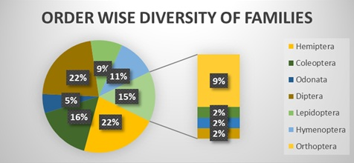

Figure 3: Order wise diversity of families (%)
Significant taxonomic diversity was discovered through the examination of insect specimens. The orders Hemiptera and Diptera were found to be the most family-rich, with 12 families each, making up 22% of all recorded families (Table 1, Figure 3). Ecologically significant species like pollinators, decomposers, agricultural pests, and sap-sucking insects are included in these groups. They were followed by nine families (16%) from Coleoptera (beetles) and six families (11%) from Hymenoptera (ants, bees, and wasps). With five families each (9%), Lepidoptera and Orthoptera emphasized their roles as herbivores and as higher trophic level prey. Three families (5% of the total) represented the Odonata, which include damselflies and dragonflies and are frequently associated with freshwater environments. With only one family and only 2% of the total, the least diverse orders were Mantodea (mantises), Dermaptera (earwigs), and Thysanoptera (thrips).
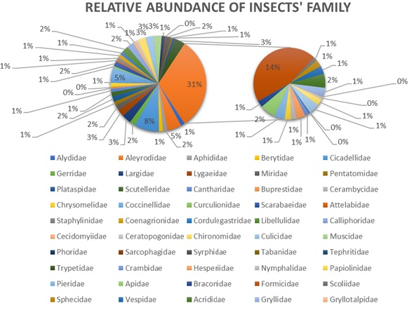
Figure 4: Relative abundance of different families of insects.
Ants, or Formicidae, were the most prevalent family in terms of relative abundance (Table 1, Figure 4), making up 14.2% of the entire insect population. Their dominance is probably influenced by their social behaviour, adaptability, and capacity to utilize a variety of resources. As plant feeders and possible plant disease vectors, cicadellidae (leafhoppers) came in second with 8.30%. Coccinellidae (ladybug beetles) and Aleyrodidae (whiteflies) made up 5.14% and 4.76%, respectively, and were both noteworthy because of their functions in agriculture, especially in the control of pests. However, with only 0.07% to 0.15% of all insects, families like Mantidae, Gryllotalpidae, Cerambycidae, and Forficulidae were underrepresented.
Table 2: - Abundance of recorded families at selected sites.
Sl. No. | Insect Family | Site-1  Agriculture Field | Site-2  Mixed Vegetation | Site-3  Disturbed Area
1 | Alydidae | 18 | 0 | 0
2 | Aleyrodidae | 24 | 38 | 0
3 | Aphididae | 7 | 13 | 0
4 | Berytidae | 18 | 0 | 0
5 | Cicadellidae | 43 | 65 | 0
6 | Gerridae | 0 | 25 | 0
7 | Largidae | 14 | 27 | 0
8 | Lygaeidae | 12 | 21 | 0
9 | Miridae | 22 | 0 | 0
10 | Pentatomidae | 6 | 8 | 3
11 | Plataspidae | 11 | 14 | 0
12 | Scutelleridae | 0 | 10 | 8
13 | Cantharidae | 15 | 0 | 0
14 | Buprestidae | 0 | 6 | 0
15 | Cerambycidae | 1 | 0 | 1
16 | Chrysomelidae | 0 | 11 | 7
17 | Coccinellidae | 29 | 23 | 15
18 | Curculionidae | 0 | 8 | 0
19 | Scarabaeidae | 7 | 12 | 4
20 | Attelabidae | 4 | 3 | 0
21 | Staphylinidae | 12 | 0 | 0
22 | Coenagrionidae | 9 | 0 | 8
23 | Cordulegastridae | 0 | 0 | 14
24 | Libellulidae | 0 | 16 | 14
25 | Calliphoridae | 4 | 25 | 1
26 | Cecidomyiidae | 0 | 13 | 0
27 | Ceratopogonidae | 0 | 10 | 0
28 | Chironomidae | 20 | 15 | 0
29 | Culicidae | 8 | 11 | 17
30 | Muscidae | 2 | 3 | 30
31 | Phoridae | 0 | 15 | 0
32 | Sarcophagidae | 0 | 3 | 2
33 | Syrphidae | 3 | 15 | 3
34 | Tabanidae | 0 | 8 | 0
35 | Tephritidae | 12 | 0 | 0
36 | Trypetidae | 18 | 27 | 0
37 | Crambidae | 4 | 3 | 1
38 | Hesperiidae | 7 | 10 | 0
39 | Nymphalidae | 2 | 6 | 2
40 | Papiolinidae | 4 | 8 | 0
41 | Pieridae | 7 | 12 | 0
42 | Apidae | 9 | 15 | 5
43 | Braconidae | 0 | 12 | 0
44 | Formicidae | 50 | 65 | 70
45 | Scoliidae | 0 | 7 | 0
46 | Sphecidae | 6 | 7 | 0
47 | Vespidae | 4 | 8 | 3
48 | Acrididae | 10 | 16 | 0
49 | Gryllidae | 7 | 10 | 0
50 | Gryllotalpidae | 0 | 1 | 0
51 | Tetigonidae | 4 | 0 | 0
52 | Tetrigidae | 0 | 13 | 0
53 | Thripidae | 14 | 5 | 0
54 | Mantidae | 0 | 1 | 0
55 | Forficulidae | 0 | 1 | 1
Total |  | 447 | 645 | 209
Site-wise analysis revealed differences in insect abundance across the three habitats (Table 2, Figure 5). Mixed Vegetation (Site 2) supported the highest insect population, with 645 individuals (50%), followed by the Agricultural Field (Site 1) with 447 individuals (34%), and the Disturbed Area (Site 3) with only 209 individuals (16%). Its heterogeneous structure, which offers a greater variety of ecological niches, more varied food sources, and favourable microclimatic conditions, is probably the reason for the higher abundance in mixed vegetation.
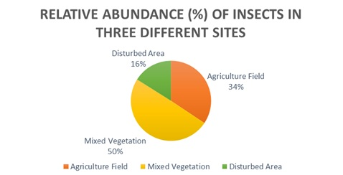

Figure 5: Relative abundance of insects in three different sites
Table 3: - Relative abundance and Diversity indices of insect orders recovered from selected sites.
Order | Relative  Abundance  (%) | Simpson’s Diversity Index (D`) | Shannon  Index (H`) | Evenness  (E`) | Richness | Margalef  Richness Index (d) | Equitability (J)
Hemiptera | 31.24 | 0.128 | 2.268 | 0.913 | 12 | 1.831 | 0.9129
Coleoptera | 12.1 | 0.230 | 1.779 | 0.810 | 9 | 1.580 | 0.8100
Odonata | 4.67 | 0.361 | 1.042 | 0.949 | 3 | 0.486 | 0.9493
Diptera | 20.31 | 0.111 | 2.309 | 0.929 | 12 | 1.971 | 0.9294
Lepidoptera | 5.05 | 0.207 | 1.559 | 0.969 | 5 | 0.954 | 0.9690
Hymenoptera | 20.01 | 0.521 | 1.040 | 0.581 | 6 | 0.898 | 0.5805
Orthoptera | 4.65 | 0.297 | 1.295 | 0.804 | 5 | 0.973 | 0.8047
Thysanoptera | 1.46 | 1 | 0 | Nil | 1 | 0 | Nil
Mantodea | 0.07 | Nil | 0 | Nil | 1 | Nil | Nil
Dermaptera | 0.15 | 1 | 0 | Nil | 1 | 0 | Nil
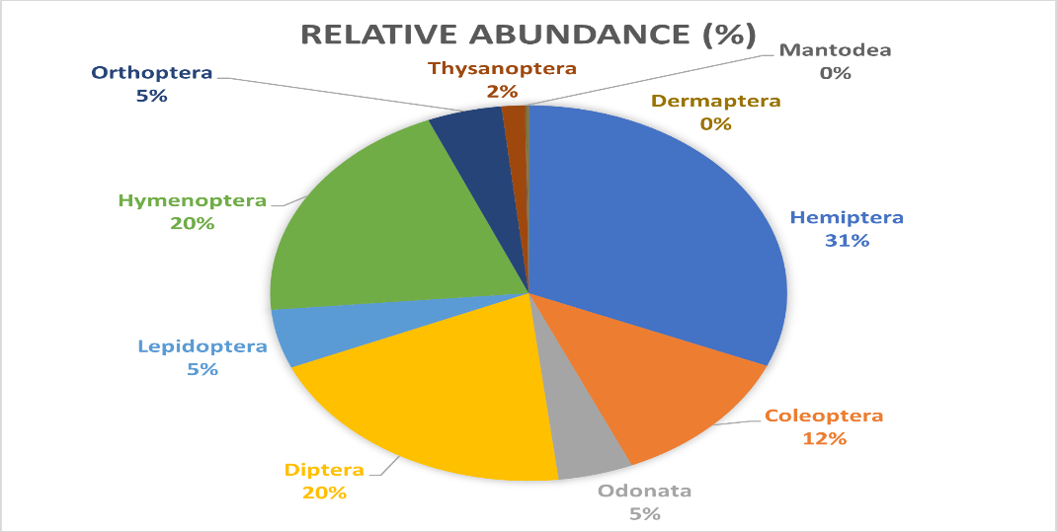

Figure 6: Relative Abundance of Different Orders of Insects

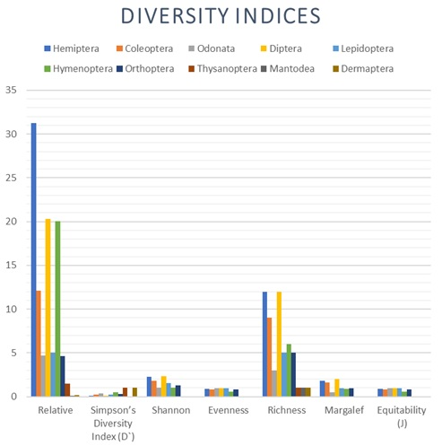
Figure 7: Diversity indices of different orders of insects found in Dhapa.
When evaluating the abundance at the order level (Table 3, Figure 6), Hemiptera emerged as the most populous group, comprising 31.24% of the total insect population, followed by Diptera at 20.31%. Conversely, Mantodea had the lowest abundance at just 0.07%. Biodiversity indices further emphasized these patterns (Table 3, Figure 7). Hemiptera showed the highest species diversity (H’ = 2.268) and species richness (d = 1.831), while Mantodea scored the lowest (H’ = 0, d = Nil). With low species counts, Thysanoptera and Dermaptera had no evenness values (E'= nil) according to evenness and equitability indices, suggesting an uneven distribution among their few species. Hymenoptera had the lowest evenness (E' = 0.581) and equitability (J = 0.5805), indicating an uneven distribution of species within that order, while Odonata and Lepidoptera displayed similarly high equitability (J = 0.9493 and 0.9690).
Table 4: - Diversity indices of insects recovered from the selected habitats in Dhapa.
Sites | Relative Abundance (%) | Simpson’s Diversity Index (D`) | Shannon Index (H`) | Evenness (E`) | Margalef Richness Index (d) | Equitability (J)
Agriculture Field | 34.35 | 0.047 | 3.297 | 0.913 | 5.899 | 0.9132
Mixed Vegetation | 49.57 | 0.041 | 3.474 | 0.912 | 6.801 | 0.9127
Disturbed Area | 16.06 | 0.155 | 2.302 | 0.768 | 3.556 | 0.7687

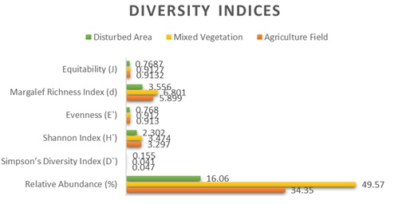
A comparison of habitats based on diversity indices (Table 4, Figure 8) showed that Mixed Vegetation outperformed the other sites in all ecological parameters. It had the highest species richness (d = 6.801), diversity (H’ = 3.474), evenness (E’ = 0.912), and equitability (J = 0.9127) values. Disturbed Area, on the other hand, showed the lowest values for species richness (d = 3.556), diversity (H' = 2.302), evenness (E' = 0.768), and equitability (J = 0.7687) of all the indices. These findings confirm that the best conditions for maintaining rich insect communities are provided by habitat complexity and plant diversity in areas with mixed vegetation.
Figure 8: Diversity indices of three different sites of Dhapa.
Table 5: - One-Way ANOVA showing difference in insect species composition across the three localities under Dhapa, Kolkata, during the present study period (September 2024 - February 2025).
Source of Variation | SS | df | MS | F | P-value | F crit
Between Groups | 1800.376 | 2 | 900.1879 | 8.987998 | 0.000199 | 3.051819
Within Groups | 16225.02 | 162 | 100.1544
Total | 18025.39 | 164
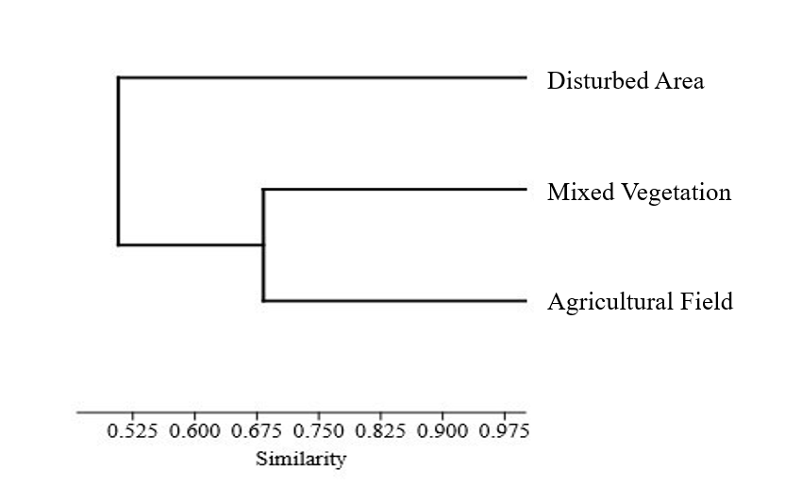

Figure 9: Cluster analysis showing the similarity among the three habitat types of Dhapa based on insect community composition.
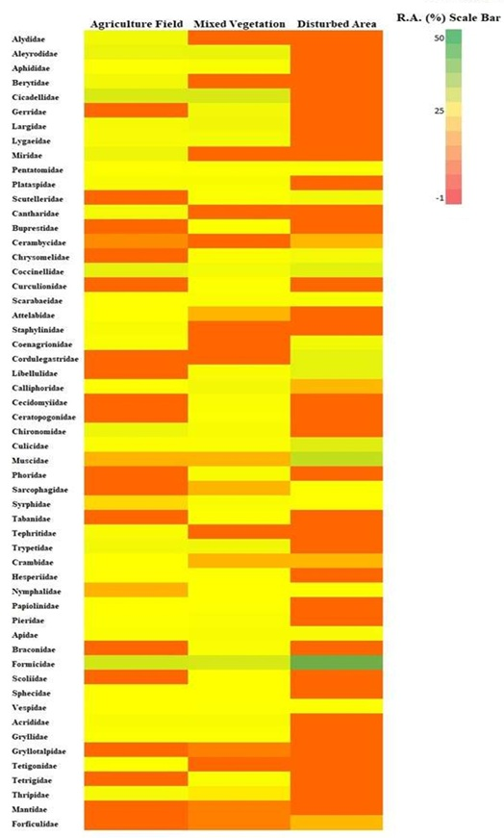
Statistical analysis using ANOVA (Table 5) confirmed that there were significant differences (P < 0.05) in the distribution of insect orders across the three study sites. This suggests that factors such as vegetation type, microhabitat conditions, and resource availability significantly influence insect community structure. A cluster analysis is shown (Figure 9) based on family-level abundance grouped Mixed Vegetation and Agricultural Fields together, indicating similar species compositions. In contrast, the Disturbed Area formed a distinct group, suggesting that it harbours a more specialized or isolated insect community.
Figure 10: Heat map of the relative abundance (R.A.) of various insect families across three distinct sites: Agricultural Field, Mixed Vegetation, and Disturbed Area.
Further insight into habitat-specific distribution patterns was gained through the use of a heatmap (Figure 10), which illustrates the relative abundance of different insect families across three habitats—agricultural fields, mixed vegetation, and disturbed areas—using a color gradient from green (high abundance) through yellow (moderate abundance) to orange/red (low abundance). In agricultural fields, the pattern shows that certain crop-associated insect families, such as Aphididae, Cicadellidae, and Chrysomelidae, are relatively more abundant. These groups are often pests or closely linked to crop plants, while beneficial groups like Syrphidae and Apidae appear in moderate numbers. This suggests that while certain insect families are supported by agriculture, broad diversity is not maintained. Several families are represented in yellow and light green hues in mixed vegetation habitats, which show more balanced distributions. This points to increased biodiversity, where natural enemies like Braconidae and Formicidae coexist in comparatively stable proportions with pollinators like Apidae, Pieridae, and Papilionidae. Herbivores and beneficial insects are supported by this habitat heterogeneity, which reflects more robust ecological relationships. However, orange and red hues predominate in disturbed areas, indicating that most families are found in extremely small numbers. Formicidae, Muscidae, and Culicidae are among the few resilient groups that exhibit greater relative abundance. While pollinators and specialized herbivores are drastically declining, these species are able to withstand environmental stress.
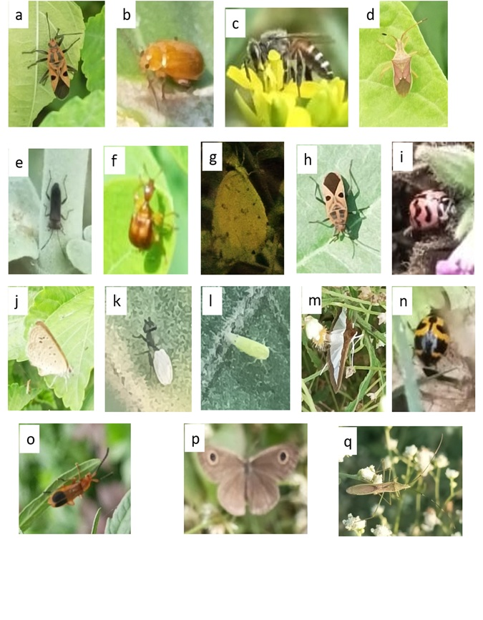
The study's findings highlight the important role that habitat type plays in the diversity and abundance of insects in the Dhapa area. The most ecologically productive habitat is mixed vegetation, which is home to a diverse range of insect species from several functional groups. Despite their relative diversity, pest species predominate in agricultural fields, with very few natural enemies. Disturbed areas that support certain adapted species, show little diversity in general. These results can guide habitat management and land-use planning to preserve insect diversity and the ecological services they offer, which is important for biodiversity conservation.
Figure 11: Picture showing few insects observed in agricultural site.
a.Graptostethus servus, b. Aulacophora foveicollis, c. Apis florea, d. Celtus sp., e. Unidentified species (coleoptera), f. Apoderus sp., g. Eurema hecabe, h. Graptostethus servus, i. Cheilomenes sexmaculata, j. Zizeeria karsandra, k.Black soldier fly, l. Empoasca flavescens, m. Spoladea recurvalis, n. Lady bug, o. Rhagonycha fulva, p. Callerebia narasingha, q. Leptocorisa acuta.
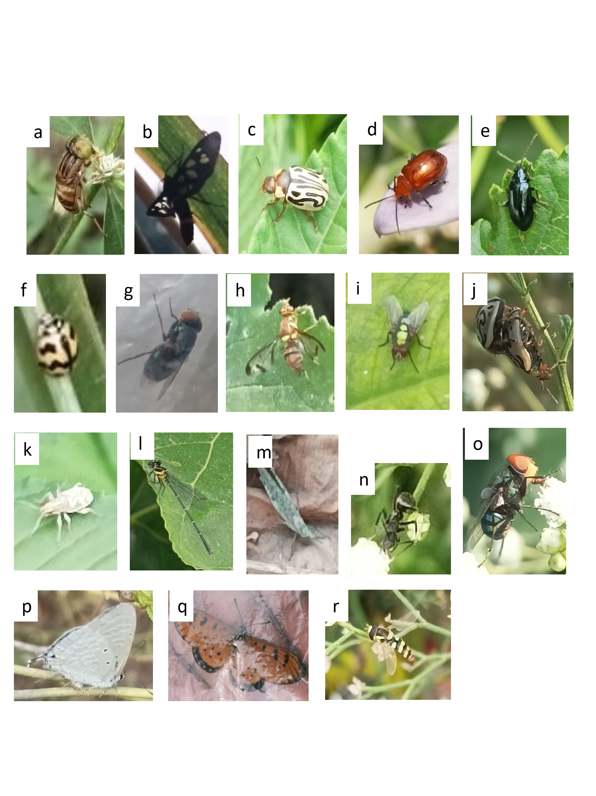
Figure 12: Picture showing few insects observed in mixed vegetation site.
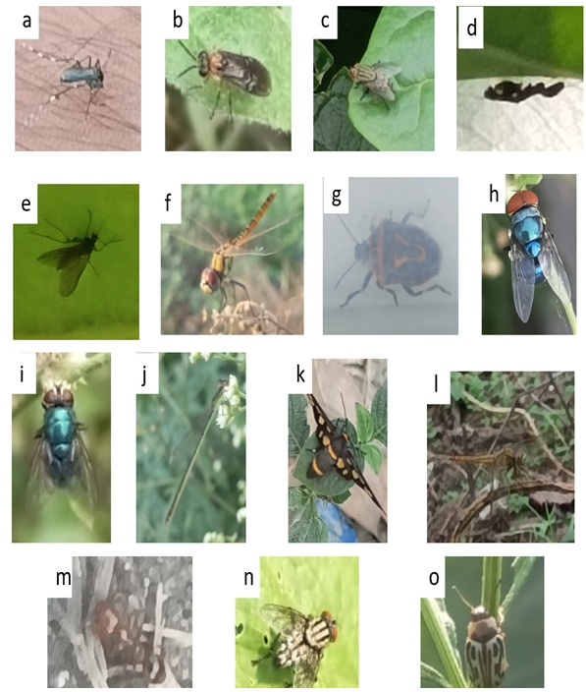
a. Eristalinus megacephalus, b. Syntomoides imaon, c. Zygogramma bicolorata, d. Aulacophora foveicollis, e. Phyllotreta cruciferae, f. Cheilomenes sexmaculata, g. Chrysomya megacephala, h. Bactrocera cucurbitae, i. Lucilia sericata, j. Zygogramma bicolorata, k. Curculionidae, l. Calicnemia imitans, m. Acrididae, n. Formicidae, o. Chrysomya megacephala, p. Catochrysops strabo, q. Acraea terpsicore, r. Syrphidae.
Figure 13: Picture showing few insects observed in disturbed area.
a. Aedes aegypti, b. Sawfly, c. Sarcophaga ruficornis, d. Mantis, e. Unidentified species (diptera), f. Crocothemis servilia, g. Perillus bioculatus, h. Chrysomya megacephala, i. Lucilia sericata, j. Ischnura senegalensis, k. Syntomoides imaon, l. Crocothemis servilia, m. Ant, n. Sarcophaga carnaria, o. Zygogramma bicolorata.

DISCUSSION
​During the present study a total of 1,301 individual insect specimens were observed in 3 different selected sites. This thorough survey offers important new information about the distribution and makeup of the local insect fauna suggesting Dhapa area to be very rich in insect diversity and ecologically significant.
This study recorded Hemiptera was the most prevalent order among those that were documented, whereas Mantodea was the least represented. The presence of varied habitats is suggested by the dominance of Hemiptera and Coleoptera which include bodies of water where these taxa are found. The significant prevalence of Diptera suggests unsanitary locations, like trash dumps and fish markets, which are a reflection of environmental changes brought on by humans.
Because of their sensitivity to environmental changes, lepidoptera—especially families like Nymphalidae and Papilionidae—are acknowledged as ecological indicators (Rosenberg et al., 1986; New et al., 1995; Nimbalkar & Shinde, 2011; Pawar and Deshpande, 2016). The ecological health of the aquatic ecosystems in the area is further indicated by the presence of Odonata species, such as damselflies and dragonflies.
Because they aid in pollination, nutrient cycling, decomposition, and soil aeration, insects are essential to the health of ecosystems. According to the relative abundance analysis, the most prevalent order was Hemiptera (30%), followed by Diptera (20.88%) and Hymenoptera (19.03%), with Mantodea (0.09%) being the least prevalent.
Comparing different habitats revealed that, with a relative abundance of 54.31%, Mixed Vegetation areas supported the greatest diversity and abundance of insects. Disturbed Areas, on the other hand, showed the least diversity and abundance, underscoring how habitat degradation affects insect populations. The importance of diverse plant communities in maintaining insect biodiversity was highlighted by the fact that Mixed Vegetation had the highest Shannon Diversity Index (H') (3.335).
The results are consistent with earlier studies that highlighted the negative impacts of habitat fragmentation and urbanization on biodiversity (Clarke et al., 2008). Insect populations and the general health of ecosystems are negatively impacted by the loss and fragmentation of habitat that urban development frequently causes.
Ecologists, conservationists, and policymakers can benefit greatly from the baseline documentation of the insect fauna in the Dhapa region provided by this study.
In order to capture seasonal variations and offer a more thorough understanding of insect diversity in the area, future research should think about broadening the geographical scope and implementing additional sampling techniques.
CONCLUSION
Despite being an urban waste disposal zone, the current study shows that Dhapa supports an exceptionally rich insect community, indicating its ecological significance. The availability of a variety of microhabitats, consistent food supplies, and stable environmental conditions allowed the Mixed Vegetation sites to exhibit the highest diversity among the three chosen habitats. Because monocropping, pesticide use, and periodic cultivation practices limit habitat complexity, agricultural fields supported moderate diversity. Disturbed areas, on the other hand, had the lowest diversity, mostly as a result of habitat loss, pollution, and decreased vegetation cover, all of which make it more difficult for insects to survive and reproduce.
The prevalence of Hemiptera, Diptera, and Hymenoptera throughout the study region demonstrates how well these taxa adapt to both natural and man-made settings. Ecological indicators that reflected habitat quality and water availability were sensitive taxa like Odonata and Lepidoptera. All things considered, this study confirms that a major factor influencing insect diversity is habitat complexity. In quickly urbanizing landscapes like Dhapa, it highlights the critical need to preserve mixed vegetation zones and implement sustainable land-use practices in order to preserve ecological stability and biodiversity.
Disclaimer (Artificial intelligence)
Option 1:
Author(s) hereby declare that NO generative AI technologies such as Large Language Models (ChatGPT, COPILOT, etc.) and text-to-image generators have been used during the writing or editing of this manuscript.

Reference
- Chatterjee, L., Samanta, T., Roy, A. B., Sinha, S., & Besra, S. (2022). Insect diversity (except Odonata and Lepidoptera) assessment of Ecopark, an urban park in Kolkata, West Bengal, India. Journal of Global Biosciences, 11(7), 9383-9392.
- Chowdhury, S., Dubey, V. K., Choudhury, S., Das, A., Jeengar, D., Sujatha, B., & Kumar, V. (2023). Insects as bioindicator: A hidden gem for environmental monitoring. Frontiers in Environmental Science, 11, 1146052.).
- Chowdhury, S., & Soren, R. (2011). Butterfly (Lepidoptera: Rhopalocera) Fauna of East Calcutta Wetlands, West Bengal, India. Check List, 7(6), 700-703.
- Clarke, K. R., Somerfield, P. J., & Chapman, M. G. (2006). On resemblance measures for ecological studies, including taxonomic dissimilarities and a zero-adjusted Bray–Curtis coefficient for denuded assemblages. Journal of experimental marine biology and ecology, 330(1), 55-80.
- Ghosh, S., & Mukherjee, A. (2018). Diversity and community structure of aquatic insects in urban wetlands of Eastern India. International Journal of Zoological Studies, 3(2), 45–52.
- Ghosh, S., & Saha, S. (2016). Seasonal diversity of butterflies with reference to habitat heterogeneity, larval host plants and nectar plants at Taki, North 24 Parganas, West Bengal, India. World Scientific News, 50, 197–238.
- Gullan, P. J., & Cranston, P. S. (2014). The insects: An outline of entomology. John Wiley & Sons.
- Hulamani, P. (2018). Effect of Urbanization on Insect Fauna: Diversity of Pollinators Across a Rural-Urban Gradient (Doctoral dissertation, University of Agricultural Sciences, GKVK.).
- Jana, G., Misra, K. K., & Bhattacharya, T. (2006). Diversity of some insect fauna in industrial and non-industrial areas of West Bengal, India. Journal of Insect Conservation, 10, 249–260.
- Kehimkar, I. (2008). The book of Indian butterflies. BNHS Publications.
- Kundu, N., Samanta, S., & Mondal, P. (2018). Sewage-fed fisheries and livelihood sustainability in East Kolkata Wetlands. Journal of Environmental Management, 217, 596–606.
- McKinney, M. L. (2008). Effects of urbanization on species richness: a review of plants and animals. Urban Ecosystems, 11(2), 161–176.
- Mitra, G., Biswas, O., Roy, S., Chakraborti, U., & Panja, B. (2016). Insect fauna diversity of Sundarbans Biosphere Reserve, West Bengal, India. International Journal of Current Research and Academic Review, 4(9), 87–98.
- Mondal, S., Biswas, P., & Khan, A. (2025). Diversity of insect fauna associated with different winter crops cultivated at Dhapa area, Kolkata, West Bengal, India. International Journal of Entomology Research, 10(3), 65–71.
- New, T. R., Pyle, R. M., Thomas, J. A., Thomas, C. D., & Hammond, P. C. (1995). Butterfly conservation management. Annual Review of Entomology, 40(1), 57–83.
- Nimbalkar, R.K., S.K. Chandekar& S.P. Khunte (2011) . Butterfly diversity in relation to nectar food plants from Bhor Tahsil, Pune District, Maharashtra, India. Journal of Threatened Taxa, 3(3): 1601-1609.
- Parikh, G., Rawtani, D., & Khatri, N. (2021). Insects as an indicator for environmental pollution. Environmental Claims Journal, 33(2), 161-181.
- Pawar, P. A., & Deshpande, V. Y. (2016). Butterfly diversity of Satara Tehsil, District Satara Maharashtra. IRA-Int J Appl Sci, 4(1), 133-144.
- Rong, A., Besra, S., Chatterjee, L., Samanta, T., Mazumdar, S., Hazra, D., Samrat, C., & Roy, A. B. (2023). A comprehensive study on diversity and land use of the bird species around Eco Park area, Kolkata, West Bengal.
- Rosenberg, D. M., Danks, H. V., & Lehmkuhl, D. M. (1986). Importance of insects in environmental impact assessment. Environmental Management, 10, 773–783.
- Saha, N., Aditya, G., Bal, A., & Kumar Saha, G. (2007). Comparative study of functional response of common Hemipteran bugs of East Calcutta wetlands, India. International Review of Hydrobiology, 92(3), 242–257.
- Samways, M. J. (2015). Future-proofing insect diversity. Current opinion in insect science, 12, 71-78.
- Subramanian, K. A. (2009). Dragonflies and Damselflies of Peninsular. India-A Field Guide. Nodia: Vigyan Prasar.

