Seasonal dynamics of major insect pests and their natural enemies in rice ecosystem of Chhattisgarh, India

ABSTRACT
This study aimed to investigate the seasonal dynamics of major insect pests and their natural enemies in the rice ecosystem of Chhattisgarh. Systematic field observations were conducted throughout the crop growth period to record pest incidence, seasonal peaks, and associated natural enemies. The major pests identified included [Scirpophaga incertulus, Cnaphalocrocis medinalis, Melanitis leda], while important natural enemies comprised [Novius cardinalis, Paradosa pseudoannulata]. Pest populations reached their highest levels during [insert critical growth stages or months], with incidence values ranging from [X–Y% or counts]. These findings provide a clear understanding of pest–enemy interactions and highlight critical periods for intervention, offering valuable guidance for timely and eco-friendly integrated pest management in Chhattisgarh rice fields.
KEY WORDS: Scirpophaga incertulus, Cnaphalocrocis medinalis, Melanitis leda, Novius cardinalis, Paradosa pseudoannulata

INTRODUCTION
According to the Ministry of Agriculture and Farmers Welfare, total rice production during 2023-24 is estimated at record 1378.25 LMT. It is higher by 20.70 LMT than previous year’s rice production of 1357.55 LMT. While in Chhattisgarh, rice occupies average of 3.6 million ha with the production of 14.7 million metric tons and productivity of the state was about 1106 kg/ha depending upon the rainfall.
More than 100 species of insects are known to attack rice crop, of which the yellow stem borer (YSB), Scirpophaga incertulus (Walker) (Lepidoptera: Pyralidae) is one of the most destructive monophagous pest of this crop and is widely distributed in the Indian subcontinent. The pest attacks all stages of the crop. Larval damage to tillers during the vegetative stage results in ‘dead heart’ symptoms (drying up of central shoot) and damage during the panicle

Initiation stage results in ‘white ear head’ (chaffy, unfilled grains). Yield loss estimate across India varied from 11.2 to 40.1% due to dead heart and 27.6 to 71.7% due to white ear heads respectively.
Other than yellow stem borer other pest like brown planthopper (Nilaparvata lugens), Gundhi bug (Leptocorisa acuta), leaffolder (Cnaphhalocrocis medianalis), case worm (Nymphula depunctalis) is important pest of rice ecosystem. There is a rich complex of natural enemies in paddy. These arthropod natural enemies have existed in this environment for thousands of years and have contributed to keep pest species below damaging levels. Natural enemies such as spider, dragonfly, damselflies,lady bird, play important role in rice ecosystem.

MATERIAL AND METHODS
Seasonal incidence of insect pests and natural enemies on rice was studied on a separate plot of 100 m2. The insect pests and natural enemies population was recorded in this unprotected plot at 7 days interval from the occurrence or initiation of pest infestation and were continued up to maturity. The incidence of insect pests and natural enemies was recorded on 10 randomly selected hills.
For the current study, weather data such as maximum and minimum temperature, relative humidity, rainfall and sunshine hours were collected from Department of Agrometeorology, Raipur (C.G.) to correlate between the occurrence of insect pests and weather parameters. The graphical representation was applied to depict the seasonal dynamics of major pests.
Percent incidence of major pests was computed as per the formulae:
- In case of plant hoppers and leaf hoppers (nymphs and adults) and caterpillars (larva’s and adults) the number of hoppers and caterpillars on 10 randomly selected hills was recorded. The total count was averaged and expressed on per plant basis.
- In case of yellow stem borer counts was taken on a number of dead hearts/white ears and the total number of tillers/panicles from 10 randomly selected hills. The incidence % (dead heart/white ears) was calculated.
Percent dead heart and white ear percent was assessed by the standard formulae viz;
Percent Incidence = Number of dead hearts / white ears x 100
Total number of tillers/ panicles

  - For leaf folder and case worm the damaged leaves and total leaves from 10 randomly selected hills was observed in each plot.

Percent leaf damage = Number of damage leaves
Total number of leaves
x 100

- In case of rice butterfly (caterpillars), the number of caterpillars on the 10 randomly selected hills was recorded. The total count will be averaged and expressed on per plant basis.
Seasonal occurrence of natural enemies in rice under field conditions.
Seasonal occurrence of natural enemies was recorded throughout the cropping period at seven days interval. During the cropping period the natural enemies appeared on the crop was observed on 10 randomly selected hills and was recorded as per their activities shown during the different growth stages of the crop during Kharif, 2024.

RESULTS
Seasonal incidence of major insect pests of rice crop

During the period of study, insect pests were observed at different growth stages of the crop. Insect pests belonging to different insect orders comprised of three lepidopteron, (Table 1). Different insect pests that were observed include, yellow stem borer, Leaffolder, and Rice butterfly from vegetative to maturity stage of the crop.
Table 1: Incidence of insect pests recorded in rice crop at Mahasamund during Kharif, 2024

S.No | Name | Scientific name | Stage of crop
1. | Yellow stem borer | Scirpophaga incertulas | Vegetative stage to maturity
2. | Rice leaffolder | Cnaphalocrocis medinalis | Vegetative
3. | Rice Butterfly | Melanitis leda | Vegetative stage to maturity

Seasonal incidence of yellow stem borer, Scirpophaga incertulas during kharif, 2024

Dead hearts incidence appeared during 32nd SMW i.e., 1st week of August with a mean percent incidence of 2.47% per hill. The incidence build up gradually and reached to its peak in the 2nd week of September 37th SMW with a mean percent incidence of 12.73 % per hill, when the maximum temperature, minimum temperature, rainfall, morning relative humidity, evening relative humidity and sunshine hours were 31.24 ºC, 25.3 ºC, 226.8 mm, 91 per cent, 72 per cent and 1.5 hrs, respectively. Then, the percent dead hearts incidence declinedand, completely disappeared after 42nd SMW and peak incidence period was third week of August to September last week.
The percent white ear heads incidence appeared during 41st SMW i.e., 2nd week of October with a mean percent incidence of 4.8 % per hill. The incidence build up gradually and reached to its peak in the 1st week of November 45th SMW, with a mean percent incidence of 16.77 % per hill, when the maximum temperature, minimum temperature, rainfall, morning relative humidity, evening relative humidity and sunshine hours were 32.4ºC, 18.3ºC, 0.0 mm, 87 per cent, 35 per cent and 7.11 hrs, respectively. Then, the percent white ear heads incidence declined. Present findings are in line with Sulagitti et al., (2017) who revealed that yellow stem borer outbreaks begin in late July (31st SMW) with per cent dead hearts incidence. Patil et al., (2020) reported that per cent incidence of dead hearts of yellow stem borer was reached to its peak in second week of September (37th SMW) and Chavan et al., (2013) reported that maximum white ear heads damage was recorded during third week of October.
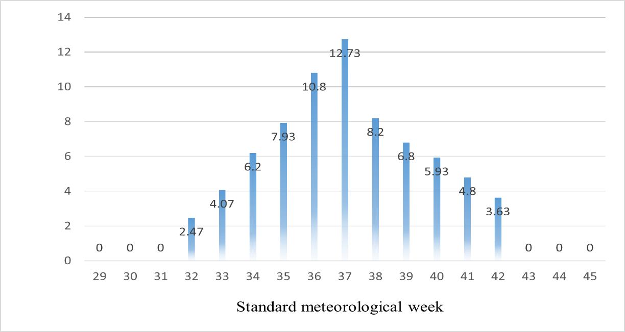
Fig 1: Dead heart caused by rice yellow stem borer during Kharif ,2024.

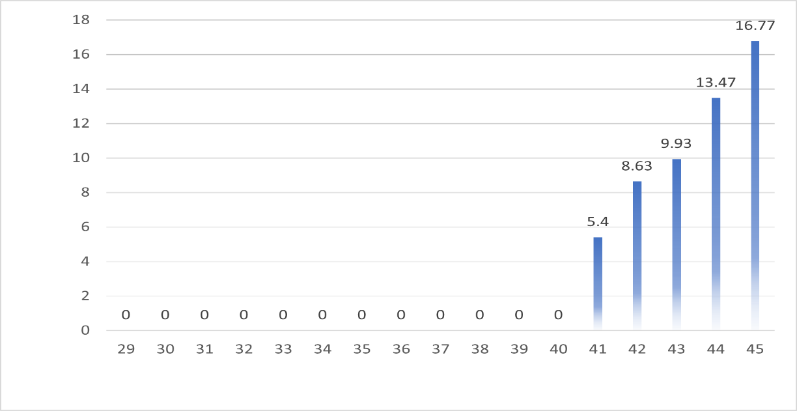
Fig 2: white ear head caused by rice yellow stem borer during Kharif ,2024. Seasonal incidence of rice leaffolder, Cnaphalocrocis medinalis during kharif 2024
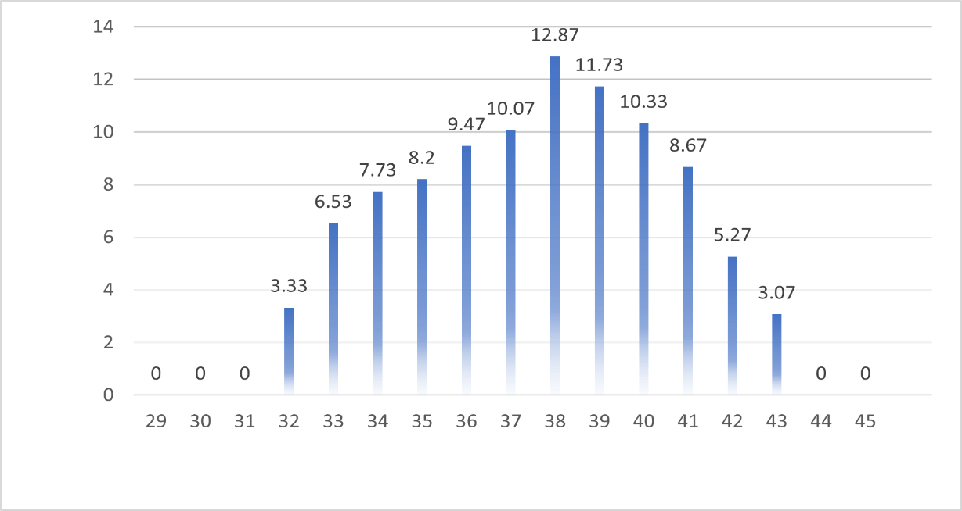
The rice leaffolder appeared during 32nd SMW i.e., 2nd week of August with a mean percent leaf damage of 3.33 % per hill. The incidence build up gradually and reached to its peak in the third week of September (38th SMW) with a mean percent leaf damage of 12.73 % per hill, when the maximum temperature, minimum temperature, rainfall, morning relative humidity, evening relative humidity and sunshine hours were 31.7 ºC, 25.2 ºC, 94.6 mm 90 per cent, 68 per cent and 4.2 hrs, respectively. Then, the percentage leaf damage declined. (Table 2) it completely disappeared after 43rd SMW and peak incidence period was last week of August to last week of September.

Fig 3: Seasonal incidence of rice leaffolder during Kharif, 2024

Seasonal incidence of rice butterfly Melanitis leda during kharif 2024

Rice butterfly appeared during 32nd SMW i.e., 1st week August of with a mean incidence of
2.27 % insects per hill. The incidence build up gradually and reached to its peak in the last week of September (39th SMW) with a mean incidence of 10.6% insects per hill, when the maximum temperature, minimum temperature, rainfall, morning relative humidity, evening relative humidity and sunshine hours were 30.8 ºC, 24.6 ºC, 121 mm, 92 per cent, 79 percent and 2.3 hrs, respectively. Then, the incidence of rice butterfly declined, (Table 2)
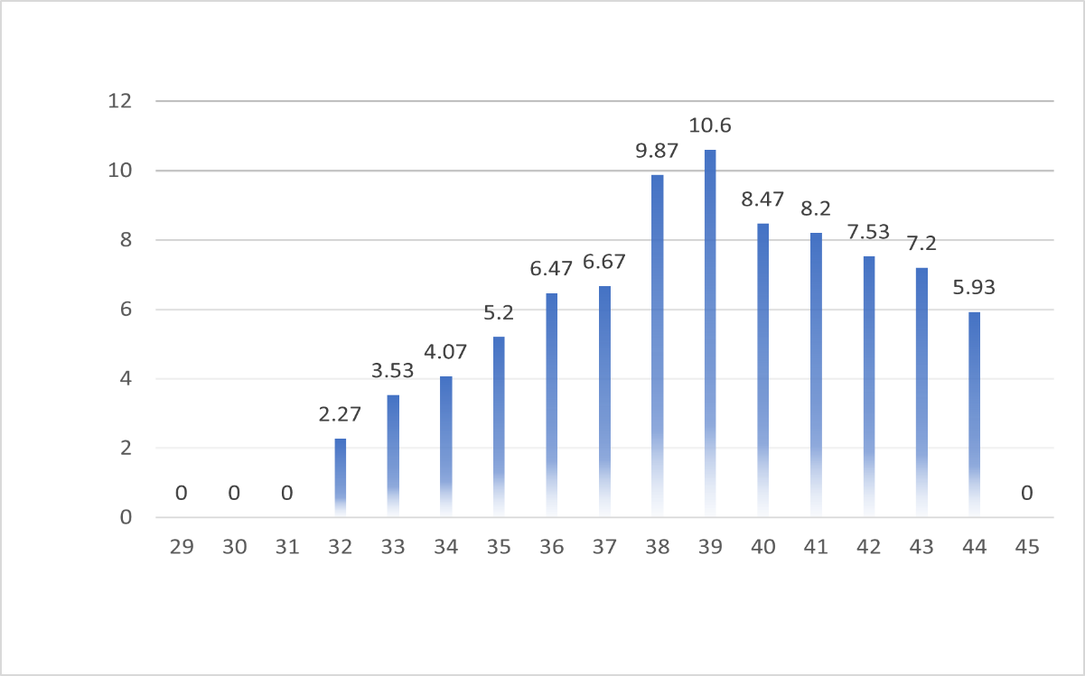
Fig 4: Seasonal incidence of rice Butterfly during Kharif, 2024

Table 2: Seasonal incidence of insect in rice crop during Kharif, 2024.

Incidence /damage average population of insect and larvae /hill
S.N. | SMW | Duration | DH | WEH | LEAFFOLDER | RICE BUTTERFLY
1 | 29 | July 16-22 | 0 | 0 | 0 | 0
2 | 30 | 23-29 | 0 | 0 | 0 | 0
3 | 31 | 30-05 | 0 | 0 | 0 | 0
4 | 32 | Aug 06-12 | 2.47 | 0 | 3.33 | 2.27
5 | 33 | 13-19 | 4.07 | 0 | 6.53 | 3.53
6 | 34 | 20-26 | 6.20 | 0 | 7.73 | 4.07
7 | 35 | 27-02 | 7.93 | 0 | 8.20 | 5.20
8 | 36 | Sep 03-09 | 10.80 | 0 | 9.47 | 6.47
9 | 37 | 10-16 | 12.73 | 0 | 10.07 | 6.67
10 | 38 | 17-23 | 8.20 | 0 | 12.87 | 9.87
11 | 39 | 24-30 | 6.80 | 0 | 11.73 | 10.6
12 | 40 | Oct 01-07 | 5.93 | 0 | 10.33 | 8.47
13 | 41 | O8-14 | 4.80 | 5.40 | 8.67 | 8.20
14 | 42 | 15-21 | 3.63 | 8.63 | 5.27 | 7.53
15 | 43 | 22-28 | 0 | 9.93 | 3.07 | 7.20
16 | 44 | 29-04 | 0 | 13.47 | 0 | 5.93
17 | 45 | Nov 05-11 | 0 | 16.77 | 0 | 0

Table 3: Seasonal incidence range of major insect’s pest of rice during kharif, 2024

Major insect pests
S.No. | Name of  insect | Scientific name | Range (%) | Active period | Peak activity period
1 | Yellow stem borer | Scirpophaga incertulas | 2.47-12.73 | Early tillering to maturity stage | September first week to 3rd week of September
2 | yellow stem borer  white ear head | Scirpophaga incertulas | 5.41-16.77 | Panicle initiation to maturity stage | October 3rd week to 4th week of October
3 | Rice leaffolder | Cnaphalocrocis medinalis | 3.33-12.87 | Late tillering to maturity stage of crop | Last week of august to first week of October
4 | Rice Butterfly | Melanitis leda | 2.27-10.60 | Late tillering to maturity stage of crop | Last week of august to first week of October

Seasonal incidence of natural enemies

In the experimental field, active period of natural enemies was recorded during the vegetative period to the crop maturity stage. Natural enemies associated with crop included the lady bird beetle and spiders. (Table 4)
Seasonal incidence of lady bird beetle in rice crop during Kharif, 2024.

Lady bird beetles of species mainly Novius cardinalis appeared during 2nd week of September (37th SMW) with initial average incidence of 0.63 adults/hill. The highest incidence was seen in the 1st week of October (40th SMW) with average incidence of 1.4 adults per hill. Later, the incidence declined to 0.5 adults/hill in the 3rd week of October (42nd SMW).

Seasonal incidence of spiders in rice crop during Kharif, 2024.

Spiders of species Paradosa pseudoanulata and Neoscona theisi appeared during 2nd week of August (33rd SMW) with initial average incidence of 0.53 adults/hill. The highest incidence was seen in the last week of September (39th SMW) with average incidence of 2.87 adults per hill. Later, the incidence declined to 0.73 adults/hill in the 3rd week of October (42nd SMW).
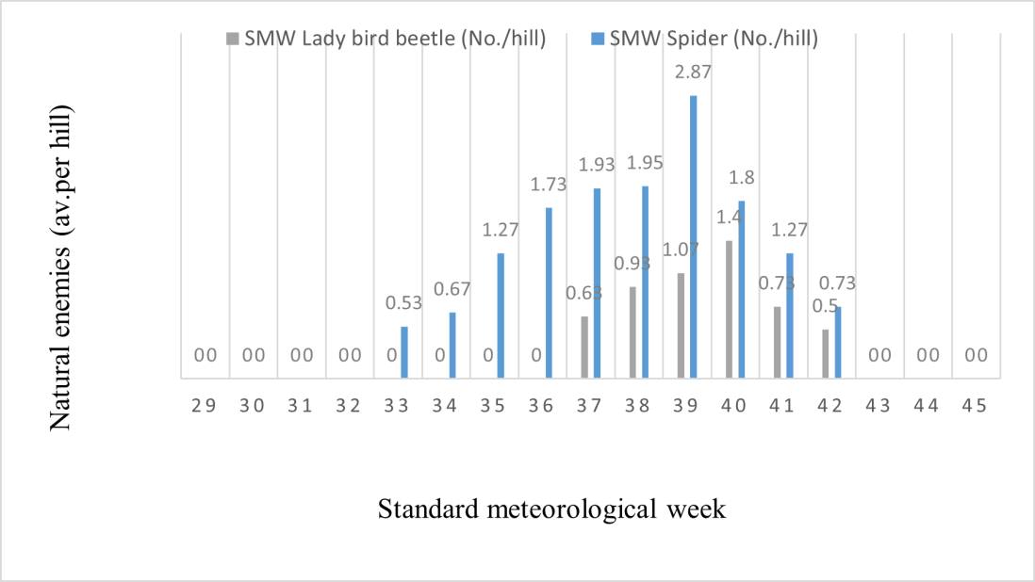

Fig 5: Seasonal incidence of natural enemies in rice crop during Kharif, 2024.

Table 4: Seasonal incidence of natural enemies in rice crop during Kharif, 2024.

 |  | Natural enemies
SMW | Duration
 | Lady bird beetle (No./hill) |  | Spider (No./hill)
29 | July 16-22 | 0 | 0
30 | 23-29 | 0 | 0
31 | 30-05 | 0 | 0
32 | Aug 06-12 | 0 | 0
33 | 13-19 | 0 | 0.53
34 | 20-26 | 0 | 0.67
35 | 27-02 | 0 | 1.27
36 | Sep 03-09 | 0 | 1.73
37 | 10-16 | 0.63 | 1.93
38 | 17-23 | 0.93 | 1.95
39 | 24-30 | 1.07 | 2.87
40 | Oct 01-07 | 1.40 | 1.80
41 | 08-14 | 0.73 | 1.27
42 | 15-21 | 0.50 | 0.73
43 | 22-28 | 0 | 0
44 | Oct 29-04 | 0 | 0
45 | Nov 05-11 | 0 | 0
 | Mean | 0.30 | 0.86

Table 5: Occurrence of Natural enemies in rice crop during Kharif, 2024

S.No | Natural enemies | Range in (%) | Period of activity | Peak period of activity
1. | Lady bird beetle | 0.5-1.4 | 2nd week of September to 3rd  week of October | last week of  September
2. | Spiders | 0.53-2.87 | 2nd week of August to 3rd week of October | last week of September

DISCUSSION

The seasonal incidence patterns observed in the Chhattisgarh rice ecosystem were broadly consistent with findings from other major rice-growing states of India. For example, peak infestations of [key pest, e.g., stem borer] during the [tillering/panicle initiation] stage align with reports from West Bengal (Sharma et al., 2022) and Odisha (Patra and Dash, 2021). Similarly, the dominance of natural enemies such as [name of predator/parasitoid] parallels observations in Tamil Nadu (Ravi et al., 2020), suggesting that these beneficial organisms are widespread and play a vital role in suppressing pest outbreaks across diverse agro-climatic zones. However, some regional differences emerged. The comparatively higher incidence of [pest name] in Chhattisgarh may reflect local climatic conditions—particularly the extended monsoon period—or specific varietal preferences, as also noted in studies from eastern Uttar Pradesh (Kumar et al., 2019). Such comparisons emphasize the need to tailor integrated pest management (IPM) strategies to regional pest complexes and cropping calendars.

CONCLUSION

The study demonstrates that timely monitoring of key pests and their natural enemies is essential for sustainable rice production in Chhattisgarh. Farmers are advised to:

- Adopt regular field scouting during the identified peak periods (e.g., [insert growth stages/months]) to enable early detection and control.
- Conserve natural enemies by minimizing indiscriminate insecticide use and encouraging habitat management (flowering borders, refugia).

- Implement region-specific IPM modules, integrating resistant rice varieties, need-based chemical applications, and biological control agents.

By aligning pest management practices with the seasonal dynamics documented here, farmers can reduce crop losses, lower input costs, and support long-term ecological balance.

IMPORTANCE OF THIS RESEARCH

This study contributes valuable information on the seasonal incidence and dynamics of key insect pests (yellow stem borer, rice leaffolder, rice butterfly) and their natural enemies (ladybird beetle, spiders) in the rice ecosystem of Chhattisgarh. Such data are essential for developing location-specific integrated pest management (IPM) strategies and predicting pest outbreaks based on seasonal and climatic factors. The findings provide a practical basis for farmers, researchers, and policymakers to implement timely pest control interventions, thereby reducing crop losses. Additionally, the study strengthens the existing literature on pest-weather interactions in Eastern India’s rice ecosystems.

ACKNOWLEDGEMENTS
I take this golden opportunity to express my deepest sense of gratitude to the chairman of my Advisory Committee Dr.Navneet Rana, Adittional member Dr. Richa Choudhary and my friend Sushant sharma for her research insight, able guidance, constant encouragement, unique supervision and kind sympathetic attitude, despite her heaviest schedule of work, her patience and creative guidance has given touch of excellence to this manuscript.

Disclaimer (Artificial intelligence)
Option 1:
Author(s) hereby declare that NO generative AI technologies such as Large Language Models (ChatGPT, COPILOT, etc.) and text-to-image generators have been used during the writing or editing of this manuscript.
Option 2:
Author(s) hereby declare that generative AI technologies such as Large Language Models, etc. have been used during the writing or editing of manuscripts. This explanation will include the name, version, model, and source of the generative AI technology and as well as all input prompts provided to the generative AI technology
Details of the AI usage are given below:
1.
2.
3.

REFERENCES:

Adiroubane, D. and Raja, K. 2006. Influence of weather parameters on the occurrence of rice yellow stem borer, Scirpophaga incertulas (Walker). J. Rice Res., 3(1): 5-9.
Anonymous, 2023a. Area and production of rice in Chhattisgarh, rice extension division Department of agriculture and farmer welfare.Govt of Chhattisgarh. Vol. 10(2), 1620.
Anonymous, 2023b. Area and production of Paddy in India. Agriculture statistics Division, Department of Agriculture, Cooporation and farmers welfare. Vol. 43(10), 13-18.
Baskaran, R. M., Sharma, K. C. and Kumar, J. 2017. Seasonal and relative abundance of stem- borer and leaffolder in wet land rice eco-system. Journal of Entomology and Zoology Studies., 5(2): 879-884
Chavan, S.M., Patel, K.G. and Arve, S.S. 2013. Seasonal incidence of rice yellow stem borer, Scirpophaga incertulas (Walker) in relation to crop growth stages under south Gujarat condition. An International e- Journal of AGRES., vol. 2: 232-239.
Dogra, I. and Choudhary, A. 2005. Some insect pests of rice, Oryza sativa Linn. in Kangra Valley of Himachal Pradesh. Insect Environment. 11(1): 21-22.
Food and Agricultural Organization of the United Nations. 2004. The state of food security in the world, FAO, Rome, Italy, pp30-31.
Patil, S.D., Kusalkar, D.V., Patil, H.M. and Bhoite, K.D. 2020. Seasonal incidence of insect pests on rice and impact of various abiotic factors on their incidence. Journal of Pharmacognosy and Phytochemistry., 9(2): 1869-1872.
Rahman., Islam, S.K., Jahan, M. and Mamun, A. 2014. Relative abundance of stem borer species and natural enemies in rice Ecosystem at Madhupur, Tangali, Bangladesh. Bangladesh Agril.Univ, 267-272.
Sulagitti, A., Raghuraman, M., Sai Reddy, M.S. and Sathua, S.K. 2017. Seasonal variation in major insect pest’s incidence on rice and impact of various abiotic factors on their incidence under Varanasi conditions. Journal of Entomology and Zoology Studies. 5(3): 1060-1063.
Seni, A. and Naik, B. 2018. Influence of different abiotic factors on the incidence of major insect pests of rice (Oryza sativa L.). Journal of Agrometeorology., 20(3): 256-258.

Singh, R., Chander, S., Lakhi, R., Kumar, R., Kumar, P. and Singh, D. 2018. Influence of weather parameters on insect pests of rice in Haryana. Journal of Agrometeorology 20 (Special Issue): 307-310.
Seni, A. and Naik, B. 2018. Influence of different abiotic factors on the incidence of major insect pests of rice (Oryza sativa L.). Journal of Agrometeorology. 20 (3): 256-258.
Seni, A., Pal, R. and Mohanty, A.K. 2022. Role of abiotic factors on the seasonal variation in infestation of the major insect pests of rice (Oryza sativa L.) in Odisha. Journal of Agrometeorology. 24 (1): 106-108.
Tiwari, S., Chaudhary, J.L., Puranik, H.V. and Singh, B. 2021. Influence of weather parameters on population dynamics of rice leaf folder (RLF) in rice crop at Raipur district of Chhattisgarh. Journal of Entomology and Zoology Studies., 9(2): 1242-1248.
Yadav, A., Gupta, P.K. and Kurulkar, U. 2019. Incidence of Insect-Pests on Rice in Faizabad. International Journal of Current Microbiology and Applied Sciences., 8(6): 551-555.
Yele, Y., Chander, S., Suroshe, S. S., Nebapure, S. M., Arya, P. S., and Prabhulinga, T. 2022. Effect of ecological engineering on incidence of key rice pests. Indian Journal of Entomology, 503-508.

