Valuation Of Ant Community Inhabiting Chincholi Wildlife Sanctuary, Kalaburagi Through Cytochrome Oxidase Subunit I Gene

ABSTRACT
DNA barcoding has been suggested to more precisely identify different organisms. There is a little information on the DNA barcoding of the ant species communities in the Kalaburagi region. Considering this, a study was conducted in 2022-2025 to do DNA barcoding of three ant specimens, which were collected from diverse habitat using hand collection, pitfall traps and aspirators inside the Chincholi wildlife sanctuary in Kalaburagi, Karnataka, India. DNA barcoding employs one or more short, standardized DNA segments to identify taxa. COI sequences of ~650 bp were successfully generated for 3 species. Cytochrome oxidase subunit I (COI) was used to do the phylogenetic connection analysis. The three unique COI gene nucleotide sequences were assigned the accession numbers PX453292 (Camponotus singularis), PX453294 (Crematogaster brunnea), and PX453302 (Monomorium indicum) upon their deposit into the GenBank database. Clustal-W in MEGA 11.0 was used to accomplish multiple sequence alignment, and a neighbour joining tree, maximum likelihood, and phylogenetic analysis were built. The study provides the first baseline DNA barcode reference library for ants of Chincholi Wildlife Sanctuary. Additionally, our results are consistent with DNA barcoding of three ant species from various Indian states and foreign nations. This study represents the first record of C. singularis and C. brunnae from Karnataka and offers thorough justification for more wet lab research that supports conventional classification.
Keywords: DNA Barcoding, COX 1 gene, Chincholi wildlife sanctuary, Comparative analysis, Phylogenetics
- INTRODUCTION
Ants deserve a specific position in the study of ecology and behavior since they are vital to the environment. Ants are eusocial insects with large biomass, high density, and a very high species richness. Given their importance to the ecology, ants provide an intriguing model system in ecological research (Begum et al., 2021). Ants are a significant collection of animals that are grouped together in the mono-family Formicide and order Hymenoptera, with over 25000 species known to science and probably more to come. Ants have developed into the most species rich and ecologically diversified group of social insects, accounting for almost 30% of the terrestrial faunal biomass worldwide (Dad et al., 2019).

Ant DNA barcoding documentation and catalogue in India has been patchy, with most of the previous research concentrating on systematics and species enumeration. The basic idea behind DNA barcoding, a technique for obtaining species-specific DNA signatures, is that sequence diversity in brief segments of an organism's genome can create a "biological barcode" that allows for species-level identification of any organism (Hebert et al., 2003; Marshall, 2005).
The mitochondrial cytochrome oxidase subunit I (COI) gene region's DNA sequence data is frequently used to determine evolutionary relationships between various insects. No comprehensive study had been conducted on DNA barcoding for specific ant species at in Chincholi wildlife sanctuary, Kalaburagi, Karnataka. For the first time, a DNA-based mitochondrial-CO1 gene approach was used to try and identify them.

- MATERIALS AND METHOD
The study's ants were gathered between January 2022 and December 2024. Chandramalli, Konchavaram, and Shadipur are the three main forest portions that make up the sample field. Chincholi Forest, Sangapur Forest, Bhonsapur Forest, Magdumpur Forest, and Shadipur Forest are the five distinct blocks. Ants were gathered using baiting, pitfall traps, active hand picking, and pounding vegetation. After being gathered, the ants were put into tubes with 95% alcohol. After that, the specimens were sorted and cleaned. Ant taxonomy keys (Bingham, 1903) were then used to identify each of the sorted morphospecies up to the species level (Bharti et al., 2016), and NCBS Bangalore evaluated and validated the results.
Methodology
Genomic DNA Isolation
Genomic DNA from ants were extracted using the acetyl trimethyl ammonium bromide (CTAB) method. Before homogenization, the specimens were rinsed with sterile distilled water to eliminate any residual alcohol. Individual ants were ground in liquid nitrogen using a mortar and pestle. The resulting material was transferred into 1.5 mL microcentrifuge tubes and suspended in 500 µL of tissue lysis buffer (containing 100 mM Tris-HCl pH 8.0, 1.4 M NaCl, 0.02 M EDTA, 2X CTAB, 2X PVP), with 2 µL of β-mercaptoethanol freshly added just before use. The homogenized samples were incubated at 65 °C for 1 hour with occasional inversion to mix. After incubation, an equal volume of chloroform-isoamyl alcohol (24:1 v/v) was added and left at room temperature for 5–10 minutes. The mixture was centrifuged at 12,000 rpm for 15 minutes, and the supernatant was transferred to a new 1.5 mL tube. An equal volume of ice-cold isopropanol was added to precipitate the DNA. This was followed by centrifugation at 13,000 rpm for 15 minutes. The DNA pellet was washed twice with 70% ethanol, air-dried, and then resuspended in 20 µL of TE buffer (1 M Tris, 0.5 M EDTA, pH 8). DNA concentration and purity were assessed using a Nanodrop spectrophotometer (Thermo Scientific, USA), and DNA integrity was confirmed via agarose gel electrophoresis.

Molecular Confirmation and phylogeny
A 658-base pair (bp) fragment of the mitochondrial cytochrome oxidase subunit I (COI) gene was amplified for molecular identification and DNA barcoding, following the method by Folmer et al., (1994). Universal COI primers LCO-1490 (5’-GGTCAACAAATCATAAAGATATTGG-3’) and HCO-2198 (5’-TAAACTTCAGGGTGACCAAAAAATCA-3’) were used for PCR amplification (Hebert et al., 2003). The PCR was carried out in a thermal cycler (Veriti, ABI-Applied Biosystems, USA) using the following conditions: initial denaturation at 94 °C for 4 minutes; 35 cycles of denaturation at 94 °C for 30 seconds, annealing at 47 °C for 45 seconds, and extension at 72 °C for 45 seconds; followed by a final extension at 72 °C for 20 minutes. Each 25 µL PCR reaction contained approximately 20 picomoles of each primer, 10 mM Tris-HCl (pH 8.3), 50 mM KCl, 2.5 mM MgCl₂, 0.25 mM of each dNTP, and 0.5 U of Taq DNA polymerase (Thermo Scientific, USA). The PCR products were separated on a 1.2% agarose gel stained with ethidium bromide (10 µg/mL) and visualized using a gel documentation system (UVITEC, USA). Bands corresponding to the expected 658 bp size were excised and purified using the Nucleo Spin Gel and PCR Clean-up Kit (Macherey-Nagel, Germany), following the manufacturer’s protocol. Sanger sequencing of the purified products was conducted by Medauxin Biotechnology, Bengaluru, Karnataka, using the same universal primers. Sequence homology was assessed using NCBI-BLAST (http://blast.ncbi.nlm.nih.gov/), and alignment was done using the Clustal W algorithm in BioEdit version 7.0 (Hall, 1999). Further phylogenetic analysis was performed in MEGA 11 (Tamura et al., 1993), and a Neighbor-Joining tree was constructed using the Kimura 2-parameter model (Kimura, 1980; Saitou and Nei, 1987).

- RESULT AND DISCUSSION
Nucleotide Composition Analysis of Selected Ant Species
To understand the molecular composition and compare the genetic sequences among selected ant species, a nucleotide frequency analysis was performed. The DNA sequences from six ant species were analysed to count the frequency of four nucleotide bases: Adenine (A), Thymine (T), Cytosine (C), and Guanine (G).
Species Name | Adenine (A) | Thymine (T) | Cytosine (C) | Guanine (G)
Camponotus singularis | 196 | 251 | 129 | 73
Crematogaster brunnea | 182 | 250 | 128 | 76
Monomorium indicum | 192 | 250 | 113 | 81
Table 1: Nucleotide Counts in DNA Sequences of Ant Species
This study represents the first record of C. singularis and C. brunnae from Karnataka. C. singularis is previously known to be native to Sikkim and West Bengal, while C. brunnae is native to Tamil Nadu, and C. brunnae rabula is native to Karnataka. The present finding thus extends the known geographical distribution of C. singularis and C. brunnae to Karnataka.
Table 2: Analysis of Genetic distance
Species | Fragment size  (bp) | A+T | G+C | Genetic Distance
Camponotus singularis | 649 | 447 (68.87) | 202 (31.12) | 0.0062
Crematogaster brunnea | 636 | 432 (67.92) | 204 (32.07) | 0.0157
Monomorium indicum | 636 | 442 (69.49) | 194 (30.50) | -
Based on G+C content, Monomorium indicum is compositionally closer to Camponotus singularis (distance = 0.0062) than to Crematogaster brunnea (distance = 0.0157).
These small differences suggest low divergence in base composition among the mitochondrial COI (or similar) fragments examined. Genetic distance was estimated using nucleotide composition (GC%) differences, calculated as:
D=∣GC1−GC2∣
This approach provides an approximate measure of sequence divergence when alignment data.
Genetic distances between Monomorium indicum and two other ant species were estimated based on differences in GC composition (Sueoka, 1961; Nei, 1972; Kimura, 1980). The results indicated that M. indicum was compositionally more similar to Camponotus singularis (D = 0.0062) than to Crematogaster brunnea (D = 0.0157).
Genetic distance among Camponotus singularis, Crematogaster brunnea, and Monomorium indicum was estimated using differences in nucleotide composition (G+C%). This approach provides a simple comparative measure of genetic divergence when sequence alignment or substitution data are unavailable (Sueoka, 1961; Nei, 1972). The G+C contents of the three species were 31.12%, 32.07%, and 30.50%, respectively. Based on these values, the calculated genetic distance between M. indicum and C. singularis was 0.0062, whereas the distance between M. indicum and C. brunnea was 0.0157. The relatively small differences suggest that all three species share similar base compositions, indicating limited divergence at the nucleotide composition level. Such compositional comparisons provide preliminary insights into molecular relationships and can complement sequence-based genetic distance models (Kimura, 1980; Tamura & Nei, 1993).

Fig 1: Grouped bar chart of nucleotide composition in different ant species
The grouped bar chart above displays the nucleotide distribution for each ant species. Each group of bars represents a species, and each bar within the group indicates the count of a specific nucleotide (A, T, C, G). The Thymine (T) content was the highest among all species, followed by Adenine (A). In contrast, Cytosine (C) and Guanine (G) were present in comparatively lower quantities. This trend indicates AT-rich sequences across all examined species, a characteristic often seen in mitochondrial DNA
4. OBSERVATIONS AND DISCUSSION
All three species show a consistent pattern of high Adenine (A) and Thymine (T) content, suggesting an AT-rich genome. Camponotus singularis had the highest Thymine (T) content (251) Adenine (A) count (196), Cytosine (C) count (129), and Guanine (G) remained the least abundant nucleotide across all species. This nucleotide composition data provides foundational insights into the molecular biology of these ant species and may assist in further comparative genetic and evolutionary studies. The mitochondrial nucleotide composition of Monomorium indicum showed dominance of wan AT-rich pattern 442 (69.49). C and G were less represented, with 194 (30.50) counts respectively.
Table 3. DNA barcoded ant species form Chincholi Wildlife Sanctuary, Kalaburagi
Species name | Accession No. | % Similarity | Location
Camponotus singularis | PX453292 | Present study | Kalaburagi Karnataka.
 | OP580130 | 99.85% (657) | Patiala, Punjab
 | JQ681084 | 93.22% (657) | Guangxi, China
 | PV353704 | 93.68% (664) | Guangdong, China
 | OP572223 | 100% (657) | Patiala, Punjab
Crematogaster brunnea | PX453294 | Present study | Kalaburagi Karnataka.
 | MV056457 | 100 (690) | Calicut, Kerala
 | ON382298 | 97.94 (635) | Delhi
 | KC501979 | 87.08 (658) | Madagascar
Monomorium indicum | PX453302 | Present study | Kalaburagi Karnataka.
 | KY000662 | 98.11 (658) | Bangalore, Karnataka
 | OQ954889 | 100 (538) | Jammu, J and K
 | ON254654 | 100 (636) | Jammu, J and K
The mitochondrial COI gene fragments of three ant species, i.e., Camponotus singularis, Crematogaster brunnea, and Monomorium indicum was obtained from Kalaburagi, Karnataka, were analyzed for sequence similarity using the NCBI BLAST tool. The Camponotus singularis sequence (Accession No. PX453292) from the present study showed the highest similarity (100%) with C. singularis sequences from Patiala, Punjab (Accession No. OP572223), and 99.85% similarity with another sequence from the same region (Accession No. OP580130). Comparatively lower similarities (93.22–93.68%) were observed with C. singularis sequences from Guangxi and Guangdong, China, indicating minor regional variations in the COI fragment.
The Crematogaster brunnea sequence (PX453294) showed complete similarity (100%) with a sequence from Calicut, Kerala (MV056457), and slightly lower similarity (97.94%) with a sequence from Delhi (ON382298), suggesting limited intraspecific variation across Indian populations. The lowest similarity (87.08%) was observed with a Crematogaster sequence from Madagascar (KC501979), indicating a higher genetic divergence between Asian and African populations.
For Monomorium indicum (PX453302), sequences showed high similarity (98.11–100%) with specimens from Bangalore, Karnataka (KY000662), and Jammu, Jammu & Kashmir (OQ954889, ON254654), demonstrating genetic uniformity across geographically distinct Indian populations. These results collectively confirm species-level identification and highlight moderate regional genetic variation consistent with previous studies on mitochondrial DNA barcoding in Formicidae (Hebert et al., 2003; Smith et al., 2005).

Fig.2 Dendrogram based on cluster analysis that shows the genetic links between 13 distinct ant species was produced using MEGA 11 Software's Bootstrap Test Phylogeny and the N-J (Neighbour-joining) method.
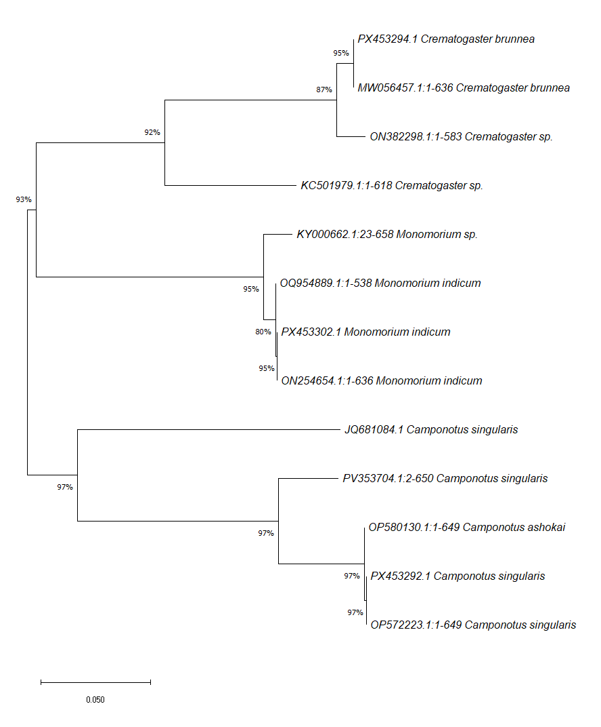

Two groups were identified via a phylogenetic tree built with the N-J approach (Fig. 2). Two sub-clades that represented two ant subfamilies made up the first cluster: Formicinae (1 species), which descended from similar ancestors. Since all three were morphologically identified using conventional morphological keys, the second main cluster included the subfamily Myrmicinae (2 species), which demonstrated the sharing of similar characters. This is in line with cladistics analysis of ant morphological data and also supports traditional phylogeny. The sequences acquired in this investigation were contrasted with GenBank homologous sequences.

5. CONCLUSION: The current study unequivocally demonstrates how taxonomic research will be substantially aided and complemented by the availability of DNA techniques for diversity assessment. Traditional taxonomy combined with DNA sequencing data will provide a model that may be used in many different fields. It will speed up the identification of new species, which will ultimately aid in addressing the current biodiversity issue. DNA barcoding has enormous potential utility in situations where species identification is challenging. According to our findings, cox1 barcoding will enable the unmistakable identification of Indian ant species; therefore, an integrated taxonomy strategy is required for the prompt identification of insect biodiversity.

DISCLAIMER (ARTIFICIAL INTELLIGENCE)
The authors hereby certify that this work was not written or edited using any generative AI tools, including text-to-image generators and large language models (ChatGPT, Gemini, etc.).
COMPETING INTERESTS
Authors have declared that no competing interests exist.
REFERENCES
Begum, R., Majagi, S. H., & Vijaykumar, K. (2021). Ants species richness and diversity in relation to different ecological habitat in selected localities of the semi-arid region of Karnataka, India. Environmental Monitoring and Assessment, 193(3), 145.
Bharti, H., Guénard, B., Bharti, M., & Economo, E. P. (2016). An updated checklist of the ants of India with their specific distributions in Indian states (Hymenoptera, Formicidae). ZooKeys, (551), 1.
Bingham, C. T. (1903). Hymenoptera: Ants and cuckoo-wasps (Vol. 913). Taylor & Francis.
Dad, J. M., Akbar, S. A., Bharti, H., & Wachkoo, A. A. (2019). Community structure and ant species diversity across select sites of Western Ghats, India. Acta Ecologica Sinica, 39(3), 219-228.
Folmer, O., Black, M., Hoeh, W., Lutz, R., & Vrijenhoek, R. (1994). DNA primers for amplification of mitochondrial cytochrome c oxidase subunit I from diverse metazoan invertebrates. Molecular marine biology and biotechnology, 3(5), 294–299.
Hall, T. A. (1999, January). BioEdit: a user-friendly biological sequence alignment editor and analysis program for Windows 95/98/NT. In Nucleic acids symposium series (Vol. 41, No. 41, pp. 95-98).
Hebert, P. D., Cywinska, A., Ball, S. L., & DeWaard, J. R. (2003). Biological identifications through DNA barcodes. Proceedings of the Royal Society of London. Series B: Biological Sciences, 270(1512), 313-321.
Kimura, M. (1980). A simple method for estimating evolutionary rates of base substitutions through comparative studies of nucleotide sequences. Journal of molecular evolution, 16(2), 111-120.
Marshall, E. (2005). Will DNA bar codes breathe life into classification?.
Nei, M. (1972). Genetic distance between populations. The American Naturalist, 106(949), 283-292.
Saitou, N., & Nei, M. (1987). The neighbor-joining method: a new method for reconstructing phylogenetic trees. Molecular biology and evolution, 4(4), 406-425.
Sueoka, N. (1961). Correlation between base composition of deoxyribonucleic acid and amino acid composition of protein. Proceedings of the National Academy of Sciences, 47(8), 1141-1149.
Tamura, K., & Nei, M. (1993). Estimation of the number of nucleotide substitutions in the control region of mitochondrial DNA in humans and chimpanzees. Molecular biology and evolution, 10(3), 512-526.

