Original Research Article
Toxicity of diverse group of insecticides against Bihar hairy caterpillar, Spilosoma obliqua Walker – an emerging legume defoliator

ABSTRACT
Bihar hairy caterpillar, Spilosoma obliqua (Walker) is a serious defoliator insect pest on blackgram, green gram, castor, sunflower, mustard, cole crops, jute and mulberry. A laboratory bioassay was conducted against the 4th instar S. obliqua larva during 2024 and 2025 to assess the toxicity and speed of kill of four different group of insecticides belonging to different mode of action like ryanodine receptor modulator, Acetyl choline esterase (Ache) inhibitor, nicotinic Acetyl choline receptor (nAChR) allosteric modulator and sodium channel modulator using the surface diet contamination method. Probit analysis revealed variable toxicity among the 4 different groups of insecticides tested showed. The sodium channel modulator i.e. Cypermethrin 25 EC has recorded lowest LC₅₀ (23.89 ppm) showing it as best insecticide for management of S. obliqua and this was followed by ryanodine receptor modulators like Chlorantraniliprole 18.5 SC (25.99ppm), Cyantraniliprole 10OD (89.35) and nAChR allosteric modulator i.e. Spinosad 45 SC (120.27 ppm). While Flubendiamide 39.35 SC (640.75 ppm) was least effective followed by Quinalphos 25 EC (500.69 ppm), and Tetraniliprole 18.18 SC (144.68 ppm). Further, LT₅₀ values of above 7 insecticides varied from 1.80 to 7.23 days. Cypermethrin 25 EC has the showed fastest knockdown effect with lowest LT₅₀ (1.8 days), followed by Spinosad (1.9 days), Tetraniliprole 18.18 SC (3.23 days) and Quinalphos 25 EC (3.74). Among diamides, Tetraniliprole (3.23 days), Cyantraniliprole (4.12 days) and Chlorantraniliprole (4.22 days) exhibited quicker action than Flubendiamide (7.23 days). Cypermethrin 25 EC was identified as most effective insecticide for S. obliqua management by considering both toxicity and speed of kill. This was followed by Spinosad 45 SC, Chlorantraniliprole 18.5 SC and Cyantraniliprole 10 OD. Thus 3 different mode of action insecticides are identified for inclusion in IPM programmes for sustainable management of S. obliqua without insecticide resistance development.
Keywords: Toxicology; Cypermethrin, Spinosad, Diamide insecticide, Surface diet contamination, LC₅₀, LT₅₀, Insecticide efficacy.

1. INTRODUCTION
The Bihar hairy caterpillar, Spilosoma obliqua (Walker) (Lepidoptera: Arctiidae) is one of the most destructive polyphagous pests infesting a wide range of crops, including pulses, oilseeds, and fibre crops across India. Its host range includes Vigna mungo, V. radiata, Cajanus cajan, Glycine max, Sesamum indicum, Gossypium hirsutum, and Ricinus communis among others, making it a major emerging constraint to sustainable legume production (Mishra & Singh, 2014; Chandrashekharaiah & Jagadish, 2018;). Further the defoliator is extending its host range in other unconventional legumes like field pea and rice bean (Sujayanand et al., 2023; Sujayanand et al., 2021). The larvae feed voraciously on the foliage, tender shoots, and sometimes pods, resulting in severe defoliation and yield loss. Under favourable environmental conditions, the pest can build up rapidly, causing complete defoliation within a few days. Its polyphagous nature, overlapping generations, and ability to survive on alternate hosts throughout the year make its management particularly difficult (Dey & Bar, 2016).
Chemical control has remained the most reliable and rapid approach for managing S. obliqua, especially during epidemic outbreaks when other management options such as biological and cultural control are less effective (Anand & Tiwary, 2009). Moreover, resistance breeding in legumes against S. obliqua was in nascent stage as most of the work is concentrated towards whitefly, aphids, thrips, stem fly and spotted pod borer (Cheema et al., 2017). A wide range of insecticides belonging to different chemical groups have been utilized against this pest, including conventional insecticides such as organophosphates and pyrethroids, and newer groups such as spinosyns and diamides (Ayyanath & Karthikeyan, 2015; Singh & Sharma, 2020). However, indiscriminate and repeated use of broad-spectrum insecticides has resulted in resistance development, pest resurgence, and negative effects on natural enemies and the environment (Ahmad & Arif, 2010). Therefore, identifying effective, selective, and eco-compatible insecticides is crucial for the sustainable management of this pest.
Among the conventional insecticides, organophosphate insecticides such as quinalphos, chlorpyrifos, and monocrotophos have been widely used due to their quick knockdown effect and broad-spectrum activity. These compounds act by inhibiting acetylcholinesterase, leading to accumulation of acetylcholine and disruption of nerve transmission (Kranthi & Jadhav, 2002). However, their prolonged use has led to reduced effectiveness due to the development of resistance in S. obliqua populations and persistence in the environment (Ahmad & Arif, 2010). Similarly, synthetic pyrethroids like cypermethrin, deltamethrin, and fenvalerate gained popularity for their high potency and low mammalian toxicity, but frequent applications have also contributed to resistance buildup and decreased efficacy (Tiwari & Dutta, 2017).
In contrast, newer insecticides with novel modes of action, such as diamides and spinosyns, have emerged as effective alternatives. Diamide insecticides, including chlorantraniliprole and flubendiamide, act on ryanodine receptors in insect muscle cells, causing uncontrolled calcium release, muscle paralysis, and death (Patil & Kulkarni, 2019). They exhibit excellent efficacy even at low concentrations, with minimal impact on beneficial organisms and the environment. Similarly, spinosyns, represented by spinosad and spinetoram, are fermentation derived insecticides produced by Saccharopolyspora spinosa. These act on nicotinic acetylcholine receptors and GABA-gated ion channels, causing hyperexcitation, paralysis, and death (Nikam & Satpute, 2015; Singh & Sharma, 2020). Due to their biological origin, low mammalian toxicity, and selectivity towards target pests, spinosyns are increasingly recommended in many integrated pest management (IPM) packages/programmes.
The evaluation of insecticidal toxicity against S. obliqua provides valuable information for selecting the most effective molecules for inclusion in IPM programs and also help in delaying insecticide resistance by rotating suitable insecticides with different mode of action. Laboratory bioassays are routinely employed to estimate lethal concentration (LC₅₀ and LC₉₀) and lethal time (LT₅₀ and LT₉₀) values, which help in determining the relative toxicity and speed of action of different insecticides (Sehsah et al., 2015). Such studies facilitate the comparison of efficacy among insecticides belonging to diverse chemical classes and help identify those with the most favourable toxicological and ecological profiles (Ayyanath & Karthikeyan, 2015). In recent years, researchers have demonstrated that both conventional and newer insecticides can provide effective control of S. obliqua under field and laboratory conditions (Mishra & Singh, 2014; Chandrashekharaiah & Jagadish, 2018). The rotation or combination of these insecticides, based on their distinct modes of action, can help delay resistance development and ensure long-term pest suppression. The use of modern insecticides with improved selectivity and safety profiles aligns well with the principles of sustainable agriculture and integrated pest management.
Hence, the present investigation on toxicity evaluation of insecticides belonging to 4 different chemical groups diamide, spinosyn, organophosphate, and pyrethroid against S. obliqua aims to identify the most potent, selective, and environmentally safe molecules for effective management. Further based on mode of action also the seven insecticides belong to either ryanodine receptor modulator (28), Acetyl choline esterase (Ache) inhibitor (1B), nicotinic Acetyl choline receptor (nAChR) allosteric modulator (5) and sodium channel modulator (3A) as per Insecticide Resistance Action Committee (IRAC). The outcomes of present studies will contribute for developing insecticide resistance management strategies and optimizing chemical control within integrated pest management frameworks for blackgram and other Vigna crops.
2. MATERIALS AND METHODS
2.1 Collection and mass rearing of Bihar hairy caterpillar larvae, S. obliqua
The lab culture of S. obliqua was maintained at Bio-ecology lab of Division of Crop Protection, ICAR-IIPR, Kanpur. The adults were maintained in breeding dish lined with blotting paper for oviposition. These freshly laid egg mass were bright green in colour and these egg laden papers were kept in Biogen® incubator wherein 26±2°C and 75±5% RH was maintained with a photoperiod of 12h dark and 8h light. The freshly hatched neonates were carefully transferred to young castor leaves with the help of camel hair brush. Mass rearing of S. obliqua larvae was done on fresh castor (Ricinus communis) leaves until the larvae reached 13 days after egg hatching. These laboratory reared larvae were utilised for conducting the insect bioassay experiments. All larvae were pre-starved for 3 hours before being exposed to the treatments so as to ensure proper feeding by the larvae.
2.2 Toxicity of seven insecticides against Bihar hairy caterpillar, S. obliqua
A laboratory bioassay was conducted during 2024 and 2025 by surface diet contamination method with 7 different insecticides in CRD design with 45 larvae for each treatment. The effectiveness of newer diamide group of insecticides (Flubendiamide 39.35 SC, Chlorantraniliprole 18.5 SC, Tetraniliprole 18.18 SC, Cyantraniliprole 10.26 OD) and spinosyns (Spinosad 45 SC) was compared with two conventional insecticides viz., Quinalphos 25 EC (Central Insecticides Board and Registration Committee (CIBRC) - recommended insecticide for BHC management), and Cypermethrin 25 EC, belonging to organophosphorus group and synthetic pyrethroid group (Table 1) for finding their toxicity against 4th instar S. obliqua (Plate 1). The five newer insecticide dose was selected from CIBRC recommendation given for managing tobacco caterpillar (defoliator pest), Spodoptera litura Fabricius. Further, five additional concentrations were prepared by multiplying the recommended dose with factors of 0.25, 0.5, 1.5, 1.75, and 2.0 making a total of six doses for each insecticide.
Table 1. Insecticides and their doses deployed against 4th instar S. obliqua larvae.
Sl. No. | Treatment details | Trade Name® | Company Name | Six different doses |  | IRAC sub- group
 |  |  |  | ml/L | PPM | IRAC sub- group
T₁ | Chlorantraniliprole 18.5 SC | Coragen | FMC | 0.1, 0.2, 0.3, 0.4, 0.5, 0.6 | 100, 200, 300, 400, 500, 600 | 28
T₂ | Flubendiamide 39.35 SC | Fame | Bayer | 0.15, 0.3, 0.6, 0.9, 1.05, 1.2 | 150, 300, 600, 900, 1050, 1200 | 28
T₃ | Tetraniliprole 18.18 SC | Vayego | Bayer | 0.025, 0.05, 0.1, 0.2, 0.3, 0.5 | 25, 50, 100, 215, 150, 300 | 28
T₄ | Cyantraniliprole 10 OD | Benevia | FMC | 0.025, 0.05, 0.1, 0.125, 0.15, 0.3 | 25, 50, 100, 125, 150, 300 | 28
T₅ | Quinalphos 25 EC | Dhanulux | Dhanuka | 0.187, 0.375, 0.750, 0.937, 1.125, 1.5 | 187, 375, 750, 937, 1125, 1500 | 1B
T₆ | Cypermethrin 25 EC | Superkiller-25 | Dhanuka | 0.0225, 0.0450, 0.090, 0.125, 0.150, 0.300 | 22.5, 45, 90, 125, 150, 300 | 3A
T₇ | Spinosad 45 SC | Spino-45 | Katyayani | 0.08, 0.16, 0.32, 0.40, 0.56, 0.64 | 80, 160, 320, 400, 560, 640 | 5
T₈ | Control | - | - | - | -
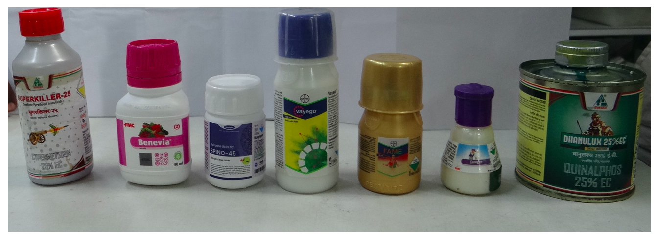
Plate 1. Insecticides screened against 4th instar S. obliqua larvae
2.3 Surface diet contamination method
A semi-synthetic artificial diet based on ‘Diet E’ of Rahman et al. (2020) was prepared with some modifications such as mulberry leaf powder was replaced with castor leaf powder. This artificial diet was deployed in surface diet contamination bioassay. Uniform diet cubes (1.5cm³) were cut and respective doses of insecticides were applied on the artificial diet surface with the help of micropipette. Each diet piece was treated with 150µL of the respective insecticide concentration using a Finnpipette® micropipette. The insecticidal solution was spread evenly across the diet surface and allowed to absorb completely in the diet piece at room temperature for 2-3 minutes to ensure uniform adhesion of toxicant on diet surface (Plate 2)..
After insecticide application the diet pieces left under fan for 3 minutes and then 3 diet cubes were placed into a sterile, labelled breeding dish, and 15 pre-starved 13 days old larvae were introduced in each breeding dish, this constituted one replication. Similarly, 2 our breeding dishes were maintained for each treatment. Control diets were treated with only double distilled sterile water using the same method. Each dose was tested in three replications, including an untreated control (Plate 3). Larval mortality was observed and recorded at 24 hours interval for seven days.
2.4 Data recording and statistical analysis
Larval mortality for eight treatments (7 insecticide and one untreated control) was recorded at 24 hour intervals up to 7 days after treatment. Then, percent larval mortality was calculated for each treatment. The percent larval mortality data were corrected using Abbott’s formula (Abbott, 1925) as given below,
$$Corrected mortality\left(\%\right)=\frac{\left(Observed mortality in treatment-Mortality in control\right)}{100-Mortality in control}×100$$
Corrected mortality data for each treatment was analysed by probit regression analysis (Finney, 1971) using SAS 9.1 software to estimate LC₅₀ and LC₉₀. Further, slope ± standard error, χ², regression equation, and 95% fiducial limits were estimated and tabulated. For LC₅₀ estimation in different insecticides the percent mortality of 6 concentrations at different time intervals [interval at which 50% mortality has crossed] was used as follows, in case of Chlorantraniliprole 18.5 SC and Flubendiamide 39.35 SC, percent mortality at 5 DAT was used. Whereas percent mortality of 3 DAT was used for Tetraniliprole 18.18 SC, Cyantraniliprole 10 OD, and Quinalphos 25 EC. Further in case of Cypermethrin 10 EC and Spinosad 45 SC, percent mortality at 2 DAT was deployed.
Time mortality data were analysed using probit regression analysis in SAS 9.1 and respective treatments, LT₅₀ and LT₉₀ were estimated along with associated slope ± SE, χ², regression equation, and fiducial limits. Goodness of fit was tested using the χ² statistic, and a heterogeneity factor was applied when χ² exceeded the critical value for the degrees of freedom. The following lowest doses viz., 100, 150, 25, 25, 187, 22.5, and 80 ppm were used for LT₅₀ estimation of Chlorantraniliprole, Flubendiamide, Tetraniliprole, Cyantraniliprole, Quinalphos Cypermethrin and Spinosad respectively.
3. RESULT AND DISCUSSION
3.1 Bio-efficacy of 7 different insecticides against S. obliqua
The susceptibility of S. obliqua larvae to seven insecticides was determined by the surface diet contamination method under laboratory conditions at Bio-Ecology Laboratory, Division of Crop Protection, ICAR–IIPR, Kanpur. Fourth instar larvae were exposed to six different concentrations of seven different insecticides by artificial diet surface contamination method and mortality observations were recorded at 24 h intervals upto 7 days for LC₅₀ and LT₅₀ estimation.
The toxicity of the seven different insecticides against 4th instar S. obliqua larvae by surface diet contamination bioassay method has revealed differences in toxicity levels among them and it ranged from 2.2% (Chlorantraniliprole 18.5 SC) to 93.3% (Spinosad 45 SC) on 2nd day after treatment (DAT) (Table 2). Further six different concentrations (100 to 600 ppm) of Chlorantraniliprole has recorded a larval mortality from 68.78% to 88.78% at 5 DAT, which has increased to 97.68 to 99.98% by 7 DAT, whereas Flubendiamide showed only 24.40 to 48.80% mortality for the six different concentrations (150 to 1200 ppm) at 5 DAT and it has recorded a larval mortality from 48.80 to100% at 7 DAT, indicating its slower action initially and lower potency at low concentrations. Tetraniliprole recorded a larval mortality of 37.70 to 55.50% at 3 DAT among the six different concentrations (25 to 500 ppm) deployed, which has reached 100% in all the concentrations by 6 DAT itself. Cyantraniliprole has caused a mortality from 13.30 to 77.70% at 3 DAT in the six different concentrations (25 to 700 ppm) and it has attained 100% kill at 6 DAT itself in all concentrations.
Quinalphos exhibited moderate toxicity with larval mortality ranging from 35.56 to 68.89% for the six different concentrations (187–1500 ppm) deployed at 3 DAT, which has increased upto 91.11 to 100% on 7 DAT reflecting a slower killing rate compared to the newer molecules. Inspite of being a conventional insecticide, Cypermethrin has recorded a mortality of 46.67 to 91.11% in the six different concentrations (22.5–180 ppm) at 2 DAT. Similarly, the spinosyn group insecticide, Spinosad also showed higher mortality from 46.67 to 93.33% in the six different concentrations (80–640 ppm) at 2 DAT. Both insecticides has reached 100% mortality by 3 to 4 DAT, confirming their rapid knockdown activity.
The percent mortality data for upto 7 DAT has revealed that Cypermethrin and Spinosad, achieved complete mortality within 3 to 4 days, whereas Tetraniliprole and Chlorantraniliprole required a time period of 5 to 7 days for total kill. Flubendiamide and Quinalphos showed delayed and lower mortality response. These mortality trends were consistent with the LC₅₀ values, which ranged from 23.897 ppm (Cypermethrin) to 640.755 ppm (Flubendiamide), demonstrating a wide variation in toxic potential among the tested insecticides. (Figure 2)
3.2 Susceptibility of S. obliqua larva to 7 different insecticides
The calculated LC₅₀ values ranged from 23.897 ppm (Cypermethrin 25 EC) to 640.755 ppm (Flubendiamide 39.35 SC) (Table 3). Among all treatments, Cypermethrin 25 EC exhibited the highest toxicity (LC₅₀ = 23.897 ppm) followed by Chlorantraniliprole 18.5% SC (25.990 ppm), Cyantraniliprole 10 OD (89.351 ppm), Spinosad 45 SC (120.267 ppm), and Tetraniliprole 18.18 SC (144.686 ppm). In contrast, Quinalphos 25 EC (500.695 ppm) and Flubendiamide 39.35 SC (640.755 ppm) recorded the least toxicity to S. obliqua larvae.
The observed toxicity trend based on LC₅₀ values was:
Cypermethrin > Chlorantraniliprole > Cyantraniliprole > Spinosad > Tetraniliprole > Quinalphos > Flubendiamide. (Figure 1)
Cypermethrin, a synthetic pyrethroid, demonstrated the greatest toxicity, which may be attributed to its rapid neurotoxic action on the sodium channels of insect nerve membranes, leading to paralysis and death. These results are in close agreement with Mandal et al. (2013), who reported higher mortality of S. obliqua larvae with cypermethrin and λ-cyhalothrin compared to endosulfan and imidacloprid in black gram. Similarly, Selvaraj et al. (2015) recorded significant efficacy of cypermethrin and emamectin benzoate against S. obliqua in jute, showing over 80 % reduction of larval infestation.
Among diamide compounds, Chlorantraniliprole 18.5% SC (LC₅₀ = 25.99 ppm, 5 DAT) was highly toxic, whereas Flubendiamide 39.35 SC (LC₅₀ = 640.76 ppm, 5 DAT) was the least effective, indicating marked variability in the potency of ryanodine receptor modulators. The higher toxicity of chlorantraniliprole might be due to its better cuticular penetration and rapid activation of the insect ryanodine receptor, leading to sustained muscle contraction and immediate feeding inhibition. These findings are consistent with Nair et al. (2007), who observed that newer diamides caused severe feeding suppression and rapid larval mortality in S. obliqua compared with conventional insecticides.
Spinosad 45 SC (LC₅₀ = 120.27 ppm, 2 DAT) showed moderate toxicity, corroborating Rahman and Khan (2010), who reported 86 % reduction in larval infestation in jute when treated with spinosyn based insecticides. The efficacy of spinosad may be due to its dual action as a stomach and contact poison affecting nicotinic acetylcholine receptors and causing feeding cessation. Comparable results were reported by Devi and Srivastava (2018), who found spinosad and imidacloprid combinations highly effective against S. obliqua under laboratory conditions.
The organophosphate, Quinalphos 25 EC (LC₅₀ = 500.69 ppm, 3 DAT) was less toxic in the present study compared with the pyrethroid and diamide groups, possibly due to development of partial resistance in S. obliqua populations resulting from prolonged field exposure. Dhingra et al. (2007) also documented cross-resistance in S. obliqua larvae to several organophosphates and their mixtures, supporting the present observation.
3.3 Speed of kill of different insecticides against Spilosoma obliqua by surface diet contamination method
The median lethal time (LT₅₀) ranged from 1.800 days (Cypermethrin 25 EC) to 7.229 days (Flubendiamide 39.35 SC) (Table 4.). The fastest knockdown was recorded with Cypermethrin 25 EC (LT₅₀ = 1.80 days; LT₉₀ = 3.32 days), followed by Spinosad 45 SC (LT₅₀ = 1.91 days; LT₉₀ = 3.53 days) and Quinalphos 25 EC (LT₅₀ = 3.74 days). Among the diamide group, Tetraniliprole 18.18 SC (LT₅₀ = 3.23 days), Cyantraniliprole 10 OD (LT₅₀ = 4.12 days) and Chlorantraniliprole 18.5% SC (LT₅₀ = 4.21 days) produced quicker mortality than Flubendiamide 39.35 SC (LT₅₀ = 7.23 days).
The order of toxicity based on LT₅₀ values was:
Cypermethrin > Spinosad > Quinalphos > Tetraniliprole > Cyantraniliprole > Chlorantraniliprole > Flubendiamide.
The quickest action of Cypermethrin may be attributed to its strong neurotoxic properties, causing rapid paralysis through sodium channel disruption. Spinosad, acting as both contact and stomach poison, also exhibited a rapid knockdown effect due to its action on nicotinic acetylcholine receptors. The relatively slower kill rate observed with Flubendiamide and Chlorantraniliprole is likely due to their ingestion-dependent mode of action on the ryanodine receptor, which primarily causes feeding cessation before mortality. Similar delayed mortality effects of diamide insecticides were reported by Selvaraj et al. (2015) and Gupta et al. (2004), who observed extended lethal time in S. obliqua and Spodoptera litura treated with these compounds.
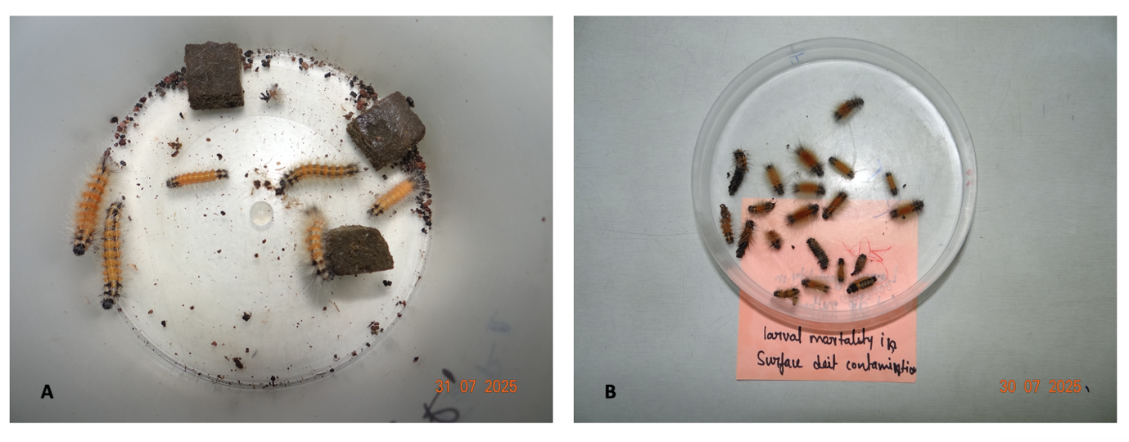
Plate 2. (B) BHC larvae on contaminated artificial diet (C) Dead larvae of BHC in 6th dose (300 PPM of Cypermethrin 25 EC)

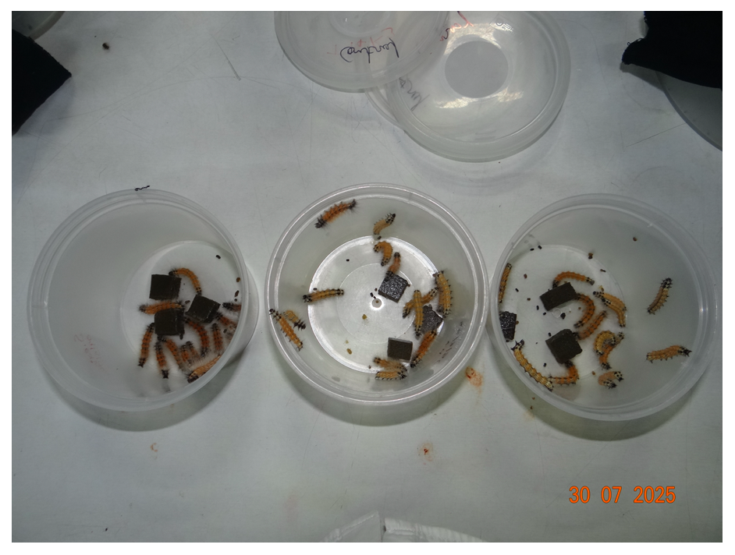
Plate 3. Larvae of BHC on artificial diet in control
Table 2. Bio-efficacy of different insecticides against 13 days old Spilosoma obliqua larvae by by surface diet contamination method
Treatment | PPM | 1DAT | 2DAT | 3DAT | 4DAT | 5DAT | 6DAT | 7DAT
Chlorantraniliprole 18.5% SC | 100 | 0 | 2.2 | 13.30 | 35.50 | 68.78 | 91.08 | 97.68
Chlorantraniliprole 18.5% SC | 200 | 0 | 2.2 | 11.10 | 42.20 | 79.98 | 91.08 | 99.98
Chlorantraniliprole 18.5% SC | 300 | 2.2 | 4.4 | 13.30 | 44.40 | 82.18 | 93.28 | 99.98
Chlorantraniliprole 18.5% SC | 400 | 2.2 | 4.4 | 11.10 | 42.20 | 79.98 | 95.50 | 99.98
Chlorantraniliprole 18.5% SC | 500 | 2.2 | 2.2 | 11.10 | 46.60 | 88.78 | 97.68 | 99.98
Chlorantraniliprole 18.5% SC | 600 | 2.2 | 2.2 | 11.10 | 53.30 | 88.78 | 97.68 | 99.98
Chlorantraniliprole 18.5% SC | Control | 0 | 0 | 0.00 | 0.00 | 2.18 | 2.18 | 2.18
Flubendiamide 39.35 SC | 150 | 0 | 2.2 | 4.40 | 13.30 | 24.40 | 37.70 | 48.80
Flubendiamide 39.35 SC | 300 | 0 | 2.2 | 4.40 | 11.10 | 22.20 | 37.70 | 53.30
Flubendiamide 39.35 SC | 600 | 0 | 2.2 | 8.80 | 20.00 | 33.30 | 48.80 | 68.80
Flubendiamide 39.35 SC | 900 | 2.2 | 4.4 | 11.10 | 24.40 | 46.60 | 60.00 | 80.00
Flubendiamide 39.35 SC | 1050 | 0 | 2.2 | 11.10 | 24.40 | 46.60 | 68.80 | 91.10
Flubendiamide 39.35 SC | 1200 | 0 | 6.6 | 11.10 | 26.60 | 48.80 | 80.00 | 100.0
Flubendiamide 39.35 SC | Control | 0 | 0 | 0.00 | 0.00 | 0.00 | 0.00 | 0.00
Tetraniliprole 18.18 SC | 25 | 0 | 6.60 | 37.70 | 77.70 | 88.78 | 100.0 | 100.0
Tetraniliprole 18.18 SC | 50 | 0 | 13.30 | 48.80 | 80.00 | 91.08 | 100.0 | 100.0
Tetraniliprole 18.18 SC | 100 | 0 | 13.30 | 48.80 | 82.20 | 91.08 | 100.0 | 100.0
Tetraniliprole 18.18 SC | 200 | 0 | 15.50 | 51.10 | 84.40 | 95.38 | 100.0 | 100.0
Tetraniliprole 18.18 SC | 300 | 0 | 15.50 | 53.30 | 86.60 | 95.38 | 100.0 | 100.0
Tetraniliprole 18.18 SC | 500 | 6.6 | 22.20 | 55.50 | 86.60 | 97.68 | 100.0 | 100.0
Tetraniliprole 18.18 SC | Control | 0 | 0.00 | 0.00 | 0.00 | 0.00 | 0.00 | 0.00
Cyantraniliprole 10 OD | 25 | 0 | 6.60 | 13.30 | 26.60 | 77.70 | 100.0 | 100.0
Cyantraniliprole 10 OD | 50 | 0 | 8.80 | 22.20 | 48.80 | 755.0 | 100.0 | 100.0
Cyantraniliprole 10 OD | 100 | 0 | 22.20 | 55.50 | 77.68 | 82.20 | 100.0 | 100.0
Cyantraniliprole 10 OD | 200 | 0 | 26.60 | 60.00 | 82.20 | 100.0 | 100.0 | 100.0
Cyantraniliprole 10 OD | 600 | 0 | 31.10 | 73.30 | 53.30 | 100.0 | 100.0 | 100.0
Cyantraniliprole 10 OD | 700 | 2.2 | 31.10 | 77.70 | 55.50 | 100.0 | 100.0 | 100.0
Cyantraniliprole 10 OD | Control | 0 | 0.00 | 0.00 | 0.00 | 0.00 | 0.00 | 0.00
Quinalphos 25 EC | 187 | 0.00 | 13.33 | 35.56 | 53.33 | 64.44 | 84.44 | 91.11
Quinalphos 25 EC | 375 | 2.22 | 20.00 | 42.22 | 60.00 | 71.11 | 86.67 | 93.33
Quinalphos 25 EC | 750 | 8.89 | 22.22 | 51.11 | 66.67 | 77.78 | 91.11 | 100.0
Quinalphos 25 EC | 937 | 20.00 | 33.33 | 64.44 | 73.33 | 93.33 | 95.56 | 100.0
Quinalphos 25 EC | 1125 | 35.56 | 46.67 | 66.67 | 75.56 | 95.56 | 100.0 | 100.0
Quinalphos 25 EC | 1500 | 48.89 | 55.56 | 68.89 | 86.67 | 100.0 | 100.0 | 100.0
Quinalphos 25 EC | Control | 0 | 0.00 | 0.00 | 0.00 | 0.00 | 0.00 | 0.00
Cypermethrin 10EC | 22.5 | 17.78 | 46.67 | 80.00 | 100.0 | 100 | 100.0 | 100.0
Cypermethrin 10EC | 45 | 20.00 | 71.11 | 84.44 | 100.0 | 100.0 | 100.0 | 100.0
Cypermethrin 10EC | 90 | 37.78 | 75.56 | 93.33 | 100.0 | 100.0 | 100.0 | 100.0
Cypermethrin 10EC | 112.5 | 40.00 | 82.22 | 95.56 | 100.0 | 100.0 | 100.0 | 100.0
Cypermethrin 10EC | 135 | 42.22 | 88.89 | 97.78 | 100.0 | 100.0 | 100.0 | 100.0
Cypermethrin 10EC | 180 | 48.89 | 91.11 | 100.0 | 100.0 | 100.0 | 100.0 | 100.0
Cypermethrin 10EC | Control | 0.00 | 0.00 | 0.00 | 0.00 | 0.00 | 0.00 | 0.00
Spinosad 45 SC | 80 | 13.33 | 46.67 | 80.00 | 93.33 | 100.0 | 100.0 | 100.0
Spinosad 45 SC | 160 | 17.78 | 53.33 | 86.67 | 97.78 | 100.0 | 100.0 | 100.0
Spinosad 45 SC | 320 | 22.22 | 60.00 | 93.33 | 100.0 | 100.0 | 100.0 | 100.0
Spinosad 45 SC | 400 | 33.33 | 80.00 | 97.78 | 100.0 | 100.0 | 100.0 | 100.0
Spinosad 45 SC | 560 | 44.44 | 88.89 | 100.0 | 100.0 | 100.0 | 100.0 | 100.0
Spinosad 45 SC | 640 | 48.89 | 93.33 | 100.0 | 100.0 | 100.0 | 100.0 | 100.0
Spinosad 45 SC | Control | 0.00 | 0.00 | 0.00 | 0.00 | 0.00 | 0.00 | 0.00

Table 3. Susceptibility of Spilosoma obliqua to different insecticides by surface diet contamination method
Insecticide | LC₅₀ (ppm) | Slope ± SE | χ² value | Degrees of freedom | 95% Fiducial limits |  | Regression equation | LC₉₀ (ppm)
 |  |  |  |  | Min | Max | Regression equation | LC₉₀ (ppm)
Chlorantraniliprole 18.5% SC | 25.990 | -2.9275± 0.8654 | 1.144 | 4 | 0.02225 | 75.704 | Y= -1.2244+0.8654 X | 786.351
Flubendiamide 39.35 SC | 640.755 | -2.2598± 1.0430 | 2.527 | 4 | 433.82857 | 1982 | Y= -2.9275+0.3110X | 10848
Tetraniliprole 18.18 SC | 144.686 | -0.6297± 0.2915 | 0.571 | 4 | - | - | Y= -0.6297+ 0.1713X | 360944
Cyantraniliprole 10 OD | 89.351 | -1.6208± 0.8307 | 0.536 | 4 | 55.68482 | 141.322 | Y= -1.6208+0.1062X | 8534
Quinalphos 25 EC | 500.695 | -2.7812± 0.7245 | 1.281 | 4 | 300.18634 | 705.500 | Y= -2.7812+1.0302X | 8781
Cypermethrin 25 EC | 23.897 | -2.0390± 0.5165 | 1.592 | 4 | 11.93044 | 34.477 | Y= -2.0390+1.4793X | 175.657
Spinosad 45 SC | 120.267 | -3.2515± 0.9437 | 8.586 | 4 | 18.08704 | 204.054 | Y= -3.2515+ 1.5631X | 794.358

Table 4. Speed of kill of different insecticides against Spilosoma obliqua by surface diet contamination method
Insecticide | LT₅₀ Days | Slope ± SE | χ² value | Degrees of freedom | 95% Fiducial limits |  | Regression equation | LT₉₀ Days
 |  |  |  |  | Min | Max | Regression equation | LT₉₀ Days
Chlorantraniliprole 18.5% SC | 4.219 | -4.8681± 7.7863 | 4.120 | 5 | 3.963 | 4.472 | Y= -4.8681+0.7961X | 6.163
Flubendiamide 39.35 SC | 7.229 | -3.5491± 4.1313 | 0.835 | 5 | 6.368 | 8.923 | Y= -3.5491+0.6839X | 14.766
Tetraniliprole 18.18 SC | 3.234 | -3.9385± 7.7256 | 2.441 | 5 | 3.008 | 3.450 | Y= -3.9385+0.7954X | 4.739
Cyantraniliprole 10 OD | 4.121 | -4.7042± 7.6481 | 34.318 | 5 | 3.038 | 5.288 | Y= -4.7042+1.9770X | 6.763
Quinalphos 25 EC | 3.738 | -2.5574± 0.3006 | 2.052 | 5 | 3.405 | 4.075 | Y= -2.5574+4.4655X | 7.239
Cypermethrin 25 EC | 1.800 | -1.2341± 7.7256 | 9.474 | 5 | 1.404 | 2.171 | Y= -1.2341+4.8313X | 3.316
Spinosad 45 SC | 1.907 | -1.3460± 0.2097 | 3.854 | 5 | 1.689 | 2.116 | Y= -1.3460+4.7980X | 3.528

Figure 1. Susceptibility LC₅₀ (ppm) of S. obliqua (A) Chlorantraniliprole 18.5% SC (B) Flubendiamide 39.35 (C) Tetraniliprole 18.18 SC (D) Cyantraniliprole 10 OD by Surface diet contamination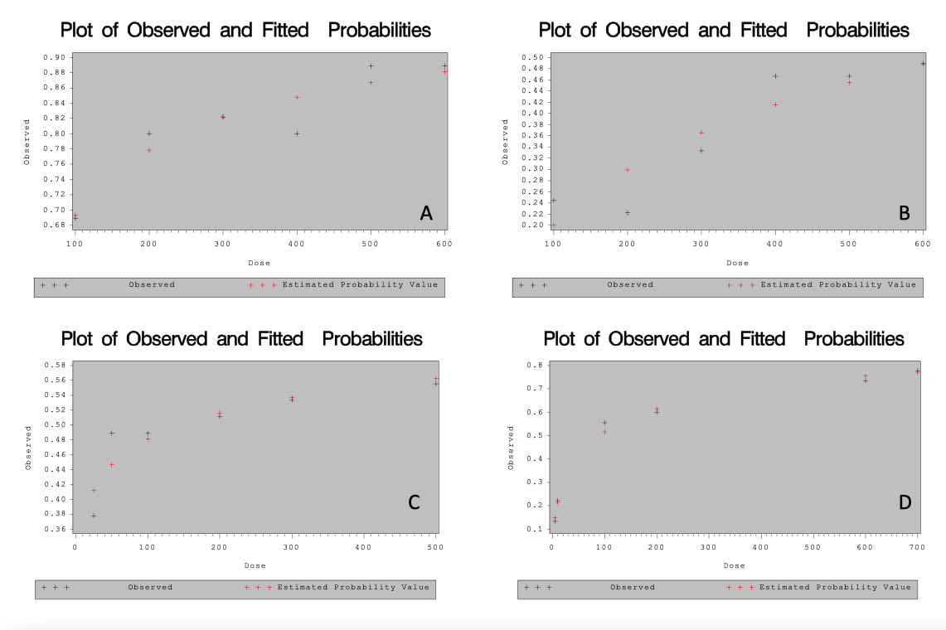
Figure 2. Susceptibility LC₅₀ (ppm) of S. obliqua (A) Quinalphos 25 EC and (B) Cypermethrin 25 EC by Surface diet contamination

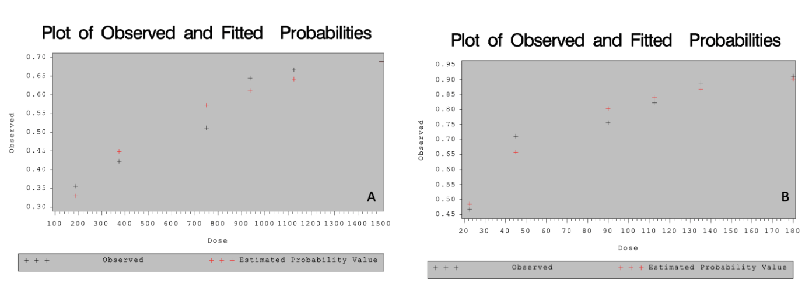

Figure 3. Susceptibility LC₅₀ (ppm) of S. obliqua Spinosad 45 SC by Surface diet contamination

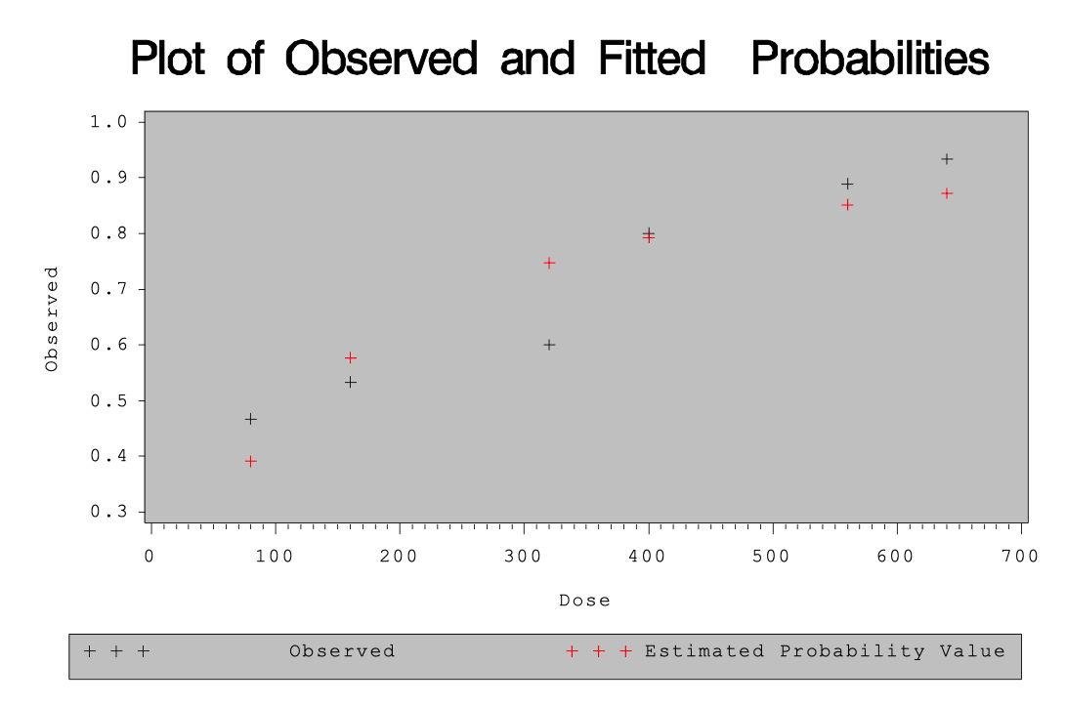4. CONCLUSION
The bioassay results clearly demonstrated significant variation in the susceptibility of fourth instar Spilosoma obliqua to different insecticides. Among all treatments, Cypermethrin 25 EC (LC₅₀ = 23.897 ppm) exhibited the highest toxicity, followed closely by Chlorantraniliprole 18.5% SC (25.990 ppm), indicating their superior effectiveness even at low concentrations. Cyantraniliprole 10 OD (89.351 ppm) and Spinosad 45 SC (120.267 ppm) showed moderate toxicity, whereas Tetraniliprole 18.18 SC (144.686 ppm), Quinalphos 25 EC (500.695 ppm), and Flubendiamide 39.35 SC (640.755 ppm) were comparatively less effective. The overall trend of toxicity was Cypermethrin > Chlorantraniliprole > Cyantraniliprole > Spinosad > Tetraniliprole > Quinalphos > Flubendiamide.
The results highlight that Cypermethrin, a synthetic pyrethroid, remains highly effective due to its rapid neurotoxic action, while Chlorantraniliprole among the diamides offers strong potential for inclusion in integrated pest management programs owing to its distinct ryanodine receptor mediated mode of action.
The lethal time analysis further confirmed substantial differences in the speed of kill among the tested insecticides against S. obliqua. The shortest LT₅₀ was observed with Cypermethrin 25 EC (1.80 days), followed by Spinosad 45 SC (1.91 days), indicating their rapid knockdown activity. Tetraniliprole 18.18 SC (3.23 days) and Quinalphos 25 EC (3.74 days) showed moderate speed of kill, while Cyantraniliprole 10 OD (4.12 days) and Chlorantraniliprole 18.5% SC (4.21 days) exhibited slightly slower but sustained mortality effects. Flubendiamide 39.35 SC (7.23 days) was the slowest acting molecule, reflecting its ingestion-dependent mode of action. The order of efficacy based on LT₅₀ was Cypermethrin > Spinosad > Tetraniliprole > Quinalphos > Cyantraniliprole > Chlorantraniliprole > Flubendiamide.
These findings indicate that while Cypermethrin and Spinosad are fast-acting neurotoxic agents, the diamide group particularly Chlorantraniliprole offers prolonged protection through feeding inhibition, making it a valuable option for sustainable management of S. obliqua populations.
From a pest management perspective, the present findings highlight that cypermethrin, spinosad and chlorantraniliprole can serve as promising candidates for the effective control of S. obliqua in blackgram and other Vigna crops. The incorporation of these insecticides into integrated pest management (IPM) strategies, with rotation among molecules of distinct mode of action, will help in delaying resistance development in the S. obliqua and ensure sustainable management of the polyphagous defoliator insect pest in legume crop-based ecosystems.

DISCLAIMER (ARTIFICIAL INTELLIGENCE)
The author(s) hereby declare that no generative AI technologies such as Large Language Models (ChatGPT, Copilot, etc.) or text-to-image generators have been used during the writing or editing of this manuscript.

COMPETING INTERESTS DISCLAIMER:
Authors have declared that they have no known competing financial interests OR non-financial interests OR personal relationships that could have appeared to influence the work reported in this paper.

REFERENCES
Abbott, W. S. (1925). A method of computing the effectiveness of an insecticide. Journal of Economic Entomology, 18(2), 265–267.
Ahmad, M., & Arif, M. I. (2010). Resistance of Spilosoma obliqua (Walker) (Lepidoptera: Arctiidae) to conventional insecticides in Pakistan. Crop Protection, 29(8), 898–902.
Anand, R., & Tiwary, B. N. (2009). Comparative efficacy of newer insecticides against Bihar hairy caterpillar, Spilosoma obliqua Walker on sunflower. Journal of Applied Zoological Researches, 20(2), 177–180.
Ayyanath, M. M., & Karthikeyan, K. (2015). Toxicity and residual activity of some new insecticides against Spilosoma obliqua (Walker) (Lepidoptera: Arctiidae). Indian Journal of Entomology, 77(2), 136–142.
Chandrashekharaiah, M., & Jagadish, K. S. (2018). Efficacy of insecticides against Bihar hairy caterpillar on black gram (Vigna mungo L.). Journal of Entomological Research, 42(3), 347–351.
Cheema, H. K., Pratap, A., & Sujayanand, G. K. (2017). Breeding for Insect Resistance in Mung Bean and Urd Bean. In: Breeding insect resistant crops for sustainable agriculture (pp. 353-385). Singapore: Springer Singapore.
Devi, N., & Srivastava, C. P. (2018). Bioefficacy of novel insecticides against Bihar hairy caterpillar, Spilosoma obliqua(Walker) on sunflower. Journal of Entomology and Zoology Studies, 6(3), 1345–1349.
Dey, D., & Bar, A. (2016). Evaluation of newer insecticides against Spilosoma obliqua Walker infesting sesame. Indian Journal of Entomology, 78(1), 80–83.
Dhingra, S., Bhandari, J. K. S., & Shankarganesh, K. (2007). Relative resistance of Bihar hairy caterpillar to insecticide mixtures. Journal of Entomological Research, 31(3), 209–212.
Finney, D. J. (1971). Probit analysis (3rd ed., p. 333). Cambridge University Press.
Gupta, A. K., Kaushik, U. K., & Dixit, S. A. (2004). Studies on chemical control of Spilosoma obliqua (Walker). Journal of Maharashtra Agricultural Universities, 29(2), 228–229.
Kranthi, K. R., & Jadhav, D. R. (2002). Resistance in cotton bollworm (Helicoverpa armigera) to conventional and new insecticides. Pest Management Science, 58(4), 397–402.
Mandal, D., Bhowmik, P., & Baral, K. (2013). Evaluation of insecticides for management of Bihar hairy caterpillar (Spilosoma obliqua) in black gram. The Bioscan, 8(2), 429–433.
Mishra, R., & Singh, R. (2014). Bioefficacy of insecticides against Bihar hairy caterpillar (Spilosoma obliqua Walker) in urdbean. Legume Research, 37(3), 330–333.
Nair, N., Sekh, K., Debnath, M., & Chakraborty, S. (2007). Relative toxicity of some new insecticides to Bihar hairy caterpillar, Spilosoma obliqua (Walker). Journal of Crop and Weed, 3(1), 1–2.
Nikam, A. S., & Satpute, N. S. (2015). Toxicity of diamide and spinosyn insecticides against lepidopteran defoliators. Journal of Experimental Zoology, India, 18(2), 707–711.
Patil, S. B., & Kulkarni, K. A. (2019). Evaluation of chlorantraniliprole and flubendiamide against lepidopteran pests of pulses. Journal of Pharmacognosy and Phytochemistry, 8(2), 2389–2393.
Rahman, M. M., & Khan, M. R. (2010). Integrated management of pest complex of jute (Corchorus olitorius L.). Journal of Plant Protection Research, 50(3), 340–346.
Rahman, M. S., Islam, M. N., Talukder, F. U., & Sultan, M. T. (2020). Evaluation of insecticides for the management of jute hairy caterpillar, Spilosoma obliqua (Walker) (Lepidoptera: Arctiidae) in jute (Corchorus olitorius). International Journal of Entomology Research, 5(4), 71–77.
Sehsah, E. M. E., El-Sayed, S. M., & El-Khawas, M. A. (2015). A digital imaging technique to estimate consumed leaf area due to insect pests’ herbivory. International Journal of Agriculture Innovations and Research, 4(1), 67–72.
Selvaraj, K., Ramesh Babu, V., Gotyal, B. S., & Satpathy, S. (2015). Toxicity and bioefficacy of insecticide combinations against jute hairy caterpillar, Spilarctia obliqua (Walker). Journal of Environmental Biology, 36(6), 1409–1414.
Singh, R., & Sharma, N. K. (2020). Field evaluation of spinosad and other insecticides against Bihar hairy caterpillar on urdbean. Journal of Entomology and Zoology Studies, 8(1), 564–569.
Sujayanand G.K., Anup Chandra, & AK Parihar. (2023). Intrusion of Bihar hairy caterpillar in fieldpea. Pulses newsletter October to December 2023, 34(4), 2.
Sujayanand, G. K., Chandra, A., Jagadeeswaran, R., Dubey, S., & Sheelamary, S. (2021). Ricebean: potential vine legume for achieving nutritional self-sufficiency in India. Vigyan Varta, 2(12), 10-14.
Tiwari, S. K., & Dutta, S. (2017). Comparative toxicity of insecticides against Spilosoma obliqua on black gram. Indian Journal of Plant Protection, 45(1), 49–53.

