Original Research Article

MORPHOMETRIC VARIATIONS USING TRUSS MEASUREMENTS, LENGTH-WEIGHT RELATIONSHIP AND RELATIVE CONDITION FACTOR IN INDO- PACIFIC TARPONS, MEGALOPS CYPRINOIDES FROM THREE DIFFERENT SALINITY HABITATS

ABSTRACT
Morphometric analyses of Indo- Pacific Tarpons, Megalops cyprinoides collected randomly from freshwater, brackish water and saltwater habitats were conducted using Truss network measurement to evaluate the variations in morphometry with salinity. Length- Weight Relationship and condition factor of the fish from three habitats were observed to analyse the growth pattern and well-being of the fish. The results of the present study indicated that the M.cyprinoides from three salinity habitats varied in their shape and structure. The regression equation of length and weight relation specified a ‘b’ value of less than 3 that indicated the negative allometric growth of the fish. The regression coefficient were near to 1 and the relative condition factor of the fish indicated a good environment for the fish growth. This study would be helpful for understanding the environmental conditions suitable for the conservation and rearing of migratory fishes at different salinity threats.
Keywords: Migration, Allometric, Isometric, landmark distances, growth.
- INTRODUCTION
Indo- Pacific Tarpons, Megalops cyprinoides (Broussonet, 1782), belonged to the family Megalopidae, which consisting of two species, Megalops cyprinoides and Megalops atlanticus, and they had a larval stage in their life cycle that altered their habitats after reaching a particular phase (Adams et al., 2014). M. cyprinoides were mostly found spawning in the seawater and the larvae migrated back to freshwater and after maturity returned to seawaters (Coates, 1987). Mehmood & Ahmed (2021), had indicated that, developing a strategy that offered insights into fish health was crucial for conserving fishery resources. Such an approach was considered a key tool for evaluating fish well-being and effectively managing their population and biomass. Study of morphometry in fish, Length-weight relationships (LWR) and condition factors played a vibrant role in managing fisherys, as they offered insights into fish development, population dynamics, structural differences, adaptive evolutions and the overall health and fitness of fish within their natural habitat (Kavya et al.,2023).
Morphometrics, the statistical techniques, helped in determining the shape and size of the organisms and were quantitative techniques that aided in measuring the external body parts and were different from meristic characters which were countable (Talwar & Jhingran, 1992; Tripathy, 2020). The comparison of the morphometric feature of different fish helps in analysing evolutionary links between the species and developing evolutionary history of fish lineages (Bookstein, 1991). Morphometric characters are influenced by genetic as well as environmental factors such as temperature, salinity, food and migration. To overcome the prevailing conditions of different environments, the fish exhibit variations in their external features such as shape and size of the body (Knouft, 2003; Turan et al., 2006). Many traditional and modern techniques were employed for morphometric studies and one of the most advanced technique was the Truss network analysis. This method utilized the distances between certain landmark points on fish in determining the shape of the organism and were considered the most effective tool in comparing the morphometric variations among the organisms (Strauss & Bookstein, 1982; Dwivedi & Dubey, 2013; Mahfuj et al., 2018).
The understanding of the relationship between the length and weight of fish was used in evaluating the biomass and in comparing the progressive stages of fish populations across various regions (Ayoade & Ikulala, 2007). Length-weight relationship (LWR) analysis served as an important biological measure of the growth conditions of species in their surrounding environments and reflected the health and well-being of fish in their habitats, as well as their physiological and biological status. It also revealed population growth patterns and dynamics (Al Nahdi et al., 2016). In addition to the length-weight relationship (LWR), the condition factor (K) served as an indicator of a fish's health in relation to its habitat and seasonal changes. Condition factor were quantitative measure for assessing the overall well-being of fish, including their feeding intensity, reproductive condition, and physiological status, which were key aspects of their fitness. Furthermore, the condition factor helped in evaluating fat reserves and understanding the development of gonads in fish (Mehmood & Ahmed, 2021).
According to Adams et al., (2013), the morphometric characters including the shape and structure of fish alter with change in the environmental surroundings. M.cyprinoides, being a migratory fish, dwelling in freshwater and saltwater faced lot of environmental fluctuations and a study of the change in their morphometry and Length- Weight parameters at differing salinities become important in terms of fish management and conservation. Although many researchers Khairul et al., (2019); Harahap et al.,(2020); Renjithkumar & Roshni, (2023) had done studies on the Length – Weight Relationship of M. cyprinoides from particular water bodies, the variation in their morphometry at different salinities were rarely understood. The present study focused on the morphometric variations in the Megalops cyprinoides collected from three different salinity habitats of freshwater, brackishwater and saltwater using Truss Network measurements. The Length- weight relationship of the fish from three habitats, the condition factor and relative condition factor of the fish in the environment in which they survived were also analyzed.
2. MATERIALS AND METHODOLOGY
2.1 Sample collection
A total of 450 fish from three different salinities i.e. freshwater (FW), brackish water (BW) and saltwater (SW) habitats were collected randomly (n=150 each). The salinity of each water bodies were analyzed. The fish collected were preserved in ice and brought to laboratory for further studies. The total length of fish from mouth tip to tip of the caudal fin was measured in cm and the total weight of the fish was measured in grams using digital balance. All the fish collected were treated in accordance with the guidelines of the local ethics committee.
2.2 Length- weight relationship
The measurements of the total length (TL) and weight (W) were used to calculate the Length- Weight relationship (LWR) using the formula
W= a L^{b}
Where, W is the weight of the fish, L is the total length of the fish measured (Cren, 2012). Values of ‘a’ and ‘b’ were calculated using the linear regression of the log transformed equation i.e.
log (W)= log (a) + b log (L),
‘a’ represents the intercept and ‘b’ the slope of the relationship. If the value of ‘b’ is 3, the growth is isometric (Ricker & Carter, 1958).
2.3 Condition factor (K)
The variation from length weight relationship was depicted by condition factor (K). Condition f actor is the general wellbeing of the fish which is calculated using the formula
K= Wx100/ L3
Where, W is weight of the fish and L is the length of the fish measured (Hile & Jobes, 1941)
2.4 Relative condition factor (Kn)

Kn is calculated to analyse the growth condition of the fish species. It is calculated using the formula,
Kn= W/Wc,
Where W is the observed weight of the fish captured and Wc is the calculated weight of the fish (aL^{b}) (Cren, 2012).
2.5 Truss network analysis
After recording the length and weight parameters of fish, certain landmark points were marked which described the features of the fish and then truss networks were constructed between these point (Anumudu & Mojekwu, 2015). These truss network distances were measured using divider and ruler. The truss networks marked were depicted in the figure below (Figure: 1).
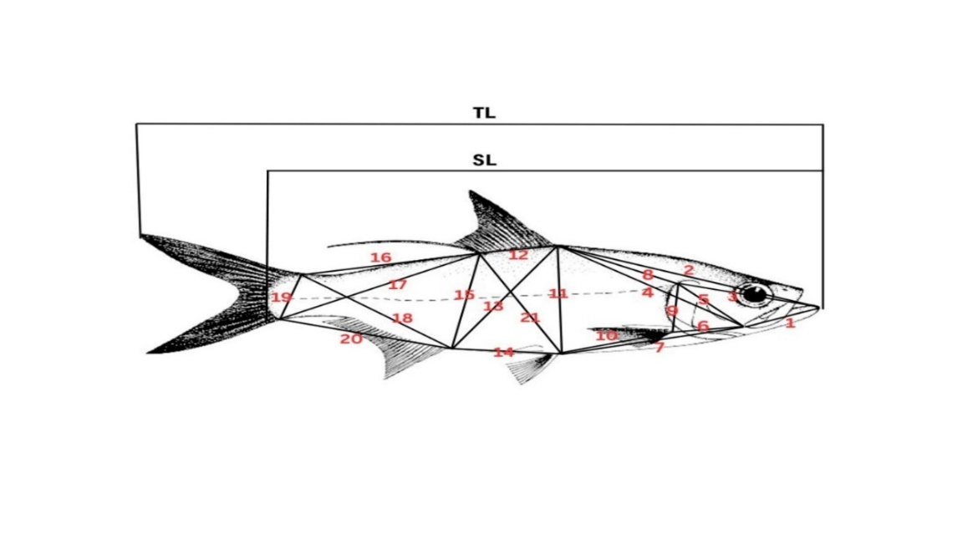
Figure 1: The truss networks measured for morphometric analysis in Megalops cyprinoides. Mouth tip to premaxilla (MTPM), 2. Mouth tip to dorsal fin (MTDF), 3. Mouth tip to operculum top (MTOT), 4. Pre maxilla to dorsal fin (PMDF), 5. Pre maxilla to operculum tip (PMOT), 6. Pre maxilla to pectoral fin (PMPC), 7. Pre maxilla to pelvic fin (PMPV), 8. Dorsal fin to operculum tip (DFOT), 9. Pectoral fin to operculum tip (PCOT), 10. Pectoral fin to pelvic fin (PCPV), 11. Dorsal fin to pelvic fin (DFPV), 12. Dorsal fin front to dorsal fin back (DFDB), 13. Dorsal fin to anal fin (DFAF), 14. Pelvic fin to anal fin (PVAF), 15. Dorsal back to anal fin (DBAF), 16. Dorsal fin back to caudal top (DBCT), 17. Dorsal back to caudal bottom (DBCB), 18. Anal fin to caudal top (AFCT), 19. Caudal top to caudal bottom (CTCB), 20. Anal fin to caudal bottom (AFCB), 21. Dorsal fin back to pelvic fin (DBPV).
  - Statistical analyses
Regression analysis was performed for calculating the length and weight relation between the species. For analysing the variation in the length and weight between each species, ANOVA was conducted at P= 0.05. The recorded truss network measurements were analysed for variation among species from different habitats using UNIVARIATE analysis of variance (ANOVA).
- RESULTS
  - Length- Weight relationship and condition factor
In the present study, the mean total length and weight of the fish from freshwater (FW), brackish water (BW) and saltwater (SW) were measured and it indicated that the freshwater species were smaller in size. The freshwater fish were smaller in size among the three salinity groups. Brackish water fish were larger in size than the freshwater fish and the saltwater fish were the largest among all the three (Table 1). The Length- Weight Relationship were obtained as Log W= -1.4129+ 2.572 log L for freshwater fish; Log W= -0.2336 + 1.083 log L for brackish water fish and Log W= -0.2114 + 1.198 Log L for saltwater fish (Figure 3, 4 and 5). The coefficient of determination (R²) and the value of ‘b’ for the three habitat fish were recorded and indicated in the table below. The highest b value obtained was for freshwater species followed by saltwater and then brackish water, which were all below the value of 3 (Table 1). The mean relative condition factor (Kn) were calculated using the formula mentioned earlier and all the values for all the fish were above 1 (Table 1). Analysis of variance (ANOVA) of length and weight between the three groups of the fish from different salinities was done to determine if variation existed between them. Significant variance (P< 0.05) was observed between the groups in terms of both length and weight.
Table 1: Length, weight and the regression analysis data for Length- Weight relationship between fish from three habitats.
FISH | TOTAL LENGTH(cm) | WEIGHT  (gm) |  | a | b |  | r |  | R² | P* |  | Kn
FW | 28.76±10.05 | 197.07±174.19 | -1.492 |  |  | 2.572 | 0.928 | 0.862 |  |  | 0.00 | 1.019
BW | 39.36±11.89 | 340.89±114.34 | -0.233 |  |  | 1.083 | 0.910 | 0.828 |  |  | 0.00 | 2.856
SW | 50.42±3.585 | 1006.47±87.37 | -0.211 |  |  | 1.198 | 0.855 | 0.731 |  |  | 0.00 | 1.001
*significant relationship exists; FW= freshwater, BW=brackishwater, SW= saltwater, R2 = coefficient of determination; r = correlation coefficient; a = rate of change of weight with length (intercept); b = weight at unit length (slope); Kn = relative condition factor.
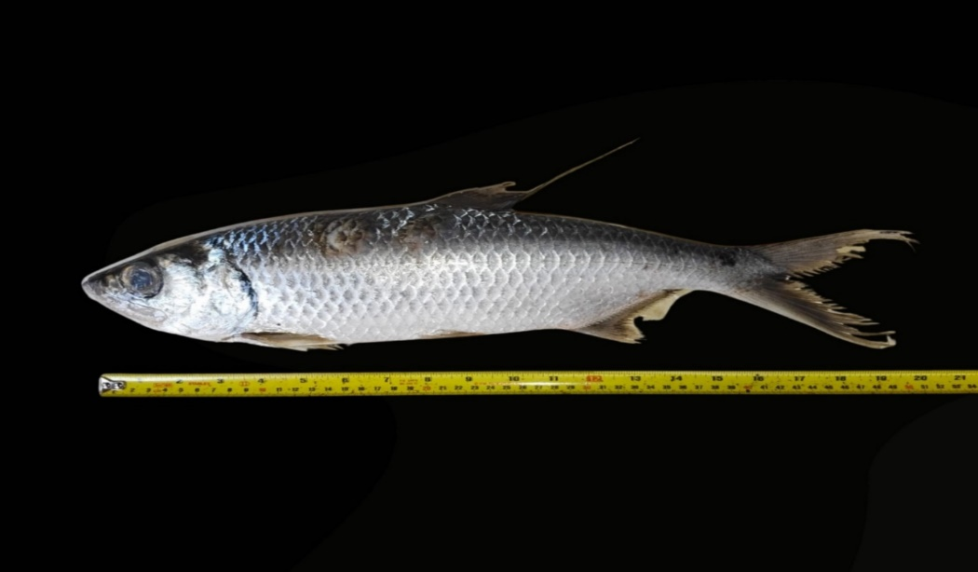
Figure 2: Megalops cyprinoides measured.

Fig 3: Graph showing logarithmic form of length- weight relation of fish from freshwater habitat

Fig 4: Graph showing logarithmic form of length- weight relation of fish from brackish water habitat

Fig 5: Graph showing logarithmic form of length- weight relation of fish from salt water habitat

  - Truss network measurements
The mean values of the distance between the truss points (Figure: 1) were calculated for fish from each habitat and is mentioned in the table 2. Greatest distance was observed between the third and fourth parameters that is, mouth tip to dorsal fin and pre maxilla to dorsal fin for all the three groups. The Analysis of variance (ANOVA) for the truss network measurements between the three groups were done and the percentage of variation of the landmark points between them were estimated. Significant differences (P< 0.05) between the fish species were observed for distances between each landmark points. The highest variance observed was in dorsal fin back to caudal top (61.13%), followed by pre maxilla to dorsal fin (60.54%). These were corresponding to the caudal region and dorsal axis of the fish. The Least variation was observed in the highest distance mouth tip to dorsal fin (6.84%)
Table 2: Statistical descriptions of fish body truss network measurements of three habitats:

NO | TRUSS  MARKS | FW |  | BW |  | SW
 |  | MEAN | SD | MEAN | SD | MEAN | SD
1 | MTPM | 2.744 | 0.962 | 7.35 | 4.12 | 6.01 | 0.43
2 | MTDF | 11.97 | 2.24 | 24.49 | 33.52 | 20.03 | 1.44
3 | MTOT | 5.15 | 1.16 | 10.81 | 4.59 | 9.51 | 0.68
4 | PMDF | 10.30 | 1.81 | 16.59 | 4.58 | 18.93 | 1.38
5 | PMOT | 3.86 | 0.82 | 9.16 | 4.47 | 5.61 | 0.41
6 | PMPC | 3.40 | 0.96 | 9.02 | 4.68 | 5.12 | 0.39
7 | PMPV | 8.61 | 1.86 | 14.79 | 5.85 | 15.49 | 1.14
8 | DFOT | 7.19 | 1.25 | 12.69 | 4.57 | 12.03 | 0.88
9 | PCOT | 3.62 | 0.79 | 8.83 | 4.66 | 5.05 | 0.35
10 | PCPV | 5.58 | 1.19 | 11.53 | 4.82 | 9.99 | 0.71
11 | DFPV | 6.15 | 1.12 | 12.19 | 5.02 | 9.81 | 0.68
12 | DFDB | 2.88 | 0.65 | 7.82 | 4.47 | 4.66 | 0.33
13 | DFAF | 7.42 | 1.32 | 13.15 | 4.31 | 12.89 | 0.92
14 | PVAF | 5.45 | 1.09 | 11.39 | 4.91 | 8.63 | 0.61
15 | DBAF | 5.91 | 1.11 | 11.91 | 4.64 | 9.78 | 0.69
16 | DBCT | 7.93 | 1.34 | 11.36 | 2.98 | 13.96 | 1.01
17 | DBCB | 8.32 | 1.36 | 14.22 | 4.41 | 14.56 | 1.06
18 | AFCT | 7.14 | 1.42 | 13.18 | 4.32 | 11.91 | 0.85
19 | CTCB | 2.47 | 0.64 | 7.89 | 4.62 | 3.78 | 0.26
20 | AFCB | 6.19 | 1.17 | 11.97 | 4.59 | 9.41 | 0.66
21 | ABPV | 6.77 | 1.25 | 13.06 | 5.06 | 11.05 | 0.77

Fig 6: Graph comparing truss measurements of freshwater, brackish water and saltwater fish.

4.DISCUSSION
The Length- Weight Relationship (LWR) of the fish depended on the environmental as well as the internal factors of the fish. The amount of food content in the gut of the fish, the prey availability in the surrounding as well as the conditions of the water body are all such factors (Mehmood &Ahmed, 2021). The LWR aided in comparing the effect of these factors on the health and living condition of the fish (Cone, 1989). The length and weight parameters of the fish from three habitats differed significantly (P<0.05). According to studies by Kuriakose, (2017), the values of the slope ‘b’ obtained from the regression analysis of length weight relationship indicated the growth patterns of the fish and its health. The value of ‘b’ when equal to 3 indicated an ideal growth of fish showing isometric growth but when the value of ‘b’ was less than 3, it indicated negative allometric growth and value of ‘b’ more than 3 indicated a positive allometric growth in fish. The value of ‘b’ in the present study on M.cyprinoides was observed to be less than 3 for all the salinities and this indicated a negative allometric growth in the fish observed. Studies in M.cyprinoides by Khairul et al., (2019) from Belawan River and Harahap et al., (2022) from estuary of Leidong River in North Labuhanbatu Regency observed positive allometric growth in the fish but studies by Renjithkumar &Roshni, (2023) indicated the isometric pattern of growth in the M.cyprinoides from kodungallur- Azhikode estuary. The difference in the growth patterns of same fish species from different locations can be due to the changes in the water bodies including the pollution in the water, salinity and temperature and even the sampling methods (Mulfizar et al., 2012). The gonad development in fish could be a reason for the low weight in the fish with respect to their length as the energy might be utilized for the developing gonad (Mazlan et al., 2008). Harahap et al., (2020) explained that the length of the fish grows faster than weight in the fish with fusiform body shape as in M.cyprinoides and this could lead to the negative allometric growth. Coefficient of Determinant (R²) value for the freshwater species indicated that the variable length affected the variable weight by 86.2% and the rest 13.8% was affected by other factors. For brackish water and saltwater fish, 82.8% and 73.1% respectively of the weight variable was affected by the length variable. The value of correlation coefficient was near to 1 for all the three habitat fish observed and this indicated good correlation between the length and weight of the fish that is, the weight of the fish increased with increase in the length (Mehmood and Ahmed, 2021).
The condition factor served as an indicator of the growth rate, development and feeding ability of the fish and was dependent on the biotic and abiotic factors of the environment in which the fish thrived. It also helped in analyzing the condition of the water body where the fish live (Blackwell, Brown & Willis, 2000). In the present study, the condition factor was less than 1 but the relative condition factor for fish at freshwater, brackish water and saltwater was more than 1 and this indicated a good living condition for fish where, the fish could thrive and grow well (Ouahb et al., 2021). Blackwell et al., (2000) had explained that, the higher values of condition factor indicated a favorable living condition of the fish and a decreased value of the condition factor indicated an unsuitable living environment for the fish growth. Similar studies by Masud et al., (2015), on Salmophasia bacaila demonstrated similar results for condition factor and explained that the fish had a heavier body weight when condition factor was higher and lighter when condition factor decreased. Length weight relationship and condition factor studies on Lates Calcalifer studied by Ratnakala et al., (2013) had similar results and were also in accordance with our present study. According to them, the climate variations in the environment that affect the temperature of the water bodies had an effect on the condition factor. Also the oxygen level of the water, the availability of the food content and also mainly the pollutants and contaminants in the water body affect the condition factor for fish growth.
Comparison of the truss network measurements of fish from different salinities were useful for understanding the variation in the shape and structure of the fish (Strauss & Bookstein,1982). The present results of the truss measurements of M. cyprinoides indicated morphometric variation among fish from different salinities. Analysis of the variance indicated a greater shape variation in the caudal region and in the dorsal top region of the fish. Significant difference (P< 0.05) was observed for each landmark distances between the fish from three habitats. This indicated that salinity affected the morphometry in the fish. Iqbal et al., (2024) studied habitat salinity and source induced variation in Mystus gulio and obtained simlilar results as in the present study and indicated that the body shape of fish varied when salinity changed. Salinity effects on the growth and morphometry of Egyptian Artemia was studied by El-Bermawi et al., (2004), and explained that the morphometric traits altered with salinity change. These studies were also in accordance with the present results.
M. cyprnoides being a migratory fish had to face different osmotic as well as morphometric challenges that aided in its successful acclimation to different salinities. The growth of the fish was more favored in the estuarine or saline habitats as smaller size fish were seen in the freshwater habitat. The length weight relationship indicated a negative allometric growth but the good correlation was observed between the two factors which indicated the effect of some other factors that affected the weight gain in fish when compared to length. Condition factor values depicted a good living conditions of the fish which were favorable for their growth and development. The salinity also affected the morphometry of the fish species. The shape variations were observed between the fish species. Thus it could be concluded that the morphometry and the length and weight of the fish varied with salinity. Purpose of this study is to identify / separate the stocks. There should be some Discussion on it.
5. CONCLUSION
The Megalops cyprinoides collected from the three different habitats - freshwater, brackish water and saltwater salinities were different in size and the statistical analyses revealed a significant difference in the morphometry and size of the fish at different salinities. The values of the relative condition factor indicated good good body health of the fish and that the fish were thriving well in the respective waters. The value of the ‘b’ obtained from linear equation of length weight relationship was less than 3 that indicated negative allometric growth and may be due to the increase in the gonad size which increases the weight of the fish when compared to the length.

COMPETING INTEREST
Authors have declared that no competing interests exist
ETHICAL APPROVAL
All authors hereby declare that "Principles of laboratory animal care" (NIH publication No. 85-23, revised 1985) were followed, as well as specific national laws were applicable. All experiments have been examined and approved by the appropriate ethics committee.
REFERENCES
Adams, A. J., Horodysky, A., McBride, R. S., & Guindon, K. (2014). Global conservation status and research needs for Tarpons (Megalopidae), Ladyfishes (Elopidae) and Bonefishes (Albulidae). Fish and Fisheries, 15(2), 280–311.
Adams, D. C., Rohlf, F. J., & Slice, D. (2013). A field comes of age: Geometric morphometrics in the 21st century. Hystrix, 24(1), 7–14.
Mojekwu, T. O., & Arumudu, C. I. (2015). Advanced Techniques for Morphometric Analysis in Fish. Journal of Aquaculture Research & Development, 6(8).
Ayoade, A. A., & Ikulala, A. O. O. (2007). Length weight relationship, condition factor and stomach contents of Hemichromis bimaculatus, Sarotherodon melanotheron and Chromidotilapia guentheri (Perciformes: Cichlidae) in Eleiyele Lake, Southwestern Nigeria. Revista de Biologia Tropical, 55(3–4), 969–977.
Blackwell, B. G., Brown, M. L., & Willis, D. W. (2000). Relative Weight (Wr) Status and Current Use in Fisheries Assessment and Management. Reviews in Fisheries Science, 8(1), 1–44.
Bookstein, F. L. (1991). Morphometric Tools for Landmark Data. Geometry and Biology. Cambridge University Press.
Coates, D. (1987). Observation on the Biology of Tarpon, Megalops cyprinoides (Broussonet) (Pisces: Megalopidae), in the Sepik River, Northern Papua New Guinea. Australian journal on marine and freshwater research, 38(4), 529-535.
Cone, R. S. (1989). The need to reconsider the use of Condition Indices in Fishery Science. Transactions of the American Fisheries Society, 118(5), 510-514.
Le Cren, E. D. (2012). The Length-Weight Relationship and Seasonal Cycle in Gonad Weight and Condition in the Perch (Perca fluviatilis). Journal of Animal Ecology, 20(2), 201–219.
Dwivedi, A. K., & Dubey, V. K. (2013). Advancements in morphometric differentiation: A review on stock identification among fish populations. Reviews in Fish Biology and Fisheries, 23(1), 23–39.
El-Bermawi, N., Baxevanis, A. D., & Sorgeloos, P. (2004). Salinity effects on survival, growth and morphometry of four Egyptian Artemia Populations (International Study on Artemia. LXVII). Hydrobiologia, 523(1–3), 175–188.
Harahap, Z. A., Maiyah, N., Susetya, I. E., Fadhilah, A., & Rangkuti, A. M. (2020). The Indo-pacific Tarpon (Megalops cyprinoides) growth analysis in Lake Siombak, Medan city, North Sumatra province, Indonesia. AACL Bioflux, 13(4), 1849–1857.
Harahap, Z. A., Awaliah, N., & Desrita, D. (2022). Analysis of abundances and growth of Indo-Pacific Tarpon fish (Megalops cyprinoides) on the estuary of Leidong River North Labuhanbatu Regency. IOP Conference Series: Earth and Environmental Science, 977(1), 0–7.
Hile, R., & Jobes, F. W. (1941). Age, Growth, and Production of the Yellow Perch, Perca Flavescens (Mitchill), of Saginaw Bay. Transactions of the American Fisheries Society, 70(1), 102–122.
Iqbal, M. Z., Chamily, F., Rahman, M., & Tasnim, R. (2024). Habitat salinity and source-induced variation in body shape of Euryhaline Long Whiskers Catfish (Mystus gulio). Regional Studies in Marine Science, 69(1).
Kavya, U. M., Nandini, N. J., & Benjamin, S. G. (2023). Morphometric Study, Length-weight Relationship and Condition Factor of Horabagrus brachysoma (Günther, 1864), an Endemic Fish in the Rivers of Western Ghats of India. Biological Forum- An International Journal, 15(1), 540–544.
Khairul, K., Machrizal, R., Harahap, A., & Gultom, M. (2019). Biological aspects of fish Indo Pacific Tarpon (Megalops cyrinoides Broussonet, 1782) at Belawan River. IOP Conference Series: Earth and Environmental Science, 348(1).
Knouft, J. H. (2003). Convergence, divergence, and the effect of congeners on body size ratios in stream fishes. Evolution, 57(10), 2374–2382.
Kuriakose, S. (2017). Estimation of length weight relationship in fishes. Course Manual Summer School on Advanced Methods for Fish Stock Assessment and Fisheries Management. Lecture Note Series, 215–220.
Mahfuj, S. E., Rahman, S., & Samad, A. (2018). Landmark-based Truss Morphometrics Delineate the Stock Structure of Lepidocephalichthys guntea. Journal of Fisheries and Aquatic Science, 14(1), 25–32.
Masud, S., & Singh, K. P. (2015). Studies on length-weight relationship and condition factor of Salmophasia bacaila (Hamilton) from the lower stretch of River Yamuna at Allahabad. International Journal of Fisheries and Aquatic Studies, 2(5), 147–150.
Mazlan, A. G., Abdullah, S., Shariman, M. G., & Arshad, A. (2008). On the biology and bioacoustic characteristic of spotted catfish Arius maculatus (Thunberg 1792) from the Malaysian estuary. Research Journal of Fisheries and Hydrobiology, 3(2), 63–70.
Mehmood, S., Ahmed, I., & Niamat, M. D. (2022). Length-weight relationship, morphometric and meristic controlling elements of three freshwater fish species inhabiting North Western Himalaya. Egyptian Journal of Aquatic Biology and Fisheries, 25(6), 243–257.
Mulfizar, M. Z. A., & Dewiyanti, I. (2012). Length-weight relationship and condition factors of three fish species found in Gigieng estuary of Aceh Besar, Aceh Province. Depik, 1(1),1–9.
Al Nahdi, A., Leaniz, C. G., & King, A. J. (2016). Spatio-temporal variation in length-weight relationships and condition of the Ribbonfish Trichiurus lepturus (Linnaeus, 1758): Implications for fisheries management. PLoS ONE, 11(8).
Ouahb, S., Bousseba, M., Ferraj, L, Moujtahid, A., & Hasnaoui, M. (2021). Weight-length relationship and relative condition factor of Micropterus salmoides (Lacépède, 1802), Cyprinus carpio (Linneaus, 1758) and Oreochromis niloticus (Linnaeus, 1758) caught in the Al-Massira Dam Lake. E3S Web of Conferences, 314.
Ratnakala, M., Kumar, M. P., & Ramulu, K. S. (2013). The length-weight relationship and condition factor of Lates calcalifer in west Godavari and Krishna districts of Andhra Pradesh. International Journal of Scientific & Technology Research, 2(7), 190–193.
Renjithkumar, C. R., & Roshni, K. (2023). Assessment of the fishery, growth, mortality and exploitation of Indo-Pacific Tarpon, Megalops cyprinoides (Broussonet, 1782) from a micro tidal tropical estuary, South West coast of India. Iranian Journal of Ichthyology, 10(3), 172–181.
Ricker, W. E., & Carter, N. M. (1958). Handbook of Computations for Biological Statistics of Fish Populations. Fisheries Research Board of Canada.
Strauss, R. E., & Bookstein, F. (1982). The Truss: Body Form Reconstructions in Morphometrics. Systematic Biology, 31(2), 113–135.
Talwar, P. K., & Jhingran, A. G. (1991). Inland fishes of India and adjacent countries. Oxford- IBH Publishing, New Delhi.
Tripathy, S. K. (2020). Significance of Traditional and Advanced Morphometry to Fishery Science. Journal of Human, Earth, and Future, 1(3), 153–166.
Turan, C., Oral, M., Ozturk, B., & Duzgunes, E. (2006). Morphometric and meristic variation between stocks of Bluefish (Pomatomus saltatrix) in the Black, Marmara, Aegean and northeastern Mediterranean Seas. Fisheries Research, 79(1), 139–147.

