On the collection of Amynthas pallidus (Michaelsen, 1892) (Clitellata: Megascolecidae) from India after a century

Abstract. Amynthas pallidus (Michaelsen, 1892) is a poorly characterised pheretimoid species, formerly considered to be a synonym of A. morrisi (Beddard, 1892). Present report concerns its recollection from the Western Himalayan biodiversity hotspot of India after a gap of 125 years. This work provides the detailed taxonomic description of the species and illustrated in detail for the first time. Besides, certain biological aspects are also discussed. Distribution of A. pallidus is confused with that of A. morrisi sensu stricto, hence careful molecular studies are needed to figure out the A. pallidus and A. morrisi records from India.

Keywords. Annelida, Dehradun, exotic peregrine, Himachal Pradesh, Perichaeta cupulifera Fedarb, 1898, Uttarakhand.

1. Introduction
‘Pheretimoids’ is an informal name assigned to the most developed Oriental megascolecid taxa (Blakemore, 2012). Which can be readily distinguished from members of most other genera of the family Megascolecidae by the presence of an oesophageal gizzard in segment 7 or behind (Easton, 1982). They are exotic to mainland India, however a number of taxa are endemic to the Andaman and Nicobar Island groups of India (Narayanan et al., 2023), which lies adjacent to the southeast Asia, the stronghold of the group. At present 43 pheretimoid species belonging to 5 genera, namely Amynthas Kinberg, 1867, Metaphire Sims & Easton, 1972, Pheretima Kinberg, 1867, Pithemera Sims & Easton, 1972 and Polypheretima Michaelsen, 1934, are reported from India (Narayanan et al., 2023, 2024; Chang et al., 2024; Hasan et al., 2024; Tiwari et al., 2024, 2025). Approximately 35% of these were reported from the Indian limits during the last fifteen years (Siddaraju et al., 2010; Ahmed & Julka, 2017; Vishwakarma & Yadav, 2017; Kharkongor, 2018; Narayanan et al., 2019, 2024; Vabeiryureilai et al., 2020; Lone et al., 2021; Tiwari et al., 2022, 2024; Chang et al., 2024; Hasan et al., 2024; Tiwari et al. 2025). However, several of these entries lack any taxonomic details, necessitating additional validation (Narayanan et al., 2023).
The genus Amynthas is one of the widespread among the various phertimoid earthworm genera with approximately 400 nominal species, but possibly more than half are synonyms (Blakemore, 2012). They are widely distributed in the Oriental, Australasian and Oceania regions, with disproportionately high numbers of peregrine species (Sims & Easton, 1972; Blakemore, 2012; Nguyen et al., 2016). Hitherto, 23 species (including one species incertae sedis) of Amynthas are reported from India (Narayanan et al., 2023, 2024; Chang et al., 2024; Tiwari et al., 2024), of these 4 are indigenous to Andaman and Nicobar Islands, which biologically share close affinities with Southeast Asian fauna (Narayanan et al., 2023).
Amynthas morrisi (Beddard, 1892) is a cosmopolitan species (Blakemore, 2012, 2014) with complex taxonomical history. Considerable variation of characters has been reported in A. morrisi, mainly due to redescriptions, synonymies, and possible misidentifications (Gates, 1972; Blakemore, 2007, 2014). Recently, Blakemore (2014) has restricted definition of A. morrisi to its missing lectotype and the original type-description. He also urged to relocate this missing type and to analyse DNA samples, preferably from Penang topotypes that comply morphologically. A. morrisi has an un-dilated spermathecal diverticulum, which has the same length as of the ampulla, paired or unpaired mid-ventral genital marks on segments 7 and 8, and no genital markings around male pores (Blakemore, 2014). During the revision of pheretimoid group, Sims & Easton (1972) included 30 species in morrisi species-group, which is characterised by spermathecal pores in intersegmental furrows 5/6/7 and holandric condition (Jiang et al., 2015; Sun et al., 2015). Since then, 20 new species have been added to the group by various workers (see Bantaowong et al., 2015; Sun et al., 2015). But Blakemore (2007) stated that 7 among the morrisi-group members may be synonyms of A. morrisi. A. pallidus (Michaelsen, 1892) is a species belongs to the morrisi-group, and Blakemore (2014) has restored its species status from the synonymy of A. morrisi. Similar to A. morrisi, A. pallidus is also a peregrine species, reported from China? Myanmar, Brazil and Chile, probably originated from China (Blakemore, 2014). Its presence in India has been reported towards the end of 19th century by Fedarb (1898) from Dehra Dun (= Dehradun) of the present day Uttarakhand State in the Western Himalaya, as Perichaeta cupulifera, a synonym of A. pallidus. Since then, there have been no additional reports of this species from India, because of its remarkable resemblance to the A. morrisi. A study conducted to document the earthworm species of the unexplored land uses of Hamirpur district in the Western Himalayan state of Himachal Pradesh, India. The same study has collected, several Amynthas species, and few were identified as A. pallidus. It was also collected from the nearby Uttarakhand State. In this communication we report the details of A. pallidus specimens collected 125 years after its first report from the Western Himalaya along with ecological notes and images.

2. Materials and Methods
2.1 Collection and preservation. Earthworms were collected by digging and hand sorting method as proposed by Julka (1990). Collected specimens were preserved in 5% formalin and later transferred to 95% ethanol. All the important morphological and anatomical characterisations of the earthworms were made by dorsal dissection under a Nikon stereomicroscope (Model: SMZ 800N). Specimens collected were identified following Blakemore (2014) and the specimens studied are housed in the earthworm museum of the Advanced Centre of Environmental Studies and Sustainable Development, Mahatma Gandhi University, Kerala, India.
2.2 Institutional abbreviations. ACESSD: Advanced Centre of Environmental Studies and Sustainable Development, Mahatma Gandhi University, Kottayam, Kerala, India; MNHU (ZMB): Zoologisches Musuem für Naturkunde der Humbboldt Universitat, Berlin, Germany.
3 Results
Taxonomic result
Family Megascolecidae Rosa, 1891
Genus Amynthas Kinberg, 1867
Type species. Amynthas aeruginosus Kinberg, 1867, by monotypy (Sims & Easton, 1972).
Amynthas pallidus (Michaelsen, 1892)
Perichaeta pallida Michaelsen, 1892: 227.
Perichaeta cupulifera Fedarb, 1898: 445.
Amynthas pallidus (Michaelsen): Blakemore 2014: 135.
For further synonyms see Blakemore (2014).
Type locality. Porto Alegre (30.0368°S, 51.2090°W), Brazil (Blakemore 2014).
Type material. ZMB Verm. 441, Typus perditus (Hartwich & Kilias 1989).
Material examined. Altogether 21 specimens. 18 clitellates, Ambota, 31.57° N, 76.56° E, Reg. No. ACESSD/EW/1670, Hamirpur District, Himachal Pradesh State, India, 21 November 2021, coll. Ankita; 1 clitellate, Barsar, 31.5255° N, 76.4606° E, Reg. No. ACESSD/EW/1672, Hamirpur District, Himachal Pradesh State, India, soybean crop field, 25 September 2021, coll. Kanika; 1 clitellate, Pauri, 30.1452° N, 78.7716° E, Reg. No. ACESSD/EW/1781, Garhwal District, Uttarakhand State, India, 1770 m a.sl., forest nursery, 27 September 2024, coll. Akash Kumar Verma; 1 clitellate, Amroh, 31.7363° N, 76.4736° E, Reg. No. ACESSD/EW/1961, Hamirpur District, Himachal Pradesh State, India, 791 m a.sl., forest, 10 March 2024, coll. Divyam Negi.
Description. External: Medium size, body cylindrical, color reddish brown in life. Length 76–118 mm, diameter 3.5–5 mm, segments 87–101. Setae perichaetine, on raised rings, 57–64 in mid body. Prostomium open epilobous, compressed (Fig. 1A). First dorsal pore on intersegmental furrow 9/10. Clitellum annular, in segments 14–16, buff colour (in preserved specimens), furrows obliterated, setal arc absent or lightly demarcated on ventral segment 16 (Fig. 2A), dorsal pores absent. Spermathecal pores two pairs, in intersegmental furrows 5/6/7, 0.31–0.43 body circumference apart (n = 5). Female pore single, ventro-median, depressed pale area, on segment 14 (Fig. 2A). Male pores paired widely separated on segment 18 (Fig. 2A–F), porophore oval to transverse, on the top of a slightly raised equatorial mounts, in a pulvinate pad with three to five circular folds, 0.21–0.31 body circumference apart (n = 11), setae visible between male pores. Genital markings present, variable (single, double, triple or quadruple) (Table 1), small circular disc-like, in segments 6, 7, 8, mainly near spermathecal pores (Fig. 1B–E), on segment 18 (varies from 6–12) and segment 19 (located behind furrow 18/19) (Fig. 2A–F), markings are located anterior to setal arc, whereas 2, 3 or 4 markings present near the male pores, located anterior and posterior to setal arc or one in setal arc. Nephridiopores not recognisable.
Internal: Pigmentation brownish. Septa 5/6/7/8 thin, 8/9/10 aborted or 9/10 membraneous, 10/11/12/13 thicker. Gizzard large, globular, in front of septum 9/10, occupying space segments 8–9; typhlosole present, simple, lamelliform; intestine origin in segment 14 or 15; intestinal caeca simple, in segments 27–26, 25, incised or lobate margins (Fig. 3A, B). Last pair of hearts in segment 13. Holandric; testis and funnels, paired, free, in segments 10 and 11; seminal vesicles two pairs (Fig. 4C), in segments 11 and 12, racemose, compact, extending to the dorsal line. Prostates paired, in segment 18, racemose, incised (Fig. 4A, B), tri-partite, occupying segments 17–20, slightly bulging into segment 21, pushing through septa 20/21, prostatic duct regular length, muscular, slightly diagonally placed, terminal portion bent, enlarged towards ectal end; vas deferens enter the glands near the junction with the duct. Spermathecae two pairs, in segments 6 and 7, ampulla oval-shaped or spheroidal, duct twisted, longer than ampulla, unidiverticulate, slender, sinuous, ectal diverticulum, diverticulum longer than the duct plus ampulla, with dilated iridescent end (Fig. 4C, D). Meronephric. Genital marking glands generally absent, but rarely present, median to spermatheca, small spheroidal mass, attached to parietes.
Variation. Genital markings near male pores varies from two to four (generally two or three), which are located adjacently. Markings in the spermathecal pore regions is typically widely paired, or single, clustered together in one specimen. The case is same for presetal genital markings on segment 18, whereas markings in segment 19 is evenly spaced (Table 1). Two specimen showed slight variation in spermathecal ampulla and duct. In these ampulla was somewhat heart-shaped with comparatively thin and slender duct. Intestinal caeca extend varied in one specimen: 27–25 in RHS and 27–26 in LHS.
Aberration. Specimen from Barsar featured an additional spermathecae median the normal one on RHS, with a smaller diverticulum compared to than the normal.
Ingesta. Mainly colloids of fine soil, small pebbles and a few pieces of dark bark-like matter, suggesting a geophagous diet.
Biology. Autotomy present, one clitellate specimen had 32 regenerated posterior segments.
Habitat. Agriculture fields and forest.
Natural history. A. pallidus was found to coexisting with species such as Metaphire houlleti (Perrier, 1872), Amynthas alexandri Beddard, 1901 and Eutyphoeus waltoni Michaelsen, 1907 at Ambota, whereas at Barsor, it shares the field with M. posthuma (Vaillant, 1868). At Uttarakhand state it is been found along with Amynthas corticis (Kinberg, 1867). All these are exotic peregrine species, except E. waltoni, which is a subendemic species (Narayanan et al., 2023).
Distribution. India: Himachal Pradesh State: Ambota*, Amroh*, Barsar*, Uttarakhand State: Dehra Dun (= Dehradun), Pauri* (*present records; Fedarb 1898) (Fig. 5); Elsewhere. Asia: China? Myanmar, Taiwan?, Americas: Brazil, Chile (Blakemore 2014).
Remarks. Blakemore (2014) stated that, A. incongruus (Chen, 1933) as described by Chang et al. (2009) from China and Taiwan may now compares to degraded forms of A. pallidus, thus it can be a synonym of the later. As of now A. incongruus has been reported only once from an unspecified locality of Mizoram state within Indian limit (Vabeiryureilai et al., 2020), but without any taxonomical description of the species and thus this record needs further authentication (Narayanan et al., 2023). Further studies are needed to check the distribution of the A. pallidus and A. incongruus in Mizoram State of India. While detailing about the Asian pheretimoid earthworms in North America north of Mexico, under the heading of A. morrisi, Chang et al. (2016) stated the Blakemore (2014) restriction of A. morrisi to specimens with no genital markings around male pores. Even though, Chang et al. (2016) kept the specimens from USA under the name A. morrisi, and also stated that ‘all US specimens registered as A. morrisi in the USNM collection appear to belong to a single species’. But from the figures provided as A. morrisi seems to be of A. pallidus.

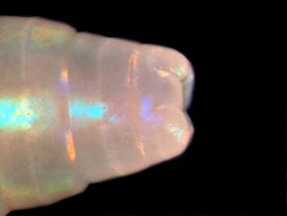 A

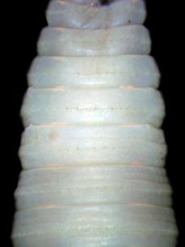B | 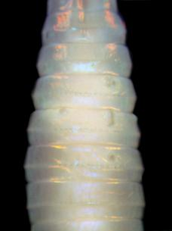C
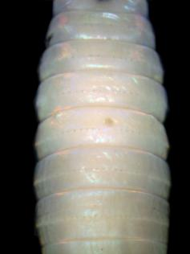D | 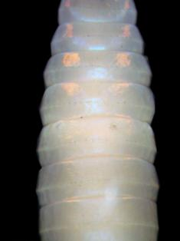E

Figure 1. Amynthas pallidus (Michaelsen, 1892), A = Prostomium, dorsal view, B-E = Spermathecal pore region.

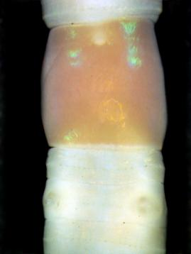 A | 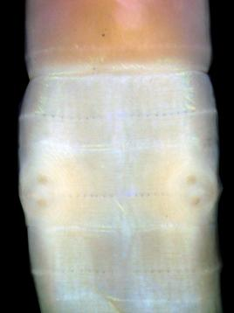 B
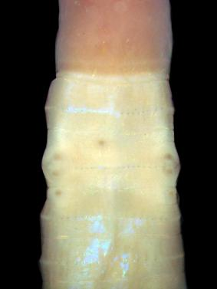 C | 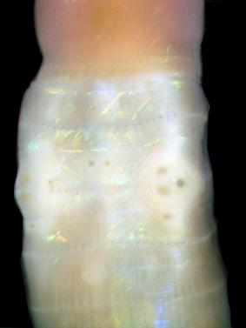 D
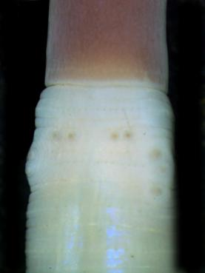 E | 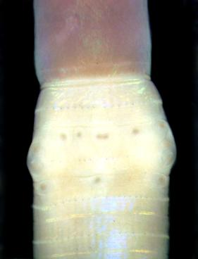 F

Figure 2. Amynthas pallidus (Michaelsen, 1892), A–F = Male field of several individuals.

Table 1. Location of genital markings in various A. pallidus individuals from Hamirpur district, Himachal Pradesh (• = individual genital marking)
Site | Segment 6 | Segment 7 | Segment 8 | Segment 18 | Segment 19
Ambota
1 | • | • • |  | •  : :
2 | ⁛ | • •  • • |  | • • • •  : : | •
3 |  | • • |  | • •  : : | •
4 |  | • • | • | • •  : :
5 |  | • • | •
6 | • | • | • | : :
7 |  | • |  | : : | • •
8 |  | • • |  | ⸱⁚ ⁚⸱ | • •
9 |  | • •  • | •  • | • •  ⸱⁚ ⁚⸱ | • • • •
10 |  | • • |  | ⸱⁚ ⁚⸱
11 |  | • • |  | • •  ⸱⁚ ⁚⸱ | • •
12 |  | • • • |  | : :
13 |  | • • |  | •  ⸱⁚ : | •
14 |  | • •  • |  | •  ⁛ ⁚⸱ | • •
15 |  |  |  | • • •• • •  ⸱⁚ ⁚⸱ | • • •
16 |  | • • |  | ••• • ••  ⸱⁚ ⁚⸱ | • •
17 |  | • • |  | : ⁚⸱ | •
18 |  | • • • | • | ⸱⁚ ⁚⸱ | •
Barsar
19 | • | • | • | : :

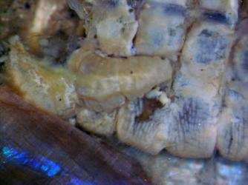 A | 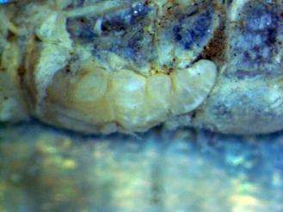 B
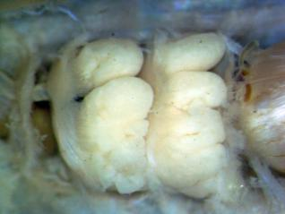 C

Figure 3. Amynthas pallidus (Michaelsen, 1892), A–B = Caeca, C = Seminal vesicles.

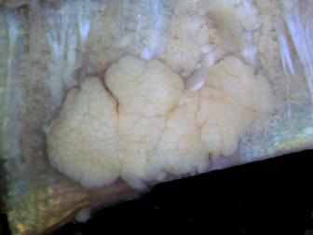A | 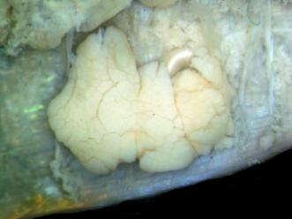B
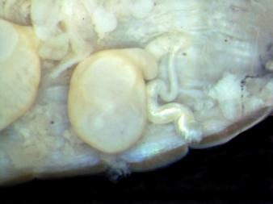C | 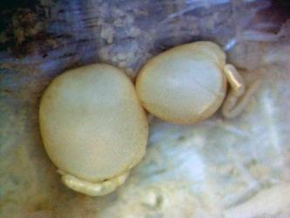D

Figure 4. Amynthas pallidus (Michaelsen, 1892), A–B = Prostate, C–D = Spermatheca.
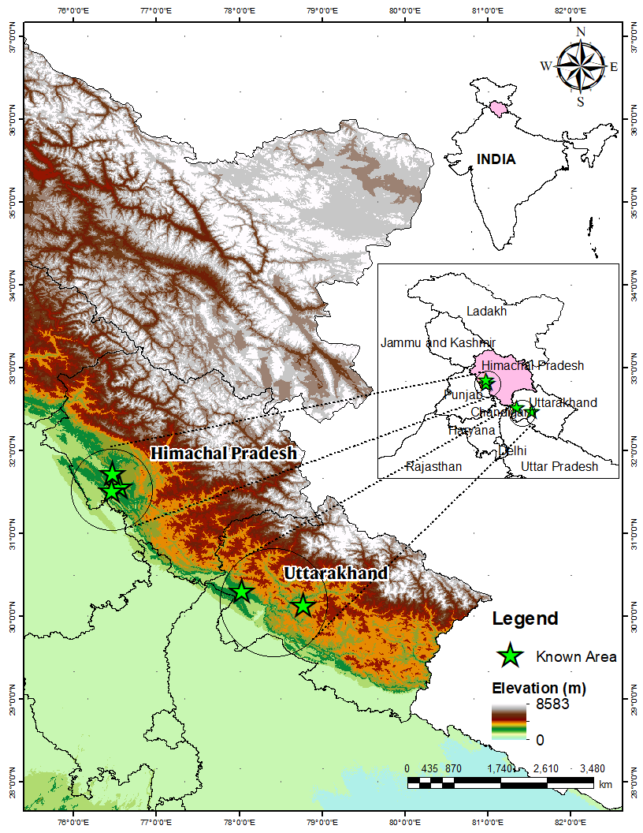
Figure 5. Current known distribution of Amynthas pallidus (Michaelsen, 1892 in India

4. Discussion
Blakemore (2012) mentioned about the capacity of pheretimoids to opportunistically occupy new areas, especially where the soil is cultivated. Specimens of A. pallidus from the Himachal Pradesh is also collected from the agriculture fields, whereas the Uttarakhand specimen was collected from a forest nursery. Blakemore (2014) stated that the distribution A. pallidus is confused with that of A. morrisi sensu stricto. The present records of A. pallidus from the Himachal Pradesh state also stress upon the statement of Blakemore (2014). According to Easton (1982) A. morrisi has been frequently recorded from warmer temperate areas throughout the world, but tropical records are rarer and usually from higher altitudes. As of now A. morrisi has been reported from several areas of 15 states and union territories of India (see Narayanan et al., 2023), but many of these reports are from the temperate and subtropical zones. Whereas, A. pallidus has been reported from the tropical, subtropical and warmer temperate zones (Michaelsen, 1892; Beddard, 1895; Fedarb, 1898; Blakemore, 2014). Classification of pheretimoid earthworm species complex is in a chaos, many species of that particular complex share similar appearances. Due to the presence of homoplasy and synapomorphy, it is difficult to distinguish them based on their morphological characteristics. A brief comparison of the key characters which differentiate both species are provided in table 2. Due to the close resemblance of both species, we presume that many previous records of A. morrisi from India would belong to the A. pallidus. Hence, populations of A. pallidus and A. morrisi species from different areas of India, especially from the Western Himalayan region of India should be studied in detail by engaging the molecular techniques to fix the identity of these two species.

Table 2. A brief comparison of the characters A. morrisi (Beddard, 1892) and A. pallidus (Michaelsen, 1892)
Character | A. morrisi (Beddard, 1892)¹ | A. pallidus (Michaelsen, 1892)^{1,2,3}
Length | 52 (80 mm shown in fig) | 76−125 mm
Width |  | 3.5−5 mm
Segments | 93 | 87−101
Setae |  | 52−64 in mid body
Male pore | Not separated by a very wide interval | Widely separated (0.21–0.31 body circumference apart)
Genital markings (GM) at spermathecal pore | Central discs, mid-ventral, presetal in 7 & 8, plus Rosa found them mid-ventral in 6 in one and in 18 in two of his non-type specimens. | Circular disc-like, variable, presetal, median to spermathecal pores as single, paired, rarely adhere together.
GM in male field | None at male pore region | Variable in male field (2, 3 or 4 papillae particular to each of the male pores, and 1–6 presetal markings on segment 18). 1–4 on segment 19, behind furrow 18/19 (generally paired)
Gizzards | In septal space of 8−10 | In front of septum 9/10, in segments 8–9
Intestine origin | ? | Intestine in 14 or 15
Caeca | ? | Simple, incised or lobate margins, in segments 27−26, 25
Spermathecal diverticulum | About as long as the ampulla, un-dilated (= not enlarged) | Longer than the duct plus ampulla, swollen entally
Data from: ¹ Blakemore (2014), ² Fedarb (1898), ³ Present study

References
- Ahmed, S., & Julka, J.M. (2017). First record of exotic earthworm, Amynthas hupiensis (Michaelsen, 1895) (Oligochaeta: Megascolecidae), from India. Megadrilogica, 22 (7), 151–154.
- Bantaowong, U., James, S.W., & Panha, S. (2015). Three new species of the Genus Amynthas Kinberg, 1867 from Thailand (Clitellata: Megascolecidae). Tropical Natural History, 15(2), 167–178.
- Beddard, F.E. (1895). A monograph of the Order Oligochaeta. Clarendon Press, Oxford, pp. 769.
- Blakemore, R.J., (2007). Updated checklist of pheretimoids (Oligochaeta : Megascolecidae : Pheretima auct.) taxa December 2007. Available from: http://www.annelida.net/earthworm/Pheretimoids.pdf (accessed 20 December 2023)
- Blakemore, R.J., (2012). Cosmopolitan earthworms – an eco-taxonomic guide to the peregrine species of the world. 5th edition: 1–850, VermEcology Solutions, Yokohama, Japan. pp. 850 + 350 figs. and internet links.
- Blakemore, R.J., (2014). Miscellaneous earthworm types in the Natural History Museum, London (Annelida: Oligochaeta: Megadrilacea: Eudrilidae, Lumbricidae, Megascolecidae, Moniligastridae, Octochaetidae). Opuscula Zoologica Budapest, 45(2), 119–155.
- Chang, C-H., Shen H-P., & Chen, J.H. (2009). Earthworm fauna of Taiwan. Biota Taiwanica. National Taiwan University Press, Taipei, Taiwan, pp vi+174.
- Chang C-H., Snyder, B.A., & Szlavecz, K. (2016). Asian pheretimoid earthworms in North America north of Mexico: An illustrated key to the genera Amynthas, Metaphire, Pithemera, and Polypheretima (Clitellata: Megascolecidae). Zootaxa, 4179(3), 495–529. http://doi.org/10.11646/zootaxa.4179.3.7
- Chang C-H., Shen, H-P., Sherlock, E., & Csuzdi, C. (2024). A review of the earthworm Amynthas masatakae (Beddard, 1892) (Clitellata, Megascolecidae), with designation of two new synonyms. Biodiversity Data Journal, 12, e119599. https://doi.org/10.3897/BDJ.12.e119599
- Easton, E.G., (1982). Australian Pheretimoid earthworms (Megascolecidae : Oligochaeta) a synopsis with the description of a new genus and five new species. Australian Journal of Zoology, 30, 711–735.
- Fedarb, S.M., (1898). On some earthworms from British India. Proceedings of the Zoological Society of London, 1898, 445–450. https://doi.org/10.1111/j.1096-3642.1898.tb03162.x
- Gates, G.E., (1972). Burmese earthworms, an introduction to the systematic and biology of the megadrile oligochaetes with special reference to Southeast Asia. Transactions of the American Philosophical Society, 62(7), 1–326.
- Hartwich, G., & Kilias, I. (1989). Die Oligochaeten -Typen des Zoologischen Museums in Berlin. Mitteleitung der Zoologischer Museum Berlin, 65(2), 249–295. https://doi.org/10.1002/mmnz.19890650210
- Jiang, J., Sun, J., Zhao, Q., & Qiu, J. (2015). Four new earthworm species of the genus Amynthas Kinberg (Oligochaeta: Megascolecidae) from the island of Hainan and Guangdong Province, China. Journal of Natural History, 49(1–2), 1–17. http://dx.doi.org/10.1080/00222933.2014.931480
- Julka, J.M., (1990). Annelida. In: Director (Ed.), Collection and preservation of animals, Zoological Survey of India, Calcutta, pp. 57–64.
- Kharkongor, I.J., (2018). Taxonomic and ecological studies on the earthworms (Annelida: Oligochaeta) of West Khasi Hills District, Meghalaya. Records of the Zoological Survey of India, 118(1), 56–74. http://dx.doi.org/10.26515/rzsi%2Fv118%2Fi1%2F2018%2F123034
- Lone, A.R., Thakur, S.S., Tiwari, N., Sokefun, O.B., & Yadav, S. (2021). DNA barcoding and genetic variability of earthworms (Clitellata: Oligochaeta) with new records from Mizoram, India. Organisms Diversity & Evolution, 21(4), 737–751. https://doi.org/10.1007/s13127-021-00520-0
- Michaelsen, W., (1892). Terricolen der Berliner Zoologischen Sammlung. II. Archiv für Naturgeschichte, 58(1), 209–261. https://doi.org/10.5962/bhl.part.8321
- Narayanan S.P., Paliwal R., Kurien, V.T., Thomas A.P., & Julka J.M. (2023). Earthworms (Clitellata: Moniligastrida, Crassiclitellata) of India: distribution and status. Department of Printing and Publishi2ng - Mahatma Gandhi University, Kottayam, 378 pp.
- Narayanan, S.P., Sathrumithra, S., Anuja, R., Christopher, G., Thomas, A.P., & Julka, J.M. (2019). First record of the exotic Metaphire bahli (Gates, 1945) (Oligochaeta: Megascolecidae) from India. Opuscula Zoologica Budapest, 50(1), 99–103. http://dx.doi.org/10.18348/opzool.2019.1.99
- Narayanan, S.P., Verma, H., Verma, A.K., & Thomas, A.P. (2024). Amynthas aspergillum (Perrier, 1872)(Clitellata, Megascolecidae): A new addition to the South Asian earthworm fauna. Opuscula Zoologica Budapest, 55, 97-104.
https://doi.org/10.18348/opzool.2024.4.97
- Nguyen, T.T., Nguyen, A.D., Tran, T.T.B., & Blakemore, R.J. (2016). A comprehensive checklist of earthworm species and subspecies from Vietnam (Annelida: Clitellata: Oligochaeta: Almidae, Eudrilidae, Glossoscolecidae, Lumbricidae, Megascolecidae, Moniligastridae, Ocnerodrilidae, Octochaetidae). Zootaxa, 4140, 1–92. http://doi.org/10.11646/zootaxa.4140.1.1
- Siddaraju, M., Sreepada, K.S., & Reynolds, J.W. (2010). Checklist of earthworms (Annelida: Oligochaeta) from Dakshina Kannada, Karnataka south west India. Megadrilogica, 14(5), 65–75.
- Sims, R.W., & Easton, E.G. (1972). A numerical revision of the earthworm genus Pheretima auct. (Megascolecidae: Oligochaeta) with the recognition of new genera and an appendix on the earthworms collected by the Royal Society North Borneo Expedition. Biological Journal of the Linnaean Society, 4, 169–268. https://doi.org/10.1111/j.1095-8312.1972.tb00694.x
- Sun, J., Jiang, J., Zhao, Q., & Qiu, J. (2015). New earthworms of the Amynthas morrisi-group (Oligochaeta, Megascolecidae) from Hainan Island, China. Zootaxa, 4058(2), 257–266. http://dx.doi.org/10.11646/zootaxa.4058.2.7
- Tiwari, N., James, S.W., & Yadav, S. (2022). First record of Pheretima vungtauensis (Clitellata: Megascolecidae) in India and its phylogenetic relationship with Metaphire houlleti. Biologia, https://doi.org/10.1007/s11756-022-01074-y
- Tiwari, N., James, S.W., & Yadav, S. (2024). Pheretimoid earthworms of India: new insight from molecular systematics and phylogenetic relationship with new records. Organisms Diversity & Evolution, https://doi.org/10.1007/s13127-024-00646-x
- Tiwari, N., Shilpi, K., James, S.W., Gupta, N., and Yadav, S. (2025). Three Novel Species of Earthworms of Genus Metaphire Sims and Easton, 1972 from Manipur, India. Zootaxa. 5589(1), 166-189. https://doi.org/10.11646/zootaxa.5589.1.14
- Vabeiryureilai, M., Zothansanga, C., Lalchhanhima, M., Kumar, N.S., & Lalthanzara, H. (2020). Study on the Amynthas (Kinberg, 1867) earthworm (Megascolecidae: Oligochaeta) diversity through DNA barcoding from Northeast India. Journal of Environnemental Biology, 41, 867–873. http://doi.org/10.22438/jeb/4(SI)/MS_1919
- Vishwakarma, A., & Yadav, S. (2017). A contribution to earthworm diversity of central India (Madhya Pradesh). In: Horton, C.G. (Ed.), Earthworms types, roles and research. Nova Science Publishers, New York, pp. 43–89.

