Efficacy of Mimosa pudica methanolic extract on BPA induces Benign Prostate Hyperplasia in albino mice.

Abstract:
Benign prostate hyperplasia is a non-cancerous enlargement of prostate gland normally observed in older men over 60years of age. The present study investigated the effect of Mimosa pudica methanolic extract to evaluate different parameters like Sperm count, Urine volume and Prostate Somatic Index (PSI) and prostate histology on BPA induced BPH model of mouse. The animal groups (3 groups-control, BPA treated and Mimosa pudica methanolic extract treated) were treated for 10 days. In result it was found that the BPA treated group showed significant decrease in sperm count whereas, increase in Urine volume and PSI than the normal control group. After the extract treatment, the 3rd experimental animal group showed significant increase in sperm count and decrease in urine volume and PSI as compared to the BPA treated group. The histological study showed reduction or shrinking enlarged glandular epithelium (GE) and infolding of GE reverse to normal state in the 3rd group which seems to be increased in the BPA treated 2nd group. The increased lumen of excretory duct (ED) due to reversal of infolding of GE is also seen in the 3rd group. BPA is environmental endocrine disruptor which can bring decrease sperm count, increase urine volume and PSI and distort prostate tissue architecture. Mimosa pudica have certain phytochemicals which may have a very positive effect against Prostate enlargement and its negative effect on male reproductive system.
Key words:BPH, Mimosa pudica, BPA, Sperm count, PSI, Urine volume.
Introduction: Benign prostatic hyperplasia (BPH), commonly known as prostate hyperplasia, is a condition in which the prostate gland, located below the bladder, becomes enlarged. It is present in more than 50% of man over 60 years of age and occurs in approximately 70% to 80% of men between the ages of 70 to 80 years (Thorpe et al., 2003, Dixon et al., 1999). On the growing age, the prostate gland grows in size and press against the urethra, causing difficulty in urination, low sperm count and other urinary symptoms. Treatment procedure includes use of alpha blockers and 5-alpha reductase inhibitors as medications. In severe cases, surgery might be necessary (Marbeen et al., 2005, Abdi et al.,2017). Herbalism, has a long history in India, with traditional systems of medicine such as Ayurveda and Unani. Herbalism is one of an option for rural areas where traditional remedies are used to manage their health ailments and BPH is one of the ailments. Bisphenol A (BPA) is a chemical compound commonly used in the production of polycarbonate plastics and epoxy resins. Low dose of BPA exposure can lead to the development of prostate hyperplasia (Wu et al., 2015). BPA may act on the endocrine system, disrupting hormonal regulation and leading to the development of prostate hyperplasia as well as it may disrupt the spermatogenesis process. It was documented that the BPA toxicity may trouble the integrity of blood testis barrier which may lead low sperm count (Li et al., 2009, Cariati eta al., 2019). Mimosa pudica, is a tropical herb that has been used in traditional medicine in various part of the world including India, Southern Asia, Africa, Northern America etc. for various ailments, including inflammation, pain, and urinary disorders. The present study has investigated the potential of Mimosa pudica extract on prostate somatic index, urine volume and sperm count on BPA treated albino mice.
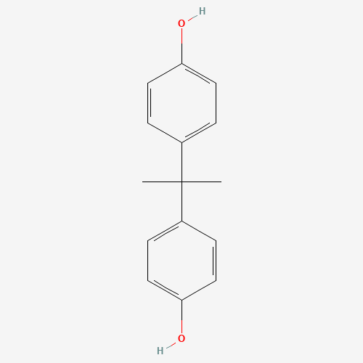
Fig 1: Structure of Bisphenol A
Source of Bisphenol A [ (CH3)2C(C6H4OH)2],(source :Pub Chem CID 6623)
Meterial and Methods:
Experimental animals
Adult male albino mice weighing 35-40 g were use for this experiment. All the animals were kept in the animal house of USTM under natural light and temperature and ad-libitum. All the animals were maintained and sacrificed following the guideline of “Institutional Animal Ethics Committee. The albino mice were treated humanely in compliance with the National Institution of Heath’s laboratory animal care guideline (NH publication No. 86-23, revised 1985). The study design of the experiment and housing of animals was approved by the Institutional Animal Ethics Committee on a meeting held on 17/05/2023 prior to the commencement of the experiment. Approval No. of this project for use of 15 Albino male mice is IAHF/USTM/2023/P-2.
Animal groupings:
3 groups of animals were made(n=5) where Group 1 (Control group) mice are orally feed with normal water. Group 2 or BPA treated group (10µg/kg/day) for 10 days (oral treatment). Group 3 or extract treated group in which, after 10 days of BPA oral administration, animals received Mimosa pudica methanolic extract (MPME) orally at daily dose of 800mg/kg for 10 days.
Chemicals:
Bisphenol A (BPA) (Sr. No. AL 0752, Batch No. BI348, Assay min. 98%) was purchased from Alpha Chemika, Mumbai, Maharasthra and Dimethyl Sulfoxide (DMSO) (Lot No. 8907357605723, purity 95%) was purchased from North East Chemical Corporation, Assam, India. BPA was solubilized in 0.5% DMSO and stored in room temperature for 7 days. After 7 days fresh solution of BPA was prepared.
Collection of plant materials
Mimosa pudica whole plants were collected from campus of USTM form February to March 2023. The plants were washed thoroughly with water and other debris are removed by hand. Then they were cut into smaller pieces and shed dried for 14 days after which they were ground into powder using mechanical grinder. One herbarium of the study plant was prepared and submitted to Dept. of Botany Gauhati University Herbarium section for proper identification and authentication of the study plant.
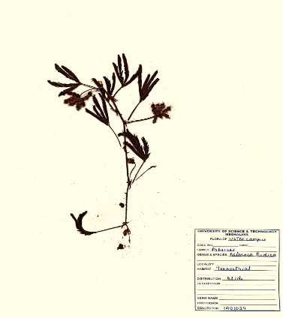
Fig: 2 Prepared herbarium for Identification of study plant Mimosa pudica.
Preparation of methanolic extract of Mimosa pudica (MEMP):
25 grams of powder is taken and put in close bottle with 250 ml of methanol for 7 days. After 7 days the mixture is filtered using Buchner funnel and Whatman No. 1 filter paper. The filtrate was concentrated at 30ºC and the extract was stored in 4ºC for subsequent use in the experiment.
Phytochemical screening of plant extract:
Detection of alkaloids: Two tests were conducted to detect alkaloids i.e., Mayer’s test and Wagner’s test. Formation of brown/reddish precipitate indicates the presence of alkaloids.
Detection of carbohydrates: Molisch ’s Test and Benedict’s Test were conducted to detect carbohydrate. Orange red precipitate indicates the presence of reducing sugars.
Detection of glycosides: Modified Borntrager’s Test was done to detect glycosides.Formation of rose-pink colour in the ammonical layer indicates the presence of anthranol glycosides.
Detection of saponins: For detection of saponins Froth Test was done where extracts were diluted with distilled water to 20ml and this was shaken in a graduated cylinder for 15 minutes. Formation of 1 cm layer of foam indicates the presence of saponins.
Detection of phytosterols: Salkowski’s Test was done to detect phytosterols. Extracts were treated with chloroform and filtered. The filtrates were treated with few drops of Conc. Sulphuric acid, shaken and allowed to stand. Appearance of golden yellow colour indicates the presence of triterpenes.
Detection of phenols: Ferric Chloride Test was done to detect phenols. Extracts were treated with 3-4 drops of ferric chloride solution. Formation of bluish black colour indicates the presence of phenols.
Detection of tannins: Gelatin Test was done to detect tannins. To the extract, 1% gelatin solution containing sodium chloride was added. Formation of white precipitate indicates the presence of tannins.
Detection of flavonoids: For Alkaline Reagent Test to detect flavonoids, extracts were treated with few drops of sodium hydroxide solution. Formation of intense yellow colour, which becomes colourless on addition of dilute acid, indicates the presence of flavonoids.
Detection of proteins and amino acids:
Xanthoproteic Test: The extracts were treated with few drops of conc. nitric acid. Formation of yellow colour indicates the presence of proteins.
Ninhydrin Test: To the extract, 0.25% w/v ninhydrin reagent was added and boiled for few minutes. Formation of blue colour indicates the presence of amino acid.
Detection of diterpenes: For this Copper acetate Test was done. Extracts were dissolved in water and treated with 3-4 drops of copper acetate solution. Formation of emerald green colour indicates the presence of diterpenes.
Sperm count
For sperm count, epididymis was removed from narcotised mice and placed in 1 ml of phosphate buffer solution and minced into small pieces using mortar and pestle and a suspension was prepared and filtered in a nylon mesh. The Suspension was incubated at 370 for 30 min to prepare aliquot and placed into neubaur’s counting chamber. Under light microscope the sperm count is done on the large squares of haemocytometer and calculated out as per standard method in neubaur’s chamber.
Urine volume
Urine from all group of mice was collected using stainless steel metabolic cage.
Prostate-Somatic Index (PSI)
Organo-somatic indices indicate the proportional sizes of organs and reflect the status of organ systems which may change in size more rapidly than organism weights and lengths increase or decrease ( Gupta et al., 2015) .Prostate-somatic index express the relationship between prostate gland (which may change its mass more rapidly than organism weights and length) and total body weight is calculated by dividing the gross weight of the prostate gland by body weight and the result is multiplied by hundred (100). Prostate-Somatic Index (PSI)=$\frac{weight of prostate gland}{weight of animal body}×100$
Histology: Histological study is done by routine hematoxylin and eosin staining. Prostate glands from all experimental groups removed after sacrificing the animal and was preserved in 10% bouin’s fluid for 24 h for fixation. After fixation, the tissues were dehydrated in a series of increasing concentrations of alcohol (30%,50%,70%,90%,100%) and then embedded in paraffin blocks. The prepared paraffin blocks were sectioned into 4-µm slices and stained with hematoxylin and eosin(H&E) for histopathological evaluation. The tissue sections were observed under a light microscope under 40 X magnification. The appearance of Glandular Epithelium (GE), Excretory Duct (ED) and supporting Stroma(S) of prostate gland of all experimental groups were examined (Huang et al., 2017).
Statistical analysis
Values are expressed as mean ± standard error (SE) and significance was calculated by using Student’s t test.
Result:
Phytochemical screening of methanolic extract:
The phytochemical screening of methanolic extract of Mimosa pudica showed the presence of flavonoid, saponin, alkaloids, Protein and amino acid, diterpenes, and tannins, while carbohydrates, phenol, phytosterols and glycosides are absent in the study (table 1).

Table 1: Phytochemical screening of methanolic extract.
Carbohydrates | _ | Alkaloids | +
Phenols | _ | Proteins and amino acids | +
Flavonoids | + | Diterpenes | +
Phytosterols | _ | Tannins | +
Saponins | + | Glycosides | _

(+)Present (-) Absent
Sperm count
In the result of sperm count analysis in control and both treated group it was found that, Group-1 has highest sperm count (0.415±0.034) followed by MPME treated Group-3 (0.273±0.026). BPA treatment significantly reduces number of sperm (0.217±0.0004) and has lowest sperm count as compare to all experimental groups. After treatment with MPME, the sperm count increases but it was very low as compared to normal control group (Fig:1, Fig:5B).
Urine volume:
In the urine volume analysis, it was found that the in the BPA treated group, urine volume is significantly increased (23.04±0.196) as compare to control Group-1 (10.6±0.212). After treatment with MPME for 10 days the urine volume has decreased than the BPA treated group which was again significant (12.42±0.158), but it was little bit higher when compared to controlled group. Result is discussed in Table 2.
Table 2: Showing difference in urine volume of different groups.
Sl. No. | Experimental groups | Urine volume (ml)
1. | Group-1: Control (Normal water) | 10.6±0.212
2. | Group-2: BPA treated (10µg/kg) | 23.04±0.196*
3. | Group-3: MEMP treated (800mg/kg) | 12.42±0.158*

Note: Data were expressed as mean±SE, BPA – Bisphenol A, MEMP-Methanolic extract of Mimosa pudica.(*P≤0.05)’
Prostate-Somatic Index (PSI)
To determine the PSI first the body weight of the experimental groups was determined. The normal control group (Group 1) average weight was 36.65±0.282. After administration of BPA in the Group 2 the body weight decreases significantly (31.77±0.98) which means BPA has certain effect on the body of animal. The third group i.e., MPME treated group showed increases body weight (33.46±0.77) after treatment, indicating it has certain protective effect against BPA (Fig:2).
The prostate gland with the accessory part like seminal vesicle and urinary bladder were dissected out from the experimental groups and then the prostate glands were separated from the accessory part by using a scalpel and weighted (Fig 5A). The prostate weight after oral administration of BPA showed significantly increases as compare to normal prostate weight in this study. Prostate weight of Group-1 is found to be 0.051±0.002 and that of Group-2 is 0.070±0.002. Upon administration of MEMP prostate wight increases almost to normal prostate weight (0.052±0.003) (Fig:3).
From the Body weight and prostate weight value the PSI was determined and, in the result, normal control group showed PSI value of 0.147±0.00160, while BPA treated group showed 0.170±0.00048. The PSI was significantly increased in Group 2 in respect to Group 1 (P≤0.03) and 0.023 difference was seen between Group-1 and Group-2. The PSI of Group 3 i.e., MPME treated group is 0.161±0.00657 which is significantly 0.009 lower than Group-2 (P≤0.05). BPA treated group has highest PSI as compare to all the groups (Fig:4)
**CV
Fig 3: Graph showing difference in sperm count of  different experimental groups. (*P≤0.05,**P≤0.03) | Fig 4: Graph showing difference in body weight of different experimental groups.. (*P value≤0.05, **P≤0.03)
**…..
**
Fig 5: Graph showing difference in prostate weight of different experimental groups. (* P value≤ 0.05. **P value≤0.03). | Fig 6: Graph showing significant difference in PSI in different experimental groups.  (*P≤0.05,**P≤0.03)

Histology:
Prostate gland is composed of supporting stroma which is a mixture of fibrous tissue and smooth muscle fibers and acini or excretory duct of prostate. Acini are surrounded by simple columnar epithelium. Hyperplasia and hypertrophy can be seen in Group-2 mice and atrophy in Group-3 mice. Main change in prostate in current study is the thickness of epithelium surrounding acinus and the size of lumen of acini. In Group-1 prostate (Normal control) (Under 40X magnification) normal glandular epithelium (GE), excretory duct (ED) and supporting stroma (S) has been seen. Histology of Group-2 prostate (BPA treated, 10µg/kg, Under 40X magnification) showing thicken or enlarged and infolded glandular epithelium (GE), narrowed lumen of excretory duct (ED) due to enlargement and infoldings of glandular epithelium. No significant changes observed in supporting stroma (S). On the other hand, group-3 (MEMP treated, 800mg/kg, Under 40X magnification) showing reduction or shrinking enlarged glandular epithelium (GE) and infolding of GE also reverse to normal state. There increased lumen of excretory duct (ED) due to reversal of infolding of GE. No significant changes observed in supporting stroma (S).
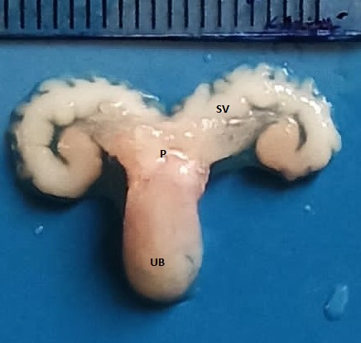 | 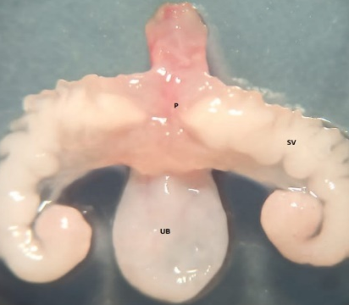 | 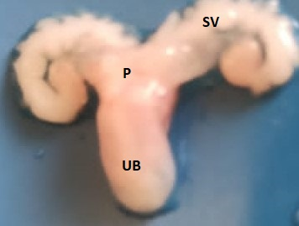
[A] Group1 | Group 2 | Group3
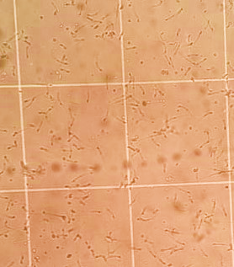 |  | 
[B] Group1 | Group2 | Group3
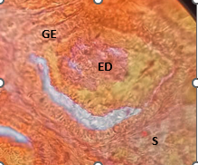 | 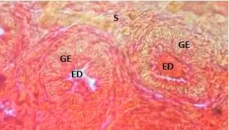 | 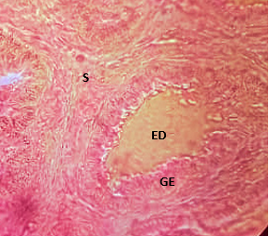
[C] Group 1 | Group 2 | Group 3
Fig 7: [A] figure showing Seminal vesicle (SV), Urinary Bladder (UB) and Prostate(P) in all the treated groups.[B]. Figure showing sperm count under microscope in all the treated groups (40x magnifiacation). [C]. Figure showing histological alteration in all treated groups. Histology of Group-1 showing normal GE, ED andS. Histology of Group-2 prostate showing thicken or enlarged and infolded GE, narrowed lumen of ED due to enlargement and infoldings of glandular epithelium. No significant changes observed in supporting S. Histology of prostate of Group-3 showing reduction or shrinking enlarged GE and infolding of GE also reverse to normal state. There increased lumen of ED due to reversal of infolding of GE. No significant changes observed in supporting S.

Discussion:
From the result it was found that the methanolic extract of Mimosa pudica is a very effective medicinal plant against BPH as it shows significant positive result in different parameters of BPA induced prostate hyperplasia mouse model. The experiment conducted using three groups of mice aimed to determine the effect of methanolic extract of Mimosa pudica on BPA-induced prostate hyperplasia. The results of the experiment indicated that BPA administration caused a significant reduction in body weight in mice. In a similar experiment by Al-Hiyasat et al., 2002 and Wu et al., 2011, get a similar kind of result but opposite to the findings of Huang et al., 2018 . In another increase in prostate weight and significant decrease in sperm count was observed (Sakaue et al., 2001). It also significantly increases urine output as compare to normal urine output. However, treatment with methanolic extract of Mimosa pudica reversed these effects, resulting in a reduction in prostate weight and slight increase in sperm count (Arayombo et al., 2018, Adesanya et al., 2021). Urine output also decreases after treatment of methanolic extract of Mimosa pudica almost equal to normal urine output. In a similar study, ethanolic extracts of Cassia sieberiana leaves on BPH model in rat and found that the extract exert potency against prostate hyperplasia by reducing prostate weight and increasing sperm count after treatment (Ekeyi et al., 2021)
Prostato-somatic index (PSI) reveals proportional increase of prostate gland with body weight (Juan et al., 2020). Group-2 mice which are treated with BPA has highest PSI indicating that prostate gland increase in weight more rapidly than body weight. The experimental Group-3 have lower PSI as compare to Group-1. This explain the protective activity of Mimosa pudica against the effect of BPA. Similar results were shown in many research work with other medicinal plants like Raphia hookeri, Croton membranaceus and Cucurbita pepo (Mbaka et al., 2013, Georgeet al., 2015, Dotto et al., 2020). Administration of those extracts overall results in reduction of prostate size and weight. In another review study it was documented that many plant based products like pumkin seed, willow herbs, tomato, Pygeum Africana, Palmetto fruit etc have a very good efficacy against BPH and sperm count (Csikos et al., 2021). From the result, it could be concluded that Mimosa pudica might be a good alternative medicine option for BPH and the related physiological ailments but more research is needed in future,
Conclusion: From the result it was clear that the Mimosa pudica methanolic extract have certain effect to improve different health condition related to BPH.
Abbreviations:
BPH: Benign Prostate Hyperplasia
BPA: Bisphenol A
PSI: Prostate Somatic Index
MPME: Mimosa Pudica Methanolic Extract
SE: Standard Error
GE: Glandular Epithelium
ED: Excretory Duct
S: Supporting Stroma
Availability of data and materials: No data will be available because this study incorporates all evaluated dataset findings
Declarations Ethics approval and consent to participate: This work received ethical approval and authorization from the Institutional Animal Ethical Committee of the Department of Zoology, University of Science and Technology meghalaya, India. (Ref: IAHF/USTM/2023/P-2. Date 17/05/2023).
Consent for publication: Not applicable.
Reference:
Thorpe, A., &Neal, D. (2003). Benign prostatic hyperplasia. Lancet. 361,1359–67.
Dixon, J.S., Chow, P.H.,&Gosling, J.A. (1999). Anatomy and function of the prostate gland. In Nickel JC(ed) Textbook of prostatis. Isis Medical Media Ltd, Oxford, UK, pp. 39-46.
Marbeen, M.I.,AL-Snafi, A.E., Marbut, M.M., & Allahwerdy, I.Y. (2005). The probable therapeutic effects of date palm pollen in the treatment of male infertility. Tikrit J Pharmaceut Sci 1,30-35.
Abdi, F., Roozbeh, N., & Mortazavian, A.M. (2017). Effects of date palm pollen on fertility: research proposal for asystematic review. BMC Res Notes .2017; 10: 363.
Wu, J., Huang, D. Su, X., Yan, H., & Sun, Z.(2015). Oral administration of low-dose bisphenol A promotes proliferation of ventral prostate and upregulates prostaglandin D2 synthase expression in adult rats. Toxicol and Ind Health. 2015, 1–11.
DOI: 10.1177/0748233715590758.
Li, M.W., Mruk, D.D., Lee, W.M., & Cheng, C.Y. (2009). Disruption of blood testes barrier integrity by bisphenol A in vitro: is this a suitable model for studying blood testes barrier dynamics? Int J Biochem Cell boil. 41, 2302-14.
Cariati, F., D’Uonno Borrillo, F., Lervolino, S., Galdiero, G., &Tomaiuolo, R. (2019).“Bisphinol a: an emerging threat to male fertility”. Rep Biol and Endocrinology. 17(6),1-8.
http://doi.org/10.1186/s12958-018-0447-6
Gupta, N., Gupta, D. K., & Sharma, P. K. (2015). Condition factor and organosomatic indices of parasitized Rattus rattus as indicators of host health. Ind Soci for Parasitol. 2015.
DOI 10.1007/s12639-015-0744-3.
Al-Hiyasat, A. S., Darmani, H., Elbetieha, A.M. (2002). Effects of bisphenol A on adult male mouse fertility. Eur J oral sci 110,163–167
Wu, J., Jiang, X., Liu, G., Liu, X., He, G., & Sun, Z.(2011) Oral exposure to low-dose bisphenol A aggravates testosterone-induced benign hyperplasia prostate in rats. Toxicol and Ind Health. 27(9), 810–819. DOI: 10.1177/0748233711399310.
Huang, D., Zheng, C., Pan, Q., Wu, Sh, Su, X., Li, L., Wu, J., & Sun, Z. (2018). Oral exposure of low-dose bisphenol A promotes proliferation of dorsolateral prostate and induces epithelial–mesenchymal transition in aged rats. Science Reports 8, 490. DOI:10.1038/s41598-017-18869-8.
Sakaue, M., Ohsako, S., Ishimura, R., Kurosawa, Sh., Kurohmaru, M., Hayashi, Y., Aoki, Y., Yonemoto, J., & Tohyama, C.H. (2001) Bisphenol-A affects spermatogenesis in the adult rat even at a low dose, J Occu Health 43, 185-190.
Arayombo, B.E., Adewole, O. S., Ojo, S.K., Adelodun, S.T., Adefule, A. K., Bejide ,R. A., Salako, K. A., Olabanji, I. O., & Ojewole, J.A.O.(2018). Effects of the aqueous extract of Mimosa pudica on experimentally-induced prostatic hyperplasia. Int J of Cont Res Rev 9(2), 20439-20444. DOI: https://doi.org/10.15520/ijcrr/2018/9/02/433.
Adesanya, O. A., Suleiman, I. A., Odubela, O. O., Sheu, O. S., & Imade, O. V.(2021). Ethanolic extract of combined Cynodon dactylo1n and Mimosa pudica ameliorated experimentally induced benign prostatic hyperplasia in Wistar rats. J Infer Rep Biol. 9(1), 22-26. DOI :https://doi.org/10.47277/JIRB/9(1)/22.
Ekeyi. ,Y., Nene, O.U., Emeka, G. A., & Lawrence, S.E. (2021). Ethanol extract of Cassia Sieberiana leaves ameliorates deviances associated with benign prostatic hyperplasia in rat. All Life. 14(1) , 473-483.
Juan, P.R.A., Jorge, L.A.A., Jose, M.O.S.,Miriam, P.P., Oscar, H.C., James, C., Agustin, R.A., Hugo,J.J.G., Americo, C.L., & Julio, H.V.(2020) Cordia lutea L. flowers : A promising medicinal plant as chemopreventive in induced prostate carcinogenesis in rats. Evi Based Comp and Alt Med. 8
DOI : http://doi.org?10.1155/2020/5062942
Mbaka, G.O., Ogbonnia, S.O., Olarewaju, O.T., & Duru, F.I. (2013). The effect of ethanol seed ectract of Raphia hookeri on exogenous testosterone and estradiol induced benign prostate hyperplasia in adult male rats. J Morphol Sci .30(4), 235-243.
George, A. A., Daniel, A., Robert, A. N., Alfred, A.A., Yvonne, A., Iddi, M., Samuel, A., Kwabena B,Q., Derick, S., Ben, A. G., Peter, A. & Domonic, A.E. (2015). Shrinkage of prostate and improved quality of life : Management of BPH patient with Croton membranaceus ethanolic root extract. Evi Based Compli Alt Med. 10
DOI : http://dx.doi.org/10.1155/2015/365205
Dotto, J.M., & Chacha, J.S. (2020). The potential of pumpkin seeds as functional food ingredient : A review. Sci. Afr. 10 ,1-14.
Csikos, E., Horvath, A., Acs, K., Papp, N., Balazs, V.L., Dolenc, M.S., Kenda, M., Kocrvar, G.N., Nagy, M., Protti, M. et al.(2021) Treatment of Benign Prostatic Hyperplasia by natural drugs. Molecules. 26 :7141.
DOI : https://goi.org/10.3390/molecules 26237141

