Regional Variation in Spider Diversity Across Akole, Parner and Sangamner in Groundnut Agro-Ecosystem.

ABSTRACT:
Peanuts (groundnuts) are a valuable legume crop that enhances soil fertility and supports various industries but faces significant pest threats that reduce yield and quality. This study evaluates spider species diversity and composition in groundnut agroecosystem across Akole, Sangamner and Parner Tehsils in Ahmednagar district, Maharashtra. As generalist predators, spiders help control pest populations, supporting ecosystem health and sustainable agriculture. The findings aim to highlight the role of spiders in pest management and their contribution to agricultural practices. The analysis highlights the significant variation in spider genus composition, In Akole, spider family dominance was Lycosidae > Oxyopidae > Salticidae > Araneidae > Dysderidae > Thomisidae, while in Parner, it was Araneidae > Lycosidae > Salticidae > Corinnidae > Oxyopidae > Theridiidae. In Sangamner, the order was Lycosidae > Salticidae > Oxyopidae > Araneidae > Theridiidae > Dysderidae, highlighting regional variations in spider family distribution. The data reveals a diverse range of spider genera, with dominant ones like Pardosa, Oxyopes, and Larinia. Notably, rare genera like Myrmarachne and Bianor appeared sporadically, contributing minimally to the overall population. These findings underscore the role of spiders as important biological control agents in the agro-ecosystem, with regional differences in genus abundance reflecting the influence of local climatic and agricultural conditions. This research highlights the significance of spider diversity in maintaining ecological balance and pest regulation in groundnut farming environments.
Keywords: Family, Genus, Akole, Sangamner, Parner, Diversity, Groundnut agro-ecosystem, Spiders.
- INTRODUCTION:
Peanuts, commonly referred to as "groundnuts" in certain regions, are the edible seeds of a legume plant, rich in protein, healthy fats, vitamins, minerals, and antioxidants (Arya et al., 2016) but also play a vital role in agriculture and the economy, improving soil fertility through nitrogen fixation (Nelwamondo et al., 2024), serving as a valuable cash crop for farmers, and supporting various industries such as food processing, cosmetics, and biodiesel production (Lungaho et al., 2025). However, its cultivation is perpetually shadowed by pest threats like Thrips, Aphids, Armyworms, and Wireworms, compromising the yield, product quality, and nutritional value, leading to significant economic repercussions and threatening food security (Wightman & Rao, 1993).
Spiders are important generalist predators in agricultural ecosystems, preying on a wide range of arthropod pests. Although no single spider species or spider community alone has been definitively proven to completely control pest populations, numerous studies have demonstrated that spiders can significantly suppress pests under certain conditions, particularly in perennialcropping systems such as orchards, vineyards, and horticultural plantations (Michalko et al., 2019). Spiders contribute significantly to nutrient cycling both directly and indirectly in various ecosystems. Directly, through excretion, defecation, and disposal of prey remains, spiders enrich soil nutrients, as seen with species like the Neotropical jumping spider Psecaschapoda, which provides essential nitrogen to its host bromeliads, enhancing their growth (Romero et al., 2006).Using spiders as bioindicators provides valuable insights into the extent of environmental contamination and supports conservation and management efforts, as their webs possess a unique ability to capture and accumulate diverse airborne pollutants including particulate matter, heavy metals, polycyclic aromatic hydrocarbons (PAHs), and dioxins, thereby serving as effective indicators of atmospheric contamination(van Laaten et al.,2020; Takano et al., 2024).
The current study focused on assessing the species diversity and composition of spiders in groundnut agroecosystem across the Tehsil of Akole, Sangamner and Parner in the Ahmednagar district of Maharashtra.
- MATERIAL AND METHOD:
2.1 Study area:The proposed study area covers the agroecosystem of the western part of Ahmednagar, Maharashtra, including the Tehsils of Akole, Sangamner and Parner. Villages like Dhokari (Akole tehsil, 19.563680° N, 73.984449° E), Mhaksewadi (Parner tehsil, 19.055303° N, 74.234683° E), and Khandgaon (Sangamner tehsil, 19.542307° N, 74.185533° E) represent the district’s diverse geography.
2.2 Collection:
Spider collection was conducted in 2024-25 in groundnut agro-ecosystem across various locations. A 50x50 meter quadrat was surveyed in-depth, with surveys held in the morning from 7:00 am to 9:00 am. Spiders were collected through active searching and hand-picking, covering all three strata. Specimens were sought for two hours, examining areas beneath logs, rocks, ground detritus, crop leaves, stems, and webs.
2.3 Preservation:
After photographing the spiders, their legs and palps were straightened by soaking them in warm water. They were then transferred to 70% ethyl alcohol in a Petri dish, with plastic U-pins used to keep the legs and palps extended. The dish was covered for 24 hours to prevent alcohol evaporation. The spiders were labelled with location, time, and quantity details, then stored in glass or plastic bottles with glycerine to prevent stiffness (Keswani, 2014).
2.4 Identification:
Spider identification followed a hierarchical approach, beginning with family-level classification and proceeding through genus to final species determination. This process relied on morphometric features of body segments and the detailed structure of male and female genitalia. Standard identification keys, the latest World Spider Catalogue, and relevant Indian and international literature were consulted throughout. Using these resources, several adult spiders were resolved to species level, while others were identified to genus or family following Tikader (1987) and Barrion and Litsinger (1995). Monthly, season-wise datasets were compiled to document the prevalence of adult males, adult females, and juveniles.
- Results:
3.1 Relative Abundance of Spider Families in groundnut agro-ecosystem:
Figure 1 shows that the spider family diversity across the Ahmednagar District in the groundnut agro-ecosystem during the summer season was dominated by Lycosidae (Wolf spiders), which accounted for 28.16%of the total spider population. Following closely were Araneidae (Orb-weaving spiders) and Oxyopidae (Lynx spiders), both representing 13.22% of the total. Salticidae (Jumping spiders) contributed 12.64%, while other families like Theridiidae (Cobweb spiders) and Cheiracanthiidae (Crab spiders) made up 6.90% and 5.75%, respectively. Dysderidae (Woodlouse hunters) and Scytodidae (Six-eyed spiders) each accounted for4.60%. Smaller contributions came from Tetragnathidae(Long-jawed spiders) at 4.02%, Corinnidae (Ant spiders) at 3.45%, and Thomisidae (Crab spiders) at 2.30%, with Trochalidae (Trochale spiders) making the smallest contribution at 1.15%. This distribution highlighted the dominance of a few key families, with Lycosidae leading the way, followed by several other diverse but less abundant families.
Figure. 1. Spider Family Composition in Groundnut Agro-Ecosystem of Ahmadnagar district, Maharashtra.

3.2 Spider Family Composition in Groundnut Agro-Ecosystem of Akole, Parner and Sangamner:The spider family diversity across Akole, Parner, and Sangamner showed distinct regional variations(Figure. 2). In Akole, Lycosidae (35.39%) dominated the spider population, followed by Oxyopidae (15.39%) and Salticidae (9.23%). Other families like Araneidae (6.15%), Dysderidae (6.15%), and Thomisidae (6.15%) were also present in notable numbers. Theridiidae and Scytodidae each contributed 4.62%, while smaller proportions came from Tetragnathidae (4.62%), Cheiracanthiidae (4.6%), and Trochalidae (3.1%). In Parner, Araneidae (26%) was the most abundant family, followed by Lycosidae (16%) and Salticidae (12%). Corinnidae (12%) and Oxyopidae (10%) also had a significant presence. Other families like Cheiracanthiidae (8%) and Scytodidae (6%) were present but in smaller numbers, while Theridiidae and Tetragnathidae each accounted for 6%. Notably, Dysderidae and Thomisidae were absent in Parner. In Sangamner, Lycosidae (30.5%) and Salticidae (16.95%) dominated, with Oxyopidae (13.56%) also contributing significantly. Araneidae (10.17%) and Theridiidae (10.17%) were present in notable numbers, and Dysderidae (6.78%) was significant as well. Smaller contributions came from Cheiracanthiidae (5.1%) and Scytodidae (3.39%). Tetragnathidae also made up 3.39%, while Corinnidae, Thomisidae, and Trochalidae were absent in this region.

3.3 Generic diversity of spiders in groundnut agro-ecosystem: The spider genus diversity across the regions shows a wide range of species, with Pardosa (Lycosidae) being the most abundant genus, accounting for 20.69% of the total population. Oxyopes (Oxyopidae) follows with 13.22%, and Larinia (Araneidae) at 10.91%. Hippasa (Lycosidae) also contributes significantly at 7.47%, while Cheiracanthium (Cheiracanthiidae) and Steatoda (Theridiidae) contribute 5.75% and 5.17%, respectively. Other genera, such as Dysdera (Dysderidae) and Scytodes (Scytodidae), both contribute 4.6%, reflecting the presence of different spider families. Smaller contributions come from Plexippus (Salticidae) and Tetragnatha (Tetragnathidae), each with 4.02%. A few less common genera, including Castianeira (Corinnidae), Phlegra (Salticidae), and Harmochirus (Salticidae), have more modest contributions at 3.45%, 2.87%, and 2.3%, respectively.
Some rare genera like Gea (Cheiracanthiidae), Bianor (Salticidae), Myrmarachne (Salticidae), Theridion (Theridiidae), Tmarus (Thomisidae), Runcinia (Thomisidae), Orthobula (Trochalidae), and Neoscona (Araneidae) have very low percentages, ranging from 1.72% to 0.57%.
Table no. 1. Abundance of Spider Genera Across the Regions of Akole, Parner, and Sangamner in the Groundnut Agro-Ecosystem.
Family | Genus | Akole | % abundance | Parner | % abundance | Sangamner | % abundance
Family | Genus | No of individuals | % abundance | No of individuals | % abundance | No of individuals | % abundance
Araneidae | Larinia | 12 | 6.15 | 27 | 18 | 18 | 10.17
Araneidae | Gea | - | - | 9 | 6 | - | -
Araneidae | Neoscona | - | - | 3 | 2 | - | -
Cheiracanthiidae | Cheiracanthium | 9 | 4.62 | 12 | 8 | 9 | 5.08
Corinnidae | Castianeira | - | - | 18 | 12 | - | -
Dysderidae | Dysdera | 12 | 6.15 | - | - | 12 | 6.78
Lycosidae | Pardosa | 45 | 23.08 | 24 | 16 | 39 | 22.03
Lycosidae | Hippasa | 24 | 12.31 | - | - | 15 | 8.47
Oxyopidae | Oxyopes | 30 | 15.38 | 15 | 10 | 24 | 13.56
Salticidae | Phlegra | - | - | 6 | 4 | 9 | 5.08
Salticidae | Bianor | 3 | 1.54 | 6 | 4 | - | -
Salticidae | Plexippus | 15 | 7.7092 | 6 | 4 | - | -
Salticidae | Myrmarachne | - | - | - | - | 9 | 5.08
Salticidae | Harmochirus | - | - | - | - | 12 | 6.78
Scytodidae | Scytodes | 9 | 4.62 | 9 | 6 | 6 | 3.39
Tetragnathidae | Tetragnatha | 9 | 4.62 | 6 | 4 | 6 | 3.39
Theridiidae | Theridion | 6 | 3.07 | 3 | 2 | - | -
Theridiidae | Steatoda | 3 | 1.54 | 6 | 4 | 18 | 10.17
Thomisidae | Tmarus | 6 | 3.08 | - | - | - | -
Thomisidae | Runcinia | 6 | 3.08 | - | - | - | -
Trochalidae | Orthobula | 6 | 3.08 | - | - | - | -
- Represent species not observed
Plate 1 : Regional Variation in Spider Diversity
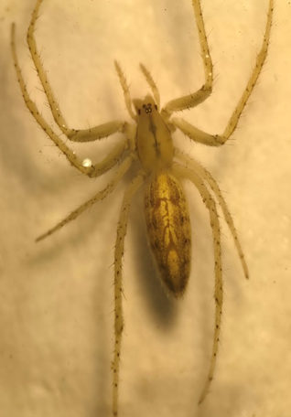 | 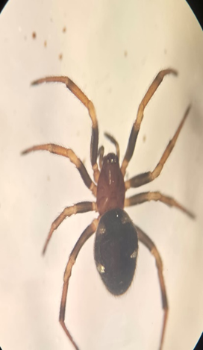 | 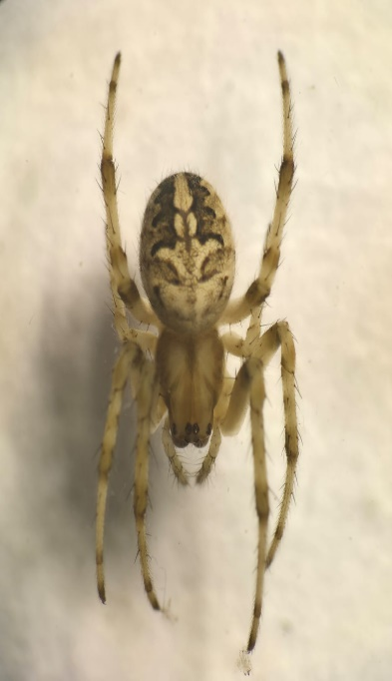
1.Larinia | 2. Gea | 3. Neoscona
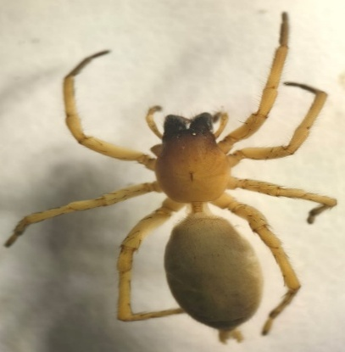 | 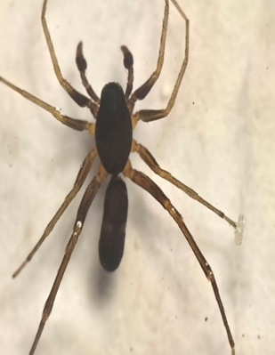 | 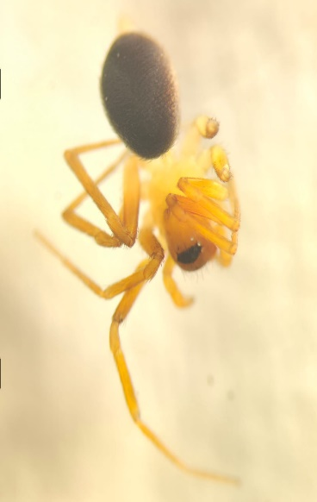
4. Cheiracanthium | 5. Castianeira | 6. Dysdera
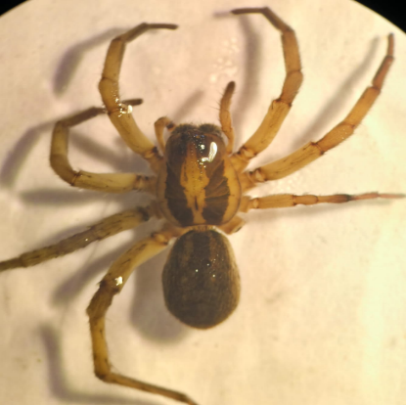 | 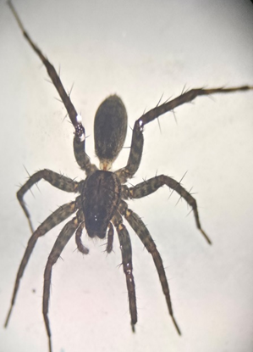 | 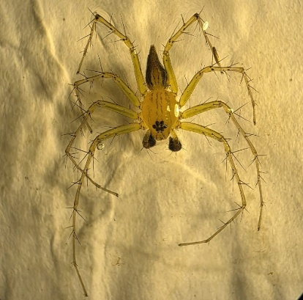
7. Pardosa | 8. Hippasa | 9. Oxyopes
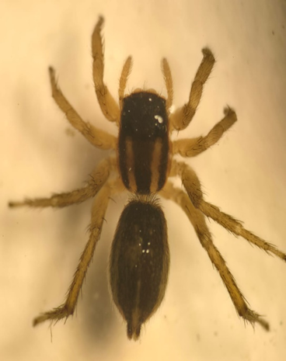 | 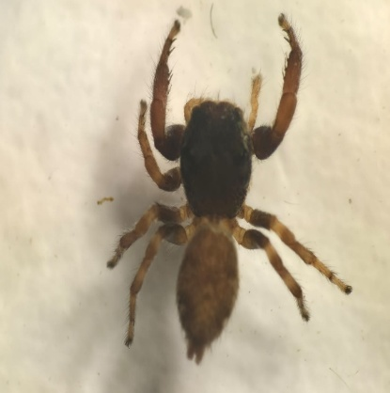 | 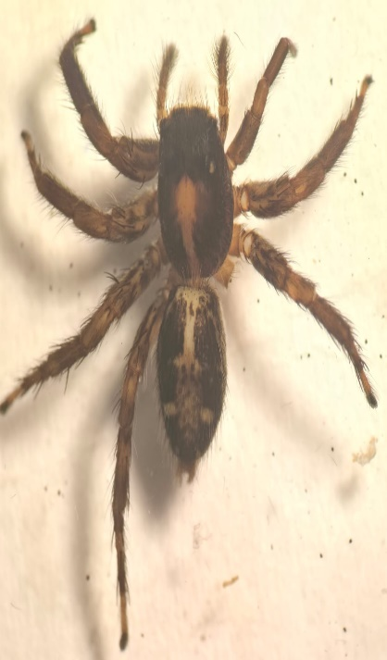
10. Phlegra | 11. Bianor | 12. Plexippus
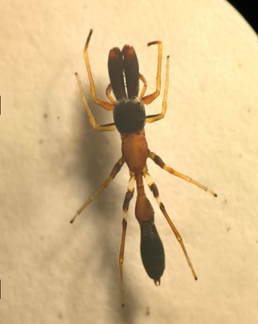 | 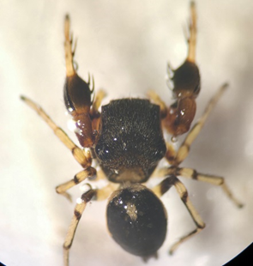 | 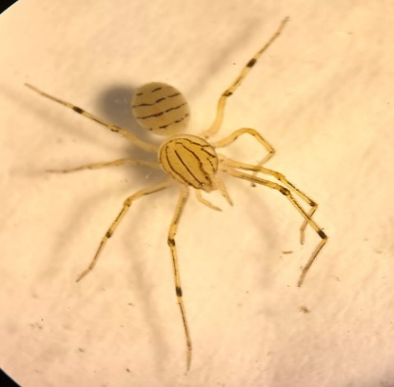
13. Myrmarachne | 14. Harmochirus | 15. Scytodes
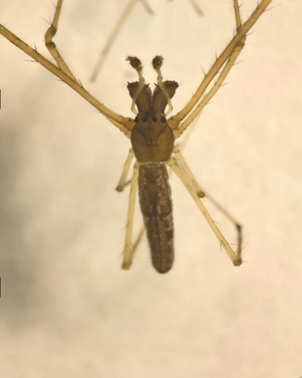 | 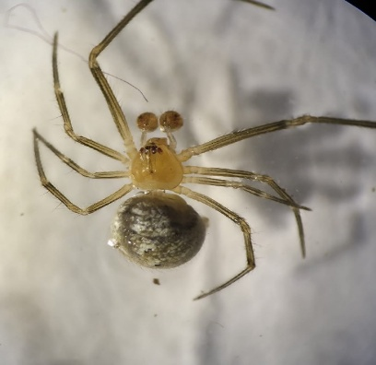 | 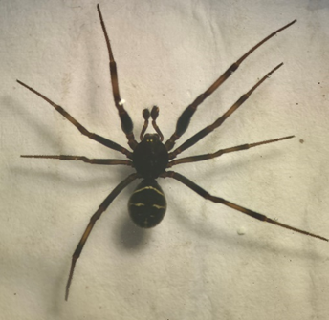
16. Tetragnatha | 17. Theridion | 18.Steatoda
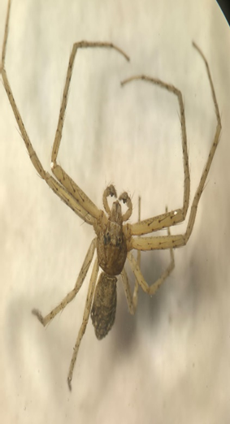 | 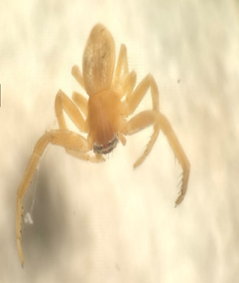 | 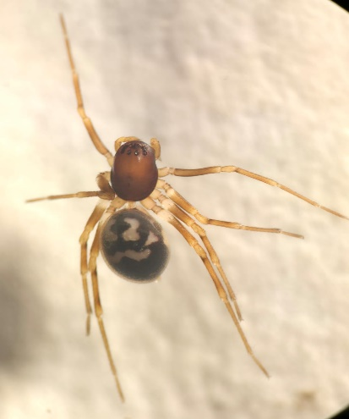
19. Tmarus | 20.Runcinia | 21. Orthobula

3.4 The percentage abundance of genus diversity across Akole, Parner, and Sangamner : The percentage abundance of genus diversity across Akole, Parner, and Sangamner highlights distinct regional variations. In Akole, Pardosa (Lycosidae) was the most abundant genus, contributing 23.08% to the total spider population. It was followed by Oxyopes (Oxyopidae) at 15.38% and Hippasa (Lycosidae) at 12.31%. Other notable genera included Larinia (Araneidae) at 6.15%, Cheiracanthium (Cheiracanthiidae) at 4.62%, and Scytodes (Scytodidae) and Tetragnatha (Tetragnathidae), each contributing 4.62%. In Parner, Larinia (Araneidae) was the dominant genus at 18%, followed by Pardosa (Lycosidae) at 16%. Oxyopes (Oxyopidae) contributed 10%, while Cheiracanthium (Cheiracanthiidae) and Bianor (Salticidae) each accounted for 4%. Other genera, such as Plexippus (Salticidae) and Steatoda (Theridiidae), contributed 4% each. Sangamner saw Pardosa (Lycosidae) as the dominant genus with 22.03%, followed by Oxyopes (Oxyopidae) at 13.56% and Harmochirus (Salticidae) at 6.78%. Steatoda (Theridiidae) was significant at 10.17%, while Dysdera (Dysderidae) and Cheiracanthium (Cheiracanthiidae) contributed 6.78% and 5.08%, respectively.
4. DISCUSSION
Spider diversity in groundnut agro ecosystem of Tehsil Akole, Sangamner and Parner from Ahmednagar district, Maharashtra was studied over a period of two years and recorded 522 individuals of spiders belonging to 21 genera under 12 families. Spiders, as ingenious predators and integral parts of ecosystems, play a crucial role in the structure of food webs and communities, serving as potential biological control agents in agroecosystems by helping manage pest populations and reducing the need for chemical pesticides, thus improving crop yields and minimizing environmental impact (Cardoso et al., 2025; Ludwig et al., 2018). As generalist predators, spiders can provide crucial biocontrol services by preventing and suppressing pest outbreaks in arable crops. By feeding on different prey items within the agroecosystem, spiders can continue to exist even when pest populations are low. (Symondson, et al, 2002). Spiders, essential for ecosystem organization and biodiversity, are a crucial yet understudied group in the Western Ghats, with 275 species across 139 genera and 39 families, including 44 endemics to India, playing key roles as predators and biodiversity indicators, particularly in 'sheet web builders', but much remains unknown about their systematics, diversity, and ecology, emphasizing the need for focused conservation efforts. (Sebastian et al., 2012). The study reveals notable regional variations in spider diversity and family composition across the groundnut agroecosystem of Akole, Sangamner and Parner. Salticidae emerged as the family with the highest generic diversity, comprising five genera, followed by Araneidae with three genera. This contrasts with findings from Rahul Patil et al. (2020), who reported Araneidae as the dominant family in other agroecosystems such as banana, sorghum, and vineyards in Anjani village, Sangli. In Akole, Lycosidae dominated, with Oxyopidae and Salticidae also well-represented, likely benefiting from the region's cooler temperatures and higher rainfall, which support a diverse spider population. Parner, in contrast, exhibited a more specialized spider community, with Araneidae and Corinnidae being the most abundant families, likely due to its hotter, drier climate. Sangamner showed a more balanced spider distribution, with families like Lycosidae, Salticidae, and Oxyopidae coexisting, likely due to the moderate temperatures and rainfall in the region. Dominant genera such as Pardosa, Oxyopes, and Larinia reflect the adaptability of these spiders to agroecosystem conditions, while rarer genera like Myrmarachne and Bianor highlight the complexity of the spider community. Overall, these findings emphasize the importance of climate and environmental factors in shaping spider diversity and their potential role in natural pest control across different agroecosystems.
- CONCLUSION
In conclusion, the study of spider diversity in the groundnut agroecosystems of Akole, Sangamner, and Parner reveals a rich and varied spider community across these regions. Spiders, as key predators, play a significant role in pest management, reducing the need for chemical pesticides and supporting sustainable farming practices. The diversity of spider families, particularly Lycosidae, Oxyopidae, and Araneidae, reflects the adaptability of these species to local environmental conditions. Akole, with its cooler climate and higher rainfall, supports the highest spider diversity, while Parner, with its hotter, drier conditions, is more specialized. Sangamner shows a balanced distribution, benefiting from moderate weather conditions. Overall, this study emphasizes the ecological importance of spiders in agroecosystems and the need for further research to understand their full role in pest control and biodiversity conservation.

REFERENCES:
- Arya, S. S., Salve, A. R., & Chauhan, S. (2016). Peanuts as functional food: a review. Journal of food science and technology, 53(1), 31-41.
- Nelwamondo, A. M., Maaza, M., & Mohale, K. C. (2024). Symbiotic nitrogen fixation and nutrient acquisition of three groundnut genotypes exposed to different concentrations of magnesium oxide and calcium carbonate nanoparticles. Biocatalysis and Agricultural Biotechnology, 59, 103246
- Lungaho, M., Ojuederie, O. B., Kareem, K. T., Odesola, K. A., Popoola, J. O., Onawo, L. O., ... &Ikhajiagbe, B. (2025). Cultivating value from waste: creating novel food, feed, and industrial applications from bambara groundnut by-products. Sustainability, 17(16), 7378.
- Wightman, J. A., & Rao, G. (1993). A peanut insect identification handbook for India. Information Bulletin No. 39: 38–51, 38-51
- Michalko, R., Petráková, L., Sentenská, L., &amp; Pekár, S. (2017). The effect of increased habitat complexity and density-dependent non-consumptive interference on pestsuppression by winter-active spiders. Agriculture, Ecosystems &amp; Environment, 242, 26-33
- Romero, G. Q., Mazzafera, P., Vasconcellos-Neto, J., &amp; Trivelin, P. C. (2006). Bromeliad‐living spiders improve host plant nutrition and growth. Ecology, 87(4), 803-808.
- van Laaten, N., Merten, D., von Tümpling, W., Schäfer, T., &amp; Pirrung, M. (2020).Comparison of spider web and moss bag biomonitoring to detect sources of airbornetrace elements. Water, Air, &amp; Soil Pollution, 231(10), 512.
- Takano, A. P. C., Rybak, J., &amp; Veras, M. M. (2024). Bioindicators and humanbiomarkers as alternative approaches for cost-effective assessment of air pollutionexposure. Frontiers in Environmental Engineering, 3, 1346863.
- Keswani, S. (2014). Diversity, population and microhabitat used by spiders in citrus agroecosystem. Indian Journal of Arachnology, 3(2), 90-101.
- Tikader, B.K. (1987): Handbook Indian Spiders. Zoological Survey of India, Culcutta, 251 pp.
- Barrion, A. T., & Litsinger, J. A. (1995). Riceland spiders of south and Southeast Asia. Int. Rice Res. Inst.
- Cardoso, P., Pekár, S., Birkhofer, K., Chuang, A., Fukushima, C. S., Hebets, E. A., ... & Mammola, S. (2025). Ecosystem services provided by spiders. Biological Reviews.
- Ludwig, L., Barbour, M. A., Guevara, J., Avilés, L., & González, A. L. (2018). Caught in the web: Spider web architecture affects prey specialization and spider–prey stoichiometric relationships. Ecology and evolution, 8(13), 6449-6462.
- Symondson, W. O. C., Sunderland, K. D., & Greenstone, M. H. (2002). Can generalist predators be effective biocontrol agents? Annual review of entomology, 47(1), 561-594.
- Sebastian, P. A., Sudhikumar, A. V., Mathew, M. J., &Sunish, E. (2012). Diversity of spiders (Araneae) in the Western Ghats–an overview. Invertebrate diversity and conservation in the Western Ghats, 235-247.
- Patil, R., Patil, Y., Salunkhe, P., & Patil, P. (2020). Diversity and distribution of agrobiont spiders (Arachnida: Araneae) from different agro‐ecosistems of Anjani village, MS (India). International Journal of Research and Analytical Reviews, 455-460.
- World Spider Catalog. (2023). *World Spider Catalog, Version 24*. Natural History Museum Bern. Retrieved from http://wsc.nmbe.ch

