Idiopathic Chylothorax in a Domestic Short-Haired Cat: Diagnosis and Successful Medical Management

ABSTRACT
Chylothorax is an uncommon but clinically significant cause of pleural effusion in cats, characterized by the accumulation of triglyceride-rich lymphatic fluid within the pleural cavity. A three-year-old male domestic short-haired cat was presented with respiratory distress and open-mouth breathing. Thoracic auscultation revealed muffled heart and lung sounds and radiography confirmed pleural effusion. Ultrasonography revealed that anechoic pleural fluid pockets with suspended internal echoes. Thoracocentesis yielded milky white fluid with a triglyceride concentration (210 mg/dL) exceeding that of serum (65 mg/dL) and a triglyceride to cholesterol ratio greater than 1, confirming a chylous effusion. Cytology revealed predominantly small lymphocytes and both Rivalta and ether clearance tests were positive for chyle. No evidence of cardiac disease, neoplasia or trauma was detected, supporting a diagnosis of idiopathic chylothorax. The cat was managed conservatively with repeated thoracocentesis, oral rutin (50 mg/kg body weight), prednisolone (0.5 mg/kg body weight) and antibiotics. Clinical signs and respiratory parameters improved markedly within two weeks and follow-up imaging confirmed complete resolution of pleural effusion. No recurrence was observed during subsequent follow-up. This case highlights the diagnostic importance of pleural fluid triglyceride estimation and supports the effectiveness of conservative management using rutin and corticosteroids in achieving successful resolution of idiopathic feline chylothorax.

Key words: Idiopathic chylothorax, Cat, Pleural effusion, Triglyceride estimation, Rutin
- INTRODUCTION
Chylothorax is a pathological condition characterized by the accumulation of chyle within the pleural cavity due to disruption, obstruction or rupture of the thoracic lymphatic system. Chylothorax is an uncommon but clinically significant cause of pleural effusion in cats, characterized by the presence of lipid rich chyle within the pleural cavity. The condition results in respiratory distress due to impaired pulmonary expansion and reduced oxygen exchange. Although chylothorax has been reported in several species, including dogs, cats, humans and occasionally large animals (Fossum et al., 1986; Michelsen and Edwards., 2012; Nelson and Couto, 2020), cats appear particularly predisposed, with the idiopathic form being the most frequently observed (Fossum et al., 2004a)
The underlying causes of feline chylothorax include traumatic disruption of the thoracic duct, mediastinal or pulmonary neoplasia, cardiac diseases such as hypertrophic cardiomyopathy, heartworm infection or congenital lymphatic malformations. However, in many cases, no definitive etiology can be identified and the condition is classified as idiopathic (Fossum et al., 2004a; Nelson and Couto, 2020). Chronic accumulation of chyle within the pleural cavity can incite inflammation and fibrosis, leading to restrictive pleuritis and impaired pulmonary compliance, which further complicate both treatment and prognosis (Fossum et al., 1986; Birchard and Sherding, 2006).
Clinically, affected cats often present with dyspnoea, tachypnoea, lethargy and reduced activity. Thoracic auscultation typically reveals muffled heart and lung sounds, while radiographic examination confirms the presence of pleural effusion. Diagnosis is established through biochemical and cytological evaluation of the pleural fluid, with confirmation based on elevated triglyceride concentrations compared to serum and the predominance of small lymphocytes (Fossum et al., 2004a). The management of chylothorax can be challenging. While surgical thoracic duct ligation offers a potential definitive solution, conservative medical therapy is generally attempted first, particularly in idiopathic or mild cases. Therapeutic measures may include repeated thoracocentesis, administration of rutin, corticosteroids and dietary fat restriction (Fossum et al., 2004b; Hawker et al., 2024).
The present report describes a case of chylothorax in a short-haired domestic cat that was successfully stabilized with conservative medical management. The case highlights the diagnostic importance of pleural fluid triglyceride estimation and discusses the therapeutic outcome following medical therapy.
- MATERIALS AND METHODS
A three-year-old male domestic short-haired cat was presented with a history of respiratory distress. A complete clinical examination was performed, including assessment of respiratory rate, mucous membrane colour and thoracic auscultation to detect abnormal lung and heart sounds.
Blood sample was collected aseptically from the cephalic vein using both EDTA-coated and plain vacutainer tubes. The EDTA sample was analysed for haematological parameters using an automated haematology analyser, while serum obtained from the plain tube after centrifugation at 3000 rpm for 10 minutes was used for biochemical evaluation with a semi-automated analyser. Thoracic imaging was performed to assess the cause of dyspnoea. Radiographs were obtained in right lateral and ventrodorsal projections (60 kVp, 4 mAs) using a digital radiography unit. Ultrasonography was subsequently performed with the cat in sternal recumbency, which revealed the presence of anechoic fluid in the pleural cavity, consistent with pleural effusion.
Based on the ultrasonographic findings and clinical suspicion of pleural effusion, thoracocentesis was performed under aseptic conditions at the 7th to 9th intercostal space. The aspirated pleural fluid was collected into plain tubes for biochemical analysis and into sterile containers for cytological evaluation. Gross examination of the fluid included evaluation of colour, odour and consistency. The specific gravity and total protein concentration were determined using a handheld refractometer. Cytological smears were prepared, air-dried and stained with Giemsa stain for microscopic examination of the cellular composition. Biochemical analysis of the pleural fluid included measurement of triglyceride and cholesterol concentrations using a semi-automated biochemical analyser.
The Rivalta test was performed to differentiate exudative from transudative effusions by adding a drop of glacial acetic acid to 8 mL of distilled water in a test tube, followed by the careful addition of one drop of pleural fluid. The formation of a gelatinous precipitate indicated a positive result (Giori et al., 2011). To confirm the chylous nature of the effusion, an ether clearance test was conducted by mixing equal volumes of pleural fluid and diethyl ether in a glass tube; clearing of the turbidity confirmed the presence of lipid-rich chylomicrons (Fossum et al., 2004a).
- RESULTS
The cat presented with open-mouth breathing, increased respiratory effort and a respiratory rate of 51 breaths/min. Mucous membranes appeared pale pink and thoracic auscultation revealed muffled heart and lung sounds, consistent with pleural fluid accumulation. The animal showed signs of discomfort on thoracic palpation but remained responsive to handling. Haematological evaluation revealed leukocytosis (55 × 10³/μL) with lymphocytosis (42%), suggestive of inflammatory and lymphatic involvement. Serum biochemical analysis showed triglyceride concentration of 65 mg/dL and cholesterol concentration of 95 mg/dL (Table 1). In contrast, pleural fluid analysis revealed a triglyceride concentration of 210 mg/dL and cholesterol concentration of 45 mg/dL, yielding a triglyceride-to-cholesterol ratio greater than 1, consistent with a chylous effusion (Fossum et al., 2004a; Nelson and Couto, 2020) (Table 2)
Table 1. Haemato-biochemical parameter
1 | Haemoglobin (g/dL) | 9.8
2 | Packed cell volume (%) | 33.5
3 | Red blood cells (10⁶ x µL) | 6.94
4 | White blood cells (103 x µL) | 55
5 | Neutrophils (%) | 53
6 | Lymphocytes (%) | 42
7 | Monocytes (%) | 3
8 | Eosinophils (%) | 2
9 | Basophils (%) | -
10 | Blood urea nitrogen (mg/dL) | 26
11 | Creatinine (mg/dL) | 1.3
12 | Triglycerides (mg/dL) | 65
13 | Cholesterol (mg/dL) | 95
14 | Total protein (g/dL) | 6.8
15 | Albumin (g/dL) | 2.9
16 | Globulin (g/dL) | 3.9
17 | Direct bilirubin (g/dL) | 0.1
Table 2. Pleural fluid analysis
1 | Appearance | Milky white fluid; Odourless
2 | Specific gravity | >1.020
3 | Total protein (g/dL) | 3.5 g/dL
4 | Albumin (g/dL) | 1.4
5 | Globulin (g/dL) | 2.1
6 | Cholesterol (mg/dL) | 45
7 | Triglycerides (mg/dL) | 210
8 | Cell count | Predominantly lymphocytes

Thoracic radiographs demonstrated a diffuse soft-tissue opacity with scalloping of the lung lobes and loss of visualization of the cardiac and diaphragmatic borders, confirming the presence of pleural effusion (Fig. 1). Ultrasonographic examination revealed anechoic pleural fluid pockets with suspended internal echoes, indicative of an exudative process. No mediastinal mass, diaphragmatic defect or cardiac abnormality was detected (Fig. 2). Thoracocentesis yielded approximately 250 mL of opaque, milky-white fluid (Fig. 3). The fluid was odourless and of moderate viscosity. The specific gravity measured >1.020 and the total protein concentration was 3.5 g/dL (Table 2). Cytological evaluation revealed a predominance of small lymphocytes with occasional macrophages and few neutrophils.
The Rivalta test produced a positive reaction, as the pleural fluid drop remained suspended in the acetic acid solution, forming a gelatinous precipitate (Fig. 4). The Ether clearance test confirmed the presence of lipid-rich chylomicrons, as the turbidity of the pleural fluid cleared immediately upon mixing with diethyl ether (Fig. 5). Following repeated thoracocentesis and initiation of medical management including oral Rutin (50 mg/kg b.wt), prednisolone (0.5 mg/kg b.wt) and antibiotics, the cat exhibited marked clinical improvement. Respiratory rate and effort normalized within two weeks of treatment and follow-up thoracic imaging revealed complete resolution of pleural effusion. No recurrence of respiratory distress was observed during subsequent follow-up evaluations.
- DISCUSSION
The present case describes idiopathic chylothorax in a 3-year-old crossbred cat, an uncommon presentation in terms of both age and breed. Chylothorax represents one of the more challenging causes of pleural effusion in small animals, as its etiology often remains obscure despite comprehensive diagnostic evaluation. The accumulation of chyle within the pleural space results primarily from impaired lymphatic drainage, increased lymphatic pressure, or thoracic duct disruption (Fossum et al., 2020).
In the current case, thoracic radiography and ultrasonography confirmed the presence of pleural effusion but did not reveal an underlying mediastinal mass, cardiac enlargement or diaphragmatic defect. Similar findings have been reported by Sturgess (2001), who emphasized that imaging alone is rarely diagnostic for chylothorax and must be complemented by biochemical fluid analysis. The pleural fluid in our case was opaque and milky, with a triglyceride concentration (210 mg/dL) more than three times that of serum (65 mg/dL) and a triglyceride-to-cholesterol ratio was more than 1, confirming its chylous nature (Nelson and Couto, 2020). Cytology showed predominance of small lymphocytes, consistent with classical descriptions of feline chylothorax (Maldonado et al., 2009).
No evidence of trauma, neoplasia, heart disease or infection (FeLV/FIV/heartworm) was detected, allowing the diagnosis of idiopathic chylothorax. Previous studies indicate that idiopathic cases constitute 40–60% of feline chylothorax presentations (Beatty and Barrs, 2010). Although this condition has been reported more frequently in purebred cats such as Siamese or Oriental breeds, the current case demonstrates that crossbred cats may also develop idiopathic chylothorax, possibly reflecting multifactorial pathogenesis involving congenital lymphatic fragility or transient thoracic duct dysfunction (Gould, 2004).
Persistent loss of chyle can result in progressive nutritional and immunological compromise due to depletion of lymphocytes, lipids and fat-soluble vitamins. In chronic cases, the presence of inflammatory mediators and lipoproteins may stimulate fibroblast proliferation, leading to restrictive pleuritis and impaired pulmonary compliance (Maldonado et al., 2009). Although the cat in this report presented with early-stage effusion, the risk of fibrosing pleuritis underscores the importance of early therapeutic intervention.
Management of chylothorax is directed at both symptomatic relief and addressing underlying causes where possible. In the present case, repeated thoracocentesis relieved respiratory distress and improved oxygenation. Adjunctive medical management using rutin and prednisolone was instituted. Rutin, a bioflavonoid, enhances macrophage-mediated lipid clearance and reduces lymphatic leakage; though its efficacy remains variable, several feline studies report partial to complete resolution within 1 to 2 months (Sturgess, 2001; Gould, 2004). The improvement observed in this cat within two weeks supports the potential utility of rutin in early idiopathic cases.
Other medical therapies, such as dietary modification with low-fat or medium-chain triglyceride (MCT) based diets, have been proposed to reduce chyle flow; however, their benefit in cats remains unsubstantiated due to differences in feline fat metabolism (Fossum et al., 2020). Surgical options including thoracic duct ligation, pericardectomy or omentalization are generally reserved for refractory cases that fail medical therapy. Thoracic duct ligation, sometimes combined with subtotal pericardiectomy, achieves long-term resolution in approximately 50–60% of feline cases (Dickson et al., 2024). Since the present case responded favourably to conservative treatment, surgical intervention was not required.
From a diagnostic standpoint, differentiation between chylous and pseudochylous effusions remains critical. The positive Rivalta test and immediate clearing on ether clearance test confirmed the lipid-rich composition of the pleural fluid, distinguishing it from cholesterol rich pseudochylous effusions. These simple bedside tests retain value in clinical settings with limited access to advanced biochemical analysis, particularly in field or institutional veterinary hospitals (Riley and Ataya, 2019).
Idiopathic chylothorax, despite being rare, poses significant challenges due to its recurrent nature and risk of chronic complications. Early identification, coupled with appropriate fluid drainage, pharmacological support and regular monitoring, can substantially improve prognosis (Riley and Ataya, 2019). In this case, the absence of recurrence during follow-up indicates a favorable short-term outcome. Nonetheless, long-term surveillance is recommended, as relapses may occur weeks to months after apparent resolution.
- CONCLUSION
Idiopathic chylothorax, although uncommon in cats, should be regarded as an important differential diagnosis in cases of pleural effusion associated with respiratory distress. Definitive diagnosis depends on the biochemical comparison of pleural fluid and serum triglyceride concentrations, complemented by cytological evaluation and simple confirmatory tests such as the Rivalta and ether clearance tests. Early recognition and prompt therapeutic intervention are vital to prevent complications including restrictive pleuritis and respiratory compromise. The present case demonstrated that conservative management through repeated thoracocentesis, rutin and corticosteroid therapy can result in complete clinical recovery without the need for surgical intervention. Continued follow-up remains essential, as recurrence may occur in chronic or advanced stages. This case underscores the diagnostic value of minimally invasive techniques and highlights the efficacy of medical management in resolving early idiopathic chylothorax in cats.
DISCLAIMER (ARTIFICIAL INTELLIGENCE)
Author(s) hereby declare that generative AI technologies have not been used during writing and editing the manuscript.

REFERENCES
Beatty, J. & Barrs, V. (2010). Pleural effusion in the cat: a practical approach to determining aetiology. Journal of Feline Medicine and Surgery, 12(9), 693-707.
Birchard, S. J. & Sherding, R.G. (2006). Saunders Manual of Small Animal Practice, 3rd ed., St. Louis: Elsevier Saunders.
Dickson, R., Adam, A., Garcia Rubio, D., Cinti, F., Singh, A., Mayhew, P., Case, J.B. & Fransson, B.A. (2024). Outcome of video-assisted thoracoscopic treatment of idiopathic chylothorax in 15 cats. Veterinary Surgery, 53(5), 852-859. doi: 10.1111/vsu.14098.
Fossum, T. W., Birchard, S. J., Jacobs, R. M., Bahr, A & Dennis, J. (1986). Chylothorax in 34 dogs and 14 cats: a retrospective study. Journal of the American Veterinary Medical Association, 188(11),1315–1318.
Fossum, T. W., Dewey, C.W., Horn, C.V. & Johnson, A.L. (2020). Small Animal Surgery (5th ed.). Elsevier.
Fossum, T.W., Birchard, S.J., Jacobs, R.M., (2004a). Chylothorax in cats: 67 cases (1983–1998). Journal of the American Veterinary Medical Association, 225(10),1468–1472.
Fossum,T.W., Mertens, M.M. M.W.Miller, Peacock, J.T. Saunders, A., Gordon, S. Pahl, G. Makarski, L.A. Bahr, A. & Hobson, P.H. (2004b). Thoracic duct ligation and pericardectomy for treatment of idiopathic chylothorax. Journal of Veterinary Internal Medicine, 18(3),307-310.
Giori, L., Giordano, A, Giudice, C., Grieco, V. & Paltrinieri, S. (2011). Performances of different diagnostic tests for feline infectious peritonitis in challenging clinical cases. Journal of Veterinary Diagnostic Investigation, 23(2), 320–323.
Gould, L. (2004). The medical management of idiopathic chylothorax in a domestic long-haired cat. Canadian Veterinary Journal, 45(1), 51-4.
Hawker, W. & Singh, A. (2024). Advances in the Treatment of Chylothorax. Veterinary Clinics of North America: Small Animal Practice, 54(4):707-720.
Maldonado, F., Hawkins, F.J., Daniels, C.E., Doerr, C.H., Decker, P.A. & Ryu, J.H. (2009). Pleural fluid characteristics of chylothorax. Mayo Clinic Proceedings, 84(2),129-33. doi: 10.4065/84.2.129.
Michelsen, J. & Edwards, G. (2012). Idiopathic chylothorax in dogs and cats: current treatments and future directions. Australian Veterinary Practitioner, 42(3), 287-292.
Nelson, R. W. & Couto, C.G. (2020). Small Animal Internal Medicine, 6th ed., St. Louis: Elsevier.
Riley, L.E. & Ataya, A. (2019). Clinical approach and review of causes of a chylothorax, Respiratory Medicine,157, 7-13.
Sturgess, K. (2001). Diagnosis and management of chylothorax in dogs and cats. In Practice: Continuing Education in Veterinary Practice, 23(9), 506–513. https://doi.org/10.1136/inpract.23.9.506

Fig 1. Thoracic radiographs showed loss of visualization of the cardiac and diaphragmatic borders, confirming the presence of pleural effusion
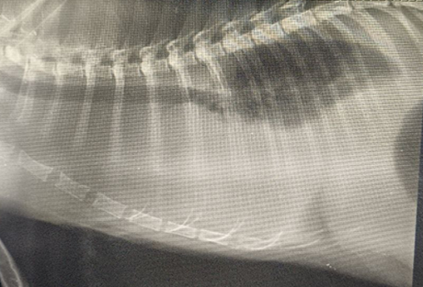 | 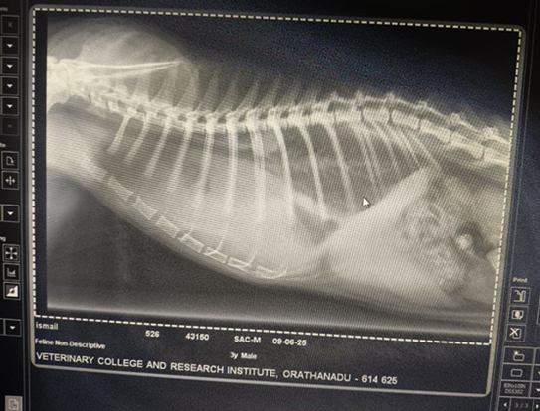

Fig 2. Ultrasonographic examination revealed anechoic pleural fluid pockets with suspended internal echoes.
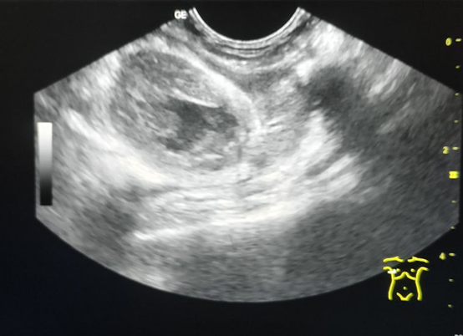 | 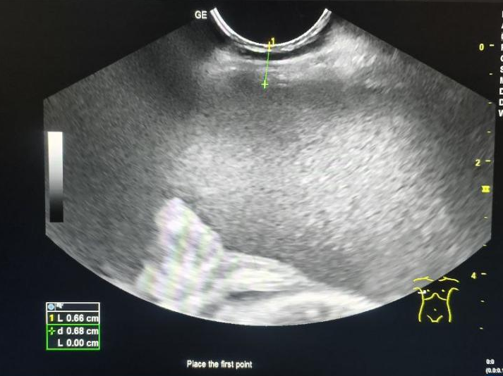

Fig 3. Thoracocentesis was performed in the 7th- 9th intercostal space
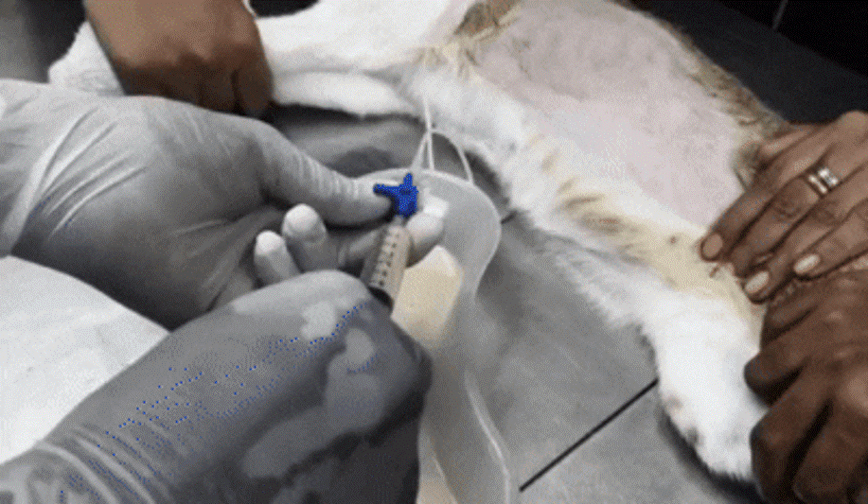

Fig 4. Rivalta test – fluid drop remained suspended and formed a gelatinous precipitate instead of dissolving, which is considered a positive Rivalta reaction.
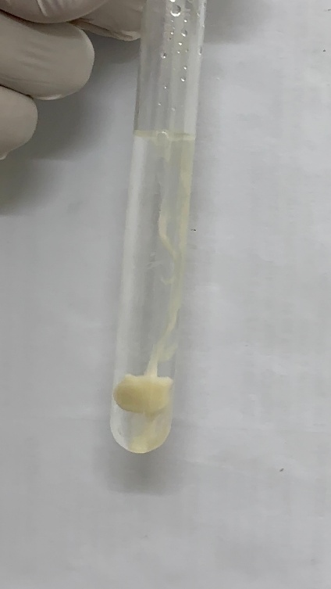

Fig 5. Ether clearance test showing dissolution of turbidity following ether addition, confirming the lipid-rich nature of the effusion
