ASSESSMENT OF FUNCTIONAL FEEDING GROUPS OF BENTHIC MACROINVERTEBRATES FROM THE BHAGIRATHI RIVER IN INDIAN HIMALAYA

Abstract
Thepresent study was focused to determine the distributional patterns of the functional feeding groups (FFG) benthic macroinvertebrate fauna in the river Bhagirathi. Bi-monthly macroinvertebrate samples were collected at seven sampling sites (S1–S7) during November 2023 to October 2024. Scrappers (31%) were most dominant group at S1, while gathering collectors (37%), filtering collectors (36%), predators (30%) and shredders(13%) at S7, S6, S3 and S4, respectively. Longitudinally, scrapers declined from S1 to S7, while gathering collectors increased from S1 to S7. However, no definite patterns were observed for filtering collectors, predators and shredders. Shredders, scrappers, gathering collectors, filtering collectors and predators were found significantly different amongthe stations.Longitudinally, scraper decreased while filtering collector increased from headwater to mouth. No definite patterns were observed for shredder, gathering collector and predator. Functionally, the river indicated shredder-scraper and collector-predator groups.
Keywords: Bhagirathi River, Functional Feeding Group, Scrapper, Gathering collector, RCC

Introduction
Water resources are essential for preserving the ecosystem's composition, functionality, and material cycles (Vorosmarty et al 2010). The Himalayan freshwater ecosystems are undergoing unprecedented changes, because the glaciers are retreating at accelerated rates and directly altering hydrological regimes of rivers like the Bhagirathi, Alaknanada etc. (Bhambri et al 2011). Benthic macroinvertebrates are one of the important sensitive communities to pollutionandhabitat changes,and theirvariations in functional feeding groups indicate the trophic status of the river. According to ‘River Continuum Concept (Vannote et al 1980) the variation in physical variables along the river length from headwater to mouth, control the structural and functional characteristics of communities.
In India, such studies are very limited especially in the Himalayan rivers (Singh and Nautiyal 1990; Nautiyal et al 2004; Mishra and Semwal 2022) and Central Indian rivers (Mishra and Nautiyal 2013, Mishra et al 2024). Thus, the present study is designed to determine the functional state of the river Bhagirathi form headwear to mouth by using benthic macroinvertebrate communities.
Materials and Methods
Study area
The river Bhagirathi, one of the principal headstreams of the sacred Ganga, originates at Gaumukh, the snout of the Gangotri Glacier, located at an elevation of about 3,900 meters above sea level in Uttarkashi district, Uttarakhand, India (Figure 1). In its upper reaches, it flows through steep and narrow valleys, cutting across rugged Himalayan terrain characterized by sharp gradients, rocky substrates, and sparse alpine vegetation. The river receives contributions from numerous snow-fed tributaries and mountain streams, which maintain its perennial flow throughout the year. Eventually, at Devprayag, the Bhagirathi merges with the river Alaknanda to form the Ganga, which is revered as one of the holiest rivers in India and holds immense cultural, spiritual, and ecological significance.
Sampling
Seven sampling stations (S1–S7) were selected along the river length form origin to mouth (Table 1). The benthic macroinvertebrates fauna was sampled bi-monthly from November 2023 to October 2024 using standardized Surber samplers (0.09 m² frame, 500 µm mesh) from 1foot square area. Three replicates were collected at each station and preserved in 4% formalin and brough to Benthic Ecology Lab (BEL) for sorting and identification family level (Burks 1953; Pennak 1953; Edmunds et al 1976). Functional feeding group (FFG) was determined by Ramusino et al (1995) and Cummins et al (2005). Cluster analysis and Correspondence analysis were determined (PAST ver 3.0.).
Results and Discussion
Total 43 benthic macroinvertebrate taxa were recorded along the river belonging to five functional feeding groups. Functionally, maximum 20 benthic macroinvertebratestaxa found belonging to predator, while 8, 6, 5 and 3 belong to gathering collectors, shredders, filtering collectors and scrappers, respectively (Table 2). However, richness increased from S1 to S4 and declined at S7 for predator, scraper and gathering collector, while shredder and filtering collector were highest at S3 then decline to S7 (Figure 2).
The one -way ANOVA indicated shredder (F_{1,12} =9.89, p<0.05), scraper (F_{1,12} =49.34, p<0.05), gathering collector (F_{1,12} =35.83, p<0.05), filtering collector (F_{1,12} =10.38, p<0.05) and predator (F_{1,12} =47.38, p<0.05) were significantly different among the stations (Table 3). Among all the functional feeding groups, the taxonomic richness of taxa having predator role were high,indicated presence of suitable environment for heterotrophic status of the Bhagirathi River. However, the taxa with collector (gathering and filtering) functioning were second important group, attributed to abundance of fine particulate organic matter (FPOM). The low richness of scrapers indicated poor autotrophic condition of the river. The abundance of heterotrophswas also evident in the river Bhagirathi in the during 1985 to 2005 (Nautiyal 2010).
The composition of functional feeding groups varied among the stations. At S1, scraper was found dominant at S1 (46%) followed predator (25%), gathering collector (20%), shredder (7&) and filtering collector (2%). Similarly, at S2, scraper and gathering collector were codominant 31% each, followed by predator (24%), shredder (9%) and filtering collector (5%). However, at S3, gathering collector and predator were dominant simultaneously 30% each followed by scraper>filtering collector>shredder. At S4 gathering collector (29%) was most dominant followed by predator>filtering collector>shredder> scraper. At S5, gathering collector (34%) was most dominant followed >filtering collector> predator>scraper> shredder. At S6, filtering collector (37%) was dominant followed by gathering collector=predator>scraper>shredder. At mouth zone (S7), gathering collector (37%) was dominant > followed by predator>filtering collector>scraper>shredder (Figure 3).
Longitudinally, scraper exhibited decreasing while filtering collector exhibited increasing trends in functional composition from headwater to mouth. However, shredder, gathering collector and predator varied irregularly along the river length (Figure 4). The cluster analysis functionally divided the river in 2 groups; a) scrapers-shredders and collectors, while taxonomically in headwater - mouth (S1-S2, S5-S6) and middle section (S3, S4-S5). However, the middle section further indicated grouping (Figure 5). Correspondence analysis (CA) indicated that axis 1 (eigen value=0.0956246) and axis 2 (eigen value=0.0167927) caused 77.33% and 13.58% variation in the functional feeding group (Figure 6).
Vannote et al (1980) defined characteristics of lotic communities and roughly be grouped into headwaters (orders 1-3), medium-sized streams (4-6), and large size rivers (>6). As per his hypothesis many headwater streams are strongly influenced by the riparian vegetations which reduces autotrophic production by shading and contributes large amounts of allochthonous detritus. By increasing stream size, the importance of terrestrial organic input is reduced with enhanced significance of autochthonous primary production and organic transport from upstream. The scrapers were dominant in the headwater section of the river indicated the autotrophic nature due to deforestation of the riparian vegetation in view of various developmental activities like hydroelectric project, tourism industry and road construction. The canopy cover area decreases in the headwater which allow sun rays penetration in to the river help periphyton growth.
The abundance of periphyton provided habitat for the scraper. However, in the rest part of the river, collectors either gathering or filtering in nature, was dominant because of dominance of fine particulate organic matter (FPOM) in the river. The dominance of FPOM in middle to mouth section of the river, was attributed to conversion of coarse particulate organic matter (CPOM) in to FPOM via natural riverine process.However, adjacent landuse and as well seasonal/perianal tributaries also provide inputs in the form of FPOM to enhance the level. Minshall (1978) suggested that shifting from heterotrophic to autotrophic zone of river is primarily dependent upon the degree of shading. Jiang et al (2011) observed the scrapers abundance upon the availability of the cobble substrate in Chinese river system. Collector gatherers were most abundant in downstream sites with fine substrates (Mishra and Nautiyal 2013). According to Rawer-Jost et al (2000) and Kelly et al (2002), the benthic macroinvertebrates can change their feeding mechanism in varied environmental conditions.Unfortunately, the FFGinformationfrom the Bhagirathi River is very scarce, and fundamental research is very essential on this subject.
Conclusion:
The present study indicated that the river Bhagirathi is basically heterotrophic state due to abundance of collectors except headwater where the scrapers were dominant which indicated autotrophic condition. The functionally, the river was in divided in to two groups; shredder-scraper group and collector-predator group.
References
Bhambri R Bolch T, & Chaujar R K (2011) Mapping of debris-covered glaciers in the Garhwal Himalayas using ASTER DEMs and thermal data. International Journal of Remote Sensing, 32(23), 8095–8119. https://doi.org/10.1080/01431161.2010.532821
Burks B D (1953) The mayflies or Ephemeroptera of Illinois.Bulletin of the Illinois Natural History Survey, 26, 1–215.
Cotta Ramusino M, Villa S, & Calamari D (1995) River continuum concept and correspondence analysis to study Alpine stream macroinvertebrate assemblage. Memorie dell’Istituto Italiano di Idrobiologia, 53, 101–114.
Cummins K W, Merritt R W, & Andrade P C N (2005) The use of invertebrate functional groups to characterize ecosystem attributes in selected streams and rivers in south Brazil. Studies on Neotropical Fauna and Environment, 40(1), 69–89.
Edmundson G F, Jenson S L, & Bermer L (1976) The mayflies of North and Central America. University of Minnesota Press.
Jianga X Xionga J, Xiea Z, & Chen Y (2011) Longitudinal patterns of macroinvertebrate functional feeding groups in a Chinese river system: A test for the river continuum concept (RCC). Quaternary International, 244, 289–295.
Kelly D W, Dick J T A, & Montgomery W I (2002) The functional role of Gammarus (Crustacea, Amphipoda): Shredders, predators, or both? Hydrobiologia, 485(1–3), 199–203.
Minshall G W (1978) Autotrophy in stream ecosystems. BioScience, 28(12), 767–771. https://doi.org/10.2307/1307250
Mishra A S, & Nautiyal P (2013) Functional composition of benthic macroinvertebrate fauna in the plateau rivers, Bundelkhand, central India. Journal of Threatened Taxa, 5(13), 4752–4758.
Mishra A S, Pandey C K, & Tiwari S (2024) Environmental drivers for benthic macroinvertebrate assemblages and distributional patterns in a plateau river of Bundelkhand region, India. International Journal of Ecology and Environmental Sciences, 50(3), 367–375. https://doi.org/10.55863/ijees.2024.0005
Mishra A, & Semwal V (2022) A study of benthic macroinvertebrate fauna in a tributary of Himalayan River Bhilangana, Uttarakhand, India. Journal of Mountain Research, 17(2), 131–140. https://doi.org/10.51220/jmr.v17i2.13
Nautiyal P (2010) Food chains of Ganga River ecosystems in the Himalayas. Aquatic Ecosystem Health & Management, 13(4), 362–373. https://doi.org/10.1080/14634988.2010.528998
Nautiyal P, Shivam A, Rawat G, Singh K R, Varma J, & Dwivedi A C (2004) Longitudinal variation in structure of benthic communities in the upland Vindhyan and Himalayan rivers: River continuum concept approach. National Journal of Life Sciences, 1(1), 85–88.
Pennak R W (1953) Ephemeroptera (Mayflies). In Freshwater invertebrates of the United States (2nd ed., pp. 512–733). John Wiley and Sons.
Rawer-Jost C, Böhmer J, Blank J, & Rahmann H (2000) Macroinvertebrate functional feeding group methods in ecological assessment. Hydrobiologia, 422–423, 225–232.
Singh H R, & Nautiyal P (1990) Altitudinal changes and the impact of municipal sewage on the community structure of macrobenthic insects in the torrential reaches of the River Ganges in the Garhwal Himalaya (India). Acta Hydrobiologica, 32(3–4), 1–12.
Vannote R L, Minshall G W, Cummins K W, Sedell J R, & Cushing C E (1980) The river continuum concept. Canadian Journal of Fisheries and Aquatic Sciences, 37(1), 130–137.
Vörösmarty C J, McIntyre P B, Gessner M O, Dudgeon D, Prusevich A, Green P, Glidden S, Bunn S E, Sullivan C A, Liermann C R, & Davies P M (2010) Global threats to human water security and river biodiversity. Nature, 467(7315), 555–561. https://doi.org/10.1038/nature09440

Table 1: Geographical characteristics of the river Ganga at various stations. Acronyms: F- Forest, F+ Tou-Forest+ Tourist Place, F+ Ag=Forest+ Agriculture, F+Ct- Forest+ City, Ct-City, R-Rock, B-Boulder, C-Cobble, P-Pebbles, Gr-Gravel, S-Sand

Station/Code | Latitude  (^{O}N) | Longitude  (^{O}E) | Altitude  (m) | Source Distance  (km) | Landuse  Type | Substrate Type
Bhojbasa (S1) | 30.94944 | 79.05 | 3794.04 | 5 | F | R+B+C
Gangotri (S2) | 30.99389 | 78.94167 | 3068.89 | 19 | F | R+B+C
Harsil (S3) | 31.03833 | 78.73833 | 2487.29 | 39 | F+Tou. | B+C+P+G
Gangori (S4) | 30.755 | 78.45667 | 1183.31 | 115 | F+Ag | B+C+P+G
Dharasu (S5) | 30.61 | 78.31694 | 865.98 | 143 | Forest | C+P+B+Gr
Koteshwar (S6) | 30.25278 | 78.52333 | 542.41 | 172 | Forest | C+P+B+Gr
Devprayag (S7) | 30.14778 | 78.5975 | 490.23 | 196 | F+Tou | C+P+B+Gr

Table 2: Taxonomic composition of macroinvertebrate taxa along the river based. SH-Shredder, SC-Scraper, GC-Gathering Collector, FC-Filtering Collector, PR- Predator
S.N. | FAMILY | FFG | S1 | S2 | S3 | S4 | S5 | S6 | S7
 | Ephemerellidae | SH | 6 | 7 | 6 | 6 | 5 | - | 1
 | Helodidae | SH | - | - | - | 2 | 4 | 1 | -
 | Elmidae | SH | - | 4 | 2 | 1 | - | 3 | 1
 | Helophoridae | SH | - | - | - | 5 | 1 | 2 | 2
 | Limnephilidae | SH | - | 1 | 6 | 11 | 10 | 2 | 2
 | Limoniidae | SH | - | - | - | 2 | 4 | - | 2
 | Heptageniidae | SC | 43 | 43 | 34 | 25 | 19 | 18 | 19
 | Psephenidae | SC | - | - | - | 1 | 2 | - | 1
 | Blephariceridae | SC | - | - | 1 | - | 7 | - | -
 | Baetidae | GC | 6 | 13 | 22 | 14 | 7 | 12 | 29
 | Leptophlebiidae | GC | 6 | 21 | 12 | 10 | 17 | 7 | 5
 | Ephemeridae | GC | 2 | 4 | 2 | 4 | 1 | 1 | -
 | Caenidae | GC | 5 | 5 | 10 | 10 | 3 | 2 | 3
 | Pyralidae | GC | - | - | - | - | - | 2 | -
 | Simuliidae | GC | - | - | 3 | 5 | 12 | 2 | 4
 | Chironomidae | GC | - | - | 7 | 17 | 32 | 5 | 3
 | Dixidae | GC | - | - | 3 | 1 | 1 | 1 | -
 | Hydropsychidae | FC | 2 | 6 | 23 | 37 | 41 | 36 | 16
 | Philopotamidae | FC | - | - | 3 | 4 | 6 | 5 | -
 | Glossosomatidae | FC | - | - | 1 | 2 | 2 | 1 | -
 | Brachycentridae | FC | - | - | 4 | 4 | 6 | - | 3
 | Annelida | FC | - | - | - | - | - | 9 | 2
 | Gomphidae | PR | - | - | - | 3 | - | - | -
 | Lestidae | PR | - | 2 | 2 | 5 | 2 | - | 3
 | Aeshnidae | PR | - | - | - | 2 | - | - | -
 | Perlidae | PR | 4 | 7 | 6 | 3 | 4 | 4 | 3
 | Perlodidae | PR | 9 | 6 | 12 | 9 | 3 | 9 | 8
 | Capniidae | PR | 6 | 8 | 15 | 7 | 7 | 3 | -
 | Chloroperlidae | PR | 2 | 3 | 9 | 3 | 6 | - | 1
 | Leuctridae | PR | - | - | - | - | 1 | 1 | -
 | Nemouridae | PR | 2 | 2 | 1 | 3 | - | 1 | -
 | Pleidae | PR | - | - | - | - | 3 | - | -
 | Dytiscidae | PR | - | - | - | 1 | 2 | - | -
 | Gyrinidae | PR | - | - | - | 1 | 2 | 1 | 1
 | Hydraenidae | PR | - | - | 1 | - | 1 | - | 7
 | Rhyacophilidae | PR | - | 1 | 1 | 3 | 1 | - | 1
 | Leptoceridae | PR | - | 1 | 3 | 3 | - | 4 | -
 | Polycentropadidae | PR | - | 3 | 1 | 3 | 2 | 3 | 2
 | Tabanidae | PR | - | - | 3 | - | - | - | -
 | Ceratopogonidae | PR | - | - | 2 | 1 | 3 | - | -
 | Tipulidae | PR | - | - | 1 | 3 | 2 | 4 | 1

Table 3: The counts values of functional feeding groups of benthic macroinvertebrate fauna at various stations in the river Bhagirathi. The table also depicts the ‘F’ values (obtained from one-way ANOVA). Functional Feeding Group (FFG) was found significantly different among the stations at P < 0.001, df_{(1,13)}, as table value > calculated value.
FFG | S1 | S2 | S3 | S4 | S5 | S6 | S7 | F-value | p-value
Shredder | 6 | 12 | 14 | 27 | 24 | 8 | 8 | 9.89 | 0.008
Scrapper | 43 | 43 | 35 | 26 | 28 | 20 | 20 | 49.34 | 0.00001
Gathering Collector | 19 | 43 | 59 | 61 | 76 | 32 | 44 | 35.83 | 0.00006
Filtering Collector | 2 | 6 | 31 | 47 | 55 | 51 | 21 | 10.38 | 0.007
Predator | 23 | 33 | 58 | 51 | 40 | 32 | 27 | 47.38 | 0.00001

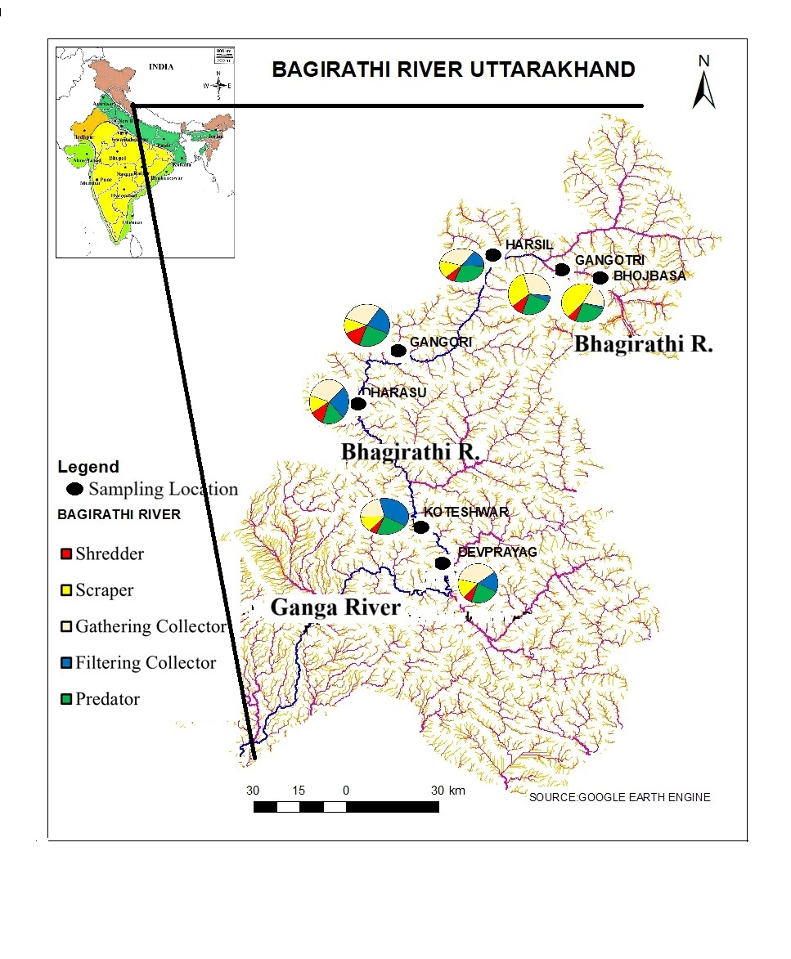
Figure 1: Location of study area in Indian map along with sampling locations in the river Bhagirathi

Figure 2: Distributional patterns of FFG at various stations along the river length

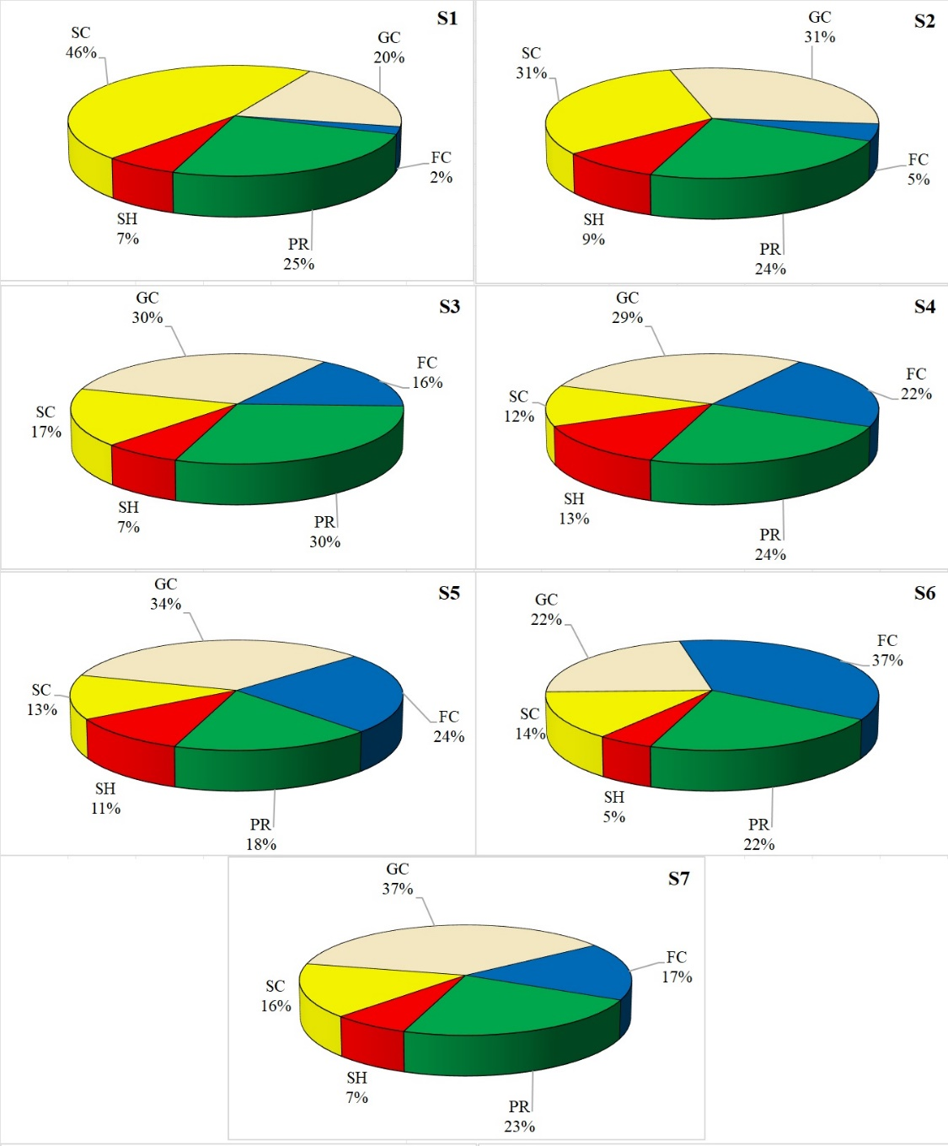

Figure 3: Functional feedings groups (FFG) analysis of benthic macroinvertebrate community at various stations in the river Bhagirathi. Acronyms: SC-Scraper, SH- Shredder, GC- Gathering Collector, FC-Filtering Collector, PR-Predator

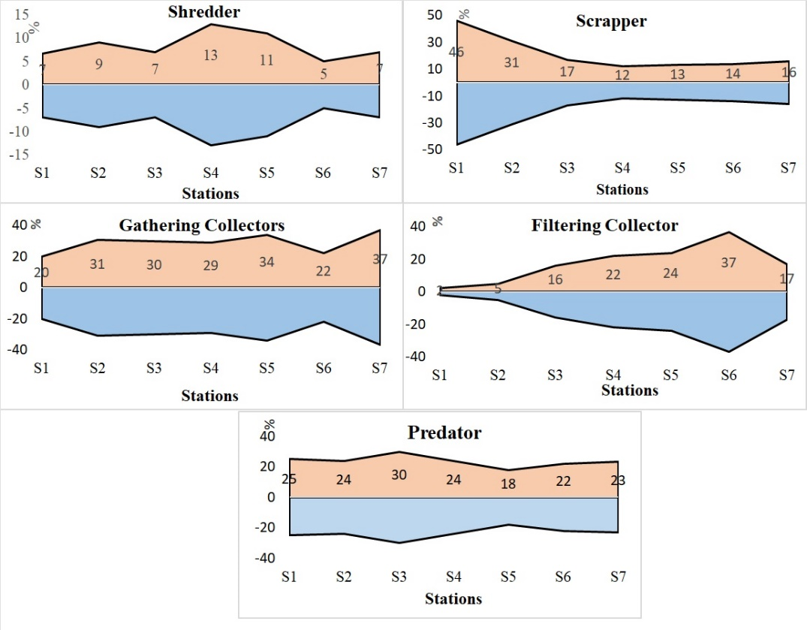

Figure 4: Longitudinal variation in taxonomic composition ofFFGat various stations from headwater to mouth.

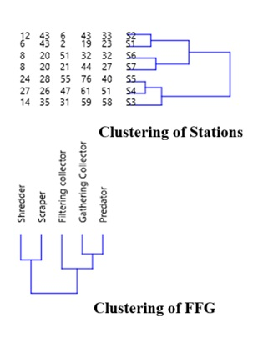

Figure 5: Cluster analysis for grouping the FFG.

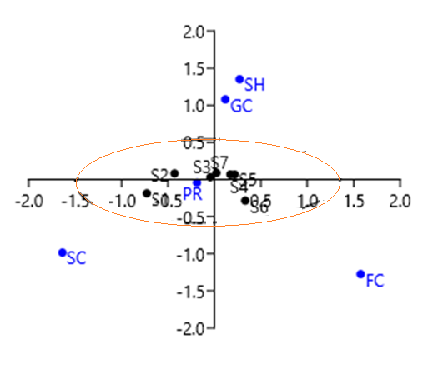
Figure 6: Correspondence analysis to determine percentage of variation in FFG (FFG) in the river Bhagirathi.

