Original Research Article
Neuro-promotive role of Quinic acid against rotenone induced rat model of Parkinson’s Disease

ABSTRACT
Parkinson's disease (PD) is a common disorder that affects the movement of aged population, which is characterized by loss of dopaminergic neurons and depletion of dopamine due to oxidative stress, mitochondrial dysfunction, inflammation and apoptosis. The present study shows the neuroprotective effect of quinic acid (QA) against rotenone induced rat model of PD. The behaviour tasks, neurochemical and biochemical indices were performed using standard procedures. QA significantly attenuated the adverse effects of rotenone by enhancing the levels of dopamine, GSH and activities of SOD, catalase and GPx and diminishing the levels of TBARS along with improved behavior performance. As to conclude, drugs with potent antioxidant property such as QA could have therapeutic potential for this pathology.
1. INTRODUCTION
Parkinson’s disease (PD) is the well-known neurodegenerative disorder that is characterised by motor symptoms. It is arised by slow and progressive loss of dopaminergic (DAergic) neurons in substantia nigra (SN) and consequent diminished level of striatal (ST) dopamine (DA) (Berg et al., 2014). It affects about 1.5% to 2.0% of aged people globally and becomes a chief cause of inability found in higher than 6 million people worldwide (Ben-Shlomo et al., 2024; Sharma et al., 2018). Although the etiology of motor disease is connected with genetic and environmental factors, the onset and progression are linked with oxidative stress, inflammation, mitochondrial dysfunction (Khatri and Juvekar, 2016). Particularly, neurons in the SN regions are specifically prone to oxidative imbalance because of their enhanced metabolic activity, presence of increased iron content, reduced antioxidant functions, enhanced oxygen uptake by the brain and the catabolism of DA by monoamine oxidases (Sun et al., 2023).
Although reactive oxygen species (ROS) are considered as the key signalling molecules controlling the transcription processes and interactions of proteins (Schieber and Chandel, 2014), they play an important role in DAergic neurodegeneration. Depending upon their subcellular accumulation, oxidative injury to proteins, lipids, DNA, and RNA can take place, leading to loss of neuronal structure and function. Even prior to the significant neuronal loss, enhanced oxidative imbalance was found in the SN of early stage PD patients (Ferrer et al., 2011) and also in their later stage (Keeney et al., 2024). Rotenone, an isoflavone of plant origin, is used mostly as an insecticide and pesticide. This toxin is metabolized to hydroxyl rotenone in hepatic tissues by the help of CYP 3A4 or 2C19 and cross the BBB due to its lipophilic nature. It binds to complex I of mitochondria with high affinity and inhibits electron transport chain, thereby hinders ATP production and induces the huge superoxide generation. This overwhelms the capacity of the enzymatic and non-enzymatic antioxidants (Alzahrani et al., 2018) and induces oxidative damage to macromolecules thereby leads to apoptotic degeneration of brain cells (Javed et al., 2016, Heinz et al., 2017)
- Although there is no cure for PD, the conventional pharmacological ailments for the disease are the usage of dopamine precursors such as levodopa, L-DOPA, etc, or dopamine agonists like apomorphine, amantadine, bromocriptine, rotigotine etc or monoamine oxidase inhibitors such as selegiline and rasagiline or the inhibitors of catechol-O-methyltransferase like entacapone and tolcapone. The prolonged administration of these drugs may lead to other psychological and motor complications and “wearing off phenomenon”. The plant extracts and its related phytochemicals are reported to offer not only the neuroprotection to diminish the premature neurodegeneration in addition to enhancing dopaminergic neurotransmission (Cacabelos et al., 2017).
Owing to antioxidant properties, plant extract and phytochemicals nullified the harmful role of oxidative imbalance in the central nervous system and can play as active drug molecules for neurodegenerative diseases including PD. Both of them are considered as cheap and safe, and their therapeutic effects have been shown from ancient days in several countries (Rahmani, et al., 2014). Quinic acid (QA) is a polyphenol with carboxylic acid cyclohexane mostly present in coffee beans, cinchona (Ercan et al., 2022), sweet potatoes and peaches (Dhondge et al., 2015). It is not synthesized endogenously in humans; but its uptake through diet is valuable as it involves in the synthesis of tryptophan, tyrosine and phenylalanine inside the gastrointestinal tract by microbes (Fricker et al., 2015, Pero 2010). Kwon et al., (2016) indicated the potent antioxidant activity of the compound, as it reduces the intracellular ROS levels in PC12 cells exposed to hydrogen peroxide (H₂O₂). However, till now, the antioxidant role of QA in rotenone induced rat model has not been clearly elucidated.
2. METHODS AND MATERIALS
2.1 Animals
Male Wistar rats (225–250 g) were obtained from the Spring Lab, Tumkur, India and maintained under standard conditions with ad libitum. The experiments were inconsistence with National Guidelines on the Proper Care and Use of Animals in Laboratory Research as mentioned by INSA, New Delhi, 2000. The protocols were accepted by Local Animal Ethics Committee (GMCHC- IAEC/1388/12/24).
2.1.1 Experiment I
30 animals were separated into five groups of 6 in each: control animals rats received sunflower oil (0.5 ml) intraperitonially for a week, rotenone injected (2.5 mg/kg i.p. for a week) (Ramkumar et al., 2018), rotenone (as in group II) and QA low dose (200 mg/kg/b.w. was administered orally) treated, rotenone and QA high dose (400 mg/kg/b.w. was administered orally) treated (Liu et al., 2020), and QA (400 mg/kg/day) alone treated. After the end of the experimental period, behaviour test (catalepsy and akinesia) was performed and the Striatum (ST) was procured for the estimation of DA and oxidative stress-related indices, respectively.
2.1.1.1 Catalepsy test
The incapacity of animal to alter its position that has been imposed externally is called as impaired cataleptic movement. Rat was lifted by holding tail individually. Their forepaws are placed on a wooden platform. Cataleptic time is the time taken for the initial paw movement (Tong et al., 2016).

2.1.1.2 Akinesia test
This experiment depicts the difficulties in starting movement in PD patients. When the test was completed in 180 seconds, the latency of rats to move all the limbs was measured in seconds. The rat was placed in a wooden bar and time taken for the rats to move all limbs was calculated (Fernandez et al., 2012).
2.1.1.3 HPLC analysis of dopamine and its metabolites
The levels of DA were quantified by HPLC - ECD by the method followed by Ramkumar et al., (2018). The dissected striatum region was sonicated in ice cold condition with perchloric acid containing ethylenediamine tetra acetic acid. Then they were centrifuged for 10 mins at 10000 g and the collected supernatant was injected into the HPLC system. The mobile phase consisting of methanol, acetonitrile and citric acid, octane sulfonic acid, monobasic phosphate sodium, KCL, heptane sulfonic acid, EDTA and o‑phosphoric acid was also injected.
2.1.1.4 Quantification of TBARS levels
The TBARS levels were measured by the method of Bhattacharya et al., (2001). The phenyl methosulphate solution and brain homogenates were incubated at room temperature in a shaker for 1 hour. Then tricarboxylic acid and thiobarbituric acid were added and centrifuged at 4000 rpm for 15 min. Supernatant was collected, boiled for 10 mins and cooled. OD was measured at 535 nm.
2.1.1.5 Measurement of GSH levels
The GSH levels were estimated by Jollow et al. (1974) method. SN tissue was homogenised and centrifuged (16,000 × g) in cold conditions for 15 mins using cooling centrifuge. To supernatant solution, dithiobis2-nitrobenzoic acid in phosphate buffer solution was added. The OD was read at 412 nm spectrophotometrically.
2.1.1.6 Determination of superoxide dismutase activity
For assaying SOD activity (Oberley and Sptiz 1984), PMS, sodium carbonate buffer containing xanthine, NBT, and EDTA and xanthine oxidase were added with homogenate. Alterations in OD were noted at 560 nm using spectrophotometer.
2.1.1.7 Assay of catalase activity
To the phosphate buffer, H₂O₂ and brain homogenate were added. Then the iterations in OD were measured at 240 nm using spectrophotometer (Claiborne 1985).
2.1.1.8 Quantification of GPx activity
The GPx assay solution contains Tris–HCl with EDTA, GSH, GSH reductase solution, NADPH, distilled water, tert-butyl hydroperoxide and brain homogenate. Alteration in OD was measured spectrophotometrically at 340 nm (Yamamoto and Takahashi, 1993).

2.2 Statistical Analysis
One-way analysis of variance and Duncan’s multiple range test (DMRT) were calculated to study statistical significance within groups (p<0.05).
3. RESULTS
3.1 Role of QA on rotenone mediated cataleptic movement
Deficit in movement coordination was measured by using the catalepsy test. Rotenone injection induced deficit in rectification of an externally forced position as compared to control animals. Co-treatment of QA to neurotoxin injected animals significantly ameliorated rotenone mediated cataleptic movement (Figure. 1). No significant alterations were found between untreated and QA alone administered animals.
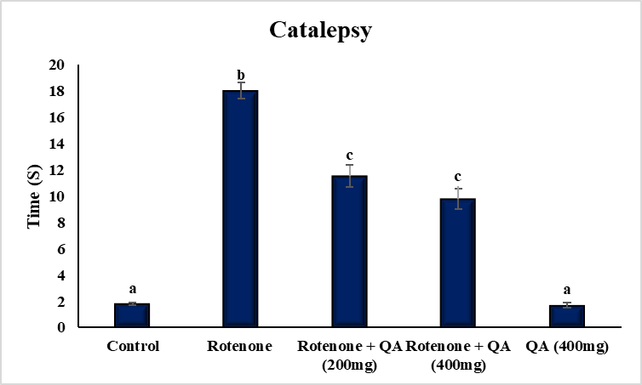

Figure 1: Effect of QA on rotenone induced cataleptic impairment. All the values are expressed as mean ± SEM; n=6, values not sharing the same alphabet differs significantly (P<0.05); ANOVA followed by Duncan’s test)
3.2 Impact of QA on rotenone mediated akinesia
Rats injected with neurotoxin exhibited a decreased capacity for movement initiation as compared to control animals. Rotenone-mediated akinetic movement was greatly reduced when QA was given orally (Figure. 2). Furthermore, no discernible difference was found between the rats treated with QA alone and the control rats.
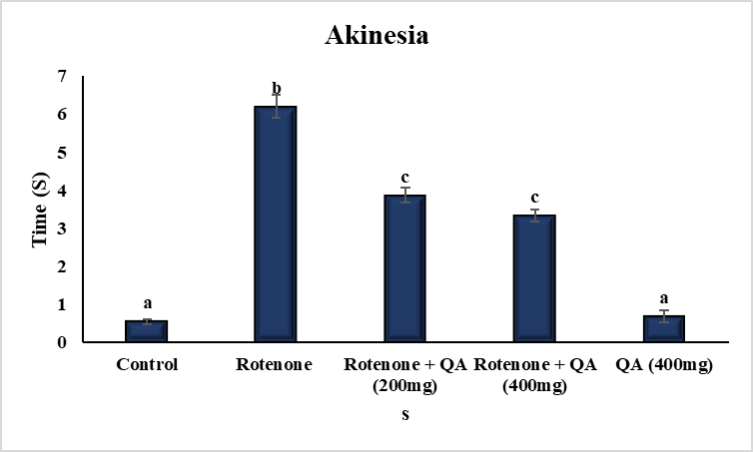

Figure 2: Effect of QA on rotenone induced akinetic impairment. All the values are expressed as mean ± SEM; n=6, values not sharing the same alphabet differs significantly (p<0.05); ANOVA followed by Duncan’s test)
3.3 Role of QA on rotenone induced reduction in the levels of dopamine
Rats injected with neurotoxin showed a reduction in the levels of dopamine as compared to control animals. Rotenone-mediated impairment in the levels of neurochemical was significantly attenuated by the low and high doses of QA (Figure.3). Furthermore, no significant alterations were found between the rats treated with QA alone and the control rats.
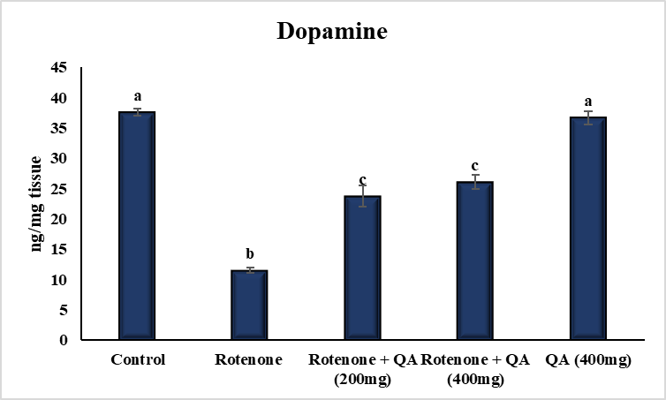

Figure 3: Effect of QA on rotenone induced striatal DA depletion. All the values are expressed as mean ± SEM; n=6, values not sharing the same alphabet differs significantly (p<0.05); ANOVA followed by Duncan’s test)

3.4 Effect of QA on rotenone induced lipid peroxidation
In the rotenone treated rats, the levels of TBARS were enhanced significantly as compared to control rats. Oral treatment of QA (low and high doses) to neurotoxin administered rats significantly diminished TBARS levels as compared to rotenone exposed rats. No significant changes were observed in TBARS levels between the group V and group I rats (Figure. 4 A).
3.5 Effect of QA on rotenone mediated reduction in GSH levels
In the rotenone treated rats, GSH levels were reduced significantly as compared to group I animals. Oral treatment of QA to rotenone exposed animals significantly increased GSH levels as compared to group II rats. No significant changes were observed in GSH levels between the group V and group I rats (Figure. 4 B).
4A
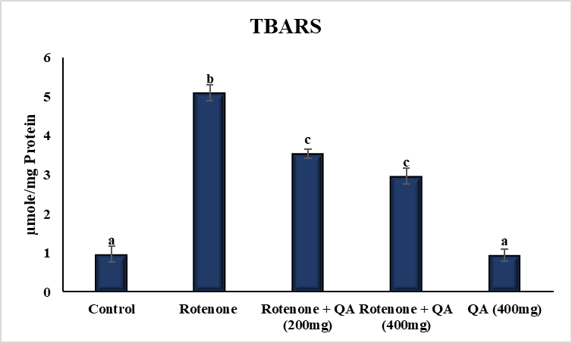
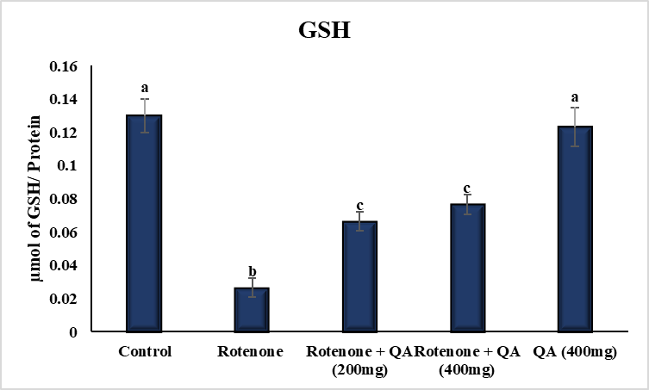
4B

Figure 4 A, B: Effect of QA on rotenone induced levels of oxidative stress and non-enzymatic antioxidant in rats. All the values are expressed as mean ± SEM; n=6, values not sharing the same alphabet differs significantly (p<0.05); ANOVA followed by Duncan’s test)
3.6 Antioxidant role of QA on rotenone induced reduction of enzymatic antioxidants
The rotenone injected animals showed the significant reduction in the SOD, catalase and GPx activities as compared to control rats. The oral treatment of QA to neurotoxin injected rats showed the significantly increased activities of antioxidants as compared to group II animals. No significant changes were present in the SOD, catalase and GPx activities between the QA alone treated and untreated animals (Figure 4 C, D and E).
4C
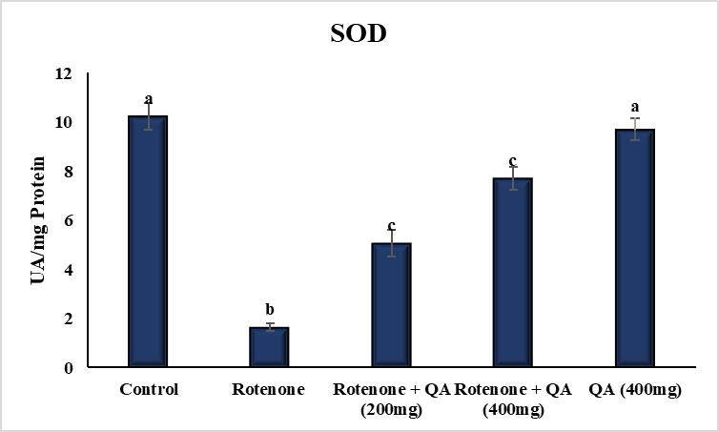

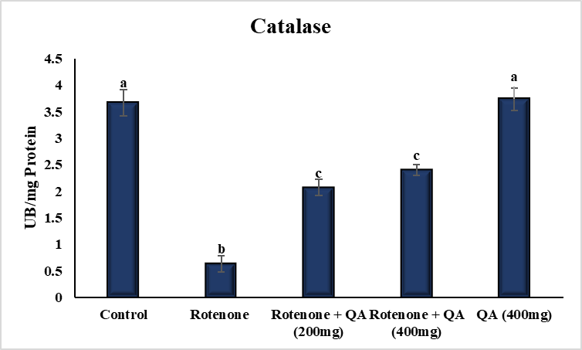
4D

4E
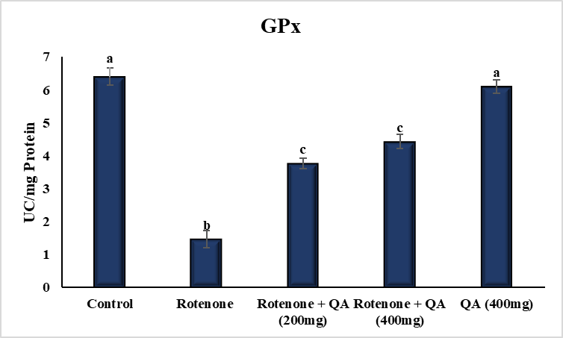

Figure 4 C, D, E: Effect of QA on rotenone induced reduction in the levels and activities of antioxidants in rats. All the values are expressed as mean ± SEM; n=6, values not sharing the same alphabet differs significantly (p<0.05); ANOVA followed by Duncan’s test)
4. DISCUSSION
The neuroprotective role of QA on the motor symptoms of PD was analysed in the rat model of PD by performing catalepsy and akinetic test. These parameters were analysed in rotenone injected animals to measure the extent of damage in DAgernic neurons and also in QA co-treated animals for their attenuation in neuronal degeneration. In rodents, Sherer et al. (2003) demonstrated that the subcutaneous injection of rotenone (2.75mg/kg) for a week induced dopaminergic neuronal loss in SN and ST along with behavioural impairments resembling early stage of PD. Previous study from our laboratory indicated that the rotenone injection (2.5 mg/kg/day, i.p for 7 days) leads to reduction in akinetic movement and cataleptic ability (Dhanalakshmi et al., 2016). Akinesia and catalepsy are commonly used to test the delayed response in starting a movement, and rigidity in rat model of PD. In the current study, the impairment in the motor functions in rotenone injected group indicated that the dopaminergic neurons in striatonigral pathway were damaged as confirmed previously (Dhanalakshmi et al., 2016). Motor impairments in rat model of PD were reduced by the supplementation of antioxidants (Zafar et al. 2003; Khuwaja et al. 2011). Various phytochemicals including, rosinidin, hibiscetin and vanillin reported to attenuated the rotenone induced akinetic and cataleptic behaviour in rodents, which is corroborated with our results (Alghamdi et al., 2023, Alzarea et al., 2022, Dhanalakshmi et al., 2016). Oral treatment of QA ameliorated aluminium mediated memory deficit in in vivo models of Alzheimer’s disease (Liu et al., 2020; Kwon et al., 2016). Moreover, oral administration of QA derivatives attenuated the cortisol mediated depressive behaviour in rats (Lim et al., 2020).
Even at the low doses, rotenone induced loss of DAgernic neurons in the nigro‑striatal pathway (Sherer et al., 2003), which is the typical pathology of PD. Striatum contains more number of dopaminergic neuronal endings that is considered as the DA source. This neurotransmitter is mainly accountable for movements, balance and integrity in rodents. In the present study, the levels of DA were significantly reduced in group II rats as compared to group I rats, whereas oral treatment of QA (low and high dose) increased the levels of neurochemical variable in rotenone‑injected PD rats. As there is no significant difference in the levels of DA between groups III and IV, low dose of QA (200 mg/kg b.w.) can be used for further experiments. The diminished levels of neurochemical indices induce ST neurons to act uncontrollably, thereby inhibiting the movement of PD patients. Drugs, which are able to attenuate the deficit in the levels of DA are considered as potent neuroprotective agents. In this background, QA mediated attenuation of behavioural indices in rotenone treated animals may be because of their neurochemical modulatory effect.
Inhibition of ETC in two sites of the mitochondria have been known as key source for the ROS generation. In NADH-dehydrogenase and cytochrome c reductase (complexes I & III), autooxidation of flavin mononucleotide and unstable ubisemiquinone may leads to generation of ROS (Turrens and Boveris 1980; Turrens et al., 1985). Rotenone inhibits the ETC from complex I (NADH dehydrogenase) resulting in the excessive synthesis of ROS, like superoxide anions (O2 •-). Intraperitoneal injection of rotenone increased the TBARS levels, a well-known index of lipid peroxidation processes and reduced levels of GSH and activities of SOD, catalase and GPx which is in consistence with previous research (Sa´nchez-Reus et al., 2007; Bashkatova et al., 2004; Sharma et al., 2015). Low dose of rotenone (1.5 mg/kg) injection in rats increased the levels of TBARS in various regions of brain (Bashkatova et al., 2004). QA offered neuroprotection against glutamate and Aβ induced toxicity by decreasing oxidative imbalance and inflammation (Rebai et al., 2017; Lee et al., 2018). QA metabolites diminished the ROS formation by inhibiting the activity of monoamine oxidase in brain (Lim et al., 2020). More toxic superoxide ion forms H2O2 spontaneously or by SOD-catalysed dismutation reaction. Both the enzymatic antioxidants like catalase and glutathione peroxidase (GPx) induces conversion of H2O2 into H2O and O2 (Birben et al., 2012). In PD, oxidative imbalance induced loss of DA-ergic neurons were enhanced by increased DA metabolism and low levels/activities of antioxidants in nigrostriatal system (Kim et al., 2000). Increased ROS formation during PD is a marker of oxidative stress that leads to rapid consumption and reduction of antioxidants. Diminished activities of SOD, catalase and GPx in rotenone treated rats may be because of the reply towards enhanced levels of ROS and LPO in rotenone treated rats. Apart from animal studies, clinical studies also indicated the reduction in the activities and levels of non-enzymatic and enzymatic antioxidants like GSH, SOD and catalase in the brain tissues (Pohl et al., 2018). A reduction in the activity of SOD has been found humans exposed to endemic rotenone (Caboni et al., 2004). Diminished SOD activity was not only found in brain, but also in other organs like heart, liver and kidney of rodents injected with rotenone (Miyazaki et al., 2020). In high concentrations, this neurotoxin may impair the activity of SOD and leading to enhanced accumulation of ROS, thereby causing cell injury (Testa et al., 2005).

In the experiment, rotenone injection showed reduction in the activities of catalase as compared to untreated animals. The results were in consistent with other studies (Lehto et al.,2013; Prema et al., 2015 and Soczynska et al., 2008). In contrast, Sharma and Bafna indicated a non -significant enhancement in the catalase activity in rotenone injected animals as compared to control animals (Sharma and Bafna, 2012). Moreover, GSH depletion, the first indicator of oxidative stress during PD progression, suggests a concomitant increase in reactive oxygen species. Dexter et al., (1994) demonstrated a reduced GSH content was found in SN of PD patients. This reduction may lead to diminished clearance of H2O2 and thus, enhance the formation of OH radical that result in the generation of ROS. Enhanced ROS induces lipid peroxidation processes that can be identified by quantifying the TBARS levels.

5. CONCLUSION
The study revealed the neuroprotective properties of QA against the rotenone induced rat model of PD. Quinic acid effectively restored the behavioural deficits and neurochemical indices and normalized the oxidative stress induced by rotenone. However, further studies should be carried out to explore the molecular mechanism behind the neuroprotective properties of QA.

Disclaimer (Artificial intelligence)
Author(s) hereby declares that NO generative AI technologies such as Large Language Models (ChatGPT, COPILOT, etc.) and text-to-image generators have been used during the writing or editing of this manuscript.
COMPETING INTERESTS
Authors have declared that they have no known competing financial interests or non-financial interests or personal relationships that could have appeared to influence the work reported in this paper.

REFERENCES
Alghamdi, A. M., Al-Abbasi, F. A., AlGhamdi, S. A., Fatima, F., Alzarea, S. I., & Kazmi, I. (2023). Rosinidin inhibits NF-κB/ Nrf2/caspase-3 expression and restores neurotransmitter levels in rotenone-activated Parkinson's disease. Saudi journal of biological sciences, 30(6), 103656.
- Alzahrani, S., Ezzat, W., Elshaer, R. E., Abd El-Lateef, A. S., Mohammad, H. M. F., Elkazaz, A. Y., et al (2018). Standardized Tribulus terrestris extract protects against rotenone-induced oxidative damage and nigral dopamine neuronal loss in mice. J Physiol Pharmacol, 69(6), 979-94.

Alzarea, S. I., Afzal, M., Alharbi, K. S., Alzarea, A. I., Alenezi, S. K., Alshammari, M. S., Alquraini, A., & Kazmi, I. (2022). Hibiscetin attenuates oxidative, nitrative stress and neuroinflammation via suppression of TNF-α signaling in rotenone induced parkinsonism in rats. Saudi pharmaceutical journal : SPJ : the official publication of the Saudi Pharmaceutical Society, 30(12), 1710–1717. https://doi.org/10.1016/j.jsps.2022.09.016
Bashkatova, V., Alam, M., Vanin, A., & Schmidt, W. J. (2004). Chronic administration of rotenone increases levels of nitric oxide and lipid peroxidation products in rat brain. Experimental neurology, 186(2), 235-241.
Ben-Shlomo, Y., Darweesh, S., Llibre-Guerra, J., Marras, C., San Luciano, M., Tanner, C. (2024). The epidemiology of Parkinson’s disease. Lancet, 403(10423):283–92.
Berg, D., Postuma, R. B., Bloem, B., Chan, P., Dubois, B., Gasser, T., et al (2014). Time to redefine PD? Introductory statement of the MDS Task Force on the definition of Parkinson's disease. Movement Disorders, 29(4), 454-462.
Bhattacharya, A., Ghosal, S., & Bhattacharya, S. K. (2001). Anti-oxidant effect of Withania somnifera glycowithanolides in chronic footshock stress-induced perturbations of oxidative free radical scavenging enzymes and lipid peroxidation in rat frontal cortex and striatum. Journal of ethnopharmacology, 74(1), 1-6.
Birben, E., Sahiner, U. M., Sackesen, C., Erzurum, S., & Kalayci, O. (2012). Oxidative stress and antioxidant defense. World allergy organization journal, 5(1), 9-19.
Caboni, P., Sherer, T. B., Zhang, N., Taylor, G., Na, H. M., Greenamyre, J. T., & Casida, J. E. (2004). Rotenone, deguelin, their metabolites, and the rat model of Parkinson's disease. Chemical research in toxicology, 17(11), 1540-1548.
Cacabelos, R. (2017). Parkinson’s disease: from pathogenesis to pharmacogenomics. International journal of molecular sciences, 18(3), 551.
Claiborne, A. J. F. C. P. (1985). Handbook of methods for oxygen radical research. Florida: CRC Press, Boca Raton, 283-284.
Dexter, D. T., Holley, A. E., Flitter, W. D., Slater, T. F., Wells, F. R., Daniel, S. E., et al (1994). Increased levels of lipid hydroperoxides in the parkinsonian substantia nigra: an HPLC and ESR study. Movement Disorders, 9(1), 92-97.
Dhanalakshmi, C., Janakiraman, U., Manivasagam, T., Justin Thenmozhi, A., Essa, M. M., Kalandar, A., et al (2016). Vanillin Attenuated Behavioural Impairments, Neurochemical Deficts, Oxidative Stress and Apoptosis Against Rotenone Induced Rat Model of Parkinson's Disease. Neurochemical research, 41(8), 1899–1910.
Dhondge, S. S., Shende, P. H., Paliwal, L. J., & Deshmukh, D. W. (2015). Volumetric and acoustic study of aqueous binary mixtures of quinine hydrochloride, guanidine hydrochloride and quinic acid at different temperatures. The Journal of Chemical Thermodynamics, 81, 34-43.
Ercan, L., Doğru, M. (2022). Antioxidant and antimicrobial capacity of quinic acid. Bitlis Eren Üniversitesi Fen Bilimleri Dergisi, 11(4):1018‐1025.
Fernandez, M., Negro, S., Slowing, K., Fernandez-Carballido, A., & Barcia, E. (2011). An effective novel delivery strategy of rasagiline for Parkinson's disease. International journal of pharmaceutics, 419(1-2), 271-280.
- Ferrer, I., Martinez, A., Blanco, R., Dalfo, E., & Carmona, M. (2011). Neuropathology of sporadic Parkinson disease before the appearance of parkinsonism: Preclinical Parkinson disease. Journal of Neural Transmission, 118(5), 821–839.
Fricker, R. A., Green, E. L., Jenkins, S. I., & Griffin, S. M. (2018). The influence of nicotinamide on health and disease in the central nervous system. International Journal of Tryptophan Research, 11, 1178646918776658.https://doi.org/10.1177/1178646918776658.
Heinz, S., Freyberger, A., Lawrenz, B., Schladt, L., Schmuck, G., & Ellinger-Ziegelbauer, H. (2017). Mechanistic investigations of the mitochondrial complex I inhibitor rotenone in the context of pharmacological and safety evaluation. Scientific reports, 7(1), 1-13.
- Javed, H., Azimullah, S., Haque, M. E., & Ojha, S. K. (2016). Cannabinoid type 2 (CB2) receptors activation protects against oxidative stress and neuroinflammation associated dopaminergic neurodegeneration in rotenone model of Parkinson's disease. Frontiers in neuroscience, 10, 321.
Jollow, D. J., Mitchell, J. R., Zampaglione, N. A., & Gillette, J. R. (1974). Bromobenzene-induced liver necrosis. Protective role of glutathione and evidence for 3, 4-bromobenzene oxide as the hepatotoxic metabolite. Pharmacology, 11(3), 151-169.
- Keeney, M. T., Rocha, E. M., Hoffman, E. K., Farmer, K., Di Maio, R., Weir, J., et al (2024). LRRK2 regulates production of reactive oxygen species in cell and animal models of Parkinson’s disease. Science Translational Medicine, 16(767), eadl3438.
- Khatri, D. K., & Juvekar, A. R. (2016). Neuroprotective effect of curcumin as evinced by abrogation of rotenone-induced motor deficits, oxidative and mitochondrial dysfunctions in mouse model of Parkinson's disease. Pharmacology Biochemistry and Behavior, 150, 39-47.
Khuwaja, G., Khan, M. M., Ishrat, T., Ahmad, A., Raza, S. S., Ashafaq, M., et al (2011). Neuroprotective effects of curcumin on 6-hydroxydopamine-induced Parkinsonism in rats: behavioral, neurochemical and immunohistochemical studies. Brain Research, 1368, 254-263.
Kim, B. G., Shin, D. H., Jeon, G. S., Seo, J. H., Kim, Y. W., Jeon, B. S., & Cho, S. S. (2000). Relative sparing of calretinin containing neurons in the substantia nigra of 6-OHDA treated rat Parkinsonian model. Brain research, 855(1), 162-165.
Kwon, Y. K., Choi, S. J., Kim, C. R., Kim, J. K., Kim, Y. J., Choi, J. H., et al (2016). Antioxidant and cognitive-enhancing activities of Arctium lappa L. roots in Aβ1-42-induced mouse model. Applied Biological Chemistry, 59(4), 553-565.
Lehto, S. M., Ruusunen, A., Tolmunen, T., Voutilainen, S., Tuomainen, T. P., & Kauhanen, J. (2013). Dietary zinc intake and the risk of depression in middle-aged men: a 20-year prospective follow-up study. Journal of affective disorders, 150(2), 682-685.
Lim, D. W., Park, J., Jung, J., Kim, S. H., Um, M. Y., Yoon, M., et al (2020). Dicaffeoylquinic acids alleviate memory loss via reduction of oxidative stress in stress-hormone-induced depressive mice. Pharmacological Research, 161, 105252.
Liu, L., Liu, Y., Zhao, J., Xing, X., Zhang, C., & Meng, H. (2020). Neuroprotective Effects of D‐(‐)‐Quinic Acid on Aluminum Chloride‐Induced Dementia in Rats. Evidence‐Based Complementary and Alternative Medicine, 2020(1), 5602597.
Miyazaki, I., Isooka, N., Imafuku, F., Sun, J., Kikuoka, R., Furukawa, C., & Asanuma, M. (2020). Chronic systemic exposure to low-dose rotenone induced central and peripheral neuropathology and motor deficits in mice: reproducible animal model of Parkinson’s disease. International journal of molecular sciences, 21(9), 3254.
Oberley, L. W., & Spitz, D. R. (1984). [61] Assay of superoxide dismutase activity in tumor tissue. In Methods in enzymology (Vol. 105, pp. 457-464). Academic Press.
Pero, R. W. (2010). Health consequences of catabolic synthesis of hippuric acid in humans. Current clinical pharmacology, 5(1), 67-73.
Pohl, F., & Kong Thoo Lin, P. (2018). The potential use of plant natural products and plant extracts with antioxidant properties for the prevention/treatment of neurodegenerative diseases: in vitro, in vivo and clinical trials. Molecules, 23(12), 3283.
Prema, A., Janakiraman, U., Manivasagam, T., & Thenmozhi, A. J. (2015). Neuroprotective effect of lycopene against MPTP induced experimental Parkinson’s disease in mice. Neuroscience letters, 599, 12-19.
Rahmani, A. H., Al Zohairy, M. A., Aly, S. M., & Khan, M. A. (2014). Curcumin: a potential candidate in prevention of cancer via modulation of molecular pathways. BioMed research international, 2014(1), 761608.
Ramkumar, M., Rajasankar, S., Gobi, V. V., Janakiraman, U., Manivasagam, T., Thenmozhi, A. J., et al (2018). Demethoxycurcumin, a Natural Derivative of Curcumin Abrogates Rotenone-induced Dopamine Depletion and Motor Deficits by Its Antioxidative and Anti-inflammatory Properties in Parkinsonian Rats. Pharmacognosy magazine, 14(53), 9–16. https://doi.org/10.4103/pm.pm_113_17.
Sánchez-Reus, M. I., Del Rio, M. G., Iglesias, I., Elorza, M., Slowing, K., & Benedi, J. (2007). Standardized Hypericum perforatum reduces oxidative stress and increases gene expression of antioxidant enzymes on rotenone-exposed rats. Neuropharmacology, 52(2), 606-616.
- Schieber, M., & Chandel, N. S. (2014). ROS function in redox signaling and oxidative stress. Current biology, 24(10), R453-R462.
Sharma, N., & Bafna, P. (2012). Effect of Cynodon dactylon on rotenone induced Parkinson’s disease. Oriental pharmacy and experimental medicine, 12(3), 167-175.
Sharma, N., & Nehru, B. (2015). Characterization of the lipopolysaccharide induced model of Parkinson's disease: Role of oxidative stress and neuroinflammation. Neurochemistry international, 87, 92-105.
Sharma, S., Kumar, P., & Deshmukh, R. (2018). Neuroprotective potential of spermidine against rotenone induced Parkinson's disease in rats. Neurochemistry International, 116, 104-111.
Sherer, T. B., Betarbet, R., Testa, C. M., Seo, B. B., Richardson, J. R., Kim, J. H., .et al (2003). Mechanism of toxicity in rotenone models of Parkinson's disease. Journal of Neuroscience, 23(34), 10756-10764.
Sherer, T. B., Kim, J. H., Betarbet, R., & Greenamyre, J. T. (2003). Subcutaneous rotenone exposure causes highly selective dopaminergic degeneration and α-synuclein aggregation. Experimental neurology, 179(1), 9-16.
Soczynska, J. K., Kennedy, S. H., Chow, C. S., Woldeyohannes, H. O., Konarski, J. Z., & McIntyre, R. S. (2008). Acetyl-L-carnitine and α-lipoic acid: possible neurotherapeutic agents for mood disorders?. Expert opinion on investigational drugs, 17(6), 827-843.
- Sun, J., Lin, X. M., Lu, D. H., Wang, M., Li, K., Li, S. R., et al (2023). Midbrain dopamine oxidation links ubiquitination of glutathione peroxidase 4 to ferroptosis of dopaminergic neurons. The Journal of clinical investigation, 133(10).
Testa, C. M., Sherer, T. B., & Greenamyre, J. T. (2005). Rotenone induces oxidative stress and dopaminergic neuron damage in organotypic substantia nigra cultures. Molecular Brain Research, 134(1), 109-118.
Tong, Q., Wu, L., Gao, Q., Ou, Z., Zhu, D., & Zhang, Y. (2016). PPARβ/δ agonist provides neuroprotection by suppression of IRE1α–Caspase-12-Mediated endoplasmic reticulum stress pathway in the rotenone rat model of Parkinson’s disease. Molecular neurobiology, 53(6), 3822-3831.
Turrens, J. F., & Boveris, A. (1980). Generation of superoxide anion by the NADH dehydrogenase of bovine heart mitochondria. Biochemical journal, 191(2), 421-427.
Turrens, J. F., Alexandre, A., & Lehninger, A. L. (1985). Ubisemiquinone is the electron donor for superoxide formation by complex III of heart mitochondria. Archives of biochemistry and biophysics, 237(2), 408-414.
Yamamoto, Y., Takahashi, K. (1993). Glutathione peroxidase isolated from plasma, reduces phospholipid hydroperoxide. Archives of Biochemistry and Biophysics 305, 541–545.
Zafar, K. S., Siddiqui, A., Sayeed, I., Ahmad, M., Salim, S., & Islam, F. (2003). Dose‐dependent protective effect of selenium in rat model of Parkinson's disease: neurobehavioral and neurochemical evidences. Journal of neurochemistry, 84(3), 438-446.

