Seasonal Population Dynamics of the Cowpea Aphid, Aphis craccivora (Koch) on Bean, and its Correlation with Abiotic Factors under Kashmir Conditions
ABSTRACT:
A two-year field investigation (2023–2024) was conducted in the Kashmir Valley to study the population dynamics of the cowpea aphid, Aphis craccivora Koch, infesting common bean (Phaseolus vulgaris L.) at three locations viz: Shalimar, Shuhama and Habak. The aphid population exhibited a characteristic sigmoidal growth pattern during both years. Initial colonization occurred in the 19th Standard Meteorological Week (SMW), followed by a gradual increase from the 20th SMW and a rapid rise by the 23rd SMW. Peak infestation was observed between the 25th and 30th SMWs, after which the population declined sharply by the 36th SMW. Mean aphid populations per three leaves were 44.79 and 46.11 at Shalimar, 47.71 and 43.30 at Shuhama, and 49.78 and 45.53 at Habak during 2023 and 2024 respectively. Highly significant positive correlation between maximum temperature and all aphid stages (nymphs, apterous, and alates), indicating that warmer conditions favored aphid multiplication and development. Minimum temperature also showed a positive but weaker correlation with aphid density. In contrast, both maximum and minimum relative humidity exhibited significant negative correlations, suggesting that humid conditions suppressed aphid buildup. These consistent trends across all sites indicate that temperature plays a promotive role, while relative humidity acts as a limiting factor in the population development of A. craccivora under Kashmir conditions.The study highlights the period between the 23rd and 25th SMWs as critical for implementing integrated pest management (IPM) strategies against A. craccivora in common bean.
Keywords: Aphis craccivora, common bean, population dynamics, temperature, relative humidity, IPM.
- INTRODUCTION
Common bean (Phaseolus vulgaris L.) is an important legume of the Fabaceae family, cultivated globally for human consumption and animal feed. It ranks third among legume crops after soybean and peanut and is the most directly consumed legume worldwide (Broughton et al., 2003). Beans are valued for their tender green pods and protein-rich dry seeds, which serve as a major source of carbohydrates, minerals, and vitamins (Ramandeep et al., 2018; McClean et al., 2004). In addition to their nutritional value, beans improve soil fertility through atmospheric nitrogen fixation and play a vital role in sustainable cropping systems (Demelash, 2018; Broughton et al., 2003).Globally, dry beans are cultivated on 36.45 million ha and green beans on 1.58 million ha. In India, major bean-producing regions include Maharashtra, Himachal Pradesh, Uttar Pradesh, Jammu & Kashmir, and the northeastern states (Vikaspedia, 2022), contributing about 2.52 million metric tonnes annually (NHB database, 2021–22). In Jammu & Kashmir, beans cover 3,353 ha with a productivity of 0.88 t/ha (Anonymous, 2019).Aphids are among the most destructive pests of beans, with their population dynamics strongly influenced by temperature and humidity (Kumar et al., 2019). They cause direct damage by sap extraction and transmit viruses such as Bean Yellow Mosaic Virus and Bean Common Mosaic Virus (Smith et al., 2019). Species such as Aphis craccivora and Aphis fabae are major pests in India, often leading to severe yield losses (Allen et al., 1996; Abrol et al., 2006). Farmers frequently depend on chemical insecticides, but their overuse disrupts natural enemies and accelerates resistance development (Kasina et al., 2006; Moreno et al., 2018). Integrated Pest Management (IPM), combining cultural, biological, and selective chemical methods, offers a sustainable approach to aphid control (Davies et al., 2019; Ali et al., 2021). The use of natural predators, parasitoids, and molecular tools for pest identification enhances the effectiveness of such strategies (Wilson & Shaw, 2018; Singh et al., 2022).
2.MATERIAL AND METHODS
The present investigation on the population dynamics of Aphis craccivora Koch infesting bean crops was carried out for two consecutive cropping seasons 2022–23 and 2023–24 at three locations in the Kashmir Valley: the experimental field of the Division of Entomology, SKUAST-K, Shalimar; the Seed Multiplication Farm, Shuhama; and the Division of Vegetable Science field, SKUAST-K, Habak. Bean cultivars ‘Sel-3’ and ‘Contender’ were sown on two different dates, i.e., 8th March and 15th March, maintaining a spacing of 30 cm between rows and 10 cm between plants with a sowing depth of 3–5 cm. All standard agronomic practices were followed to ensure proper crop growth. The primary objective of the study was to assess the extent of aphid infestation under field conditions and its relationship with prevailing abiotic factors. Observations on the aphid population were recorded at weekly intervals. On each sampling date, ten plants were randomly selected from each experimental site. From every plant, three leaves representing the top, middle, and bottom portions were examined. All individuals of A. craccivora were counted and categorized as nymphs, apterous (wingless) adults, and alate (winged) adults. The population density for each stage was expressed as the mean number of aphids per three leaves. Pest incidence was assessed by inspecting ten randomly selected plants per plot. The percentage of plant infestation was calculated using the formula:
Plant infestation (%) = Number of infested plants × 100
Total number of plants
Statistical Analysis: To determine the influence of abiotic factors on aphid population build-up weekly average meteorological data on maximum and minimum temperatures and relative humidity were obtained from the Division of Agrometeorology, Faculty of Horticulture, SKUAST-K, Kashmir. The correlation between aphid population data and weather parameters for both cropping seasons was computed. Statistical analysis was performed using OPSTAT online software.
3. RESULTS AND DISCUSSION
3.1. Population Dynamics of Aphis craccivora
The population density of Aphis craccivora displayed a highly uniform sigmoidal growth pattern across all three locations during both study years (Figure 1-6). This pattern consisted of four distinct phases: initial establishment, exponential growth, a distinct peak, and a subsequent rapid decline. Infestation began in the 19th SMW (mid-May) with mean densities below 3.0 aphids per three leaves at all sites. A gradual population increase started from the 20th SMW, transitioning into a phase of exponential growth around the 23rd SMW. Peak densities were observed between the 25th and 30th SMWs, with similar values across locations: Shalimar (44.79 in 2023; 46.11 in 2024), Shuhama (47.71; 43.30), and Habak (49.78; 45.53) aphids per three leaves. Slight variations in the timing and magnitude of these peaks between years suggest inter-annual fluctuations in population dynamics. A swift and consistent population collapse followed, with numbers falling to less than 3.0 aphids per three leaves by the 36th SMW (early September). The observed sigmoidal growth pattern is likely a consequence of synergistic effects between favorable weather and host plant development. Initial colonization coincided with the bean crops vegetative stage, which offers tender foliage and a suitable microclimate. The exponential rise from late May to June aligned with moderate temperatures (22–26°C) and relative humidity (65–75 per cent), conditions known to be optimal for aphid reproduction (Blackman and Eastop, 2000; Singh and Srivastava, 2001). The population peak in late June corresponded with the flowering stage, a period of high nutrient availability and phloem sap flow that supports intense aphid feeding and multiplication (Kumar et al., 2017). The subsequent decline was likely driven by rising temperatures beyond the optimal range, increased rainfall, and host plant maturation. High temperatures and heavy precipitation negatively impact aphid survival through direct mortality, dislodgement from plants, and reduced reproductive rates (Katis et al., 2007; Sharma et al., 2014). Furthermore, senescing host plants offer lower nutritional quality, contributing to population decline.
Throughout the season, nymphs were the dominant , followed by apterous adults and a smaller fraction of alates. A marked increase in the proportion of alates during SMWs 24–25 occurred alongside population crowding and declining host quality, indicating the initiation of dispersal behavior to locate new host plants a common adaptive strategy in aphids (Dixon, 1998; Van Emden and Harrington, 2007). The synchronization of the peak aphid population (around SMW 25) with the pod formation stage is critically important, as this phenological stage is highly susceptible to aphid feeding damage and represents a period of potential economic injury (Obopile and Ositile, 2019). The population crash that follows aligns with plant senescence and increased activity of natural predators. The surge in alate production before the peak is a well-established adaptive response to high colony density and deteriorating host conditions, facilitating dispersal (Messelink et al., 2022). This predictable population pattern identifies SMWs 23-25 as a crucial period for pest management actions. Intensive monitoring should begin in early June to allow for timely intervention before the exponential growth phase, thereby preventing significant economic losses (Rakhshan et al., 2023).

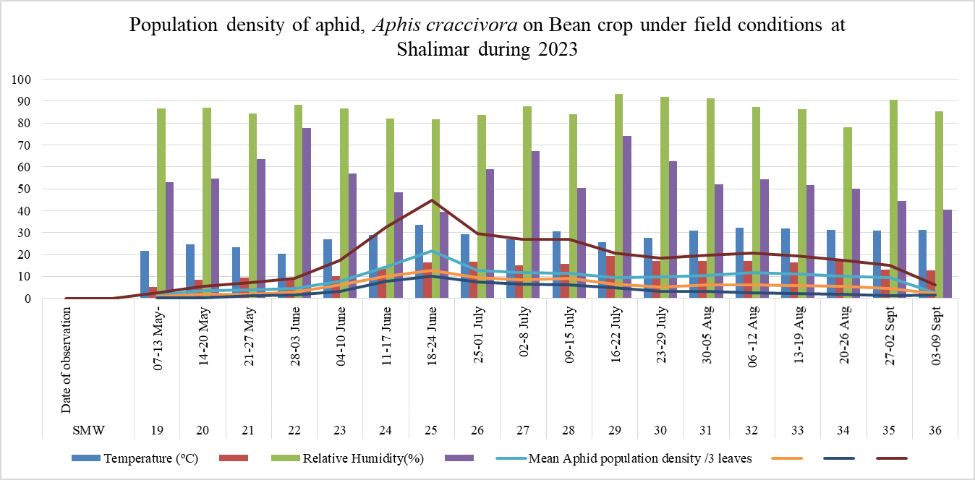
Fig.1.Population density of aphid, Aphis craccivora on Bean crop under field conditions at Shalimar during year, 2023.

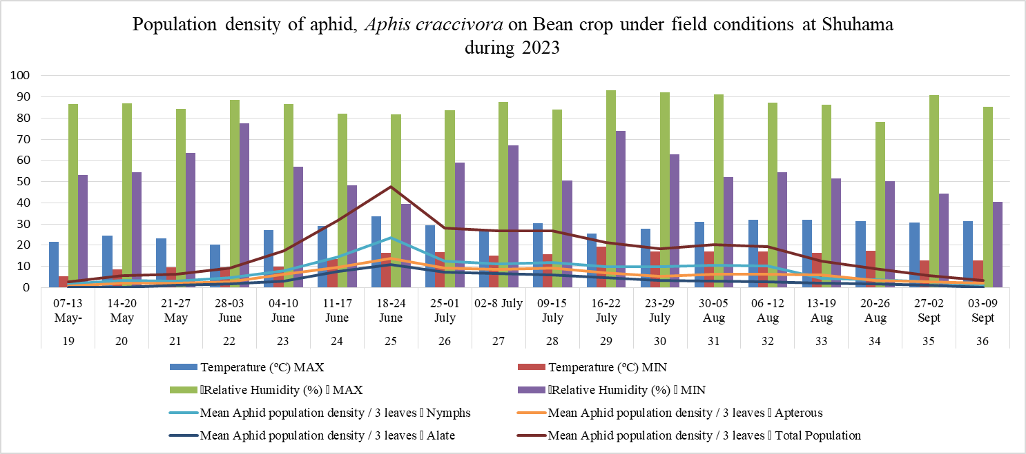
Fig.2. Population density of aphid, Aphis craccivora on Bean crop under field conditions at Shuhama during year, 2023.

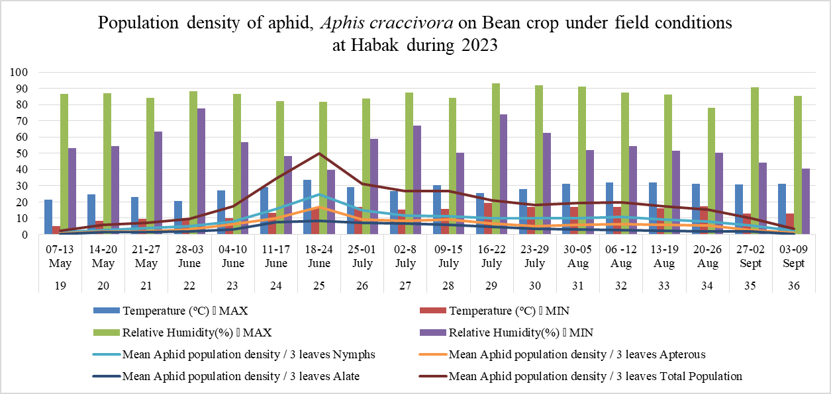
Fig.3. Population density of aphid, Aphis craccivora on Bean crop under field conditions at Habak during year, 2023.
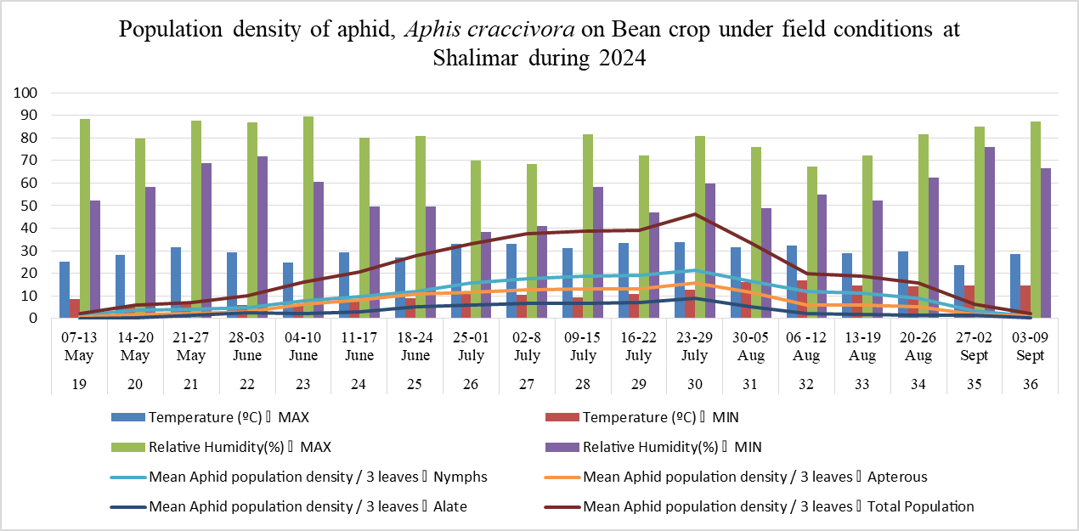
Fig.4. Population density of aphid, Aphis craccivora on Bean crop under field conditions at Shalimar during year, 2024.

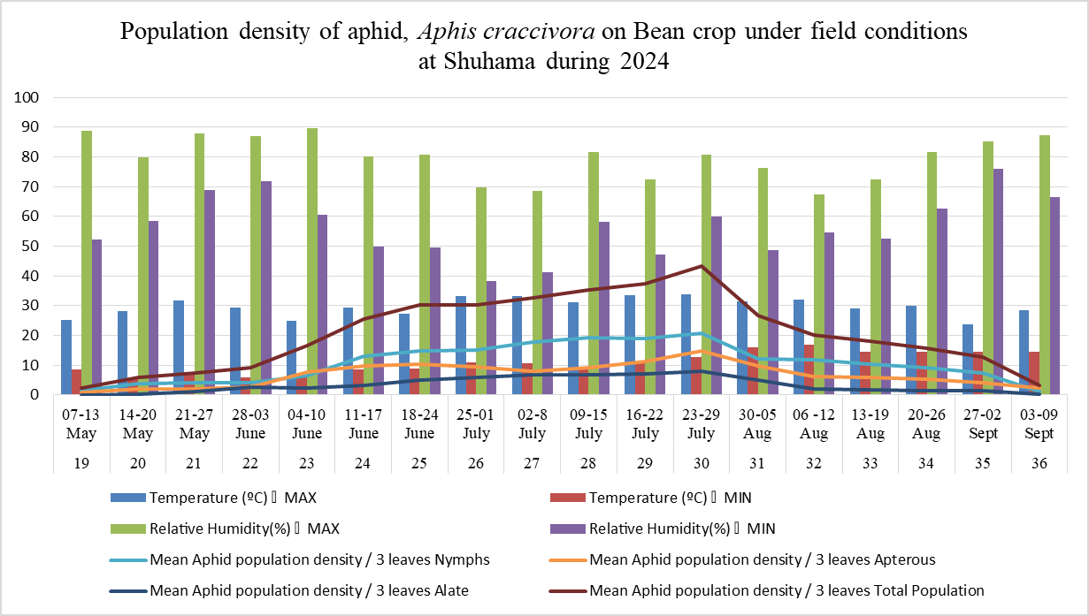
Fig.5. Population density of aphid, Aphis craccivora on Bean crop under field conditions at Shuhama during year, 2024.

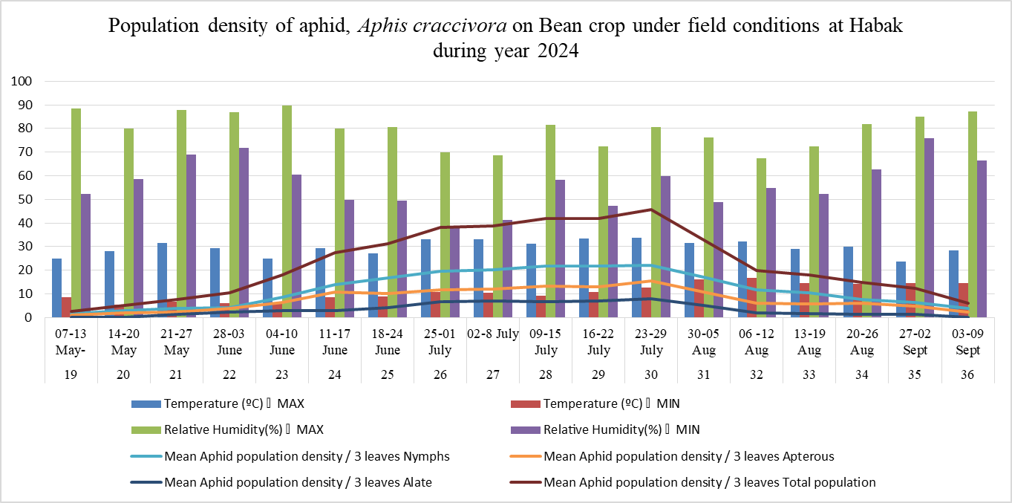
Fig.6. Population density of aphid, Aphis craccivora on Bean crop under field conditions at Habak during year, 2024.
3.2. Influence of Abiotic Factors on Aphid Population
Correlation analysis demonstrated significant and consistent relationships between aphid density and key weather variables across all sites and years (p < 0.05). Both maximum and minimum temperatures showed significant positive correlations with all aphid morphs (nymphs, apterous, alates) (Fig.7). The correlation with maximum temperature was particularly strong and consistent at Shuhama (r = 0.634 in both years). These positive correlations confirm that temperature is a primary abiotic factor driving A. craccivora population growth. This is consistent with aphid physiology, where developmental rate, fecundity, and generation turnover are highly dependent on temperature (Aqueel and Leather, 2023). Warmer conditions within the observed range accelerate these processes, leading to rapid population expansion. The stronger correlation at Shuhama may indicate site-specific microclimatic influences or interactions with other unmeasured factors like soil nutrition or cultivar traits. In contrast, both maximum and minimum relative humidity consistently exhibited negative correlations with aphid densities (Fig. 7). The strongest negative correlations were generally with maximum RH, most notably at Shuhama (r = -0.523 in both years). This inverse relationship is significant. While aphids require some ambient moisture, persistently high humidity levels (e.g., >90% Max RH later in the season) can be unfavorable. Such conditions promote the growth of entomopathogenic fungi, such as pandora neoaphidis, which are major aphid pathogens (Dean and Wilding, 2022). Additionally, high humidity can disrupt aphid feeding and reproductive behavior (Glinwood and Pettersson, 2021). This finding underscores that in Kashmirs climate, warm but relatively drier periods are more conducive to aphid outbreaks, while the high humidity later in the season acts as a contributing factor to the population collapse.

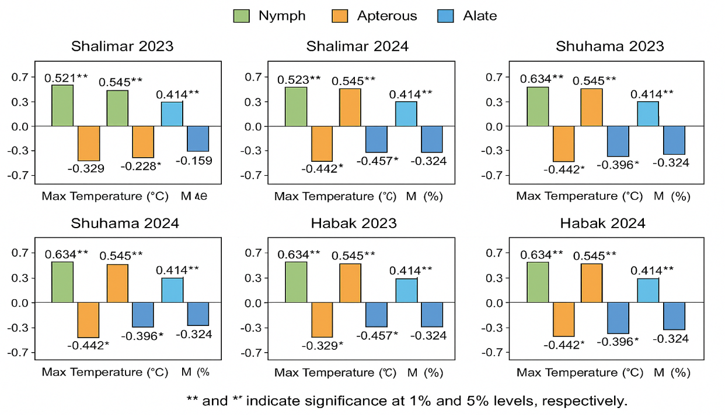
Fig. 7. Correlation between abiotic factors and population of different stages of Aphis craccivora (nymphs, apterous, and alates) across three locations (Shalimar, Shuhama, and Habak) during 2023 and 2024.

3.4. Conclusion
The population dynamics of A. craccivora in the Kashmir valley result from a complex interaction of abiotic and biotic factors. Favorable temperature conditions in the early to mid-season serve as the main catalyst for population growth, leading to predictable outbreaks that coincide with the crops vulnerable pod formation stage. The subsequent population collapse is triggered by a combination of less favorable abiotic conditions, particularly high humidity. This understanding is essential for developing effective Integrated Pest Management (IPM) strategies. Monitoring temperature trends can provide an early warning system for predicting outbreak risks, enabling timely and targeted control measures.

REFERENCES
Abrol, D. P., Bhat, A. I., and Bali, G. (2006). Arthropod pests associated with French bean (Phaseolus vulgaris L.) in Jammu region and their management. Journal of Entomological Research, 30 (3), 221–227.
Ali, A., Khan, M. A., & Ahmad, M. (2021). Integrated pest management strategies: A sustainable approach to control insect pests. Agricultural Reviews, 42(1), 75–83.
Allen, D. J., Ampofo, J. K. O., Wortmann, C. S., & Winch, T. J. (1996). Pest, diseases and nutritional disorders of the common bean in Africa: A field guide. CIAT Publication, Cali, Colombia.
Anonymous. (2019). Statistical Abstract of Jammu and Kashmir 2018–2019. Directorate of Economics & Statistics, Government of Jammu and Kashmir, India.
Aqueel, M. A., & Leather, S. R. (2023). Temperature-dependent growth and fecundity in aphids: Implications for pest forecasting under climate change. Insects, 14(2), 135.
Badii, K. B., Asante, S. K., & Agyemang, D. (2021). Impact of aphid infestation on photosynthetic activity and yield of common beans. International Journal of Pest Management, 67(4), 289–298.
Benelli, G., Canale, A., & Conti, B. (2020). Eco-friendly control of aphids: A review of biological and behavioral tools. Environmental Science and Pollution Research, 27, 32320–32334.
Blackman, R. L., & Eastop, V. F. (2000). Aphids on the World’s Crops: An Identification and Information Guide (2nd ed.). John Wiley & Sons, Chichester, UK.
Broughton, W. J., Hernández, G., Blair, M., Beebe, S., Gepts, P., & Vanderleyden, J. (2003). Beans (Phaseolus spp.) model food legumes. Plant and Soil, 252, 55–128.
Dean, G. J., & Wilding, N. (2022). Fungal pathogens of aphids and their role in regulating populations under humid conditions. Biocontrol Science and Technology, 32(5), 497–509.
Demelash, N. (2018). Role of grain legumes in improving soil fertility and crop productivity: A review. Agriculture and Food Security, 7, 85.
Davies, A. P., Singh, R., & Kumar, V. (2019). Effectiveness of integrated pest management on legume aphid populations. Journal of Applied Entomology, 143(3), 257–265.
Dixon, A. F. G. (1998). Aphid Ecology: An Optimization Approach (2nd ed.). Chapman and Hall, London.
Ge, F., Sun, Y. C., & Wu, K. M. (2020). Advances in biological control of aphids using natural enemies. Annual Review of Entomology, 65, 435–455.
Glinwood, R., & Pettersson, J. (2021). Environmental factors influencing aphid host selection and performance. Entomologia Experimentalis et Applicata, 169 (5), 437–448.
Hayat, I., Ahmad, A., Masud, T., Ahmed, A., & Bashir, S. (2014). Nutritional and health perspectives of beans (Phaseolus vulgaris L.): An overview. Critical Reviews in Food Science and Nutrition, 54(5), 580–592.
Katis, N. I., Tsitsipis, J. A., & Margaritopoulos, J. T. (2007). Transmission of plant viruses by aphids in relation to climate and host phenology. Virus Research, 127, 15–23.
Kasina, M. J., Nderitu, J. H., & Olubayo, F. M. (2006). Insecticide use patterns and their impact on non-target insects in common bean fields in Kenya. Crop Protection, 25(11), 1140–1146.
Kumar, R., Sharma, R. P., & Singh, B. (2017). Impact of temperature and host phenology on population build-up of Aphis craccivora on legumes. Journal of Entomology and Zoology Studies, 5(2), 1021–1026.
Kumar, S., Gupta, S. K., & Singh, H. (2019). Effect of weather parameters on population dynamics of aphids infesting beans. Indian Journal of Entomology, 81(3), 564–570.
McClean, P. E., Burridge, J., Beebe, S., Rao, I. M., & Porch, T. G. (2004). Common bean: Genetic and genomic resources for crop improvement. Plant Genome, 2(1), 29–38.
Mehnaj, M., Singh, R., & Lal, S. (2017). Population dynamics of mustard aphid and their natural enemies in relation to weather parameters. Indian Journal of Entomology, 79(3), 330–335.
Messelink, G. J., Bloemhard, C. M. J., & Janssen, A. (2022). Dispersal behavior of alate aphids in relation to crowding and host plant quality. Ecological Entomology, 47(2), 201–210.
Moreno, A., Garzo, E., & Fereres, A. (2018). Aphid resistance mechanisms and their implications for sustainable control. Frontiers in Plant Science, 9, 221.
Obopile, M., & Ositile, B. (2019). Influence of phenological stages of beans on aphid population dynamics and yield losses. African Entomology, 27(1), 65–72.

Oyewale, R. O., & Bamaiyi, L. J. (2013). Management of insect pests of cowpea: A review. International Journal of Science and Research, 2(8), 2319–7064.
Rakhshan, M., Ahmad, S., & Bhat, A. (2023). Temporal dynamics of bean aphid (Aphis craccivora Koch) in relation to weather variables under temperate conditions. Journal of Applied and Natural Science, 15(2), 422–430.
Ramandeep, K., Singh, P., & Sharma, N. (2018). Genetic diversity and utilization of common bean (Phaseolus vulgaris L.) in India. Legume Research, 41(6), 911–916.
Ramsden, M. W., Kendall, S. L., Ellis, S. A., & Berry, P. M. (2017). Effects of crop rotation and intercropping on aphid abundance in legume systems. Agricultural and Forest Entomology, 19(2), 151–159.
Sharma, H. C., Pampapathy, G., & Reddy, B. V. S. (2005). Insect pests of food legumes and their management. Indian Journal of Pulses Research, 18(1), 25–40.
Sharma, R., Singh, B., & Kaur, G. (2014). Effect of abiotic factors on aphid population fluctuations in vegetable crops. Journal of Insect Science, 14(1), 101–108.
Singh, S. R., & Schwartz, H. F. (2011). Common Bean Diseases and Pests. CIAT, Cali, Colombia.
Singh, R., & Srivastava, R. K. (2001). Population dynamics of Aphis craccivora on legumes in relation to weather parameters. Indian Journal of Entomology, 63(1), 41–47.
Singh, P., Yadav, S. K., & Kaur, M. (2022). Advances in the biological control of aphids: Recent trends and challenges. Biological Control, 170, 104921.
Smith, C. M., Boyko, E. V., & Nault, B. A. (2019). Virus transmission by aphids: Mechanisms and management strategies. Plant Disease, 103(5), 951–967.
Van Emden, H. F., & Harrington, R. (2007). Aphids as Crop Pests. CABI Publishing, Wallingford, UK.
Vikaspedia. (2022). Bean Cultivation in India. Retrieved from https://vikaspedia.in/agriculture.
Wilson, A. C. C., & Shaw, M. K. (2018). Molecular identification and genetic diversity of aphid populations in legume systems. Entomologia Generalis, 38(4), 295–310.
Xu, T., Li, J., & Zhang, Z. (2022). Role of natural enemies in suppressing aphid populations under field conditions. Journal of Integrative Agriculture, 21(8), 2320–2330

