Discerning pigeonpea, Cajanus cajan (L.) Millsp. Genotypes for their resistance against pod borer, Helicoverpa armigera (Hubner)

ABSTRACT
An experiment was conducted during kharif 2023-24 and 2024-25 to screen 100 pigeonpea, Cajanus cajan (L.) genotypes in relation to their resistance against pod borer, Helicoverpa armigera. Pod damage ranged from 1.25% to 48.00% across the genotypes.The minimum pod damage was recorded in the genotype ICP 8146-1(1.25%), while it was highest in ICP 1535-1 (48.00%). Fifteen genotypes includingICP 7076-1, ICP 13906-1, ICP 10559-1, ICP 7426-7, ICP 9049-1, ICP 9891-1, ICP 11259-1, ICPL 20201-1, ICP 7314-1, ICP 4715-1, ICP 939-1, ICP 4266-1, ICP 16674-1, ICP 655-1 and ICP 8146-11were categorized resistant (R) with 3.75 to 4.75% pod damage (PSR scale of ‘2’). The minimum grain damage was recorded in the genotype ICP 9045-1(1.80%) whereas, highest damage (%) was recorded in the genotype ICP 4029-1, (20.00), followed by ICP 13244-1 (18.87) and ICP 5863-1 (18.71). Genotypes ICP 12515-1(5538.42 kg/ha), ICP 6815-1(4139.62 kg/ha), ICP 9049-1(4005.54 kg/ha), ICP 15185-1(3821.49 kg/ha) and ICP16264-1(3268.92 kg/ha) showed superior performance in yield, along with several other promising entries in comparison to standard check: NA-1, Asha, and IPA-203.
Key Word: Grain damage, Pest Susceptibility Rating, Pod damage, Susceptibility, Variation, Yield
Introduction
Pulses are vital for human health and nutrition. They are rich sources of plant-based protein, dietary fibre, vitamins, and essential minerals such as iron, zinc, and folate. Beyond nutrition, pulses are affordable and accessible, making them a cornerstone of food security worldwide. These crops are highly important for agricultural sustainability. They fix atmospheric nitrogen (N) through symbiosis with rhizobia, reducing the need for synthetic N fertilizers and thereby lowering both input costs and environmental pollution. Among pulses, pigeonpea, Cajanus cajan (L.) Millsp., is an important legume crop widely grown in tropical and subtropical regions. It is popularly known as Arhar in Hindi and Red gram in English, Adhaki and Tuvarika in Sanskrit. In India, it is the second most grown pulse crop next to Bengal gram and is generally sown in Kharif season (Nene et al., 1990).Among the total pulses grown in India, pigeonpea occupies almost 16% share, each in area as well as in productivity (Chandra et al., 2025). The crop is attacked by a diverse suite of insect pests, especially at flowering, pod filling and seed stages, which together can severely reduce yield up to 39% to 45%. Among these, the pod borer, Helicoverpa armigera (Hubner), is one of the most serious pests of pigeonpea. The larvae attack flowers, buds and pods, causing direct damage and reducing seed set (Karrem et al., 2025). A single larva can damage multiple pods in its life time(Ganguly et al., 2022; Mishra et al., 2025). It feeds on tender shoots and young seeds making circular holes. While feeding, half of its body remains outside, a key characteristic feature of the larvae.In severe cases it can cause damage up to 40 to 45 % (Ojha et al., 2017). Relying harshly on chemical insecticides is not desirable from pollination and other ecological view point (Chandra et al., 2022), and calls for ‘Host Plant Resistance’ in order to minimize pod borer incidences. Pigeonpea shows varying degree of susceptibility to the pod borer, H. armigera (Sujayanand et al., 2025), considering which the present study has been undertaken.
Materials and Methods:
The experiment was conducted during kharif 2023-24 and 2024-25 at New Research Farm of ICAR-Indian Institute Pulses Research, Kanpur. A panel of 100 pigeonpea genotypes was evaluated in relation to infestation levels against H. armigera under field conditions in an Augmented Bock Design with 2 replications.The observations were recorded on pod damage, expressed in percentage. Damaged pods due to pod borer were separated based on the nature of damage from 100 randomly collected pods from 5 plants of each genotype at the time of harvest. The pods weresorted out into two groups;damaged pods (caused by H. armigera) and the healthy pods. Per cent pod damage was calculated by the formula given below: The pods damaged by the gram pod borer had characteristic big holes with irregular edges (Sharma, 1998; Mishra et al., 2025).
Per cent pod damage =$\frac{Number of damaged pods}{Total number of pods}×100$
- Total number of pods: Filled/ unfilled pod with seed.
Further, the pods were split open to weigh the healthy and damaged seeds and the per cent seed damage was calculated (Gangwar et al., 2009).
$$Per cent seed damage =\frac{Weight of damage seed}{Total weight of seed}×100$$
The weight of grain was taken for each genotype and the total yield per plot was calculated in kg/ha.
Grain yield (kg/ha) =$\frac{Weight of grain yield in kg/plot}{{Plot area in m}^{2}}×10000$
Statistical analysis:
The obtained data (per cent) were subjected to statistical analysis after using appropriate arcsine transformation Sin-1 (√x /100). Datawere analyzed by the method of analysis of variance (ANOVA) as described by Gomez and Gomez (1984) at 5 per cent level of significance using R programme (version 4.5.0).
Estimation of pest susceptibility/resistance for pigeonpea genotypes:
The pest susceptibility (%) of genotypes were calculated by the following formula and then categorized into 1 to 9 pest susceptibility rating scale (Table 1) as given by Abbott (1925).
Pest susceptibility (%) =$\frac{\%P.D of check -\% P.D in Test cultivar}{\% P.D of check }×100$
* P.D.= Pod damage.
Table 1: Percent susceptibility and their corresponding Pest susceptibility rating (PSR) and resistance category:
Susceptibility rating (1 to 9 scale)
Susceptibility (%) | PSR | Category
100 | 1 | Highly Resistant
75 to 99.9 | 2 | Resistant
50 to 74.9 | 3 | Moderately Resistant
25 to 49.9 | 4 | Moderately Resistant
10 to 24.9 | 5 | Moderately Susceptible
-10 to 9.9 | 6 | Moderately Susceptible
-25 to -9.9 | 7 | Susceptible
-50 to -24.9 | 8 | Highly Susceptible
-50 or less | 9 | Highly Susceptible
Result and Discussion:
Performance of pigeonpea genotypes against H. armigera during Kharif, 2023-24:
During Kharif 2023–24, pod damageby H. armigera in various genotypes ranged from 0.00% to 47.50% under natural infestation. Most of the genotypes recorded per cent pod damage ranging from 0 to 20% (Fig. 1). No pod damage was recorded in 3 genotypes viz., ICP 16674-1, ICP 60-1, and ICP 8146-1 and minimum pod damage was observed in the genotypes viz., ICP 939-1 (0.50%) and ICP 11281-1(0.50%), whereas, maximum was in ICP 7803-1(47.50%) followed by ICP 1535-1 (42.50%). Pod damages in check genotypes viz., NA-1, Asha, and IPA-203, were 9.50%, 17.50%, and 5.50%, respectively. In relation to pest susceptibility per cent, three genotypes viz., ICP 16674-1, ICP 60-1, and ICP 8146-1 were categorized as highly resistant (HR) with PSR scale of ‘1’(0.00% pod damage) whereas, 17 genotypes viz., ICP 4307-1, ICP 8618-1, ICP 10276-1, ICP 4029-1, ICP 14120-1, ICP 8242-1, ICP 3451-1, ICP 1279-1, ICP 16264-1, ICP 10531-1, ICPL 20092-1, ICP 9236-1, ICP 14722-1, ICP 8921-1, ICP 9577-1, ICP 1535-1, and ICP 7803-1 were categorized into highly susceptible (HS) with PSR scale of ‘8 to 9’(22.50 to 47.50% pod damage). However, maximum numbers of the genotypes were recorded with PSR ‘3’ (Moderately Resistant) (Fig 2). Significant variations were also observed in case of grain damage across genotypes (Fig 1). The minimum grain damage was recorded in genotype ICP 9045(1.00%) which was found at par with ICP68151 (5.55%) whereas, the maximum was in genotype ICP 4029-1 with 21.41 per cent followed by ICP 7314-1(18.01%). Significant differences were observed in the grain yield of different genotypes ranging from 71.11 kg/ha in the genotype ICP 7076-1 to 5066.62 kg/ha in ICP 12515-1.
Performance of pigeonpea genotypes against H. armigera during Kharif, 2024-25:
The per cent pod damage during the Kharif 2024–25 varied significantly among the test genotypes, which ranged from 1.00% to 53.50%. Most of the genotypes recorded per cent pod damage between 0 to 20% (Fig 1). The minimum pod damage was recorded in the genotype ICP 4715-1 (1.00%), which was found at par with ICP 1071-1 (1.5%). Maximum pod damagewas recorded in ICP 1535-1(53.50%) followed by ICP 7803-1(43.50%) and ICP 14722-1(42.00%). Pod damages in check genotypes viz., NA-1, Asha, and IPA-203, were 7.00%, 22.25%, and 6.13%, respectively. On the basis ofper cent pest susceptibility, twenty six genotypes viz., ICP 4715-1, ICP 9049-1, ICPL 20201-1, ICP 939-1, ICP 8146-1, ICP 9891-1, ICP 7896-1, ICP 7028-1, ICP 16674-1, ICP 4903-1, ICP 7426-7, ICP 10613-1, ICP 7076-1, ICP 11259-1, ICP 6990-1, ICP 8211-1, ICP 9252-1, ICP 11230-1, ICP 13906-1, ICP 13304-1, ICP 4266-1, ICP 655-1, ICP 9045-1, ICP 11833-1, ICP 6359-1, and ICP 10503-1were categorized as resistant (R) with PSR scale of ‘2’(1.00 to 5.50% pod damage) whereas, ten genotypes viz., ICP 9577-1, ICP 4307-1, ICP 14120-1, ICP 14294-1, ICP 10531-1, ICP 3451-1, ICP 8921-1, ICP 14722-1, ICP 7803-1and ICP 1535-1 were categorized as highly susceptible (HS) with PSR scale of ‘8 to 9’(30.00 to 53.50% pod damage). Most of the genotypes were observed with PSR ‘2’, ‘3’ and ‘4’ (Fig. 2). The minimum grain damage was recorded in genotype viz., ICP 9577-1(1.95%) followed by ICP 16674-1(2.24%) and ICP 6992-1(2.29%) whereas, maximum was recorded in ICP 13244-1(19.97%). Significant differences were observed in the grain yield among the different genotypes (Fig. 2), which ranged from 98.23kg/ha in the genotype ICP 7076-1 to 5066.62 kg/ha in ICP 12515-1.
Overall performance of pigeonpea genotypes against H. armigera (pooled data-2023-24 and 2024-25):
The per cent of pod damage, as per the pooled data of 2023-24 and 2024–25, varied significantly among the test genotypesranging from 1.25% to 48.00%. The minimum pod damage was recorded in the genotype ICP 8146-1(1.25%),which was found at par with ICP 10654-1(9.00%) whereas, maximum pod damagewas recorded in ICP 1535-1 (48.00%) followed by ICP 7803-1(45.50%) and ICP 14722-1(40.75%). Per cent pod damage in check genotypes viz., NA-1, Asha, and IPA-203, were 8.25%, 19.88%, and 5.81%, respectively. Pod damage, in both the years, observed positive correlations between them (Fig. 3). As per the per cent pest susceptibility, fifteen genotypes viz., ICP 7076-1, ICP 13906-1, ICP 10559-1, ICP 7426-7, ICP 9049-1, ICP 9891-1, ICP 11259-1, ICPL 20201-1, ICP 7314-1, ICP 4715-1, ICP 939-1, ICP 4266-1, ICP 16674-1, ICP 655-1 and ICP 8146-1 were categorized as resistant (R) with PSR scale of ‘2’(3.75 to 4.75% pod damage) whereas, thirteen genotypes viz., ICP 16264-1, ICPL 20092-1, ICP 4307-1, ICP 14294-1, ICP 14120-1, ICP 9236-1, ICP 14722-1, ICP 1535-1, ICP 9577-1, ICP 3451-1, ICP 10531-1, ICP 7803-1 and ICP 8921-1were categorized as highly susceptible (HS) with PSR scale of ‘8 to 9’ (26.00 to 48.00% pod damage)(Table 2). PSR of both the years showed positive associations between them (Fig. 3). Strong positive correlation was also observed between pod damage and pest susceptibility ranking in both the years (Fig. 3). The minimum grain damage was recorded in the genotype ICP 9045-1(1.80%) followed by ICP 9577-1 (2.70%) whereas maximum damage (%) was observed in the genotype ICP 4029-1, (20.00), followed by ICP 13244-1 (18.87) which were at par with ICP 14147-1(15.54).There were positive correlation between the grain damage recorded in both the years (Fig. 3). Significant differences were observed in the grain yield among the different genotypes ranging from 90.56kg/ha in the genotype ICP 7076-1 to 5538.42 kg/ha in ICP 12515-1.
In relation to pod damage, the results are in agreement with the findings of Kumar et al., (2017) who, screened 35 genotypes of pigeonpea against H. armigera in Uttar Pradesh, India and found the per cent pod damage ranging from 0.60%to 48.20%. Similar findings were reported by Rathod et al., (2014) who, screened ten genotypes of pigeonpea for their resistance/tolerance against pod-borer under natural infestation in pesticides free open field. The BSMR 853 recorded lowest percent pod damage due to pod borer (4.59%) whereas, ICPL 87119 recorded highest per cent pod damage (46.56%). Banu et al., (2007), screened 17 pigeonpea lines with ‘Asha’ as check against H. armigera and recorded per cent pod damage ranging from 2.70% to 47.40%. Similarly, Srivastava and Mohapatra (2003) reported that the damage extent of pods by pod borer, H. armigera varies from 1.0 to o 53.1 per cent.
In relation to pest susceptibility, the results are closely related to Sai et al. (2019), who categorized (based on percent pod damage and grain damage) five genotypes viz., LRG 30, LRG 41, ICPL 87119, ICP 8863 and BSMR 853 as highly resistant (HR) with PSR scale of ‘1’(0.00% pod damage) and nine genotypes viz., TDRG 33, Guliyal local, WRP 1, CO 6, LRG134, RVSA 9, SKNP 224, ICPL 4503 and WRG 79 as highly susceptible (HS) against H. armigera with PSR scale of ‘8’(up to 45.00% pod damage). The results are in accordance with Divyasree et al., (2020), who screened twenty genotypes against H. armigera in pigeonpea and categorized 5 genotypes viz., CO 6, TRG 38, BRG 2, BRG 10-4, and CRG 2010-01as resistant (R) with PSR scale of ‘2’(2.80 to 5.00% pod damage). Close findings were also reported by Kavitha and Vijayaraghavan (2017) who, screened 145 entries to identify the sources of resistance in pigeonpea against H. armigera and reported nine entries i.e., ICP 11007, H 23, BAHAR, DA 322, GR 28, ICP 49114, ICP 11957, SMR 1693158, BRG 10-02 as promising as those were exhibiting stable resistant(R) with PSR scale of ‘2’.
As far as the grain damage and yield performance are concerned, our results are similar with that the findings of Gupta et al.(2018), who screened twenty-five pigeonpea genotypes against the pod borer and reported a minimum grain damage of 2.23% and a maximum grain damage of 26.72%. The results are in agreement with the findings of Kooner and Cheema (2006), who reported the grain damage due to H. armigerain the range of 10.21% to 20.21% among different genotypes. Similar results were also obtained by Chauhan and Dahiya (1993), who reported grain damage due to pod borer in the range of 5.00% to 26.3% among different genotypes. In yield, the results are agreement with the findings of Chakravarthy et al. (2016), who screened ten genotypes of pigeonpea under field conditions during 2013-14. They reported highest grain yield of 5108.78 kg/ha from PUSA 2012-1 which differed significantly from other genotypes however, the lowest grain yield of 68.56 kg/ha was obtained from AL 1747, followed by Manak (71.72 kg/ha). The results are in accordance with Sreekanth et al. (2017), who reported highest grain yield of 5760.78 kg/ha in WRP-1 which was significantly different from other genotypes.

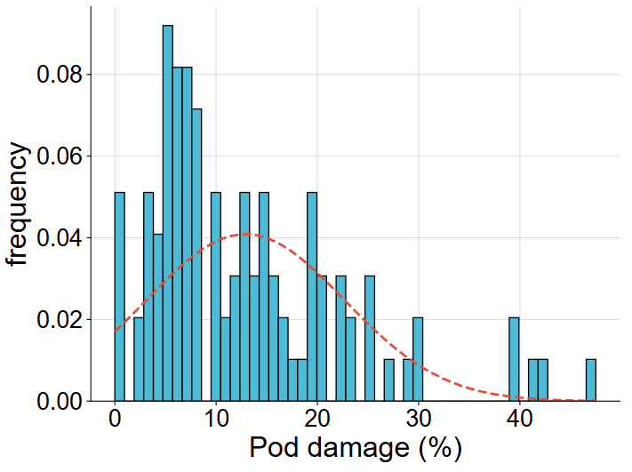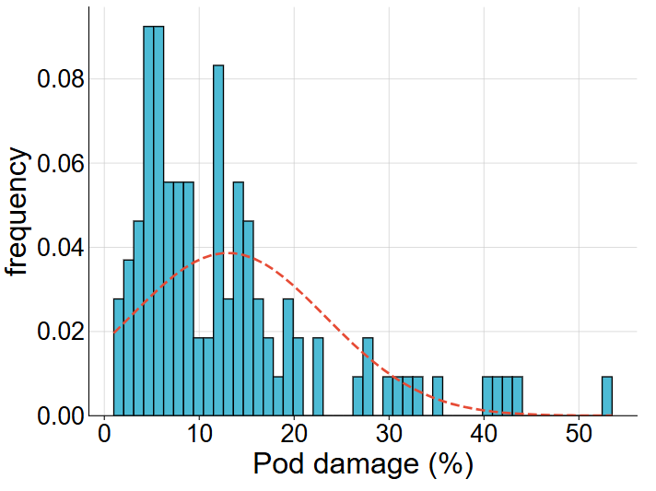
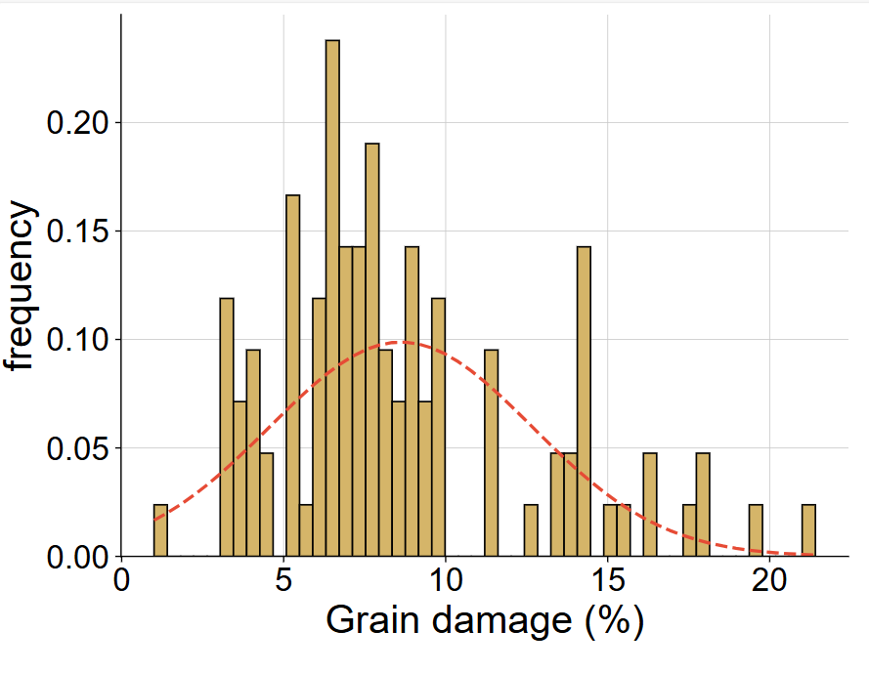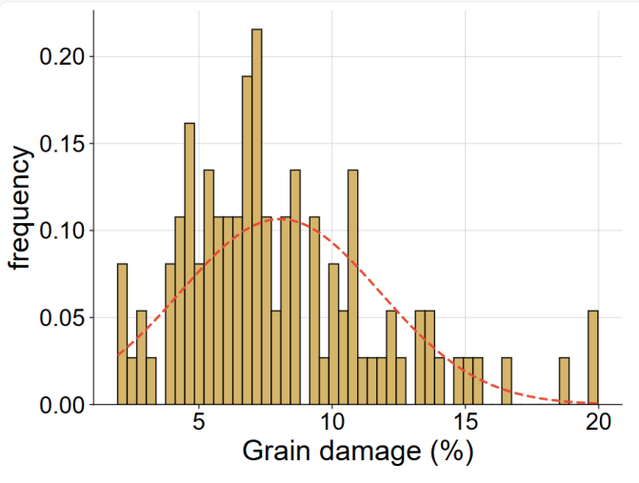
Parameter | Min | Max | Mean | SE | Median | SD | S² | Kurtosis | Skewness | CI95%
Pod damage (%) Y-I | 0.00 | 47.50 | 12.90 | 0.97 | 9.50 | 9.80 | 96.1 | 1.97 | 1.38 | 1.92
Grain Damage (%) Y-I | 1.00 | 21.41 | 8.62 | 0.40 | 7.71 | 4.06 | 16.5 | 0.60 | 0.98 | 0.79
Pod damage (%) Y-II | 1.00 | 53.50 | 13.02 | 1.02 | 10.00 | 10.36 | 107.4 | 2.82 | 1.67 | 2.03
Grain Damage (%) Y-II | 1.95 | 19.97 | 8.05 | 0.37 | 7.15 | 3.76 | 14.1 | 1.13 | 1.02 | 0.73
Fig. 1. Histogram depicting the variation in per cent pod and grain damage (left: 2023-24; right: 2024-25) inflicted by H. armigera across genotypes (n = 103), with corresponding descriptive statistics.

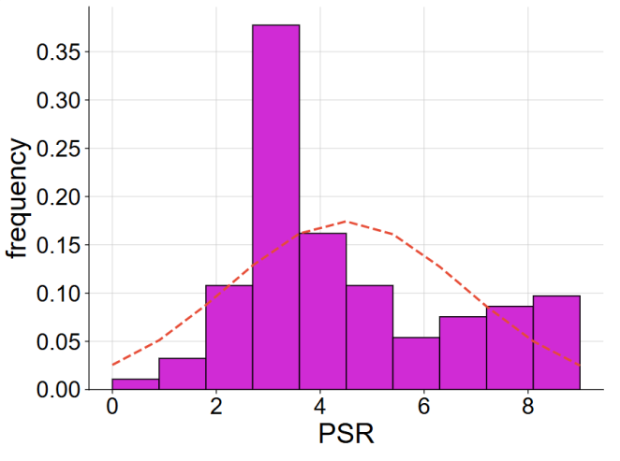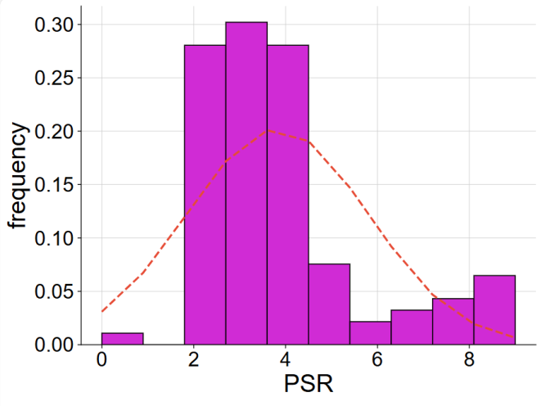
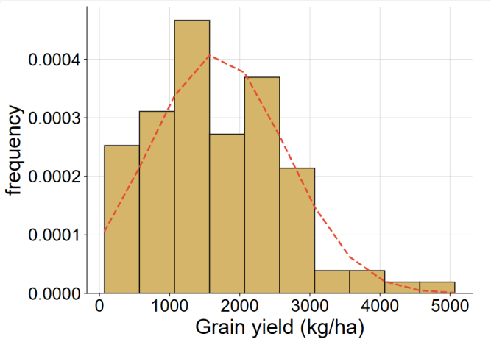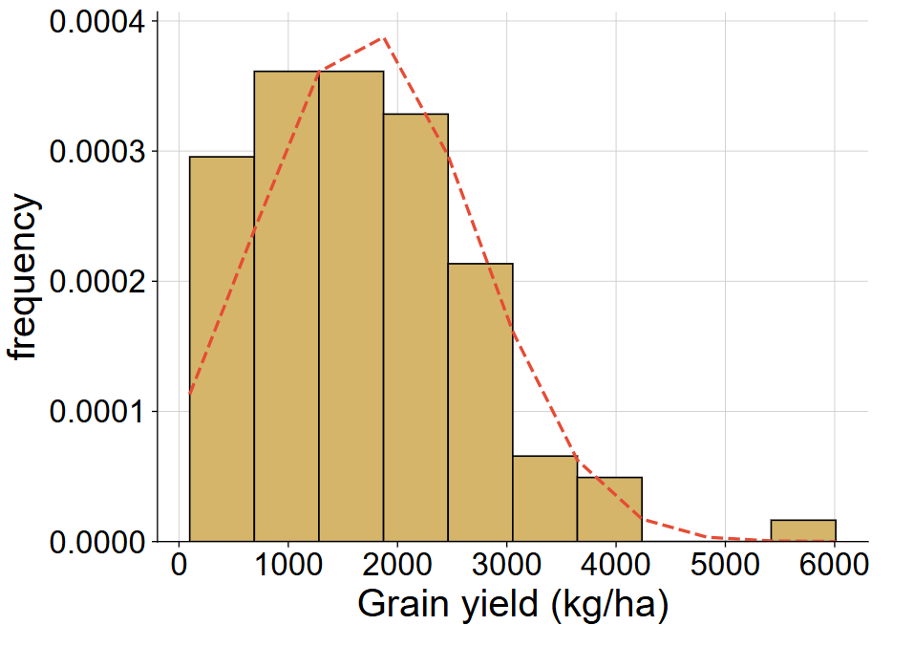
Parameter | Min | Max | Mean | SE | Median | SD | S² | Kurtosis | Skewness | CI95%
PSR Y-I | 0.0 | 9.0 | 4.49 | 0.23 | 4.00 | 2.30 | 5.29 | -0.61 | 0.67 | 0.45
PSR Y-II | 0.0 | 9.0 | 3.83 | 0.20 | 3.00 | 1.98 | 3.93 | 1.22 | 1.31 | 0.39
Grain yield Y-I | 71 | 5067 | 1675 | 97 | 1511 | 980 | 960471 | 0.42 | 0.63 | 192
Grain yield Y-II | 98 | 6010 | 1700 | 100 | 1552 | 1020 | 1039970 | 2.08 | 0.97 | 199
Fig. 2. Histogram depicting the variation in pest susceptibility rank (PSR) and grain yield across genotypes (n = 103), (left 2023-24; right 2024-25) with corresponding descriptive statistics.

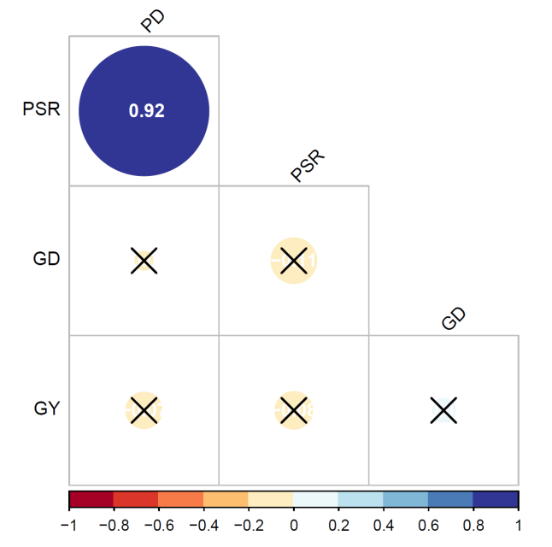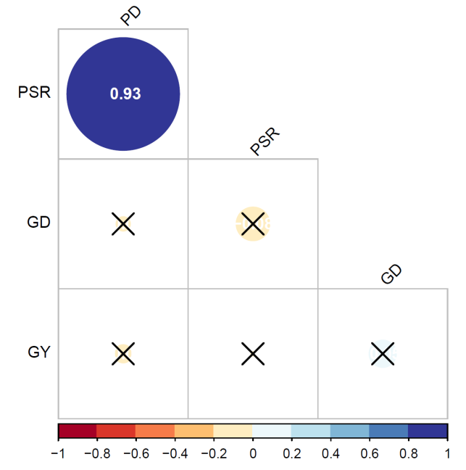
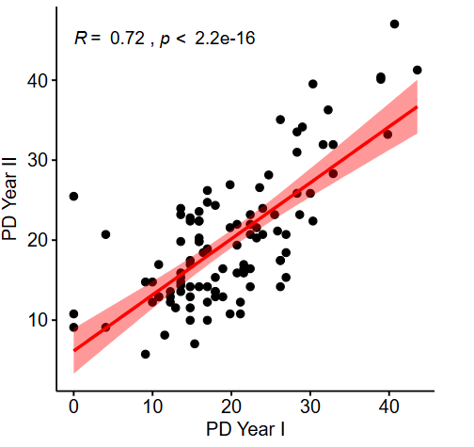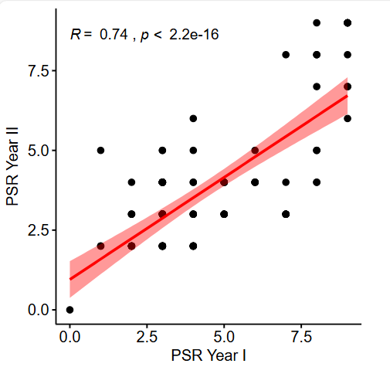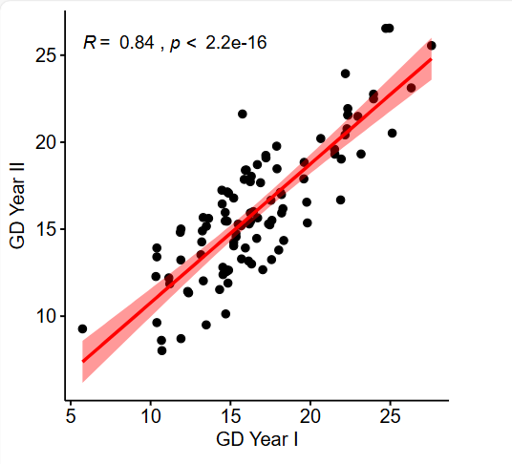
Fig. 3. Correlation matrix plot among the variables; pod damage (PD), grain damage (GD), pest susceptibility rank (PSR) and grain yield (GY) for the year 1 (upper left) and year 2 (upper right). Co-associations of a variables within the year 1 and 2 (lower left, middle & right).

Table 2: Categorization of pigeonpea genotypes on the basis of degree of susceptibility as per the pooled data of 2023-24 and 2024-25:
S. No. | Category | Genotypes
1. | Highly Resistant | -
2. | Resistant | ICP 7076-1, ICP 13906-1, ICP 10559-1, ICP 7426-7, ICP 9049-1, ICP 9891-1, ICP 11259-1, ICPL 20201-1, ICP 7314-1, ICP 4715-1, ICP 939-1, ICP 4266-1, ICP 16674-1, ICP 655-1, ICP 8146-1
3. | Moderately Resistant | ICP 5863-1, ICP 12680-1, ICP 9252-1, ICP 11230-1, ICP 12142-1, ICP 6668-1, ICP 13571-1, ICP 15493-1, ICP 10654-1, ICP 13304-1, ICP 7028-1, ICP 6990-1, ICP 11281-1, ICP 8700-1, ICP 10613-1, ICP 6049-1, ICP 9045-1, ICP 11833-1, ICP 10508-1, ICP 10094-1, ICP 11321-1, ICP 7896-1, ICP 8860-6, ICP 6359-1, ICP 4903-1, ICP 7-1, ICP 8211-1, ICP 1071-1, ICP 60-1, ICP 10503-1, ICP 11320-1, ICP 14147-1, ICP 7035-51, ICP 15185-1, ICP 9691-1, ICP 14209-7, ICP 6815-1, ICP 16440-1, ICP 9062-1, ICP 8776-1, ICP 14524-1, ICP 8144-1, ICP 6845-1, ICPL 20205-1, ICP 12105-1, ICP 13998-1, ICP 8194-1, ICP 15382-1, ICP 13244-1, ICP 8949-1, ICP 12123-1, ICP 11406-1, ICP 11969-1, ICP 6869-1, ICP 13431-1, ICP 6128-1, ICP 995-1, ICP 8152-1, ICP 6992-1
4. | Moderately Susceptible | ICP 8384-1, ICP 4213-1, ICP 7507-1, ICP 2405-1, ICP 14545-1, ICP 4317-1, ICP 12515-1, ICP 8266-1, ICP 1279-1, ICP 10276-1, ICP 4029-1
5. | Susceptible | ICP 8618-1, ICP 8242-1
6. | Highly Susceptible | ICP 16264-1, ICPL 20092-1, ICP 4307-1, ICP 14294-1, ICP 14120-1, ICP 9236-1, ICP 14722-1, ICP 1535-1, ICP 9577-1, ICP 3451-1, ICP 10531-1, ICP 7803-1, ICP 8921-1

Conclusion:
Above studies clearly indicates that fifteen genotypes including ICP 7076-1and ICP 8146-1were categorized resistant (R) with 3.75 to 4.75% pod damage (PSR scale of ‘2’). The minimum grain damage was recorded in the genotype ICP 9045-1(1.80%) whereas, highest damage (%) was recorded in genotype ICP 4029-1 (20.00). Genotypes ICP 12515-1(5538.42 kg/ha), ICP 6815-1(4139.62 kg/ha), ICP 9049-1(4005.54 kg/ha), ICP 15185-1(3821.49 kg/ha) and ICP16264-1(3268.92 kg/ha) showed better performance in yield, along with several other promising entries in comparison to standard check: NA-1, Asha, and IPA-203.
References
Abbott, W. S. (1925). A method of computing the effectiveness of an insecticide. Journal of Economic Entomology, 18(2), 265-267.
Banu, M. R., Muthiah, A. R., & Ashok, S. (2007). Field screening and evaluation of pigeonpea genotypes against pod borer (Helicoverpa armigera). Pakistan Journal of Biological Sciences: PJBS, 10(7), 1149-1150.
Chakravarty, S., Bera, T., Agnihotri, M., & Jaba, J. (2016). Screening of short duration pigeonpea [Cajanus cajan (L.) Millsp.] genotypes against major insect pests. Journal of Pure and Applied Microbiology, 10(4), 3009-3016.
Chandra, A., Sujayanand, G.K., Revanasidda, Bandi, S.M., Angami, T., Kanwat, M. (2022). Insect Pollinators and Hybrid Seed Production: Relevance to Climate Change and Sustainability. In: Bohra, A., Parihar, A.K., Naik SJ, S., Chandra, A. (eds) Plant Male Sterility Systems for Accelerating Crop Improvement. Springer, Singapore. https://doi.org/10.1007/978-981-19-3808-5_12
Chandra A, Gupta DS, Kumar Y, Tiwari TN, Patel DP, Katiyar PK, Sah U and Dixit GP. Outreach Programmes of IIPR. ICAR-Indian Institute of Pulses Research. Sep 2025. ISBN: 978-93-343-8399-7.
Chauhan, R., &Dahiya, B. (1993).Response of some pigeonpea genotypes to pod borer, Helicoverpa armigera and pod fly, Melanagromyza obtusa in Haryana. Indian Journal of Plant Protection, 21, 172-172.
Divyasree, C., Sreekanth, M., Chiranjeevi, C., & Adinarayana, M. (2020).Field screening of pigeonpea genotypes to pod borer, Helicoverpa armigera. Int J Fauna Biol Stud, 7(6), 18-22
Ganguly, S., Chaudhuri, R. K., & Chakraborti, D. (2022). Genetic Improvement of Pigeonpea (Cajanus cajan (L.) Millsp.) for Insect Resistance: Strategies and Achievements. Genetic Methods and Tools for Managing Crop Pests, 579-596.
Gangwar, L. K., Bajpai, G. C., Kerkhi, S. A., &Sachan, S. K. (2009). Pod borer susceptibility reaction in interspesific hybrids of pigeonpea.Indian Journal of Genetics and Plant Breeding, 69(01): 58-61.
Gomez, K. A. (1984). Statistical procedures for agricultural research. John NewYork: Wiley and Sons.
Gupta, S., Rana, N., &Bhagat, J. (2018).Screening of pigeonpea germplasms against the pod borer complex over a period of two years under field conditions. J. Pharmacogn. Phytochem, 7, 2402-2405.
Karrem, A and Haveri, R V and Yogendra, K and Prabhuraj, A and Hanchinal, S and Kalyan, A and Mishra, S P and Laxuman, C and Jaba, J (2025) Understanding resistance mechanisms in crop wild relatives (CWRs) of pigeonpea (Cajanus cajan L.) against pod borer Helicoverpa armigera (Hub.). Genetic Resources and Crop Evolution. pp. 1-21. ISSN 0925-9864
Kavitha, Z., &Vijayaraghavan, C. (2017). Screening of pigeonpea genotypes against webbing caterpillar [Maruca vitrata (Geyer)] and gram pod borer [Helicoverpa armigera (Hubner)]. International Journal of Current Microbiology and Applied Science, 6(12), 3899-3907.
Kooner, B. S., &Cheema, H. K. (2006).Evaluation of pigeonpea genotypes for resistance to pod borer complex. Indian Journal of Crop Science, 1(1-2), 194-196.
Kumar, A., & Nath, P. (2017).Pest complex and their population dynamics on an early variety of pigeonpea UPAS-120 at Varanasi. Indian Journal of Entomology (India), 65(4).
Mishra, V., Chugh, V., Purwar, S., & Singh, A. K. (2025). Plant Protease Inhibitors Towards Modulating Resistance Response to Insect-Pests in Legumes. In Integrated Improvement of Food Legumes (pp. 77-99). Cham: Springer Nature Switzerland.
Nene YL, Susan DH and Sheila VK. 1990. The Pigeonpea. C.A.B. International Wallingford for ICRISAT, Patancheru, India.Pp. 490.
Ojha, P. K., Kumari, R., Chaudhary, R. S., &Pandey, N. K. (2017). Incremental cost-benefit ratio of certain bio-pesticides against Helicoverpa armigera (Hubner) (Noctuidae: Lepidoptera) in chickpea. Legume Research-An International Journal, 42(1), 119-126.
Rathod, N. P., Vala, G. S., Dudhat, A. S., & Kachhadiya, N. M. (2014). Screening of different varieties of pigeonpea against pod borer complex.
Sai Y, Sreekanth M, Kumar Sairam DV, Kumar Manoj V. Evaluation of medium duration pigeonpea genotypes against pod borers. Journal of Entomology and Zoology Studies. 2019; 7(4):1404-1410.
Sharma, H. C. (1998). Bionomics, host plant resistance, and management of the legume pod borer, Maruca vitrata-a review. Crop protection, 17(5), 373-386.
Sreekanth, M., Rajamani, S., &Ramana, M. V. (2017). Screening of some promising pigeonpea (Cajanus cajan (L.) millsp.) genotypes against major insect pests. International Journal of Biology Research, 2(4), 94-96.
Srivastava, C. P., & Mohapatra, S. D. (2003). Efficacy and Economic of Insecticides along with NSKE against pigeonpea pod fly and Pod borer. Annals of Plant Protection Sciences, 11(1), 143-145.
Sujayanand, G. K., Dubey, S. Datta D, Naik S, Tewari K, Chandra A, Devi R, Govindasamy, P. and Dixit G. P. (2025). Identification of pod borer resistant pigeonpea: an introgression breeding with Cajanus scarabaeoides accompanied by integrated screening. Arthropod-Plant Interactions 19(5), https://doi.org/10.1007/s11829-025-10178-6.

