First Record and Morphological Notes on Alpheus longiforceps Hayashi & Nagata, 2002 (Decapoda: Alpheidae) from Indian Coast

ABSTRACT
This study reports the occurrence of Alpheus longiforceps, a snapping shrimp species newly recorded from the Indian coast, previously known only from the Indo-West and North-West Pacific regions. Specimens were collected as bycatch at the Mudasalodai landing site in July to August 2024. The key traits such as rostral structure, chelae proportions, and carapace characteristics were analysed and compared with previous studies. The species is distinguished by unique coloration, such as alternating reddish-orange and off-white bands, with dark orange spots on the fifth abdominal segment. Comparative morphometry reveals variations in proportion of antennular peduncle, telson ratio, and chela size. These findings expand the current knowledge of Alpheus longiforceps distribution.
Keywords: Alpheus longiforceps, snapping shrimp, caridean shrimp, morphometric analysis, crustacean taxonomy.
- INTRODUCTION
The Alpheus shrimps, also known as pistol shrimps, are a decapod crustacean commonly found in Indian coastal waters (Thomas, 1976). Their renowned to produce a loud snapping sound, these shrimps use their asymmetrical claws, with one enlarged for snapping, and possess a joint with a plunger-like structure called the dactyl, a socket-like structure referred to as the propodus, and a robust muscle to generate forces, another slender one (Kim & Abele, 1988; Cromarty., 2000). Alpheus shrimps live in a wide range of marine habitats, ranging from coral reefs, seagrass meadows, rocky coasts, mangrove forests, and intertidal areas to offshore, deeper waters. They contribute to ecosystem health by acting as both predators and burrowers, creating complex shelters that increase overall biodiversity. The snapping claw, one of the strongest and most versatile tool, used for defence, predation, and communication within groups. This communication, characterized by distinct snap patterns, is crucial for territorial maintenance, courtship, and mutual recognition (Lillis, 2017). These creatures are specialized for both defence and hunting through their snapping claws. The specialized snapping claw having unique shapes, grooves for water jet direction (Anker, 2006), and a regenerative capability in case of loss (Hopkins & Das, 2015).
In the coral reefs habitat, these shrimps form burrows within the reef structure, providing protection, shelter and refuge (Banner & Banner,1983). In seagrass beds, they excavate burrow into the sandy or muddy seabed (Anker & De Grave,2016). On rocky shores, they inhabit burrows in rock gaps and crevices (Dehghani, 2019). A few species live in mangroves, having a symbiotic association with gobies (Anker & De Grave,2016). Intertidal habitats illustrate their tolerance of changing water levels and aerial exposure (Anker et al., 2015). While some Alpheus species inhabit deeper offshore environments, their preferences are not as well-documented as those in shallow waters (Chace, 1988).
Alpheus shrimp showcase a rich variety of colours and patterns, capturing attention with their visual attraction and becoming focus for both marine enthusiasts and researchers. Genus Alpheus were first documented in India by Thomas in 1976, identifying four species of such as A. distinguendus, A. rapax, A. euphrosyne and A. malabaricus. Subsequent studies by Radhakrishnan et al., (2012) recorded 16 species, and Samuel et al., (2016) documenting 14 species. Ramachandran et al., in 2019, reported the presence of Alpheus bisincisus on the west coast of India, an important record to the known diversity of this genus in India. The recent identification of Alpheus longiforceps represents a significant record to the known Alpheus shrimp of India. This result increases our knowledge of Indian marine ecosystems' crustacean biodiversity and indicates ongoing scientific endeavours to document and describe the species richness of the region.
- MATERIAL AND METHODS
Specimens of Alpheus longiforceps (Fig. 1) were obtained as bycatch from the Mudasalodai landing centre, Tamil Nadu, India, during July - August 2024. Specimens were preserved in 70% ethanol for morphological examination. Voucher specimen was deposited in the Marine Biology Museum, Centre of Advanced Study in Marine Biology, Annamalai University (Reg. Nos. CAS/ALO/TRL/006).
Morphometric data were recorded with a Mitutoyo CD-6′′ASX digital calliper (accuracy 0.1 mm), following the protocol outlined by Wicksten & McClure (1997). Carapace length (CL) was measured from the tip of the rostrum to the posterior margin of the carapace. The following abbreviations are used: TL, total length; CL, carapace length; AL, abdominal length; ASL, antennular segment length; MpL, major chela propodus length; MdL, major chela dactyl length; NpL, minor chela propodus length; TIL, telson length.
Line illustrations were prepared digitally using an Inspiroy H430P tablet. Comparative morphology was evaluated against the original description of Alpheus longiforceps by Hayashi & Nagata (2002).

- RESULT
3.1 Scientific position
Class: Malacostraca
Order: Decapoda
Family: Alpheidae
Genus: Alpheus Fabricius,1798
Species: longiforceps Hayashi & Nagata, 2002.
3.2 Types
3.2.1 Holotype
Japan, Collector M. Hanano, Voucher NFU530-2-2358 (Hayashi & Nagata 2002).
3.2.2 Paratype
Gulf of Thailand, Collector P. K. L. Ng, Voucher MNHN 13618 (Hayashi & Nagata 2002).
3.3 Distribution
Hayashi & Nagata, 2002 was described Alpheus longiforceps collected in the Gulf of Thailand. Subsequent records have confirmed its presence in Japanese waters, indicating its distribution in the northwestern Pacific. This study presents the first record of Alpheus longiforceps from the Indian coastal water (Tamil Nadu), representing a new westernmost record and significantly extending the known distribution range of Alpheus longiforceps within the Indo-West Pacific region.
3.3.1 Type Locality
Mudasal Odai landing centre, Tamil Nadu, India.
3.4 Taxonomic account
Specimens were examined and identified following the diagnostic criteria and morphological keys provided by Hayashi & Nagata (2002).
3.5 Ecology
Mixed rocky-sandy shores and coral reef flats, under rocks and coral rubble; intertidal to at least 32 - 37m depth (Hayashi & Nagata, 2002).
3.6 Description
The overall morphometric ratios of the examined specimens are presented in Table 1, which provides a quantitative basis for the following detailed morphological description. Body smooth and not partially compressed and depressed below orbital hoods, with dorsolateral grooves. Rostrum acute, well developed, sharply triangular, slightly longer than broad approximately 2.5 times its basal width extending to the distal edge of the first antennular peduncle segment. The rostral carina is prominently compressed, acute, high and narrow, slightly extending well beyond the posterior end of the eye. Carina is reaching up to the distal end of the first antennular segment. The orbital hoods are swollen, unarmed, and frontally enclosed, with anterior edges projecting forward into rounded lobes on either side of the rostrum, surpassing its tip. The orbito-rostral process consists of two short lobes separated by a shallow groove, delimiting posteriorly and slightly extending beyond the eye. There are no setae present on the orbital hoods, rostral carina and orbito-rostral grooves. The Carapace is smooth, narrow and broad with small protrusion near to ocular width. Pterygostomial angle rounded with no spines and, while the pterygostomian margin extends forward beneath the base of the basicerite. They have a tiny carina, running along the anterior surface towards the articulation with the antennule. No additional spines are observed on the carapace (Fig: 2a-c).
Abdomen smooth, pleura of 1st, 2nd and 4th somites are rounded in shape, 3rd somites subtriangular in structure, 5th somite is slightly elongated at its posteroventral edge, and the sternite lacks any spine (Fig: 2k). The ocular hoods completely enclose the eyes. The antennule bears a stylocerite with a sharp, acute spine at the distolateral end, though it does not extend to the distal margin of the first antennular article. The first antennular segment exhibits a very faint, shallow carina along its ventral inner margin. The second segment is robust, measuring 1.3 times long for the visible portion of first segment and twice the length of third segment. The basicerite is moderately developed and shorter than the stylocerite, with blunt tip. The lateral spine of the scaphocerite extends well beyond the antennular peduncle and surpasses the length of the flattened part. The carpocerite is slightly longer than the scaphocerite.
The stylocerite bears a tooth that is directed outward. The scaphocerite is 3.5 times longer than it is wide. Its distal spine extends beyond the distal end of the antennular article, reaching the distal end of carpocerite. The inner blade is narrow distally and also reaches the distal margin of the antennular article. A noticeable cleft separates the distal spine from the inner blade and nearly extends to the scaphocerite end. The carpocerite and the third segment of the antennular peduncle are nearly equal in length. The basicerite has a blunt lateral end that does not exceed the length of the rostrum. Additionally a minor spine is located beneath the basicerite.
The third maxilliped is slender and extends straight forward, reaching the distal end of the scaphocerite. Tip is rounded and densely lined with long setae along the distal edge, while the inner surface is covered with fine scales. The ultimate segment is 2.1 times the length of the penultimate segment. The penultimate segment is around 1.8 times longer than its distal width, expanded along the lower distal edge, and bears numerous long setae on both the upper and lower margins, with some extending beyond the tip of the ultimate segment. The antepenultimate segment is equipped with a few short setae on the lower margin and several long setae on the upper distal margin.
The major first pereopod extends up to the distal end of the carpocerite, surpassing most of the carpus. The major cheliped noticeably compressed laterally, with a length three times its width, and setae at the tips of the fingers. A transverse groove is present just behind the articulation of the dactylus on the dorsal side of the major chela. Both superior and inferior margins of the flattened region of the chela bear rows of sweeping hairs. The flattened hand of inferior margin seems like convex portion. The palmar portion is soft, absence of granules and doesn’t have sculptures. Comparing to dactylus, propodus has less setae’s. The hand is large, soft, compressed, absences of granules on the upper margin and slightly convex in ventral side of the propodus proximal region. Socket were present in the proximal region of inferior ductylus margin. The immovable finger shows a dorsally concave margin just before the tip, which is sharply pointed, while the ventral margin is nearly straight. The dorsal transverse groove is broad, deep, and U-shaped, with the proximal shoulder not overhanging the groove. The movable finger is laterally compressed, with a gently rounded upper edge and a bluntly rounded tip that does not extend beyond the fixed finger. Cup shaped carpus with shape edges. Merus with inner surface very rough texture and inner margin bearing 6 strong acute spines, superior margin soft with sharp edge (Fig: 2d).
The minor cheliped is 4.2 times longer than it is wide, with fingers measuring about three times the length of the palm and lacking the balaeniceps form. The fingers remain gaping when closed, and their tips do not overlap. Long sweeping setae extend from the propodus to the dactylus. Both the superior and inferior surfaces of the fingers are covered with setae. The palm is distinctly convex and exhibits a rough texture. The movable finger is non-balaeniceps in both males and females. A small spine is located on the distal side of the corpus. The merus is about four times longer than its width, with a coarse ventral surface that bears six sharp spines, while the dorsal surface carries sparse setae. Ischium bearing a spine in inferior margin (Fig: 2e).
The second pereopod is slender, with the merus being slightly shorter than the ischium. The distal end of the merus extends beyond the both third maxilliped and carpocerite. The carpus is composed of five segments; the first segment closely resembles the second, which is 2.5 times the length of the third (Fig: 2f). The third, fourth, and fifth segments are roughly equal in length. The chela’s fingers are soft, smooth in texture, and marginally longer than the palm.
The third pereopod has an ischium bearing a small ventrolateral spine. The merus is elongated, seven times longer than it is wide, with several long setae present at its distal end. The carpus is slightly less than half the length of the merus, unarmed, but carries long setae and features a tooth-like projection along its upper distal margin. The propodus is slightly longer than the carpus but significantly shorter than the merus; it lacks movable spines along the lower margin but has setae at the distal tip. The dactylus is simple and conical, roughly twice the length of the propodus, with a slightly concave ventral surface (Fig: 2g).
The fourth pereopod is largely similar to the third, but it is distinguished by the presence of a movable spine (Fig: 2h).
The fifth pereopod is significantly narrower than the third, with the ischium lacking any spines. Both the distal ends of corpus and propodus are fringed with hairs. The dactylus is 1.6 times shorter than the propodus (Fig: 2i).
The telson is elongated and symmetrical, with the anterior portion being 1.8 times longer than its posterior width (Table: 1). It bears two pairs of dorsal spines and lacks longitudinal depression along the dorsal surface. The lateral margins are nearly straight. The dorsal spine pairs are positioned in a manner that divides the telson into three nearly equal sections. The posterior margin carries a pair of spines on each lateral edge, which do not extend to the midpoint of the posterior margin (Fig: 2j).
The uropodal endopod features subtle, seta-like spines along its distal margin, while the anterior half displays an indistinct inner depression. The lateral margin terminates in a sharp, fixed lobe, which is bordered internally by rounded lobes. A transverse suture separates the structure into two prominently convex lobes. A distinct distolateral tooth is also present.
3.7 Colour pattern
The carapace, abdomen, and uropod of the shrimp exhibit a distinctive coloration pattern characterized by a mix of light reddish-orange and pale off-white or beige. The body displays alternating bands or stripes of light reddish-orange and pale off-white, with varying stripe counts across different abdominal segments. Notably, the fifth abdominal segment features a prominent dark orange spot on its ventral side consider as identical key character in present study. The lower ventral regions of the carapace and abdomen are milkfish white.
The rostrum and rostral grooves display a yellow-orange coloration, while the gastric region shares this hue, accentuated with beige markings. Light orange tinges are also visible on the antennal and antennular peduncles, including the stylocerite. The far ends of the carpocerite and scaphocerite, along with the final segment of the third maxilliped, appear in a pale orange shade. In contrast, the orbital hood lacks any pigmentation.
Both the major and minor claws are orange, with the inner palm being either white or colourless. The distal end of the major claw displays a pattern of both white and orange. In the uropod, the protopod, exopod, endopod, and telson are all orange, with the distolateral tooth remaining colourless.
- DISCUSSION
In contrast to the accounts given by Hayashi & Nagata (2002), there are both congruence and differences in some of the present specimens' morphological characters. The telson in our material measured 1.8 times longer than wide and bore two pairs of dorsal spines, which is consistent with their reported range of 1.6-2.1 and similar armature. The second and third segments of antennular peduncle were 1.96 mm and 0.83 mm long, respectively, having a ratio of 2.36. This value lies within the 2.2-3.2 range documented by Hayashi & Nagata (2002).
Examination of the third maxilliped revealed notable differences. In our material, the ultimate was 1.8 times longer than the penultimate, and the antepenultimate was 1.26 times the ultimate. On the contrary, Hayashi & Nagata (2002) reported the penultimate as 0.4–0.6 times the ultimate, and the antepenultimate as 1.2-1.8 times the ultimate.
The ratio of the large cheliped was mostly consistent with earlier reports. The chela was 1.3 times carapace lengths, consistent with the measurements provided by Hayashi & Nagata (2002). But the chela width was 2.7 times carapace widths, narrower than their range of 2.8-3.7. The dactylus was marginally shorter than the fixed finger, with a length to width ratio of 0.6, a value intermediate within the 0.5–0.8 range relative to palm length noted by Hayashi & Nagata.
Substantial deviation was observed in the carpus, which in the present specimens was cup-shaped, finely granulated, and measured 1.8 times the palm length. This is considerably greater than the 0.2-0.3 times reported by Hayashi & Nagata (2002). The merus was 2.3 times palm length, within their range of 2.3-3.0; however, Hayashi & Nagata only documented 2-9 moveable spines on the merus, whereas five occurred in our samples. The ischium was compressed and armed with a single spine, in contrast to the 1-3 spines reported previously.
Several features were found to be in close agreement with the earlier account, particularly the relative length of the fingers on the minor cheliped and the general colouration. Both accounted for a prominent crescent-shaped band on the carapace and two clear dark spots on the fourth abdominal segment, furthering taxonomic consistency of these diagnostic features. The morphometric proportions of the present specimens (Table 1) largely fall within the range reported by Hayashi and Nagata (2002), thereby supporting their identification as Alpheus longiforceps.
- CONCLUSION
The finding of Alpheus longiforceps along the southeast coast of India is a notable westward extension of its distribution into the Bay of Bengal. The diagnostic characters noted in the current material are reconcilable with previous accounts, while minor morphometric differences presumably indicate local population-level variation. This finding supports the record of alpheid shrimps from Indian waters and emphasizes the importance of ongoing regional surveys for the delineation of species distributions and an evaluation of marine biodiversity.
DISCLAIMER (ARTIFICIAL INTELLIGENCE)
Author(s) hereby declares that NO generative AI technologies such as Large Language Models (ChatGPT, COPILOT, etc.) and text-to-image generators have been used during the writing or editing of this manuscript.

REFERENCES
Anker, A. & De Grave, S. 2016. An updated and annotated checklist of marine and brackish caridean shrimps of Singapore (Crustacea, Decapoda). Raffles Bulletin of Zoology, 64: 300–400.
Anker, A.; Pratama, I.S.; Firdaus, M. & Rahayu, D.L. 2015. On some interesting marine decapod crustaceans (Alpheidae, Laomediidae, Strahlaxiidae) from Lombok, Indonesia. Zootaxa, 3911(3): 301–342. https://doi.org/10.11646/zootaxa.3911.3.1
Anker, A.; Ahyong, S.T.; Noël, P.Y. & Palmer, A.R. 2006. Morphological phylogeny of alpheid shrimps: parallel preadaptation and the origin of a key morphological innovation, the snapping claw. Evolution, 60(12): 2507–2528. https://doi.org/10.1111/j.0014-3820.2006.tb01890.x
Banner, A.H. & Banner, D.M. 1966. Contributions to the knowledge of the alpheid shrimp of the Pacific Ocean: Part X. Collections from Fiji, Tonga, and Samoa. Pacific Science, 20: 145–188.
Banner, A.H. & Banner, D.M. 1973. The alpheid shrimp of Australia, Part I: The lower genera. Records of the Australian Museum, 28: 291–382. https://doi.org/10.3853/j.0067-1975.28.1973.410
Banner, A.H. & Banner, D.M. 1982. The alpheid shrimps of Australia, Part III: The remaining alpheids, principally the genus Alpheus, and the family Ogyrididae. Records of the Australian Museum, 34: 1–357. https://doi.org/10.3853/j.0067-1975.34.1982.433
Banner, A.H. & Banner, D.M. 1983. An annotated checklist of the alpheid shrimp from the western Indian Ocean. ORSTOM, Paris. (Travaux et Documents de l’ORSTOM, 645).
Chace, F.A. 1988. The caridean shrimps (Crustacea: Decapoda) of the Albatross Philippine Expedition, 1907–1910. Part 5: Family Alpheidae. Smithsonian Institution Press, Washington, D.C. (Smithsonian Contributions to Zoology, 466).
Cromarty, S.I.; Mello, J. & Kass-Simon, G. 2000. Molt-related and size-dependent differences in the escape response and post-threat behavior of the American lobster, Homarus americanus. The Biological Bulletin, 199(3): 265–277. https://doi.org/10.2307/1543182
De Grave, S. & Anker, A. 2017. An annotated checklist of marine caridean and stenopodidean shrimps (Malacostraca: Decapoda) of the Caribbean coast of Panama. Nauplius, 25: e2017015. https://doi.org/10.1590/2358-2936e2017015
Dehghani, A.; Sari, A. & Naderloo, R. 2019. Annotated checklist of the snapping shrimps of the genus Alpheus Fabricius, 1798 (Crustacea: Decapoda: Alpheidae) from the Persian Gulf and Gulf of Oman, Iran. Zootaxa, 4544(4): 479–504. https://doi.org/10.11646/zootaxa.4544.4.3
Hayashi, K.I. & Nagata, M. 2002. Identity of Alpheus digitalis De Haan, 1844 and description of a new closely related species from the northwestern Pacific (Decapoda: Caridea: Alpheidae). Crustacean Research, 31: 73–90.
Hopkins, P.M. & Das, S. 2015. Regeneration in crustaceans. In: Thiel, M. & Watling, L. (Eds.), The natural history of the Crustacea. Oxford University Press, Oxford, 4: 168–198.
Kim, W. & Abele, L.G. 1988. The snapping shrimp genus Alpheus from the eastern Pacific (Decapoda, Caridea, Alpheidae). Smithsonian Institution Press, Washington, D.C. (Smithsonian Contributions to Zoology, 454).
Lillis, A.; Perelman, J.N.; Panyi, A. & Mooney, T.A. 2017. Sound production patterns of big-clawed snapping shrimp (Alpheus spp.) are influenced by time-of-day and social context. The Journal of the Acoustical Society of America, 142(5): 3311–3320. https://doi.org/10.1121/1.5010171
Radhakrishnan, E.V.; Deshmukh, V.D.; Maheswarudu, G.; Josileen, J.; Dineshbabu, A.P.; Philipose, K.K. & Raju, B. 2012. Prawn fauna (Crustacea: Decapoda) of India – an annotated checklist of the penaeoid, sergestoid, stenopodid and caridean prawns. Journal of the Marine Biological Association of India, 54(1): 50–72. https://doi.org/10.6024/jmbai.2012.54.1.01743-08
Ramachandran, S.; Varghese, S.P.; Unnikrishnan, N.; Gulati, D.K.; Ayoob, A.E. & Ramalingam, L. 2019. New record of Alpheus bisincisus De Haan, 1844 (Caridea: Alpheidae) from the west coast of India. Journal of the Marine Biological Association of India, 61(2): 95–99. https://doi.org/10.6024/jmbai.2019.61.2.2085-12
Ridley, H.N. 1890. Notes on the zoology of Fernando Noronha. Zoological Journal of the Linnean Society, 20(124–125): 473–570. https://doi.org/10.1111/j.1096-3642.1890.tb01409.x
Samuel, V.K.D.; Sreeraj, C.R.; Krishnan, P.; Parthiban, C.; Sekar, V.; Chamundeeswari, K. & Ramesh, R. 2016. An updated checklist of shrimps on the Indian coast. Journal of Threatened Taxa, 8(7): 8977–8988. https://doi.org/10.11609/jott.2380.8.7.8977-8988
Thomas, M.M. 1976. New records of four alpheid shrimps from the Indian waters. Journal of the Marine Biological Association of India, 18(3): 667–669.
Wicksten, M.K. & McClure, M.R. 1997. Morphological variation of species of the edwardsii group of Alpheus in the northern Gulf of Mexico and northwestern Atlantic (Decapoda: Caridea: Alpheidae). Journal of Crustacean Biology, 17(3): 480–487. https://doi.org/10.2307/1549323

Table 1. Morphometric data of Alpheus longiforceps specimens
Characters ± SD | N = 40
Total length (mm) | 27 ± 2.2
Proportions
Carapace Length (%TL) | 39.3 ± 1.7
Abdominal Length (%TL) | 60.6 ± 1.7
Ocular Width (%AL) | 14.6 ± 2.1
First antennular segment (%ASL) | 30.9 ± 5.0
second antennular segment (%ASL) | 50.2 ± 6.9
Third antennular segment (%ASL) | 23.3 ± 4.9
Telson length (%AL) | 23.2 ± 3.5
Telson width Proximal (%TIL) | 59.1 ± 8.5
Telson width Distal (%TIL) | 35.1 ± 7.5
Major chela dactyl length (%MpL) | 36.1 ± 4.6
Major chela propodus height (%MpL) | 30.9 ± 4.0
Major hand Height (%MdL) | 62.3 ± 8.1
Minor chela propodus height (%NpL) | 22.7 ± 2.3
Minor chela dactyl Length (%NpL) | 66.6 ± 4.4

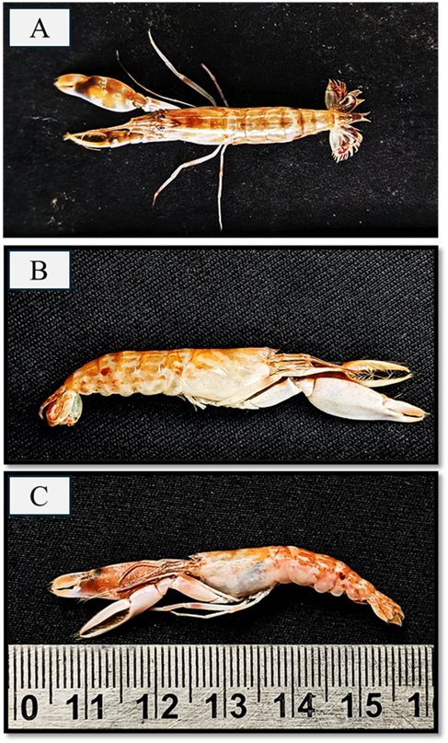
Figure 1. Alpheus longiforceps Lateral and Dorsal view.

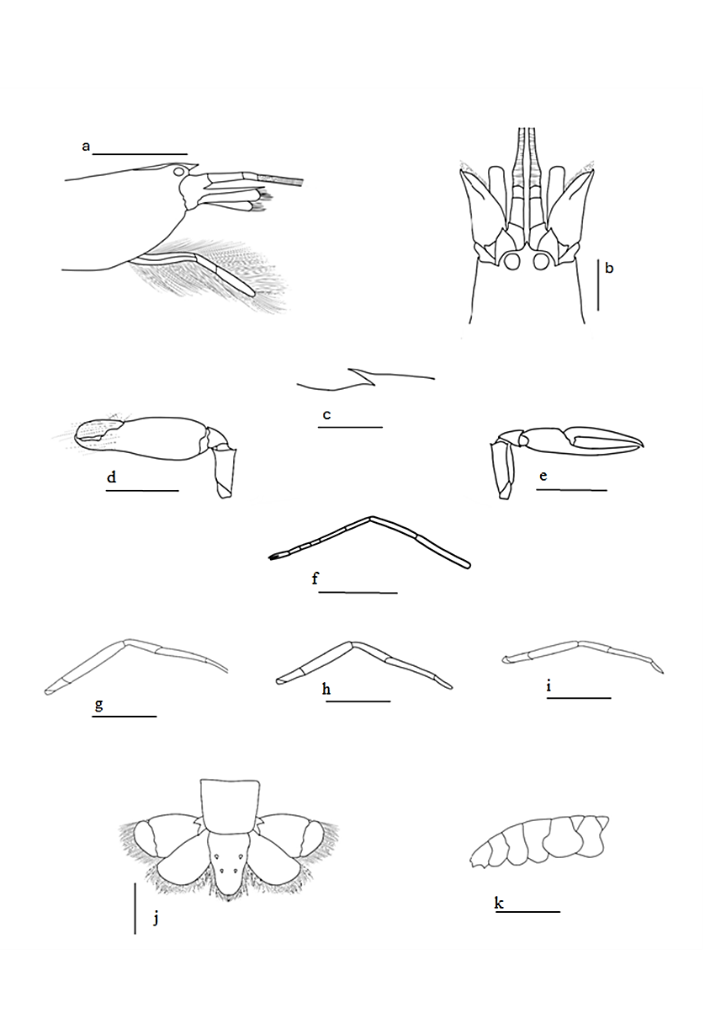
Figure 2. Alpheus longiforceps, paratype, cl 10.6 mm from Mudasal Odai: a, anterior region, lateral view; b, same, dorsal view; c, carina below right first antennular segments; d, major first pereopod; e, minor first pereopod; f, left second pereopod; g, right third pereopod; h, right fourth pereopod; i, right fifth pereopod; j, telson and uropod; k, abdomen. (Scale 10 mm: a,b,d,e,f,g,h,i,k ; scale 5 mm: c and j)

