DENSITY AND HABITAT SELECTION OF INDIAN BLUE PEAFOWL (PAVO CRISTATUS) AT THIRUVIDAIMARUTHUR TALUK OF THANJAVUR DISTRICT, TAMIL NADU
Abstract
The Indian Peafowl Pavo cristatus (Galliformes: Phasianidae) is the national bird of India, and is widespread and broadly scattered in the Indian Subcontinent. The population of the Indian peafowl is on the decline and the bird has become locally extinct in some areas of its past distribution range. A total of 20 line transects were sampled. Each transect was one kilometre length. The study was carried out for six months. The Indian Peafowl population was estimated using the line transect approach. Transects of one kilometres in length were used to walk across the cultivated fields and natural habitats which were regarded as the sampling unit. The Peafowl abundance was studied in different habitats such teak trees, sugarcane, banana plantations, bamboo vegetation, and paddy fields. The overall Peafowl density in different habitats was studied. The density of overall peafowl in the Paddy field was 8.65/km² and in Banana plantation 5.25/km². The density in Bamboo vegetation was 5.20/km² and Sugar cane 4.20/km² and Teak tree 5.95/km². This study showed the habitat selection in Indian peafowl in the study area in which paddy field was highly preferred (selected) than sugar cane habitat by Indian peafowl. The other habitats such banana plantation, bamboo habitat and teak wood habitats were moderately used.
Key words: density, habitat, selection, indian blue peafowl, thanjavur
Introduction:
The population of the Indian peafowl is on the decline and the bird has become locally extinct in some areas of its past distribution range (Ramesh K, Mcgowan P 2009, Divya J, Sarita R. 2013). Medium-sized omnivores, peacocks are members of the phasianidae family under the Galliformes order (Johnsgard, 1986; Ali and Ripley, 1989). Development of reliable methods for estimating abundance is a prerequisite for assessing a species conservation status (Conroy & Caroll 2001). Galliformes are useful indicators of environmental quality and the assessment of their status is essential for management purposes (Fuller & Garson 2000).
The Indian Peafowl Pavo cristatus (Galliformes: Phasianidae) is the national bird of India, and is widespread and broadly scattered in the Indian Subcontinent (Ali S, Ripley SD 1989). However, its distribution is irregular and ranges from the Himalayas in the north to peninsular India in the south. Currently three species of peafowl are found in the world, i.e., Burmese peafowl from eastwards to Sumatra, African peafowl in Belgian Congo and Indian peafowl or blue peafowl in Indian subcontinent. The Indian peafowl is the biggest among all the pheasants and known as the national bird of India (Ali S, Ripley SD 1989). In Tamil Nadu, peafowl population is plentiful in Pudukottai, Madurai, Ramanathapuram, Nilgiri, and Coimbatore districts (Veeramani A, Sathyanarayana MC 1999). Despite its wide distribution, there have been very few ecological studies on peafowl populations (Sharma, I. K.1979, Johnsingh AJT, Murali S1980, Trivedi P, Johnsingh AJT1995, Yasmin S, Yahya HAS1996, Yasmin S1997, Veeramani A, Sathyanarayana MC1999). Few data exist for the majority of Galliformes, which constitute one of the most threatened bird families in the world. Monitoring the population status of wild animal forms an important component of conservation effort and effective wildlife management. It provides information on the status of wildlife population and can help evaluating effective conservation actions, thereby allows for adaptive management (Williams et al. 2002).
It's interesting to note that because of the COVID-19 lockout, there is less human involvement, which results in less noise and air pollution, which benefits the avifauna. In order to understand the decreased human disturbance of birds, the current study evaluates the effect of lockdown on the population and distribution of Indian peafowl.
The most important component of our ecosystems are birds, and the Indian Peafowl serves as a bioindicator of climate change (Nameer 2020). They are extremely vulnerable to changes in their surroundings, such as habitat loss and pollution brought on by human activities. Therefore, issues with avian survival serve as early warnings or indicators of issues with human survival in the natural world. However, almost one-third of pheasant species are categorized as endangered in the International Union for Conservation of Nature's (IUCN) Red Data Book. Peafowl are the most sensitive birds that reside close to people and might be seen as a symbol of environmental values . According to Ambuel and Temple (1983). April to October is when Indian peafowl breed (Mushtaq-ul-Hassan et al., 2012). The scientific community has long been fascinated by and divided over the male's complex train and display, which is a visual cue aimed at females (Harikrishnan et al., 2010).
They are estimated to number over 100,000 by conservatives. McGowan and Madge (2002). However, illegal hunting for meat is still going on, however some regions of India have seen a decrease in this practice (Ramesh and McGowan, 2009). Since Indian legislation only permits the gathering of feathers that have been shed, techniques to determine whether feathers have been plucked or have been shed spontaneously have been devised (Sahajpal and Goyal, 2008). This study focusing about the density of Indian peafowl and its distribution in different habitats in the selected area from January 2025 and June 2025.
Materials and Methods:-
The study area Thiruvidaimaruthur (Latitude: 10° 59' 54.85" N Longitude: 79° 27' 8.17" E ) taluk belongs to Thanjavur District, Tamil Nadu was chosen for this study (Map 1). In addition to having a large number of urbanized cities and agricultural areas, these districts are part of Tamil Nadu's well-developed and modernized state. There is a significant amount of agricultural land along with different habitats in the areas. The majority of individuals relied solely on agricultural practices for their livelihoods. Sugarcane, vegetables, and paddy were the main crops grown here. The Peafowl abundance was examined in all the study locations and habitats between January 2025 and June 2025 (six months).
There were twenty locations were selected in the study area. The Indian Peafowl population was estimated using the line transect approach (Anderson et al. 1979, Burnham et al. 1980, Buckland et al. 1993). Transects of one kilometres in length were used to walk across the cultivated fields and natural habitats which were regarded as the sampling unit. A sampling effort of 20 km was made in each of the months during the study period by walking a total of 20 permanently marked transects in the morning and evening. The detection time, group size, age and sex class, and sighting from the transect line were all noted for every sighting of the peafowl species.

MAP 1: MAP OF STUDY AREA
(Thiruvidaimaruthur Taluk, Thanjavur District Tamil Nadu)
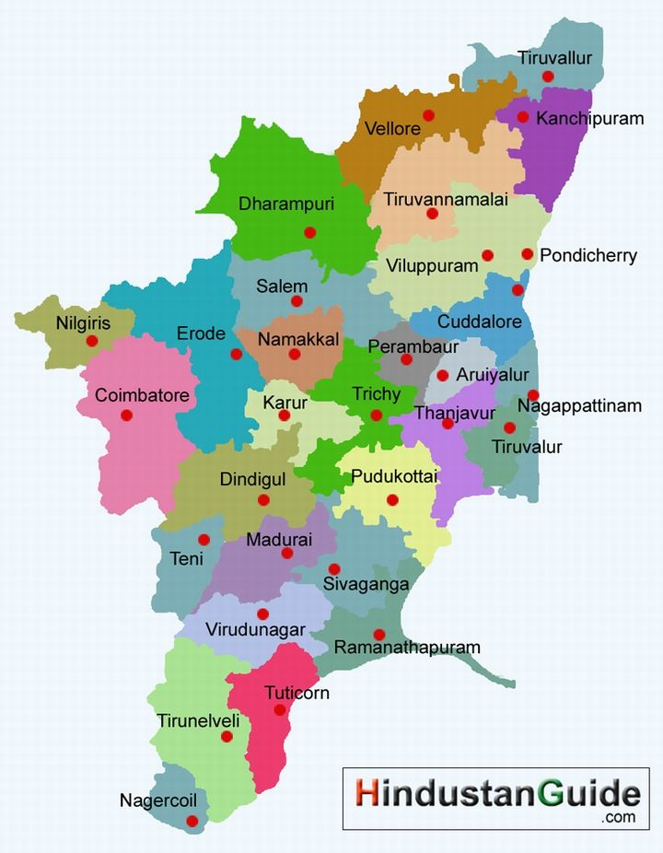

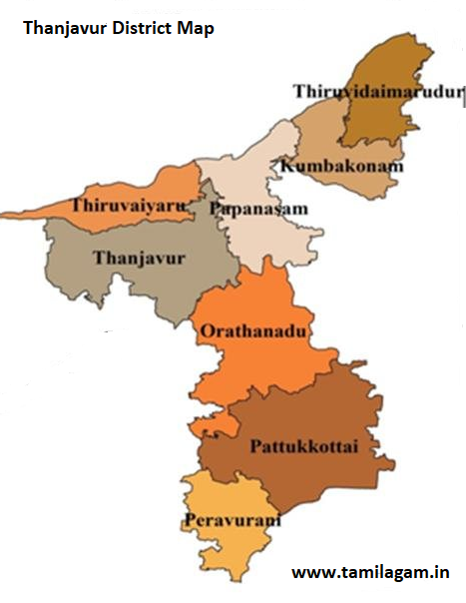
RESULTS
Overall Peafowl Abundance in the study area:
A total of 20 line transects were sampled. Each transect was one kilometre length. The study was carried out for six months. The aim of the current study was to determine the abundance of peafowl in different habitats. The research area's peafowl abundance fluctuated monthly, and this was noted. In the study region, the peafowl population from different study points was examined. In the research area 585 peafowl were obtained. The overall Peafowl 5.85/km² (N=585 LCL 5.35 and UCL 7.35). The density of Peacock 2.60/km² (N=260; LCL 2.10 and UCL 4.10), the density of Peahen 2.95/km² (N=295; LCL 2.45 and UCL 4.45) and density of Chicks 0.30/km² (N=30; LCL 0.13 and UCL 1.80) Table 1 and Fig 1.
Table 1: The Overall peafowl density in the study area (Density/km²)
Sl.No | Overall | No. of Peafowl (N) | Density/km² | Lower Confidence Limit | Upper Confidence Limit
1 | Peacock | 260 | 2.60 | 2.10 | 4.10
2 | Peahen | 295 | 2.95 | 2.45 | 4.45
3 | Chicks | 30 | 0.30 | 0.13 | 1.80
 | Overall | 585 | 5.85 | 5.35 | 7.35

Fig 1: The Overall peafowl density in the study area (Density/km²)

Habitat-wise Peafowl Abundance:
The Peafowl abundance was studied in different habitats such teak trees, sugarcane, banana plantations, bamboo vegetation, and paddy fields.
Density of Peacock in different Habitat:
The Peacock density in different habitats were studied in which the Paddy 4.30/km² (N=86; LCL 3.80 and UCL 5.80), Banana plantation 2.40/km² (N=48; LCL 1.90 and UCL 3.90), Bamboo vegetation 2.15/km² (N=43; LCL 1.65 and UCL 3.65), Sugar cane 1.65/km² (N=33; LCL 1.15 and UCL 3.15) and Teak tree 2.50/km² (N=50; LCL 2.00 and UCL 4.00) Table 2 and Fig 2.
Table 2: Density of Peacock in different habitats (Density/km²)
Sl.No | Habitat | No. of Peacock (N) | Density/km² | Lower Confidence Limit | Upper Confidence Limit
1 | Paddy | 86 | 4.30 | 3.80 | 5.80
2 | Banana Plantation | 48 | 2.40 | 1.90 | 3.90
3 | Bamboo vegetation | 43 | 2.15 | 1.65 | 3.65
4 | Sugar cane | 33 | 1.65 | 1.15 | 3.15
5 | Teak tree | 50 | 2.50 | 2.00 | 4.00

Fig 2: Density of Peacock in different habitats (Density/km²)

Density of Peahen in different Habitat:
The Paddy 3.60/km² (N=72; LCL 3.10 and UCL 5.10), Banana plantation 2.75/km² (N=55; LCL 2.25 and UCL 4.25), Bamboo vegetation 2.85/km² (N=57; LCL 2.35 and UCL 4.35), Sugar cane 2.30/km² (N=46; LCL 1.80 and UCL 3.80) and Teak tree 3.25/km² (N=65; LCL 2.75 and UCL 4.75) Table 3 and Fig 3.

Table 3: Density of Peahen in different habitats (Density/km²)
Sl.No | Habitat | No. of Peahen | Density/km² | Lower Confidence Limit | Upper Confidence Limit
1 | Paddy | 72 | 3.60 | 3.10 | 5.10
2 | Banana Plantation | 55 | 2.75 | 2.25 | 4.25
3 | Bamboo vegetation | 57 | 2.85 | 2.35 | 4.35
4 | Sugar cane | 46 | 2.30 | 1.80 | 3.80
5 | Teak tree | 65 | 3.25 | 2.75 | 4.75

Fig 3: Density of Peahen in different habitats (Density/km²)

Density of chicks in different Habitat:
The Paddy 0.75/km² (N=15; LCL 0.12 and UCL 2.25), Banana plantation 0.10/km² (N=2; LCL 0.11 and UCL 1.60), Bamboo vegetation 0.20/km² (N=4; LCL 0.12 and UCL 1.70), Sugar cane 0.25/km² (N=5; LCL 0.13 and UCL 1.75) and Teak tree 0.20/km² (N=4; LCL 0.11 and UCL 1.70) Table 4 and Fig 4.
Table 4: Density of Chicks in different habitats (Density/km²)
Sl.No | Habitat | No. of Chicks | Density/km² | Lower Confidence Limit | Upper Confidence Limit
1 | Paddy | 15 | 0.75 | 0.12 | 2.25
2 | Banana Plantation | 2 | 0.10 | 0.11 | 1.60
3 | Bamboo vegetation | 4 | 0.20 | 0.12 | 1.70
4 | Sugar cane | 5 | 0.25 | 0.13 | 1.75
5 | Teak tree | 4 | 0.20 | 0.11 | 1.70

Fig 4: Density of Chicks in different habitats (Density/km²)

The overall Peafowl density in different habitats:
The overall Peafowl density in different habitats was studied. The density of overall peafowl in the Paddy field was 8.65/km² (N=173; LCL 8.15 and UCL 10.15), and in Banana plantation 5.25/km² (N=105; LCL 4.75 and UCL 6.75). The density in Bamboo vegetation was 5.20/km² (N=104; LCL 4.70 and UCL 6.70), Sugar cane 4.20/km² (N=84; LCL 3.70 and UCL 5.70) and Teak tree 5.95/km² (N=119; LCL 5.45 and UCL 7.45) Table 5 and Fig 5. This study showed the habitat selection in Indian peafowl in the study area in which paddy field was highly preferred (selected) than sugar cane habitat by Indian peafowl. The other habitats such banana plantation, bamboo habitat and teak wood habitats were moderately used.
Table 5: The overall peafowl density in different habitats (Density/km²)
Sl.No | Habitat | No. of Peafowl | Density/km² | Lower Confidence Limit | Upper Confidence Limit
1 | Paddy | 173 | 8.65 | 8.15 | 10.15
2 | Banana Plantation | 105 | 5.25 | 4.75 | 6.75
3 | Bamboo vegetation | 104 | 5.20 | 4.70 | 6.70
4 | Sugar cane | 84 | 4.20 | 3.70 | 5.70
5 | Teak tree | 119 | 5.95 | 5.45 | 7.45

Fig 5: The overall peafowl density in different habitats (Density/km²)

Discussion
The purpose of the current study was to determine the abundance of peafowl in the study area's varied habitats. This study showed the habitat selection in Indian peafowl in the study area in which paddy field was highly preferred (selected) than sugar cane habitat by Indian peafowl. The other habitats such banana plantation, bamboo habitat and teak wood habitats were moderately used. Additionally, this study demonstrated that Indian Peafowl numbers were higher in some habitats than others, and they were primarily found in the study area's open forest areas. Indian Peafowls may be more common in scrub jungles because there are enough food plants, insects, roosting trees, and healthy ground cover for nesting and protection. When compared to southern subtropical hill forests, peafowl prefer scrub jungle, which may be the cause of ground litter and fruiting plants (Rameshkumar, et al., 2017). The availability of enough food plants, insects, roosting trees, and suitable ground cover for nesting and protection may be the cause of the Indian Peafowls' abundance in scrub jungle (Sathyanarayana, et al., 1993). When compared to southern subtropical hill forests, the grey jungle bird prefers scrub jungle, according to Subramanian et al. They also emphasized the importance of ground litters and fruiting plants (Subramanian, et al., 2008).
Conclusion
This study reveals the density of overall population of peafowl in different habitats. The distribution of peafowl in gender-wise (Peacock, Hen and Chicks) density were also discussed. The selection of habitats also discussed for the Indian peafowl in the study area. In which, paddy field habitats are preferred higher than other habitats. Contrary, the sugar cane habitat by Indian peafowl preferred lesser than other habitats. The other habitats such banana plantation, bamboo habitat and teak wood habitats were moderately used by Indian peafowl in the study area.

Reference
Ali S and Ripley SD. (1989). Handbook of the birds of India and Pakistan. New Delhi: Oxford University Press.
Conroy M.J. & Carroll J.P. (2001). Estimating abundance of Galliformes; tools and application. In: Proceeding of the 7th international Galliformes Symposium, Kathmandu, Nepal (Eds. Woodburn M., McGowan P., Carroll J., Masavi A. & Zang D.Z.), World Pheasant Association, UK., pp. 204−215.
Fuller R.A. & Garson P.J. (2000). Pheasants: Status Survey and Conservation Action Plan 2000−2004, WPA/Birdlife/SSC Pheasant Specialist Group, IUCN, Gland, Switzerland and Cambridge, UK, and the World Pheasant Association, Reading, UK.
Ali S, Ripley SD. (1989). Handbook of the birds of India and Pakistan. Second edition. New Delhi: Oxford University Press.
Veeramani A, Sathyanarayana MC. (1999). Ecology and behaviour of the Indian Peafowl (Pavo cristatus) in Mudumalai Wildlife Sanctuary, Tamil Nadu, India. Pavo, 137(1& 2):1–6.
Sharma, I. K. (1979). Ecological aspects of population trends of the Peafowl Pavo cristatus at Jodhpur, India. Pavo, 17(1&2), 50–53.
Johnsingh AJT, Murali S. (1980). The ecology and behaviour of the Indian Peafowl (Pavo cristatus) Linn. of Injar. J. Bombay Nat. Hist. Soc, 75 (Suppl.) 1069–1079.
Trivedi P, Johnsingh AJT. (1995). Diet of Indian Peafowl Pavo cristatus Linn.in Gir Forest, Gujarat. Journal of Bombay Natural History Society, 92(1–3), 262–263.
Yasmin S, Yahya HAS. (1996). Correlates of mating success in Indian peafowl. Auk, (113)490-492.
Yasmin S. (1997). Group size and composition of Indian Peafowl (Pavo cristatus) in an agroecosystem at Aligarh. Uttar Pradesh. J. Bombay Nat. Hist. Soc, (94), 478- 482.
Veeramani A, Sathyanarayana MC. (1999). Ecology and behaviour of the Indian Peafowl (Pavo cristatus) in Mudumalai Wildlife Sanctuary, Tamil Nadu, India. Pavo, 37(1& 2), 1–6.
Ramesh K, McGowan P. (2009). On the current status of Indian Peafowl Pavo cristatus (Aves: Galliformes: Phasianidae): Keeping the common species common. Journal of Threatened Taxa, 1(2), 106-108.
Divya J, Sarita R. (2013). Population indices and habitat association of Indian Peafowl (Pavo cristatus) in Haryana using line transect and call count method. Indian Journal of Animal Research, (47), 152– 155.
Williams B. K, Nichols J.D. & Conroy M.J. (2002). Analysis and Management of animal population, (1st ed.). Academic Press, San Diego, California, USA.
Nameer P.O. (2020) .The expanding distribution of the Indian peafowl (Pavo cristatus) as an indicator of the changing climate in Kerala, Southern India. A modeling study using max ent. Ecological indicators.(110), 105930.
Ambuel B and Temple SA. (1983). Area-dependent changes in the bird communities and vegetation of southern Wisconsin forests. Ecol, (64), 1057‐1068.
Mushtaq-ul-Hassan, M. Ali, Z, Arshad, M.I, Mahmood, S and Mahmood-ul-Hassan, M. (2012). Effect of matting sex ratios in Indian peafowl (Pavo cristatus) on production performance at Wildlife Research Institute, Faisalabad (Pakistan). Iranian J. Vet. Res. Vol. 13(2), 143-146.
Harikrishnan, S., Vasudevan, K. and Sivakumar, K. (2010). "Behavior of Indian Peafowl Pavo cristatus Linn. 1758 During the Mating Period in a Natural Population". The Open Ornithology Journal, (3) 13–19.
Madge,S. and McGowan.P. (2002). Pheasants, Partridges and Grouse, Including Buttonquails, and Allies. Helm Identification Guides, Christopher Helm, London, 488pp.
Ramesh, K. and Mcgowan, P. (2009). On the current status of Indian Peafowl Pavo cristatus Aves: Galliformes: Phasianidae): keeping the common species common. Journal of Threatened Taxa, (1), 106-108.
Sahajpal, V. and Goyal, S.P. (2008). "Identification of shed or plucked origin of Indian Peafowl (Pavo cristatus) tail feathers: Preliminary findings". Science and Justice 48 (2), 76–78.

