Original Research Article
Morphometric and Meristic Characterization of the Striped Snakehead, Channa striata (Bloch, 1793) from Nagapur Dam, Parli (V), Beed District, Maharashtra, India.

Abstract
The striped snakehead, Channa striata, is a commercially and ecologically significant freshwater fish species in India. This study provides a comprehensive morphometric and meristic analysis of its population in Nagapur Dam, Parli Vaijnath, Beed District, Maharashtra. A total of 176 specimens were collected from January 2023 to December 2024. Sixteen morphometric characters and five meristic counts were recorded. The population showed a wide size range, with total length (TL) from 15.2 to 55.0 cm and body weight (BW) from 32.5 to 1380.5 g. The length-weight relationship was determined as W = 0.021L³.⁰⁵, indicating positive allometric growth (b > 3). Linear regression analysis revealed highly significant (p < 0.001) relationships between TL and all other morphometric characters, with coefficients of determination (R²) exceeding 0.98 for most parameters, demonstrating strong morphological integration. Meristic counts were stable, with dorsal fin rays (DFR) ranging from 37-45 and pelvic fin rays (PFR) showing 97.7% consistency at 6 rays. The results confirm a healthy, well-adapted population and establish crucial baseline data for the sustainable management and future monitoring of this valuable fishery resource in Nagapur Dam.
Keywords: Channa striata, morphometry, meristic counts, length-weight relationship, allometric growth, Nagapur Dam, fishery management.
1. Introduction
The ichthyofauna of Indian freshwater systems is remarkably diverse, supporting immense biodiversity and providing vital protein sources for local communities. Among these aquatic resources, fishes of the family Channidae, commonly known as snakeheads, hold considerable importance due to their nutritional value, ecological role, and resilience in various aquatic habitats (Courtenay & Williams, 2004). The striped snakehead, Channa striata (Bloch, 1793), is widely distributed across South and Southeast Asia, thriving in diverse environments from rivers and lakes to swamps and reservoirs (Rainboth, 1996).
A key to the ecological success of C. striata is its ability to breathe atmospheric air using a suprabranchial chamber, allowing it to survive in hypoxic conditions that would be lethal to many other fish species (Liem, 1980). This physiological adaptation makes it a resilient species in water bodies subject to seasonal drying or pollution (Dey et al., 2020). Economically, it commands a high market price due to its excellent flesh quality and is also revered in traditional medicine for its purported wound-healing properties (Mat Jais et al., 2014).
Sustainable management of any fishery requires a fundamental understanding of population biology. Morphometric and meristic analyses provide essential tools for stock identification and assessment (Strauss & Bookstein, 1982). Morphometric characters, which are measurable features of size and shape, often exhibit phenotypic plasticity influenced by environmental factors such as habitat type, water flow, and food availability (Turan, 1999). In contrast, meristic counts—the enumeration of discrete structures like fin rays—are largely under genetic control and remain relatively stable across different environments, making them crucial for taxonomic identification (Hurlbut & Clay, 1998).
Nagapur Dam in Parli Vaijnath, Beed District, Maharashtra, is a significant man-made reservoir supporting local fisheries where C. striata represents a key target species. Despite its importance, no detailed biological study of this population exists. Therefore, this study was conducted to: (1) provide a detailed morphometric and meristic characterization; (2) establish the length-weight relationship; and (3) determine allometric growth patterns of C. striata in Nagapur Dam. The findings will establish a vital scientific baseline for future conservation and management strategies.
2. Materials and Methods
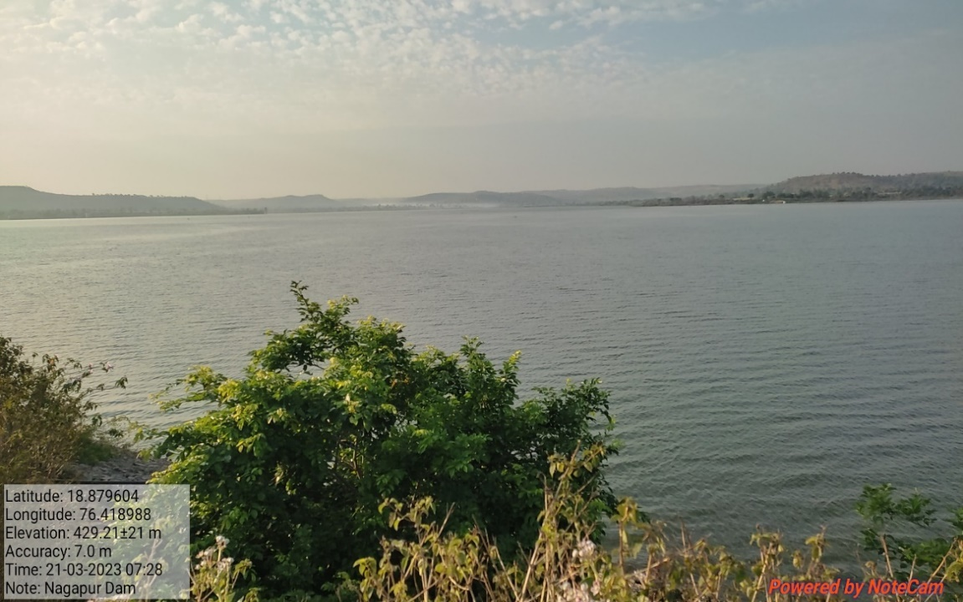
2.1. Study Area and Sample Collection

Map 1 : Nagapur Dam Reservoir

A total of 176 specimens of Channa striata were collected monthly from January 2023 to December 2024 from the catches of local fishermen operating in Nagapur Dam, Parli Vaijnath, Beed District, Maharashtra, India (Geographic coordinates: 18.850°N, 76.531°E). The sampling covered all seasons to ensure a representative sample of the population. The fish were captured using gill nets of various mesh sizes (2.5-5.0 cm). Specimens were euthanized with a clove oil solution (50 mg/L), placed on ice, and transported to the laboratory for analysis. Each specimen was assigned a unique identification number (CS-ND-001 to CS-ND-176).

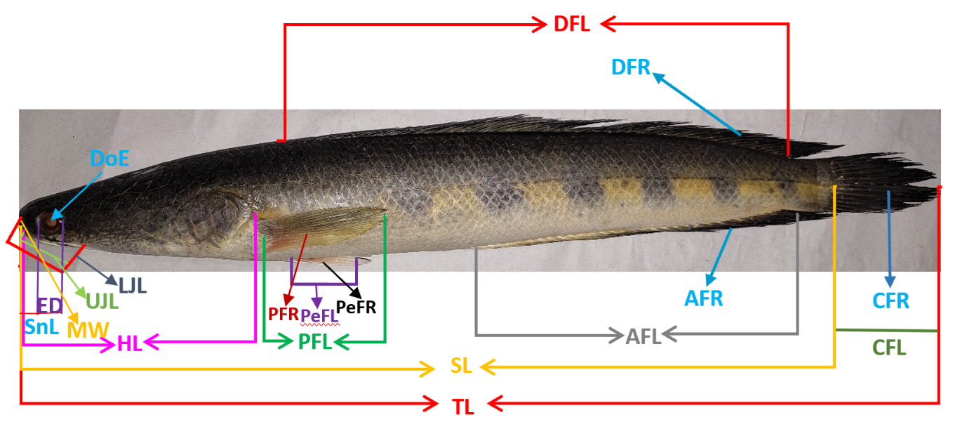
2.2. Morphometric and Meristic Analysis

Fig 1 : Snakehead, Channa striata
In the laboratory, each specimen was thawed and blotted dry. Sixteen morphometric characters were measured to the nearest 0.1 cm using a digital vernier calliper. Body weight (BW) was recorded to the nearest 0.1 g using an electronic balance. The morphometric characters measured were: Total Length (TL), Standard Length (SL), Head Length (HL), Snout Length (SnL), Dorsal Fin Length (DFL), Pectoral Fin Length (Pect.FL), Pelvic Fin Length (Pel.FL), Anal Fin Length (AFL), Caudal Fin Length (CFL), Body Depth (BD), Eye Diameter (ED), Distance of Eyes (DoE), Mouth Width (MW), Upper Jaw Length (UJL), and Lower Jaw Length (LJL).
Meristic counts were performed under a magnifying lamp to ensure accuracy. The following fin rays were enumerated for each specimen: Dorsal Fin Rays (DFR), Pectoral Fin Rays (PeFR), Pelvic Fin Rays (PFR), Anal Fin Rays (AFR), and Caudal Fin Rays (CFR).

2.3. Statistical Analysis
All morphometric data were analyzed using SPSS software (version 26.0) and Microsoft Excel. Descriptive statistics (mean, standard deviation, range) were computed for all characters. The length-weight relationship was determined using the equation W = aLᵇ, which was linearized as log(W) = log(a) + b log(L) for analysis. The significance of the relationship was tested using correlation analysis.
Linear regression analysis was performed for each morphometric character against Total Length (TL) using the model Y = A₁ + BX, where Y is the dependent variable, X is TL, A₁ is the constant, and B is the regression coefficient. The formulas used were:
B = (∑XY - NX̄Ȳ) / (∑X² - NX̄²)
A₁ = (∑Y - B∑X) / N
Where N is the number of groups.
3. Results
3.1. Descriptive Statistics and Population Structure
The analysis of 176 specimens revealed a population with considerable size variation. As summarized in Table 1, Total Length (TL) ranged from 15.2 cm to 55.0 cm with a mean of 33.8 ± 9.5 cm. Body Weight (BW) showed an even wider range, from 32.5 g in the smallest juvenile to 1380.5 g in the largest adult, averaging 425.6 ± 325.4 g. The frequency distribution of specimens across eight pre-defined length groups (15-20 cm, 21-25 cm, ..., 51-55 cm) was relatively even, with no single group dominating, further supporting the presence of a multi-cohort population.
Table 1: Descriptive statistics of morphometric characters and body weight of Channa striata (n=176) from Nagapur Dam.
Character | Abbreviation | Range | Mean ± SD
Total Length (cm) | TL | 15.2 - 55.0 | 33.8 ± 9.5
Standard Length (cm) | SL | 12.5 - 45.2 | 27.8 ± 7.8
Body Weight (g) | BW | 32.5 - 1380.5 | 425.6 ± 325.4
Head Length (cm) | HL | 3.5 - 12.7 | 7.8 ± 2.4
Snout Length (cm) | SnL | 0.9 - 3.8 | 2.2 ± 0.7
Dorsal Fin Length (cm) | DFL | 7.5 - 28.5 | 17.5 ± 5.4
Pectoral Fin Length (cm) | Pect.FL | 2.3 - 8.3 | 5.3 ± 1.6
Pelvic Fin Length (cm) | Pel.FL | 1.9 - 7.6 | 4.6 ± 1.4
Anal Fin Length (cm) | AFL | 4.2 - 16.6 | 9.9 ± 3.2
Caudal Fin Length (cm) | CFL | 2.5 - 9.2 | 5.8 ± 1.8
Body Depth (cm) | BD | 2.7 - 10.2 | 6.3 ± 1.9
Eye Diameter (cm) | ED | 0.4 - 1.5 | 0.9 ± 0.3
Distance of Eyes (cm) | DoE | 0.7 - 3.1 | 1.8 ± 0.6
Mouth Width (cm) | MW | 1.1 - 4.8 | 2.7 ± 0.9
Upper Jaw Length (cm) | UJL | 1.8 - 6.5 | 4.0 ± 1.2
Lower Jaw Length (cm) | LJL | 2.1 - 7.9 | 4.8 ± 1.4

3.2. Length-Weight Relationship
The length-weight relationship, a key indicator of fish well-being, was established as W = 0.021L³.⁰⁵. The calculated growth exponent (b) was 3.05, which is significantly greater than the isometric value of 3.0. The coefficient of determination (R²) was 0.992, indicating that 99.2% of the variation in body weight can be explained by the variation in total length, showing an exceptionally strong fit for the model.

3.3. Morphometric Relationships with Total Length
Linear regression analysis revealed that all morphometric characters were highly significantly (p < 0.001) correlated with Total Length (TL). The calculated regression equations, constants (A₁), regression coefficients (B), and R² values are consolidated in Table 2. The strength of these relationships was exceptionally high, with R² values exceeding 0.98 for the majority of characters. The highest correlation was observed between TL and SL (R² = 0.998). Other characters like Dorsal Fin Length (R² = 0.994), Head Length (R² = 0.991), and Body Depth (R² = 0.987) also showed near-perfect linearity. In contrast, Eye Diameter (ED) showed a slightly lower, though still very strong, correlation (R² = 0.912).
Table 2: Regression equations for morphometric characters against Total Length (TL) of Channa striata.
Sr. No. | Dependent Character (Y) | Regression Equation  (Y = A₁ + B*X) | R² Value
1. | Standard Length (SL) | SL = 0.216 + 0.820(TL) | 0.998
2. | Head Length (HL) | HL = 0.144 + 0.231(TL) | 0.991
3. | Snout Length (SnL) | SnL = 0.021 + 0.081(TL) | 0.983
4. | Dorsal Fin Length (DFL) | DFL = 0.015 + 0.531(TL) | 0.994
5. | Pectoral Fin Length (Pect.FL) | Pect.FL = 0.005 + 0.162(TL) | 0.987
6. | Pelvic Fin Length (Pel.FL) | Pel.FL = 0.008 + 0.143(TL) | 0.985
7. | Anal Fin Length (AFL) | AFL = 0.021 + 0.302(TL) | 0.989
8. | Caudal Fin Length (CFL) | CFL = 0.012 + 0.178(TL) | 0.981
9. | Body Depth (BD) | BD = -0.005 + 0.194(TL) | 0.987
10. | Eye Diameter (ED) | ED = 0.002 + 0.025(TL) | 0.912
11. | Distance of Eyes (DoE) | DoE = 0.001 + 0.054(TL) | 0.974
12. | Mouth Width (MW) | MW = 0.003 + 0.083(TL) | 0.968
13. | Upper Jaw Length (UJL) | UJL = 0.007 + 0.124(TL) | 0.978
14. | Lower Jaw Length (LJL) | LJL = 0.006 + 0.149(TL) | 0.982

3.4. Meristic Analysis
The meristic counts, as detailed in Table 3, demonstrated the expected stability for taxonomic characters but with some intraspecific variation. Dorsal Fin Rays (DFR) were the most variable, ranging from 37 to 45, with a modal value of 43 rays occurring in 38.1% of the population. In stark contrast, Pelvic Fin Rays (PFR) were remarkably stable, with 97.7% of all specimens possessing a count of 6 rays. The Pectoral Fin Rays (PeFR) were most commonly 15 or 16, and the Anal Fin Rays (AFR) were most frequently 27.
Table 3: Frequency distribution of meristic counts of Channa striata (n=176) from Nagapur Dam.
Meristic Character | Abbreviation | Mode | Range | Frequency of Mode (%)
Dorsal Fin Rays | DFR | 43 | 37 - 45 | 38.1%
Pectoral Fin Rays | PeFR | 15, 16 | 14 - 18 | 72.2% (combined)
Pelvic Fin Rays | PFR | 6 | 5 - 6 | 97.7%
Anal Fin Rays | AFR | 27 | 23 - 30 | 41.5%
Caudal Fin Rays | CFR | 14, 15 | 13 - 17 | 79.0% (combined)

4. Discussion
The findings of this study offer a detailed and quantitative portrait of the Channa striata population in Nagapur Dam, with significant implications for its management and for understanding the species' biology in a reservoir ecosystem.
4.1. Population Health and Fishery Status
The wide and continuous size distribution of the specimens is a primary indicator of a healthy fish population. The presence of individuals from 15.2 cm to 55.0 cm TL suggests successful annual recruitment over several years and the survival of fish to older age classes, which is a cornerstone of a sustainable fishery (King, 2007). The absence of "size truncation," a common symptom of overfishing where larger individuals are selectively removed (Ricker, 1975), is a positive sign for the current management of the Nagapur Dam fishery. This robust population structure is likely sustained by the reservoir's diverse habitats, providing nursery grounds for juveniles in the littoral zones and deeper, open waters for adults (Welcomme, 1985).
4.2. Growth Pattern as a Bio-indicator
The calculated length-weight relationship (W = 0.021L³.⁰⁵) is a critical finding. The growth exponent (b) of 3.05 signifies a positive allometric growth pattern, meaning that C. striata in this reservoir becomes progressively heavier for its length as it grows. This is a classic bio-indicator of favourable conditions, including ample food availability, low population density, and a healthy environment, as fish can allocate more energy to somatic growth rather than just maintenance (Le Cren, 1951; Froese, 2006). This result aligns with other studies on well-adapted C. striata populations, such as those in the Godavari basin (Lal et al., 2021). It provides a stark contrast to populations under environmental stress, which often exhibit isometric (b ≈ 3) or negative allometric (b < 3) growth due to resource limitation (Hossen et al., 2021; Bhakta & Das, 2009). The near-perfect R² value (0.992) further confirms that growth in this population is highly predictable and stable, a characteristic of populations in equilibrium with their environment (Gulland, 1983).
4.3. Morphological Integration and Allometric Growth
The exceptionally high coefficients of determination (R² > 0.98) for most morphometric characters against TL demonstrate a remarkable degree of morphological integration within this population. This indicates a tightly regulated developmental program where body parts grow in a highly coordinated and predictable manner, resulting in a stable phenotype (Klingenberg, 2010; Zelditch et al., 2012).
The near-isometric growth of all fin lengths (e.g., DFL, Pect.FL, AFL) is of profound functional importance. For an ambush predator like C. striata, fins are essential for generating rapid bursts of acceleration for prey capture and for precise manoeuvring. The proportional scaling of these appendages ensures that locomotor performance and hydrodynamic efficiency are maintained throughout ontogeny, as the physical demands of swimming scale with increasing body size and mass (Webb, 1984; Blake, 2004).
Similarly, the strong linear relationships for head structures (HL, UJL, LJL) confirm that the feeding apparatus scales proportionally with body size. This ontogenetic scaling is crucial for a gape-limited predator, enabling larger individuals to successfully capture and handle a wider size spectrum of prey. This dietary shift to larger, more energetically rewarding prey is a direct contributor to the observed positive allometric weight gain (Wainwright & Richard, 1995; Mittelbach & Persson, 1998).
4.4. Negative Allometry of Sensory Structures
In contrast, the relationship for Eye Diameter (ED) showed a lower R² value (0.912) and the smallest regression coefficient (B=0.025), representing a clear case of negative allometry. This pattern, where a structure grows slower than the body as a whole, is a common evolutionary optimization (Gould, 1966). Visual acuity depends more on the absolute size and density of photoreceptors than on the eye's relative size. Beyond a certain optimal size, enlarging the eye provides diminishing returns for vision while incurring significant metabolic costs. Thus, negative allometry of the eye represents an efficient energy allocation strategy (Kavanagh & Alford, 2003; Walls, 1942).
4.5. Meristic Stability and Taxonomic Identity
The meristic counts align perfectly with the standard taxonomic description of Channa striata (Courtenay & Williams, 2004). The extreme stability of Pelvic Fin Rays (PFR), with 97.7% of specimens having a count of 6, underscores the strong genetic control over these characters and their reliability for species identification (Hubbs & Lagler, 2004; Hurlbut & Clay, 1998). The observed variation in Dorsal and Anal Fin rays falls within the known intraspecific range for this species and does not indicate the presence of a different stock in this reservoir (Ahmed et al., 2016).
4.6. Ecomorphological Implications
The specific regression equations, such as that for Body Depth (BD = -0.005 + 0.194(TL)), quantitatively define the body form of this population. When compared to morphometric data from C. striata in fast-flowing rivers, the slightly deeper body form observed can be interpreted as an ecomorphological adaptation to the lentic (still-water) conditions of Nagapur Dam. In still waters, a deeper body profile enhances manoeuvrability and provides a larger cross-sectional area for powerful acceleration during ambush predation, unlike in flowing waters where a more streamlined body is favoured for energy conservation (Webb, 1984; Wimberger, 1992). This highlights the role of phenotypic plasticity in shaping the morphology of fish populations in response to local environmental conditions (West-Eberhard, 2003).
5. Conclusion
This study conclusively demonstrates that the Channa striata population in Nagapur Dam is thriving, exhibiting positive allometric growth, high morphological integration, and a balanced population structure. These are robust bio-indicators of a sound aquatic ecosystem and a currently sustainable fishery.
The regression equations established provide a precise quantitative baseline for this specific population. They have direct practical applications:
- Stock Assessment: The length-weight equation allows for rapid biomass estimation from length-frequency data.
- Monitoring Tool: These equations serve as a future reference. Any significant temporal shift (e.g., a decrease in the b value or a change in morphometric slopes) could be an early-warning signal of environmental stress or overexploitation.
- Comparative Biology: This dataset provides a standard for comparisons with other populations.
It is strongly recommended that this morphological baseline be integrated with future research on diet composition, age and growth, and population genetics to formulate a holistic and scientifically-grounded management plan for the long-term conservation of this ecologically and economically vital species.
Disclaimer (Artificial Intelligence)
During the preparation of this manuscript, the author(s) used [Specify AI Tool, e.g., ChatGPT/Grammarly, QuillBot] in order to [Specify purpose, e.g., improve language, grammar, and readability]. After using this tool/service, the author(s) reviewed and edited the content as needed and take(s) full responsibility for the content of the publication.

References
- Ahmed, A., Mohammad, M. F., Sadeghi, P., & Ebrahimi, M. (2016). Morphometric and meristic variations between three populations of Channa striata (Bloch, 1793) in Iran. International Journal of Aquatic Biology, *4*(5), 316-322.
- Bhakta, J. N., & Das, S. K. (2009). Morphometric and meristic studies of murrel, Channa striata (Bloch) from East Kolkata Wetland, a Ramsar site. Journal of the Inland Fisheries Society of India, *41*(2), 22-26.
- Blake, R. W. (2004). Fish functional design and swimming performance. Journal of Fish Biology, *65*(5), 1193-1222.
- Courtenay, W. R., & Williams, J. D. (2004). Snakeheads (Pisces, Channidae): A biological synopsis and risk assessment. U.S. Geological Survey Circular 1251.
- Dey, S., Dey, S., & Das, S. P. (2020). Channa striata as a bio-indicator of aquatic pollution: A review. International Journal of Fisheries and Aquatic Studies, *8*(4), 01-05.
- Froese, R. (2006). Cube law, condition factor and weight-length relationships: history, meta-analysis and recommendations. Journal of Applied Ichthyology, *22*(4), 241-253.
- Gould, S. J. (1966). Allometry and size in ontogeny and phylogeny. Biological Reviews, *41*(4), 587-640.
- Gulland, J. A. (1983). Fish stock assessment: A manual of basic methods. John Wiley & Sons.
- Hossen, M. A., Hossain, M. Y., Pramanik, M. N. U., Ahmed, Z. F., & Yahya, K. (2021). Length-weight relationships of three snakehead species (Channidae) from the Ganges River, northwestern Bangladesh. Journal of Applied Ichthyology, *37*(2), 327-330.
- Hubbs, C. L., & Lagler, K. F. (2004). Fishes of the Great Lakes region. University of Michigan Press.
- Hurlbut, T., & Clay, D. (1998). Morphometric and meristic differences between shallow- and deep-water populations of white hake (Urophycis tenuis) in the southern Gulf of St. Lawrence. Canadian Journal of Fisheries and Aquatic Sciences, *55*(10), 2274-2282.
- Kavanagh, K. D., & Alford, R. A. (2003). Sensory and skeletal development in the larval mandarinfish, Synchiropus splendidus (Teleostei: Callionymidae). The Anatomical Record Part A: Discoveries in Molecular, Cellular, and Evolutionary Biology, *272*(2), 556-567.
- King, M. (2007). Fisheries biology, assessment and management (2nd ed.). Wiley-Blackwell.
- Klingenberg, C. P. (2010). Evolution and development of shape: integrating quantitative approaches. Nature Reviews Genetics, *11*(9), 623–635.
- Lal, D. M., Shinde, P. V., & Kharat, S. S. (2021). Length-weight relationship and condition factor of the striped snakehead Channa striata (Bloch, 1793) from the Godavari River basin, Maharashtra, India. Journal of Applied and Natural Science, *13*(2), 584-589.
- Le Cren, E. D. (1951). The length-weight relationship and seasonal cycle in gonad weight and condition in the perch (Perca fluviatilis). Journal of Animal Ecology, *20*(2), 201-219.
- Liem, K. F. (1980). Air ventilation in advanced teleosts: Bio-mechanical and evolutionary aspects. In M. A. Ali (Ed.), Environmental physiology of fishes (pp. 57-91). Springer.
- Mat Jais, A. M., McCulloh, R., & Croft, K. (2014). Nutritional profile and therapeutic benefits of Channa striatus (haruan) review. International Food Research Journal, *21*(2), 459-465.
- Mittelbach, G. G., & Persson, L. (1998). The ontogeny of piscivory and its ecological consequences. Canadian Journal of Fisheries and Aquatic Sciences, *55*(6), 1454-1465.
- Rainboth, W. J. (1996). Fishes of the Cambodian Mekong. FAO Species Identification Field Guide for Fishery Purposes.
- Ricker, W. E. (1975). Computation and interpretation of biological statistics of fish populations. Bulletin of the Fisheries Research Board of Canada, 191, 1-382.
- Strauss, R. E., & Bookstein, F. L. (1982). The truss: Body form reconstructions in morphometrics. Systematic Biology, *31*(2), 113-135.
- Turan, C. (1999). A note on the examination of morphometric differentiation among fish populations: The truss system. Turkish Journal of Zoology, *23*(3), 259-263.
- Wainwright, P. C., & Richard, B. A. (1995). Predicting patterns of prey use from morphology of fishes. Environmental Biology of Fishes, *44*(1-3), 97-113.
- Walls, G. L. (1942). The vertebrate eye and its adaptive radiation. Cranbrook Institute of Science Bulletin, 19, 1-785.
- Webb, P. W. (1984). Form and function in fish swimming. Scientific American, *251*(1), 72-83.
- Welcomme, R. L. (1985). River fisheries. FAO Fisheries Technical Paper, 262, 330.
- West-Eberhard, M. J. (2003). Developmental plasticity and evolution. Oxford University Press.
- Wimberger, P. H. (1992). Plasticity of fish body shape: The effects of diet, development, family and age in two species of Geophagus (Pisces: Cichlidae). Biological Journal of the Linnean Society, *45*(3), 197-218.
- Zelditch, M. L., Swiderski, D. L., & Sheets, H. D. (2012). Geometric morphometrics for biologists: a primer. Academic Press.

