Assessment of Time-Dependent Alterations in Renal Biomarkers of Mice Following Exposure to Aspartame and Sacoglottis gabonensis ethanolic extract.

Abstract
Aim: This study aimed at assessing the time-dependent Alterations in Renal Biomarkers of Mice Following Exposure to Aspartame and Sacoglottis gabonensis ethanolic extract.
Study Design: The study was a completely randomized design employing relevant statistical tools for analysis and interpretation.
Place and Duration of Study: The study was carried out in the Department of Animal and Environmental Biology, Rivers State University. The experiment lasted for 90 days between January and April 2021.
Methodology: A total of ninety mice were assigned to six groups (A-F) of fifteen mice each. Group A received 50mg/kg/bw/day of aspartame and 250mg/kg/bw/day of ethanolic leaf extract of Sacoglottis gabonensis. Group B received 50mg/kg/bw/day of aspartame and 250mg/kg/bw/day of ethanolic bark extract of S.gabonensis. Group C received 50mg/kg/bw/day of aspartame and 250mg/kg/bw/day of a combination of bark and leaf extract Group D received 50mg/kg/bw/day of aspartame and 500mg/kg/bw/day of a combination of bark and leaf extract. Group E was negative control, Group F was positive control and received 50mg/kg/bw/day of aspartame. All the groups were exposed to the treatment by oral gavage for 30, 60 and 90days. Blood samples were collected individually by cardiac puncture to assay for the kidney function biomarkers. Result: Results show a no significant difference in the biomarkers at 30 days but significant difference (p<0.001) in all biomarkers was recorded at 60 and 90 days. Total protein levels was observed across the different experimental periods, with the highest value recorded at 60 days in group F,the lowest values in group A and E. Albumin levels peaking at 60 days in group F but the lowest value at 60 days in group A. Similarly, total bilirubin had the highest level at 60 days in group B and the lowest at 90 days in group C and F. Conjugated bilirubin had the highest value at 60 days in group F and the lowest at 90 days in group C. Urea concentration was highest mean at 60 days in group F and lowest at 90 days in groups A,B, and D. Creatinine showed the highest concentration at 60 days in group F and the lowest at 90 days in groups D,E and F.
Conclusion: the transient elevation in creatinine, urea, and protein levels at 60 days suggests temporary renal stress, while the subsequent normalization by 90 days indicates the protective effects of the plant extract. Overall, S. gabonensis demonstrated a potential nephroprotective role, mitigating the adverse biochemical effects induced by aspartame.
Keywords: Aspartame, biochemical, Kidney, Renal stress, Sacoglottis gabonensis
- Introduction
Recent alterations in eating habits and lifestyle are largely attributed to the increasing global pursuit of improved health, wellness and disease prevention.
With increased consumer’s quest in reducing sugar intake, food products made with synthetic sweeteners have increased because of their low calories, significance in diabetes and obesity, and organization to keep away from the effects of sucrose [1–2]. Very small amounts of synthetic sweeteners are required for sweetening foods because they are effectively sweeter than sucrose. Artificial sweeteners are widely used in squeeze fruits, carbonated drinks, parched products, dairy products, and drink mixtures with powder in high quantities as low-calorie products. Even though many sweeteners have been permitted by food and drug organizations, most of the sweeteners that are used are artificial, and it has been reported that too much consumption leads to undesirable health effects, either in animal models or humans [3]
Recent research has suggested associations between the intake of artificial sweeteners and metabolic syndrome[4,5] diabetes, and cardiovascular diseases [6]. Specific links have been found between saccharin with migraines [7,8]and insulin insensitivity [9] and between aspartame and prostate cancer and breast cancer[10].
Aspartame (l-aspartyl l-phenylalanine methyl ester) is a type of artificial sweetener discovered by James Schlatter in 1965 [11]. It is one of the most used artificial sweeteners worldwide, with an annual consumption of 16,000 tons [12]. Based on the safety evaluation of aspartame, the Food and Drug Administration set its maximum daily intake (ADI) at 50 mg/kg/day. Aspartame is present in various foods consumed daily, and its consumption is likely to continue rising. However, there are concerns regarding the safety of aspartame in obesity, diabetes mellitus , children and fetuses, autism, neurodegeneration, phenylketonuria, allergies, and skin problems, as well as its carcinogenic properties and genotoxicity [11]. Several studies have reported that aspartame metabolism leads to the generation of methanol, which is further converted to formaldehyde and formic acid, both of which are toxic metabolites capable of inducing oxidative stress [13].
The side effects of aspartame on the kidneys have been investigated in animal experiments and reported to cause damage to the glomeruli and renal tubules, as well as renal dysfunction [14]. Research by [15] demonstrated that long-term aspartame administration in rodents caused significant alterations in kidney biochemical parameters and histopathological damage, including tubular degeneration and glomerular atrophy. The mechanism of toxicity is largely attributed to increased reactive oxygen species (ROS) generation, lipid peroxidation, and reduced antioxidant enzyme activity such as superoxide dismutase (SOD) and catalase.
Moreover, aspartame exposure has been linked with disturbances in protein metabolism, electrolyte imbalance [16] and elevation of renal biomarkers [17], suggesting nephrotoxic potential at high or prolonged doses. Additionally, long-term ASP intake was associated with increased expression of stress-response proteins and markers of apoptosis [18].
Plants, have been utilized as natural medicines throughout human history. Medicinal plants are regarded as an acceptable, cheap, easily available and relatively safe source of many active compounds for pharmaceuticals. Several studies have explored the potential of plant-derived antioxidants in mitigating artificial sweetener-induced toxicity. Natural extracts rich in flavonoids and phenolics have been reported to reduce oxidative stress, restore enzyme activities, and normalize biochemical parameters altered by aspartame exposure [19].
Sacoglottis gabonensis stem bark is a popular and much used medicine in west Africa, An infusion is used as an emetic and in the treatment of fevers, diarrhoea, gonorrhoea and abdominal pain - it is also sometimes used to treat hypertension and diabetes. It is claimed to prolong the shelf life of the wine, add potency, reduce foaming and impart a bitter taste. It is also reported to have aphrodisiac properties. The alcohol content of palm wine from Raphia hookeri, when the stem bark was added, became almost twice as high as that of untreated palm wine. It was found that the ethanol tolerance and osmo-tolerance of the yeast Saccharomyces cerevisiae were enhanced by the bark extract, whereas flocculation and invertase activity were reduced. The co-administration of such plant extracts with aspartame can help clarify whether natural antioxidants can attenuate or potentiate the toxic effects of synthetic food additives. However, there is limited information on the combined effect of aspartame and Sacoglottis gabonensis on renal function biomarkers, making this research timely and significant.

Materials and methods
Study location and duration
The study was carried out in the green house of the Department of Animal and Environmental Biology, Rivers State University, Nkpolu Oroworukwo, Port Harcourt, Nigeria (Coordinates 4º48’14”N6º59’12”E). The experiment was conducted from January to April, 2021.
Sources and Preparation of Plant Material
The bark and leaves of Sacoglottis gabonensis were harvested in Etche Local Government area of Rivers State and allowed to dry under room temperature (18ºc-27ºc).The dried samples were blended into fine powder and stored for use. 50g of the fine powder of S.gabonensis was dissolved in 200ml of ethanol. The mixture was allowed to stay for fourteen days before they were administered to the experimental animals

Animal care and management
A total of Ninety (90) adult male mice (mean weight (18.57±3.35g) were used for the study. The mice were housed in rubber case under standard condition and acclimatized for two weeks. All animal were fed with standard rodent pellet and cool clean water ad libitum. All experiments were conducted according to the institutional animal came protocol at the Rivers State University, Nigeria and followed approved guidelines for the ethical treatment of the experimental animals.
Experimental design
Ninety mice were assigned to six groups (A-F) of fifteen mice each. Group A received 50mg/kg/bw/day of aspartame and 250mg/kg/bw/day of ethanolic leaf extract of Sacoglottis gabonensis. Group B received 50mg/kg/bw/day of aspartame and 250mg/kg/bw/day of ethanolic bark extract of S.gabonensis. Group C received 50mg/kg/bw/day of aspartame and 250mg/kg/bw/day of a combination of bark and leaf extract Group D received 50mg/kg/bw/day of aspartame and 500mg/kg/bw/day of a combination of bark and leaf extract Group E was the negative control and they were not given any treatment, but only given pellet and clean tap water. Group F was the positive control and received 50mg/kg/bw/day of aspartame. All the groups were exposed to the treatment by oral gavage for 30, 60 and 90days. Feed was withdrawn from the animals 24 hours before the termination of experiment.

Biochemical Analysis of Kidney Biomarkers: The blood samples were collected individually by cardiac puncture into sterile tubes and the serum separated at 2500 g for 10 min and stored for determination of Total bilurubin (TB), Total protein (TP) and Creatinine were determined as reported in [20]. Albumin (ALB) concentration was assayed according to Sigma Diagnostics based on the procedure of[21].

Statistical Analysis

Data management and statistical analyses were conducted using Statistical Analyses System SAS 9.4 (SAS Institute, Cary, North Carolina, USA). Graphical representations and data visualizations were carried out using the JMP statistical discovery™softwareversion14.3.
3.Results
3.1 Effect of Aspartame and Sacoglottis gabonensis on the Kidney Biomarkers of Swiss Mice Exposed for 30 days
Results for the differences in kidney biomarkers in Swiss mice exposed to aspartame and Sacoglottis gabonensis for 30 days is presented in Figure 1.
Although the mean total protein levels varied slightly among the experimental groups, the differences were not statistically significant (p > 0.05). Group E recorded the highest mean value (71.33 ± 1.45 g/L), followed closely by Group A (71.00 ± 2.31 g/L), while Group C had the lowest (62.67 ± 2.60 g/L). There was no significant difference in the values of albumin (ALB g/l) in all the treatment groups as compared with the control groups. Total bilirubin (TB mmol/l) was significantly (P<0.0001) higher in the group administered Aspartame only (group F) than in the control (group E). There was no significant difference in the levels of conjugated bilirubin (CB, mmol/L) among the treatment groups. Similarly, there was no significant difference in urea concentration (UR, mmol/L) across all groups. The recorded mean values were within the range of 3.33 ± 0.15 in group B and 4.17 ± 0.20 in group E.
However, a significant difference was observed in creatinine levels (CR, mmol/L) after 30 days of treatment. Group A recorded a mean value of 85.67 ± 3.48, Group B had the lowest value (67.00 ± 1.73), while Group C exhibited the highest level (102.00 ± 1.73)

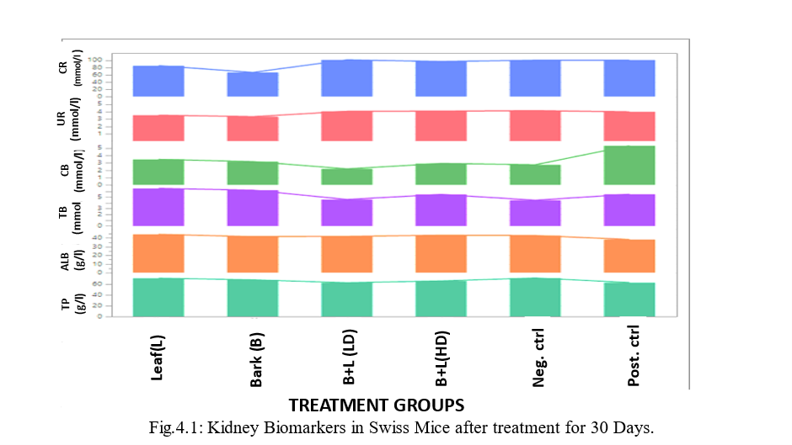
A B C D E F
TREATMENT GROUPS

Figure 1: Kidney biomarkers in Swiss mice after treatment with aspartame and Sacoglottis gabonensis for 30 days

Kidney biomarkers in Swiss mice after treatment with aspartame and Sacoglottis gabonensis for 60 days.
Fig 2 shows the level of kidney biomarkers for 60 days. There was a significant (P < 0.0001) difference in total protein (TP) levels across the treatment groups. Group A recorded the lowest mean value (51.00 ± 1.15 g/L), while Group F showed the highest mean value (87.00 ± 1.15 g/L). Albumin levels also differed significantly among groups (P < 0.0001), with the highest concentrations observed in Group F (49.67 ± 1.45 g/L) and group A had the lowest albumin concentration (32.00 ± 1.53 g/L). There was a significant difference in total bilirubin levels across the treatment groups. Groups B and F recorded the highest mean values (9.10 ± 0.20 µmol/L and 8.50 ± 0.20 µmol/L, respectively), while Group D exhibited the lowest level (4.03 ± 0.21 µmol/L), indicating a significant decrease in total bilirubin among some treatment groups. Urea levels were also significantly affected (P < 0.0001). The highest concentration was recorded in Group F (6.20 ± 0.44 mmol/L), while the negative control group (E) showed the lowest mean value (3.10 ± 0.30 mmol/L).. Similarly, there was a significant difference (P < 0.0001) in conjugated bilirubin levels between the positive control and other groups. Creatinine concentrations also differed significantly (P < 0.0001) across the groups. The mean values were 115.00 ± 1.15 µmol/L (Group A), 134.67 ± 2.60 µmol/L (Group B), 122.00 ± 1.73 µmol/L (Group C), 100.00 ± 1.15 µmol/L (Group D), 87.67 ± 1.45 µmol/L (negative control), and 144.67 ± 2.03 µmol/L (positive control).
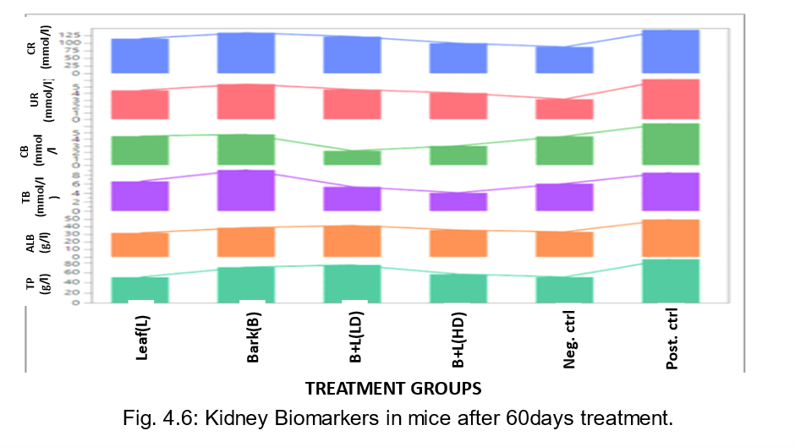Figure 2: Kidney biomarkers in Swiss mice after treatment with aspartame and Sacoglottis gabonensis for 60 days.
A B C D E F
TREATMENT GROUPS

Kidney Biomarkers in Swiss Mice after Treatment with Aspartame and Sacoglottis gabonensis for 90 Days
A significant (P < 0.01) difference was observed in total protein and Albumin levels across the treatment groups. Group A recorded the highest mean value of total Protein (69.00 ± 2.65 g/L), followed closely by group B with 68.00 ± 2.08 g/L, and lowest (55.33 ± 1.45 g/L)in group E. The concentration of Albumin concentration was highest ingroup B(45.33 ± 0.33 g/L) and lowest in group E (34.67 ± 2.03 g/L). Total bilirubin significantly increased (P < 0.0001) in group D 4.67 ± 0.09 µmol/L compared to 3.23 ± 0.09 µmol/L in group F. Conjugated bilirubin levels also varied significantly (P < 0.0001). Groups A and F had the joint highest mean value (2.47 ± 0.09 µmol/L) while group C recorded the lowest mean value (1.60 ± 0.06 µmol/L).
Urea levels showed significant differences (P < 0.0001) among the groups with group C having the highest value of 3.53 ± 0.20 mmol/L and 2.23 ± 0.07 mmol/L in group F. Creatinine concentration significantly (P < 0.0001) increased in group C (75.33 ± 1.45mmol/L) when compared to 53.33 ± 0.88 µmol/L in group F.
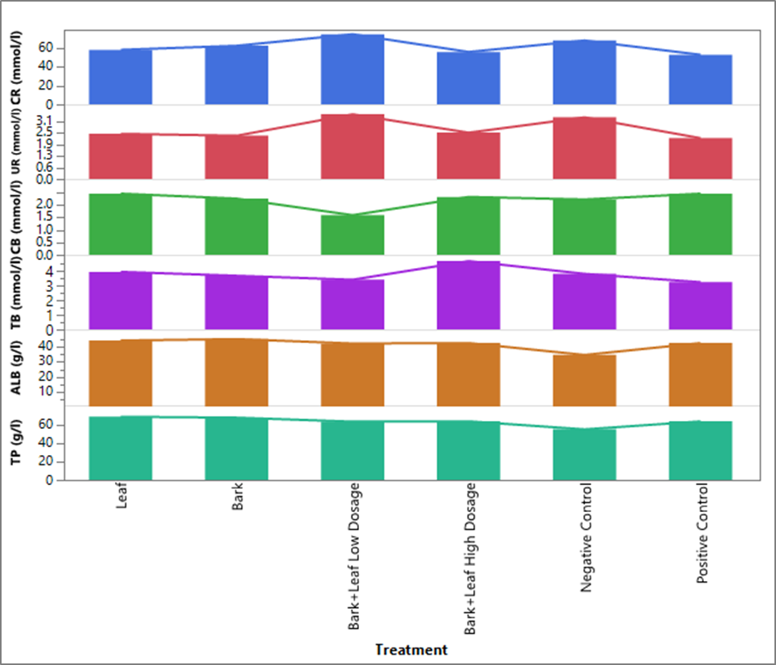
A B C D E F
TREATMENT GROUPS
Figure 3: Kidney biomarkers in Swiss Mice after treatment with aspartame and Sacoglottis gabonensis for 90 days

Combined monthly influence of treatment with aspartame and Sacoglottis gabonensis and duration interaction on kidney biomarkers in Swiss mice.
The combined influence of treatment and duration on these biomarkers is shown in Figure 4.24. A significant variation in total protein (TP) levels was observed across the different experimental periods, with the highest value recorded at 60 days in the positive control group, while the lowest values occurred at 60 days in group A and E. Albumin (Alb) levels also showed significant differences across the experimental periods, peaking at 60 days in group F and reaching the lowest value at 60 days in group A.
Similarly, total bilirubin (Tb) concentrations varied significantly across treatment duration, with the highest level at 60 days in group B and the lowest at 90 days in group C and F. Conjugated bilirubin levels differed significantly across experimental duration, attaining the highest value at 60 days in group F and the lowest at 90 days in group C. Urea concentrations also exhibited significant variation, with the highest mean at 60 days in group F and the lowest at 90 days in groups A,B, and D.
Creatinine levels varied significantly across the experimental periods, showing the highest concentration at 60 days in group F and the lowest at 90 days in groups D,E and F. Overall, there was a significant interaction effect between treatment and duration on kidney function biomarkers throughout the experimental period.

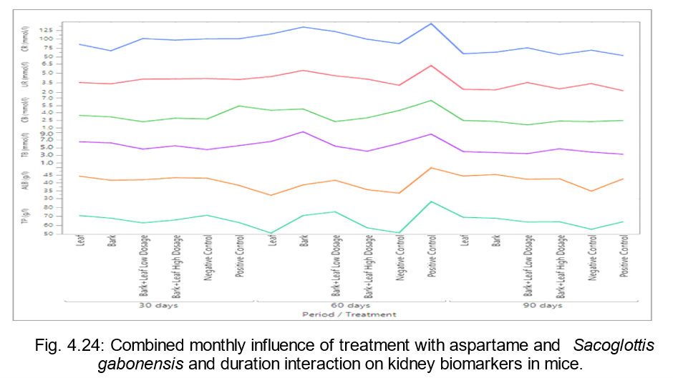Figure 4: Combined monthly influence of treatment with aspartame and Sacoglottis gabonensis and duration interaction on kidney biomarkers in Swiss mice.
A B C D E F

A B C D E F

A B C D E F

DISCUSSION
The kidney is an organ that is responsible for removing waste and extra fluid from the body, it also removes acid that is produced by the cells and maintain a healthy balance of water, salts and minerals. The present study evaluated the effect of co-administration of aspartame and Sacoglottis gabonensis extract on kidney function biomarkers (creatinine, urea, total bilirubin, albumin, and total protein) in male Swiss mice over a 90-day period. The pattern observed across the study duration revealed dynamic changes, suggesting both toxic and adaptive renal responses depending on treatment duration and extract composition.
Creatinine and urea levels, which are key indices of glomerular filtration efficiency, showed an increase at 60 days, particularly in group C, indicating transient renal stress or reduced clearance ability. However, the subsequent decline at 90 days suggests possible renal adaptation or partial recovery of kidney function. This trend implies that while prolonged aspartame exposure may initially compromise renal performance, [22] who reported an increase in serum urea, creatinine concentration in experimental animals after the administration of aspartame. Research by [15] demonstrated that long-term aspartame administration in rodents caused significant alterations in kidney biochemical parameters and histopathological damage, including tubular degeneration and glomerular atrophy [23]. However, the phytochemicals in S. gabonensis could exert a mitigating or nephroprotective effect through antioxidant and anti-inflammatory mechanisms. [23] showed that S. gabonensis extract exhibited hepatoprotective and nephroprotective effects in rats treated with carbon tetrachloride, likely due to its ability to enhance the activity of endogenous antioxidants and reduce lipid peroxidation.
Additionally, its use in traditional medicine includes treatment of fever, liver disorders, and inflammatory conditions, further supporting its role as a natural therapeutic agent with detoxifying potential. Albumin and total protein levels also showed fluctuations, with initial increases at 60 days followed by mild decreases at 90 days. Elevated albumin may reflect compensatory hepatic protein synthesis or early-stage renal filtration alterations, while the eventual decline may indicate stabilization of metabolic processes. The moderate changes in total bilirubin across groups suggest that S. gabonensis administration did not induce significant hepatic or biliary dysfunction, implying overall biochemical stability. The 60-day mark appeared to be a critical point of physiological stress, likely due to cumulative aspartame metabolism producing formaldehyde and methanol derivatives that transiently burden renal tissue. The observed normalization of biomarkers by 90 days, particularly in co-treated groups, supports the protective influence of S. gabonensis bioactive compounds such as polyphenols, tannins, and flavonoids, which are known for scavenging free radicals and supporting renal homeostasis. These findings align with previous reports that aspartame exposure can cause oxidative damage to renal tissues, while plant-derived antioxidants offer modulatory protection. The combined use of S. gabonensis may thus offset the nephrotoxic effects of aspartame through improved antioxidant status and stabilization of metabolic processes.

Conclusion
The co-administration of Sacoglottis gabonensis extract and aspartame in Swiss mice produced time-dependent alterations in kidney biomarkers. The transient elevation in creatinine, urea, and protein levels at 60 days suggests temporary renal stress, while the subsequent normalization by 90 days indicates adaptive or protective effects of the plant extract. Overall, S. gabonensis demonstrated a potential nephroprotective role, mitigating the adverse biochemical effects induced by aspartame. These results highlight the importance of natural antioxidants in preserving renal integrity under chemical stress. Further histopathological and molecular investigations are recommended to confirm the mechanisms underlying this protective effect.
References
1. Swithers, S.E., Baker, C.R. and Davidson, T.L. (2009). General and persistent effects of high-intensity sweeteners on body weight gain and caloric compensation in rats. Behavioral Neuroscience, 123(4), 772 (2009). https://doi.org/10.1037/a0016139
2. Polyák, É., Gombos, K., Hajnal, B., Bonyár-Müller, K., Szabó, S., Gubicskó-Kisbenedek, A., Marton, K.and Ember, I. (2010) Effects of artificial sweeteners on body weight, food and drink intake. Acta Physiologica Hungarica, 97(4), 401-407 (2010). https://doi.org/10.1556/aphysiol.97.2010.4.9
3. Lohner, S., Toews, I. and Meerpohl, J.J.(2017). Health outcomes of non-nutritive sweeteners: analysis of the research landscape. Nutrition Journal, 16(1), 1-21. 2017). https://doi.org/10.1186/s12937-017-0278-x
4. Swithers, SE. Artificial sweeteners produce the counterintuitive effect of inducing metabolic derangements. Trends Endocrinol Metab. (2013) 24:431–41. doi: 10.1016/j.tem.2013.05.00
5.Curhan, GC, and Forman, JP. Sugar-sweetened beverages and chronic disease. Kidney Int. (2010) 77:569–70. doi: 10.1038/ki.2009.543
6. Debras, C, Chazelas, E, Sellem, L, Porcher, R, Druesne-Pecollo, N, Esseddik, Y, et al. Artificial sweeteners and risk of cardiovascular diseases: results from the prospective NutriNet-Santé cohort. BMJ. (2022) 378:e071204. doi: 10.1136/bmj-2022-071204
7. Bigal, ME, and Krymchantowski, AV. Migraine triggered by sucralose—a case report. Headache. (2006) 46:515–7. doi: 10.1111/j.1526-4610.2006.00386
8. Newman, LC, and Lipton, RB. Migraine MLT-down: an unusual presentation of migraine in patients with aspartame-triggered headaches. Headache. (2001) 41:899–901. doi: 10.1111/j.1526-4610.2001.01164.x
9. Ahmad, SY, Friel, JK, and Mackay, DS. Effect of sucralose and aspartame on glucose metabolism and gut hormones. Nutr Rev. (2020) 78:725–46. doi: 10.1093/nutrit/nuz099
10. Debras, C, Chazelas, E, Srour, B, Druesne-Pecollo, N, Esseddik, Y, Szabo de Edelenyi, F, et al. Artificial sweeteners and cancer risk: results from the NutriNet-Santé population-based cohort study. PLoS Med. (2022) 19:e1003950. doi: 10.1371/journal.pmed.1003950
11 Czarnecka K, Pilarz A, Rogut A, Maj P, Szymańska J, Olejnik Ł. and Szymańsk,P. (2021) . Aspartame-true or false? Narrative review of safety analysis of general use in products. Nutrients. 13:1957. 10.3390/nu13061957. [DOI] [PMC free article] [PubMed]
- Belpoggi F, Soffritti M, Padovani M, Degli Esposti D, Lauriola M, and Minardi F (2006). Results of long-term carcinogenicity bioassay on Sprague-Dawley rats exposed to Aspartame administered in feed. Ann N Y Acad Sci,1076:559–77. doi: 10.1196/annals.1371.080.
13 Iyyaswamy, A., & Rathinasamy, S. (2012). Effect of chronic exposure to aspartame on oxidative stress in the brain of albino rats. Journal of Biosciences, 37(4), 679–688. https://doi.org/10.1007/s12038-012-9248-1
14 Ardalan, MR, Tabibi H, Ebrahimzadeh Attari V, Malek Mahdavi A. Nephrotoxic effect of Aspartame as an artificial sweetener: a brief review. Iran J Kidney Dis. 2017;11:339–43
- Abhilash, M., Sauganth Paul, M. V., Varghese, M. V., & Nair, R. H. (2013). Effect of long-term intake of aspartame on antioxidant defense status in liver. Food and Chemical Toxicology, 51, 222–226. https://doi.org/10.1016/j.fct.2012.10.017
- Wekhe-Emenike, A., Obulor, A.O. and Orlu,E.E. (2022). Influence of Sacoglottis gabonensis Ethanolic Extract on the Electrolytes of Swiss Mice Administered Aspartame. Asian Journal of Biochemistry, Genetics and Molecular Biology, 11(4), 35-42,
- Bandyopadhyay, A., Ghoshal, S., & Mukherjee, A. (2008). Genotoxicity testing of low-calorie sweeteners: Aspartame, acesulfame-K, and saccharin. Drug and Chemical Toxicology, 31(4), 447–457. https://doi.org/10.1080/01480540802494483.
- Ashok, I.; Sheeladevi, R. Oxidant Stress Evoked Damage in Rat Hepatocyte Leading to Triggered Nitric Oxide Synthase (NOS) Levels on Long Term Consumption of Aspartame. J. Food Drug Anal. 2015, 23, 679–691.
- Sharma, A., Gulati, S., & Malla, R. (2018). Protective effects of natural antioxidants against aspartame-induced toxicity: A review. Journal of Food Biochemistry, 42(5), e12582. https://doi.org/10.1111/jfbc.12582
- Lowry, O.H., Rosebrough, N.J., Farr, A.L. & Randall, R. J. (1951). Total protein estimation by Lowry’s method. Journal of Biology and Chemistry, 193, 265
- Doumas, B.T., Watson, W.A. & Biggs, H.G. (1971). Albumin standards and measurement of serum-albumin with bromocresol green. Clinical ChimicaActa Journal, 31, 87-92.
- Abdelmonem, G., Madboly, M. D., Eslam, S., Metwally, M. D., Ghada, A. and Abd El-Fattah, M. D. (2019). Nephrotoxicity of Tow Food Additives (Aspartame and Monosodium Glutamate) in Adult Albino Rats: Biochemical and Histopathological Effects. Journal of Environmental Science, Toxicology and Food Technology, 13, (4) 1, 20-29.
- Udeh, N. E., Eze, G. I., & Okeke, E. C. (2017). Protective effects of Sacoglottis gabonensis bark extract on carbon tetrachloride-induced liver and kidney damage in rats. Nigerian Journal of Biochemistry and Molecular Biology, 32(1), 45–52.

