A RETROSPECTIVE STUDY AND THE RISK FACTORS OF LASSA FEVER INFECTION IN SOME SELECTED STATES IN THE NORTH CENTRAL ZONE OF NIGERIA.

ABSTRACT
Lassa fever is an acute rodent borne viral hemorrhagic fever which is caused by contacts with the multi-mammate rat, Mastomys natalensis which is commonly found in human households, eaten as a delicacy in several African countries and lives in close contact with humans. The aim of the study is to carry out a retrospective study and risk factors of Lassa fever infection in some selected States in the North Central zone of Nigeria. Purposive sampling was used in selecting 3 States in North Central Nigeria. Based on rodent availability, Benue, Nasarawa and Plateau States were selected. Ethical report was obtained from the Federal Ministry of Health Headquarters, Abuja, Nigeria. Secondary data were obtained from NCDC Intergrated Disease Surveillance and Response (IDSR) records in Nigeria from 2016-2019. Hundred (100) closed-ended and well-structured questionnaires were administered randomly to students, clinicians, farmers and members of the public within Benue, Nasarawa and Plateau States. Data were generated based on participant response on Lassa fever Infection from the 3 selected States under the study. Chi square tool was used to analyze the level of significance between the States and the years under the study. Values below p < 0.05 were considered insignificant. The total prevalence in the three states in 2016 were 27.3%, 17.5% in 2017, 9.5% in 2018 followed by a spike in the number of recorded cases at 45.7% in 2019. A total of 68.06% of the patients survived while 15.25% of the patients died during this period. A total of 23.76% of the patients were within 31 – 40 years old. There was no significant difference (P=0.01) between the age group of patients and the outcome of cases during the period under study. Five-point Likert scale was used to analyze the questionnaire. Observed means greater than 3.0 indicated that the respondents agreed with the question and if less than 3.0, the respondent disagreed with the question. Thirty-one percent (31%) of the respondents agreed that they would be willing to take a vaccine against Lassa fever infection once it is available. In conclusion, the prevalence of Lassa fever infection in the north central region of Nigeria remains a burden and a more realistic and time bound approach need to be put in place by policy makers and other stakeholders in order to curb the spread of the virus. Personal and environmental hygiene remains the first and most effective line of defense against Lassa fever infection. Provision of food storage facilities and adequate safety measures in food and water consumption will aid in the reduction of outbreak of the viral infection.

INTRODUCTION

Nigeria is one of the Lassa fever virus disease endemic countries in West Africa and reports indicate that it may account for up to 6% of febrile admissions in endemic areas in the country (Omilabu et al., 2005). Its initial clinical manifestations are difficult to differentiate from those of other common febrile illnesses such as malaria (Okokhere et al., 2013). Every year, approximately 100, 000 – 300, 000 people contract Lassa virus and 5,000 people die from the infection (WHO, 2017). Due to its potential for zoonotic and human transmission as well as difficulties in treatment and prevention, Lassa fever virus is one of the high-priority pathogens identified on the WHO (R and D) Blueprint (CDC, 2017; WHO, 2017).
Lassa fever is a viral hemorrhagic fever endemic to countries in West Africa which includes Nigeria, Benin, Ghana, Guinea, Liberia, Mali and Seirria Leone (CDC, 2018), placing 2 million persons per annum at risk of becoming infected, with 5,000–10,000 fatalities annually (Frame et al., 1970). It is a zoonotic disease whose animal reservoir is the ‘multi-mammate rat’, a rodent of the genus Mastomys, which shed virus in their urine and faeces (WHO, 2018).
Lassa virus (LASV, Arenaviridae) is the causative agent of Lassa fever (LF), which is a systemic infectious disease that can lead to acute hemorrhage, as well as neurological disorders (McCormick, 1999). Due to international travel, LF poses a significant risk to both visitors to endemic countries and populations in non-endemic regions (McCormick, 1999). Lassa fever was brought to the consciousness of the medical community world-wide when a nurse became infected in 1969 while working in a small missionary hospital at Lassa town in North East Nigeria (Frame et al., 1970).
According to the World Health Organization, the current outbreak of Lassa fever in Nigeria re-emerged on December 2016 and involved 17 States of Nigeria (WHO, 2018). In June 2017, there were a total of 501 suspected cases including 104 deaths with a Case Fatality Rate (CFR) of 21% (WHO, 2017). In August 2017, two cases of Lassa fever were also reported in Lagos State in adults, both of whom died (WHO, 2018). The recent 2018 outbreak in Nigeria saw 423 confirmed cases with a CFR of 25% (WHO, 2018) and a higher CFR of up to 50%–70% have been reported (WHO, 2017).
Most infections with Lassa virus in Africa are asymptomatic, mild or subclinical, but case fatality in hospitalized patients can be as high as 15–25% (Isa et al., 2013; Shehu et al., 2018). Clinical manifestations are variable and often nonspecific as many of those are seen in other febrile infectious diseases in endemic areas. The incubation period of Lassa fever is between 3 -21 days (Shehu et al., 2018).
About 80% of human infections are without symptoms while the remaining cases have severe multiple organ disease affecting several organs in the body such as the liver, spleen and kidneys. According to the WHO (2016), the onset of the disease, when it is symptomatic is usually gradual, starting with fever, general weakness, muscle and joint pains, prostration, and malaise. After a few days, headache, sore throat from pharyngitis, muscle pain, retrosternal pain, nausea, vomiting, diarrhea, cough, and abdominal pain may follow. Hearing loss is common in adults (among those who survive, about a quarter have deafness which improves over time) (WHO, 2016).
Spontaneous abortion and birth defects have been documented (Shehu et al., 2018). When Lassa fever infects pregnant women late in their third trimester, induction of labor is necessary for the mother to have a good chance of survival (Isa et al., 2013). This is because the virus has an affinity for the placenta and other highly vascular tissues. The fetus has only a one in ten chance of survival no matter what course of action is taken (Isa et al., 2013). Following delivery, women should receive the same treatment as other Lassa fever patients (Ogbu et al., 2007). In severe cases, facial edema, pulmonary edema, bleeding from the mouth, nose, vagina, or GI tract, and low blood pressure may develop. Shock, seizures, tremor, disorientation, and coma may be seen in the later stages. The virus is excreted in urine for 3–9 weeks and in semen for 3 months (Ogbu et al., 2007).

Statement of the Problem

Despite concerted efforts by the government and international organizations towards prevention and control of Lassa fever, the disease continues to increase in high proportion. There is need to carry out a retrospective study of the disease in endemic areas to determine the impact of the infection.

The incidence of Lassa fever in past years in Nigeria in the endemic areas has been devastating. It has caused heavy economic burden, high morbidity and mortality in the country. A retrospective study is necessary to ascertain the levels of social and health burden of the disease in endemic areas.

Due to poorly collected data and follow-up to ascertain the survival and mortality rate of the disease, a retrospective study is essential to determine the survival and death rate of patients who have been diagnosed of Lassa fever infection after being exposed to treatment.

Despite the epidemic risk, little is known about the distribution of Lassa fever in the North central States of Nigeria. The circulating virus in Nigeria has been reported to be more diverse and genetically distinct than the virus seen elsewhere (Robinson et al., 2016).

Justification
The findings will help us to understand the nature of spread of the virus across age groups and gender to enable stakeholders ascertain major predisposing factors and mode of transmission of the disease in the environment.
The prevalence and predictors of Lassa fever in North Central States of Nigeria is not yet public knowledge. Data from this study will be documented for policy makers and stakeholders to utilize.

Subsequently a retrospective study of Lassa fever virus infection in the areas under study will provide information to ascertain if various government-sponsored programmes and their implementations have had any effect in curbing the spread of the disease in endemic areas.

The findings will add to the existing data on Lassa fever infection in Nigeria.

Aim of the Study

The aim of this study is to carry out a retrospective study and risk factors of Lassa fever infection in some selected States in the North Central zone of Nigeria.

Objectives of the Study
- To determine the prevalence of Lassa virus infections in North Central States of Nigeria within the period 2016-2019.
- To determine the outcome (survival and deaths) of Lassa fever infection in the North Central States of Nigeria within the period 2016-2019.
- To compare the prevalence of Lassa fever infection in the North Central States of Nigeria within 2016-2019.
- To investigate the distribution of Lassa fever in relation to age and sex of the patients in the North Central States of Nigeria.
- To determine the Knowledge, Attitude and Practices (KAP) as regarding Lassa virus Infection of people in the North Central States of Nigeria.
Research Questions
- What is the recorded prevalence of Lassa fever infection in the North Central States of Nigeria?
- What are the recorded outcomes (survival rate) of Lassa fever infection in the North Central States of Nigeria?
- Are there any differences in the age of Lassa fever patients in the North Central States of Nigeria?
- Are there any differences in the gender of the Lassa fever patients in the North Central States of Nigeria?
- How knowledgeable about Lassa fever infection are the residents of the North Central States of Nigeria?

MATERIALS AND METHODS
Study Area
The study was carried out in the North Central zone of the country which consists of Nasarawa State, Benue State, Plateau State, Niger State, Kogi State, Kwara State and the Federal Capital Territory (FCT).
Nasarawa State lies between latitude 7º 45’ and 9º 25’ of the equator and longitude 7º and 9º 37’ of the Greenwich meridian. It has a total land area of 27,137.8 sq.km and a population size of 1,869,377 (NPC, 2006). Niger state lies between latitude 8º and 11ºN and longitude 3º and 7ºE of the prime-time meridian with a population size of 3,950,429 in 2006 (NPC, 2006). Benue State lies between latitude 6º30’ and 8º24’ N, longitude 7º40’ and 10º00’E with a land mass of 31,400sq.km and a population size of 4,253,641 by 2006 population census (Hilhorst et al., 2006). Kogi State lies between latitude 6º30N and 8º42N and longitude 5º18E and 7º54E with a land mass of approximately 28,312 Km². It has a population size of 3,314,043 (NPC, 2006). Kwara State lies between latitude 7ºN and 12ºN and longitude 3ºE and 7ºE and with a population size of 2,365,353 in 2006 (NPC, 2006). Plateau State is located between longitude 8º40’ and 9º50’E and latitude 9º and 10º45’N. These six states surround the Federal Capital Territory (FCT), Abuja (Fig. 1).
The people of Nasarawa State commonly speak Hausa, other tribes include Eggon, Gbagyi, Gwandara, Kanuri, Basa, Ebira and so on. The indigenes of Benue State are predominantly Tiv, Idoma, Igede, Abakpa, Etulo, Jukun, Nyifon and Akweya. Plateau State indegienes are Berom, Afizere, Amo, Jarawa (Jarauci), Buji, Tarok, Challa, Fulani, Taroh (Tarok) and Jukun (CRS, 2007).

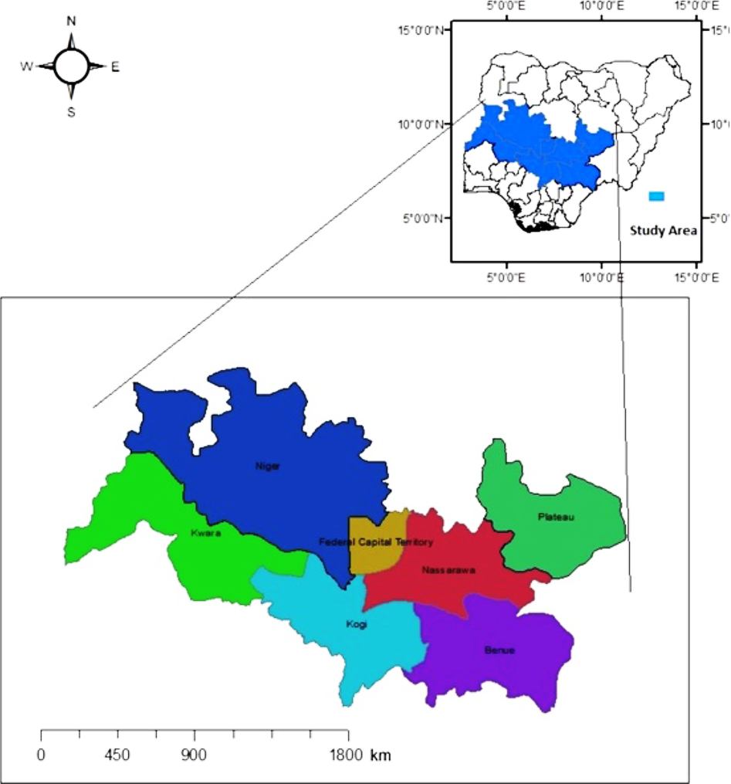
Figure 1: Map of the Study Area (Alhaji and Yatswako, 2017)
Research Design and Sampling
This study is a retrospective study of the occurrence of Lassa fever in the North Central States of Nigeria. Purposive sampling was used in selecting the 3 states in North Central Nigeria. Based on rodents’ availability, Benue, Nasarawa and Plateau States were the states selected during the course of this study.
Questionnaire Survey
Hundred (100) closed-ended structured questionnaires were administered randomly to students, clinicians, farmers and members of the public within Benue, Nasarawa and Plateau States. Data was generated based on participant response on Lassa fever Infection from the 3 selected states under the study.
All the participants responded to the questionnaire administered to them promptly. Information obtained was based on socio-demographic characteristics, knowledge on Lassa fever infection and Awareness of infection among others.
The Hypothesized mean, standard deviation, and frequency distribution from the respondents shows the decision is either Accepted or Rejected. Therefore, any observed mean that is greater than 3.0, indicated that the respondents Agreed with the question and if the observed mean is less than 3.0, the respondents disagreed with the question.
Study Population
The study population was a secondary data obtained from the Lassa fever specific Integrated Disease Surveillance and Response (IDSR) records in Nigeria from 2016-2019. IDSR weekly epidemiological data line-list for the years under review was obtained from the Surveillance and Epidemiology Department, Nigeria Center for Disease Control (NCDC). The variables reported were; State of residence, and Lassa fever classification based on laboratory diagnosis (suspected, confirmed).
Collection and Analysis of data
Weekly epidemiological reports covering Lassa fever endemicity in the North Central region from 2016 to 2019 was obtained from the Nigeria Center for Disease Control (NCDC). The data was analyzed for prevalence and significant difference in the prevalence (p < 0.05; 95% CI).

RESULTS
4.1 The Prevalence of Lassa fever in North Central Geopolitical Zone.
The prevalence of LASV in Benue was 0.00%, 0.00%, 3.34% and 8.07% for the year 2016, 2017, 2018 and 2019 respectively. In Nasarawa State the prevalence of LASV was 45.88%, 52.3%, 35.60% and 9.47% for the year 2016, 2017, 2018 and 2019 respectively. While in Plateau State, the prevalence of LASV was 54.12%, 47.70%, 61.06% and 82.46% for 2016, 2017, 2018 and 2019 respectively, (Table 1).

Table 1: Prevalence of Lassa fever in North Central Geopolitical Zone.

State 2016 2017 2018 2019
Cases % Cases % Cases % Cases %
(n) (n) (n) (n)
Benue 0 0.00 0 0.00 2 3.34 23 8.07
Nasarawa 78 45.88 57 52.3 21 35.6 27 9.47
Plateau 92 54.12 52 47.7 36 61.6 235 82.46
Total 170 100 109 100 59 100 285 100

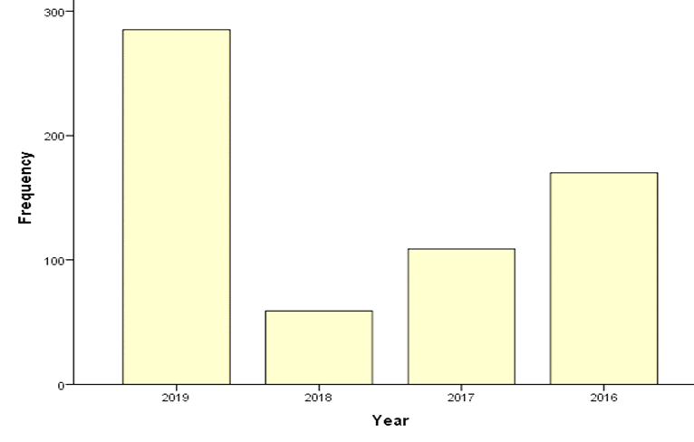
Fig 2 Overall Prevalence of Lassa fever infection in Plateau, Benue and Nasarawa States per year from 2016-2019.

4.2 The outcome (Survival/Death rate) of cases of Lassa Fever Infection in the States under study.
Table .2 shows the recorded outcome of Lassa Fever Infection in Nasarawa, Benue and Plateau States during the period under study. The total number of patients who recovered in the three states during the period under study is 424. Benue state had 0.47%, Nasarawa State had 22.41% while Plateau State had 77.12%. The total number of patients who died during the period under study in the three States was 95. Benue State recorded 2.11%, Nasarawa State recorded 41.05% while Plateau State recorded 56.84%. However, from the data collected there were cases with no recorded outcomes. The total number of cases with no outcomes is 104. Benue State had 20.20%, Nasarawa State had 46.15% while Plateau State had 33.65%.

Table 2: Outcome of cases by State within 2016-2019.
Outcome
State Total Recovered Death No outcome
No of cases No % No % No %
Benue 25 2 0.47 2 2.11 21 20.20
Nasarawa 182 95 22.41 39 41.05 48 46.15
Plateau 416 327 77.12 54 56.84 35 33.65
Total 623 424 100 95 100 104 100

Figure 3 The graph shows the outcome of cases during the period under study.

4.3 A comparism of the prevalence of LASV in the 3 states per year under the study.
Table .3 shows the comparism of the recorded prevalence in the three States under the study between years 2016-2019. In 2016, 2018 and 2019, Plateau State recorded the highest prevalence while in 2017 Nasarawa State recorded the highest prevalence. The graphical illustration of the prevalence of LASV in Benue, Nasarawa and Plateau States are shown in the figures below.

Table 3: Table showing the comparism of the prevalence of LASV in Benue, Nasarawa and Plateau states between 2016-2019
Year
States 2016 2017 2018 2019
Cases (n) % Cases (n) % Cases (n) % Cases (n) %
Benue 0 0.00 0 0.00 2 3.33 23 8.07
Nasarawa 79 46.20 55 51.40 21 35.00 27 9.47
Plateau 92 53.80 52 48.60 37 61.67 235 82.46
Total 171 100 107 100 60 100 285 100

Figure 4.: The graph shows the number of cases per State for year 2016.

Figure 5: The graph shows the number of cases per State for year 2017.

Figure 6: The graph shows the number of Cases per State for Year 2018

Figure 7: The graph shows the number of Cases per State for Year 2019.

4.4 Age distribution of Lassa Fever Infected Patients during the period under study.
Table 4 shows the age distribution of patients in the three states during the period under study. The ranges used for the age distribution include 1-10, 11-20, 21-30, 31-40, 41-50, 51-60, 61-70, 71-80, 81-90. The highest recorded number of cases fell within 31-40 years age range with a total number of 148 recorded cases while the age groups with the lowest number of patients were 71-80 and 80-90 which had one (1) case each recorded during the years under this study. Chi square value showed that there was significant relationship between Lassa fever infection and age of patients during the period under study where p < 0.05.

Table 4: The table shows the age distribution of the infected patients.
Age Range | Number of patients | Percentage % P-value
1 – 10 | 114 | 18.30 0.01
11 – 20 | 126 | 20.22
21 – 30 | 144 | 23.11
31 – 40 | 148 | 23.76
41 – 50 | 53 | 8.51
51 - 60 | 24 | 3.85
61 – 70 | 12 | 1.93
71 – 80 | 1 | 0.16
81 – 90 | 1 | 0.16
Total | 623 | 100

P < 0.05.

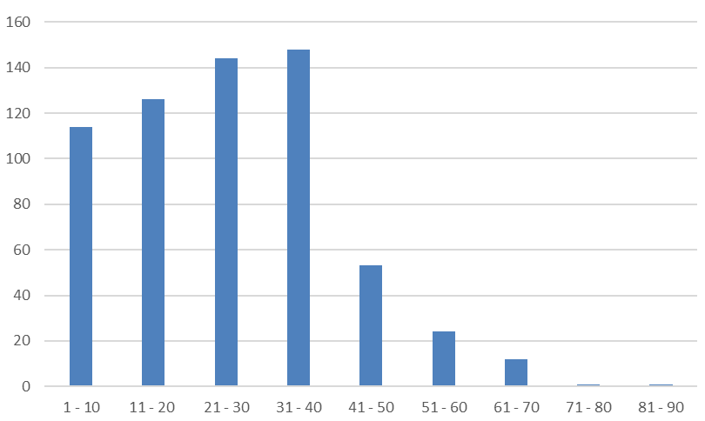
Figure 8: The graph shows the age distribution of infected patients during the period under study.

4.5 Sex distribution of LASV during the period under study.
Figure 9 shows the graphical illustration of the sex of LASV patients in Benue, Nasarawa and Plateau States during the period under study. The data obtained from NCDC showed that a total of 225 patients were females while 313 were males. There was no significant difference between sex of patients and Lassa fever infection, P > 0.05.

Table .5 Showing the Sex Distribution of LASV Patients in the three states under study.

Sex Total no. of patient in the Percentage P-value
3 states under the study.
(n) (%)
Male 313 58.18 0.132
Female 225 41.82
Total 538 100
P > 0.05

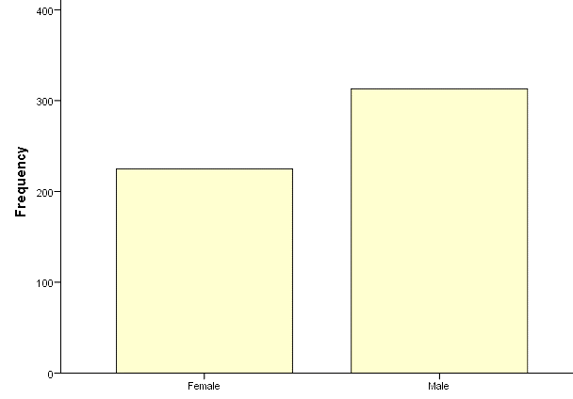
Sex
Figure 9: The graph shows the sex distributions of patients during the period under study.

4.6 Socio-demographic characteristics of the respondents.
Table 6 shows the socio-demographic characteristics of the respondents to the questionnaire administered across the 3 states under the study. A total number of 100 participants were involved in this study. Benue State had 31 respondents, Nasarawa and Plateau States had 40 and 29 respectively, 49 of the participants were from Urban Areas while 51 participants were from rural settlements. A total of 67% of the respondents from Benue, Nasarawa and Plateau States collectively were between ages 19-40 years while 51% of the respondents were single/ unmarried, 53% of the respondents had tertiary education and 51% of the respondents had between 1-5 years of working experience.

Table 6: Socio-demographic characteristics of the respondents
Characteristics Frequency (n) Percentage (%)
State
Benue 31 31.0
Nasarawa 40 40.0
Plateau 29 29.0
Settlement (Benue, Nasarawa and Plateau States).
Urban 49 49.0
Rural 51 51.0
Gender (Benue, Nasarawa and Plateau States).
Male 46 46.0
Female 54 54.0
Age group (Benue, Nasarawa and Plateau States).
0-10 Years 6 6.0
11-18 Years 11 11.0
19-40 Years 67 67.0
41-Above 16 16.0
Marital Status (Benue, Nasarawa and Plateau States).
Single 51 51.0
Married 39 39.0
Widow 3 3.0
Divorced 4 4.0
Separated 3 3.0

Characteristics Frequency (n) Percentage (%)
Educational Level (Benue, Nasarawa and Plateau States).
Primary 17 17.0
Secondary 17 17.0
Tertiary 53 53.0
Informal 13 13.0
Occupation (Benue, Nasarawa and Plateau States).
Student 20 20.0
Clinician 7 7.0
Farmer 14 14.0
Religious leader 5 5.0
Teacher 9 9.0
Others 45 45.0
Working Experience (Benue, Nasarawa and Plateau States).
Less than 1 year 21 21.0
1-5 years 51 51.0
6 years and above 28 28.0

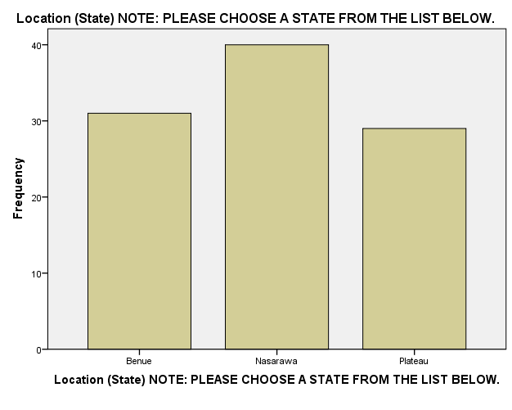
State

Figure 10: Chart showing the state distribution of respondents.

s
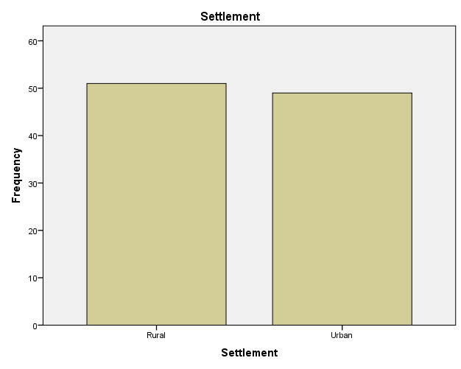
Settlement

Figure 11: Chart showing the Settlement distribution of respondents.

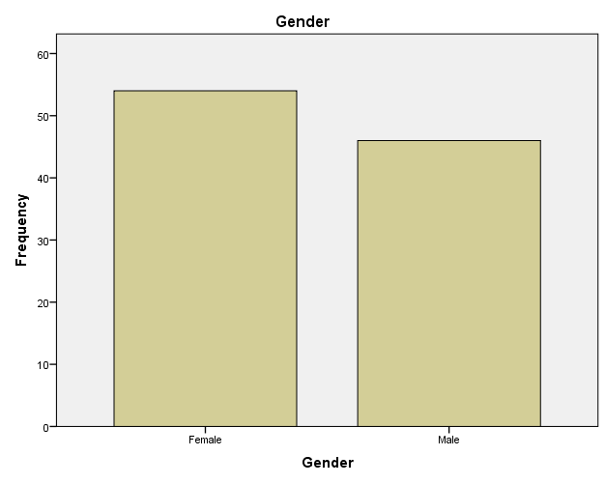

Figure 12: Chart showing the Gender distribution of respondents.

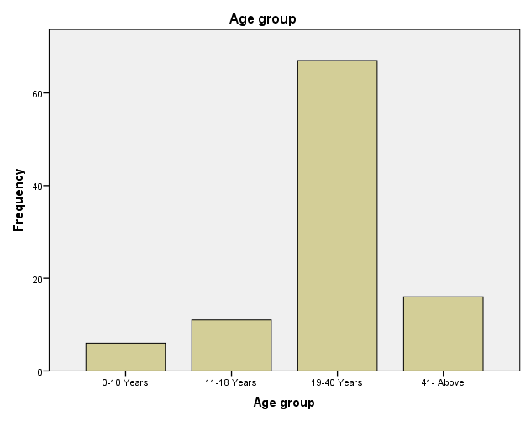

Figure 13: chart showing Age distribution of respondents.

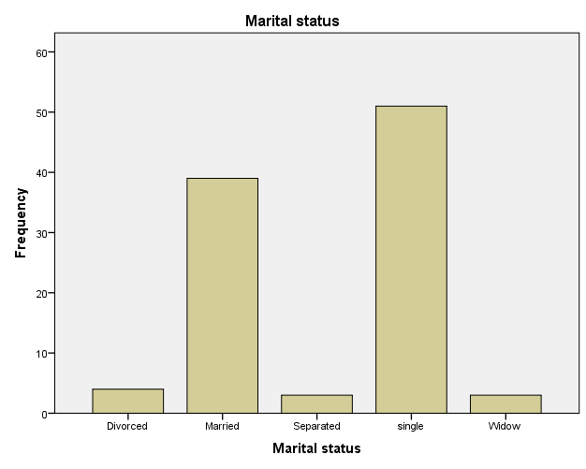

Figure 14: Chart showing marital status of respondents.

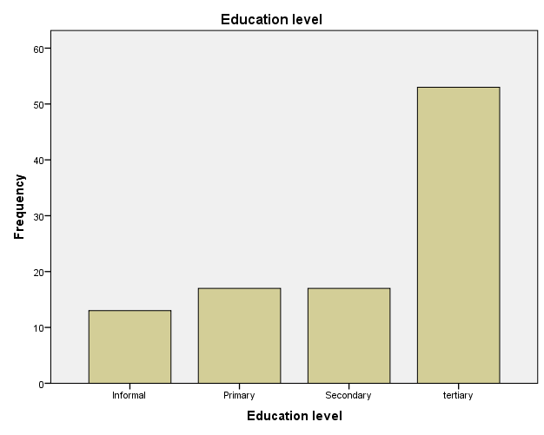

Figure 15: Chart showing Education level of respondents.

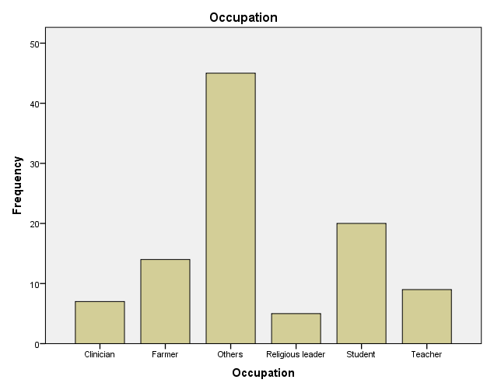

Figure 16: Chart showing Occupation of respondents.

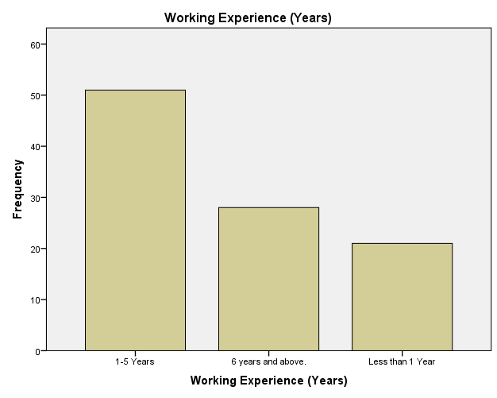

Figure 17: Chart showing Working experience of respondents.

4.7 Knowledge, Attitude and Practices of Respondents on Lassa fever Infection.
Table 6 shows the various questions asked in the questionnaire and the feedback obtained from respondents. The level of acceptance ranged from “Strongly agree” (SA), “Agree” (A), “Neutral” (N), “Disagree” (DA) and “Strongly disagree” (SDA). A total of 44% of the respondents agreed that Lassa fever infection exists while 39% of the respondents agree that they will be willing to take a vaccine if available to curb spread of the virus. While 50% of the respondents’ burn and dispose their wastes and refuse frequently.

Table 7: Knowledge, Attitude and Practices of respondents on Lassa fever infection.
Question SA A N DA SDA Total
Lassa Fever Infection exist. 42 44 10 2 2 100
There are rats or rodents 30 34 19 12 5 100
around my house.

I eat rats or rodents. 13 17 11 24 35 100
I have contact with urine, 5 39 8 33 15 100
Faeces, etc. of rodents.

Lassa fever is caused by 27 45 20 4 4 100
a virus.

I always wash my kitchen 35 47 14 3 1 100
utensils before use to avoid
contamination.

I will be willing to take a Vaccine 23 39 29 6 3 100
against Lassa fever infection.

I will show some discriminatory 19 25 20 24 12 100
attitude towards people who are
infected with Lassa fever.

I clear and burn the refuse in my 33 50 13 2 2 100
surroundings frequently.

I store foodstuff in closed buckets 34 44 18 3 1 100
and containers.

Key:
“SA”- Strongly Agree
“A” - Agree
“N” - Neutral
“DA”- Disagree
“SDA”- Strongly Disagree

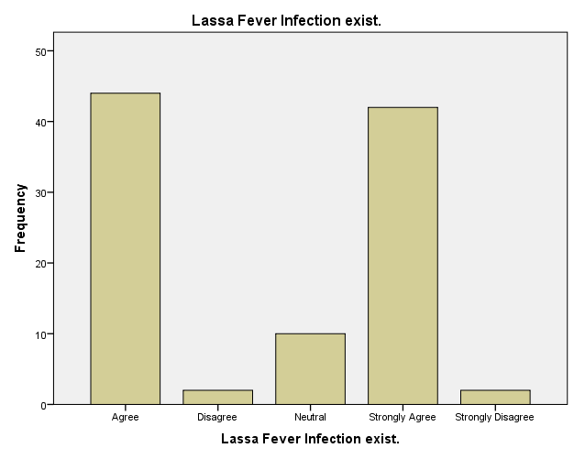

Figure 18: Chart showing respondent’s knowledge, attitude, and practices on Lassa fever infection.

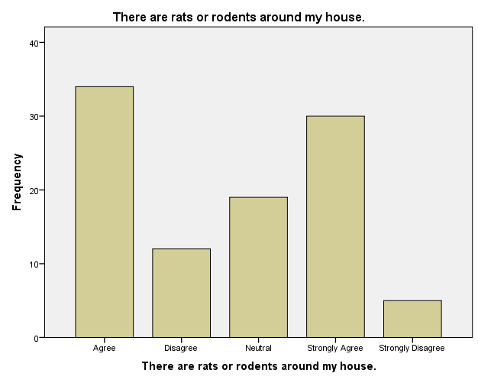

Figure 19: Chart showing that there are rats or rodents around the respondent’s house and environment.

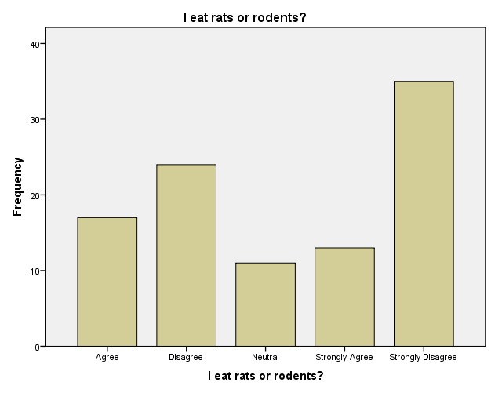
Figure 20: Chart showing the respondents knowledge and attitude on rats or rodents consumption.

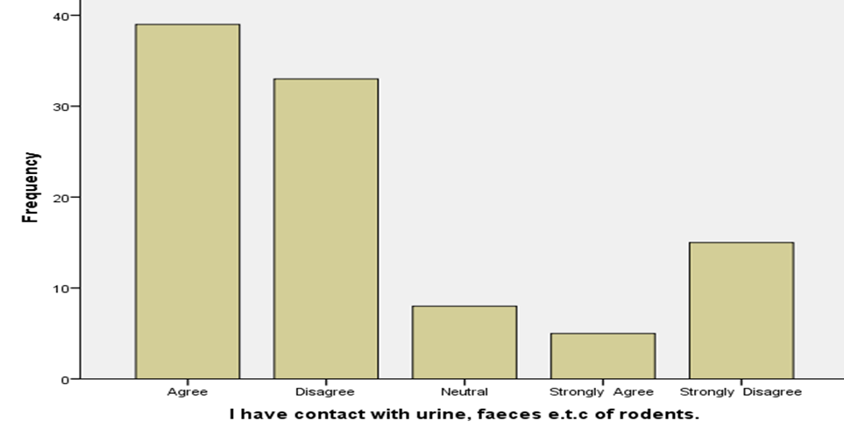

Figure 21: Chart showing respondents knowledge and attitude on having contact with urine, faeces etc. of rodents.

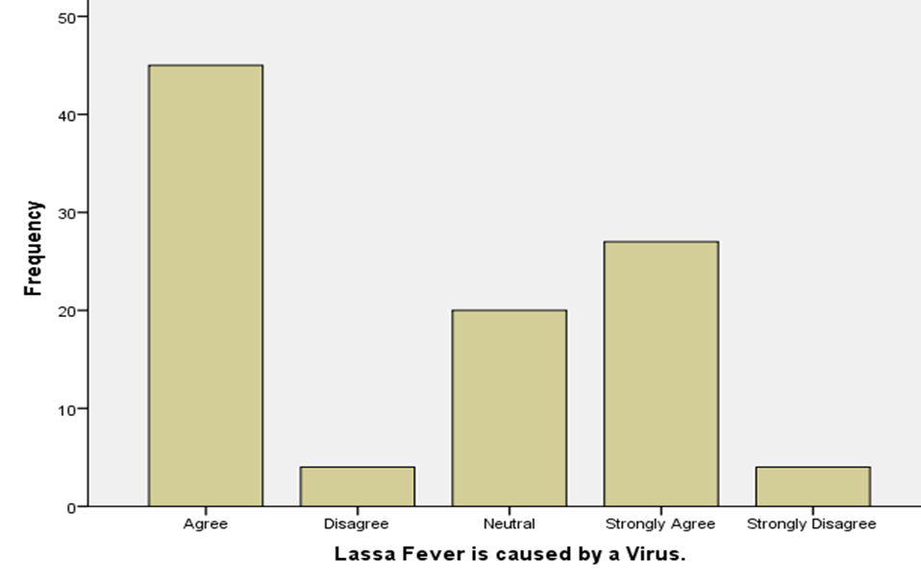

Figure 22: Chart showing respondents knowledge and attitude that Lassa fever is caused by a virus.

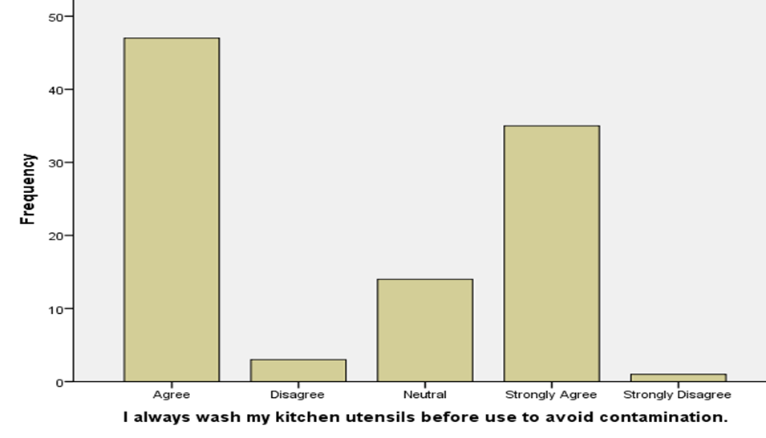

Figure 23: Chart showing respondents knowledge and attitude on washing of kitchen utensils before use to avoid contamination.

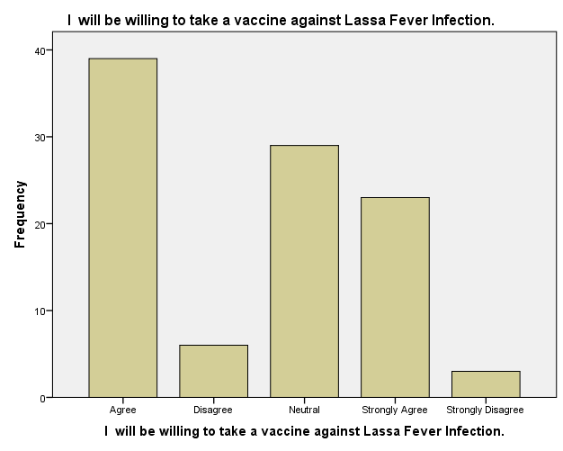
Figure 24: Chart showing respondents willingness to take a vaccine against Lassa fever infection.

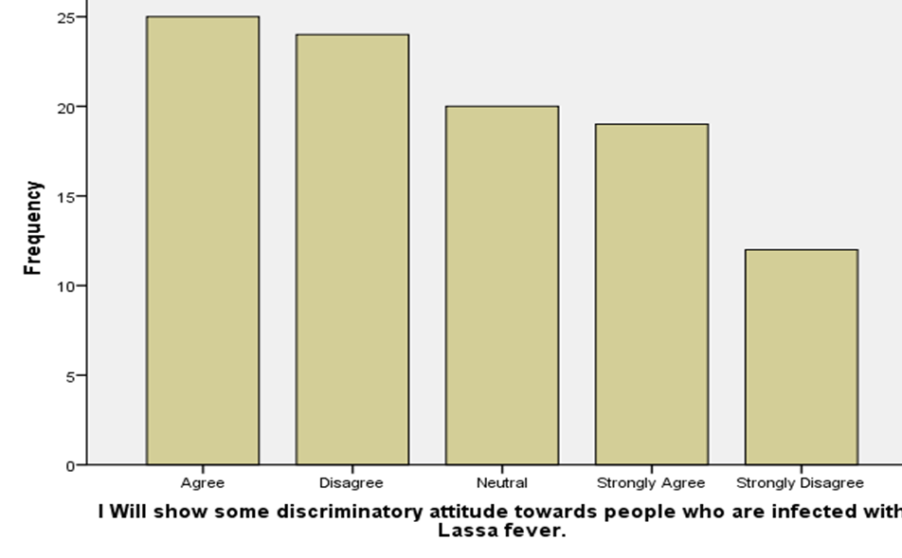

Figure 25: Chart showing respondents knowledge on some discriminatory attitude towards people who are infected with Lassa fever.

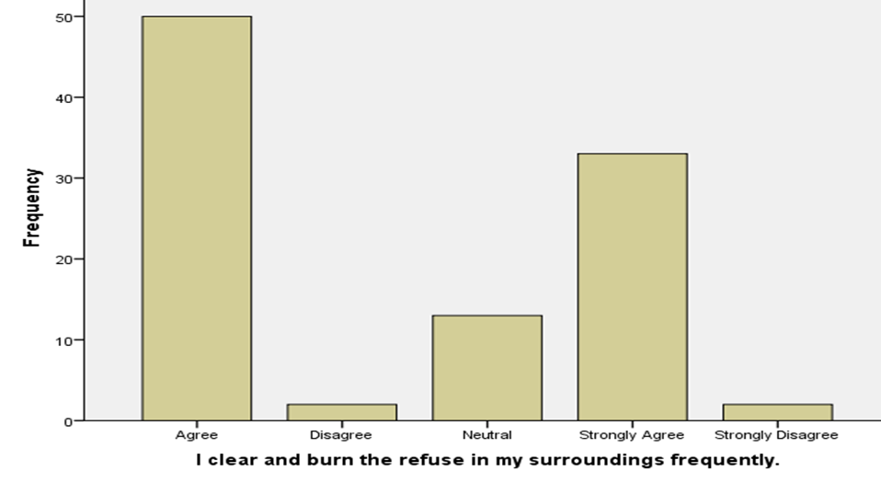

Figure 26 Chart showing respondents knowledge and attitude on sanitation practices, clearing, and burning of refuse in their surroundings frequently.

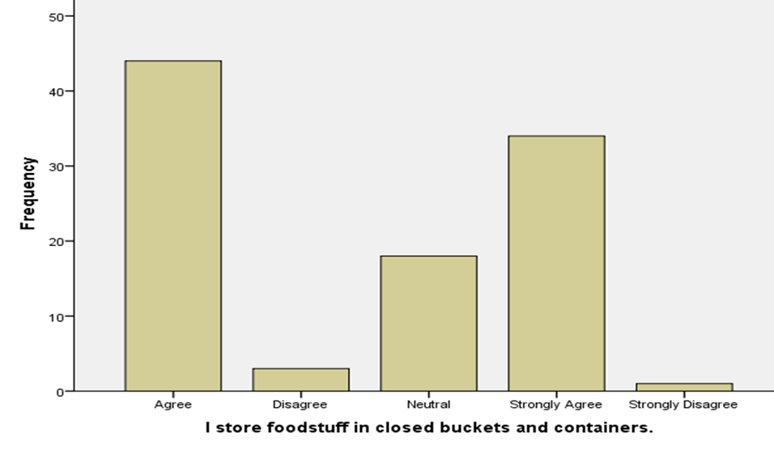
Figure 27: Chart showing respondents knowledge and attitude on food storage in closed buckets and containers.

List 1 : Summary of the frequency distributions, Means and Standard Deviations of the Questionnaire
Question | SA(5) | A(4) | N(3) | D(2) | SD(1) | Mean | S.Dev | Decision
Lassa Fever Infection exist | 42 | 44 | 10 | 2 | 2 | 4.22 | 0.86 | Acceptance
There are rats or rodents around my house | 30 | 34 | 19 | 12 | 5 | 3.72 | 1.164 | Acceptance
I eat rats or rodents? | 13 | 17 | 11 | 24 | 35 | 2.49 | 1.446 | Rejection
I have contact with urine, faeces e.t.c of rodents. | 5 | 39 | 8 | 33 | 15 | 2.86 | 1.231 | Rejection
Lassa Fever is caused by a Virus. | 27 | 45 | 20 | 4 | 4 | 3.87 | 0.991 | Acceptance
I always wash my kitchen utensils before use to avoid contamination. | 35 | 47 | 14 | 3 | 1 | 4.12 | 0.832 | Acceptance
I will be willing to take a vaccine against Lassa Fever Infection. | 23 | 39 | 29 | 6 | 3 | 3.73 | 0.983 | Acceptance
I Will show some discriminatory attitude towards people who are infected with Lassa fever. | 19 | 25 | 20 | 24 | 12 | 3.15 | 1.313 | Acceptance
I clear and burn the refuse in my surroundings frequently. | 33 | 50 | 13 | 2 | 2 | 4.10 | 0.847 | Acceptance
I store foodstuff in closed buckets and containers. | 34 | 44 | 18 | 3 | 1 | 4.07 | 0.856 | Acceptance

Discussion
Lassa fever is an animal-borne, or zoonotic, acute viral illness spread by the common African rat. It is endemic in parts of West Africa including Sierra Leone, Liberia, Guinea and Nigeria. Neighboring countries are also at risk because the animal vector lives throughout the region (CDC, 2022).
In the current study, the prevalence of Lassa fever virus from 2016 – 2019 was higher in Plateau and Nasarawa States compared to Benue State. The high prevalence of LASV in Plateau and Nasarawa States may be attributed to weak surveillance report, cultural and religious beliefs particularly in these States. Studies in literature have also attributed the heightened prevalence of Lassa fever in this region to internally displaced persons fleeing Boko Haram insurgence (Denue et al., 2017).
The findings also showed the outcome of cases during the period under study. The percentage of patients who survived is 68.06%, the percentage of those who died is 15.25% while the percentage of those with “no recorded outcome yet” as at the point of data collection is 16.69%. This shows that the presence of both Government and Private medical facilities within the states under study aided in the successful recovery of majority of the patients during the period under study. According to WHO, the overall case-fatality rate is 1%. Among patients who are hospitalized with severe clinical presentation of Lassa fever, case-fatality is estimated at around 15% (WHO, 2018). Early supportive care with rehydration and symptomatic treatment improves survival, (WHO, 2023). This validates the findings in this research which showed that there was a case fatality of 15.25% from year 2016-2019.
The result showed the prevalence of Lassa Fever infection in three North Central States of Nigeria; Benue, Nasarawa and Plateau States which was recorded over a period of four years, from 2016 to 2019. The total prevalence in the three States in 2016 was 27.3.%, however, there was a decrease in the number of recorded cases in 2017 which was 17.5% and a further decrease in the number of recorded cases of 9.5% was seen in 2018 followed by a spike in the number of recorded cases to 45.7% which was seen in 2019. The reduction in the prevalence in 2018 may be due to continuous awareness and government policies which could have led to the relaxation in compliance to strict personal hygiene in the States under study which later accounted for highest number of recorded cases which was in 2019. A prior study by Solomonaudu et al., (2019) studying the prevalence of Lassa fever in Nasarawa State from November 2018 to January 2019 reported a prevalence of 16.7% in suspected cases. These finding further shows that there is indeed the burden of LFI in the study area.
The result showed a clear breakdown of cases among age group between the ages 1-10, 11-20, 21-30, 31-40, 41-50, 51-60, 61-70, 71-80 and 81-90 with the percentage of 18.30%, 20.22%, 23.11%, 23.76%, 8.51%, 3.85%, 1.93%, 0.16% and 0.16% respectively. From the study, most patient of LASV in the three states were between the age of 31-40 with 23.76% while the age group with the lowest number of cases during the period under study are 71-80, 81-90 with the percentage 0.16 and 0.16% respectively. John et al., (2021), studying the epidemiological trends of Lassa fever in Nigeria from 2015-2021 also noted that the predominant age group which was infected was between ages 21-40 years. This similarity further suggests that the young adults (21-40) are the most active people in the population which engage in various activities including; farming, mining, hunting, artisans etc.
A test for significance difference between age groups and outcome of cases of LASV during the period under study was carried out; chi square (0.010) where p<0.05, which showed that there was a significant difference between the age group of patients and the outcome of cases during the period under study. The implication of this findings shows that there is high level of prevalence of LASV among the youth and adult from 31 year and above.
The result also showed the sex of infected patients in the three states within period under study, 36.1% of the patients were female, 50.2% of the patients were male while the sex of 13.6% of the patients were unknown. The sex of the patient’s unknown could be attributed to poorly collected data and monitoring. Solomonaudu et al., (2019), found that more Lassa fever cases occurred in males (52%) than females (47%). This is in contrast with a study carried out by Owoseye et al., (2020) which showed that the infection affects females 1.2 times more than males.
The findings showed the test for significant difference between the sex of patients and the outcome of cases of LASV during the period under study. The chi square value of (0.132) where p<0.05 shows that there is no significant difference between the sex of patients and the outcome of cases during the period under study.
The questionnaire was administered to determine the knowledge, attitude and practices of respondents in order to analyze the level of information received concerning LASV and the roles the lifestyle of respondents have played in aiding or preventing the spread of the virus. However, there was no significant association between age or socioeconomic class and a diagnosis of LF. This is in conformity with previous findings that showed all age and socioeconomic groups are susceptible to LF (WHO, 2018., Richmond et al, 2003).
The result showed the association between age group and those who agree that “Lassa Fever exists”. Sixty-seven percent (67%) of the respondents between ages 19-40 years agree that Lassa fever exists. A study indicated that in the general Nigerian population, there is a low level of knowledge of Lassa fever (Adegoke et al., 2017); however, a later study showed that there have been recent improvements in overall public knowledge of Lassa fever (Odionye et al., 2019) which is in line with the findings from this research. In Table 7there is an association between those who agree that there is the presence of rodents around their house and the existence of Lassa fever, Thirty-four percent (34%) of the respondents who agreed that there are rats and rodents around their homes also eats rats or rodents. This in line with a study which showed that 83% of respondents selected from urban and rural areas of Lafia still have rodents in and around their residences, 24% eat rodents contaminated food, 33% eat rodents, and 28% regularly come in contact with the bodily secretions from rodents (Reuben and Gyar, 2016). Generally, contact with and/or consumption of rats constitutes a major risk factor for Lassa fever, and eating rats is essentially a predisposing factor to the disease (Ben-Enukora et al., 2020; Erubami, 2022).
The summary of the frequency distributions, mean and stand deviation table, show only the third and fourth questions were rejected where the observed mean is accepted. if the observed mean is greater than µ=3.0 and rejected if the observed mean is less than µ=3.0. This is in line with a previous study which showed that 24% eat rodents contaminated food, 33% eat rodents, and 28% regularly come in contact with the bodily secretions from rodents (Reuben and Gyar, 2016).
Conclusion
Lassa Fever Infection remains an endemic disease in the North Central region of Nigeria especially in the states under this study. On the February 20th, 2020, in a statement, WHO points out that, “Lassa fever is endemic in Nigeria and the annual peak of human cases is usually observed during the dry season (December–April) following the reproduction cycle of the Mastomys rats in the wet season (May–June)” (NCBI, 2020). As 90–95% of human infections of Lassa virus result from indirect exposure or direct contact with infected mastomys rats, the substantially increased density and circulation of the virus among the young and non-immune rats during the wet season “create a potential for further human infection, thus, the number of infections is expected to continue to rise until the end of the dry season” (NCBI, 2020).
The Prevalence of Lassa fever in the North Central Region of Nigeria remains a burden and more realistic and time bound policies need to be put in place to curb the spread of the virus. From the study, the high prevalence of LASV in Plateau and Nasarawa States may be attributed to weak surveillance, reporting, cultural and religious beliefs particularly in these States.
The recorded outcomes showed that 68.06% of the total patients recorded survived, while 15.25% died and 16.69% of the patients had no recorded outcome as at the time of data collection from the Nigeria Centre for Disease Control.
The emergence of the disease mostly among youth between the ages of 18-45 year shows that they are the most active individuals in the population who engage in various kinds of activities ranging from farming, mining, animal husbandry, health care workers and so on.
The results and analysis have shown why there is no significant difference between the sex of patients and outcome of cases during the period under study, but there is a significant difference between the sex of patients and the years under study. This further shows that Lassa fever infection in the States under study is not restricted to a particular gender but that an individual can be a victim of the infection after he or she has been exposed to the predisposing factors.
Accordingly, the KAP analyses showed that many of the respondents have been sensitized about the knowledge, attitude and practices on Lassa fever infection based on the response gotten and many are willing to be vaccinated against the virus if a vaccine is produced.
Recommendations
It is important for policy makers and healthcare facilities to put in place more effective policy measures to strengthen already existing policies in other to tackle the spread of the disease. It is also necessary for continuous awareness by the government and various advocacy groups in other to inform and constantly remind the public that rodent are the vectors of the causative agents that spread the disease and a call for modern environmental sanitation practice.
Proper data collection and monitoring is very necessary to enable researchers get a true picture of the degree of spread of the disease and to be able to provide accurate detailed recommendations in other to curb the spread of the virus such as:

- Washing of hands frequently with soap under running water can prevent the spread of the disease.
- Maintaining a proper personal hygiene and cough etiquette in a public place will also help in preventing the spread of the disease.
- Sensitizing the public on always carrying out proper waste management and sanitation practices in their homes and surroundings.
- Proper storage of food stuffs in rat proof or covered containers will prevent the rodent’s urine or feaces from entering stored food.
- There should be proper cooking of food before eating and also avoid eating food and fruits already eaten by rats/rodents.
- Blocking all the holes or openings in the house to reduce entry point for rodents.
- Avoid contact with dead or living rats.
- Avoid body contact with someone who has the disease and if you suspect a sign and symptoms of Lassa fever infection, avoid self-medications but go to approved health facilities for proper treatment.

REFERENCES
Adegoke, O. O., Ajibola, O. F., & Ogundairo, J. A. (2017). Knowledge, attitude and practices of foodstuff sellers on Lassa fever in major markets in Ibadan. African Journal for the Psychological Study of Social Issues, 20(2), 165-176.

Alhaji N.B., and Yatswako, S. (2017). https://www.researchgate.net/figure/Map-of-North-central-zone-of-Nigeria-study-area_fig1_318183914
Ben-Enukora, C., Oyero, O., Okorie, N., Oyesomi, K., & Adeyeye, B. (2020). Effectiveness of Yoruba language radio jingle in promoting knowledge, attitude and practices regarding Lassa fever among women in Ondo state, Nigeria. Journal of Public Health in Africa, 11(2), 109-113.
Catholic Relief Services, (2007). https://smileprojectnigeria.crs.org
Centers for Disease Control, (2017). Lassa fever. Available from: https://www.cdc.gov/vhf/lassa/index.html.
Centers for Disease Control and Prevention. Fact sheet: Lassa fever, (2018). www.cdc.gov/.
Centers for Disease Control and Prevention, National Center for Emerging and Zoonotic Infectious Diseases (NCEZID), Division of High-Consequence Pathogens and Pathology (DHCPP), Viral Special Pathogens Branch (VSPB), April 2022.
Denue, B.A., Stephen, M. and Dauvoux, I. (2017). The unending threat of Lassa fever in Nigeria, what can be done; what should be done. Port Harcourt Medical Journal, 11:113-121.
Erubami, J.A.(2022). Mass media exposure and Lassa fever knowledge, attitudes and practices in rural Nigeria. Journal of Public Health and Development, 20(1), 244-253.
Frame J.D, Baldwin J.M.J, Gocke D.J, Troup J.M (1970) Lassa fever, a new virus disease of man from West Africa. Am J Trop Med Hyg 19: 670–676.
Hilhorst T., Liere M.J., Ode A.V., (2006). Impact of AIDS on rural livelihoods in Benue State, Nigeria. Journal of Social Aspects of HIV/AIDS. 2006; 3:382–393.
Isa S.E., Shehu N.Y., Juryit R.N., Simji S.G., Shuaibu J.A., Egah D.Z., Banwat E.B. and Chikaike O. (2013). Epidemiological and clinical description of Lassa fever in Jos, Nigeria. Highland Medical Research Journal / Vol. 13 No. 1 (2013).
John-Ugwuanya A.G., Ifunanya J.E. and Nnenna U. (2021). Epidemiological trends of Lassa fever in Nigeria from 2015-2021: A review. Therapeutic Advances in Infectious Disease. 2021 Jan-Dec; 8: 20499361211058252. Published online 2021 Nov 29. doi: 10.1177/20499361211058252
McCormick J.B, (1999) Lassa fever. In: Saluzzo JF, Dodet B, editors. Emergence and control of rodent-borne viral diseases. Elsevier. pp. 177–195.
National Centre for Biotechnology Information (2020). Lancet Infectious Diseases; 20(5): 543.
National Population Commission (NPC), (2006). Abuja, Nigeria.
Odionye, C. M., Anorue, L. I., & Ekwe, O. (2019). A knowledge, attitude and practices analysis (KAP) of Lassa fever media campaigns among residents of South-east, Nigeria. African Population Studies, 33(1), 4738-4749
Ogbu, O., Ajuluchukwu, E. and Uneke, C. J. (2007). Lassa fever in West African sub-region: an overview. Journal of Vector Borne Disease, 44: 1–11.
Okokhere, P.O and Akpede G.O. (2013). Central nervous system manifestations of Lassa fever in Nigeria and the effect on mortality. Journal of Neurological Science, 333 (October) (2013), p. e604
Omilabu S.A, Badaru S.O, Okokhere P, Asogun D, Drosten C, Emmerich P, (2005). Lassa fever, Nigeria, 2003 and 2004 [letter]. Emerg Infect Dis [serial on the Internet]. 2005 Oct [date cited]. http://dx.doi.org/10.3201/eid1110.041343.
Owoseye, Ayodamola (11 March 2020). "Lassa Fever: Nigeria's death toll reaches 144". Retrieved 13 March 2020.
Reuben, C. R., & Gyar, S. D. (2016). Knowledge, attitudes and practices of Lassa fever in and around Lafia, Central Nigeria. International Journal of Public Health and Epidemiological Research, 2(1), 13-19.
Richmond, K. J. and Baglole, D. J. (2003). Lassa fever: epidemiology, clinical features, and social consequences. British Medical Journal, 327: 1271.
Robinson J.E, Hastie K.M, Cross R.W, Yenni R.E, Elliott D.H, Rouelle J.A, (2016). Nature Communications 2016 May 10; 7:11544. doi: 10.1038/ncomms11544.PMID: 27161536.
Shehu N.Y., Gomerep S.S., Isah S.E., Iraoyah K.O., Mafuka, J., Bitrus, N., Dachom M.C., Ogwuche J.E., Onukak A.E., Onyedibe K.i., Ogbaini-Emovon, E., Egah, D.Z., Mateer E.J., Paesler S. (2018). Lassa Fever 2016 Outbreak in Plateau State, Nigeria—The Changing Epidemiology and Clinical Presentation. Secondary Infectious Diseases: Epidemiology and Prevention. Volume 6 - 2018 | https://doi.org/10.3389/fpubh.2018.00232
Solomonaudu, E., Adiukwu, C., Surajudeen, B., Ashuku, Y.A., Alhassan, I.A. and Usman L.M. (2019). Lassa fever burden among suspected cases presenting in health facilities in Nasarawa State, North Central Nigeria. International Journal of Dental and Medical Science, 18(2): 25-29.
World Health Organization (WHO). Lassa fever—Nigeria. Geneva: WHO; (2016) (cited 8 Feb 2016). http://www.who.int/csr/don/27-january-2016-lassa-fever-nigeria/en/#.
World Health Organization WHO, (2017). Lassa fever. Available from: http://www.who.int/csr/disease/lassafever/en/ [accessed 26 Oct 2018].
World Health Organization WHO, (2018). Lassa fever outbreak news. Available from: http://www.who.int/csr/don/archive/disease/lassa_fever/en/ [accessed 26 Oct 2018].
World Health Organization, (2023). Who.int/health-topics/lassa-fever. Retrieved June 2023.

