Original Research Article
Interconnection of Climate Parameters and Reference Evapotranspiration over Nigeria

Abstract
This study investigated temporal variations in reference evapotranspiration (ETo) and its interconnection with climate parameters across four climatic regions in Nigeria over a 42-year period (1979-2021). The ETo datasets were collected from the Archive of ECMWF-ERA-5 at a resolution of 0.25° by 0.25° grid system over Nigeria. The interconnection analyses between ETo and climate parameters were conducted using the cross-correlation test, Mann-Kendall tests, and four homogeneity tests at a 5% significance level. The results demonstrated strong correlations between ETo and relative humidity (RH) in the Sahel, Guinea Savannah, and Coastal regions, with R² values of 0.7343, 0.8418, and 0.7662, respectively. Trend analysis using the Mann-Kendall test indicated significant increasing trends in ETo for the Sahel, Guinea Savannah, and Rainforest regions, while the Coastal region exhibited a significant decreasing trend. Change point analyses using the four homogeneity tests revealed that ETo experienced significant changes primarily in 1999 in the Sahel and Guinea Savannah regions, 1996 in the Rainforest region, and 2006 in the Coastal region. In conclusion, relative humidity emerged as the most sensitive parameter to ETo, with immediate response time lags observed in the Sahel and Guinea Savannah regions, and a one-month response time lag in the Rainforest and Coastal regions of Nigeria.
Keywords: Reference evapotranspiration, Interconnection, Climate change, Correlation, Nigeria.
- Introduction
According to several studies (Goyal, 2004; Alexandris et al., 2008; Hikaru et al., 2008; McVicar et al., 2012; Thomas, 2008), evapotranspiration—the process of combining evaporation and transpiration—is an essential component of the hydrological cycle and regulates the movement of moisture from the Earth's surface to the atmosphere. After precipitation, it is the second-most crucial hydrologic factor. Reference evapotranspiration (ETo) is a measurement of the rate of evapotranspiration from a reference crop under ideal conditions, with certain parameters assumed (Allen et al., 1998). Understanding water availability and irrigation needs in agricultural systems requires evaluating ETo. There are many ways to calculate ETo, including using lysimeters and empirical equations, but the FAO Penman-Monteith method is strongly recommended as the preferred method due to its accuracy. However, there is limited research focusing on the climatic regions of Nigeria and the correlation of ETo with meteorological variables in this area.
The effects of global climate change and human activity on hydrological processes have been highlighted in earlier studies (Easterling et al., 2000; Monirul et al., 2002; Li et al., 2007; IPCC, 2007). These elements have affected evapotranspiration rates, increased the frequency of floods and droughts, and changed precipitation patterns (Harmsen et al., 2009). Depending on climatic conditions and regional factors, there are different relationships between ETo and meteorological parameters like atmospheric temperature, vapor pressure, precipitation, and wind speed (Debnath et al., 2015). Emeka et al. (2021) conducted research in Nigeria to examine how FAO Penman-Monteith reference evapotranspiration (ETo) changed in response to climatic variables under various climate types. According to the study, the maximum temperature is the factor that affects ETo the most in Maiduguri, Sokoto, Kaduna, and Jos. ETo is most sensitive to relative humidity in Port Harcourt, whereas it is most sensitive to variations in solar radiation in Enugu and Ibadan. Zhang et al. (2015) looked into the effects of climate change on reference evapotranspiration, aridity index, and their temporal-spatial variations in the Yellow River Basin (YRB), China, from 1961 to 2012. The researchers found that the spatial change trends of the aridity index were widespread across the YRB and were consistent with the declining trend of reference evapotranspiration. Huo et al. (2013) also looked into how climate change in China's arid region affected the aridity index and reference evapotranspiration.. The study found that the annual temperature, humidity, and precipitation all exhibited rising trends over time. Radiation and wind speed both showed a downward trend. ETo was sensitive to wind, humidity, temperature, and radiation, whereas AI was sensitive to precipitation. There aren't, however, a lot of studies that are specifically concerned with the climates of Nigeria. For the region's agricultural planning and sustainable management of water resources, it is essential to comprehend ETo dynamics in Nigeria and its response to climate change.
By providing a thorough analysis of reference evapotranspiration and its correlation with meteorological variables in Nigeria's climatic regions, this study seeks to close the knowledge gap. The specific goals include calculating ETo using the FAO-PM 56 equation, looking at the relationship between ETo and meteorological variables, and looking into the seasonal and inter-annual trends of ETo. By focusing on these goals, the study will advance knowledge of the hydrological dynamics and potential effects of climate change on Nigeria's evapotranspiration patterns. The information will be useful for the region's strategies for managing water resources, planning agriculture, and adapting to climate change.
- Methodology
Study Area
Located on the western coast of Africa between latitudes 4° and 14° N and longitudes 2° to 14° E, Nigeria has a land area of 923,769 km2, as shown in Figure 1. According to Ojo (2022) the four main climatic regions of Nigeria are the Sahel, Guinea Savannah, Rainforest, and Coastal Regions. Eludoyin et al. (2014) found that three atmospheric air masses—the maritime tropical (mT), continental tropical (cT), and equatorial easterlies—have an effect on Nigeria's climate. The mT and cT air masses come from the Atlantic Ocean and the Sahara Desert, respectively. The pattern and timing of rainfall are controlled by the inter-tropical discontinuity (ITD), which is where the two air masses converge (Ugbah et al., 2020).
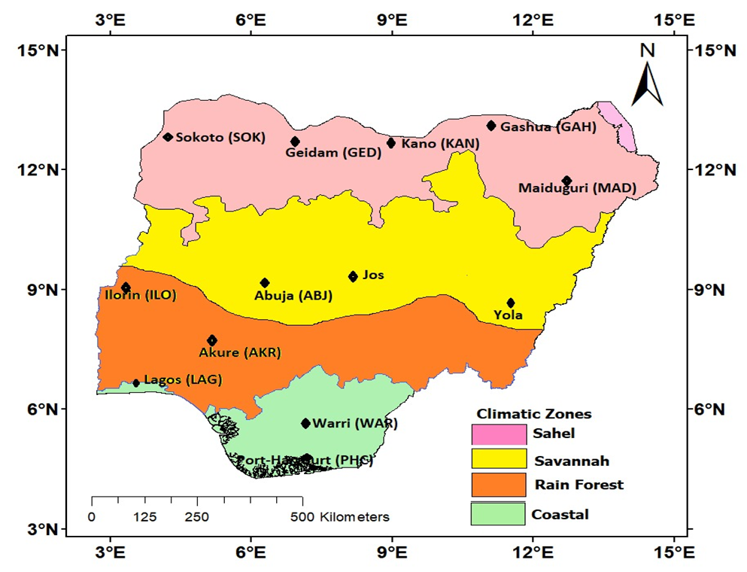
Figure 1: Map of Nigeria showing 4 climatic regions and some selected stations (Ojo, 2022)

In Nigeria, there are two distinct seasons: wet and dry. With an average annual rainfall of 1,200–3,000 mm, the south typically experiences 8–10 months of rain, compared to the north's 2-4 months of rain and 400–1,100 mm annual average. The close proximity of the Sahara Desert in the north and the Atlantic Ocean in the south is what causes the significant variation in rainfall. The south typically experiences bimodal rainfall peaks in June and September, as opposed to the north, which has a single peak in August. In the rainy season, temperatures range between 25 and 30 C, while in the dry season, they are between 20 and 30 C (Ugbah et al., 2020).
Data Acquisition and Analysis
The European Centre for Medium-Range Weather Forecasts Reanalysis version 5 database (ERA 5) archive was used in this study to obtain daily data on temperature (oC), wind speed (m/s), relative humidity (%), and solar radiation (MJ/m2 day). The data were processed into monthly and annual averages over Nigeria for the four (4) climatic regions of the Sahel, Guinea, Rainforest, and Coastal Regions over a 42-year period (1979-2021). In order to calculate ETo, FAO recommended and revised the Penman-Monteith model in 1998 (FAO 1998; Allen et al. 1998). It can be expressed as:
$${ET}_{o} = \frac{0.408∆ \left(R_{n}-G\right)+γ\frac{900}{T+273}\left[e_{s}-e_{a}\right]u_{2}}{Δ+γ×\left(1+0.34×u_{2}\right)} (1)$$
where ET_{o} is reference evapotranspiration(mm/d); Rn is the net radiation at the crop surface (MJ/m²d); G is the soil heat flux density (MJ/m²d), T is the air temperature at 2m height(C), U₂ is the wind speed at 2 m height (m/s), e_{s} is the vapor pressure of the air at saturation (kPa), e_{a} is the actual vapor pressure (kPa), $Δ$ is the slope of the vapor pressure curve (kPa/C) and $γ$ is the psychometric constant (kPa/C).
The trend in ETo was examined using the Mann-Kendall test (M-K test). The Mann-Kendall test (M-K test), also known as the Kendall's tau test, is a rank-based non-parametric test for determining the significance of a trend as a result of Mann (1945) and Kendall (1975). It has been extensively used in studies that analyze climate change and hydrological trend detection (Fu et al., 2004; Huo et al., 2013; Zhang et al., 2009; Chaouche et al., 2010). The M-K test is an easy-to-use and trustworthy method for handling missing values and values that are below a detection threshold. According to Tabari et al. (2011) and (2012), the test is also appropriate for data that do not follow a normal distribution. The statistic S of Kendall’s tau test is defined as follows:
$$S= \sum_{j=1}^{n-1}{\sum_{i=j+1}^{n}{\begin{aligned}sign\left(x_{i}-x_{j}\right) \left(2\right) \\ \end{aligned}}}$$
where x_{i} is the data value at time i, x_{j} is the data value at time t_{j}, n is the length of the data set and sign () is the sign function which can be computed as:
$$sign \left(x_{i}-x_{j}\right)= \left\{\begin{aligned}1 if\left(x_{i}-x_{j}\right)>0 \\ 0 if\left(x_{i}-x_{j}\right)= 0 \\ -1 if \left(x_{i}-x_{j}\right)<0\end{aligned}\right. (3)$$
The statistic S is normally distributed when n$>$ 10. The variance (Var) of S is given by:
$$Var\left(S\right)=\frac{[n\left(n-1\right)\left(2n+5\right)]-\sum_{m-1}^{n}{t_{m}(m-1)(2m+5)}}{18} (4)$$
where t_{m} represents the number of ties of extent m. The standardized test Z_{c} is calculated by:
$Z_{c}=\left\{\begin{aligned}\frac{S-1}{\sqrt{Var(S)}} if S>0 \\ 0 if S=0 \\ \frac{S+1}{\sqrt{Var(S)}} if S<0\end{aligned}\right. (5)$
Zc values that are positive or negative represent an increasing or decreasing trend, respectively. When it is zero, no change in trend has been noticed.
Also, the point of change in time series is detected using homogeneity tests which include the Pettitt test (K), standard normal homogeneity test (T_{o}), Buishand test (Q) and Von Neumann ratio test (N). The Pettitt test, as proposed by Pettitt (1979), is a nonparametric test that enables the identification of the point at which any significant shift occurred in time series. This method finds a significant change in a time series' mean even when the change's precise timing is unknown. In order to determine whether the two samples $x_{1}$,…, $x_{t}$ and $x_{t+1}$,…, $x_{N}$ are drawn from the same population, the test uses the Mann-Whitney statistic $U_{t,N}$ (Huo et al., 2013; Ahmed et al., 2018). The test statistic$U_{t,N}$ is given as:
$U_{t,N}= U_{t-1, N}+\sum_{j=1}^{N}{sgn(x_{t}}-x_{j}) for t=2,…,N$ (6)
$\begin{matrix}if \left(x_{t}-x_{j}\right)>0 & sgn\left(x_{t}-x_{j}\right)=1 \\ if \left(x_{t}-x_{j}\right)=0 & sgn\left(x_{t}-x_{j}\right)=0 \\ if \left(x_{t}-x_{j}\right)<0 & sgn\left(x_{t}-x_{j}\right)=-1\end{matrix}$ (7)
The test statistic measures how often more first sample participants than second sample participants. In Pettitt's test, the null hypothesis is the absence of a changing point. The following are its statistic k(t) and the associated probabilities for significance testing:
$$K\left(t\right)={Max}_{1≤t≥N}\left|U_{t,N}\right| (8)$$
$$p≅2 exp\left\{\frac{-{6\left(K_{N}\right)}^{2}}{{(N}^{3}+N^{2})}\right\} (9)$$
The Standard Normal Homogeneity Test was proposed by Alexandersson (1986). The null hypothesis is same as the Pettitt test. T(k) is computed as
$T\left(k\right)={k\overline{Z_{1}}}^{2}+\left(n-k\right){\overline{Z_{2}}}^{2}, k=1,2, …,N (10)$
where
$\overline{Z_{1}}=\frac{1}{k}\frac{\sum_{i=1}^{k}{(Y_{i}-\overline{Y})}}{s}$ and $\overline{Z_{2}}=\frac{1}{n-k}\frac{\sum_{i=k+1}^{n}{(Y_{i}-\overline{Y})}}{s}$
If the break is located at the point k, T(k) reaches its maximum value at k=K. the test statistics T_{o} is defined as
$$T_{o}=\max\left(T\left(k\right)\right) for 1≤k<n (11)$$
If $T_{o}$ exceeds the test statistics value, the null hypothesis is rejected
The Buishand test assumes that the data are distributed independently and randomly, which is consistent with the H0 hypothesis. This test, which is conducted by Wijngaard et al. (2003), is sensitive to time series breaks in the middle and it is given by:
$$S_{o}^{*}=0; S_{k}^{*}=\sum_{i=1}^{k}{(X_{i}-\overline{X}}), k=1, 2, …,N (12)$$
where: $\overline{X}$ is the mean of time series observations ($X_{1},X_{2},…,X_{N})$
$k$ is the number of the observation at which a break point has occurred.
Rescaled adjusted partial sums are obtained by dividing $S_{k}^{*}$ by the sample standard deviation (Buishand, 1982):
$S_{K}^{**}=\frac{S_{k}^{*}}{D_{x}}, k=1,2, …,N (14)$
$$D_{x}=\sqrt{\frac{\sum_{i=1}^{N}{({X_{i}-\overline{X})}^{2}}}{N} } (15)$$
The statistics used to analyze homogeneity is expressed as follows:
$Q=\max_{0≤k≤N}\left|S_{k}^{**}\right| (16)$
$Q/{\sqrt{N}}$ value is compared with the critical value (Buishand, 1982). If the calculated value is less than the critical value, the null hypothesis is accepted, otherwise it is rejected (Alghazali and Alawadi 2014).
The Von Neumann ratio test (N), in accordance with Wijngaard et al. (2003), does not identify a particular region where homogeneity is compromised and does not provide information regarding when homogeneity is compromised. The mean squared proportion of the variance in succession is described by N in this test (Von Neumann, 1941):
$$N=\frac{\sum_{i=1}^{n-1}{{(Y_{i}-Y_{i+1})}^{2}}}{\sum_{i=1}^{n}{{(Y_{i}-\overline{Y})}^{2}}} (17)$$
Critical values of this test are given in Wijngaard et al. (2003). If the calculated N value exceeds the critical N value, H0 hypothesis is considered homogeneous.
In order to evaluate the sensitivity and responsiveness of the reference evapotranspiration and aridity index time-lagged relationships, the cross-correlation function was also used. According to Ojo et al. (2021), responsiveness is measured by the CCF peak's lag, whereas sensitivity is determined by the CCF peak's cross-correlation strength. According to Boyd, the ratio of covariance to root-mean variance can be used to express how closely the time series Y and X are correlated:
$$ρ_{y,x}=\frac{Υ_{y,x}}{\sqrt{σ_{y}^{2}σ_{x}^{2}}} (18)$$
Where ρ is the cross-correlation function of the two time-series, γ is the covariance of the two time-series, σ is the standard deviation of time-series and X. The covariance between Y and X time-series is given by:
$$Υ_{y,x}=\frac{1}{N} \sum_{i=0}^{N}{\left(Y-X\right)\left(X-Y\right) } (19)$$
In this study, Y would stand for the aridity index time-series and X would stand for the reference evapotranspiration time-series between 1979 and 2021. Cross-correlations are dimensionless, with values ranging from -1.0 to +1.0.
Results and Discussion
Correlation of Meteorological Variables with Reference Evapotranspiration
The scattergrams presented in Figures 2 – 5 (a-f) demonstrate the correlations between reference evapotranspiration (ET_{o}) and its six climate parameters in Nigeria's climatic regions. The findings revealed that ET_{o} in the Sahel, Guinea, and Coastal regions was strongly influenced by relative humidity (RH), with R² values of 0.7343, 0.8418, and 0.7662, respectively. The negative slopes of the downward trend lines indicated an inverse relationship, that is, a decrease in relative humidity would lead to an increase in reference evapotranspiration, and vice versa. This correlation highlights the impact of the dry and hot atmospheric conditions prevalent in those regions, which result in increased water loss to the atmosphere. Conversely, a moister atmosphere leads to a lower rate of water loss. These findings align with previous studies and emphasize the importance of considering relative humidity when assessing evapotranspiration in those regions. Furthermore, in the Rainforest region, ET_{o} exhibits a strong positive correlation with net radiation (RN), with an R² value of 0.8400. This implies that an increase in net radiation contributes to higher evapotranspiration in this region. The implications of this correlation suggest that variations in net radiation, influenced by factors such as cloud cover and solar radiation, play a significant role in regulating evapotranspiration rates in the Rainforest region. The findings are valuable for understanding and managing water resources in different climatic zones within Nigeria.

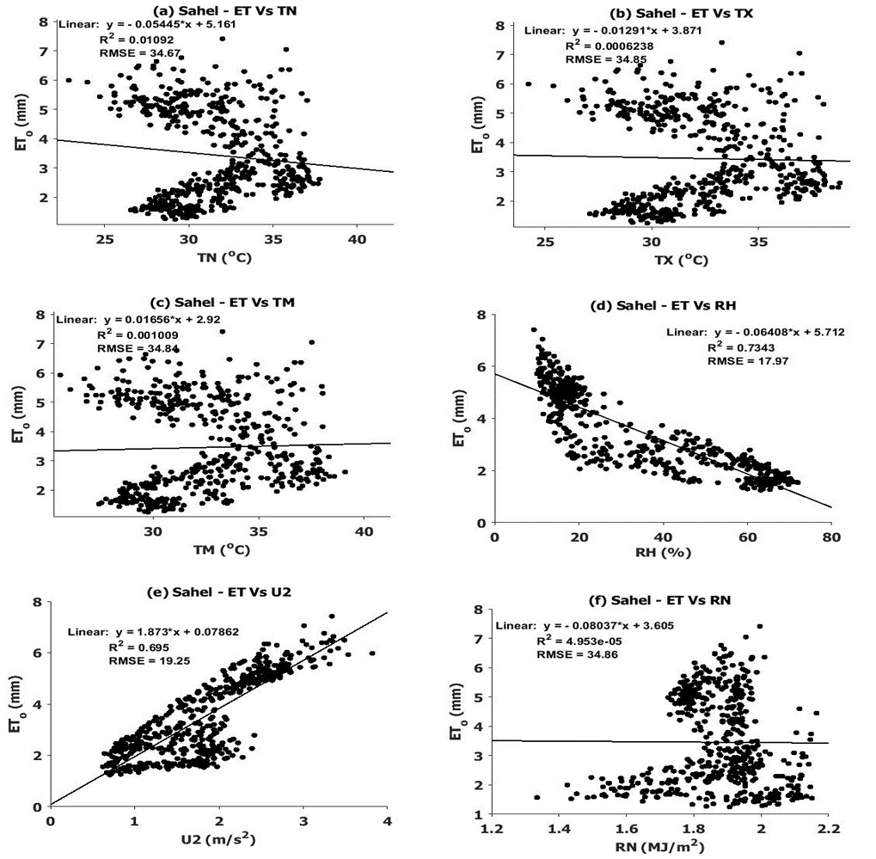
Figure 2: Scattergrams of Correlation between reference evapotranspiration and its constituents climate parameters in the Sahel region
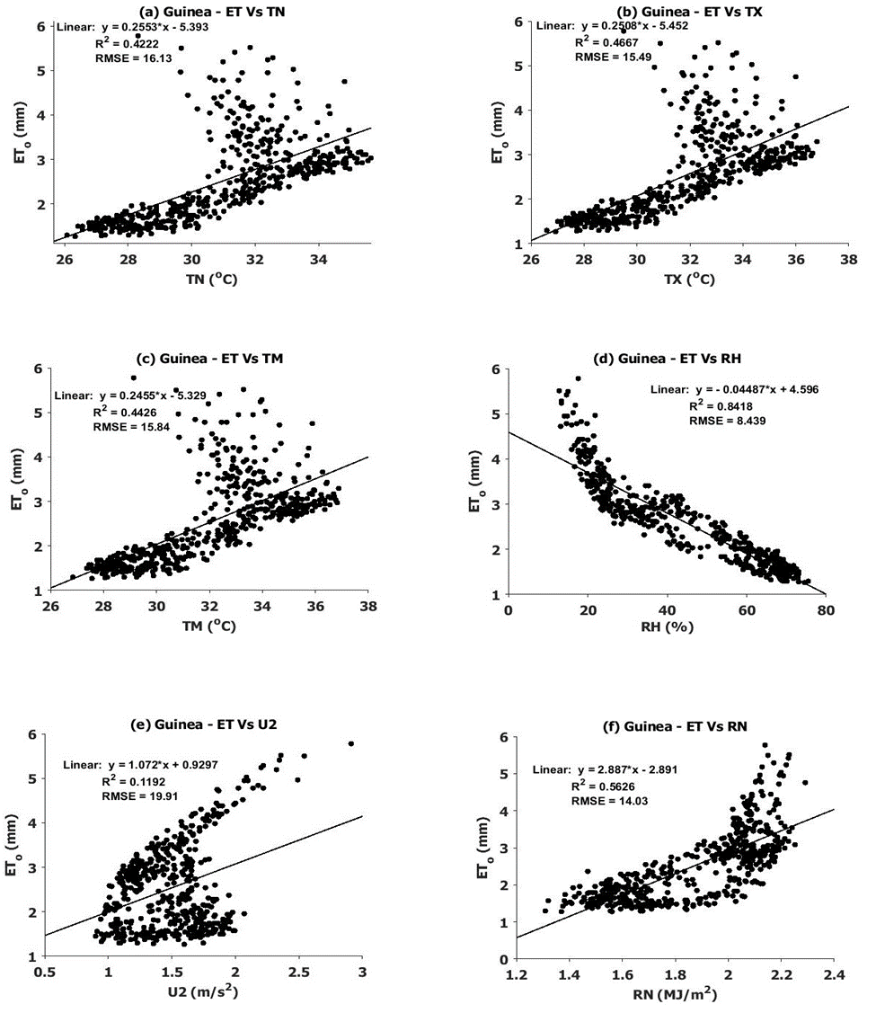
Figure 3: Scattergrams of Correlation between reference evapotranspiration and its constituents climate parameters in the Guinea region

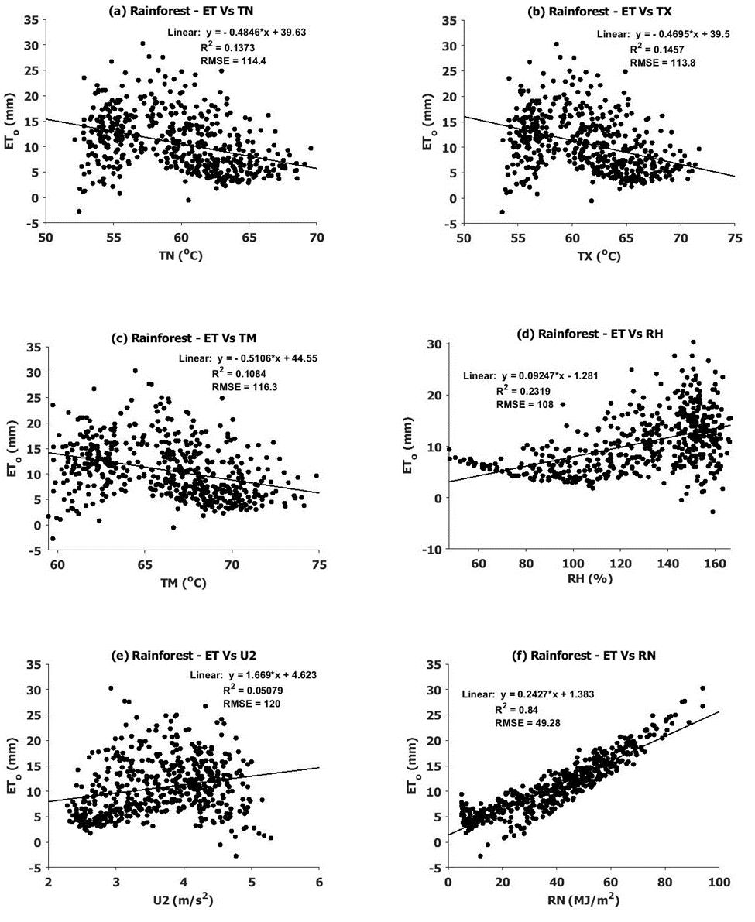
Figure 4: Scattergrams of Correlation between reference evapotranspiration and its constituents climate parameters in the Rainforest region

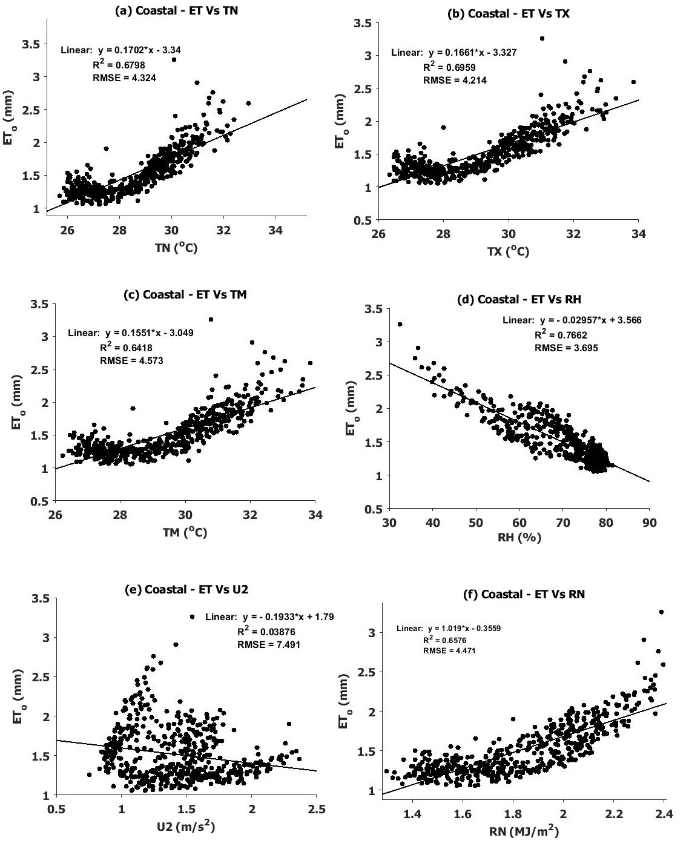
Figure 5: Scattergrams of Correlation between reference evapotranspiration and its constituents climate parameters in the Coastal region

Seasonal Variations of ET_{o} and Meteorological Variables
Figures 6-9 (a-f) show the seasonal variations for ETo and meteorological variables in all regions. The Sahel region (Figure 6) showed that reference evapotranspiration fell to minimum between April and September, which are transition months from the dry season to rainy months and from wet season to dry season. It rose from October to March, which are the dry season months. On the other hand, TM, TN, and TX followed the same pattern of increase in dry months and fall on the rainy months. This demonstrates how a rise in temperature influences ETo by raising the air's ability to hold water vapor (Allen et al. 1998). The rate of evapotranspiration would therefore rise as the temperature rose. With r-value of 0.7752 though, it did have a strong correlation with wind speed. In the rainy and dry seasons, respectively, the relative humidity increased. At the beginning of the rainy (April) and dry (Oct) months, the net radiation (RN) experienced two peaks. The warm air rising in the atmosphere during these times may be the cause of this.
This was also true for the Guinea region (Figure 7) which had strong correlation with RH as r = 0.95, implying that relative humidity affected the monthly variations of ET_{o}. In the Rainforest region (Figure 8), reference evapotranspiration was on the increase between the months of March to October, which are the rainy months, with a rapid fall in the month of August (owing to the August break), its value was closely related with net radiation RN as r = 0.9922. The values of temperature and net radiation dropped during the rainy month and found to be rising in the dry months while relative humidity was on the rise by the rainy months and fell during the dry months as expected. This shows that the more humid the atmosphere, the average temperature condition and net radiation would be decreasing.
The reference evapotranspiration in the Coastal regions (Figure 9) was found to fall during the rainy months (April to Oct) and was rising during the dry months with its peak at March, this pattern was found to be true for temperature and net radiation with stronger relation on maximum temperature as r = 0.8393. While wind speed U2 was observed to have two peaks at the rainy season; at the onset (April) and at the core rainy month (August) and then it dropped, while relative humidity was on the increase in the rainy months and fell in the dry months. Therefore, ET_{o} in Nigeria exhibits seasonal variations, with low values observed during the core rainy month of August due to the prevalence of rain-bearing clouds that diminish solar radiation reaching the Earth's surface (Chineke et al., 2011; Ogolo & Adeyemi, 2009). The reduced ET_{o} during this period has implications for water resource management and agriculture. Conversely, evapotranspiration increases during dry months, driven by higher temperatures, net radiation, and wind, which promote water transport and uptake.
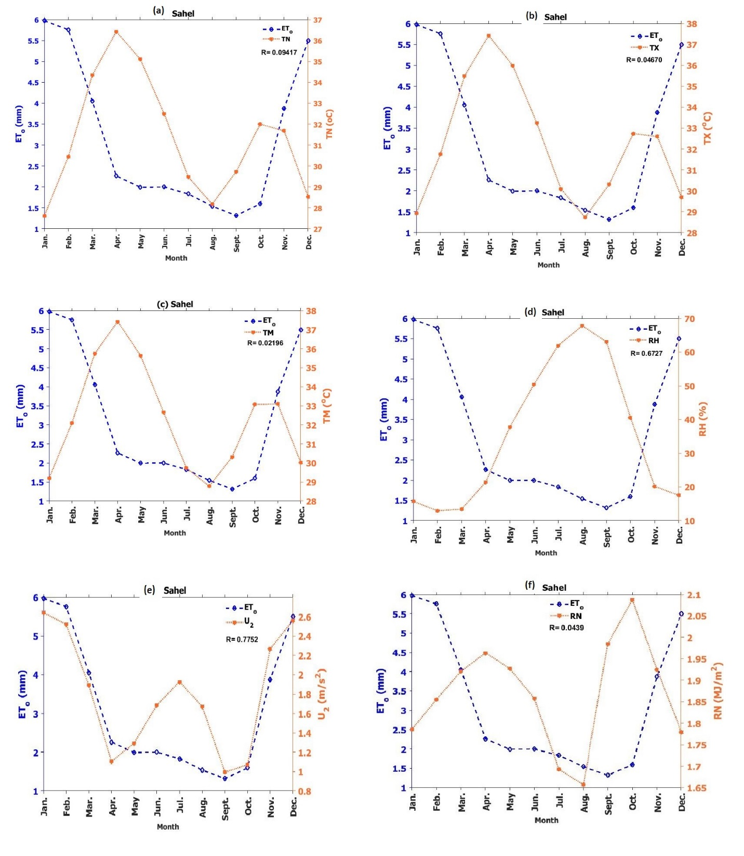
Figure 6: Seasonal variation of reference transpiration and climate variables in the Sahel
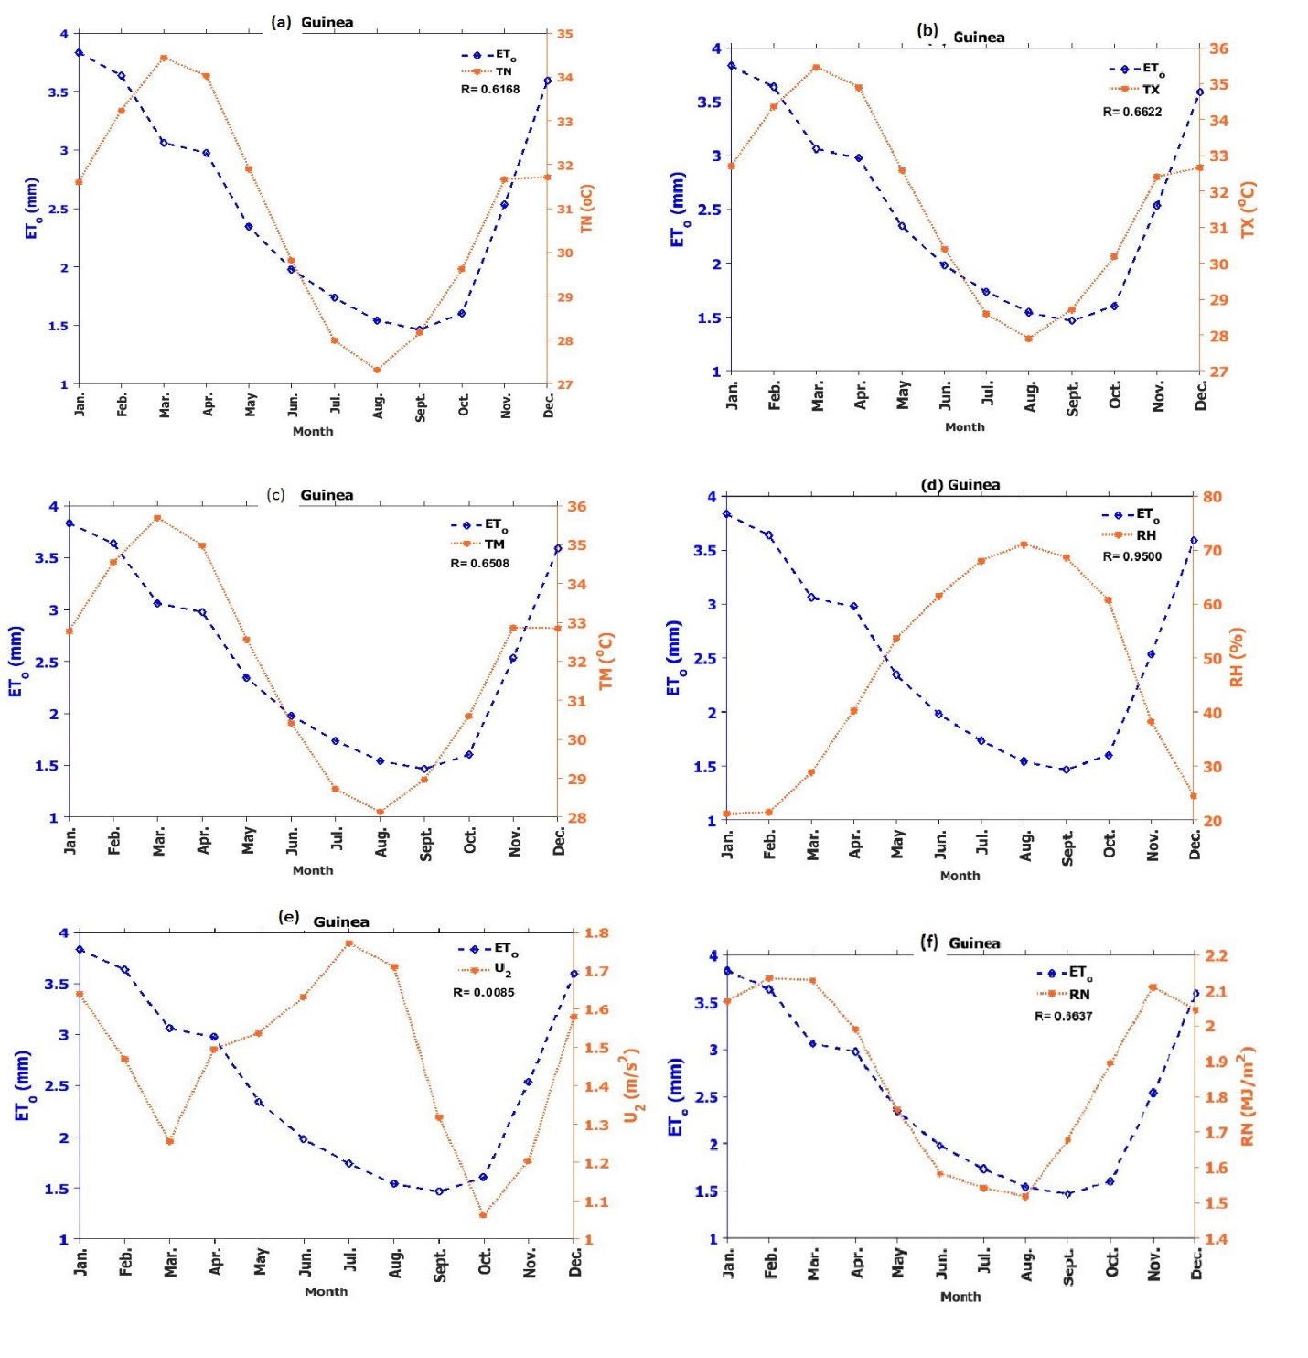
Figure 7: Seasonal variation of reference transpiration and climate variables in the Guinea

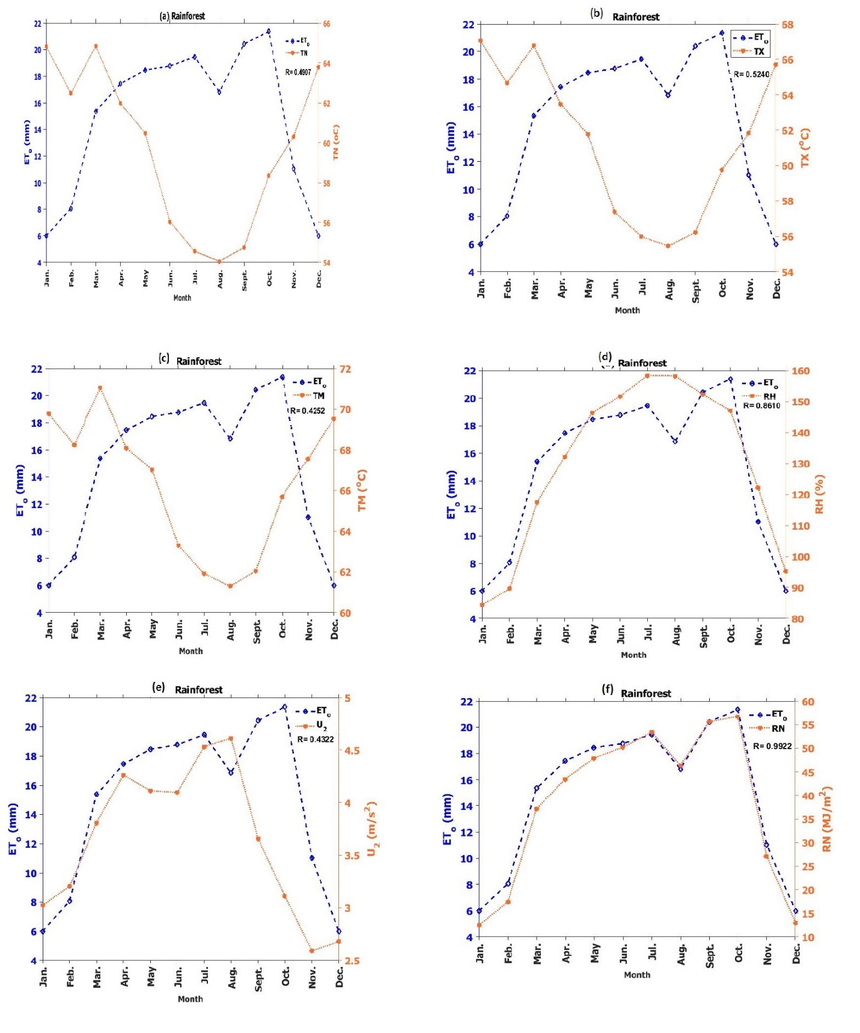
Figure 8: Seasonal variation of reference transpiration and climate variables in the Rainforest
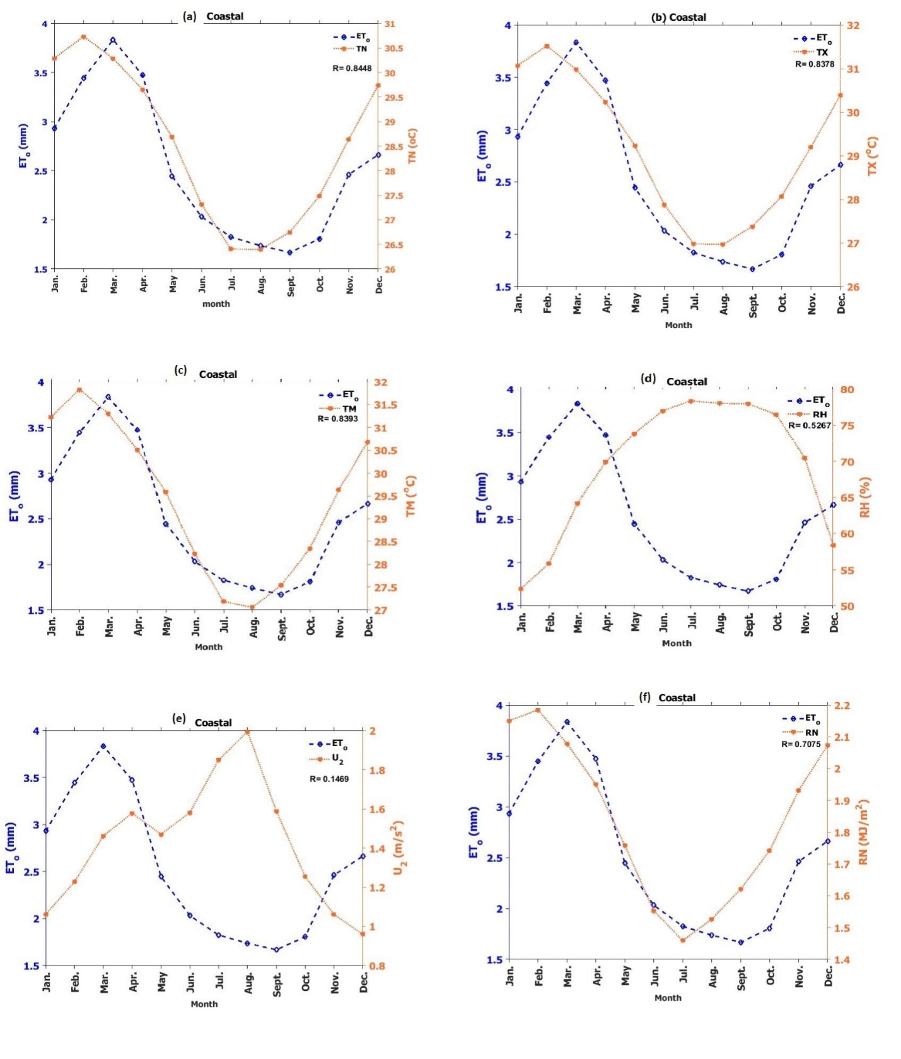
Figure 9: Seasonal variation of reference transpiration and climate variables in the Coastal
Cloud cover plays a significant role in the amount of solar radiation reaching the surface, with cloudless skies resulting in warmer temperatures and cloudy skies leading to cooler temperatures (Isikwue et al., 2014; Vicente-Serrano et al., 2014). Understanding these seasonal variations and their influencing factors is crucial for effective water management and climate change impact assessments in Nigeria. Generally, in all regions, reference evapotranspiration decreased during the rainy months with relative humidity being highly correlated in those months. This is due to the fact that lower evapotranspiration rates occur in humid weather due to both the high air humidity and the presence of clouds. This was consistent with studies by Akinsanola and Ogunjobi (2014) and Isikwue et al. (2015).
Inter-annual Variation of ET_{o} and Meteorological Variables
Figures 10-13 (a-f) depict the interannual variations of Evapotranspiration (ET_{o}) and its six constituent variables across four climatic regions in Nigeria from 1979 to 2021. The analysis of interannual variations of Evapotranspiration (ET_{o}) and its constituent variables in different climatic regions of Nigeria from 1979 to 2021 reveals distinct patterns. In the Sahel region (Figure 10), mean temperature (TM), maximum temperature (TX), and minimum temperature (TN) experienced substantial increasing rates of 0.02452/year, 0.02002/year, and 0.01925/year, respectively, compared to the relatively lower rate of ET_{o} increase at 0.0005916/year. The correlation coefficient between ET_{o} and wind speed (U2) of 0.836 indicates a positive relationship, suggesting that the rise in U2, coupled with increasing temperatures due to climate change, leads to higher evapotranspiration rates by introducing drier winds and additional heat energy to the evapotranspiration site (Sushanta and Sarkar, 2018; Eric W. Harmsen et al., 2009). Moving to the Guinea region (Figure 11), the increasing rates of TX, TN, and TM at 0.02095/year, 0.02081/year, and 0.02058/year, respectively, outpaced the rate of ET_{o} increase, which stood at 0.001447/year. Additionally, rainfall (RN) exhibited an increasing trend with a rate of 0.001783/year, while both wind speed (U2) and relative humidity (RH) displayed decreasing trends at rates of 0.001302/year and 0.005602/year, respectively. These variations suggest that factors beyond temperature, such as rainfall, wind speed, and relative humidity, contribute to the interannual variability of ET_{o} in the Guinea region. In the Rainforest regions (Figure 12), ET_{o} exhibited a decreasing trend at 0.04681/year, despite the increasing rates of TM, TN, and TX at 0.5927/year, 0.5299/year, and 0.526/year, respectively. The high correlation coefficient of 0.9987 between ETo and rainfall (RN) indicates a strong relationship, highlighting the significant influence of rainfall on ET_{o} variation within the Rainforest region. This finding aligns with studies conducted in other regions, such as Northeast China (Cao and Zhou, 2019) and the Qilian Mountains of China (Lin et al., 2018), where wind speed, relative humidity, and other factors contributed to decreased ET_{o}. The role of wind speed (U2) and relative humidity (RH) in the Rainforest region is evident with correlation coefficients of 0.0040 and 0.2627, respectively, further emphasizing their contribution to the ET_{o} variation. In the Coastal region (Figure 13), ETo displayed a relatively low increasing rate of 0.00137/year, while TM, TX, and TN exhibited increasing rates of 0.02437/year, 0.01608/year, and 0.01536/year, respectively. Notably, relative humidity (RH) and rainfall (RN) demonstrated decreasing trends at rates of 0.0262/year and 0.003619/year, respectively, while wind speed (U2) displayed a slight increasing trend of 0.0004197/year. These observations suggest that in the Coastal region, factors such as temperature and wind speed play a role in ET_{o} variation, while relative humidity and rainfall have contrasting effects. Generally, the analysis highlights the region-specific characteristics in the interannual variations of ET_{o} and its constituent variables in Nigeria. The findings emphasize the influence of various climatic factors, including temperature, wind speed, relative humidity, and rainfall, on the observed trends of ET_{o}.
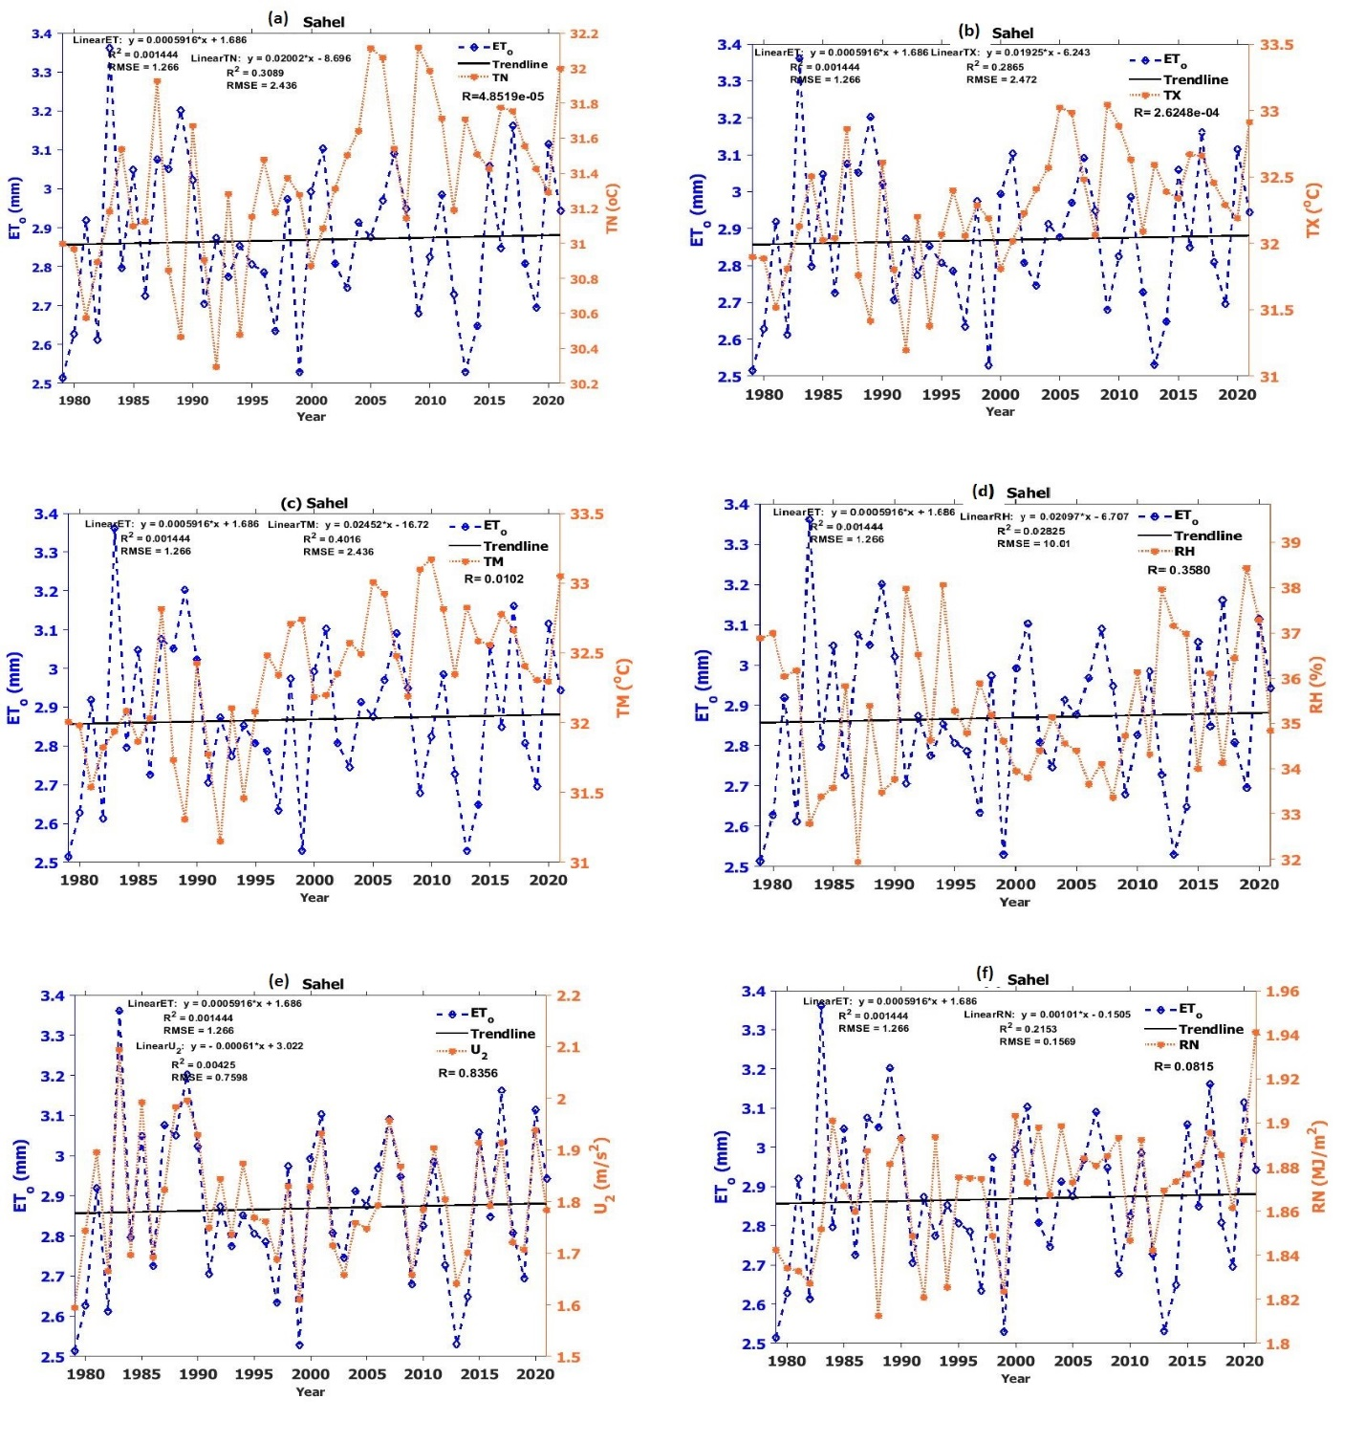
Figure 10: Inter-annual variation of reference transpiration and climate variables in the Sahel region, Nigeria
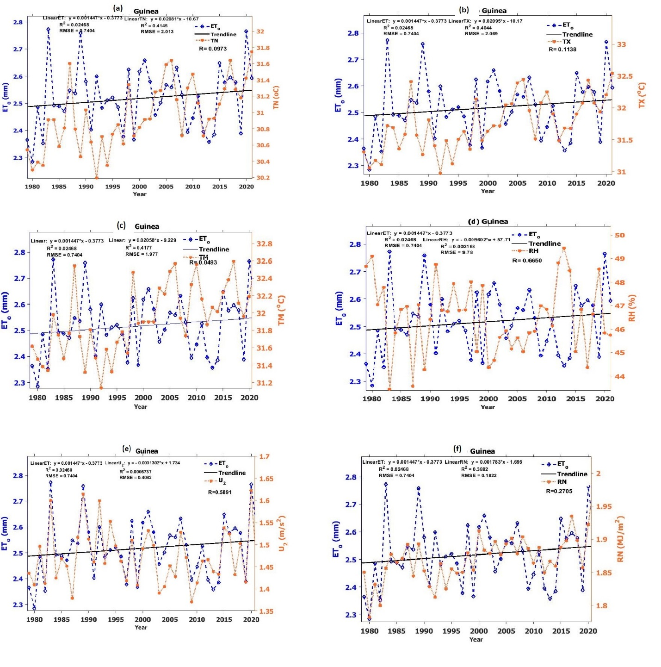
Figure 11: Inter-annual variation of reference transpiration and climate variables in the Guinea Savannah region, Nigeria

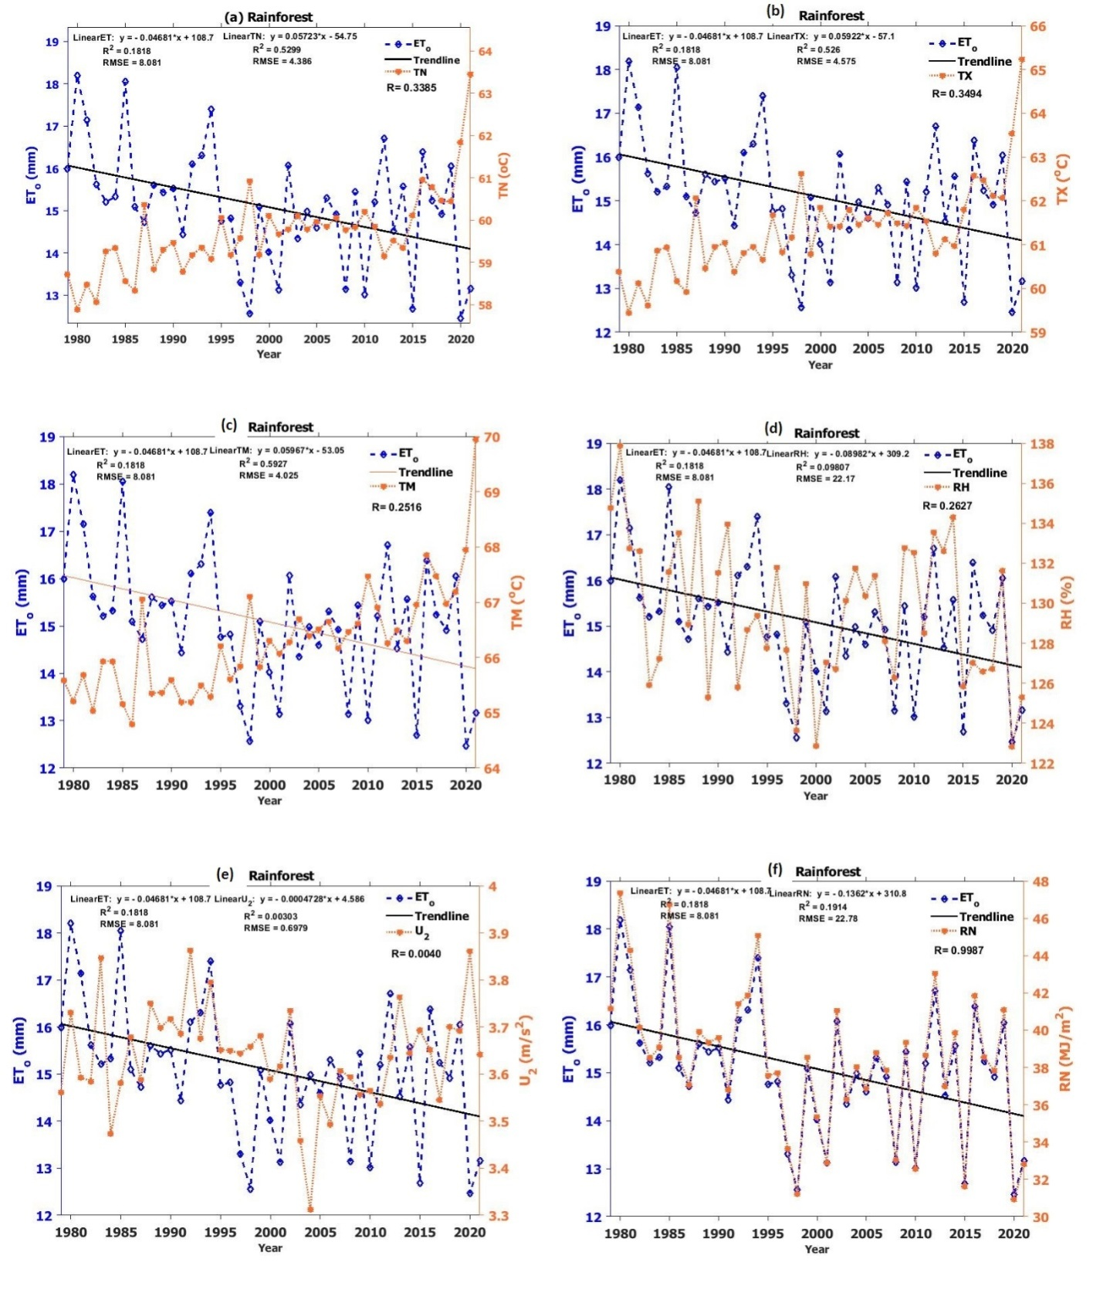
Figure 12: Inter-annual variation of reference transpiration and climate variables in the Rainforest region, Nigeria
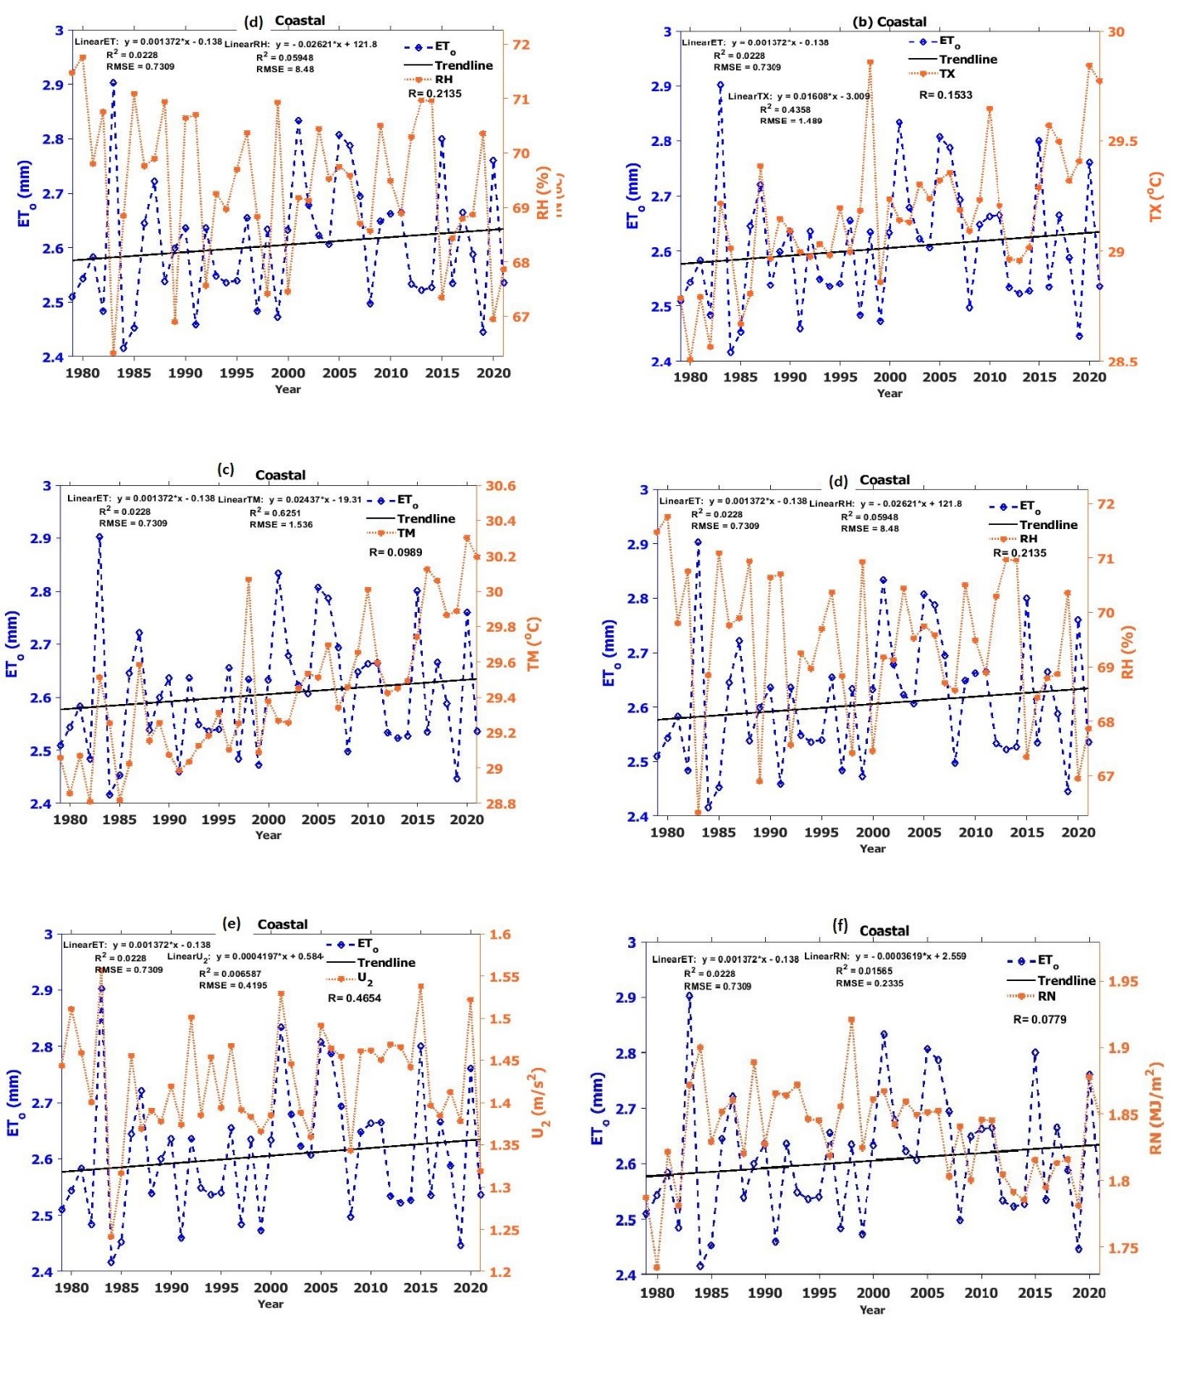
Figure 13: Inter-annual variation of reference transpiration and climate variables in the Coastal region, Nigeria

Trend analysis and Homogeneity Test
Tables 1 – 4 display Mann-Kendall trends and homogeneity tests of ETo across four climatic regions in Nigeria. The value of Z indicates the strength of the increasing trend (positive Z value) or decreasing trend (negative Z value) in ET_{o} trend, with higher values implying stronger ETo in the respective area at a significance level of P<0.05 (alpha level). Moreover, K, To, Q, and N represent the strength of change points in ETo using the Pettit, Standardized Normal Homogeneity Test (SNHT), Buishand, and Von-Neumann ratio, respectively. A significant change point (year) signifies inhomogeneity, indicating a sudden shift in ETo variability in a particular area. In the Sahel region (Table 1), all ten stations demonstrated an increasing trend in ETo. However, Sokoto, Katsina, and Dutse exhibited non-significant trends, as indicated by their P-values exceeding the alpha level of 0.05. The increasing trends detected in Sahel region, being a region with limited rainfall, can lead to drier conditions, which may result in reduced vegetation cover, increased risk of drought stress, and changes in ecosystem composition. Based on the study's criteria of being supported by at least two out of three change point tests, 1999 was established as the year of homogeneous/inhomogeneous change in ETo in nine out of ten stations. Only Katsina experienced a change in ETo starting from 1983. Among the stations, Maiduguri recorded the highest values of Z, K, To, Q, and N, indicating the most pronounced and significant trends and change points in the region. In the Guinea region (Table 2), ten out of eleven stations exhibited significant increasing trends in ETo. Jos was the only station with an insignificant trend, as indicated by a P-value greater than the alpha level of significance (0.05). As previously established, six out of the eleven stations had their change points in the year 1999, while Makurdi, Minna, Lafia, and Lokoja had their change points established as 1997. Only Bauchi had its change point in 2002. Abuja and Bauchi recorded the highest values of Z, K, To, Q, and N, indicating strong significant trends and change points in these locations. In the Rainforest region (Table 3), ETo exhibited an increasing trend overall, although Ewekoro and Shagamu had insignificant trends with P-values exceeding the alpha level of significance (0.05). The study revealed that three out of ten stations experienced change points in the year 1996. Ilorin and Akure had their change points in 1999, Akure and Ado-Ekiti in 1994, while Ewekoro and Shagamu exhibited inhomogeneous change points in 1982. Only Benin experienced a change point in 2006.
Table 1: Mann-Kendall Trend and Homogeneity test for the Sahel and Guinea Savannah Region
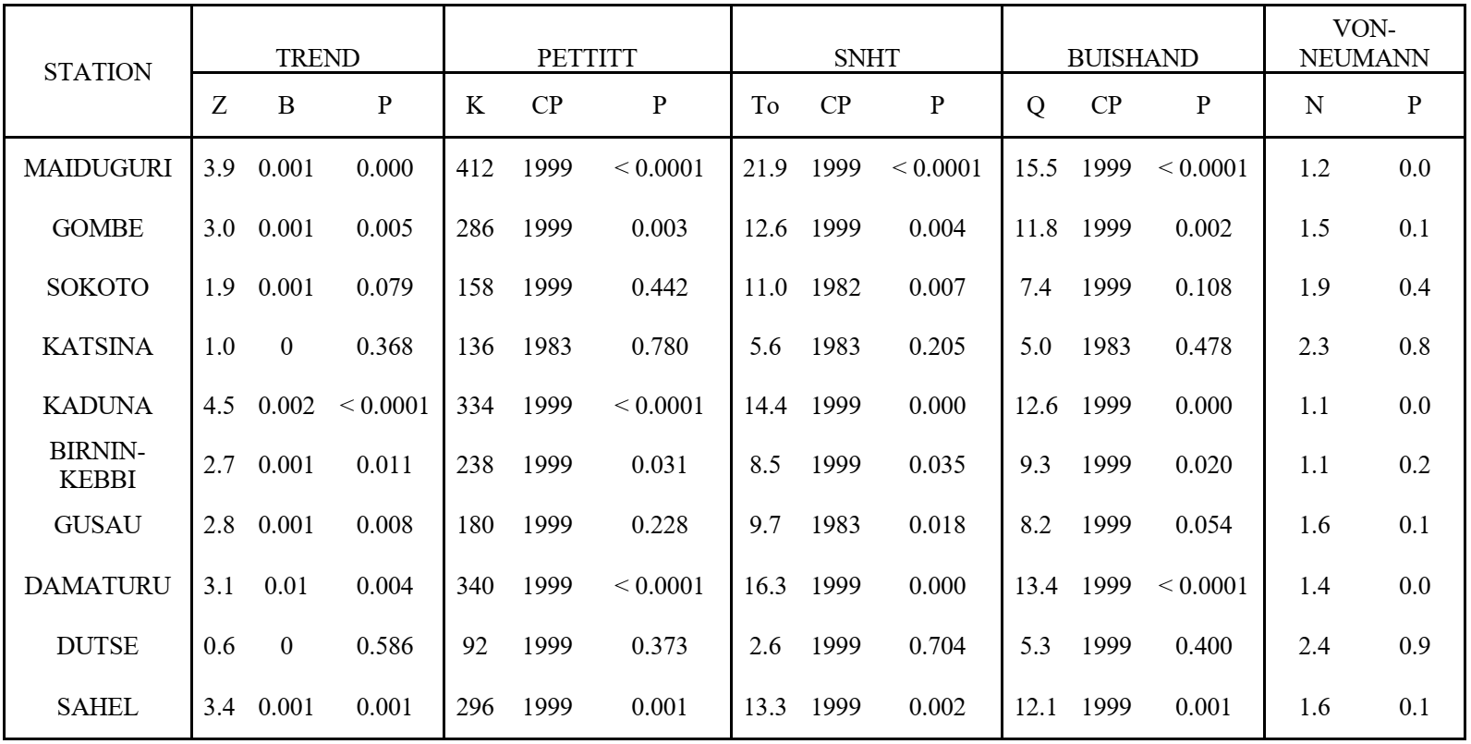
Table 2: Mann-Kendal Trend and Homogeneity Tests of the Guinea Savannah Region
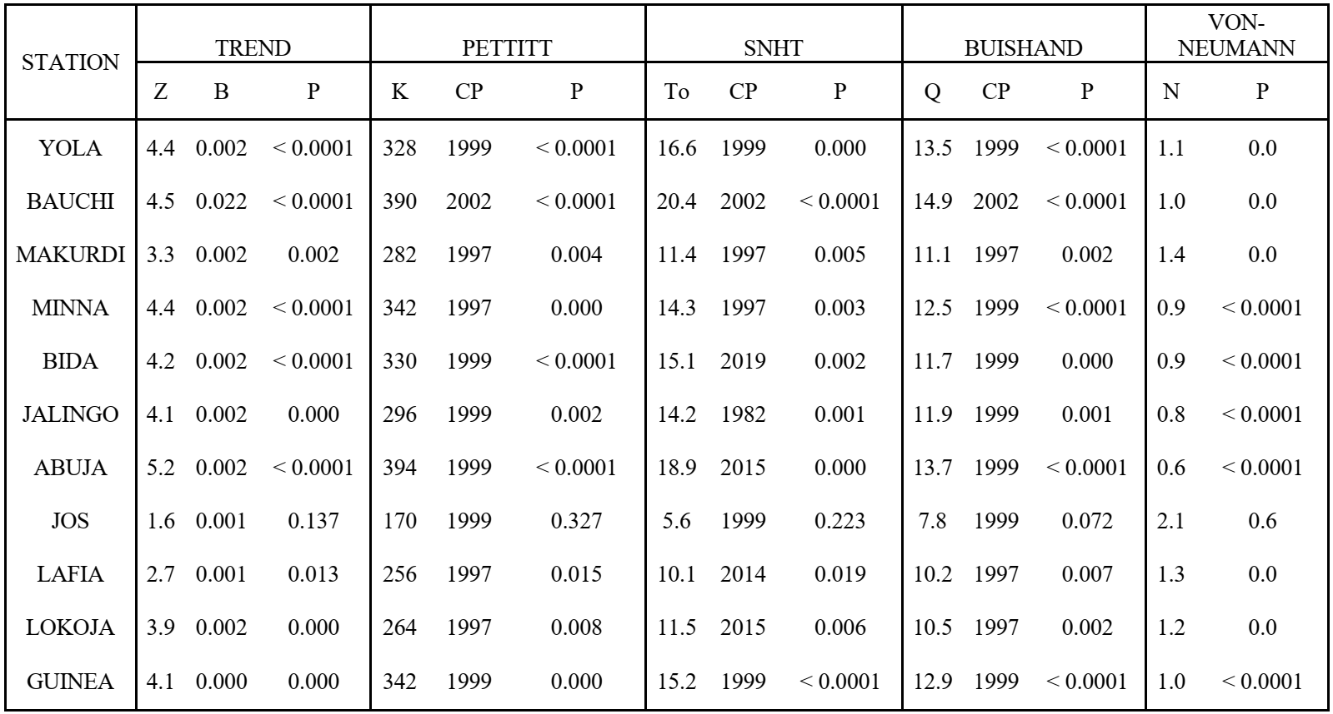
Ilorin recorded the strongest significant trend and change point, as it displayed the highest values of Z, K, To, Q, and N. In the Coastal region (Table 4), eight stations exhibited an insignificant decreasing trend in ETo, while only Bonny displayed a significant decreasing trend. Ikeja, Enugu, and Asaba showed insignificant increasing trends. Seven out of twelve stations experienced homogeneous/inhomogeneous change points in ETo in 2006, whereas Yenagoa and Okpe had their inhomogeneous change points in 2008. Ikeja and Enugu also exhibited inhomogeneous changes in 1982, while Asaba experienced inhomogeneous change in ET_{o} in 1996. Calabar and Port-Harcourt recorded the highest values of Z, K, To, Q, and N, indicating the strongest insignificant decreasing trend and change point in the Coastal region. Generally, changes in ET_{o} can have socio-economic consequences. For example, shifts in agricultural productivity can affect food security, livelihoods of farmers, and rural economies. Additionally, variations in water availability due to ET_{o} changes can impact hydropower generation, water-dependent industries, and human settlements reliant on consistent water supplies.

Table 3: Mann-Kendall Trend and Homogeneity test for the Rainforest Region
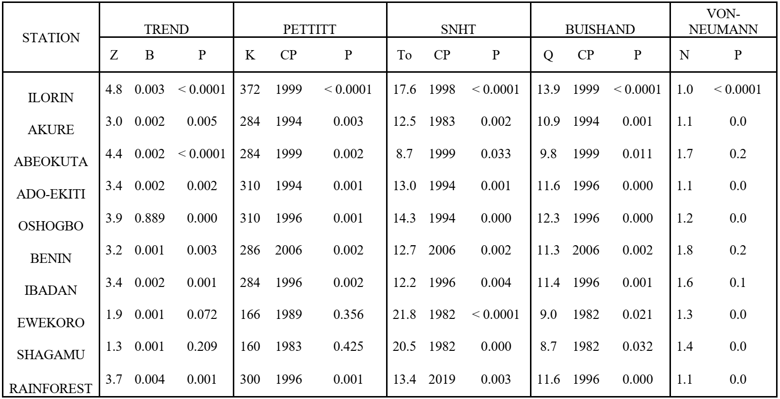

Table 4: Mann-Kendall Trend and Homogeneity test for the Coastal Region
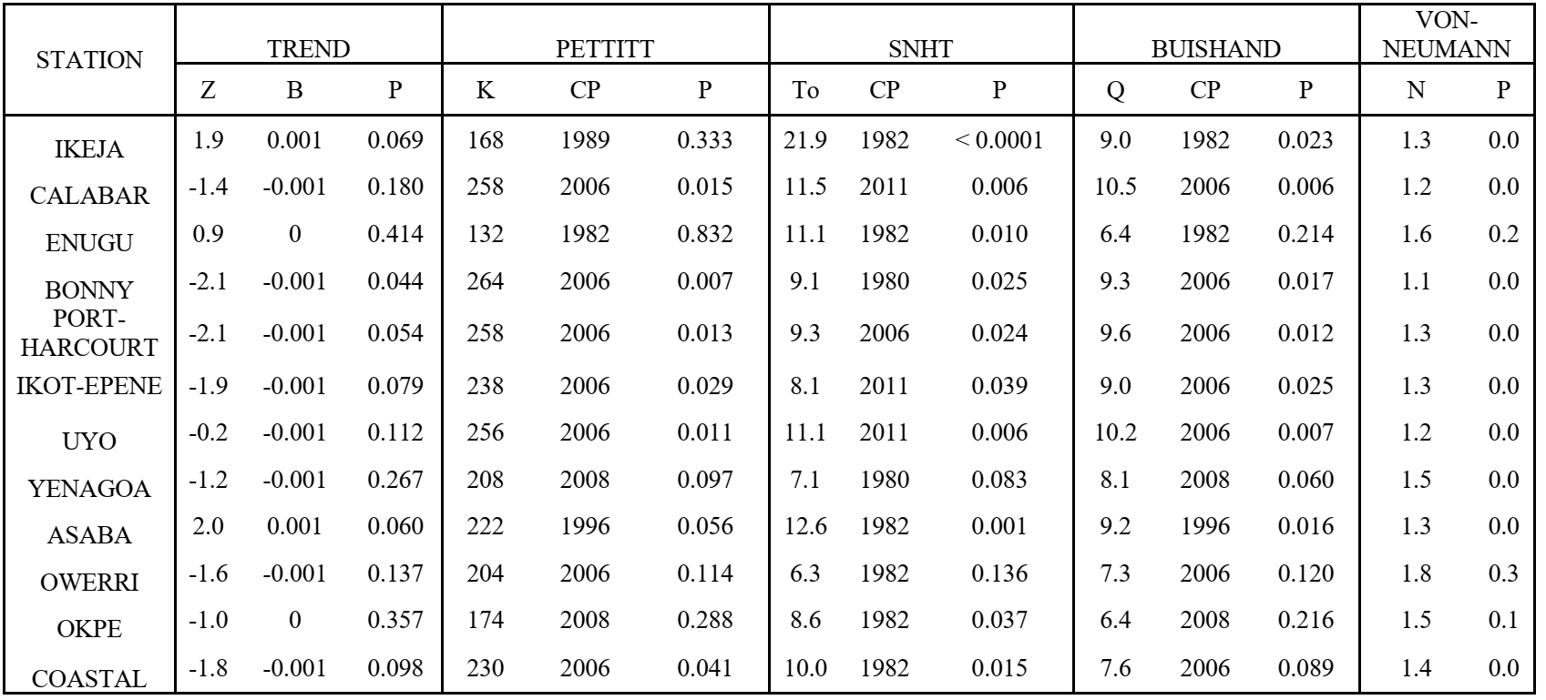
Cross Correlation of ET_{o} and Meteorological Variables
Figures 14 - 17 (a-f) illustrate the cross-correlation plots between evapotranspiration (ET_{o}) and meteorological variables in different climatic regions of Nigeria. The left and right sides of the plots indicate the degree of sensitivity, with correlation values between 0-0.4 considered as weak sensitivity, 0.45-0.65 as moderate sensitivity, and 0.7-1 as strong sensitivity. The time response of each parameter (in months) is provided at the bottom of the plots.In the Sahel region (Figure 14 (a-f)), ET_{o} demonstrated moderate sensitivity with a correlation value of 0.65 and a one-month lead response time with TN, TX, and TM. ETo and RH exhibited a strong negative sensitivity with a correlation value of 0.7 at an immediate response time lag. ETo and U2 displayed moderate positive sensitivity with a correlation value of 0.55 and a one-month response time lag. ETo and RN also showed moderate positive sensitivity with a correlation value of 0.5 and a four-month lead response time. These results indicate that ETo tends to increase with higher values of TN, TM, TX, and U2, while decreasing with reduced RH and RN in the Sahel region. In the Guinea Savannah region (Figure 15 (a-f)), ETo exhibited a strong positive sensitivity with a correlation value of 0.98 and no significant response time lag with TN, TX, and TM.
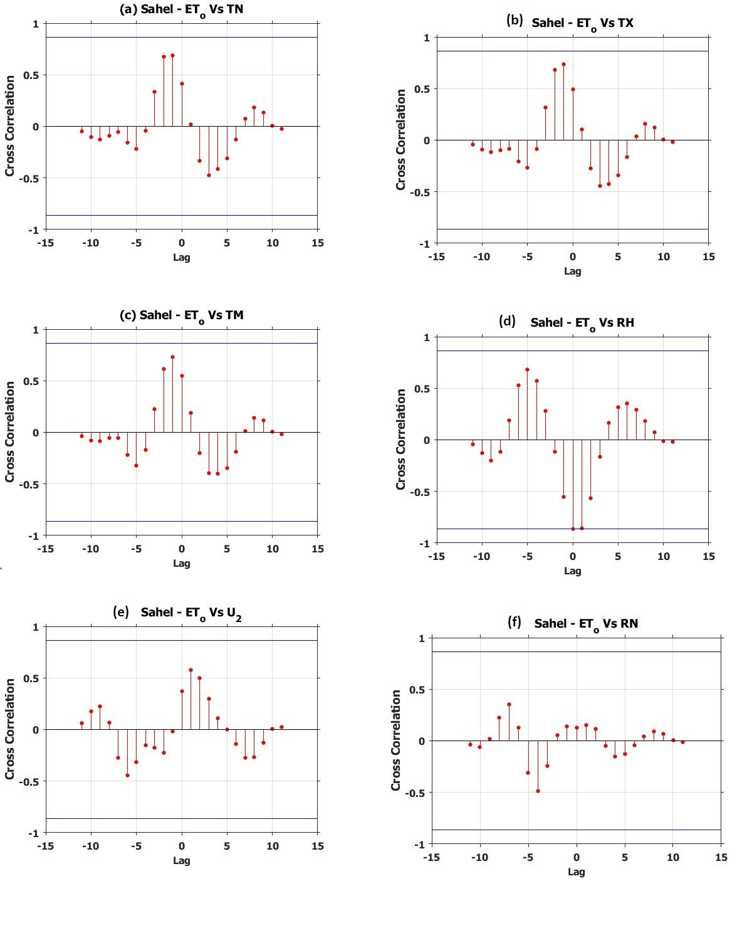
Figure 14: Cross correlation of reference evapotranspiration and climatic variables in the Sahel Region
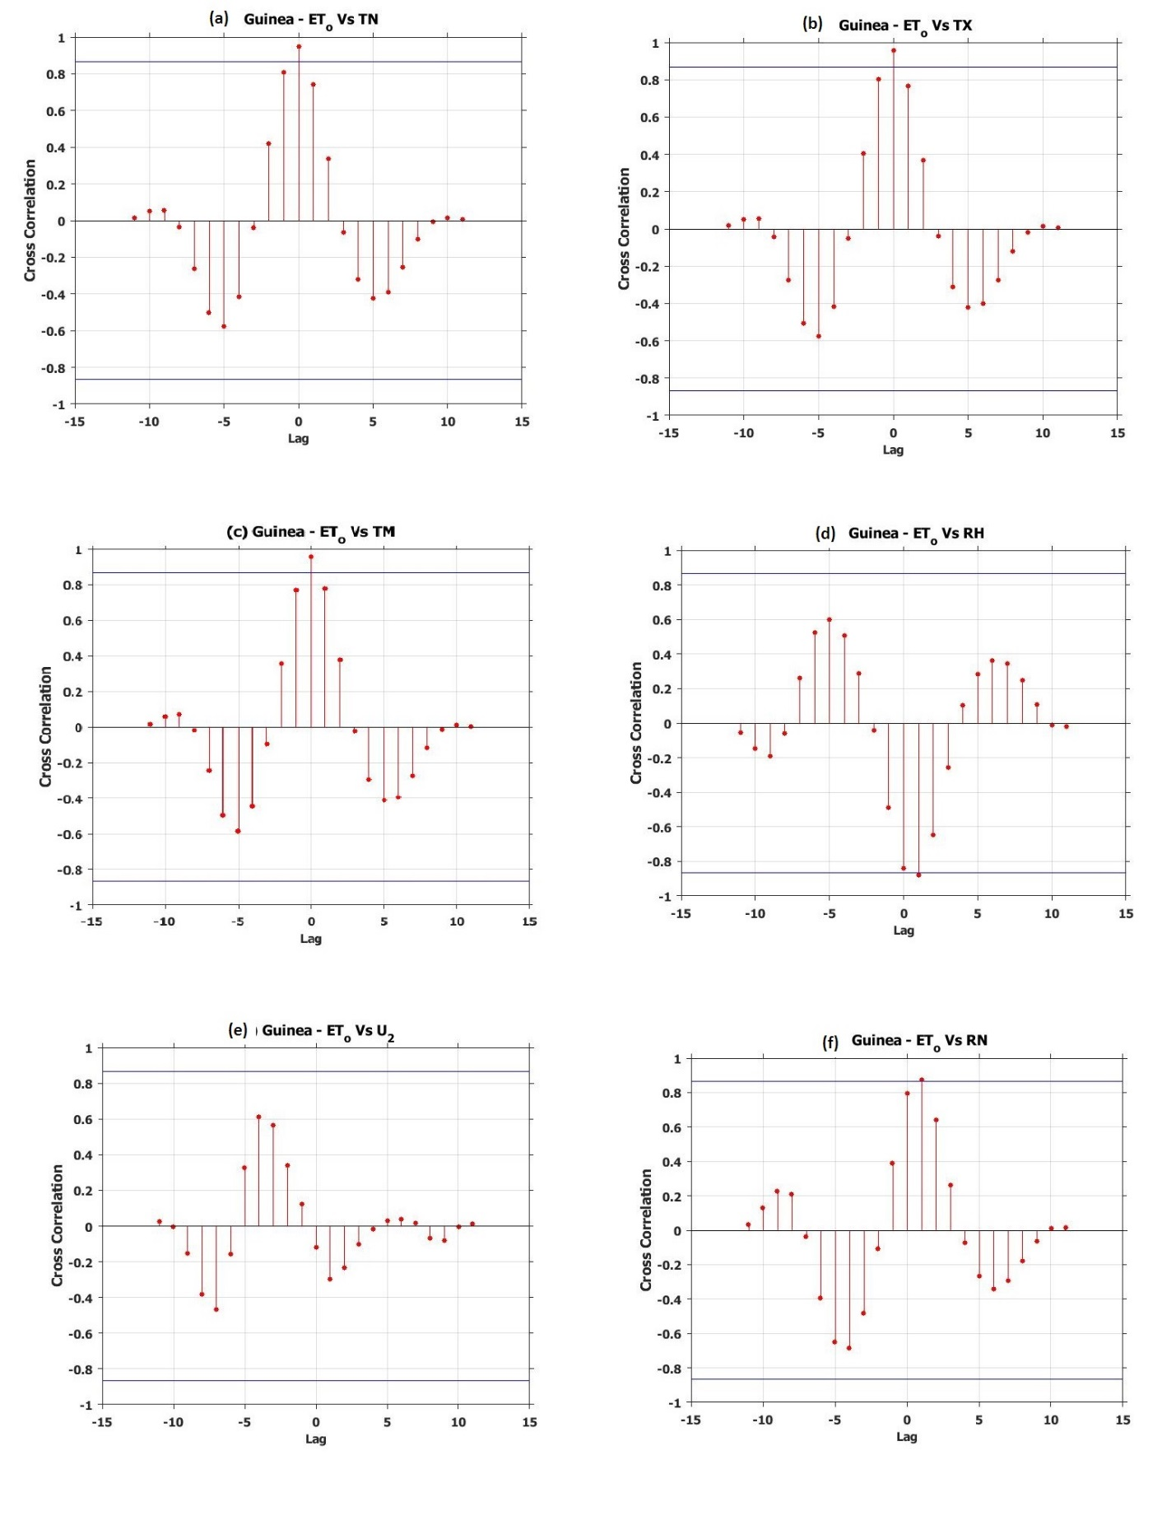
Figure 15: Cross correlation of reference evapotranspiration and climatic variables in the Guinea Savannah Region
ETo and RH showed a strong negative sensitivity with a correlation value of 0.85 and a one-month response time lag. ETo and U2 displayed moderate positive sensitivity with a correlation value of 0.6 and a four-month lead response time. However, the sensitivity between ETo and RN was insignificant, despite a strong correlation value of 0.85 and a one-month response time lag. These findings suggest that ETo tends to increase with higher values of TN, TM, TX, U2, and RN, while decreasing with reduced RH in the Guinea Savannah region. Similarly, in the Rainforest region (Figure 16 (a-f)), ETo showed strong positive sensitivity with a correlation value of 0.85 and no response time lag with TN, TX, and TM. ETo and RH exhibited a strong negative sensitivity with a correlation value of 0.85 and a one-month response time lag. ETo and U2 displayed strong positive sensitivity with a correlation value of 0.75 and a four-month lead response time. ETo and RN also showed a strong negative sensitivity with a correlation value of 0.75 and a one-month response time lag. These results indicate that ETo tends to increase with higher values of TN, TM, TX, and U2, while decreasing with reduced RH and RN in the Rainforest region. In the Coastal region (Figure 16 (a-f)), ETo exhibited an insignificant response time lag and a strong positive sensitivity of 0.9 with TN, TX, and TM. ETo and RH showed a strong negative sensitivity with a correlation value of 0.85 and a one-month response time lag. ETo and U2 demonstrated strong positive sensitivity with a correlation value of 0.7 and a four-month lead response time. ETo and RN also displayed strong positive sensitivity with a correlation value of 0.85 and a one-month response time lag. These findings suggest that ETo tends to increase with higher values of TN, TM, TX, RN, and U2, while decreasing with reduced RH in the Coastal region. Generally, these results indicate that variations in ETo are largely influenced by changes in TN, TM, TX, U2, RH, and RN in their respective climatic regions. Understanding these sensitivities and response times between ETo and meteorological variables can have relevant implications for water resource management, agriculture, and climate adaptation strategies in different regions of Nigeria.

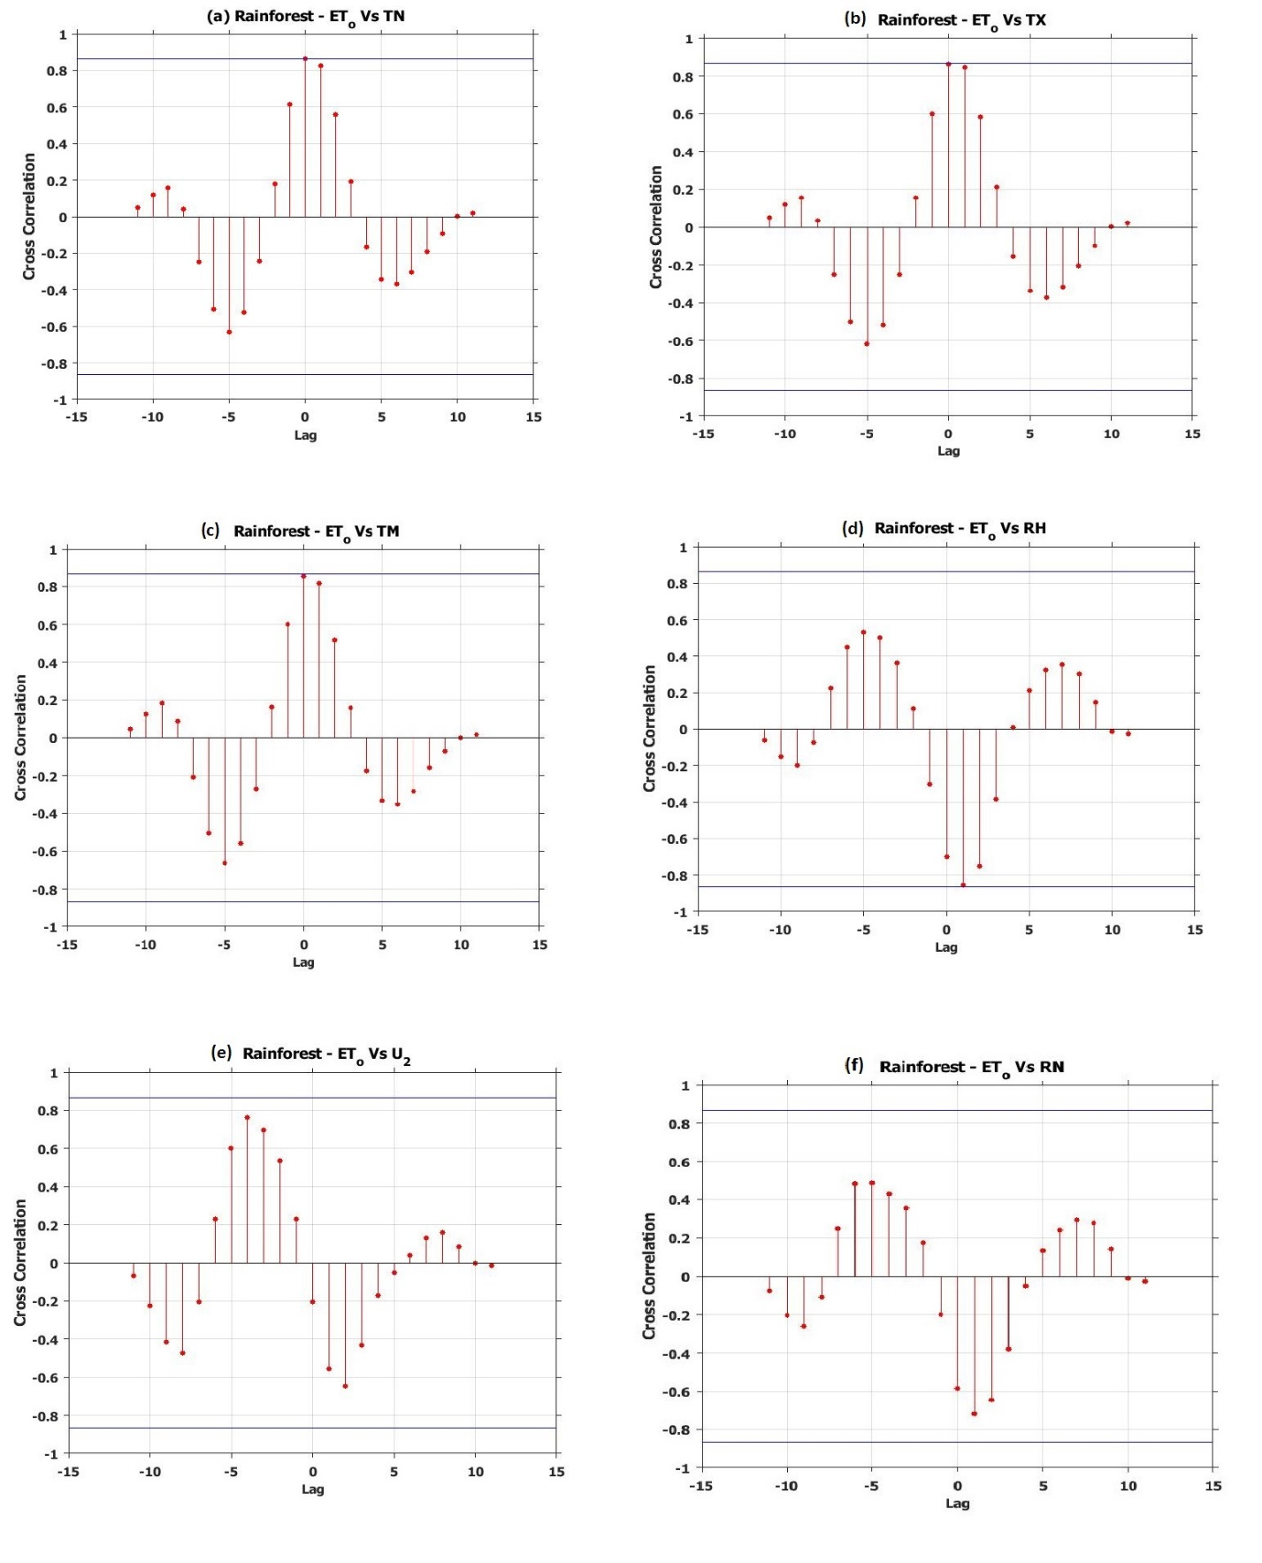
Figure 16: Cross correlation of reference evapotranspiration and climatic variables in the Rainforest Region
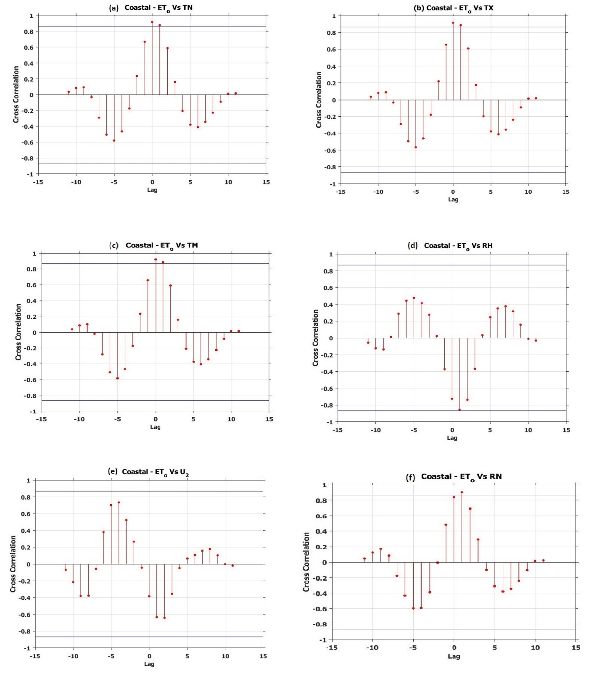
Figure 17: Cross correlation of reference evapotranspiration and climatic variables in the Coastal Region

Conclusion
In this study, a comprehensive analysis of the interconnection between reference evapotranspiration and meteorological variables during 1979-2021 in climatic regions over Nigeria was carried out. The quantitative contributions of the meteorological variables revealed that ET_{o} was strongly negatively correlated in the Sahel, Guinea and Coastal regions to relative humidity (RH) with values of R² as 0.7343, 0.8418, and 0.7662 respectively. The analysis of trends, homogeneity, and cross-correlation in different climatic regions of Nigeria reveals insightful findings. In the Sahel region, most stations exhibited an increasing trend in Evapotranspiration (ET_{o}), although some trends in Sokoto, Katsina, and Dutse were non-significant. The year 1999 was identified as the year of homogeneous/inhomogeneous change in ETo for most stations, except for Katsina, which experienced a change in 1983. Strong significant trends and change points were observed in Maiduguri. Similarly, the Guinea region displayed a significant increasing trend in ET_{o} across most stations, with Abuja and Bauchi showing prominent trends and change points. The Rainforest region exhibited an overall increasing trend in ET_{o}, with Ilorin displaying the strongest significant trend and change point. In the Coastal region, most stations had insignificant decreasing trends, while Calabar and Port-Harcourt showed the strongest insignificant decreasing trends and change points. The cross-correlation analysis revealed that ET_{o} in the Sahel, Guinea, Rainforest, and Coastal regions was influenced by various meteorological variables. Temperature variables (TN, TX, TM) exhibited positive sensitivity, while relative humidity (RH) showed negative sensitivity. Wind speed (U2) and rainfall (RN) displayed both positive and insignificant sensitivities. Understanding these patterns can assist in water resource management, agriculture, and climate adaptation strategies tailored to the specific climatic regions of Nigeria. uture studies could also consider examining the relationships between ET_{o} and other climatic indices, such as the North Atlantic Oscillation (NAO) or El Niño-Southern Oscillation (ENSO), to assess any potential teleconnections and improve climate prediction models. Lastly, considering the potential effects of climate change on ETo patterns in these regions and projecting future trends under different climate scenarios would be valuable for adaptation planning and policy formulation.

Data Availability: The data and codes used for this study are available on requent.

References
Alexandersson H (1986) A homogeneity test applied to precipitation data. J Clim 6(6):661–675. https://doi.org/10.1002/joc.3370060607
Allen, R. G., Pereira, L. S., Raes, D., & Smith, M. (1998). Crop evapotranspiration-Guidelines for computing crop water requirements-FAO Irrigation and drainage paper 56. FAO, Rome, 300(9), D05109.
Buishand T.A (1982) Some methods for testing the homogeneity of rain-fall records. Journal of Hydrology, Elsevier Scientific Publishing Company, 58, 11–27, Amsterdam, Netherlands, 1-2, DOI: https://doi.org/10.1016/0022-1694(82)90066-X
Debnath, S., Adamala, S., Raghuwanshi, N.S., 2015. Sensitivity analysis of FAO-56 Penman-Monteith method for different agro-ecological regions of India. Environ. Process. 2, 689–704. https://doi.org/10.1007/s40710-015-0107-1.
Easterling, D. R., Evans, J. L., Groisman, P. Y., Karl, T. R., Kunkel, K. E., & Ambenje, P. (2000). Observed variability and trends in extreme climate events: a brief review. Bulletin of the American Meteorological Society, 81(3), 417-426.
Eludoyin, O. M., Adelekan, I. O., Webster, R., & Eludoyin, A. O. (2014). Air temperature, relative humidity, climate regionalization and thermal comfort of Nigeria. International Journal of Climatology, 34(6), 2000-2018.
Emeka, N., Ikenna, O., Okechukwu, M., Chinenye, A., & Emmanuel, E. (2021). Sensitivity of FAO Penman–Monteith reference evapotranspiration (ETo) to climatic variables under different climate types in Nigeria. Journal of Water and Climate Change, 12(3), 858-878.
Huo, Z., Dai, X., Feng, S., Kang, S., & Huang, G. (2013). Effect of climate change on reference evapotranspiration and aridity index in arid region of China. Journal of Hydrology, 492, 24-34.
Parry, M. L. (Ed.). (2007). Climate change 2007-impacts, adaptation and vulnerability: Working group II contribution to the fourth assessment report of the IPCC (Vol. 4). Cambridge University Press.
Isikwue, B. C., M. O. Audu, and E. J. Eweh. 2015. Correlation of evapotranspiration with climatic parameters in some selected cities in Nigeria. Journal of Earth Sciences and Geotechnical Engineering, 5(4): 103–115
Kendall MG (1975) Rank correlation methods. Griffin, London
Li Z, Jiang FQ (2007) A study of abrupt climate change in Xinjiang region during 1961–2004. J Glaciol Geocryol 29(3):351–359 (in Chinese with English abstract)
Mann HB (1945) Nonparametric tests against trend. Econometrica 13: 245–259
McVicar, T.R., Roderick, M.L., Donohue, R.J., 2012. Global review and synthesis of trends in observed terrestrial near-surface wind speeds: implications for evaporation. J. Hydrol. 416–417, 182–205
Monirul Qader Mirza, M., 2002. Global warming and changes in the probability of occurrence of ﬂoods in Bangladesh and implications. Global Environmental Change 12 (2), 127e138.
Ojo, O. S., Emmanuel, I., Adeyemi, B., & Ogolo, E. O. (2021). Effect of the radiation balance on warming occurrence over West Africa. Scientific African, 11, e00700.Pettitt A. N (1979) A non-parametric approach to the change-point problem. Applied Statistics, Leics, England, 28, No 2, 126–135
Sushanta Sarkar and S Sarkar. A review on impact of climate change on evapotranspiration. The Pharma Innovation Journal 2018; 7(11): 387-390
Thomas, A., 2008. Development and properties of 0.25-degree gridded evapotranspiration data ﬁelds of China for hydrological studies. J. Hydrol. 358, 145–158, 2008).
Von Neumann J (1941) Distribution of the ratio of the mean square successive difference to the variance. Ann Math Stat 13:367–395
Wijngaard JB, Klein Tank AMG, Konnen GP (2003) Homogeneity of 20th century European daily temperature and precipitation series. Int J Climatol 23(6):679–692.
Zhang, K. X., Pan, S. M., Zhang, W., Xu, Y. H., Cao, L. G., Hao, Y. P., & Wang, Y. (2015). Influence of climate change on reference evapotranspiration and aridity index and their temporal-spatial variations in the Yellow River Basin, China, from 1961 to 2012. Quaternary International, 380, 75-82.

