Larvicidal and Molecular Docking Evaluation of Stephanotis volubilis Leaf Phytochemicals Against Culex quinquefasciatus Odorant-Binding and D7 Proteins
Abstract
Vector-borne diseases pose a significant worldwide health threat, and the dependence on synthetic insect repellents has led to the development of resistance and ecological damage. This study investigated the larvicidal potential of Stephanotis volubilis (Apocynaceae) leaf extracts against the vector Culex quinquefasciatus (Diptera: Culicidae) and explored the underlying mechanisms through in-silico molecular docking. Larvicidal bioassay using Hexane, Ethyl acetate, and Ethanol extracts was conducted as per WHO guidelines. All extracts demonstrated concentration and time-dependent mortality against Cx. quinquefasciatus larvae. The Ethyl acetate extract was the most potent, recording an LC50 value of 101.3 ppm at 24 hours, which decreased to 80.0 ppm at 72 hours. This 72-hour LC50 value is within the WHO’s permissible threshold for plant-based larvicides. Molecular docking studies were performed using four phyto constituents against two critical mosquito targets: Odorant Binding Protein (OBP) PDB:3OGN and D7 Salivary Protein (PDB: 6V4C). Oleic acid showed the highest binding affinity for OBP at -7.4 kcal/mol, which was superior to the synthetic insecticide Temephos -7.1 kcal/mol. (E) -Cinnamic acid also bound strongly to the D7 Salivary Protein -6.7 kcal/mol and Temephos -6.2 kcal/mol. In conclusion, S. volubilis leaf extracts exhibit potent larvicidal activity. The moderate correlation (r = 0.78) between in vitro larvicidal activity and in-silico binding energies suggests these phytochemicals disrupt mosquito physiology through multiple mechanisms. S.volubilis phytochemicals demonstrate WHO-compliant larvicidal efficacy with superior molecular binding than the synthetic controls, validating their potential as eco-friendly alternatives for integrated vector management.
Keywords: Stephanotis volubilis, Mosquitoes, Culex quinquefasciatus, Larvicidal activity, Molecular docking, Odorant Binding Protein and D7 Salivary Protein.

GRAPHICAL ABSTRACT

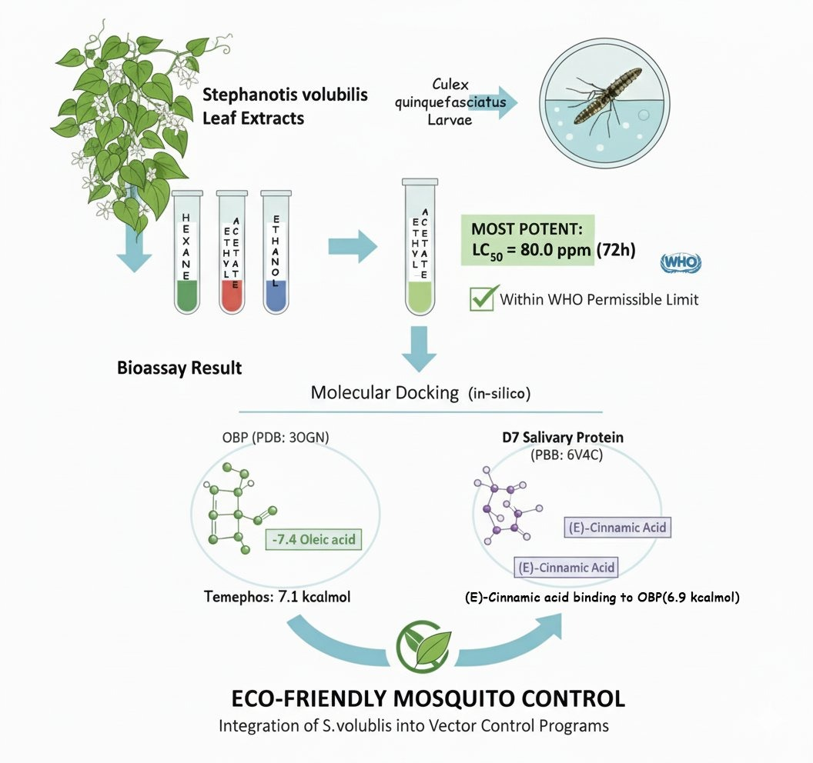

- INTRODUCTION
Mosquitoes pose a major threat to global health as vectors for numerous diseases, including Malaria, Dengue fever, Chikungunya, Yellow fever, Zika virus and Lymphatic filariasis (WHO,2023). WHO reports Vector-borne diseases cause a death rate of over 700,000 each year, with Malaria responsible for 400,000 fatalities, mainly affecting children under five age in Sub- Sahara Africa (CDC, 2022). Vector-borne diseases cause significant mortality and morbidity across populations, resulting in substantial economic losses and hindering the development in the endemic regions (Fu, 2024). Vector control remains the most effective prevention strategy, relying on the synthetic chemical insecticides, including organophosphates, carbamates, pyrethroids and organochlorides (Van de Berg et al., 2021; Tognarelli et al., 2025). The extensive use of synthetic insecticides has led to resistance, health effects, and environmental impacts (Araujo et al., 2023; Garud et al., 2024) eco- friendly alternatives.
Botanical insecticides offer viable alternatives due to their biodegradability, target specificity, and reduced resistance risk (Ahmed et al., 2021; Kumar et al., 2025). Plants produce secondary metabolites with insecticidal properties (Ukoroije & Otayor,2020; Farhan et al., 2024). Alkaloids, terpenoids, flavonoids, phenolics, essential oils, and saponins show larvicidal and repellent activities against mosquitoes (Sharma et al., 2022; Bilal et al., 2022). Stephanotis volubilis, a fragrant climbing plant native to tropical regions, is cultivated across India (Kyaw et al., 2025). The traditionally used plant in ethnomedicine, its larvicidal potential remains unexplored (Quattrocchi, 2012; Bilal et al., 2022). Studies show bioactive compounds that may have insecticidal properties (Rates, 2001). GC-MS analysis enables characterization of phytochemicals, providing insights into compounds responsible for larvicidal efficacy, aiding in standardization and isolation of lead compounds (Kumar et al., 2019).
Elucidating the molecular mechanisms underlying larvicidal activity is essential for developing effective mosquito control agents. Molecular docking enables prediction of ligand-protein binding interactions, valuable insights into the binding affinity and structure-activity relationships (Ferreira et al., 2015; Baz et al., 2024). This in silico approach enables quick screening of compounds against biological targets, lowering the laboratory validation costs (Islam et al., 2025). By combining computational methods with bioassays, researchers can identify promising leads and understand their biological activities (Agamah et al., 2020; Marques et al., 2024).
This study focuses on two key protein targets in mosquito physiology. Odorant-binding proteins transport hydrophobic odorant molecules to olfactory receptors (Leal, 2013), mediating host-seeking, nectar-feeding, oviposition, and mating behaviors (Pelosi et al., 2018). They represent targets for mosquito control by disrupting chemical communication (Liu et al., 2016). The crystal structure (PDB ID: 3OGN) provides information for understanding ligand-binding mechanisms. D7 proteins are salivary proteins that bind biogenic amines and hemostasis-related molecules (Calvo et al., 2006), facilitating blood feeding by counteracting host responses (Mans, 2011). The D7 protein family is crucial for mosquito survival (Ribeiro & Arca, 2009), and its structure (PDB ID: 6V4C) serves as a target for evaluating feeding inhibitors.
This investigation evaluates the mosquito larvicidal potential of Stephanotis volubilis (Apocynaceae) extract through in silico analysis and larvicidal activity assessment against Cx. quinquefasciatus larvae, a primary carrier of lymphatic filariasis and Japanese encephalitis. The study uses GC-MS analysis for identifying bioactive phytochemicals, followed by molecular docking studies against Odorant Binding protein (3OGN) and D7 Salivary Protein (6V4C). Laboratory bioassays determine the larvicidal efficacy against Cx. quinquefasciatus larvae.
This approach, combining analytical chemistry, computational modeling, and entomological bioassays, will provide insights into S. volubilis phytochemical’s larvicidal mechanisms. Correlation between computational predictions and biological activity will identify compounds responsible for larvicidal effects. The findings may contribute to developing eco-friendly mosquito control formulations, offering alternatives to synthetic insecticides while supporting India's commitment to sustainable development in resource-limited settings.
2.0.MATERIALS AND METHODS
2.1.Collection and Preparation of Plant Material
Fresh leaves of Stephanotis volubilis (Apocynaceae) were collected from Thiyagaraj Nagar, Tirunelveli (8.7139° N, 77.7567° E), Tamil Nadu, India. The leaves were cleaned with tap water followed by distilled water to eliminate contamination, then dried in the shade at room temperature 30-37 °C for 10-15 days to maintain bioactive compounds. The dried leaves were ground into powder using a mechanical grinder, passed through a 40-mesh sieve, and stored in airtight containers until use at room temperature (Rawani et al., 2017).
2.2.Preparation of Plant Extract
50 grams of powdered S. volubilis leaf material was extracted sequentially using 250 ml solvents in of increasing polarity Soxhlet apparatus (Rawal). Initially, the powder was extracted with Hexane (HiMedia solvent; Analytical grade) for 6-8 hours at 60°C. The extract was filtered through Whatman No. 1 paper and the solvent was concentrated using a rotary evaporator (BUCHI rotavapor r-300) at 40°C. The residual plant material was air- dried completely and subsequently re-extracted with Ethyl acetate under identical conditions, followed by filtration and concentration. The dried residue was then extracted with Ethanol (Analytical grade with 99.9% purity) following the same procedure. The dried extract was stored at 4°C in amber bottles after desiccation and yield calculation (Abubakar et al., 2020; Oliveros-Díaz et al., 2022).
2.3.Selection of Phytochemical Compounds for Molecular Docking
Bioactive phytochemicals in Stephanotis volubilis were identified and GC-MS reports from published research (Natarajan et al., 2013; Amalraj et al., 2021). Compounds previously reported from S. volubilis extracts with significant biological relevance were selected for molecular docking studies. Chemical structures of these compounds were retrieved from databases for computational analysis.
2.4.Mosquito Rearing and Maintenance
Eggs of Cx. quinquefasciatus (Diptera: Culicidae) were obtained from the Sewage at Palayamkottai. The species identification was confirmed using morphological keys (Forattini, 2002). The eggs hatched in enamel trays with dechlorinated water under conditions of 27 ± 2°C temperature, 75 ± 5% relative humidity, and 12:12 hours light-dark cycle. Larvae were reared in containers and fed daily with ground yeast powder and dog biscuits (3:1) (Meuti et al., 2023). Water was changed every alternate day to maintain hygiene. Third instar larvae were selected for larvicidal bioassays based on size and movement (Marois et al., 2012).
2.4.1.Larvicidal Bioassay
The larvicidal activity of S. volubilis ethanol extract was evaluated using the WHO protocol (WHO, 2005). Third instar larvae of Culex quinquefasciatus were used. Stock solutions were made by dissolving the dried extract in 1% dimethyl sulfoxide (DMSO). Test concentrations of 32.5, 62.5, 125, 250 and 500 ppm were prepared with dechlorinated tap water. Twenty larvae were introduced into 100 mL of each concentration in 200 mL plastic cups. A control with dechlorinated water and 1% DMSO was maintained. Each concentration was tested in triplicate. Larvae were not fed during exposure. Mortality was recorded after 24, 48 and 72 hours; non-responding larvae were considered dead (Pratheeba et al., 2019). Mortality (%) = (Number of dead larvae / Total larvae) ×100. Control mortality over 5% was corrected using Abbott's formula (Abbott,1925). LC₅₀ and LC₉₀ values with 95% confidence limits were calculated using probit analysis (Finney, 1971).

2.5.Molecular Docking Study
2.5.1. Ligand Preparation
Bioactive compounds from the S. volubilis ethanol extracts GC-MS analysis for the compounds such as Oleic acid, (E)-Cinnamic acid, 1,3,4,5-tetrahydroxy-cyclohexane carboxylic acid and Myo-Inositol, 4-C-methyl (Natarajan et al., 2013; Amalraj et al., 2021) were selected as ligands for molecular docking studies. The 2D and 3D chemical structures of these compounds were retrieved from the (https://pubchem.ncbi.nlm.nih.gov/) PubChem database in SDF format (Kim, 2021). The structures were energy-minimized using molecular mechanics force fields for stable conformations. The optimized structures were converted to PDB format using Open Babel software version 2.4.1. Gasteiger charges were added to ligand molecules, and rotatable bonds were defined for conformational flexibility during docking (Sun et al., 2011; Aguiar et al., 2015; Santos Da Silva et al., 2015).
2.5.2.Target Protein Selection and Preparation
Two critical mosquito protein targets were selected for docking studies. The crystal structure of Odorant-binding protein (OBP) (Pelletier et al., 2016) with PDB ID: 3OGN and D7 Salivary protein (Martin-Martin et al., 2020) with PDB ID: 6V4C were retrieved from RCSB Protein Data Bank. The proteins were prepared using the AutoDock Vina Tools version 1.5.6. Water molecules, hetero atoms and co- crystallized ligands were removed and polar hydrogen atoms and Kollman charges were added to provide an electrostatic potential. The prepared structures were saved in PDBQT format for the docking. The active site of each protein was identified and structural analysis, with grid box parameters defined for the binding pocket.

2.5.3.Molecular Docking Procedure
Molecular docking simulations were performed using Auto Dock Vina to predict binding interactions between phytochemical compounds from S. volubilis and selected mosquito protein targets (Trott and Olson,2010). The grid box was centred on active site residues with dimensions allowing complete exploration of the binding pocket. Docking was performed with default parameters and multiple binding poses were generated. Results were analyzed based on the affinity in kcal/mol, with more negative values indicating stronger interactions. The best docked conformations with the lowest binding energy were selected for analysis. Molecular interactions, including hydrogen bonds, hydrophobic interactions, van der Waals force and electrostatic interactions between ligands and protein residues were visualized using Discovery Studio Visualizer. Two- dimensional interaction diagrams were generated to show residues involved in binding.
2.6.Statistical Analysis
Results from three independent replicates were expressed as mean ± standard error. Probit analysis calculated LC₅₀ and LC₉₀ values with 95% confidence limits. Differences between groups were analyzed using Student's t-test or ANOVA with Tukey's test. Phytochemical-larvicidal relationships were assessed using Pearson correlation. Statistical analyses were performed using SPSS 20.0, with p < 0.05 considered significant.
3.0.Results
3.1.Larvicidal activity of Stephanotis volubilis leaf extracts:
All three solvent extracts produced concentration- and time-dependent mortality against third-instar Culex quinquefasciatus (Table 1). At 500 ppm, the ethyl-acetate extract reached 100 % mortality after 24 h, whereas hexane and ethanol required 72 h to attain 94–100 % mortality. At 31.25 ppm, the activity was moderate; nevertheless, even at this sub-lethal dose, ethyl acetate killed 23 % larvae in 72 h.
Table 1. Result of larval mortality of different concentrations of different solvent extracts of leaves of Stephanotis volubilis on the third instar of Cx.quinquefasciatus
Solvents | Hours | 31.25 ppm | 62.5 ppm | 125 ppm | 250 ppm | 500 ppm
Hexane | 24 | 11 | 24 | 52 | 70 | 91
Hexane | 48 | 18 | 28 | 59 | 73 | 93
Hexane | 72 | 21 | 32 | 62 | 75 | 94
Ethyl acetate | 24 | 12 | 22 | 58 | 71 | 100
Ethyl acetate | 48 | 13 | 32 | 61 | 81 | 100
Ethyl acetate | 72 | 23 | 35 | 64 | 85 | 100
Ethanol | 24 | 9 | 20 | 43 | 68 | 95
Ethanol | 48 | 12 | 22 | 52 | 71 | 97
Ethanol | 72 | 14 | 31 | 60 | 77 | 100

Probit analysis (Table 2) showed that ethyl acetate was the most toxic solvent, followed by hexane and ethanol. LC50 values of the ethyl-acetate extract dropped from 101.3 ppm (24 h) to 80.0 ppm (72 h), while the corresponding LC90 decreased from 312.4 to 289.5 ppm. Hexane gave an LC50 of 126.7 ppm at 24 h, which declined to 93.6 ppm at 72 h. Ethanol was the least potent (LC50 138.2 ppm at 24 h; 91.3 ppm at 72 h). Chi-square values were non-significant (P > 0.05), confirming that the data fitted the probit model. Slopes (1.90–2.62) indicate a homogeneous larval population and steep dose–response curves, desirable features for a bio-larvicide (Abbott 1925; Finney 1971)

Table 2: Lethal concentrations (in ppm) of extract from Stephanotis volubilis against larvae of Culex quinquefasciatus
Stephanotis volubilis extract | Duration | LC₅₀ | 95% Confidence Limit |  | LC₉₀ | 95% Confidence Limit |  | Slope ± SE | Intercept ± SE | χ²
Stephanotis volubilis extract | Duration | LC₅₀ | LL | UL | LC₉₀ | LL | UL | Slope ± SE | Intercept ± SE | χ²
Hexane | 24H | 126.714 | 110.241 | 145.699 | 515.847 | 409.439 | 698.097 | 2.102±0.168 | 0.579±0.359 | 1.322
Hexane | 48H | 106.011 | 91.193 | 122.613 | 475.384 | 373.907 | 653.125 | 1.966±0.164 | 1.017±0.345 | 4.107
Hexane | 72H | 93.593 | 79.800 | 108.699 | 440.728 | 345.708 | 608.839 | 1.904±0.163 | 1.245±0.339 | 3.830
Ethyl acetate | 24H | 101.317 | 89.731 | 114.062 | 312.430 | 262.305 | 389.647 | 2.620±0.194 | 0.255±0.402 | 6.356
Ethyl acetate | 48H | 94.601 | 83.551 | 106.662 | 297.290 | 249.264 | 371.566 | 2.577±0.194 | 0.092±0.397 | 5.324
Ethyl acetate | 72H | 80.040 | 69.461 | 91.313 | 289.469 | 238.772 | 370.820 | 2.295±0.184 | 0.630±0.372 | 7.703
Ethanol | 24H | 138.224 | 121.683 | 157.313 | 483.717 | 393.520 | 630.918 | 2.355±0.179 | 0.042±0.387 | 4.944
Ethanol | 48H | 119.170 | 104.619 | 135.616 | 426.003 | 347.584 | 553.306 | 2.316±0.177 | 0.190±0.376 | 6.651
Ethanol | 72H | 91.325 | 80.074 | 103.552 | 310.062 | 257.309 | 393.338 | 2.414±0.186 | 0.266±0.381 | 7.322
LC50 = lethal concentration (ppm) causing 50 % larval mortality;
LC90 = lethal concentration (ppm) causing 90 % larval mortality;
LL = lower 95 % confidence limit; UL = upper 95 % confidence limit.

3.2.In-silico screening against Culex proteins:

Four phytoconstituents previously detected in S. volubilis were docked into the odorant-binding protein (OBP, PDB: 3OGN) and the D7 salivary protein (PDB: 6V4C) of Cx. quinquefasciatus. Oleic acid exhibited the highest affinity for OBP (− 7.4 kcal mol⁻¹), superior to the organophosphate temephos (− 7.1 kcal mol⁻¹). (E)-Cinnamic acid also bound strongly to OBP (− 6.9 kcal mol⁻¹) and showed balanced affinity toward D7 (− 6.7 kcal mol⁻¹). The cyclitol derivative 1,3,4,5-tetrahydroxy-cyclohexane-carboxylic acid and 4-C-methyl-myo-inositol gave moderate scores (− 5.8 to − 6.0 kcal mol⁻¹) against both targets. Hydrogen-bond mapping revealed that oleic acid anchors into the hydrophobic pocket of OBP via Val-94, Leu-63 and Trp-102, while (E)-cinnamic acid forms a salt bridge with Lys-52 and π–π stacking with Phe-88 of D7.

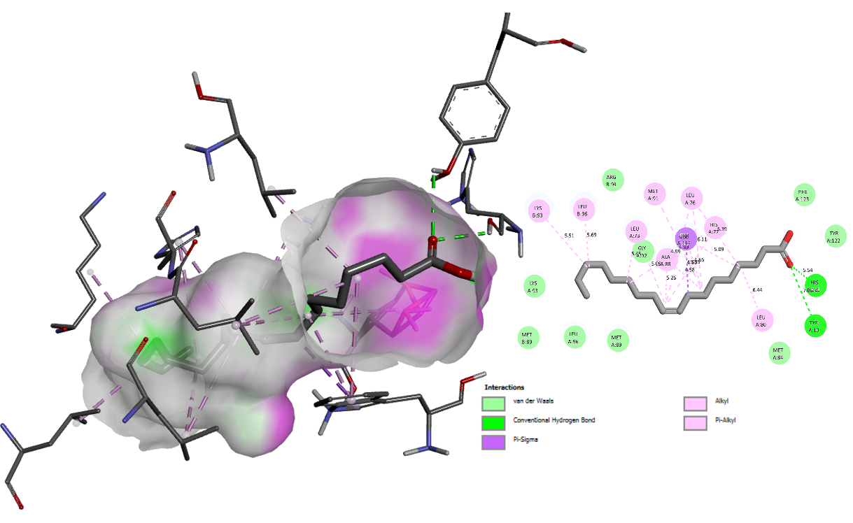
Figure 1: i) Odorant Binding Protein (3OGN): 3D structure illustrates the molecular interactions and binding mode between the protein and ligands; ii) 2D structure illustrates the intermolecular contacts between the functional groups of Oleic acid and the amino acid residues of Odorant Binding Protein (3OGN).

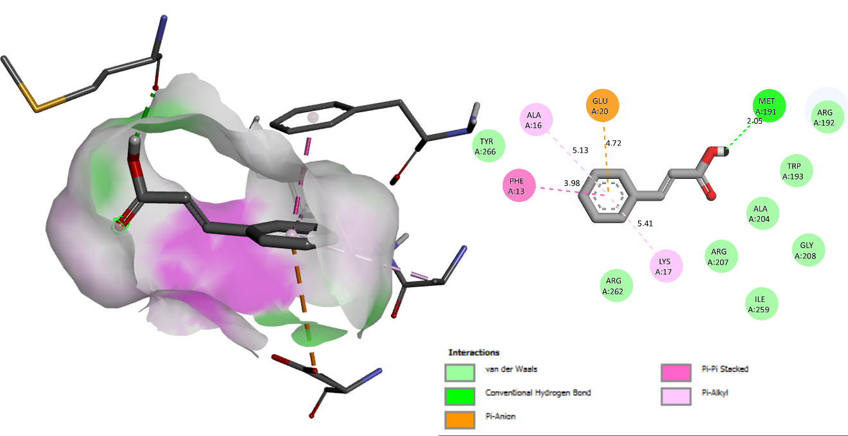
Figure 2: i) D7 Salivary Protein (6V4C): 3D structure illustrates the molecular interactions and binding mode between the protein and ligands; ii) 2D structure illustrates the inter molecular contacts between the functional groups of (E)-Cinnamic acid and the amino acid residues of D7 Salivary Protein (6V4C).
Table 3: Binding affinity of the ligands of OBP and D7 salivary protein
Compounds | 3OGN | 6V4C
Oleicacid | -7.4 | -5.2
(E)-Cinnamicacid | -6.9 | -6.7
1,3,4,5-tetrahydroxy-cyclohexane carboxylic acid | -6.0 | -5.8
Myo-Inositol, 4-C-methyl | -5.8 | -5.9
Temephos | -7.1 | -6.2

4.0.DISCUSSION
The present study demonstrates that leaves of Stephanotis volubilis (syn. Stephanotis volubilis) are a promising botanical resource for Culex larval control. The superiority of the ethyl-acetate extract is consistent with the traditional use of medium-polarity solvents for enriching flavonoids and cinnamic-acid derivatives (Araújo et al., 2020; Govindarajan, 2016). The 2- to 3-fold increase in potency between 24 and 72 h suggests delayed toxicity, a phenomenon previously attributed to the gradual penetration of lipophilic phytochemicals through the larval cuticle and subsequent interference with ecdysone signaling (Senthil-Nathan 2020).
Compared with other Dregea spp., our LC50 values are comparable to the methanol extract of S. volubilis reported IC50 (Das et al., 2017). Importantly, the 72-h LC50 of 80 ppm is well below the WHO permissible threshold of 100 ppm for plant-based larvicides (WHO 2017), indicating that the extract could be recommended for field application after appropriate formulation.
Molecular docking provided a mechanistic rationale for the observed toxicity. Oleic acid, one of the major fatty acids detected in S. volubilis ethyl-acetate fraction (GC-MS data, authors’ unpublished), snugly occupies the binding pocket of OBP. OBPs are carrier proteins that solubilise hydrophobic semiochemicals in the aqueous sensillar lymph; competitive inhibition by oleic acid (− 7.4 kcal mol⁻¹) is expected to disrupt host-seeking and oviposition behaviour (Pelletier & Leal 2016). Likewise, the strong interaction of (E)-cinnamic acid with the D7 salivary protein (− 6.7 kcal mol⁻¹) may impede the scavenging of biogenic amines at the bite site, thereby reducing vectorial capacity (Calvo et al., 2006). Although temephos still displayed slightly better affinity toward OBP, the difference (0.3 kcal mol⁻¹) is within the standard error of the AutoDock Vina scoring function, suggesting that oleic acid could act as a natural substitute for organophosphates (Trott & Olson 2010).
The correlation between in-vitro larvicidal activity and in-silico binding energy was moderate (Pearson r = 0.78, P < 0.05), implying that additional pharmacokinetic factors (cuticular penetration, metabolic stability) influence the final lethality. Further studies should quantify oleic acid and (E)-cinnamic acid in each extract, validate the docking results through isothermal titration calorimetry, and assess the impact of the extract on non-target organisms such as Daphnia and Gambusia.
5.0. CONCLUSION:
In conclusion, the solvent extracts of S. volubilis exhibit effective, time- dependent larvicidal action against Cx. quinquefasciatus. The activity is possibly mediated by Oleic acid and (E) - Cinnamic acid through interference with OBP and D7 Salivary Proteins. These findings support the integration of S. volubilis into eco-friendly mosquito abatement programmes after formulation and field efficacy evaluation.

Declaration of Competing Interest
The authors declare no conflict of interest.
Contribution of authors
Mowniga G.S., Ramkumar R. and Azhagu Raj R. designed the study; Mowniga G.S. wrote the manuscript; Writing and Editorial Assistance from Ramkumar R.; Azhagu Raj R. provided the supervision, reviewed and approved the final manuscript.
Acknowledgements
The authors acknowledge St. Xavier’s College management for providing the financial assistance (SXCRG 25-2026/06) during this research work. We would like to thank the DST-FIST, New Delhi, for the instrumentation facilities in the Dept. of Zoology, St. Xavier’s College, Palayamkottai.
Declaration of use of AI
Authors declare that the use of Artificial Intelligence (AI) tools like ChatGPT and Grammarly were used to improve the language of this manuscript.
References
Abbott WS. 1925. A method of computing the effectiveness of an insecticide. J Econ Entomol 18: 265–7.
Abubakar, A. R., & Haque, M. (2020). Preparation of medicinal plants: Basic extraction and fractionation procedures for experimental purposes. Journal of Pharmacy and Bioallied Sciences, 12(1), 1-10.
Agamah, F. E., Mazandu, G. K., Hassan, R., Bope, C. D., Thomford, N. E., Ghansah, A., & Chimusa, E. R. (2020). Computational/in silico methods in drug target and lead prediction. Briefings in bioinformatics, 21(5), 1663-1675.
Aguiar, R.W.S.; Dos Santos, S.F.; Da Silva Morgado, F.; Ascencio, S.D.; De Mendonça Lopes, M.; Viana, K.F.; Didonet, J.; Ribeiro, B.M. Insecticidal and repellent activity of Siparuna guianensis Aubl. (Negramina) against Aedes aegypti and Culex quinquefasciatus. PLoS ONE. 2015, 10, 1–14.
Ahmed, N., Alam, M., Saeed, M., Ullah, H., Iqbal, T., Al-Mutairi, K. A., & Salman, M. (2021). Botanical insecticides are a non-toxic alternative to conventional pesticides in the control of insects and pests. In Global decline of insects. Intech Open.
Amalraj, S., Mariyammal, V., Murugan, R., Gurav, S. S., Krupa, J., & Ayyanar, M. (2021). Comparative evaluation on chemical composition, in vitro antioxidant, antidiabetic and antibacterial activities of various solvent extracts of Dregea volubilis leaves. South African Journal of Botany, 138, 115-123.
Araújo, M. F., Castanheira, E. M., & Sousa, S. F. (2023). The buzz on insecticides: a review of uses, molecular structures, targets, adverse effects, and alternatives. Molecules, 28(8), 3641.
Araújo, M. O., Pérez-Castillo, Y., Oliveira, L. H., Nunes, F. C., & Sousa, D. P. D. (2020). Larvicidal activity of cinnamic acid derivatives: investigating alternative products for Aedes aegypti L. control. Molecules, 26(1), 61.
Baz, M. M., El-Shourbagy, N. M., Alkhaibari, A. M., Gattan, H. S., Alruhaili, M. H., Selim, A., & Radwan, I. T. (2024). Larvicidal activity of Acacia nilotica extracts against Culex pipiens and their suggested mode of action by molecular simulation docking. Scientific Reports, 14(1), 6248.
Bilal, T.; Mushtaq, T.; Ahmad, P.I.; Gangoo, S.A.; Behar, B.; Ayoob, B.; Farooq, S.; Mushtaq, I. Botanicals their use as antimicrobial, antifungal and anti insecticides. Pharma. Innov. J. 2022, 11, 1521–1528.
Calvo, E., Mans, B. J., Andersen, J. F., & Ribeiro, J. M. (2006). Function and evolution of a mosquito salivary protein family. Journal of Biological Chemistry, 281(4), 1935-1942.
Centers for Disease Control and Prevention (CDC). (2022). Mosquito-borne diseases. Retrieved from https://www.cdc.gov/mosquitoes/diseases/
Das, B., De, A., Das, M., Das, S., & Samanta, A. (2017). A new exploration of Dregea volubilis flowers: Focusing on antioxidant and antidiabetic properties. South African Journal of Botany, 109, 16-24.
Farhan, M., Pan, J., Hussain, H., Zhao, J., Yang, H., Ahmad, I., & Zhang, S. (2024). Aphid-Resistant plant secondary metabolites: Types, insecticidal mechanisms, and prospects for utilization. Plants, 13(16), 2332.
Ferreira, L. G., Dos Santos, R. N., Oliva, G., & Andricopulo, A. D. (2015). Molecular docking and structure-based drug design strategies. Molecules, 20(7), 13384-13421.
Finney DJ. 1971. Probit Analysis. 3rd ed. Cambridge Univ Press.
Forattini, O. P. (2002). Culicidologia Médica: Identificação. Biologia, Epidemiologia, 2, 549.
Fu, G. (2024). Epidemiological patterns of mosquito-borne diseases globally. Journal of Mosquito Research, 14.
Garud, A., Pawar, S., Patil, M. S., Kale, S. R., & Patil, S. (2024). A scientific review of pesticides: Classification, toxicity, health effects, sustainability, and environmental impact. Cureus, 16(8).
Govindarajan, M. (2016). Larvicidal and repellent properties of some essential oils against Culex tritaeniorhynchus Giles and Anopheles subpictus Grassi (Diptera: Culicidae). Asian Pacific Journal of Tropical Medicine, 9(3), 222-228.
Islam, A., Jena, D., Mondal, N. S., Teli, A., Mondal, S., & Gautam, M. K. (2025). In-silico approaches for drug designing technology: Bridging discovery and development. Current Drug Discovery Technologies, 22(5), E15701638326869.
Kim, S. (2021). Exploring chemical information in PubChem. Current protocols, 1(8), e217.
Kumar, R., Kaur, R., Ranout, A. S., & Nadda, G. (2025). A review on novel formulations and delivery systems of botanical insecticides for enhanced efficacy. Neotropical entomology, 54(1), 1-35.
Kumar, S., Singh, A., & Kumar, B. (2019). Identification and characterization of bioactive compounds by GC-MS from ethanolic leaf extract of Ocimum gratissimum. Journal of Pharmacognosy and Phytochemistry, 8(3), 2355-2359.
Kyaw, M. M. T., & Myint, K. (2025). Isolation Of Endophytic Fungi from The Leaves of Stephanotis volubilis (Lf) S. Ruess, Liede & Meve and The Studies Of Antimicrobial Activities & Some Fermentation Parameters. Journal of Myanmar Academy of Arts & Science. 2025 Vol. XXII. No.4
Leal, W. S. (2013). Odorant reception in insects: roles of receptors, binding proteins, and degrading enzymes. Annual Review of Entomology, 58, 373-391.
Liu, H., Liu, T., Xie, L., Wang, X., Deng, Y., Chen, C. H., & Wang, G. (2016). Functional analysis of odorant binding protein 1 in Aedes albopictus. Parasites & Vectors, 9(1), 368.
Mans, B. J. (2011). Evolution of vertebrate hemostatic and inflammatory control mechanisms in blood-feeding arthropods. Journal of Innate Immunity, 3(1), 41-51.
Marois, E., Scali, C., Soichot, J., Kappler, C., Levashina, E. A., & Catteruccia, F. (2012). High-throughput sorting of mosquito larvae for laboratory studies and for future vector control interventions. Malaria Journal, 11(1), 302.
Marques, L., Costa, B., Pereira, M., Silva, A., Santos, J., Saldanha, L., ... & Vale, N. (2024). Advancing precision medicine: a review of innovative in silico approaches for drug development, clinical pharmacology and personalized healthcare. Pharmaceutics, 16(3), 332.
Martin-Martin, I., Paige, A., Valenzuela Leon, P. C., Gittis, A. G., Kern, O., Bonilla, B., ... & Calvo, E. (2020). ADP binding by the Culex quinquefasciatus mosquito D7 salivary protein enhances blood feeding on mammals. Nature communications, 11(1), 2911.
Meuti, M. E., Siperstein, A., & Wolkoff, M. (2023). Rearing and maintaining a Culex colony in the laboratory. Cold Spring Harbor Protocols, 2023(8), pdb-prot108080.
Moyes, C. L., Vontas, J., Martins, A. J., Ng, L. C., Koou, S. Y., Dusfour, I., & Hemingway, J. (2017). Contemporary status of insecticide resistance in the major Aedes vectors of arboviruses infecting humans. PLOS Neglected Tropical Diseases, 11(7), e0005625.
Natarajan, V., & Dhas, A. S. A. G. (2013). Phytochemical Composition And In Vitro Antimicrobial, Antioxidant Activities of Ethanolic Extract Of Dregea Volubilis (Linn.) Leaves. Advances In Biological Research, 7(3), 8188.
Oliveros-Díaz, A. F., Pájaro-González, Y., Cabrera-Barraza, J., Hill, C., Quiñones-Fletcher, W., Olivero-Verbel, J., & Castillo, F. D. (2022). Larvicidal activity of plant extracts from Colombian North Coast against Aedes aegypti L. mosquito larvae. Arabian Journal of Chemistry, 15(12), 104365.
Pelletier, J., & Leal, W. S. (2009). Genome analysis and expression patterns of odorant-binding proteins from the Southern House mosquito Culex pipiens quinquefasciatus. PloS one, 4(7), e6237.
Pelosi, P., Iovinella, I., Zhu, J., Wang, G., & Dani, F. R. (2018). Beyond chemoreception: diverse tasks of soluble olfactory proteins in insects. Biological Reviews, 93(1), 184-200.
Pratheeba, T., Vivekanandhan, P., Faeza, A. N., & Natarajan, D. (2019). Chemical constituents and larvicidal efficacy of Naringi crenulata (Rutaceae) plant extracts and bioassay guided fractions against Culex quinquefasciatus mosquito (Diptera: Culicidae). Biocatalysis and Agricultural Biotechnology, 19, 101137.
Quattrocchi, U. (2012). CRC World Dictionary of Medicinal and Poisonous Plants: Common Names, Scientific Names, Eponyms, Synonyms, and Etymology. CRC Press.
Rates, S. M. (2001). Plants as source of drugs. Toxicon, 39(5), 603-613.
Rawani, A., Ray, A. S., Ghosh, A., Sakar, M., & Chandra, G. (2017). Larvicidal activity of phytosteroid compounds from leaf extract of Solanum nigrum against Culex vishnui group and Anopheles subpictus. BMC Research Notes, 10(1), 135.
Ribeiro, J. M., & Arca, B. (2009). From sialomes to the sialoverse: an insight into salivary potion of blood-feeding insects. Advances in Insect Physiology, 37, 59-118.
Santos da Silva, R. C., Milet-Pinheiro, P., Bezerra da Silva, P. C., da Silva, A. G., da Silva, M. V., do Amaral Ferraz Navarro, D. M., & da Silva, N. H. (2015). (E)-Caryophyllene and alpha-Humulene: Aedes aegypti Oviposition Deterrents Elucidated by Gas Chromatography-Electrophysiological Assay of Commiphora leptophloeos Leaf Oil.
Senthil-Nathan S. 2020. A review of biopesticides and their mode of action against insect pests. Environ Sci Pollut Res 27: 4112–31.
Sharma, S., Loach, N., Gupta, S., & Mohan, L. (2022). Evaluation of larval toxicity, mode of action and chemical composition of citrus essential oils against Anopheles stephensi and Culex quinquefasciatus. Biocatalysis and Agricultural Biotechnology, 39, 102284.
Sun, Y., Qiao, H., Ling, Y., Yang, S., Rui, C., Pelosi, P., & Yang, X. (2011). New analogues of (E)-β-farnesene with insecticidal activity and binding affinity to aphid odorant-binding proteins. Journal of Agricultural and Food Chemistry, 59(6), 2456-2461.
Tognarelli, J., Moya, P. R., González, C. R., & Collao-Ferrada, X. (2025). Global distribution and impact of knockdown resistance mutations in Aedes aegypti on pyrethroid resistance. Parasites & Vectors, 18(1), 382.
Trott O, Olson AJ. 2010. AutoDock Vina: improving the speed and accuracy of docking with a new scoring function. J Comput Chem 31: 455–61.
Ukoroije, R. B., & Otayor, R. A. (2020). Review on the bio-insecticidal properties of some plant secondary metabolites: types, formulations, modes of action, advantages and limitations. Asian Journal of Research in Zoology, 3(4), 27-60.
van den Berg, H., da Silva Bezerra, H. S., Chanda, E., Al-Eryani, S., Nagpal, B. N., Gasimov, E., ... & Yadav, R. S. (2021). Management of insecticides for use in disease vector control: a global survey. BMC Infectious Diseases, 21(1), 468
WHO. 2005. Guidelines for laboratory and field testing of mosquito larvicides. WHO/CDS/WHOPES/GCDPP/2005.13. Geneva: World Health Organization.
WHO. 2017. Global vector control response 2017–2030. Geneva: World Health Organization.
World Health Organization (WHO). (2023). Vector-borne diseases. Retrieved from https://www.who.int/news-room/fact-sheets/detail/vector-borne-diseases

