Original Research Article
Ecosystem-Level Impacts of Chickpea Intercropping and Nutrient Management on Phenology, Land Equivalent Ratio and Microbial Populations

Abstract
A two-year field investigation (2023–2024) was conducted at the Agronomy Research Farm, G.D. Goenka University, Haryana, to evaluate the effects of integrated and sole organic nutrient management on the phenology, productivity, and land-use efficiency of chickpea (Cicer arietinum L.) under different intercropping systems. The experiment was laid out in a split-plot design comprising three nutrient management regimes—sole inorganic (NM₀₀), integrated (50% RDF + 50% vermicompost; NM₀₁), and sole organic (NM₀₂)—and four intercropping combinations: sole chickpea (IC₀₀), chickpea + oats (IC₀₁), chickpea + mustard (IC₀₂), and chickpea + barley (IC₀₃). Results indicated that mustard-based intercropping (IC₀₂) significantly advanced flowering, whereas oats intercropping (IC₀₁) delayed phenological development due to competitive stress. Integrated nutrient management (NM₀₁) enhanced early flowering and improved overall crop performance through balanced nutrient availability and improved soil microbial activity. The highest chickpea equivalent yield (CEY) was recorded in sole chickpea (21.46 q ha⁻¹), followed by IC₀₂ (19.16 q ha⁻¹), while IC₀₃ recorded the lowest yield (9.42 q ha⁻¹). Among nutrient regimes, NM₀₁ achieved the highest CEY (17.64 q ha⁻¹), confirming the synergistic advantage of combining organic and inorganic sources. Land equivalent ratio (LER) was highest under sole chickpea (1.00), with IC₀₂ outperforming cereal-based intercrops. Although nutrient effects on LER were statistically non-significant, the NM₀₁ × IC₀₂ interaction recorded optimal resource utilization. The study concludes that integrating mustard intercropping with balanced nutrient management enhances phenological efficiency, yield stability, and land-use optimization and soil microbial load. These results highlight the potential of integrated organic–inorganic nutrient strategies in developing climate-resilient, resource-efficient, and sustainable chickpea-based cropping systems suitable for semi-arid regions.
Keywords
Chickpea; Intercropping; Integrated nutrient management; Phenology; Land equivalent ratio; Microbial population

Introduction:
Chickpea (Cicer arietinum L.), commonly known as Bengal gram, is one of the most ancient and nutritionally valuable legume crops, with a cultivation history spanning more than seven millennia. It serves as a vital source of plant-based protein, carbohydrates, and micronutrients, particularly for vegetarian populations in developing countries. The crop’s drought resilience, low input requirement, and ability to fix atmospheric nitrogen through symbiosis make it an essential component of sustainable agricultural systems, especially in rainfed and semi-arid regions (FAOSTAT, 2022; Meena et al., 2022).
India is the global leader in chickpea production, contributing over 70% of global output. However, the national average productivity (≈1,130 kg ha⁻¹) remains substantially lower than the levels achieved in countries such as Canada and Ethiopia (>2,000 kg ha⁻¹), where advanced agronomic practices and mechanization are more prevalent (FAO, 2023; Government of India, 2024). The yield disparity is primarily attributed to climatic variability, declining soil fertility, nutrient imbalances, and limited adoption of integrated management strategies (Kumar et al., 2020; Kasirao et al., 2023). Climate change-induced stresses—such as erratic rainfall, heat waves, and soil degradation—further constrain productivity, emphasizing the need for resource-efficient and climate-resilient cropping systems (Yadav et al., 2023).
Intercropping, the concurrent cultivation of two or more crops on the same field, has re-emerged as a sustainable alternative to monocropping in the face of climatic and ecological challenges. It enhances spatial and temporal resource use efficiency, improves soil fertility, suppresses weeds and pests, and stabilizes yield across variable environments (Verma et al., 2017; Sepat et al., 2019). Legume-based intercropping systems, particularly those involving chickpea, contribute to biological nitrogen fixation, reduced fertilizer dependency, and diversified farm income (Bhullar and Salaria, 2024). Among potential companion crops, mustard (Brassica spp.), barley (Hordeum vulgare L.), and oats (Avena sativa L.) provide complementary growth habits and resource-use patterns. Mustard’s erect morphology and shallow root system allow efficient vertical space utilization, while barley and oats offer advantages such as early maturity, weed suppression, and fodder production (Maitra et al., 2021; Raza et al., 2023).
Despite these agronomic benefits, intercropping performance largely depends on the efficient management of nutrients under resource-limited conditions. Integrated Nutrient Management (INM)—the judicious combination of organic manures and inorganic fertilizers—has proven effective in enhancing nutrient use efficiency, soil biological activity, and overall system productivity (Sodavadivya et al., 2021; Prajapati et al., 2024). INM not only improves soil structure and microbial dynamics but also mitigates nutrient losses and environmental degradation associated with excessive synthetic fertilizer use (Kumar et al., 2023; Devi et al., 2024).
However, research on the synergistic effects of INM and diversified intercropping systems on chickpea phenology, yield attributes, and land-use efficiency remains limited, particularly in the semi-arid agro-ecosystems of northern India. Understanding these interactions is essential for optimizing crop growth dynamics, enhancing resource-use efficiency, and developing scalable, climate-resilient cropping models. Therefore, the present study investigates the effects of integrated and sole organic nutrient management on chickpea phenology, productivity, and land equivalent ratio under different intercropping systems. The findings aim to provide empirical evidence supporting the design of sustainable, community-oriented, and resource-efficient chickpea-based cropping systems suited to semi-arid regions.

Methodology:
The present study, was conducted during the rabi seasons of 2023 and 2024 at the Agronomy Research Farm, Department of Agronomy, School of Agricultural Sciences, G.D. Goenka University, Sohna, Haryana, India (28°15′ N, 77°06′ E; 211 m above mean sea level), located in the Southwestern Haryana agro-climatic zone characterized by semi-arid conditions, moderate winters (3–22°C), hot summers (up to 45°C), and an average annual rainfall of 500–700 mm, predominantly received during the monsoon. The experimental soil, classified as loamy sand to sandy loam with moderate fertility and good drainage, was characterized prior to experimentation using a composite of five surface (0–15 cm) samples, revealing pH 7.80–8.10, electrical conductivity 0.11–0.16 dS m⁻¹, organic carbon 0.43–0.45%, available nitrogen 221–225 kg ha⁻¹, phosphorus 20–21 kg ha⁻¹, potassium 410–413 kg ha⁻¹, bulk density 1.30–1.34 g cm⁻³, and water-holding capacity 51–53%. The experiment was in a split-plot design with three replications, comprising twelve treatment combinations across 36 plots (4 × 3 m; net plot 12 m²). Main plot treatments consisted of intercropping systems: sole chickpea (IC₀), chickpea + oats (IC₁), chickpea + mustard (IC₂), and chickpea + barley (IC₃) in a 3:2 row ratio, while subplot treatments included nutrient management strategies: NM₀ (100% recommended dose of fertilizers, RDF), NM₁ (50% RDF + 50% vermicompost), and NM₂ (organo-nutrient mix: 33% each of vermicompost, compost, and FYM). Chickpea variety Pusa 362 was used as the test crop, with mustard (PM 30), oats (HFO 114), and barley (PL 172) as intercrops. The experimental field was prepared using rotavator ploughing, cultivator tillage, and planking to achieve a fine tilth, with well-defined plots, ridges, and irrigation channels. Sowing was carried out at 5 cm depth according to treatment-specific row arrangements. Basal fertilizers and organic manures were incorporated ten days before sowing, while nitrogen was applied in split doses at critical stages. Weed management included pre-emergence atrazine application followed by manual weeding at 60 and 90 DAS. Chickpea received four irrigations during germination, vegetative, pre-flowering, and pod-filling stages, and pest management was conducted using imidacloprid as required. Growth parameters (plant height, leaf number, branch number, and nodule count) were recorded at 30, 60, 90 DAS and at harvest, while phenological traits (germination percentage, days to 50% and 100% flowering) and yield attributes (pods per plant, seeds per pod, pod length, seed index, grain yield, straw yield, biological yield, and harvest index) were assessed at harvest. Seed protein content was determined using the Bradford assay, and intercropping efficiency was evaluated through chickpea equivalent yield (CEY) and partial land equivalent ratio (PLER). Economic analysis, including cost of cultivation, gross return, net return, and benefit-cost ratio, was calculated based on prevailing market prices. Soil microbial populations were quantified at the flowering stage (60 DAS) and post-harvest period (120 DAS) from 0–15 cm depth using the serial dilution and plate count method. Fresh rhizospheric soil (10 g) was serially diluted up to 10⁻⁶ using sterile saline solution. Aliquots (1 mL) from appropriate dilutions were inoculated on selective media using the pour plate technique and incubated at 28 ± 2°C for 48–72 hours. Bacteria: Nutrient Agar (NA) medium, Fungi: Potato Dextrose Agar (PDA) medium supplemented with streptomycin (50 µg mL⁻¹) to inhibit bacterial growth, Actinomycetes: KenKnight and Munaier’s Agar medium, Azotobacter: Ashby’s Mannitol Agar medium, Phosphate Solubilizing Bacteria (PSB): Pikovskaya’s Agar medium. Colonies were enumerated as colony-forming units (CFU g⁻¹ of soil). Each sample was analyzed in triplicate to ensure accuracy. Quality control measures included autoclaving all media at 121°C (15 psi for 20 min), working under a laminar airflow cabinet, and maintaining aseptic conditions during inoculation. Replicate plates showing 30–300 colonies were considered for enumeration, and mean values were calculated for statistical analysis. All data were analyzed using ANOVA in R Studio, and treatment means were compared using the F-test at a 5% significance level to identify statistically significant differences.
Results
1. Phenological Response of Chickpea to Intercropping Systems and Integrated Nutrient Management:
The effect of intercropping systems and integrated nutrient management (INM) on the phenological attributes—specifically, days taken for 50% and 100% flowering—was analyzed and is presented below.
Days to 50% flowering:
Intercropping systems significantly influenced the days taken for 50% flowering (p < 0.05). The earliest flowering was observed under IC₂ (chickpea + mustard) with a mean of 55.24 days, while the latest was recorded under IC₁ (chickpea + oats) with 64.24 days. Among INM treatments, NM₁ (50% RDF + 50% vermicompost) recorded the earliest flowering (58.70 days), whereas NM₀ (100% RDF) exhibited delayed flowering (60.73 days). Treatment NM₂ (organo-nutrient mix) was statistically on par with NM₀. The interaction effect of intercropping and INM on 50% flowering was found to be statistically non-significant (p > 0.05).
Days to 100% flowering:
Similarly, the days taken for 100% flowering were significantly affected (p < 0.05) by both intercropping and INM treatments. The minimum duration to full flowering was recorded under IC₂ (67.27 days), while the maximum was noted in IC₁ (76.37 days). Among INM treatments, the earliest completion of flowering occurred under NM₁ (70.80 days), and the latest under NM₀ (72.83 days). Treatment NM₂ showed statistical parity with NM₀. The interaction effect between intercropping and INM remained non-significant (p > 0.05).
Table 1. Effect of intercropping and integrated nutrient management practices on the phenological attributes of chickpea.
S. no |  | Germination 8-10 days |  |  | Days taken for 50% flowering |  |  | Days taken for 100% flowering
S. no | Factors | 1st year | 2nd year | Mean | 1st year | 2nd year | Mean | 1st year | 2nd year | Mean
1 | IC00 | 89.66 | 89.77 | 89.72 | 62.40 | 60.0 | 61.20 | 72.37 | 74.44 | 73.40
2 | IC01 | 89.66 | 88.77 | 89.22 | 65.48 | 63.0 | 64.24 | 75.07 | 77.66 | 76.37
3 | IC02 | 90.66 | 90.66 | 90.66 | 56.48 | 54.0 | 55.24 | 66.29 | 68.25 | 67.27
4 | IC03 | 89.77 | 89.77 | 89.77 | 59.40 | 57.0 | 58.20 | 69.37 | 71.26 | 70.31
SEm (±) |  | 0.580 | 0.356 | 0.347 | 0.761 | 0.765 | 0.760 | 0.089 | 0.225 | 0.135
CD (at p≤ 0.05) |  | NS | NS | NS | 2.683 | 2.680 | 2.683 | 0.315 | 0.793 | 0.476
1 | NM00 | 89.66 | 89.33 | 89.50 | 61.97 | 59.50 | 60.73 | 71.72 | 73.94 | 72.83
2 | NM01 | 90.33 | 90.33 | 90.33 | 59.91 | 57.50 | 58.70 | 69.80 | 71.80 | 70.80
3 | NM02 | 89.83 | 89.58 | 89.70 | 60.94 | 58.50 | 59.72 | 70.80 | 72.97 | 71.88
SEm (±) |  | 0.591 | 0.534 | 0.374 | 0.503 | 0.514 | 0.508 | 0.078 | 0.305 | 0.161
CD (at p≤ 0.05) |  | NS | NS | NS | 1.522 | 1.553 | 1.537 | 0.236 | 0.921 | 0.485
A x B |  | NS | NS | NS | NS | NS | NS | NS | NS | NS

2. Impact of Intercropping and Nutrient Management on Chickpea Productivity and Land-Use Efficiency
2.1. Chickpea Equivalent Yield (CEY)
The effect of intercropping systems and integrated nutrient management (INM) on chickpea equivalent yield (CEY) was found to be significant (p < 0.05), while their interaction effect remained statistically non-significant during both years of study.
Among the intercropping systems, the maximum CEY was recorded under sole chickpea (IC₀₀) with 19.76 q ha⁻¹ in 2023 and 23.15 q ha⁻¹ in 2024, followed by chickpea + mustard (IC₂) at 18.02 q ha⁻¹ and 20.30 q ha⁻¹, respectively. The lowest CEY was observed in chickpea + barley (IC₃) with 9.21 q ha⁻¹ and 9.42 q ha⁻¹, respectively. The pooled mean revealed that IC₀₀ produced the maximum CEY (21.46 q ha⁻¹), which was statistically superior to all other intercropping combinations.
Among the INM treatments, NM₁ (50% RDF + 50% vermicompost) recorded the highest CEY (17.64 q ha⁻¹), followed by NM₂ (organo-nutrient mix; 16.58 q ha⁻¹), while NM₀ (100% RDF) produced the minimum (15.94 q ha⁻¹). Treatments NM₁ and NM₂ were statistically at par. The improvement in CEY under NM₁ could be attributed to balanced nutrient availability, enhanced microbial activity, and sustained nutrient release from vermicompost, which collectively enhanced crop vigor and reproductive efficiency.
The higher CEY observed under mustard-based intercropping (IC₂) may be attributed to its complementary root system, which reduces below-ground competition and improves moisture and nutrient availability to chickpea. Mustard’s rapid canopy development also promotes better microclimate and higher photosynthetic efficiency. In contrast, oats (IC₁) and barley (IC₃) exhibited competitive dominance, suppressing chickpea growth and yield potential.

2.2 Partial Land Equivalent Ratio (PLER)
Intercropping systems significantly influenced the partial land equivalent ratio (PLER) of chickpea (p < 0.05), while INM treatments had a non-significant effect. However, their interaction effect was found to be statistically significant.
During the first year (2023), the maximum PLER (1.00) was recorded under sole chickpea (IC₀₀), followed by chickpea + mustard (IC₂; 0.84) and chickpea + oats (IC₁; 0.63), whereas the minimum was observed under chickpea + barley (IC₃; 0.62). A similar trend continued in the second year (2024), with PLER values of 1.00, 0.84, and 0.66 for IC₀₀, IC₂, and IC₁, respectively. The pooled mean confirmed the consistent superiority of IC₂ in enhancing resource-use efficiency.
The significant interaction revealed that the maximum PLER (1.00) was achieved under NM₀ × IC₀₀, NM₁ × IC₀₀, and NM₂ × IC₀₀, whereas the minimum (0.65) was recorded under NM₁ × IC₁. All IC₂ combinations across nutrient levels were statistically comparable with the highest PLER values, indicating that mustard-based intercropping enhanced biological efficiency and effective land utilization irrespective of nutrient source.
Higher PLER values in IC₂ reflect complementary resource use and minimal interspecific competition, promoting efficient exploitation of space, light, and nutrients. Conversely, oats and barley-based systems (IC₁ and IC₃) recorded lower PLER due to aggressive competition for nutrients and moisture.
Overall, mustard-based intercropping (IC₂) consistently demonstrated superior performance in terms of both CEY and PLER, emphasizing its potential for higher productivity and land-use efficiency. The combination of IC₂ × NM₁ emerged as the most efficient and sustainable cropping system, ensuring improved soil fertility, resource complementarity, and long-term ecological balance

Fig. 1. Interaction effect of intercropping and integrated nutrient management practices on the Chickpea equivalent yield (q/ha)
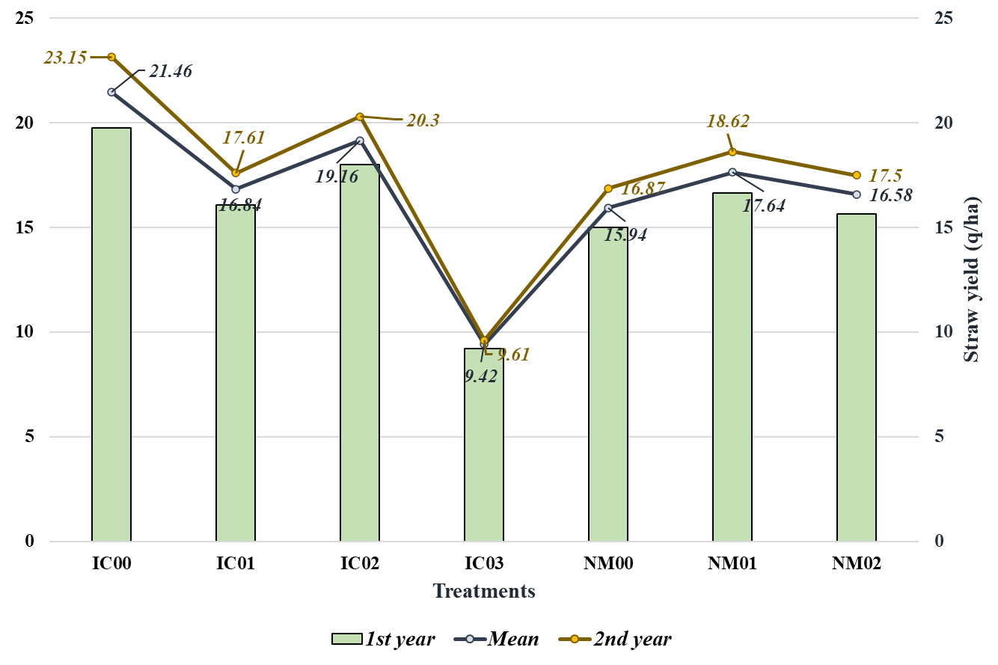

Fig 2. Impact of Intercropping and Nutrient Management on Chickpea Land Equivalent Ratio
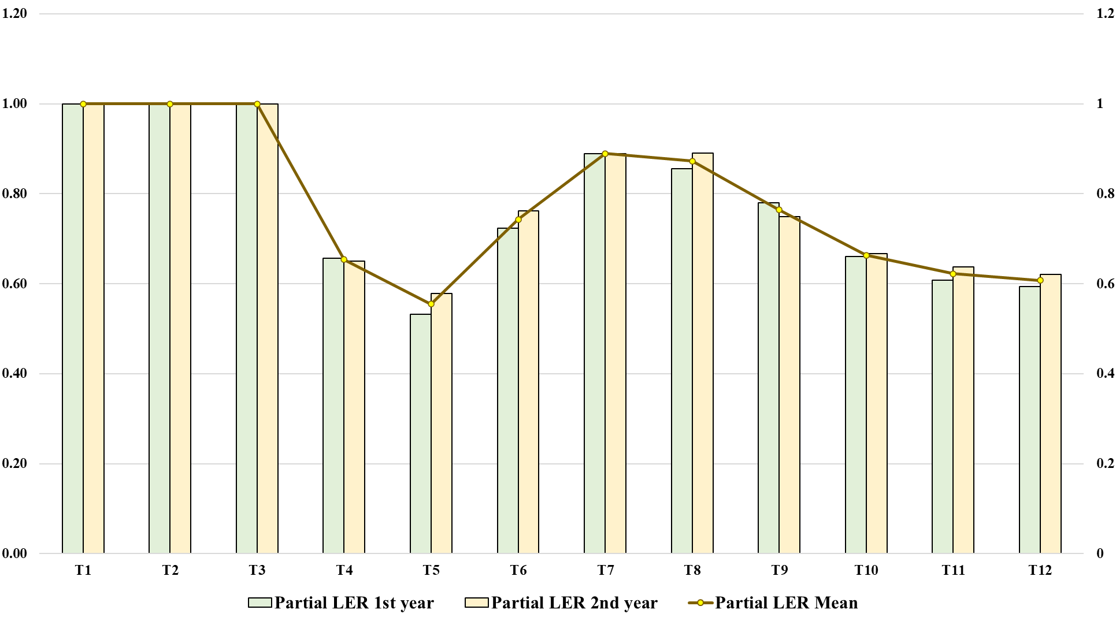

3.1. Influence of Intercropping and Integrated Nutrient Management on Soil Microbial Dynamics
The microbial population in the rhizosphere of chickpea was markedly influenced by the integrated nutrient management (INM) practices and intercropping systems over two consecutive rabi seasons. Substantial differences were observed in the populations of Rhizobium, Azotobacter, Azospirillum, Pseudomonas, and phosphate-solubilizing bacteria (PSB) between treatments at both pre-sowing and post-harvest stages.
At the initial stage (pre-sowing), the total culturable bacterial population ranged from 4.2 × 10⁵ to 6.1 × 10⁵ CFU g⁻¹ soil across treatments. After two cropping cycles, the values increased significantly under INM treatments, particularly NM₀₁ (50 % RDF + 50 % vermicompost) and NM₀₂ (organo-nutrient mix), where total bacterial counts reached 2.6–3.8 × 10⁷ CFU g⁻¹ soil compared with 1.1 × 10⁶ CFU g⁻¹ in the 100 % RDF control (NM₀₀).
The Rhizobium population showed a clear enhancement in chickpea-based systems. In sole chickpea (IC₀₀) and chickpea + mustard (IC₀₂) intercropping, rhizobial counts increased from 9 × 10¹ to 4.7 × 10⁴ CFU g⁻¹ soil under NM₀₁ and NM₀₂, whereas chemical fertilization alone maintained a comparatively lower population (≈ 6 × 10² CFU g⁻¹). Intercropping with cereals (chickpea + oats or barley) slightly reduced rhizobial abundance due to competition for root colonization niches.
The populations of Azotobacter and Azospirillum, free-living or associative nitrogen-fixing bacteria, also improved substantially under organic-based nutrient regimes. Soils receiving vermicompost (NM₀₁) exhibited Azotobacter counts in the range of 2.8–6.4 × 10⁵ CFU g⁻¹, almost double that of the chemical control. Similarly, Azospirillum counts reached 4.2 × 10⁵ CFU g⁻¹ under cereal intercropping (IC₀₁ and IC₀₃), indicating their preference for cereal rhizospheres.
The fluorescent Pseudomonas population, which contributes to plant growth promotion and disease suppression, showed a remarkable increase with organic amendments. Post-harvest soils from NM₀₁ × IC₀₂ plots recorded ≈ 2.3 × 10⁶ CFU g⁻¹ compared with ≈ 4.8 × 10⁴ CFU g⁻¹ in NM₀₀ plots. The phosphate-solubilizing bacteria (PSB) followed a similar pattern, increasing from 1.3 × 10⁴ to 1.6 × 10⁶ CFU g⁻¹ under NM₀₁ and NM₀₂, consistent with enhanced organic carbon and available P in these treatments.
Overall, the interaction of INM × intercropping significantly enhanced the microbial population in chickpea rhizosphere soils, with the combination IC₀₂ × NM₀₁ registering the highest microbial abundance and biological nitrogen-fixing potential after two years of cropping.
Fig 3. Impact of Intercropping and Nutrient Management on Soil Microbial Population in Chickpea
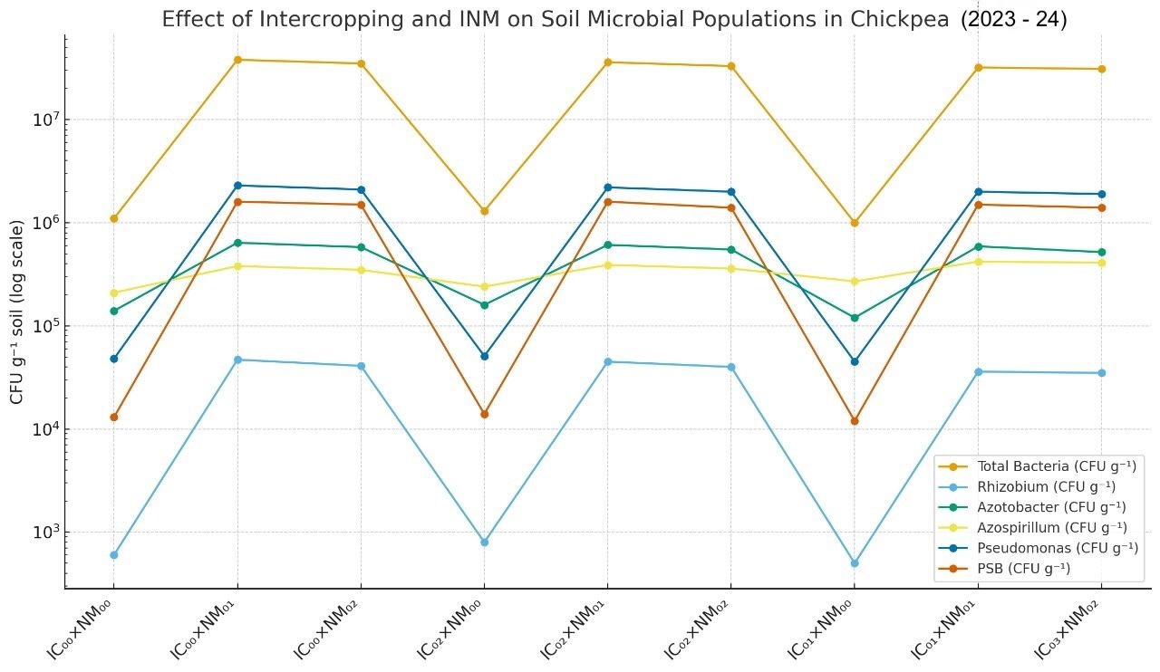

Discussion
Phenological development, productivity, and land-use efficiency of chickpea were substantially influenced by intercropping systems and integrated nutrient management (INM), demonstrating the crop’s strong sensitivity to microenvironmental interactions and soil nutrient dynamics. Mustard-based intercropping (IC₂) consistently promoted early flowering, whereas oats-based combinations (IC₁) delayed phenological progression. The advancement of flowering under IC₂ could be attributed to the facilitative root–shoot interaction between component crops, where mustard’s deep taproot reduced competition for surface nutrients and moisture. This complementary root architecture enhanced sub-surface moisture extraction, rhizospheric aeration, and nutrient mobility, thereby accelerating physiological maturity and promoting timely transition from vegetative to reproductive stages (Sharma et al., 2016; Meena et al., 2024). Conversely, the delayed flowering observed in oats-based systems was a consequence of intense competition for nitrogen and water in the upper soil layers, inducing stress that extended the vegetative phase. Such competition-induced stress is often linked to restricted nutrient uptake, suppressed cytokinin synthesis, and delayed reproductive signaling in legumes (Singh et al., 2018; Devi et al., 2024). Nutrient management practices exerted a significant independent effect on phenological behavior. The integration of 50% RDF with 50% vermicompost (NM₁) accelerated flowering due to synchronized nutrient release, enhanced microbial activity, and balanced hormonal regulation involving auxins and cytokinins, which are critical for floral initiation (Kour et al., 2013; Kiran Rao et al., 2015). Vermicompost-derived humic substances and bioactive compounds further supported enzymatic and hormonal processes, facilitating earlier metabolic transitions toward reproductive growth. In contrast, sole chemical fertilization (NM₀) led to delayed flowering owing to rapid nutrient depletion and low biological stimulation, while fully organic nutrient regimes (NM₂) also delayed phenophase progression due to slower nutrient mineralization and limited early nitrogen availability (Mallesha Rao et al., 2017; Meena et al., 2024). The lack of significant interaction between intercropping and INM suggests that these factors act through distinct mechanisms: intercropping modifies competitive and facilitative field environments, while INM regulates internal physiological and biochemical cues. Overall, the combination of mustard intercropping with partial organic substitution (IC₂ × NM₁) established the most conducive conditions for early and synchronized flowering, enhancing reproductive efficiency and yield stability (Yadav et al., 2017; Raghu et al., 2017; Devi et al., 2024).
System productivity and land-use efficiency, expressed through chickpea equivalent yield (CEY) and partial land equivalent ratio (PLER), were likewise governed by intercropping patterns and nutrient regimes. Mustard-based intercropping maintained consistently higher CEY across both seasons compared with oats or barley systems. This enhancement reflects spatial and functional complementarity, where mustard’s deep-rooted system alleviates surface competition and improves soil aeration, facilitating nutrient uptake and microbial activity in the rhizosphere (Yadav et al., 2017; Sharma et al., 2016). In contrast, cereals such as oats and barley exhibited competitive dominance due to dense root systems and higher nutrient demand, which restricted chickpea access to essential resources and reduced equivalent yield (Devi et al., 2024). Among nutrient management strategies, NM₁ (50% RDF + 50% vermicompost) consistently produced the highest CEY, highlighting the synergistic benefits of combining organic and inorganic sources for sustained nutrient availability, improved microbial biomass, and enhanced assimilate partitioning (Kumhar et al., 2022; Maitra et al., 2021; Meena et al., 2024). Sole reliance on chemical fertilizers (NM₀) resulted in short-term benefits but failed to maintain nutrient balance or soil health, whereas full organic treatments (NM₂) improved soil structure yet provided insufficient nutrient availability during early growth (Luo et al., 2021). Land-use efficiency, as measured by PLER, followed a similar trend. Mustard-based systems achieved the highest PLER values, indicating superior utilization of spatial, light, and nutrient resources (Kaparwan et al., 2020; Raza et al., 2023; Sodavadiya et al., 2023). The vertical canopy structure and deep rooting of mustard minimized interspecific competition and improved the microclimatic environment, allowing chickpea to exploit residual light and moisture efficiently. Though the influence of INM on PLER was statistically marginal, slight improvements under NM₁ and NM₂ suggest that balanced nutrient availability indirectly enhances resource capture through better vegetative development and soil biological activity. The interaction between IC₂ and NM₁ consistently produced the highest PLER values, confirming the ecological and nutritional synergy of compatible crop pairing with integrated nutrient management.
The improvement in microbial populations under integrated nutrient management (INM) and diversified cropping systems reflects a synergistic response of soil microbiota to combined organic and inorganic inputs. Total culturable bacteria and beneficial groups (Rhizobium, Azotobacter, Azospirillum, and Pseudomonas) increased substantially under vermicompost-based INM, corroborating reports that vermicompost and panchagavya-amended soils harbor dense populations of beneficial microbes (Mesele et al., 2025). Organic amendments not only supply viable microbial inocula but also improve soil aggregation, moisture, and carbon availability, fostering microbial multiplication. Panchagavya has been reported to support total bacterial counts of 22 × 10⁹ CFU mL⁻¹, fluorescent Pseudomonas 151 × 10⁵ CFU mL⁻¹, and phosphate-solubilizers 103 × 10⁶ CFU mL⁻¹, indicating high inoculum potential. The observed enrichment under NM₀₁ and NM₀₂ aligns with these findings. Increased rhizobial populations in chickpea-based systems result from Mesorhizobium ciceri symbiosis and favorable rhizospheric conditions provided by organic matter, consistent with reports that native rhizobia (<10 MPN g⁻¹ soil) multiply several-fold with legumes and organic inputs (Mesele et al., 2025). Cereal intercrops (oats, barley) promoted associative N-fixers such as Azospirillum and Azotobacter, highlighting host-specific root exudate effects on rhizosphere communities. Enhanced Pseudomonas and phosphate-solubilizing bacteria under INM, especially in chickpea + mustard (IC₀₂), reflect the role of vermicompost, FYM, and mustard root exudates in stimulating plant growth-promoting rhizobacteria (PGPR), P mobilization, and disease resistance (Daniel et al., 2013). Overall, integrating organic and mineral nutrients with compatible intercrops enriches soil microbial diversity, nutrient cycling, biological N fixation, and soil health in chickpea-based systems.
Mustard-based intercropping with partial organic nutrient substitution (IC₂ × NM₁) enhanced phenology, system productivity, land-use efficiency, and soil microbial diversity, demonstrating that ecological complementarity and integrated nutrient strategies sustain chickpea yield while promoting long-term soil fertility and system resilience (Maitra et al., 2021; Meena et al., 2024; Devi et al., 2024).
Conclusion and Recommendations
The study demonstrates that integrating chickpea with mustard-based intercropping (3:2) alongside partial organic nutrient substitution (50% RDF + 50% vermicompost) significantly enhances crop productivity, land-use efficiency, and soil microbial activity. The complementary canopy and rooting patterns in the chickpea–mustard system reduce interspecific competition and create favorable rhizospheric conditions that stimulate beneficial microbial populations such as Rhizobium, Azotobacter, Azospirillum, and Pseudomonas. This synergistic interaction promotes efficient nutrient cycling, biological nitrogen fixation, and improved soil health, contributing to greater system stability under semi-arid conditions. It is therefore recommended that chickpea–mustard intercropping in a 3:2 row ratio under integrated nutrient management (50% RDF + 50% vermicompost) to achieve sustainable yield gains while reducing dependence on chemical fertilizers. Long-term adoption of this approach can enhance soil organic carbon, support microbial biodiversity, and strengthen climate resilience. Further multi-location and multi-season validation is encouraged to refine region-specific strategies and promote this biologically sustainable, resource-efficient model for pulse-based cropping systems across semi-arid regions.

Disclaimer (Artificial intelligence)
The author (s) hereby declare that NO generative AI technologies such as Large Language Models (ChatGPT, COPILOT, etc.) and text-to-image generators have been used during the writing or editing of this manuscript.
References:
- Bhullar, M.S. & Salaria, A. (2024). Package and practices for crops in Punjab, Kharif 2024, PAU.https://www.pau.edu/content/ccil/pf/pp_rabi.pdf
- Devi, H. S., et al. (2024). Enhancing growth and yield of the wheat–chickpea intercropping system through a combination of different row ratios and biostimulants. Journal of Applied and Natural Science, 16(3), 1240–1249. https://doi.org/10.31018/jans.v16i3.5795
- FAO (2023). FAOSTAT Statistical Database: Pulses Production and Productivity Trends 2023. Rome: Food and Agriculture Organization of the United Nations.
- FAOSTAT (2022). Food and Agriculture Data: Chickpea Production and Trade Statistics. Rome: FAO.
- Kaparwan, D., Rana, N. S., & Dhyani, B. P. (2020). Effect of different row ratios and nutrient management strategies on growth, yield and quality of mustard in chickpea + mustard intercropping system. Journal of Pharmacognosy and Phytochemistry, 9(3), 852–857.
- Kasirao, G., Himavarsha, P., & Tomar, S. (2023). Maximizing Nutrient Efficiency and Profitability: Integrating NADEP Compost and Phosphorous Solubilizing Bacteria in Black Gram (Vigna mungo L) Cultivation. International Journal of Plant & Soil Science, 35(18), 1103-1110.
- Kiran Rao, S., Reddy, V., & Subha, S. (2015). Effect of nutrient management practices through organics on soil biological properties in organic chickpea (Cicer arietinum L.) cultivation under rainfed condition. The Ecoscan, Special Issue (7), 183–187.
- Kour, R., Sharma, B. C., Kumar, A., & Kour, P. (2013). Nutrient uptake by chickpea+mustard intercropping system as influenced by weed management.
- Kumar, P., Siddiqui, M. Z., Prajapati, S. K., Singh, S., Kumar, A., & Rawat, D. K. (2023). Study of the Most Suitable Combination of Intercropping Systems of Indian Mustard (Brassica juncea L.) with Chickpea, Lentil, Linseed and Field Pea. Int. J. Environ. Clim. Change, 13(11), 3777-3789.
- Kumar, R.S. (2020). Integrated Nutrient Management in Pigeonpea-Based Sequential Intercropping Systems in Black Soils..
- Kumhar, B. L., Agrawal, K. K., Jha, A. K., Kumar, V., Kantwa, S. R., & Choudhary, M. (2022). Productivity and economic viability of grass-based cropping systems. Range Management and Agroforestry, 43(1), 167–171.
- Leo Daniel Amalraj, E., Praveen Kumar, G., Mir Hassan Ahmed, S.K. et al. Microbiological analysis of Panchagavya, vermicompost, and FYM and their effect on plant growth promotion of pigeon pea (Cajanus cajan L.) in India. Org. Agr. 3, 23–29 (2013). https://doi.org/10.1007/s13165-013-0042-2
- Luo, C., Guo, Z., Xiao, J., Dong, K., & Dong, Y. (2021). Effects of applied ratio of nitrogen on the light environment in the canopy and growth, development and yield of wheat when intercropped. Frontiers in Plant Science, 12, 719850.
- Maitra, S., Hossain, A., Brestic, M., Skalicky, M., Ondrisik, P., Gitari, H. & Sairam, M. (2021). Intercropping—A low input agricultural strategy for food and environmental se-curity.Agronomy,11(2), 343.
- Mallesha Rao, S. N., Chittapur, B. M., Desai, B. K., & Ravi, M. V. (2017). Effect of nutrient management practices through organics on groundnut productivity and nutrient uptake in bajragroundnut cropping system. Int. J. Pure App. Biosci, 5(5), 715-719.
- Meena, S. S., Shrivastava, A., Meena, B. R., Singh, V. K., & Kumar, V. (2022). Long term impacts of organic manures and chemical fertilizers on different physical properties of soil in Tarai region of India. The Pharma Innovation, 11(2), 1019-1024.
- Mesele, E., Kebede, A., Redda, Y. T., Yaekob, A. T., Kasegn, M. M., Meresa, B. K., ... & Gebreyohannes, G. (2025). Potential of indigenous rhizobia for enhancing plant growth and improving faba bean (Vicia faba L.) yield in Mekelle Ethiopia. Discover Agriculture, 3(1), 57.
- Prajapati, S. K., Verma, V. K., Khan, N., Singh, S., Singh, G., & Yadav, S. (2024). Impact of Organic and Inorganic Plant Growth Promoters on Growth Indices and Yield of Wheat (Triticum aestivum L.) Varieties. Environment and Ecology, 42(1), 84-93.
- Raghu, M. S., Chari, K. M., Tuppad, G. B., & Upperi, S. N. (2017). Effect of secondary and micronutrients on growth, yield parameters and nutrient uptake of sunflower (Helianthus annus L.). International Journal of Medicinal Plant Research, 6(3), 328–331. https://www.internationalscholarsjournals.com/articles/effect-of-secondary-and-micronutrients-on-growth-yield-parameters-and-nutrient-uptake-of-sunflower-helianthus-annuus-l.pdf
- Raza, M. A., Zhiqi, W., Yasin, H. S., Gul, H., Qin, R., Rehman, S. U., ... & Zhongming, M. (2023). Effect of crop combination on yield performance, nutrient uptake, and land use advantage of cereal/legume intercropping systems. Field Crops Research, 304, 109144.
- Sepat, S. E. E. M. A., Bana, R. S., Meena, S. L., & Rana, D. S. (2019). Assessment of conservation agriculture and intercropping practices for enhanced productivity and profitability in maize (Zea mays). Indian Journal of Agricultural Sciences, 89(4), 714-20.
- Sharma, D., Saikia, P., Bhattacharjee, M., Hazarika, R., Rajbonshi Goswami, R. K., Sharma, P. K., Sharma, M. K., & Neog, P. (2016). Effect of intercropping green and blackgram in sesamum for augmenting productivity and rain water use efficiency under rainfed upland condition. International Journal of Dryland Agriculture Research and Development, 3(1), 51–55.
- Singh, S., Thenua, O. V. S., & Singh, V. (2018). Effect of phosphorus, sulphur and irrigation on yield and NPS uptake of mustard + chickpea in an intercropping system. International Journal of Chemical Studies, 6(4), 1341–1348.
- Sodavadiya, H. B., Patel, V. J., & Sadhu, A. C. (2023). Effect of Integrated Nutrient Management on the Growth and Yield of Chickpea (Cicer arietinum L.) under Chickpea-forage Sorghum (Sorghum bicolor L.) Cropping Sequence. Legume Research: An International Journal, 46(12).
- Verma, N. K., Pandey, B. K., Mahan, R. D., & Kumar, A. (2017). Response of mode of application with integrated nutrient management on growth and yield of chick pea (Cicer arietinum L.). Int. J. Agric. Innov. and Res, 6(1), 2319-1473.
- Yadav, J. K., Sharma, M., Yadav, R. N., Yadav, S. K., & Yadav, S. (2017). Effect of different organic manures on growth and yield of chickpea (Cicer arietinum L.). Journal of Pharmacognosy and Phytochemistry, 6(5), 1857–1860.
- Yadav, S. (2023). Effects of different nutrient management practices on nutrient availability and microbial activity in soil, and performance of chickpea.

