A STUDY ON PYOMETRA IN CANINES

.
ABSTRACT
Aim: To study the incidence of and to review pyometra in canines.

Place and Duration of Study: Veterinary Clinical Complex, Krantisinh Nana Patil College of Veterinary Science, Shirwal, Satara. September 4th, 2024 to February 26th, 2025.
Methodology: We included 11 bitches with pyometra, both open and closed cervix type, as confirmed by clinical signs and transabdominal ultrasound. Hematological studies were also carried out.
Results: There were 140 case records of bitches with the history of physio-pathological reproductive problems presented in TVCC during the period from September 4th, 2024 to February 26th, 2025. Out of 140 case records, 11 cases (or 7.85%) were pyometra in canines. Ovariohysterectomy was the treatment of choice in seven out of the 11 cases. The rest were managed medically to preserve the future breeding potential of the bitches, which included treatment with antibiotic ceftriaxone/tazobactum, anti-prolactin drug cabergoline and supportive fluid therapy. 100% resolution was observed in both treatment regimens however; the disease recurred in one out of the 4 medically managed cases in the next estrous cycle.
Conclusion: Pyometra is a common reproductive disorder in canines.

Keywords: Pyometra, Transabdominal Ultrasound, Canine, Cabergoline

1. INTRODUCTION

Pyometra is a common reproductive disorder of canines characterized by endometrial hyperplasia, inflammation and subsequent accumulation of purulent exudate in the uterus and is associated with hormonal alterations and bacterial infection (Kempisty et al., 2013). It has a wide range of clinicopathological manifestations and is life-threatening in severe cases. It is responsible for a large part of emergency veterinary care, and depending on the microorganisms involved, it can lead to death due to endotoxemia. Despite modern treatment routines, the mortality rate due to pyometra is still high (Jitpean, 2015). Pyometra is usually seen in bitches between 9 months and 18 years of age, with a median age of 9 years. Nulliparous bitches have a moderately higher risk of developing pyometra than primiparous and multiparous animals (Kumar et al., 2019).
Clinically, closed and open cervix forms of pyometra can be distinguished, and the clinical signs vary with cervical patency (Jitpean et al., 2016). Some cases become acute and severe within a week or two and require immediate and early attention to save the patient’s life. In other cases, especially those with an open cervix from which pus is draining, the disease may run a course of a month or more. The onset of clinical signs is gradual and insidious. The most obvious sign noticed by owners is vaginal discharge, which may be serosanguinous to mucopurulent. Other signs include depression, inappetence, polyuria, polydipsia and vomition (Bostrom, 2018).
The diagnosis of pyometra is established by the history, stage of estrous cycle, physical examination, laboratory and radiologic imaging abnormalities. Transabdominal ultrasonography is useful in differentiating fetal structures, solid masses and luminal fluids. A considerable alteration occurs in hematological and blood biochemical profiles of pyometra-affected bitches. Leukocytosis and neutrophilia with a regenerative shift to left and monocytosis are observed in cases of closed cervix pyometra and is less marked in cases of open cervix pyometra (Jitpean et al., 2016). Because of prolonged pyometra, liver and kidney disorders occur that may be determined by serum biochemical tests such as aspartate amino transferase (AST), alanine amino transferase (ALT) levels for liver function, whereas blood urea nitrogen (BUN) and creatinine for kidney function. The characteristic uterine pathology includes an enlarged uterus with accumulation of pus grossly (Bostrom, 2018) and large cystic endometrial glands with an inflow of inflammatory cells into the glandular and uterine luminal areas microscopically (Kempisty et al., 2013).
Although pyometra is a unique condition, it can be triggered by different bacterial genera. The most commonly isolated bacterium in bitches with pyometra is Escherichia coli. However, other gram-negative as well as gram-positive bacteria have also been associated with pyometra in bitches (Ylhäinen et al., 2025). Broad range antibiotics against these bacteria, especially those targeting E. coli have been used effectively in pyometra affected bitches. Perusal of the available literature revealed various reports on canine pyometra in India and abroad. This paper is a review study on pyometra in canines as observed in the Veterinary Clinical Complex, Krantisinh Nana Patil College of Veterinary Science, Shirwal, Satara.

2. material and methods

2.1 Selection of Animals
A total of eleven (n=11) bitches diagnosed with pyometra with the help of gynaeco-clinical examination, diagnostic imaging techniques such as transabdominal ultrasonography, in the Department of Animal Reproduction, Gynaecology and Obstetrics, Krantisinh Nana Patil College of Veterinary Science, Shirwal at Teaching Veterinary Clinical Complex (TVCC) during the period from September 4th, 2024 to February 26th, 2025, were selected for this research work. Blood and serum samples were collected from the pyometra-affected cases and were utilized for hematological and biochemical studies.
2.2 Restraint
Selected bitches were restrained with the help of the owner of the animal, an assistant and a muzzle.
2.3 Technique for Ultrasound Scanning
A real-time B-mode portable ultrasonography machine (Hitachi F31 Aloka) with a 5-7.5 MHz multi-frequency curvilinear transabdominal transducer was used to scan the uterus and ovaries. Prior to the scan, the probe was prepared by applying liberal amounts of the coupling gel on the footprint.
The restrained bitch was well-secured in place before starting the scan on dorsal recumbency. The probe was positioned on the inguinal region to visualize the urinary bladder, which was the first ultrasonically striking organ. The gains were then adjusted with reference to the echogenicity of the urine in the bladder. After visualization of the urinary bladder, the ultrasound probe was advanced cranially until the uterus appeared on the screen. In normal cases, the uterus is rarely visualized, however, in bitches affected with pyometra, multiple pockets of variable sizes filled with anechoic (black) fluid are observed in the uterine lumen. The endometrial wall thickness increases in size owing to inflammation.
2.4 Blood Collection
Blood and serum samples were collected from the 11 pyometra-affected bitches. From each dog, 2 ml of whole blood was collected from the cephalic vein into vacutainer tubes with EDTA [K3] (VAKU-8, Hindustan syringes & Medical Devices Ltd., Faridabad, India) and was processed on the same day. For serum biochemistry, 2 ml of blood was collected in sterile vials with clot activator (AcCuvet, Peerless Biotech Pvt. Ltd., Chennai, India). The serum was separated out by centrifugation of blood samples a 3000 rpm for 15 minutes and was deep frozen at -20°C till analyzed.
2.5 Hematology
The Packed cell volume (PCV), Hemoglobin (Hb), total red blood cell count (TRBC), total leucocyte count (TLC) and differential leucocyte count (DLC) were evaluated as per the standard procedures (Coles, 1986). PCV (%) was estimated by microhematocrit method and Hb (g/dl) was estimated by acid hematin method. TRBC (millions/cm³) and TLC (thousands/cm³) were carried out by using hemocytometer method. Blood smears were stained with Leishman’s stain and DLC was carried out by battlement method. The absolute leucocyte counts were estimated from the DLC and TLC values (Coles, 1986).
2.6 Serum Biochemistry
Blood urea nitrogen (BUN), creatinine, aspartate amino transferase (AST) and alanine amino transferase (ALT) were estimated in the serum samples by using assay kits (Erba, India) on semi auto-analyzer (Erba CHEM-5 plus v2). The methods employed as per the manufacturer were Urease-GLDH method for BUN (mg/dl), Jaffe’s method for serum creatinine (mg/dl), Modified IFCC method for AST (IU/L) and IFCC method for ALT (IU/L).

3. results and discussion

The present study was planned to study the incidence of pyometra and to review the pathological condition through its diagnosis done on the basis of clinical examination and transabdominal ultrasound, and to evaluate the treatment response of the bitches affected with pyometra to antibiotic and anti-prolactin therapy. Hematological and biochemical factors have also been evaluated in these bitches.
There were 140 case records of canines with the history of physio-pathological reproductive problems presented in the TVCC of Krantisinh Nana Patil College of Veterinary Science, Shirwal, Satara, during the period from September 4th, 2024 to February 26th, 2025. Out of 140 case records, physiological conditions contributed 37.08 percent, out of which pregnancy diagnosis (21.14%) contributed major segment followed by estrus detection (10.39%). Ovariohysterectomy and castration were performed in 3.63% and 0.21% dogs, respectively. Mis-mating was recorded in 1.14% and semen evaluation was done in 0.57% of dogs. Among pathological conditions (27.41%), transmissible venereal tumor (TVT) in male and female dogs was a major pathological problem (9.7%) followed by pyometra (7.85%) and vaginal hyperplasia (3.13%) in bitches. Other problems encountered were pseudopregnancy (1.57%), anestrus (1.28%), repeat breeder (1.2%), prolapse of uterus and vagina (1.00%), vaginal hypertrophy (0.92%), vaginitis (0.36%), endometritis (0.28%), cystic ovary (0.21%) and brucellosis (0.07%). Amongst diseases of gestation and parturition (33.38%), dystocia (32.6%) was encountered most commonly. Other problems encountered were abortion (0.71%) and mummification (0.07%).
The incidence of pyometra varies from previous research works wherein, Unnikrishnan (2018) and Vidya (2019) noted an occurrence as high as 56.52 and 56.00 per cent, respectively whereas Gibson et al. (2013) and Norelli et al. (2019) conducted a retrospective cross-sectional study and observed an incidence of 2.2 and 4.4 per cent, respectively. Kumar et al. (2019) recorded the incidence of canine pyometra as 16.61 per cent out of 289 gynaecological cases studied. Achary (2020) opined that out of a total of 23 cases screened in a period of four months, an incidence of 15.54 per cent was reported as canine pyometra which was diagnosed based on clinical signs and symptoms.
Following ovulation, the plasma progesterone concentration is increased, often exceeding 40 ng/ml. Progesterone causes hypertrophy of endometrial glands, increases uterine glandular secretions and suppresses myometrial activity, thus allowing accumulation of glandular secretions. These secretions provide an excellent environment for overgrowth of bacteria that normally reside in vagina and enter the uterus via the dilated cervix during estrus. Repeated estrous cycles result in a cumulative effect explaining the increased incidence in middle aged to older bitches. All the cases but one (90.9%) in the present study belonged to the age group 4 to 10 years of age. This is in alignment to the study done by Kumar et al. (2019). The author had recorded a higher incidence of canine pyometra (41.67%) in bitches aged between 5 to 10 years (middle aged group), followed by the group below the age of 5 years (31.25%) and above the age of 10 years (27.08%). Bhat et al. (2018) reported that the mean age was 8.25 ± 0.53 years with the range of 5 to 12 years among which, 58.33 per cent of the bitches affected with pyometra were aged between 6 to 9 years.
Among the breeds, the highest incidence was seen in Labrador (36.36%), followed by Golden Retriever (27.27%), German Shepherd and Pug breeds (18.18% each). Kumar et al. (2019) also observed the highest incidence in Labradors and Pomeranians (29.17% each). Bostrom (2018) recorded the incidence of pyometra was highest in Labradors (9.2%).
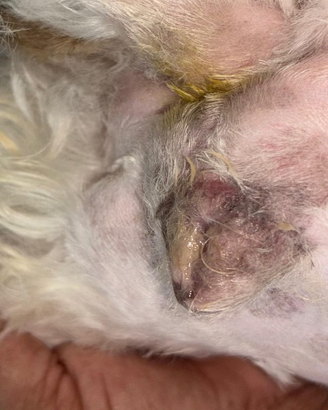
Obvious sanguineous to mucopurulent discharge was observed 4-8 weeks after standing heat in open cervix pyometra. Other signs included lethargy, dullness, depression, inappetence/anorexia, anemia, emesis, diarrhea, polyuria/ polydipsia, abdominal distension. The signs were variably observed in the experimental animals, and to a varied extent. The most common signs were abdominal distension and vulvar oedema, which were observed in all the animals. Clinical signs were also more severe in closed-cervix pyometra.

Fig. 1. Vulvar oedema and presence of mucopurulent vaginal discharge on vulvar lips in a 4-year-old Lhasa with open cervix pyometra

Bitches with closed cervix pyometra are often more severely ill at the time of diagnosis when compared to open type, with marked clinical signs of depression, lethargy, polyuria, polydipsia, vomiting, diarrhea and abdominal distension. There is no evidence of vulvar discharge. In the present study, only two (or 18.18%) out of 11 cases were closed cervix type and remaining nine (or 81.81%) were open cervix pyometra.
A carefully obtained history, clinical signs, results of hemogram, biochemistry, radiography and ultrasonography will aid to differentiate pyometra (both open and closed) from a severe vaginal infection. The most valuable of these tests was the transabdominal ultrasonography as it also helped to differentially diagnose the condition from pregnancy. Ultrasonography allowed the determination of size of the uterus, thickness of the uterine wall and the presence of fluid accumulation within the lumen. The uterus was visualized with multiple anechoic (black) fluid-filled pouches of variable diameters, depending on the extent of pus accumulation. The mean diameter of these pockets was found to be larger in bitches showing closed pyometra than those with open cervix pyometra. The ovaries of all the bitches showed presence of a functional corpus luteum during transabdominal ultrasonography indicating the stage of estrous cycle to be diestrus phase.
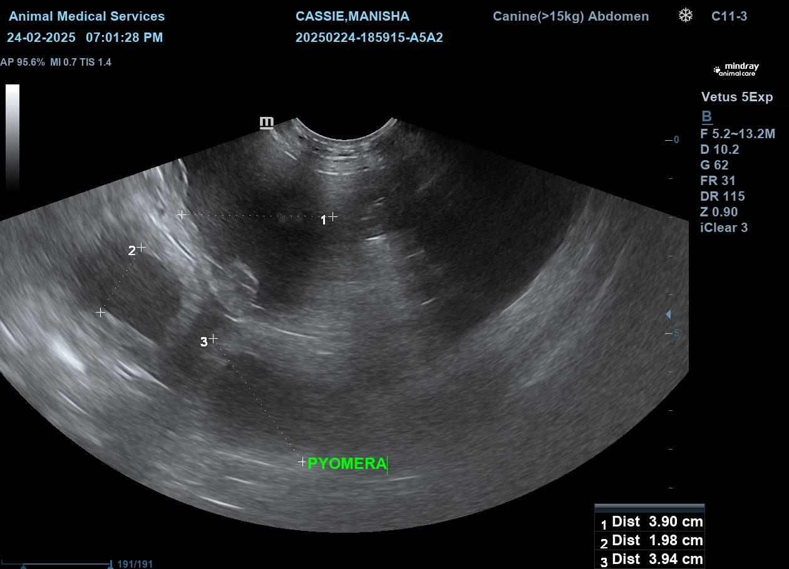
Fig. 2. Anechoic (black) fluid-filled pouches seen in the uterus of a 7-year-old Labrador Retriever on transabdominal ultrasound.

Upon the results of laboratory tests such as hematology and biochemistry, there was a common trend of decreased PCV (%), lowered Hb (g/dl) and TRBC (millions/cm³) count. No significant change was seen in the MCV, MCH and MCHC indicating a normocytic, normochromic anemia. However, the total leukocyte count (TLC) (thousands/cm³) had increased owing to inflammation. The differential leukocyte count (DLC) showed left-shift neutrophilia. No significant change was observed in absolute lymphocyte, monocyte and eosinophil counts. Serum biochemistry recorded a drastically high blood urea nitrogen (BUN) and a slightly elevated creatinine in majority (or 90.9%) of the cases.

Since estrogens potentiate the stimulatory effect of progesterone on uterus, their administration for treatment of misalliance was strongly discouraged. Exogenous progesterone administration for suppression of estrus also contributes to development of pyometra.
Ovariohysterectomy continues to be the choice of treatment for all cases of pyometra. It was opted in seven (two closed cervix, five open cervix) out of the 11 cases of pyometra. However, medical management was opted in the remaining four cases where, the future breeding potential of the bitch had to be preserved. The antibiotic of choice was a combination of ceftriaxone and tazobactam @ 15-25 mg/kg body weight depending on severity of clinical signs and extent of pus accumulation. Antiemetics like ondansetron @ 0.5 mg/kg and antacids like ranitidine @ 2 mg/kg body weight were also given to curb symptoms such as vomition and diarrhea, respectively. Supportive therapy included multivitamins, intravenous fluids to counter the dehydration and hematinics to counter the anemia accompanying pyometra. Anti-prolactin drugs like cabergoline @ 0.05 mg/ kg once a day orally for 7 days resolves pyometra by regressing corpus luteum and removing the bitch out of diestrus phase, since canines are dependent on prolactin for CL function. It was administered in the cases treated medically.
All the animals (100%) resolved uneventfully under either treatment regimens however, one out of the 4 medically managed bitch had recurrent open pyometra in the next estrous cycle. Ovariohysterectomy was performed to treat the condition.

4. Conclusion

In the present study, transabdominal ultrasonography was utilized to diagnose pyometra in bitches and blood samples were collected to perform hematological and biochemical studies. Out of 140 bitches presented to the Department of Animal Reproduction, Gynaecology and Obstetrics at TVCC during the period from September 4th, 2024 to February 26th, 2025 for various ailments, eleven were diagnosed with pyometra by clinical examination, radiography and ultrasonography with an incidence of 7.85%. The age-wise incidence was highest (90.9%) in the age group of 4-10 years. Among the breeds, the highest incidence was seen in Labrador (36.36%), followed by Golden Retriever (27.27%), German Shepherd and Pug breeds (18.18% each).
In the present study, open (81.81%) and closed (18.18%) types of pyometra were noticed and all the bitches were in diestrus phase. Abdominal distension and vulvar oedema were the most common symptoms recorded. Obvious sanguineous to mucopurulent vaginal discharges with fetid odor were seen in all the cases of open pyometra.
Ultrasonographic imaging of the uterus showed pockets of anechoic (black) fluid of variable sizes in all the bitches. The mean diameter of these pockets was found to be larger in bitches showing closed pyometra than those with open cervix pyometra. The bitches were all found in diestrus phase of their cycle.
In the present study, the mean values of PCV, Hb and TRBC values showed a decrease compared to the normal range of canines, whereas no significant change was seen in the MCV, MCH and MCHC indicating a normocytic, normochromic anemia. Significant leukocytosis with an increase in the absolute counts of mature and immature neutrophils in pyometra were observed indicating a regenerative or shift to left neutrophilia. No significant change was observed in absolute lymphocyte, monocyte and eosinophil counts. There was a drastic increase in blood urea nitrogen levels and a slightly elevated creatinine in majority of the cases.

All the animals in the present study recovered uneventfully either through medical or surgical management, although surgical methods were recommended to curb the recurrence of pyometra in these bitches.

Ethical Approval
Animal Ethic committee approval has been collected and preserved by the author(s)

AcknowledgEments

I would like to thank my mentor, Dr. K. P. Khillare, for guiding me through this research work. I would like to thank my professors, Dr. M. N. Rangnekar, Dr. R. R. Shelar, Dr. A. B. Mali, for their valuable suggestions. I would also like to thank my colleagues, M. Y. Chaudhari, K. S. Shelkar and A. A. Gaikwad, for their constant support and help.

Disclaimer (Artificial intelligence)
Option 1:
Author(s) hereby declare that NO generative AI technologies such as Large Language Models (ChatGPT, COPILOT, etc.) and text-to-image generators have been used during the writing or editing of this manuscript.
Option 2:
Author(s) hereby declare that generative AI technologies such as Large Language Models, etc. have been used during the writing or editing of manuscripts. This explanation will include the name, version, model, and source of the generative AI technology and as well as all input prompts provided to the generative AI technology
Details of the AI usage are given below:
1.
2.
3.

References

Achary, K.H. 2020. Clinico-pathological studies of canine Pyometra in and around Bhubaneswar. M.V.Sc thesis. College of Veterinary Science & Animal Husbandry, Bhubaneswar, 91p.

Bhat F H, Sharma U, Pande N, Pandey A K and Mudasir M 2018 Incidence of canine pyometra in an around Jammu region. The Pharma Innovation Journal 7(11) : 192-196.

Bostrom N J 2018 A retrospective study of prognostic markers in bitches diagnosed with pyometra. Master Thesis of Integrated studies of Veterinary Medicine, Lithuanian University of Health Sciences, Kaunas.

Coles E H 1986 Veterinary Clinical Pathology 4th edn. W B Saunders Company, Philadelphia.
Gibson A, Dean R, Yates D and Stavisky J 2013 A retrospective study of pyometra at five RSPCA hospitals in the UK: 1728 cases from 2006 to 2011. The Veterinary Record 173(16) : 396.
Jitpean, S. (2015). Predictive markers and risk factors in canine pyometra (No. 2015: 85).

Jitpean, S., Ambrosen, A., Emanuelson, U., & Hagman, R. (2016). Closed cervix is associated with more severe illness in bitches with pyometra. BMC veterinary research, 13(1), 11.

Kempisty B, Bucowska D, Wozna M, Piotrowska H, Jacowska M, Zuraw A,Ciesiolka S, Antosik P, Maryniak H, Ociepa E, PorowskiSz, Brussow K P, Jaskowski J M and Nowicki M 2013 Endometritis and pyometra in bitches: A review. Veterinari Medicina 58(6) : 289-297.

Kumar P, Shukla S N and Shrivastava M J O 2019 An incidence of cystic endometrial hyperplasia-pyometra complex in female bitches. Pharma Innovation 8(6) : 522 526.

Norelli C S, Cahua U, Jacqueline G Z, Armando and Gavidia C C 2019 Frequency of pyometra in female dogs of the Minor Animal Clinic of the Faculty of Veterinary Medicine of the National University of San Marcos during the period 2009-2013. Journal of Veterinary Research of Peru 30(1) : 512-516.

Unnikrishnan, M. P. (2018). Diagnosis and therapeutic management of canine pyometra for restoring breeding efficiency. Doctrol thesis.

Vidya, V. K. (2019). Prognostic evaluation of canine pyometra based on serum prostaglandin metabolite concentration and haematological changes (Doctoral dissertation, College of Veterinary and animal Science, Mannuthy).

Ylhäinen, A., Mölsä, S., Thomson, K., Laitinen-Vapaavuori, O., Rantala, M., & Grönthal, T. (2025). Bacteria associated with canine pyometra and concurrent bacteriuria: A prospective study. Veterinary Microbiology, 301, 110362.

