Study of Pre-Mating Behavior and Reproductive Indicators in Indian Rhinoceros (Rhinoceros unicornis) with Ethogram

ABSTRACT
This study investigates the courtship behavior and reproductive indicators of Indian rhinoceroses (Rhinoceros unicornis) housed at Kanpur Zoological Park. Over a 12-month observational period, both behavioral and hormonal data were collected to better understand the pre-mating, mating, and post-mating phases in a captive environment. Using focal and Ad libitum sampling, specific behaviors such as scent-marking, tactile stimulation, and vocalizations were documented and correlated with hormonal trends derived from fecal and serum analysis. The findings reveal a strong reliance on chemosensory cues and subtle physical gestures during courtship, with hormonal synchronization playing a critical role in mating success. An ethogram was developed to categorize and standardize observed behaviors. The study highlights the importance of environmental enrichment, social structure, and hormonal monitoring in enhancing reproductive success in conservation breeding programs. These insights can inform better management practices in zoos and contribute to in-situ conservation efforts.

Keywords: Captive Breeding; Courtship Behavior; Estrus Cycle; Ethogram; Kanpur Zoological Park; Reproductive hormones

INTRODUCTION
Rhinoceros biodiversity includes five species found in Asia and Africa: Indian, Javan, Sumatran, Black, and White rhinos. Each species occupies a unique habitat, from grasslands to tropical forests, and plays a key role in maintaining ecosystem balance through grazing and seed dispersal. However, rhinos face severe threats from poaching, habitat loss, and slow reproduction (Arya, 2025). Their declining numbers highlight the urgent need for conservation. Protecting rhinos not only preserves a unique group of megafauna but also supports broader biodiversity. Conservation efforts like habitat protection, anti-poaching laws, and breeding programs are essential to safeguard rhinoceroses’ biodiversity for future generations. Rhinoceroses, though solitary megafauna, engage in complex behaviors during mating periods. Unlike herd-based ungulates, rhinocerotids depend on olfactory and tactile cues for reproductive communication. Understanding pre-mating behaviors is vital for conservation and captive breeding programs, where mismatches in courtship cues may hinder reproductive outcomes. The Kanpur Zoological Park, also known as Allen Forest Zoo, is home to a diverse array of wildlife, including the majestic Indian Rhinoceros (Rhinoceros unicornis). Nestled within a natural forest setting, the zoo provides a semi-wild habitat that closely mimics the rhino’s native environment (Rani et al. 2023).
The Indian rhinoceros, also known as the one-horned rhinoceros, is a flagship species for conservation in India and plays a vital role in ecological education and awareness. At Kanpur Zoo, these gentle giants are housed in spacious, moated enclosures that allow for natural behaviors such as wallowing, grazing, and scent-marking. Their presence not only enhances the zoo’s biodiversity but also supports conservation breeding efforts under the Central Zoo Authority’s guidelines (Laurie, 1982). As herbivores, Indian rhinoceroses mostly consume plants or plant components. They are also categorized as lignivores, which consume wood, and folivores, which consume leaves. Grass, fruit, leaves, branches, aquatic plants, and farmed crops make up their diet. Compared to short species, tall reedy grasses are preferred. Species of rhinoceroses have prehensile upper lips and are generalist browsers (Brown et al., 2001, Bhatt, et al. 2025). They can grasp and drag woody branches into their mouths because of their prehensile upper lip. To bend and bite the stalk tips, these rhinos typically wrap their upper lips around the stems during twilight and nighttime feeding. (Anon,1997 and Stoops et al., 2007) They are the most aquatic rhinoceros as well. They are frequently spotted swimming or wading in broad rivers.
By selecting this problem for study, we aim to bridge the knowledge gap in behavioral ecology, particularly focusing on how environmental, social, and physiological factors influence reproductive outcomes in captivity. Hildebrandt et al., (2006) Studying the reproductive behavior of rhinoceroses at Kanpur Zoo offers a controlled setting for detailed observations, providing valuable insights that can be applied to similar conservation programs across India. The findings will help in designing evidence-based breeding protocols, improving animal welfare, and supporting species recovery plans (Subedi et al. 2013). Hence, this research is not only scientifically significant but also aligned with national biodiversity conservation priorities.

2. MATERIAL AND METHODS

2.1. Study Sites and Subjects
The study was conducted at Kanpur Zoological Park under conservation breeding programs. In Kanpur Zoo there was two male, and one female rhinoceros are present. For this study permission was taken from the chief conservator of forest wildlife, Uttar Pradesh, Lucknow under the guidelines for scientific research in protected areas issued on dated 26.07.2006 by Ministry of Environment, Forest and Climate Change, Government of India, New Delhi.

2.2. Observation Period
Behavioral data were collected over a 12-month period to encompass multiple estrous cycles and seasonal variations. Observations were conducted during peak activity hours, that is early morning and late afternoon.

2.3. Behavioral Sampling Techniques

2.3.1 Focal Animal Sampling
Individual rhinos were observed for 30-minute sessions, recording all reproductive behaviors including scent-marking, vocalizations, courtship gestures, and mating attempts.

2.3.2 Ad libitum Sampling
Opportunistic recording of rare or unexpected behaviors, especially during introductions in captive settings.

2.3.3 Ethogram Development
A detailed ethogram was constructed based on prior literature and preliminary observations, categorizing behaviors into pre-mating, mating, and post-mating phases.

2.4. Hormonal Monitoring
Fecal Sample Collection: Weekly fecal samples were collected non-invasively and analyzed for progesterone and estrogen metabolites to determine female reproductive status.

2.5. Environmental and Social Variables
Habitat type, enclosure size, and human interaction levels were recorded to assess their influence on reproductive behavior. In captive settings, introduction protocols (visual, olfactory, and physical) were documented to evaluate behavioral responses.
2.6. Data Analysis
Behavioral frequencies and durations were analyzed using descriptive statistics. Hormonal data were correlated with observed behaviors to identify reliable indicators of estrus and mating readiness. Comparative analysis was conducted between wild and captive populations to assess behavioral consistency and adaptability.

3. RESULTS AND DISCUSSION
The present study focuses on the pre-mating behavior and reproductive indicators in Indian Rhinoceros (Rhinoceros unicornis) under captive conditions. Observations revealed a series of behavioral cues including sniffing, vocalization, scent marking, and tactile interactions that precede successful mating The behaviors varied in frequency and intensity based on the reproductive status and social dynamics of the individuals (Table.1). The findings are discussed in relation to existing literature and their significance for improving captive breeding programs. present work aims to interpret these behaviors as reliable indicators of reproductive readiness (Curlewis et al., 1993).
Table 1: Summary of Reproductive Behavior and Hormonal Trends in Rhinoceros unicornis
Activities | Frequency/Pattern | Correlated Hormonal Trend | Notes (Wild vs. Captive)
Scent-marking (male and female) | Daily during estrus | ↑ Estrogen in females | Consistent in both settings
Urine sniffing (male) | 4–6 times per hour during female's fertile phase | ↑ Testosterone in males | More active in captive introductions
Vocalizations (grunts, bellows) | 2–3 times per hour during peak interaction | No direct correlation, but linked to courtship | Louder and more frequent in dense habitats (wild)
Tactile stimulation (nudge, chin) | Precedes 70% of mating attempts | Occurs during estrogen peak | More observable in enriched enclosures
Tail lifting and pacing (female) | 1–3 days pre-copulation | ↑ Estrogen, ↓ Progesterone | Reliable visual cue in both environments
Successful copulations | 77% in hormonally timed introductions (captive) | Aligns with synchronized hormone levels | Demonstrates utility of endocrinological monitoring
Gestation outcome | 1 live birth (Kanpur Zoo) | Normal hormonal progression | Validates captive breeding when behavior-hormone aligned

3.1 Scent marking and sniffing
It’s the earliest courtship indicators, often preceding any physical proximity. In this behavior the male is closely approaching the female, often a sign of interest. Its head toward the female posterior area, which is common in checking pheromonal cues reproductive status. This posture by the male is indication of investigative and potentially submissive or non-aggressive intent, typical of courtship. There are no visible signs of hostility, suggestive or reproductive rather than interaction (fig.1). The reproductive success of captive Indian rhinoceroses (Rhinoceros unicornis) remains a significant challenge in wildlife conservation programs. This issue is particularly relevant in zoological parks Kanpur Zoo, where breeding outcomes have been inconsistent despite suitable infrastructure and veterinary support. The selection of this problem stems from the urgent need to address the declining population of this vulnerable species and to enhance the effectiveness of ex-situ conservation strategies. Limited knowledge about species-specific reproductive behavior under captive conditions often leads to poor pair bonding, undetected estrus cycles, and unsuccessful matings (Roth, 2024 and Lee, 2025).
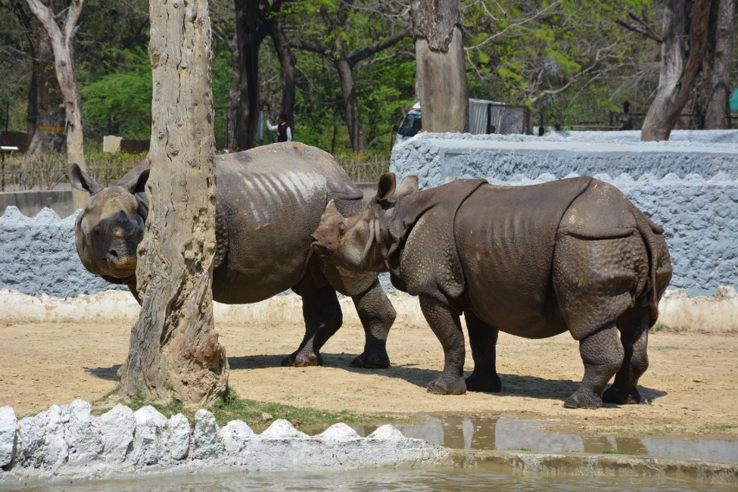
Fig. 1- showing Sniffing and nuzzling Behavior.

3.2 Courtship behavior
They are displaying head-to-head touching. Male and female show mutual interest. Sometime this can also be a non-aggressive social interaction indicating familiarity or mutual tolerance. We assess that it can also be a form of tactile communication where both individuals assess each other’s readiness or mood. We observed that this is not aggressive behavior, as their body language appears relaxed. There was no charging, gaping mouths, and flared ears were observed. It showed early stage reproductive or affiliative behavior(fig.2,3). Kretzschmar et al (2019) conducted expewriment on white rhinocerous and studied mate choice, reproductive success and inbreeding and found similar results.
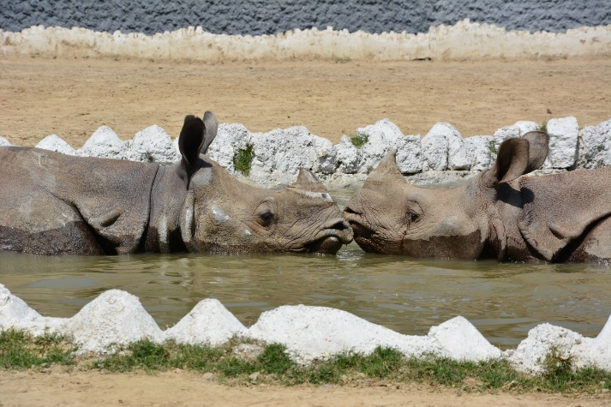
Fig.2: Premating behavior showing snout to snout contact, affiliative behavior and testing receptivity.
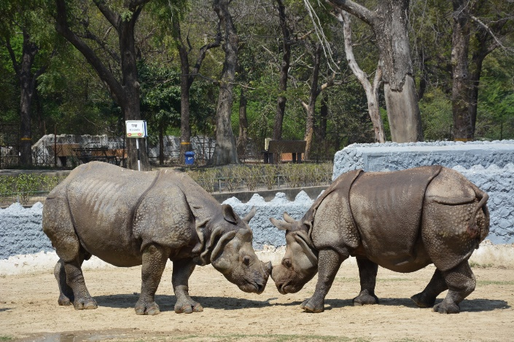

Fig.3- showing premating interaction (male and female)

Vocalizations
Vocalizations were more common in black rhinos, potentially due to denser habitats requiring acoustic signaling. Scent marking and sniffing are crucial components of the communication and reproductive behavior in rhinoceroses. The study revealed that both male and female Indian rhinoceroses engage in frequent sniffing of urine, feces, and marked areas to gather information about the reproductive status, identity, and territorial boundaries of conspecifics (Burnham et al. 2023). Adult males were observed to intensely sniff urine patches and dung piles, particularly those of females, indicating the use of chemical cues to detect estrus and readiness for mating. Scent marking by dung piling and urination was more frequent in dominant individuals, suggesting a role in territorial assertion and mate attraction. Females in estrus exhibited increased urination and allowed males to sniff them, facilitating reproductive synchronization. The results confirm that olfactory cues play a significant role in mate recognition, courtship initiation, and social hierarchy establishment in rhinoceroses (Hermes et al.,2006; Alison et al. 2016). These behaviors were found especially prominent in semi-natural enclosures at Kanpur Zoo, highlighting their importance even in captive conditions.

3.3: Sexual arousal behavior/Tactile stimulation
Such as nudging or chin-resting, frequently occurred before copulation. In females, increased restlessness and tail movements were observed as indicators of estrus receptivity. It was observed when the male detects the scent or presence of a female. There was found that male exhibit sniffing the air or ground, following into female pheromones. the female, curling the lip and spraying the urine (Odula, 2025). This is a normal reproductive display observed the mating season or in response(fig.4). Anthony and Blumenstein (2000) also observed the sexual behaviour of Rhinoceros and found similar results in their research.
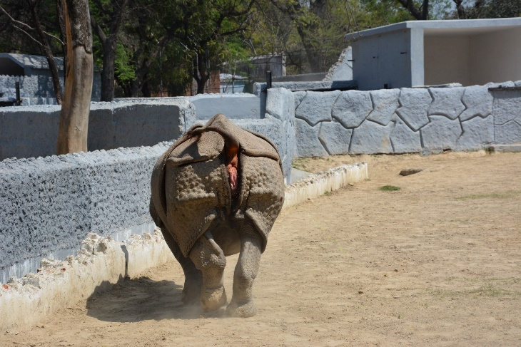
Fig.4: Showing premating or sexual arousal behavior, Scent communication

Ethogram study
An ethogram is a comprehensive catalog of behaviors exhibited by an animal species, typically used in behavioral studies. Ethogram for the Indian Rhinoceros (Rhinoceros unicornis), developed based on potential observations from a preliminary field study. This ethogram includes categorized behaviors under activity, social, maintenance, communication, and abnormal behaviors.
Table 2: Ethogram for Indian Rhinoceros (Rhinoceros unicornis)
Behavior Category | Behavior | Description
Locomotion | Walking | Slow, deliberate movement across terrain
Locomotion | Trotting | Faster gait than walking, often used to move short distances
Locomotion | Running | Rapid movement, usually in response to threat or aggression
Locomotion | Swimming | Entering water and propelling body through aquatic environments
Feeding | Grazing | Eating grass or low-lying vegetation
Feeding | Browsing | Feeding on shrubs, tree leaves, and higher vegetation
Feeding | Drinking | Drawing water from a source using the upper lip
Resting | Lying down | Body positioned on the ground with minimal movement
Resting | Standing rest | Motionless but upright, often with eyes closed
Maintenance/comfort behaviors | Mud wallowing | Rolling or lying in mud, often for thermoregulation and parasite control
Maintenance/comfort behaviors | Scratching | Rubbing body against trees, rocks, or with limbs to relieve irritation
Maintenance/comfort behaviors | Urinating/Defecating | Elimination of waste, sometimes used in territorial marking
Social Behaviors | Mother–calf interaction | Nuzzling, following, vocalizations, and nursing
Social Behaviors | Aggression (sparring) | Charging, horn clashing, biting, or chasing another rhino
Social Behaviors | Play (calves/subadults) | Running, mock fighting, or interacting without aggression
Social Behaviors | Courtship/mating | Following, sniffing, mounting behavior
Communication | Vocalization | Snorts, grunts, or bellows used to convey information
Communication | Scent-marking | Dung piles or urine spraying for territory or reproductive status
Communication | Ear posture | Changes in ear orientation as a sign of alertness or mood
Communication | Tail flicking | Flicking tail as a sign of irritation or fly avoidance
Alertness/Threat | Head raising | Lifting head high, ears forward—indicates vigilance
Alertness/Threat | Snorting | Audible response to disturbance or alertness
Alertness/Threat | Mock charge | Short aggressive burst toward perceived threat without full contact
Abnormal Behavior | Pacing | Repetitive walking in the same pattern (often seen in captivity)
Abnormal Behavior | Excessive vocalizing | Repetitive loud calls without social cause—may indicate stress or discomfort

The observed courtship rituals showed a strong dependence on chemosensory and auditory cues. These behaviors serve dual functions. facilitating mate recognition and reducing aggressive encounters (Swaisgood et al., 2002). Environmental factors such as terrain and vegetation density influenced the duration and type of behavior observed (Pant et al. 2020). Tactile stimulation such as nudging and chin-resting frequently preceded mating and aligned with hormonal peaks, reaffirming results from prior captive studies. Rispoli and Roth (2023) and Roth et al. (2023) also found similar results in their investigations.
Hormonal analysis supported behavioral cues of reproductive readiness. Estrogen levels in females peaked during periods of pacing and tail lifting, while testosterone increased in males following urine sniffing of receptive females (Curlewis et al., 1993; Brown et al., 2001). This supports the hypothesis that behavior and hormonal synchronization are key to mating success in captivity (Stoops and Roth, 2007).
Ethogram-based documentation allowed for a structured behavioral comparison, showing consistency with observations from Chitwan National Park (Adhikari and Lamichhane, 2017). Enhanced reproductive outcomes in hormonally synchronized introductions reflect the critical role of multi-modal monitoring (Sutherland,1998).

Conclusion
In conducting this study on the pre-mating behavior and reproductive indicators of the Indian rhinoceros (Rhinoceros unicornis), we ensured that all observations were strictly non-invasive and carried out from a safe distance so as not to disturb the animals or alter their natural behavior. No physical intervention, restraint, or experimental manipulation was involved at any stage. We took care to minimize stress by limiting human presence and avoiding prolonged encounters, while also ensuring that the natural habitat of the rhinoceros was not disturbed. As the species is listed as Vulnerable by the IUCN, we designed our research to contribute to conservation knowledge without compromising the welfare or reproductive success of the animals.
Ethical Approval
The study was conducted in accordance with established ethical guidelines for wildlife research, with full emphasis on animal welfare, humane treatment, and minimal disturbance.

Disclaimer (Artificial intelligence)
Option 1:
Author(s) hereby declare that NO generative AI technologies such as Large Language Models (ChatGPT, COPILOT, etc.) and text-to-image generators have been used during the writing or editing of this manuscript.

REFERENCES
- Adhikari, B., and Lamichhane, B. R. (2017). Breeding behavior of Greater One-horned Rhinoceros (Rhinoceros unicornis) in Chitwan National Park, Nepal. Journal of Institute of Science and Technology, 22(1), 61–67.
- Alison.L, Tal O. B, Daniel T. B. Swaisgood R.R. Clark S. W., William J.S. (2016) Research Priorities from Animal Behaviour for Maximising Conservation Progress. Trends in Ecology and Evolution, 31, (12):953-964 doi 10.1016/j.tree.2016.09.001
- Anonymous (1997) Animal Behavior Society Ethogram Standards. https://www.animalbehaviorsociety.org.
- Anthony, L. L. & Blumenstein, D. T. (2000). Integrating behavior into wildlife conservation: The multiple ways that behavior can reduce N_{(e)}. Biological Conservation, 95, 303–315.doi 10.1016/S0006-3207(00)00037-9
- Arya, S. (2025) Wetland Ecosystem: A better place for rich biodiversity. International Journal of Fauna and Biological Studies. 11 (6): 106-110. DOI: 10.22271/23940522.2024.v11.i6b.1066
- Arya, S., Rani, D., Singh, R. (2024) Sarus crane, biodiversity and pesticides: A review. International Journal of Fauna and Biological Studies. 11 (1): 29-31. DOI: 10.22271/23940522.2024.v11.i1a.1005
- Bhatt, R., Joshi, K. P., Karki, J. B., Ayer, K., Bhusal, A., Miya, M. S., Pant, G., Thagunna, R. S., Joshi, L. R., & Dhami, B. (2025). The rhinoceros relocation mystery: Unraveling the determinants of habitat use and conservation threats of translocated population in Nepal. International Journal of Zoology, (1), 1–10.
- Brown, J. L., Bellem, A., Fouraker, M., Wildt, D. E., and Roth, T. L. (2001). Comparative analysis of gonadal and adrenal activity in the black and white rhinoceros in North America by noninvasive endocrine monitoring. Zoo Biology, 20(6), 463–486.
- Burnham, C. M., McKenney, E. A., Ange‑van Heugten, K., Trivedi, S., and Minter,J. L. (2023). Effects of age, seasonality, and reproductive status on the gut microbiome of southern white rhinoceros at North Carolina. Zoo. Animal Microbiome, 5: doi:10.1186/s42523-023-00249-5.
- Curlewis, J. D., Kay, J. M., and Czekala, N. M. (1993). Monitoring of ovarian activity in the greater one-horned rhinoceros (Rhinoceros unicornis) using fecal steroid analysis. Zoo Biology, 12(6), 543–551.
- Hermes, R., Göritz, F., Hildebrandt, T. B., and Blottner, S. (2006). Reproductive soundness of captive southern and northern white rhinoceroses (Ceratotherium simum). Theriogenology, 65(8), 1492–1510.
- Hildebrandt, T. B., Göritz, F., & Hermes, R. (2006). Ultrasonography: An important tool in captive breeding management in elephants and rhinoceroses. European Journal of Wildlife Research, 52(1), 23–27. https://doi.org/10.1007/s10344-005-0012-4.

- Kretzschmar, P., Auld, H., Boag, P., Ganslober, U., Scott, C., Van Coeverden de Groot, P. J., & Courtiol, A. (2019). Mate choice, reproductive success and inbreeding in white rhinoceros: New insights for conservation management. Evolutionary Applications, 13(4), 699–714. https://doi.org/10.1111/eva.12894
- Laurie, W.A. (1982). Behavioral ecology of the Greater One-Horned Rhinoceros. Journal of Zoology. 196(3):307-341
- Lee, A. (2025) How Rhinoceros Males Compete for Mating Rights in the Wild. Animal around the Globe. https://www.animalsaroundtheglobe.com/
- Odula, T. (2025) A rhino got pregnant from embryo transfer, in a success that may help nearly extinct subspecies, https://phys.org/news/2024-01-rhino pregnant-embryo-success-extinct.htm
- Owen (1984). Spatial and temporal components of the mating system of the white rhinoceros (Ceratotherium simum). Zeitschrift für Tierpsychologie, 64(1), 125–136.
- Pant, G., Maraseni, T., Apan, A., & Allen, B. L. (2020). Trends and current state of research on greater one-horned rhinoceros (Rhinoceros unicornis): A systematic review of the literature over a period of 33 years (1985–2018). Science of The Total Environment, 710, 136349. DOI: 10.1016/j.scitotenv.2019.136349
- Rani, K., Singh, S., Prakash, S., Arya, S. (2023) A review on behavior of Muscovy duck (Carina moschata). International Journal on Biological Sciences. 14 (2): 74-80. DOI: 10.33545/26646536.2024.v6.i1a.47
- Rispoli, L. A., and Roth, T. L. (2023). Validation of the Sperm for assessing rhinoceros’ sperm. Theriogenology Wild, DOI: 10.1016/j.therwi.2023.100048
- Roth, T. L. (2024). That was then, this is now – Over two decades of progress in rhinoceros reproductive science and technology. Theriogenology Wild, DOI: 10.1016/j.therwi.2023.100065.
- Roth, T. L., Donelan, E. M., Rispoli, L. A., and Reilly, T. (2023). Prolactin enzyme-linked immunosorbent assay for rhinoceroses – another tool for assessing reproductive function and dysfunction. Theriogenology Wild, doi:10.1016/j.therwi.2023.100035.
- Stoops, M. A., and Roth, T. L. (2007). Endocrine and behavioral evaluation of asynchronous estrous cycles and nonconceptive estrus in the female southern white rhinoceros (Ceratotherium simum simum). Zoo Biology, 26(2), 157–166.
- Subedi, N., Jnawali, S. R., Dhakal, M., Pradhan, N. M. B., Lamichhane, B. R., Malla, S., Amin, R., & Jhala, Y. V. (2013). Population status, structure and distribution of the greater one-horned rhinoceros Rhinoceros unicornis in Nepal. Oryx, 47(3), 352–360. DOI: 10.1017/S0030605313000562
- Sutherland, W. J. (1998). The importance of behavioural studies in conservation biology. Animal Behaviour,56(4), 801–809. https://doi.org/10.1006/anbe.1998.0896
- Swaisgood, R. R., Montagne, J. P., and Wildt, D. E. (2002). Behavioral indicators of estrus in the southern white rhinoceros (Ceratotherium simum simum). Animal Behaviour, 63(2), 263–27 Zoology and Ecology 25(4):1-7. DOI: 10.1080/21658005.2015.1090118

