Description of a new tapeworm Stilesia pushpai sp.n. (Cestoda: Thysanosomidae Fuhrman, 1907) from goat (Capra hircus) in Wake, Nasik, Maharashtra, India
Abstract:
Stilesia pushpai sp. nov., a new species of the genus Stilesia Railliet, was discovered in the small intestine of a goat (Capra hircus) from Wake, Malegaon, Dist. Nashik, (M.S.), India, in 1893. The current worm under consideration has a medium-sized, globular scolex, four oval to spherical suckers, a medium-sized neck that is broad in front and narrows in back. The adult segments are nearly 15–16 times wider than long, with unilateral genital pores that alternate often, and are located close to the posterior edge of the segments. The ovary is oval, a single mass with many acini, and the vagina is located in front of the cirrus pouch. The testes are spherical, five to eight on each side, and the cirrus pouch is medium, oval, thin, and convoluted.
Key words: Stilesia, Scolex, Genital pore, Cirrus pouch, Acini, etc.
Introduction:
The genus Stilesia was raised Railliet, in 1893 from Ovis aries, in Europe, Asia and Africa as Stilesia globipunctata (Rivolta, 1874) later on Stilesia vittata was reported by Railliet, in 1896 from Camelus dromedarius in Africa and India. Stilesia hepatica was added to this genus by Wolffhugel, in 1903 from Buffelus caffer and Bos taurus in Asia and Africa. Stilesia okapi was erected as a new species, of this genus by Leiper, in 1936 from Okapi in Africa, is regarded by Baer, in 1950 as a variety of S. globipunctata. This study adds to our understanding of the taxonomy and biodiversity of parasitic helminths by reporting a new species of tapeworm, Stilesia pushpai sp. nov., from goats (Capra hircus) in India. Understanding host-parasite relationships, species distribution, and evolutionary trends all depend on the accurate identification of new parasites. Additionally, it has veterinary significance since parasite diseases can have an impact on the health, growth, and production of goats, which can have an effect on the economy and management of livestock. Furthermore, this study benefits scientific research as well as cattle health management by providing baseline data for next epidemiological studies, parasite control tactics, and comparative taxonomy. The current correspondence addresses the description of Stilesia pushpai n.sp. collected from intestine of goat (Capra hircus) from Wake, Malegaon, Dist. Nashik, (M.S.), India.
Material and Methods:
The investigation was carried out for two years during the period from July 2020 to June 2021 and July 2021 to June 2022. About 25 samples of the cestode parasite were taken from different slaughter houses of Nashik region. Intestines of the host Capra hircus were dissected and observed for the degree of infection. Most of the intestines were infected by cestode parasites. After being preserved in hot 4% formalin, the free worms were stained with Harris hematoxylin, run through a series of alcohol grades, cleaned in xylene, mounted in D.P.X., and the whole mount slides were ready for anatomical investigations. The camera Lucida was used to create the illustrations, and unless otherwise noted, all measurements are expressed in millimeters. The Holotype and Paratype specimens have been deposited in P.G and Research Department of Zoology N.Y.N.C.College, Chalisgaon Dist-Jalgaon,Maharastra (India)

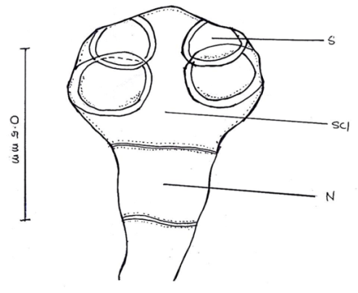
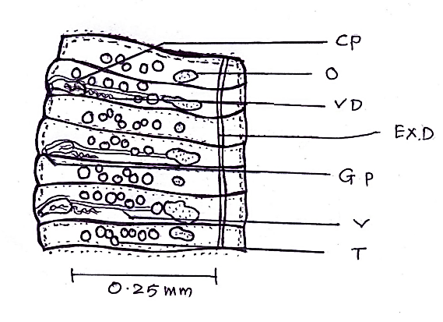

A B

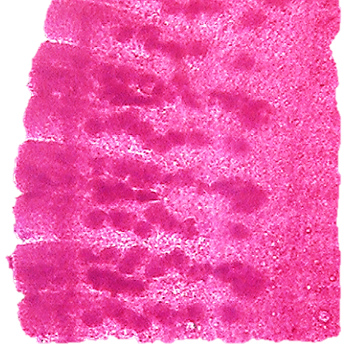
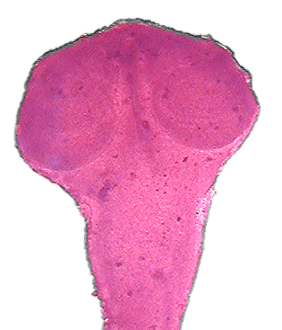

A B

Fig1: Camera Lucida sketches and Microphotographs of Stilesia pushpai n. sp.
A- Scolex (X 100) B- Mature segments (X 100)
(S=Suckers, Scl= Solex, N=Neck, CP=Cirrus pouch, O=Ovary, VD=Vas deference, Ex.D=Exterior duct, GP=Genital pore, V=Vagina, T=Testies)

Description:
Every parasite is small to medium in size, has a scolex, thin muscles, and several immature and mature segments. Measuring 0.3972 to 0.4109 in length and 0.5753 to 0.5821 in width, the medium, globular scolex is clearly distinguished from the strobila. It is thin anteriorly and large posteriorly. The scolex has four medium-sized, unarmed suckers that are oval to spherical in shape. They are organized in two pairs, one pair in each half of the scolex, and they overlap each other in both pairs and the lateral margin of the scolex. Their measurements are 0.1369 to 0.1849 in length and 0.1849 to 0.2397 in width. There is no rostellum. The neck is medium in size, measuring 0.2191 to 0.2397 in length and 0.2191 to 0.3082 in width. It is broad anteriorly and narrows posteriorly. The mature proglottids are 0.0479 to 0.0547 in length and 0.3424 to 0.3561 in width. They are medium in size, thin, have only one pair of reproductive organs in each segment, are nearly 15–16 times broader than long, and have obvious segmentation and convex lateral borders. The testes are medium in size, circular in shape, unevenly distributed, and range in diameter from 0.0140 to 0.0205. There are five to eight testes on each lateral side in each segment. The cirrus pouch, which is located in the posterior corner of the segment, is medium in size, oval in shape, somewhat obliquely or transversally positioned, slightly open, and has dimensions of 0.0479 to 0.0547 in length and 0.0205 to 0.0280 in width. The cirrus, which is 0.0205 to 0.0280 in length and 0.0068 in width, is thin, wavy, and unarmed. It is housed inside the cirrus pouch. The vas deferens has dimensions of 0.0068 in length and 0.0890 to 0.1027 in width. It is thin, lengthy, and convoluted, running transversally. The ovary is small, single-mass, oval-shaped, elongated, and located close to the posterior edge of the segment. Its dimensions are 0.0205 to 0.0684 in length and 0.0140 to 0.0280 in width. The vagina is thin, straight tube, anterior to the cirrus pouch, arise from the genital pore, run transversally and measures 0.1917 to 0.2054 in length and 0.0068 in breadth. The genital pores are small in size, unilateral, open marginally, regularly alternate, and placed at posterior region of the segment and measure 0.0068 to 0.0140 in breadth. The vitelline gland is absent. The excretory channels are tiny, longitudinal, and have a width of 0.0068.
Discussion and conclusion
Railliet created the genus Stilesia in 1893 using the type species globipunctata from Ovis aries. Subsequently, 33 species are introduced to the genus by various global workers. The worm in question has a medium, globular scolex, four oval to spherical suckers, a medium neck that is broad in the front and narrows in the back. The adult segments are nearly 15–16 times wider than long, with unilateral genital pores that alternate often, and are located close to the posterior edge of the segments. The ovary is oval, a single mass with many acini, and the vagina is located in front of the cirrus pouch. The testes are spherical, five to eight on each side, and the cirrus pouch is medium, oval, thin, and convoluted.
The current tapeworm is different from S. globipunctata, which has a round scolex, four to seven testis on each side, vas deference that is not tightly wound and located between the excretory canal and the cirrus pouch, a small, pyriform cirrus pouch that is ventral to the vagina, a globular ovary, and a vagina that is dorsal to the cirrus pouch. It is found in Ovis aries. The worm is different from S. vittata, which is found in Camelus dromedarius and has two groups of testes five to nine on each side an elongated, cylindrical, cirrus-armed pouch, a rounded ovary, and a vagina behind the pouch. The worm in question is not the same as S. hepatica, which is found in Buffelus caffer and Bos taurus and has two groups of testes, six to seven on each side, preovarian in the anterior half of the segments, and genital pore in the middle of the segments. The current tapeworms are different from S. leiperi, which is found in Ovis bharal and has a circular scolex, two groups of five to six testes on each side, a vas deference that is not tightly coiled, an elongated, cylindrical cirrus pouch, and a vagina posterior to the pouch. In contrast to S. caballeroi, the cestode under consideration has testes 1–11 on each side, a vagina posterior to the cirrus pouch, and a less dense bundle of convolutions anterior to the testes. The current parasite is different from S. southwelli in that it has a quadrangular scolex, a mature segment that is five times wider than long, only four testes per group, a big, sac-like cirrus pouch, a medium, spherical, compact ovary without acini, and a vagina posterior to the cirrus pouch. The worm, which is found in Ovis bharal, is different from S. aurangabadensis in that it has a large, spherical scolex, two lateral groups of five testes on each side, a straight vas deference that extends to the longitudinal excretory canal, an elongated, cylindrical, cirrus-coiled cirrus pouch, and a vagina that is posteriodorsal to the cirrus pouch. In contrast to S. garhwalensis, the worm in question has oval to spherical testes, 0–9 on each lateral side, a coiled vas deference, a spherical ovary, a vagina posterior to the cirrus pouch, and irregularly alternating genital pores. The current forms, which are seen in Ovis aries, differ from S. kotdwarensis in that they have 1–12 testes, a coiled vas deferens, a vagina posterior to the cirrus pouch, and irregularly alternating genital pores. The current parasites are different from S. marathwadaensis in that they have a circular scolex, five to seven testes in two groups, a straight vas deference that extends to the longitudinal excretory canal, an ovary in the anterior part of the segment, and a vagina behind the cirrus pouch. In contrast to S. yawalensis, the current cestodes have a quadrangular scolex, two to three testes on each side, an ovary that is medium, spherical, and irregularly alternating genital pores. The current forms, which are reported from Ovis bharal, are different from S. jadhavae in that the mature segment is eight times wider than long, there are five to seven testes, and the ovary is spherical. In contrast to S. alii, the current tapeworm has an oval scolex that is broad in the middle and small at both ends, squarish mature segments, and medium testes that are unevenly distributed and number 11 (5+6 or 6+5). The current parasites are different from S. dhondagae in that they have a quadrangular scolex, eight to ten testes that are placed in two rows, a clearly bilobed ovary that is elongated with eight to nine acini in each lobe, and simple uterine structures. In contrast to S. caprai, the current cestode has a squarish mature segment, eight or nine testes distributed in two lateral fields, a slightly curved vas deference, a vagina posterior to the cirrus pouch, and irregularly alternating genital pores. The worm in question is different from S. pandeyi in that it has 20 testes grouped in two lateral fields, a vas deference curve, an ovary close to the segment's anterior border, and a vagina behind the cirrus pouch. In contrast to S. daulatabadensis, the current tapeworm has a squarish mature segment, eleven testes seven on the poral side and four on the aporal side a medium, slightly curved vas deference, and a genital pore in the anterior part of the segment. The current form is different from S. indapurensis in that the scolex is quadrangular, the mature segment is squarish, the testes are medium and number eight or nine, the cirrus pouch is huge and elongated, and the vagina is located behind the cirrus pouch. The current cestode is different from S. jadhavi in that it has a big scolex, 14 testes dispersed on the dorsal, lateral, and ventral sides of the ovary, a bilobed ovary with several acini at the posterior portion of the segment, and a vagina posterior to the cirrus pouch. The current worms are different from S. hircusi in that they have a circular scolex, ten to twelve testes, a medium globular ovary, and a bilobed uterine sac. In contrast to S. kapadnaensis, the current cestodes have mature segments that are eight times wider than longer, four to six testes, a vaginal dorsal to cirrus pouch, and irregularly alternating genital pores. The current form is different from S. shrigondaensis in that it has a circular scolex, a mature segment that is 9–10 times wider than long, 10–12 testes spread across two lateral fields, and a vagina beyond the cirrus pouch. In contrast to S. songirensis, the current parasites have mature segments that are acraspidote, seven or eight testes, a vagina posterior to the cirrus pouch, and irregularly alternating genital pores. The current worms are different from S. kanegaonensis in that they have an oval scolex, 17–19 testes in two lateral groups, a vagina posterior to the cirrus pouch, and have been recorded from Ovis bharal. The current cestodes, which are described from Ovis bharal, are different from S. intestinalis in that they have a rectangular scolex, a mature segment that is eight times wider than long, and four testes on each side. The current parasite is different from S. alii (minor) in that it has a quadrangular scolex, a mature segment that is 12 to 13 times wider than long, nine to ten testes on each side, and a vagina that is posterior to the cirrus pouch. The current parasites are different from S. indiana in that they have four to five testes, a curved vas deference, a short, elongated cirrus pouch, a compact, U-shaped ovary, and a vagina behind the cirrus pouch. In contrast to S. gangakhedensis, the current form has a quadrangular scolex, a squarish mature segment, an acraspedot, nine testes—four on the poral side and five on the aporal side a cylindrical cirrus pouch, a vagina behind the cirrus pouch, and two large paruterine structures. In contrast to S. abhimanyui, the current tapeworms have a circular scolex, mature segments that are 20–30 times larger than long, 11–12 testes, a pyriform cirrus pouch, and irregularly alternating genital pores. The current cestodes are different from S. gangadharraoi in that they have eight to ten testes in two lateral fields: the paruterine organs on each lateral side and the vagina posterior to the cirrus pouch. The present cestodes, differs from S. gangadharraoi in having testes 8-10 in number, in two lateral fields, vagina posterior to cirrus pouch and par uterine organs one on each lateral side. The current worms are different from S. jadhavae (minor) in that they have a quadrangular scolex, 24 testes in two lateral fields, a medium, bilobed ovary, a vagina posterior to the cirrus pouch, and an irregularly alternating genital pore. The current worms are different from S. bhadgaonensis in that they have a dome-shaped scolex, three to four testes in two lateral fields, a spherical ovary, a vagina posterior to the cirrus pouch, irregularly alternating genital pores, and two paruterine organs. In contrast to S. shindei, the current cestodes have a quadrangular scolex, three testes in two lateral fields, a vagina posterior to the cirrus pouch, irregularly alternating genital pores, and two paruterine organs on each lateral side.
The current work is noteworthy since it describes the discovery of a novel species of tapeworm, Stilesia pushpai sp. nov., from the small intestine of a goat (Capra hircus) in Wake, Nashik District, Maharashtra, India. This finding increases the genus Stilesia's known range in India and enhances the taxonomic richness of the Thysanosomidae family. For systematic and evolutionary research, a thorough morphological description of the parasite is crucial for precise identification and separation from closely related species. Because parasite infections in goats can negatively impact health, growth, and output and result in financial losses, the study is particularly important from a veterinary perspective. Developing suitable diagnostic, preventative, and control measures is aided by knowledge of both novel and old cestode species. Additionally, the biogeographical and biodiversity records of helminths in the Indian subcontinent are improved by the addition of S. pushpai sp. nov. to the parasite fauna of domestic ruminants.
The name S. pushpai n. sp. is suggested in honor of the guides' mother because the aforementioned traits are sufficient to classify these worms as a new species.

Disclaimer (Artificial intelligence)
Author(s) hereby declare that NO generative AI technologies such as Large Language Models (ChatGPT, COPILOT, etc.) and text-to-image generators have been used during the writing or editing of this manuscript.
References:
- Ahuwalia S S (1960) Gastrodiscoides hominis (Lewis and Mc.Connel) Leiper,1913 (Amphistome parasite of pig). Indian J. Medical Res. 48, 315-325.
- Amjadi A R (1971) Studies on histopathology of Stilesia globipuntata infection in Iran. Veterinary Record 88, 486-488.
- Gul-e-Lala, K., Khan, A., Ghazi, R. R., Khatoon, N., & Das, S. N. (2020). On a new tapeworm Stilesia cribbi sp. nov. (Cestoda: Thysanosomatidae) from goat (Capra hircus) in Pakistan. International Journal of Biology and Biotechnology, 17(1), 121–124. https://doi.org/10.5555/20203231527
- Humbe , A., Jadhav, S. Borade, S. N. (2011):Biochemical studies of gastrointestinal cestode parasites in Capra hircus (L.) and Ovis bharal (L.) from Marathwada region. Int. Multidi scip. Res. J., 1(12):08–10.
- Jadhav, B. V., Kadam, S. S., & Shinde, G. B. (2021). A new species of Stilesia Railliet, 1893 (Cestoda: Thysanosomatinae) from sheep and goats at Aurangabad, Maharashtra, India. International Journal of Science and Research (IJSR), 6(2), 374–376. https://www.zoologyjournals.com/assets/archives/2021/vol6issue2/6-1-22-374.pd
- Jadhav B.V., Shivesh P.Singh, Bhure D.B. and Padwal N.D., 2008.Biosystematic studies of Davainea shindei n.sp. (Cestoda- Davainidae) Fuhrmann,1907 from Gallus gallus domesticus. National Acdemy of Science Letter Vol.31 No.7&8 pp.245-250.
- Leiper, R.T. (1935). Report on the helminth parasites of the okapi living in Society’s Gardens. Proceedings of Zoological Society London, pp. 11-12.
- Nanware Sanjay Shamrao (1996) Bio-Systematic Studies of Some Cestode Parasites From Capra hircus L. at Aurangabad District. Ph.D. Thesis, Dr. B. A.M.University, Aurangabad pp.1-150.
- Nanware Sanjay S, Jadhav Baba and Kalyankar S N (2005) Histopathological studies on Anoplocephaline cestodes, Moniezia (Blanchariezia) kalawati Sp.Nov. infecting Capra hircus L. Natl. J. Life Sci. 2, 123-124.
- Nanware Sanjay Shamrao (2010) Taxonometric evaluation of a new mammalian cestode Moniezia (Blanchariezia) maharashtrae Sp.Nov. (Cestoda: Anoplocephallidae) infecting Capra hircus L. The Asian J. Animal Sci. 5, 94-97.
- Nanware Sanjay Shamrao and Bhure Dhanraj Balbhim (2011) Histopathology of intestinal tissue of host Capra hircus caused by anoplocephalidean Cestode Stilesia. J. Exp. Sci. 2, 38-39
- Nanware Sanjay Shamrao and Bhure Dhanraj Balbhim (2013) Studies on the cestode Stilesia Railliet, 1893 intestinal infection in Capra hircus L. with reference to histopathology. Asian J. Bio Sci. 8, 76-78
- Patil, M., Patil, S., & Kalse, A. (2023). Studies on biochemical contents of Stilesia sp. (Cestoda: Anaplocephalidea) in Capra hircus (L.) from Nashik region. International Journal of Science and Research (IJSR), 12(7), 1300–1303. https://www.ijsr.net/archive/v12i7/SR23626111300.pdf
- Railliet, A. (1896). “Sur quelques parasites du Dromadaire.” Comptes Rend. Societe de Biologie Paris.Vol. XLVIII, pp. 489-492.
- Railliet, A. (1893). Traite de Zoologie Medicale et Agricole. Deuxieme Edition. Asselin et Houzaeu. Paris
- Railliet, A. 1892. Notices parasitologiques: Taenia Tenuirostris Rud. Chez Poie domestique: remarques sur pa classification des cestodes parasites des oiseaux. Bull soc. Zool rance 17, 110- 117.
- Rivolta, S. (1874). Sopra alenne specie di Taenia della Pecora. Pisa.
- Sampatrao, J. S., & Lakhe, A. D. (2020). A new tapeworm Stilesia jadhavae sp. nov. from the intestine of goat Capra hircus at Patoda tehsil of Beed district, Maharashtra, India. World Journal of Advanced Research and Reviews, 7(1), 222–226. https://doi.org/10.5281/zenodo.4316957
- Shinde, M.S., S.S. Nanware and D.B. Bhure (2013). Systematic observation of the genus Stilesia Railliet, 1893 from Ovis bharal with description of a new species. Asian Journal of Biological Sciences, 8: 52-56.
- Wolffhugel, K. (1903). Stilesia hepatica nov.sp. in Band Wurmans den Gallengangen Von Schafen und Ziegen Ostafrikas kan Nerlin. Tierarzt Wochenscher, 43: 661-665.

