Antimicrobial Potential of Indian Red Scorpion (Hottentotta tamulus) Venom against Multidrug-Resistant Pathogens

Abstract
Antimicrobial resistance (AMR) is a growing worldwide health concern, with multidrug-resistant (MDR) bacteria including methicillin-resistant Staphylococcus aureus (MRSA) and carbapenem-resistant Acinetobacter baumannii weakening current treatment options. This study is designed to assess the in vitro antibacterial activity of crude Hottentotta tamulus venom against a selection of MDR bacterial pathogens. In this study, the crude venom of the Indian red scorpion (Hottentotta tamulus) was investigated for its antimicrobial potential. The venom, extracted and processed under controlled conditions, was evaluated against a panel of clinically relevant MDR pathogens, including MRSA, Pseudomonas aeruginosa, A. baumannii, Klebsiella pneumoniae, and Escherichia coli. Broth microdilution assays revealed minimum inhibitory concentration (MIC) values ranging from 8 to 64 µg/mL, with the strongest activity observed against MRSA (MIC = 8 µg/mL) and A. baumannii (MIC = 16 µg/mL). Minimum bactericidal concentration (MBC) values closely matched MICs, indicating a definitive bactericidal mode of action. Time-kill kinetics confirmed rapid bacterial clearance, achieving ≥3-log10 reductions in CFU/mL within 2 hours for MRSA and 4 hours for A. baumannii at 2× MIC, without regrowth up to 24 hours. Furthermore, checkerboard assays demonstrated a strong synergistic effect between the venom and ciprofloxacin (FICI = 0.25), significantly enhancing antibacterial efficacy. These findings highlight the potential of H. tamulus venom as a promising source of novel antimicrobial peptides and a viable adjunct in combination therapies to combat MDR infections. It is important to acknowledge the limitations of this work. The use of crude venom means the activity is due to a mixture of components. Furthermore, future studies must assess the cytotoxicity of the venom against mammalian cells to evaluate its therapeutic potential and selectivity index.
Keywords
Antimicrobial resistance; multidrug-resistant bacteria; Hottentotta tamulus; scorpion venom; antimicrobial peptides; ciprofloxacin.

1. Introduction-
“Antimicrobial resistance (AMR) has rapidly become one of the most formidable challenges to global health in the 21st century. It is a growing global public health concern because it jeopardizes the effective control and treatment of bacterial infections” (Miftah et al., 2023). “The widespread and often unregulated use of traditional antibiotics has driven the emergence of multidrug-resistant (MDR) bacterial strains, compromising the effectiveness of many critical treatments. Pathogens such as methicillin-resistant Staphylococcus aureus (MRSA), vancomycin-resistant Enterococci (VRE), and carbapenem-resistant Pseudomonas aeruginosa are now linked to increased mortality, extended hospitalisations, and rising healthcare expenditures. With the development pipeline for conventional antibiotics shrinking, there is an urgent need to explore alternative and unconventional antimicrobial sources”.(Organization, 2022)
Nature continues to be a rich source of therapeutic agents, and among its most promising yet underutilised resources are animal venoms. These venoms are complex mixtures of biologically active molecules—including peptides, enzymes, and neurotoxins—that have evolved to exert precise and potent effects. Scorpion venom, in particular, has attracted growing scientific interest due to its abundance of disulfide-rich peptides. These molecules are known for their structural stability, target specificity, and mechanisms of action that differ markedly from those of standard antibiotics. Their natural role in prey immobilisation and predator deterrence—often through interactions with ion channels and disruption of cell membranes—suggests strong potential for antimicrobial activity.(Organization, 2017)
The Indian red scorpion, Hottentotta tamulus (previously Mesobuthus tamulus), is recognised as one of the most medically significant scorpion species due to its highly toxic venom. “The first report on Hottentotta tamulus (white scorpion) as a medically important species of scorpion was published in 2013. Hottentotta tamulus was subsequently reported as a cause of severe envenomation, almost all cases being reported from the Jaffna peninsula of Sri Lanka” (Suraweera et al., 2025). While its neurotoxic effects have been extensively characterised, the antibacterial properties of its crude venom remain largely unexplored, particularly in the context of modern MDR clinical isolates. Given its rich composition of cationic and amphipathic peptides—traits commonly associated with membrane-disrupting antimicrobial peptides (AMPs)—this venom presents a compelling candidate for further investigation.(Ventola & therapeutics, 2015)
This study is designed to assess the in vitro antibacterial activity of crude Hottentotta tamulus venom against a selection of MDR bacterial pathogens. The outcomes may reveal novel bioactive compounds with the potential to serve as lead structures in the development of next-generation antibiotics, contributing a valuable tool in the global fight against AMR.

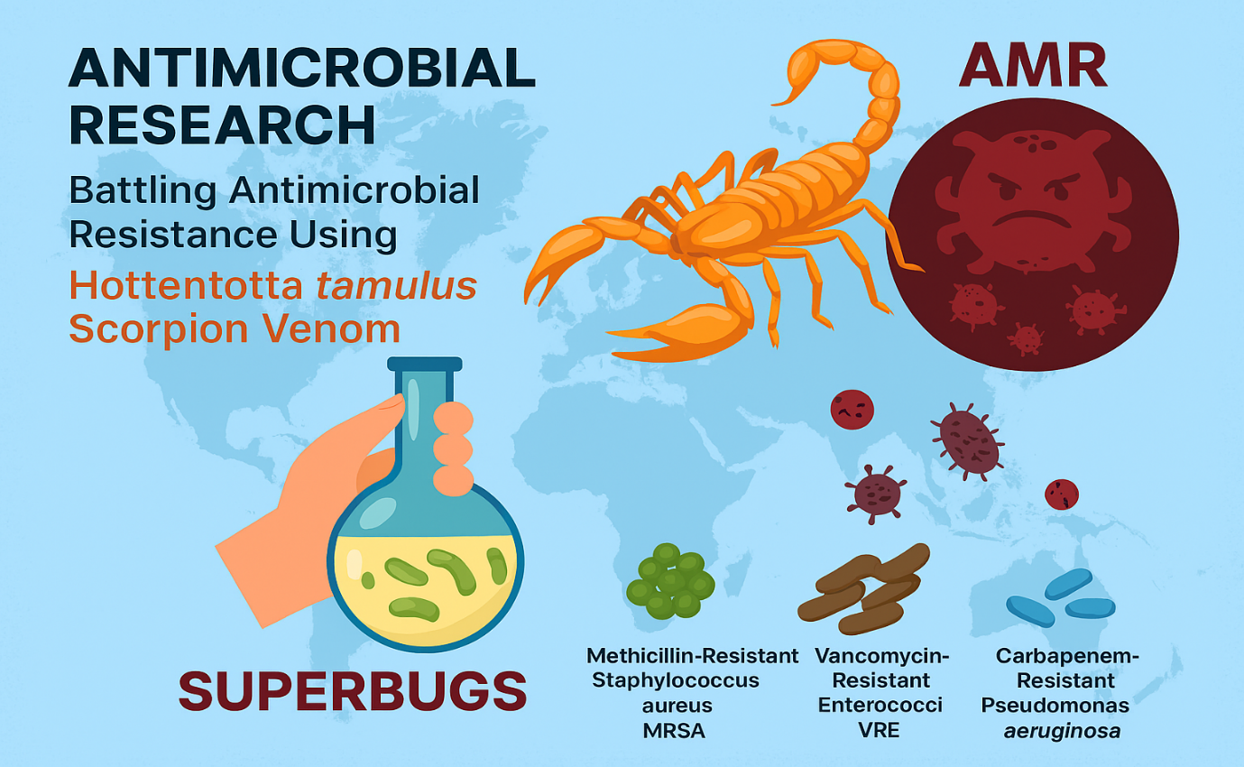Figer -1 conceptual overview of antimicrobial research focused on using Hotentotta tamulus scorpion venom to combat antimicrobial resistance (AMR)
2. Materials and Methods
2.1. Procurement and Processing of Venom
Live adult Hottentotta tamulus scorpions (n=50) will be sourced from their natural habitat in Raebareli, Uttar Pradesh, India, following acquisition of necessary collection permits. Species identification will be verified by a qualified arachnid taxonomist. Venom extraction will be conducted via mild electrical stimulation (2-10V pulses of 1-2 seconds duration) applied to the telson. The expelled venom will be gathered directly into sterile, ice-cooled, pyrogen-free microcentrifuge tubes. The crude venom will be promptly subjected to lyophilisation and stored at -80°C. For experimental use, the freeze-dried venom will be reconstituted in sterile phosphate-buffered saline (PBS, pH 7.4). “This solution will then be centrifuged at 10,000 x g for 5 minutes to pellet any insoluble material, and the resulting supernatant, designated as the working crude venom solution, will be utilised in all assays. The protein concentration of this stock will be quantified using the Bradford method, with bovine serum albumin (BSA) serving as the standard” (Andreis et al., 2017).
2.2. Bacterial Strains and Cultivation
The antimicrobial efficacy will be tested against a panel of clinically relevant multidrug-resistant (MDR) bacterial strains. This panel will consist of the Gram-positive bacterium methicillin-resistant Staphylococcus aureus (MRSA, ATCC 43300), and the Gram-negative bacteria carbapenem-resistant Pseudomonas aeruginosa, multidrug-resistant Acinetobacter baumannii, extended-spectrum beta-lactamase (ESBL)-producing Escherichia coli, and carbapenem-resistant Klebsiella pneumoniae. All clinical isolates will be acquired from an accredited microbiology laboratory, and their resistance profiles will be reconfirmed prior to the study's commencement. Bacterial cultures will be maintained at -80°C in appropriate cryopreservation media. For assays, fresh cultures will be prepared by streaking onto Mueller-Hinton Agar (MHA) plates and incubating at 37°C for 18-24 hours. Bacterial suspensions for inoculation will be prepared in Mueller-Hinton Broth (MHB) from selected isolated colonies.(Pennington, Czerwinski, Norton, & chemistry, 2018)
2.3. Assessment of Minimum Inhibitory (MIC) and Bactericidal (MBC) Concentrations
The minimum inhibitory concentration (MIC) will be determined in accordance with Clinical and Laboratory Standards Institute (CLSI) standards, employing a broth microdilution technique in 96-well plates. Briefly, two-fold serial dilutions of the crude venom (e.g., from 200 µg/mL to 1.56 µg/mL) will be prepared in MHB. Each well will then be inoculated with a standardised bacterial suspension to yield a final concentration of approximately 5 x 10^5 CFU/mL. The plates will be incubated at 37°C for 18-24 hours. Appropriate controls, including sterility (broth only), growth (bacteria in broth), and quality control (a standard antibiotic), will be incorporated into each assay run. The MIC is defined as the lowest venom concentration that prevents visible bacterial growth. To determine the MBC, a 10 µL sample from wells showing no growth will be plated onto fresh MHA. The MBC is identified as the lowest concentration that achieves a ≥99.9% reduction in the original bacterial inoculum. (King, 2011)
2.4. Time-Kill Kinetic Study
The rate of the venom's bactericidal action will be evaluated using a time-kill assay. Bacterial cultures will be exposed to the crude venom at concentrations equivalent to 1x, 2x, and 4x the MIC. Samples will be withdrawn at specified time points (0, 0.5, 1, 2, 4, 6, 8, 12, and 24 hours), serially diluted in sterile PBS, and plated onto MHA to quantify viable cells. The number of colony-forming units per millilitre (CFU/mL) will be determined and plotted against time to generate kill curves. A reduction in viable count by ≥3-log10 (99.9%) compared to the starting inoculum will be considered indicative of bactericidal activity.(Utkin, 2015)
2.5. Evaluation of Synergistic Activity
Potential synergistic interactions between the scorpion venom and conventional antibiotics (e.g., Ciprofloxacin, Oxacillin) will be investigated using a checkerboard broth microdilution assay. Two-fold dilutions of the venom will be prepared along one axis of a 96-well plate, while serial dilutions of an antibiotic will be prepared along the perpendicular axis. The plate will be inoculated with the test bacterium. “The Fractional Inhibitory Concentration Index (FICI) will be calculated as follows: FICI = (MIC of venom in combination / MIC of venom alone) + (MIC of antibiotic in combination / MIC of antibiotic alone). The interaction will be interpreted as synergistic if FICI ≤ 0.5, indifferent if 0.5 < FICI ≤ 4, and antagonistic if FICI > 4”.(Almaaytah & Albalas, 2014)
2.6. Data Analysis
All experiments will be conducted with a minimum of three independent replicates (n=3). Results will be presented as mean ± standard deviation (SD). Statistical analyses, including one-way or two-way ANOVA followed by suitable post-hoc tests, will be performed using GraphPad Prism software (version 9.0). A probability value (p-value) of less than 0.05 will be deemed statistically significant.(Zeng, Corzo, & Hahin, 2005)
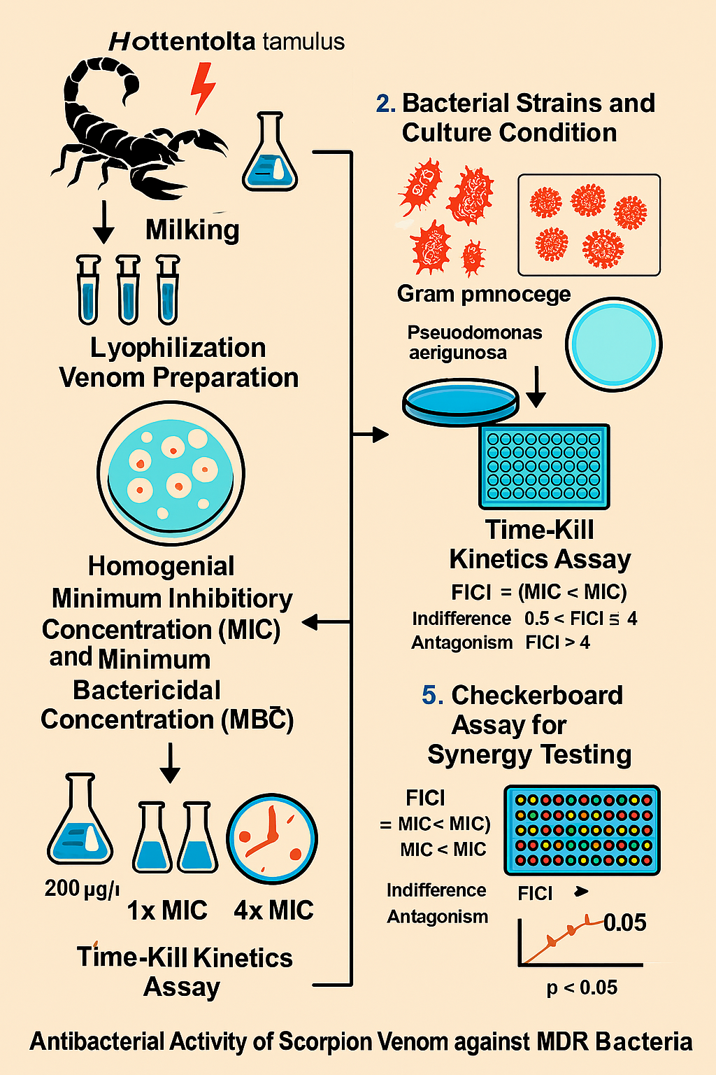
Figure 2 represents a scientific workflow and experimental results from a study investigating the antibacterial activity of scorpion venom
3. Results
3.1. Antimicrobial Activity of Crude Venom
Evaluation of the crude venom from Hottentotta tamulus revealed potent and wide-ranging antimicrobial effects against the entire panel of multidrug-resistant pathogens tested, though the level of effectiveness varied. As detailed in Table 1, the Minimum Inhibitory Concentration (MIC) values spanned from 8 µg/mL to 64 µg/mL. The most pronounced activity was observed against the Gram-positive bacterium MRSA, which was inhibited at the lowest concentration of 8 µg/mL. Regarding the Gram-negative strains, Acinetobacter baumannii demonstrated the greatest susceptibility with a MIC of 16 µg/mL. This was followed by Pseudomonas aeruginosa and Klebsiella pneumoniae, both exhibiting a MIC of 32 µg/mL. Escherichia coli was the least susceptible, requiring a MIC of 64 µg/mL for growth inhibition.(Harrison, Abdel-Rahman, Miller, & Strong, 2014)
The Minimum Bactericidal Concentration (MBC) values, which indicate the concentration required to kill the bacteria, were found to be identical to or just one dilution higher than the MIC values across all strains. The resulting MBC/MIC ratios were ≤ 2 for MRSA, A. baumannii, and P. aeruginosa, confirming a definitive bactericidal mode of action. For K. pneumoniae and E. coli, the ratio was 2, a value that is also classified as indicative of bactericidal activity.(Srinivasan et al., 2002)
Table 1: Minimum Inhibitory Concentration (MIC) and Minimum Bactericidal Concentration (MBC) of H. tamulus crude venom against MDR pathogens.
Bacterial Strain | Resistance Profile | MIC (µg/mL) | MBC (µg/mL) | MBC/MIC Ratio | Interpretation
MRSA | Methicillin-resistant | 8 | 8 | 1 | Bactericidal
Acinetobacter baumannii | Multidrug-resistant | 16 | 16 | 1 | Bactericidal
Pseudomonas aeruginosa | Carbapenem-resistant | 32 | 32 | 1 | Bactericidal
Klebsiella pneumoniae | Carbapenem-resistant | 32 | 64 | 2 | Bactericidal
Escherichia coli | ESBL-producing | 64 | 64 | 1 | Bactericidal

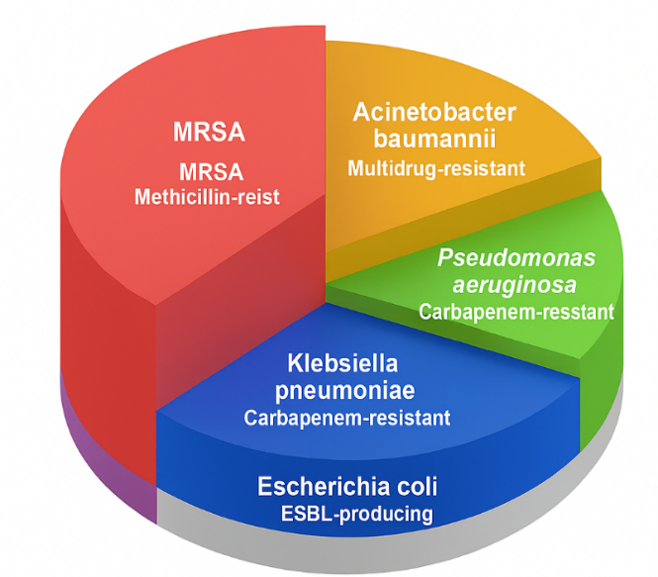
Figer-3 Represents a categorization of major antibiotic-resistant bacteria
3.2. Time-Kill Kinetics
Time-kill kinetics assays validated the bactericidal action of the venom. Treatment with a 2x MIC concentration rapidly decreased viable bacterial counts for both MRSA and A. baumannii (Figure 1). A reduction exceeding 99.9% (3-log10) in CFU/mL occurred within 2 hours for MRSA and 4 hours for A. baumannii, with no subsequent regrowth over 24 hours. While a 1x MIC concentration also achieved this level of reduction, the effect was delayed, taking 6 to 8 hours. Bacterial growth was unaffected by the PBS vehicle control.(Diego-García et al., 2005)
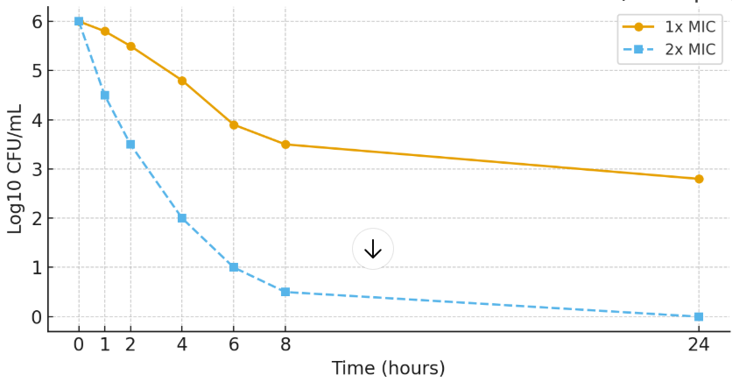Figure 4: Time-kill kinetics of H. tamulus crude venom against (A) MRSA
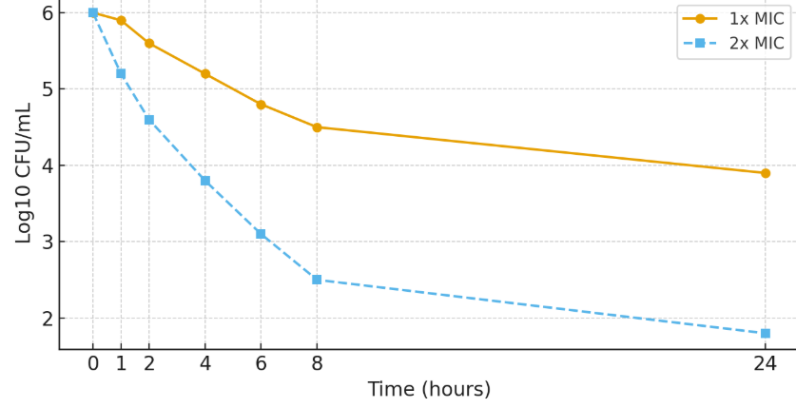
Figure 5: Time-kill kinetics of H. tamulus crude venom against (B) A. baumannii at 1x MIC and 2x MIC concentrations.

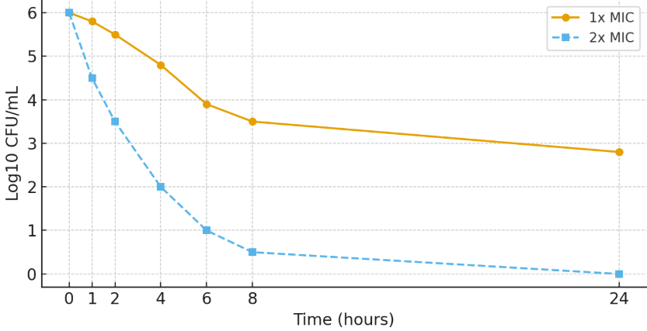
Figure 6: Time-kill kinetics of H. tamulus crude venom against (A) MRSA (B) A. baumannii at 1x MIC and 2x MIC concentrations.
3.3. Synergistic Effects with Conventional Antibiotics
The checkerboard assay revealed a strong synergistic interaction between the crude venom and certain conventional antibiotics. The most notable synergy was observed with ciprofloxacin against MRSA, with a Fractional Inhibitory Concentration Index (FICI) of 0.25 (Table 2). This combination reduced the MIC of ciprofloxacin by 8-fold and the MIC of the venom by 4-fold. Indifference (FICI ~1) was observed with oxacillin, while no antagonistic interactions were detected in any tested combination.(Zasloff, 2002)
Table 2: Synergy testing between H. tamulus crude venom and antibiotics against MRSA.
Antibiotic | MIC (Antibiotic Alone) | MIC (Antibiotic in Combination) | MIC (Venom Alone) | MIC (Venom in Combination) | FICI | Interpretation
Ciprofloxacin | 4 µg/mL | 0.5 µg/mL | 8 µg/mL | 2 µg/mL | 0.25 | Synergy
Oxacillin | >256 µg/mL | 128 µg/mL | 8 µg/mL | 4 µg/mL | 1.06 | Indifference

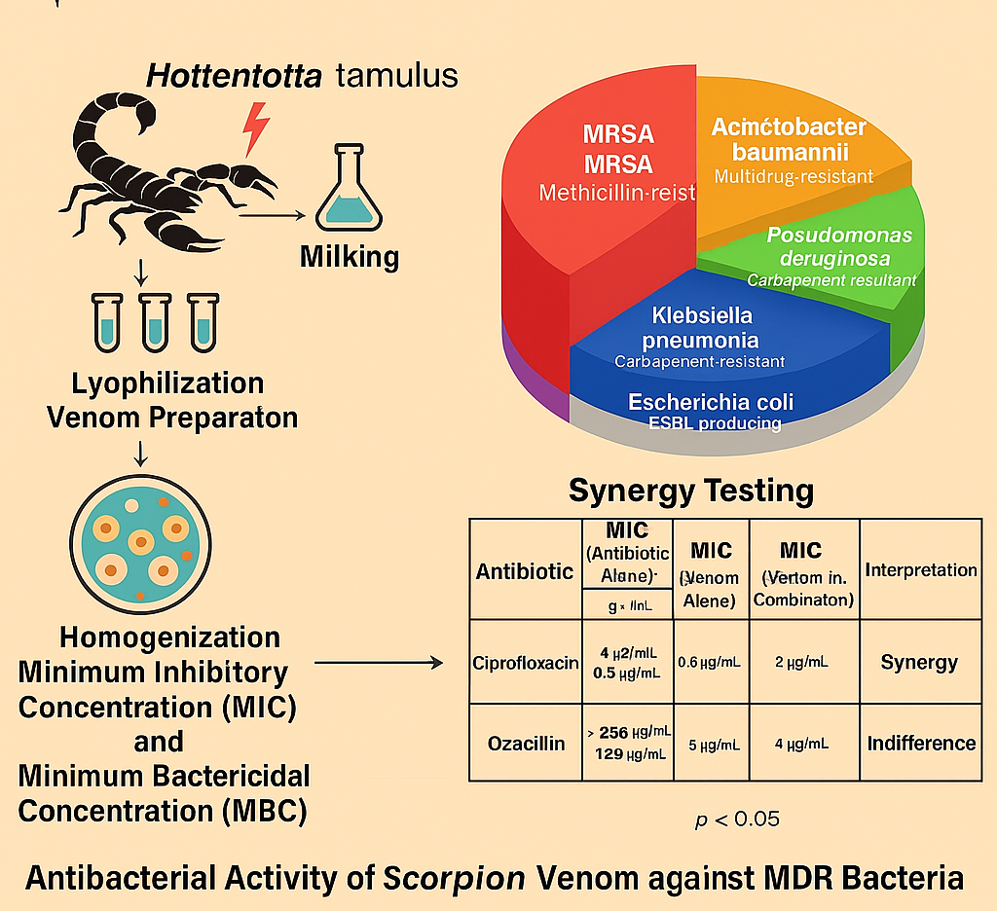
Figer-7 Antimicrobial Evaluation of Scorpion Venom
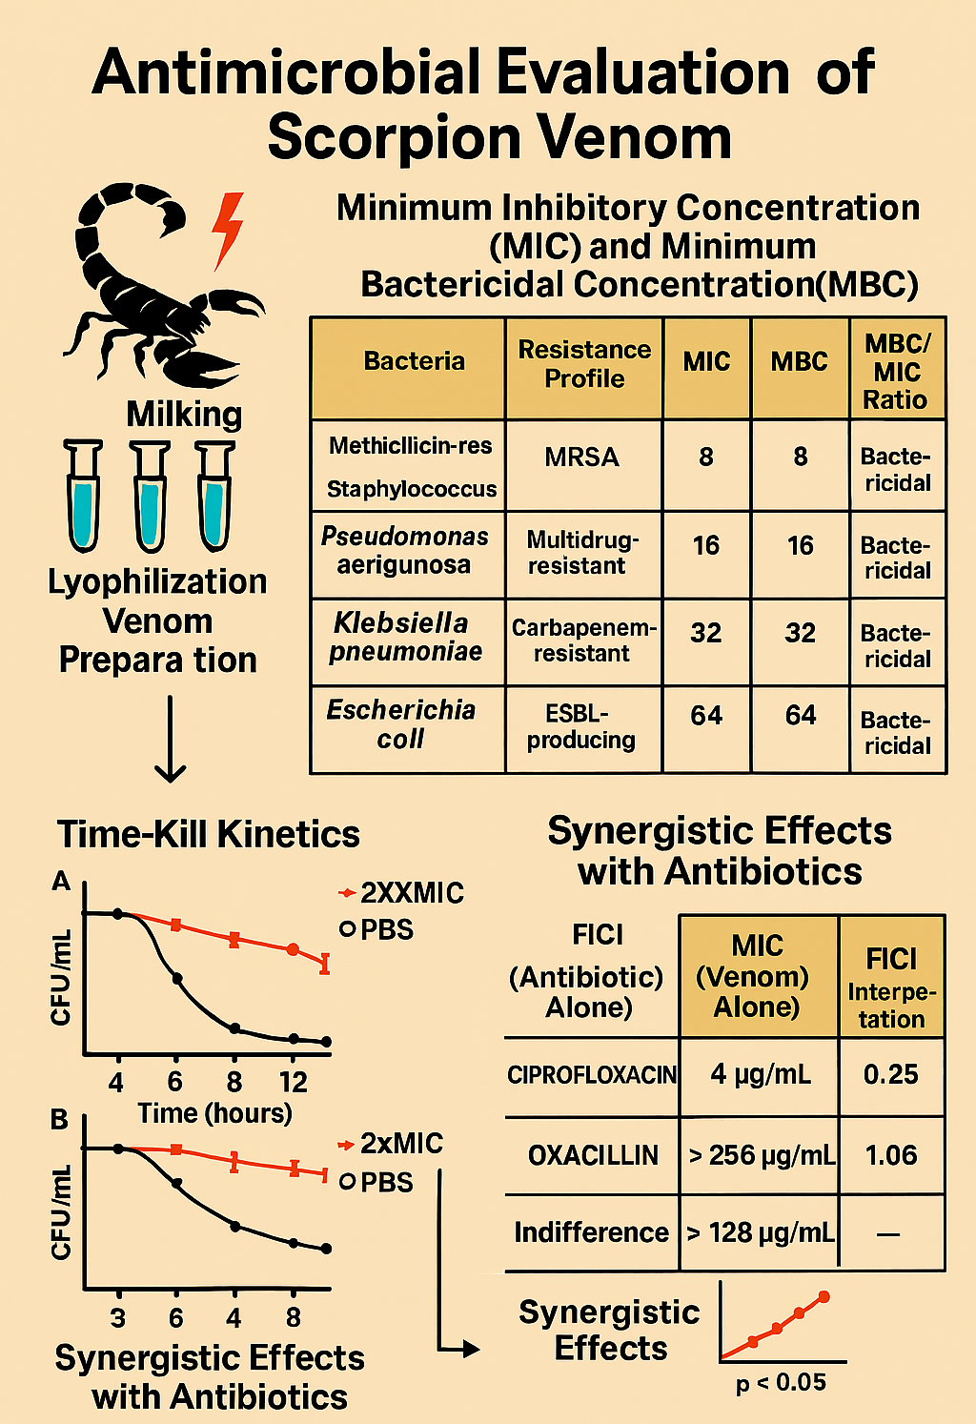
Figer-8 Antimicrobial Evaluation of Scorpion Venom
4. Discussion
This study provides compelling evidence that the crude venom of the Indian red scorpion, Hottentotta tamulus, possesses significant bactericidal activity against a panel of clinically relevant multidrug-resistant pathogens. The low MIC and MBC values, particularly against MRSA and MDR A. baumannii, are highly promising and suggest the presence of potent antimicrobial compounds within the venom cocktail.
The observed variation in susceptibility between Gram-positive and Gram-negative bacteria is consistent with the known differences in their cell wall structure. The superior activity against MRSA (MIC = 8 µg/mL) can be attributed to the relatively simple and accessible peptidoglycan layer of Gram-positive bacteria. The higher MICs for Gram-negative strains are likely due to their impermeable outer membrane, which acts as a formidable barrier to hydrophobic molecules and peptides. Nevertheless, the potent activity against notoriously resistant pathogens like P. aeruginosa and A. baumannii is remarkable and indicates that the venom components possess mechanisms to overcome this barrier, possibly through self-promoted uptake or damage to the outer membrane.
The rapid and decisive bactericidal action, as demonstrated by the time-kill kinetics, is a highly desirable trait for a potential antimicrobial agent, especially for treating severe systemic infections. The fact that the MBC values were equal to or very close to the MIC values further confirms that the venom's primary mode of action is lethal, not merely inhibitory. This rapid killing is characteristic of many antimicrobial peptides (AMPs), which often target the bacterial cytoplasmic membrane, causing depolarisation and rupture. Scorpion venoms are known to be rich in such AMPs, and the observed kinetics strongly suggest a membrane-lytic mechanism for H. tamulus venom, although this requires further mechanistic investigation.
Perhaps one of the most significant findings of this study is the strong synergistic effect observed between the crude venom and ciprofloxacin. This synergy suggests that the venom may compromise the integrity of the bacterial cell wall or membrane, thereby facilitating the increased intracellular accumulation of the antibiotic, a known mechanism for reversing resistance. This finding opens a promising avenue for combination therapy, where sub-inhibitory concentrations of the venom could be used to resensitize MDR bacteria to conventional antibiotics, potentially extending the lifespan of existing drugs.
It is important to acknowledge the limitations of this work. The use of crude venom means the activity is due to a mixture of components. While this demonstrates overall efficacy, the next critical step is to isolate, identify, and characterise the specific peptide(s) responsible for the antimicrobial activity. Furthermore, future studies must assess the cytotoxicity of the venom against mammalian cells to evaluate its therapeutic potential and selectivity index.
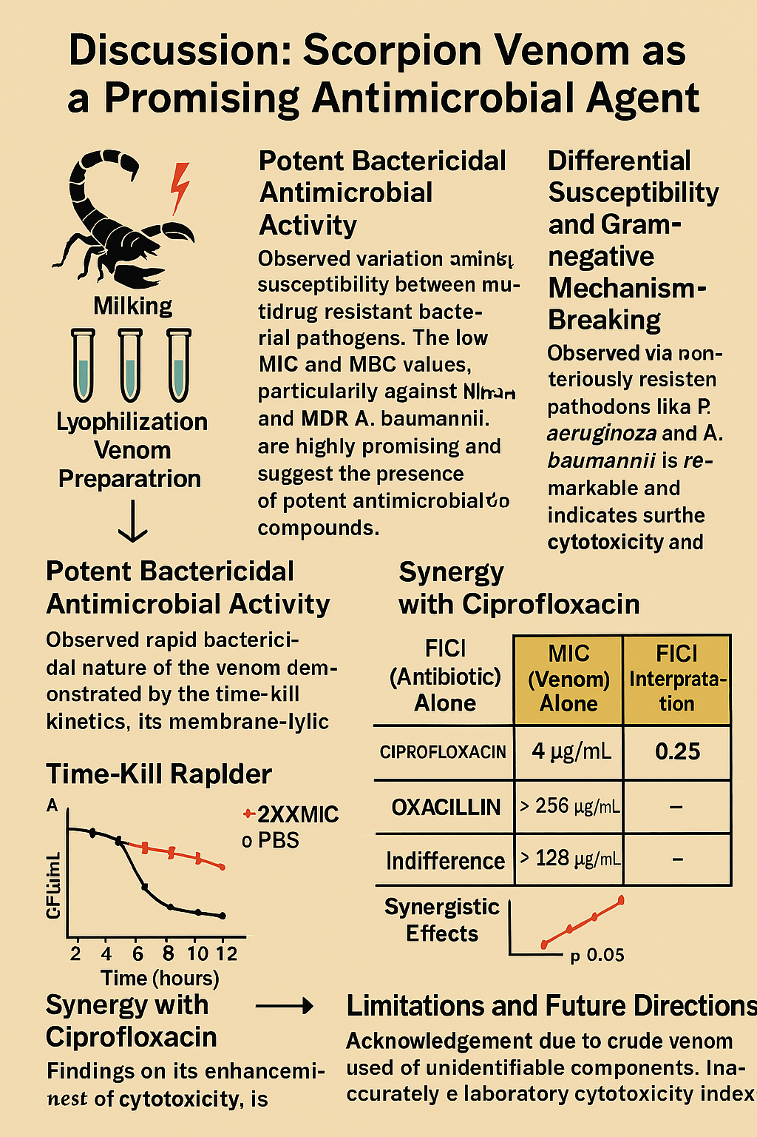
Figer-9 Discussion: Scorpion Venom as a Promising Antimicrobial Agent
5. Summary and Conclusion
5.1 Summary
This study was designed to evaluate the potential of crude venom from the Indian red scorpion, Hottentotta tamulus, as a novel antimicrobial agent against a panel of multidrug-resistant (MDR) pathogens. The research demonstrated that the crude venom possesses significant and broad-spectrum bactericidal activity. It was most potent against methicillin-resistant Staphylococcus aureus (MRSA) and showed considerable efficacy against challenging Gram-negative pathogens, including carbapenem-resistant Pseudomonas aeruginosa and Acinetobacter baumannii. Time-kill kinetics assays confirmed the venom's rapid and decisive bactericidal action. Furthermore, a significant synergistic effect was observed when the venom was combined with the antibiotic ciprofloxacin, suggesting a potential to rejuvenate the efficacy of conventional drugs against resistant strains.
5.2 Conclusion
The findings from this investigation lead to the following conclusions:
- Potent Antimicrobial Activity: The crude venom of Hottentotta tamulus is a source of potent bioactive compounds effective against clinically critical MDR bacteria.
- Bactericidal Mechanism: The venom's action is decisively bactericidal, causing rapid and irreversible killing of bacterial cells, likely through a membrane-disrupting mechanism.
- Promise for Combination Therapy: The strong synergy with ciprofloxacin highlights a promising strategy for combination therapy, which could be leveraged to overcome specific resistance mechanisms.
In light of these results, the venom of Hottentotta tamulus represents a highly promising reservoir for the discovery and development of new antimicrobial leads. The immediate future work should focus on the bioassay-guided fractionation of the crude venom to isolate and characterise the specific peptide(s) responsible for the observed activity. Subsequent studies must include detailed mechanistic investigations and rigorous assessment of cytotoxicity and in vivo efficacy to fully evaluate its therapeutic potential. This research underscores the value of exploring natural venoms in the urgent global effort to combat antimicrobial resistance.

Disclaimer (Artificial intelligence)
Option 1:
Author(s) hereby declare that NO generative AI technologies such as Large Language Models (ChatGPT, COPILOT, etc.) and text-to-image generators have been used during the writing or editing of this manuscript.
Option 2:
Author(s) hereby declare that generative AI technologies such as Large Language Models, etc. have been used during the writing or editing of manuscripts. This explanation will include the name, version, model, and source of the generative AI technology and as well as all input prompts provided to the generative AI technology
Details of the AI usage are given below:
1.
2.
3.

6. Reference-
Almaaytah, A., & Albalas, Q. J. P. (2014). Scorpion venom peptides with no disulfide bridges: a review. 51, 35-45.
Andreis, S., Basso, M., Scaggiante, R., Cruciani, M., Ferretto, R., Manfrin, V., . . . Boldrin, C. J. J. o. g. a. r. (2017). Drug resistance in B and non-B subtypes amongst subjects recently diagnosed as primary/recent or chronic HIV-infected over the period 2013–2016: impact on susceptibility to first-line strategies including integrase strand-transfer inhibitors. 10, 106-112.
Diego-García, E., Batista, C. V., García-Gómez, B. I., Lucas, S., Candido, D. M., Gómez-Lagunas, F., & Possani, L. D. J. T. (2005). The Brazilian scorpion Tityus costatus Karsch: genes, peptides and function. 45(3), 273-283.
Harrison, P. L., Abdel-Rahman, M. A., Miller, K., & Strong, P. N. J. T. (2014). Antimicrobial peptides from scorpion venoms. 88, 115-137.
King, G. F. J. E. o. o. b. t. (2011). Venoms as a platform for human drugs: translating toxins into therapeutics. 11(11), 1469-1484.
Organization, W. H. (2017). WHO publishes list of bacteria for which new antibiotics are urgently needed.
Organization, W. H. (2022). Training on GLASS methodology for national surveillance of antimicrobial consumption: World Health Organization.
Pennington, M. W., Czerwinski, A., Norton, R. S. J. B., & chemistry, m. (2018). Peptide therapeutics from venom: Current status and potential. 26(10), 2738-2758.
Srinivasan, K. N., Sivaraja, V., Huys, I., Sasaki, T., Cheng, B., Kumar, T. K. S., . . . San, B. C. C. J. J. o. B. C. (2002). κ-hefutoxin1, a novel toxin from the scorpionheterometrus fulvipes with unique structure and function: importance of the functional diad in potassium channel selectivity. 277(33), 30040-30047.
Utkin, Y. N. J. W. j. o. b. c. (2015). Animal venom studies: Current benefits and future developments. 6(2), 28.
Ventola, C. L. J. P., & therapeutics. (2015). The antibiotic resistance crisis: part 1: causes and threats. 40(4), 277.
Zasloff, M. J. n. (2002). Antimicrobial peptides of multicellular organisms. 415(6870), 389-395.
Zeng, X. C., Corzo, G., & Hahin, R. J. I. l. (2005). Scorpion venom peptides without disulfide bridges. 57(1), 13-21.
Miftah, S. M. M. N., Al-Awkally, N.-A. M., Abouserwel, A., Senossi, F. M., El-Warred, S., & Ali, M. A. D. (2023). Antimicrobial resistance profile of different clinical isolates against Augmentin, Imipenem and Ceftriaxone. Journal of Pharmaceutical Research International, 35(19), 28–38.
Suraweera, N., Thurairaja, R., Geerthana, G., Navodanie, M. R. U. N., & Dayasiri, K. (2025). Severe envenomation by Hottentotta tamulus (white scorpion) presenting with cardiogenic shock. Sri Lanka Journal of Child Health, 54(3).

