A Study on the Phototoxic effect of LED bulbs on the
Zebrafish (Danio rerio) embryos

ABSTRACT
Light emitting diodes (LEDs) constitute a recent light source right from home, office lightings. The advantage of the LEDs is that they offer superior light intensity, efficiency even being smaller than the traditional lighting system. LEDs are highly specific when it comes to wavelengths of light. The current investigation assessed the effects of various light wavelengths emitted by light-emitting diodes (LEDs) on the development of zebrafish at the embryo and larval stages. The coloured LEDs used had the wavelength of 630 nm (red), 450nm (blue), 530nm (green) and yellow (585) white light (full spectra). Zebrafish has become the leading model organism in research to investigate human diseases, high-throughput drug screening, assessing toxicity and biological rhythms. The large number of eggs which are transparent and with its low maintenance cost makes zebrafish as a popular model organism in contemporary biomedical research. The present study investigated the phototoxic effect of different wavelengths of light which induced apoptosis in zebrafish 5 dpf larva. The apoptosis caused by the phototoxicity of LEDs were assessed by using the vital dye Acridine orange (AO). Often AO is used as a marker of apoptotic cells. The fluorescent images recorded were manipulated and analysed using the ImageJ software. The results showed that among the different LEDs, blue light indeed caused more apoptosis in the 5dpf larva. The study significantly contributes to toxicology by presenting a comparative analysis of LED phototoxicity across various wavelengths, which is crucial given the pervasive use of LED technology.​

Keywords: Zebrafish (Danio rerio), Light-emitting diodes (LEDs), Wavelength-specific phototoxicity, Apoptosis, Acridine Orange staining, Fluorescence imaging

INTRODUCTION:
LED lights have grossly replaced the traditional lighting system and has become the very integral part of daily living. The impact of the LEDs and their effects have not been widely studied. Electronic items like mobile phones to large display screens have revolutionized usage of LEDs in our day today life. As it cuts down the power usage and electricity costs, and extended life, the usage has become very wide throughout the sphere. Since LEDs it has a speciﬁc output, narrow-band wavelengths, it can be used to test or analyse the physiological reactions to varying wavelengths through the light treatments. Studies have concluded that the effect of LEDs on aquatic animals has both positive as well as negative outcomes, for example the green (530 nm) light regulates the hypothalamic–pituitary–gonadal axis and also enhances sexual maturity in goldﬁsh [H.S. Shin, 2014]. While the infrared light (840 nm) does not inﬂuence the circadian rhythm of the zebraﬁsh [M.P. Dekens, 2017]. It is found that the red light (630 nm) induces the oxidative stress in yellow clownﬁsh [H.S. Shin, 2011] and blue light (455 nm) exposure on the tropical damselfish signiﬁcantly brings down the ocular melatonin within 30 min of exposure [Y. Takeuchi, 2014]; and it also reduces stress in Nile tilapia [C.M. Maia, 2013]. How ever long-term effects of the LEDs on the model animals have not been closely examined.
The zebraﬁsh provides is widely used as an animal model because its small size, and the ability to produce large number of transparent eggs (C.B. Kimmel et.al., 1995). Zebrafish is also widely used due to its whole genome being sequenced. The usage of Zebrafish is applied in many research fields such as developmental biology, biomedical research ﬁelds, toxicology, and drug development as well as in behavioural studies. In the very recent years, zebraﬁsh has become the third most sort genetically well characterized animal species, after the mouse and the fruit ﬂy [V. Grunwald, 2002].
Apoptosis in zebrafish embryos is commonly performed by staining the organism with the vital dye acridine orange (Abrams JM, 1993) that permeates into dying cells to bind chromatin, where the stained cells can be counted under a microscope. The fluorescence of the treated group of zebrafish embryos which has diffused apoptotic cells can be assessed by using by using ImageJ (Tucker, B., & Lardelli, M., 2007).
The systemic impact of LED exposure has also been documented, with very recent studies demonstrating a significant relationship between exposure to white LED light and the development of pericardial edema in zebrafish embryos (Stae & Sisson, 2024), where the severity increased with exposure duration (Stae and Sisson, 2024) (Stae & Sisson, 2024). Furthermore, another 2024 study showed that co-exposure to various colored LED lights and increasing temperature has combined effects on the early development of zebrafish larvae ("Co-exposure effect", 2024) (Pir et al., 2024) (Otsuka et al., 2024). This growing understanding of LED-induced damage is now being applied in therapeutic contexts, where phototoxicity models validate the safety of novel photosensitizers (Silva et al., 2023) ("BASHY Dyes", 2023) and explore phototoxicity avoidance as a treatment strategy. For instance, in an EYS-knockout zebrafish model of retinal dystrophy, exposure to white LED light caused drastic photoreceptor loss and retinal disruption (Otsuka et al., 2024), and related organoid models showed this cell death was especially pronounced under blue light exposure (Otsuka et al., 2024) (Otsuka et al., 2024) (Otsuka et al., 2024), suggesting that restricting high-energy short-wavelength light could be a viable therapeutic approach (Otsuka et al., 2024) (Otsuka et al., 2024) (Otsuka et al., 2024).

MATERIALS & METHODS
Animals, Housing and Ethics
The adult Zebrafish (Danio rerio) was obtained from a local fish farm and the fishes were maintained as per the standards within a water system on a 14h light and 10h dark cycle (H. Daims, 2006). Breeding tanks were set and embryos were raised according to (Kimmel et al., 1995). Zebrafish larvae at 5 days post fertilization (dpf) were used for light exposure experiments. All experimental procedures on Zebrafish were approved by the Institutional Animal Care of Holy Cross College, Tiruchirappalli, Tamil Nadu, India (001/HCC/IAEC/RPP/2024) and carried out in accordance with the approved guidelines.
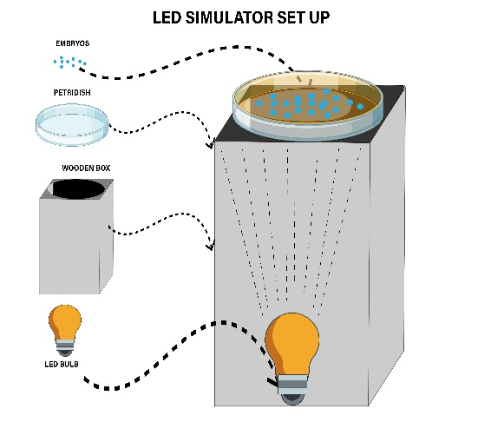

Figure 1: LED simulation set up, where the larva kept under the E3 medium in a petriplate is placed over the wooden set up and underneath the LED is simulated.

Within two hours of spawning, the fertilized eggs were collected and pooled. 20 eggs were maintained into sterile Petri dishes (90x10 mm) ﬁlled with an E3 medium (Nusslein-Volhard C et.al., 2002). LEDs bulbs with the spectral value of 630nm (Red), 685 (Yellow), 510 (Green), 460 (Blue) and White (wide range) was used for the exposure studies on the 5dpf larva of zebrafish. The lights were illuminated from the base (fig 1).
Image processing using ImageJ and ﬂuorescence intensity analysis
This foundational capability to turn images into numbers enabled researchers to quantitatively measure fluorescence intensity (Arena, E. et.al., 2017). These general tools were soon applied to the zebrafish model, where ImageJ macros were developed for tasks like the automated analysis of larval avoidance behavior (Pelkowski et.al., 2011) and quantifying fluorescence from novel probes like carbon quantum dots in embryos and larvae (Kang, et.al., 2015) This period established ImageJ's core role in moving biological imaging from qualitative observation to quantitative science, providing validated protocols for analyzing objects in fluorescence images (Miura, 2020) (Hartig, 2013).
The promising computerized image processing tool, ImageJ , is one of the most versatile and used for quantifying fluorescent intensity in a way that's valid and reliable across the image and for all images in a series (Fontenete et al., 2016). Microscopic acquisition of the fluorescent images was followed by the analysis of the green channel (the wavelength at which the probe fluoresces) in order to obtain the Mean Fluorescence Intensity. With the command “Analyze Particles”, the ROIs were outlined. With the option “Measure” in the ROI interface, the fluorescence intensity of each ROI was provided (Figure 2).

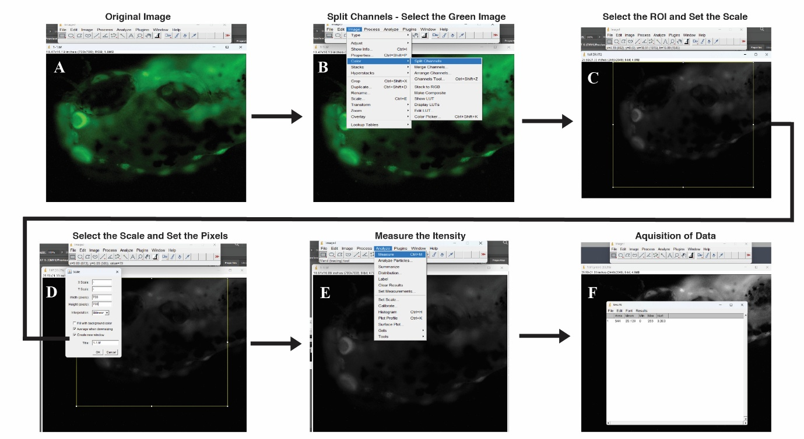
Figure 2: Acridine orange which is used as a fluorescent dye detects the apoptosis by emitting green florescence. The intensity of the fluorescence is studied with the image processing software ImageJ. The image capture through the fluorescent camera is selected (A). Then the image is converted to 8 bit and the image is split into three channels (B). Among the three channels, the green channel is selected and the scale is set by drawing a rectangle on the intensity area to be measured (C). The scale was set to 700x700 pixels (D) and menu Analyse, the measure option is selected (E) and the mean intensity data along with Kurt value is acquired (F).
RESULTS AND DISCUSSION
The 5dpf larva exposed to different wavelengths of light showed varying intensity of fluorescence through the acridine orange staining. The studies earlier have detected the impact of blue light induced in retinal cell apoptosis during the early 1999 and 2001, Wu et al., (2016) and Takita, S., & Seko, Y. (2024) showed evidence regarding the rat retinal tissue apoptosis induced by blue light. It is more common that the blue light screens are becoming more common which are in turn very much dependent on light emitting diodes (LEDs) causes retinal tissue degeneration in humans is of a greater concern.
Early visualization techniques involved chemical staining, where in vivo acridine orange (AO) staining was employed to visualize apoptotic events ("Zebrafish: A", 2002) in embryos treated with various compounds (Parng et al., 2002). This was later refined into a rapid, large-scale group fluorescence method for analyzing relative apoptosis levels based on densitometry (Tucker and Lardelli, 2007). The model was subsequently used to study apoptosis induced by various toxicants, such as the synergistic effects of bisphenol A and heavy metals, which were shown to increase mRNA expression of pro-apoptotic genes like caspase-3, caspase-9, and bax (Paola et al., 2021). Other studies demonstrated that exposure to biosynthesized silver nanoparticles induced biogenicity- and concentration-dependent cytotoxicity via oxidative stress and apoptosis (Verma et al., 2018), and that zinc oxide nanoparticles reduced embryo hatching rates and activated apoptosis (Zhao et al., 2016). Crucially, phototoxicity studies emerged, demonstrating that light exposure is a key trigger for apoptosis. For example, methylene blue toxicity in a zebrafish cell line was shown to be dependent on light exposure (Costa and Monteiro, 2016), and a water-soluble photosensitizer was found to induce cell apoptosis and generate reactive oxygen species upon light illumination in zebrafish (Wang and Qian, 2019). More specifically, phototoxicity from silicon quantum dot nanoparticles was observed in zebrafish embryos illuminated with 450 nm blue LED light (Srivastava et al., 2019). This line of inquiry extended to mechanistic studies on blue-light-induced damage, which was found to cause early apoptosis in the retinal pigment epithelium through a phototoxic mechanism (Cheng et al., 2021) and, most recently, to the study of LiPF6 from batteries, where 40 µM exposure combined with AO staining revealed a significant increase in fluorescence, indicating an expanded apoptotic effect (Yang et al., 2024).
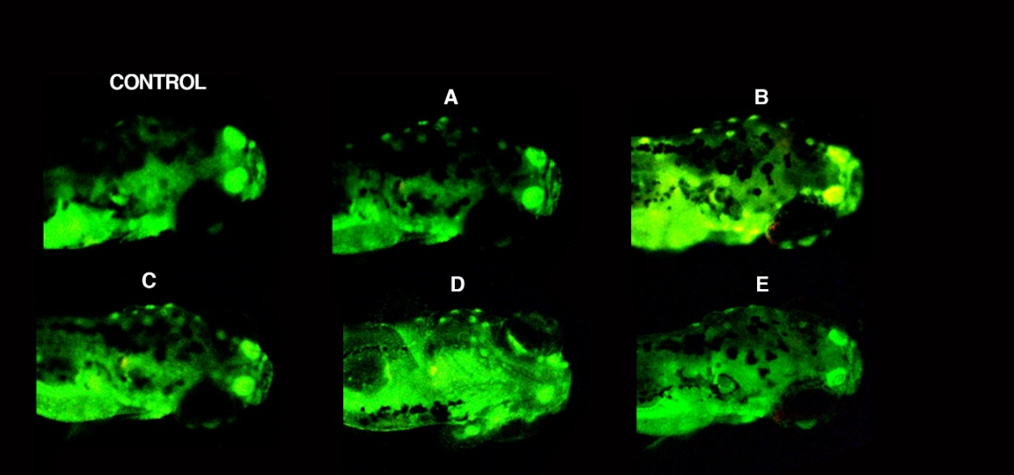

Fig 3: The apoptosis caused by the phototoxicity of LEDs were assessed by using the vital dye Acridine orange (AO). Often AO is used as a marker of apoptotic cells (Ben Tucker, 2007). No apoptosis was seen in the Control. The other fluorescent images result showed that among the different LEDs, Blue LED exposed (B) larvae had the highest intensity with more apoptotic region followed by the Yellow LED exposed (D), Green LED exposed (C) Red LED exposed (A) while the White LED exposed (E) was indeed moderately favourable to the larva with limited apoptotic region.

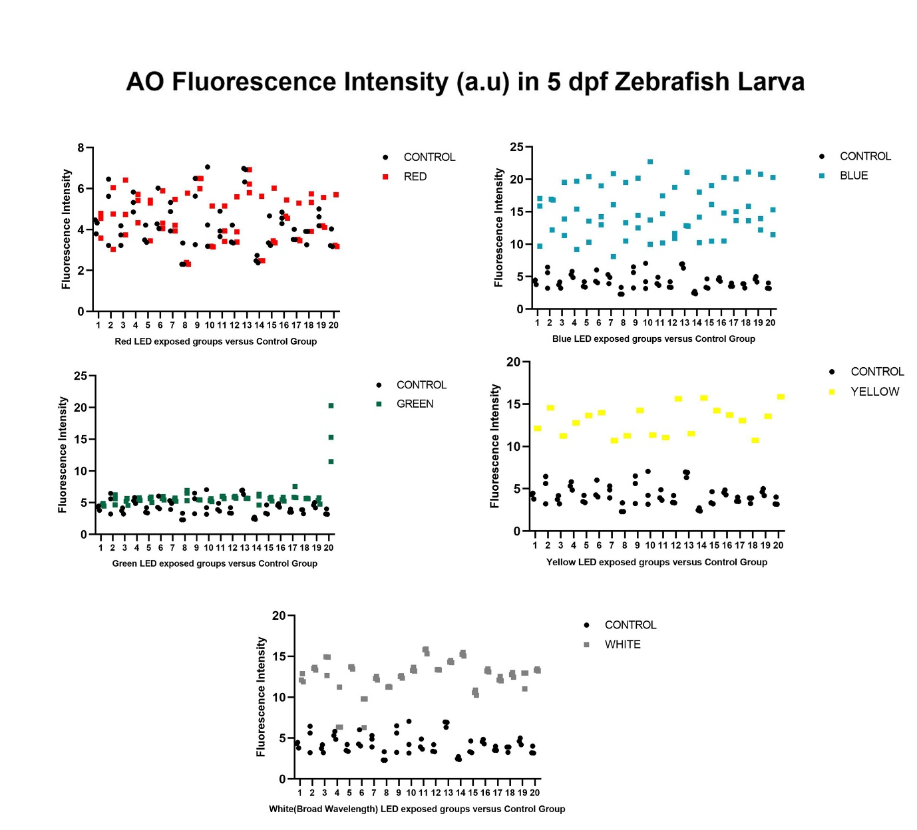
Figure 4: The data acquisition through the ImageJ software shows various fluorescence intensities of the 5dpf larva exposed to red, blue, green, yellow and white LEDs. The acridine orange fluorescence assay showed clear differences in apoptosis intensity among zebrafish larvae (5 dpf) subjected to different LED wavelengths. Larvae exposed to blue LEDs exhibited the strongest apoptotic response, with fluorescence intensities consistently above 20 a.u. Yellow LED exposure also generated markedly higher fluorescence than the control, indicating significant phototoxic stress. White LED exposure produced moderate to high apoptotic signals with some variability across replicates. In contrast, larvae under green and red LEDs displayed lower fluorescence levels, generally below 10 a.u., suggesting minimal apoptotic activity. Overall, these findings reveal a wavelength-dependent phototoxic effect, where shorter wavelengths (blue and yellow light) induce stronger apoptosis, while longer wavelengths (red and green light) cause comparatively weaker responses. Results are compared using two-way analysis of variance (ANOVA) by applying Tukey multiple-comparisons test, using GraphPad Prism version 5 software (GraphPad Sofware, San Diego, USA, p=<0.0001).

CONCLUSION:
The programmed cell death known as apoptosis is of critical importance in various biological contexts, playing key roles during embryogenesis, in maintaining the homeostatic balance of tissues, and in regulating the immune system. The zebrafish—an extraordinary vertebrate model organism that offers powerful experimental advantages—has been used extensively to examine apoptotic cell death in both normal developmental contexts and in various experimental paradigms that stress cells and tissues. Under blue and yellow lights (Fig. 4.), zebrafish exhibited higher apoptosis rate. The increased apoptosis observed under blue and yellow LED illumination suggests potential mechanisms involving oxidative stress, similar to findings with nanoparticles (Bar-Ilan et.al., 2011) or chemical phototoxicity (Reber et.al., 1994). Further theoretical contributions could involve hypothesizing that these wavelengths efficiently generate reactive oxygen species in developing zebrafish, thus providing a breakthrough insight into LED-specific phototoxic pathways. This novel methodology would directly test the hypothesis of oxidative stress as a primary mechanism, providing a deeper understanding of the observed differential apoptosis. Collectively, our study emphasizes two key outcomes:

1. Zebrafish as a sensitive model system to evaluate environmental stressors such as light-induced apoptosis.
2. The importance of wavelength-specific effects of light exposure, with shorter wavelengths posing a significantly higher risk to cellular health.

Future studies should aim to dissect the molecular mechanisms underlying this wavelength-dependent apoptosis, particularly focusing on oxidative stress pathways, mitochondrial dysfunction and caspase activation. Moreover, long-term exposure experiments and protective strategies (e.g., light filters, antioxidants) could provide translational insights into mitigating the phototoxic effects of LEDs in humans.
Thus, this work not only advances our understanding of light-induced apoptosis in zebrafish development but also underscores the growing relevance of environmental light as a factor influencing vertebrate health, bridging experimental biology with public health concerns.

Disclaimer (Artificial intelligence)
Option 1:
Author(s) hereby declare that NO generative AI technologies such as Large Language Models (ChatGPT, COPILOT, etc.) and text-to-image generators have been used during the writing or editing of this manuscript.
Option 2:
Author(s) hereby declare that generative AI technologies such as Large Language Models, etc. have been used during the writing or editing of manuscripts. This explanation will include the name, version, model, and source of the generative AI technology and as well as all input prompts provided to the generative AI technology
Details of the AI usage are given below:
1. ImageJ generated results are alone used for writing this article
2.
3.

.
REFERENCES:
Abrams, J. M. (1993). Programmed cell death during Drosophila embryogenesis. Development, 117(1), 29–43.
Arena, E., Rueden, C., & Hiner, M. (2017). Quantitating the cell: Turning images into numbers with ImageJ. Wiley Interdisciplinary Reviews: Developmental Biology. https://doi.org/10.1002/wdev.260
Bar-Ilan, O., Louis, K. M., Yang, S. P., Pedersen, J. A., Hamers, R. J., Peterson, R. E., & Heideman, W. (2011). Titanium dioxide nanoparticles produce phototoxicity in the developing zebrafish. Nanotoxicology, 6(6), 670–679. https://doi.org/10.3109/17435390.2011.604438
Cheng, K., Hsu, Y., Liu, W., Huang, H., & Chen, L. (2021). The role of oxidative stress and autophagy in blue-light-induced damage to the retinal pigment epithelium in zebrafish in vitro and in vivo. International Journal of Molecular Sciences, 22(3), 1338. https://doi.org/10.3390/ijms22031338
Daims, H., Lücker, S., & Wagner, M. (2006). daime, a novel image analysis program for microbial ecology and biofilm research. Environmental Microbiology, 8(2), 200–213. https://doi.org/10.1111/j.1462-2920.2005.00880.x
Dekens, M. P., Foulkes, N. S., & Tessmar-Raible, K. (2017). Instrument design and protocol for studying light-controlled processes in aquatic organisms: Application to infrared light on zebrafish. PLoS ONE, 12(2), e0172038. https://doi.org/10.1371/journal.pone.0172038
Fontenete, S., Carvalho, D. T. O., Lourenço, A., Guimarães, N., Madureira, P., Figueiredo, C., & Azevedo, N. F. (2016). FISHji: New ImageJ macros for fluorescence quantification in epifluorescence images. Biochemical Engineering Journal, 112, 61–69. https://doi.org/10.1016/j.bej.2016.04.001
Grunwald, V., DeGraffenried, L., Russel, D., Friedrichs, W. E., Ray, R. B., & Hidalgo, M. (2002). Inhibitors of mTOR reverse doxorubicin resistance conferred by PTEN status in prostate cancer cells. Cancer Research, 62(21), 6141–6145.
Hartig, S. M. (2013). Basic image analysis and manipulation in ImageJ. Current Protocols in Molecular Biology. https://doi.org/10.1002/0471142727.mb1415s102
Kang, Y., Li, Y., Fang, Y., Xu, Y., Wei, X., & Yin, X. (2015). Carbon quantum dots for zebrafish fluorescence imaging. Scientific Reports, 5, 11835. https://doi.org/10.1038/srep11835
Kimmel, C. B., Ballard, W. W., Kimmel, S. R., Ullmann, B., & Schilling, T. F. (1995). Stages of embryonic development of the zebrafish. Developmental Dynamics, 203(3), 253–310. https://doi.org/10.1002/aja.1002030302
Lieschke, G. J., & Currie, P. D. (2007). Animal models of human disease: Zebrafish swim into view. Nature Reviews Genetics, 8(5), 353–367. https://doi.org/10.1038/nrg2091
Maia, C. M., & Volpato, G. L. (2013). Environmental light color affects the stress response of Nile tilapia. Zoology (Jena), 116(1), 64–66. https://doi.org/10.1016/j.zool.2012.09.002
Nüsslein-Volhard, C., & Dahm, R. (2002). Zebrafish: A practical approach. Oxford University Press.
Parng, C., Seng, W. L., Semino, C. E., & McGrath, P. (2002). Zebrafish: A preclinical model for drug screening. Assay and Drug Development Technologies, 1(1), 41–48. https://doi.org/10.1089/154065802761001293
Paola, D. D., Capparucci, F., Lanteri, G., Cordaro, M., Crupi, R., Siracusa, R., … Peritore, A. (2021). RETRACTED: Combined toxicity of xenobiotics Bisphenol A and heavy metals on zebrafish embryos (Danio rerio). Toxics, 9(12), 344. https://doi.org/10.3390/toxics9120344
Pelkowski, S., Kapoor, M., & Richendrfer, H. (2011). A novel high-throughput imaging system for automated analyses of avoidance behavior in zebrafish larvae. Behavioural Brain Research, 223(1), 135–141.* https://doi.org/10.1016/j.bbr.2011.04.054
Reber, J., Spacie, A., & Collodi, P. R. (1994). Oxidative stress as a mechanism for PAH phototoxicity in cultured fish cells. Environmental Toxicology and Chemistry, 13(11), 1807–1816.*
Reimers, M. J., La Du, J. K., Periera, C. B., Giovanini, J., & Tanguay, R. L. (2006). Ethanol-dependent toxicity in zebrafish is mediated by acetaldehyde. Neurotoxicology and Teratology, 28(3), 374–385. https://doi.org/10.1016/j.ntt.2006.01.012
Shin, H. S., Habibi, H. R., & Choi, C. Y. (2014). Environmental regulation of maturation in goldfish (Carassius auratus): Effects of various LED light spectra. Comparative Biochemistry and Physiology Part A, 168, 17–24. https://doi.org/10.1016/j.cbpa.2013.11.006
Shin, H. S., Lee, J., & Choi, C. Y. (2011). Effects of LED light spectra on oxidative stress and the protective role of melatonin in Amphiprion clarkii. Comparative Biochemistry and Physiology Part A, 160(2), 221–228. https://doi.org/10.1016/j.cbpa.2011.06.005
Srivastava, P., Han, S., Tu, C., & Jing, L. (2019). Phototoxicity generated by silicon quantum dot nanoparticles on zebrafish embryos. ACS Applied Bio Materials, 2(8), 3432–3442.* https://doi.org/10.1021/acsabm.9b00264
Takita, S., & Seko, Y. (2024). Zebrafish as an experimental model for inherited retinal diseases. IntechOpen. https://doi.org/10.5772/intechopen.1004858
Takeuchi, Y., Imamura, S., Sawada, Y., Hur, S. P., & Takemura, A. (2014). Effects of different colors of light on melatonin suppression and expression of Aanat1 and melanopsin in the eye of a tropical damselfish. General and Comparative Endocrinology, 204, 158–165. https://doi.org/10.1016/j.ygcen.2014.04.038
Tucker, B., & Lardelli, M. (2007). A rapid apoptosis assay measuring relative acridine orange fluorescence in zebrafish embryos. Zebrafish, 4(2), 113–116. https://doi.org/10.1089/zeb.2007.0508
Verma, S., Jha, E., Panda, P., Mishra, A., Thirumurugan, A., Das, B., Parashar, S., & Suar, M. (2018). Rapid facile biosynthesized silver nanoparticles induce concentration-dependent in vivo cytotoxicity in embryonic zebrafish. Toxicological Sciences, 161(1), 125–139.* https://doi.org/10.1093/toxsci/kfx209
Wu, B. K., Yuan, R. Y., Lien, H. W., Hung, C. C., Hwang, P. P., Chen, R. P., Chang, C. C., Liao, Y. F., & Huang, C. J. (2016). Multiple signaling factors and drugs alleviate neuronal death induced by tau expression in zebrafish. Journal of Biomedical Science, 23, 25. https://doi.org/10.1186/s12929-016-0241-6
Yang, B., Sun, L., Peng, Z., Zhang, Q., Lin, M., Peng, Z., & Zheng, L. (2024). Developmental Toxicity and Apoptosis in Zebrafish: The Impact of Lithium Hexafluorophosphate (LiPF6) from Lithium-Ion Battery Electrolytes. International Journal of Molecular Sciences. https://www.mdpi.com/1422-0067/25/17/9307

