Water Quality Profiling of Kiliyur Lake, Tiruchirappalli District, Tamil Nadu, India

Abstract
This investigation aims to study the physicochemical parameters of the freshwater environment in Kiliyur Lake, located in the Tiruchirappalli district of Tamil Nadu. Freshwater lakes are crucial water resources that serve various purposes. A lake is an inland body of standing water, either naturally or artificially formed, that occupies a basin and is surrounded by land. Lakes play a vital role in the hydrological cycle, providing habitats, ecological services, and water resources. The water quality of freshwater environments is assessed through physicochemical parameters. In this study, the physicochemical characteristics of Kiliyur Lake were analyzed over the course of one year, from January 2024 to December 2024. Water samples were collected from four sampling stations within the lake and analyzed in the laboratory. Selected specific and important water quality parameter in this study. The physicochemical parameters examined include atmospheric temperature, surface water temperature, dissolved oxygen, salinity, pH, ammonia, phosphate, chloride, nitrite, nitrate, magnesium, calcium, and sulphate. These parameters are analyzed by APHA guideline. The results of this study highlight the observed changes in these parameters, which are essential for maintaining the ecological health of freshwater lakes. Based on the observed results, we have suggested that important of physico-chemical parameters and protecting of aquatic environment.
Keywords: Freshwater lake, physico-chemical parameters, Kiliyur lake, Sampling station.

Introduction
Water is often referred to as the elixir of life—an invaluable gift from nature to humanity and countless other species on Earth. It is crucial for the transportation of nutrients, both organic and inorganic, to living organisms, as water acts as a universal solvent. The quality of water is assessed based on its physical, chemical, and biological characteristics. Polluted surface water cannot support a balanced ecosystem (Sivachandrabose and Maheswari, 2023). A balanced ecosystem is one in which living organisms and their environment interact in a mutually beneficial way. Clearly, water quality plays a vital role in maintaining a well-balanced environment.
Aquatic ecosystems provide numerous benefits to humans, including recreational activities, municipal and industrial applications. Freshwater environments encompass a variety of ecosystems such as lakes, rivers, ponds, streams, temporary puddles, and thermal springs. Lakes are critical natural resources that supply freshwater, replenish groundwater, and serve as habitats for a diverse range of flora and fauna. These ecosystems play a vital role in the survival of living organisms on Earth (Govindasamy and Viji, 2012; Aravinth et al., 2023). Lakes are among the most biologically diverse and productive inland surface water habitats. The water from lakes is used for agricultural irrigation and fish farming by local communities.
The biotic (living) and abiotic (non-living) factors in these ecosystems are defined by biological and microbial diversity, which, along with physicochemical parameters, influence overall water quality (Ayele and Atlabachew, 2021; Ramya et al., 2022). Physicochemical parameters refer to the physical and chemical characteristics of a substance, mixture, or environmental sample. These parameters are assessed, monitored, and managed to determine the quality of natural resources such as water, soil, and air, as well as industrial products and biological systems. They also provide insight into life history and the assemblage of inhabitant fish (Jeyaraj et al., 2016; Roy and Saikia et al., 2023).
The interaction between the physical and chemical properties of water significantly influences the abundance, distribution, diversity, growth, reproduction, and movement of aquatic organisms (Anne Rebecca, 2019). Key physicochemical parameters include temperature, salinity, dissolved oxygen, ammonia, phosphate, nitrite, nitrate, and chloride levels. These factors are essential for evaluating the functioning of freshwater ecosystems. They help define biological activity, water quality, and the overall condition of the aquatic environment.
The primary objective of this research paper is to identify, examine, and analyze significant environmental physicochemical properties at Kiliyur Lake, located in Tiruchirappalli, Tamil Nadu, India. This includes studying temperature, salinity, dissolved oxygen, ammonia, phosphate, nitrite, nitrate, and chloride levels, as well as abundance data collected from four sampling stations in the lake.

Materials and Methods

Study Area
Kiliyur Lake, located to the east of the Tiruchirappalli headquarters in Tamil Nadu, India, was selected as the study area. The geographical coordinates of Kiliyur Lake are Latitude 10.9077204 and Longitude 79.3441774, covering an area of 860.94 hectares. For the duration of the study, the lake was divided into four sampling stations: North, East, West, and South.

Sample Collection and Analysis

Study Site
Water samples were collected from the four different sites of Kiliyur Lake in Tiruchirappalli (Site 1: North, Site 2: East, Site 3: West, and Site 4: South) for the analysis of physicochemical parameters.

Collection of Water Samples
The collected lake water samples were stored in sterilized reagent bottles (250 mL capacity) to protect them from direct sunlight. The samples were transported to the laboratory immediately after collection. The water samples were analyzed within three days, during which they were kept in cold storage, as suggested by Kulshrestha et al. (1991). Sample analysis followed the methods recommended by Golterman (1975), the American Public Health Association (APHA, 1976), and the National Environmental Engineering Research Institute (NEERI, 1986).

Qualitative Analysis of Water Samples
The selected physicochemical parameters for analysis included temperature and pH, which were measured at the time of collection using a thermometer and pH meter, respectively. Other parameters such as salinity, dissolved oxygen, phosphate, nitrate, nitrite, and chloride were determined according to the guidelines set by the APHA (Standard Methods).
Results and Discussion
The physicochemical parameters collectively define water quality, influencing the health of aquatic ecosystems, the potability of water, and its suitability for agricultural and industrial use. Monitoring these parameters is essential for managing pollution, ensuring safe drinking water, and protecting aquatic biodiversity. This research focused on sampling and analyzing the surface water of Kiliyur Lake throughout 2024, utilizing various physicochemical indices based on the measured parameters.
Figures 1 and 2 represent the atmospheric temperature and surface water temperatures at selected sites (Site 1, Site 2, Site 3, and Site 4) of Kiliyur Lake over the period of one year (January to December 2024). The highest atmospheric temperature recorded was 35ºC in May and June during the summer months, while the lowest temperature of 22ºC occurred in January during the winter. Similarly, the highest surface water temperature of 35ºC was observed in May, followed by June, August, and September, with temperatures reaching 31ºC. The lowest surface water temperature recorded was 21ºC in January. There is significant evidence that rising temperatures are a perilous consequence of climate change, resulting in an alarming increase in both the frequency and intensity of extreme weather events worldwide. These events pose serious threats to natural ecosystems, socioeconomic stability, and human well-being, potentially leading to irreversible ecological and societal impacts. Additionally, decreased atmospheric temperatures can have various consequences, including slower biological and physiological cycles, disruption of nutrient cycles, changes in species distribution, increased oxygen solubility in water, and shifts in climatic or seasonal patterns. These observations support similar findings reported by Singh et al. (2023), Rasakatla and Aruna (2023) and Kaur and Naseer, 2023.

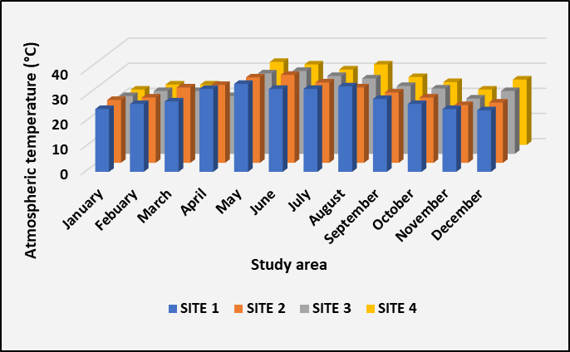
Figure. 1. Analysis of atmospheric temperature in Kiliyur Lake
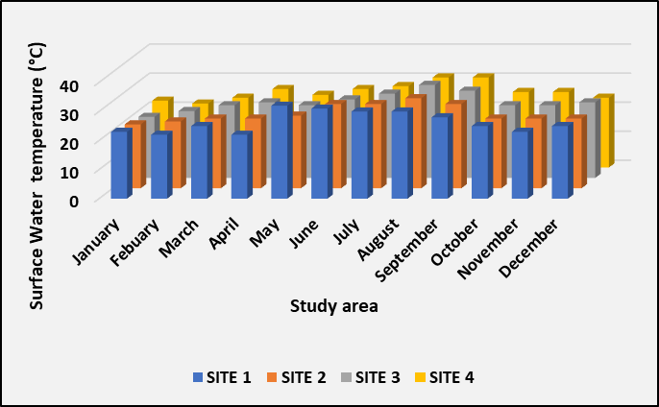
Figure. 2. Analysis of surface water temperature in Kiliyur Lake
Dissolved oxygen (DO) is a vital component of aquatic ecosystems, representing the concentration of oxygen dissolved in water. It is essential for the survival and health of most aquatic organisms, which rely on it for respiration. DO is a key on-site parameter and serves as an indicator of organic pollution in a water body. Figure 3 illustrates the dissolved oxygen levels of water samples taken from selected sites in Kiliyur Lake. In the present study, the highest DO level recorded was 7 mg/L in December, while the lowest levels were observed in June and October. These findings are consistent with the observations of Priya et al. (2022) in Saroornagar Lake and Ramanadhapur Peddu Cheruvu Lake. A decrease in dissolved oxygen can lead to the suffocation of aquatic organisms, disrupt the ecosystem, and result in poor water quality. Additionally, low oxygen levels can promote the growth of anaerobic bacteria, which produce harmful substances such as hydrogen sulphide, ammonia, and methane.
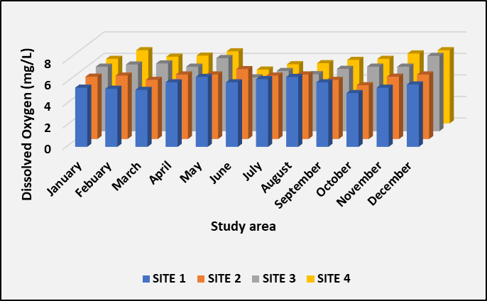
Figure. 3. Analysis of dissolved oxygen in Kiliyur Lake

Figure 4 shows the salinity levels of water samples collected from all sites in Kiliyur Lake throughout the year 2024. Salinity is an important parameter as it regulates water chemistry, influences the distribution of aquatic life, and affects ecosystem productivity as well as global climate patterns. An increase in salinity, measured at 0.58 ppt at Site 3 in August, may be attributed to factors such as evaporation, drought, or minor salt pollution. Elevated salinity levels can potentially lead to a decrease in dissolved oxygen, thereby impacting aquatic organisms and overall water quality. A similar result was observed by Potharaju and Aruna (2023) in a freshwater ecosystem.
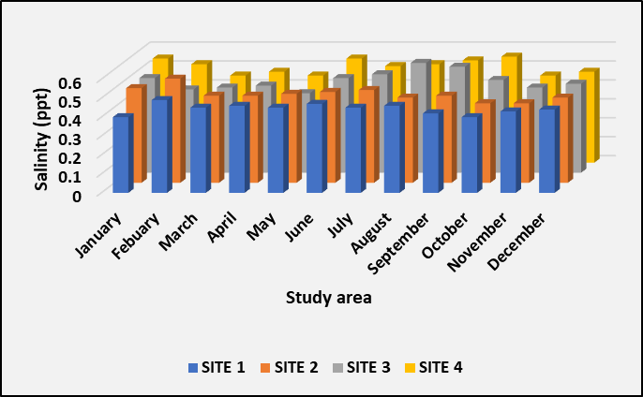
Figure. 4. Analysis of salinity in Kiliyur Lake

pH (power of hydrogen) measures the concentration of H⁺ ions in a liquid. It indicates the acidity or alkalinity of a solution and is a crucial physicochemical parameter that regulates water chemistry, supports aquatic life survival, and maintains environmental stability (Tiwari, 2017). In this study, pH levels in Kiliyur Lake were monitored throughout the year 2024 (Figure 5). During this period, the highest pH values were recorded at Site 1, measuring 7.8 in November and 7.7 in February. Conversely, the lowest pH level of 6.3 was observed in September at the same site. Abnormal pH levels in a lake can lead to serious environmental issues such as fish kills, the release of toxic metals, ammonia poisoning, algal blooms, loss of biodiversity, and overall poor water quality. The findings of this study are consistent with those reported by Fikadu (2022) and Roy and Saikia (2023) in similar freshwater environments.
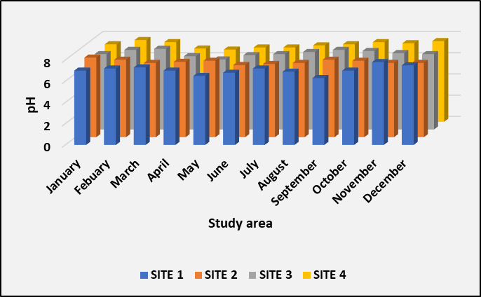
Figure. 5. Analysis of pH in Kiliyur Lake
Figure 6 shows the levels of ammonia present in water samples from Kiliyur Lake. Ammonia is a common industrial chemical used in the synthesis of many nitrogen-containing organic and inorganic compounds. Monitoring ammonia levels is vital for maintaining water quality and protecting aquatic ecosystems. In this study, the highest concentration of ammonia was observed in February. However, the measured levels remained within the acceptable range for a freshwater lake system. Similarly, Boussaha et al. (2024) reported that both elevated and reduced ammonia levels can have harmful effects on the aquatic environment.
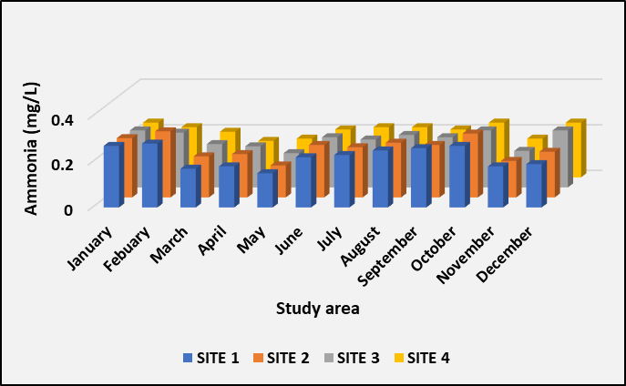
Figure. 6. Analysis of ammonia in Kiliyur Lake
Figure 7 illustrates the phosphate levels at selected sites (1, 2, 3, and 4) of Kiliyur Lake. Phosphate is both essential and potentially harmful in aquatic environments. In moderate amounts, it supports the food web; however, elevated levels can lead to negative consequences. In this study, phosphate levels were measured from September to December, ranging from 0.9 mg/L to 0.99 mg/L. The increase in phosphate concentration may be attributed to surface water runoff, human activities, and agricultural water discharge into the lake. Such conditions can drive eutrophication, cause algal blooms, and contribute to ecosystem decline. Loucif and Chenchouni (2024) similarly reported abnormal phosphate levels in freshwater environments.
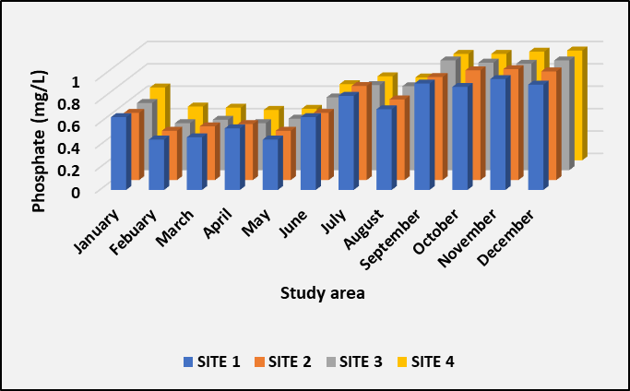
Figure. 7. Analysis of phosphate in Kiliyur Lake
Chloride levels were monitored at selected sites in a freshwater lake during the observation period of 2024 (Figure 8). Chloride ions are among the most common ions found in aquatic environments. In freshwater lakes, chloride typically refers to the concentration of chloride ions (Cl⁻) dissolved in the water. It is a critical parameter used in limnology and water quality monitoring. In this study, the maximum chloride concentration recorded was 99.8 mg/L in November, while the minimum was 44.5 mg/L in April. Elevated chloride levels in freshwater lakes can lead to decreased dissolved oxygen (DO) content, loss of biodiversity, stress in fish and amphibians, deterioration of water quality, oxygen depletion, and long-term damage to the ecosystem. Similarly, Tafure et al. (2022) and Kaura and Naseer, 2023 reported that both increased and decreased chloride concentrations cause several environmental changes and adverse health effects in humans.
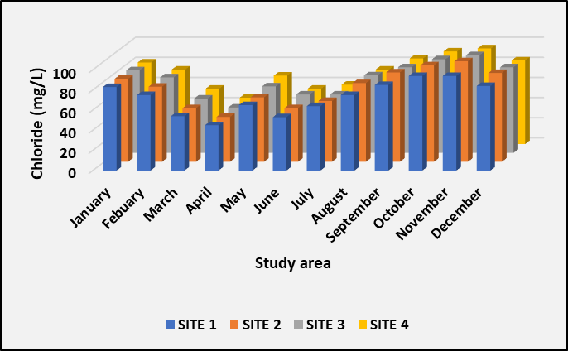
Figure. 8. Analysis of chloride in Kiliyur Lake
Figures 9 and 10 illustrate the concentrations of nitrite and nitrate at selected sites in Kiliyur Lake throughout the year 2024. Both nitrite and nitrate are important nitrogen compounds that regulate and maintain the health of freshwater aquatic environments. They are closely linked to the nitrogen cycle, which influences water quality, nutrient availability, and overall ecosystem health. The observed nitrite levels ranged from 0.2 mg/L to 0.52 mg/L, with the highest concentration detected in April and the lowest in July. In comparison, the highest nitrate level of 0.58 mg/L was observed in May, while the lowest levels of 0.3 mg/L were recorded in October and November. These findings are consistent with those reported by Nirmala et al. (2022), who studied the effects of physicochemical parameters on biotic populations. Abnormal levels of nitrite and nitrate in freshwater ecosystems—often caused by nitrification, incomplete denitrification, and human activities—can lead to eutrophication, algal blooms, hypoxia (low oxygen), and fish kills.

Figure. 9. Analysis of nitrite in Kiliyur Lake
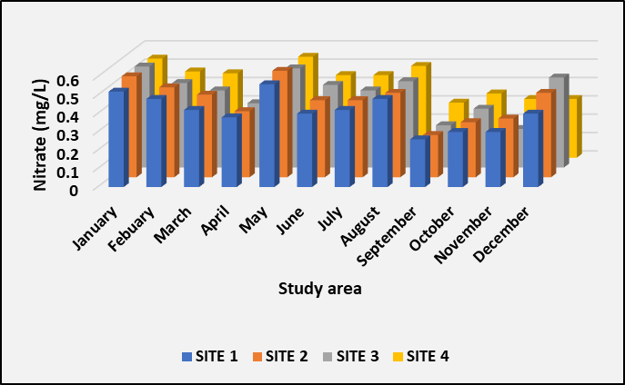
Figure. 10. Analysis of nitrate in Kiliyur Lake
Figure 11 presents the magnesium levels measured at the selected sites of Kiliyur Lake. Magnesium is essential for photosynthesis, nutrient cycling, buffering water chemistry, and supporting the aquatic food web, as well as various biological processes in freshwater lakes. In this study, the maximum magnesium concentration of 11 mg/L was recorded in December, while the minimum level of 9 mg/L was observed in July. Anthropogenic activities can sometimes lead to elevated magnesium levels, but natural processes and other factors can also cause lower concentrations. A deficiency of this vital element can disrupt the ecological balance of the lake, potentially harming various species, including ecologically important freshwater mussels. Similar results were reported by Boussaha et al. (2024).
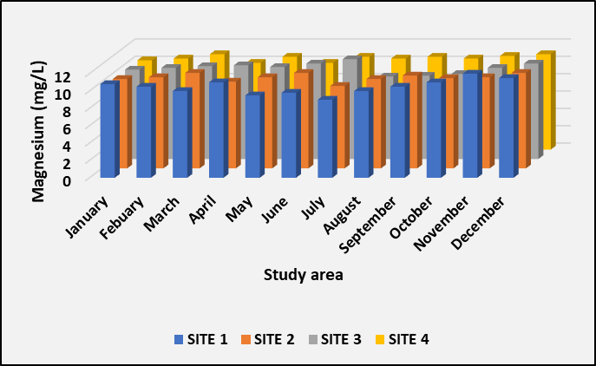
Figure. 11. Analysis of magnesium in Kiliyur Lake
Figure 12 illustrates the observed calcium levels, ranging from 52 mg/L to 75 mg/L. In freshwater lakes, calcium primarily exists as dissolved Ca²⁺ ions, derived from geological, atmospheric, and anthropogenic sources. Calcium serves as an important micronutrient for many aquatic organisms and plays a vital role in water chemistry and aquatic life. It influences factors such as water hardness, buffering capacity, and the survival of calcium-dependent species. In this study, the maximum calcium concentration was recorded in January, while the lowest concentration was observed in May. Similarly, Ramya et al. (2022) reported an increase in calcium levels in Veeranam Lake, Tamil Nadu. An abnormal presence of calcium in freshwater ecosystems can lead to weak shells, reduced biodiversity, stressed fish populations, an increase in invasive mussels, alterations in nutrient cycles, and changes in species composition.
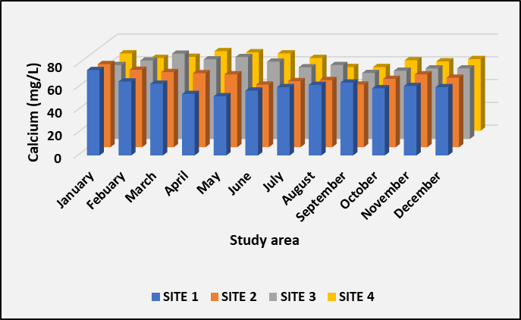
Figure. 12. Analysis of calcium in Kiliyur Lake
Figure 13 depicts the sulphate levels at selected sites of Kiliyur Lake throughout each month of 2024. The highest concentration, 100 mg/L, was recorded in May during the summer season, while the lowest level, 80 mg/L, was observed in February. Similarly, Davis (2010) reported an increase in sulphate levels due to the leaching of natural deposits of sodium sulphate and magnesium sulphate. Elevated sulphate concentrations can cause unwanted laxative effects. Sulphate is present in all natural waters as the dissolved form of sulphur (SO₄²⁻), playing a crucial role in the sulphur cycle and affecting water chemistry, acidity, and biological processes. Variations in sulphate concentration can lead to acidification, release of toxic metals, and hydrogen sulphide production, but can also contribute to lake health by aiding recovery from acidification and enhancing biodiversity.
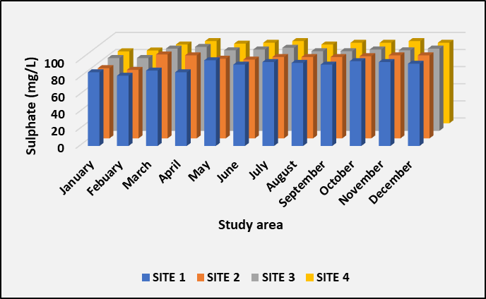
Figure. 13. Analysis of sulphate in Kiliyur Lake
Conclusion
The analysis of physicochemical parameters in Kiliyur Lake indicates that most values fall within the permissible limits set by the World Health Organization (WHO). The assessment revealed seasonal variations in water quality throughout the study period, with generally higher values observed during the summer months. In conclusion, the study suggests that further investigation, including plankton identification and toxicity studies, is essential to comprehensively assess the lake’s water quality for safe domestic and agricultural use.

Disclaimer (Artificial intelligence)
Option 1:
Author(s) hereby declare that NO generative AI technologies such as Large Language Models (ChatGPT, COPILOT, etc.) and text-to-image generators have been used during the writing or editing of this manuscript.
Option 2:
Author(s) hereby declare that generative AI technologies such as Large Language Models, etc. have been used during the writing or editing of manuscripts. This explanation will include the name, version, model, and source of the generative AI technology and as well as all input prompts provided to the generative AI technology
Details of the AI usage are given below:
1.
2.
3.

References
Sivachandrabose, K. and Maheswari, M. (2023). Assessment of Physicochemical Parameters of Water in Puliyanthangal Lake of Ranipet, Tamilnadu, India. International Journal of Zoology and Animal Biology, 6(1), 1-10.
Govindasamy, C. and Viji, J. (2012). Present status of maniyampattu and puliyanthangal lakes Ranipettai, Tamilnadu, India. World Applied. Sciences. Journal, 16(10), 1409-1415.
Aravinth, A., Kannan, R., Chinnadurai, G., Manickam, N., Raju, P., Perumal, P. and Santhanam, P. (2023). Temporal changes in plankton diversity in relation to hydrographical characteristics at Perumal Lake, Cuddalore District, Tamil Nadu, India. The Journal of Basic and Applied Zoology, 84(1), 13.
Ayele, H.S., Atlabachew, M. (2021). Review of characterization, factors, impacts, and solutions of Lake eutrophication: lesson for lake Tana, Ethiopia. Environmental Science and Pollution Research, 28, 14233–14252
Ramya. M., Elumalai, S.,Umamaheswari, A. (2022). Study of physicochemical and statistical analysis of water quality parameters in Veeranam Lake, Cuddalore district, Tamil Nadu, India. Materials Today Proceedings. 49, 7, 2934-2942.
Jeyaraj, M., Ramakrishnan, K., Jai, A., Arunachalam, S. and Magudeswaran, P.N. (2016). Investigation of physico-chemical and biological characteristics of various lake water in Coimbatore district, Tamilnadu, India. Oriental Journal of Chemistry, 32(4), 2087-2094.
Roy, S. and Saikia, S.K. (2023). Characterization of Some Physico-Chemical Parameters of Water Bodies Inhabited by Small Indigenous Fish Species (SIFs): A Case Study. European Journal of Aquatic Sciences, 2(3), 1-7.
Anne Rebecca, A. (2019). Diversity and distribution of planktonic communities in Krishnampathy Lake, Coimbatore district, Tamil Nadu, India. Environment and Ecology, 37(4), 1230-1239.
Kulshrestha, U.C., Sarkar, A.K., Srivastava, S.S. and Parashar, D.C. (1996). Investigation into atmospheric deposition through precipitation studies at New Delhi (India). Atmospheric Environment, 30(24), 4149-4154
Golterman, H.L. (1984). Sediments, modifying and equilibrating factors in the chemistry of freshwater: With 28 figures in the text. InternationaleVereinigung für theoretische und angewandteLimnologie: Verhandlungen, 22(1), 23-59.
American Public Health Association (APHA) (1976) Standard Methods for the Examination of Water and Wastewater. 14th Edition, American Public Health Association, Washington DC, 1193.
NEERI (1986). Manual on water and waste water analysis. National Environmental Engineering Research Institute, Nagpur, 340.
Singh, R., Niranjan, S. and Nagar, S. (2023). Study of Physico-chemical Parameters on a Fresh Water Pond of Orai, UP, India. Uttar Pradesh Journal of Zoology.
Rasakatla, B and Aruna, M. (2023). Analysis of physico-chemical parameters of a fresh water lake in Nizamabad District Telangana State. World JWorld Journal of Biology Pharmacy and Health Sciences. 16(01), 021–030
Simerjit Kaur, and Sahreen Naseer. 2023.Water Quality Assessment of Sahastradhara Stream, Dehradun, Uttarakhand, India. Asian Journal of Environment & Ecology. 22 (1), 29–39.
Priya, K.P., Seeta, Y. and Reddy, P.M. (2022). Comparative Study of Physico-Chemical Parameters in Saroornagar Lake and Ramanthapur Pedda Cheruvu. International Journal of Scientific Research in Science and Technology. 9(2), 11-12.
Potharaju, R. and Aruna, M. (2023). Estimation of Water Quality and Physico-chemical Parameters of a Freshwater Lake. Journal of Survey in Fisheries Sciences, 10(3), 1168-1178.
Fikadu, G. (2022). Determination of Selected physicochemical water quality parameters of the upper stream of Amerti watershed of Western Ethiopia. Environmental Challenges, 8, 100558.
Boussaha, A., Bezzalla, A., Zebsa, R., Amari, H., Houhamdi, M., Chenchouni, H. (2024). Monitoring and assessment of spatial and seasonal variability in water quality at Lake of Birds (Algeria) using physicochemical parameters and bacterial quality indicators. Environmental Nanotechnology, Monitoring, and Management, 22, 100955.
Loucif, K. and Chenchouni, H. (2024). Water physicochemical quality as driver of spatial and temporal patterns of microbial community composition in lake ecosystems. Applied Water Science, 14(6), 115.
Leiva-Tafur, D., Gonas, M., Culqui, L., Santa Cruz, C., Rascón, J. and Oliva-Cruz, M. (2022). Spatiotemporal distribution of physicochemical parameters and toxic elements in Lake Pomacochas, Amazonas, Peru. Frontiers in Environmental Science, 10, 885591.
Nirmala, K., Kumar, P.S., Ambujam, N.K. and Srinivasalu, S.J.E.R. (2022). Assessment of physico-chemical parameters of surface waters of a tropical brackish water lake in South Asia. Environmental Research, 214, 113958.
Davis, M.L. (2010). Water and Wastewater Engineering—Design Principles and Practice. New York: McGraw-Hill;

