Seasonal incidence and management of tea mosquito bug, Helopeltis spp. Infesting Guava in southern Karnataka, India
Abstract
Seasonal incidence and management of tea mosquito bug (TMB), Helopeltis spp. infesting guava was studied at College of Sericulture, Chintamani, during 2023-2024. To study the seasonal incidence, observations were recorded at fortnightly intervals on various parts of the plant. TMB were observed infesting young leaves of guava plants during the first fortnight of July. The infestation continued throughout the second fortnight of December, affecting both young leaves and fruits. The population then declined and completely disappeared from January onwards. The pest population reached its peak during September 2023, with a per cent damage of 15.10 per cent on leaves and 17.11 per cent on guava fruits, with an average population of 3.95 bugs per five sweeps. The correlation studies revealed that the maximum temperature was negatively correlated, but minimum temperature, morning and evening relative humidity was positively correlated, whereas, total rainfall was significantly positively correlated with the incidence of the tea mosquito bug. To evaluate the efficacy of novel insecticides against the guava tea mosquito bug, Helopeltis spp. It is evidenced that fipronil 5% SC, which was significantly superior compared to the rest of the treatments, with per cent reduction of 76.36% and 78.45% (leaves and fruits). Lambdacyhalothrin 5% EC, Imidacloprid 17.8% SL were next best treatments, followed by moderate efficacy observed with thiamethoxam 25% WG and buprofezin 25% SC. Beauveria bassiana (2 × 10⁸ cfu/g) and Lecanicillium lecanii (2 × 10⁸ cfu/g) showed comparable statistical performance. However, azadirachtin 10000 ppm proved to be the least effective in controlling TMB incidence. A similar pattern was observed during the second spray.

Key words: Population dynamics, Tea mosquito bug, insecticides, Guava

1. Introduction:
Guava (Psidium guajava L.), a member of the Myrtaceae family, is native to tropical regions of the Americas and is an essential fruit crop in India, often referred to as the "apple of the tropics". Its popularity stems from its rich nutritional content, pleasant aroma, and flavour, along with its affordability and year-round availability. Guava is an excellent source of vitamin C and pectin, as well as a fair source of vitamins A, B, and C, iron, and phosphorus, earning it the nickname "apple of the tropics". Its high calorific value makes it a popular choice among middle-income groups, earning it another title, "Poor man’s apple". The leaves are used in traditional remedies for various ailments, such as stomach and respiratory disorders, and they are also used to increase platelet count in dengue patients [5]. Over 80 insect species have been recorded on guava. The tea mosquito bug, Helopeltis spp. (Plates 1&2), poses a significant threat by causing 60 to 70% yield loss in guava fruits [1]. The bug sucks sap from tender shoots, leaves, flower buds, and fruits, leading to the formation of necrotic lesions on the affected parts. When fruits mature, feeding punctures expand, resulting in the formation of corky scabs. Abiotic factors like temperature, rainfall, and relative humidity also influence the abundance of the tea mosquito bug on guava. Given the severity of the damage caused by the tea mosquito bug, Effective management is critical to minimise the economic losses caused by this pest. Various synthetic insecticides and biopesticides have been employed to control Helopeltis spp. populations, but it is important to identify insecticides with higher efficacy in controlling the tea mosquito bug under field conditions. Hence, the present investigation was conducted to study the seasonal incidence and management of the tea mosquito bug on guava plants.
2. Materials and Methods:
The present investigation was conducted during 2023-2024 at the College of Sericulture, Chintamani. The incidence of the tea mosquito bug was studied by recording observations on the percentage of damage inflicted by the bug on various parts of the plant. The method followed for estimating the damage was as follows: twenty plants were randomly selected, and four branches were tagged on each selected plant. Observations were made on the total number of both affected and healthy parts, namely young leaves, flower buds, and fruits, at fortnightly intervals from July 2023 to June 2024 at the guava plot, College of Sericulture, Chintamani. Using the sweep method, the adult and nymphal populations were also assessed by making five sweeps per tree using a hand net. Correlation analysis was also conducted using SPSS software to determine how weather parameters, such as total rainfall (mm), number of rainy days, maximum temperature (T max), minimum temperature (T min), and morning and evening relative humidity (%), affect the incidence of the bug.
Further, the observations were made on
total number of bugs (Adult + nymph) per sweep.
total number of young leaves/branches
total number of damaged young leaves/branch
total number of flower buds/branch
total number of damaged flower buds/branch
total number of fruits/branches
total number of damaged fruits/branches.
The above data on different parameters were used for estimating per cent damage, which was worked out by following the formula:
Per cent damage = | No. of young leaves/flower buds/fruits damaged | × 100
Per cent damage = | No. of young leaves/flower buds/fruits observed | × 100
To study the efficacy of different molecules total of six synthetic insecticides and three bio-rational agents were tested for their efficacy in managing the tea mosquito bug along with an untreated control. The experiment was conducted in randomised complete block design with 9 treatments and 3 replications. Each tree formed one treatment. Totally 27 trees were used for the experiment. The treatments are randomly assigned to individual trees. Insecticides are applied at the time of severe infestation. Knapsack sprayer was used for imposing the treatments. The treatments were imposed twice at 15 days intervals. Commencing the first spray with the incidence of Helopeltis spp. During July 2024 and the second spray was given at15days interval after the first spray application. Pre-treatment count was made a day before imposition of treatments. Post-treatment counts were taken at interval of three, seven and fifteen days, respectively, after treatment. For recording observations, four branches were selected from each plant in each direction. Observations were made on the total number of both affected and healthy parts, viz., young leaves, flower buds and fruits of the plants. Guava fruits at pea and marble size were selected for recording observations. The same was done for the second spray of insecticides. Data was analysed using ANOVA to draw suitable inferences. The percentage incidence due to TMB obtained was subjected to Arc sign transformation using OPI STAT and then subjected to statistical analysis.

The data obtained was converted into per cent damage using the following formula:
Per cent pest damage = | No. of young leaves/flower buds/fruits damaged | × 100
Per cent pest damage = | No. of young leaves/flower buds/fruits observed | × 100
Further, the percentage reduction of tea mosquito bug incidence over control was calculated using the following formula:
Per cent reduction = | C_{b} - T_{a} | × 100
Per cent reduction = | C_{b} | × 100
Where,
T_{a} = Per cent incidence due to TMB in the treated plot after insecticide application
C_{b}= Per cent incidence due to TMB in untreated control
3. Results and Discussion
Seasonal incidence of tea mosquito bug
The results regarding the population dynamics of the tea mosquito bug at KVK, College of Sericulture, Chintamani, revealed that the incidence of damage caused by the tea mosquito bug (Plates 3&4) on leaves and fruits was observed from the first fortnight of July to the second fortnight of December. The infestation, which began in July, continued to increase and reached its peak in September. The highest infestation was recorded during the second fortnight of September, with a percentage of damage of 15.10% on leaves and 17.11% on guava fruits (Table 1). The infestation declined thereafter and completely disappeared from December onwards. No infestation on flower buds was observed throughout the investigation. The present investigation agrees with the findings of Kumar on guava, who observed the peak population of the pest during the second fortnight of September, 18.54% and 39.28% on leaves and fruits of guava at the Dharwad location [5&6].
Relationship between weather parameters and tea mosquito bug infestation on guava
Correlation studies between weather parameters and per cent infestation done by tea mosquito on guava (leaves and fruits) depicted thatmaximum temperature (-0.328 and -0.357)was negatively correlated and minimum temperature (0.185 and 0.390), morning (0.021 and 0.065) and evening relative humidity (0.215 and 0.313) was positively correlated whereas, total rainfall (0.597 and 0.598) was significantly positive correlate with incidence of tea mosquito bug and number of rainy days (0.618) was significantly positive correlate with per cent damage caused by tea mosquito bug on fruits (Table. 2). The maximum temperature has negatively correlated with tea mosquito bug incidence on guava [4&7]. The total rainfall was negatively correlated with the abundance of tea mosquito bug on tamarind at College of Sericulture, Chintamani [9&10].
Multiple linear regression analysis between weather parameters and the incidence of tea mosquito bug infesting guava
Multiple linear regression analysis between weather parameters and incidence of tea mosquito bug on guava at KVK, College of Sericulture, Chintamani showed an R² value of 0.738 indicating that 73.8 of % influence of weather parameters on tea mosquito bug incidence on leaves of guava (Table 3).
The multiple linear regression equation:
Y = 116.376 + 0.060X₁ – 0.563X₂ – 1.997X₃ + 0.670X₄ – 0.899X₅ + 0.102X₆
R² value of 0.840 indicated that 84% influence of weather parameters on tea mosquito bug incidence on the fruits of guava.
The multiple linear regression equation:
Y = 144.584 + 0.019X₁ + 0.000X₂ – 2.723X₃ + 1.382X₄ – 1.206X₅ + 0.206X₆

Efficacy of synthetic and bio-rational insecticides against the tea mosquito bug
Relative efficacy and Per cent reduction over control with various insecticides are presented in Tables 4 & 5. Fig.2. It is evident that treatment with various chemical insecticides, bio-control agents and botanical revealed that during first spray treatment with fipronil 5% SC which was significantly superior compared to rest of the treatments with per cent reduction of 76.36% and 78.45% (leaves and fruits) and followed by lambdacyhalothrin 5% EC (63.97% and 66.85%), imidacloprid 17.8% SL (55.70% and 57.87%), thiamethoxam 25%WG (47.81% and 48.32%), and buprofezin 25% SC(43.25% and 42.86%). The treatments with Beauveria bassiana (2 × 10⁸ cfu/g) (34.85% and 34.50%) and Lecanicillium lecanii (2 × 10⁸ cfu/g) (33.89% and 34.65%) are statistically on par with each other. However, the least per cent reduction was recorded from azadirachtin 10000 ppm (19.08% and 18.60%) treated trees.These results were in accordance with the observations [11] who reported Highest percentage of tea mosquito bug suppression was registered in fipronil 5% SC (96.19%) followed by lambda cyhalothrin 5% EC (1.5ml / l) (91.86%): In cashew 0.003% lambda-cyhalothrin was observed significantly superior. Thus, fipronil 5% SC was the most effective [3&8] and considering the cost thiamethoxam 25% WG or lambda cyhalothrin 5% EC can be recommended.
Enumerated data of per cent reduction over control in second spray indicated that highest reduction of damaged leaves and fruits was registered in fipronil 5% SC(84.77% and 91.72%) followed by lambda cyhalothrin 5% EC (76.39% and 85.12%). In other treatments the percent reduction over control varied from 38.60 to 72.90 percent and 41.88 and 81.19 per cent on leaves and fruits respectively.

4. Conclusion:
The study on the population dynamics of the tea mosquito bug Helopeltis spp. on guava concluded that the percentage of leaves and fruits infested by the tea mosquito bug was observed from July to December, with the bug incidence peaking in September. Correlation studies showed a non-significant negative relationship with maximum temperature and a significant positive correlation, at the 5% level, with the number of rainy days and total rainfall. Comparative assessment of various insecticides against tea mosquito bug (Helopeltis spp. sign.) on guava revealed that application of fipronil 5% SC (2ml/l) was found to be the most effective in reducing the percentage of damage caused by tea mosquito bug on fruits and leaves followed by lambda cyhalothrin 5% EC (1.5ml/l). Azadirachtin 10000 ppm (2ml/l) was least effective in controlling the tea mosquito bug. Use of biopesticides and timely, alternating insecticide applications with proper safety intervals, is the most sustainable and effective strategy for minimizing tea mosquito bug damage and ensuring a profitable harvest, so these strategies can be append in the integrated pest management approach.

Table 1. Seasonal incidence and percent damage of Helopeltis spp. on guava during 2023 – 2024 at College of Sericulture, Chintamani
Period | Fortnight | Damage on leaves |  |  | Damage on flower buds |  |  | Damage on fruits |  |  | N+A* population
Period | Fortnight | No. observed | No. damage | % damage | No. observed | No. damage | % damage | No. observed | No. damage | % damage | N+A* population
Jul-2023 | I | 974.99 | 10.34 | 1.14 | 0 | 0 | 0 | 87.71 | 3.39 | 3.80 | 0.3
Jul-2023 | II | 963.53 | 13.76 | 1.47 | 0 | 0 | 0 | 89.20 | 7.13 | 7.98 | 0.35
Aug-2023 | I | 770.16 | 17.50 | 2.36 | 0 | 0 | 0 | 87.58 | 9.24 | 10.35 | 3.75
Aug-2023 | II | 642.08 | 26.74 | 4.22 | 0 | 0 | 0 | 90.51 | 11.13 | 12.35 | 5.6
Sep-2023 | I | 360.79 | 46.75 | 13.21 | 0 | 0 | 0 | 87.16 | 12.56 | 15.48 | 4.6
Sep-2023 | II | 296.20 | 44.33 | 15.10 | 0 | 0 | 0 | 89.29 | 15.23 | 17.11 | 3.95
Oct-2023 | I | 300.93 | 35.95 | 11.96 | 0 | 0 | 0 | 16.61 | 1.80 | 14.90 | 0.2
Oct-2023 | II | 364.38 | 30.48 | 9.26 | 0 | 0 | 0 | 16.86 | 0.64 | 4.01 | 0.05
Nov-2023 | I | 609.53 | 40.11 | 6.38 | 5.53 | 0 | 0 | 11.65 | 0.88 | 5.68 | 0
Nov-2023 | II | 736.95 | 15.96 | 2.45 | 6.04 | 0 | 0 | 1.05 | 0.10 | 6.91 | 0
Dec-2023 | I | 955.60 | 8.56 | 1.15 | 0.64 | 0 | 0 | 3.08 | 0 | 0 | 0.05
Dec-2023 | II | 965.78 | 2.28 | 0.27 | 0.23 | 0 | 0 | 5.61 | 0 | 0 | 0.05
Jan-2024 | I | 909.43 | 0 | 0 | 0.86 | 0 | 0 | 6.10 | 0 | 0 | 0
Jan-2024 | II | 910.63 | 0 | 0 | 0.09 | 0 | 0 | 5.19 | 0 | 0 | 0
Feb-2024 | I | 604.85 | 0 | 0 | 0.04 | 0 | 0 | 4.46 | 0 | 0 | 0
Feb-2024 | II | 621.60 | 0 | 0 | 0.04 | 0 | 0 | 1.66 | 0 | 0 | 0
Mar-2024 | I | 290.84 | 0 | 0 | 0.08 | 0 | 0 | 0.79 | 0 | 0 | 0
Mar-2024 | II | 95.59 | 0 | 0 | 1.20 | 0 | 0 | 0.60 | 0 | 0 | 0
Apr-2024 | I | 148.56 | 0 | 0 | 1.49 | 0 | 0 | 0.03 | 0 | 0 | 0
Apr-2024 | II | 160.15 | 0 | 0 | 2.58 | 0 | 0 | 0.03 | 0 | 0 | 0
May-2024 | I | 182.35 | 0 | 0 | 178.89 | 0 | 0 | 7.65 | 0 | 0 | 0
May-2024 | II | 919.71 | 0 | 0 | 566 | 0 | 0 | 8.37 | 0 | 0 | 0
Jun-2024 | I | 1017.81 | 0 | 0 | 599.78 | 0 | 0 | 8.37 | 0 | 0 | 0
Jun-2024 | II | 1120.85 | 0 | 0 | 468.56 | 0 | 0 | 9.8 | 0 | 0 | 0
*N+A = Nymph and Adult population per 5 sweeps

Table 2. Correlation between weather parameters and incidence of tea mosquito bug infesting guava during July 2023-June 2024
Weather parameters |  | Leaves infestation (%) | Fruits infestation (%)
Temperature (ºC) | Max. | -0.328 | -0.357
Temperature (ºC) | Min. | 0.185 | 0.390
Relative humidity (%) | Morn. | 0.021 | 0.065
Relative humidity (%) | Even. | 0.215 | 0.313
Total rainfall (mm) |  | 0.597* | 0.589*
No. Rainy days |  | 0.457 | 0.618*
* Correlation coefficient is significant at 5% level
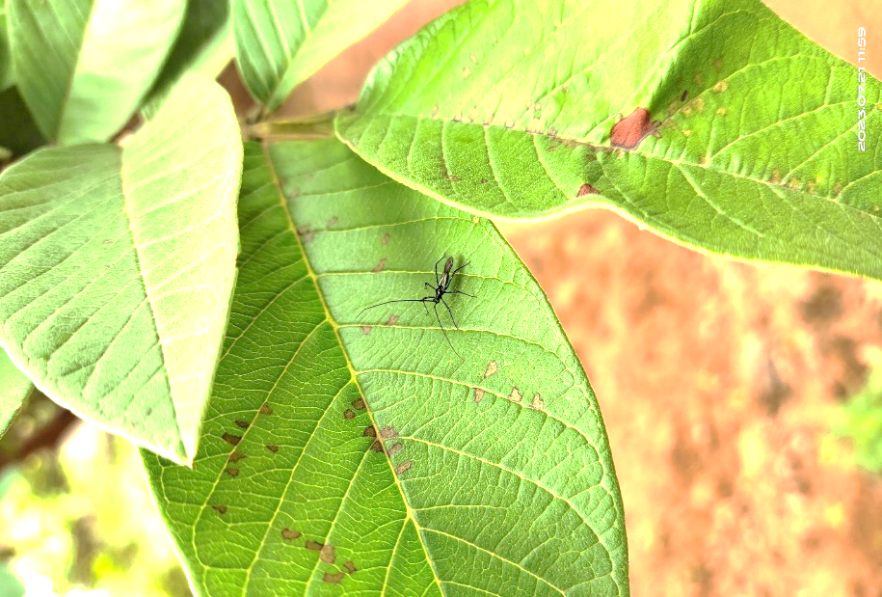
Table 3. Multiple linear regression analysis between weather parameters and incidence of tea mosquito bug infesting guava during July 2023-May 2024
Variables |  | Regression coefficient (Y)  (Leaves) | Regression coefficient (Y)  (Fruits)
Intercept |  | 116.376 | 144.584
Temperature (ºC) | Max. | 0.060 | 0.019
Temperature (ºC) | Min. | -0.563 | 0.000
Relative humidity (%) | Morn. | -1.997 | 2.723
Relative humidity (%) | Even. | 0.670 | 1.382
Total rainfall (mm) |  | -0.899 | -1.206
No. Rainy days |  | 0.102 | 0.206
Plate 4. Necrotic lesions caused by Helopeltisspp. on guava leaves

Plate 3. Formation of corky scab due to damage caused by tea mosquito bug
Plate 2. Adult of Helopeltis bradyi
Plate 1. Adult of Helopeltis antonii
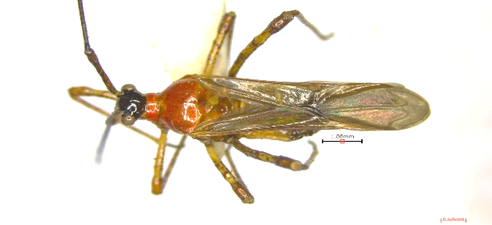

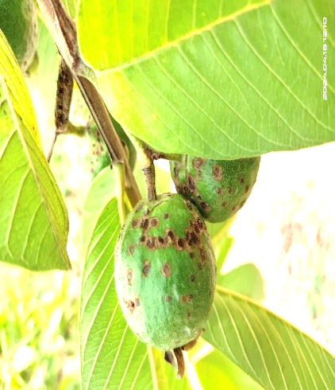
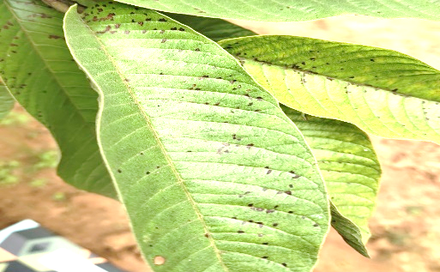

Fig. 1: Seasonal incidence and per cent damage of Helopeltis spp. on guava during 2023-2024at College of Sericulture, Chintamani

Disclaimer (Artificial intelligence)
Option 1:
Author(s) hereby declare that NO generative AI technologies such as Large Language Models (ChatGPT, COPILOT, etc.) and text-to-image generators have been used during the writing or editing of this manuscript.
Option 2:
Author(s) hereby declare that generative AI technologies such as Large Language Models, etc. have been used during the writing or editing of manuscripts. This explanation will include the name, version, model, and source of the generative AI technology and as well as all input prompts provided to the generative AI technology
Details of the AI usage are given below:
1.
2.
3.
5. References
- Anandkumar V, Hugar PS, and Hiremath SM. Seasonal incidence of tea mosquito bug, Helopeltis spp. in guava, cv. L-49 at MARS, Dharwad, Karnataka. Biological Forum- An Int. J. 2022; 14(1): 1262-1268.
- Aravinthraju K, Suresh K, Manisegaran S, and Rajamanickam. Efficacy of certain insecticides against tea mosquito bug Helopeltis antonii Signoret in guava. Ind. J. Entomol., 2021; 83: 1-2.
- Chaitanya B, Bheemanna M,, Prabhuraj A, Shankara MM,, Harischandra Naik R, and Aswathanarayana DS. Biology and Management of Tea Mosquito Bug, Helopeltis Antonii on Neem. Research square, 2024; p.22.
- Devi GT, Emmanuel N, and Sehar V. Seasonal incidence of sucking pest complex of guava cv. Taiwan white in Andhra Pradesh. Pharma Innov. J., 2023; 12(3): 4154-4158.
- Jalgaonkar VN, Gawankar M.S, Bendale VM, Patil D. Efficacy of some insecticides against cashew tea mosquito bug Helopeltis antonii Sign. The Journal of Plant Protection Sciences, 2009; 1(1): 96-97.
- Kumar M, Tomar M, Amarowicz R, Saurabh V, Nair MS. Maheshwari C, Sasi M, Prajapati, U, Hasan M, Singh S, Changan S. Guava (Psidium guajava L.) leaves: Nutritional composition, phytochemical profile, and health-promoting bioactivities. Foods. 2021; 10(4), pp.752.
- Kumar S. Studies on seasonal incidence and loss estimation in guava due to tea mosquito bug, Helopeltis antonii Signoret (Hemiptera: Miridae). M.Sc. (Agri.) Thesis, Univ. Agric. Sci., Dharwad. 2020.
- Manasa K, Bhagwan A, Sikha Deka, Irulandi, Ganga visalakshy PN. Management of tea mosquito bug, Helopeltis antonii Sign. on guava using entomopathogen fungus. Pest management in Horticultural ecosystem, 2020; 26(2): 175-178.
- Sanjay HN, Manjunatha R, Sumithramma N, Mulimani V, and Reddy GN. Seasonal incidence, damage and impact of abiotic factors on tea mosquito bug, Helopeltis antonii Signoret (Hemiptera: Miridae) infesting tamarind. The Pharma Innovation, 2022; 11(8): 1340-1343.
- Sanjay HN. Studies on insect pests of tamarind, Tamarindus indica L. with special reference to tea mosquito bug, Helopeltis antonii Sign. (Miridae: Hemiptera). M.Sc. (Agri.)Thesis, Uni. Agric. Sci., Bangalore. 2021.
- Sanjay HN, Manjunatha R, Narasareddy G, Mulimani V, and Mohan KM. Evaluation of different insecticides against tea mosquito bug, Helopeltis antonii Sign. (Miridae: Hemiptera) on tamarind. Pharma Innov., 2023; 12(9): 01-03.

Table 4. Bio efficacy of different insecticides and biopesticides against tea mosquito bug (TMB), Helopeltisspp. on guava during 2023-2024 (First spray)
Tree  No. | Treatment details | Dosage  (ml/g/l) | Per cent incidence of TMB |  |  |  |  |  |  |  | Per cent Reduction over control
Tree  No. | Treatment details | Dosage  (ml/g/l) | Young leaves |  |  |  | Fruits
Tree  No. | Treatment details | Dosage  (ml/g/l) | 1 DBS | 3 DAS | 7 DAS | 15 DAS | 1 DBS | 3 DAS | 7 DAS | 15 DAS | Young leaves | Fruits
T₁ | Imidacloprid 17.8% SL | 0.3 | 10.26  (18.67) | 6.86  (15.19) | 5.23  (13.22) | 7.26  (15.63) | 10.93  (19.27) | 7.17  (15.53) | 5.23  (13.22) | 6.48  (14.74) | 55.70 | 57.87
T₂ | Thiamethoxam 25% WG | 0.3 | 10.66  (19.03) | 7.46  (15.85) | 6.66  (14.96) | 8.40  (16.84) | 12.33  (20.54) | 8.94  (17.39) | 6.66  (14.96) | 7.89  (16.31) | 47.81 | 48.32
T₃ | Fipronil 5% SC | 2 | 9.30  (17.75) | 3.56  (10.87) | 2.40  (8.91) | 4.33  (12.01) | 9.66  (18.05) | 4.46  (12.20) | 2.40  (8.91) | 3.18  (10.27) | 76.36 | 78.45
T₄ | Lambda cyhalothrin 5% EC | 1.5 | 10.29  (18.70) | 5.13  (13.09) | 4.26  (11.92) | 6.36  (14.61) | 12.00  (20.25) | 5.94  (14.11) | 4.26  (11.92) | 5.12  (13.07) | 63.97 | 66.85
T₅ | Beauveria bassiana  (2 × 10⁸ cfu/g) | 2 | 11.2  (19.61) | 9.36  (17.82) | 8.17  (16.60) | 10.32  (18.74) | 12.70  (20.87) | 10.55  (18.95) | 8.17  (16.60) | 10.86  (19.23) | 34.85 | 34.50
T₆ | Lecanicilliumlecanii  (2× 10⁸ cfu/g) | 2 | 11.66  (19.96) | 9.56  (18.01) | 8.00  (16.43) | 10.60  (18.99) | 13.59  (21.62) | 10.56  (18.96) | 8.00  (16.43) | 10.72  (19.11) | 33.89 | 34.65
T₇ | Azadirachtin 10000 ppm | 2 | 12.66  (20.84) | 11.16  (19.52) | 10.26  (18.68) | 11.40 (19.72) | 15.41  (23.11) | 13.61  (21.64) | 10.26  (18.68) | 12.78  (20.94) | 19.08 | 18.60
T₈ | Buprofezin 25% EC | 1.25 | 12.33  (20.53) | 8.16  (16.59) | 7.11  (15.46) | 8.98  (17.44) | 12.85  (21.00) | 9.69  (18.13) | 7.11  (15.46) | 8.85  (17.30) | 43.25 | 42.86
T₉ | Control | - | 11.00  (19.37) | 12.60  (20.79) | 14.55  (22.42) | 15.20  (22.94) | 12.26  (20.48) | 13.67  (21.66) | 16.66  (24.07) | 17.32  (24.54) | - | -
S.EM. |  |  | 0.398 | 0.113 | 0.138 | 0.167 | 0.619 | 0.233 | 0.258 | 0.421 | - | -
CD (P= 0.05) |  |  | 1.242 | 0.338 | 0.414 | 0.505 | 1.871 | 0.705 | 0.781 | 1.274 | - | -
Figures in the parentheses are arcsine transformed values
Note: DBS – Day before spray, DAS – Day after spray

Table 5. Bio efficacy of different insecticides and biopesticides against tea mosquito bug (TMB), Helopeltisspp. on guava during 2023-2024 (Second spray)
Tree  No. | Treatment details | Dosage  (ml/g/l) | Per cent incidence of TMB |  |  |  |  |  |  |  | Per cent Reduction over control
Tree  No. | Treatment details | Dosage  (ml/g/l) | Young leaves |  |  |  | Fruits
Tree  No. | Treatment details | Dosage  (ml/g/l) | 1 DBS | 3 DAS | 7 DAS | 15 DAS | 1 DBS | 3 DAS | 7 DAS | 15 DAS | Young leaves | Fruits
T₁ | Imidacloprid 17.8% SL | 0.3 | 7.26  (15.63) | 5.17  (13.14) | 3.33  (10.52) | 5.12  (13.08) | 6.48  (14.74) | 3.73  (11.13) | 2.33  (8.78) | 4.63  (12.42) | 72.90 | 81.19
T₂ | Thiamethoxam 25% WG | 0.3 | 8.40  (16.84) | 6.31  (14.55) | 4.57  (12.35) | 6.33  (14.57) | 7.89  (16.31) | 4.99  (12.91) | 3.59  (10.93) | 5.89  (14.05) | 65.68 | 73.88
T₃ | Fipronil 5% SC | 2 | 4.33  (12.01) | 3.24  (10.37) | 1.79  (7.69) | 2.41  (8.92) | 3.18  (10.27) | 1.70  (7.50) | 0.30  (3.17) | 2.60  (9.29) | 84.77 | 91.72
T₄ | Lambda cyhalothrin 5% EC | 1.5 | 6.36  (14.61) | 4.51  (12.27) | 2.97  (9.92) | 4.30  (11.96) | 5.12  (13.07) | 2.94  (9.87) | 1.54  (7.12) | 3.84  (11.30) | 76.39 | 85.12
T₅ | Beauveria bassiana  (2 × 10⁸ cfu/g) | 2 | 10.32  (18.74) | 9.10  (17.55) | 6.980  (15.31) | 8.95  (17.40) | 10.86  (19.23) | 7.47  (15.86) | 6.07  (14.27) | 8.37  (16.82) | 49.95 | 60.54
T₆ | Lecanicilliumlecanii  (2× 10⁸ cfu/g) | 2 | 10.60  (18.99) | 9.40  (17.85) | 7.13  (15.48) | 9.06  (17.52) | 10.72  (19.11) | 7.84  (16.25) | 6.44  (14.69) | 8.74  (17.19) | 48.62 | 56.22
T₇ | Azadirachtin 10000 ppm | 2 | 11.40 (19.72) | 10.78  (19.17) | 9.01  (17.47) | 10.91  (19.28) | 12.78  (20.94) | 10.66  (19.05) | 9.26  (17.71) | 11.56  (19.87) | 38.60 | 41.88
T₈ | Buprofezin 25% EC | 1.25 | 8.98  (17.44) | 7.42  (15.81) | 5.49  (13.55) | 7.59  (15.99) | 8.85  (17.30) | 5.84  (13.99) | 4.44  (12.17) | 6.74  (15.05) | 59.03 | 69.53
T₉ | Control | - | 15.20  (22.94) | 15.92  (23.51) | 16.42  (23.90) | 17.67  (24.85) | 17.32  (24.54) | 17.86  (25.00) | 18.43  (25.42) | 19.06  (25.89) | - | -
S.EM. |  |  | 0.167 | 0.106 | 0.151 | 0.058 | 0.421 | 0.243 | 0.229 | 0.118 | - | -
CD (P= 0.05) |  |  | 0.505 | 0.317 | 0.453 | 0.173 | 1.274 | 0.729 | 0.688 | 0.565 | - | -
Figures in the parentheses are arcsine transformed values
Note: DBS – Day before spray, DAS – Day after spray

Fig. 2: Per cent reduction of tea mosquito bug damage in leaves and fruits of guava in different treatments

