THE MOLECULAR MECHANISM OF DICOFOL AS AN AGONIST OF THE HUMAN ESTROGEN RECEPTOR: INSIGHTS FROM MOLECULAR DOCKING AND MM-GBSA STUDIES.

ABSTRACT
The risk to human health has increased worldwide due to the widespread use of organochlorine pesticides. Dicofol (DCF), an organochlorine pesticide, is one of the most contentious endocrine disruptors; it can interact with nuclear receptors and interfere with their regular function. A member of the steroid hormone receptor family, the estrogen receptor (ER) is found in many bodily tissues. It binds to androgens and controls the activity of genes that are responsive to androgens. There is a chance that DCF will disrupt the estrogen receptor. In light of these specifics, we tested the ER disruption and related mechanisms of DCF using Molecular Docking, Generalized Born, and Surface Area Continuum Salvation (MM GBSA) in Molecular Mechanics. Dicofol may bind to the ER with efficiency, according to the docking results that were obtained. The MMGBSA results demonstrated that lipophilic interactions were the primary driver of the stable binding process. The current study supports the structural evidence that DCF is an endocrine disruptor and provides crucial guidance for finding safer alternatives.
KEY WORDS: Dicofol, Molecular docking, MM-GBSA, Estrogen receptor, Agonism
INTRODUCTION
There is increasing awareness of the potential health risks associated with endocrine-disrupting chemicals (EDCs). EDCs are chemicals found in our food, environment, and consumer goods that disrupt hormone metabolism, biosynthesis, or action, leading to a disruption in normal homeostatic control or reproduction (Diamanti-Kandarakis et al., 2009). Many EDCs are synthetic and are released into the environment by the plasticizers, organotins, pesticides, or alkylphenols industries (Metcalfe et al., 2022; Li et al., 2015). Numerous substances discharged into the environment have physicochemical characteristics in common with natural ligands, which enable them to attach to nuclear receptors (NRs) and either activate or inhibit their function, leading to a variety of abnormalities in human and wildlife development, reproduction, neurological function, and metabolism (Delfosse et al., 2015). Organochlorine pesticides (OCPs) are synthetic poly chlorinated hydrocarbon derivatives that are widely used in agriculture and the chemical industry. However, because of their high toxicity, slow degradation, and bioaccumulation, overuse of these chemicals raises the possibility of toxicity to non-target species (Jayaraj et al., 2016). Many persistent OCPs exert reproductive and develop breast cancer, through interaction with the human estrogen receptor (Høyer et al., 2001; Okubo et al., 2004; Vasanth et al., 2024). Numerous attempts have been made in recent years to look into the specific effects of EDCs on mammal systems. While direct pesticide exposure is possible, secondary poisonings like consuming pesticide-exposed prey or groundwater contamination and runoff are the most common ways that pesticides affect mammals.
Dicofol is a organochlorine insecticide has a chemical structure of C₁₄H₉Cl₅O that is very effective against spider mites (PubChem, n.d.). According to Ahmad et al., (2024) humans have been exposed to a variety of hazardous chemicals in the workplace and environment in recent years, particularly pesticides. According to the US EPA, (2013), dicofol can enter the human body through the mouth, skin, or lungs. Since dicofol shares a structure with DDT, it is viewed with similar concerns. This is because DDT has detrimental effects on both humans and animals, including bioaccumulation, long-range transport, persistence, endocrine disruption, and reproductive toxicity (A. Ahmad & Ahmad, 2017; Clark Jr. et al., 1990; El-Kashoury et al., 2010; Qi et al., 2022). However, use of this has caused criticism by many environmentalists; due to its persistence in environment and human samples (Fujii et al., 2011). Moreover, WHO categorized the dicofol as a level II moderately hazardous pesticide. Numerous pieces of evidence indicate that the mechanisms underlying OCPs involve different pathways, such as agonist and antagonist actions on the androgen and estrogen receptors (Hoekstra et al., 2006; Qi et al., 2022; Yang & Chen, 1999; Zhuang et al., 2012).
Dicofol has attracted considerable attention and controversy as an endocrine disruptor. Meanwhile, it has been hypothesized that exposure to dicofol causes impairment in reproductive, system in mammals (Jadaramkunti and Kaliwal, 2002; El-Kashoury et al., 2010). At present, many lines of evidence revealed that dicofol could interact with nuclear hormone receptors such as estrogen receptor (Okubo et al., 2004). Estrogen receptor ERs are ligand-dependent transcription factors that facilitate the normal biological functions of estrogens by controlling gene transcription through estrogen response elements (EREs). However, a number of illnesses, including reproductive system failure, can be brought on by aberrant ER signaling (Chen et al., 2022). In the meantime, endocrine disruptors from the external environment can also interact with the ligand binding domains (LBDs) of nuclear receptors, which can lead to a disorder of the signaling pathways downstream. However, dicofol has been demonstrated in numerous biological tests to disrupt the regular operation of nuclear receptors (Thiel et al., 2011). The precise molecular mechanism underlying the interaction between dicofol and the estrogen receptor has yet to be identified. To estimate the free energy of the binding of the receptor–ligand complex and to ascertain the affinities and modes of binding of particular receptor targets, Molecular docking and Molecular Mechanics Generalized Born and Surface Area continuum solvation (MM/GBSA) have proven to be very useful and effective (Morris & Lim-Wilby, 2008; Wang et al., 2019; Zhang et al., 2017). In order to study the complex interactions of dicofol with estrogen receptor LBDs and uncover the mechanism by which dicofol interacts with nuclear receptors, we employed molecular docking and molecular mechanics generalized born surface area (MM-GBSA) computations. The interaction between AR and testosterone was also examined using the docking score and MM-GBSA in order to determine whether dicofol interacts with nuclear receptors by simulating the action of its natural agonist of nuclear receptors.
MATERIALS AND METHODS
Software:
The computational studies are conducted with the Schrödinger suite 2018 by maestro 9.9 (Schrödinger 2018: Maestro, version 9.9, Schrödinger, LLC, NY, 2018), a 64-bit Intel® Core i5-2500 CPU running at 3.30 GHz, and a Linux CentOS 6 operating system.
Protein preparation:
Estrogen receptor α protein crystal structure was accessed from Protein Data Bank (PDB ID – 5WGD) and it was designed using Schrodinger module. Schrödinger's Small-Molecule Drug Discovery Suite (Schrödinger Release 2018-3: Protein Preparation Wizard; Epik version 2.9, Schrödinger, LLC, NY, 2018; Impact version 6.4, Schrödinger, LLC, NY, 2018; Prime version 3.7, Schrödinger, LLC, NY, 2018) was used to prepare the protein structure for docking using the protein preparation wizard (Sastry et al., 2013). At a pH of 7.4, all hydrogens were added, and protonation states were ascertained. Using prime, missing side chain atoms and loops were filled, and then the H-bond was optimized. In order to correct the molecular geometries and preserve particular chirality, the entire protein is finally reduced to the lowest energy state needed for docking using the OPLS (Optimized potential for liquid simulations) 2005 force field.
Ligand preparation:
The structures of dicofol ligand were downloaded from PubChem (https://pubchem.ncbi.nlm.nih.gov/compound/dicofol#section=Top). The LigPrep tool was used to prepare these structures, as described by Sastry et al., (2013). Version 3.1 of LigPrep, Schrödinger, LLC, New York, 2018. A number of procedures are involved in ligand preparation, including conversions from 2D to 3D, ionization at biological pH 7.4 to preserve particular chirality, ring conformation minimization, and molecular geometries correction using the OPLS-2005 force field.

Molecular docking studies
In-Silico molecular docking studies were done in the Sophisticated Analytical Instrument Facility (SAIF) centre, Karnatak University, Dharwad. The Glide program (Small-Molecule Drug Discovery Suite 2018-3: Glide, version 6.4, Schrödinger, LLC, NY, 2018) used the Glide algorithm for docking, as described by Friesner et al., (2004). The program used the XP mode with flexible ligand sampling, which includes options for sample ring conformation and nitrogen inversion adding epik state penalty. Van der Waals radii of 0.8 and partial charge cut off of 0.15 are the receptor grid scaling of the ligands to be docked. Pose viewer files are created that show each ligand's optimal position in the specific site, posing the more nonbonding interactions that are then examined.
Binding free energy calculation
Binding free energy was calculated as described by Wang et al., (2019). The binding free energy was calculated using Prime MM-GBSA (Prime, version 3.6, Schrödinger, LLC, NY, 2018) with the pose viewer files produced by docking. The salvation model VSGB was set with force field OPLS 2005, and the sampling techniques were configured to minimize side chains. The binding free energy was calculated using Prime MM-GBSA (Prime, version 3.6, Schrödinger, LLC, NY, 2018) with the pose viewer files produced by docking. The salvation model VSGB was set with force field OPLS 2005, and the sampling techniques were configured to minimize side chains. of salvation model VSGB with force field OPLS 2005 and the sampling methods were set to do minimization of side chains.

Table 1: showing calculated docking score of estradiol and dicofol with ERα
Compounds | G score | Docking score
Estradiol | -11.71 Kcal/Mol | -11.78
Dicofol | -9.64 Kcal/Mol | -09.88

Table 2: Calculated glide score and binding free energy with its components based on docking and MM-GBSA scoring method
 | dG bind Coulomb | dG bind  Covelent | dG bind  H- bond | dG bind  Lipo | dG bind  Packing | dG bind  Solvation GB | dG_Bind  Van der Waals | Total  dG Bind
Estradiol | -12.94 | 1.25 | -1.30 | -67.15 | -0.78 | 14.58 | -44.66 | -111.01
Dicofol | 0.10 | 5.53 | 0 | -82.10 | -0.80 | 10.310 | -11.05 | -78.00

RESULTS AND DISCUSSION
Molecular Docking Study: A flexible ligand is docked to a rigid receptor binding pocket in molecular docking studies to evaluate the binding sites of dicofol and its detailed mechanism of interaction with ER. The Glide program, which is used in structure-based drug designing, is used to predict the binding affinity (Friesner et al., 2004). A docking study is conducted between dicofol and ER in comparison to the powerful estrogen compound estradiol. As the most common form of estrogen, estradiol is also essential for male spermatogenesis (Schulster et al., 2016). As shown in Fig. 1, hydrogen bonding with amino acid Leu 387 and Pi-Pi stacking with Phe404 are the primary mechanisms that favor the estrogen receptor-estradiol interaction, as indicated by the docking results, which showed a docking score of -11.71 kcal/mol. Glu353, Ala350, Leu349, Phe404, Thr 347, Leu346, Met343, Arg394, Leu391, Met388, Leu387, Leu384, Trp383, Met528, Leu525, His524, Gly521, Ile424, and Met421 are additional amino acids that comprise the active site. Crucially, dicofol binds in the same hydrophobic pocket of the ER active site by forming Pi-Pi stacking with Phe 404 in chain A of ER, as indicated by table 1 and figure 1, with a docking glide score of -9.64 kcal/mol. The occupation of this area may also be a significant characteristic of ERα agonism, according to our findings of Nettles et al., (2007) and Zhuang et al., (2012).
.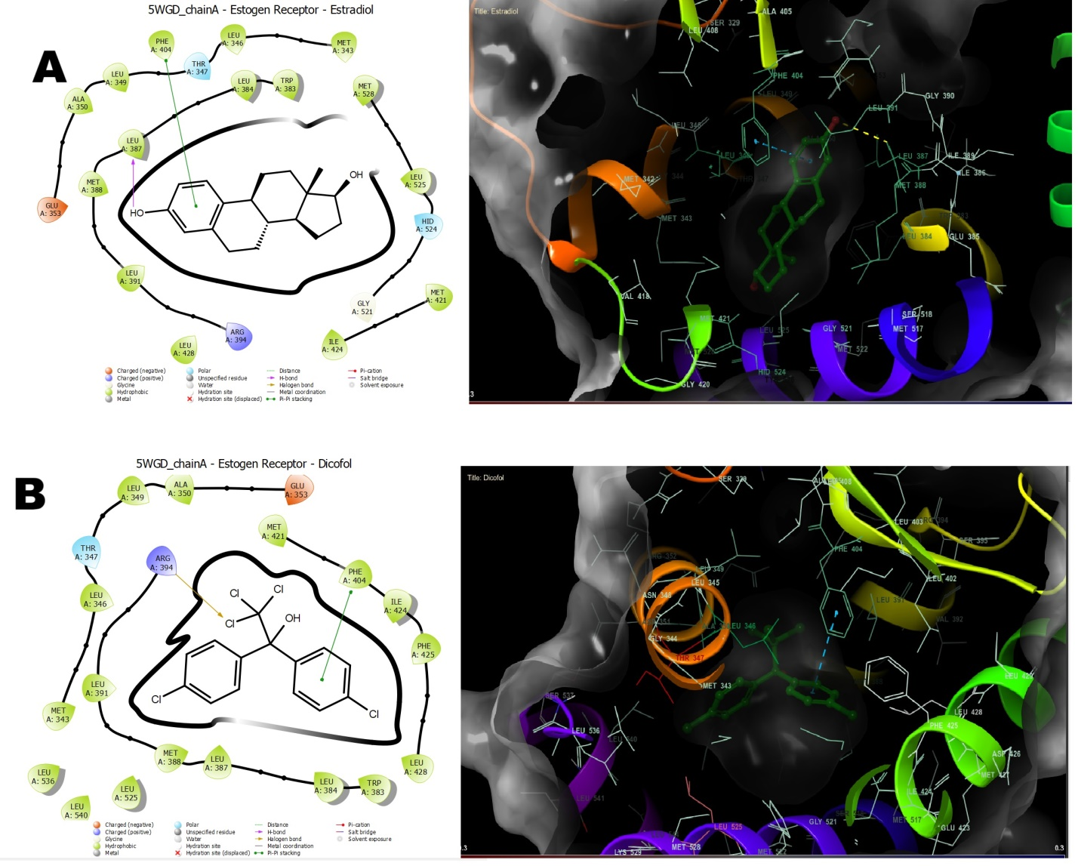
Fig. 1. Interaction diagrams of the ligand-binding domain of ERα (PDB ID-5WGD) with its ligands: (A) Estradiol; (B) Dicofol.

Binding Free Energy Calculations by MM GBSA:
In thermodynamics, free energy refers to the amount of internal energy of the system that can be used to do work, and it determines the direction of the thermodynamic process as well as the probability that the system will remain in a given state. Since experimental measurements of the thermodynamic properties of biomolecular systems are often expensive and time-consuming, accurate theoretical calculations of their free energies by numerical simulation are becoming more and more important in many research fields, such as rational drug design, protein folding, protein–protein interactions (Wang et al., 2019). The MM energy is calculated with the OPLS protein force-field enhanced by several physics-based corrections. In order to gain insight into the contribution spectrum of binding energy for estradiol and dicofol to estrogen receptor, the total energy contributions during the docking studies were calculated for each system using the MM-GBSA method and were shown in (Table 2).
Natural estrogenic hormone estradiol bound to the ER with the strongest affinity of binding free energy of -111.01 kcal/mol. However, dicofol is also binding to the ER with the total binding free energies of -78.00kcal/mol. It indicates dicofol binds to ER with slightly lowered binding energy as compared to estradiol. The total contribution of various energy components of binding free energies are sown in Table 2. The current study indicates that dicofol has greater covalent and lipophilic binding potencies to the ER than does estradiol in the binding site. According to our calculations the ligand binds stronger to the ER due to its closer contacts with Phe404 and Arg394. Therefore, stabilization of the interaction in the biding site is another explanation for the remarkable agonistic activity of dicofol. The findings are consistent with those of Zhuang et al., (2012).
CONCLUSION
This study used MM-GBSA calculations and molecular docking to examine the molecular mechanism of dicofol binding to the ER. According to the docking results, dicofol can attach itself to the hydrophobic pocket and establish a long-lasting bond with the ER. According to binding mode analysis, dicofol can imitate the actions of the natural estrogen hormone estradiol in order to remain in the active site and interact with the important residues in the pocket. Furthermore, the binding process is primarily fueled by covalent van der Waals and lipophilic interactions, and the calculated binding free energies are favorable for dicofol binding. It is evident from the obtained results that dicofol exhibits estrogen receptor agonistic activity structurally. Therefore, we advise looking for safer dicofol alternatives.
DISCLAIMER (ARTIFICIAL INTELLIGENCE)
Author(s) hereby declare that NO generative AI technologies such as Large Language Models (ChatGPT, COPILOT, etc.) and text-to-image generators have been used during the writing or editing of this manuscript.
ACKNOWLEDGEMENT
The authors are thankful to DST PURSE Phase II Program New Delhi, UGC Major Research Project scheme (F. No. 41- 103/2012 (SR); UGC SAP scheme [No. F.4-18/2015/DSA-I (SAP-II)] and UGC-UPE/FAR I [(37-245/2009 (SR)] for providing financial support. Authors are also thanking to Karnatak University SAIF centre Dharwad, for providing molecular modeling software to perform present work.
CONFLICT OF INTEREST STATEMENT
Authors declare no conflicts interest.
REFERENCE
Ahmad, M. F., Ahmad, F. A., Alsayegh, A. A., Zeyaullah, Md., AlShahrani, A. M., Muzammil, K., Saati, A. A., Wahab, S., Elbendary, E. Y., Kambal, N., Abdelrahman, M. H., & Hussain, S. (2024). Pesticides impacts on human health and the environment with their mechanisms of action and possible countermeasures. Heliyon, 10(7), e29128. https://doi.org/10.1016/j.heliyon.2024.e29128
Chen, P., Li, B., & Ou-Yang, L. (2022). Role of estrogen receptors in health and disease. Frontiers in Endocrinology, 13, 839005. https://doi.org/10.3389/fendo.2022.839005
Delfosse, V., Maire, A. le, Balaguer, P., & Bourguet, W. (2015). A structural perspective on nuclear receptors as targets of environmental compounds. Acta Pharmacologica Sinica, 36(1), 88–101. https://doi.org/10.1038/aps.2014.133
Diamanti-Kandarakis, E., Bourguignon, J.-P., Giudice, L. C., Hauser, R., Prins, G. S., Soto, A. M., Zoeller, R. T., & Gore, A. C. (2009). Endocrine-Disrupting Chemicals: An Endocrine Society Scientific Statement. Endocrine Reviews, 30(4), 293–342. https://doi.org/10.1210/er.2009-0002
El-Kashoury, A. A., Salama, A. F., Selim, A. I., & Mohamed, R. A. (2010). Chronic Exposure Of Dicofol Promotes Reproductive Toxicity In Male Rats. 7(3).
Friesner, R. A., Banks, J. L., Murphy, R. B., Halgren, T. A., Klicic, J. J., Mainz, D. T., Repasky, M. P., Knoll, E. H., Shelley, M., Perry, J. K., Shaw, D. E., Francis, P., & Shenkin, P. S. (2004). Glide: A New Approach for Rapid, Accurate Docking and Scoring. 1. Method and Assessment of Docking Accuracy. Journal of Medicinal Chemistry, 47(7), 1739–1749. https://doi.org/10.1021/jm0306430
Fujii, Y., Haraguchi, K., Harada, K. H., Hitomi, T., Inoue, K., Itoh, Y., Watanabe, T., Takenaka, K., Uehara, S., Yang, H.-R., Kim, M.-Y., Moon, C.-S., Kim, H.-S., Wang, P., Liu, A., Hung, N. N., & Koizumi, A. (2011). Detection of dicofol and related pesticides in human breast milk from China, Korea and Japan. Chemosphere, 82(1), 25–31. https://doi.org/10.1016/j.chemosphere.2010.10.036
Hoekstra, P. F., Burnison, B. K., Garrison, A. W., Neheli, T., & Muir, D. C. G. (2006). Estrogenic activity of dicofol with the human estrogen receptor: Isomer- and enantiomer-specific implications. Chemosphere, 64(1), 174–177. https://doi.org/10.1016/j.chemosphere.2005.10.043
Høyer, A. P., Jørgensen, T., Rank, F., & Grandjean, P. (2001). Organochlorine exposures influence on breast cancer risk and survival according to estrogen receptor status: A Danish cohort-nested case-control study. BMC Cancer, 1, 8. https://doi.org/10.1186/1471-2407-1-8
Jadaramkunti UC, Kaliwal BB; Dicofol Formulation Induced Toxicity on Testes and Accessory Reproductive Organs in Albino Rats. Bull. Environ. Contam. Toxicol. (2002) 69:741–748.
Jayaraj, R., Megha, P., & Sreedev, P. (2016). Organochlorine pesticides, their toxic effects on living organisms and their fate in the environment. Interdisciplinary Toxicology, 9(3–4), 90–100. https://doi.org/10.1515/intox-2016-0012
Li, Z., Xiang, X., Li, M., Ma, Y., Wang, J., & Liu, X. (2015). Occurrence and risk assessment of pharmaceuticals and personal care products and endocrine disrupting chemicals in reclaimed water and receiving groundwater in China. Ecotoxicology and Environmental Safety, 119, 74–80. https://doi.org/10.1016/j.ecoenv.2015.04.031
Metcalfe, C. D., Bayen, S., Desrosiers, M., Muñoz, G., Sauvé, S., & Yargeau, V. (2022). An introduction to the sources, fate, occurrence and effects of endocrine disrupting chemicals released into the environment. Environmental Research, 207, 112658. https://doi.org/10.1016/j.envres.2021.112658
Morris, G. M., & Lim-Wilby, M. (2008). Molecular docking. Methods in Molecular Biology (Clifton, N.J.), 443, 365–382. https://doi.org/10.1007/978-1-59745-177-2_19
Nettles, K. W., Bruning, J. B., Gil, G., O’Neill, E. E., Nowak, J., Hughs, A., Kim, Y., DeSombre, E. R., Dilis, R., Hanson, R. N., Joachimiak, A., & Greene, G. L. (2007). Structural plasticity in the oestrogen receptor ligand-binding domain. EMBO Reports, 8(6), 563–568. https://doi.org/10.1038/sj.embor.7400963
Okubo, T., Yokoyama, Y., Kano, K., Soya, Y., & Kano, I. (2004). Estimation of estrogenic and antiestrogenic activities of selected pesticides by MCF-7 cell proliferation assay. Archives of Environmental Contamination and Toxicology, 46(4), 445–453. https://doi.org/10.1007/s00244-003-3017-6
PubChem. (n.d.). Dicofol. Retrieved October 28, 2024, from https://pubchem.ncbi.nlm.nih.gov/compound/8268
Qi, S.-Y., Xu, X.-L., Ma, W.-Z., Deng, S.-L., Lian, Z.-X., & Yu, K. (2022). Effects of Organochlorine Pesticide Residues in Maternal Body on Infants. Frontiers in Endocrinology, 13, 890307. https://doi.org/10.3389/fendo.2022.890307
Sastry, G. M., Adzhigirey, M., Day, T., Annabhimoju, R., & Sherman, W. (2013). Protein and ligand preparation: Parameters, protocols, and influence on virtual screening enrichments. Journal of Computer-Aided Molecular Design, 27(3), 221–234. https://doi.org/10.1007/s10822-013-9644-8
Schulster, M., Bernie, A. M., & Ramasamy, R. (2016). The role of estradiol in male reproductive function. Asian Journal of Andrology, 18(3), 435–440. https://doi.org/10.4103/1008-682X.173932
Thibaut, R., & Porte, C. (2004). Effects of endocrine disrupters on sex steroid synthesis and metabolism pathways in fish. The Journal of Steroid Biochemistry and Molecular Biology, 92(5), 485–494. https://doi.org/10.1016/j.jsbmb.2004.10.008
Thiel, A., Guth, S., Böhm, S., & Eisenbrand, G. (2011). Dicofol degradation to p,p’-dichlorobenzophenone—A potential antiandrogen. Toxicology, 282(3), 88–93. https://doi.org/10.1016/j.tox.2011.01.016
Vasanth, A., Gopi, S., & Akkaiah, S. (2024). A Review of Organochlorine-induced Male Reproductive Disorders. Asian Journal of Research in Chemistry, 17(1), 59–66. https://doi.org/10.52711/0974-4150.2024.00012
Wang, E., Sun, H., Wang, J., Wang, Z., Liu, H., Zhang, J. Z. H., & Hou, T. (2019). End-Point Binding Free Energy Calculation with MM/PBSA and MM/GBSA: Strategies and Applications in Drug Design. Chemical Reviews, 119(16), 9478–9508. https://doi.org/10.1021/acs.chemrev.9b00055
Yang, C., & Chen, S. (1999). Two organochlorine pesticides, toxaphene and chlordane, are antagonists for estrogen-related receptor alpha-1 orphan receptor. Cancer Research, 59(18), 4519–4524.
Zhang, X., Perez-Sanchez, H., & Lightstone, F. C. (2017). A Comprehensive Docking and MM/GBSA Rescoring Study of Ligand Recognition upon Binding Antithrombin. Current Topics in Medicinal Chemistry, 17(14), 1631–1639. https://doi.org/10.2174/1568026616666161117112604
Zhuang, S., Zhang, J., Wen, Y., Zhang, C., & Liu, W. (2012). Distinct mechanisms of endocrine disruption of DDT‐related pesticides toward estrogen receptor α and estrogen‐related receptor γ. Environmental Toxicology and Chemistry, 31(11), 2597–2605. https://doi.org/10.1002/etc.1986

