Review Article
STRUCTURAL CHARACTERIZATION OF ANTENNAE OF STORED GRAIN PESTS (COLEOPTERA): A REVIEW
ABSTRACT
This review article is aimed at stored grain pests which are a serious threat to global food security. Insect infestations can have a devastating impact on grain facilities, leading to significant economic losses in the agricultural sector. These insects possess sophisticated antennae in their head capsules, which contain numerous sensory receptors and organs. These specialized structures enable the insects to navigate their environment, locate food, seek shelter, find mates, identify breeding sites, and evade predators and other threats.Researchers study the intricate structure of these antennae using advanced techniques such as the scanning electron microscope (SEM). By gaining a deeper understanding of the antennal structure, experts hope to develop more effective strategies to prevent and combat insect damage in storage facilities.
KEYWORDS: Antennae, Types of sensilla, Role of sensilla, Chemoreception of Stored Grain Pests, Management of Stored Grain Pests.
INTRODUCTION
The order Coleoptera (beetles) has around 250,000 recognized species which is the largest group of insects. They are found in all habitats. Morphologically, beetles often have two sets of wings. The back pair, which is transparent and membrane-covered, is protected from the rear by the hard, leathery "elytra" projections on the front pairs, which act as sheaths. The modification of the spiracles to open into the body cavity lowers water loss during respiration and prevents desiccation of the abdomen.Insects have chemosensory structures called sensilla, which contain sensory neurons for olfactory stimuli and taste. These sensilla are located on the antennae, where most of the olfactory receptor neurons (ORNs) are also found. The chemical senses are important for detecting various environmental chemical information[7].
Approximately 25% of all known life forms are insects. Beetles make up roughly 400,000 species, or 40% of all insect species that have been identified, and new species are often found.Approximately 500 families and subfamilies are included here. One of the earliest hypothesized counts of all the species of beetles on Earth[1].
The seven familiesencompass the most crucial storage pest species are Bostrichidae, Bruchidae, Cucujidae, Curculionidae, Dermestidae, Silvanidae, and Tenebrionidae. Their impact on the integrity of these crops makes them significant targets for pest management and crop preservation efforts[2]. Stored grain pests are a major threat to dried, stored, durable, and perishable agricultural products and non-food derivatives of farm products worldwide which cause qualitative and quantitative loss[3,4]. Based on their feeding behavior, the stored grain pests are categorized as external and internal feeders [5]. These insects are tough to control as they thrive in extreme temperatures, and dry environments, and are resistant to many insecticides[5].
Synthetic pesticides have been the primary means of controlling insect pests in recent years, and they are currently the principal means of preventing insect damage to grains that have been stored. One promising source of chemicals for pest control is botanicals. The kingdom of plants can provide a wealth of different compounds that could be developed into effective pest control treatments[20] and [21].
Plant secondary chemicals, such as flavonoids, phenolics, terpenoids, and alkaloids, can affect insects in a variety of ways. They can function as attractants, deterrents, phago-stimulants, antifeedants, or alter oviposition. They can also seriously disrupt critical metabolic pathways and result in fast mortality. Additionally, they could quicken or slow down growth[22].
The stored grain pests are categorized as external and internal feedersbased on their feeding behaviour[5].
Table 1: List of pest insects destroying stored grain on the basis of pest status as external and internal feeder.
S.No. | Common name | Scientific Name | Order | Family | Pest Status
1. | Pulse Beetles | Callosobruchus sp. | Coleoptera | Bruchidae | External Feeder
2. | Khapra Beetle | Trogoderma granarium | Coleoptera | Dermestidae | External Feeder
3. | Flour Beetle | Tribolium sp. | Coleoptera | Tenebrionidae | External Feeder
4. | Ciggarette Beetle | Lasiodermaserricorne | Coleoptera | Anobiidae | Internal
5. | Lesser grain borer | Rhyzoperthadominica | Coleoptera | Bostrichidae | Internal
6. | Rice weevil | Sitophilus oryzae | Coleoptera | Curculionidae | Internal
7. | Maize weevil | Sitophilus zeamis | Coleoptera | Curculionidae | Internal
This paper provides a detailed examination of the distribution of antennal sensilla using high-resolution scanning electron microscopy. Additionally, it elucidates the crucial role of sensilla in governing insect behavior.
Morphology of Antennae of Stored Grain Pests
Insects possess a pair of appendages located on the head. The antenna is composed of a scape, a pedicel, and the flagellum, which is further divided into two parts: the funicle (comprising the proximal six flagellomeres) and the club (comprising the three distal flagellomeres)[8].
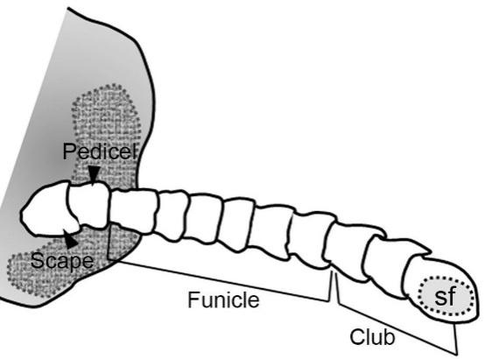

The schematic representation of the antennae[8].
Table 2. Comparison of antennae types among stored grain pests is listed below as follows:
STORED GRAIN PESTS | ANTENNAE
Tribolium castaneum | Based on the study, it was observed that the two primary sensilla species found on the antennae were sensilla basiconica, which had six subtypes, and sensilla trichodea, which had two subtypes. The most prevalent type of sensilla was Sensilla trichodea. It was noted that while they were present in all antennal segments, the final three segments had the highest concentration of them. Sensilla basiconica, on the other hand, was only detected on the final three segments of the antennae[10].  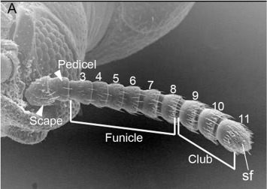Scanning electron microscope of antennae Tribolium castaneum showing scape, pedicel, and flagellum[9].
Sitophilus oryzae | The species possesses six flagellomeres, a pedicel, and a scape as part of its antennae structure. The scape, being the longest part, is followed by a small pedicel. As we move towards the widest point, which is the sixth flagellomere, the breadth of the flagellomeres increases distally. Additionally, scale-like structures can be observed covering each section of the antenna[10].  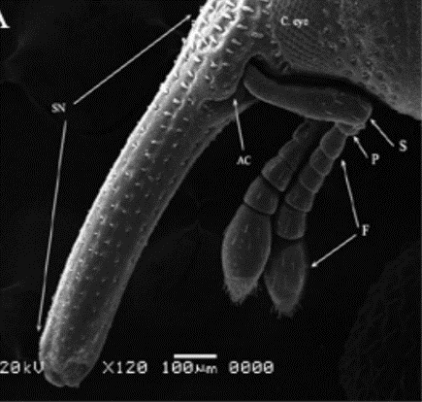  Scanning electron micrograph of ateannae of adult Sitophilus oryzae : S(Scape), P( Pedicel), F(Flagellomere)[11].
Oryzaephilus surinamensis | The antennae of Oryzaephilus surinamensis have eleven segments, with the distal three segments expanded to form a club[12].  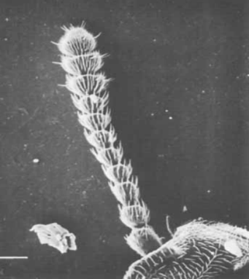  Oryzaephilus surinamensis antennae dorsal view[12].
Rhyzopertha dominica | Upon reaching maturity, the R. dominica insect's antenna measured 197 ± 9.4 µm in length. The antenna was composed of the pedicel, flagellum, and antennae I. The flagellum consisted of eight flagellomeres, including a large distal club and a thin proximal funicle. Additionally, two clusters of Böhm's sensilla were observed at the base of the pedicel and scape branches, adding complexity to the intricate structure of the antenna[13].  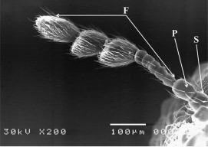  Scanning electron microscope of Rhyzopertha dominica scape, pedicel, and flagellum[16].
Table 3 Types of Sensilla in Stord Grain Pests
STORED GRAIN PESTS | SENSORY ORGANS OF ANTENNAE
Tribolium castaneum | Both male and female antennae exhibited two main types of sensilla: sensilla basiconica, which had six subtypes, and sensilla trichodea, which had two subtypes. Sensilla trichodea was the most abundant type, present across all segments of the antennae, with the highest concentration observed on the final three segments. Sensilla basiconica, on the other hand, was exclusively detected on the final three segments of the antennae [10].
Sitophilus oryzae | - Two types of sensilla trichoidea (ST1 & ST2) were found on the tip of the sixth flagellomere, along with basiconic sensilla (SB).  - Sensilla chaetica (SC) are dispersed on all segments based on their shape, size, distribution, and cuticular attachment.  - ST1 (Sensilla trichoidea) have sharp, almost straight, or slightly curled tips.  - ST2 (Sensilla trichoidea) are shorter compared to ST1 and have blunt tips.  - Sensilla chaetica (SC) are found on each antennal appendage with blunt tips and grooved surfaces.  - Sensilla basiconica (SB) are distinguished by their blunt tips and smooth cuticles[11].  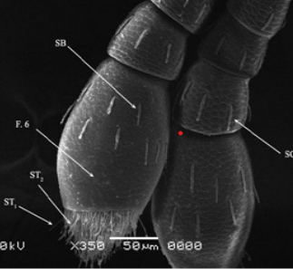  Scanning electron microphs of sensilla of Sitophilus oryzae[11].
Oryzaephilus surinamensis | Seven morphologically different sensilla types were examined using scanning electron microscopy (SEM) and transmission electron microscopy (TEM): non-porous hairs (NPH); non-porous pegs with inflexible sockets (NPP-is); non-porous pegs with flexible sockets; uniporous sensilla (UP); multi-porous pegs (MPP); multi-porous grooved pegs with single and double walls[12].
Rhyzopertha dominica | The adult R. dominica has six types of antennal sensilla. The density of sensilla increases from the proximal to the distal portions of the antenna, with only the distal three antennal club flagellomeres containing all types of sensilla. Sensilla trichodea and S. basiconica are the predominant types, particularly on the distal club flagellomeres. Sensilla trichodea was found in every segment of the flagellum[13].  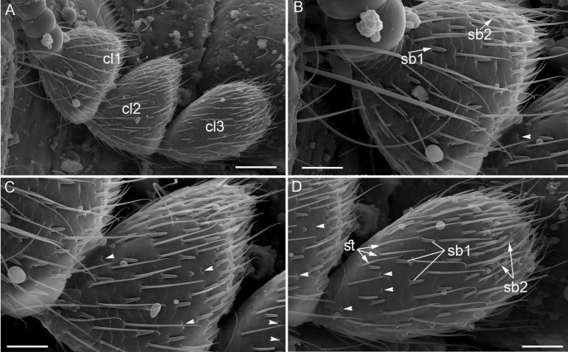  Scanning electron micrographs of distal part of the antennae of Rhyzopertha dominica[13].

Vital Role of Sensilla
The function and importance of sensilla are significant and can greatly impact various processes. The various types of sensilla found on insect antennae play crucial roles in perceiving the environment. Sensilla trichodea 1 (ST1) is known for its mechanoreceptive functions, detecting mechanical stimuli. On the other hand, Sensilla Trichodea 2 (ST2) is commonly found on insect antennae and is believed to serve as an important sex pheromone receptor.
The study discovered sensilla chaetica (SC) distributed across different parts of the flagella, consistent with previous research findings in other insects. With its lack of wall pores and the presence of a tubular body, SC sensilla are thought to offer a combined mechanosensory and gustatory function.
Similarly, sensilla basiconica 1 and 2 (SB1 and SB2) resemble those found in Phoracantha semipunctataas well as in Callosobruchus maculatus and Callosobruchus Chinensis. It is believed that these sensilla have a vital role as sex-pheromone receptors and are involved in olfactory functions.
Furthermore, grooved peg sensilla in Callosobruchus maculatus share similarities with sensilla styloconicum in the cigarette beetle Lasioderma serricorne, sensilla basiconica type IV in Limonius aeruginosus, and Basiconica capitate peg sensillum (B.C.P.S) in Liporrhopalum tentacularis. These sensilla likely function in chemo- or thermoreception [18].
Chemoreception in Stored Grain Beetles
In the animal kingdom, the chemical senses play a crucial role for insects, aiding in the detection of environmental chemical information and the search for suitable host plants. Chemosensory sensilla, located on various parts of the insect's body, serves as the key sensory structures for detecting olfactory stimuli and taste, contributing significantly to their development and reproduction[14]. The study investigated the expression of specific proteins involved in chemoreception in the antennae of the beetle T. brevicornis, a stored food product pest. The researchers used a combination of morphological, electrophysiological, and proteomics techniques. The results included a detailed characterization of the ultrastructure of different types of sensilla located in the antennae. Additionally, the electrophysiological evidence showed that sensilla basiconica, organized in a crown at the tip of the antenna, responded to sucrose and NaCl solutions[15].
The researchers compared how different harmful species of the genus Sitophilus, which are adapted to field and storage habitats, perceive their aggregation pheromones and corresponding stereoisomers. They found that both male and female rice weevils and maize weevils had similar responses to (4S,5R)-sitophilure, confirming its role as an aggregation pheromone[17].
“Effective Management of Stored Grain Pests"The study found that treating adult beetles with 9 ppm of Lufenuron resulted in abnormalities in their antennae shape and longer sensilla length, except for (BB). Fusion of some sensillae was observed in treated sensilla trichodea, and pores appeared in sensilla basiconica. These abnormalities may be linked to the insect growth regulator's effect on the release of ecdysteroids by interfering with hormone release from neuroendocrine sites[18].
The rising need for environmentally friendly and non-harmful products to control store weevil infestations has sparked an increased interest in the potentially toxic and repellent effects of natural products, such as essential oils derived from plants. Exploring the effectiveness of essential oils extracted from native plants could lead to the use of these products in controlling grain weevil infestations, reducing the reliance on less sustainable control methods. The essential oils from C. nubigenum and C. tomentosum demonstrated a powerful repellent effect on adult S. zeamais, involving the insect's antennal olfactory system. However, further research is necessary to determine these substances' optimal concentration and application methods [19].
CONCLUSION: The order Coleoptera comprises the largest group of insects, totaling approximately 250,000 species. Some of these insects have been known to cause damage to stored grain products in warehouses or homes, resulting in economic losses. The antennae of these insects play critical roles in host recognition, location, and other behaviors. They are equipped with sensory receptors that perceive smell, taste, sound, and vision, as well as senses of temperature, humidity, and geology.Antennae of these pests have been studied using a scanning electron microscope. Sensory organs found in the antennae respond to various stimuli in the environment.

Disclaimer (Artificial intelligence)
Option 1:
Author(s) hereby declare that NO generative AI technologies such as Large Language Models (ChatGPT, COPILOT, etc) and text-to-image generators have been used during writing or editing of manuscripts.
Option 2:
Author(s) hereby declare that generative AI technologies such as Large Language Models, etc have been used during writing or editing of manuscripts. This explanation will include the name, version, model, and source of the generative AI technology and as well as all input prompts provided to the generative AI technology
Details of the AI usage are given below:
1.
2.
3.
REFERENCES
- Hao YN, Sun YX, Liu CZ. Functional morphology of antennae and sensilla of Hippodamia variegata (Coleoptera: Coccinellidae). PLoS One. 2020 Aug 7;15(8):e0237452.
- Rees DP. Coleoptera. In Integrated management of insects in stored products .2018. (pp. 1-39). CRC Press.
- Ahmad R, Hassan S, Ahmad S, Nighat S, Devi YK, Javeed K, Usmani S, Ansari MJ, Erturk S, Alkan M, Hussain B. Stored grain pests and current advances for their management. Postharvest technology-recent advances, new perspectives, and applications. 2021 Dec 28.
- Upadhyay RK, Ahmad S. Management strategies for control of stored grain insect pests in farmer stores and public warehouses. World Journal of Agricultural Sciences. 2011;7(5):527-49.
- Srivastava C, Subramanian S. Storage insect pests and their damage symptoms: an overview. Indian Journal of Entomology. 2016;78(special):53-8.
- Wei C, Ren B, Chen X, Zhou X, Wang W, Wang Z. Scanning electron microscope observations on the antennal sensilla of two stored grain pests Trogoderma granarium and Trogoderma variabile(Coleoptera: Dermestidae). Florida entomologist. 2015 Mar;98(1):140-8.
- Abdel-Latief M. A family of chemoreceptors in Triboliumcastaneum (Tenebrionidae: Coleoptera). PloS one. 2007 Dec 19;2(12):e1319.
- Rocha I, Hoffmann A, Souto P. Insect morphology. Encyclopedia of animal cognition and behavior. Springer. 2020.
- Seada MA, Hamza AM. Differential morphology of the sensory sensilla of antennae, palpi, foretarsi, and ovipositor of adult Tribolium castaneum (Herbst)(Coleoptera: Tenebrionidae). Annals of Agricultural Sciences. 2018 Jun 1;63(1):1-8.
- Ali SA, Diakite MM, Ali S, Wang MQ. Effects of the antennal sensilla distribution pattern on the behavioral responses of Tribolium castaneum(Coleoptera: Tenebrionidae). Florida Entomologist. 2016 Mar;99(1):52-9.
- Fouda MA, Al-Dali AG, Ghannam IS. Ultrastructure of sensory receptors on the antennae and mouthparts of the adult, Sitophilus oryzae L. and Sitophilus granarius L.(Coleoptera: Curculionidae). J. Nucl. Technol. Appl. Sci. 2016;4:25-33.
- WHITE PR, LUKE BM. Fine structure, function, and distribution of antennal sensilla in the saw‐toothed grain beetle, Oryzaephilus surinamensis. Physiological entomology. 1986 Jun;11(2):227-38.
- Seada MA, Hamza AM. Comparative morphology of sensilla of antennae, maxillary and labial palpi of adult Rhyzopertha dominica (F.)(Coleoptera: Bostrichidae), with specific reference to the typology and possible functions. The Journal of Basic and Applied Zoology. 2023 Mar 24;84(1):14.
- Abdel-Latief M. A family of chemoreceptors in Tribolium castaneum(Tenebrionidae: Coleoptera). PloS one. 2007 Dec 19;2(12):e1319.
- Alabi T, Marion‐Poll F, Danho M, Mazzucchelli GD, De Pauw E, Haubruge E, Francis F. Identification of taste receptors and proteomic characterization of the antenna and legs of Tribolium brevicornis, a stored food product pest. Insect Molecular Biology. 2014 Feb;23(1):1-2.
- Sawires SG, Elbassiouny AM. Effect of Gamma irradiation on the morphology of antennal sensilla of Rhyzopertha dominica(Coleoptera: Bostrichidae). Journal of Radiation Research and Applied Sciences. 2019 Jan 1;12(1):234-9.
- Levinson HZ, Levinson A, Ren Z, Mori K. Comparative olfactory perception of the aggregation pheromones of Sitophilus oryzae (L.), S. zeamais(Motsch.) and S. granarius(L.), as well as the stereoisomers of these pheromones. Journal of Applied Entomology. 1990 Jan 12;110(1‐5):203-13.
- Khalil MW, Abo-zeid NR, Hafez SE, Hamed RK, Hamouda LS. Morphological changes induced in the antenna of the cowpea beetle, Callosobruchus maculatus (Fabricius)(Coleoptera: Bruchidae) after treatment with lufenuron. Egyptian Academic Journal of Biological Sciences. A, Entomology. 2009 Jun 1;2(1):207-18.
- Romani R, Bedini S, Salerno G, Ascrizzi R, Flamini G, Echeverria MC, Farina P, Conti B. Andean flora as a source of new repellents against insect pests: Behavioral, morphological and electrophysiological studies on Sitophilus zeamais (Coleoptera: Curculionidae). Insects. 2019 Jun 14;10(6):171.
- Rahman MM, Schmidt GH. Effect of Acorus calamus (L.)(Araceae) essential oil vapours from various origins on Callosobruchus phaseoli (Gyllenhal)(Coleoptera: Bruchidae). Journal of Stored Products Research. 1999 Jul 1;35(3):285-95.
- Ali WK, Mohammed HH. Toxic effect of some plant extracts on the mortality of flour beetle Triboliumconfusum (Duval)(Coleoptera: Tenebrionidae). EntomolOrnitholHerpetol. 2013;2(115):2161-0983.
- Smet H, Mellaert HV, Rans M, Loof AD. The effect on mortality and reproduction of beta-asaronevapors on two insect species of stored grain: Ephestiakuehniella (Lepidoptera) and Triboliumconfusum Duval (Coleoptera).

