ANTIOXIDANT AND ALPHA AMYLASE INHIBITORY ACTIVITY OF APIGENIN IN ALLOXAN INDUCED DIABETIC RATS

ABSTRACT
Purpose: to study the antioxidant, inhibitory activity of alpha amylase, antidiabetic, effects of flavonoid Apigeninin in diabetic rats.
Methods: The effect of Apigeninon on blood glucose and antioxidant activities were estimated in alloxan induced diabetic and treated rats. The α-amylase inhibitory activity in the serum was assessed after oral administration of 7thday, 14th day, and 21st days treatment of Apigenin.
Results: The Apigenin was reduced the serum glucose, α-amylase levels and increased antioxidant levels significantly (P<0.05) in Apigenin alone and combination with Metformin treated groups.
Conclusion: The present investigation concludes that flavonoid Apigenin, single drug and combination with Metformin was increased antioxidant and inhibited the alpha-amylase activity and hypoglycemic effect in alloxan induced diabetes rats.

Keywords: Apigenin, Antioxidant, α-amylase, flavonoids, blood glucose, antioxidant activity.

INTRODUCTION
Diabetes is metabolic disorder, characterised by hyperglycaemia an inadequate insulin secretion from pancreatic Beta-cells. Treatment of Diabetes mellitus by oral hypoglycaemic drugs like Metformin is primarily reduces the hepatic glucose production and stimulates the peripheral insulin sensitivity[1].. Diabetes mellitus was regulated by several natural source of plant and their extracts [2].and also hyperglycaemia has been regulates the phytochemicals and flavonoids [3-8] .
Apigenin is a flavonoid has posses’ antihyperlipidemic, antidepressant, antidiabetic properties[9-10]..and glucose can induces the reactive oxygen species (ROS) from mitochondrial are responsible for hyperglycemias and vascular abnormality[11].. The approaches are to control the hyperglycemia at different mode of actions by increases the glucose uptake and inhibits gluconeogenesis [12].and reduce the hyperglycemias after postprandial [13-17].. The enzyme α-amylase is catalyses and breakdown of carbohydrates in to glucoses [18]. , So that inhibition of alpha amylase enzyme, leads to control the blood glucose levels[19].. Therefore in this study investigating the Apigenin efficacy in regulating blood glucose levels by inhibition of alpha amylase in alloxan induced type 2 diabetes.
MATERIALS AND METHODS
Experimental animals
Male Wister rats weight 150-180gm were procured and housed in well aerated cages at normal atmospheric temperature (25±5 °C) and 12- hours light/dark cycle, free access to water and standard diet of ad libitum and kept for about 7 days before the experiment.
Chemicals
Alloxan (A), Apigenin (APG) was purchased from Sigma (USA) Metformin as gift samples from Natco.pharma. Hyderabad, India.
Induction and treatment of diabetes

Diabetes mellitus was induced by using a single dose of alloxan (120 mg/kg i.p) injection for atleast 16 hours after fasting rats, Blood glucose was estimated after 48 hours of alloxan and confirmed the development of diabetes mellitus with increasing of blood glucose > 200mg/dl. All the diabetic rats were selected for this study, divided them as groups and treated with Apigenin 40mg/kg (p.o) (APG40), Apigenin 80mg/kg (p.o) (APG80) and Metformin 60mg/kg (p.o) [20]. for 21days.
Experimental design
The rats were divided into 7 groups (n =6) and treated as follows:
Group I: normal control (Sod. carboxymethyl cellulose-1% (CMC), orally).
Group II: diabetic control (Alloxan)
Group III: diabetics + Apigenin (APG40)
Group IV: diabetics + Apigenin(APG80)
Group V: diabetics + Metformin (60mg/kg)

Apigenin plus Metformin 60mg/kg combination treated groups are IIIa & IVa. Which were received APG40 and APG 80[21].
Biochemical evaluation
Blood samples was withdrawn from the eye retro orbital region of all 7 groups of rats, on 0 day, 7th day, 14th day and 21st days after treatment, centrifuged the blood samples at 1000 rpm for 15 minutes and separated the serum, estimated the blood glucose[22]., Serum antioxidant[23]., Superoxide dismutase (SOD) [24]. and α-amylase [25]. levels were estimated.
Statistical analysis
The data has Mean ± S.D., Statistical comparisons were made by one-way analysis of variance (ANOVA) andConsidered the significancy when the pvalues were lower than 0.05.
RESULTS
The effects of Apigenin on blood glucose levels of (0day, 7th day, 14th day and 21 days) Control, Diabetic, Apigenin and Metformin treated rats,results were represented in Figs. 1 and 2. The results of SOD, TAS (after 21days Apigenin treatment) were represented in Table 1. α-amylase inhibitory activity (0 day, 7thdays, 14th days and 21days) is represented in figs 3&4 . Flavonoid Apigenin 40mg/kg, Apigenin80mg/kg aloneand Apigenin combination with Metformin treated groups rats were significantly (p < 0.05) reduced the levels of blood glucose. The flavonoid APG40,APG80 doses treated diabetic ratswere significantly (p < 0.001) increasedserum SOD, TAS levels and reduced α-amylase activity.

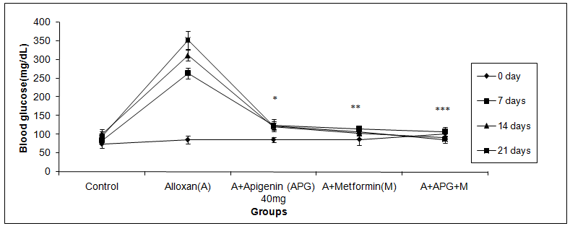

Figure 1: Blood glucose concentrations (mg/dl) of Control, Diabetic, Apigenin 40 and Apigenin40 (APG40)+Metformin (60mg/kg)treated groups., (Mean±SD( n=6)
(The p-values as*p<0.05, ** p<0.01, *** p<0.001,Comparedcontrolvs. diabetic& treated)

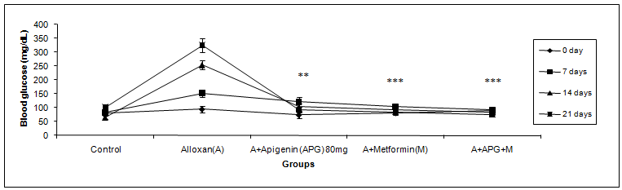

Figure 2: Blood glucose concentrations (mg/dl) of Control, Diabetic, Apigenin 80 and Apigenin40 (APG80) +Metformin (60mg/kg) treated groups., (Mean±SD( n=6)
(The p-values as *p<0.05, ** p<0.01, *** p<0.001,Compared control vs. diabetic& treated)

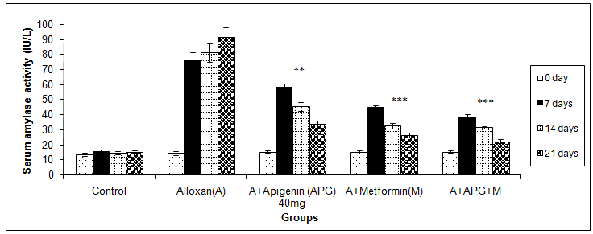

Figure 3: serum α-amylase inhibitory activity (IU/L) of Control, Diabetic, Apigenin 40 and Apigenin40 (APG40)+Metformin (60mg/kg) treated groups., Mean±SD( n=6)
(The p- values *p<0.05, ** p<0.01, *** p<0.001,Compared control vs. diabetic and treated)

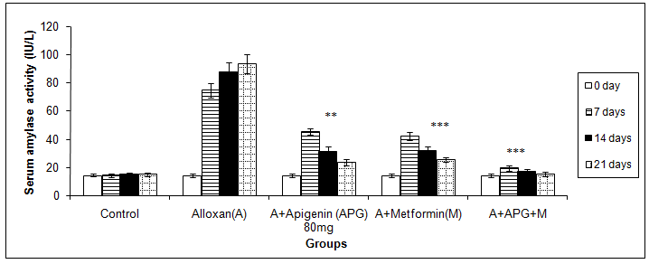

Figure 4: serum α-amylase inhibitory activity (IU/L) of Control, Diabetic, Apigenin 80 and Apigenin80 (APG80) +Metformin (60mg/kg) treated groups., Mean±SD( n=6)
(The p-values *p<0.05, ** p<0.01, *** p<0.001,Compared control vs. diabetic and treated)

Table 1: Effect of Apigenin 40mg , Apigenin 80mg and Metformin (60mg/kg)alone and combinations for 21 days treatment on serum SOD and Total antioxidant status (TAS) of control, diabetic and treated groups. (Mean ± SD, n = 6)

Groups/Parametes | SOD(IU) | Total antioxidant status(TAS) (nM of ascorbic acid))
Control | 38.61±10.26 | 25.89 ± 9.41
Alloxan(A) | 11.3±2.82 | 5.2±1.11
A+ Apigenin 40 (APG) | 17.3±11.1* | 8.3±1.68*
A+Metformin60mg/kg(M) | 22.6±8.25* | 9.7±3.25*
A+APG40+M | 26.23±0.36* | 12.26±3.56*
A+ Apigenin 80 | 30.31±9.1** | 19.42±1.41**
A+APG80+M | 36.57±12.5*** | 22.11±3.5***

(p-values *p<0.05, ** p<0.01, *** p<0.001, compared control vs diabetic and treated)

DISCUSSION
Many flavonoids have been reported to reduce the glucose production from carbohydrates and glucose absorptions. Alpha amylase is an enzyme which is converts the polysaccharides into sugars, they can ready to absorption in intestine. The inhibition of alpha amylase enzyme considered to reduces the hyperglycemia in diabetes.
In our study results has been indicates that inhibition of alpha amylase levels with flavonoids treatment, these findings were support of Tadera et al. (2006) [26-28]., has reported that inhibition of alpha-glucosidase and alpha amylase with flavonoids therapy. Another study Lo Piparo et al. (2008) [29]., reported that flavonoids control the carbohydrates degradation by inhibition of alpha-amylase[11]. hence, reduces the blood glucose level[30]. Inhibition of α-amylases causes delaying the hydrolysis of carbohydrates and their absorption can limit the hyperglycemia of post-prandial [31]. .The present study results reveals that decreased the blood glucose with flavonoid APG, these study support of Ali et al. (2006) [32] reported that antioxidant and hypoglycaemic effects of favonoids [33-34] .
“In present study elevated the alpha amylase levels due to cause of reactive oxygen species (ROS) and inflammatory mediators in diabetes mellitus, which was brought to normal by treatment with flavonoids alone and combination of Metformin”. [41] The indirect mechanism of flavonoids and metformin inhibited the alpha amylase levels [35]. these findings were support of Mira et al. (2002) [36-37]., reported that flavonoids has been antioxidant and anti-inflammatory effects, which are protects the pancreatic β-cells from inflammatory mediators[38-40]. The study indicates that flavonoids posse’s antidiabetic as well as inhibiting the alpha amylase activity in type 2 diabetic rats. Free radical scavenging activity and reduced hepatic lipidperoxidations by Apigenin(6).. The Apigenin may have potential agent to regulate the hyperglycemias in diabetes mellitus by inhibition of alpha amylase and hepatic protection.Therefore further investigations needs for its possible use in human.
CONCLUSION
Our study results shows that the treatment of Apigenin alone and combinations has been effectively controlled the alloxan-induced diabetes mellitus by reductionof blood glucose, inhibition of α-amylase activity and improvement of antioxidant status by scavenging the free radical. We suggesting that the diabetes mellitus may be prevented by flavonoids contents like Apigenin

Ethical Approval: All procedures followed accordance with the animal ethical Committee approval of viswabharati education society (006/1963/PO/Re/S/17/CPCSEA).

REFERENCES

- Bailey CJ. 1992. Biguanides and NIDDM. Diabetes Care.15(6):755-772.
- Valcheva-Kuzmanova, S., Kuzmanov, K., Tancheva, S., Belcheva,A., et al., 2007. Hypoglycemic and hypolipididemic effects of Aronia melanocarpa fruit juice in streptozotocin induced diabetic rats. Methods Find. Exp. Clin. Pharmacol.29: 101-105.
- Lee, J. S. 2006. Effects of soya protein and genistein on blood glucose, antioxidant enzyme activities and lipid profile in streptozotocin induced diabetic rats. Life Sci., 13: 1578–1584
- Sharma, K. K., Gupta, R. K., Gupta, S., Samuel, K. C. et al., 1977. Antihyperglycaemic of onion: effect on fasting blood sugar and induced hyperglycemia in man. Ind. J. Med. Res. 65: 422–429.
- Li, W., Dai, R. J., Yu, Y. H., Li, L., Wu, C. M., Luan, W. W., Meng, W. W., Zhang, X. S., Deng, Y. L. et.al.,2007. Antihyperglycemic effect of Cephalotaxus sinensis leaves and GLUT-4 translocation facilitating activity of its flavonoid constituents. Biol. Pharm. Bull. , 30: 1123–1129.
- Zhang L, Tu Z, Yuan T, Wang H, Xie X, Fu Z (2016) Antioxidants and α-glucosidase inhibitors from Ipomoea batatas leaves identified by bioassay-guided approach and structure-activity relationships. Food Chem 208:61–67.
- Zhou, C., Tan, Y., Xu, B.,Wang, Y., & Cheang,W.-S. (2022). 3,4’,5-Trimethoxytrans- stilbene Alleviates endothelial dysfunction in diabetic and obese mice via activation of the AMPK/SIRT1/eNOS pathway. Antioxidants, 11(7), 1286.
- 6. Singh, J. P., Selvendirank, K., Banu, S. M., Padmavathi, R., Sakthisekeran, D.,etal., 2004 Protective role of apigenin on the status of lipid peroxidation and antioxidant defense against hepatocarcinogenesis in Wistar albino rats. Phytomedicine. 11: 309–314.
- Shunkla, R., Anand, K., Prabhu, K. M., Murthy, P. S,etal.,2000. Hypolipidemic effect of water extract of Ficus bengalensis in alloxan induced diabetes mellitus rabbits. Ind. J. Clin. iochem. 3: 321–421 103–1105.
- Kaiser N, Sasson S, Feener EP, Boukobza N, Higashi S, and Moller DE.,etal., 1993. Differential regulation of glucose transport and transporters by glucose in vascular endothelial and smooth muscle cells. Diabetes, 42:80–89.
- Youn JY, Park HY and Cho KH. 2004. Anti-hyperglycemic activity of Commelina communis L.: inhibition of alpha-glucosidase. Diabetes Res. Clin. Pract. 66: 149-155.
- Kim YM, Jeong YK, Wang MH, Lee WY and Rhee HI.,etal., 2005. Inhibitory effect of pine extract on alpha-glucosidase activity and postprandial hyperglycemia. Nutrition, 21: 756-761
- Seuring T, Archangelidi O, Suhrcke M (2015) The economic costs of type 2 diabetes: a global systematic review. Pharmacoeconomics 33(8):811–831.
- Li K, Fan H, Yin PP, Yang LG, Xue Q, Li X, Sun LW, Liu YJ (2018) Structureactivity relationship of eight primary flavonoids analyzed with a preliminary assign-score method and their contribution to antioxidant ability of flavonoids-rich extract from Scutellaria baicalensis shoots. Arabian J Chem 11:159–170.
- Rodriguez, C., Contreras, C., Saenz-Medina, J., Munoz, M., Corbacho, C., Carballido, J. N., Garcia-Sacristan, A., Hernandez, M., Lopez, M., Rivera, L., & Prieto, D. (2020). Activation of the AMP-related kinase (AMPK) induces renal vasodilatation and downregulates Nox-derived reactive oxygen species (ROS) generation. Redox Biology, 34, 101575.
- Mai TT, Thu NN, Tien PG and Van Chuyen N.,etal.,2007. Alpha-glucosidase inhibitory and antioxidant activities of Vietnamese edible plants and their relationships with polyphenol contents. J. Nutr. Sci. Vitaminol.53: 267-276
- Kotowaroo MI, Mahomoodally MF, Gurib-Fakim A and Subratty AH.,etal., 2006 Screening of traditional antidiabetic medicinal plants of Mauritius for possible alpha-amylase inhibitory effects in vitro. Phytother. Res. 20: 228-231.
- Funke I and Melzig MF. 2006. Traditionally used plants in diabetes therapy-phytotherapeutics as inhibitors of α-amylase activity. Braz. J. Pharmacogn. 16: 1-5.
- Ami Naik , Sherif Babatunde Adeyemi, Bhavin Vyas, Ramar Krishnamurthy.,et al., 2022. Effect of co-administration of metformin and extracts of Costus pictus D.Don leaves on alloxan-induced diabetes in rats. Journal of Traditional and Complementary Medicine., 12 :269-280
- Mahesh T, Menon VP.2004. Quercetin alleviates oxidative stress in streptozotocin-induced diabetic rats. Phytother res, 18: 123-127.
- De boer VCJ, Dihal AA,Van der woude H, Arts ICW,Wolffram S, Alink GM,Rietjens IMCM, keijer J, Hollman PCH. , etal., 2005. Tissue distribution of quercetin in rats and pigs. J nutr, 135: 1718-1725.
- Trinder, P. 1969. Determination of blood glucose using an oxidaseperoxidase system with a non-carcinogenic chemogen. J Clin Pathol, 22:158-161.
- Blios, M.S. 1958. Antioxidant determination by the use of stable free radical. Nature. 26:1199-1200.
- Misra, H. P., and Fridowich, I. 1977. Superoxide dismutase, a photochemical augmentation assay. Archives of Biochemistry and Biophysics, 181, 308-312.
- Street HV and Close JR. 1956. Assay method of amylase activity. Clin. chim. Acta, 1: 256-257.
- Tadera, K.; Minami, Y.; Takamatsu, K.; Matsuoka, T,et al., 2006. Inhibition of alpha-glucosidase and alphaamylase by flavonoids. J. Nutr. Sci. Vitaminol. (Tokyo), 52, 149–15.
- Tan, Y., Cheong, M. S., & Cheang, W. S. (2022). Roles of reactive oxygen species in vascular complications of diabetes: Therapeutic properties of medicinal plants and food. Oxygen, 2(3), 246–268.
- Miao, L., Cheong,M. S., Zhou, C., Farag, M., Cheang,W. S., & Xiao, J. (2023). Apigenin alleviates diabetic endothelial dysfunction through activating AMPK/PI3K/Akt/eNOS and Nrf2/HO-1 signaling pathways. Food Frontiers, 4, 420–431.
- Lo Piparo, E.; Scheib, H.; Frei, N.; Williamson, G.; Grigorov, M.; Chou, C.J, etal., 2008. Flavonoids for controlling starch digestion: Structural requirements for inhibiting human alpha-amylase. J. Med.Chem.51, 3555–3561.
- Kwon YI, Jang HD and Shetty K. 2006. Evaluation of Rhodiola crenulata and Rhodiola rosea for management of type II diabetes and hypertension. Asia Pac. J. Clin. Nutr. 15: 425-432.
- David SH, Bell MB. 2004. Type 2 diabetes mellitus: What is the optimal treatment regimen? Am J Med, 116: 23-29.
- Ali H, Houghton PJ and Soumyanath A. 2006. Alpha-Amylase inhibitory activity of some Malaysian plants used to treat diabetes; with particular reference to Phyllanthus amarus. J. Ethnopharmacol. 107: 449-455.
- Lean MEJ, Noroozi M, Kelly I, Burns J, Talwar D, Sattar N, Crozier A, et al., 1999. Dietary flavonols protect diabetic human lymphocytes against oxidative damage to dna. Diabetes, 48:176-181.
- Jung UJ, Lee M-K, Park YB, Kang MA ET Choi MS,etal.,2006. Effect of citrus flavonoids on lipid metabolism and glucose-regulating enzyme mrna levels in type-2 diabetic mice. Int. J. Biochem. Cell. Biol. 38: 1134–1145.
- Andrade-Cetto A, Becerra-Jiménez J, Cárdenas-Vázquez R, etal.,2008. Alfa- glucosidase-inhibiting activity of some Mexican plants used in the treatment of Type 2 diabetes. J Ethnopharmacol, 116(1):27-32.
- Mira L, Fernandez M.T, and Santos M, Rocha R, Florencio M.H, Jennings K.R,etal., 2002. Interactions of flavonoids with iron and copper ions: a mechanism for their antioxidant activity. Free Radical Res., 36, 1199-1208.
- Zhang, X., Zhou, C., Miao, L., Tan, Y., Zhou, Y., Cheong, M. S., Huang, Y., Wang, Y., Yu, H., & Cheang, W. S. (2021). Panax notoginseng protects against diabetes-associated endothelial dysfunction: Comparison between ethanolic extract and total saponin. OxidativeMedicine and Cellular Longevity, 2021, 4722797.
- Ren B, Qin W, Wu F, Wang S, Pan C, Wang L, Zeng B, Ma S, Liang J. Apigenin and naringenin regulate glucose and lipid metabolism, and ameliorate vascular dysfunction in type 2 diabetic rats. Eur J Pharmacol 773: 13–23,
- Della-Logia, A., Ragazzi, E. and Tubaro,etal.,1988. Anti-inflammatory activity of benzopyrones that are inhibitors of cyclo-and lipo-oxygenases. Pharmacol. Res. Commun., 1988; 20: 91–94.
- Kim, H. P., Mani, I. and Ziboh, V. A.,etal., 1998. Effects of naturally-occuring flavonoids and bio-flavonoids on epidermal cyclooxygenase from guinea-pigs. Prostaglandins Leukot. Essent. Fatty Acids, 58: 17–24.
- Puligilla Shankaraiah PS, Raju Devde RD, Reddy YN. Alpha amylase inhibitory activity of flavonoids in diabetic induced rats. Journal of Pharmacy Research Vol.5 Issue 2.February 2012Puligilla Shankaraiahet al. / Journal of Pharmacy Research 2012,5(2),1183-1187

