The Role of Biodegrading-bacteria to Remove Bisphenol-A from Polluted Soils
Abstract:
Background: Bisphenol A (BPA), is an organic component, functions as an endocrine disruptor (EDC). It ubiquitously exists in both, the environment and the food sources, leading to continuous and unintentional exposure among populations of human and animal. Aim of the study: Investigate biodegradation activity of BPA by bacteria isolated from polluted soil with plastic wastes. Materials and Methods: 50 samples were taken from polluted soil with plastic wastes of different sites in Kerbala province; minimal salt media (MSM) were used to identify the capability of the isolates to bioremediate 200 mg/L, as a final concentration of BPA by using HPLC analysis. Results: the bacterial isolates could degrade the BPA in different ranges started from 18.7% to 99.9%. the recent study found that, Serratia plymuthica, Pantoea spp, Shingomonas paucimobilis, Pseudomonas aeruginosa and Bacillus spp. were more efficient in BPA biodegradation than Acinetobacter haemolyticus, Acinetobacter lwoffii, Escherichia coli and Proteus spp. Conclusion: Many types of bacterial isolates could convert the toxic organic compound Bisphenol A to another metabolites and according to recent study we could employee these activity to eliminate these materials safely from the polluted soils and water efficiently than using chemicals that might be toxic to environment, human being and animals.
Keywords: BPA, Biodegradation, Sphingomonas paucimobilis, HPLC, Minimal salt Media, Estrogen-mimic.
Introduction:
Public Health
Bisphenol A (BPA) considered as an organic substance employed in the manufacturing of resins' epoxy, polycarbonate and also, plastics included polyvinyl chloride; its inception dates back to 1891, gaining widespread utilization about 1930 when researchers developed polycarbonate plastic incorporating BPA successfully (1). Epoxy resins and polycarbonate plastics found application in various commodities, such as bottles of water, milk and babies, plastic of plates and cups, paints, coatings materials, and packaging for products of dairy; the migration of BPA, inherent in these types of plastics, transpires from the packaging of the materials to the products of dairy over time (2). Bisphenol A (BPA) did not naturally occur within the environmental milieu; but, its pervasive integration as an industrial constituent in plastic materials had rendered it a ubiquitous element within the global ecosystem; the contamination of the environment by BPA emanates due to various conduits, including effluent wastes from BPA manufacturing processes and the introduction of BPA-laden products into the environmental matrix (3,4). The disintegration of synthetic polymers, incineration of domestic refuse, deposition of refuse in substantial quantities among other activities, constitute essential sources of BPA influx into aquatic, terrestrial and atmospheric realms; these aforementioned mechanisms collectively gave rise to the propagation of contamination by BPA (5).
Bisphenol A (BPA) serves as an endocrine disturbance (EDC), and ubiquitously present in both the food sources and environmental milieu, leading to continuous and inadvertent exposure for both populations of human and animal to this endocrine-disrupting agent; owing to its considerable impact on health, endeavours had been undertaken to explore substitutes for its utilization (6). Bisphenol A (BPA) manifest acute toxicity in the animal kingdom; coupled with mutagenic as well as estrogenic implications on human health (7). Estrogens and their mimics, in addition to inducing heightened expression of the estrogen-receptors, also prompt the upregulation of receptors and related genes and associated with various biochemical entities, including cytokines, peptides and lipids present within the endometrial milieu (8,9,10). Nevertheless, these deleterious substances were polluting surfaces and subsurface water sources (11).
In vitro investigations and animal trials suggested that, BPA exposure could exert influences on reproductive and cardiovascular systems, besides thyroid functions. additionally, BPA might be associated with metabolic as well as oxidative stress disorders, encompassing diabetes and obesity; furthermore, various detrimental effects of BPA on wildlife had been documented, encompassing developmental inhibition, malformations, and reproductive system dysfunctions (12). In experimental trials, exposure to BPA had demonstrated detrimental impacts on the reproductive system; specifically, in reproduction of female, neonatal and perinatal; so, exposure to BPA had been documented to induce notable histological modifications in the reproductive tract, disrupt the heat cyclicity, diminish reproductive capacity and induce alterations in hormone levels during adults’ life (6,13).
The employment of BPA-degrading microorganisms in bioremediation held promises for the elimination of BPA from contaminated environments (14). In contrast to conventional chemical remediation methods, bacterial-mediated biodegradation proves cost-effective, environmentally benign and efficacious, even at minimal concentrations (15). The efficacy of bioremediation hinges predominantly on the selected bacterium's capacity to flourish in the contaminated environments; consequently, the potential of using bacterial strains that, obtained from contaminated soils appears to be promising in addressing the cleanup of harmful and hazardous pollutants (16).
Numerous organisms encompassing bacteria, fungi, algae as well as plants, exhibit the capability to degrade BPA within the environment; nonetheless, bacterial biodegradation emerges as the most pertinent focus in the realm of biodegradation studies (17). Within bacterial bioremediation, the efficacy of the process rests upon bacterial metabolism, wherein bacteria derived benefits from pollutant substances as both a source for carbon and substrate for the energy generation by the bacteria; consequently, bacterial biodegradation prove instrumental in the bioremediation process, and facilitating the reduction or removal of environmental concentrations of contaminants (18).
Sphingobacterium sp. and Pseudomonas aeruginosa were assessed for their ability to degrade plastics within soil environments; Sphingobacterium sp. was known to inhabit diverse habitats such as soil, activated sludge, forests, compost, fecal matter, lakes and various food sources; additionally, these bacterial species had been documented to exhibit potential in the biodegradation of various pollutants, including plastic mixture wastes (19). Prior researches had demonstrated that, bacteria such as Sphingobium sp., Pseudomonas putida, Bacillus megaterium, Arthrobacter sp., and Achromobacter xylosoxidans exhibited the capacity to degrade BPA effectively (20,21).
Materials and Methods:
A) Isolation of bacterial strains:
1) 50 samples were taken from polluted soil with plastic wastes of different sites in Kerbala province.
2) These samples were prepared and cultured on different media such as (MacConkey agar, blood agar, nutrient agar). For identification of these types of bacteria, the isolates identified by VITEK 2 System.
B) Preparation of Minimal salts media (MSM):
Minimal salts media (MSM) was employed to assess the bacterial isolates' capability to degrade BPA, consisting of (1.5 gm) of KH2PO4, (3.5 gm) of K₂HPO₄, (0.5 gm) of (NH4)2SO4, (0.5 gm) of NaCl, (0.5 gm) of (NH₄)₂SO₄, and finally (0.15 gm) of MgSO.7H₂O. Additionally, trace elements were incorporated, comprising (0.3 gm) MnSO₄.4H₂O, (0.2 gm) ZnSO₄.7H2O, (0.05 gm) CaCl2.2H2O, (2 gm) of NaHCO3.10 H2O, (0.02 gm) (NH₄) Mo₇O₂.4H₂O, (0.5 gm) CoCl₂.6H₂O, (0.1 gm) CuSO4.5H2O, and (0.5 gm) FeSO₄.7H₂O dissolved in one litter of distilled water (DW); furthermore, sterilized by using autoclave equipement at 121⁰C for 15 minutes in 15 bar. Subsequent cooled to 50⁰C, BPA was introduced into the mixture as only carbon source provided at a final Conc. of 200 mg/L. This medium was utilized for the detection of BPA-degrading activity (7).
C) High-Performance Liquid Chromatography (HPLC) analysis:
Following the fourth-day incubation period at 37°C, one ml of each bacterial broth culture underwent centrifugation for 10 minutes at 12,000 rpm. The resultant supernatant was then filtered using a 0.22 µm Millipore filter to eliminate insoluble components potentially; then the resulting filtrate was employed for the residual concentration and quantification of BPA (22).
Bisphenol A residual concentration within the culture media was determined using (HPLC) on a column of C18 type, employing (Shimadzu system/Japan). The mobile phase consisted of water and/or acetonitrile, with running time of 25 minutes a totally, and a flow rate set at one ml/min. Elution occurred at a rate of one ml/min, and detection was performed at an absorption wavelength of 220nm. The retention time for BPA was observed between 3.9 to 6 minutes (23).
Results:
Fifty swabs were taken from polluted soils from different areas in Kerbala province/ Iraq. And these isolates were subjected to examine their ability to degraded bisphenol a by using MSM with BPA as sole carbon source for bacterial growth. Table (1).

Table (1): Positive bacterial growth grown in Bisphenol-a containing media
No. of isolates | Positive bacterial growth | Negative bacterial growth
50 | 31 (62%) | 19 (38%)

After inoculation the bacterial isolates to the MSM with bisphenol A. Each isolate that could grow in the Bisphenol A-containing media subjected to identify by VITEK 2 equipment. The results obtained revealed in the following table. Out of 50 samples taken from different sites of polluted soils.

Table (2): The bacterial isolates that grow in Bisphenol a-containing media according to identification by VITEK 2.

No. | Bacterial isolates | Number of isolates
1 | Serratia plymuthica | 5
2 | Pantoea spp | 3
3 | Shingomonas paucimobilis | 5
4 | Acinetobacter haemolyticus | 2
5 | Acinetobacter lwoffii | 2
6 | Pseudomonas aeruginosa | 4
7 | Escherichia coli | 5
8 | Bacillus spp. | 1
9 | Proteus spp. | 4
Total number |  | 31

After 3-4 days of incubation of bacterial isolates in MSM with bisphenol A. The broth centrifugated to filtrate it from bacterial growth. As well as, Millipore filter used to ultra-filtration. And the residues of BPA in these solutions calculated by HPLC, by using specific column, retention time and mobile phase. Figure (1), showed the control tube (that was replicated three time for precise results). The tube without bacterial inoculation and determined as a control with area under curve 100% and height 100%; all other tubes that inoculated with bacterial isolates compared to this tube to detect the residues of BPA. Examples of BPA biodegradation showed in Figure (2 and 3)
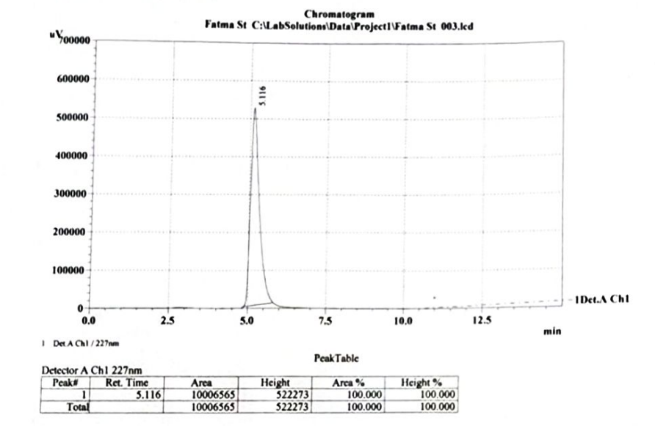
Figure (1): Bisphenol A control tube, the area under curve and height 100%
The results found that, the bacterial isolates could degrade the BPA in different ranges started from 18.7% to 99.9%. the recent study found that, Serratia plymuthica, Pantoea spp, Shingomonas paucimobilis, Pseudomonas aeruginosa and Bacillus spp. were more efficient in BPA biodegradation than Acinetobacter haemolyticus, Acinetobacter lwoffii, Escherichia coli and Proteus spp.
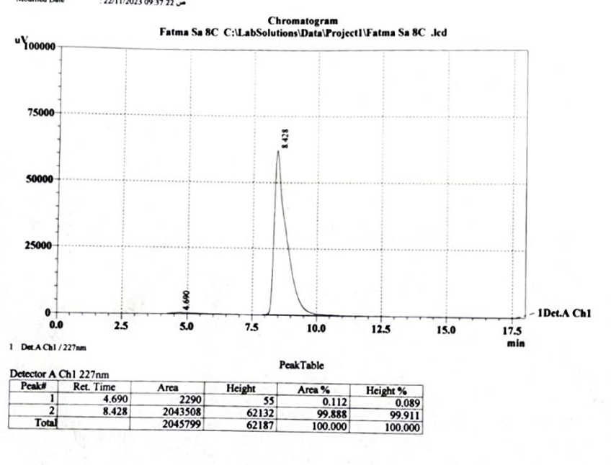
Figure (2): The ability of Shingomonas paucimobilis to biodegrade BPA. using HPLC.

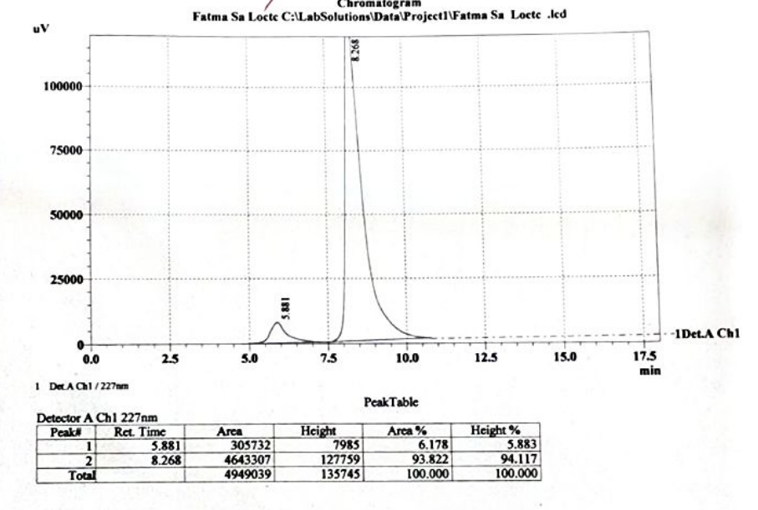
Figure (3): The ability of Bacillus spp. to biodegrade BPA using HPLC.
The results of capacity of biodegradation of BPA of all isolates illustrated in the table (3), as comparing to the control tube.
Table (3): The Percentage of area, height and biodegradation capacity of bacterial isolates according to HPLC results.
No. | Bacteria | Area % | Height % | Biodegradation capacity
1 | Serratia plymuthica | 0.046 | 0.486 | 99.9 %
1 | Serratia plymuthica | 0.128 | 0.565 | 99.8%
1 | Serratia plymuthica | 0.680 | 1.396 | 99.3%
1 | Serratia plymuthica | 0.821 | 1.757 | 99.1%
1 | Serratia plymuthica | 74.718 | 85.274 | 25.2%
2 | Pantoea spp | 0.410 | 1.246 | 99.5%
2 | Pantoea spp | 2.068 | 1.457 | 97.9%
2 | Pantoea spp | 0.453 | 0.745 | 99.5%
3 | Shingomonas paucimobilis | 6.131 | 5.237 | 93.8%
3 | Shingomonas paucimobilis | 20.026 | 24.741 | 79.9%
3 | Shingomonas paucimobilis | 0.112 | 0.089 | 99.8%
3 | Shingomonas paucimobilis | 11.197 | 9.564 | 88.8%
3 | Shingomonas paucimobilis | 7.681 | 5.907 | 92.3%
4 | Acinetobacter haemolyticus | 67.868 | 91.164 | 32.1%
4 | Acinetobacter haemolyticus | 65.243 | 90.341 | 34.7%
5 | Acinetobacter lwoffii | 74.160 | 93.420 | 25.8%
5 | Acinetobacter lwoffii | 72.166 | 93.001 | 27.8%
 | Pseudomonas aeruginosa | 19.459 | 28.122 | 80.5%
 | Pseudomonas aeruginosa | 15.182 | 19.967 | 84.8%
 | Pseudomonas aeruginosa | 17.124 | 20.235 | 82.8%
 | Pseudomonas aeruginosa | 14.451 | 19.11 | 85.5%
6 | Escherichia coli | 81.262 | 89.833 | 18.7%
6 | Escherichia coli | 75.458 | 77.999 | 24.5%
6 | Escherichia coli | 80.821 | 88.122 | 19.1%
6 | Escherichia coli | 57.564 | 85.999 | 42.4%
6 | Escherichia coli | 55.754 | 82.233 | 44.2%
7 | Bacillus spp. | 6.178 | 5.883 | 93.8%
8 | Proteus spp. | 75.904 | 91.071 | 24.0%
8 | Proteus spp. | 55.327 | 88.629 | 44.6%
8 | Proteus spp. | 56.21 | 88.232 | 43.7%
8 | Proteus spp. | 66.573 | 90.122 | 33.4%
Total Bacterial isolates: 31

Discussion:
Bisphenol A (BPA), an organic chemical substances, included with industrial significance, which serving as a crucial raw material in the synthesis of food containers, polycarbonates, industry of thermal paper, epoxy resins, and also, various other products; the extensive utilization of these chemical compounds results in substantial quantities of BPA being released directly into terrestrial and aquatic environments, posing a severe toxicity threat to numerous types of organisms (24).
According to Vijayalakshmi et al., who were observed that, the bacterium Pseudomonas aeruginosa demonstrated the ability to thrive in a nutrient broth medium containing varying concentrations of BPA, spanning from 5 mM reaching to 35 mM (25). The highest BPA elimination rates, amounting of 100% and 96%, were noted under conditions characterized by an initial bacterial amount of 15 ml and a salinity level of 2 percent for concentrations of BPA at 10 and 20 mg/L respectively; the primary metabolites resulting from the biodegradation of BPA, included chloro-benzene, hexa-decanoic acid, chloro-thymol, and 2,6 di-tert-butyl-4,phenylphenol; furthermore, the degradability of the effluent reached 69%, accompanied by a concurrent reduction in toxicity to 7% at all (26).
The BPA-degrading bacterium Pseudomonas paucimobilis had demonstrated the capability to mineralize about 60% of the total carbon content of BPA into carbon dioxide (CO2), additionally, it could assimilate 20% of BPA into bacterial cells, while the remaining 20% is transformed into soluble organic compounds (7). Enterobacter, when cultivated in MSM with a singular carbon source of 200 mg/L BPA, exhibited a significant capability for BPA degradation; subsequent to 8, 24, and finally 48 hours of cultivation, the residual quantity of BPA within the cultures was assessed through analysis using HPLC; so, remarkably, these bacteria demonstrated the capacity to biodegrade 53.50±0.153 mg/L of BPA within the 48-hour period, surpassing the degradation observed in the control medium (27).
At least there were four potential pathways for BPA degradation had been identified; the cytochrome P450 monooxygenase system had a notable enzyme complex playing a pivotal role in this process; this system comprises cytochrome P450, ferredoxin and also, ferredoxin reductase; notably, the functions of cytochrome P450 and ferredoxin in this system exhibited similarities to those found in Sphingomonas bacteria, as reported by Das et al. (28). According to bacterial biodegradation, the efficacy of the process hinges on bacterial metabolism, wherein bacteria utilized pollutant molecules as solely carbon source and substrate for the energy generation by the bacteria; consequently, bacterial biodegradation emerges as a valuable tool in the bioremediation processes, contributing to the removal or reduction of environmental concentrations of contaminants (29). Despite advancements in various remediation techniques, it was noteworthy that biodegradation by the bacteria remained the predominant method for addressing BPA contamination; this underscores the significance of harnessing the metabolic capabilities of bacteria in effectively breaking down and mitigating the environmental impact of BPA (30).
The pivotal role of Pseudomonas aeruginosa in the biodegradation of various polymers, encompassing degradation of the xenobiotic compounds; moreover, its involvement in the breakdown of plastics, dyes, and oils had been extensively documented; similarly, Sphingobacterium had been reported to exhibit notable biodegradation of diverse pollutants potentially; including the ability to contribute to the degradation of mixed plastic wastes; this emphasized the versatility of these bacterial strains in environmental remediation efforts targeting a range of pollutants and substances of polymer-based (31). In the pursuit of degradation of BPA, beyond chemical and physical treatment methods, microbial degradation had emerged as a focal point of scientific attention; in recent, microbial treatment had gained prominence as an environmentally friendly alternative, offering sustainable approaches to the degradation of plastics, including BPA; this shift towards microbial degradation underscores the potential of harnessing microorganisms to address pollution of plastics and highlights the importance of eco-friendly solutions in strategies of environmental remediation (32).
The analytical study conducted by Yue et al. revealed that, while Sphingomonas spp. exhibited the capability to fully degrade BPA, the process was deemed inefficient as intermediates tended to accumulate; in contrast, Pseudomonas sp. demonstrated more rapid utilization of these intermediates, thereby facilitating the overall mineralization of BPA within the microbial community; this observation cleared the intricate dynamics of microbial interactions and the significance of specific bacterial strains in optimizing the efficiency of BPA degradation pathways (33). Furthermore, Bacillus spp. had the capability to utilizing BPA as the only carbon source; isolated from the creek sediment located within recycling electronic-waste sites, these bacteria demonstrated remarkable efficiency by completely removing 100 percent of 5 mg/L BPA under an optimal aerobic conditions; this underscores the efficiency of Bacillus spp. in serving as effective agents for BPA biodegradation, especially in environments associated with electronic-waste contamination (34). On the other hand, Park and Chin reported that, Bacillus sp. abled to grow in a BPA-enriched MSM; remarkably, Bacillus sp. demonstrated the ability to degrade 84.68% of BPA within a 72-hour period, employing an initial BPA concentration at about 25 ppb; this finding highlights the proficiency of these bacteria in efficiently degrading BPA under controlled environmental conditions (35).
The toxicity bioassay indicated that, the degradation of BPA by Acinetobacter spp. not only led to elimination of this component, but also correlated with a reduction in its harmful effects; this suggests that, the tested strains of Acinetobacter spp. had served as effective tools for BPA removal in the context of wastewater treatment, emphasizing their significance in mitigating the environmental impact of this pollutant (36). Acinetobacter sp. demonstrated the ability to eliminate 20±3% of BPA at an initial level about 100 mg/L; considering the profound influence of pH values on the activity of the numerous enzymes; their impact on the capacity of BPA degradation by the bacteria were systematically evaluated; it was noted that pH variations might impede the remediation process by blocking the most active sites of the degradation enzymes potentially, thereby inhibiting the efficiency of the BPA degradation processes (37). As a result, a strain exhibiting significant BPA breakdown capability was isolated and identified as Proteus mirabilis throughout this study. Subsequently, it was observed that, these bacteria were able to decomposing 1 mg/L and 20 mg/L of BPA by 98.22% and 66.77%, respectively, within a 72-hour period; this highlighted the efficacy of Proteus mirabilis in BPA degradation and expressed its potential applicability in environmental remediation processes (38).
The interactions between BPA and microorganisms throughout the biodegradation process are indeed intricate; Microorganisms exhibited a range of metabolic control mechanisms aimed to countering and neutralizing BPA-induced stress; these mechanisms were orchestrated by the microbial community to adapted to and efficiently degraded BPA, thereby mitigating its adverse effects on the environment totally (39,40).
The examination of bacterial degradation behaviour had predominantly focused on the impact of metabolites such as enzymes and polysaccharides; hence, there are inherent limitations in elucidating the breakdown mechanism of BPA solely by using these methods (41,42). Indeed, molecular analysis held the promise of providing a more profound and comprehensive understanding of cognition; this approach allowed for detailed exploration of various aspects, as identifying the metabolites involved in bacterial degradation functions, elucidating the pathways employed by bacteria for degradation of pollutants and uncovering the modes of bacterial transport to pollutants; by delving into these molecular intricacies, researchers can gain deeper insights into the mechanisms and processes underlying bacterial degradation of pollutants, contributing to more nuanced comprehensions of cognitive functions in this context (43,44). Hence, there remained a notable gap in research concerning the evaluation of biodegradation mechanisms from a sufficiently comprehensive perspective. (45).
Conclusion:
Many types of bacterial that isolated from polluted soils with plastics could convert the toxic organic compound Bisphenol A to other metabolites and according to recent study we could employee this activity to eliminate these materials safely from the polluted soils and water efficiently than using chemicals that might be toxic to environment, human being and animals.
Ethical Approval
The research was carried out according to ethical principles rooted in the Helsinki Declaration. The protocol of this study, along with the subject information underwent scrutiny, and received approval from a local committee ethics; identified by the reference number (UOK. VET. HE.2023.067).
References:
1. Metz CM. Bisphenol A: understanding the controversy. Workplace Health Saf. 2016; 64:28-36. https://doi.org/10.1177/2165079915623790.
2. Yang L, Chen Y, Shen Y, Yang M, Li X, Han X, Jiang X, Zhao B. SERS strategy based on the modified Au nanoparticles for highly sensitive detection of bisphenol A residues in milk. Talanta. 2018; 179:37-42. https://doi.org/10.1016/j.talanta.2017.10.055.
3. Ramakrishna MG, Girigoswami A, Chakraborty S, Girigoswami K. Bisphenol A-an Overview on its Effect on Health and Environment. Biointerface Research in Applied Chemistry. Volume 2022; 12(1) :105-119.
https://doi.org/10.33263/BRIAC121.105119.
4. Kadhim TA, Al Sa’ady AT, Khayoon HA, Hameed DM, Hussain SS, Kareem AS, et al. The bacterial contamination in the burn unit of Al-Hussain Teaching Hospital at Al-Samawa City, Iraq. Med J Babylon 2023;20:357-61.
5. Crain DA, Eriksen M, Iguchi T, Jobling S, Laufer H, LeBlanc GA, Guillette Jr LJ. An ecological assessment of bisphenol-A: evidence from comparative biology. Reprod. Toxicol. 2007; 24: 225-239. https://doi.org/10.1016/j.reprotox.2007.05.008.
6. Molina-López AM, Bujalance-Reyes F, Ayala-Soldado N, Mora-Medina R, Lora-Benítez A, Moyano-Salvago R. An Overview of the Health Effects of Bisphenol A from a One Health Perspective. Animals. 2023, 13(15): 2439; https://doi.org/10.3390/ani13152439.
7. Badiefar L, Yakhchali B, Rodriguez-Couto S, Veloso A, Garcia-Arenzana JM, Yoshinobu Matsumuraf Y, Khodabandeh M. Biodegradation of bisphenol A by the newlyisolated Enterobacter gergoviae strain BYK-7 enhanced using genetic manipulation. RSC Adv., 2015; 5:29563–29572. DOI: 10.1039/C5RA01818H.
8. Mohammed BA, Al-Saaidi JA. Effect of experimentally induced prepubertal hyperthyroidism on postubertal reproductive activity in male rats. Iraqi Journal of Veterinary Sciences, 2023, 37; 1:297-304. DOI: 10.33899/ijvs.2022.133976.2325.
9. Landahur R, Santoso B, Widjiati W, Luqman EM. The endometrial expression level of estrogen-α and VEGF-A in female rats administered with a low dose of estrogen in early clomiphene citrate therapy. Iraqi Journal of Veterinary Sciences, 2023, 37;1:223-228. DOI: 10.33899/ijvs.2022.133333.2207 .
10. Mari ZM, Smaism MF, Al-Hilli NM. Effect of obesity on androgen receptor and androgen levels in the serum of women with infertility in Babylon, Iraq. Med J Babylon 2023;20:433-6.
11. Kareem SI, Hussein RH, Rasheed RO. Bioaccumulation of heavy metals in common carp fish (Cyprinus carpio) and its relationship with the protein content. Iraqi Journal of Veterinary Sciences. 2022, 36; Supplement I: 173-178. DOI: 10.33899/ijvs.2022.135834.2531.
12. Catenza CJ, Farooq A, Shubear NS, Donkor KK (2021) A targeted review on fate, occurrence, risk and health implications of bisphenol analogues. Chemosphere 268:129273. https://doi.org/10.1016/j.chemosphere.2020.129273
13. Behayaa HR, Juda TM, Mohammed SB. The effect of androgen hormones in acne pathogenesis: A review. Med J Babylon 2022;19:345-9
14. Kamaraj M, Sivaraj R, Venckatesh R. Biodegradation of Bisphenol A by the tolerant bacterial species isolated from coastal regions of Chennai, Tamil Nadu, India. Int. Biodeterior. Biodegrad., 2014; 93:216-222. https://doi.org/10.1016/j.ibiod.2014.02.014.
15. Jaafar RS. Bioremediation of lead and cadmium and the strive role of Pediococcus pentosaceus probiotic. Iraqi Journal of Veterinary Sciences. 2020,34;1:51-57.
16. Saiyood S, Vangnai A, Thiravetyan P, Inthorn D. Bisphenol A removal by the Dracaena plant and the role of plant-associating bacteria. J. Hazard. Mater. 2010, 178:777–785.
17. Eltoukhy A, Jia Y, Nahurira R, et al. Biodegradation of endocrine disruptor Bisphenol A by Pseudomonas putida strain YC-AE1 isolated from polluted soil, Guangdong, China. BMC Microbiol. 2020, 20:1–14. https://doi.org/10.1186/s12866-020-1699-9.
18. Noszczyńska M, Piotrowska-Seget Z. Bisphenols: Application, occurrence, safety, and biodegradation mediated by bacterial communities in wastewater treatment plants and rivers. Chemosphere. 2018, 201:214–223. https://doi.org/10.1016/j.chemosphere.2018.02.179.
19. Satti SM. Biodegradation of Poly (lactic acid) in Soil Microcosms at Ambient Temperature: Evaluation of Natural Attenuation, Bio-augmentation and Bio-stimulation. Journal of Polymers and the Environment. 2018:1-10.
20. Ren L, Jia Y, Ruth N, Shi Y, Wang J, Qiao C, et al. Biotransformations of bisphenols mediated by a novel Arthrobacter sp. strain YC-RL1. Appl Microbiol Biotechnol. 2016;100:1967–76.
21. Eltoukhy A, Jia Y, Lamraoui I, Abo-Kadoum MA, Atta OM, Nahurira R, Junhuan Wang J, Yan Y. Transcriptome analysis and cytochrome P450 monooxygenase reveal the molecular mechanism of Bisphenol A degradation by Pseudomonas putida strain YC-AE1. BMC Microbiology. 2022, 22:294. https://doi.org/10.1186/s12866-022-02689-6.
22. Louati I, Dammak M, Nasri R, Belbahri L, Nasri M, Abdelkaf S, Mechichi T. Biodegradation and detoxification of bisphenol A by bacteria isolated from desert soils. 3 Biotech, 2019; 9:228.
23. Jia Y, Eltoukhy A, Wang J, Li X, Hlaing TS, Aung MM , Nwe MT, Lamraoui I, Yan Y. Biodegradation of Bisphenol A by Sphingobium sp. YC-JY1 and the Essential Role of Cytochrome P450 Monooxygenase. Int. J. Mol. Sci. 2020, 21; 3588. doi:10.3390/ijms21103588.
24. Inoue D, Hara S, kahinhara M, Murai Y, Danzyl E, Sei K, et al. Degradation of Bis (4-hydroxyphenyl) methane Bisphenol F by Sphinogibum yaboikuyae strain FM2 isolated from river. Water and Applied Environmental Microbiology. 2008, 74(2): 352-358.
25. Vijayalakshmi V, Senthilkumar P, Mophin-Kani K , Sivamani S , Sivarajasekar N, Vasantharaj S. Bio-degradation of Bisphenol A by Pseudomonas aeruginosa PAb1 isolated from effluent of thermal paper industry: Kinetic modeling and process optimization. Journal of Radiation Research and Applied Sciences, 2018; 11 56-65.
26. Neisia A, Rahmanib AR , Ghafaric S, Jorfia S, Almasi H. Biodegradation of Bisphenol A in a saline industrial wastewater using Alcaligenes faecalis strain BPAN5. Desalination and Water Treatment. 2020, 189:276–282.
27. Zhang C, Zeng G, Yuan L, Yu J, Li J, Huang G, Xi B, Liu H. Aerobic degradation of bisphenol A by Achromobacter xylosoxidans strain B-16 isolated from compost leachate of municipal solid waste. Chemosphere. 2007, 68, 181-190.
28. Das R, Liang Z, Li G, Mai B, An T. Genome sequence of a spore-laccase forming, BPA-degrading Bacillus sp. GZB isolated from an electronic-waste recycling site reveals insights into BPA degradation pathways. Archives of Microbiology. 2019, https://doi.org/10.1007/s00203-019-01622-2.
29. Farias JM, Krepsky N. Bacterial degradation of bisphenol A and its analogues: An overview. Research square. 2022, https://doi.org/10.21203/rs.3.rs-1631241/v1.
30. Usman A, Ikhlas S, Ahmad M. Occurrence, toxicity and endocrine disrupting potential of Bisphenol-B and Bisphenol-F: A mini-review. Toxicol Lett. 2019, 312:222–227. https://doi.org/10.1016/j.toxlet.2019.05.018.
31. Satti SM, Shah AA, Auras R, Marsh TL. Genome annotation of Poly(lactic acid) degrading Pseudomonas aeruginosa and Sphingobacterium sp. bioRxiv. 2019. https://doi.org/10.1101/609883.
32. Yu K, Yi S,† , Li B, Guo F,5, Peng X, Wang Z, Wu Y , Alvarez-Cohen L, Zhang T. An integrated meta-omics approach reveals substrates involved in synergistic interactions in a bisphenol A (BPA)- degrading microbial community. Microbiome. 2019; 7:16. https://doi.org/10.1186/s40168-019-0634-5.
33. Yue W, Yin C, Sun L, Zhang J, Xu Y, Zhou N. Biodegradation of bisphenol-A polycarbonate plastic by Pseudoxanthomonas sp. strain NyZ600. Journal of Hazardous Materials. 2021,416; 125775. https://doi.org/10.1016/j.jhazmat.2021.125775.
34. Zhang W, Yin K, Chen L. Bacteria-mediated bisphenol A degradation. Appl Microbiol Biotechnol. 2013, 97:5681-5689. DOI 10.1007/s00253-013-4949-z.
35. Park YK and Chin Y-W. Degradation of Bisphenol A by Bacillus subtilis P74 Isolated from Traditional Fermented Soybean Foods. Microorganisms 2023, 11(9):2132. https://doi.org/10.3390/microorganisms11092132.
36. Noszczyn´ska M, Chodo´r M, Jałowiecki L, Piotrowska-Seget Z, A comprehensive study on bisphenol A degradation by newly isolated strains Acinetobacter sp. K1MN and Pseudomonas sp. BG12. Biodegradation. 2021, 32:1-15. https://doi.org/10.1007/s10532-020-09919-6.
37. Go´rny D, Guzik U, Hupert-Kocurek K, Wojcieszyn´ska D. Naproxen ecotoxicity and biodegradation by Bacillus thuringiensis B1(2015b) strain. Ecotoxicol Environ Saf. 2019, 167:505–512. https://doi.org/10.1016/j.ecoenv.2018.10.067.
38. Hou S and Yang P. BPA biodegradation driven by isolated strain SQ-2 and its metabolism mechanism elucidation. Biochemical Engineering Journal. 2022, 185:108540.
39. Tian K, Yu Y, Qiu Q, Sun X, Meng F, Bi Y, Gu J, Wang Y, Zhang F, and Huo H. Mechanisms of BPA Degradation and Toxicity Resistance in Rhodococcus equi. Microorganisms. 2023,11(1): 67.
40. McDonough CM, Xu HS, Guo TL. Toxicity of bisphenol analogues on the reproductive, nervous, and immune systems, and their relationships to gut microbiome and metabolism: Insights from a multi-species comparison. Crit. Rev. Toxicol. 2021, 51,283–300.
41. Han Y, Dai H, Rong X, Jiang H and Xue Y. Research Progressof Methods for Degradation of Bisphenol A. Molecules. 2023, 28:8028. https://doi.org/10.3390/molecules28248028.
42. Li S, Tian K, Qiu Q, Yu Y, Li H, Chang M, Sun X, Gu J, Zhang F, Wang Y and Huo H. Study on Genomics of the Bisphenol A-Degrading Bacterium Pseudomonas sp. P1. Water. 2023, 15(4):830. https://doi.org/10.3390/w15040830.
43. Zhu Y, Xie Q, Ye J, Wang R, Yin X, Xie W and Li D.Metabolic Mechanism of Bacillus sp.LM24 under Abamectin Stress. Int. J. Environ. Res. Public Health, 2023. 20, 3068. https://doi.org/10.3390/ijerph20043068.
44. Xiao C, Wang L, Zhou Q and Huang X. Hazards of bisphenol A (BPA) exposure: A systematic review of plant toxicology studies. Journal of Hazardous Materials, 2020, 384, 15 :121488.
45. Koh LM and Khor SM. Biodegradation Process: Basics, Factors Affecting, and Industrial Applications. Biodegradation Process: Basics, Factors Affecting, and Industrial Applications. In: Ali, G.A.M., Makhlouf, A.S.H. (eds) Handbook of Biodegradable Materials. Springer, Cham.2022. https://doi.org/10.1007/978-3-030-83783-9_66-1.

